Nguyễn Văn Sang
1150080072
Lab 3: Thiết kế giao diện trên Android Studio (tiếp)
Code:
MainActivity.java
package com.example.lab3;
import android.content.Intent;
import android.content.pm.ActivityInfo;
import android.os.Bundle;
import android.widget.Button;
import android.widget.CompoundButton;
import android.widget.Switch;
import androidx.appcompat.app.AppCompatActivity;
public class MainActivity extends AppCompatActivity {
Switch switchOrientation;
Button btnLanguage;
@Override
protected void onCreate(Bundle savedInstanceState) {
super.onCreate(savedInstanceState);
setContentView(R.layout.activity_main);
switchOrientation = findViewById(R.id.switchOrientation);
btnLanguage = findViewById(R.id.btnLanguage);
switchOrientation.setOnCheckedChangeListener(new CompoundButton.OnCheckedChangeListener() {
@Override
public void onCheckedChanged(CompoundButton buttonView, boolean isChecked) {
if (isChecked)
setRequestedOrientation(ActivityInfo.SCREEN_ORIENTATION_SENSOR);
else
setRequestedOrientation(ActivityInfo.SCREEN_ORIENTATION_PORTRAIT);
}
});
btnLanguage.setOnClickListener(v -> {
Intent intent = new Intent(MainActivity.this, LanguageActivity.class);
startActivity(intent);
});
}
}
LanguageActivity.java
package com.example.lab3;
import android.content.Intent;
import android.content.res.Configuration;
import android.os.Bundle;
import android.widget.TextView;
import androidx.appcompat.app.AppCompatActivity;
import java.util.Locale;
public class LanguageActivity extends AppCompatActivity {
@Override
protected void onCreate(Bundle savedInstanceState) {
super.onCreate(savedInstanceState);
setContentView(R.layout.activity_language);
TextView tvVi = findViewById(R.id.tvVi);
TextView tvEn = findViewById(R.id.tvEn);
TextView tvFr = findViewById(R.id.tvFr);
tvVi.setOnClickListener(v -> setLocale("vi"));
tvEn.setOnClickListener(v -> setLocale("en"));
tvFr.setOnClickListener(v -> setLocale("fr"));
}
private void setLocale(String lang) {
Locale locale = new Locale(lang);
Locale.setDefault(locale);
Configuration config = new Configuration();
config.setLocale(locale);
getResources().updateConfiguration(config, getResources().getDisplayMetrics());
Intent refresh = new Intent(this, LanguageActivity.class);
finish();
startActivity(refresh);
}
}
Kết quả:
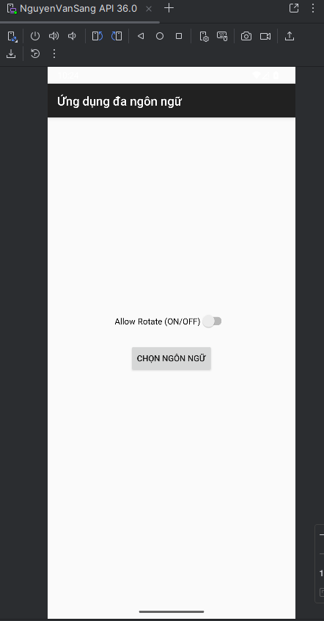
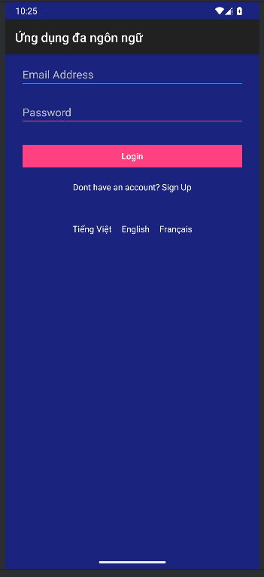
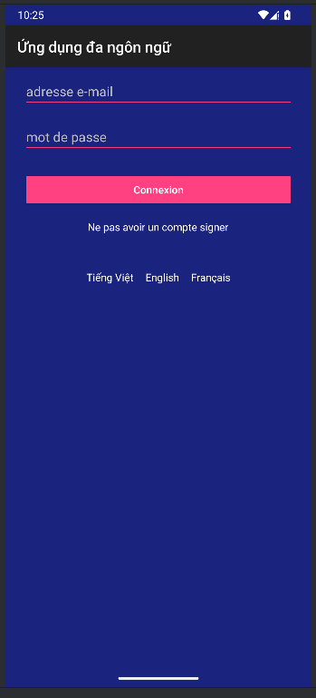

Lab 4: Thiết kế giao diện động trên Android Studio
Code:
MainActivity.java
package com.example.lab4;
import android.content.Intent;
import android.os.Bundle;
import android.widget.LinearLayout;
import android.widget.TextView;
import android.widget.ImageView;
import android.view.LayoutInflater;
import android.view.View;
import android.widget.Toast;
import androidx.appcompat.app.AppCompatActivity;
public class MainActivity extends AppCompatActivity {
private int[] topicIcons = {
R.drawable.ic_mess, R.drawable.ic_flight,
R.drawable.ic_hospital, R.drawable.ic_hotel, R.drawable.ic_restaurant
};
private String[] topicNames = {"Essentials", "Travel", "Hospital", "Hotel", "Restaurant"};
@Override
protected void onCreate(Bundle savedInstanceState) {
super.onCreate(savedInstanceState);
setContentView(R.layout.activity_main);
LinearLayout lnMain = findViewById(R.id.ln_main);
LayoutInflater inflater = LayoutInflater.from(this);
for (int i = 0; i < topicNames.length; i++) {
View item = inflater.inflate(R.layout.item_topic, lnMain, false);
ImageView img = item.findViewById(R.id.iv_topic);
TextView tv = item.findViewById(R.id.tv_topic);
img.setImageResource(topicIcons[i]);
tv.setText(topicNames[i]);
int index = i;
item.setOnClickListener(v -> {
Toast.makeText(this, "Chủ đề: " + topicNames[index], Toast.LENGTH_SHORT).show();
Intent intent = new Intent(this, WordListActivity.class);
intent.putExtra("topic", topicNames[index]);
startActivity(intent);
});
lnMain.addView(item);
}
}
}
LoginActivity.java
package com.example.lab4;
import android.os.Bundle;
import android.view.LayoutInflater;
import android.view.View;
import android.widget.EditText;
import android.widget.ImageView;
import android.widget.TextView;
import android.widget.Toast;
import androidx.appcompat.app.AppCompatActivity;
import android.content.Intent;
public class LoginActivity extends AppCompatActivity {
EditText edtEmail, edtPassword;
View btnLogin;
@Override
protected void onCreate(Bundle savedInstanceState) {
super.onCreate(savedInstanceState);
setContentView(R.layout.m001_act_login);
edtEmail = findViewById(R.id.edtEmail);
edtPassword = findViewById(R.id.edtPassword);
btnLogin = findViewById(R.id.btnLogin);
btnLogin.setOnClickListener(v -> {
showCustomToast();
// Sau khi hiện Toast, chuyển sang MainActivity
Intent intent = new Intent(LoginActivity.this, MainActivity.class);
startActivity(intent);
});
}
private void showCustomToast() {
String email = edtEmail.getText().toString().trim();
String pass = edtPassword.getText().toString().trim();
LayoutInflater inflater = getLayoutInflater();
View layout = inflater.inflate(R.layout.custom_toast, findViewById(android.R.id.content), false);
ImageView img = layout.findViewById(R.id.img_toast);
img.setImageResource(R.drawable.ic_check);
TextView text = layout.findViewById(R.id.txt_toast);
text.setText("Bạn đã đăng nhập thành công với email: " + email + " và mật khẩu: " + pass);
Toast toast = new Toast(LoginActivity.this);
toast.setView(layout);
toast.setDuration(Toast.LENGTH_LONG);
toast.show();
}
}
WordListActivity
package com.example.lab4;
import android.os.Bundle;
import android.view.LayoutInflater;
import android.view.View;
import android.widget.EditText;
import android.widget.ImageView;
import android.widget.TextView;
import android.widget.Toast;
import androidx.appcompat.app.AppCompatActivity;
import android.content.Intent;
public class LoginActivity extends AppCompatActivity {
EditText edtEmail, edtPassword;
View btnLogin;
@Override
protected void onCreate(Bundle savedInstanceState) {
super.onCreate(savedInstanceState);
setContentView(R.layout.m001_act_login);
edtEmail = findViewById(R.id.edtEmail);
edtPassword = findViewById(R.id.edtPassword);
btnLogin = findViewById(R.id.btnLogin);
btnLogin.setOnClickListener(v -> {
showCustomToast();
// Sau khi hiện Toast, chuyển sang MainActivity
Intent intent = new Intent(LoginActivity.this, MainActivity.class);
startActivity(intent);
});
}
private void showCustomToast() {
String email = edtEmail.getText().toString().trim();
String pass = edtPassword.getText().toString().trim();
LayoutInflater inflater = getLayoutInflater();
View layout = inflater.inflate(R.layout.custom_toast, findViewById(android.R.id.content), false);
ImageView img = layout.findViewById(R.id.img_toast);
img.setImageResource(R.drawable.ic_check);
TextView text = layout.findViewById(R.id.txt_toast);
text.setText("Bạn đã đăng nhập thành công với email: " + email + " và mật khẩu: " + pass);
Toast toast = new Toast(LoginActivity.this);
toast.setView(layout);
toast.setDuration(Toast.LENGTH_LONG);
toast.show();
}
}
EmojiActivity.java
package com.example.lab4;
import android.os.Bundle;
import android.view.LayoutInflater;
import android.view.View;
import android.widget.EditText;
import android.widget.ImageView;
import android.widget.TextView;
import android.widget.Toast;
import androidx.appcompat.app.AppCompatActivity;
import android.content.Intent;
public class LoginActivity extends AppCompatActivity {
EditText edtEmail, edtPassword;
View btnLogin;
@Override
protected void onCreate(Bundle savedInstanceState) {
super.onCreate(savedInstanceState);
setContentView(R.layout.m001_act_login);
edtEmail = findViewById(R.id.edtEmail);
edtPassword = findViewById(R.id.edtPassword);
btnLogin = findViewById(R.id.btnLogin);
btnLogin.setOnClickListener(v -> {
showCustomToast();
// Sau khi hiện Toast, chuyển sang MainActivity
Intent intent = new Intent(LoginActivity.this, MainActivity.class);
startActivity(intent);
});
}
private void showCustomToast() {
String email = edtEmail.getText().toString().trim();
String pass = edtPassword.getText().toString().trim();
LayoutInflater inflater = getLayoutInflater();
View layout = inflater.inflate(R.layout.custom_toast, findViewById(android.R.id.content), false);
ImageView img = layout.findViewById(R.id.img_toast);
img.setImageResource(R.drawable.ic_check);
TextView text = layout.findViewById(R.id.txt_toast);
text.setText("Bạn đã đăng nhập thành công với email: " + email + " và mật khẩu: " + pass);
Toast toast = new Toast(LoginActivity.this);
toast.setView(layout);
toast.setDuration(Toast.LENGTH_LONG);
toast.show();
}
}
Kết quả:

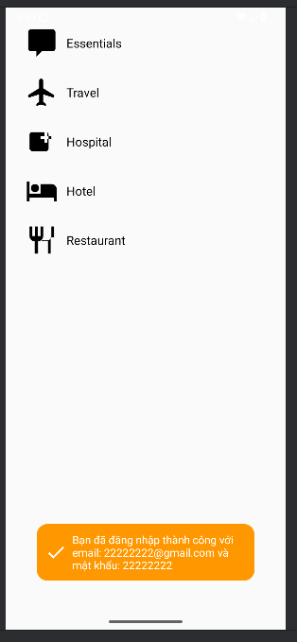
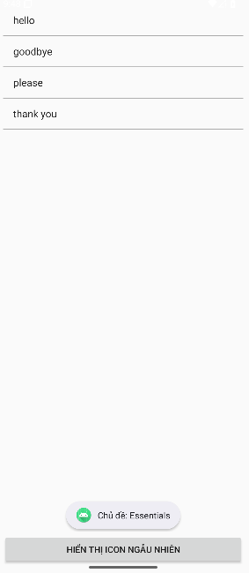
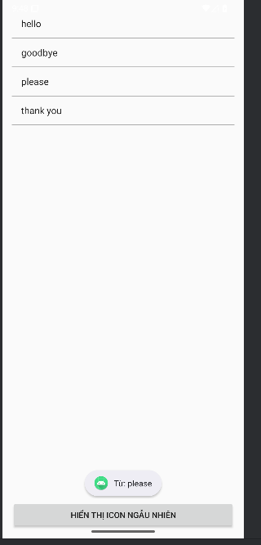
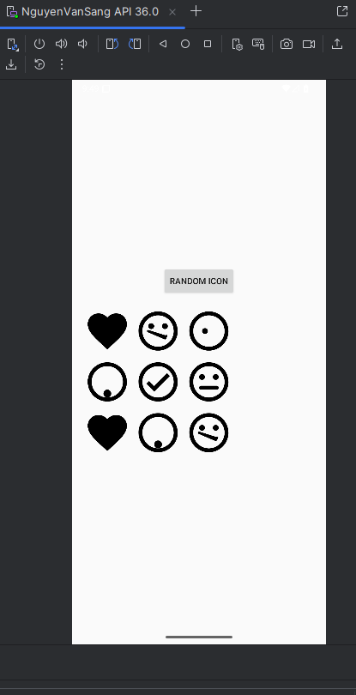
Lab 5: Giao diện và ứng dụng
Code:
MainActivity.java
package com.example.lab5;
import android.os.Bundle;
import android.view.View;
import android.view.animation.Animation;
import android.view.animation.AnimationUtils;
import android.widget.Button;
import android.widget.ImageView;
import androidx.appcompat.app.AppCompatActivity;
import java.util.Random;
public class MainActivity extends AppCompatActivity {
private int[] anims = {R.anim.alpha, R.anim.rotate, R.anim.scale, R.anim.translate};
private ImageView imgElephant;
@Override
protected void onCreate(Bundle savedInstanceState) {
super.onCreate(savedInstanceState);
setContentView(R.layout.activity_main);
imgElephant = findViewById(R.id.img_elephant);
Button btnRandom = findViewById(R.id.btn_random);
imgElephant.setOnClickListener(v -> playRandomAnimation());
btnRandom.setOnClickListener(v -> playRandomAnimation());
}
private void playRandomAnimation() {
int random = new Random().nextInt(anims.length);
Animation animation = AnimationUtils.loadAnimation(this, anims[random]);
imgElephant.startAnimation(animation);
}
}
QuickCallActivity.java
package com.example.lab5;
import android.os.Bundle;
import android.view.View;
import android.view.animation.Animation;
import android.view.animation.AnimationUtils;
import androidx.appcompat.app.AppCompatActivity;
import java.util.Random;
public class QuickCallActivity extends AppCompatActivity implements View.OnClickListener {
private int[] anims = {
R.anim.alpha,
R.anim.rotate,
R.anim.scale,
R.anim.translate
};
@Override
protected void onCreate(Bundle savedInstanceState) {
super.onCreate(savedInstanceState);
setContentView(R.layout.activity_quickcall);
findViewById(R.id.fr_mom).setOnClickListener(this);
findViewById(R.id.fr_dad).setOnClickListener(this);
findViewById(R.id.fr_crush).setOnClickListener(this);
findViewById(R.id.fr_best_friend).setOnClickListener(this);
}
@Override
public void onClick(View v) {
int random = new Random().nextInt(anims.length);
Animation animation = AnimationUtils.loadAnimation(this, anims[random]);
v.startAnimation(animation);
}
}
Kết quả:
