Technical Design Document

Project name: **Flight Reservation System**

* Nagasuri Venkata Seshaiah ( 46022690)

**Introduction:**

Flight Reservation System is created to meet the needs of online flight reservation system, with 1 actors: Customer. The architecture implemented is Spring Boot REST.

**Functional Requirements:**

The functional requirements of the project are:

**For the Customer:**

* Login
* Register
* Search Flights
* Book Flight Ticket
* View Tickets
* Cancel Booking

**Services:**

The different services in which this project is divided into are:

* **User Service:** Register a new account and login (as a customer).
* **Flight Service:** Search for Flights and Book flight Ticket
* **Ticket Service:** View booked tickets and Cancel Tickets.
* **Passenger Service:** Add, remove, edit and get all passenger details.

**Overall Architecture Diagram:**

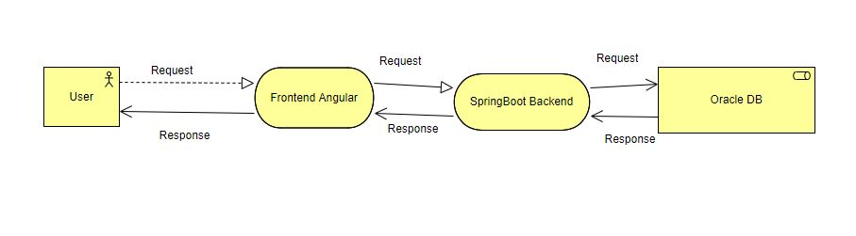

**Overall Entity Relationship Diagram:**

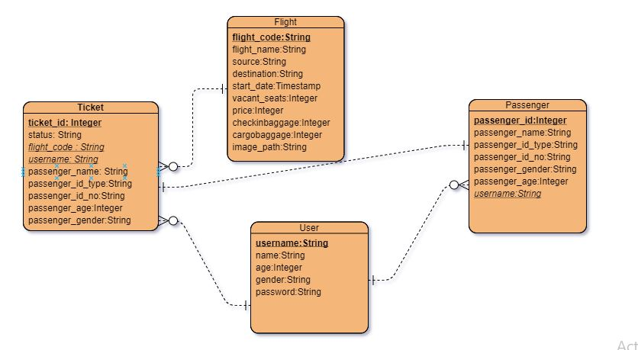

**Sequence Diagrams**

**User Service:**

**Login –**

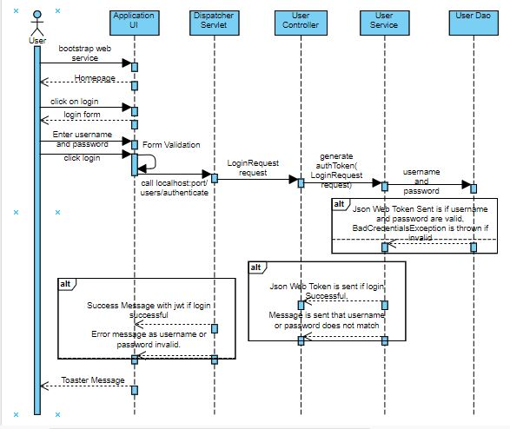

**Registration of new User -**

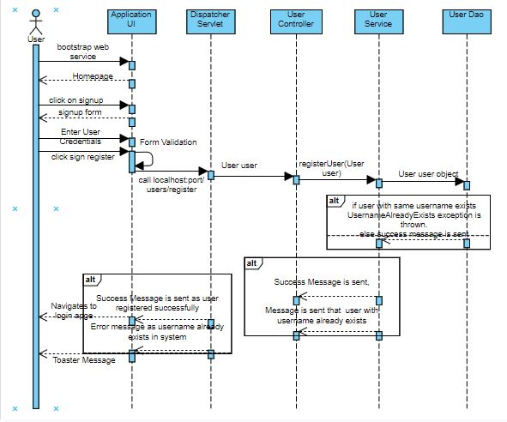

**Search Flights:**

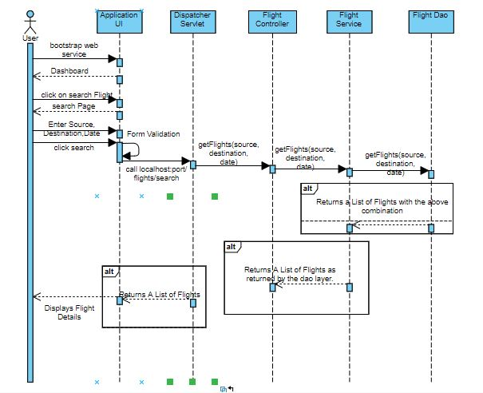

**Book Flight Ticket**

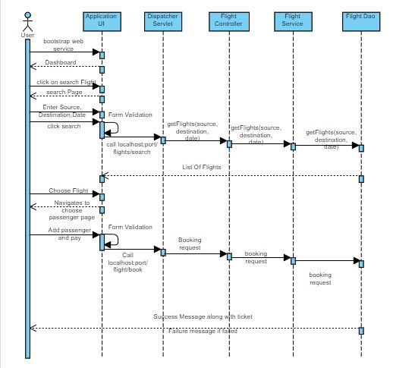

**Cancel Ticket:**

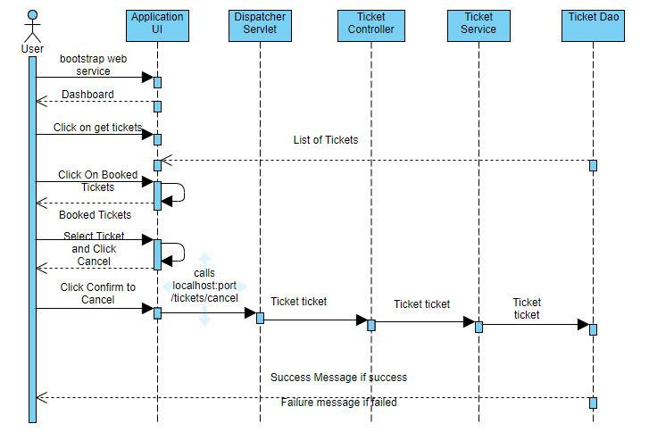

**Class Diagram**

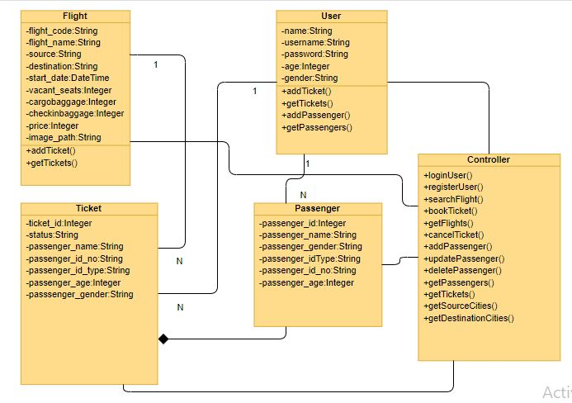

**Activity Diagrams**

User Service:

**Login:**

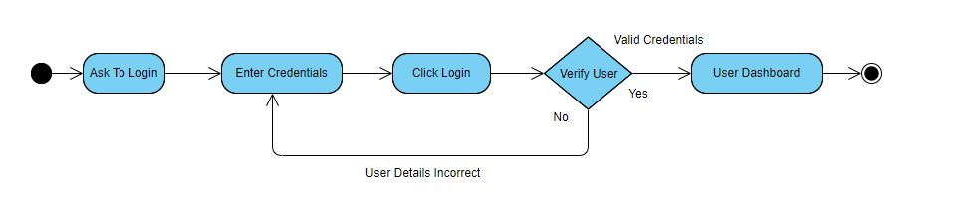

**Registration:**

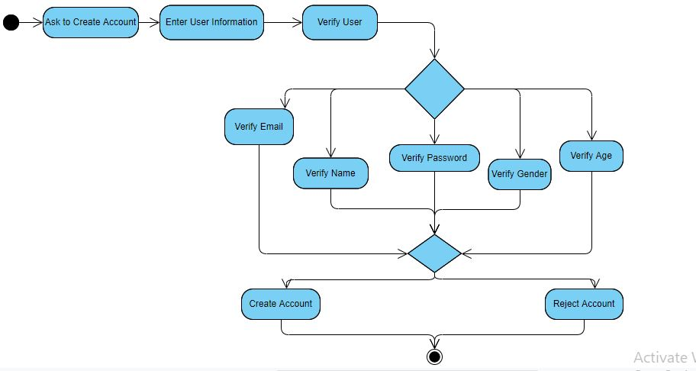

Flight Booking Service:

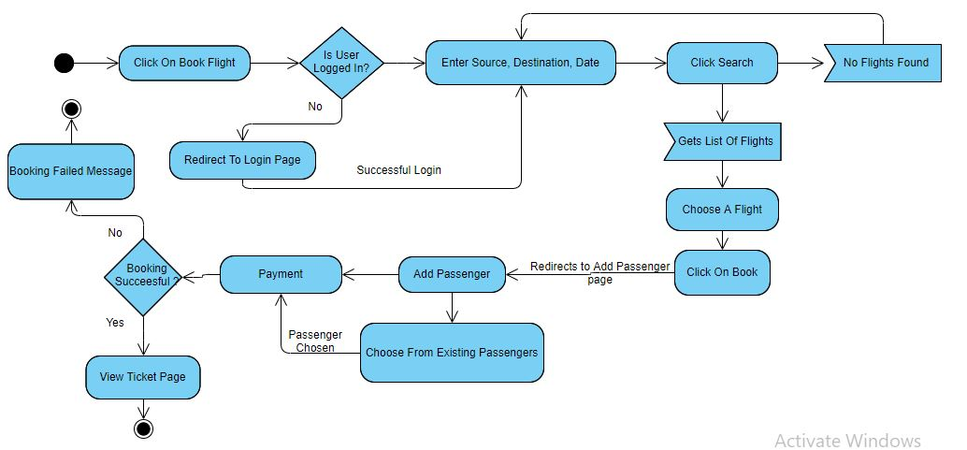

Ticket Service

**View Tickets:**

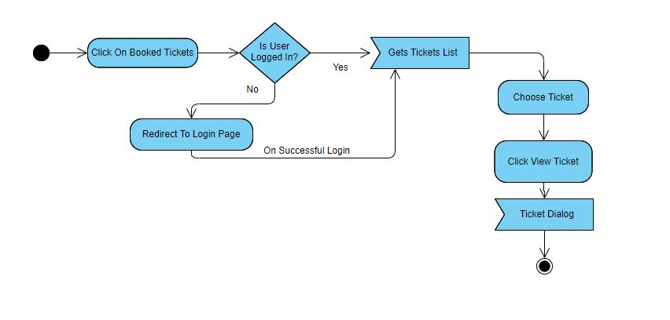

**Cancel Ticket:**

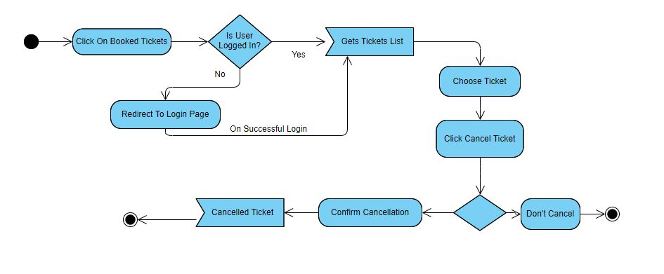

**Use Case Diagram**

