VISVESVARAYA TECHNOLOGICAL UNIVERSITY

JNANA SANGAMA, BELGAUM - 590014



A Report on

“ BLOOD BANK MANAGEMENT SYSTEM”

Submitted in the partial fulfillment for Database Management Laboratory:

An Open Ended Problem.

Submitted By :

SHIVAKUMAR N V 1SI16CS100
SAGAR S B 1SI16CS089

Under the guidance of :

Mrs. Shruthi K Mrs. Thejaswini S
Assistant Profrssor Assistant Professor



DEPARTMENT OF COMPUTER SCIENCE AND ENGINEERING

SIDDAGANGA INSTITUTE OF TECHNOLOGY, TUMKUR-572103

(An Autonomous Institute, Affiliated to Visvesvaraya Technological University, Belgaum, Recognized by AICTE and Accredited by NBA, New Delhi)
2018-2019
ACKNOWLEDGEMENT

Most importantly, our team sincerely thankful to our advisor
Asst. Prof. Shruthi K and Asst. Prof. Thejaswini S for giving us proper guidance to complete our senior project. Without their support we wouldn't be able to complete. Finally, we would like to give our special thanks to Siddaganga Institute of Engineering for giving us enough knowledge and skills that made us to innovatively and successfully research and compile this project.

CONTENT

- Introduction

- Requirement Specification

- Requirements

- Entities and their Attributes

- Relationship Types

- Constraints

- Design

- Implementation

- Conclusion

- References

ABSTRACT:

The basic building aim is to provide blood donation service to the city recently. Blood Bank Management System (BBMS) is a Data based application that is designed to store, process, retrieve and analyze information concerned with the administrative and inventory management within a blood bank. This project aims at maintaining all the information pertaining to blood donors, different blood groups available in each blood bank and help them manage in a better way.
Project Aim is to provide transparency in this field, make the process of obtaining blood from a blood bank hassle free and corruption free and make the system of blood bank management effective. Blood Bank donation system can collect blood from many donators in short from various sources and distribute that blood to needy people who require blood.

1.INTRODUCTION

A blood donation is a process whereby a person voluntarily has blood drawn to be used for future transfusions when in need at hospitals for treatment procedures that require them. Donation may be of whole blood (blood drawn directly from the body) or of specific components of the blood; such as red blood cells, white blood cells, plasma, and platelets. Blood banks often participate in the process of collecting blood and other procedures such as managing stocks, approving blood requests and updating donation information. The inspiration of this project is to improve blood banks in India and to develop a blood bank information system which focuses on making an online system that is accessible for both donors and administrators. Donors can directly receive information regarding their previous blood donations, including their blood results and donation history, in order to easily schedule their next donations. They can also update the personal information through the system, without having to contact the blood bank registry. The system is also developed for the administrators, who are the main authority in the system. Administrators can add, modify, delete, and query any donation information if necessary.

2. Requirement Specification

Following requirements were identified during the requirement collection and analysis to design the database.
- Donor details.
- Accepter details.
- Hospital details.
- Blood bank details.
- Blood details

Entities and their Attributes:
Donar:
D_ID | Name | Sex | Address | Ph_No | Age

Blood:
Code | Blood_Type | Cost | Date of C | Expiry_date

BloodBank:

B_B_No | B_B_Name | B_B_Ph_no | B_B_Address

Hospital:

H_Name | H_Address | H_Ph_No

Employee:

E_ID | E_Name | E_Address | E_Ph_No

Dependent:
D_Name | Sex | Relationship
Orders:

O_ID | O_Date

Shipment:
S_ID | S_Date

3. Constraints

NOT NULL:
NOT NULL constraint makes sure that a column does not hold NULL value. When we don’t provide value for a particular column while inserting a record into a table, it takes NULL value by default. By specifying NULL constraint, we can be sure that a particular column(s) cannot have NULL values.

UNIQUE:
UNIQUE Constraint enforces a column or set of columns to have unique values. If a column has a unique constraint, it means that particular column cannot have duplicate values in a table.

DEFAULT:
The DEFAULT constraint provides a default value to a column when there is no value provided while inserting a record into a table.

CHECK:
This constraint is used for specifying range of values for a particular column of a table. When this constraint is being set on a column, it ensures that the specified column must have the value falling in the specified range.

PRIMARY KEY:
Primary key uniquely identifies each record in a table. It must have unique values and cannot contain nulls.

FOREIGN KEY:
Foreign keys are the columns of a table that points to the primary key of another table. They act as a cross-reference between tables.

DOMAIN CONSTRAINT:
Each table has certain set of columns and each column allows a same type of data, based on its data type. The column does not accept values of any other data type.

4. Design
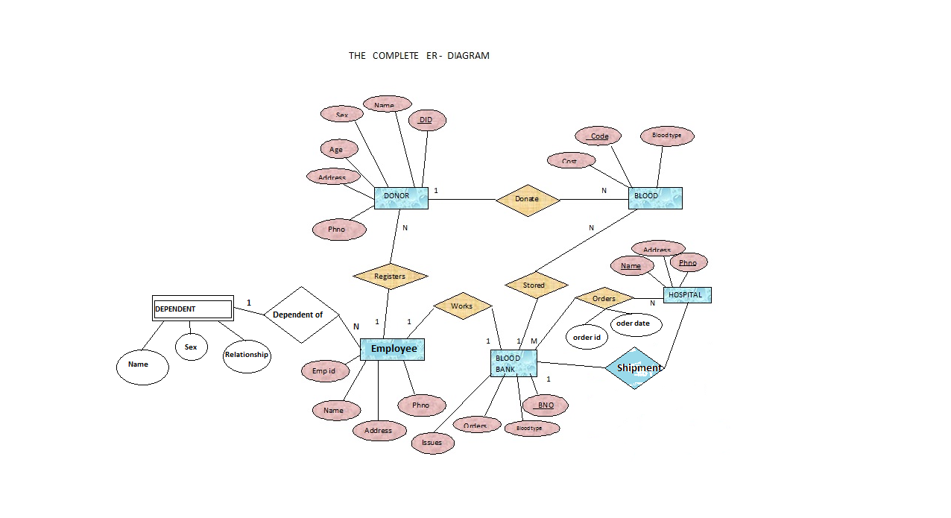

Schema:
Donor:
DID | DNAME | DADDRESS | AGE | SEX | DPHNO | E_EMPID

Employee:

E_EMPID | E_NAME | E_ADDRESS | E_PHNO | BBNO

Blood bank:

BBNO | BBNAME | BBADDRESS | BBPHNO

Hospital:

HOS_NAME | HOS_ADDRESS | HOS_PHNO

Blood:

CODE | BLOODTYPE | COST | DATEOFCOLLECTION | EXPIRY_DATE | DID | BBNO

Orders:

ORDERID | HOS_NAME | BBNO | CODE | ORDERDATE

Shipment:

SHIPMENTID | ORDERID | SHIPMENTDATE

Dependent:

D_NAME | D_SEX | D_RELATIONSHIP | E_EMPID

5. Implementation :

Queries:

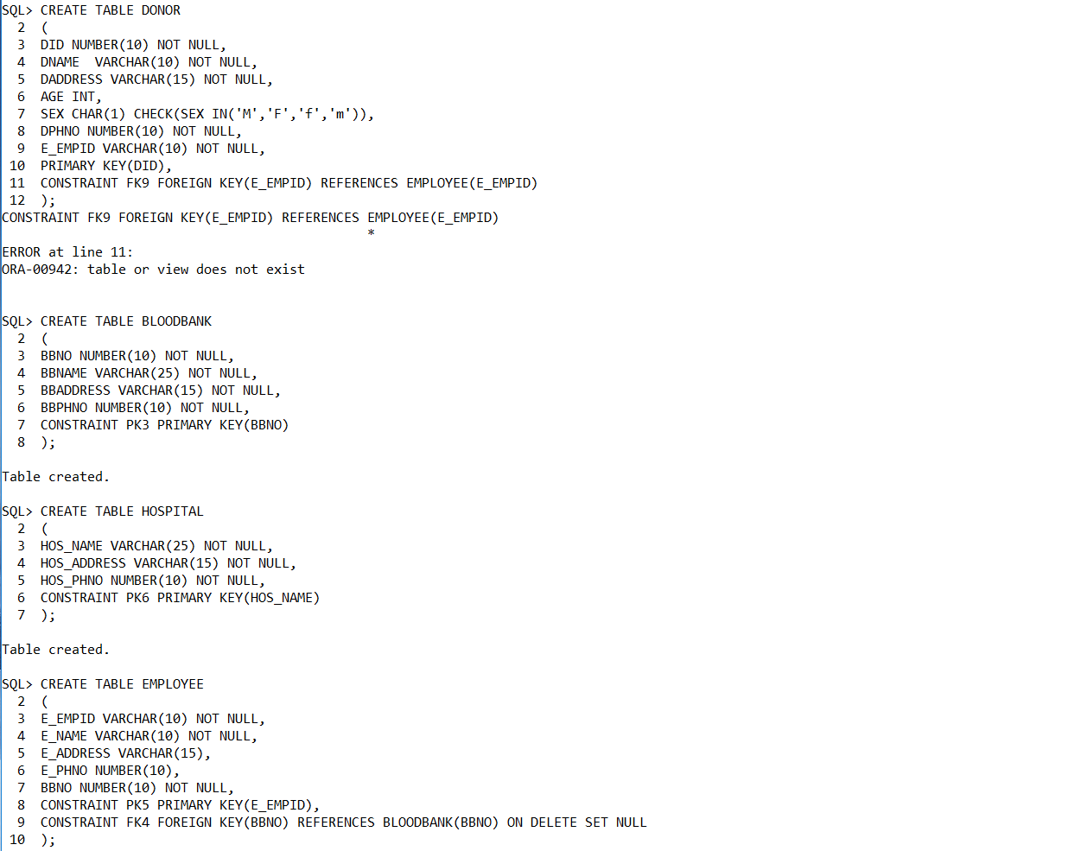

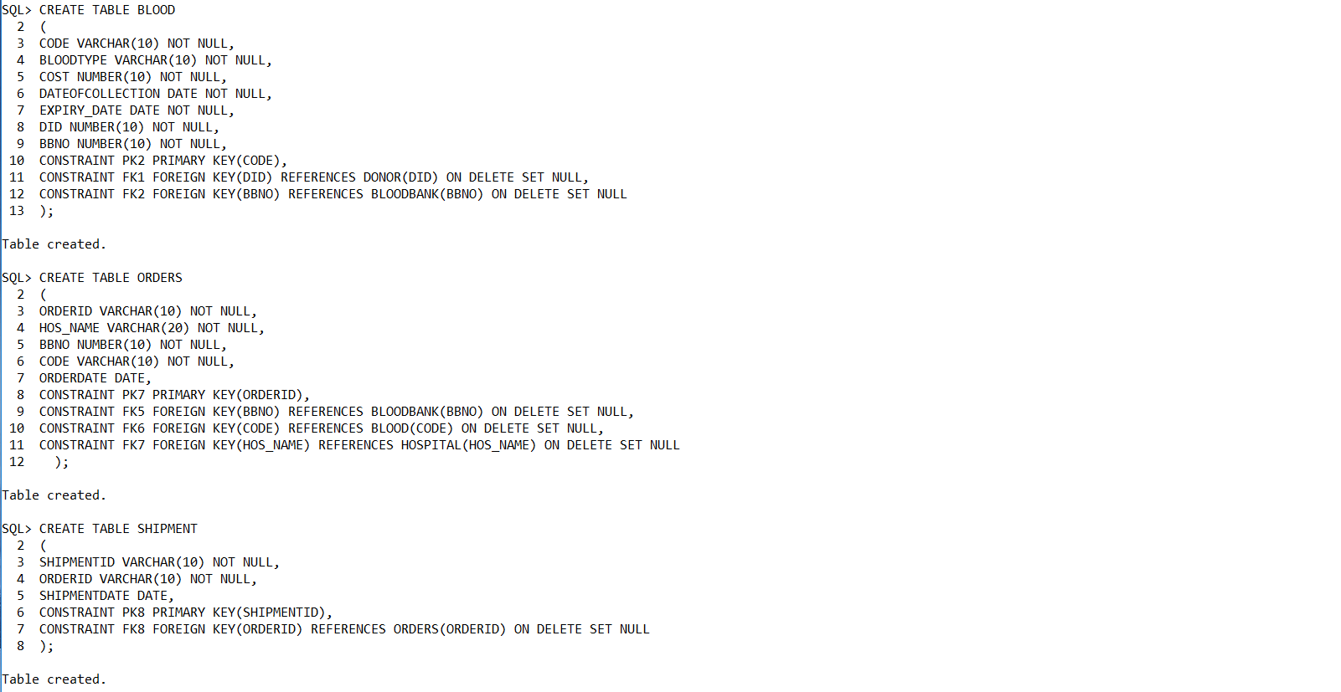

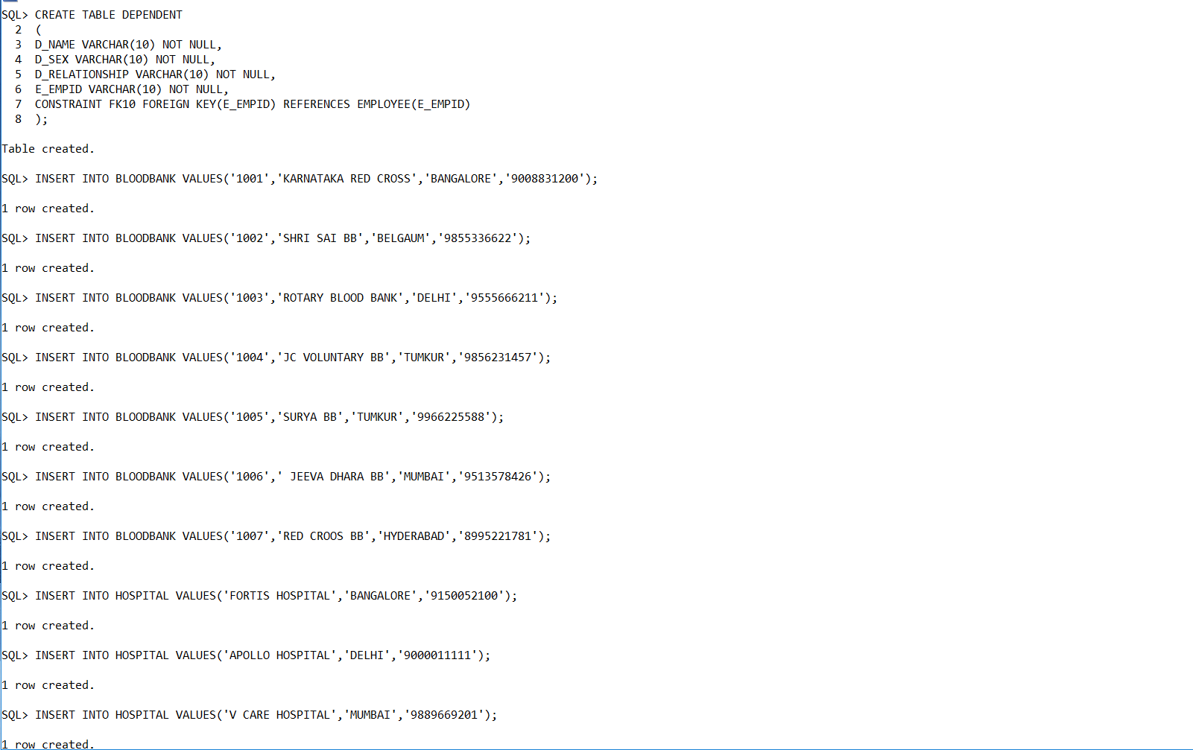

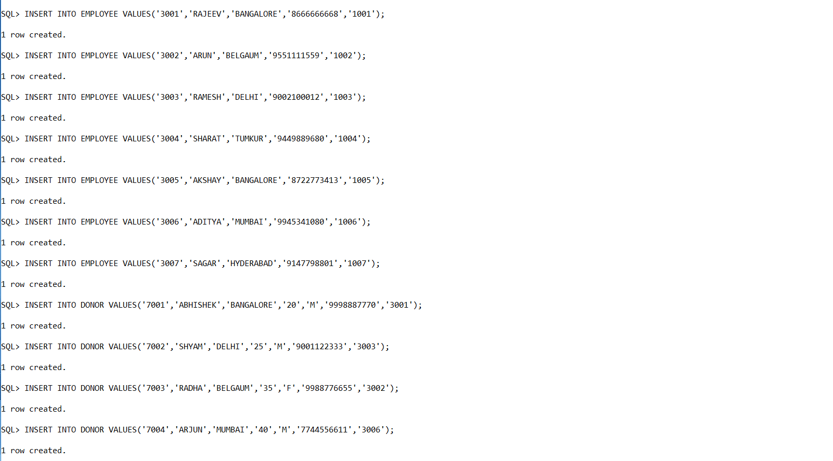

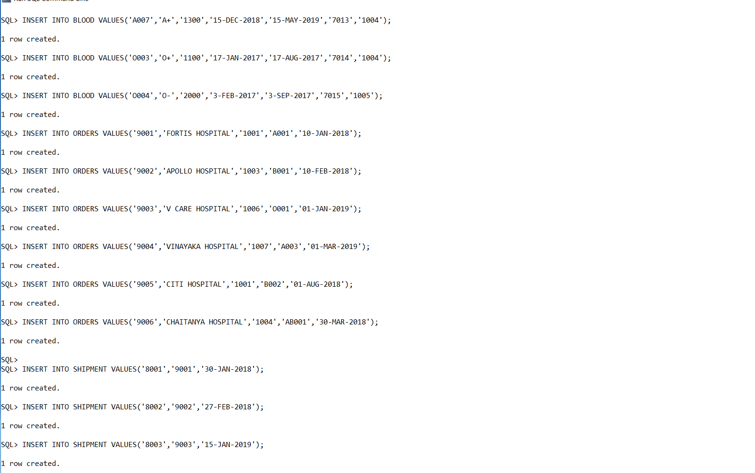

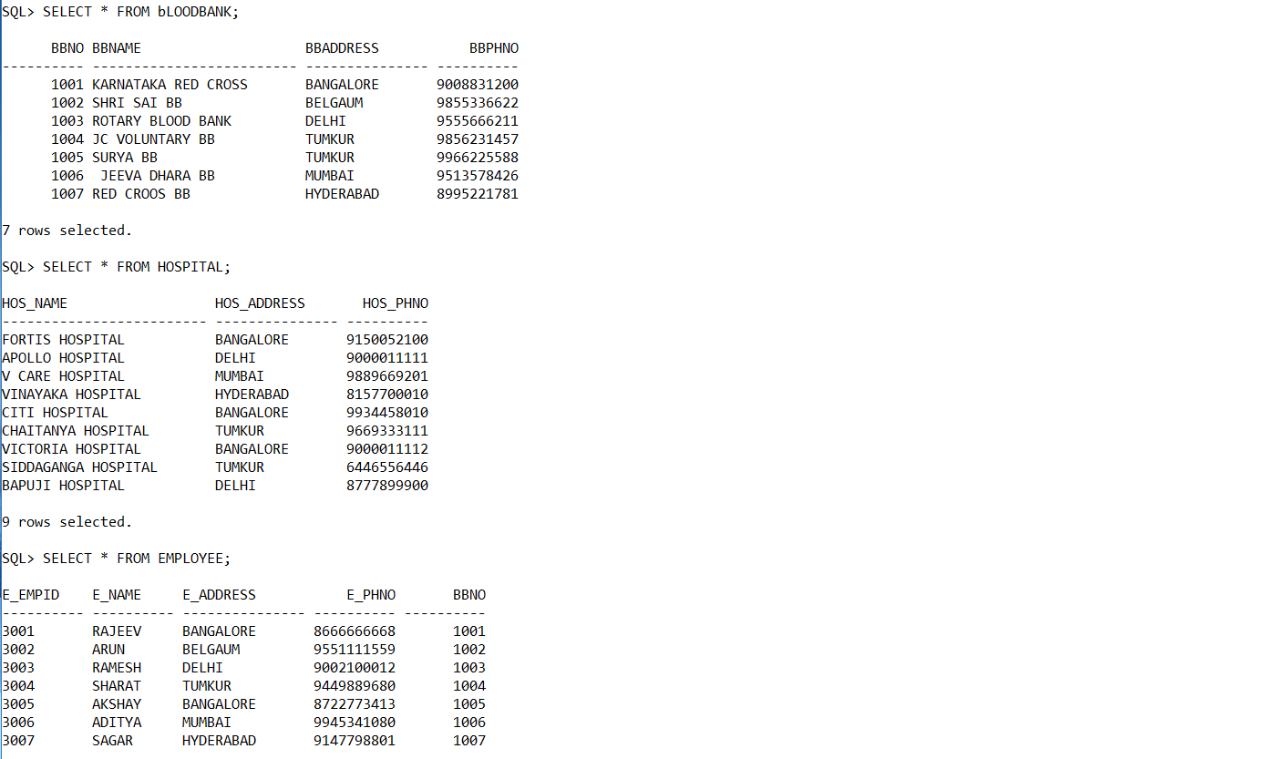

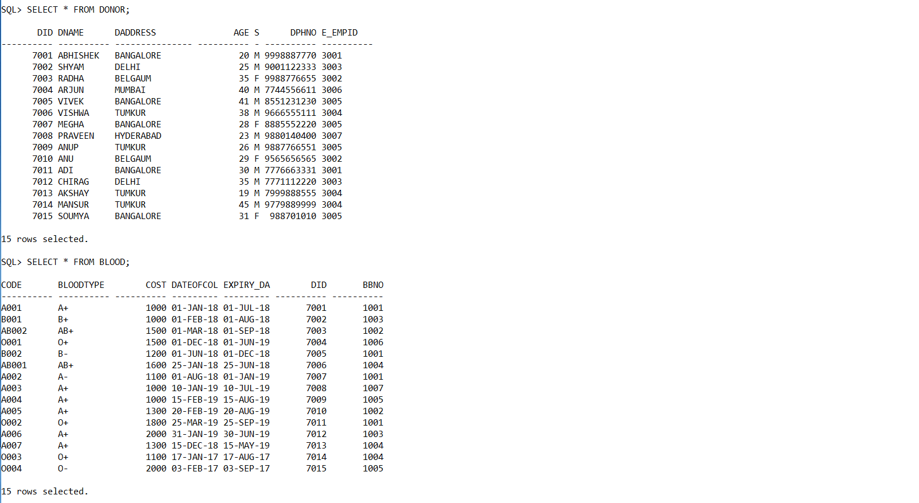

List the name,age,id of the donor who is registered by EMPLOYEE 'rajeev' and who have B+ blood group?
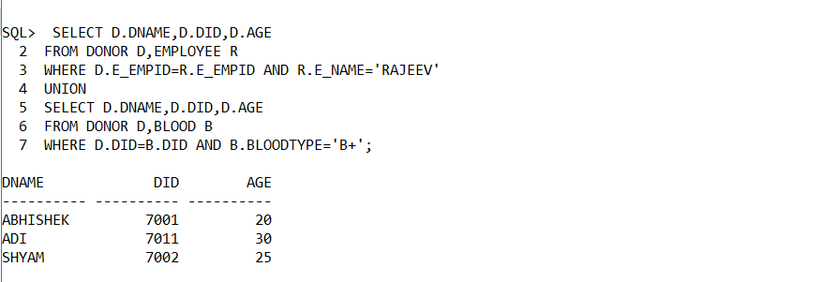

List the names of the blood banks that have O+ blood group stored

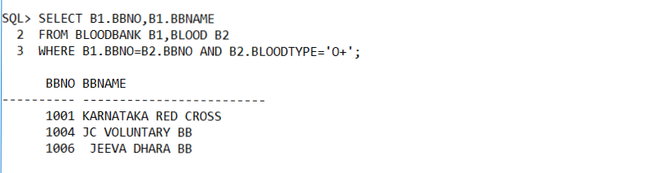

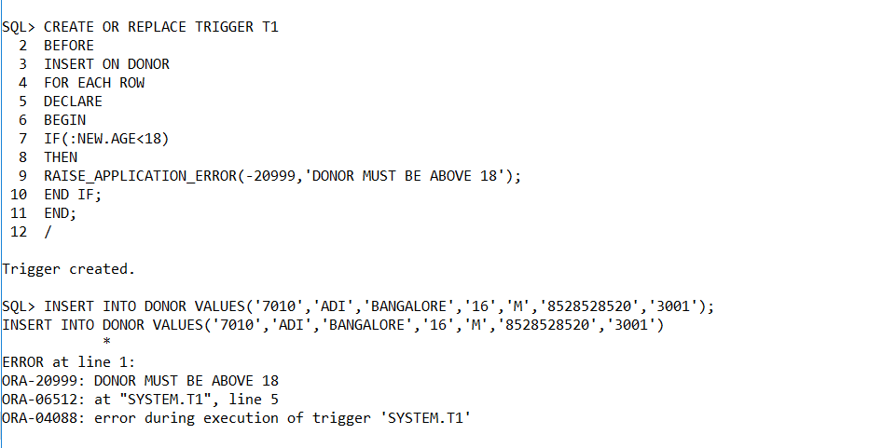

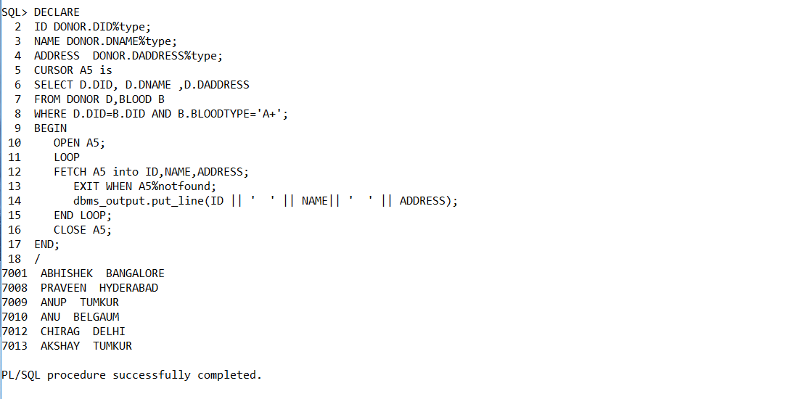

6.CONCLUSION:

Blood bank database management helps us in centralizing the data used for managing the tasks performed in a blood bank. The theoretical process involved in database design has been practically implemented. The project provides user friendly interface for the users to interact with the database. All database operations including insertion, deletion, update and Retrievals
are supported along with support for trigger and stored procedure.

7.REFERENCE:

[1] https://web.ku.ac.th/saranaroo/chap5a.htm

[2] http://porcheckin.com/2014/05/blood-การบรจาคเลอด/

[3] Risk Management in Blood Banks

[4] https://www.redcross.or.th/forum/16095

[5] GoDaddy: https://www.godaddy.com/hosting/web-hosting

Other studies:

https://www.blood.co.uk/the-donation-process/further-information/tests-we-carryout/

http://www.redcrossblood.org/donating-blood/donation-faqs

http://www.redcrossblood.org/learn-about-blood/blood-types

http://www.nhs.uk/Conditions/Blood-groups/Pages/Introduction.aspx

http://www.webmd.com/a-to-z-guides/blood-type-test#1

https://en.wikipedia.org/wiki/Blood_type

https://en.wikipedia.org/wiki/Rh_blood_group_system

http://www.mayoclinic.org/tests-procedures/rh-factor/basics/definition/ prc-20013476

http://anthro.palomar.edu/blood/ABO_system.htm

http://www.redcrossblood.org/learn-about-blood/blood-testing

http://www.donateblood.com.au/eligibility/blood-testing-and-safety

