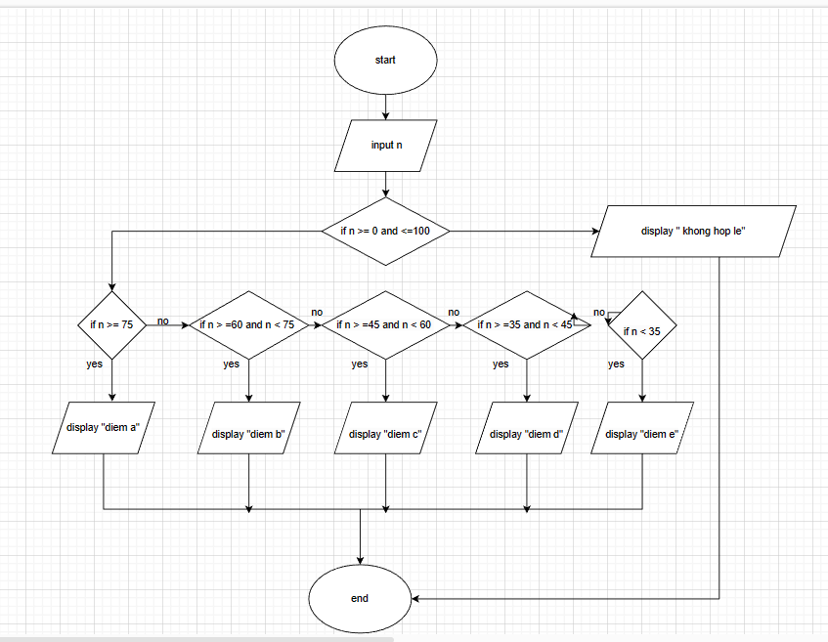

Begin

Input n

If n>=0 and <=100

If n >=75

Display “ Diem A”

End if

Else if n>=65 and n<75

Display “ Diem B”

End if

Else if n>=45 and n<60

Display “ Diem C”

End if

Else if n>=35 and n<45

Display “ Diem D”

End if

Else n<35

Display “ Diem E”

End if

Else display “ diem khong hop le”

end