Process 01:
rmse.train = 219.7596
rmse.test = 320.5317

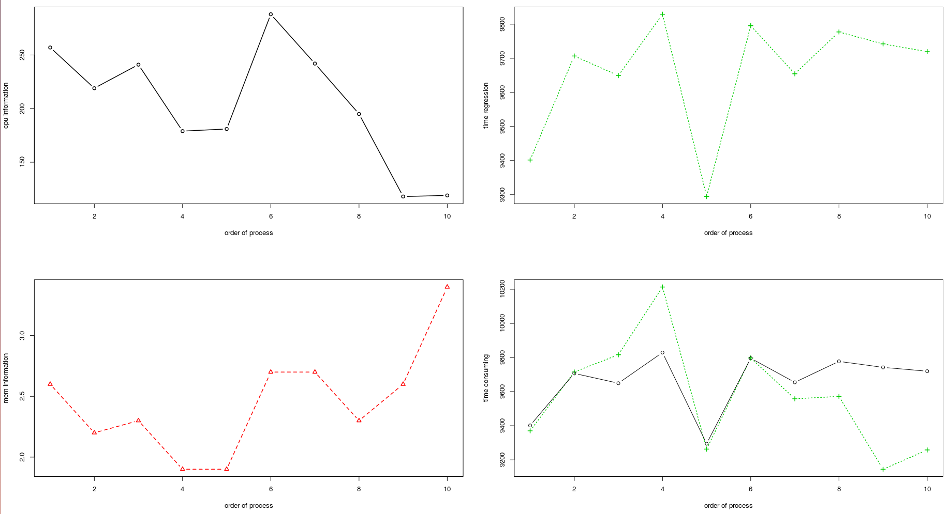

Process 02:
rmse.train = 212.1234
rmse.test = 354.111

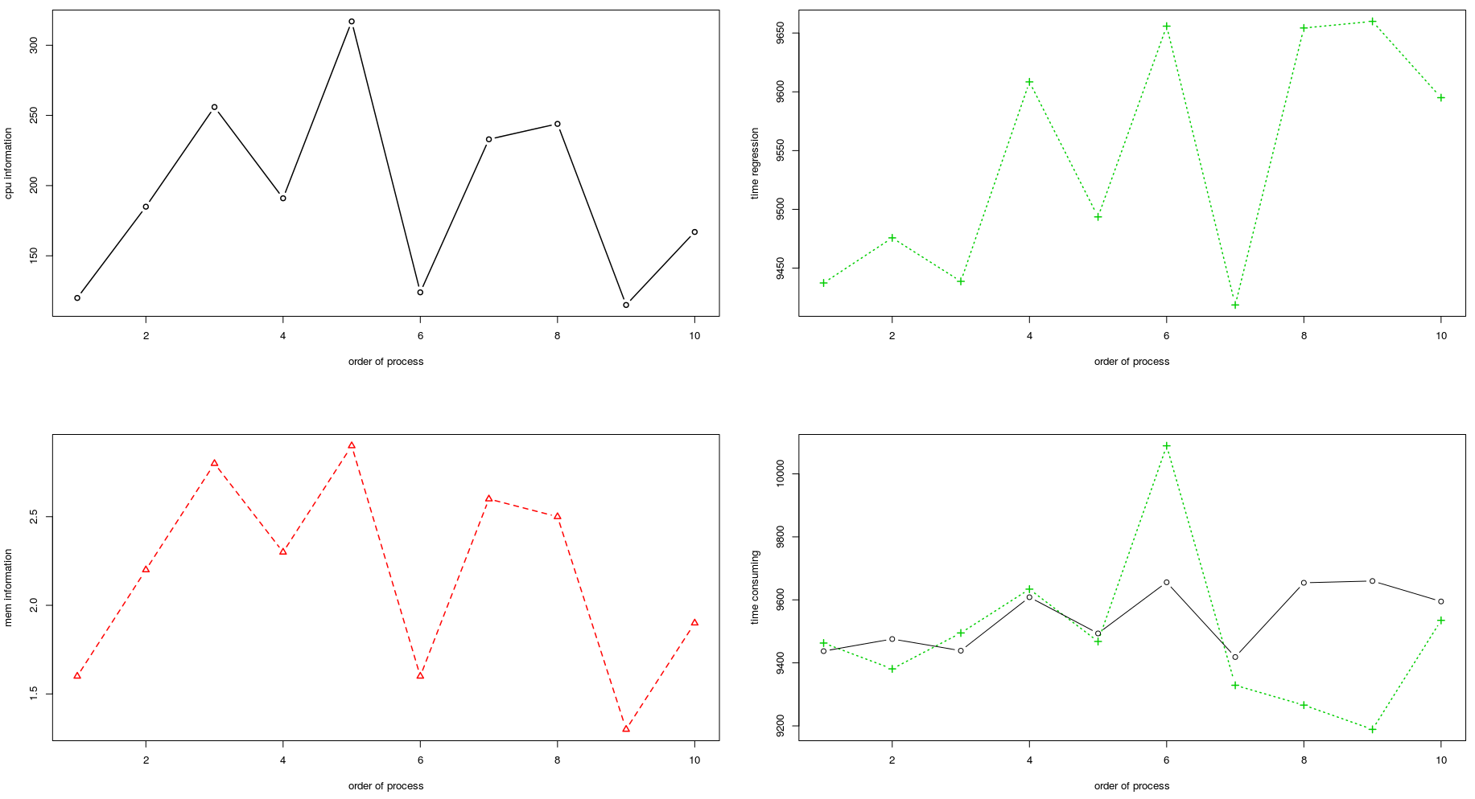

Process 03:
rmse.train = 285.4006
rmse.test = 372.5459

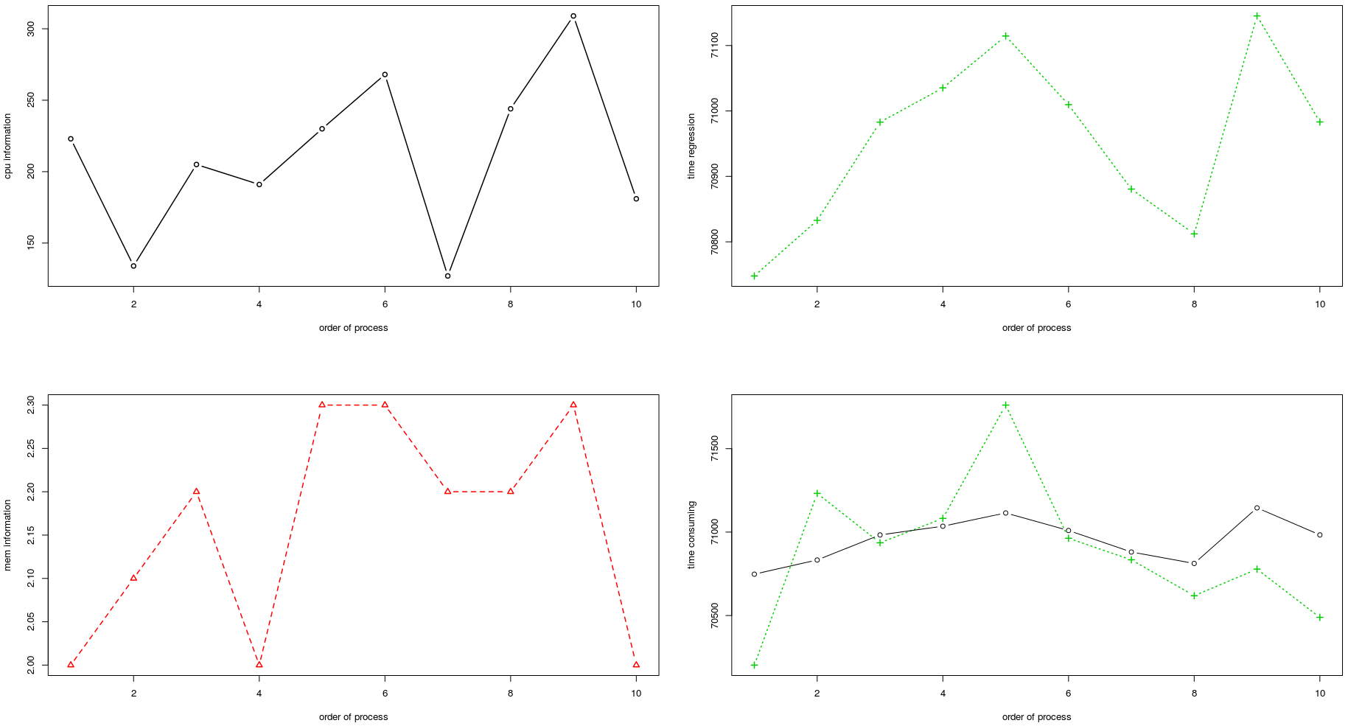

Process 04:
rmse.train = 665.8555
rmse.test = 1078.11

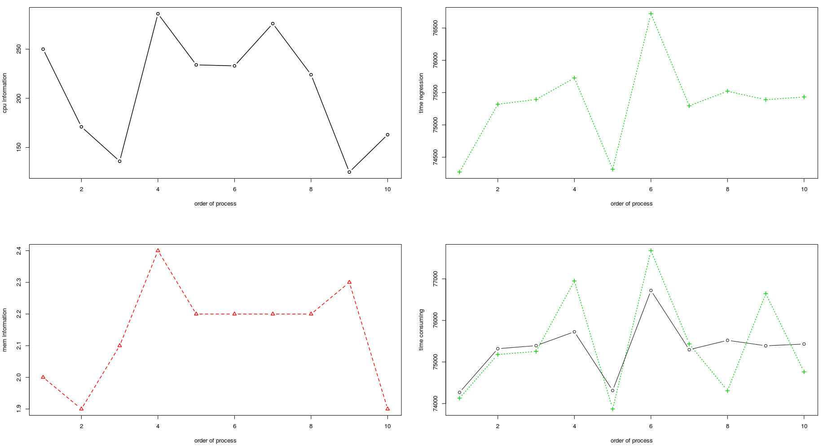

Process 05:
rmse.train = 70.59253
rmse.test = 99.33234

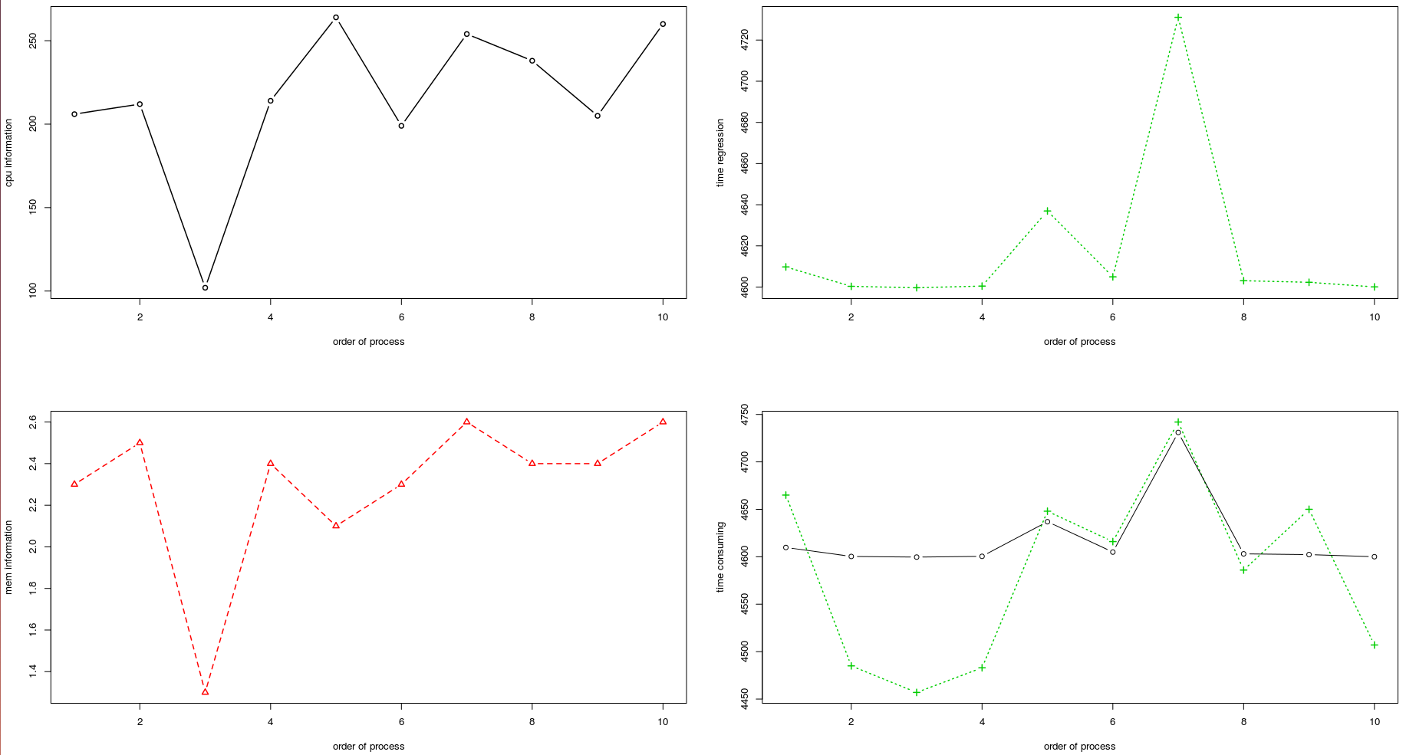

Process 06:
rmse.train = 1829.953
rmse.test = 2807.715

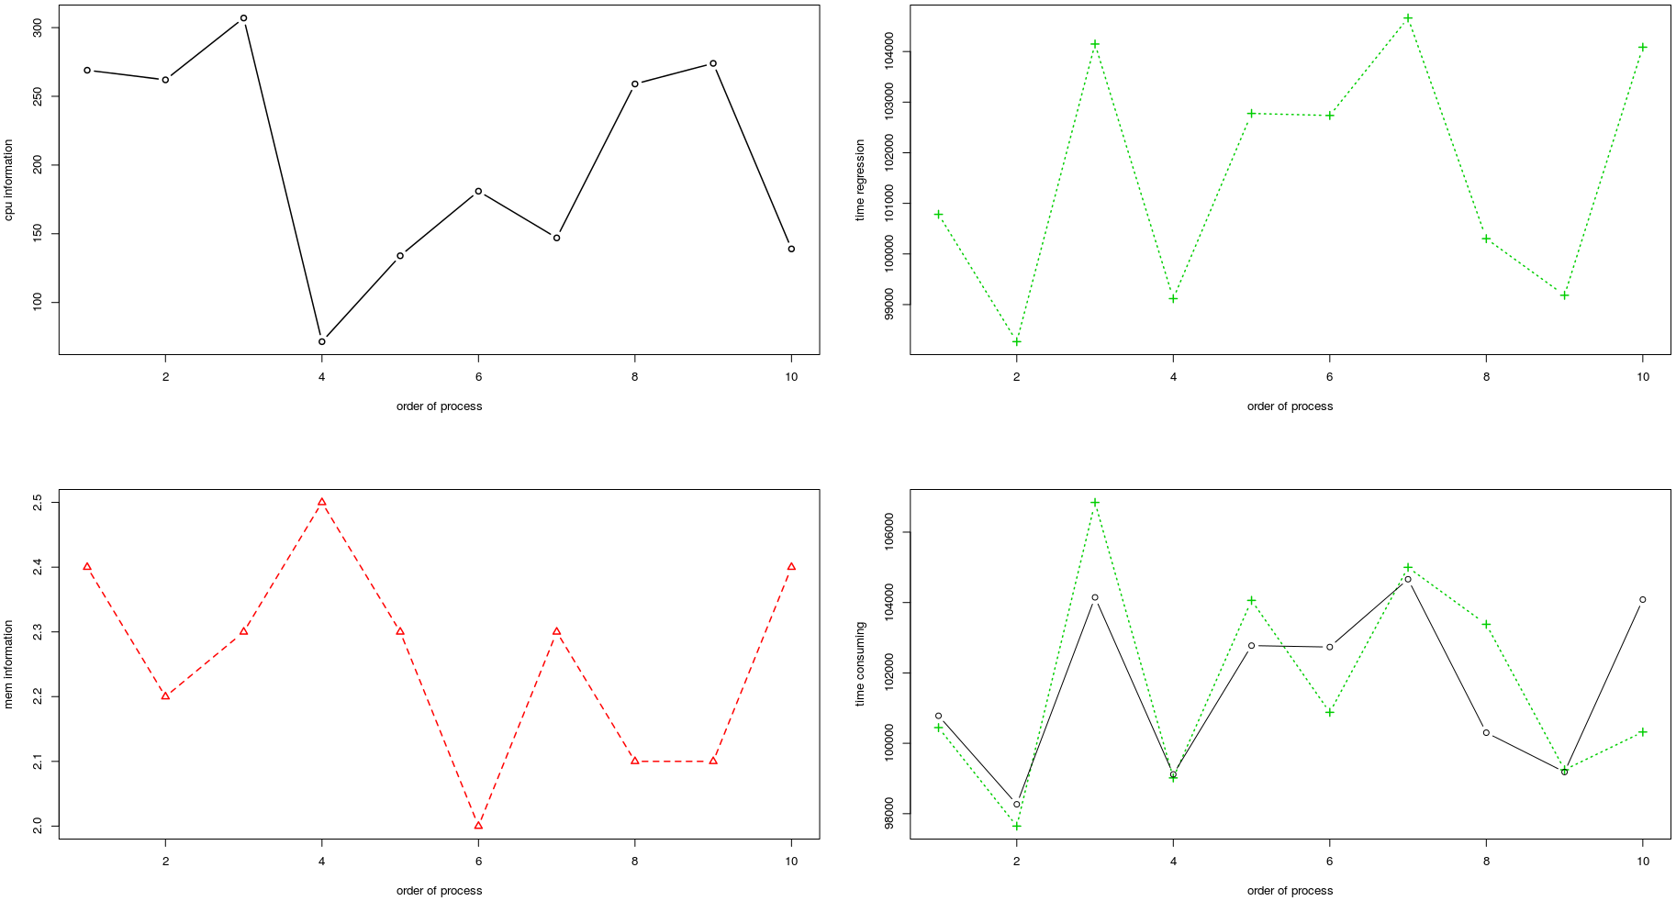

Process 07:
rmse.train = 129.9684
rmse.test = 139.8493

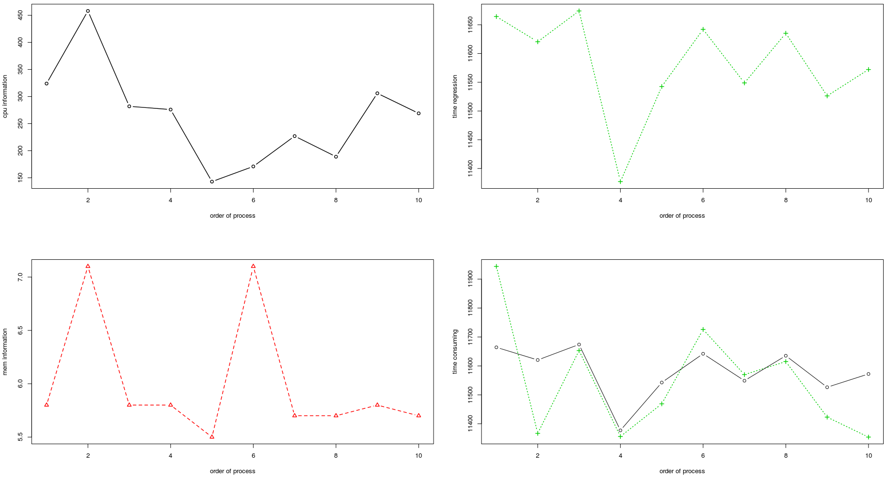

Process 08:
rmse.train = 247.4266
rmse.test = 361.1489

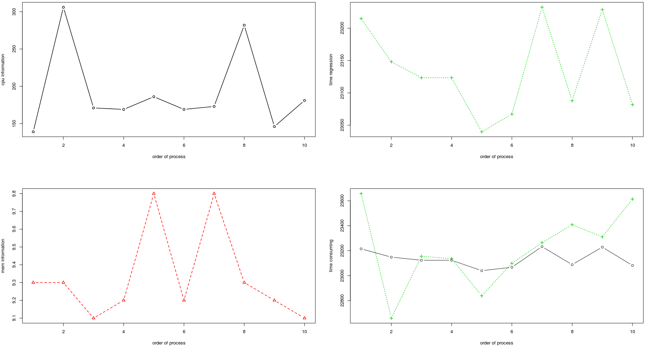

Process 09:
rmse.train = 908.0899
rmse.test = 1055.256

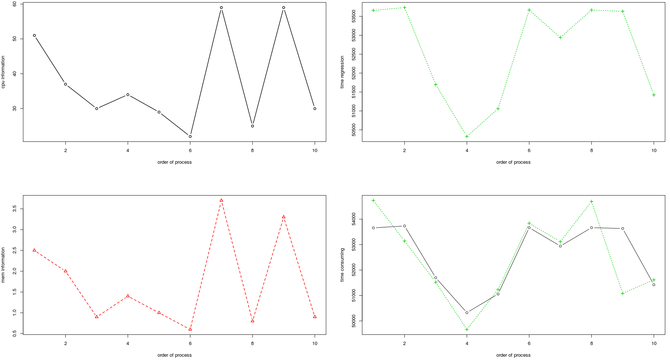
Process 10:
rmse.train = 116.407
rmse.test = 28.71436

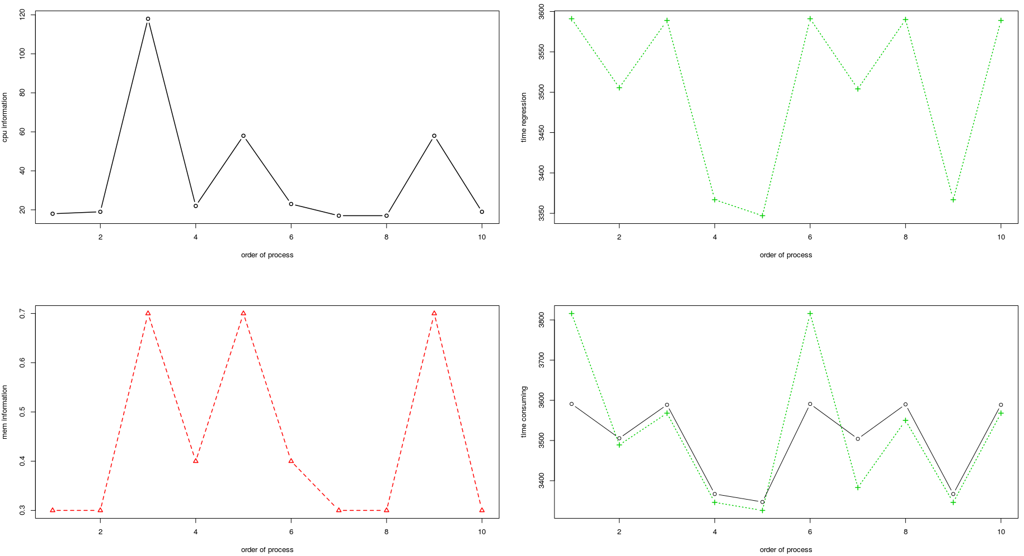

Total process:
Without multiply ID features
[{"ep_i":0,"c_i":6.1,"g_i":1,"rmse.test":16962.7142,"rmse.train":13406.5703}]

