Storyboard
For
I-ppliance Website
Individual Assignment #2 Sem. 2 / AY 2025–2026
John-Mark Whittick (1907528)
School of Computing and Information Systems: University of Technology, Jamaica
CIT2011: Web Programming
Day/Time: Friday, 5 pm
Sirisha Bhadika
March 28, 2026

TABLE OF CONTENTS
Github Hosting Link …………..…………………………………………………….……...1
Desktop Wireframe…………..…………………………………………………….……...1
Mobile Wireframe………………………………………………….……………………….2
Background of I-ppliance………………………………………………....………………...3
Intended Audience of I-ppliance…………………………………………………………....4
The logo of I-ppliance……………………………………………………….………………5
Slogan…………………………………………………………..…………………………...6

Mission Statement……………………………………………………………….……..........6

Vision Statement …………………………………………………………….………..……..6

Colour Palette & Justification………………………………………………………..………7
APA References……………………………………………………………………….…….8

Github Hosting Link: https://johnmark-whittick.github.io/1907528_IA2_S1AY26/

Desktop Wireframe
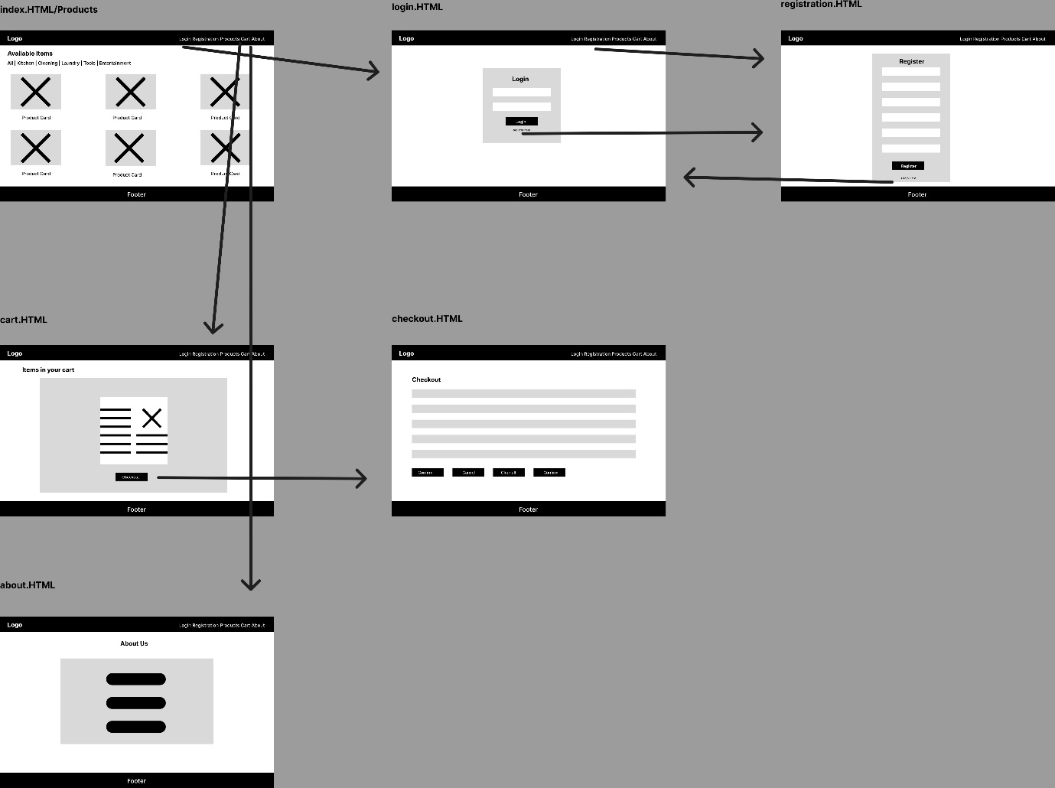

Mobile Wireframe
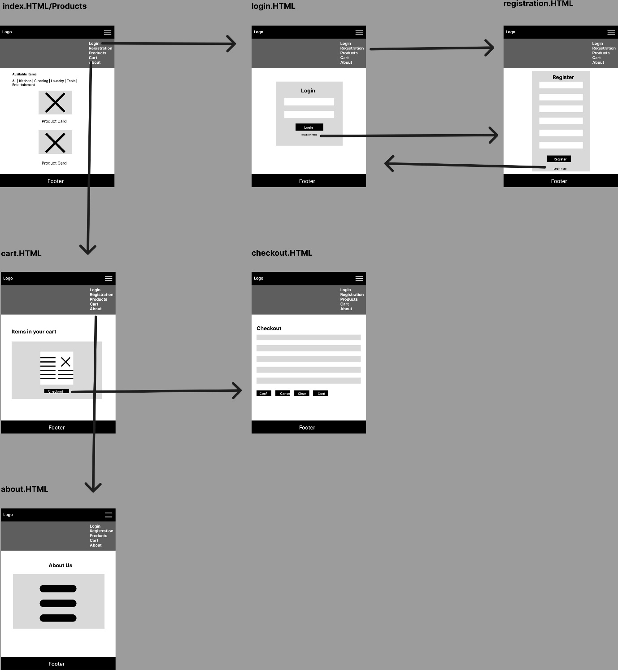

Background of I-ppliance
I-ppliance is a Jamaican digital appliance retailer. This business provides households across Jamaica with convenient access to a wide range of premium home appliances. These appliances range from kitchen equipment and laundry machines to cleaning devices, entertainment systems, and power tools, all of which are available through the website's seamless e-commerce experience. The name I-ppliance was carefully chosen to represent a fusion of two core identities: the "I" primarily stands for the Internet, highlighting the digital-first, e-commerce nature of the website, while simultaneously representing "Island," grounding the brand in its Jamaican roots and commitment to local service.

Intended Audience of I-ppliance
I-ppliance is designed to serve Jamaican homeowners, renters, and households island-wide who are looking for a convenient way to purchase home appliances and tools online. The primary target audience includes:
Adults aged 25 to 55 who are setting up or upgrading their homes and prefer the convenience of online shopping over visiting physical stores. This includes first-time homeowners, apartment renters, and families upgrading existing appliances.
Small business owners and tradespeople in Jamaica who need reliable power tools and cleaning equipment and prefer to source them online with transparent pricing in Jamaican dollars.
Digitally literate consumers who are comfortable using e-commerce platforms and expect a professional, responsive, and easy-to-navigate online shopping experience accessible on both desktop and mobile devices.

The logo of I-ppliance
The I-ppliance logo is built for a clean, modern look for readability, whether through scrolling on a phone or browsing on a desktop. It uses a bold, app-like font that stays sharp and readable even when reduced for a mobile header.
The design is intended to match today’s top tech brands, but a layer of meaning is added through interaction. While the logo starts as a clean white, it changes to a vibrant gold whenever a user hovers over it. This change represents a "connection being made", which symbolizes the moment a customer plugs in a new device.

Slogan
Operating under the slogan “Jamaica’s Digital Gateway to Better Living”, the company positions itself as more than just a store, but as a starting point for a more efficient and modern lifestyle for all Jamaicans.

Mission Statement
Our mission is to provide reliable, high-quality home appliances and tools to households across Jamaica, making everyday living more convenient, efficient, and comfortable through exceptional products and outstanding customer service.

Vision Statement
Our vision is to become Jamaica's most trusted online appliance retailer by transforming how Jamaicans access home appliances — making the purchasing process faster, easier, and more accessible through a seamless and user-friendly online experience.

Colour Palette & Justification

Colour Palette
Primary Dark Grey | Accent Gold | Background Light | White
#1a1a1a | RGB(26,26,26) | #e6b800 | RGB(230,184,0) | #f4f7f9 | RGB(244,247,249) | #ffffff | RGB(255,255,255)
The colour palette for I-ppliance is built on a high-contrast mix of black and gold to give the store a premium yet familiar feel. Using black as the primary colour provides a sleek, modern backdrop that makes the product images pop while giving the entire site a sense of professional authority. This dark aesthetic is common in high-end tech marketing because it feels sophisticated and "expensive" without being cluttered.
The gold accent carries a double meaning. On a technical level, the gold represents electricity and the literal "spark" or power that brings every appliance in the store to life. On a cultural level, pairing black and gold creates a strong national feel that resonates with Jamaican identity. This combination makes the brand feel globally competitive but also deeply rooted in the island, building an immediate sense of trust and local pride with every visitor.

APA References
References
11 Amp Variable-Temperature Heat Gun. (2024). Ryobitools.com. https://www.ryobitools.com/products/33287145140
Black+Decker MAX AdvancedClean 12V HHVK320J61 Vacuum Cleaner Review - Consumer Reports. (2018). Consumer Reports. https://www.consumerreports.org/appliances/vacuum-cleaners/black-decker-max-advancedclean-12v-hhvk320j61/m405960/
Breville The Compact Smart Oven BOV650XL Toaster & Toaster Oven Review - Consumer Reports. (2018). Consumer Reports. https://www.consumerreports.org/appliances/toasters-toaster-ovens/breville-the-compact-smart-oven-bov650xl/m147904/
Croma. (2025). Croma.com. https://www.croma.com/black-decker-2200-watts-380ml-steam-iron-ceramic-sole-plate-bxir2202in-grey-/p/218060
DeWALT XR Brushless Keyless 18V Cordless Drill Driver Li-Ion, UK Plug. (2020). Rs-Online.com. https://uk.rs-online.com/web/p/drills/1248954
Dyson V11 Absolute Pro (Nickel/Blue) with swappable battery. (2022). Dyson.in. https://www.dyson.in/dyson-v11-absolute-nickel-blue-cord-free-vacuum-with-swappable-battery
Envato. (2021). Color Psychology | Red, Blue, Yellow, Green, Pink, White, Black, Gray & Gold. In YouTube. https://www.youtube.com/watch?v=8J0nbuunDXc
eywamedia.com. (2026). Buy Latest Home & Kitchen Appliances in Tamilnadu, Pondicherry and Andhra Pradesh. Sathya Electronics. https://www.sathya.store/category/washing-machine/front-loading/lg-110-kg-front-load-washing-machine-with-ai-direct-drive-washer-with-steam-and-thinq-fhp1411z9p
front Black. (2024, May 24). Samsung Africa_en. https://www.samsung.com/africa_en/tvs/uhd-4k-tv/du7000-55-inch-crystal-uhd-4k-tizen-os-smart-tv-ua55du7000uxke/
Hamilton Beach Big Mouth Juice Extractor. (2026). SC Jamaica Website. https://www.courts.com/jamaica/juice-extractor-hamilton-beach-67601-big-mouth-505087/p
https://www.facebook.com/santansolar. (2024, September 5). Anker SOLIX C800X Portable Power Station - 768Wh | 1600W. SanTan Solar. https://www.santansolar.com/product/anker-solix-c800x-portable-power-station-768wh-1600w/
IMALENT MS18 Brightest Flashlight. (n.d.). Imalentstore. https://www.imalentstore.com/products/imalent-ms18-100000-lumen-flashlight
Inch. (2025). LG LED | 43 Inch Smart TV | LM6370 Series| Full HD | Sleek & Slim Design | Active HDR | WebOS | ThinQ. LG East Africa. https://www.lg.com/eastafrica/tvs/lg-43lm6370pva
iRobot Roomba 650 Robot Vacuum with Manufacturer’s Warranty. (2016). Walmart.com. https://www.walmart.com/ip/iRobot-Roomba-650-Robot-Vacuum-with-Manufacturer-s-Warranty/34974435
JBL Waterproof Portable Bluetooth Speaker | PriceSmart | Jamaica. (2026). Pricesmart.com. https://www.pricesmart.com/en-jm/product/jbl-waterproof-portable-bluetooth-speaker-474873/474873
Makita USA - Product Details -HS7610. (2026). Makita USA. https://makitatools.com/products/details/HS7610
NEBULA. (2021). Nebula. https://www.seenebula.com/products/d2350-cosmos-laser-4k-2200-ansi-lumen?variant=46196814217391
Nintendo Switch - Nintendo Official Site. (2025). Nintendo.com. https://www.nintendo.com/us/store/products/nintendo-switch-117972-3/
Philips 3.7L Airfryer 3000 Series HD9100/20 HD9100/80 (BK). (2026). SNF Online. https://www.snfonline.com.my/products/philips-3-7l-airfryer-3000-series-hd9100-20
Samsung 30 Cu. Ft. Mega Capacity 3-Door French Refrigerator with Family Hub RF32CG5900SRAA - Stainless Steel. (2026). SC Jamaica Website. https://www.courts.com/jamaica/refrigerator-samsung-rf32cg5900sraa-30-cf-french-door-family-hub-stainless-steel-311329/p
Samsung Dryer, 16kg, 18 Programs, Inverter Heat Pump, WiFi, Black. (2016). Samsung Dryer, 16kg, 18 Programs, Inverter Heat Pump, WiFi, Black - EXtra . https://www.extra.com/en-sa/white-goods/dryers/european-dryer/samsung-dryer-16kg-18-programs-inverter-heat-pump-wifi-black/p/100318219
Sony. (2023). PlayStation®5 | Play Has No Limits. PlayStation. https://www.playstation.com/en-us/ps5/
Sony 400W 5.1ch Home Cinema Soundbar System | HT-S20R. (2024). Sony. https://www.sony.com/ke/electronics/sound-bars/ht-s20r
Stanley 123 Piece Tool Set | PriceSmart | Jamaica. (2026). Pricesmart.com. https://www.pricesmart.com/en-jm/product/stanley-123-piece-tool-set-486929/486929
W3Schools. (2020). JavaScript Syntax. W3schools.com. https://www.w3schools.com/js/js_syntax.asp
Whirlpool® 5.2 - 5.3 Cu. Ft. Volcano Black Removable Agitator Top Load Washer | Classic Maytag | Woodward, OK. (2025). Classic Maytag Home Appliance Center. https://www.classicmaytag.com/product/whirlpool-52-53-cu-ft-2-in-1-removable-agitator-volcano-black-top-load-washer-wtw6157pb-1345183
(2026). Ubuy Jamaica. https://www.ubuy.com.jm/product/OUC2EC-oster-party-blender-with-xl-8-cup-jar-and-blend-n-go-cup

