PI-Guard — Review 1 Council Report
  - Chapters 1–2 and Review 1 assessment
Project: A Machine-Learning Guardrail for Detecting Prompt Injection and Jailbreak Attacks on LLM Applications
Course: IAP491, FPT University, Fall 2026
Team members
Nguyễn Văn Trường (SE182034)
Nguyễn Quí Đức (SE182087)
Phạm Minh Hoàng Việt (SE181851)
Đỗ Đoàn Duy Phương (SE180235)
Review 1 evidence cut-off: 30 September 2026

CHAPTER 1 — INTRODUCTION

1.1. Background
LLM applications may combine application instructions with user prompts and externally supplied content. Direct prompt injection targets a model through a user prompt; indirect prompt injection can enter through retrieved or otherwise application-supplied text. Jailbreak prompts address the related but distinct goal of eliciting behavior that a model’s safety policy is intended to refuse. These threats should be described and evaluated according to their source, context, and annotation protocol rather than treated as interchangeable labels. [2] [3] [4] [9]
PI-Guard is scoped as an external, text-based guardrail with three intended labels: Benign, Prompt Injection, and Jailbreak. The retained PIDS-Bench result is its same-paper binary TF-IDF + Logistic Regression baseline. A separate PIGuard-only run uses public evaluation assets released with the PIGuard paper [17]. The local ProtectAI cross-paper comparisons have been withdrawn; neither retained run establishes three-class PI-Guard performance or a cascade.

1.2. Problem Statement
LLM-integrated applications can consume attacker-controlled text through direct prompts or external content. Prior work documents indirect attack paths in applications that retrieve or process external material, while jailbreak research examines attempts to evade refusal behavior. This evidence motivates the guardrail problem but does not establish the effectiveness of PI-Guard or any particular classifier. [2] [3] [4]
The research problem is whether an external text classifier can distinguish the project’s three declared categories while avoiding excessive flagging of benign inputs, under an evaluation protocol that preserves source labels and denominators. A binary flag from a released comparator cannot answer this three-class question, and a classifier flag alone does not show that an attack succeeded against a downstream LLM.
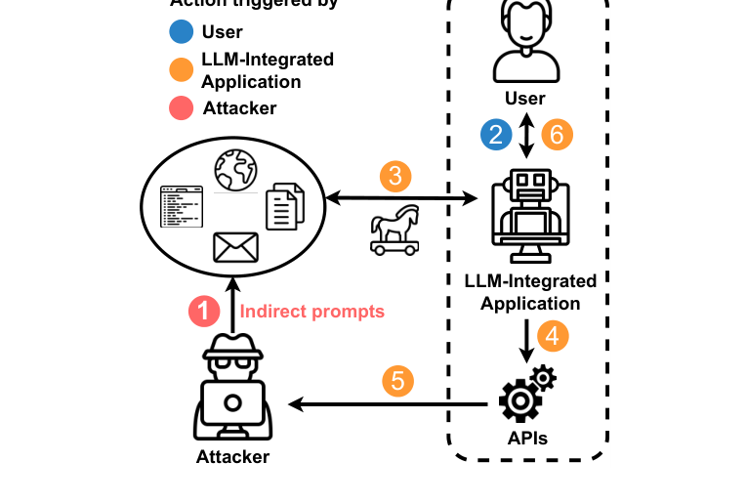
Figure 1. Example indirect prompt-injection flow in an LLM-integrated application. Reproduced from Greshake et al. [3, Fig. 1]. The figure illustrates a threat documented in prior work; it is not a PI-Guard experiment.

1.3. Research Objectives
General objective. To design and evaluate an external text guardrail for LLM applications that classifies prompts as benign, prompt injection, or jailbreak, and to assess its generalization, robustness to specified prompt obfuscations, and false-positive behavior using a documented evaluation protocol.
Specific objectives.
- Define the threat categories and retain the provenance, labels, and construction context of each evaluation source.
- Compare record-random and group-aware evaluation so the effect of related examples crossing data partitions can be measured.
- Establish paper-backed binary reference baselines separately from the planned three-class PI-Guard evaluation; assess an integrated arrangement only in a later shared-set study.
- Evaluate class-wise detection and benign-input false positives, and assess robustness to specified obfuscations such as leetspeak, Base64, and spacing.
- Integrate a trained classifier into an academic proof-of-concept API that blocks or flags malicious prompts before they reach the downstream LLM.

The objectives are guided by three research questions:
RQ1 — Generalization under data partitioning: How do performance estimates for the same three-class classifier change when related examples are kept in group-aware partitions rather than assigned by record-random splitting?
RQ2 — Robustness to prompt obfuscation: How does each classifier’s detection change under specified prompt obfuscations such as leetspeak, Base64, and spacing, and does the effect differ by attack source?
RQ3 — Three-class detection and benign false positives: On held-out data, how do candidate classifiers compare in detecting benign, prompt-injection, and jailbreak inputs, and what false-positive burden do they impose on benign prompts?

1.4. Significance of the Study
The study can contribute an evidence-bounded comparison of text guardrails by preserving dataset provenance, distinguishing attack categories, and reporting benign false positives alongside attack detection. Published systems and benchmarks use different tasks, labels, models, and test protocols, so their scores are not directly interchangeable. [5] [6] [13] [14] [15]
Its practical contribution, if established, would be an academic proof of concept for checking text at an application boundary. An ingress classifier can be evaluated as one control in a larger application, but it cannot by itself guarantee detection of all attacks or replace downstream authorization and output controls. [11]

1.5. Scope and Limitations
Dimension | Scope for this study | Limitation at Review 1
Task labels | Three output labels: Benign, Prompt Injection, and Jailbreak. | Dataset labels originate from different annotation protocols and must not be assumed semantically identical.
Inputs | English text, including direct prompts and text supplied through an LLM-integrated application. | No verified Vietnamese, multimodal, or systematic multi-turn evaluation.
Guardrail location | Proposed external ingress classifier before a downstream LLM application treated as a black box. | No inspection of downstream model weights, hidden states, or KV cache; no claim of complete protection.
Classifier design | Classical and contextual classifier candidates; a two-tier arrangement is a proposal. | No project-trained DeBERTa or end-to-end two-tier cascade result is established at this cut-off.
Evaluation | Source-aware detection and benign-input false-positive analysis; later project work may test defined text transformations. | No PI-Guard-trained classifier evaluation is established at Review 1.
Deployment | Academic proof-of-concept API and dashboard, subject to non-mocked evidence. | Not production-ready; mock providers and fallback classifiers are not security evidence.

1.6. Thesis Structure
Chapter 1 introduces the problem and study purpose; Chapter 2 reviews previous research and states the bounded contribution. The remaining thesis chapters are planned to describe methodology, completed experiments and results, discussion, and conclusions supported by the eventual evidence.

CHAPTER 2 — LITERATURE REVIEW

2.1. Review of Previous Studies
Prompt injection and jailbreak research. Perez and Ribeiro describe direct prompt-injection techniques, including instruction redirection and prompt extraction. Greshake et al. analyze indirect prompt injection in applications that incorporate external content, showing why application context and content source matter. Ouyang et al. study instruction following with human feedback as alignment context, while jailbreak studies examine failures of safety behavior and prompts collected in the wild. These works motivate keeping the input source and intended outcome visible in evaluation; the cited alignment and guardrail systems are references, not PI-Guard results. [1] [2] [3] [4] [9] [12]
Guardrail approaches. Llama Guard illustrates an LLM-based safeguard for input and output content. NeMo Guardrails presents an application toolkit for controlling LLM interactions through configurable flows. They represent different system approaches and should be compared only under aligned data, labels, hardware, and measurement protocols. [5] [6]
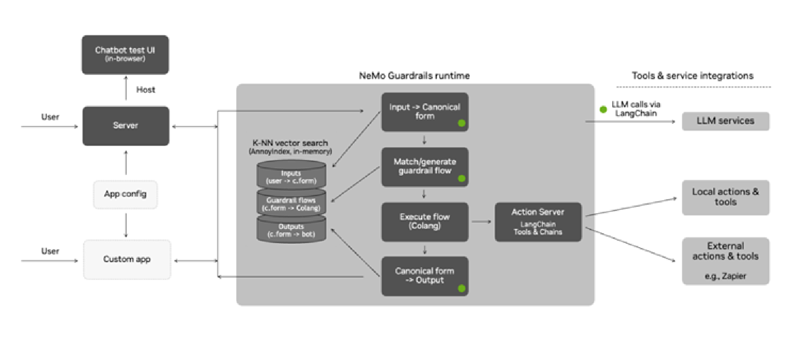
Figure 2. NeMo Guardrails runtime and application integrations. Reproduced from Rebedea et al. [6, Fig. 3]. This is an example from the cited system paper, not the PI-Guard architecture or a PI-Guard result.
Jain et al. evaluate baseline defenses against adversarial attacks on aligned language models. InjecGuard examines over-defense in prompt-injection guardrails and motivates evaluating benign-input flagging as well as attack detection. Their findings belong to the papers’ own models and protocols; they are not PI-Guard outcomes. DeBERTa-v3 is a pretrained encoder candidate, but its pretraining results do not establish prompt-security performance for a fine-tuned PI-Guard model. [7] [10] [13]
Evaluation resources. BIPIA supplies indirect prompt-injection tasks with constructed application contexts; JailbreakBench supplies jailbreak prompt artifacts and metadata. A prompt flag on either source is not equivalent to the downstream attack-success outcome used in target-model evaluations. Work on undesired-content detection and guardrail over-defense supports measuring false positives on an explicitly described benign population. [8] [13] [14] [15]
Research area | Contribution relevant to this study | Implication for PI-Guard
Direct prompt injection | Prompt-level manipulation and extraction attempts have been documented. [2] | Preserve attack source and label meaning.
Indirect prompt injection | External content incorporated by an application can carry adversarial instructions. [3] [14] | Preserve application context; a payload-only input is a different task.
Jailbreak behavior | Safety-alignment failures and in-the-wild jailbreak prompts have been studied. [4] [9] [12] | Keep detector flags separate from target-model jailbreak success.
Guardrail approaches | LLM safeguards and application-flow toolkits use different mechanisms. [5] [6] | Avoid cross-system ranking without matched protocols.
Benign-input behavior | Prior work studies undesired-content detection and guardrail over-defense. [8] [13] | Report benign false positives alongside attack detection.
Evaluation datasets | BIPIA and JailbreakBench define source-specific tasks and artifacts. [14] [15] | Identify the task, source, and outcome being studied.

2.2. Summary of the Literature Review
The literature supports three conclusions. First, direct injection, indirect injection, and jailbreaks may all appear as text but differ in source, context, and intended outcome. Second, published scores depend on model, labels, input construction, and test protocol; they cannot be transferred to PI-Guard without a matching experiment. Third, when a guardrail can incorrectly flag benign requests, attack detection should be reported alongside benign-input behavior. The literature motivates a source-aware empirical study but does not establish PI-Guard’s classifier quality, robustness, or integration safety. [2] [3] [4] [5] [6] [8] [13] [14] [15]

2.3. Contribution of Research
The intended contribution is an applied empirical evaluation and academic proof of concept, not a new foundational model. A paper-backed binary reference benchmark is now available; it does not replace the project task of evaluating three labels, group-aware splits, and specified transformations.

Assessment of the Problem Statement
The problem is relevant to LLM application security and researchable as a three-class text-classification study with a separately measured benign false-positive burden. Its framing is adequate when it distinguishes direct and indirect prompt injection from jailbreak behavior. Reference systems in the literature provide context but do not establish PI-Guard performance or demonstrate downstream attack success. The Greshake figure in Section 1.2 is a suitable, cited illustration of the indirect attack path.

Assessment of the Research Questions
Question | Review 1 assessment | Evidence status at 30 September 2026
RQ1 — Generalization under data partitioning | Compare the same data and classifier under record-random and group-aware splits; define grouping before the comparison. | Not yet evaluated with a PI-Guard classifier at Review 1.
RQ2 — Robustness to prompt obfuscation | Specify obfuscations such as leetspeak, Base64, and spacing, then compare detection by source and class. | No project obfuscation experiment is established in the Review 1 artifacts.
RQ3 — Three-class detection and benign false positives | Evaluate the three labels on held-out data and report class-wise detection with benign false positives. | Not yet evaluated with a PI-Guard-trained three-class classifier; cited models are literature context only.

The questions address distinct outcomes: split sensitivity, robustness to specified prompt obfuscations, and the target classification/false-positive trade-off. Each requires a specified data protocol before results can answer it.

Assessment of the Research Objectives
The objectives align with the three questions and form a feasible sequence: define labels and provenance, establish the project evaluation split, train the planned three-class classifier, evaluate registered obfuscations and benign-input behavior, and integrate only after those results are available. The PIDS-Bench binary reference run is separate from this project-model work.

Assessment of the Proposed Solution
The proposed design may evaluate lexical and contextual components before a downstream LLM application, but no current result measures a chained system. The retained PIDS-Bench TF-IDF run was recomputed from 3,918 source-matched test predictions at threshold 0.5: accuracy 96.4012%, macro-F1 0.9638, injection F1 0.9663, recall 97.6812%, benign FPR 5.0325%, and confusion matrix [[1755,93],[48,2022]]. This is a binary, single-seed same-paper baseline on the PIDS-Bench protocol [16]. ProtectAI-on-PIDS-Bench metrics and dependent comparisons are withdrawn under the paper-origin rule.
Component | Proposed role | Review 1 status
TF-IDF reference | PIDS-Bench word unigram/bigram TF-IDF + Logistic Regression. | Locally fit on the paper binary train split; not the PI-Guard three-class model.
Policy and API | Apply an allow/block/flag decision and record status. | Scaffolding exists, but mock provider and classifier fallback paths prevent treating route presence as verified security behavior.

The NeMo figure in Section 2.1 is a literature reference, not evidence that PI-Guard uses the same architecture. The proposed PI-Guard arrangement remains a design proposal at Review 1.

Assessment of the Project Boundary
An English-text, ingress-focused academic prototype is a manageable project boundary. The boundary is clear when it excludes systematic Vietnamese or multimodal evaluation, stateful multi-turn protection, downstream model internals, universal attack coverage, production readiness, and security guarantees. Source-specific prompt-injection and jailbreak labels should remain distinct where the originating benchmark distinguishes them.

Assessment of Feasibility Based on Work Completed to Date
The process workbook records project-model fine-tuning and API/dashboard integration as not started at its cut-off. A separate PIDS-Bench reference benchmark is now available; it does not change the status of project-model training or establish validated PI-Guard behavior. The API scaffolding and mock/fallback paths are not empirical security evidence.

The repository also contains API and classifier scaffolding. The reviewed API startup uses a mock downstream provider and can fall back to a dummy classifier when a model artifact is unavailable; the transformer module contains a score-simulation fallback. These paths are not empirical security evidence. API initialization API provider Transformer fallback
The current local evidence consists of the source-matched PIDS-Bench TF-IDF baseline and a separate PIGuard checkpoint run on assets released with the PIGuard paper [17]. They use different data and protocols and are not compared as a model ranking. The process workbook records PI-Guard fine-tuning and API/dashboard integration as not started; no formal acceptance record was found.

Implementation Progress as a Share of Scheduled Time
The process workbook gives the project period as 7 September–20 December 2026. From 7 September to the Review 1 cut-off of 30 September, 23 of 104 calendar days had elapsed, or 22.1% of scheduled time. This is elapsed schedule time, not a verified percentage of implementation completed.
The workbook snapshot lists T14 and T16 as in progress, and T17 project dataset splitting/training, T20 project DeBERTa fine-tuning, and T21 API/dashboard integration as not started. The PIDS-Bench TF-IDF and PIGuard-only runs do not measure the proposed three-class PI-Guard model or a cascade.

References
[1] L. Ouyang et al., “Training Language Models to Follow Instructions with Human Feedback,” NeurIPS, 2022.
[2] F. Perez and I. Ribeiro, “Ignore Previous Prompt: Attack Techniques For Language Models,” NeurIPS ML Safety Workshop, 2022.
[3] K. Greshake et al., “Not What You’ve Signed Up For: Compromising Real-World LLM-Integrated Applications with Indirect Prompt Injection,” ACM AISec, 2023.
[4] A. Wei et al., “Jailbroken: How Does LLM Safety Training Fail?” NeurIPS, 2023.
[5] H. Inan et al., “Llama Guard: LLM-Based Input-Output Safeguard for Human-AI Conversations,” 2023.
[6] T. Rebedea et al., “NeMo Guardrails: A Toolkit for Controllable and Safe LLM Applications with Programmable Rails,” EMNLP System Demonstrations, 2023.
[7] P. He, J. Gao, and W. Chen, “DeBERTaV3: Improving DeBERTa using ELECTRA-Style Pre-Training with Gradient-Disentangled Embedding Sharing,” ICLR, 2023.
[8] T. Markov et al., “A Holistic Approach to Undesired Content Detection in the Real World,” AAAI HCOMP, 2023.
[9] X. Shen et al., “‘Do Anything Now’: Characterizing and Evaluating In-The-Wild Jailbreak Prompts on Large Language Models,” ACM CCS, 2024.
[10] N. Jain et al., “Baseline Defenses for Adversarial Attacks Against Aligned Language Models,” arXiv:2309.00614, 2023.
[11] J. H. Saltzer and M. D. Schroeder, “The Protection of Information in Computer Systems,” Proceedings of the IEEE, 1975.
[12] Y. Yuan et al., “GPT-4 Is Too Smart To Be Safe: Stealthy Chat with LLMs via Cipher,” ICLR, 2024.
[13] H. Li, X. Liu, N. Zhang, and C. Xiao, “InjecGuard: Benchmarking and Mitigating Over-defense in Prompt Injection Guardrail Models,” ACL, 2025.
[14] J. Yi et al., “Benchmarking and Defending Against Indirect Prompt Injection Attacks on Large Language Models,” NAACL, 2024.
[15] P. Chao et al., “JailbreakBench: An Open Robustness Benchmark for Jailbreaking Large Language Models,” NeurIPS, 2024.
[16] Y. K. Shire and S.-C. Kim, PIDS-Bench: A Benchmark for Prompt Injection Detection Systems, IEEE Access, 2026. DOI 10.1109/ACCESS.2026.3728186. Author code: github.com/ShirePyDev/Prompt-Injection-Detection-System, tag v1.0-pids-bench.
[17] H. Li et al., “PIGuard: Prompt Injection Guardrail via Mitigating Overdefense for Free,” ACL, 2025. https://aclanthology.org/2025.acl-long.1468/.

