Scoreboard Interface

Nick Wilmsmeyer

University of Missouri – Kansas City

Table of Contents
Vision Statement 3
Requirements 4
Product Backlog 5
Sprint #1 6
Review 6
Retrospective 6
Sprint #2 7
Review 7
Retrospective 7
Sprint #3 8
Review 8
Retrospective 8
Sprint #4 9
Review 9
Retrospective 9
Sprint #5 10
Review 10
Retrospective 10
Sprint #6 11
Review 11
Retrospective 11

Vision Statement
This app is designed to be a tool to allow the user to update an HTML based scoreboard on the web. The ideal candidate for this app is someone who is running a trivia night and needs an easy way to update the running scoreboard for all the trivia teams. The scoreboard itself will be built with a combination of HTML/CSS/PHP/SQL knowledge and the app will interface with the SQL database via PHP/AJAX commands. This app would allow the user to walk around the room and still be able to update the scoreboard for the trivia night.
My Dad and I actually ran into this exact problem about a month ago when he was hosting a trivia night, and did not want to have to carry around a laptop to update the individual team scores all night. Having this functionality built inside an app would cut down on the amount of hassle it takes to update the scores, and allow the user to be able to move freely around the room, watching the teams and having a good time, instead of being tethered to a laptop containing a boring spreadsheet displaying the team names and scores.

Requirements
A discussion of what your application is required to have in functionality. It should identify user roles and goals/actions, and what the key features of the app should be.
Actor | Goal
End User | Able to update HTML based scoreboard remotely from Android phone
End User | Able to change and modify scores should an error occur in the score entry (ex. Inputting 7 instead of 17)
End User | Able to clear the scoreboard upon completion of the game
End User | See visual representation of the scoreboard inside the app
Me | Provide functionality to update scores from inside the app via PHP/AJAX requests
Me | Allow the user to modify/delete scores due to an error in the entry
Me | Allow the user to save the scoreboard to another database or clear the scoreboard completely at the end of a game
Me | Allow the user to see a representation of the scoreboard inside the app

Product Backlog
This will be updated throughout the semester as new PBIs are added, larger items are broken into smaller ones, and completed items removed.

Story ID | Story | Story Points  (in est. hours) | Priority | Status
1 | Creating the database for the scores to be held inside, and outlining the schema for the database | .5 | High | Finished
2 | Creating test webpage to make sure I can interface with the database correctly | 2 | Medium | Finished
3 | Building database editing functionality into the app, allowing the user to edit the database via the app | 10 | High | In Progress
4 | Testing the post methods of the app, making sure they are posting to the correct fields inside the database, etc. | 5 | Medium | Not Started

Sprint 1 Goal:
- Complete the initial setup of the database & database schema, allowing me to get started on the web interface for the scoreboard itself.
- Create simple test webpage to verify all credentials to the database are correct, and that I can post to the database remotely.
- Start researching the methods used by Android to communicate with SQL databases via Java/Kotlin
- Begin initial phases of implementing the post methods into the app

Sprint #1

Sprint Backlog
Story ID | Story / Task | Estimated  Hours | Actual  Hours
1 | Creating the Database & schema for the database to hold the score information for each team | 1 | 1
2 | Linking the database and its information to the HTML/PHP based webpage, to display the leaderboard | 2 | 5
3 | Researching the methods used to implement the equivalent of a PHP post method inside an android app to post scores to the SQL database | 2 | 1
4 | Beginning to implement the POST and retrieval methods in the app to communicate with the database | 8 | 12
5 | Reformatting the database table on the webpage to better suit the display format of the end-goal webpage. | 1 | 2
6 | Explore the possibility of arming this app with a built in web server, making the app fully self contained and not requiring the use of an outside database or web server to host the leaderboard page. | 1 | ?

Review
This is the first iteration of my database design. I keep going through the database and attempting to figure out better ways to lay out the table that is keeping track of all the scores.
At this point, I have a working table of the database being displayed on the webpage. Although it is very minimal at the moment, during future iterations I will be expanding on the look of the final leaderboard.

Webpage view:
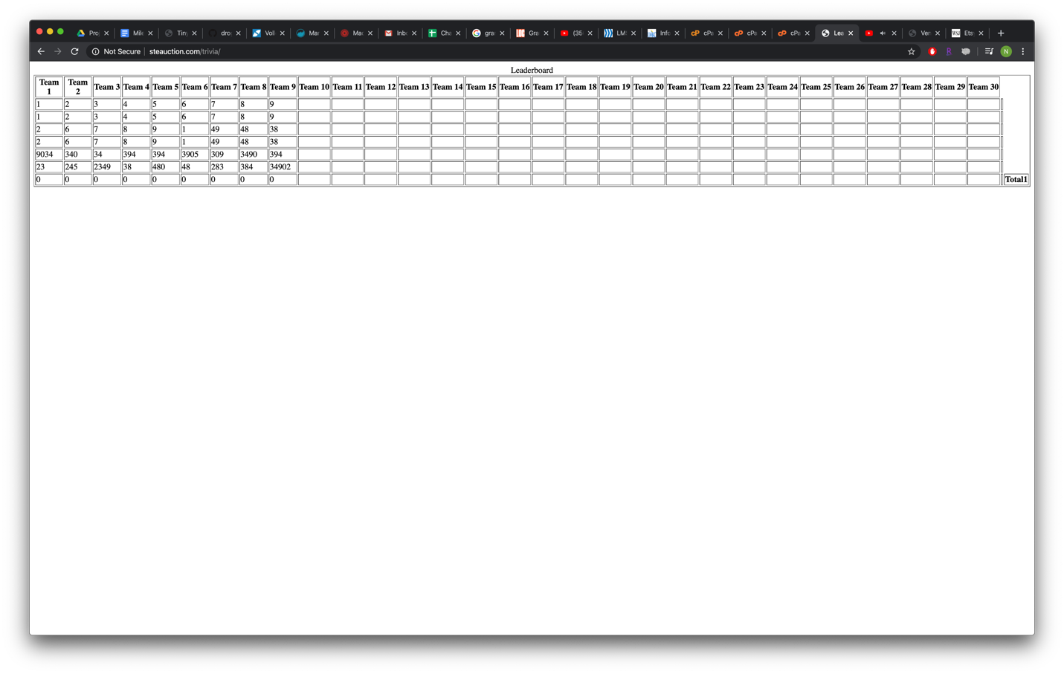
Database View:
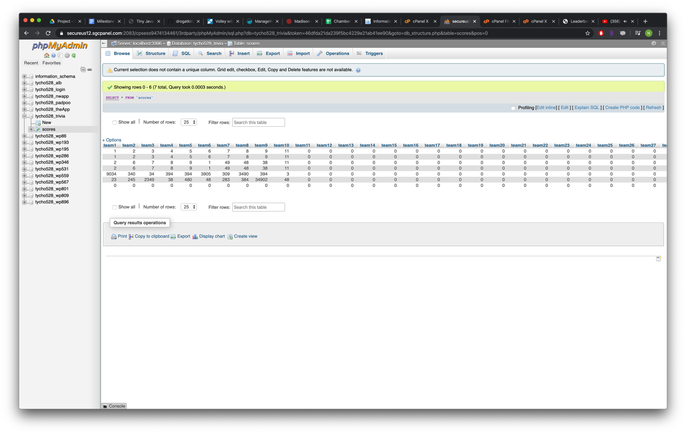
I am currently working on the research for the PHP modules that will convert the POST methods in PHP to a format that the android app can understand. Here are some of the websites I have found that are helping me with this feature:
http://tjws.sourceforge.net/
https://www.simplifiedcoding.net/volley-with-kotlin/
https://www.w3schools.com/jquery/jquery_ref_ajax.asp

I will be parsing the PHP requests with Jquery to give the app the ability to directly push data to and pull data from the database containing scores. I have also toyed around with the idea of making this a completely self sufficient app, containing the “Tiny Java Web Server” I have linked to above. I am not yet sure how feasible this is given the time constraints, but it is a possibility.

Retrospective
I believe the database and web portion of this project is going well so far since I have a fairly extensive background in SQL and web design. The linking of the database to the app will be the most difficult part of this project though, by far. I have drawn out a very basic design of how I want the app to look, but have not yet designed it in Android Studio yet. The layout of this app in particular is very peculiar because it has so many different functions that making sure all of them are equally accessible is going to be a challenge. I think doing these code sprints is definitely a great way to make sure that the project remains on task, as opposed to just having the entire project due at once with no “checkpoints”.

Sprint #2

Sprint Backlog
Story ID | Story / Task | Estimated  Hours | Actual  Hours
1 | Implement the PHP post and retrieval methods to/from the database and make sure they are accurately interfacing with the db. | 10 | -
2 | Allow the app to create a realtime view of the “leaderboard” page that will be displayed | 3 | -
3 | Explore the possibility of implementing the Tiny Java Web server into the app, to allow for a fully self contained version of the app, not relying on outside db’s or servers. | 5 | -
4 | Change the layout of the leaderboard web view to account for larger team size numbers. Add the ability to name the teams besides the default names. | 2 | -

Review

[Screenshots, etc go here. This is where you discuss the product, describing what was done this sprint (potentially shippable product increment) and what was planned for the sprint but was not done. ]

Retrospective
[This is where you discuss the process. What went well (and are you planning to do more of that?) What didn’t go so well (and do you have a way to do less of that)? What changes are you planning to make in how you plan & carry out the next sprint?]

Sprint #3

Sprint Backlog
Story ID | Story / Task | Estimated  Hours | Actual  Hours

Review

[Screenshots, etc go here. This is where you discuss the product, describing what was done this sprint (potentially shippable product increment) and what was planned for the sprint but was not done. ]

Retrospective
[This is where you discuss the process. What went well (and are you planning to do more of that?) What didn’t go so well (and do you have a way to do less of that)? What changes are you planning to make in how you plan & carry out the next sprint?]

Sprint #4

Sprint Backlog
Story ID | Story / Task | Estimated  Hours | Actual  Hours

Review

[Screenshots, etc go here. This is where you discuss the product, describing what was done this sprint (potentially shippable product increment) and what was planned for the sprint but was not done. ]

Retrospective
[This is where you discuss the process. What went well (and are you planning to do more of that?) What didn’t go so well (and do you have a way to do less of that)? What changes are you planning to make in how you plan & carry out the next sprint?]

Sprint #5

Sprint Backlog
Story ID | Story / Task | Estimated  Hours | Actual  Hours

Review

[Screenshots, etc go here. This is where you discuss the product, describing what was done this sprint (potentially shippable product increment) and what was planned for the sprint but was not done. ]

Retrospective
[This is where you discuss the process. What went well (and are you planning to do more of that?) What didn’t go so well (and do you have a way to do less of that)? What changes are you planning to make in how you plan & carry out the next sprint?]

Sprint #6

Sprint Backlog
Story ID | Story / Task | Estimated  Hours | Actual  Hours

Review

[Screenshots, etc go here. This is where you discuss the product, describing what was done this sprint (potentially shippable product increment) and what was planned for the sprint but was not done. ]

Retrospective
[This is where you discuss the process. What went well (and are you planning to do more of that?) What didn’t go so well (and do you have a way to do less of that)? What changes are you planning to make in how you plan & carry out the next sprint?]

