**Personal Safety IOT System**

By

Artur Lach

June 2017

**ABSTRACT**

To the most of everyone there is not a single more important thing in life than safety and security of their loved ones whether it being children, significant other or elderly parent. Everyone do what they can to provide this safety at all times and under all circumstances. However, the truth is today’s world as beautiful and evolved it is, can also be a dangerous place with tragedies such as: people getting lost in unknown environments, kidnappings, sexual assaults and even murders happening everyday. One approach to have a better control and influence over this brutal reality is use of technological advancements such as smartphones or smartwatches that provide ability to pinpoint person location in case of emergency. However, such devices are well known to the attackers and most of the time are first to be disposed making it very difficult to being able to monitor and make sure nothing bad is currently happening to someone close, or take efficient actions as quickly as possible in case of unfortunate event already happening. Furthermore, invasion of privacy has to be considered whenever the idea of tracking someone is brought to the table. The focus of this paper is to propose a wearable IOT device easily embedded in everyday clothing such as belts or shoes, combined with easy, but not obvious emergency triggering mechanism as well as configurable, learning intelligent agent in the cloud infrastructure. Proposed device has ability to send current location of person in trouble when triggered or when abnormality is detected by intelligent agent if learning option is desired and activated by the user. The idea behind the system is to provide ability for faster and more accurate response to an emergency and greater chance for successful resolution. (Keywords: IOT, Wearables, Emergency Response).

**TABLE OF CONTENTS**

I. INTRODUCTION 4

a. Problem Definition 4

II. DISCUSSION 5

a. Proposed Solution 5

b. Solution Details 6

III. CONCLUSION 11

IV. REFERENCES 13

**I. INTRODUCTION**

**a. Problem Definition**

Internet of things and intelligent systems are big trends and find application in many industries and products ranging from smart coffee machines to complicated manufacturing robots that can be monitored and controlled remotely, or operate autonomously. IOT devices can be used to collect and transport data to intelligent agents stored in the cloud or on the servers, where it can be analyzed to understand variety of parameters, including human behavior and even intentions. IOT devices can also function as end agents and perform actions that can be triggered by logic embedded into the device or by remote agent. It is really significant that IOT devices can and are used to make life more convenient and more understandable, however it seems that so far usage of IOT devices, at least in consumer market, is somewhat limited to gadgets that are “cool” and “hype”, but don’t necessarily improve safety or security of life. Safety and security of loved ones is the most important aspect of life for many people, and although hope nothing bad will ever happen to loved ones is great to have, today’s world can be brutal and dangerous environment. Almost, every day there is story in the news about people, very often women and children being abducted, attacked or sexually assaulted. In those scenarios there are two main factors that influence how the situation is resolved: knowing person’s current location and responding in fast and efficient manner. Although, law enforcement does a great job handling those cases, sometimes they just have too little information and not enough time, especially considering that in homicide cases death of abducted person typically occurs within 3 hours of the abduction [1], to successfully help the person in trouble. Although, in some cases technology such as GPS integrated in smartphones or smartwatches greatly assists in resolution, these devices are so well known that they are typically disposed by attacker within minutes. With thats said the main problem is not, whether or not technology and IOT specifically, could assist and help in life or death situations, such as abductions and other similar, but how can it be used with a degree of secret and intelligence, but without violating privacy rights.

**II. DISCUSSION**

**a. Proposed Solution**

Proposed solution is a system that consists of multiple components spawning hardware, software, connectivity and intelligent agent. First, part of the system is a wearable IOT device that is embedded in everyday clothing. This device is connected and communicates to the cloud, sending information such as: emergency trigger and GPS location. Additionally, since the device uses cellular technology it has ability to send periodic text messages with current location to registered emergency responders in case of trigger being activated. Cloud is responsible for collecting data received from the IOT device and making it available to a control agent. Control agent is the most intelligent piece of the system and performs multiple tasks: learns user’s typical every day behavior, for example: where does the user spend most of the time, how long does the user spend in each location, identifies abnormalities in typical behavior, provides tracking of the user in case of abnormal behavior or emergency trigger , and has ability to send person’s information to all active system users close to person’s current location. Additionally, due to the fact that no one’s behavior is 100% predictable, for example behavior on the weekends can be much different than behavior during week days, control agent can be configured to respond only to emergency trigger in order to avoid false triggering. Last part of the system is application software used for configuration and communication to both IOT device and control agent. One of the main usage of the application is to configure list of emergency contacts/responders. Additionally, since privacy is a big concern in a system like this, application allows user to disable learning abilities of the control agent and disable/enable sharing information with other users of the system, in case of emergency. Lastly, application provides tracking interface, showing current location and traveling speed when the emergency mode is triggered.

**b. Solution Details**

* **System Architecture**

Figure on the following page represents architecture of the system including components and communication flow between components. Black arrows indicate internal line of communication, blue arrows indicate informational, external communication and red arrows indicate communication in emergency situation. Lines are unidirectional and represent which component/object is a sender and which one is a receiver. Focus of this system diagram is to show high level working of the system and this is why diagram highlights most important modules of the system without going into comprehensive details related to the actual implementation.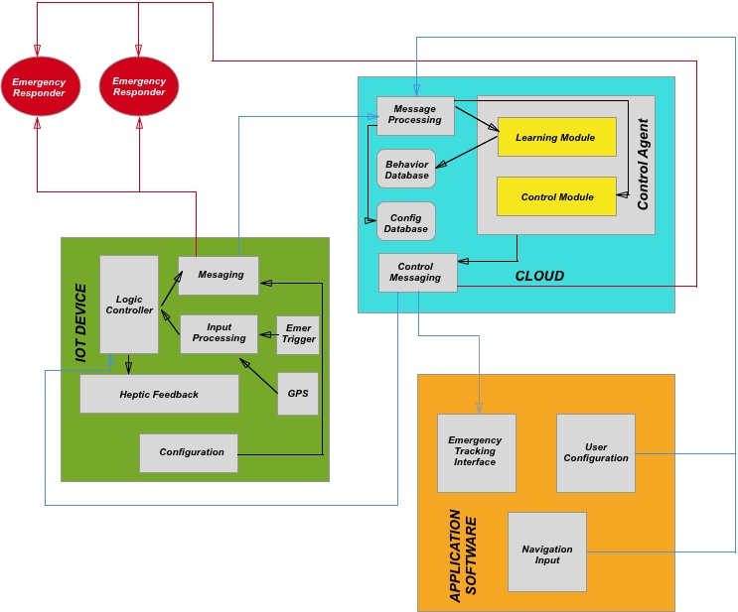

Figure 1: System Architecture

* **System Logic**

The operation of the system starts with configuration performed using application software. Configuration has to always be performed when the device is first activated, and can also be performed when the device is already in use. Configuration parameters include device user profile and emergency responder contact information. Additionally, user has to specify if he/she desires the control agent to learn the behavior and whether user information could be shared with other emergency responders in case of emergency. Once, this information is configured it is saved in wearable IOT device and the database in the cloud. If user allows control agent to learn his/her behavior the system, and the behavior has not been learned yet, the system is placed in learning mode. During learning mode, learning module inside of control agent monitors and stores user behavior. User behavior in this context means that the agent learns: when and how long user spends time at specific locations, what time does the user typically travel to these locations, where is home location, where is work or school location. This learning operation is very similar to that of Google Maps which takes about 3 days to automatically learn home and work location [2]. During the learning time, system does not trigger emergency based on behavior prediction, but nevertheless emergency can be activated when triggered by IOT device. Once the system is learned it can be triggered in two different ways: by emergency trigger in IOT device and by control agent in the cloud when it determines abnormality in the behavior. Additionally, system considers three levels of emergencies: soft, intermediate and hard. Soft level is raised when emergency is triggered by control agent, intermediate when triggered by IOT device and hard when triggered by both. Levels are based on how likely it is that the emergency is real. Emergency triggered by control agent is considered soft, because there is a chance system did not properly interpret user behavior. Intermediate level is raised when triggered directly by IOT device, meaning user had to physically trigger emergency. This is considered intermediate level since, although unlikely if the triggering procedure is well designed, it can still be possible for the user to trigger the system by mistake. Third and final hard level is a combination of both prediction by control agent and trigger by IOT. It is considered as a hard level, because probability of emergency being real in this case is the highest. When emergency is triggered by either IOT device or control agent, there are few things that happen: first emergency responders (stored in the database) receive the text message indicating person is in trouble and the person’s current location, hectic feedback is provided to the user wearing the IOT (“Haptic feedback, often referred to as simply "haptics", is the use of the sense of touch in a user interface design to provide information to an end user” [3])., control agent actively tracks user location (with much higher frequency compared to non emergency situation) simultaneously providing tracking information to application software interface, and finally (if accepted by user in the configuration) control agent identifies any emergency responders (ones not directly assigned to the user account) in close distance to the user and sends notifications to them regarding user in emergency. Once text message is received by emergency responders (assigned to the user account) they can log in to application software to view person’s current location as well as previous locations, overlaid on the map. Important to note is that by using hectic feedback false prediction and triggers can be minimized. When user receives haptic feedback, but is not in real emergency he/she can cancel procedure by using application software.

* **Control Agents Predictions**

Since the system proposes to use control agent in the cloud to automatically predict whether user is in trouble, it is required to provide high level overview of how control agent functions. The idea of control agent is that since person’s everyday behavior is mostly predictable, for example adults are typically at work or at home at specific time and for specific amount of time (same can be said with children and school), it can be predicted when something abnormal is happening. The system learns and stores information about user and based on this and using machine learning decides whether current situation is normal or not. In order to predict this behavior GPS location as well as time is used. In current state of the proposal/project a specific learning algorithm to achieve the task is not proposed since it requires more research to decide what would work best. Additionally, since prediction of the control agent is in big extent based on where user typically is at specific time, there are scenarios when false predictions are likely. Good example of this is a situation when user typically goes to work on specific day (for example Monday), but in one instance of time user takes a day off, and decides to go somewhere that has not been visited before. In this case control agent would be very likely to predict false emergency situation. Proposed solution to this issue is to use navigation input from the smartphone (application software), whenever it is used. Idea behind it is that when user is about to travel to some new location, there is a high probability user will look for directions to the place on smartphone. According to article by Monica Anderson, getting location information on the smartphone is activity that is common across all groups [4]. By using this information control agent can understand that user’s behavior is normal in this case, even though it falls outside of learned range.

* **Simple Example**

Due to stage of this proposal as well as idea behind the system, it is hard to present real time example of usefulness or successfulness of the system. However, theoretical example can be used to highlight how the system could help in an emergency scenario. To present this example first consider a situation where the user of IOT device - 12 year old middle school student and the emergency responder- student’s father do not use the proposed system. Every Monday student walks to school which is 7 minutes away and spends 8 hours there. One terrifying Monday the student does not arrive at school. No one has an idea what happened, but teachers at school notice the absence of the student and notify the father. Two hours pass until law enforcement are notified of the situation and start investigating the case. Typical procedure starts, mainly trying to find if anyone has seen or heard from the student. Luckily, after couple more hours of investigation police officers get a tip and are able to locate and rescue the student. Now consider same example, but assuming student and the father are the active users of the system. Since the system has learned student’s behavior, system identifies that student is traveling on completely different path than typically on Monday, in the direction completely opposite to that of the school. Almost immediately system identifies abnormal behavior and sends information to student’s father, who in turn logs in the application and is actively tracking student’s location. In the meantime father contacts the police and provides them with the current location of the student. With exact location of the student, police officers are able to quickly locate and safe the student. In both scenarios of this theoretical example, police officers were able to rescue the student, however when proposed system was used, police offers were able to do their job not only more efficiently, but also much faster.

**III. CONCLUSION**

At current stage of this proposal there is still a lot work to be done: it needs to be figured out how to embed the IOT device into a wearable item, how and what machine learning algorithms need to be implemented in order to be able to predict emergency scenarios, physical architecture of the cloud and communication between components. Nevertheless, the concept and goal remains the same and that is to make emergency scenarios more predictable and with better outcome, without violating privacy. The proposed solution is able to that by combining multiple components and making them work cooperatively. By embedding the IOT device into wearable clothing, it is made to be not obvious to the attacker, but yet something that can be used everyday without really affecting user’s ability to function. Also, by integrating learning component into the system it is made so that it can handle situations when the user is not able to physically trigger the emergency. Additionally, by tracking the user location the system is able to provide accurate information regarding whereabouts of the user. All these combined help with two issues that are most important when handling emergency situation : cutting response time and providing location information. Proposed system also addresses issue of privacy of the user. System provides user with the ability to decide whether intelligent system should be able to learn and what information should be provided to other people. Additionally, although the system is aware of user’s current location at all times, only in cases of emergencies this information is provided to other parties involved. Proposed system is definitely not as cool as a smart toaster or smart assistant and no doubt it would raise concerns of some people. In the end however, when it is shown that the system can save lives, people will buy into an idea of another object knowing their location, object that can actually make a real difference.

**IV. REFERENCES**

[1] Tompkins, A., March 12,2003, “Thursday Eiditon: Kidnapping Facts”, Available:  
https://www.poynter.org/2003/thursday-edition-kidnapping-facts/8155/

[2] Hill, K., Jul 9, 2012, “It Takes Google 'Now' Three Days To Figure Out Where You Live”, Available: [https://www.forbes.com/sites/kashmirhill/2012/07/09/it-takes-google-now-three-days-to-figure-out-where-you-live/#5400c4887d68](https://www.forbes.com/sites/kashmirhill/2012/07/09/it-takes-google-now-three-days-to-figure-out-where-you-live/%235400c4887d68)

[3] “What is "haptic feedback”?, Available: <http://www.mobileburn.com/definition.jsp?term=haptic+feedback>

[4] Anderson, M, Jan 29,2016, “More Americans using smartphones for getting directions, streaming TV”, Available: <http://www.pewresearch.org/fact-tank/2016/01/29/us-smartphone-use/>