SubSystem title

# ERD for UX process

Place your ERD diagram here.

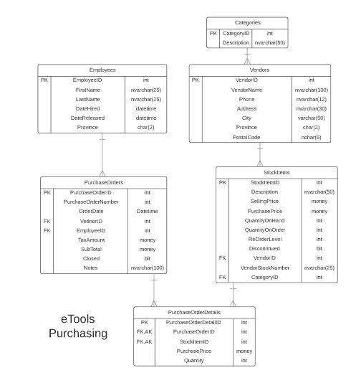

# Possible UX Interface

Place your screen design(s) here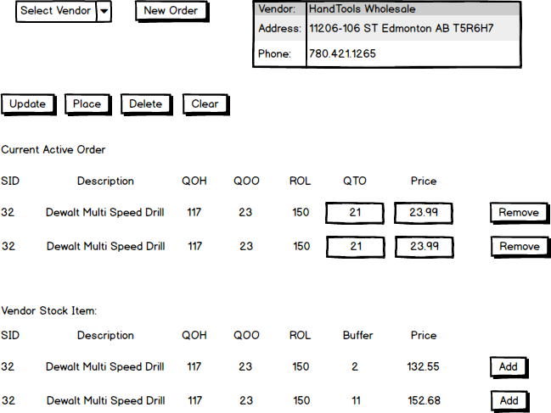

# Samples

|  |  |  |
| --- | --- | --- |
| **Controls** | | **Events** |
| VendorDDL | | None / wired via ObjectDataSource |
| **BBL Class(es) and Method (s)** | | |
| VendorController | List<SelectionList> List_VendorNames()  Retrieve a list of vendor names and vendor id for DDL | |
| **SQL Table(s): (C,R,U,D)** | | **Entities/DTOs/POCOs** |
| Vendors (R) | | SelectionList (P) |

|  |  |  |
| --- | --- | --- |
| **Controls** | | **Events** |
| Fetch (Vendor info) | | OnClick / wired via ObjectDataSource   * Move selection value(vendorid) to PurchaseOrder By vendorid (Closed = 0); * CommandArg send StockItemID to StockItems |
| **BBL Class(es) and Method (s)** | | |
| PurchaseOrderDetailController | List<VendorOrderDetail> OrderDetail_ByVendor (int vendorid)   * Collect PurchaseOrderDetail information and StockItem name and validate;   List<StockItem> StockItem_ByVendornotOnList (int itemid)   * Collect StockItem information not on OrderDetail | |
| **SQL Table(s): (C,R,U,D)** | | **Entities/DTOs/POCOs** |
| PurchaseOrderDetail (R), StockItem(R) | | VendorOrderDetail (P) |

|  |  |  |
| --- | --- | --- |
| **Controls** | | **Events** |
| Remove: PuchaseOrderDetail | | OnClick   * Collect PurchaseOrderDetail * Send remove to BLL * Refesh PODetailList |
| **BBL Class(es) and Method (s)** | | |
| PurchaseOrderDetailController | Void Remove_PusrchaseOrderDetail (PurchaseOrderDetail item)   * Delete the PurchaseOrderDetail | |
| **SQL Table(s): (C,R,U,D)** | | **Entities/DTOs/POCOs** |
| PurchaseOrderDetail (D) | | PurcahseOrderDetail (E) |

|  |  |  |
| --- | --- | --- |
| **Controls** | | **Events** |
| Add: StockItem | | OnClick   * Collect StockItem * Send Add to Bll * Refesh PODetailList |
| **BBL Class(es) and Method (s)** | | |
| PurchaseOrderDetailController | < StockItems > Add_PusrchaseOrderDetail (PurchaseOrderDetail item)   * Add PurchaseOrderDetail item | |
| **SQL Table(s): (C,R,U,D)** | | **Entities/DTOs/POCOs** |
| PurchaseOrderDetail (C), StockItems(R) | | PurcahseOrderDetail (E) |

|  |  |  |
| --- | --- | --- |
| **Controls** | | **Events** |
| Update: PurchaseOrderDetail | | OnClick   * Collect PurchaseOrderDetail * Send Add to Bll * Refesh PODetailList |
| **BBL Class(es) and Method (s)** | | |
| PurchaseOrderDetailController | < PurchaseOrderDetail > Update_PusrchaseOrderDetail (PurchaseOrderDetail item) | |
| **SQL Table(s): (C,R,U,D)** | | **Entities/DTOs/POCOs** |
| PurchaseOrderDetail (U) | | PurcahseOrderDetail (E) |

|  |  |  |
| --- | --- | --- |
| **Controls** | | **Events** |
| Place: close the PurchaseOrder | | OnClick   * Collect PurchaseOrderDetail * Update PurchaseOrder to close |
| **BBL Class(es) and Method (s)** | | |
| PurchaseOrderController | < PurchaseOrderDetail > Update_PusrchaseOrder (int poid) | |
| **SQL Table(s): (C,R,U,D)** | | **Entities/DTOs/POCOs** |
| PurchaseOrderDetail (U) | | PurcahseOrderDetail (E) |

|  |  |  |
| --- | --- | --- |
| **Controls** | | **Events** |
| Delete: PurchaseOrder | | OnClick   * Collect PurchaseOrderID |
| **BBL Class(es) and Method (s)** | | |
| PurchaseOrderController | < PurchaseOrderl > Delete_PusrchaseOrder (int poid) | |
| **SQL Table(s): (C,R,U,D)** | | **Entities/DTOs/POCOs** |
| PurchaseOrder (D) | | PurcahseOrder (E) |

Comments

You might have a high level understanding of the process but your documentation lacks the details to convey this understanding. I am concerned about your full understanding of the work required by you to complete this project.