**Running R Test**

1. Install R on your machine.

2. Start and run R (R.exe on windows) via command line.

Starting R will run an R Console through the command line.

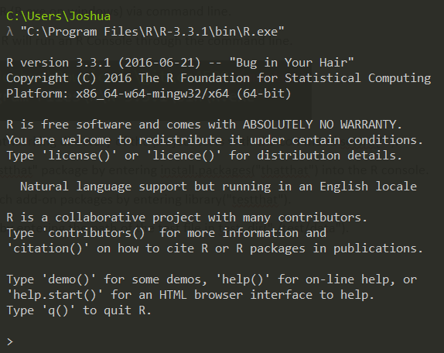

3. Set the current working directory of the project tests with the command setwd("").



4. Install the "testthat" package by entering install.packages("thatthat") into the R console.

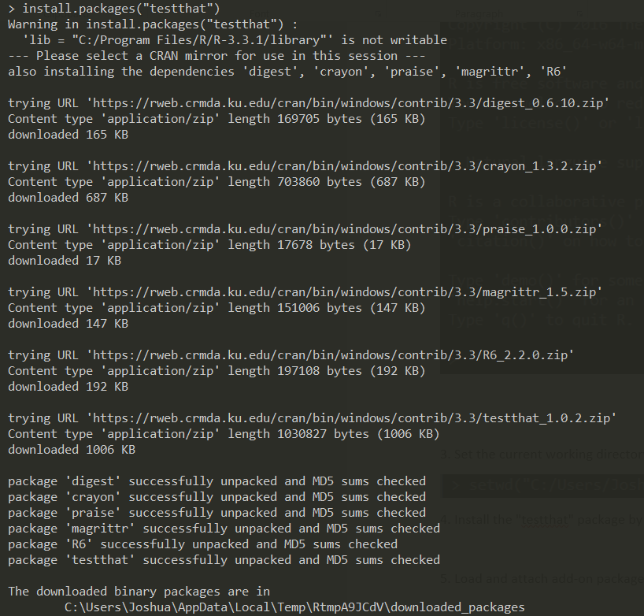

5. Load and attach add-on packages by entering library("testthat").



6. Run the tests by entering the path of the test file in test_dir("./test/data").

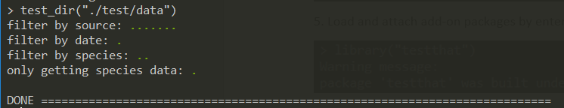

**Understanding Outputs from Test**

1. Open test Directory

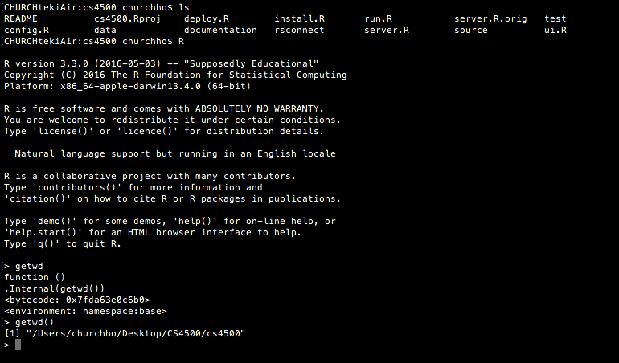

1. The first mock-test with correct input

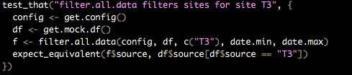

This filters all data by the 3rd testing site and only the 3rd testing site.

1. Running the first test to make sure it runs with the right input

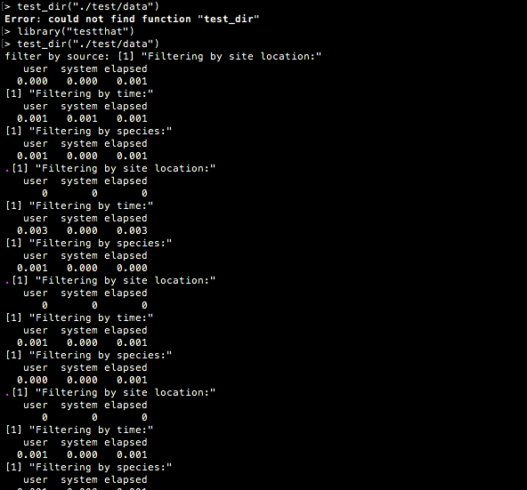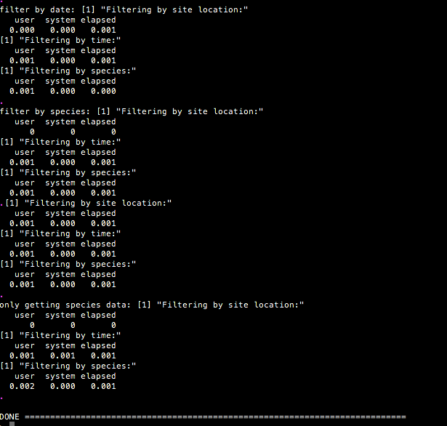

This shows that the test was ran and able to run all filtrations given the correct input in the testing site. The data being displayed to screen shows a successful completion of the test.

1. Changing the mock-data to fail making sure that it doesn’t try and work with incorrect data

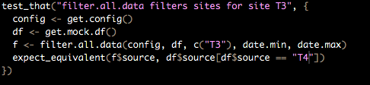

This will attempt to run the test on a 4th test site which doesn’t exist and should fail.

1. The test failing from the incorrect input

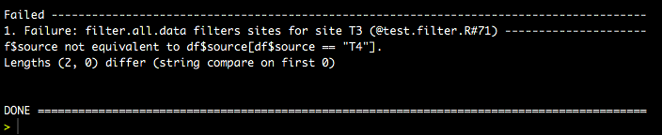

The test shows failure with the very first line reading, “Failure: filter.all.data filters sites for site T3”. Letting us know that the program isn’t trying to access or run on data sets that don’t exist.