Application of General Adversarial Networks in Smoothing Handwriting

YuMei Bennett, Edward Fry, Muchigi Kimari, Ikenna Nwaogu, and John Santerre

Master of Science in Data Science, Southern Methodist University,  
Dallas, TX 75275 USA

{ybennett, edwardf, mkimari, inwaogu, jsanterre}@smu.edu

Abstract. Dysgraphia is a mental disorder that affects fine motor skills such as writing. In this paper, recent development in neural network deep learning methods are presented in order to help smooth and style one’s handwriting. Our work focuses on Generative Adversarial Networks (GAN) and Long Short-Term Memory (LSTM) networks. To achieve this object detection modeling was used to successfully model and label letters from handwritten images. The letters are then used in the GAN modeling.

Keywords: Dysgraphia, Generative Adversarial Networks, GAN, Handwriting, Smooth Poor Handwriting, Style Transfer, Object Detection

1. Introduction

Although handwriting applications have been made available on smart phones, tablets and PC screens, these note-taking or form-filling applications generally rely on the electronic stylus to provide letter by letter stroke information. In conjunction with language dictionary, these apps were able to provide acceptable accuracy for general usage. Handwriting recognition or handwritten text recognition (HTR) is still considered a challenging problem to solve. The high variance in handwriting styles between people along with the poor quality of the handwritten text compared to printed text pose significant hurdles in converting it to machine readable text.

This project is aimed to help people with dysgraphia, a developmental deficit in the acquisition of writing skills (developmental dysgraphia), to gain confidence and encourage creative development without having to worry about showing their own handwriting at any time during interaction with others. Dysgraphia is common and could have significant consequences for those who suffer from them. Dysgraphia impacts both child and adult, and there is no cure for the disease. Dysgraphia is not life threatening, but it is something that has been misunderstood and that has received relatively little attention from researchers.

In this project, we take on the challenge not only for normal handwriting recognition but take a step further to style dysgraphia handwriting. Recent advancements in deep learning such as the advent of transformer architectures have fast-tracked our progress in cracking handwritten text recognition. Recognizing handwritten text is termed Intelligent Character Recognition (ICR) because the algorithms needed to solve ICR need much more intelligence than solving generic machine printing text recognition.

1. Literature Review

2.1 What is Dysgraphia?

Dysgraphia is a disability that affects fine motor skills like writing, buttoning a shirt, or tying a shoelace [30]. It’s a neurological disorder that can affect children or adults. People with dysgraphia tend to find it difficult to express their ideas on paper. In addition to difficulty in expressing their ideas, academic progress for children with dysgraphia can be vastly affected [25].

Below is an example of handwriting from a child with dysgraphia.

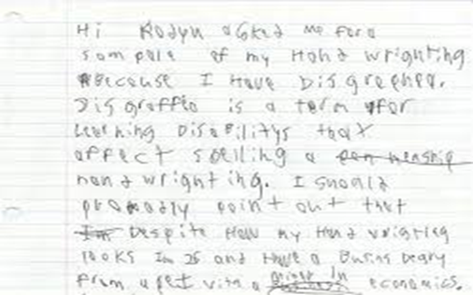

Figure 1. Dysgraphia Handwriting Example

Most children with dysgraphia are bright (and are often skilled readers and speakers) [31]; therefore, it is a dilemma of our society that in most of the cases when parents find their child confronting written impairment, they consider it as if he or she is reluctant towards studying and learning. This means that a child with dysgraphia could easily reach adulthood without receiving any diagnosis, constantly trying to self-correct, feeling frustrated, and having low self-esteem.

Since so many adults with dysgraphia remain undiagnosed, it’s difficult to estimate just how many are living with the condition. In children, the rate is often estimated between 4 to 20 percent. Since dysgraphia can’t be outgrown, many adults are still living with this learning disability [29].

2.2 Importance of Legible Handwriting

Comprehensible handwriting is important when it comes to academics. Writing plays a pivotal role in the development of any child [30]. It makes a student capable of transferring the attained knowledge, honing cognitive skills, augmenting the confidence level, and, above all, legible handwriting skills that anticipate success in the future.

If writing has been a lifelong challenge, a patient is likely to have devised strategies to compensate or to avoid writing altogether. With that in mind, symptoms of dysgraphia in adults will manifest as more than just indecipherable handwriting; they’ll also appear in the purposeful avoidance of writing and in weak fine motor skills. Symptoms of dysgraphia at home might look like [32]:

* Highly illegible handwriting, often to the point that even the patient can’t read what they wrote
* Difficulty drawing, tracing, or painting
* Avoids writing whenever possible; prefers a digital grocery list to a written one, for instance
* Makes spelling errors in simple notes
* Inappropriate sizing and spacing of letters
* Unusual body or hand position when writing
* Tight hold on pen or pencil resulting in hand cramps
* Omitting letters and words from sentences

As more jobs depend on computers, writing may not factor into someone’s day-to-day work. Dysgraphia can still cause challenges by making other fine motor tasks difficult. Symptoms of dysgraphia in the work environment may include [33]:

* Trouble filling in routine forms by hand, particularly if they require fitting words into set boxes
* Illegible handwriting: for instance, not being able to read one’s own meeting notes or coworkers complain that memos are indecipherable
* Mixes lowercase and uppercase letters, or print and cursive letters, seemingly randomly
* Often leaves out individual letters or the ends of words, particularly when writing quickly
* Has trouble telling when words are misspelled
* Often uses grammatically incorrect sentences in emails or reports
* May be overly reliant on simple sentence structures
* Prefers to give or get directions orally instead of in writing
* Has trouble “getting to the point” in written communication; emails may be rambling, or reports may repeat the same ideas several times
* Able to explain self clearly when speaking but not when writing

People with dysgraphia often struggle to multitask when writing. Their difficulty in physically writing down each word can lead to missed parts of what is said during meetings or lectures.

Students with dysgraphia may also be accused of being careless because their handwriting isn’t legible. This can affect self-esteem and lead to anxiety, a lack of confidence, and negative attitudes toward school.

2.3 What causes dysgraphia?

In childhood, dysgraphia is usually the result of a problem with orthographic coding [29]. Orthographic coding is an aspect of working memory that allows you to permanently remember written words and the way your hands or fingers must move to write those words.

Researchers are still learning the reasons why some children have learning disabilities, such as dysgraphia. Learning disabilities can be hereditary or can be related to abnormal prenatal development [31].

2.4 Does keyboarding solve all the problems?

Keyboarding does help children to express their ideas at the level of their intellect, and it should be encouraged; however, handwriting should not be ignored completely for several reasons [33]:

* There are times when handwriting is needed, e.g. for certain school subjects (such as math and science) and in other everyday circumstances.
* There is some evidence that the physical act of handwriting helps the flow of ideas for written composition in ways which keyboarding doesn’t.
* Handwriting is very personal. It is an expression of a person’s identity. In adolescence it is common to find young people adopting a style of handwriting to suit their personal image.

2.5 Treatment for Dysgraphia

There is no cure for dysgraphia. Occupational therapy may be helpful in improving handwriting skills. Therapeutic activities may include:

* Holding a pencil or pen in a new way to make writing easier
* Working with modeling clay
* Tracing letters in shaving cream on a desk
* Drawing lines within mazes
* Doing connect-the-dots puzzles

There are not many studies about dysgraphia, so the prevalence of this writing disability is not known; however, it is estimated that between 5-20% of the population has a varied degree of dysgraphia. Since people with dysgraphia are intelligent and high functioning, many misunderstand their disorder as a quirk rather than a problem. Dysgraphia is real and can have a significant negative impact.

However, recent developments in machine learning may present a solution. In this paper, we explore using new algorithms, such as Generative Adversarial Networks, that may be able to take unreadable handwriting and present it in a realistic handwritten text. First, sample handwriting is used to train the models of interest. Then, we analyze the results of that training on new samples. The results section describes our models and methods in greater detail. Ethical considerations of changing handwriting are then discussed, followed by conclusions and recommendations for follow-up work.

2.6 History of Deep Learning and Neuron Networks

While not commonly known today, deep learning has been around since the 1940s [34].

A broader look at the history of Deep Learning reveals 3 major waves of advancements:

* Cybernetics — During 1940–1960
* Connectionism — During 1980–1990
* Deep Learning — Since 2006

Cybernetics was kicked off by the development of the McCulloch-Pitts Neuron. It was an attempt to mimic the biological neuron. It was based on a linear model that would take various inputs [X1, X2 …. Xn], for each input the model had some weights [W1, W2 … Wn] and the output f(x,w) = X1W1 + X2W2 + …. + XnWn. This model could only output True/False based on the inputs and weights.

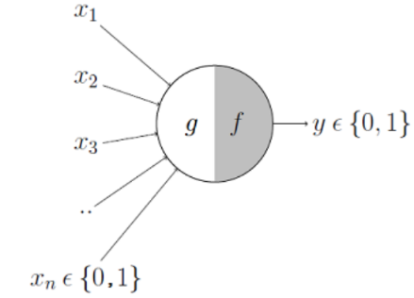

Figure-2 McCulloch-Pitts Model

The weights in McCulloch’s model need to be set manually. Later, in the 1950s, the Perceptron was developed by Frank Rosenblatt, an American psychologist, that would learn the weights automatically. Another model was developed by Bernard Widrow around the same time and could also adapt to the weights based on the weighted sum of the inputs during the learning phase.

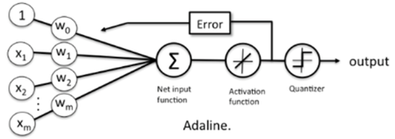

Figure-3 Adaline Model

The learning function from the Adaline model is like Stochastic Gradient Descent (SGD), which is used in Linear Regression (LR) today [34].

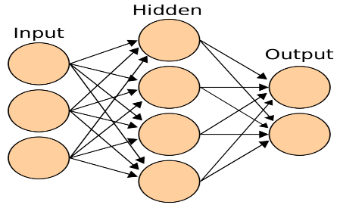

Figure-4 Artificial Neural Networks

Connectionism, also known as Parallel Distributed Processing, become popular in the 1980s, and this approach was inspired by cognitive sciences. The concept of Artificial Neural Network (ANNs) was introduced during this wave. The main idea behind ANNs was to develop a network of individual units that can be programmed to achieve intelligent behavior. This was the first time the concept of hidden layers was introduced [34].

This approach is very similar to how the human nervous system works. During the wave of Connectionism, many models, like LSTM, Distributed Representation and Processing, and Back Propagation to train deep neural nets, were developed and continue to remain key components of various advanced applications of Deep Learning to this date.

But, during the 90s, hype about artificial intelligence was unrealistic. This, combined with a lack of computational resources for sophisticated models, caused investors to pull back, and this led to a second period of deep learning dip.

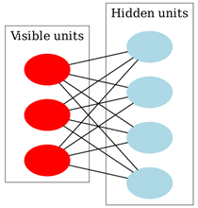

Figure-5 Deep Belief Network

In 2006, a breakthrough was made by Geoffrey Hinton’s Greedy Layer-wise Training to train Deep Belief Networks. In the simplest of forms the DBN’s are a composition of multiple hidden layers with each layer containing various latent variables. Connections exist between layers but not between the variables inside each layer [34].

The advancements by Geoffrey Hinton were used by other researchers to train different types of Deep Networks. This enabled researchers around the world to train deeper and deeper neural networks and led to the popularization of the term Deep Learning.

Significant advancement in computer chipsets has also fueled the recent artificial intelligence development. Some algorithms developed in the past started to give better results when trained on larger and larger datasets. The better results attracted more researchers to look for better and more efficient models.

2.7 Convolutional Neural Network

A CNN uses a system much like a multilayer perceptron that has been designed for reduced processing requirements. The layers of a CNN consist of an input layer, an output layer and hidden layer that includes multiple convolutional layers, pooling layers, fully connected layers, and normalization layers. The layers of neurons are arranged in such a way as to cover the entire visual field, thus avoiding the piecemeal image processing problem of traditional neural networks [15].

Images typically have multiple channels (for example, Red-Green-Blue channels). It is possible to modify the traditional CNN architecture to work with multiple channel inputs. This removes limitations and increases the efficiency for image processing, resulting in a system that is far more effective and simpler to train for image and natural language processing.

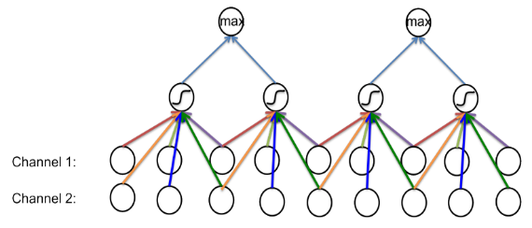

Figure-6 Image with Two Channels CNN

2.8 Recurrent Neural Network

Recurrent neural networks (RNN) are a class of neural networks that allow previous outputs to be used as inputs while having hidden states. RNNs are a rich class of dynamic models that have been used to generate sequences in domains as diverse as music, text, and motion capture data. RNNs can be trained for sequence generation by processing real data sequences one step at a time and predicting what comes next [14].

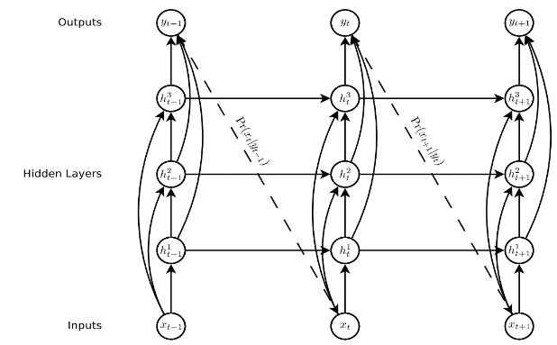

Figure-7 Deep Recurrent Neural Network [14]

2.9 Neural Style Transfer

This is an optimization technique used to copy the style from the style image and apply it to the content image [26]. “Style” is an indication of the patterns, the brushstrokes, and so on of handwriting. Neural style transfer takes three images: a content image, a style reference image, and an input image to be styled and then blended together such that the input image is transformed to look like the content image but “painted” in the style of the style image.

The principle of neural style transfer is to define two distance functions, one that describes how different the content of two images are and one that describes the difference between the two images in terms of their style. Then, given three images, a desired style image, a desired content image, and the input image (initialized with the content image), the input image is transformed to minimize the content distance with the content image and its style distance with the style image.

A 2016 paper by Johnson et al. was the first to train an independent neural network to stylize images in a single, feed-forward pass. Large VGG16 models pre-trained on ImageNet are used for feature extractors, and a relatively small encoder-decoder network serves as the transfer network. In this approach, a single transfer network is trained for each desired style.

In 2017, a year after the original fast style transfer technique was published, researchers at Google extended the technique to allow a single transfer network to produce images in multiple styles and even blend more than one style together [36]. Their main contribution was the inclusion of “conditional instance normalization” layers within the network so that the stylized image produced could be conditioned on an additional model input.

2.10 Generative Adversarial Networks

This is a Neural Network used for unsupervised machine learning. Developed by Ian Goodfellow in 2014, GANs can be simplified into two parts, the generator and the discriminator. The main idea is that the generator creates fake data, and the discriminator validates to see if its real or fake. The goal for the generator is to fool the discriminator [3]. Since GANs are typically used in processing many images, it can be applied to improving bad handwriting.

In a paper published by Shengyu Zhao et al. [2], Differentiable Augmentation (DiffAugment) is proposed to further enhance traditional GAN, a simple method that improves the data efficiency of GANs by imposing various types of differentiable augmentations on both real and fake samples. DiffAugment enables model to adopt the differentiable augmentation for the generated samples, effectively stabilizes training, and leads to better convergence. Experiments demonstrate consistent gains over a variety of GAN architectures and loss functions for both unconditional and class-conditional generation.

GAN is a relatively new deep learning methodology, and multiple adversarial loss functions for training either generative or discriminative models exist. Yet it remains unclear what certain types of functions are valid adversarial losses and how these loss functions perform against one another. A paper by Yi-Hsuan Yang etc. in May 2020 [8] proposes a deeper understanding of adversarial losses by decoupling the effects of their component functions and regularization terms. A simple comparative framework, dubbed DANTest, is used to systematically compare different adversarial losses.

2.11 Discriminative Adversarial Networks (DANs).

This project seeks to produce a handwriting smoother that can be used by two audiences. The first type of audience would be normal (non-data scientist) people, who would simply scan a sample of their handwriting into an application and have smoothed results returned. The second audience would be the machine learning community, who would have access to the project code (open source with an MIT license) and to a full software package that can be imported and used in code.

To meet these goals, the smoother will need to be a trained machine learning model, so the next step is to evaluate possible candidates through the literature research and expert guidance. Five potential machine learning options emerge: Generative Adversarial Networks (GAN), Neural Style Transfer (ST), Auto-encoders, Singular Value Decomposition (SVD), and Recurrent Neural Networks (RNNs). Of these, Generative Adversarial Networks and Style Transfer seem to show the most promise, so the project begins its focus on those two.

Deﬁning and extracting handwriting styles alone is a challenging problem since there are no formal deﬁnitions for these styles. Smoothing dysgraphia handwriting and extracting a style is a new area of research.

1. Methods

3.1 Data Sources

In the interest of proper scale for a project of this size, the scope has a few limitations. First, only black and white training images are used. Second, only printed characters are supported. Finally, the character set is limited to upper- and lower-case English letters and numeric digits.

A total of 8 sources for the data were considered.

1. *UCI Letter Recognition Data Set* [17] – This repository is maintained by the University of California at Irvine and includes about 20000 capital letters in 20 different fonts.
2. *The Chars74K dataset* [18] – This collection of data includes about 74000 letters and numbers, but only 3410 of them are handwritten.
3. *EMNIST Dataset* [19] – These handwritten characters have been converted to the same 28x28 structure as the famous MNIST dataset. It includes 145,600 letters and 280,000 digits.
4. *MNIST DATABASE of handwritten digits* [20] – This famous dataset includes 70,000 handwritten numeric digits in 28x28 format.
5. *CVL-DATABASE* [21] – 310 writers wrote 7 texts out by hand in cursive script in this dataset.
6. *IAM Handwriting Top50* [22] – This collection of handwritten passages is broken out by sentences, lines of text, and individual words. It is mostly written in cursive.
7. *Yu Qiao* – This site is a collection of links to various handwriting samples and resources.
8. *Novel dataset creation* – In the event that no existing datasets contain the quality, type, or number of samples needed, a new dataset can be commissioned using a service such as Mechanical Turk.
9. *IAM Online Handwriting Database* [37] – Whereas most of the data sources that we examined were raster images, this data source is a time series of {x,y} data points captured as participants wrote on a digital whiteboard.

The most promising datasets initially were *EMNIST*, *MNIST*, and *UCI* since they meet the requirements of individual printed numbers and letters in black and white. These are the data sources used in the construction of the training models.

However, after careful additional study of [14] and [37], it became clear that the advantages of a coordinate-based dataset were significant. The distance between points as given by their capture time gives a very good sense of the stroke. With stroke information, any kind of stroke – printing, cursive, letter-spaces, etc. – could be used, which expands the original proposed capability of the system. In addition, any improvements to the stroke would intrinsically retain the original character of the handwriting. Because of these clear benefits, the online data is explored much further in this study.

3.2 Tools and Utilities

Python will be used for this project. It is widely regarded as a suitable and standard programming language for machine learning and data science. Python is preferred because it supports object-oriented, and it has a wide variety of packages for cleaning data and machine learning. In addition, PyTorch has similar syntax to NumPy. The only difference is an option to use Graphic Processing Units (GPUs) [28]. The use of GPUs in PyTorch speeds the training of deep learning models.

Images by their very nature often have a lot of features since the individual pixels are typically used, so even a 28x28 image would have at least 784 features. Because of this, algorithm performance becomes a concern. To address this, we need to implement a distributed Python computing platform using Dask [27]. This platform automatically splits data and computation amongst a potentially unlimited number of computing nodes known as clusters. Thus, additional computers can be added to the cluster at any time to increase the speed of processing.

In addition, Dask supports the use of graphical processing units (GPUs), which are highly optimized for the sorts of linear algebra operations that most machine learning algorithms employ, thus adding both a greater quantity and a more performant set of computation resources to the execution of these machine learning algorithms.

Having dysgraphia does not affect someone's mental capabilities; they just need extra help in handwriting skills. Consequently, the solution to challenges with having dysgraphia can be solved by Generative Adversarial Networks. GANs will be able to take bad handwriting from a document and present it in a better realistic handwritten text. Solving this problem will help people with dysgraphia focus more on expressing their ideas rather than how to write.

3.3 Approach

Initial requirements for the system were obtained through interviews with Dr John Santerre. The final product is to be a command-line utility that takes as its input a data representation of human handwriting and gives as its output a smoothed version of that handwriting in the same data format as the input. The application should also graphically display the original handwriting and its smoothed output.

Several promising techniques were explored. Style transfer, while not an algorithm per se, is ultimately the goal of the project, and the other algorithms were chosen for their potential to transfer writing styles. Generative Adversarial Network (GANs) were promising from their ability find a desired output from initial random noise. Singular value decomposition (SVD) was considered due to its many applications in image processing, and recurrent neural networks (RNNs) have been examined in other contexts for handwriting recognition.

Ultimately, the method described in [14] utilized a long short-term memory network (LSTM), and that is the direction these efforts eventually followed. The data was the online dataset from [37].

For computation, Dask was used to add parallelism to the processing, and the Southern Methodist University Maneframe II was leveraged for its high-performance compute nodes, graphic processing units (GPUs), and parallel processing capability.

3.4 Data Preparation

Data preparation involves taking the files with different handwriting and converting them to arrays. This is done using openCV package.

The openCV transforms the image from 3D color array representation to a 2D array format, which is the data representation a of grey scale image, but the models used will be expecting the image in 3D array. Therefore, each image will have to be added an additional dimensional for the greyscale channel when it is ready to be used for modeling. This can be done using the cvtColor function in the openCV package.

3.5 Model Training

There are 2 main parts to successfully train a handwriting. The first part is object detection. Since this project involves individually classifying each letter, model or application must be built to detect each letter. So, it involves first taking a handwriting image and breaking it down to letters. This can also be done using the openCV package. The application and or model should identify where each line of the handwriting starts and then detect the objects within the line. The line would be a specific size which would contain all the pixels involved in the line where the letters and words are. Both methods were used in this case and performance of both were measured. After separating the letters, each letter will have to be normalized from [0,255] to [0 to 1].

The second part is applying GAN algorithm to train the individual letter detected from the object detection model. Due to time constraints, the GAN model hasn’t been applied yet.

For the online dataset, the code from [14] was first rewritten in Python to validate that the approach in that paper was sound and could be adapted to this project. Then, the code was extended to allow for easy adjustments of the biases, which ultimately determines how much smoothing is applied to the incoming handwriting sample.

3.6 Application

The final product is a command line application written in Python. The application is meant for two audiences. For the layman who wants to smooth their handwriting, the program will take a sample of their handwriting as an input along with the preferred model to use from amongst the supported models. Smoothed handwriting will be output.

The second audience of technical professionals can specify training data and one or more models to be trained. The application will train the model(s) and output the computed error of the training.

The application is written in such a way that it can be executed as a Python script from the command line, as a standalone module, or as an imported Python module used as part of another program.

The main part of the program processes the command line arguments and controls the trainers. Each trainer implements a programming interface that lets them be executed polymorphically by the controller. This allows for a common reporting of test results and training of the models.

4 Results

The metrics used for measuring the object detection are Precision and Recall. Accuracy wasn’t used because it can be very misleading since it doesn’t deal well with imbalanced data. To be able to apply any of these performance metrics, the measure of the correctness of each detection needs to be established. For any given detection, a bounding box or a circle is placed on the object. The metric that measures the correctness of a giving bounding box or circle is called IoU which is the Intersection over Union. This is the ratio between the intersection and the union of the predicted box or circle and the grounding truth box. Grounding truth box or circle is the correct box representation that would cover each letter. 20 labeled image files from the data sample were used to measure the performance of each of the detection application used and the mean Precision and mean Recall were recorded. Both the openCV application and the pretrained model used had a mean precision of 0.9 and 0.85 respectively and a mean recall of 0.8 and 0.76 respectively. Even though that the pretrained model performed better, both applications were able to detect and separate the letters well because whether the letter detected is fully in the designated box or not, it was able to extract part of the data that would be used for modeling and prediction using the GAN model.

Implementation of simple GAN and DCGAN (Deep Convolutional GAN) yielded similar outcome. Both models were successful in learning and making predictions from the MNIST data set. Figure-8 below illustrates the simple GAN progression from starting point to end point. The model was configured to use 50 epochs and 100 batches. Figure-9 below shows the DCGAN model learning progression also illustrating from start to finish. The model was configured to use a batch size of 128 and epoch of 5.

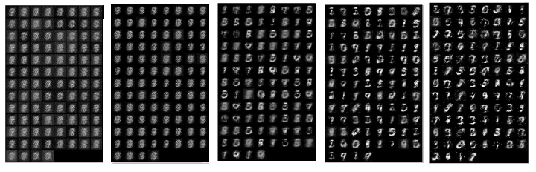Figure-8 Learning Progression for the simple GAN

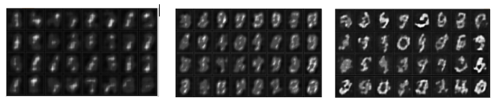Figure-9 Learning Progression for the Deep Convolutional GAN

5 Discussion

As explained in the introduction, dysgraphia is a learning disability which strictly affects the ability to write properly. This project seeks to provide a better way to help people with this condition to communicate when writing. In this project, an application will take an image input of a handwriting sample, and the application will replace the writing with smoother writing that is similar to the original input’s handwriting style.

Two different approaches are promising. The first is Generative Adversarial Networks (GANs), which is a generative deep learning neural network model that generates realistic new samples of the input. The second is the use of autoencoders, which are also generative deep learning models that would, instead of generating new samples, just reconstruct the input. GAN will be explored more because its unique functionality seems well-tailored to a smoothing problem. would make a better prediction model than the autoencoders. A GAN model has 2 main components: the generator and the discriminator. A discriminator is a classifier that tries to classify if a data is a real data or if the data was created by the generator. The generator learns to create a fake data and gets feedback from the discriminator.

Evaluating the two GAN models, the simple GAN and the DCGAN, shows that even though the DCGAN model is more advanced model than the simple GAN model, the DCGAN model still performed similarly to when comparing then visually. Model configurations is very significant to how both models worked. Because of the run time of DCGAN models, the configuration assign to it was less impactful because it would have taken a longer time to run. The next step in the project is to tune the DCGAN better and see if it would generate better results. Another promising approach would be an introduction of another type of GAN model called cycleGAN. CycleGAN is more advanced than the two previous GAN models. With a good parameter tuning for DCGAN and cycleGAN would likely generate a better result as the project progresses.

Unfortunately, there no objective/loss functions used in training a GAN model. This means that there are no ways of checking the progress or efficiency of the model using a traditional loss function. Therefore, models will be evaluated by manually inspecting the generated image or using quantitative measures like inception score and boundary distortion. The evaluation process is replicated in other evaluated models in order to validate results evenly. Other options may be available to evaluate GANs, and this project explores the best options for both smoothing and for evaluation.

Another promising and obvious next step of research would be to convert raster bitmap representations of handwriting into an online form that could then benefit from the LTSM smoothing explored here. A possible approach would be to use a GAN within the LTSM. The discriminator of such a GAN would minimize the error between the original bitmap and a bitmapped conversation of online coordinates. This could be a beneficial area of research all by itself, perhaps eventually leading to a way to capture an artist’s stroke information in artworks, for example.

At the conclusion of this project, the application will be released as open source so that anyone that needs it would be able to have access to it. Finally, since the core goal of the project is to assist with a disability, there does not seem to be any negative impact to ethics.

6 Conclusion

Due to the impacts of dysgraphia on children and adults, this application is meant to help people who suffer from this condition to communicate better. The application would create handwriting that is more consistent and easier to read from an original image of a person’s handwriting. The application will not only help people with dysgraphia but also hopefully promote additional research into this area with the planned Python package to drive improvement in the years ahead.

Acknowledgments. Jacquelyn Cheun, PhD. – Capstone Professor

References

1. Renzhuo Wan, Shuping Mei, Jun Wang, Min Liu and Fan Yang. Multivariate Temporal Convolutional Network: A Deep Neural Networks Approach for Multivariate Time Series Forecasting. Electronics 2019, 8(8), 876; https://doi.org/10.3390/electronics8080876
2. Shengyu Zhao IIIS, Tsinghua University and MIT Zhijian Liu MIT Ji Lin MIT Jun-Yan Zhu Adobe Research Song Han MIT. Differentiable Augmentation for Data-Efficient GAN Training. https://arxiv.org/pdf/2006.10738.pdf
3. Martin Heusel, Hubert Ramsauer, Thomas Unterthiner, Bernhard Nessler and Sepp Hochreiter. GANs Trained by a Two Time-Scale Update Rule Converge to a Local Nash Equilibrium. https://arxiv.org/pdf/1706.08500.pdf
4. Phillip Isola Jun-Yan Zhu Tinghui Zhou Alexei A. Efros. Berkeley AI Research (BAIR) Laboratory, UC Berkeley. Image-to-Image Translation with Conditional Adversarial Networks. https://arxiv.org/pdf/1611.070f04.pd
5. Andrew Brock Heriot Watt University, Jeff Donahue DeepMind, Karen Simonyan DeepMind. Large Scale Gan Training For High Fidelity Natural Image Synthesis. https://arxiv.org/pdf/1809.11096.pdf
6. Yasin Yazıcı Nanyang Technological University (NTU), Chuan-Sheng Foo Institute for Infocomm Research, Stefan Winkler National University of Singapore (NUS), Kim-Hui Yap Nanyang Technological University (NTU), Georgios Piliouras Singapore University of Technology and Design, Vijay Chandrasekhar Institute for Infocomm Research. Unusual Effectiveness Of Averaging In Gan Training. https://arxiv.org/pdf/1806.04498.pdf
7. Han Zhang, Zizhao Zhang, Augustus Odena, Honglak Lee Google Research. Consistency Regularization For Generative Adversarial Networks. https://arxiv.org/pdf/1910.12027.pdf
8. Hao-Wen Dong · Yi-Hsuan Yang. May 2020. Towards a Deeper Understanding of Adversarial Losses under a Discriminative Adversarial Network Setting. https://arxiv.org/pdf/1901.08753.pdf
9. David Ha, Douglas Eck. A Neural Representation of Sketch Drawings. https://arxiv.org/abs/1704.03477
10. Adrian Rosebrock on August 24, 2020. Handwriting recognition with OpenCV, Keras, and TensorFlow. https://www.pyimagesearch.com/2020/08/24/ocr-handwriting-recognition-with-opencv-keras-and-tensorflow/
11. Omar Mohammed, Gerard Bailly, Damien Pellier, Univ. Grenoble-Alpes. Style Transfer and Extraction for the Handwritten Letters Using Deep Learning. https://arxiv.org/pdf/1812.07103.pdf
12. Bo Chang∗ Qiong Zhang∗ Shenyi Pan Lili Meng, University of British Columbia. Generating Handwritten Chinese Characters using CycleGAN. https://arxiv.org/pdf/1801.08624.pdf
13. Bharath Narasimhan University of Massachusetts Amherst. Calligraphy Style Transfer using Generative Adversarial Networks. https://people.cs.umass.edu/~bnarasimhan/Cast.pdf
14. Alex Graves Department of Computer Science University of Toronto. Generating Sequences with Recurrent Neural Networks. https://arxiv.org/pdf/1308.0850)
15. Quoc V. Le Google Brain, Google Inc. A Tutorial on Deep Learning Part 2: Autoencoders, Convolutional Neural Networks and Recurrent Neural Networks. Oct 2015.
16. Piotr Teterwak Aaron Sarna Dilip Krishnan Aaron Maschinot David Belanger, Ce Liu, William T. Freeman Google Research. Boundless: Generative Adversarial Networks for Image Extension. https://arxiv.org/pdf/1908.07007.pdf
17. Dua, D. and Graff, C. (2019). UCI Machine Learning Repository [http://archive.ics.uci.edu/ml]. Irvine, CA: University of California, School of Information and Computer Science.
18. De Campos, T.E., Babu, B.R. and Varma, M. (2009). The Chars74K dataset: Character Recognition in Natural Images [http://www.ee.surrey.ac.uk/CVSSP/demos/chars74k/]. Microsoft India
19. Cohen, G., Afshar, S., Tapson, J., & van Schaik, A. (2017). EMNIST: an extension of MNIST to handwritten letters. Retrieved from http://arxiv.org/abs/1702.05373
20. Y. LeCun, L. Bottou, Y. Bengio, and P. Haffner. "Gradient-based learning applied to document recognition." Proceedings of the IEEE, 86(11):2278-2324, November 1998.
21. Florian Kleber, Stefan Fiel, Markus Diem and Robert Sablatnig, CVL-Database: An Off-line Database for Writer Retrieval, Writer Identification and Word Spotting, In Proc. of the 12th Int. Conference on Document Analysis and Recognition (ICDAR) 2013, pp. 560-564, 2013.
22. U. Marti and H. Bunke. The IAM-database: An English Sentence Database for Off-line Handwriting Recognition. Int. Journal on Document Analysis and Recognition, Volume 5, pages 39 - 46, 2002.
23. Edgard Chammas and Chafic Mokel. Handwriting Recognition of Historical Documents with few labeled data. Nov 2018. March 2019. https://arxiv.org/pdf/1811.07768.pdf
24. Eloi Alonso, Ecole des Ponts and Bastien Moysset. Adversarial Generation of Handwritten Text Images Conditioned on Sequences. Nov 2018. https://arxiv.org/pdf/1903.00277.pdf
25. Biotteau, Maëlle et al. “Developmental Coordination Disorder and dysgraphia: Signs and Symptoms, Diagnosis, and Rehabilitation.” Neuropsychiatric disease and treatment 15 (2019): 1873–1885. Web.
26. Y.-L. Chen and C.-T. Hsu. Towards deep style transfer: A content-aware perspective. In Proceedings of the British Machine Vision Conference, 2016.
27. Matei Zaharia, Mosharaf Chowdhury, Michael J. Franklin, Scott Shenker, Ion Stoica. Spark: Cluster Computing with Working Sets. Amplab, University of California at Berkely, 2010.
28. Adam Paszke, Sam Gross, Francisco Massa, Adam Lerer, James Bradbury, Gregory Chanan, Trevor Killeen, Zeming Lin, Natalia Gimelshein, Luca Antiga, Alban Desmaison, Andreas Köpf, Edward Yang, Zach DeVito, Martin Raison, Alykhan Tejani, Sasank Chilamkurthy, Benoit Steiner, Lu Fang, Junjie Bai, Soumith Chintala. PyTorch: An Imperative Style, High-Performance Deep Learning Library. 33rd Conference on Neural Information Processing Systems, NeurIPS, 2019.
29. Michael McCloskey and Brenda Rapp. Developmental dysgraphia: An Overview and Framework for Research. US National Library of Medicine, National Institutes of Health Search database PMC 2018. https://www.ncbi.nlm.nih.gov/pmc/articles/PMC6238209/
30. Ileana Felipe Santos. Importance of Legible Handwriting. Ecademia.edu 2020
31. Akinmosin, Kemi Adejoke. The Effect of Poor Handwriting on the Academic Performance of the Gifted Learning-Disabled Students. Department of Education for the Gifted and TalentedSchool of Special Education Federal College of Education (Special), Oyo. 2018
32. James Roland on December 7, 2018. What Is dysgraphia? https://www.healthline.com/health/what-is-dysgraphia
33. What Does dysgraphia Look Like in Adults? https://www.additudemag.com/dysgraphia-in-adults-recognizing-symptoms-later-in-life
34. Varun Bansal. The Evolution of Deep Learning. Towards Data Science April 2020. https://towardsdatascience.com/the-deep-history-of-deep-learning-3bebeb810fb2.
35. Justin Johnson, Alexandre Alahi, and Li Fei-Fei. Perceptual Losses for Real-Time Style Transfer and Super-Resolution. Stanford University 2016
36. Vincent Dumoulin, Jonathon Shlens, Manjunath Kudlur. A Learned Representation for Artistic Style. Cornell University Feb 2017. https://arxiv.org/abs/1610.07629
37. Liwicki, M. and Bunke, H.: IAM-OnDB - an On-Line English Sentence Database Acquired from Handwritten Text on a Whiteboard. 8th Intl. Conf. on Document Analysis and Recognition, 2005, Volume 2, pp. 956 – 961. https://fki.tic.heia-fr.ch/databases

Appendix

Leave here if needed for additional information.