Unit 4 HW

Ikenna Nwaogu

02/01/2020

## HW Instructions

The weekly HW assignments are designed to accomplish 2 goals for the MSDS student. The first is to provide a series of conceptual and analtical questions so the student can get a feel for their current understanding of the unit. The second goal is to introduce the students to standard functions and routines in R that effectively do the same things that the “Procs” do in SAS.

R and SAS are both wonderful tools and as we go through the assignments, students will begin to recognize very quickly that they both have pros and cons.

The formatting of the HW is as follows:  
1. A series of high level questions will be asked with either short answers or simple multiple choice responses.  
2. Analytical questions will be provided but a short vignette example of how R functions work for a given topic or method will be given. The student will then be asked a follow up question or two based on the output provided.  
3. Thirdly, a new data set will be given to allow the student to gain some experience with a new data set from start to finish.

Solutions to the HW will be provided a day or two after the HW is submitted. It is up to the student to “shore up” any confusion or missunderstanding of a topic. Grading will be based on a combination of correctness, completion, and overall conciseness.

The student may provide there answers in a seperate word document. Just make sure that it is easy to follow and that all questions have been addressed for the grader. You are welcome to use R markdown, but it is not required.

## Time Series Conceptual questions

1. State the necessary requirements for a time series to be stationary.

Mean, variance, autocorrelation should be constant over time.

1. TRUE or FALSE? If a time series model includes an explanatory variable such as time itself or some other predictor, then the original time series of the response is not stationary.

True

1. What is the major draw back of having serially correlated observations.

It affects the efficiency of ordinary least square values which may lead to reject of a null hypothesis when it should not be rejected.

1. What is the major advantage of having serially correlated observations.

If dataset is serially correlated, then it would be easier to make predictions with it.

1. What is the purpose of the Durbin Watson test?

Durbin Watson test is used to test for autocorrelation in residuals.

## Exercise #1 Simulating time series data to help with ACF and PACF diagnostics.

The most common issue that students have with time series is reading/interpreting the ACF and PACF diagnostic plots and using the rules of thumb to help identify what correlation structures should be used. The following scripts are going to provide you with simulated data sets in which we know how the correlation structure truly is (AR(1), AR(2), …etc.). We will then look at the diagnostics and general graphics to see how things can change depending on sample size and just repeated sampling.

The following codes provide simulations of various time series models discussed in class lets examine the AR(1) model first to get familiar with some of the R syntax.

The following code provides a stationary AR(1) model with a lag 1 autocorrelation of 0.8. To help visualize the diagnostics more cleanly, I have simulated 10,000 observations. There are three plots. The first is time series itself which is hard to make anything form it since there are so many data points. The remaining two are the ACF and PACT respectively.

*AR1 Behavior*

AR1<-arima.sim(list(ar=c(0.8)),10000) #AR1 is just a vector of values. They will be centered around 0 unless we add a shift or include some other source of variation like a predictor.  
par(mfrow=c(1,3))  
plot(1:10000,AR1,type="l")  
acf(AR1,main="ACF")  
pacf(AR1,main="PACF")

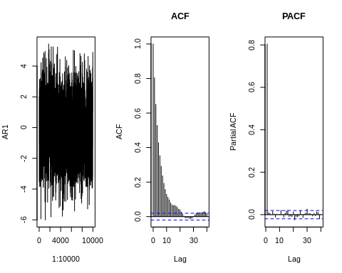

**HOMEWORK QUESTION**

1. Verify using the rules of thumb table provided in live session, that the simulated data does in fact exhibit the same behaviors in the ACF and PACF plots that an AR(1) model would have. Verify also that the lag1 autocorrelation value is roughly 0.8 as expected.

There is only 1 significant value which is the previous data point shown in the PCAF which suggests that the AR(1) model should be used. Also, ACF plot has many significant values that would make the MA model complex.

1. Repeat the previous code but only simulate a data set that has 50 observations rather than 10,000. Generate the 3 plots that were generated before. Repeat this process 2 more times, each one having only 50 observations. The point of this exercise is to recognize in smaller data sets, the ACF and PACF plots are not perfect and gives the student some experience on the variation of the plots from data set to set (like examining qqplots for residual assumption checking in regression or anova).

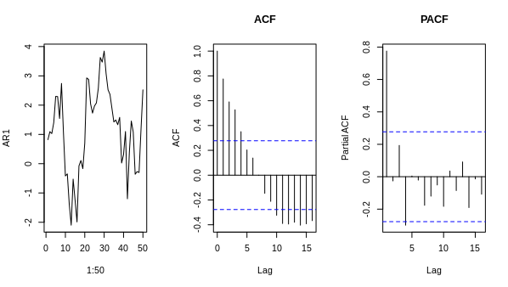

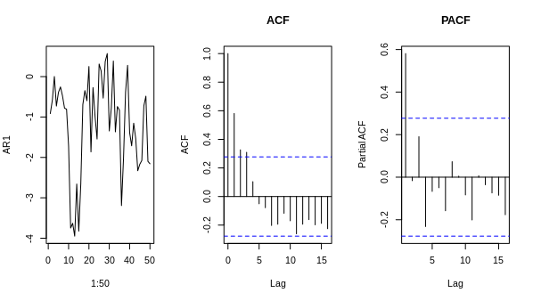

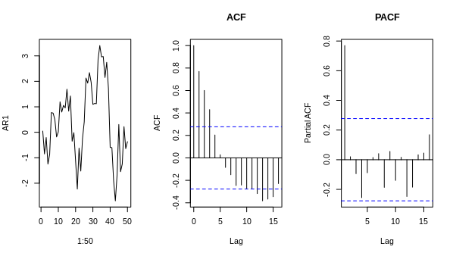

1. If the lag 1 autocorrelation of a AR(1) model is set to 0, then there is no serial correlation present in the data. This is what we would like to see when we actually fit a time series model to the data, the resulting residuals from that model should behave uncorrelated (aka “white noise”). Simulate this scenario using the above code and provide the ACF and PACF plots. This is what time series data (or residuals from a time series model) looks like when no serial correlation is present.

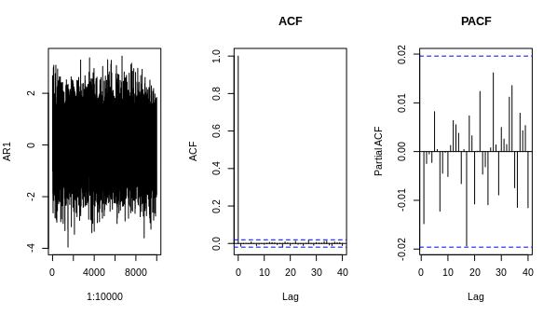There are no significance in the PACF model but only one for ACF. MA would be used in this case.

**Homework Questions**

1. For each of the following scenarios, run the script and provide the 3 graphics. Verify that the ACF and PACF plots match the rules of thumb description for there specific scenario.

*AR2 Behavior*

rho1<-.8  
rho2<-.6  
a1<-(rho1*(1-rho2)/(1-rho1^2))  
a2<-(rho2-rho1^2)/(1-rho1^2)  
AR2<-arima.sim(list(ar=c(a1,a2)),10000)  
par(mfrow=c(1,3))  
plot(1:10000,AR2,type="l")  
acf(AR2)  
pacf(AR2,main="PACF")

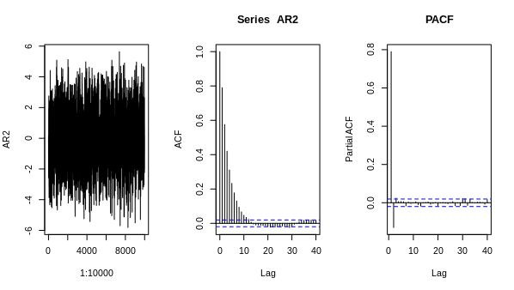As we can see in the above PACF plot, there are 2 significant values which are the 2 previous data points. Also, ACF plot has many significant values that would make the MA model complex.

*AR3 Behavior*

a1<-1.5  
a2<--1.21  
a3<-.46  
AR3<-arima.sim(list(ar=c(a1,a2,a3)),10000)  
par(mfrow=c(1,3))  
plot(1:10000,AR3,type="l")  
acf(AR3,main="ACF")  
pacf(AR3,main="PACF")

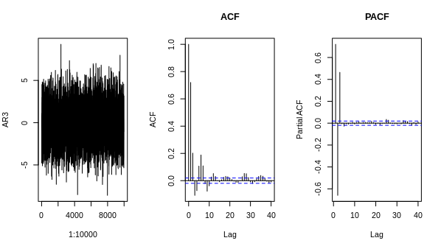

Similar to the previous r code simulation, the PACF plot shows 3 significant values that are above the threshold. Also, ACF plot has many significant values that would make the MA model complex.

*ARMA(3,2) Behavior*

a1<-1.5  
a2<--1.21  
a3<-.46  
b1<--.2  
b2<--.9  
ARMA32<-arima.sim(list(ar=c(a1,a2,a3),ma=c(b1,b2)),10000)  
par(mfrow=c(1,3))  
plot(1:10000,ARMA32,type="l")  
acf(ARMA32,main="ACF")  
pacf(ARMA32,main="PACF")

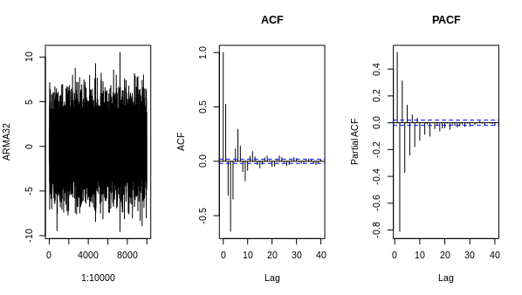As you can see above both have significant values for the ACF as well as PACF so ARMA model can be used as a better model instead of using complex AR or MA model.

*Moving Average MA(2) Behavior*

b1<- .2  
b2<- .9  
MA2<-arima.sim(list(ma=c(b1,b2)),10000)  
par(mfrow=c(1,3))  
plot(1:10000,MA2,type="l")  
acf(MA2,main="ACF")  
pacf(MA2,main="PACF")

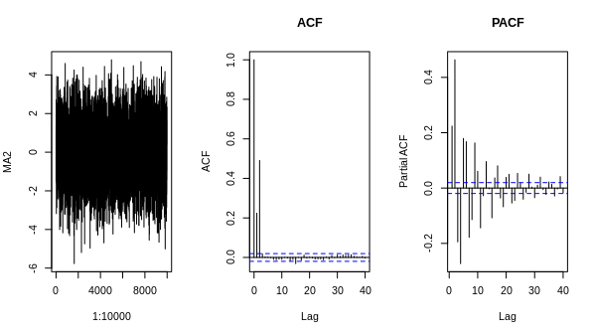Above shows a better ACF plot because we have only 3 significant values so MA model is better than a complex AR which is indicated in the PACF plot.

##Exercise 3: A good, simple example of time series One of your fellow MSDS students was curious if he could model the fluctuations he sees in his electric bill. The data is included in Unit 4 zipped folder with the title “ElectricBill.csv”. In addition to just the amount due each month, he thought it might be helpful to include a predictor that could help aid in prediction. The potential predictor was the average monthly temperature of the city he lived in (Fort Worth).

Lets start off by assuming that we did not have access to the temperature data (the student had to work to get that) and just work with what was the easiest available, the monthly electric bill. A plot of the time series is a good starting point.

#setwd("D:/MSDS6372/HWMark")  
setwd("~/datascience/DS6372/Unit4/Unit4HW")  
library(tseries)

## Registered S3 method overwritten by 'xts':  
## method from  
## as.zoo.xts zoo

## Registered S3 method overwritten by 'quantmod':  
## method from  
## as.zoo.data.frame zoo

library(forecast)

## Registered S3 methods overwritten by 'forecast':  
## method from   
## fitted.fracdiff fracdiff  
## residuals.fracdiff fracdiff

library(ggplot2)  
  
bills<-read.csv("ElectricBill.csv")  
head(bills)

## Date Bill AvgTemp  
## 1 5/1/2015 383.37 71.40  
## 2 6/1/2015 490.36 78.60  
## 3 7/1/2015 481.11 80.00  
## 4 8/1/2015 517.13 86.35  
## 5 9/1/2015 381.30 79.15  
## 6 10/1/2015 253.40 67.95

bills$DateIndex<-1:nrow(bills)  
  
ggplot()+geom_line(data=bills,aes(x=DateIndex,y=Bill))

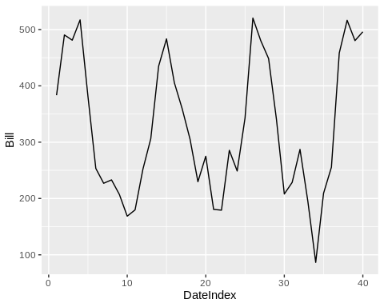

The plot of electric bill overtime appears to show some cyclic behavior as expected. At face value, it appears that the time series has a common mean and variability appears to be roughly constant. The high peaks tend to be pretty sharp, while the valley tend to be drawn out is a little bit of concern and could benefit from a log transformation. Before doing that, lets examine the ACF and PACF plots on the original data set.

attach(bills)  
Acf(Bill)

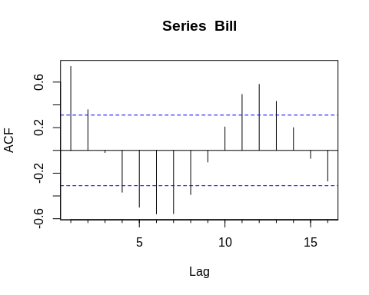

Pacf(Bill)

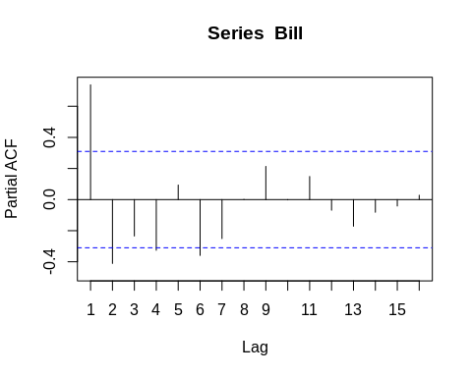

From the ACF and PACF, we clearly see an evidence of serial correlation. There is some evidence of nonstationarity as the correlations from the larger lags are still pretty strong. However, with this small of a data set it is hard to tell. With a much larger data set, we could examine the lags farther out at least two lag 24 so we have the full years, to examine the cyclical behavior.

For completeness, I’ve included the Durbin Watson test statistic for auto correlation. The way this function works is that you have to feed the function a linear regression model. In this particular case, we are assuming the data is stationary already, with no need of any predictors so we can provide a regression model with just an intercept (make note that the an intercept model is just a means model). As expected, the Durbin Watson test rejects the null hypothesis, the time series has no serial correlation for a specific lag.

library(car)

## Loading required package: carData

durbinWatsonTest(lm(Bill~1),max.lag=4)

## lag Autocorrelation D-W Statistic p-value  
## 1 0.7380876 0.469104 0.000  
## 2 0.3577343 1.143470 0.006  
## 3 -0.0194295 1.795373 0.728  
## 4 -0.3676480 2.400021 0.084  
## Alternative hypothesis: rho[lag] != 0

With no major concerns that the time series is not stationary, we will begin to try to model the serial correlation that is present. Using our rules of thumb, it appears that an auto regressive model using 5 or 6 lags would be one candidate starting model. If one views the PACF as dying out gradually over time, an ARMA type model may be more appropriate. Lets first start out by fitting a few AR(p) models.

AR1<-arima(Bill,order=c(1,0,0))  
AR2<-arima(Bill,order=c(2,0,0))  
AR3<-arima(Bill,order=c(3,0,0))

To examine the model fit we can obtain residual diagnostics to see how well the autoregressive models have accounted for the serial correlation. If the model fits well, then the residuals should behave more and more like uncorrelated time series.

tsdisplay(residuals(AR1),lag.max=15,main="AR(1) Resid. Diagnostics")

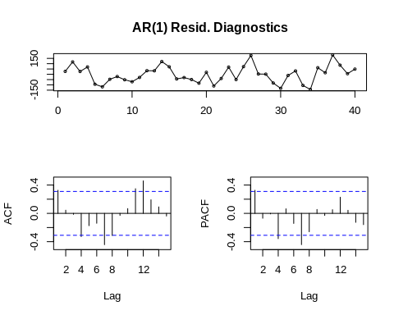

**Homework Questions**

1. The residuals from the AR(1) model above look to still have serial correlation present, fit an additional AR(4) and AR(5) model. Compare the residual diagnostics of all 5 models to see if the ACF and PACF start to behave more like uncorrelated time series.

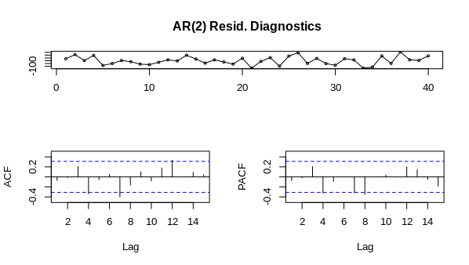

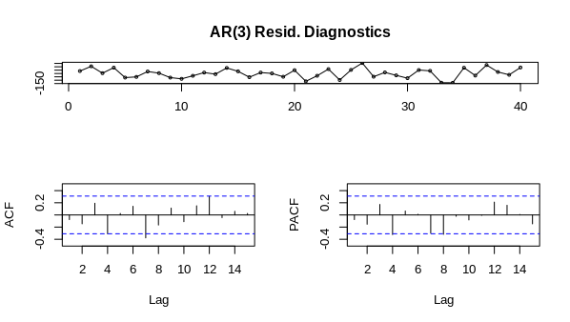

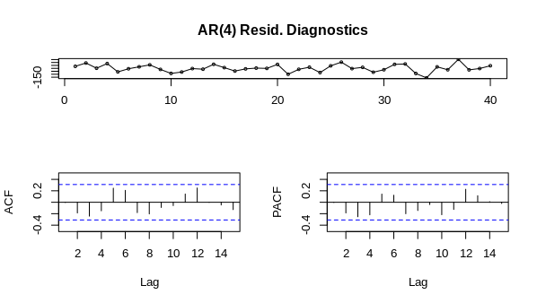

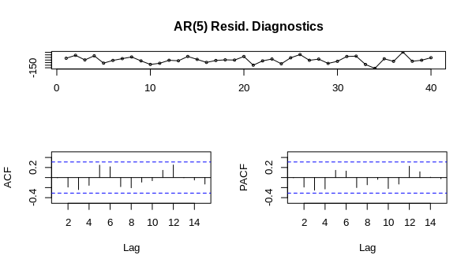As the no of lag grows, the number of significance decreases. AR(5) and AR(4) shows no significant values for the PAF and ACF while the other 3 models do. This means that model 4 and 5 serial correlation is almost none.

1. Use the AIC function (ex: AIC(AR1)) to obtain the AIC of each of the 5 models from #2. Does the model that yields the lowest AIC provide a residual plot that looks the best in terms of having removed the serial correlation?

> AIC(AR1)

[1] 470.0568

> AIC(AR2)

[1] 464.3603

> AIC(AR3)

[1] 464.4424

> AIC(AR4)

[1] 458.2644

> AIC(AR5)

[1] 460.2588

The lowest AIC is AR(4) model. It seems like AIC decreases with a less correlation of the in model.

##Exercise 3 Continued Rather than iteratively fit models and check AIC metrics, we can perform an automated procedure that search a more divers set of ARIMA models. Not here that this algorithm by default uses a stepwise procedure and doesn’t necessary find a global minimum AIC value. For example, lets run the automated procedure using all the defaults

ARIMA.fit<-auto.arima(Bill,seasonal=FALSE)  
ARIMA.fit

## Series: Bill   
## ARIMA(2,0,0) with non-zero mean   
##   
## Coefficients:  
## ar1 ar2 mean  
## 1.0811 -0.4344 326.1589  
## s.e. 0.1419 0.1472 31.8184  
##   
## sigma^2 estimated as 5528: log likelihood=-228.18  
## AIC=464.36 AICc=465.5 BIC=471.12

Notice here the automated procedure selected the AR(2) model which we know from the previous exercises that AR(4) has a lower AIC. This is due to the stepwise selection process of auto.arima. To get them to correspond,

ARIMA.fit<-auto.arima(Bill,seasonal=FALSE,stepwise=FALSE)  
ARIMA.fit

## Series: Bill   
## ARIMA(4,0,0) with non-zero mean   
##   
## Coefficients:  
## ar1 ar2 ar3 ar4 mean  
## 0.8751 -0.3024 0.1918 -0.4628 311.7293  
## s.e. 0.1415 0.2025 0.1998 0.1473 14.7687  
##   
## sigma^2 estimated as 4386: log likelihood=-223.13  
## AIC=458.26 AICc=460.81 BIC=468.4

This function has a ton of bells and whistles and can also handle seasonal ARIMA models.. Take a look at ?auto.arim.

Providing forecasts of a final model fit is relatively simple to do. Syntactically, the h in the forecast function provides the future forecast up to h time points ahead. In addition, to the forecasts, I’ve overlayed the model fit on the previous data to get look at that as well.

plot(forecast(ARIMA.fit,h=10))  
points(1:length(Bill),fitted(ARIMA.fit),type="l",col="blue")

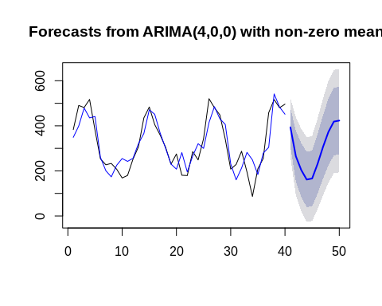

**Homework Exercises**

1. We know from previous explorations that the AR(1) model fits poorly as serial correlation is still unaccounted for. Provide a forecast from the AR(1) model and compare it to the previous AR(4). What properties do the forecasts from this predictive model (AR1) lack in comparison to the AR(4)? What about the prediction interval bands?

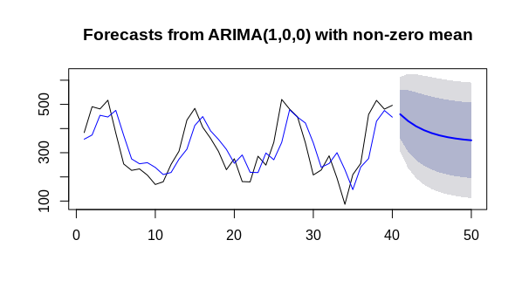

The AR1 model lacks the lacks the trend continuation from the prediction plot. The prediction intervals looks a lot linear and broader which indicates that it isn’t the best model.

1. Provide another plot of the forecasts for the AR(4) model but forecast out to the next 100 observations. Sometimes students are blown away and not satisfied by the result. Can you explain, in a common sense way, why the forecasts behave the way they do?

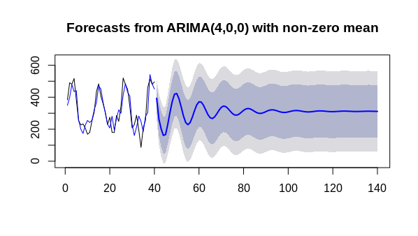

Forecasting behaves the way it does because we are making prediction using previous data points. So it be better to make prediction short term and then use the actual value or the current value to optimize the model. Short/long forecasting also depends on the amount of data point we have have.

##Exercise 3 Continued The electric bill data set also contained some additional information, local area monthly temperatures. This could be helpful to include as a predictor if it can help explain the variation in the response. Like any regression plot, lets examine the a scatter plot of bills versus average temperature.

plot(AvgTemp,Bill,xlab="Avg. Temperature")  
ols<-lm(Bill~AvgTemp)  
abline(ols)  
text(80,200,paste("Cor=",round(cor(Bill,AvgTemp),2)))

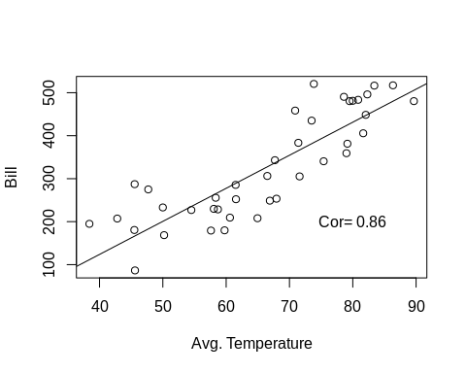

The correlation is quite strong (maybe even a little quadratic) suggesting that this could be used to help improve our forecasts. Including a predictor is straightforward, but keep in mind by including a deterministic component in your model, you are making the decision that the original time series model is not stationary any more.

Also logistically speaking, to make future predictions we now need to have access to the observed observations of the predictor. Having said this, moving forward we are going to hold out the last 5 observations of the original time series, to make forecasts since we need information on the temperatures. Lets examine the ACF and PACF of the residuals after regressing Bill on AvgTemp.

holdout.test<-window(ts(Bill),start=36)  
train<-Bill[1:35]  
predictor<-as.matrix(AvgTemp[1:35])  
simpleols<-arima(train,order=c(0,0,0),xreg=predictor)  
tsdisplay(residuals(simpleols),lag.max=15,main="Resid. Diagnostics of OLS")

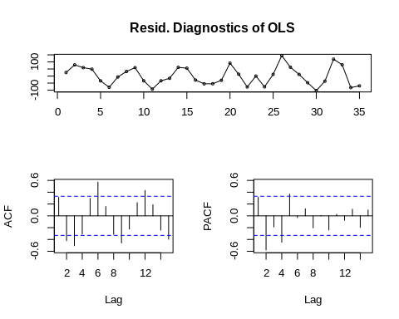

ARIMA.with.Pred<-auto.arima(train,xreg=predictor,stepwise=FALSE)  
#ARIMA.with.Pred<-auto.arima(predictor,stepwise=FALSE)  
#ARIMA.with.Pred<-auto.arima(train,stepwise=FALSE)  
ARIMA.with.Pred

Series: train

Regression with ARIMA(4,0,0) errors

Coefficients:

ar1 ar2 ar3 ar4 intercept xreg

-0.0106 -0.7357 -0.1832 -0.7500 -235.4348 8.3784

s.e. 0.1173 0.1139 0.1138 0.1095 16.2467 0.2481

sigma^2 estimated as 1136: log likelihood=-171.98

AIC=357.97 AICc=362.11 BIC=368.85

tsdisplay(residuals(ARIMA.with.Pred),lag.max=15,main="Resid. Diagnostics with AR(4)")

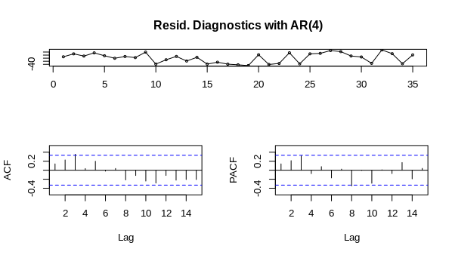

plot(forecast(ARIMA.with.Pred,h=5,xreg=data.frame(predictor=AvgTemp[36:40])))

## Warning in forecast.forecast_ARIMA(ARIMA.with.Pred, h = 5, xreg =  
## data.frame(predictor = AvgTemp[36:40])): xreg not required by this model,  
## ignoring the provided regressors

points(1:length(train),fitted(ARIMA.with.Pred),type="l",col="blue")  
points(1:40,Bill,type="l")

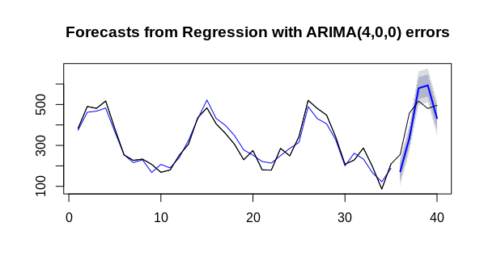

The most obvious benefit of including the predictor can be seen by the prediction interval band of the forecast. By modeling out variation in the data, their is less variability in the residuals which creates less uncertainty in the forecast. However like any regression model, if the model developed using any set of predictors is not accurate (Bias/Variance trade off) then forecasts will suffer from the same issues.

The natural followup question when incorporating predictors is deciding on the best fit and safe guarding against under and over fitting those predictors. To illustrate this I’ve included a second model fit including a quadratic term. Since we have test set (only 5 observations here but you get the point), we can produce ASE type metrics to compare models.

**New Quadratic Fit**

newpred<-as.matrix(cbind(predictor,predictor^2))  
colnames(newpred)<-c("Pred","Pred2")  
ARIMA.with.Pred2<-auto.arima(train,xreg=newpred,stepwise=FALSE)  
ARIMA.with.Pred2

## Series: train   
## Regression with ARIMA(4,0,0) errors   
##   
## Coefficients:  
## ar1 ar2 ar3 ar4 Pred Pred2  
## 0.0382 -0.7339 -0.1458 -0.7136 0.6933 0.0602  
## s.e. 0.1215 0.1201 0.1202 0.1153 0.2998 0.0044  
##   
## sigma^2 estimated as 1133: log likelihood=-171.58  
## AIC=357.16 AICc=361.31 BIC=368.05

tsdisplay(residuals(ARIMA.with.Pred2),lag.max=15,main="Resid. Diagnostics AR(4) Quadratic")

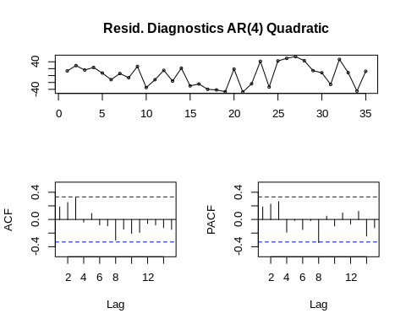

test.pred<-as.matrix(cbind(AvgTemp[36:40],AvgTemp[36:40]^2))  
colnames(test.pred)<-c("Pred","Pred2")  
plot(forecast(ARIMA.with.Pred2,h=5,xreg=test.pred))  
points(1:length(train),fitted(ARIMA.with.Pred2),type="l",col="blue")  
points(1:40,Bill,type="l")

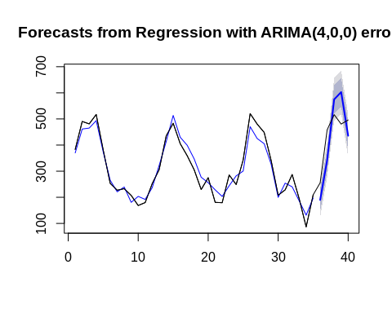

To compare models we can use the accuracy function. You simply store your forecast results in an object and then provide the true test set responses. Numerous metrics are then provided RootMSE is the closes to ASE that we have seen in SAS previously. Check out the R help documentation for references on the different prediction accuracy metrics.

casts.avgtemp<-forecast(ARIMA.with.Pred,h=5,xreg=data.frame(predictor=AvgTemp[36:40]))

## Warning in forecast.forecast_ARIMA(ARIMA.with.Pred, h = 5, xreg =  
## data.frame(predictor = AvgTemp[36:40])): xreg not required by this model,  
## ignoring the provided regressors

accuracy(casts.avgtemp,Bill[36:40])

## ME RMSE MAE MPE MAPE  
## Training set 0.2327983 3.973257 3.022515 -0.1365531 5.066849  
## Test set 361.5620673 372.778919 361.562067 80.9511975 80.951198  
## MASE ACF1  
## Training set 0.4356317 -0.04485213  
## Test set 52.1115315 NA

cast.avgtemp.quad<-forecast(ARIMA.with.Pred2,h=5,xreg=test.pred)  
accuracy(cast.avgtemp.quad,Bill[36:40])

## ME RMSE MAE MPE MAPE MASE  
## Training set 1.717535 30.64328 26.88489 -1.975446 10.26099 0.3886736  
## Test set 12.186182 89.18941 84.51464 5.260677 19.97953 1.2218239  
## ACF1  
## Training set 0.1834575  
## Test set NA

Taking this with a grain of salt since the test set only has 5 observations, the accuracy metrics on the test set are all lower for the quadratic term indicating that an improvement has been made although it is not drastic. Compared to how well the training fit is, it looks like we have some work to do.

**HW Exerises** 14. Use the same train,test split previous discussed to fit an AR(4) model (do not include the predictor for AvgTemp) to the training and forecast the last 5 observations. Provide a graphic of the forecast and produce the accuracy results on the 5 test set observations for comparison of the previous fits which included a predictor. Bonus question….why should we be careful, when comparing test accuracy metrics from models that are assumed stationary (AR4) and those that are not stationary (models with predictors)? Does it matter how many observations I include in the test set? Think about your result in 13.

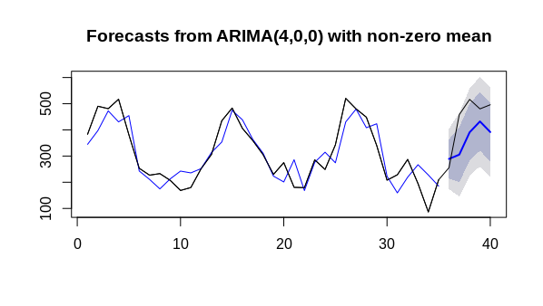

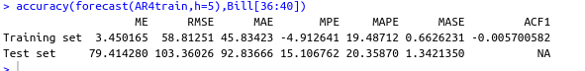

##Differencing data to create a stationary model. No More Assignments Past this point.  
The one thing that the HW doesn’t cover so far is the idea of taking a first order time series to render a stationary time series. One way to do this is to use the ?diff. This makes it a little challenging to make forecasts back on the original scale. The way to do this using the tools already covered is realizes that an ARIMA(0,1,0), produces residuals that follow the same 1st order difference pattern. They are just centered at 0 instead of the original mean.

To illustrate, lets consider the melanoma time series from pre live work.

melanoma<-read.csv("Melanomatimeseries.csv")  
attach(melanoma)  
par(mfrow=c(3,1))  
plot(Year,Melanoma,type="l",main="Original Data")  
Acf(Melanoma)  
Pacf(Melanoma)

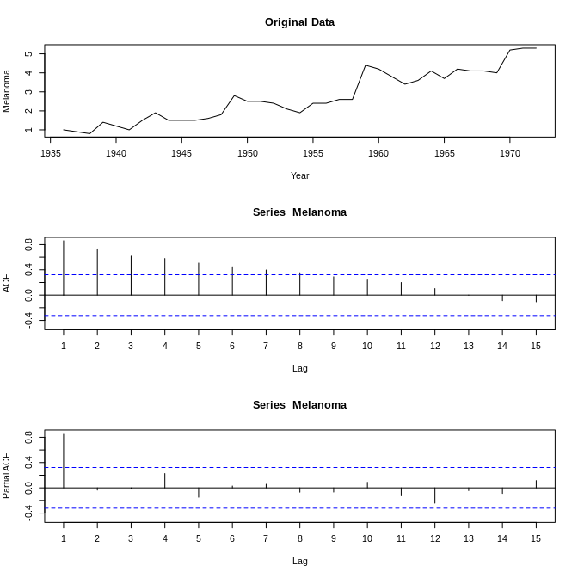

par(mfrow=c(1,1))  
diff.data<-arima(Melanoma,order=c(0,1,0))  
tsdisplay(residuals(diff.data),lag.max=15,main="Resid. Diagnostics 1st Order Difference")

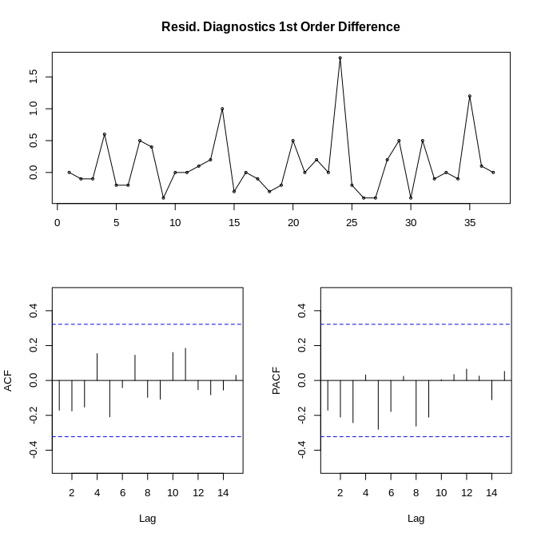

We can see that by differencing the data, not only that we have a stationary time series, but there really is no serial correlation left to model! In many situations serial correlation will still exist after differencing the data, and the previous techniques can be used to model it out.