Unit 9 HW
Ikenna Nwaogu
3/4/2019

PCA Conceptual questions
- TRUE/FALSE Principle component analysis is a predictive modeling technique such as linear regression and lda.
False
- TRUE or FALSE? Technically speaking, PCA should not be applied to categorical variables.
True
- An analyst conducts a pca on continuous variables 1 through 20 and settled on reducing the variable down to 4. The analyst then proceeds to conduct a linear regression using the 4 pcs components as predictors and the response is variable 1. Why is this a horrible idea?
Because the response variable was part of the PCA which would affect the results.
- Why is it important to conduct PCA on standardized variables (aka using the correlation matrix)?
Because not scaling affects the results of the PCA.

Exercise #1 PCA Basics
The example conducted in class did not do a very good job of illustrating the interpretation goals of PCA. For this reason, we will switch to a baseball data set to go over the basics and play around with interpretation. The baseball data set is located in the Lahman package. The data set is quite comprehensive having baseball player statistics dating back to 1871. We are going to examine the earliest year, 2016, by itself. Lets take a quick summary to see what variables we have.
library(Lahman)
data(Batting)
index<-which(Batting$yearID==2016)
Bat16<-Batting[index,]
summary(Bat16)
## playerID yearID stint teamID lgID
## Length:1483 Min. :2016 Min. :1.000 ATL : 60 AA: 0
## Class :character 1st Qu.:2016 1st Qu.:1.000 SDN : 58 AL:734
## Mode :character Median :2016 Median :1.000 LAN : 55 FL: 0
## Mean :2016 Mean :1.092 PIT : 55 NA: 0
## 3rd Qu.:2016 3rd Qu.:1.000 SEA : 54 NL:749
## Max. :2016 Max. :4.000 LAA : 53 PL: 0
## (Other):1148 UA: 0
## G AB R H
## Min. : 1.00 Min. : 0.0 Min. : 0.00 Min. : 0.00
## 1st Qu.: 13.00 1st Qu.: 0.0 1st Qu.: 0.00 1st Qu.: 0.00
## Median : 31.00 Median : 11.0 Median : 1.00 Median : 1.00
## Mean : 47.51 Mean :111.6 Mean : 14.66 Mean : 28.51
## 3rd Qu.: 69.00 3rd Qu.:155.0 3rd Qu.: 18.00 3rd Qu.: 36.00
## Max. :162.00 Max. :672.0 Max. :123.00 Max. :216.00
##
## X2B X3B HR RBI
## Min. : 0.000 Min. : 0.0000 Min. : 0.000 Min. : 0.00
## 1st Qu.: 0.000 1st Qu.: 0.0000 1st Qu.: 0.000 1st Qu.: 0.00
## Median : 0.000 Median : 0.0000 Median : 0.000 Median : 0.00
## Mean : 5.566 Mean : 0.5887 Mean : 3.783 Mean : 13.99
## 3rd Qu.: 7.000 3rd Qu.: 0.0000 3rd Qu.: 3.000 3rd Qu.: 15.50
## Max. :48.000 Max. :11.0000 Max. :47.000 Max. :133.00
##
## SB CS BB SO
## Min. : 0.000 Min. : 0.000 Min. : 0.00 Min. : 0.00
## 1st Qu.: 0.000 1st Qu.: 0.000 1st Qu.: 0.00 1st Qu.: 0.00
## Median : 0.000 Median : 0.000 Median : 0.00 Median : 4.00
## Mean : 1.711 Mean : 0.675 Mean : 10.17 Mean : 26.29
## 3rd Qu.: 1.000 3rd Qu.: 0.000 3rd Qu.: 13.00 3rd Qu.: 38.00
## Max. :62.000 Max. :18.000 Max. :116.00 Max. :219.00
##
## IBB HBP SH SF
## Min. : 0.0000 Min. : 0.000 Min. : 0.0000 Min. : 0.0000
## 1st Qu.: 0.0000 1st Qu.: 0.000 1st Qu.: 0.0000 1st Qu.: 0.0000
## Median : 0.0000 Median : 0.000 Median : 0.0000 Median : 0.0000
## Mean : 0.6285 Mean : 1.113 Mean : 0.6912 Mean : 0.8186
## 3rd Qu.: 0.0000 3rd Qu.: 1.000 3rd Qu.: 1.0000 3rd Qu.: 1.0000
## Max. :20.0000 Max. :24.000 Max. :13.0000 Max. :15.0000
##
## GIDP
## Min. : 0.000
## 1st Qu.: 0.000
## Median : 0.000
## Mean : 2.508
## 3rd Qu.: 3.000
## Max. :26.000
##
For those of you who do not know too much about baseball, the first 5 variables are just general information, G is the number of games played while the rest are information for players batting ability. G is games, AB is number of batting attempts, R-Runs, H-hits, X2B and X3B are doubles and triples, HR-homeruns, RBI-Runs Batted In. These are all general information on how well the batters can hit the ball. SB-stolen bases and CS- caught stealing are statistics about a players ability to run the bases, BB and IBB are when the batter gets a walk, HBP is hit by a pitch, SH and SF are sacrifice hit and fly’s where the player doesn’t get a hit but their hit is still productive, and lastley GIDP is grounded into double plays.
Sports data sets lend themselves well to PCA. We will use this example to go through similar concepts discussed in class. For starters lets just start off with just a few variables in the set to verify PCA is doing what we expect it to. Here is a quick scatterplot matrix. The variables here are highly correlated with each other.
reduced<-Bat16[,6:10]
pairs(reduced)
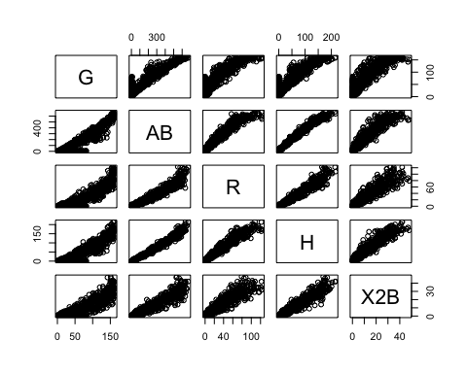
Let’s take a quick look at the summary statistics and in particular lets calculate the variance of each variable and add them up to obtain the total variance.
apply(reduced,2,summary)
## G AB R H X2B
## Min. 1.00000 0.0000 0.00000 0.00000 0.000000
## 1st Qu. 13.00000 0.0000 0.00000 0.00000 0.000000
## Median 31.00000 11.0000 1.00000 1.00000 0.000000
## Mean 47.50573 111.6392 14.66217 28.50708 5.565745
## 3rd Qu. 69.00000 155.0000 18.00000 36.00000 7.000000
## Max. 162.00000 672.0000 123.00000 216.00000 48.000000
var.raw<-apply(reduced,2,var)
var.raw
## G AB R H X2B
## 2054.72517 31658.76653 665.77851 2363.88035 96.32951
#Total variance
sum(var.raw)
## [1] 36839.48
We have been talking about the covariance matrix a lot lately. An estimate for any given set of continuous variables can be obtained using the cov function. You can see that the diagonals of this matrix are the same as the variances calculated one at a time from before.
cov(reduced)
## G AB R H X2B
## G 2054.7252 7423.272 1048.0832 1999.3891 391.50924
## AB 7423.2723 31658.767 4479.3423 8574.1257 1678.82164
## R 1048.0832 4479.342 665.7785 1229.5547 240.89233
## H 1999.3891 8574.126 1229.5547 2363.8803 462.93830
## X2B 391.5092 1678.822 240.8923 462.9383 96.32951
#Another way to get total variance
sum(diag(cov(reduced)))
## [1] 36839.48
Running PCA is relatively straight forward. The following script conducts a PCA using the covariance matrix (nonstandardized variables) and stores the results in an object. This object contains the eigenvectors, eigenvalue, and the new principle component vectors. Lets start by producing a correlation matrix to verify that new principle component variables are uncorrelated.
pc.result<-prcomp(reduced,scale.=FALSE)
pc.scores<-pc.result$x
pairs(pc.scores)
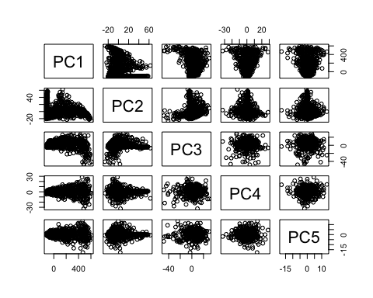
cor(pc.scores)
## PC1 PC2 PC3 PC4 PC5
## PC1 1.000000e+00 3.883426e-15 -9.277437e-15 1.552181e-14 -1.433233e-14
## PC2 3.883426e-15 1.000000e+00 -7.001366e-17 5.291058e-15 -5.983462e-15
## PC3 -9.277437e-15 -7.001366e-17 1.000000e+00 -1.141962e-15 -6.650849e-16
## PC4 1.552181e-14 5.291058e-15 -1.141962e-15 1.000000e+00 3.636272e-16
## PC5 -1.433233e-14 -5.983462e-15 -6.650849e-16 3.636272e-16 1.000000e+00
We can again verify that the total variance in the new PC variables is exactly the same as the original data. The eigenvectors are stored inside of “pc.result” as well in the “rotation” object.
var.pca<-apply(pc.scores,2,var)
var.pca
## PC1 PC2 PC3 PC4 PC5
## 36462.584984 301.411677 50.103822 19.963419 5.416166
#Total Variance of PC's
sum(var.pca)
## [1] 36839.48
#Total Variance of Original Variables.
sum(var.raw)
## [1] 36839.48
#List of eigenvectors
pc.result$rotation
## PC1 PC2 PC3 PC4 PC5
## G 0.22024127 0.97397742 -0.05059877 0.01730636 -0.001420923
## AB 0.93156585 -0.19396824 0.30281622 -0.05283321 0.008507431
## R 0.13202633 -0.04546002 -0.57626905 -0.80501489 0.019168837
## H 0.25258860 -0.10598044 -0.73885937 0.57082967 -0.230667442
## X2B 0.04946609 -0.02111491 -0.16656204 0.15170255 0.972805577
A scree plot of the eigenvalues used to determine how many pc’s to keep can be plotted in the following way:
par(mfrow=c(1,2))
eigenvals<-(pc.result$sdev)^2
plot(1:5,eigenvals/sum(eigenvals),type="l",main="Scree Plot",ylab="Prop. Var. Explained")
cumulative.prop<-cumsum(eigenvals/sum(eigenvals))
plot(1:5,cumulative.prop,type="l",main="Cumulative proportion",ylim=c(0,1))
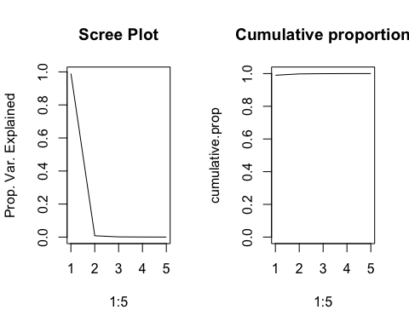
par(mfrow=c(1,1))
Since all of the variables are not on the same scale, we see a very similar phenomenon that we discussed in the pre live session. To conduct the pca on the correlation matrix, just set scale.=TRUE inside of the prcomp function.

HW Assignment #1
- Conduct the PCA analysis but use the entire set of variables starting with the column 6, the Games played variable, all the way down to the end at GIDP. Provide a scree plot and determine the amount of PC’s needed to retain approximately 90% of the total variation in the data set.
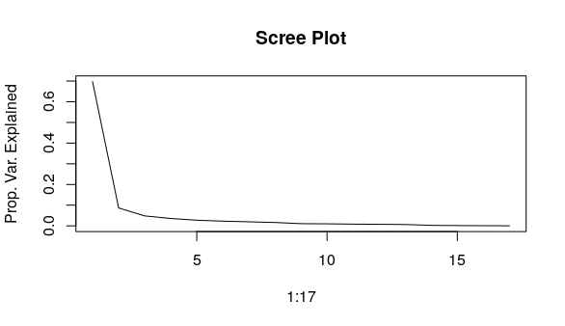
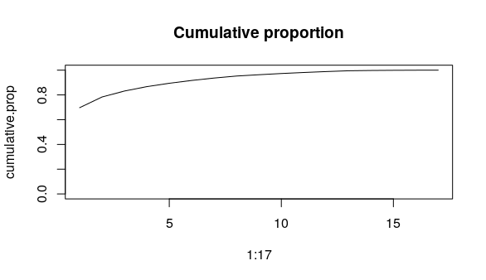
The amount of PC’s needed would be 17.
- Provide the eigenvector matrix and examine the loading (coefficients) that determine the linear combinations of each principle component. Verify that PC1 is essentially a weighted average of all the variables together (minus the SH, sacrifice hit variable.)
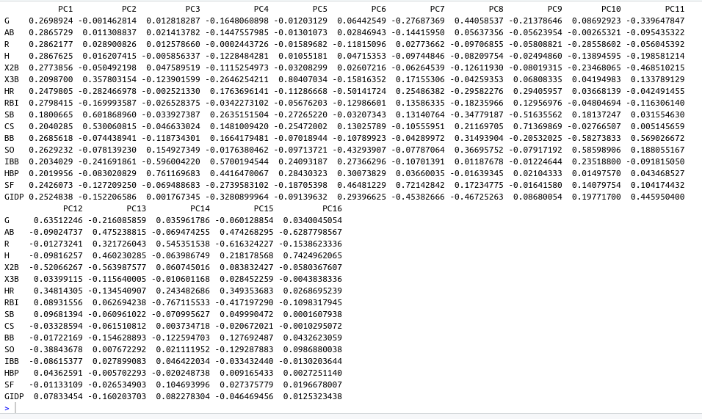
PC1 have similar values for all variables. All about 0.2.
- Verify that PC2 has big negative loading on triples (X3B), stolen bases (SB), caught stealing (CS), and sacrifice hits (SH). This variable could be interpreted to be a general indication of a players speed or general utility since all of the variables require situation awareness and running ability. (You don't need to provide an answer here, just verify))
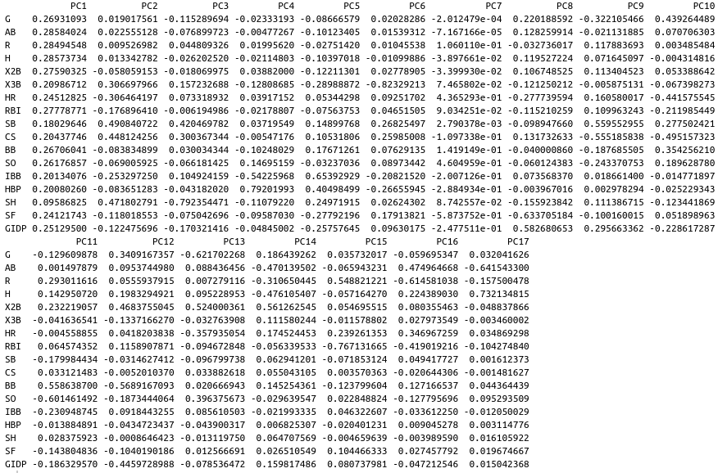
In PC2 you can see that the values for the one listed plus HR are higher than the rest.

PCA as an exploratory technique for Classification
This exercise is designed to walk you through how PCA can be used as an informative unsupervised analysis of your predictors to get a high level view of whether the predictors are actually going to do a good job or not before a predictive model for categorical responses is even applied.
The following data set is a breast cancer data set that has numerous measurements taken from tumor biopsies. The goal of using this data set is to predict using the metrics alone if the biopsy is cancer or not. When continuous variables are available it is often helpful to create a pairs plot of data color coded by the response status (Diagnostics). The first variable is an id number and is not needed.
bc<-read.table("https://archive.ics.uci.edu/ml/machine-learning-databases/breast-cancer-wisconsin/wdbc.data",header=F,sep=",")
names(bc)<- c('id_number', 'diagnosis', 'radius_mean',
'texture_mean', 'perimeter_mean', 'area_mean',
'smoothness_mean', 'compactness_mean',
'concavity_mean','concave_points_mean',
'symmetry_mean', 'fractal_dimension_mean',
'radius_se', 'texture_se', 'perimeter_se',
'area_se', 'smoothness_se', 'compactness_se',
'concavity_se', 'concave_points_se',
'symmetry_se', 'fractal_dimension_se',
'radius_worst', 'texture_worst',
'perimeter_worst', 'area_worst',
'smoothness_worst', 'compactness_worst',
'concavity_worst', 'concave_points_worst',
'symmetry_worst', 'fractal_dimension_worst')
#Getting a look at the distribution
table(bc$diagnosis)
##
## B M
## 357 212
#Scatter plots color coded by response for just the first few variables
pairs(bc[,3:6],col=bc$diagnosis)
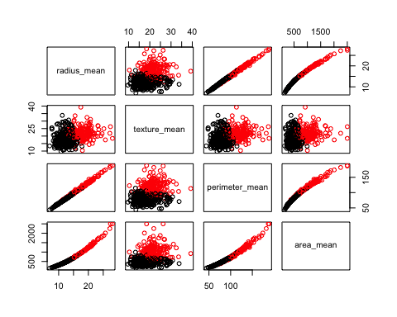
So we can see from this pairs plot of just the first few variables, separation between the cancer and non cancer groups are pretty well separated. Unfortunately we may not always see clear separations but that does not necessarily mean that something like LDA or some other predictive tool won’t work. It could be due to the fact we cant see the separation of the groups unless we can actually see in higher dimensions. One way to still get at this, is to conduct a PCA analysis and provide a some scatter plots for the first few PC’s. If separation exists in the PC’s, then a predictive model will probably do well.
Below we will conduct PCA on all of the predictors and plot the first few PC’s against each other and look for separation. The number of PCs to explore can be dictated by the scree plot.
pc.bc<-prcomp(bc[,-c(1,2)],scale.=TRUE)
pc.bc.scores<-pc.bc$x
#Adding the response column to the PC's data frame
pc.bc.scores<-data.frame(pc.bc.scores)
pc.bc.scores$Diagnosis<-bc$diagnosis
#Use ggplot2 to plot the first few pc's
library(ggplot2)
ggplot(data = pc.bc.scores, aes(x = PC1, y = PC2)) +
geom_point(aes(col=Diagnosis), size=1)+
ggtitle("PCA of Breast Cancer Tumor Biopsies")
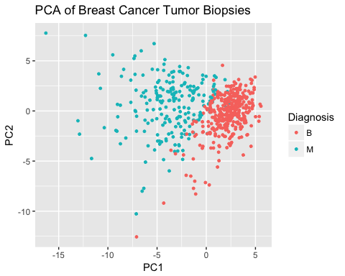
ggplot(data = pc.bc.scores, aes(x = PC2, y = PC3)) +
geom_point(aes(col=Diagnosis), size=1)+
ggtitle("PCA of Breast Cancer Tumor Biopsies")

So we can see in the first graphic a clear separation exists for the two cancer groups. So the PCA is telling us in effect what we already know from looking at the original variables. The power of this approach is that you only need to look at 2-4 graphs each time, versus potentially having to examine massive scatter plot matrices to see if anything is there or not!

HW Assignment 2
- Given what we see in the PCA analysis, its not too surprising that an LDA will probably do a good job here in predicting the categorical responses. Perform an LDA on the original set of variables and calculate a confusion matrix. Note: For this problem you do not have to do a training and test set split, lets recognize that the prediction performance that we obtain is potentially biased too low due to overfitting. The main point here is that the accuracy is pretty good as expected via the PCA look.
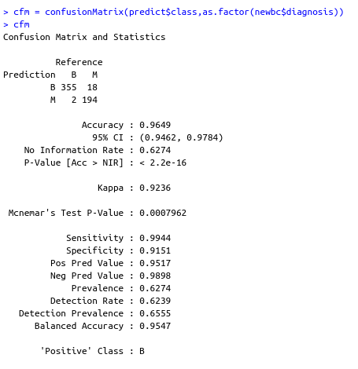
- Consider now another great sanity check when building predictive models. The code below takes the original data set and randomly scrambles the response variable. This effectively breaks up any relationship that existed between the predictors and the response.
fake<-bc
fake$diagnosis<-sample(fake$diagnosis,569,replace=F)
- Plot PC1 and PC2 using the scrambled data set.
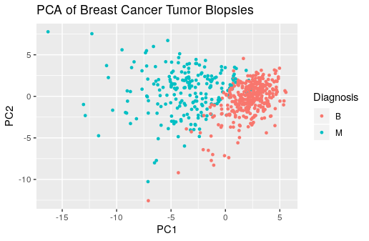
Same as above.
- Perform an LDA with this data set and look at the confusion matrix. Do they correspond?
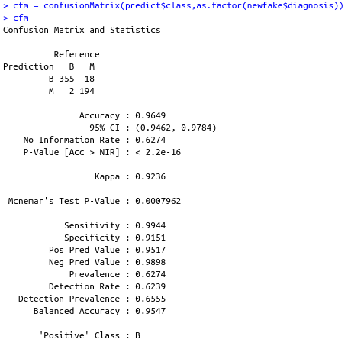
Same as well. I guess because we are using same predictor variables, it will always have same model so it doesn't matter what the response variables were. I know the accuracy would sill be high percentage because of over-fitting but wasn't expecting it to be the same values. No matter how you change the response variable, the predictions are always the same.
Note: This little trick is extremely helpful when you are predicting a response that is heavily imbalance (ex: lots of Cancer obs, few Healthy ones ). LDA and other algorithms can behave quite weirdly in extreme cases and prediction performances can look good all the time. By conducting a separate analysis on scrambled data, if the prediction performance still looks good, you’ve recognized a problem. We can discuss this topic more as we get closer to finishing up Project 2.

