Final Exam Time Series Summer 2020 (70 pts)
Full credit for 30 points has already been earned from simply completing your Project!

By taking this exam and typing your name below, you are agreeing to abide by your honor and the SMU Honor Code. This includes agreeing to not communicate with anyone except for Bivin Sadler about this exam until after Tuesday August 12 11:59pm Central Time. (Discussion with spouses, partners or friends about how it went or how awesome it was are ok.) If you agree to these terms on your honor please type your name here: ___Ikenna Nwaogu__________

True or False (1 pts each):

- The Cochrane-Orcutt procedure is helpful in adjusting a linear model for serial correlation. True
- Any invertible MA(q) model can be written as an infinite order AR(p). True
- An AR(4) model can have a single peak in the spectral density at 0. True
- All invertible models are stationary. False
- Yule-Walker estimation of parameters from data generated from a non-stationary model will always yield a stationary model. True
- If we have data that we generated from a white noise process and we conduct a Ljung-Box test with this data, the pvalue must be smaller than .05. False

- Consider the time series 3,3,5,5 and the model. Assume that you would like to estimate with 95% prediction intervals. However, this is not a large data set and your client, from previous experience, indicates she would like you to use 2.0 as the estimate of the standard error of the white noise (). Calculate and the 95% prediction limits “by hand”. You may use pen/pencil and paper, R or excel… but you must show your work in calculating the forecast and the margin of error. (2 pts)

- Consider the 4 realizations from two different processes below (A and B). Which set of realizations provide more evidence of the process that generated it (A or B) is stationary. (3 pts)

A
B

a.A
b.B
c. They both show equal evidence of stationarity.
d. They both show equal evidence of non-stationarity.

- Blast from the past! Below is a question I took from Dr. Woodwards old test from the 90’s. (Well… that’s not that old!) Anyhow … here it is! (3 pts)
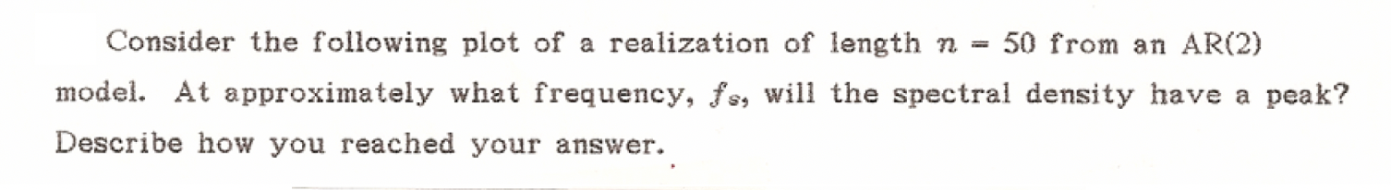
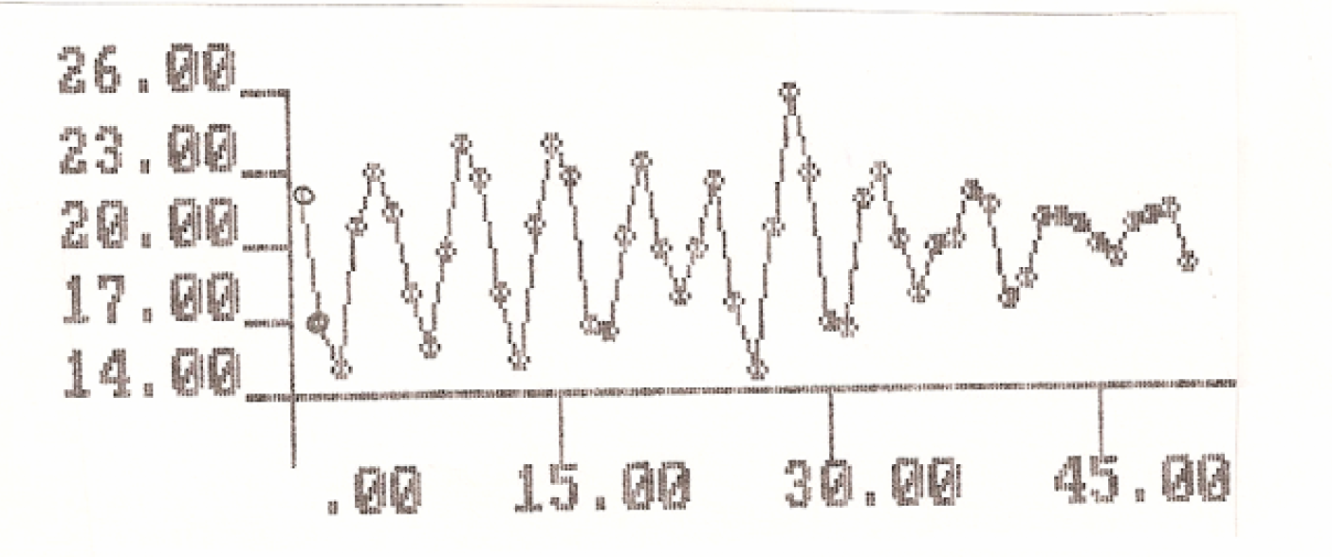

peak is at 5 so frequency would be 1/5 = 0.2.

- Below are the daily corporate bond rates from January 2000 - August 2010 and four different forecasts of the next 100 days. Match the forecast with the corresponding model that produced those forecasts. (2 pts each)

_E__ _C__ __D_ __G_

- φ(Β)(1-B)Xt = θ(Β)at
- ΑR(2) Complex Roots
- (1-.6B)Xt=at
- (1+.6B)Xt=at
- (1-.99B)Xt = at
- (1+.99B)Xt = at
- φ(Β)(1-B^{s})Xt = θ(Β)at
- (1-B)Xt = at

- Consider the following models. Identify if they are stationary or non-stationary and invertible or non-invertible and why? Show your mathematical work by hand (written and take a pic) or you may use tswge and show the relevant output if you wish. (2 pts each)

  - (1 - .8B)(1+ .99B)Xt = (1-.3B)at Stationary/non-invertible
  - (1-.9B+1.4B²)Xt = (1-1.2B+.9B²)at non-stationary/non-invertible

- Match the ACF on the left with the corresponding spectral density or realization on the right. Simply place the letter next to the corresponding number below the plots. (2 pts each)
1. 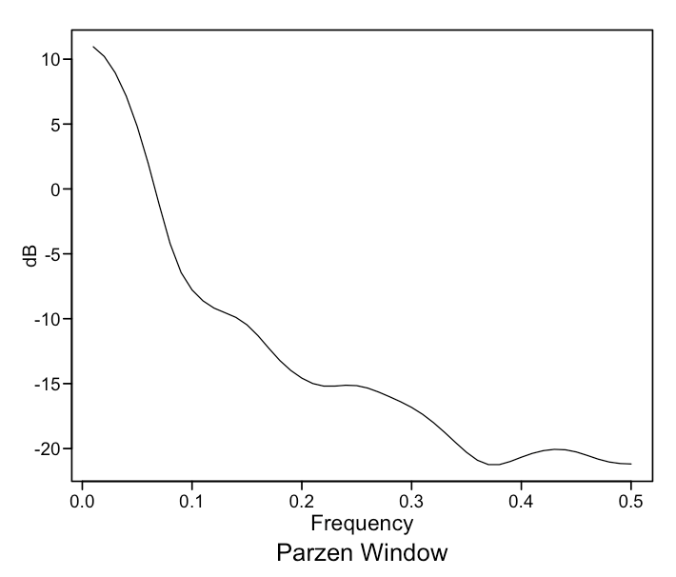 |  | a. 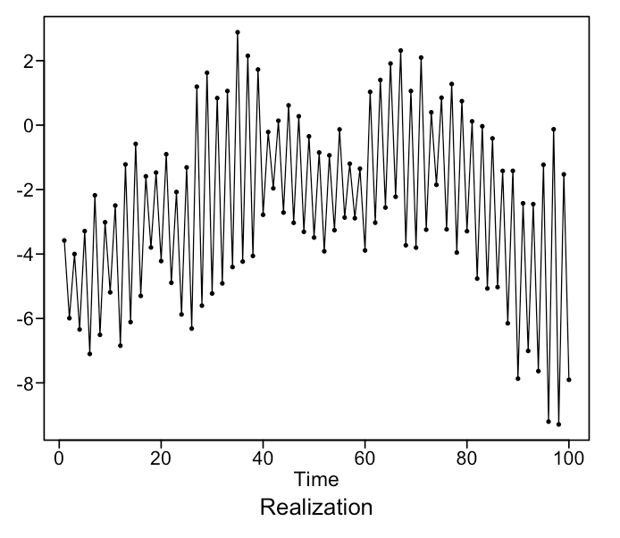
2. 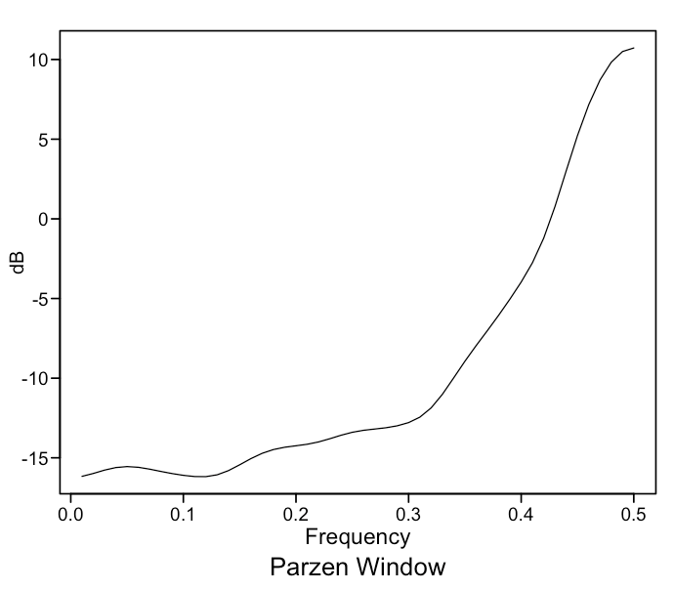 |  | b. 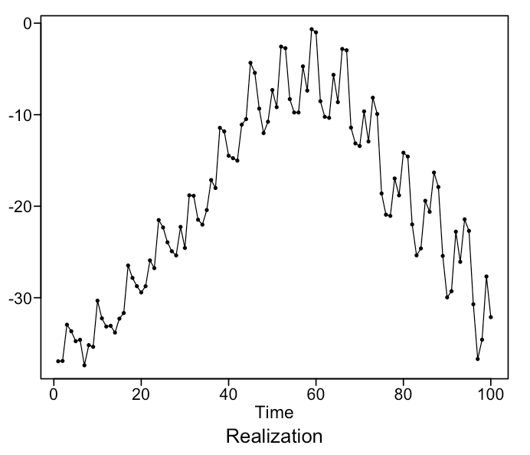
3. 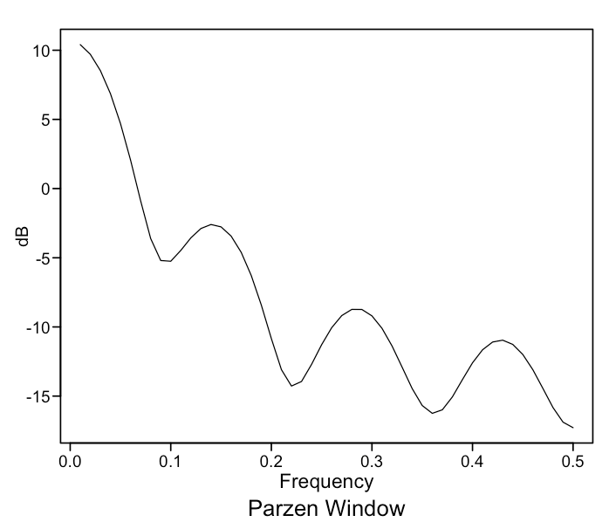 |  | c. 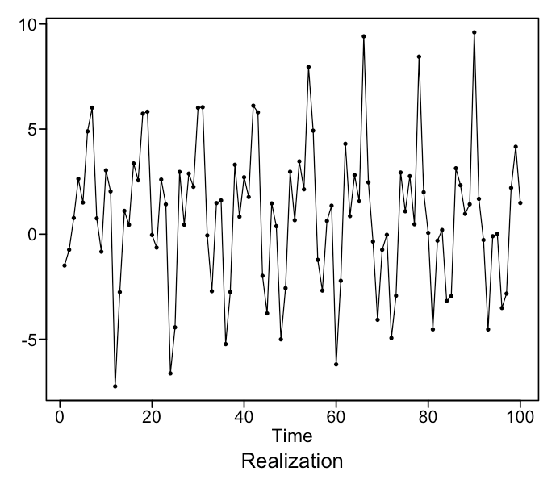
4. 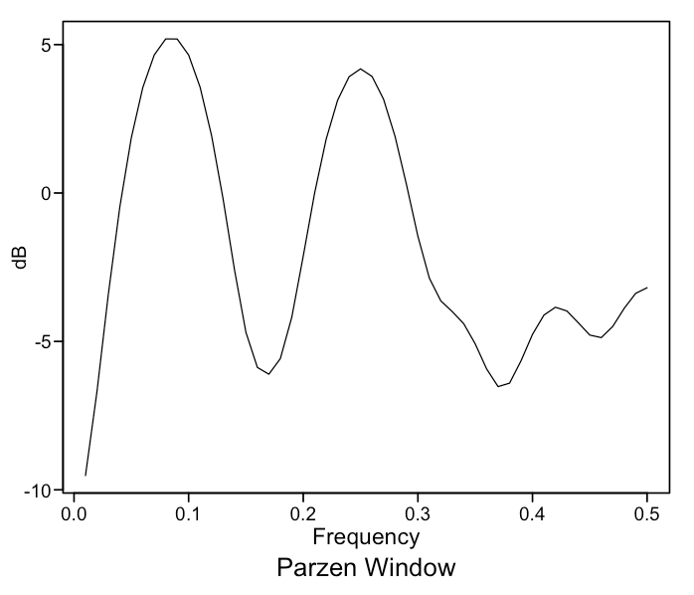 |  | d. 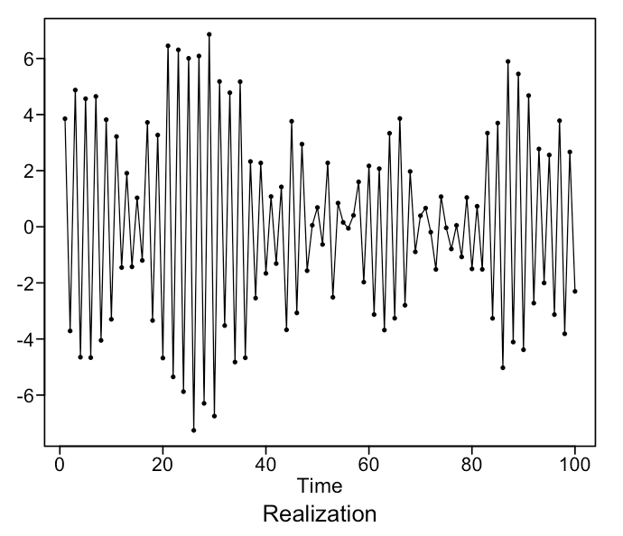
5. 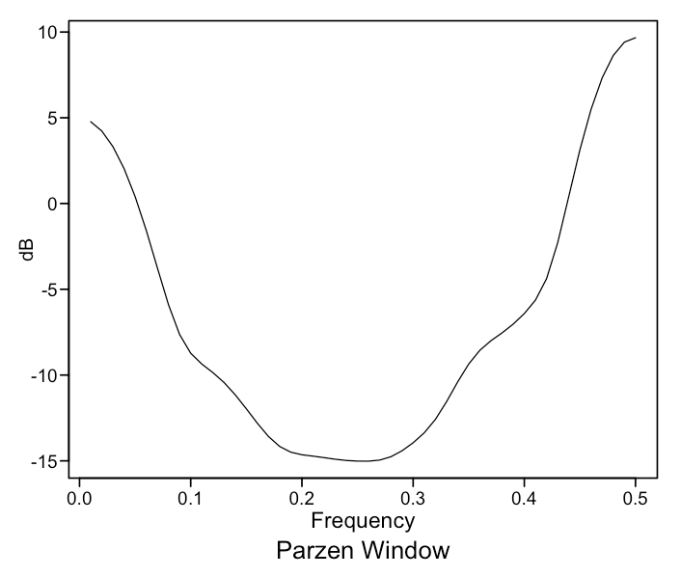 |  | e. 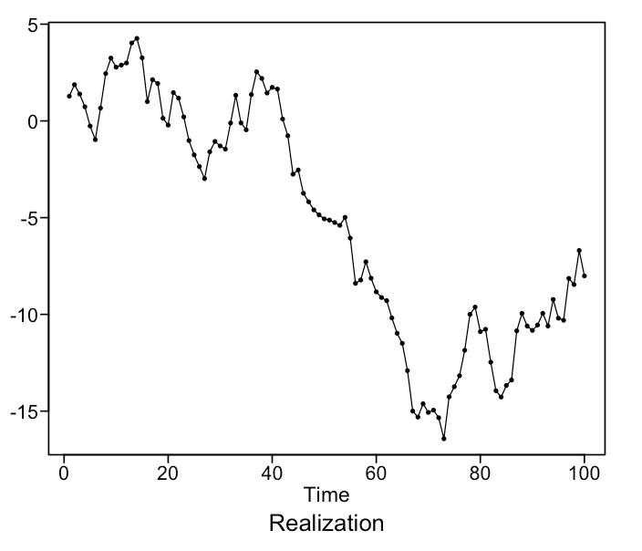

- _E__ 2.__D_ 3. _B_ 4. _C_ 5. __A_

- More than halfway done! Who was Dr. Woodward’s mentor and co-author of his book? He was also Dr. Woodward’s collaborator in their airline model that was part of the airline competition we had between Parzen and Box. (1 pts) Dr Grey
- Consider the data in the realization in FinalExamData1.csv. (3 pts each)

  - Perform a Durbin-Watson test on the realization and copy and paste the output and write a one sentence conclusion.
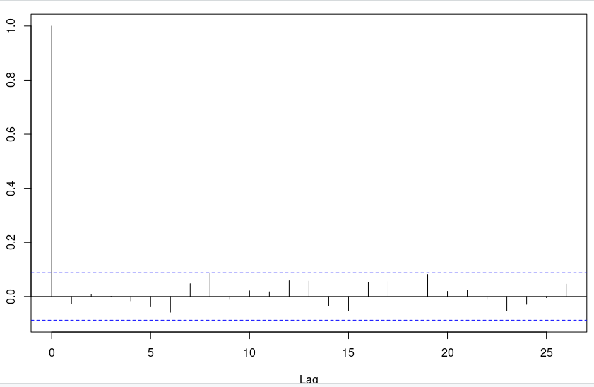

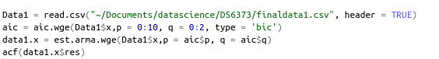
Residual is consistent with white noise.

  - Perform a first difference filter on the data ( take out a (1-B)Xt) and provide a plot of the first differenced data and an acf of the first differenced data.

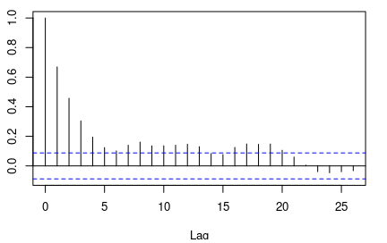

  - Perform a Ljung-Box test on the first differenced data and provide a one sentence conclusion. Copy and paste the code and output of the test as well.

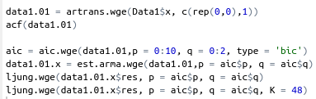

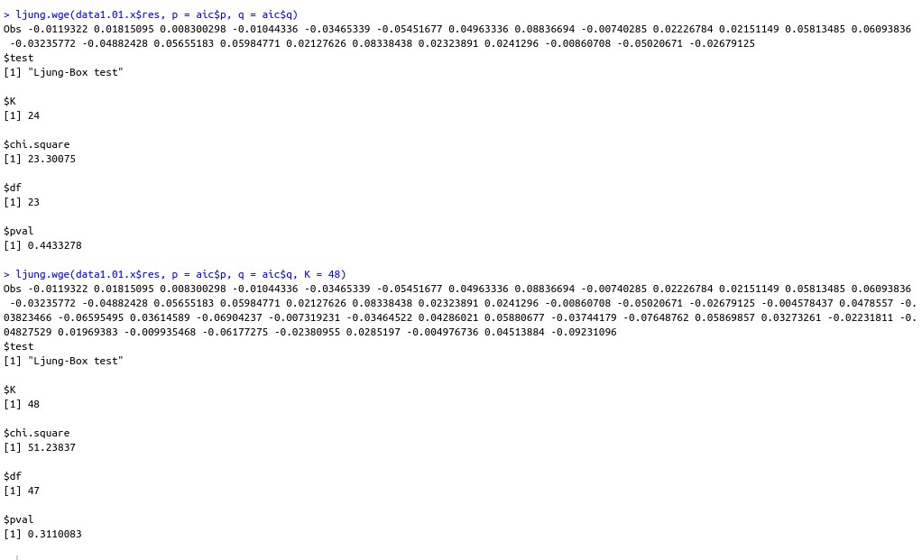

  - Assume the first differenced data is stationary and use the AIC to identify the order (p and q) of the best fitting model. Allow for p to be as large as 10 and q to be as large as 2. Again, copy and paste the code and the output and clearly identify the p and q.

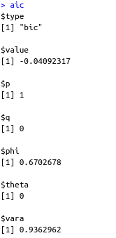

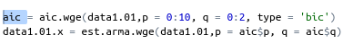

  - Fit the model (using all the data) suggested by the AIC above and use that output to formally write out the model specification of the complete model including all stationary and non-stationary factors. Also include an estimate of the white noise variance. Finally, you may assume the mean of the series is 0.

(1-B)(1-0.67B) = a^t var = 0.94

  - Find the ASE from the last 30 observations from the model from the last question (the one fit using all the data). Copy and paste your code and output that includes the ASE (just from the last 30, not a rolling window ASE).
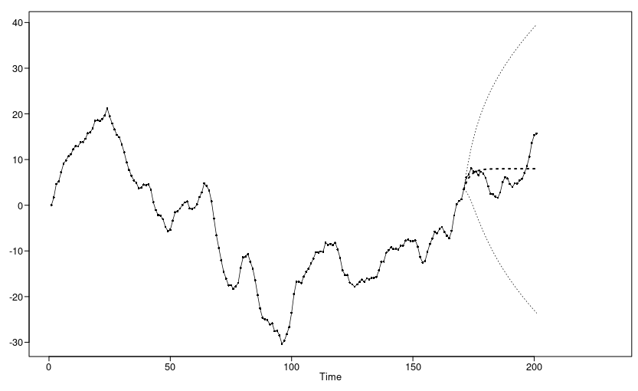

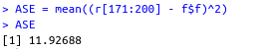
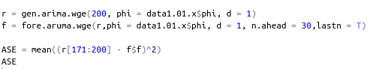
  - Fit a univariate MLP model to the realization using 50 repetitions reserving the last 30 observations to find the ASE. Find and report this ASE. Simply copy and paste the code and output.

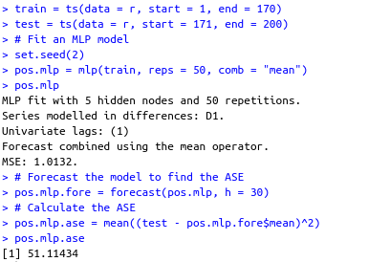

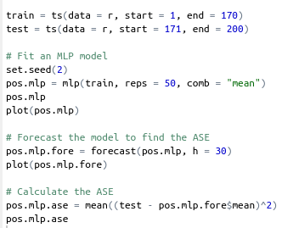
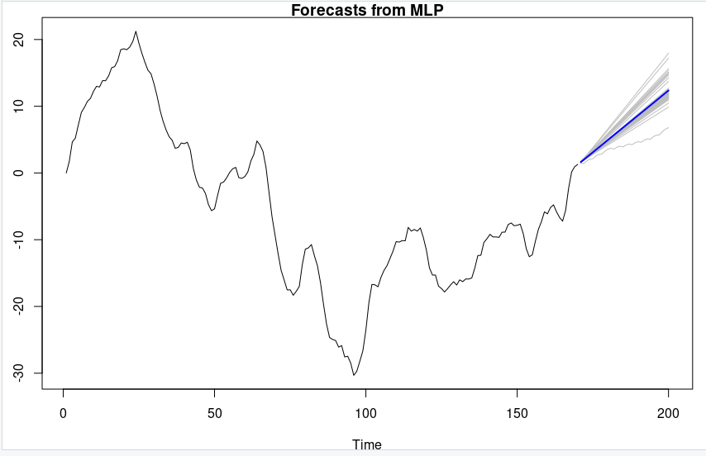

  - Given you answers in f and g, which model do you feel is most useful in forecasting the next 30 observations? Why? (One sentence should suffice.)
The best model was the ARIMA model. At some point it predicted constant values so it could have predicted the mean of the last 30 while the mlp predicted up.

- Consider the data in the realization in FinalExamData2.csv. Our variable of interest is X1(we would like to provide useful forecasts for X1) and can use X2 and X3 if they are found to be useful. We will judge these models based on the AIC only. (3 pts each)

  - Fit a VAR model that uses all three variables in the response vector. Also allow for the model to fit an intercept (constant) and trend. Allow for p up to 5. Simply copy and paste your code and output and report the AIC.

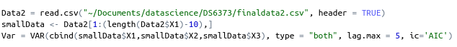

  - Next, fit a VAR model that uses all three variables in the response vector but this time only allows for the intercept (constant) and no trend. Allow for p up to 5. Simply copy and paste your code and output and report the AIC.

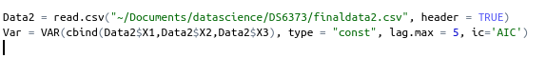

  - Which model do think is most appropriate and why? Use this model to provide the forecast of the next 5 observations of the X1 variable (the variable of interest). Simply copy and paste your code and the 5 forecasts.

