CS 7337 – Natural Language Processing
Midterm Exam
Instructions: Clarity of answers is more important than length of answers. Although not
required (unless indicated otherwise), feel free to use graphs, charts, visuals, et al in your
answers if you feel these artifacts can help support your answers. There are no bonus points for
using these artifacts.

Due date: See instructors note; submission should be in PDF or Word DOCX file format.

Q1 . a. [5 pts] Define homonymy and polysemy and give an example of each.

Homonyms are words that are spelled and pronounced similarly but has different meaning.

For example, sow as a verb is to plant seed and Sow as a noun is a female pig.

Polysemys are words or phrases that can have different meaning in a related way or from same origin. They can introduce a degree of vagueness.

For example, woods can mean a materials made from a trees as well as a geographical area with many trees.

b. [5 pts] Define NLU and NLG and give an example of each.

Natural Language Understanding is a part of NLP that deals with machine reading comprehension. It involves transforming natural language into a machine readable format This is the most area data scientists work in.

NLU application example is machine translation like Goggle Translate. Translating one natural language to another.

Natural language Generator is a part of NLP that deals with natural language generator from an natural language data input.

NLG application example is a conversational text bot that can generate text based on the text input.

Q2.You are given the following grammar for expressions:
E → I
E → E + E
E → E * E
E → (E)
I → a
I → b
I → 0
I → 2

a. [10 pts] Show parse tree(s) for the expression 2 + 2 * 2

From the grammar expression given, E can go to I and to 2. So the parse tree would look like the following.

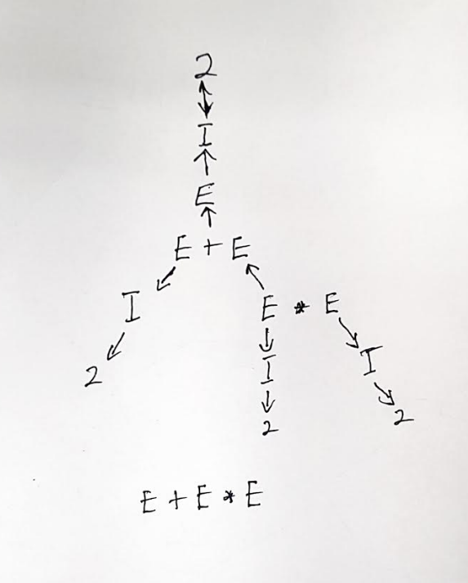

b. [10 pts] Describe any interesting observations in your answer to a.

E can be any of other character on any tree.

Q3. Consider the following grammar and sentence:

Sentence: I booked a flight from LA

a. [10 pts] In what way is this sentence ambiguous? Describe different interpretations of
this sentence.

The ambiguity lies in whether the flight is from LA or I am from LA.

The interpretation can be that I booked a flight while in LA or that I booked flight that is leaving from LA.

b. [10 pts] Show the parse trees for this sentence and where the ambiguity manifests in the
parse trees.

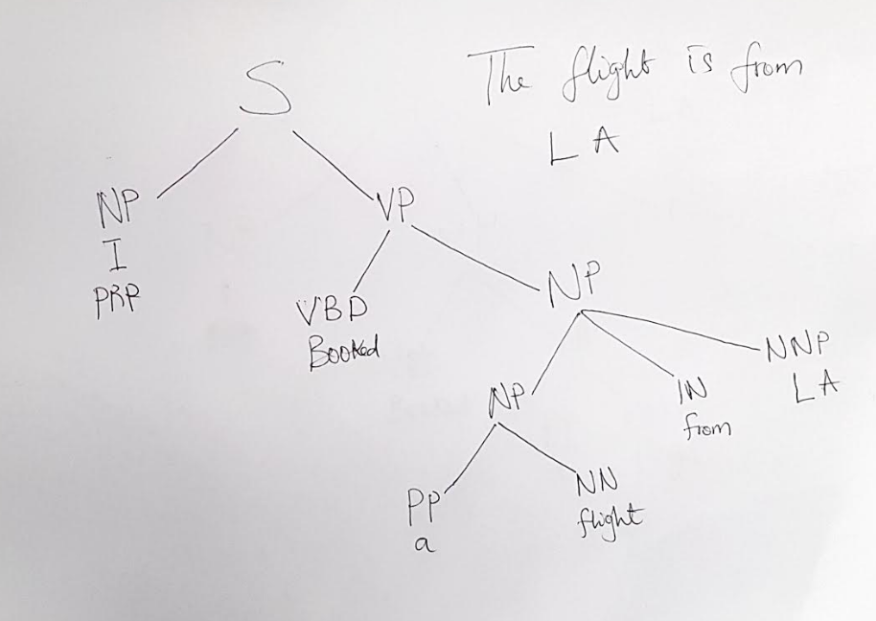
The parse tree figure above shows when the flight is leaving from LA

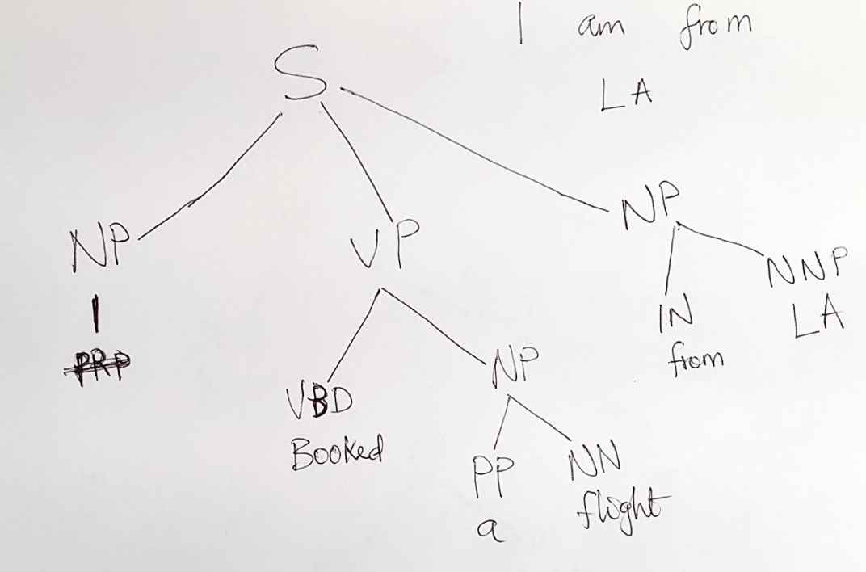
The parse tree above shows when I am from LA booking a flight

Q4.The image below shows Google search results for the query “harry potter”
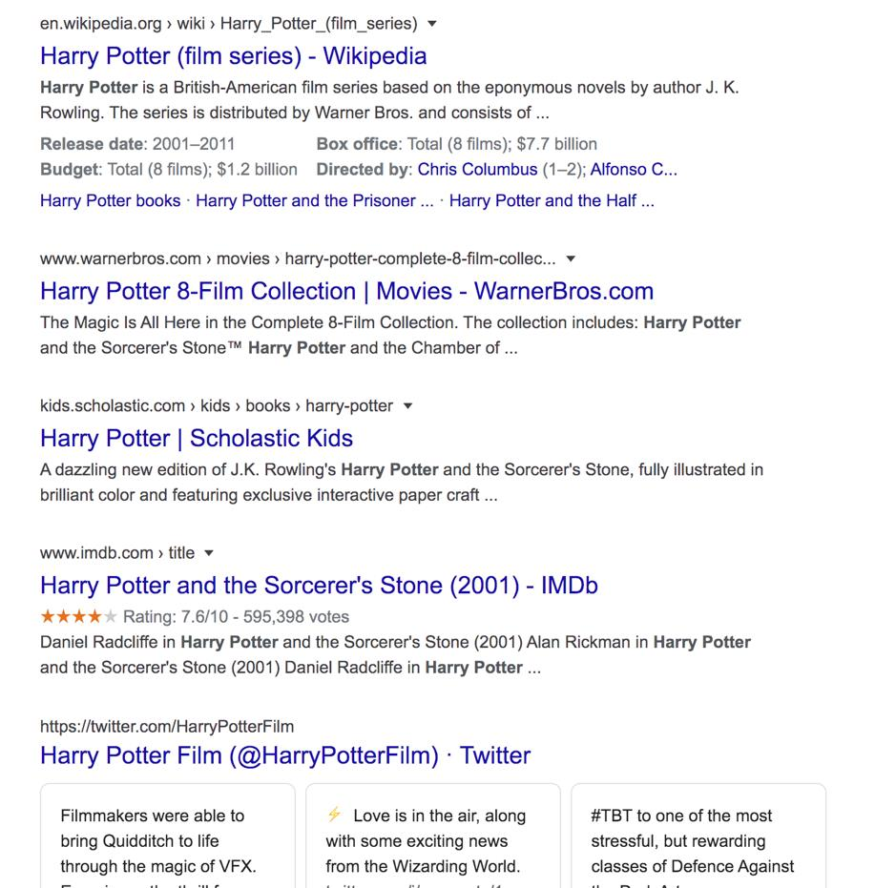
As the results show, the query could represent any of the seven books in the harry potter
franchise, any of the film adaptations of the books, a theme park, or a ride, an audiobook,
cartoons, et al.

a. [10 pts] Discuss why google shows a mix of such results and what factors can influence the
search results for this query that will be presented to you.

Google showed a mixture results because the search query was too broad. Harry potter has many entities so the search results tries to cover some of the top entities. To help refine the query, a more specific query must be entered. For example, a specific harry porter book with book to differentiate it from the movies, adding theme park or words related to it, audiobooks, etc.

Be more specific.

b. [15 pts] Consider the following sentence:

The bank can guarantee deposits will eventually cover future tuition costs because it invests in
adjustable-rate mortgage securities.

The word bank has multiple senses. Use Wordnet to show the top two sense, glossaries and
examples for bank and describe (at a high level) how you can use this information to find the
proper sense for this word in a sentence.

Since the word bank is represented as a Noun in this sentence, we would look under the Noun senses of the word. The top two senses are shown below.

S: (n) bank (sloping land (especially the slope beside a body of water)) "they pulled the canoe up on the bank"; "he sat on the bank of the river and watched the currents"
S: (n) depository financial institution, bank, banking concern, banking company (a financial institution that accepts deposits and channels the money into lending activities) "he cashed a check at the bank"; "that bank holds the mortgage on my home"
The second sense contains words that are the same with the sentence that is being analyzed. Words like deposits, depository, money, mortgage are related an/or the same as ones in the sentence.

Q5.You are building an online moving streaming service which enables looking up
information on movies, genres, directors, actors and customer movie preferences.

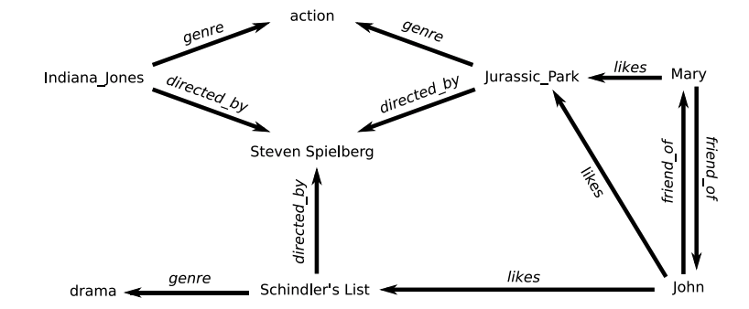
**(Indiana Jones refers to Raiders of the Lost Ark (1981))

a. [10 pts] What is the customers intent (i.e. what are they looking for) with the following
queries? (these are individual queries, not queries entered in succession)

“Drama”, “Jurassic Park”, “Indiana Jones: Raiders of the lost ark”, “Steven Spielberg”

“Drama” - The customer is looking for movies in the drama genre.

“Jurassic Park” – The customer is looking for any of the Jurassic park movies.

“Indiana Jones: Raiders of the lost ark” – The customer is looking for a specific Indian Jones movies

“Steven Spielberg” – The customer is looking for a Steven Spielbergs movie.

b. [5 pts] A customer searches for “Indiana Jones” but clicks on and watches “Jurassic Park” –
what insights can you get from this customer action?

Both Jurassic Park and Indiana Jones movie are action genre movie and were directed by Steven Spielberg.

c. [10 pts] The customer searches for “Indiana Jones: Raiders of the lost Ark” but it’s not
available in their region (US, EU, Asia). What search results would you show the customer?
Discuss how you would build that experience from a technical design perspective.

Given that the movie is an action movie and is also directed by Steven Spielberg, we would show them list of action movies which were also directed by Steven Spielberg. If there are none, then we can show them action movies and then other movies which were directed by Steven Spielberg.

