**Group 9 – “Last Minute”**

**Introduction to Information Technology**

**COSC2083**

**Assignment 2: The IT World**

Contents

**1. Team Profile** 3

1.1 Team name 3

1.2 Personal information 3

1.3 Team Profile 4

1.4 Ideal Jobs 8

**2. Tools** 13

2.1 Team Website 13

2.2 Team Github 13

**3. IT Work** 14

3.1 What kind of work is done by the IT Professional? 14

3.2 What kinds of people does the IT professional interact with? Are they other IT professionals? Clients? Investors? The general public? 14

3.3 Where do the IT professionals spend most of their time? 14

3.4 What aspect of their position is most challenging? 14

**4. IT Technologies** 15

4.1 Cybersecurity – Phuong Hoang 15

4.2 Cloud Technologies – Nwar Alain Bin Hazmi 16

4.3 Artificial Intelligence and Machine Learning – Khoi Tran 17

4.4 Robots – Minh Nguyen 18

**5. Project Ideas** 19

5.1 Overview 19

5.2 Motivation 19

5.3 Description 19

5.4 Tools and technologies 19

5.5 Skills required 20

5.6 Outcome 20

**6. Feedback** 21

# **1. Team Profile**

## 1.1 Team name

* Last Minute

## 1.2 Personal information

* Phuong Hoang (S3885751):
* My name is Hoang Duc Phuong (s3885751), and I am now a student at RMIT University in Melbourne, Australia. Even though I am twenty years old, this is my first year at RMIT. My family and I are devout Christians, so we devote an hour on Sundays to attending church services. I had just returned to Viet Nam last year due to the pandemic, which occurred while I was studying in Australia for two years at the time. I have already completed my first semester at Swinburne University in Australia, however I have decided to leave the university and return to Viet Nam. In addition, I am a person who is full of energy. In the meantime, I participate in a variety of activities, including tennis on Mondays, Wednesdays, and Fridays, and soccer on Thursdays. If anyone is interested in joining me, please contact me through my school email address: s3885751@rmit.edu.vn or my phone number: 0824933333
* Nwar Alain Hazmi (S3915079):
* My name is Nwar Alain Bin Hazmi, people generally call me by my second name Alain/Alan. **I have lived in 5 different countries, Malaysia (5 Years), Korea (1 Year), Sudan (3 Years), Singapore (12 Years) and now Vietnam. Prior coming to RMIT, I used to work as an IT engineer for four years in total. I am interested in Cloud computing technologies and I wish to dive deeper while undertaking my degree. I enjoy playing the piano, boxing and playing first-person shooter games on my laptop.**
* Minh Nguyen
* My name is Nguyen Hoanh Minh (s3915233), I’m currently studying my second semester in RMIT University here in Saigon. Before that, I’ve spent 2 years studying in the US, my Senior year of high school and my first year of university as an Electrical Engineering Student. I’ve spent most of my high school years working on IoT, STEM and robotics projects, including participating in related clubs, too. Due to covid, I was forced to return home last year. I’ve worked in minor roles as a Market Research and a Product Operations intern. It was through my time in Product Operations that I found my interests in IT. My dream job in the IT field is currently still in its early stages, but so far, I’ve found interest in software development, and I hope that through studying here, my dream job would be more concrete. Some of my hobbies are: playing my classical music on my guitar, listening to music, running (daily), swimming and playing video games.
* Khoi Tran (S3916827):
* My name is Khoi Minh Tran and this is my second semester at RMIT University. I have studied aboard in United States for almost four years and have lots of experience in English. I choose RMIT because I get used to learn everything by English, also I can have a chance to keep improving it and RMIT can guide me to choose IT job that suit me best since I have not decided it yet. I love playing soccer, badminton and playing games.

## 1.3 Team Profile

* Phuong Hoang  
    
  Table

  Description automatically generated  
    
  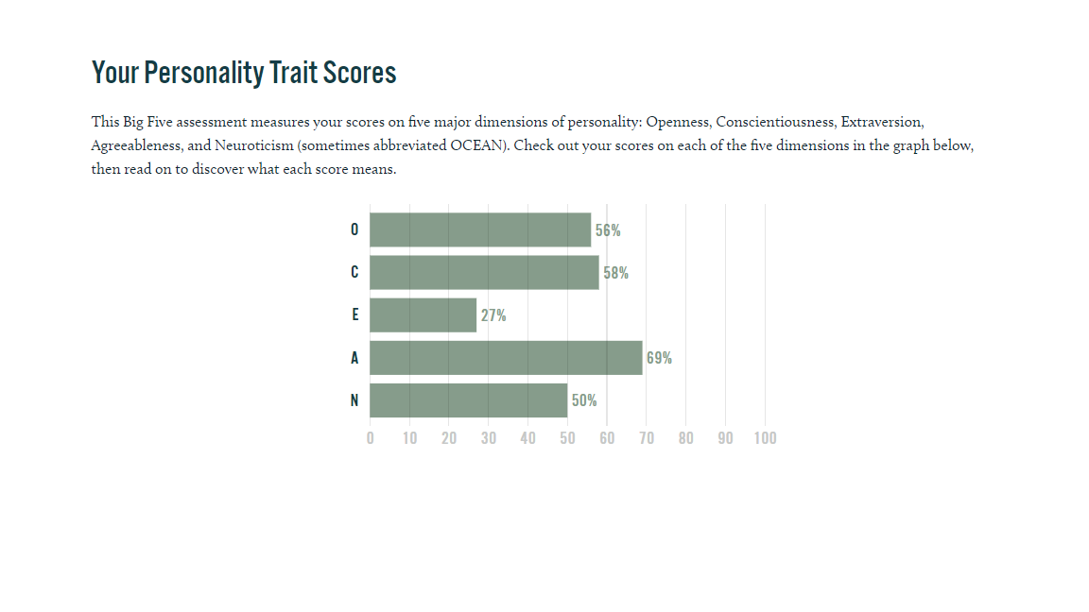  
    
  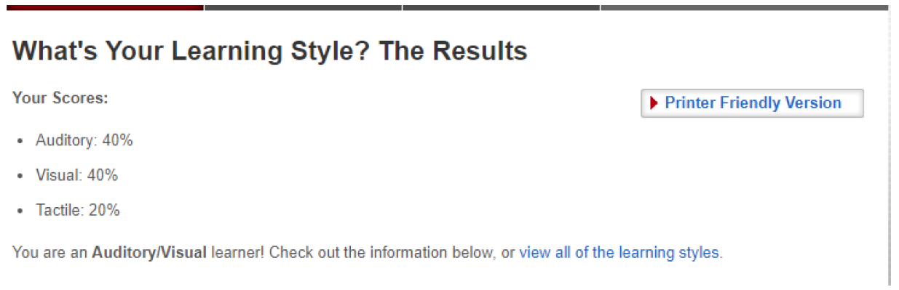

* Nwar Alain Hazmi  
    
  Graphical user interface, application

  Description automatically generated  
    
  Chart, bar chart

  Description automatically generated  
    
  Graphical user interface, text, application, email

  Description automatically generated
* Minh Nguyen

* Khoi Tran

## 1.4 Ideal Jobs

* Phuong Hoang

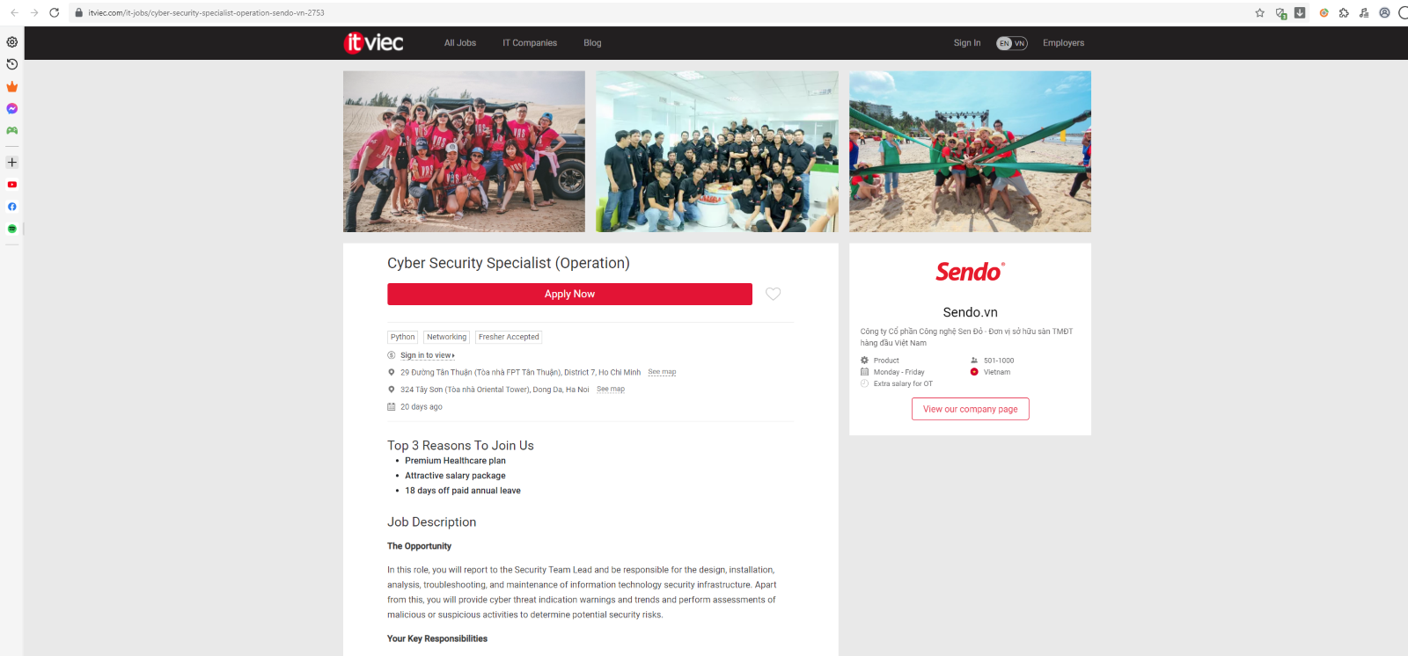

As a security team lead, I was expected to design, develop, analyze, debug, and maintain an information system's security infrastructure, all while reporting to the Security Team Lead. As part of the Security Team, I'll work closely with other members to guarantee that the infrastructure is protected. I will also offer cyber threat alerts and trends, undertake analysis of damaging or suspicious behaviour, and identify possible security threats.

Contrast with teammates:

Alain usually provides a solution to his clients and customers whether I am working with my teams or groups to protect the infrastructure.

* Nwar Alain Bin Hazmi

I will be working in one of the biggest companies in the technology industry, Microsoft. This position appeals to me as I will be handling issues providing solutions to customers/clients within Microsoft 365 scope.

Contrast with teammates:

The similarity is that we all will be working with a group of other IT professionals. From what I understand is that I will be managing and providing solutions to the customer based on their infrastructure it will be different with Phuong Hoang as he will be managing the security side of things such as doing penetration testing. In comparison with Khoi Tran, he will be working on software development which is different from my role as I only come in to play after the development phase is done.

* Minh Nguyen

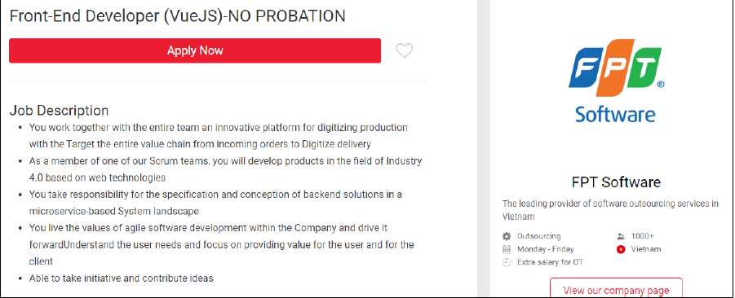

I will be working in one of the more notable tech companies in Vietnam, FPT, as a Software developer (Front-end dev). As a front-end developer I will be working with on the specification and conception of back-end solutions in a microservice-based (multiple small services) landscape and developing 4.0-based web technologies. I will be working in scrum teams using the agile software development method. For senior levels, I would have the additional responsibility to coach junior team members to help them reach their maximum potential.

Contrast with teammates:

Similar to my job position, Khoi will be working on Software development in the back-end. Both front and back end jobs usually work together in the development to solve problems and create new projects. In contrast, Alain will be working on supporting, solving clients problems and providing them with solutions. On the other hand, Phuong will be working in the security section, specifically the cybersecurity of the Information System, this includes every job and position that uses IT to work. Because our group will be working in IT-related jobs, if we all work in the same company with our preferred job positions, there’s a high chance that we’ll all be working with each other in one way or another

* Khoi Tran

I will be working as a Backend Leader in one of newest bank named Tyme in Vietnam and the main language is Java. As the team leader, I will guide my teammates to do their best job, I will have responsibility to review and test or fix their code. Also, in this position I must make everything more performance and reliable. And in the hard case, I must have professional problem-solving skills which a leader must have to lead everyone so the team will not be stressed or overwhelmed.

Contrast with teammates:

Compare to other teammates. in this position I want to have it requires many years of experience and lots of conditions when other teammate dream job does not require many years of experience which they immediately might have after they graduate. When I must work for many years in different companies to get more experience and after that I might get that job. With Minh Nguyen position, we might work together in the future because Front-end and Back-end always work together also we are doing software development. On the other hand, Alain will support the client by giving them the best solution and he will meet more customers than my job when mostly my job is trying to write the best program. Also, Phuong Hoang is a security leader who will try to protect our program or information in the company and check if there is any suspicious activity that is trying to get into our system.

# **2. Tools**

## 2.1 Team Website

* <https://nwar96.github.io/Group9-COSC2083/index.html>

## 2.2 Team Github

* <https://github.com/nwar96/Group9-COSC2083>

# **3. IT Work**

## 3.1 What kind of work is done by the IT Professional?

* He is working as an Infrastructure engineer, maintaining the current environment of the customer on Microsoft Azure to perform as expected. He manages a change request which is the addition, modification, or removal of anything that could have a direct or indirect effect on services according to Information Technology Infrastructure Library (ITIL) standard requested by the customers or new considerations from the solution architect or subject matter expert. With each environment he also in charge of setting up new virtual machine which host web and application servers. Every month he has a scheduled maintenance to update all the application and web servers

## 3.2 What kinds of people does the IT professional interact with? Are they other IT professionals? Clients? Investors? The general public?

* He is currently working in a group comprises of other IT professionals. Working with clients directly, at times he will need to interact with the key stake holders and generally during those meetings, a solution architect and a subject matter expert would be present. Whenever a change request is required, he will need to interact with the Change Advisory Members for them to approve the change request.

## 3.3 Where do the IT professionals spend most of their time?

* Normally he spends most of his time at office at his desktop. There are times where sensitive info are required, therefore he will often travel to the customer office to discuss and exchange information.

## 3.4 What aspect of their position is most challenging?

* Managing expectations of the customer. Customers may have the misconception that we are responsible for any issues faced which needs to be fixed within a day, but ultimately there are some issues which requires more than a day and multiple trial and error runs, for other issues it might escalate further and involve the Solution Architect (SA), Subject Matter Expert (SME) and other key personnel such as the project manager.
* At times during launch of a certain application, the engineer would need to monitor all functioning components of the environment is working as expected, if there are any issues that appear throughout his cycle (which may take up to weeks) he will need to troubleshoot which may escalate to a Solution Architect (SA), Subject Matter Expert (SME) and the customer themselves, which could happen at any given time.

# **4. IT Technologies**

***What does it do? (600 words)*** ​What is the state of the art of this new technology? What can be done now? What is likely to be able to do be done soon (say in the next 3 years)? What technological or other developments make this possible?

***What is the likely impact? (300 words)*** ​What is the potential impact of this development? What is likely to change? Which people will be most affected and how? Will this create, replace or make redundant any current jobs or technologies?

***How will this affect you? (300 words)*** ​In your daily life, how will this affect you? What will be different for you? How might this affect members of your family or your friends?

## **4.1 Cybersecurity – Phuong Hoang**

The technique of protecting electronic systems, networks, and data, including computers, servers, mobile devices, and other electronic devices, from hostile intrusions is known as cyber security. Electronic information security and information technology security are other terms for the same thing. For example, the phrase can be used in a wide range of contexts, from the workplace to mobile computing. Here are some example of what security can be done nowadays.

* Network security: Protecting a computer network from intruders, whether they're malicious insiders or random invaders, is what network security is all about.
* Application security: The goal of application security is to avoid software and devices from being infected by malicious code. In the event of an application being hacked, the data it is supposed to safeguard could be accessed. In order for a software or gadget to be secure, it must be designed before it is put into use.
* Information security: Application security is concerned with preventing harmful code from infecting software and devices. Data that is supposed to be protected by an application can be accessible if it is hacked. Before it can be used, a piece of software or gadget must be thoroughly tested for security flaws.

Cybersecurity can only be done now by human physically. As cyberattacks become more sophisticated and difficult to predict, businesses are doing all in their power to protect themselves. Identifying the next significant malware threat is even more difficult, as the Zeus trojan and Locky ransomware were once serious concerns, but today things like Emotet botnet, Trickbot trojan, and Ryuk ransomware are things to watch out for. Cyber criminals take advantage of the fact that it's tough to protect your perimeter against unknown threats.

A growing number of cybersecurity systems are leveraging artificial intelligence (AI) and machine learning (ML) to identify possible hazards, such as an employee account that is clicking on suspicious links, or a new type of malware. The fight between attackers and defenders remains ongoing, however. It's not a new strategy for cybercriminals to modify their malware code so that it's no longer flagged as bad. Defenders are increasingly relying on AI and ML to detect even the most obscure new varieties of malware attack, because it is difficult to detect malware that has been purposefully disguised. The machine-learning database is able to get information on any previously discovered virus. By checking the code against the database, the system is able to detect new forms of malware, such as altered variants of current malware or completely original threats and stop them if comparable occurrences have previously been identified as malicious.

In cybersecurity, machine learning can identify and respond to possible problems almost instantly, preventing them from interrupting the operation of the company. As a result of installing AI-based cybersecurity from Darktrace, the McLaren Formula One team hopes to maintain the network's safety without relying on people to accomplish the impossible task of monitoring everything at once. Despite the fact that AI and ML can have a positive impact on cybersecurity, organizations must understand that these tools are not a substitute for human security personnel. As an example, if a machine learning-based security tool has been developed poorly, the algorithms may miss out on things that are obvious or even surprising. This is a big concern if the tool doesn't recognize a particular type of cyberattack since it doesn't take into account key parameters.

## **4.2 Cloud Technologies – Nwar Alain Bin Hazmi**

Simply described, cloud computing is the distribution of computer services over the Internet ("the cloud") in order to provide speedier innovation, more flexible resources, and economies of scale. You normally only pay for the cloud services you use, which helps you cut expenses, manage your infrastructure more effectively, and scale as your business grows.   
  
Cloud computing represents a significant departure from how organizations have traditionally viewed IT resources. The following are seven of the most prevalent reasons why businesses are turning to cloud computing services:

* Costs - Cloud computing reduces the upfront costs of purchasing hardware and software, as well as the costs of building up and maintaining on-site datacenters—the racks of servers, the round-the-clock power and cooling, and the IT specialists to manage the infrastructure. It's easy to lose track of how much money you're spending.
* Efficiency - Most cloud computing services are self-service and on-demand, which means that even massive quantities of computing resources may be deployed in minutes, usually with only a few mouse clicks, offering enterprises a lot of flexibility and relieving capacity planning strain.
* Scale - The capacity to scale elastically is one of the advantages of cloud computing services. That implies delivering the proper amount of IT resources—for example, more or less computing power, storage, and bandwidth—at the right time and from the right geographic place, in cloud language.
* Productivity - On-site datacenters often need a great deal of "racking and stacking"—hardware configuration, software patching, and other time-consuming IT administration tasks. Many of these duties are no longer necessary thanks to cloud computing, allowing IT professionals to focus on more critical business objectives.
* Performance - The most popular cloud computing services are hosted on a global network of secure datacenters that are updated on a regular basis with the current generation of fast and efficient computing hardware. This has various advantages over a single corporate datacenter, including lower application network latency and higher economies of scale.
* Security - Many cloud providers offer a broad set of policies, technologies, and controls that strengthen your security posture overall, helping protect your data, apps, and infrastructure from potential threats.

Cloud computing may not have a direct impact to my daily life unless I ventured it as my profession. As of now business are transitioning into cloud from on-premises at a very fast rate as mentioned previously offers more benefits as compared to traditional on-premises servers. Perhaps in the near future there are further improvements which may need me to do a lot of catching up by reading and upskilling myself by completing the examinations related to cloud computing. Since nowadays, my family members and friends tend to save their data in the cloud using their mobile phones, in this case not much have change and the only change would only be how easily accessible the data that they have uploaded to the cloud.

## **4.3 Artificial Intelligence and Machine Learning – Khoi Tran**

In general, AI systems operate by consuming huge volumes of labeled training data, evaluating the data for correlations and patterns, and then using these patterns to forecast future states. By examining millions of instances, a chatbot given examples of text chats may learn to make lifelike dialogues with humans, while an image recognition program can learn to recognize and describe items in photographs. After doing some research, there are lots of examples of how AI was doing those days:

* Automation: Automation tools, when combined with AI technology, may increase the volume and variety of jobs completed. Robotic process automation (RPA) is one example. RPA is a sort of software that automates repetitive, rules-based data processing operations that were previously performed by people. RPA, when integrated with machine learning and other AI technologies, has the potential to automate more amounts of business jobs, allowing RPA's tactical bots to pass along AI intelligence and adapt to process changes.
* Machine Learning: This is the science of making a computer act without the need for programming. Deep learning is a subset of machine learning that, in simplest terms, may be thought of as predictive analytics automation. And there are 3 types of machine learning: Supervised learning, Unsupervised learning, and Reinforcement learning.
* AI in Finance: AI in personal finance apps like Intuit Mint and TurboTax is upending financial institutions. These kinds of applications capture personal information and offer financial advice. Other systems, including IBM Watson, have been used in the home-buying process.

AI has a significant influence because it may provide organizations with insights into their operations that they were previously unaware of and because, in some situations, AI can do tasks better than people. AI tools, particularly when it comes to repetitive, detail-oriented activities like reviewing huge quantities of legal papers to verify important fields are correctly filled in, frequently accomplish assignments swiftly and with few errors. For example, it would have been difficult to conceive of employing computer software to link riders to cabs, but Uber has grown to become one of the world's largest firms by doing precisely that. It uses powerful machine learning algorithms to estimate when people are likely to require rides in certain places, allowing drivers to be on the road before they are needed such as Grab, Bee, etc. in Vietnam.

AI has been affected me a lot since I went to college in United States and now it still influences a lot of in my daily life. While the massive amount of data generated daily, AI solutions that employ machine learning can swiftly transform that data into usable knowledge which I can find on the Internet. Also, it can reduce time for data heavy tasks such as writing, right now I can easily press on the keyboard to type I do not have to get a piece of paper and a pen to write down my assignments. And our teammates do not have to give each other a piece of paper to read when we can share our document where we can save every work of everyone. Of course, AI will affect my family, and my friends since AI is evolving every day and people are using it more to make humans have an easier and better life. Nowadays, people do not know anything about something they can easily search on Google because AI mostly gives consistent outcomes for them.

## **4.4 Robots – Minh Nguyen**

The textbook definition of a robot is a machine, the ones programmable by a computer and capable of carrying out a complex series of actions automatically. Robots have many functions which are used in multiple industries and specialized jobs. All types of robots are developing rapidly as the demands for new technology increases, whether through the public for products or through specialists for tools and research.

There are multiple types of robots, ranging from small one to massive ones, that are being utilized in many different industries and some are used by more specialized roles. Here are some of them:

* Pre-programmed robots: These are robots that have been programmed with simple, repetitive functions. These usually take the form of mechanical arms used on assembly lines in mass production factories. Given Vietnam’s production and manufacturing An interesting example of this type of robot would be the Canadarm, used on space shuttles and the ISS in assisting astronauts in capturing and moving payloads.
* Humanoid robots: Humanoid robots are robots that have functions, looks like or is able to mimic the behavior of a human. They usually have the ability can walk, are capable of using their hands (and fingers if given) to carry objects or carry out other human-like activities. Examples of this would be the Boston Dynamics’ Atlas robot or the “Stuntronics” stunt robot created by Disney to perform stunts. Other humanoid robots have a human-like face which is capable of displaying a range of emotions or move their mouths if they can talk. A well-known example with be Sofia, the social humanoid robot. Humanoid robots’ developments are parallel to the development of AI and machine learning in order to better mimic like humans.
* Autonomous robots: These robots operate independently from human operators, usually used in environments that don’t require human supervision. They usually require specific sensors to sense their environment and surroundings. An example of this type of robot would be the Roomba automatic robot vacuum cleaner.
* Teleoperated robots: These are semi-autonomous robots used by humans from a safe distance using wireless network. They are used in extreme, dangerous, and hazardous weather, geographical and environmental conditions. An example of this robot would be any one of NASA’s rovers, a recent example would be the Perseverance Mars rover, which landed on Mars on July 2021. Other examples include mine-clearing robots used in the US military.
* Augmenting robots: Augmented robots are robots that are used by humans to replace the capabilities they may have lost. Human body augmentation has been inspired by science fiction and has been increased in development due to the availability and access of tools and knowledge required to develop it. Most importantly, it could help those who have lost their limbs through accidents or through combat to regain their normal capabilities. In the future, augmentations may even have the potential to extending human capabilities (jump higher, be stronger) further than the human limit.

With the rapid development of robots they will be affecting not just our jobs but our daily lives too. Pre-programmed robots will further increase the efficiency of the manufacturing of products. Autonomous robots will be used more integrated in our daily lives with helper robots. Humanoid robots will be developed to perform more human-like tasks that could help temporarily or permanently replace certain dangerous or risky duties. Teleoperated robots will be further developed as we explore and research more dangerous and hazardous areas, on earth and in space. Augmenting robots will mainly be developed to have their functions more human-like in order for the amputees to seamlessly integrate into their daily activities. I think those who suffer most from these technological development and progress are labor workers, manufacturing workers in 3rd world countries and certain public service jobs.

When it comes to advance and specialized robots such as the humanoid, and pre-programmed and the teleport robots. I don’t think it’s development and changes will affect me unless I will be in a profession that will be working and interacting with it in the future. Although, they will be affecting lots of laboring jobs in a few years’ time. However, certain robots such as Autonomous robots will become more prevalent in my life as time goes on. Not only do cleaning robots might come into my daily life but other robots used in smart home technologies might also do too.

# **5. Project Ideas**

## 5.1 Overview

* In terms of our idea, we would like to establish a website or app where gamers can discover teammates to play with. In terms of the website, we will make a link that folks can easily copy and paste. Also, gamers must sign up and enter information such as their name, the game they play, their account details, and a personality to choose from (play for fun, grind hard, etc.) so that the website or app can discover others to play with. Furthermore, it may display people's ratings and remarks from other players, allowing others to determine whether that person is friendly.

## 5.2 Motivation

* Creating a website or program like PlayerDuo, Discord, and others is beneficial for gamers, however this website does not demand payment to play with others. Since the Covid-19 epidemic occurred in Vietnam, we know people may go out as usual right now, but some individuals believe it is still unsafe. Also, with the advancement of technology and the quality of many games, we believe that many people now choose to play online games. So, we believe it will be beneficial if we establish a website where people can look for someone to play with since it is more enjoyable and allows you to meet new people.

## 5.3 Description

* When you use our website service, clicking on the link or typing the exact website link will take you to our home page. On our main page, the logo or name of the website will be shown in the upper left corner to ensure that clients are visiting the correct website. It will also contain log-in and sign-up buttons in the upper right corner for easy access. If you have already checked in, it will display numerous rooms with many individuals waiting in them, and you may request to join in to play with them. When our website is new and unpopular in Vietnam, we will put a "How it works" guide on a bar for new visitors who are unsure what to do on my website. "How it works" will walk clients through the process of signing up, logging in, entering their information, and so on. When you join up and log in, you will be asked to input your location, what games you play, and other information so that we can identify the best-fit gamers or rooms for you. Following that, we will have "Features," where you will see what my website is capable of. Well, on our websites, we will have private messaging to make it simpler for people to connect and talk, and it will offer several rooms for people to request, as well as games next to them so people can see what games they are playing. Finally, we will offer "Supports" where clients may seek assistance and send emails to us to resolve issues with the website or the players with whom they play.

## 5.4 Tools and technologies

* According to our research, to establish a website, we need website scripting, a web browser, a file transfer protocol, and so on. Contact forms, interactive buttons and controls, website databases, and shared material between web pages are all required in website scripting (What is Needed for a Website? - Code Conquest, 2021). Because each web browser generates HTML and CSS in a unique way, you must guarantee that your website displays and runs properly in each one. We also need web hosting, which is a service that keeps your website files (HTML, CSS, images, scripts, and so on) on a server for anybody to access. A domain name is the address of your website (for example, facebook.com). Another type of protocol is a file transfer protocol (FTP). You must use FTP to transfer your website files from your computer to the server that will host your website. To put it simply, this is the process of uploading files to the Internet.

## 5.5 Skills required

* You must be proficient in HTML and CSS to create a website. The reason for this is because HTML and CSS are the core languages of websites, and you will need both to create a functional one. HTML without CSS not only looks poor, but it may convey the idea that your site has a fundamental problem.

## 5.6 Outcome

* If this idea is a success, we will create a large gaming community. People will form several associations with others; they may meet friends or lovers. Individuals will leave the streets, allowing the authorities to easily heal and control other people who are suffering Covid-19. Some people, we know, do not believe in internet dating, but if you are lucky, you could meet a nice individual up there. If you are wondering how we know that we will tell you. So, we have a lot of online friends with whom we play games, and we have met them in person as well. They are unexpectedly kind folks who care about one another. They educated and assisted us in a variety of ways to help us become a better person in life, which we much appreciate. So, we hope that individuals who are going through a tough time may join online and play online games with each other to be happy in life and make a lot of friends, so they do not feel lonely.

# **6. Feedback**

* Phuong Hoang
* I am very lucky to be a member of this group. With great leadership skills from Nwar Alain Hazmi we manage to overcome the struggle we have for the assignment. Khoi Tran has a strong responsibility on his part; he is always finished the group before other members with accuracy. Minh Nguyen has a very important role at this time as his opinion is very necessary for our group assignment.
* Nwar Alain Hazmi
* Good overall experience, everyone contributed equally and lent a helping hand towards members that were struggling during the assignment. Phuong Hoang helped in managing and scheduling meetings with the team. Minh Nguyen contributed in a timely manner on the contents required for the assignment. Khoi Tran was professional when it comes to meetings and was well prepared with his contribution.
* Minh Nguyen
* Our team has done a great job in planning and working on the assignment, everyone did their best to contribute to the group assignment and to help each other through through the process. Nwar Alain Hazmi had a great display of leadership, leading the team through the project. Phuong Hoang has helped in planning and organizing our meetings in an appropriate timeframe for all team members. Khoi has made great contributions to the project and the team as a whole.
* Khoi Tran
* I feel like everyone is trying their best to help each other and put effort into the group assignments. Nwar Alain Hazmi is doing a wonderful job as a team leader whenever we have a meeting, he always shares his screen and guides everyone into each part in a professional way. Phuong Hoang always tries to contact everyone and schedule every meeting to choose the best suit time for everyone. Minh Nguyen always tries to put his best effort to give his opinion in each part.