Mama G's General Store

Customer Loyalty Tracker, Release 1.0

Requirements Functional Specification

Revision 1.0

Specification Version: 1.0

Published: October 1, 2015

Author: Group 03

Table of Contents

**Customer Loyalty Tracker, Release 1.0**

1.0 Business Objective 5

2.0 Out of Scope/Assumptions 6

3.0 Summary of All Actors 7

4.0 Summary of All Use Cases 8

4.1 Use Case Descriptions 8

4.2 Diagram of All Use Cases 9

Well-written example 9

4.3 Individual Use Cases 10

User Login 10

Customer Registration 11

View Sales Report 12

Absent Customer Report 13

Coupon Ratio Report 14

Create Coupon 15

View Available Coupons 16

Generate Report 17

Frequent Buyer Report 17

Change Password 18

5.0 Proposed Site Map 20

Well-written example 20

6.0 Security 21

6.1 Security Requirements 21

• System Security 21

• Security Approach 21

• Third Party Software Security 21

• Interface Security 21

• Metrics 21

• User Authentication 21

6.2 Encryption Requirements 21

• Full Encryption Areas 21

• Application Data 21

• Encryption Business Policy 21

• Encryption in Transit 22

• Encryption in Storage 22

• Other Encryption Info 22

6.3 Access Control 22

7.0 System Metrics 23

7.1 Performance and Availability 23

• Performance Metric 23

• Availability Metric 23

• Other Metrics 23

• Volume of Users 23

• User Growth 23

• Most Traffic- Functionality 23

• Most Traffic- Time Periods 23

• Error Logging 24

• Connection Types 24

• User Locations 24

8.0 Platform Requirements 25

9.0 Risks 26

10.0 Sign-off 27

11.0 Glossary 28

11.1 Definitions of terms used in this document 28

***Document Revision Chart***

The following chart lists the revisions made to this document tracked by specification version. Use this to describe the changes and additions each time this document is re-published (both draft and final). The description should include as many details of the changes as possible.

|  |  |  |  |
| --- | --- | --- | --- |
| #.# | Section Modified and Revision Description | Date | Author |
| 1.0 | Initial Draft | 9/29/2015 | cfreas |
|  |  |  |  |
|  |  |  |  |
|  |  |  |  |
|  |  |  |  |
|  |  |  |  |

**Customer Loyalty Tracker, Release 1.0**

# Business Objective

The primary objective of the Customer Loyalty Tracker application for Mama G’s General Store is to use tracking data obtained from customer purchases to reward customers by providing them coupons for items that other customers frequently buy as a means of driving new sales. Customers who have stopped making purchases for a 90 day period are given coupons to incentivize them to return to Mama G’s.

The secondary business objective is to provide a means of understanding sales trends to more accurately incentivize customer purchases by providing timely, relevant coupons to these customers without overwhelming them with irrelevant marketing or too much marketing.

# Out of Scope/Assumptions

* It is assumed that Mama G’s General Store is a single brick-and-morter store (not a chain)
* It is assumed that the store owner will be the primary user of this application
* It is assumed that the store owner will be the administrative user of this application
* It is assumed that all store employees will have their own login credentials and access privileges
* Obtaining customer data for the loyalty program is out of scope for this document; the store owner must train his/her employees on how to capture this data and enter it into the application
* It is assumed that this application will require periodic maintenance and notification will be provided to the store owner in advance of any such maintenance

# Summary of All Actors

List of the actors for this application or website. Actors are users (humans) or other systems (non-humans) that participate in the actions of any use case. External systems can be actors only if they initiate some action within the system, or if they require some information from the system.

Note to Authors: A database within the system is generally not considered an actor.

| **Actor #** | **Actor** | **Human or System?** | **Description of Actor** |
| --- | --- | --- | --- |
| 1 | Store Admin | H | The store owner. Administrative access granted in order to manage the overall customer loyalty program but has no access to any internal or system components |
| 2 | Store Employee | H | Employees. Limited access granted to create and modify customer information as needed for proper functioning of the loyalty program |
| 3 | Developer | H | Application developers. Full administrative access is granted so updates can be provided and any problems with the system can be investigated. |
| 4 | System | S | System actor. This actor works in the background to take customer information and use it to generate coupons, send emails, and so on. |

# Summary of All Use Cases

## Use Case Descriptions

|  |  |  |
| --- | --- | --- |
| **Requirement #** | **Use Case Description** | **UC Rank (Priority)** |
| 1 | UC1_User_Login | 2 |
| 2 | UC2_Loyalty_Tracking_System: Register the user | 1 |
| 3 | UC3_View_Sales_Report | 3 |
| 4 | UC4_Customer_Absent_Report | 6 |
| 5 | UC5_Coupon_Ratio_Report – ratio of coupons issued versus used | 8 |
| 6 | UC6_Create_Coupon – user generated coupon creation | 9 |
| 7 | UC7_View_Available_Coupons | 7 |
| 8 | UC8_Generate_Report (sales, costs, coupons, reports, inventory) | 4 |
| 9 | UC9_Frequent_Buyer_Report | 5 |
| 10 | UC10_Change_Password | 10 |

## Diagram of All Use Cases

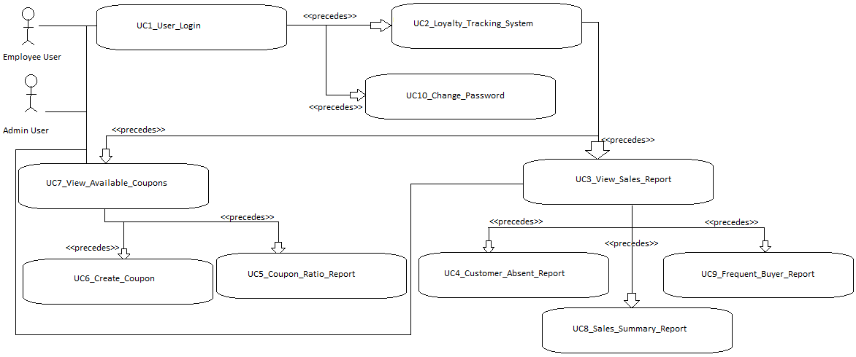

## Individual Use Cases

## User Login

|  |  |  |  |  |
| --- | --- | --- | --- | --- |
| Characteristic Information | | | | |
| Use Case ID | | * UC1_User_Login | | |
| Preconditions | | * User has browser window open | | |
| Successful Post Condition | | * User enters site; Mama G’s Home Page displays | | |
| Failed Post Conditions | | * User shown invalid username/password message | | |
| Primary Actors | | * Admin Users | | |
| Secondary Actors | |  | | |
| Related Use Cases | |  | | |
| Primary Scenario | | | | |
| Step | Scenario Action | | | Expected Behavior |
| 1 | Go to Home Login Screen  http://mamagstore.com | | | Mama G’s Login page displays |
| 2 | Enter username | | | Username displays in username field |
| 3 | Enter password | | | Astericks display in password field |
| 4 | Click Submit | | | User is forwarded to home page |
| 5 | End use case | | |  |
|  |  | | |  |
| Secondary Scenario 1 – User enters invalid Username | | | | |
| Step | Scenario Action | | | Expected Behavior |
| 1 | Go to Home Login Screen  http://mamagstore.com | | | Mama G’s Login page displays |
| 2 | Enter username | | | Username displays in username field |
| 3 | Enter password | | | Astericks display in password field |
| 4 | Click submit | | | User is shown invalid username/password message |
| 5 | End use case | | |  |
| Secondary Scenario 2 – Brief description of another Secondary Scenario | | | | |
| Step | Scenario Action | | | Expected Behavior |
| 1 | Go to Home Login Screen  http://mamagstore.com | | | Mama G’s Login page displays |
| 2 | Enter username | | | Username displays in username field |
| 3 | Enter password | | | Astericks display in password field |
| 4 | Click submit | | | User is shown invalid username/password message |
| 5 | End use case | | |  |
| Related Information | | | | |
| Systems Impacted | | | * Mama G’s web app. | |
| Error or E-mail Messages | | | * Username / Password not recognized. | |
| Special Requirements | | | * User must have a valid username and password to enter site. | |

## Customer Registration

|  |  |  |  |  |
| --- | --- | --- | --- | --- |
| Characteristic Information | | | | |
| Use Case ID | | * UC2_Loyalty_Tracking_System: Register the user | | |
| Preconditions | | * User has the site or app open | | |
| Successful Post Condition | | * Registration successful, user details are stored into the database and user is directed to the login page | | |
| Failed Post Conditions | | * User is redirected to registration with error message | | |
| Primary Actors | | * Admin Users | | |
| Secondary Actors | |  | | |
| Related Use Cases | |  | | |
| Primary Scenario – Registration | | | | |
| Step | Scenario Action | | | Expected Behavior |
| 1 | Go to the portal registration page by clicking the Register here option | | | The user is redirected to the registration page which requests for the user’s name, e-mail, phone number, date of birth and password |
| 2 | Enter user’s name | | | User’s name is displayed in the name field |
| 3 | Enter e-mail | | | User’s e-mail is displayed in the e-mail field |
| 4 | Enter phone number | | | User’s phone number is displayed in the phone number field |
| 5 | Enter date of birth (DOB) in the format MM/DD/YYYY | | | User’s DOB is displayed in the DOB field |
| 6 | Enter password (at least 8 characters) | | | The ‘*’ will be displayed in the password field |
| 7 | Click submit | | | User is forwarded to the Login page |
| 8 | End use case | | |  |
| Related Information | | | | |
| Systems Impacted | | | * Mama G’s web app. | |
| Error or E-mail Messages | | | * “Unknown error please contact system administrator | |
| Special Requirements | | | * User has the site or app open | |

## View Sales Report

|  |  |  |  |  |
| --- | --- | --- | --- | --- |
| Characteristic Information | | | | |
| Use Case ID | | * UC3_View_Sales_Report | | |
| Preconditions | | * User has logged into site successfully | | |
| Successful Post Condition | | * User can see and analyze sales report | | |
| Failed Post Conditions | | * User receives error ( if precondition true, then bug exists ) | | |
| Primary Actors | | * Admin Users | | |
| Secondary Actors | |  | | |
| Related Use Cases | |  | | |
| Primary Scenario | | | | |
| Step | Scenario Action | | | Expected Behavior |
| 1 | Log into site | | | Mama G’s Home page displays |
| 2 | Click the reports tab on the side bar. | | | User taken to main reports screen |
| 3 | Click sales report | | | User given filter options for report |
| 4 | Enter filter information ( To/from date, etc. ) | | | Text entered is captured in the text boxes |
| 5 | Click search | | | User is shown generated report with information filtered as intended |
| 6 | End use case | | |  |
| Secondary Scenario 1 – User runs report with no filters | | | | |
| Step | Scenario Action | | | Expected Behavior |
| 1 | Log into site | | | Mama G’s Home page displays |
| 2 | Click the reports tab on the side bar. | | | User taken to main reports screen |
| 3 | Click sales report | | | User given filter options for report |
| 4 | Click search | | | User is shown generate report without any filters ( all data ) |
| 5 | End use case | | |  |
| Secondary Scenario 2 – Brief description of another Secondary Scenario | | | | |
| Step | Scenario Action | | | Expected Behavior |
| 1 |  | | |  |
| 2 |  | | |  |
| 3 |  | | |  |
| 4 |  | | |  |
| 5 | End use case | | |  |
| Related Information | | | | |
| Systems Impacted | | | * Mama G’s web app. | |
| Error or E-mail Messages | | | * Unknown error please contact system administrator | |
| Special Requirements | | | * User must have a valid username and password to enter site. | |

## Absent Customer Report

|  |  |  |  |  |
| --- | --- | --- | --- | --- |
| Characteristic Information | | | | |
| Use Case ID | | * UC4_Customer_Absent_Report | | |
| Preconditions | | * User has logged into site successfully | | |
| Successful Post Condition | | * User can see and analyze customer absent report | | |
| Failed Post Conditions | | * User receives error ( if precondition true, then bug exists ) | | |
| Primary Actors | | * Admin Users | | |
| Secondary Actors | |  | | |
| Related Use Cases | |  | | |
| Primary Scenario | | | | |
| Step | Scenario Action | | | Expected Behavior |
| 1 | Log into site | | | Mama G’s Home page displays |
| 2 | Click the reports tab on the side bar. | | | User taken to main reports screen |
| 3 | Click customer absent report | | | User given filter options for report |
| 4 | Enter filter information ( To/from date, etc. ) | | | Text entered is captured in the text boxes |
| 5 | Click search | | | User is shown generated report with information filtered as intended |
| 6 | End use case | | |  |
| Secondary Scenario 1 – Brief description of a Secondary Scenario | | | | |
| Step | Scenario Action | | | Expected Behavior |
| 1 | Log into site | | | Mama G’s Home page displays |
| 2 | Click the reports tab on the side bar. | | | User taken to main reports screen |
| 3 | Click customer absent report | | | User given filter options for report |
| 4 | Click search | | | User is shown generate report without any filters ( all data ) |
| 5 | End use case | | |  |
| Secondary Scenario 2 – Brief description of another Secondary Scenario | | | | |
| Step | Scenario Action | | | Expected Behavior |
| 1 |  | | |  |
| 2 |  | | |  |
| 3 |  | | |  |
| 4 |  | | |  |
| 5 | End use case | | |  |
| Related Information | | | | |
| Systems Impacted | | | * Mama G’s web app. | |
| Error or E-mail Messages | | | * Unknown error please contact system administrator | |
| Special Requirements | | | * User must have a valid username and password to enter site. | |

## Coupon Ratio Report

|  |  |  |  |  |
| --- | --- | --- | --- | --- |
| Characteristic Information | | | | |
| Use Case ID | | * UC5_Coupon_Ratio_Report | | |
| Preconditions | | * User has logged into site successfully | | |
| Successful Post Condition | | * User can see and analyze coupon sales ratio report | | |
| Failed Post Conditions | | * User receives error ( if precondition true, then bug exists ) | | |
| Primary Actors | | * Admin Users | | |
| Secondary Actors | |  | | |
| Related Use Cases | |  | | |
| Primary Scenario | | | | |
| Step | Scenario Action | | | Expected Behavior |
| 1 | Log into site | | | Mama G’s Home page displays |
| 2 | Click the reports tab on the side bar. | | | User taken to main reports screen |
| 3 | Click coupon sales ratio report | | | User given filter options for report |
| 4 | Enter filter information ( To/from date, etc. ) | | | Text entered is captured in the text boxes |
| 5 | Click search | | | User is shown generated report with information filtered as intended |
| 6 | End use case | | |  |
| Secondary Scenario 1 – Brief description of a Secondary Scenario | | | | |
| Step | Scenario Action | | | Expected Behavior |
| 1 |  | | |  |
| 2 |  | | |  |
| 3 |  | | |  |
| 4 |  | | |  |
| 5 | End use case | | |  |
| Secondary Scenario 2 – Brief description of another Secondary Scenario | | | | |
| Step | Scenario Action | | | Expected Behavior |
| 1 |  | | |  |
| 2 |  | | |  |
| 3 |  | | |  |
| 4 |  | | |  |
| 5 | End use case | | |  |
| Related Information | | | | |
| Systems Impacted | | | * Mama G’s web app. | |
| Error or E-mail Messages | | | * Unknown error please contact system administrator | |
| Special Requirements | | | * User must have a valid username and password to enter site. | |

## Create Coupon

|  |  |  |  |  |
| --- | --- | --- | --- | --- |
| Characteristic Information | | | | |
| Use Case ID | | * UC6_Create_Coupon | | |
| Preconditions | | * User has logged into site successfully | | |
| Successful Post Condition | | * User can create new coupon | | |
| Failed Post Conditions | | * User receives error ( if precondition true, then bug exists ) | | |
| Primary Actors | | * Admin Users | | |
| Secondary Actors | |  | | |
| Related Use Cases | |  | | |
| Primary Scenario | | | | |
| Step | Scenario Action | | | Expected Behavior |
| 1 | Log into site | | | Mama G’s Home page displays |
| 2 | Click the coupons tab on the side bar. | | | User taken to main coupons screen |
| 3 | Click used coupon link | | | User taken to create coupon screen |
| 4 | Enter information ( name, expiration, item, etc. ) | | | Text entered is captured in the text boxes |
| 5 | Click submit | | | User is shown successful coupon created message |
| 6 | End use case | | |  |
| Secondary Scenario 1 – Brief description of a Secondary Scenario | | | | |
| Step | Scenario Action | | | Expected Behavior |
| 1 |  | | |  |
| 2 |  | | |  |
| 3 |  | | |  |
| 4 |  | | |  |
| 5 | End use case | | |  |
| Secondary Scenario 2 – Brief description of another Secondary Scenario | | | | |
| Step | Scenario Action | | | Expected Behavior |
| 1 |  | | |  |
| 2 |  | | |  |
| 3 |  | | |  |
| 4 |  | | |  |
| 5 | End use case | | |  |
| Related Information | | | | |
| Systems Impacted | | | * Mama G’s web app. | |
| Error or E-mail Messages | | | * Unknown error please contact system administrator | |
| Special Requirements | | | * User must have a valid username and password to enter site. | |

## View Available Coupons

|  |  |  |  |  |
| --- | --- | --- | --- | --- |
| Characteristic Information | | | | |
| Use Case ID | | * UC7_View_Available_Coupons | | |
| Preconditions | | * User has logged into site successfully | | |
| Successful Post Condition | | * User can view all store coupons | | |
| Failed Post Conditions | | * User receives error ( if precondition true, then bug exists ) | | |
| Primary Actors | | * Admin Users | | |
| Secondary Actors | |  | | |
| Related Use Cases | |  | | |
| Primary Scenario | | | | |
| Step | Scenario Action | | | Expected Behavior |
| 1 | Log into site | | | Mama G’s Home page displays |
| 2 | Click the coupons tab on the side bar. | | | User taken to main coupons screen |
| 3 | Click the All Coupons link | | | User taken to All Coupons screen |
| 4 | End use case | | |  |
| Secondary Scenario 1 – Brief description of a Secondary Scenario | | | | |
| Step | Scenario Action | | | Expected Behavior |
| 1 |  | | |  |
| 2 |  | | |  |
| 3 |  | | |  |
| 4 |  | | |  |
| 5 | End use case | | |  |
| Secondary Scenario 2 – Brief description of another Secondary Scenario | | | | |
| Step | Scenario Action | | | Expected Behavior |
| 1 |  | | |  |
| 2 |  | | |  |
| 3 |  | | |  |
| 4 |  | | |  |
| 5 | End use case | | |  |
| Related Information | | | | |
| Systems Impacted | | | * Mama G’s web app. | |
| Error or E-mail Messages | | | * Unknown error please contact system administrator | |
| Special Requirements | | | * User must have a valid username and password to enter site. | |

## Sales Summary Report

|  |  |  |  |  |
| --- | --- | --- | --- | --- |
| Characteristic Information | | | | |
| Use Case ID | | * UC8_Generate_Report | | |
| Preconditions | | * User has logged into site successfully | | |
| Successful Post Condition | | * User can view all available reports on the store (sales, costs, coupons, reports, inventory) | | |
| Failed Post Conditions | | * User receives error ( if precondition true, then bug exists ) | | |
| Primary Actors | | * Admin Users | | |
| Secondary Actors | |  | | |
| Related Use Cases | |  | | |
| Primary Scenario | | | | |
| Step | Scenario Action | | | Expected Behavior |
| 1 | Log into site | | | Mama G’s Home page displays |
| 2 | Click the reports tab on the side bar. | | | User taken to report screen. User can view and choose any available report. |
| 3 | End use case | | |  |
| Related Information | | | | |
| Systems Impacted | | | * Mama G’s web app. | |
| Error or E-mail Messages | | | * Unknown error please contact system administrator | |
| Special Requirements | | | * User must have a valid username and password to enter site. | |

## Frequent Buyer Report

|  |  |  |  |  |
| --- | --- | --- | --- | --- |
| Characteristic Information | | | | |
| Use Case ID | | * UC9_Frequent_Buyer_Report | | |
| Preconditions | | * User has logged into site successfully | | |
| Successful Post Condition | | * User can see and analyze frequent buyer report | | |
| Failed Post Conditions | | * User receives error ( if precondition true, then bug exists ) | | |
| Primary Actors | | * Admin Users | | |
| Secondary Actors | |  | | |
| Related Use Cases | |  | | |
| Primary Scenario | | | | |
| Step | Scenario Action | | | Expected Behavior |
| 1 | Log into site | | | Mama G’s Home page displays |
| 2 | Click the reports tab on the side bar. | | | User taken to main reports screen |
| 3 | Click frequent buyer report | | | User given filter options for report |
| 4 | Enter filter information ( To/from date, etc. ) | | | Text entered is captured in the text boxes |
| 5 | Click search | | | User is shown generated report with information filtered as intended |
| 6 | End use case | | |  |
| Secondary Scenario 1 – Brief description of a Secondary Scenario | | | | |
| Step | Scenario Action | | | Expected Behavior |
| 1 | Log into site | | | Mama G’s Home page displays |
| 2 | Click the reports tab on the side bar. | | | User taken to main reports screen |
| 3 | Click frequent buyer report | | | User given filter options for report |
| 4 | Click search | | | User is shown generate report without any filters ( all data ) |
| 5 | End use case | | |  |
| Secondary Scenario 2 – Brief description of another Secondary Scenario | | | | |
| Step | Scenario Action | | | Expected Behavior |
| 1 |  | | |  |
| 2 |  | | |  |
| 3 |  | | |  |
| 4 |  | | |  |
| 5 | End use case | | |  |
| Related Information | | | | |
| Systems Impacted | | | * Mama G’s web app. | |
| Error or E-mail Messages | | | * Unknown error please contact system administrator | |
| Special Requirements | | | * User must have a valid username and password to enter site. | |

## Change Password

|  |  |  |  |  |
| --- | --- | --- | --- | --- |
| Characteristic Information | | | | |
| Use Case ID | | * UC10_Change_Password | | |
| Preconditions | | * User has logged into site successfully | | |
| Successful Post Condition | | * User sees a confirmation that their password was changed | | |
| Failed Post Conditions | | * User receives error ( if precondition true, then bug exists ) | | |
| Primary Actors | | * All Users | | |
| Secondary Actors | |  | | |
| Related Use Cases | |  | | |
| Primary Scenario | | | | |
| Step | Scenario Action | | | Expected Behavior |
| 1 | Log into site | | | Mama G’s Home page displays |
| 2 | Click the profile tab on the side bar. | | | User taken to profile screen |
| 3 | Click change password option | | | User sees a password change form |
| 4 | Enter old and new passwords | | | Text entered is captured in the text boxes |
| 5 | Click Confirm | | | User is shown a confirmation that their password change was successful |
| 6 | End use case | | |  |
| Secondary Scenario 1 – Brief description of a Secondary Scenario | | | | |
| Step | Scenario Action | | | Expected Behavior |
| 1 |  | | |  |
| 2 |  | | |  |
| 3 |  | | |  |
| 4 |  | | |  |
| 5 | End use case | | |  |
| Secondary Scenario 2 – Brief description of another Secondary Scenario | | | | |
| Step | Scenario Action | | | Expected Behavior |
| 1 |  | | |  |
| 2 |  | | |  |
| 3 |  | | |  |
| 4 |  | | |  |
| 5 | End use case | | |  |
| Related Information | | | | |
| Systems Impacted | | | * Mama G’s web app. | |
| Error or E-mail Messages | | | * Unknown error please contact system administrator | |
| Special Requirements | | | * User must have a valid username and password to enter site. | |

# Proposed Site Map

Mama G’s site map:

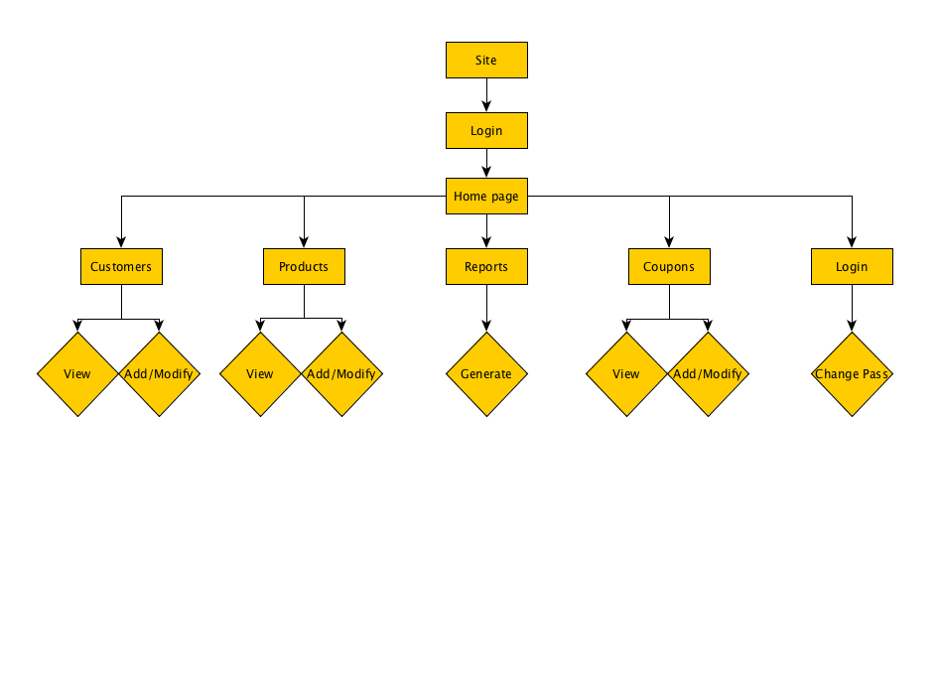

# Security

## Security Requirements

### System Security

The Customer Loyalty Tracker application will primarily be a web based application run locally on employee terminals. The backend server hosting the application will be locked in a safe location in the store, away from customers and employees.

### Security Approach

All users of the application will log into the application using an initial username and password and will be required to change their password upon their first login and periodically.

### Third Party Software Security

N/A

### Interface Security

A username and password is required to log into the application.

### Metrics

Metrics consist of logging user logins and activity for the purpose of application improvement and security monitoring.

### User Authentication

A username and password is required to log into the application.

## Encryption Requirements

Complete this section only if encryption is required.

### Full Encryption Areas

N/A

### Application Data

Customer sensitive data such as credit card numbers should be encrypted using standard encryption algorithms.

### Encryption Business Policy

N/A

### Encryption in Transit

N/A

### Encryption in Storage

Customer sensitive data stored on the application server should be encrypted using standard encryption algorithms.

### Other Encryption Info

N/A

## Access Control

|  |  |  |  |  |  |
| --- | --- | --- | --- | --- | --- |
| **UC #** | **UC Name** | **Store Admin** | **Store Employee** | **Developer** | **System** |
| 1 | UC1_User_Login | X | **X** |  |  |
| 2 | UC2_Loyalty_Tracking_System | X | **X** |  |  |
| 3 | UC3_View_Sales_Report | X |  |  | X |
| 4 | UC4_Customer_Absent_Report | X |  |  | X |
| 5 | UC5_Coupon_Ratio_Report | X |  |  | X |
| 6 | UC6_Create_Coupon | X | X |  | X |
| 7 | UC7_View_Available_Coupons | X | X |  | X |
| 8 | UC8_Generate_Report | X |  |  | X |
| 9 | UC9_Frequent_Buyer_Report | X |  |  | X |
| 10 | UC10_Change_Password | X | X |  |  |

# System Metrics

## Performance and Availability

### Performance Metric

The Customer Loyalty application should provide information to users in less than five seconds in any query screen. Any data entered should be accepted by the system (assuming it passes any input validation and error checking) in less than five seconds.

### Availability Metric

The application should be available during normal business hours (considered to be 7 a.m. to 8 p.m. Monday through Saturday) and should be available for maintenance work (maintenance hours are midnight Saturday through 6 a.m. Sunday morning).

### Other Metrics

N/A

### Volume of Users

The system should support at minimum the store owner and employees, or at most 10 users.

### User Growth

User growth isn’t expected to be a factor since the store owner has no plans at the current time to expand to additional stores.

### Most Traffic- Functionality

All use cases involving multiple employees accessing the system concurrently will account for the maximum traffic experienced by the application.

### Most Traffic- Time Periods

Peak traffic is expected to occur weekday afternoons starting at 3 p.m. until closing and all day Saturday.

### Error Logging

All errors encountered capturing customer information, updating customer information, and generating coupons should be captured in an error log.

### Connection Types

Each user will log into the application from their terminal using a web browser over the local network in the store.

### User Locations

All users will be located in the store.

# Platform Requirements

| Platform Requirements | | |
| --- | --- | --- |
| Supported Platforms | Description of Platform | Platform Support Required |
| Internet Explorer | Internet Explorer Browser | Application must run on Internet Explorer, version 9.0 or higher. |
| Chrome | Chrome Browser | All versions of Chrome supported |
| Safari | Safari Browser | All versions of Safari supported |
| Firefox | Firefox Browser | All versions of Firefox supported |
|  |  |  |
|  |  |  |
|  |  |  |
|  |  |  |
|  |  |  |
|  |  |  |
|  |  |  |
|  |  |  |

# Risks

Describe the risks that have been identified for this project (resource issues, data integrity issues, and so on). The risks are tied to individual use cases if appropriate.

Note to Authors: If a risk is not tied to an individual use case, then just put “N/A” in the UC # and UC Name columns

| **UC#** | **UC Name** | **Type of Risk** | **Risk Description** |
| --- | --- | --- | --- |
| 1 | UC1_User_Login | Security | Attempts at getting around authentication or using another user’s credentials |
| 2 | UC2_Loyalty_Tracking_System | Resource, Data Integrity | Data stored could be inaccurate or lost |
| 3 | UC3_View_Sales_Report | Data Integrity | Data could be inaccurate |
| 4 | UC4_Customer_Absent_Report | Data Integrity | Data could be inaccurate |
| 5 | UC5_Coupon_Ratio_Report | Data Integrity | Data could be inaccurate |
| 6 | UC6_Create_Coupon | Data Integrity | Data could be inaccurate |
| 7 | UC7_View_Available_Coupons | Data Integrity | Data could be inaccurate |
| 8 | UC8_Generate_Report | Data Integrity | Data could be inaccurate |
| 9 | UC9_Frequent_Buyer_Report | Data Integrity | Data could be inaccurate |
| 10 | UC10_Change_Password | Security | Attempts at using weak passwords or sharing passwords |

# Sign-off

| **Signature** | **Name & Title** | **Date** | **Comments** |
| --- | --- | --- | --- |
| Seyana Luong | Business Initiative Leader | 10-01-2015 |  |
| Chris Freas | Business Project Leader | 10-01-2015 |  |
| Rett Gerst | IT Project Manager | 10-01-2015 |  |
| Michael Woodie | IT Executive Sponsor | 10-01-2015 |  |
| Brandon Lai | Business Executive Sponsor | 10-01-2015 |  |
| Mama G | Other Stakeholder [As Necessary] | 10-01-2015 | Owner |
| Papa G | Other Stakeholder [As Necessary] | 10-01-2015 | Owner |
| Lil G | Other Stakeholder [As Necessary] | 10-01-2015 | Head Manager |

# Glossary

## Definitions of terms used in this document

* <Clearly list all terms and/or acronyms in alphabetical order that were used in this document which may be ambiguous, context- or industry-specific. Provide a definition for each term and/or acronym listed. >