

Statement of Issues
11 September 2015

Coles - proposed acquisition of nine Supabarn supermarkets in New South Wales and the Australian Capital Territory

Purpose
- Outlined below is the Statement of Issues released by the Australian Competition and Consumer Commission (ACCC) on the proposed acquisition by Coles Supermarkets Australia Pty Ltd (Coles) of eight existing supermarkets and one proposed supermarket from Supabarn Supermarkets Pty Ltd (Supabarn) and its related bodies corporate (proposed acquisition). Together the Supabarn stores the subject of the proposed acquisition will be referred to in this document as the target stores.
- This Statement of Issues aims to:
  - give the ACCC’s preliminary views on competition issues arising from the proposed acquisition
  - identify areas of further inquiry
  - give all interested parties an opportunity to comment
  - invite interested parties to submit information to assist the ACCC in its assessment of the issues.
- This Statement of Issues is structured in the following way:
  - Issues arising from the effect of the proposed acquisition of Supabarn as a supermarket chain are discussed first, including the effect on competition among retail chains (particularly in the Canberra region) and in wholesale markets.
  - The remainder of the Statement of Issues deals with the effects of the proposed acquisition in local markets surrounding each Supabarn store.
- Given its overall length, in responding to this Statement of Issues readers are invited to focus on the issues and markets that are most relevant to them.

Overview of ACCC’s preliminary views
- The legal test which the ACCC applies in considering the proposed acquisition is in section 50 of the Competition and Consumer Act 2010 (Act). Section 50 prohibits acquisitions that substantially lessen competition in any market, or are likely to do so.
- The ACCC is considering the proposed acquisition as a whole, as well as its effect on local markets surrounding each target store. The preliminary views in each of these categories have been further classified into: 'issues of concern', 'issues that may raise concerns' and ‘issues unlikely to raise concerns’.

Issues arising from the proposed acquisition of a supermarket chain

Issues that may raise concerns
- The ACCC is considering whether the removal of the Supabarn chain would be likely to lead to a substantial lessening of competition in supermarket retailing in the Canberra region (including Queanbeyan).

Issues unlikely to raise concerns
- The ACCC considers that the proposed acquisition is unlikely to lead to a substantial lessening of competition in the following markets:
  - a market for takeaway liquor retailing encompassing New South Wales (NSW) and the Australian Capital Territory (ACT)
  - markets for the wholesale supply and acquisition of supermarket and liquor products, encompassing NSW and the ACT.

Issues arising in local markets
- The ACCC is considering the effect of the proposed acquisition on competition in the local markets surrounding each target store. However, if the ACCC concludes that the proposed acquisition would lead to a substantial lessening of competition in supermarket retailing in the Canberra region, the analysis of local markets in Canberra would no longer be relevant.

Issues of concern
- The ACCC is concerned that the proposed acquisition would be likely to lead to a substantial lessening of competition in the following markets:
  - local markets for supermarket retailing surrounding the Sans Souci and Sutherland Supabarn stores in NSW
  - a local market for supermarket retailing surrounding the proposed Casey Supabarn store in the ACT
  - a local market for the retail supply of takeaway liquor surrounding the Sans Souci Supabarn store in NSW.

Issues that may raise concerns
- The ACCC is considering whether the proposed acquisition would be likely to lead to a substantial lessening of competition in the following markets:
  - a local market for supermarket retailing surrounding the Annandale Supabarn store in NSW
  - local markets for supermarket retailing surrounding each of the Kaleen, Crace, Canberra City, and Wanniassa Supabarn stores in the ACT
  - a local market for the retail supply of takeaway liquor surrounding the Five Dock Supabarn store in NSW.

Issues unlikely to raise concerns
- The ACCC considers that the proposed acquisition is unlikely to lead to a substantial lessening of competition in the following local markets:
  - a local market for supermarket retailing surrounding the Five Dock Supabarn store in NSW
  - local markets for the retail supply of takeaway liquor surrounding each of the target stores, with the exception of the local markets surrounding the Sans Souci and Five Dock Supabarn stores.

Making a submission
- The ACCC is seeking submissions from interested parties, particularly on the following key issues:
  - Whether the loss of the Supabarn chain would lead to meaningful competitive harm across Canberra and Queanbeyan, given the prominence of Supabarn in the region.
  - The extent to which customers choose to shop at Supabarn not merely because of the convenience of its locations but because they perceive its offer to be differentiated from, and/or superior to, other supermarkets (including Coles and Woolworths).
  - The geographic dimension of each of the local markets surrounding the target stores, including the geographic dimension of local markets for the supply of takeaway liquor surrounding Sans Souci Supabarn and Five Dock Supabarn.
  - Whether the loss of Supabarn would have a meaningful impact on competition and consumer choice in local markets, notwithstanding that Coles, Woolworths, ALDI and smaller format supermarkets (such as IGA) would remain in many local markets if the proposed acquisition proceeds.
- Detailed discussion of these and other issues, along with specific questions, is contained in this Statement of Issues.
- Interested parties should provide submissions by no later than 5pm on 1 October 2015. Responses may be emailed to Coles-Supabarn-Mergers@accc.gov.au. If you would like to discuss the matter with ACCC staff over the telephone or in person, or have any questions about this Statement of Issues, please contact Claudia Oakeshott on 02 6243 1362 or Andrew Sudol on 02 6243 1222.
- The ACCC anticipates making a final decision by 26 November 2015; however, this timeline may change. To keep abreast of possible changes in relation to timing and to find relevant documents, interested parties should visit the Mergers Register on the ACCC's website at www.accc.gov.au/mergersregister.

Confidentiality of submissions
- The ACCC will not publish submissions regarding the proposed acquisition. We will not disclose submissions to third parties (except our advisors/consultants) unless compelled by law (for example, under freedom of information legislation or during court proceedings) or in accordance with s155AAA of the Act. Where the ACCC is required to disclose confidential information, the ACCC will notify you in advance where possible so that you may have an opportunity to be heard. Therefore, if the information provided to the ACCC is of a confidential nature, please indicate as such. Our Informal Merger Review Process Guidelines contain more information.

About ACCC ‘Statements of Issues’
- A Statement of Issues published by the ACCC is not a final decision about a proposed acquisition, but provides the ACCC’s preliminary views, drawing attention to particular issues of varying degrees of competition concern, as well as identifying the lines of further inquiry that the ACCC wishes to undertake.
- A Statement of Issues provides an opportunity for all interested parties (including customers, competitors, shareholders and other stakeholders) to consider the primary issues identified by the ACCC. It is also intended to provide the merger parties and other interested parties with the basis for making further submissions should they wish to do so.

Timeline
Date | Event
22 June 2015 | ACCC commenced review of the proposed acquisition
20 July 2015 | Closing date for submissions from interested parties.
3 August 2015 | ACCC hosted public consumer forum
11 September 2015 | ACCC publication of Statement of Issues
1 October 2015 | Deadline for submissions from interested parties in response to this Statement of Issues
26 November 2015 | Anticipated date for ACCC final decision

The parties

The acquirer: Coles Supermarkets Australia Pty Ltd
- Coles is owned by Wesfarmers Limited, an Australian listed public company with diverse business operations in the retail, resources, insurance, chemicals, energy, fertilisers and industrial sectors.
- Coles is a leading food, liquor and convenience retailer, with a presence in every mainland Australian state and territory. Coles currently has 774 supermarkets nationally, including 234 in NSW and eight in the ACT.

The vendor: Supabarn Supermarkets Pty Ltd
- Supabarn is a privately owned retail chain operating supermarkets in the ACT and NSW. In addition to the target stores, Supabarn has a supermarket in Gymea in NSW, and a supermarket development site at Kingston in the ACT, both of which it proposes to retain. Supabarn also provides marketing support and other services to four small independently owned stores in the ACT. These four stores operate under the ‘SupaExpress’ banner and are not part of the proposed acquisition.

Other industry participants

Woolworths Limited
- Woolworths is an Australian listed public company and Australia’s largest grocery retailer. It operates over 800 supermarkets across Australia. Relevantly, it also owns liquor retailers Beer Wine Spirits (BWS) and Dan Murphy’s.

ALDI Australia
- ALDI Australia is part of a privately-owned global supermarket operator that entered Australia in 2001. It has over 300 stores across NSW, the ACT, Queensland and Victoria. ALDI has announced plans to expand its operations into South Australia and Western Australia, with the first supermarkets in those states to open in 2016.
- ALDI can be characterised as a limited assortment discounter. Limited assortment discounters:
  - emphasise private label products
  - have a limited depth of range (i.e. a limited choice of varieties of each product) compared with full-line supermarkets (such as Woolworths, Coles and Supabarn)
  - are generally smaller format stores than full-line supermarkets.

Metcash Trading Limited
- Metcash is an Australian listed public company that provides marketing, wholesaling and distribution services to independent supermarket, liquor and hardware retailers. Metcash is a wholesaler to Supabarn and other independent supermarkets, mostly operating under the IGA banner. The IGA banner includes full-line Supa IGA supermarkets, as well as smaller formats branded IGA and IGA Express. Metcash also supplies liquor retailers under various national banners. It provides marketing support and other services to these supermarkets and liquor retailers. It holds a shareholding interest in some of them.

Costco Wholesale
- Costco Wholesale (Costco) is an international company which operates membership-only warehouse supermarkets. Costco operates seven warehouse supermarkets in Australia, including one in the ACT (near Canberra airport) and two in NSW (at Liverpool and Auburn). Costco’s business model is to offer a broad range of grocery, fresh and liquor products, both branded and private label, with a limited depth of range. These products are typically sold in bulk quantities. It markets itself as selling products at low unit prices but in large volumes, to both businesses and household customers. Costco also sells durable household goods, including electronics and furniture.

The proposed acquisition
- The target stores are listed in the table below.
Table 1: The target stores
Store | Location | Size m² (SFA)
Canberra Centre Civic | ACT | 2,950
Kaleen | ACT | 1,728
Crace | ACT | 1,302
Casey (due to open in 2016) | ACT | 2,960
Wanniassa | ACT | 1,924
Five Dock | NSW | 2,159
Sutherland | NSW | 1,531
Sans Souci | NSW | 2,086
Annandale | NSW | 768

Market inquiries
- On 22 June 2015 the ACCC commenced a public review of the proposed acquisition. Submissions from interested parties closed on 20 July 2015. The ACCC has received information from a range of interested parties, including customers, competitors and suppliers.
- On 3 August 2015, the ACCC held a public consumer forum in Canberra, at which interested parties expressed their views on the proposed acquisition directly to the ACCC.
- The ACCC is now calling for further information from interested parties to assist with its investigation, as set out below.

Future with and without the acquisition
- Section 50 of the Act prohibits mergers or acquisitions that would have the effect, or be likely to have the effect, of substantially lessening competition in a market. In assessing a proposed acquisition pursuant to section 50 of the Act, the ACCC considers the effects of the acquisition by comparing the likely future competitive environment post-acquisition if the acquisition proceeds (the ‘with’ position) to the likely future competitive environment if the acquisition does not proceed (the ‘without’ position) to determine whether the proposed acquisition is likely to substantially lessen competition in any relevant market.
- If the acquisition goes ahead, Coles will convert all of the target stores into Coles stores with its standardised offering (which varies in some respects by store and by region).
- On the basis of the information currently available, the ACCC considers that in the absence of the proposed acquisition, the target stores would continue to be owned and operated independently of, and in competition with, Coles. However, if the proposed acquisition does not proceed, the ACCC considers that it is likely that Coles would seek instead to open new supermarkets in Canberra, where it has previously submitted that it is underrepresented, and potentially in some of the relevant local markets in NSW. The ACCC is considering further the extent to which Coles opening additional stores could increase the level of competition in relevant markets.

Market definition
- The ACCC assesses the competitive effects of the proposed acquisition in relevant markets. The starting point for defining relevant markets involves identifying the products actually or potentially supplied by the merger parties. The ACCC then considers what other products constitute sufficiently close substitutes to provide a significant source of competitive constraint on the merged entity.

Areas of overlap
- The ACCC considers that the key areas of competitive overlap between the parties to the proposed acquisition are:
  - supermarket retailing
  - retail supply of takeaway liquor
  - wholesale acquisition of products sold in supermarkets
  - wholesale acquisition of takeaway liquor products.

Product dimension of relevant markets

Supermarkets
- The ACCC considers that supermarket retailing and related wholesale markets are relevant to the proposed acquisition. This is consistent with the ACCC’s approach to previous matters.
- A supermarket offers a range of fresh produce and packaged groceries in one location. Supermarkets compete primarily with other supermarkets, which offer a broadly similar retail experience. There is a range of different types of supermarket, such as small independent local supermarkets, limited assortment discounters like ALDI, warehouse stores like Costco, and full-line supermarkets including Coles, Supabarn, Woolworths and Supa IGA. The ACCC considers all such supermarkets should be considered part of the same market, although they do not necessarily constrain each other equally; some are closer competitors than others and have more similar offers.
- The ACCC considers that specialist retailers, such as greengrocers, butchers and bakers, are not sufficiently close substitutes to supermarkets to be included in the relevant market. These specialists sell some of the supermarkets’ important products (particularly considering Supabarn’s emphasis on the quality of its fresh food, which is discussed further below).
- Fresh and local produce is also sold in some locations at ‘fresh food markets’, where several specialist retailers are co-located. For example, Canberra has fresh food markets in Belconnen and Fyshwick, and there are weekly farmers’ markets in north and south Canberra. The fresh food markets are open for part of the week only. The ACCC considers that they offer additional options for customers seeking to purchase fresh and local produce. .
- However, specialist retailers and fresh food markets are relatively weak substitutes for supermarkets, particularly full-line supermarkets. They do not offer the same diverse range of products in one location, and (especially in the case of fresh food markets) they offer significantly shorter trading hours than supermarkets. Taking this into account, the ACCC does not consider them sufficiently close substitutes to be included in the definition of the relevant market. This does not mean that specialist retailers are excluded from the ACCC’s competition analysis, but it reflects the fact that they impose a weaker, more distant and less consistent competitive constraint on supermarkets.

Liquor
- The ACCC considers that markets for the wholesale acquisition, and retail sale, of takeaway liquor are relevant to the proposed acquisition. These markets exclude the sale of liquor for on-premises consumption due to the contrasting characteristics of on-premises and off-premises purchases. These markets also exclude hotels and other premises which sell takeaway liquor sporadically and in small quantities for patrons to consume off-premises, but which do not have any separate retail liquor section.

Geographic dimension of retail markets

Plurality of markets
- The ACCC considers that in retail markets involving chains or buying groups, competition may occur at more than one geographic level. While all retailers compete to attract customers from other similar retailers in the same local area, retail chains and multi-store brands also compete through elements of their retail offers that may be determined across a broader area. They make such broader decisions by reference to the broader offer of other chains and the aggregate constraint imposed by independent retailers. These broader decisions also include decisions to extend the chain’s network by adding new stores. This is true in markets for supermarket retailing and in takeaway liquor markets.

Markets relevant to competition between retail chains
- Retail chains compete with each other by means of their overall offers. This competition occurs over a broader geographic area than the local competition between individual stores. Supabarn is a supermarket chain with particular importance in Canberra. Therefore the ACCC is considering whether the removal of Supabarn would affect competition between supermarket chains in the Canberra region (including Queanbeyan, NSW, given its proximity to Canberra).
- Supabarn’s competitive significance as a chain is primarily as a supermarket rather than a liquor retailer. Therefore the factors that justify analysing competition for supermarket retailing in the Canberra region are not as relevant to takeaway liquor retailing. For takeaway liquor, the ACCC considers a market encompassing both NSW and the ACT is relevant.

Local markets
- When assessing local retail markets, the ACCC aims to identify the competitive constraints on the store-level retail offers of the target store and other nearby stores operated by the acquiring firm. In each case the market definition is influenced by considering how far customers would be willing to travel to access a substitute, in response to an increase in prices (or a decrease in quality or services) at the target store.
- Specific market definition issues for each local market are addressed below. However, the ACCC ultimately may not need to reach a final view on the precise product or geographic boundaries of the markets. Market definition is a matter of degree. Some competitors within a posited market may be stronger constraints than others. Other potential competitors excluded from the market may nevertheless have some relevance and should be taken into account in the competition analysis. Therefore, precise market definitions are not likely to determine the assessment of the competition issues arising from the proposed acquisition.

Geographic dimension of wholesale markets
- Supermarket and takeaway liquor wholesalers tend to organise their activities over broad geographic areas. The ACCC’s preliminary view is that the relevant wholesale markets for each of supermarket products and takeaway liquor cover NSW and the ACT.

Questions for interested parties
The ACCC invites comments from interested parties on its preliminary views on market definition.

Interested parties may wish to address the following questions:
- To what extent are the following types of supermarkets a substitute for full-line supermarkets typical of Coles and Supabarn?
  - small independent supermarkets, such as those in local shopping centres
  - limited assortment discounters, such as ALDI
  - membership-only warehouse supermarkets, such as Costco.
- To what extent are specialist retailers a substitute for the full-line supermarkets of Supabarn and Coles? Please consider, in particular, the substitutability of specialist fresh food retailers (such as greengrocers, butchers and fresh food markets) for Supabarn supermarkets, given Supabarn’s emphasis on fresh and local produce in its marketing.
- To what extent do supermarket chains make and apply decisions about matters such as pricing, promotions, range, store features and other aspects of their operations at the Canberra region level?

Issues arising from the proposed acquisition of a supermarket chain

The relevant legal test
- As discussed above, an acquisition breaches section 50 of the Act if it would have the effect, or likely effect, of substantially lessening competition in a market. ‘Substantial’ is not defined in the Act, but it has been interpreted judicially as meaning “that the effect of the acquisition be ‘meaningful or relevant to the competitive process’”.
- The ACCC’s preliminary view is that Supabarn is a substantial competitor, especially in the Canberra region and also in the local markets surrounding its stores. Supabarn currently has 9 per cent of the supermarkets in the Canberra region (excluding smaller format IGAs, as discussed further below). It has a differentiated offer, which customers value, is perceived to be competitive on price, and it has plans to expand further (via new stores at Casey and Kingston).

Customer feedback on Supabarn’s differentiated offer
- In its market inquiries, the ACCC received feedback from customers that Supabarn has a differentiated offer in markets for supermarket retailing, and that customers value that offer.
- In particular, customers perceive that Supabarn offers a broader and superior range of branded goods, higher quality and/or fresher fruit, vegetables, meats and seafood, and better customer service than other supermarket chains (including Coles). Customers also told the ACCC that they value Supabarn’s range, including specialty and locally sourced products which are not available from supermarket chains such as Coles and Woolworths.
- Customers also submitted that they value Supabarn’s distinct promotional offer, including its promotional catalogue, its loyalty programme, discounts for senior citizens on Wednesdays, and a 10 per cent discount offered on the first Thursday of every month for purchases above $100.
- In addition, some customers expressed the view that Supabarn’s prices are comparable to those of the other supermarket chains across the product range as a whole. The ACCC also received feedback that some customers are prepared to pay slightly higher prices for a better shopping experience, better quality products, and/or a deeper range of branded and locally sourced products. Some customers expressed, specifically, a preference for a product offer that includes a range of branded goods, as distinct from private label/generic products. Some customers also expressed a preference to shop at a full-line supermarket owned independently of Coles and Woolworths.

Relevance of the differentiated offer to competition
- The customer perceptions summarised above are a product of Supabarn’s efforts to differentiate its offer from other supermarket chains, including Coles and Woolworths. The ACCC’s preliminary view is that this differentiated offer is in part a competitive response to rival supermarket chains, and includes:
  - offering what is perceived to be a broader and different range of branded products
  - offering a broader range of locally-sourced products
  - marketing and/or offering fresher and better quality fruit, vegetables, meats, deli products, and seafood
  - offering a superior shopping experience, including customer service
  - presenting unique promotions on a different schedule to other supermarket chains
  - identifying itself as an independent chain with links to the local community.
- Some elements of Supabarn’s differentiated offer are replicated by other businesses. For example, some IGA supermarkets offer locally-sourced products, and specialist greengrocers can market themselves as selling high quality fruit and vegetables. However, Supabarn’s offer is distinctive because it brings several such elements together in a full-line supermarket. The ACCC’s competition analysis seeks to understand the effect of Supabarn’s offer as a whole.
- Supabarn’s promotional material shows that it differentiates its offer for the purpose of competing against its rivals. For example, Supabarn’s ‘CLIP’ programme (‘Consistently LOWER In-store PRICES’) appears to be in direct response to the pricing of Coles and Woolworths: ‘We have cut the price on 100’s of everyday products to match or beat the major supermarket chains’.
- Likewise, Supabarn’s marketing and sourcing of its fresh produce is directed at setting itself apart from the fresh food offers from other chains, including Coles and Woolworths. For instance, Supabarn differentiates and markets its business on acquiring fresh produce and conveying it directly to stores with no warehouse time, in contrast to Coles and Woolworths. Hence it claims, and customers have submitted to the ACCC, that its fresh produce lasts longer. Examples of such marketing are both online and in-store. Such marketing includes:
  - ‘We believe in fair trade for Aussie farmers’
  - ‘Our fresh produce comes straight from a farm and not a warehouse’
  - ‘Sure, we could buy some produce cheaper from overseas, but to us, it doesn’t seem like a good thing to do’
  - ‘We will always promote in-season produce heavily (it’s cheaper and fresher and supports Aussie farmers)’.
  - ‘If it’s grown in Australia we buy it from Australian farmers’
- Supabarn’s service standards are also valued by customers, including assistance from staff in the store and at the checkout, and home deliveries (at least for some customers).
- The ACCC considers that this differentiated offer is highly relevant to the Canberra region, as well as all local markets for supermarket retailing.
- Relevantly for the Canberra region, Supabarn has over a long period marketed itself as part of the Canberra community, including through its previous sponsorship of the Canberra Raiders rugby league team and its ongoing support of local charities.
- In most of the relevant markets, and importantly in the Canberra region, the proposed acquisition would remove Supabarn’s differentiated offer and replace it with Coles’ standardised offer, which is already available (although it varies in some respects between stores), and which Supabarn competes against by differentiating its offer. The proposed acquisition would therefore reduce consumer choice, and may substantially lessen competition.
- Whether the proposed acquisition is likely to lead to a substantial lessening of competition depends, in part, on the significance of Supabarn’s differentiated offer to the competitive process. The ACCC considers that, among other things, it may be important if a significant proportion of customers choose to shop at Supabarn, in preference to Coles and other chains, because they value Supabarn’s differentiated offer.
- On the other hand, if Supabarn’s customers only choose to shop at its stores because of their convenient location and do not value other aspects of its offer, the proposed acquisition would be less likely to lead to a substantial lessening of competition - the location of the target stores will not change as a result of the proposed acquisition.

Potential competition
- Because the ACCC applies a forward-looking test (see paragraph 32), it is relevant to consider the potential for enhanced competition from Supabarn in the future. Supabarn has grown from a single supermarket when it was established in 1991 to a chain of nine. It is continuing to expand, with two new supermarkets in development (at Casey and Kingston in the ACT). Any further growth, through investment, expansion or acquisition, in the absence of the proposed acquisition, would strengthen Supabarn’s competitive influence. There may also be potential for Supabarn to strengthen its competitive position by conducting some level of wholesaling and distribution (particularly for non-grocery items) and expanding the number of SupaExpress stores to which it provides branding and other support.
- The ACCC is considering whether such expansion is likely to occur in the absence of the proposed acquisition, whether under the current owners of Supabarn or in the hands of another independent operator.

Other competitors
- The ACCC’s competition analysis also requires consideration of the remaining competition the merged entity would face. The removal of Supabarn’s differentiated offer is more significant in markets where there are few other competitors.
- In the Canberra region, Coles and Supabarn compete against Woolworths, ALDI, Costco, and smaller supermarkets. The degree of competitive constraint from these supermarkets varies: as full-line supermarkets, chains such as Supabarn, Coles and Woolworths are close competitors. As noted above under market definition, specialist retailers and fresh food markets provide additional options for customers for certain products, but are not close constraints on full-line supermarkets.
- The relevant local retail markets each contain some or all of these competitors. The ACCC’s preliminary competition concerns are strongest in local markets where there are fewer of these competitive alternatives available.

Barriers to entry and expansion
- It is also relevant to consider whether the merged entity would be competitively constrained by the threat of new entry, or expansion of smaller existing competitors.
- As the ACCC has noted previously, barriers to entry to supermarket retailing are generally high, including in the Canberra region. At a local level, there are considerable lead times and sunk costs involved in establishing a new supermarket, which can pose a particular barrier when the market is already served by multiple existing supermarkets (even more so if they include a scaled incumbent). Lack of access to suitable sites can also be a significant barrier to new entry, particularly if local planning laws impose restrictions.
- The ACCC is aware of some sites that may be suitable for new supermarkets. These are discussed below in the context of their relevant markets.
- Entry of a new supermarket retail brand faces significantly higher barriers than entry of a single store, due to the need to find and finance multiple sites, establish a supply chain and compete with established brands, among many other things.

Questions for interested parties
The ACCC invites comments from interested parties on its approach to the competition analysis.
Interested parties may wish to address the following questions:
- How Supabarn’s offer differs from its rivals, and what aspects of its differentiated offer particularly attract or deter customers.
- To what extent do customers on the whole choose to shop at Supabarn, in preference to Coles and other supermarket retailers, because of Supabarn’s differentiated offer, rather than simply its location?
- How significant would be the loss of Supabarn’s differentiated offer from a market in which Coles, Woolworths, ALDI, Costco and/or smaller supermarkets such as IGA would remain?

Competition analysis: issue that may raise concerns
- The ACCC is considering whether the proposed acquisition is likely to lead to a substantial lessening of competition between supermarket chains. Because of the significance of Supabarn in supermarket retailing in Canberra, the competitive harm is likely to be most substantial in the Canberra region (including Queanbeyan).

Summary of concerns
- Operating as a retail chain brings particular competitive significance that individually owned supermarkets lack. For example, chains can market themselves under a single brand and with a uniform approach, giving customers an understanding of their offer that does not depend on customers visiting a particular store. Their larger sale volumes allow them additional options for competitive activity, such as Supabarn’s independent sourcing of competitive fresh food.
- The distinctive features of Supabarn’s offer are described above (paragraphs 51 to 64). The ACCC is assessing whether, particularly in the Canberra region, customers value those features in Supabarn as a chain (rather than Supabarn’s stores taken individually). The ACCC is also considering whether the loss of Supabarn’s chain offer would relax an important constraint that applies pressure on Coles and other competitors to provide an attractive overall offer in order to avoid losing customers. The relaxation of this constraint may potentially allow Coles and other chains to reduce the overall quality of their offers. In particular, removal of a chain may lessen the competitive constraint on the remaining chains. Given the very high barriers to entry of new supermarket chains, the lost offer could not be replicated easily.

Market concentration
- The following table shows market shares of the full-line supermarkets and limited assortment discounters in the Canberra region, calculated by store numbers, as the ACCC understands them currently to be. The ACCC also takes into account the competitive effect of smaller format supermarkets such as IGAs in its analysis. While there are many of these smaller stores, for reasons discussed above, they impose a less significant competitive constraint than other full-line supermarkets. Therefore, the ACCC considers that including smaller format stores such as IGAs would risk giving a misleading view of market shares (when calculated by store numbers).
- Having said this, the ACCC recognises that store numbers are just one way to measure market shares. Other measures such as revenue and selling floor area (SFA) may show a different picture.
- The proposed acquisition would lift Coles from having 21 per cent to 30 per cent of the total number of larger format supermarkets in Canberra and Queanbeyan. The three largest supermarket chains would control 96 per cent of supermarkets in the market.
Table 2: Market shares, Canberra and Queanbeyan
Operator | Number of stores | % of total
Woolworths | 18 | 42%
ALDI | 10 | 23%
Coles | 9 | 21%
Supabarn | 4 | 9%
Costco | 1 | 2%
Supa IGA | 1 | 2%
Total | 43 | 100%
Note: includes existing supermarkets only.

Importance of Supabarn to competition between chains
- Supabarn is a significant supermarket chain in the Canberra region (including Queanbeyan):
  - It is one of four supermarket chains, the others being Woolworths, Coles and ALDI.
  - It has (currently) the only full-line supermarkets in Canberra other than Woolworths and Coles. (However, the ACCC is taking into account the full-line Supa IGA at Karabar in Queanbeyan and some IGA supermarkets in Canberra, such as Ainslie, which provide something closer to a full-line offer than a typical IGA.)
  - Supabarn’s broader offer is differentiated from Coles and Woolworths, including by its ranging decisions, marketing, shelf prices, store lay-out, promotions and service (as summarised at paragraphs 51 to 64 above).
  - ALDI and Costco are also relevant competitors, particularly on price, but in other aspects of their offer they are less close competitors than full-line supermarkets, given their shallower range and contrasting marketing and general business models.
  - Specialist retailers (including fresh food markets and farmers’ markets) also offer some constraint, but this is limited since they do not offer the wide product range of a full-line supermarket.

Effect of the proposed acquisition
- If the proposed acquisition proceeds, Supabarn’s differentiated offer would be removed from the market. It would be replaced by Coles’ standardised offer, which is already present. Supabarn would retain a presence in Kingston (a proposed supermarket) but this would become a single independent supermarket. Supabarn as a chain would no longer exist or compete in the Canberra region.
- Supabarn makes overall decisions for its chain based on the chain-wide offers of other supermarket chains and the aggregate constraint from independent supermarkets (as discussed at paragraph 43 above). These broader decisions include many aspects of Supabarn’s pricing, promotional activities, its ranging decisions and store features.
- Supabarn’s differentiated offer is in part a competitive response to the other supermarket chains in the Canberra region and provides a different option that is valued by many consumers. Removing this competitive response and differentiated offer would lessen competition and consumer choice.
- If the proposed acquisition proceeds, some customers who value Supabarn’s differentiated offer would instead have to visit a supermarket with an offer they consider to be inferior, whether it is because of a different product range, reduced quality or service or a different price. The effect of this on consumer welfare may be considered to be equivalent to a price rise for those customers. Whether this amounts to a substantial lessening of competition depends in part on:
  - the number of affected customers
  - how superior Supabarn’s offer is, for them, compared to the remaining alternatives
  - whether other supermarket retailers would reposition their offers after the proposed acquisition, to fill the gap left in the market.
- Further, to the extent that other supermarket chains such as Coles and Woolworths can and do vary their offer in the Canberra region, as distinct from their offer in NSW, the proposed acquisition would reduce the competitive constraint that they face. This could lead to a degradation in the offers of Coles and Woolworths in the Canberra region. Such a degradation could take many forms (and may simply involve reduced pressure to improve, rather than an absolute reduction in quality). It may affect the price and non-price aspects of their offers, such as product range and quality, promotions, store quality and/or service levels.
- The four small SupaExpress supermarkets in the ACT would remain. Although these operate under a banner related to Supabarn, they are not part of the Supabarn chain. They are smaller stores, which are owned and operated independently of Supabarn. The ACCC’s view is that the SupaExpress stores would not replace the differentiated offer of the Supabarn chain.

Questions for interested parties
The ACCC invites comments from market participants on its preliminary views on the potential impact of the proposed acquisition on competition in the Canberra region market for supermarket retailing.
Market participants may wish to address the following questions:
- To what extent do supermarket chains vary their offer in the Canberra region (including Queanbeyan) compared to NSW?
- What is the significance in the Canberra region (including Queanbeyan) of Supabarn being acquired by Coles, beyond the local competitive impact of each of its stores, including the removal of customers’ ability to choose Supabarn’s unique offer, and any loss of competitive response from Coles, Woolworths or other stores to Supabarn’s offer?

Issues unlikely to raise concerns
- The ACCC is considering whether the proposed acquisition is likely to lead to a substantial lessening of competition in the following markets:
  - a market for takeaway liquor retailing encompassing NSW and the ACT
  - markets for the wholesale supply and acquisition of supermarket and liquor products, encompassing NSW and the ACT.

Market for retail supply of takeaway liquor encompassing NSW and the ACT
- The ACCC’s preliminary view is that the proposed acquisition is unlikely to substantially lessen competition in the broader market for the supply of takeaway liquor in NSW and the ACT (as opposed to local markets, which are analysed later in this Statement of Issues).
- Supabarn’s liquor retail business is not a significant competitor chain to Coles (which owns Liquorland, 1st Choice and Vintage Cellars), Woolworths (which owns BWS and Dan Murphy’s), or to independent banner groups such as Bottlemart. While Supabarn is a member of Independent Liquor Retailers (which owns the brands Local Liquor and Countrywide Liquor), the ACCC does not anticipate that the proposed acquisition would affect the ability of Independent Liquor Retailers to continue to compete in NSW and the ACT.
- The addition of up to nine Coles-owned liquor stores in NSW and the ACT is unlikely to have a significant impact on Coles’ state-wide market share.

Wholesale markets
- Independent supermarkets typically acquire packaged groceries from a dedicated grocery wholesaler. Metcash supplies a large proportion of the groceries purchased by independent supermarkets. Retailers can also approach suppliers directly, particularly for niche and locally supplied products, and independent supermarkets normally acquire fresh produce directly from various suppliers.
- Vertically integrated supermarket chains (including Coles and Woolworths) do not rely on an intermediary such as Metcash. They generally contract directly with producers, importers and suppliers of the goods they stock.
- Supabarn is among the larger independent supermarket businesses in NSW and the ACT. The proposed acquisition therefore has potential impacts on competition for the wholesaling of packaged groceries to independent supermarkets.
- Metcash is the only significant wholesale supplier of packaged groceries to independent supermarkets in NSW and the ACT. One potential competitive constraint on Metcash could arise from the threat of new entry by a new wholesaler willing to compete with it if it were to increase prices or reduce services to independent wholesalers. Such entry could lead to lower prices and more favourable supply terms for independent supermarkets, which in turn might allow them to compete more effectively in retail markets.
- A new wholesaler would face barriers to entry, including economies of scale. It would need to secure contracts with supermarkets giving enough sales volume to justify the fixed costs of establishing a wholesaling business. In this context, a substantial chain of supermarkets such as Supabarn might anchor the new venture.
- The proposed acquisition would remove Supabarn (and its demand volume) from the market for the acquisition of wholesale packaged groceries. It would remove the potential option of a new wholesale entrant securing baseline volume by entering into a wholesale supply agreement with Supabarn. In this sense, it would raise barriers to entry for wholesalers.
- The ACCC is considering whether the proposed acquisition therefore has potential to harm competition in wholesale markets. The ACCC considers that competition in wholesale packaged grocery markets is important and desirable. However, the nine target supermarkets would account for a small proportion of the wholesale volumes in the NSW and ACT market. This may not be sufficient to make a substantial difference to the prospects for new entry of a wholesaler. The ACCC is continuing to investigate the issue, but has reached the preliminary conclusion that the proposed acquisition is not likely to substantially lessen competition in wholesale markets.

Issues arising in local markets

Local markets - approach
- As discussed above, the ACCC is concerned that there may be a reduction in consumer choice and welfare in markets for supermarket retailing as a result of reduced chain on chain competition; and, specifically the loss of Supabarn’s differentiated offer, and that this may result in a substantial lessening of competition in markets relevant to competition between chains.
- The ACCC considers that Supabarn’s differentiated offer is also relevant to the competition analysis in each local market for supermarket retailing. However, additional specific competition concerns may arise in particular local markets, and may amount to a substantial lessening of competition in certain local markets regardless of the final view adopted about the effect of the acquisition on overall chain on chain competition.
- The local market analyses which follow focus on the particular circumstances and features of each local market relevant to market definition and competition. These include local market structure and concentration, as well as geographic factors (such as major roads and travel patterns) and demographic factors (such as population density).
- Maps are included showing the areas surrounding each target store and giving circles of 3km and 5km radii centred on the relevant target store. This reflects, in part, the ACCC’s established practice of generally using 3-5km radii around target stores as a starting point in defining local markets. The circles are included primarily for scale. They do not represent the ACCC’s view of the dimensions of the local markets. Rather, the ACCC takes into account geographic and other factors when considering which nearby stores are sufficiently close substitutes to form part of the relevant market.
- Stores located outside the relevant geographic market are not ignored as part of the ACCC’s competition analysis, but they are not considered to be close substitutes and therefore the constraint they impose on the merged entity is weaker than that of nearby competitors.

Issues of concern in local markets
- The following section describes the ACCC’s preliminary concerns in certain local markets and seeks further information from interested parties.

Sans Souci: supermarket retailing

Market definition
- The local supermarket retailers surrounding Supabarn Sans Souci are shown below.
Figure 1: Sans Souci supermarket map
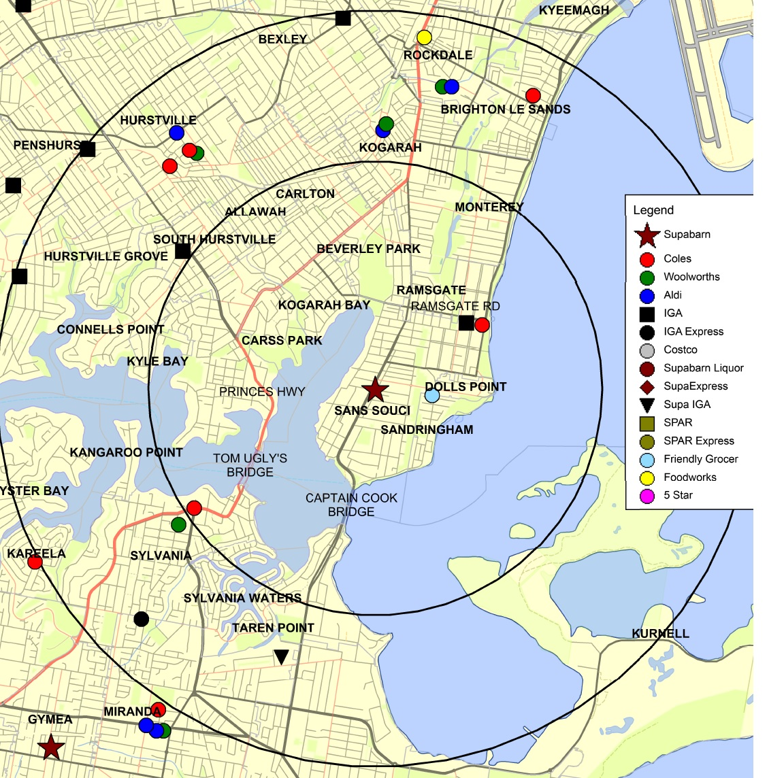
- The ACCC regards the following features of the local market surrounding Supabarn Sans Souci to be relevant to market definition:
  - Supabarn Sans Souci is on a peninsula. Substitute stores across the water on either side of the peninsula, and across the Captain Cook and Tom Ugly’s bridges (such as in Sylvania and Taren Point), are not likely to be close constraints, due in part to the driving time required for customers to reach them. The geographic dimensions of the local market are therefore likely to be confined largely to the peninsula.
  - Ramsgate Road (a four lane highway) is likely to operate as a barrier deterring consumers from crossing to supermarkets to the north-west, weakening the competitive constraint from supermarkets at Kogarah and Rockdale. The Princes Highway may be a further barrier.
- Taking those features into account, the ACCC’s preliminary view is that the relevant local market includes supermarkets on the Sans Souci peninsula (Sans Souci, Dolls Point, Sandringham and Ramsgate), but not those further afield.

Preliminary competition analysis
- Within the local market identified above, the Coles store at Ramsgate is the only full-line supermarket other than Supabarn Sans Souci. Coles Ramsgate is approximately 2.7 kilometres from the target site (in a straight line) and is likely to be the closest constraint on the Supabarn store at Sans Souci.
- The ACCC considers that the IGA store at Ramsgate and the Friendly Grocer at Dolls Point are likely to be weaker competitive constraints due to their smaller format and offering (including customer perceptions of their offering).
- If the proposed acquisition proceeds, Coles will therefore operate the only full-line supermarkets on the Sans Souci peninsula (at Ramsgate and Sans Souci). The ACCC considers that these are the two supermarkets which impose the closest constraints on each other.
- There may be some degree of competitive constraint from supermarkets at the geographic periphery of the local market (including Woolworths and ALDI stores at Kogarah, Hurstville and Rockdale), but the ACCC’s preliminary view is that these are likely to be weak constraints, and that the closest competitor to Supabarn Sans Souci is Coles Ramsgate.
- The ACCC understands that there is the potential for a supermarket to be developed at Beverley Park, which may be within the local market. If that site is developed and includes a supermarket, it might provide competition to Coles Ramsgate and Supabarn Sans Souci. However, there is uncertainty about the prospect of a supermarket entering at Beverley Park; and, if it did, who would be likely to operate it.
- For these reasons, the ACCC is concerned about Coles’ proposed acquisition of Supabarn Sans Souci. The ACCC is concerned that it would give Coles the majority of stores in the local market and that thereafter it would face limited competitive constraint.

Preliminary conclusion
- The ACCC’s preliminary view is that the proposed acquisition is likely to substantially lessen competition in a local market for supermarket retailing surrounding Supabarn Sans Souci.

Questions for interested parties
The ACCC invites comments from interested parties on its preliminary analysis of the local market for supermarket retailing surrounding Supabarn Sans Souci.
Interested parties may wish to address the following questions:
- The extent to which the ALDI and Woolworths stores at Rockdale, Kogarah and Hurstville, the IGA store at Ramsgate and the Friendly Grocer at Dolls Point, are substitutes for Supabarn Sans Souci and Coles Ramsgate.
- The extent to which customers consider supermarket retailers operating to the south of the Captain Cook and Tom Ugly’s bridges to be close substitutes for Supabarn Sans Souci and Coles Ramsgate.
- The extent to which Ramsgate Road and/or the Princes Highway influence customer shopping behaviour.
- Whether a new supermarket is likely to be established at Beverley Park; and, if so, when and who is likely to operate it (or them, if more than one).

Sans Souci: liquor retailing

Market definition
- The local liquor retailers surrounding Supabarn Sans Souci are shown below.
Figure 2: Sans Souci liquor map
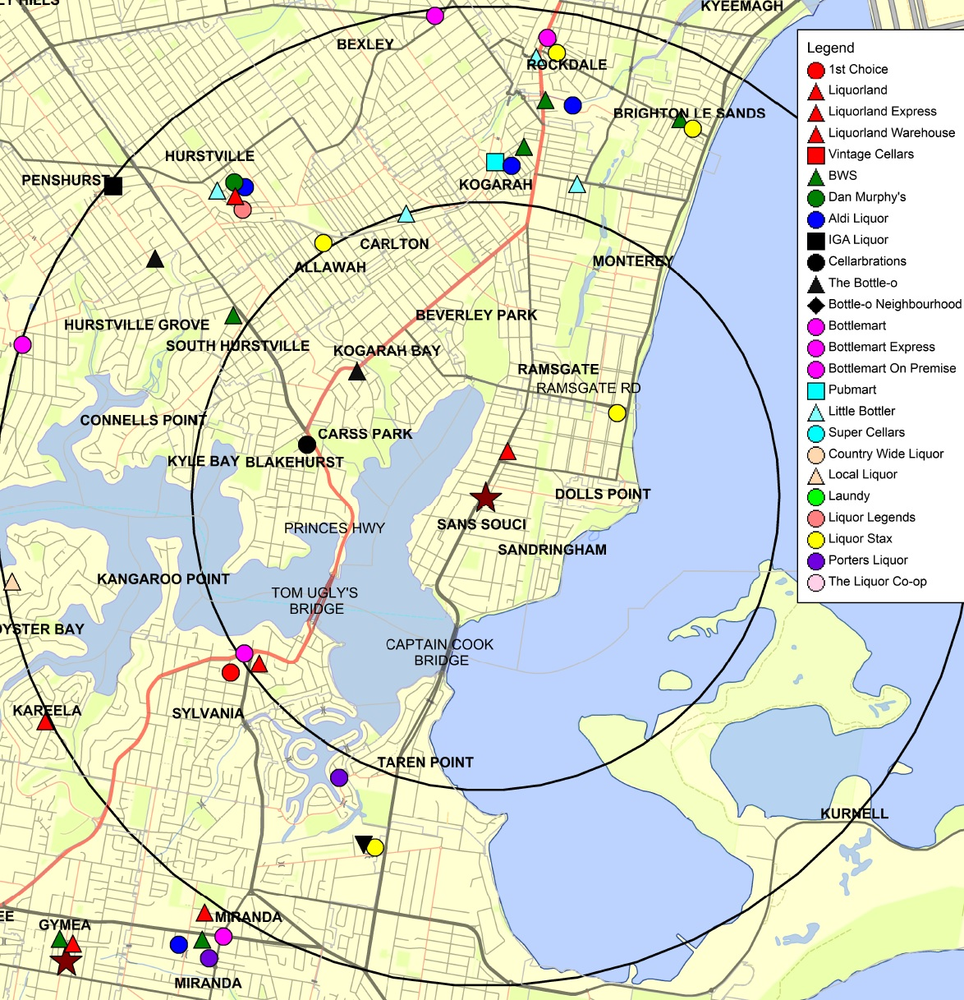
- The ACCC regards the relevant features of the local market for liquor retailing surrounding Supabarn Sans Souci to be similar to those for supermarket retailing; namely:
  - The target store is on a peninsula – liquor retailers on either side of that peninsula, and across the Captain Cook and Tom Ugly’s bridges, are not likely to be close substitutes.
  - Ramsgate Road and/or the Princes Highway may influence customer travel and shopping behaviour.
- Accordingly, and similar to the Sans Souci local market for supermarket retailing, the ACCC considers that the relevant local market for liquor retailing includes liquor stores on the Sans Souci peninsula (Sans Souci, Dolls Point, Sandringham and Ramsgate). Stores further afield are at the periphery of the relevant market and the ACCC considers them likely to impose a significantly less close constraint.

Preliminary competition analysis
- Coles operates the closest liquor store on the peninsula to the target store at Liquorland on Rocky Point Road. There is also a Mr Liquor store (Liquor Stax) on Grand Parade at Ramsgate. Customers seeking a substitute for Supabarn Sans Souci for takeaway liquor would need to drive past the Liquorland on Rocky Point Road to reach Mr Liquor.
- The need for a liquor licence and planning approval impose a barrier to a new entrant in the local market for liquor retailing.
- The ACCC’s preliminary view, consistent with its view about the market for supermarket retailing in the Sans Souci local market, is that other liquor retailers at Kogarah, Rockdale and Hurstville are unlikely to impose close constraints on the target store.
- There is a Dan Murphy’s store at Hurstville, which may act as a destination store for customers spread over a wide area including Sans Souci. The ACCC considers this relevant to local competition. Customers can also buy liquor online; however, the ACCC’s preliminary view is that online stores do not impose a close constraint. Customer research suggests convenience is a very important factor in takeaway liquor purchasing decisions, and online sales involve a delay in customers receiving the product they have ordered.
- The ACCC’s preliminary view is that liquor stores located on the Sans Souci peninsula compete most closely with each other for customers located there. If the proposed acquisition goes ahead, the choices available to customers for takeaway liquor stores on the Sans Souci peninsula will be reduced from three to two; with the two stores that are currently each other’s closest competitors instead both being operated by Coles.

Preliminary conclusion
- The ACCC’s preliminary view is that the proposed acquisition is likely to substantially lessen competition in a local market for liquor retailing surrounding Supabarn Sans Souci.

Questions for interested parties
The ACCC invites comments from interested parties on its preliminary analysis of the Sans Souci takeaway liquor market.
Interested parties may wish to address the following questions:
- The extent to which liquor stores off the Sans Souci peninsula, including at Rockdale, Kogarah and Hurstville, and south of the Captain Cook and Tom Ugly’s bridges, are substitutes for and provide a close competitive constraint on Supabarn Sans Souci and Liquorland Ramsgate.
- The likelihood of a new liquor store being established in the local market and the likely identity of the entrant and timing for any such entry.

Sutherland

Market definition
- The local area surrounding Supabarn Sutherland is shown below.
Figure 3: Sutherland map
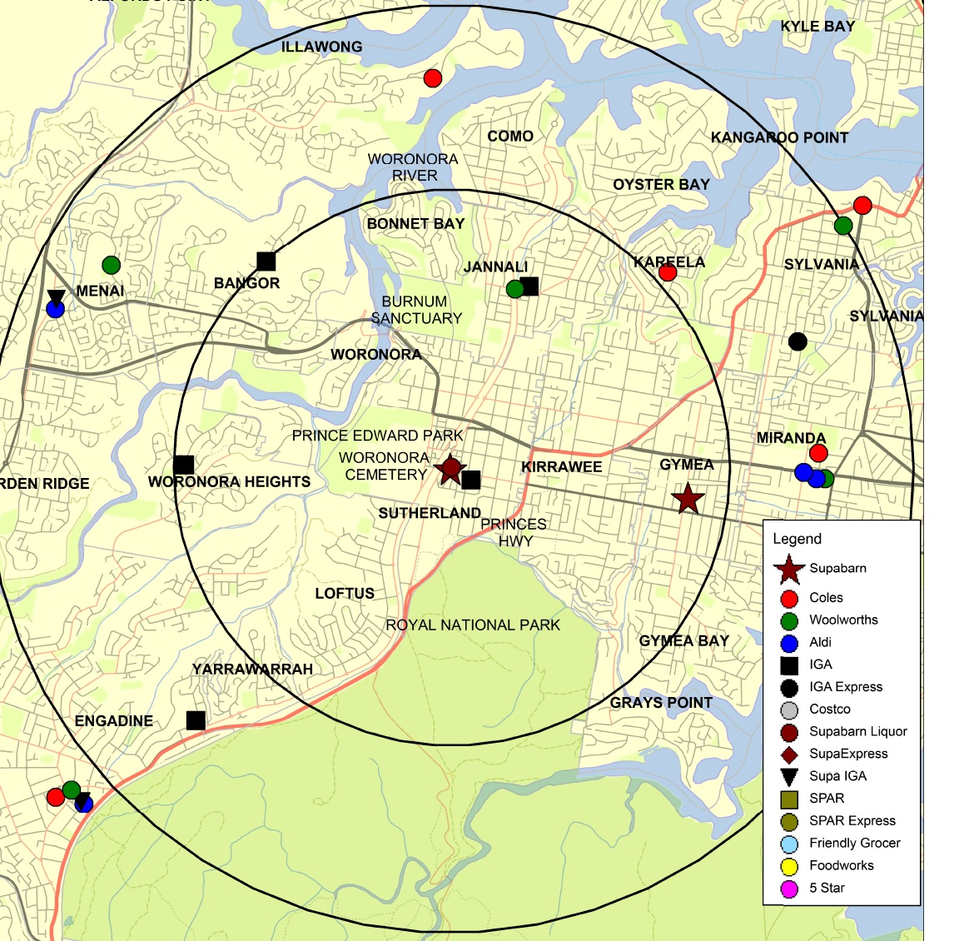
- The ACCC regards the following features of the local market surrounding Supabarn Sutherland to be relevant to market definition:
  - The Sutherland Supabarn store is located in southern Sydney on the Old Princes Highway, in the Sutherland Shire. This is an outer suburban area, in which customers are likely to be willing and able to travel further to visit supermarkets compared with more densely populated areas where traffic is more difficult to negotiate.
  - Sutherland is separated from nearby suburbia in three directions by geographic features: Royal National Park to the south, Prince Edward Park and Woronora Cemetery to the west and, further north, the Woronora River (and Burnum Sanctuary).
  - Nearby full-line supermarkets to the east of the target store are likely to be the closest substitutes to the target store. The Old Princes Highway may influence customer travel and shopping behaviour to some extent, but market feedback has not suggested this is a significant barrier.
- Taking those features into account, the ACCC considers the relevant local market to include supermarkets in Kirrawee, Jannali, Kareela and (as a more distant constraint) Miranda; with supermarkets located further to the north (such as in Illawong and Bangor), and south-west (such as Engadine) imposing significantly weaker constraints.

Preliminary competition analysis
- Coles currently operates, at Kareela, the closest full-line supermarket to the target store. Coles currently also operates a supermarket at Miranda.
- The ACCC understands, further, that Coles intends to open a new store at Kirrawee (approximately 1.5km from the target site, in a straight line) and a more distant store in the Westfield shopping centre at Miranda (at an old Franklins site). The proposed Coles store at Kirrawee would become the target store’s closest competitor.
- There is a small format Woolworths/Flemings store at Jannali, which is likely to be within the local market but to impose a weak constraint due to its limited size and offering.
- Otherwise, the closest Woolworths and ALDI stores are at Miranda and Menai, at the periphery of the local market or beyond, and not likely to be close substitutes.
- Given Coles’ existing local market share, as well as its entry plans, and the relative lack of close competitors to Coles apart from the target Supabarn store, there is the potential for substantial competitive harm from the proposed acquisition.

Preliminary conclusion
- The ACCC’s preliminary view is that the proposed acquisition is likely to substantially lessen competition in a local market for supermarket retailing surrounding Supabarn Sutherland.

Questions for interested parties
The ACCC invites comments from interested parties on its preliminary analysis of the local market for supermarket retailing surrounding Supabarn Sutherland.
Interested parties may wish to address the following questions:
- The extent to which consumers consider the small format Woolworths/Flemings store at Jannali to be a substitute for the target store and the existing and planned Coles stores within the local market.
- The extent to which consumers consider the Woolworths and ALDI stores at Miranda and Menai are close substitutes for the target store, and for the existing and planned Coles stores within the local market.
- Whether new supermarkets are likely to be established at Miranda and within the local market; and, if so, when they will open and who will operate them.

Casey (proposed)

Market definition
- The local area surrounding the proposed Supabarn store in Casey is shown below.
Figure 4: Casey map
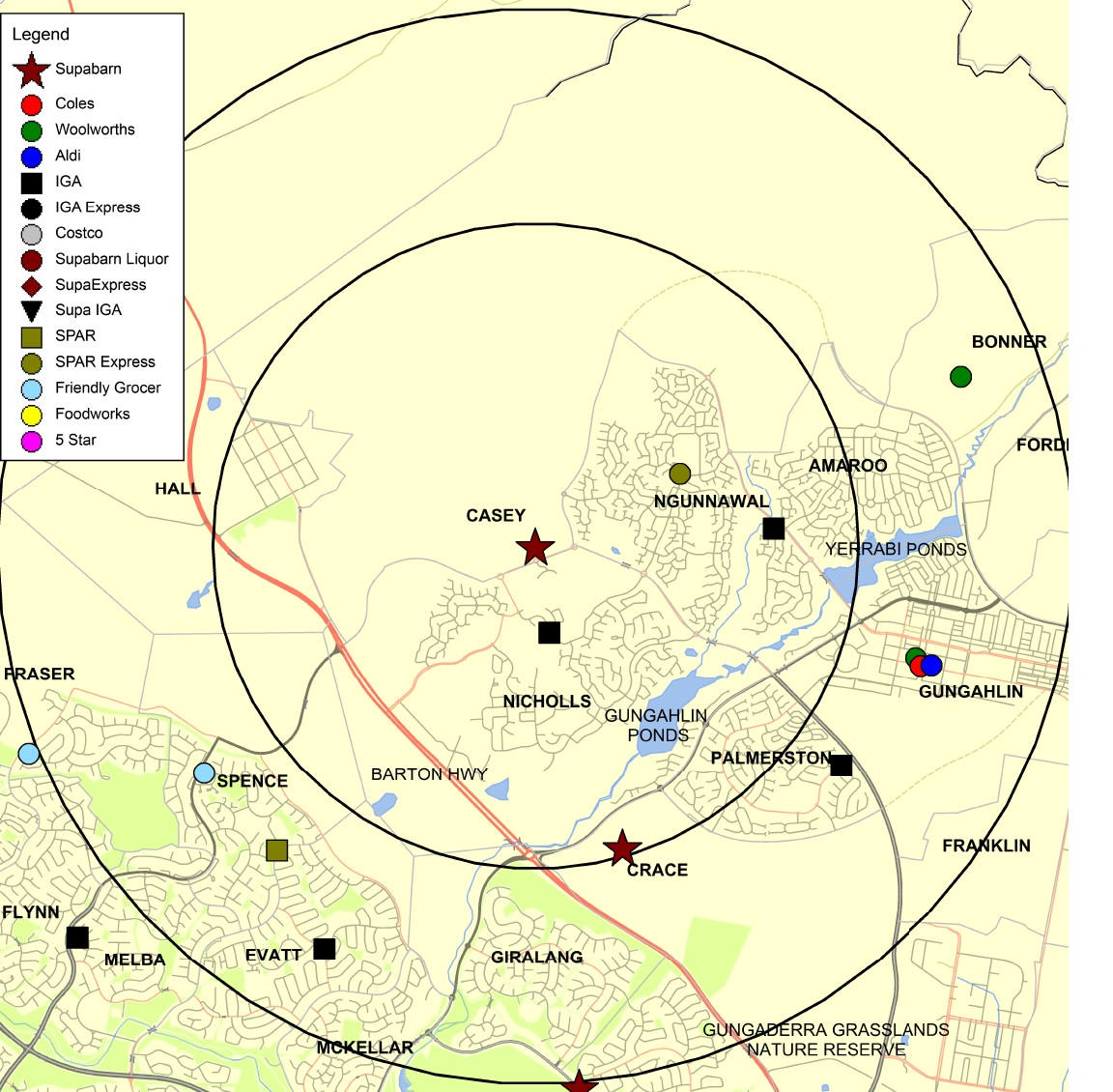
- The ACCC regards the following features of the local market surrounding the proposed Supabarn store at Casey to be relevant to market definition:
  - The proposed Supabarn at Casey is in northern Canberra, north east of the Barton Highway. It is in a growing outer suburb in Canberra in which population density is low and customers are likely to be willing and able to travel further to visit supermarkets than in higher density areas.
  - Other than the Barton Highway, there do not appear to be any significant physical barriers limiting the local geographical market, which is likely to include supermarkets at Gungahlin (a major town centre) and at Amaroo.
  - Information available to the ACCC suggests that supermarkets at Gungahlin and Amaroo may be close substitutes for the proposed Supabarn store at Casey.

Preliminary competition analysis
- The proposed Supabarn supermarket at Casey would be the largest in the Supabarn chain.
- The closest supermarket to the proposed Supabarn at Casey would be an ALDI that is being developed in the same complex.
- The closest full-line supermarket to the proposed Supabarn Casey is Supabarn Crace (another target store), approximately 3km to the south.
- The next nearest full-line supermarkets to the target store would be the proposed Coles at Amaroo, and the Coles and Woolworths supermarkets in Gungahlin.
- The ACCC considers that Coles Amaroo would be a close competitor to the target store based on geographic proximity. The ACCC also considers that the Coles and Woolworths supermarkets in Gungahlin would be close competitors to the target store because, among other things, Gungahlin is an important regional centre and would draw customers from a broad catchment area that includes Casey. There is also an ALDI in Gungahlin.
- The ACCC’s preliminary view is that the Woolworths supermarket at Bonner and the proposed Woolworths supermarket at Giralang would be less close substitutes to the proposed Supabarn store at Casey. While these supermarkets are a similar distance from the target store as the supermarkets in Gungahlin, the ACCC considers that these are primarily suburban supermarkets with a narrower catchment area than the Gungahlin stores. Giralang is also divided from Casey by the Barton Highway.
- While there are a number of smaller format IGA and Spar stores in the area around the proposed Supabarn Casey, these are not full-line supermarkets and are unlikely to be strong competitive constraints on other supermarket operators in the area.
- Coles already owns two of the closest competitors to the proposed Supabarn Casey. It would own three if it also acquired Supabarn Crace (another target store).
- The ACCC is concerned about the close concentration of Coles’ supermarkets in the area if it acquires Supabarn Casey. The ACCC’s preliminary view is that there would be an insufficient competitive constraint to prevent a likely substantial lessening of competition in this local market.

Preliminary conclusion
- The ACCC’s preliminary view is that the proposed acquisition is likely to substantially lessen competition in a local market for supermarket retailing surrounding the proposed Supabarn store at Casey.

Questions for interested parties
The ACCC invites comments from interested parties on its analysis of the local market for supermarket retailing surrounding the proposed Supabarn store at Casey.
Interested parties may wish to address the following questions:
- The extent to which the Woolworths stores at Bonner and Gungahlin and the proposed Woolworths at Giralang are substitutes for the target store and the existing and planned Coles stores within the local market.
- The extent to which the ALDI stores at Casey and in Gungahlin are substitutes for the target store and the existing and planned Coles stores within the local market.
- The extent to which customers consider IGA and other smaller-format independent stores in the local area to be close substitutes for the target store.
- The extent to which the Barton Highway influences customer purchasing behaviour.

Issues that may raise concerns in local markets
- The ACCC is considering whether the proposed acquisition is likely to lead to a substantial lessening of competition in the following local markets:
  - a local market for supermarket retailing surrounding Supabarn Annandale in NSW
  - local markets for supermarket retailing surrounding the Kaleen, Crace, Canberra City and Wanniassa Supabarn stores in the ACT
  - a local market for the retailing of takeaway liquor surrounding Supabarn Five Dock in NSW.
- The following section describes the ACCC’s preliminary concerns in these markets and provides details of further information sought from interested parties.

Annandale

Market definition
- The local area surrounding Supabarn Annandale is shown below.
Figure 5: Annandale map
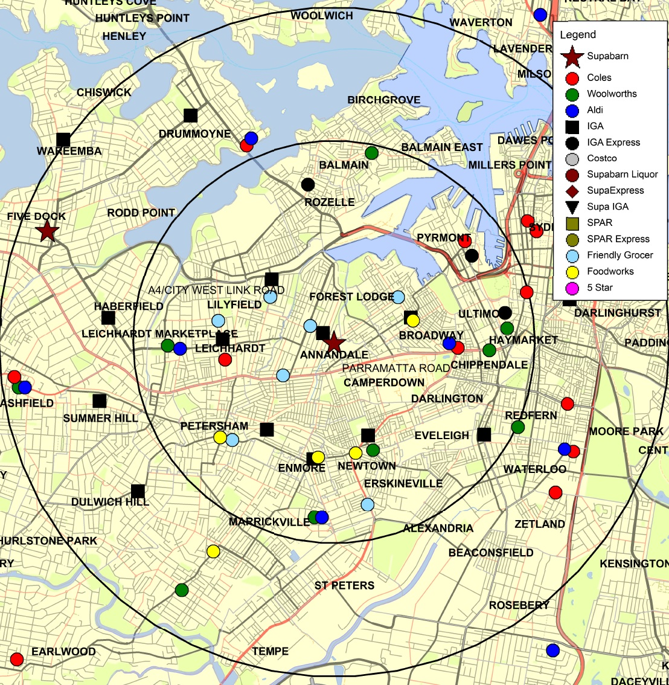
- The ACCC regards the following features of the local market surrounding Supabarn Annandale to be relevant to market definition:
  - Annandale is in the inner western suburbs of Sydney, where population density is high and traffic is busy. Customers are likely to travel a relatively short distance to visit a supermarket and are therefore likely to substitute between supermarkets only if they are located close to each other.
  - Parramatta Road, a busy arterial route, runs to the south of Supabarn Annandale. It is a significant dual lane highway, many parts of which are difficult to cross, particularly at peak hours. This is likely to be a barrier to customers switching between supermarkets such that supermarkets south of Parramatta Road are unlikely to be close substitutes for Supabarn Annandale or other supermarkets located north of Parramatta Road.
  - The A4 motorway/City West Link Road to the north is similarly likely to be a barrier to customer switching.
- Taking these features into account, the ACCC’s preliminary view is that the relevant local market is likely to be small, and that the close substitutes to Supabarn Annandale are confined to the north of Parramatta Road and south of the A4.

Preliminary competition analysis
- Given the local features summarised above, the Coles stores at Leichhardt and Broadway appear likely to be two of the closest competitors to the target store. The Coles store at Broadway may be the less close constraint of the two due to difficult parking and consequent customer perceptions of inaccessibility.
- There is also an ALDI at Broadway shopping centre. However, customers seeking a full-line supermarket substitute for Supabarn Annandale would need to travel past a Coles supermarket to find an alternative, including to shop at the Woolworths store at Leichhardt Marketplace.
- There are smaller format stores potentially within the local market (including small IGA stores at Annandale, Leichhardt and Lilyfield). The ACCC’s preliminary view is that these impose weak constraints due to their size and limited offer compared with full-line supermarkets. (Other small IGA stores at Newtown and Erskineville are also divided from Supabarn Annandale by Parramatta Road.)
- The Annandale Supabarn is also relatively small, at 768m² SFA. However, the ACCC received numerous submissions from consumers expressing concern about the loss of Supabarn Annandale from the local market. Customers responding to the ACCC’s market inquiries also reported that they use it for their main weekly grocery shop in preference to Coles - largely due to its differentiated offer, including superior customer service. Therefore the Supabarn store at Annandale may be a more significant competitor in this local market than is typical for a supermarket of its size.
- Given the closeness of competition between Coles and Supabarn in this local market, and the lack of other close competitors, the ACCC is concerned that the removal of Supabarn’s differentiated offer may be likely to substantially lessen competition.
- The ACCC is aware of potential supermarket sites at Lilyfield and Forest Lodge (the former Harold Park raceway). If developed into supermarkets, these sites could potentially provide competition to Coles. However, the ACCC has limited information at present about the prospects for supermarkets to enter at these sites; and, if there were to be new supermarkets, who would operate them.

Preliminary conclusion
- The ACCC’s preliminary view is that the proposed acquisition may lead to a substantial lessening of competition in a local market for supermarket retailing surrounding Supabarn Annandale.

Questions for interested parties
The ACCC invites comments from interested parties on its preliminary analysis of the local market for supermarket retailing surrounding Supabarn Annandale.
Interested parties may wish to address the following questions:
- The extent to which the Woolworths store at Leichhardt Marketplace, the ALDI store at Broadway, and/or, any of the small format IGA convenience stores, and/or supermarkets south of Parramatta Road, are substitutes for Supabarn Annandale and the nearby Coles stores at Leichhardt and Broadway.
- The extent to which the A4 motorway/City West Link Road influences customer shopping behaviour.
- The extent to which customers consider IGA and other independent stores in the local area to be close substitutes for Supabarn Annandale.
- Whether new supermarkets are likely to be established at Lilyfield and Forest Lodge; and, if so, when and who is likely to operate them.

Kaleen

Market definition
- The local area surrounding Supabarn Kaleen is shown below.
Figure 6: Kaleen map
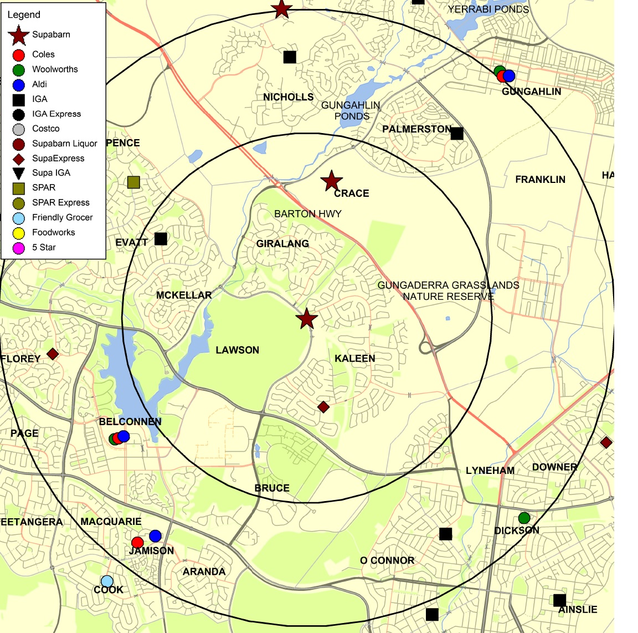
- The ACCC regards the following features of the local market surrounding Supabarn Kaleen to be relevant to market definition:
  - The Supabarn Kaleen store is located in the north of Canberra about seven kilometres from Canberra City, just south west of the Barton Highway.
  - The Barton Highway, dividing Kaleen from the Gungahlin region, may reduce the willingness of customers to travel further to the east of Kaleen for supermarket shopping. There do not appear to be any other significant physical barriers limiting the local market.
  - Therefore supermarkets available in Giralang, Belconnen, Jamison and Dickson are potentially close substitutes for the Kaleen supermarket. Stores the other side of the Barton Highway, such as in Crace and Casey, may be weaker substitutes.

Preliminary competition analysis
- Coles presently operates two full-line supermarkets likely to be within the local market discussed above, at Jamison and Belconnen. It proposes to open a new supermarket at Dickson.
- In the same area, Woolworths has stores at Dickson and Belconnen, and plans to open a store at Giralang. ALDI is present at Jamison and Belconnen and the ACCC understands that ALDI also proposes to open a store at Dickson.
- Potentially relevant supermarkets north east of the Barton Highway include Coles’ Gungahlin store and two target stores (Casey and Crace). Woolworths and ALDI each have a store at Gungahlin. Including this wider area, Coles would have up to seven supermarkets after the proposed acquisition, compared to up to four Woolworths and four ALDI. The ACCC considers this to be significant market concentration.
- There are also a number of smaller independent retailers in the local market, including the SupaExpress store at Kaleen.
- If the proposed acquisition goes ahead, Woolworths, ALDI and several smaller independent supermarkets would remain in the market. However, given Coles’ potential market concentration, and notwithstanding that some of its stores are at the periphery of the local market, the ACCC is concerned that the proposed acquisition may result in substantial competitive harm in the local market.

Preliminary conclusion
- The ACCC’s preliminary view is that the proposed acquisition may substantially lessen competition in a local market for supermarket retailing surrounding Supabarn Kaleen.

Questions for interested parties
The ACCC invites comments from interested parties on its preliminary analysis of the local market for supermarket retailing surrounding Supabarn Kaleen.
Interested parties may wish to address the following questions:
- The extent to which the ALDI stores at Jamison and Belconnen, and the Woolworths stores at Dickson and Belconnen, and any of the smaller independent supermarkets in the local market, are substitutes for the target store.
- Whether potential new supermarkets at Giralang and Dickson are likely to be close substitutes for the target store.
- The extent to which customers consider IGA and other independent stores in the local area to be a close substitute for the target store.

Crace

Market definition
- The local area surrounding Supabarn Crace is shown below.
Figure 7: Crace map
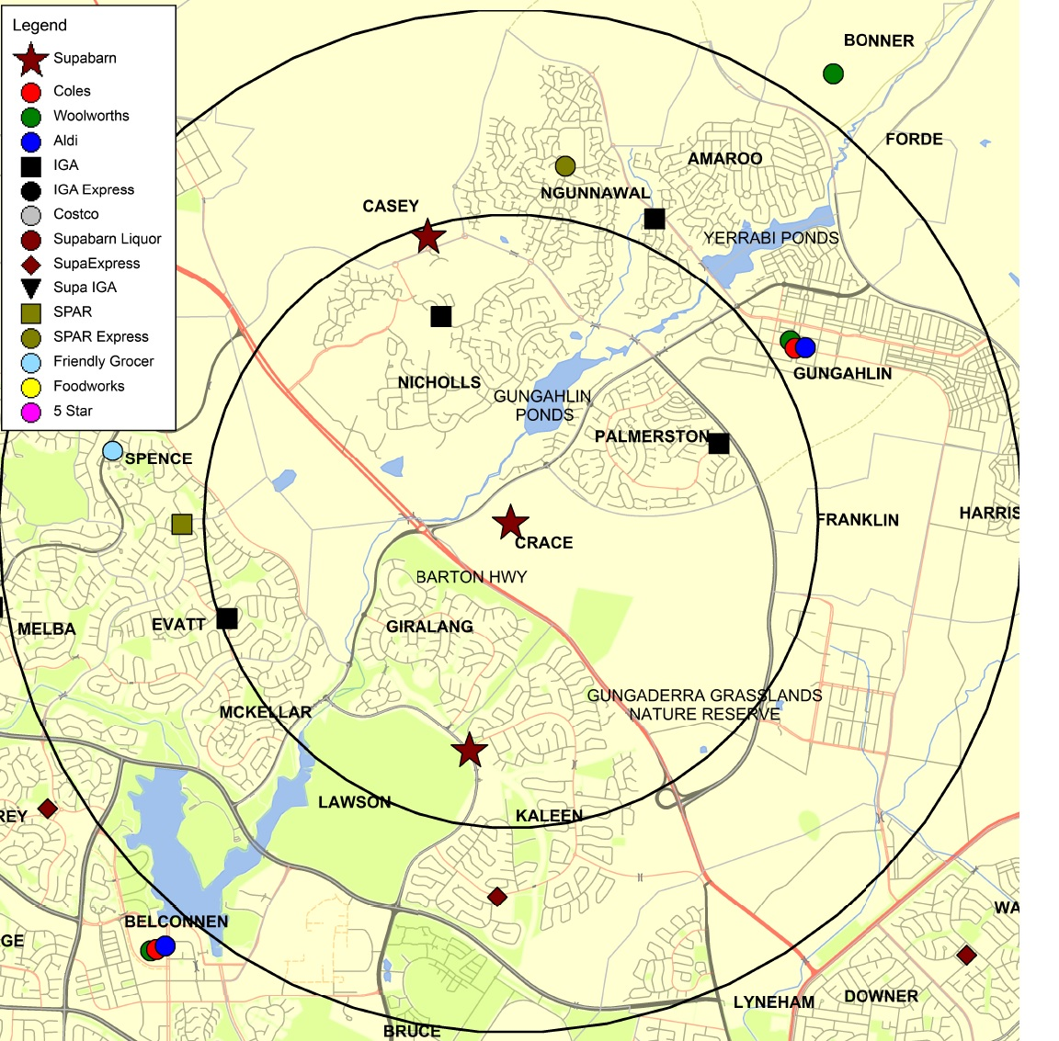
- The ACCC regards the following features of the local market surrounding the Supabarn store at Crace to be relevant to market definition:
  - Supabarn Crace is located in northern Canberra, north east of the Barton Highway, in an area with relatively low population density and light traffic compared to inner city areas.
  - There do not appear to be any significant physical barriers limiting the local market, apart from possibly the Barton Highway, as discussed above. In particular, none of the Gungahlin or Yerrabi Ponds, or the Gungaderra Grasslands Reserve, appear to impose barriers.

Preliminary competition analysis
- The closest full-line supermarket to the target store, geographically, is Supabarn Kaleen (another target store), but the extent to which customers consider it a substitute might be influenced by the Barton Highway. Otherwise, the next closest full-line supermarket will be the proposed Supabarn store at Casey (another target store), on the same side of the Barton Highway.
- Coles currently operates a store at Gungahlin and the ACCC understands that it proposes to open a store at Amaroo. Unlike the local market surrounding Supabarn Kaleen, the ACCC’s preliminary view is that the Coles stores at Belconnen, Jamison, and Dickson (proposed), and the potential Woolworths store at Giralang, are likely to be less close substitutes given their distance from the target store.
- While ALDI and Woolworths are present in Gungahlin, the ACCC is concerned that the proposed acquisition may result in a substantial lessening of competition due to Coles’ concentration in the local market. The ACCC’s concern is elevated because Coles plans to buy Supabarn’s proposed supermarket in nearby Casey, and intends to develop a new store at Amaroo.

Preliminary conclusion
- The ACCC’s preliminary view is that the proposed acquisition may substantially lessen competition in a local market for supermarket retailing surrounding Supabarn Crace.

Questions for interested parties
The ACCC invites comments from interested parties on its preliminary analysis of the local market for supermarket retailing surrounding Supabarn Crace.
Interested parties may wish to address the following questions:
- Whether the Woolworths and ALDI stores at Gungahlin are likely to be a substitute for the target store, as well as the target store at Casey, the proposed store at Coles Amaroo and any smaller supermarkets in the local market.
- As above, the extent to which the Barton Highway influences customer purchasing behaviour.

Canberra City

Market definition
- The local area surrounding Supabarn Canberra City is shown below.
Figure 8: Canberra City map
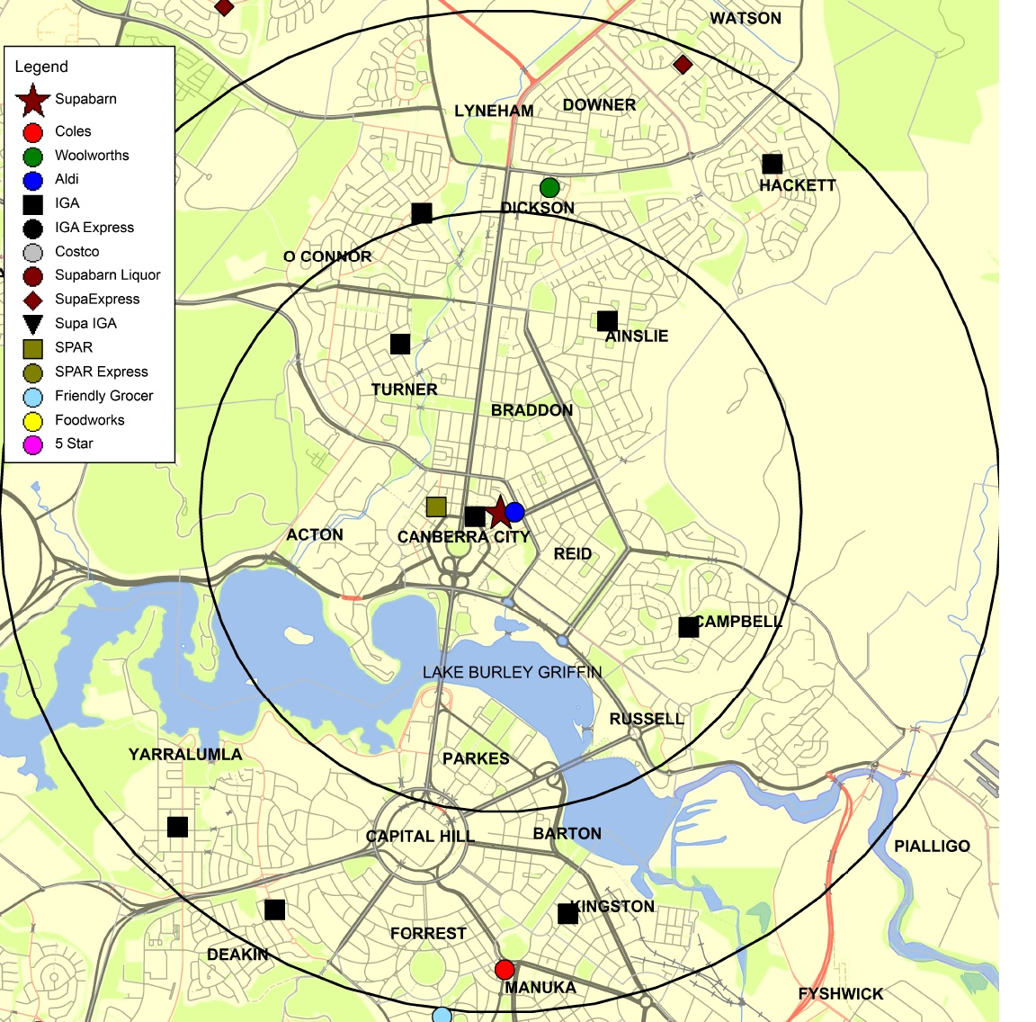
- The ACCC regards the following features of the local market surrounding the Supabarn store at Canberra City to be relevant to market definition:
  - The Supabarn supermarket at the Canberra Centre in Civic (Canberra City) is in a major shopping complex, north of Lake Burley Griffin.
  - In comparison to the areas surrounding other ACT stores, Canberra City is more densely populated and more difficult to navigate by car.
  - Information available to the ACCC suggests that supermarkets at Dickson may impose some constraint on supermarkets in Canberra City but that supermarkets south of Lake Burley Griffin, including at Manuka, are less likely to be substitutes given the need to cross the lake to reach them.
- Given these features, the ACCC’s preliminary view is that local market surrounding Supabarn Canberra City is likely to be relatively small, but possibly extending north to Dickson. The ACCC’s preliminary view is that supermarkets south of Lake Burley Griffin are likely to fall outside of the local market.

Preliminary competition analysis
- The Supabarn supermarket in Canberra City is known as its ‘flagship’ store and is its largest (although the new store at Casey will be slightly larger).
- Woolworths currently operates a supermarket further to the north at the Dickson shopping centre, which in the ACCC’s preliminary view possibly falls within the same local market as the target store. Coles and ALDI intend to open supermarkets at the Dickson shopping centre.
- Given Coles' plans to open a supermarket in Dickson, there is potential for close competition between Coles Dickson and Supabarn Canberra City in the future without the proposed acquisition.
- The ACCC is also considering the potential for entry of another supermarket in the Canberra Centre (in Canberra City) and its likely impact on competition around the target store. However, the ACCC does not have definitive information about the likelihood of such entry.
- There is a large-format IGA store at Ainslie which offers something close to a full-line supermarket and is likely to impose some constraint. There are also a number of smaller format IGA (and other) stores within the local market; however, the ACCC’s preliminary view is that those smaller stores impose weak constraints due to their small size and limited offers.

Preliminary conclusion
- The ACCC’s preliminary view is that the proposed acquisition may substantially lessen competition in a local market for supermarket retailing surrounding Supabarn Canberra City.

Questions for interested parties
The ACCC invites comments from interested parties on its analysis of the local market for supermarket retailing surrounding Supabarn Canberra City.
Interested parties may wish to address the following questions:
- Are supermarkets in Canberra City and Dickson likely to be close substitutes for each other?
- Are supermarkets south of Lake Burley Griffin, including at Manuka, likely to be substitutes for supermarkets in Canberra City?
- Are supermarkets at Canberra airport likely to be close substitutes for supermarkets in Canberra City?
- What competitive constraint does the nearby large IGA supermarket at Ainslie impose, and what constraint do other independent supermarkets in the area impose?
- What is the likelihood of Coles opening a supermarket in Canberra City if it does not acquire Supabarn Canberra City?
- What is the likelihood of entry by other supermarket operators in Canberra City?

Wanniassa

Market definition
- The local supermarket retailers surrounding Supabarn Wanniassa are shown below.
Figure 9: Wanniassa map
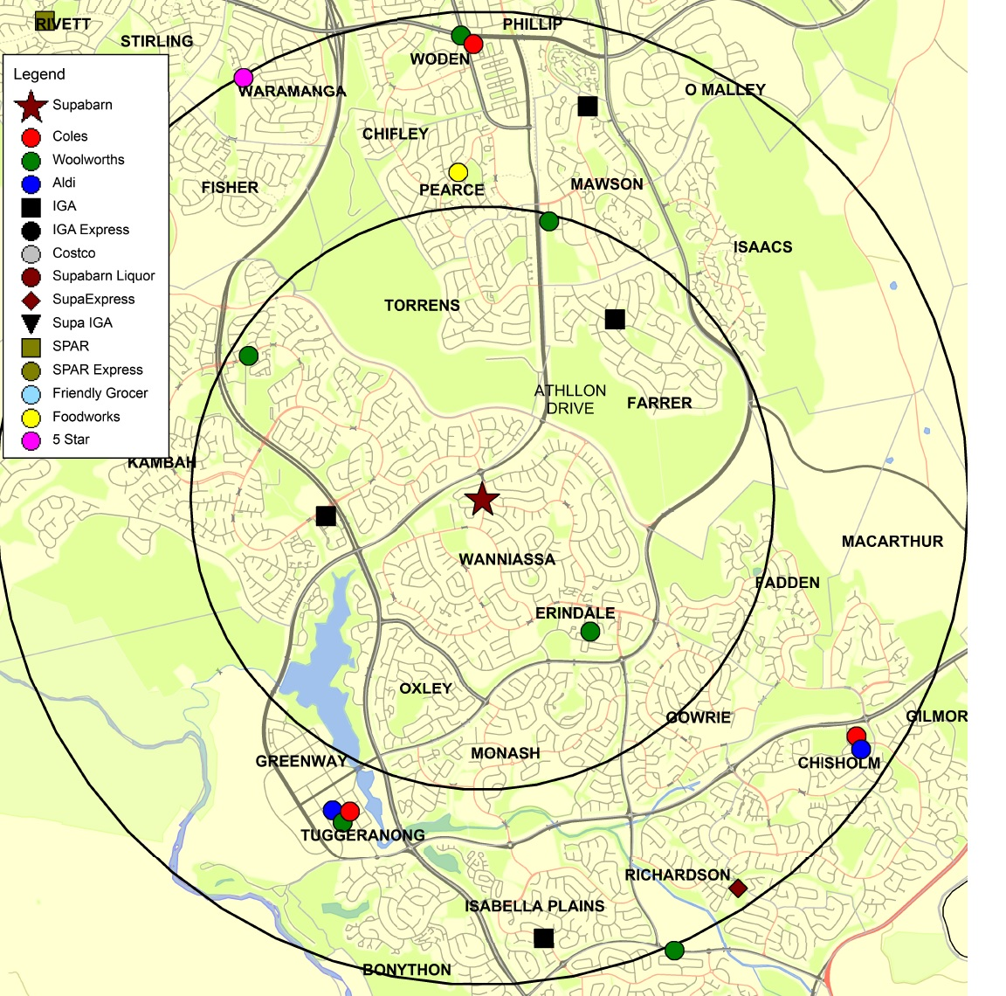
- The ACCC regards the following features of the local market surrounding the Supabarn store at Wanniassa to be relevant to market definition:
  - Supabarn Wanniassa is in a local shopping centre in southern Canberra adjacent to Athllon Drive, an arterial road linking the Woden and Tuggeranong town centres.
  - There do not appear to be any significant physical barriers limiting the local geographic market, other than arterial roads and traffic flows (which are likely to be relatively light due to low population density).
  - Supermarkets at the nearby Erindale local centre, to the south-east of the target store and also in Wanniassa, are likely to be close substitutes for the Wanniassa supermarket, as are the supermarket sites in Kambah to the north-west.
  - The ACCC’s preliminary view is that supermarkets in the Tuggeranong town centre are also likely to be substitutes for the Wanniassa supermarket, although less close substitutes than those in Erindale and Kambah, including because they are more distant and parking is less convenient. Supermarkets at Mawson, Chisholm, and Woden may also be substitutes, but impose a weaker constraint.
- Taking into account these features, the ACCC’s preliminary view is that the local market stretches further to the south towards Tuggeranong than north towards Woden.

Preliminary competition analysis
- The ACCC received numerous submissions from consumers expressing concern about the loss of Supabarn's Wanniassa supermarket, which is the only Supabarn supermarket in Canberra’s south.
- These concerns focus more on the loss of the unique offer of Supabarn than local concentration of Coles stores; the closest existing full-line supermarkets to Supabarn's Wanniassa site are owned by Woolworths (at Erindale and Kambah). ALDI, Woolworths and Coles are also present in Tuggeranong.
- There are also independent supermarkets in the local market (including, at the periphery, a SupaExpress at Richardson); but, for reasons expressed above, the ACCC’s preliminary view is that these smaller format stores impose a less close constraint than other full-line supermarkets.
- The ACCC understands that there may be potential for new supermarkets to be established at one or more of the shopping centres in this local market. However, the ACCC does not have sufficient information at present to assess the prospects for new entry at either site, or the identity of the potential new entrant(s).
- The ACCC’s concerns are less pronounced in this local market than some of the other local markets for supermarket retailing. However, the level of concern may be elevated if the Coles supermarket at Tuggeranong competes closely with the target store; and/or if Coles has entry plans at either of the local centres at Kambah or Erindale.

Preliminary conclusion
- The ACCC’s preliminary view is that the proposed acquisition may lead to a substantial lessening of competition in a local market for supermarket retailing surrounding Supabarn Wanniassa.

Questions for interested parties
The ACCC invites comments from interested parties on its analysis of the Wanniassa local market.
Interested parties may wish to address the following questions:
- To what extent are supermarkets in the Tuggeranong Town Centre (including Coles in the Tuggeranong Hyperdome) close substitutes for the Wanniassa supermarket?
- Is a new supermarket likely to be established at any of the shopping centres in the local market? If so, by whom?

Five Dock: Liquor

Market definition
- The local takeaway liquor retailers surrounding Supabarn Five Dock are shown below.
Figure 10: Five Dock liquor map
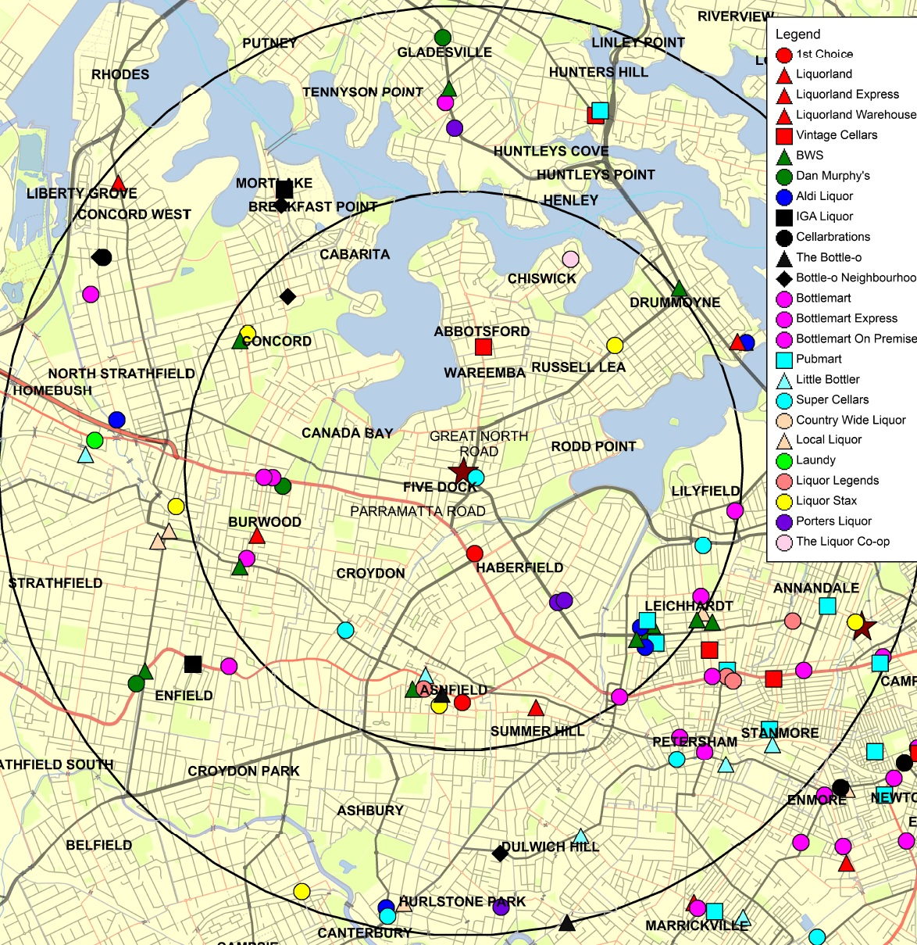
- The ACCC regards the following features of the local market for liquor retailing surrounding the Supabarn store at Five Dock to be relevant to market definition:
  - As with the market for supermarket retailing in Annandale, this market is likely to be small, given its inner suburban location.
  - The ACCC’s preliminary view is that the closest substitutes for Supabarn’s liquor offering are likely to be liquor stores north of Parramatta Road and close to the target site.

Preliminary competition analysis
- Potential concerns arise in this market because of the close proximity of liquor stores already owned by Coles:
  - 1st Choice Liquor, a large format destination liquor store at Haberfield, on the north side of Parramatta Road
  - Vintage Cellars at Abbotsford.
- If the proposed acquisition proceeds, Coles would own three takeaway liquor retailers within about a 2.4km drive along the Great North Road and Parramatta Road (Supabarn Five Dock is just off Great North Road). The closest competing takeaway liquor retailer would be the liquor store at the Five Dock Hotel, on Great North Road, close to the Supabarn.
- Barriers to entry in this market are likely to be high, given the need for an entrant to obtain a liquor licence and planning approval.
- The ACCC is therefore concerned that the proposed acquisition would give Coles significant concentration in the local market. The ACCC is considering whether the more distant alternative liquor stores in Haberfield, Drummoyne and Leichhardt would constrain Coles if the acquisition goes ahead.

Preliminary conclusion
- The ACCC’s preliminary view is that the proposed acquisition may lead to a substantial lessening of competition in a local market for liquor retailing surrounding Supabarn Five Dock.

Questions for interested parties
The ACCC invites comments from interested parties on its analysis of the Five Dock local takeaway liquor market.
Interested parties may wish to address the following questions:
- How far do customers travel in the Five Dock area to purchase takeaway liquor?
- In particular, are liquor stores such as Haberfield Cellars and Mr Liquor Drummoyne likely to be close substitutes for Supabarn Five Dock and the nearby 1st Choice and Vintage Cellars?

Issue unlikely to raise concerns in local markets
- The ACCC considers that the proposed acquisition is unlikely to lead to a substantial lessening of competition in the following local markets:
  - a local market for supermarket retailing surrounding the Five Dock Supabarn store in NSW
  - local markets for the retail supply of takeaway liquor surrounding all of the target stores, with the exception of the local markets surrounding the Sans Souci and Five Dock Supabarn stores
- The following section describes the ACCC’s preliminary views about these markets and provides details of further information sought from interested parties.

Five Dock: supermarket retailing

Market definition
- The local area surrounding Supabarn Five Dock is shown below.
Figure 11: Five Dock supermarket map
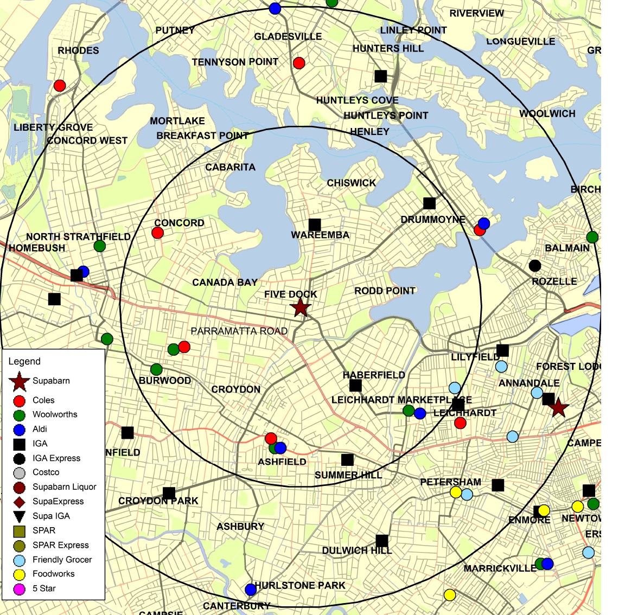
- Like the corresponding liquor market, the local market for supermarket retailing around Five Dock is likely to be small, given its inner suburban location, heavy traffic, and the presence of Parramatta Road.

Preliminary competition analysis
- The ACCC has analysed data showing customer shopping patterns. This data indicates little overlap between the customer catchments of Supabarn Five Dock and the Coles supermarkets in surrounding suburbs. This suggests the Supabarn and Coles stores are weak substitutes for each other, and may not be in the same local market.
- The ACCC’s preliminary view is that there is limited competitive overlap between the merger parties in this local market. However, the ACCC is continuing to assess the appropriate market definition and would welcome comments from interested parties.

Preliminary conclusion
- The ACCC’s preliminary view is that the proposed acquisition is not likely to lead to a substantial lessening of competition in a local market for supermarket retailing surrounding Supabarn Five Dock. However, the ACCC is continuing to assess appropriate market definition and customers’ competition concerns.

Questions for interested parties
The ACCC invites comments from interested parties on its analysis of the local market for supermarket retailing surrounding the Supabarn Five Dock store.
Interested parties may wish to address the following question:
- To what extent are Coles’ supermarkets in the vicinity of Five Dock (such as Concord and Leichhardt) close substitutes for the Five Dock supermarket?

Other local markets: liquor
- The ACCC has also considered the proposed acquisition in local markets for takeaway liquor retailing surrounding each Supabarn site other than Sans Souci and Five Dock, already discussed above.
- In each of these other local takeaway liquor markets, Coles would face competition from a variety of other retailers. Therefore the ACCC’s preliminary view is that the proposed acquisition is not likely to lead to a substantial lessening of competition in any of these markets.

ACCC's future steps
- The ACCC will finalise its view on this matter after it considers submissions invited by this Statement of Issues.
- The ACCC now seeks submissions from market participants on each of the issues identified in this Statement of Issues and on any other issue that may be relevant to the ACCC's assessment of this matter.
- As noted above, submissions are to be received by the ACCC no later than 1 October 2015.
- The ACCC intends to publicly announce its final view by 26 November 2015. However the anticipated timeline may change in line with the Merger Review Process Guidelines. A Public Competition Assessment for the purpose of explaining the ACCC's final view may be published following the ACCC's public announcement.

Selling Floor Area
http://www.parliament.act.gov.au/__data/assets/pdf_file/0019/375022/08._Coles_Supermarket.pdf, p7.
In this sense the ACCC measures ‘closeness’ of competition to include a range of dimensions (such as product range and competitive focus), not just geography.
Australian Gas Light Company v ACCC (No 3) [2003] FCA 1525 at [351].
www.supabarn.com.au, accessed 4 September 2015.

