

Statement of Issues
21 October 2015

GPC Asia Pacific Pty Ltd –
proposed acquisition of the Covs Parts business from Automotive Holdings Group Limited

Purpose
This Statement of issues aims to:
- give the Australian Competition and Consumer Commission’s (ACCC) preliminary views on competition issues arising from GPC Asia Pacific Pty Ltd’s (GPC) proposed acquisition of the Covs Parts business (Covs) from Automotive Holdings Group Limited (AHG) (the proposed acquisition)
- identify areas of further inquiry
- give all parties an opportunity to comment
- invite interested parties to submit information to assist us in our assessment of the issues.

Overview of ACCC’s preliminary views
- The legal test which the ACCC applies in considering the proposed acquisition is in section 50 of the Competition and Consumer Act 2010. Section 50 prohibits acquisitions that substantially lessen competition in a market, or are likely to do so.
In this Statement of Issues, the ACCC has divided its preliminary views into two categories, 'issues of concern' and ‘issues unlikely to raise concerns’.

Issues of concern
The ACCC is concerned that the proposed acquisition would substantially lessen competition in the supply of automotive hard parts and accessories (automotive parts) to trade customers in the local markets of Albany, Bunbury, Busselton, Esperance, Geraldton, Kalgoorlie, Karratha, Mandurah and Port Hedland.
In each of the local markets identified above, GPC would become the only generalist supplier of automotive parts or one of two generalist suppliers of automotive parts.

Issues unlikely to raise concerns
- The ACCC considers that the proposed acquisition would be unlikely to substantially lessen competition in the supply of automotive parts in the greater metropolitan Perth region due to the presence of existing competitive constraints.
- The ACCC considers that the proposed acquisition would be unlikely to substantially lessen competition in the supply of automotive parts to mining and industrial customers due to the minimal competitive overlap between the parties.

Making a submission
The ACCC is seeking submissions from interested parties, particularly on the following key issues:
- the product market, including the extent to which original equipment parts are substitutable for aftermarket parts;
- the geographic dimensions of each of the local markets, including the extent to which suppliers located in Perth are close substitutes to suppliers located in each of the regional areas (and particularly in Bunbury, Busselton and Mandurah);
- whether the loss of Covs would have a meaningful impact on competition and consumer choice in local markets;
- the availability of substitutes to competitively constrain the pricing activities of the merged entity in each of the local markets; and
- the likelihood of sufficient entry or expansion in each of the local markets within the foreseeable future.
Detailed discussion of these and other issues, along with specific questions, is contained in this Statement of Issues.
Interested parties should provide submissions by no later than 5pm on 5 November 2015. Responses may be emailed to mergers@accc.gov.au with the title: Submission re: GPC’s proposed acquisition of Covs Parts - attention Kate Reader/Serena Wong. If you would like to discuss the matter with ACCC officers over the telephone or in person, or have any questions about this letter, please contact Serena Wong on (02) 9230 9188 or Kate Reader on (02) 9230 3822.
The ACCC anticipates making a final decision on 26 November 2015, however, this timeline can change. To keep abreast of possible changes in relation to timing and to find relevant documents, interested parties should visit the Mergers Register on the ACCC's website at www.accc.gov.au/mergersregister.

Confidentiality of submissions
- The ACCC will not publish submissions regarding the proposed acquisition. We will not disclose submissions to third parties (except our advisors/consultants) unless compelled by law (for example, under freedom of information legislation or during court proceedings) or in accordance with s155AAA of the Competition and Consumer Act 2010. Where the ACCC is required to disclose confidential information, the ACCC will notify you in advance where possible so that you may have an opportunity to be heard. Therefore, if the information provided to the ACCC is of a confidential nature, please indicate as such. Our Informal Merger Review Process Guidelines contain more information.

About ACCC ‘Statements of Issues’
A Statement of Issues published by the ACCC is not a final decision about a proposed acquisition, but provides the ACCC’s preliminary views, drawing attention to particular issues of varying degrees of competition concern, as well as identifying the lines of further inquiry that the ACCC wishes to undertake.
A Statement of Issues provides an opportunity for all interested parties (including customers, competitors, shareholders and other stakeholders) to ascertain and consider the primary issues identified by the ACCC. It is also intended to provide the merger parties and other interested parties with the basis for making further submissions should they consider it necessary.

Timeline
Date | Event
26 August 2015 | ACCC commenced review of the proposed acquisition
21 October 2015 | ACCC publication of Statement of Issues
5 November 2015 | Deadline for submissions from interested parties in response to this Statement of Issues
26 November 2015 | Anticipated date for ACCC final decision (this date may be delayed)

The parties

The acquirer
- GPC (owned by Genuine Parts Company) is a distributor and retailer of automotive parts in Australia and New Zealand to both trade and retail customers. GPC owns Repco, an automotive parts supplier to trade and retail customers and Ashdown-Ingram (AI), a specialist supplier of automotive electrical parts to trade, reseller, mining and industrial customers.
- In Western Australia, GPC operates 36 Repco stores and 8 AI branches. Repco supplies aftermarket (non-genuine) automotive parts and does not supply original equipment (OE) parts.

The target
- AHG acquired Covs from the Coventry Group in 2011. Covs operates a 25 branch network in Western Australia and supplies a broad range of automotive parts, primarily to trade customers. Covs has three business streams:
- automotive hard parts, consumables, tools and workshop equipment;
- mining and industrial sector – this part of the business supplies automotive and other parts (such as safety products, chemicals, cleaning and janitorial products) to mining and industrial customers across Australia and overseas; and
- drivetrain – this is a specialist business unit which focuses on truck driveline assemblies and components such as gearbox, clutch, drive shafts and hubs.
- Covs supplies both OE and aftermarket automotive parts, and is currently the exclusive distributor of Ford and Holden OE parts to OE dealers and trade customers in Western Australia. Post-acquisition, AHG intends to retain the exclusive distribution of Ford and Holden OE parts in Western Australia within Amcap, a division of AHG.
- Amcap provides warehousing and distribution of OE spare parts and automotive consumables to customers. It distributes products (including through Covs stores) to OE dealers throughout Australia out of its distribution centre in Welshpool, Perth. Amcap is not part of the proposed acquisition.

Other industry participants

Burson
- Burson Auto Parts (Burson) is a trade-focused supplier of automotive parts with over 100 stores across Australia. In 2015, Burson purchased Metcash’s automotive business, which includes the Autobarn and AutoPro chains. Burson previously sought to acquire Covs in 2014 but this transaction did not proceed. In Western Australia, Burson operates 3 stores in Malaga, Belmont and Osborne Park in the greater metropolitan Perth region, and owns the Autobarn and AutoPro stores across Western Australia.

Veale
- Veale Auto Parts (Veale) is a trade-focused generalist supplier of automotive parts in Western Australia. Veale has 17 stores in Western Australia, with 15 stores in the greater metropolitan Perth region and two stores in regional areas (Bunbury and Mandurah).

Retail-focused suppliers
- Suppliers with a strong focus on retail customers operating in Western Australia include:
- Super Cheap Auto (SCA), a nationwide retailer of automotive parts with 28 stores across Western Australia;
- Auto Barn, which operates a franchised business, stocking a range of automotive parts primarily aimed at retail customers; there are 7 stores operating under this brand in Western Australia;
- Auto Pro, which supplies to both trade and retail customers; there are 18 stores operating under the Auto Pro brand in Western Australia, including 3 ‘superstores’; and
- Auto One, an independent, member-owned automotive parts group operating from 5 stores in Western Australia, located in Kalgoorlie, Geraldton, Midland, Kalamunda and Wanneroo.
- The extent to which retail-focused suppliers competitively constrain the activities of trade-focused suppliers is considered further below.

Capricorn
- Capricorn Buying Group (Capricorn) is a buying group with over 15,800 members and 2,000 preferred suppliers in Australia (including Repco and Covs). It offers its trade members:
- single account invoicing for all group purchases (rather than individual invoices from many suppliers);
- access to a range of preferred suppliers for its members and in doing so enables channel-skipping, with purchases made direct from manufacturers; and
- delivery times and transport prices, negotiated on behalf of its trade customer members.

Industry background
- In Australia, the majority of automotive parts are acquired from offshore manufacturers or local third party importers. Manufacturers include:
- OE manufacturers, who sell new motor vehicles in Australia. All OE manufacturers either manufacture ‘genuine’ or ‘branded’ spare parts, which the OE manufacturers then distribute through their OE dealer network (for use in the OE dealers own service centres), via OE dealers to non-affiliated end users (such as independent workshops) or through distributors such as Covs.
- Aftermarket manufacturers, who manufacture aftermarket parts to precisely match the relevant functional and technical specifications of OE parts, but which are not branded as OE parts or sold on behalf of OE manufacturers.
- OE and aftermarket parts are distributed by various wholesalers/intermediary resellers, including:
- generalist automotive parts resellers (such as Repco and Covs);
- specialist resellers, who specialise in dealing in a particular set or sets of components or parts (such as AI);
- OE parts resellers, including OE dealers; and
- direct supply to end users by the manufacturer/importer (including through Capricorn).
- OE and aftermarket parts are acquired by a wide range of users of automotive parts, including retail customers/DIY repairers and vehicle repairers such as:
- independent vehicle repairers;
- mechanical vehicle repair chains;
- specialist repairers;
- dealer service centres (which includes single brand dealers with one service centre dedicated to their single make of car, multiple brand dealers with separate workshops for each car make and multiple brand dealers with combined workshops which service several makes of cars).
- Different classes of end users have varying demand characteristics, which influences the distribution models and service offerings of distributors and resellers. In particular, market feedback has indicated that resellers tend to focus on supplying automotive parts to either trade customers or to retail customers, due to the differing requirements of these two kinds of customers. This is further discussed below.

The proposed transaction
GPC proposes to acquire Covs from AHG, through the purchase of 100% of the shares in Covs Parts Pty Ltd, the corporate entity in which the Covs business currently resides. GPC has indicated that it would retain the Covs brand and continue operating existing Covs as standalone stores.

Future with and without the acquisition
Section 50 of the Act prohibits mergers or acquisitions that would have the effect or be likely to have the effect of substantially lessening competition in a market. In assessing a proposed acquisition pursuant to section 50 of the Act, the ACCC considers the effects of the acquisition by comparing the likely future competitive environment post-acquisition if the acquisition proceeds (the “with” position) to the likely future competitive environment if the acquisition does not proceed (the “without” position) to determine whether the proposed acquisition is likely to substantially lessen competition in any relevant market.
- The ACCC’s preliminary view is that the likely competition effects of the proposed transaction are most appropriately assessed against a future in which competition remains broadly as it currently stands (the status quo).
- It is possible that in the absence of the proposed acquisition by GPC, another buyer would acquire Covs. However, based on presently available information, the ACCC does not consider that any such alternative transaction is likely to alter its view as to the appropriate ‘future without’ against which to assess the proposed acquisition.

Market Definition
- The ACCC’s starting point for delineating relevant markets to assess the competitive effects of the proposed acquisition involves identifying the products actually or potentially supplied by the merger parties. The ACCC then considers what other products constitute sufficiently close substitutes to provide a significant source of constraint on the merged entity.

Areas of overlap
- The ACCC understands that the merger parties overlap in the supply of automotive hard parts, consumables and tools.
- The ACCC considers that the key area of competitive overlap between the parties to the proposed acquisition is in the supply of automotive parts to trade customers in the following areas of Western Australia:
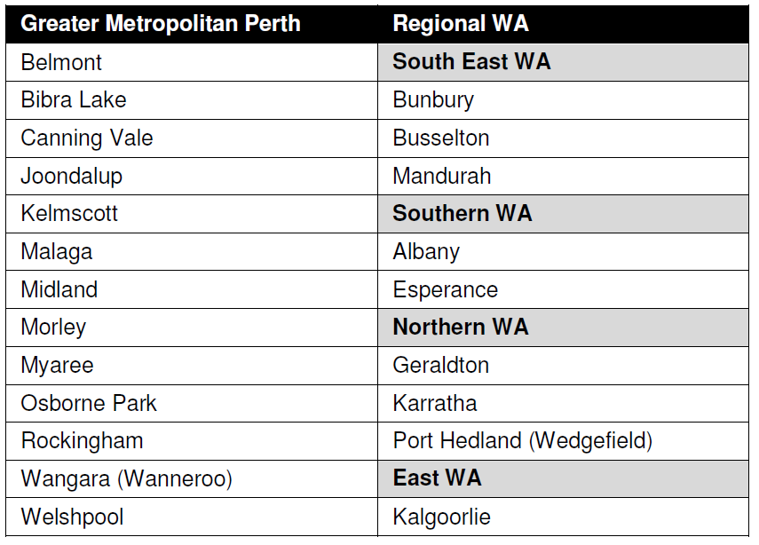
- Maps of the above areas of Western Australia and the industry participants’ operations are set out below.
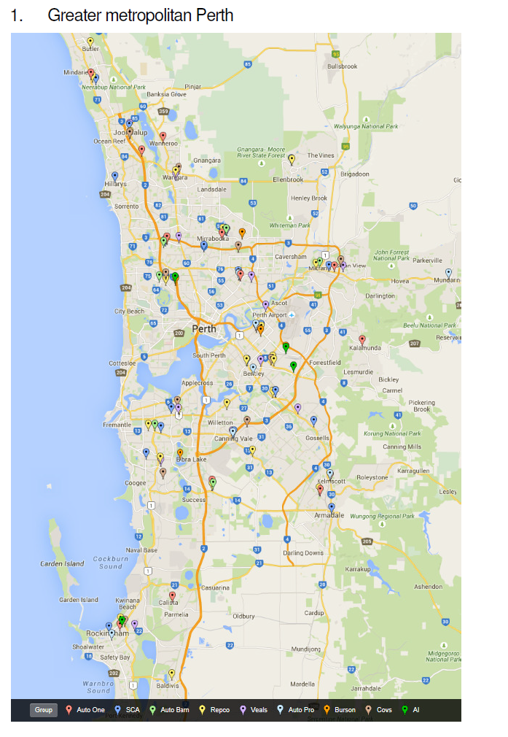

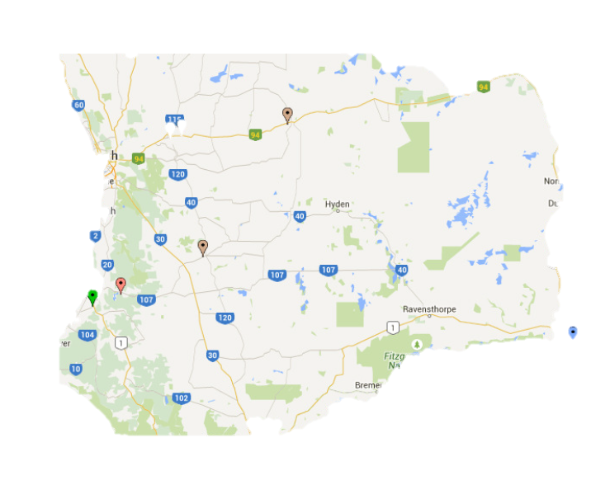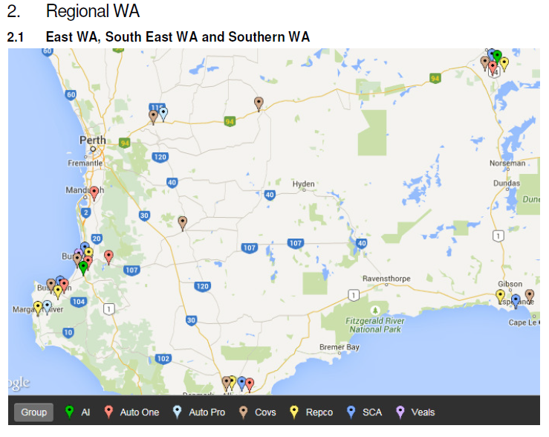
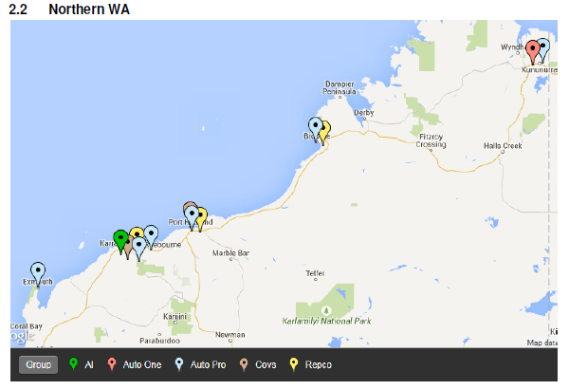

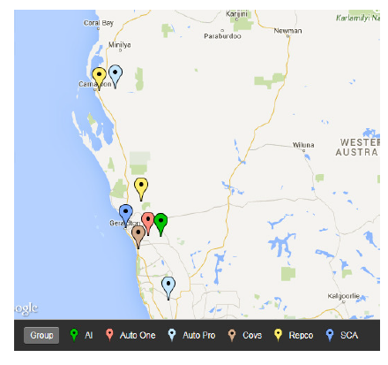

Product market
- The ACCC considers the relevant product market to be the supply of automotive hard parts to trade customers, which the ACCC understands is generally different from the types of automotive parts acquired by retail customers, although there may be some overlap between the two.

Trade customers
- The ACCC considers that there are separate markets for the supply of automotive parts to trade customers and to retail customers, due to their different demand characteristics. The ACCC notes that while some suppliers, such as Repco, supply both trade and retail customers, the products and services required by these customers are different. The ACCC understands that Repco employs a ‘dual format’ stores, in which it services both trade and retail customers.
- In general, trade customers do not view retail-focused suppliers (such as SCA and Auto Pro) as substitutable for trade-focused suppliers (such as Covs and Repco), due to their business needs. For instance, a number of trade customers have identified retail-focused stores as:
- not stocking the range or volume of products commonly required by trade customers for servicing and repairing vehicles;
- not providing delivery services required by trade customers; and
- not providing the same quality of customer service (primarily due to limited staff knowledge and expertise).
- Market feedback also indicated that trade-focused suppliers have a network of delivery and transport options, which allows parts to be delivered on a frequent and timely basis to trade customers. In particular, market feedback suggested that trade workshops typically cannot carry their own inventory, operating a just-in-time model. Accordingly, timeliness of supply and delivery for trade customers is crucial.
- In addition, some trade customers have highlighted the benefit of trade pricing offered by trade-focused suppliers, which is generally lower than retail pricing.

OE parts
- The ACCC notes that the key competitive overlap between the two parties is in the supply of aftermarket parts to trade customers, given that Repco does not supply OE parts. However, market feedback indicated that trade customers purchase a mix of OE and aftermarket parts. In this respect, while the ACCC understands that aftermarket parts are functionally substitutable for OE parts, the majority of market feedback has indicated that OE parts and aftermarket parts are not demand-side substitutes as OE parts are significantly more expensive than aftermarket parts – anywhere from 20% to 80% more expensive, depending on the relevant part). For this reason, market participants have submitted that OE parts do not provide a strong competitive constraint on the pricing of aftermarket parts.
- Market participants have submitted that the decision to purchase OE parts is driven by factors other than price, such as where:
- the end user specifically requests the use of OE parts in their vehicles;
- the end user’s vehicle is still under warranty (OE parts are used to ensure the warranty is not void); some market feedback also suggested that as warranty periods are being extended by dealers, there is an increase in the demand for OE parts; and
- the trade customer is a dealership and is required by the relevant car manufacturer to use OE parts where possible.
- The ACCC has received some market feedback to the effect that OE parts are similarly priced. The ACCC welcomes further information as to any trend in OE parts becoming more price competitive with aftermarket parts in recent years.
- The ACCC also understands that a number of car manufacturers have trade clubs to encourage the purchase of OE parts. The Holden Trade Club, for example, states that it stocks Holden and ACDelco parts at lower than normal trade prices. The ACCC is also aware of the Ford Trade Club and the GetGenuine Club which aims to encourage the purchase of OE parts. However, the ACCC understands that the demand for OE parts from trade clubs may be limited to specific manufacturers and vehicle models.
- The ACCC is further considering the extent to which new technological developments in car manufacturing and repairs is impacting on the demand for OE parts, particularly in light of the potentially lower prices of OE parts sold by trade clubs and other suppliers. For instance, market feedback indicated that with newer vehicles with electronic components, OE dealers can use an electronic parts catalogue to check which parts of a vehicle need to be replaced or repaired, which would then recommend an OE part (as opposed to an aftermarket part). However, this may represent a shift in the demand for OE parts, rather than customers switching from aftermarket parts to OE parts on the basis of a price constraint. The ACCC invites any additional information on the extent to which trade clubs constrain generalist suppliers of aftermarket parts and the extent to which new vehicle repair technologies and new makes and models of vehicles is influencing the demand for OE parts (particularly in comparison to the demand for aftermarket parts).
- The ACCC’s preliminary view is that OE parts do not compete strongly with aftermarket parts due to the limited willingness of trade customers to switch from aftermarket parts to OE parts due to the price differential between these products, which would likely remain even after a significant price rise for aftermarket parts. Accordingly, the key area of competitive overlap between the merger parties is in the supply of aftermarket automotive parts, with OE parts offering a limited constraint. However, the ACCC notes that it has received mixed feedback in this respect and would welcome any further information regarding the degree of price competition between OE parts and aftermarket parts.

Specialist resellers
- As mentioned above, Covs and Repco are generalist resellers of automotive parts, therefore providing a full range of automotive parts to their customers. In general, market feedback suggested that trade customers source the vast majority of their automotive parts from either Covs or Repco, purchasing only a minimal proportion of parts from specialist resellers, or on an ad hoc basis. The ACCC understands that certain trade customers, depending on the focus of their workshop, may have a higher demand for specialist parts and accordingly, purchase a more significant proportion of their parts from specialist suppliers.
- The ACCC also understands that there is limited supply side substitutability on the part of specialist resellers, given the different range of automotive parts offered by specialist resellers and generalist resellers. Accordingly, the ACCC’s preliminary view is that specialist resellers offer only a limited competitive constraint to the merger parties.

Geographic market dimension
- Market inquiries suggested that the proposed acquisition should be considered in the context of the local markets of Albany, Bunbury, Busselton, Esperance, Geraldton, Kalgoorlie, Karratha, Mandurah and Port Hedland, due to the demand characteristics of trade customers and the weak supply-side substitutability of automotive parts providers located outside of these areas.
- The majority of trade customers emphasised the importance of the availability and timely delivery of parts to their business operations. Market feedback indicated the majority of parts are required on a same-day basis. Accordingly, trade customers have a strong preference to source automotive parts from local suppliers due to their ability to provide same-day (as opposed to overnight) delivery, with most local suppliers offering free hourly deliveries. In this respect, trade customers have indicated that timeliness of supply is critical and a driving factor in selecting a supplier of automotive parts, given that delays in returning a vehicle to an end user involve reputational risks to the business of the trade customer.
- Price is also a key factor to trade customers’ choice of supplier. A number of customers have indicated their preference for local suppliers due to free delivery offered with purchases of automotive parts or alternatively, the minimal distance required to travel in order to pick up the purchased parts. Where an automotive part is not in stock, the local supplier can order the part in without charging additional freight to the customer.
- As a result, trade customers have indicated a general reluctance to order parts from Perth or interstate because of the cost of freight and the potential for delayed delivery, particularly to more remote areas of Western Australia.
- Based on market inquiries to date, the ACCC’s preliminary view is that the proposed acquisition appears likely to give rise to competition concerns in each of the local markets identified above. The ACCC is considering the dimensions of the affected local markets and in particular, the extent to which the local markets of Bunbury and Busselton, and Mandurah and Perth overlap.

Bunbury and Busselton
- Market feedback indicated that trade customers in Bunbury and Busselton source automotive parts from their local Repco and Covs branches and the Veale’s branch located in Bunbury. However, the level of demand substitutability between Busselton and Bunbury appears to be low, with trade customers located in Busselton purchasing only minimal volumes of product from Veale’s Bunbury branch. Market feedback suggested that Busselton trade customers consider Veale to be a secondary option due to the relatively low frequency of Veale’s deliveries to Busselton (three times a day), compared to local suppliers (hourly).

Mandurah and Perth
- Although trade customers in Mandurah have expressed a strong preference for sourcing automotive parts from local suppliers, market feedback has identified the potential for same day delivery of parts from suppliers in Perth to customers in Mandurah. However, some trade customers have noted that unlike local suppliers, Perth suppliers cannot deliver on an hourly basis and may only be able to deliver once or twice a day. In addition, Perth suppliers may charge an additional courier fee.

Albany, Esperance, Geraldton, Kalgoorlie, Karratha and Port Hedland
- Due to the relatively isolated nature of regional towns in Western Australia and the need for timely delivery of parts, most interested parties indicated that they purchase the vast majority of automotive parts from local suppliers, and only consider suppliers in Perth or other regions where parts are not available locally (and cannot be ordered by a local supplier) or where parts are not urgently required.
- As mentioned above, interested parties have indicated a reluctance to order automotive parts from Perth or other regional areas due to the cost of freight and longer delivery times. This reluctance is further heightened by the fact that local suppliers (in most cases, the merger parties) are able to transfer products from other areas without charging additional costs for freight (at least where the product is normally stocked by that supplier). Accordingly, the ACCC considers that online suppliers of automotive parts and suppliers located in Perth and interstate only offer a limited competitive constraint.

Preliminary view on relevant markets
- Based on information received by the ACCC to date, the ACCC’s preliminary view is that the markets relevant for assessing the competition effects of the acquisition are the markets for the supply of automotive parts to trade customers in each of the local markets of Albany, Esperance, Bunbury, Busselton, Geraldton, Kalgoorlie, Karratha, Mandurah and Port Hedland.
The ACCC invites comments from market participants on its preliminary views about the definition of the relevant market. In particular market participants may wish to comment on:
- the extent to which retail-focused suppliers compete with trade-focused suppliers;
- the extent to which specialist resellers compete with generalist resellers;
- whether trade customers use trade clubs (such as Holden Trade Club or the GetGenuine Trade Club) to purchase OE parts and if so, whether the prices of OE parts are competitive with the prices of aftermarket parts;
- the geographic boundaries of each of the local markets. In particular, whether Bunbury, Busselton and Mandurah should be considered as a single region or as separate areas of competition; in this respect, please consider the extent to which:
- customers operating in Bunbury would purchase products from
Busselton and vice versa; and
- customers operating in Mandurah would purchase products from Perth;
- the extent to which trade customers operating in each of the local markets purchase automotive parts from Perth, online or interstate, or would do so if the merged entity increased the prices of automotive parts.

Issue of concern: supply of automotive parts to trade customers in local markets
The ACCC’s preliminary view is that the proposed acquisition is likely to substantially lessen competition in the supply of automotive parts to trade customers in each of the local markets of Albany, Bunbury, Busselton, Esperance, Geraldton, Kalgoorlie, Karratha, Mandurah and Port Hedland.
Based on market inquiries to date, the ACCC is concerned that the proposed acquisition would result in an increased incentive on the part of the merged entity to raise prices and/or decrease service levels.
Reducing the number of local suppliers
As discussed above, the ACCC considers that specialist resellers and OE dealers would exercise only a limited competitive constraint on the merged entity. The proposed acquisition would accordingly remove an effective generalist supplier of automotive parts from each of the local markets, leaving Veale as the only other generalist supplier in Bunbury and Mandurah and no other generalist suppliers in the other local markets.
At the local level the acquisition of Covs would reduce the number of generalist suppliers owned by separate entitles in the relevant local markets from three to two, or two to one.
In Bunbury, Busselton and Mandurah, GPC would own two out of the three generalist trade suppliers. The ACCC notes that in relation to Mandurah a Burson store opening in the surrounding area may reduce GPC’s incentive to raise prices or decrease service levels.
- In Albany, Esperance, Kalgoorlie, Karratha, Geraldton and Port Hedland, GPC would own both generalist trade suppliers. Market feedback indicated that while there is an alternative generalist reseller in Kalgoorlie, that supplier is effectively a reseller of Covs’ products. Further market feedback also indicated that the Mach One/Auto One is retail-focused and does not provide a wide range of ‘hard parts’ required by trade customers. Accordingly, market feedback suggested that GPC would be the only generalist supplier of automotive parts to trade customers in each of these local markets post-acquisition.

Removal of closest competitor
- Market inquiries indicated that Repco and Covs compete closely in the supply of automotive parts to trade customers in the local markets identified. Some customers have indicated that Repco has a stronger retail focus than Covs but for the vast majority of customers, Repco and Covs appear to be generally substitutable in their supply of automotive parts to trade customers.
- During the course of market inquiries, trade customers submitted their preference for purchasing automotive parts from Repco and Covs, with most customers purchasing at least 75% of parts from either, or both, stores. This trend appears consistent across all local markets, even in areas where there are alternative generalist suppliers, such as in Mandurah and Bunbury. As a result, the ACCC is concerned that the proposed acquisition would result in significant concentration in all local markets, giving rise to a likely substantial lessening of competition.
- Most trade customers identified price as a key factor in their purchasing decisions between local suppliers. In addition, some trade customers have indicated that Covs provides products at a cheaper price point than Repco and that the proposed acquisition may result in the loss of a lower cost supplier, as well as removing GPC’s closest competitor.

Availability of substitutes
- Market feedback suggested that there would be only limited alternative suppliers to the merger parties following the proposed acquisition.
Burson
- As discussed above, the ACCC considers suppliers located in Perth to offer a limited competitive constraint to the merged entity. However, the ACCC understands that Burson has recently opened three stores in greater metropolitan Perth, and may seek to increase its footprint across regional Australia as part of its national expansion. The potential for Burson to enter the local markets (in which there may be competition concerns) is considered further below.

Veale (Bunbury, Busselton and Mandurah)
- A number of trade customers in Bunbury and Busselton have indicated that Veale (located in Bunbury) is a viable alternative to Covs and Repco. Similarly, some trade customers in Mandurah have identified the Veale branch in Mandurah as a competitive constraint to the Repco and Covs branches.
- In this respect, the ACCC notes that while the proposed acquisition would not result in a single supplier in those regions, it would still lead to a significant concentration of suppliers in those markets and the increased incentive and ability for the merged entity to raise prices and/or decrease service levels.

Capricorn
- Capricorn offers trade customers the convenience of a single account invoicing system through which they can purchase automotive parts from a range of resellers and directly from manufacturers. The ACCC therefore understands that Capricorn is a conduit or channel through which customers can purchase automotive parts from a range of manufacturers, distributors and resellers.
- Market feedback suggested that trade customers primarily utilise Capricorn to purchase parts from resellers, such as Repco and Covs, or on an ad hoc basis, where required parts are not available locally. Some market participants in the relevant local markets did not use Capricorn or had previously used Capricorn but had ceased to do so as there was no perceived difference in price to ordering direct from the supplier. In addition, as with suppliers located in Perth, there are issues related to timeliness of delivery and convenience of supply.
- The ACCC’s preliminary view is that it may not be a real substitute for the merger parties. However, the ACCC understands that customers’ use of Capricorn has been growing in the last few years. The ACCC welcomes any further information regarding the extent to which Capricorn users utilise Capricorn as a conduit for purchases from Repco, AI and Covs, and/or as a means of purchasing products from alternative suppliers (locally and from Perth).

Perth and online resellers
- As discussed above, trade customers have not indicated that online suppliers of automotive parts or suppliers located in Perth are viable alternatives to local suppliers, due to the need for timely and frequent deliveries. In addition, online suppliers appear to be unable to supply high volumes of parts as efficiently as local suppliers.
OE dealers
- As discussed above, market feedback indicated that a substantial number of trade customers do not consider that OE dealers are viable alternative suppliers to Covs or Repco. The ACCC invites further information on the extent to which the trade clubs of OE dealers are competing aggressively on price, such that the purchase of OE parts from OE dealers is becoming more attractive to trade customers. The ACCC also welcomes further information on the scope of the constraint provided by OE dealers to generalist suppliers given the supply of OE parts by a given OE dealer will be limited to specific manufacturers and vehicle models.

Barriers to entry
The ACCC understands that barriers to entry and expansion in the supply of automotive parts to trade customers in each of the local markets vary according to the location of each of the markets relative to Perth. The further away an area is from Perth, the more difficult it would be to enter into that market. Nonetheless, the ACCC’s preliminary view is that barriers to entry and expansion exist in each of the local markets and is further heightened by the proposed acquisition.
While opening a standalone store in any of the local markets may not incur significant capital or sunk costs, market feedback indicated that the cost of establishing a logistics network of distribution centres and vehicles across metropolitan and regional Western Australia is significant. This logistics network is a necessary component for the supply of automotive parts to trade customers, due to the need for timely and frequent deliveries. The ACCC understands that the cost of establishing an automotive parts retail/trade chain, with branches across a number of local areas in Western Australia, would be even greater, due to the need for sufficient economies of scale in relation to the distribution and warehousing of automotive parts.
The ACCC notes Burson’s recent entry into Western Australia and Veale’s presence in metropolitan and regional Western Australia (albeit in regional areas located relatively close to Perth, compared to other areas). However, the ACCC notes that all of Burson’s stores and most of Veale’s stores are located in the greater metropolitan Perth region. The remoteness of many regional towns in Western Australia, and the relatively smaller population in those towns (and consequently, lower demand), may mean that barriers to entry and expansion are higher in these areas. The addition of one more outlet in these locations would significantly increase total supply and reduce the expected returns from entry. The ACCC has received market feedback to suggest that the relatively smaller population in the more isolated regional towns (such as Karratha and Port Hedland) reduces the incentive for existing suppliers to expand or new suppliers to enter those markets.
- In addition, concerns have been raised with the ACCC that the merged entity would be the largest trade supplier in Western Australia and would have an increased ability and incentive to deter new entry and expansion through exclusive customer arrangements and targeted pricing strategies. Accordingly, the ACCC considers that the risk of retaliatory action by the incumbent against new entry also represents a barrier to entry or expansion in each of the local markets.
Likelihood of expansion
- As mentioned above, market feedback identified Veale as an alternative supplier in Bunbury, Busselton and Mandurah. Accordingly, should the merged entity increase prices, Veale may be able to expand its supply of automotive parts through increased deliveries or new stores, to meet increased demand from customers unwilling to pay higher prices, given its existing network of facilities across these metropolitan Perth and these areas of Western Australia. In this respect, the ACCC understands that switching costs are presently low. However, the ACCC also recognises that the incumbent has an incentive to attempt to deter expansion by Veale or others by locking customers into exclusive long-term contracts or engaging in price wars. This may make expansion more difficult.
- The ACCC has also considered whether existing retail-focused suppliers could expand their product offering to supply to trade customers, noting that retail-focused suppliers would have similar economies of scale to trade-focused suppliers. Some retail-focused suppliers appear to have products that cater to trade customers (albeit on a limited basis) or limited trade supply programs. Following market inquiries, the ACCC considers it unlikely that retail-focused suppliers would expand into supplying trade customers in the local markets beyond their current offerings in the foreseeable future.
Likelihood of new entry
- The ACCC has received information that suggests there may be new entry in Albany, Geraldton and the Mandurah area. The ACCC notes that the extent of competitive constraint by any new entrant would likely depend on:
- how closely the new store would compete with existing local suppliers in Albany, Geraldton and Mandurah;
- the willingness of customers to substitute to the new store;
- the frequency of deliveries to customers in each of those towns; and
- any retaliatory conduct by the incumbent suppliers.
- At present, it does not appear that such entry would be timely (that is, within the foreseeable future) or sufficient to constrain the merged entity. Accordingly, based on information at hand, the ACCC’s preliminary view is that the likelihood of new entry or expansion would not be sufficient to constrain the merged entity and may in fact be reduced by the proposed acquisition.

ACCC’s preliminary views
In summary, the ACCC is concerned that the proposed acquisition would:
- increase market concentration;
- remove a key competitive constraint;
- raise barriers to entry and expansion;
- and that timely entry or expansion is unlikely
resulting in an increased ability and incentive on the part of the merged entity to raise prices or decrease service levels in the supply of automotive parts to trade customers in each of the local markets identified above.
The ACCC invites comments from market participants on its concerns in relation to GPC’s increased ability to raise prices and/or decrease service levels. In particular market participants may wish to comment on the following:
- the extent to which Veale (in Bunbury, Busselton and Mandurah), specialist resellers, OE dealers and direct suppliers (through Capricorn) would competitively constrain the merged entity;
- barriers to entry or expansion in each of the local areas; in particular:
- whether barriers to entry are different for each area; and
- whether a new supplier needs to establish a network of stores,
distribution and warehousing facilities in order to compete with the
merged entity and if so, the capital required to do so;
- the extent to which the proposed acquisition would raise barriers to
entry and expansion;
- the likelihood of timely new entry or expansion; in particular:
- the likelihood of new entry by existing suppliers (such as Veale or
Burson) in each of the local markets;
- whether new entry in Albany, Geraldton and the Mandurah area would
be sufficient to constrain the pricing activities of the merged entity in
each of Albany, Geraldton and Mandurah;
- if the merged entity increases prices:
- the likelihood of existing trade-focused suppliers (such as Veale in
Bunbury and Mandurah) expanding their supply (for instance, by
lowering prices or increasing frequency of delivery);
- the likelihood of retail-focused suppliers changing or expanding the
focus of their supply of automotive parts from retail customers to trade
customers;
- the extent to which the merger parties have engaged in exclusive customer arrangements (for instance, 12 month fixed contracts with customers) in the past and the likelihood of the merged entity engaging in such conduct.

Issue unlikely to raise concerns: supply of automotive parts in the greater metropolitan Perth region
- The ACCC considers that the proposed acquisition would be unlikely to substantially lessen competition in the supply of automotive parts in the greater metropolitan Perth region due to the presence of sufficient existing competitive constraints.

Issue unlikely to raise concerns: supply of automotive parts to mining and industrial customers
The ACCC’s preliminary view is that the proposed acquisition is unlikely to substantially lessen competition in the supply of automotive parts to mining and industrial customers due to the merger parties’ minimal share of this market. However, the ACCC welcomes any information in this respect.

ACCC's future steps
The ACCC will finalise its view on this matter after it considers submissions invited by this Statement of Issues.
As noted above, the ACCC now seeks submissions from market participants on each of the issues identified in this Statement of Issues and on any other issue that may be relevant to the ACCC's assessment of this matter. Submissions are to be received by the ACCC no later than 5 November 2015 and should be emailed to mergers@accc.gov.au.
The ACCC intends to publicly announce its final view by 26 November 2015. However the anticipated timeline may change in line with the Merger Review Process Guidelines. A Public Competition Assessment for the purpose of explaining the ACCC's final view may be published following the ACCC's public announcement.

https://www.holdentradeclub.com.au/HoldenParts
http://www.burson.com.au/burson-auto-parts-national-expansion/

