

Statement of Issues
17 September 2015

Royal Dutch Shell plc – proposed acquisition of BG Group plc

Purpose
- This Statement of Issues aims to:
- provide the Australian Competition and Consumer Commission’s (ACCC’s) preliminary views on competition issues arising from Royal Dutch Shell plc’s (Shell) proposed acquisition BG Group plc (BG)
- identify areas of further inquiry
- give all interested parties an opportunity to comment
- invite interested parties to submit information to assist us in our assessment of the issues.

Overview of ACCC’s preliminary views
- The legal test which the ACCC applies in considering the proposed acquisition is in section 50 of the Competition and Consumer Act 2010 (the Act). Section 50 prohibits acquisitions that substantially lessen competition in a market, or are likely to do so.
- The ACCC divides its preliminary views in this Statement of Issues into two categories: 'issues that may raise concerns' and ‘issues unlikely to raise concerns’.

Issue that may raise concerns
- The ACCC’s preliminary view is that the proposed acquisition would align Shell’s interests with BG’s interest in the QCLNG liquefied natural gas (LNG) project and may decrease the incentive for Arrow (a joint venture in which Shell holds a 50% interest) to supply gas to the domestic market. By removing some (or all) of Arrow’s gas from the domestic market, the proposed acquisition could substantially lessen competition in either the Queensland or eastern Australian gas market.
- By reducing the supply of gas to the domestic market, the proposed acquisition could increase the market power of the limited number of other potential suppliers to the domestic market. This could lead to higher domestic prices and more restrictive non-price contractual terms relative to the situation without the proposed acquisition.

Issue unlikely to raise concerns
- The ACCC considers that the proposed acquisition would be unlikely to increase the ability or incentive of Shell to foreclose supply of gas to rival LNG plants because the merged entity would only supply a small share of the global LNG market.

Making a submission
- The ACCC is seeking submissions from interested parties, particularly on the likelihood that the proposed acquisition would lead to higher wholesale prices for natural gas in the Queensland or broader eastern Australia gas market.
- Detailed discussion of these and other issues, along with specific questions, is contained in this Statement of Issues.
- Interested parties should provide submissions by no later than 5pm on 8 October 2015. Responses may be emailed to mergers@accc.gov.au with the title: Submission re: Shell’s proposed acquisition of BG – attention Andrew Sudol / Lisa Beckmann. If you would like to discuss the matter with ACCC officers by telephone or in person, or have any questions about this letter, please contact Andrew Sudol on (02) 6243 1222 or Lisa Beckmann on (02) 9230 9164.
- The ACCC anticipates making a final decision on 12 November 2015; however, this timeline can change. To keep abreast of possible changes in relation to timing and to find relevant documents, interested parties should visit the Mergers Register on the ACCC's website at www.accc.gov.au/mergersregister.

Confidentiality of submissions
- The ACCC will not publish submissions regarding the proposed acquisition. We will not disclose submissions to third parties (except our advisors/consultants) unless compelled by law (for example, under freedom of information legislation or during court proceedings) or in accordance with s155AAA of the Act. Where the ACCC is required to disclose confidential information, we will notify you in advance where possible so that you may have an opportunity to be heard. Therefore, if the information provided to the ACCC is of a confidential nature, please indicate as such. Our Informal Merger Review Process Guidelines contain more information.

About ACCC ‘Statements of Issues’
- A Statement of Issues published by the ACCC is not a final decision about a proposed acquisition, but provides the ACCC’s preliminary views, drawing attention to particular issues of varying degrees of competition concern, as well as identifying the lines of further inquiry that the ACCC wishes to undertake.
- A Statement of Issues provides an opportunity for all interested parties (including customers, competitors, shareholders and other stakeholders) to ascertain and consider the primary issues identified by the ACCC. It is also intended to provide the merger parties and other interested parties with the basis for making further submissions should they consider it necessary.

The ACCC’s (separate) East Coast Gas Inquiry
- Separate to this merger review, the ACCC is undertaking a broader assessment of the competitiveness of wholesale gas supplies and prices, and the structure of the upstream, processing, transportation, storage and marketing segments of the gas industry in eastern Australia (the East Coast Gas Inquiry). As part of that inquiry, the ACCC has released an issues paper and has been conducting public hearings. The East Coast Gas Inquiry is scheduled to release its final report in April 2016.
- If you wish to make general comments on the competitiveness of the wholesale gas industry, as distinct from the competition effects of the proposed acquisition, or if you wish to find out further information about the East Coast Gas Inquiry, please see http://www.accc.gov.au/regulated-infrastructure/energy/east-coast-gas-inquiry-2015.

Timeline
Date | Event
11 June 2015 | ACCC commenced review of the proposed acquisition
17 September 2015 | ACCC publication of Statement of Issues
8 October 2015 | Closing date for submissions relating to Statement of Issues
12 November 2015 | Proposed date for announcement of ACCC’s final decision

The merger parties
- On 8 April 2015, Shell announced its intention to acquire BG. Under the proposal, BG would become a wholly owned subsidiary of Shell.
- Shell is a global group of energy and petrochemicals companies. Shell operates upstream exploration businesses and downstream refining, manufacturing and marketing businesses in a number of countries.
- BG is an international explorer and producer of oil and gas, and supplier of LNG. BG undertakes upstream exploration, development and production of natural gas and oil, as well as downstream LNG shipping and marketing in a number of countries.
- The focus of the ACCC’s review is Shell’s and BG’s gas operations in Queensland and in eastern Australia more broadly. While Shell also has oil and gas interests offshore in Western Australia and the Northern Territory, all of BG’s Australian interests are in eastern Australia.

Shell’s eastern Australian gas operations
- Shell holds a 50% interest in Arrow Energy Pty Ltd (Arrow), a joint venture (JV) with PetroChina (on behalf of the China National Petroleum Company, CNPC). Arrow is a Queensland coal seam gas (CSG) company that produces gas in the Surat and Bowen Basins (Figure 1). Arrow is involved in the exploration and development of CSG fields, gas production and sales, and some electricity generation activities.
- Arrow, or joint ventures in which Arrow is involved, supply gas to domestic customers that include:
- Incitec Pivot, which receives gas from the Moranbah Gas Project, a 50/50 joint venture between Arrow and AGL (Bowen Basin)
- Queensland Nickel, which receives gas from the Moranbah Gas Project (Bowen Basin)
- Moranbah and Townsville Power Stations, which receive gas from the Moranbah Gas Project (Bowen Basin)
- Alinta's Braemar 1 power station (Surat Basin)
- related parties of Arrow, including the Daandine and the Braemar 2 Power Stations (Surat Basin)
- CS Energy's Swanbank E Power Station which receives gas from Arrow's Kogan North JV with CS Energy (Surat Basin).
- Most of Arrow’s domestic supply contracts are contracts that Arrow entered into prior to Shell and PetroChina’s acquisition of Arrow in 2010. Since this acquisition, Arrow has entered into few new contracts for the wholesale supply of gas.
- Arrow previously intended to develop its own LNG export facility in Gladstone. However, these plans were delayed in 2014 and publicly cancelled in January 2015.
- Arrow’s reserves constitute a significant proportion of the non-LNG aligned proved and probable (2P) gas reserves in eastern Australia at over 56% (see Table 3 below). For the purposes of this paper, the ACCC uses the expression ‘LNG alignment’ where one or more parties have significant ownership interests in both gas reserves and LNG facilities.
- Prior to the announcement of the proposed acquisition, Arrow had been actively exploring options for commercialising its reserves through a large scale development involving commercial arrangements with an LNG project, which would secure a significant foundation volume. Documents supporting this have been provided to the ACCC.
- Currently, Arrow’s Bowen Basin reserves are only connected to the North Queensland Gas Pipeline (which runs between Moranbah and Townsville). Without a pipeline to take Arrow’s gas south from the Bowen Basin, Arrow is currently unable to deliver gas from its Bowen Basin fields to either the LNG plants at Gladstone or to southern domestic gas users. Arrow is currently considering the development of a transmission pipeline from the Bowen region to Gladstone, having called for expressions of interest for the design and construction of its proposed Arrow-Bowen pipeline; the proposed route is shown in Figure 1 below.
- While Arrow's Surat Basin reserves are not currently directly connected to a high-pressure transmission pipeline, there are a number of existing transmission pipelines close to Arrow’s fields, including transmission pipelines to the LNG projects in Gladstone (including to BG’s QCLNG Project) and the Roma to Brisbane pipeline (these pipelines are shown in Figure 4). The ACCC understands that Arrow currently uses small capacity pipelines, or obtains access to existing pipelines, to transport gas to domestic customers located near Dalby and Ipswich. Arrow has also been considering developing a pipeline between its Surat reserves and Gladstone; the proposed route is shown in Figure 1 below.
Figure 1: Arrow’s tenements and proposed pipeline routes
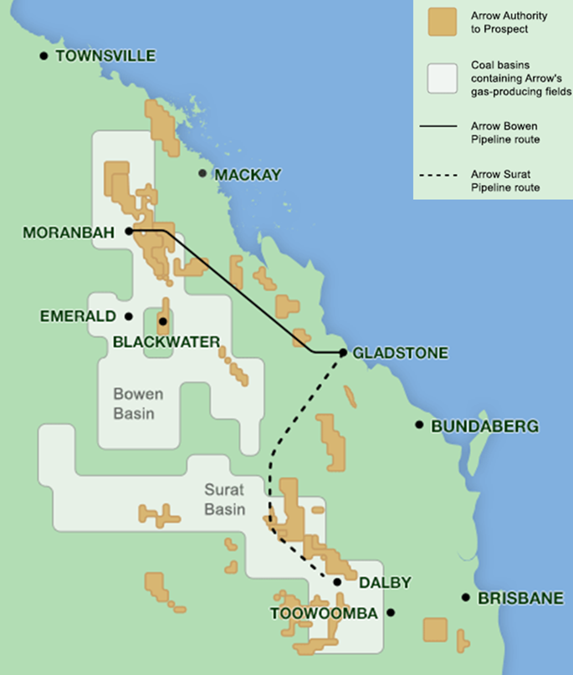
Source: Arrow Energy, www.arrowenergy.com.au/our-company/our-projects, August 2015.

BG’s east Australian gas operations
- BG’s major interests are held by QGC, a wholly owned Australian subsidiary which BG acquired in 2008. QGC holds interests in natural gas tenements and production facilities in the Surat Basin in Queensland, and exploration rights in the Bowen and Cooper Basins (see Figure 2).
- QGC also has a majority interest (74%) in an LNG plant on Curtis Island (QCLNG) with China National Offshore Oil Corporation (CNOOC) and Tokyo Gas. The plant currently converts gas sourced from production wells in the Surat Basin into LNG for shipment to export markets. See Table 2 for more detail on QCLNG.
- BG (through QGC) currently has domestic gas contracts with power stations, industrial users and gas retailers and supplies about 20% of Queensland's gas demand. However its main focus appears to be on LNG exports through QCLNG. The ACCC understands that the domestic contracts BG has entered into in recent years have been short term contracts for the supply of ‘ramp’ gas, which is produced during the commissioning phase of LNG plants.
- BG’s Surat Basin reserves are connected to the east coast pipeline network.
Figure 2: BG’s east Australian tenements
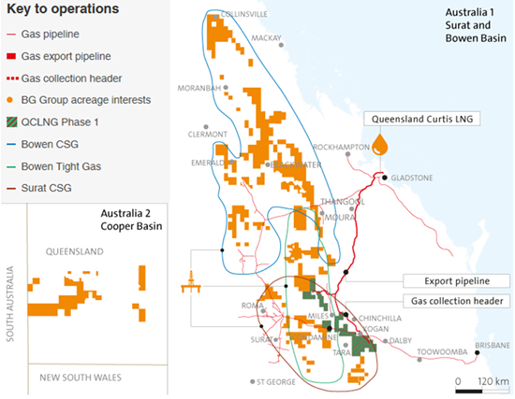
Source: BG Group, www.bg-group.com/assets/files/cms/CountryData/BG_Data_Australia.pdf, 2015

Main areas of overlap
- As outlined above, both Arrow and BG produce gas from interests in the Surat Basin in Queensland. Arrow currently produces gas in the Bowen Basin in Queensland while BG holds currently undeveloped interests in that basin.
- Further details about Arrow and BG’s reserves and production in eastern Australia are contained below under the heading ‘Market participants’.

Other areas of overlap
- Table 1 below summarises other areas of overlap between the parties in Australia.
- The ACCC considers that the extent of the overlap between Shell and BG in these areas is small in the context of the relevant markets, and is unlikely to have any material competitive impact. The ACCC has not therefore considered these areas of overlap further.
Table 1: Other areas of overlap between the merger parties in Australia
Area of overlap | Shell / Arrow | BG
International supply of LNG | Shell participates in a number of upstream gas exploration and production projects in Western Australia. These include LNG projects, such as the Prelude Floating LNG Project, North West Shelf (16.67%), Gorgon LNG JV (25%), Browse JV (27%) and Sunrise gas field (26.6%).  Globally, Shell has LNG supply projects in operation or under construction in nine countries.  Shell also holds a minority interest in Woodside. | BG has an interest in the QCLNG Project (50% interest in Train 1, 97.5% interest in Train 2), which currently converts gas sourced from the Surat Basin into LNG for shipment.  Globally, BG has an LNG shipping and marketing business, which purchases, ships, markets and sells LNG.
Development, production and supply of crude oil | Shell holds a minority interest in Woodside Petroleum a large producer of oil and gas primarily in Western Australia. | Through QGC, BG holds a minority interest in Drillsearch, which produces oil and small volumes of gas.
Electricity generation in Queensland | Arrow has some electricity generation activities (including owning the 450MW capacity Braemar 2 power station). | Through QGC, BG owns the 140MW capacity Condamine power station.

Industry background
- The main potential competition issues associated with the proposed acquisition relate to the wholesale supply of natural gas to the domestic market.
- The main uses of natural gas are in power generation, heating, cooking, as a fuel for vehicles and as a feedstock in the production of plastics, chemicals, fertilisers and explosives. It can also be transformed into LNG for export. The process of liquefying natural gas for export occurs in a production facility called an LNG train.
- Figure 3 below provides a high level overview of the main stages of the supply chain of natural gas.
Figure 3: Overview of the natural gas supply chain
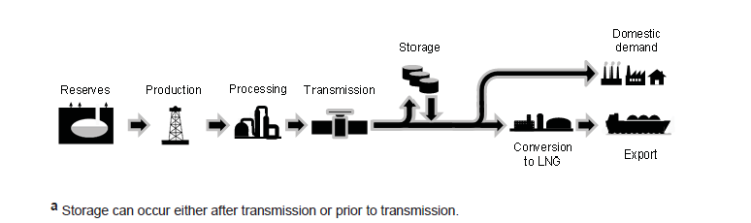
Source: Productivity Commission, Examining Barriers to More Efficient Gas Markets, 2015, p. 26.
- In eastern Australia, most natural gas is produced from either sedimentary basins (conventional gas) or from coal seams (CSG). Conventional gas is predominantly produced from offshore Victoria in the Gippsland, Bass and Otway Basins, and onshore in the Cooper Basin. Current CSG production is limited to Queensland and a very small amount in New South Wales. Other unconventional gas resources (shale, deep coals and tight gas) are in sedimentary basins across Australia although much of these resources are not currently commercially or technically recoverable.
- Extracted gas is processed before being transmitted from gas fields to customers via high pressure transmission pipelines. As shown in Figure 4, an interconnected transmission pipeline system links the major gas basins in southern and eastern Australia to demand centres. While gas tends to be purchased from the closest possible source to minimise transport costs, pipeline interconnections have the potential to enhance supply competition in the market by enabling gas customers to source gas from different producers or gas basins, either physically or though entering into gas swap arrangements.
Figure 4: Eastern Australian gas basins and infrastructure
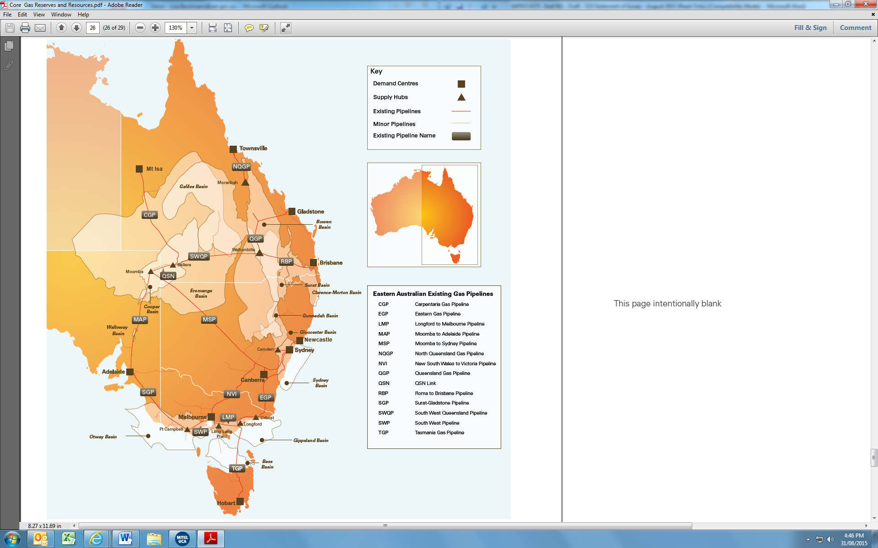Source: Core Energy Group, Gas reserves and resources: Eastern and South Eastern Australia, February 2015, p. 26.

Liquefied natural gas and changing market dynamics
- There are currently three JVs with LNG facilities that are in production or nearing completion in Gladstone—Queensland Curtis LNG (QCLNG), Gladstone LNG (GLNG) and Australia Pacific LNG (APLNG). BG has a significant interest in the QCLNG project (see Table 2). The three LNG JVs have entered into large long-term LNG export agreements; they will need access to significant gas reserves to underpin production to meet their export obligations over the duration of their export agreements. Table 2 sets out details on these projects.
Table 2: Gladstone LNG projects
Project | QCLNG | GLNG | APLNG
Participants | - BG (50% Train 1, 97.2% Train 2)  - CNOOC (50% Train 1)  - Tokyo Gas (2.5% Train 2) | - Santos (30%)  - Petronas (27.5%)  - Total (27.5%)  - KOGAS (15%) | - Origin (37.5%)  - ConocoPhillips (37.5%)  - Sinopec (25%)
Production capacity | 2 Trains (8.5Mtpa) | 2 Trains (7.8Mtpa) | 2 Trains (9Mtpa)
Start date | Train 1 first shipment Jan 2015  Train 2 first shipment Jul 2015  Full capacity expected in 2016 | Train 1 first shipment expected in fourth quarter 2015 | Train 1 first LNG shipment expected in fourth quarter 2015
Note: Mtpa = million tonnes per annum.
- The LNG projects are significantly altering the supply and demand dynamics in the domestic gas industry in eastern Australia. Domestic gas users have been exposed, for the first time, to international gas prices and there are uncertainties about the future availability of gas for domestic use in eastern Australia. It is expected that a large share of gas reserves in Queensland will eventually be directed to LNG export when the three LNG plants are operating at full capacity. This has caused various market participants to have concerns about potential shortages in domestic supply.
- As shown in Figure 5, once the three LNG plants reach a steady state of production at around 2018-19, they will require around 1350-1450 petajoules (PJ) of gas per annum. At the same time, the Australian Energy Market Operator has (AEMO) forecast that demand for domestic gas in eastern Australia will fall from 700 PJ to around 520 PJ per annum by 2019. The decrease is mainly driven by forecast falls in the use of gas for electricity generation (GPG).
Figure 5: Annual gas consumption (including LNG exports) for eastern Australia
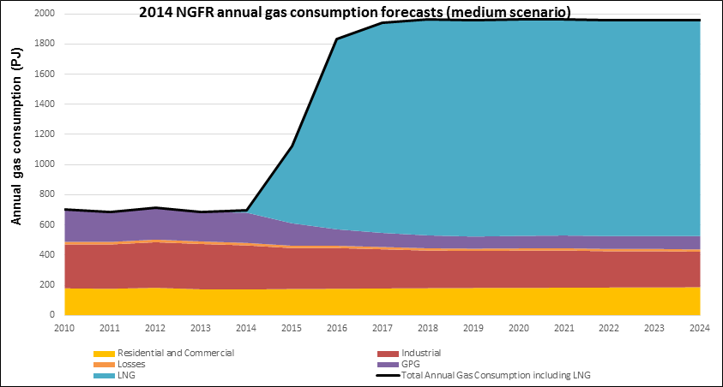
Source: AEMO, National gas forecasting report 2014, December 2014, p. 14.

Market definition
- The ACCC assesses the competitive effects of the proposed acquisition in relevant markets. The starting point for defining relevant markets involves identifying the products actually or potentially supplied by the merger parties. The ACCC then considers what other products constitute sufficiently close substitutes to provide a significant source of constraint on the merged entity.
- The key area of overlap between Shell and BG for the purposes of this review is Shell and BG’s interests in the production and wholesale supply of natural gas in Queensland / eastern Australia (described above in the section headed ‘The merger parties’).

Customer substitution opportunities for wholesale natural gas
- The ACCC’s preliminary view is that substitution options for purchasers of wholesale natural gas are limited.
- Some customers use natural gas as a feedstock. For example, it is an input in the production of fertilizer. Where gas is used as a feedstock, switching from natural gas to other fuels is not possible.
- Other large customers use gas as an energy input (for example, to generate power for manufacturing facilities). The ACCC’s market inquiries suggest that for customers of this type, the costs involved in changing fuels in terms of plant upgrades or retrofits, typically make substitution uneconomical as a response to a small but significant increase in the price of gas.
- For these reasons, the ACCC’s preliminary view is that the relevant market is for the supply of wholesale natural gas only, and does not include any other products.

Geographic market
- The ACCC’s market inquiries have provided it with mixed information on whether the geographic scope of the relevant market is limited to Queensland or eastern Australia.
- The merger parties’ east coast gas operations are both located entirely within Queensland. However, as shown above in Figure 4, an interconnected transmission pipeline system links the major gas basins in southern and eastern Australia to demand centres.
- The ACCC is considering the extent to which this interconnected pipeline system means that gas produced in other parts of eastern Australia is a close substitute for gas produced within Queensland.
- There are currently no pipelines linking gas markets in Western Australia and the Northern Territory to eastern Australia. The Northern Territory Government has proposed a pipeline connecting the Northern Territory gas network with the eastern Australian gas network, but the final design, route and timing for construction of the pipeline are uncertain. The ACCC understands that even after the pipeline is built, it is likely that relatively small volumes of gas would be available initially and that further successful exploration and development activities would be needed to produce greater quantities of gas for the pipeline. The ACCC is not aware of any current plans to extend pipeline linkages to the WA pipeline system. For these reasons, the ACCC does not consider there is a national gas market or a market with a broader geographic scope than eastern Australia.
- Some market participants submitted that physical, contractual and/or gas specification constraints have the effect of either preventing the movement of gas by pipeline between some basins and some customers, or making such movements commercially unviable. However, the ACCC notes that a number of pipelines in eastern Australia have been enhanced (or are being enhanced) for bi-directional gas flow capability. These developments allow a greater flow of gas to the north than has historically been the case. The extent to which gas from the southern states is substitutable for gas produced in Queensland may well depend on the location of the relevant customer. The ACCC notes that the Queensland domestic market is currently supplied wholly from gas indigenous to Queensland.

Preliminary view on relevant market(s)
- The ACCC is still considering the geographic scope of the relevant market. Based on information received by the ACCC to date, its preliminary view is that the relevant markets for assessing the competition effects of the acquisition are likely to be for:
- the wholesale production and supply of natural gas in eastern Australia, or
- the wholesale production and supply of natural gas in Queensland.
The ACCC invites comments from market participants on its preliminary views about the definition of the relevant market(s). In particular market participants may wish to comment on:
- whether the Queensland gas market is a separate market to the rest of the east Australian gas market. If so, please provide reasons and supporting evidence.
- the extent to which gas produced outside of Queensland is, or could in the future be, an economically viable source of supply for Queensland gas users. Please include reasons and any supporting evidence for your view.
- the extent to which gas produced in Queensland is, or could in the future be, an economically viable source of supply for gas users in other parts of eastern Australia. Please include reasons and any supporting evidence for your view.
- the significance of gas swap arrangements for defining the geographic dimension of the market.
- whether the geographic dimension of the market should be expanded to reflect the proposed construction of a pipeline to allow gas from the Northern Territory to be supplied to eastern Australia.
In answering the above questions, please comment on whether there are physical and/or contractual constraints that have the effect of either preventing the movement of gas between some basins and some customers, or making such movements economically unviable.

Market participants
- A number of wholesale gas producers and suppliers have operations in eastern Australia. Due to the high costs and risks associated with gas projects, the majority of domestic gas projects are joint ventures.
- Table 3 sets out gas production in the 12 months to May 2015 and reserve positions of natural gas projects on the east coast. There are a number of industry participants (including joint ventures) with large amounts of 2P gas reserves in eastern Australia, many of which are currently aligned to LNG projects, as well as a range of industry participants with interests in smaller quantities of 2P reserves.

Table 3: Eastern Australia gas production and reserves (by project)
Project | Ownership / JV Interests | LNG aligned?ª | Production | Share of production | 2P Reserves | Share of  Reserves
 |  |  | PJ | % | PJ | %
Arrow | Shell 50%  PetroChina 50% | No | 31 | 4 | 8,844 | 18
Queensland LNG plants^{b} |  |  | 269 | 36 | 29,462 | 60
APLNG | Origin 37.5% (operator upstream)  ConocoPhillips 37.5% (operator downstream)  Sinopec 25% | Yes | 173^{c} | 21 | 13,778 | 28
GLNG | Santos 30.0% (operator)  PETRONAS 27.5%  Total 27.5%  KOGAS 15.0% | Yes | 36 | 4 | 5,603 | 12
QCLNG | BG 74% upstream resources and infrastructure (operator)  CNOOC 24.5%  Tokyo Gas 1.5% | Yes | 157^{c} | 19 | 9,320 | 19
Other Queensland Coal Seam Gas |  |  | 12 | 1 | 4,335 | 9
AGL Qld | AGL (share of Moranbah with Arrow) | No | 6 | 1 | 1,257 | 3
Santos other CSG | Santos holds permits in own right (not as part of GLNG) | Yes | 0 | 0 | 471 | 1
PetroChina | PetroChina holds permits in own right (not as part of Arrow JV) | No | 0 | 0 | 435 | 1
Origin Ironbark | Origin holds permits in own right (not as part of APLNG) | Yes | 0 | 0 | 256 | 1
Senex CSG | Senex 100% | No | 0 | 0 | 473 | 1
Meridian | Landbridge and Mitsui | No | 2 | 0 | 680 | 1
Other CSG | Various companies with small interests |  | 3 | 0 | 763 | 2
NSW Coal Seam Gas |  |  | 5 | 1 | 1,280 | 3
Santos Narrabri | Santos 80% (operator)  Energy Australia 20% (in development) | Yes | 1 | 0 | 777 | 2
AGL NSW | AGL 100% Camden Project (operating) and Gloucester Project (in development) | No | 4 | 1 | 503 | 1
Conventional Gas Onshore |  |  | 94 | 11 | 1,662 | 3
Cooper Basin JVs | Two separate JVs (SA and Western Qld) with Santos, Beach and Origin | Yes | 88 | 11 | 1,425 | 3
Other Cooper Basin | Drillsearch, Senex, Strike Energy | No | 3 | 0 | 119 | 0
Other Qld Conventional Gas | Various small interests |  | 3 | 0 | 118 | 0
Conventional Gas Offshore |  |  | 328 | 40 | 3,913 | 8
Gippsland Basin JV | ExxonMobil 50% (operator)  BHPB 50% | No | 217 | 26 | 2,484 | 5
Kipper Gas | ExxonMobil 32.5% (operator)  BHPB 32.5%  Santos 35% (in development first gas 2016) | Yes | 0 | 0 | 622 | 1
Longtom | Seven Holdings 100% | No | 7 | 1 | 0 | 0
BassGas | Origin 42.5%, AWE 35%, Toyota Tsusho 11.25%, Prize Petroleum International 11.25%. | Yes | 12 | 1 | 158 | 0
Otway | Origin 67.23%, Benaris 27.77% and Toyota Tsusho 5% | Yes | 43 | 5 | 280 | 1
Casino/Henty | Santos 50% (operator), AWE 25%, Mitsui 25%. | Yes | 26 | 3 | 216 | 0
Minerva | BHP Billiton 90% (operator), Santos 10% | No | 24 | 3 | 82 | 0
Origin (Halladale) | Origin 100% (no production developed) | Yes | 0 | 0 | 71 | 0
Total |  |  | 835 | - | 48,735 | -
Source: Energy Quest unpublished data, August 2015 (numbers may not add up due to rounding).
Notes: a The ACCC is using the expression ‘LNG alignment’ where one or more parties have significant ownership interests in both gas reserves and LNG facilities. However, this does not necessarily mean that all gas in an LNG aligned project is destined to be sent to an LNG plant. b Reserve figures in this section are reserves held by the LNG joint ventures themselves. Reserves held by members of those JVs in their own right are listed separately. c APLNG and QCLNG production has been increasing with the start up on the LNG trains

- Table 3 illustrates several key features of the market:
- The vast majority (about 68%) of eastern Australian 2P gas reserves are held by market participants that are aligned with the LNG plants. This would increase to about 86% if Arrow’s reserves become aligned to QCLNG.
- Arrow’s reserves represent a substantial proportion of 2P reserves that are currently not aligned with an LNG plant (over 56%) and are the largest share of unaligned gas reserves.
- Currently, the largest gas producer in eastern Australia is the Gippsland Basin JV between ExxonMobil and BHPB. Neither ExxonMobil nor BHPB have an ownership interest in any of the LNG plants in Queensland.
- While there are a number of smaller gas suppliers in the market, their collective market share is small both as a proportion of production and as a proportion of reserves.
- The proposed acquisition would further increase the proportion of eastern Australian gas reserves that are aligned with an LNG plant. During the ACCC’s market inquiries, many market participants expressed significant concerns that, by increasing the concentration of gas reserves that are aligned with LNG plants, the proposed acquisition would substantially lessen competition for the wholesale production and supply of natural gas in the domestic market (in Queensland or eastern Australia).
- On the basis of the information available to it, the ACCC understands that many of the operators listed in Table 3 may be unlikely to offer new gas supply agreements to domestic gas users in the Queensland or eastern Australian wholesale gas market:
- The primary purpose of LNG plant owners holding gas reserves is to secure supply for their own LNG projects.
- A number of operators listed in Table 3 have already committed their reserves to satisfying existing contractual obligations (with domestic gas users and/or LNG plants).
- Constraints related to the pipeline network may create barriers to gas from particular suppliers being delivered to particular gas users, or being delivered at a market price. These constraints may include capacity constraints in existing infrastructure, the directional flow of gas within the network, contractual commitments, and the costs of transportation.
- In addition, the ACCC’s market inquiries suggested that some larger domestic customers are reluctant to make gas supply agreements with smaller suppliers, due to concerns about reliability of supply for large volumes of gas.
- Taking into account these market factors, and the large proportion of reserves that are currently held by operators that are aligned with LNG plants, the ACCC considers that there is currently a limited number of potential suppliers to the domestic market that have substantial gas reserves, apart from Arrow.
The ACCC invites comments on its assessment of the current state of the market for the wholesale production and supply of natural gas in Queensland and/or eastern Australia.

Future with and without the acquisition
- In assessing a proposed acquisition pursuant to section 50 of the Act, the ACCC considers the effects of the acquisition by comparing the likely future competitive environment if the acquisition proceeds (the “with” position) to the likely future competitive environment if the acquisition does not proceed (the “without” position) to determine whether the proposed acquisition is likely to substantially lessen competition in any relevant market.
- The ACCC's preliminary view is that the likely competition effects of the proposed acquisition are most appropriately assessed against a future in which BG and Shell (and Arrow) continue to operate under current ownership (the status quo). The ACCC’s preliminary views on the likely relevant behaviour of each of Shell (Arrow) and BG with and without the proposed acquisition are set out in the competition analysis below.

Issue that may raise concerns: reduced competition to supply domestic gas users and higher prices
- The ACCC is concerned that the effect of the proposed acquisition in aligning Shell’s interests with BG’s interest in the QCLNG project may decrease the incentive for Arrow to supply gas to the domestic market. By removing some (or all) of Arrow’s gas from the domestic market, the proposed acquisition could substantially lessen competition to supply gas users in either the Queensland or eastern Australian gas market, leading to:
- reduced supplies of gas in those markets and difficulties for domestic gas users in obtaining gas supply contracts
- the potential for gas suppliers that do supply in the domestic market to increase gas prices and/or include less favourable non-price terms in supply contracts than would be the case in the absence of the proposed acquisition.
- The potential for these outcomes to occur is discussed below, along with the ACCC’s preliminary assessment of the likelihood of new entry into the domestic gas market.

Effect of the proposed acquisition on Arrow’s incentives to compete to supply gas in the domestic market
- The ACCC’s preliminary view is that Arrow is likely to have a strong incentive to supply a significant proportion of its gas to an LNG customer, both with and without the acquisition. This is because:
- Most of Arrow’s reserves are currently undeveloped, and Arrow will have to incur significant capital expenditures to develop its extensive 2P reserves and transport the gas to domestic and LNG export markets.
- Arrow will have a commercial incentive to reduce its risks in undertaking large, long-term capital expenditures by securing high volume, long-term contracts to underpin those expenditures.
- Domestic supply agreements are unlikely to be of sufficient scale to provide the foundational contract(s) that are needed to underpin development of Arrow’s resources.
- In the absence of the proposed acquisition, the ACCC considers that Arrow would be indifferent to whether it supplies its remaining gas (that is, gas not committed under the terms of its commercial arrangements with a foundation customer) to domestic customers or the LNG plants, subject to those customers offering equivalent terms (including price, volume, and duration of supply contract).
- The ACCC is concerned the proposed acquisition may change Shell’s incentives such that it will choose to direct more (and possibly all) of Arrow’s gas towards the QCLNG project.
- A number of market participants have told the ACCC that at present QCLNG does not have access to sufficient gas to satisfy its existing LNG supply agreements. QGC has stated publicly that it has global LNG sales agreements for almost 10 million tonnes a year with CNOOC, Tokyo Gas, GNL Chile, Chubu Electric, and the Energy Market Authority of Singapore.
- As a result of aligning Shell’s interests with the QCLNG project, Arrow may have an incentive to prioritise supply to the QCLNG project over competing gas users. Subject to the views of PetroChina (Shell’s joint venture partner in Arrow), Arrow’s reserves may be committed to supplying the QCLNG plant and meeting existing legacy gas supply agreements with domestic gas users following the proposed acquisition. This is because Shell may have an incentive to reduce the risks associated with failure to meet QGC’s contractual LNG supply obligations by reserving some of Arrow’s reserves (that would otherwise be offered to other gas users) as a contingency against potential future supply problems.
- There may be a greater likelihood that Arrow will offer its gas to competing gas users in the absence of the proposed acquisition. These could include domestic gas users and other LNG projects, as well as to the QCLNG project.
- Since Arrow’s large gas reserves constitute the largest uncontracted gas reserves in eastern Australia, the removal or reduction in the importance of Arrow as a potential supplier may substantially lessen competition in the domestic gas market. This could result in supply/demand imbalances in the domestic market, at least for an extended transitional period during which alternative existing gas reserves are developed and additional gas reserves are discovered and developed.
- The removal or reduction in the importance of Arrow as a potential supplier could increase the market power of the limited number of other suppliers with substantial gas reserves that would be able to offer to supply gas in the domestic market. These alternative suppliers could exercise their market power to increase gas prices and impose more restrictive non-price contractual terms (such as shorter contract duration, more restrictive ‘take or pay’ obligations, and less flexible delivery options) compared to the likely situation without the proposed acquisition.

Effect of the proposed acquisition on BG’s incentives to compete to supply gas in the domestic market
- The ACCC considers that, in the absence of the proposed acquisition, BG may in future offer new supply contracts to domestic gas users if it were to have excess gas after meeting its LNG requirements (and existing legacy contracts). In that case, BG would have an incentive to supply some of its excess gas to domestic customers, subject to those customers offering commercially attractive prices and/or other terms for that gas.
- However, as noted above, market participants have told the ACCC that at present QCLNG does not have access to sufficient gas to satisfy its existing LNG supply agreements.
- The ACCC’s preliminary view, based on this information, is that BG is unlikely to be a potential supplier of new long-term gas supply agreements to domestic gas users irrespective of the proposed acquisition.

Effect of the proposed acquisition on Arrow’s and BG’s incentives to develop their gas reserves and explore for gas
- The ACCC is also concerned that the proposed acquisition could reduce the amount of gas offered to domestic gas users and other LNG plants by changing Shell’s incentives in relation to the timing of developing BG’s and Arrow’s reserves.
- As noted in the ‘Industry background’ section above, the LNG projects are significantly altering the supply and demand dynamics in the domestic gas market in eastern Australia. These developments, and associated uncertainty in the market over the future supply and demand balance, have resulted in higher contract price offers and more restrictive contract terms. Some sources of gas that have traditionally supplied domestic gas users in the southern states, such as gas from the Cooper Basin, may be redirected to supplying LNG projects, reducing the supply options for customers in the southern states and increasing their reliance on the few remaining suppliers.
- In this context, any new gas supplies in the market have the potential to have a material effect on competition for domestic customers. This is true even if new gas production is used to supply an LNG project, as that LNG project would then have less demand for gas from other sources and that gas may then be offered to domestic gas users. Therefore, the ACCC considers that if the proposed acquisition resulted in a reduction in Shell’s incentives to develop BG’s and Arrow’s reserves in a timely manner, this could have a substantial impact on the level of competition in relevant gas market or markets.
- Any resulting reduction in the supply of gas to the domestic market could, by increasing the market power of the limited number of other potential suppliers to the domestic market, lead to higher domestic prices and more restrictive non-price contractual terms relative to the situation without the proposed acquisition.
- The ACCC has considered a number of ways in which the proposed acquisition could change Shell’s incentives and delay the timely development of BG’s and Arrow’s reserves and/or reduce exploration activities.
- First, if the relative cost of producing gas from Arrow’s reserves were to be lower than producing gas from BG’s reserves (or other alternative sources of gas for the QCLNG plant), Shell may have an incentive post-acquisition to substitute cheaper Arrow gas for gas that would have been produced from BG’s existing reserves and defer development of BG’s higher-cost reserves.
- As a result of gaining a committed source of gas for the QCLNG plant, BG may have an incentive to decrease its exploration activities post-acquisition (taking into account the costs and risks associated with gas exploration compared to using Arrow’s existing 2P reserves). The proposed acquisition may therefore have the potential to further reduce the supply of gas to the domestic market and increase the market power of the limited number of other potential suppliers to the domestic market, and lead to the outcomes identified above.
- Second, the ACCC is also considering whether the proposed acquisition could reduce the likelihood that Arrow will develop its Bowen Basin reserves by changing the relative costs of developing Arrow’s Surat Basin reserves compared to its Bowen Basin reserves.
- The ACCC understands that BG and Arrow have adjacent tenements in the Surat Basin. The proposed acquisition may give Arrow the ability to develop its reserves using any spare capacity in existing BG-owned upstream infrastructure in the Surat Basin. Arrow may also be able to gain access to the QCLNG pipeline to Gladstone, subject to the availability of pipeline capacity and BG’s access arrangements with the pipeline owner, APA Group (which acquired the pipeline from BG in June 2015).
- The ACCC has received different views on the likely effect of these potential synergies and it is considering those submissions.
- Some submissions stated that the proposed acquisition might, by giving Arrow access to existing BG infrastructure and expertise, reduce the cost of developing Arrow’s reserves and increase its gas production. This may increase the quantity of gas that Arrow could supply to domestic customers because it would have more surplus gas after meeting QCLNG’s demand for gas.
- However, some market participants submitted that as a result of the potential synergies in the Surat Basin, Shell would have less incentive to develop Arrow’s reserves in the Bowen Basin (where Arrow would need to construct infrastructure to develop those reserves).
- Third, the ACCC considers that reducing Shell’s incentives to develop Arrow’s Bowen Basin reserves would be likely to delay the construction of Arrow’s proposed Bowen to Gladstone Pipeline, which is currently in the front end engineering design (FEED) phase. The ACCC understands that no other gas producer in the Bowen Basin currently has plans to construct a pipeline to transport gas from the Bowen Basin to Gladstone or to connect with other pipelines in the east coast pipeline network. The ACCC is considering whether, in the event that Arrow were to deprioritise the development of its Bowen Basin reserves, gas reserves owned by other gas producers and explorers in the Bowen Basin may become ‘stranded’ if the development of their reserves is contingent on obtaining access to third party pipeline infrastructure.
- However, in respect of all of the above, the ACCC is also considering the incentives created by the Queensland Government's regulatory regime for tenure management. In particular, the ACCC is considering whether the legal framework creates a sufficient incentive for Arrow to develop its reserves or risk consequences that could include loss of some tenure.

Likelihood of new entry into the domestic gas market
- The ACCC’s preliminary view is that significant new entry into the market is unlikely in the foreseeable future.
- While some smaller gas suppliers have announced ambitious plans for expansion, the ACCC’s market inquiries suggest that gas explorers and junior gas producers face significant barriers—in the form of long lead times, high capital costs and significant financial pressures in the current low oil price environment—to entering and achieving the scale necessary to constrain suppliers with more significant reserves in a timely manner.
- Barriers to entry are further heightened by regulatory restrictions in NSW and Victoria. For instance, in NSW, there is a moratorium on new CSG exploration licences and on CSG production in water catchments. In Victoria, there is a moratorium on all hydraulic fracturing and new onshore exploration licences. Since 2014, Victoria has placed a further hold on all exploration drilling for existing licences.
- Market inquiries indicated that on occasion large domestic gas users may sponsor the entry or expansion of a smaller supplier of natural gas. For instance, Strike Energy has Gas Sales Agreements (GSAs) with three large customers that have made gas pre‐payments to advance Strike Energy’s appraisal program.
- However, the ACCC understands that such sponsorship is not common. Market inquiries indicated that it comes at significant cost and risk for the domestic gas user, which many would be either unable or unwilling to bear. Sponsoring customers often seek to reduce their risks—Strike’s gas supply obligations under the GSAs are conditional upon a final investment decision for the commercialisation of a particular project, based on the commercial and technical viability of the project.
- For these reasons, the ACCC considers that significant new entry into the market is unlikely in the foreseeable future.
The ACCC invites comments on whether the proposed acquisition would affect the likelihood of Arrow supplying gas to domestic users, or the quantity of gas that it would be likely to supply to the domestic market. In particular, please comment on:
- the proposition that Arrow’s development of its reserves is contingent on obtaining large foundational contract(s) and, if so, whether a sufficiently large and long-term foundational contract could only be agreed with an LNG plant operator
- the amount of gas that Arrow would be likely to supply to the domestic market both in the event that the proposed acquisition does not occur and in the event that the proposed acquisition does occur, and the reasons for your view.
The ACCC also invites comments on:
- whether and how the proposed acquisition would change Arrow’s and BG’s incentives to develop their reserves, invest in infrastructure and explore for gas in Queensland
- whether the Queensland Government’s regulatory regime for tenure management would create a sufficient incentive for Arrow and BG not to reduce their reserve development and gas production activities. Please give reasons
- the likelihood of new entry into the domestic gas market. If possible, please provide recent examples of successful entry or attempts to enter.
Please provide evidence to support your views.

Issues unlikely to raise concerns: foreclosure of other LNG plants
- The ACCC has considered whether the proposed acquisition would raise any vertical competition concerns. In particular, the ACCC considered whether the merged entity could use any market power arising from its large share of 2P reserves to foreclose rival LNG plants from accessing gas.
- The ACCC’s preliminary view is that the merged entity would have little incentive to pursue this strategy. This is because the merged entity would only supply a small share of the global LNG market and competition in the global LNG market would constrain the merged entity from being able to increase the price of its LNG exports. As such, this issue is unlikely to raise concerns.
The ACCC invites comments from market participants on the potential for Shell to foreclose rival LNG plants. In particular, market participants may wish to comment on whether the merged entity would have the incentive or ability to foreclose rival LNG plants to influence prices in the global market.

ACCC's next steps
- The ACCC will finalise its view on this matter after it considers submissions provided in response to this Statement of Issues.
- The ACCC seeks submissions from market participants on each of the issues identified in this Statement of Issues and on any other issue that may be relevant to the ACCC's assessment of this matter. Submissions are to be received by the ACCC no later than 8 October 2015 and should be emailed to mergers@accc.gov.au.
- The ACCC intends to publicly announce its final view by 12 November 2015. However the anticipated timeline may change in line with the Merger Review Process Guidelines. A Public Competition Assessment for the purpose of explaining the ACCC's final view may be published following the ACCC's public announcement.

SMH, Moranbah gas supply problems to hit Incitec Pivot profit, 8 July 2015, http://www.smh.com.au/business/moranbah-gas-supply-problems-to-hit-incitec-pivot-profit-20150707-gi7dxf.html
AGL, ASX & Media Release, 11 February 2015, http://www.agl.com.au/~/media/AGL/About%20AGL/Documents/Investor%20Centre/2015/150211_REsults_Presentation.pdf
Arrow, Arrow Bowen Gas Project EIS, p. 3. https://www.arrowenergy.com.au/__data/assets/pdf_file/0017/3824/Section_01-Introduction.pdf
Arrow, Our operations, https://www.arrowenergy.com.au/our-company/our-projects
Ibid
Ibid
Ibid
Tight gas is natural gas produced from reservoir rocks with such low permeability that hydraulic fracturing is necessary to produce the well at economic rates.
ACCC East Coast Gas Inquiry, Issues Paper, p. 3.
In testing whether one product is a close substitute for another, it is common practice to ask whether substitution would occur in response to a sustained small but significant price increase (say 5–10%).
ACCC East Coast Gas Inquiry, Issues Paper, p. 19.
QGC, ‘Export and Domestic Markets’, www.qgc.com.au/qclng-project/export-domestic-markets.aspx, September 2015.
See Arrow Energy, ‘Arrow Bowen Pipeline’, www.arrowenergy.com.au/projects/arrow-bowen-pipeline, April 2015.
See for example Beach Energy’s Strategy Review of 12 August 2015, available at http://www.beachenergy.com.au/IRM/Company/ShowPage.aspx/PDFs/4293-10000000/StrategyReview and Strike Energy’s announcements on their Southern Cooper Basin Project available at http://www.strikeenergy.com.au/.
Strike Energy, Public submission to ACCC re: East Coast Gas Inquiry, 2 July 2015, p. 2.
Strike Energy, Public submission to ACCC re: East Coast Gas Inquiry, 2 July 2015, p. 2.

