

Statement of Issues
5 June 2014

Elgas Limited - proposed acquisition of Wesfarmers Kleenheat Gas Pty Ltd's east coast LPG assets

Introduction
Outlined below is the Statement of Issues released by the Australian Competition and Consumer Commission (ACCC) on the proposed acquisition of Wesfarmers Kleenheat Gas Pty Ltd's (Kleenheat) east coast Liquefied Petroleum Gas (LPG) assets by Elgas Limited (Elgas) (proposed acquisition).
A Statement of Issues published by the ACCC is not a final decision about a proposed acquisition, but provides the ACCC’s preliminary views, drawing attention to particular issues of varying degrees of competition concern, as well as identifying the lines of further inquiry that the ACCC wishes to undertake.
In line with the ACCC’s Informal Merger Review Process Guidelines (at www.accc.gov.au/processguidelines) the ACCC has established a secondary timeline for further consideration of the issues. The ACCC anticipates completing further market inquiries by 26 June 2014 and anticipates making a final decision by 24 July 2014. However, the anticipated timeline can change in line with the Merger Review Process Guidelines. To keep abreast of possible changes in relation to timing and to find relevant documents, market participants should visit the Mergers Register on the ACCC's website at www.accc.gov.au/mergersregister.
A Statement of Issues provides an opportunity for all interested parties (including customers, competitors, shareholders and other stakeholders) to ascertain and consider the primary issues identified by the ACCC. It is also intended to provide the merger parties and other interested parties with the basis for making further submissions should they consider it necessary.

Background
On 10 April 2014, the ACCC commenced a public review of the proposed acquisition after receiving a submission from Elgas seeking informal clearance from the ACCC.

The merger parties & industry participants

Elgas Limited
- Elgas is a major wholesaler and distributor of automotive and non-automotive LPG in Australia. It uses a range of transport options and storage facilities to supply LPG in both cylinders and bulk to a variety of customer segments. Elgas is a member of the BOC Group of companies, which is owned by the Linde Group, an international gases and engineering company.
- Elgas owns and operates the Elgas Cavern, which is a major LPG import and storage facility in Sydney. Elgas also owns and operates a network of terminal and depot facilities throughout Australia.

Wesfarmers Kleenheat Gas Pty Ltd
- Kleenheat is a major wholesaler and distributor of automotive and non-automotive LPG in Australia, supplying LPG in cylinders and bulk to all customer segments. Kleenheat is a wholly-owned subsidiary of Wesfarmers Limited and is part of Wesfarmers’ Chemicals, Energy & Fertiliser division. Wesfarmers Limited is listed on the Australian Securities Exchange.
- Kleenheat owns a production facility in Perth and operates an extensive network of terminal and depot facilities throughout Australia. It is one of the two largest competitors to Elgas in LPG, the other being Origin Energy Limited (Origin).

Origin Energy Limited
Origin is a national energy retailer which wholesales and distributes automotive and non-automotive LPG (bulk and cylinder) to a variety of customer segments. Origin has LPG operations in all Australian states and territories; it owns and operates seven seaboard terminals on the east coast of Australia, and a network of terminal and depot facilities throughout Australia. Origin is listed on the Australian Securities Exchange. Origin operates its LPG businesses under the following four brands: Origin LPG, Speed-e-gas, Powergas and Quickswap.

Other industry participants
Supagas Pty Ltd (Supagas) is a non-automotive LPG distributor (bulk and cylinder) operating in Victoria, South Australia, Tasmania, Northern Territory, and Western Australia. It operates a number of depot facilities within these states and territories. Supagas is a private company which began in Melbourne in 1968 under the name of Australian Forklifts.
Renegade Gas Pty Ltd (Renegade) is a non-automotive LPG distributor (bulk and cylinder) operating in New South Wales, Queensland, and the Australian Capital Territory. It operates a number of depot facilities within these states and territories. Renegade is a private company which was established in 1997. Renegade trades under the name “Supagas”, but is a separate entity and business from Supagas Pty Ltd.
United Gas is a non-automotive LPG distributor (bulk and cylinder) operating in South Australia and Victoria. The ACCC understands that United Gas was acquired by Arcadia Energy Trading Limited (AET) around 18 months ago. AET is a wholesale commodity trader specialising in the energy sector; it is part of the global Farahead Group of companies which owns major oil shipping and physical oil trading companies worldwide.
Direct Gas is a non-automotive LPG distributor (bulk and cylinder) operating in Dandenong, Victoria. Direct Gas began supplying non-automotive LPG about two years ago.
Air Liquide Australia is a member of the Air Liquide Group, an international industrial gas company. In Australia, Air Liquide Australia’s business is predominantly in industrial gases, but currently distributes non-automotive LPG (cylinder only) in Sydney.

The transaction
On 10 April 2014, Elgas announced a proposal to acquire the east coast LPG assets of Kleenheat. The proposed acquisition is subject to a condition precedent which requires informal merger clearance from the ACCC. For the purposes of the transaction (and this Statement of Issues), ‘east coast’ refers to Queensland, New South Wales, the Australian Capital Territory, Victoria, Tasmania and South Australia. Kleenheat will retain its LPG assets in Western Australia and Northern Territory.

Market inquiries
On 10 April 2014, the ACCC commenced market inquiries regarding the proposed acquisition. A range of interested parties provided responses, including wholesalers and distributors of LPG, dealers and customers (residential, commercial and industrial).

With/without test
Section 50 of the Act prohibits mergers or acquisitions that would have the effect or be likely to have the effect of substantially lessening competition in a market. In assessing a proposed acquisition pursuant to section 50 of the Act, the ACCC considers the effects of the acquisition by comparing the likely future competitive environment post-acquisition if the acquisition proceeds (the “with” position) to the likely future competitive environment if the acquisition does not proceed (the “without” position) to determine whether the proposed acquisition is likely to substantially lessen competition in any relevant market.
The ACCC’s preliminary view is that without the proposed acquisition, Kleenheat would continue to operate its LPG assets on the east coast independently of Elgas. Therefore, the likely competition effects of the proposed transaction are most appropriately assessed against a future in which competition remains broadly as it currently stands (the status quo).

Industry background
LPG is the generic name for mixtures of light hydrocarbon gas, consisting mainly of propane and butane, or propane only. LPG can be stored and transported by different methods, including by sea, road, or pipeline to bulk storage facilities. The LPG supply chain in Australia, in particular the east coast, is further explained below at [23-51].
There are many different levels in the supply chains for LPG, and the supply chains vary widely. Although the definitions are not always precise, for the purposes of the ACCC’s competition assessment:
  - “Wholesale supply” is the supply of LPG from a production or importation facility. Industry participants that are supplying someone from refineries, gas production facilities or import terminals are engaging in wholesale supply.
  - “Distributors” of LPG refer to those that purchase wholesale LPG and then typically truck, pipe or ship (or a combination of these) the LPG to depots. The depots typically store around 20 to 100 tonnes of LPG on site and are used to fill bottles or smaller trucks for distribution. The key distributors are Elgas, Kleenheat, and Origin. Elgas and Origin are also wholesalers to other distributors and each other on the east coast (and Kleenheat may also be to some extent, as discussed below at [113-114]). They are the only vertically integrated (with wholesale supply) participants in the industry.
  - Dealers and agents act as intermediaries between LPG distributors and end users. Distributors engage such intermediaries for some customers (e.g. to reach end users located at a distance from the distributor’s depot). The business model for such intermediaries varies: some sell gas on commission as an agent of the distributor; others acquire gas from the distributor and resell it at a profit.
- Not all of the above steps in the supply chain are always followed. For example, some LPG will be delivered directly from the source of wholesale supply to the end customer (especially in the case of large customers).

Production and importation of LPG
- LPG enters the Australian supply chain at the point of production or via imports (discussed below at [25-40]).
- Australia is also an exporter of LPG, via export facilities located in Westernport in Victoria, Port Bonython in South Australia, and Kwinana and Dampier in Western Australia. As such, local producers’ wholesale LPG prices are influenced by the world price.

Production of LPG
LPG is produced:
  - directly through the processing of crude oil and natural gas
  - as a by-product of refining crude oil.
- Crude oil and natural gas processing plants, as well as the majority of oil refineries, typically produce and store propane and butane separately. They supply the propane to the non-automotive LPG industry and also supply propane or propane/butane mix to the automotive LPG industry.
- Major companies involved in producing LPG from oil and gas fields on the east coast of Australia include:
  - the Otway Gas Project (a joint venture between Origin, Benaris and CalEnergy; the gas processing plant is located in Port Campbell, Victoria)
  - the BassGas Project (a joint venture between Origin, AWE Limited and Toyota Tsusho Gas E&P Trefoil Pty Ltd; the gas is extracted from the Yolla gas field in Bass Strait and piped to a gas processing plant in Lang Lang, Victoria)
  - ExxonMobil (the Long Island Point plant at Hastings, Victoria, carries out the final stage in LPG processing of Bass Strait oil and gas piped from the Longford plants near Sale, Victoria)
  - Port Bonython (a joint venture between Santos (operator), Delhi and Origin; a plant near Whyalla, South Australia, processes gas piped from the Cooper Basin).
- Kleenheat owns an LPG extraction plant in Kwinana, in Perth. This plant is regarded as the major source of LPG in Western Australia. The other LPG extraction plant in Western Australia is the North West Shelf Project at Karratha, operated by Woodside Energy.
- Refining companies producing LPG on the east coast of Australia include:
  - BP (at its refinery on Bulwer Island in Brisbane, Queensland)
  - Shell (at its refinery in Geelong, Victoria)
  - Mobil (at its refinery in Altona, Victoria)
  - Caltex (at its refineries at Kurnell in Sydney, New South Wales and at Lytton in Brisbane, Queensland).
Shell announced in February 2014 that it will sell its downstream business (including the Geelong refinery) to Vitol.
The ACCC also notes that:
  - Shell’s Clyde refinery in Sydney has recently closed
  - the Caltex refinery in Kurnell is due to close in in the second half of 2014, and that it is currently only supplying a propane/butane mix for the automotive LPG market
  - BP has announced the closure of its Bulwer Island refinery in 2015.
These refineries have historically supplied wholesale LPG.
- Market participants have indicated that LPG producers typically require their customers to take a large volume of LPG, and do so reliably. Producers need to dispose of the LPG produced as a by-product of their main activity: otherwise, they risk needing to stop production when their storage reaches capacity. Therefore producers favour contracts with large downstream LPG distributors who can commit to regular offtake.

LPG imports
LPG is imported (mostly from the Middle East) in shipments and stored at an import terminal.
Elgas owns and operates the ‘Cavern’, located at Port Botany, New South Wales. It is the largest LPG import storage terminal on the east coast, with a 65,000 tonne underground storage capacity. The Cavern is capable of receiving large volumes of LPG from very large gas ships.
Origin also operates a smaller import storage facility at Port Botany (4,200 tonne pressurised storage terminal), and ships LPG from various sources to other smaller terminals it owns along the Queensland coast, Darwin and Tasmania.
- In addition, Origin’s overseas supplier, GeoGAS, operates a floating storage vessel off the coast of Queensland. This vessel acts as a feeder vessel for Origin’s ships servicing smaller terminals located in Darwin, Cairns, Townsville, Gladstone, Brisbane, Devonport, New Zealand, Papua New Guinea, and the Pacific Islands. Tasmania imports all its LPG from Victoria via Origin’s small import facilities.
- Kleenheat also owns a small import facility at Kwinana. This is the only LPG import facility in Western Australia.
- Market inquiries indicate that import terminals impose minimum purchase amounts on their customers. Typically, downstream distributors enter into annual contracts with maximum and minimum monthly offtake amounts.

Location of major wholesale supply points
The map below depicts the location of the major LPG wholesale supply points discussed above.
Map 1: Major LPG wholesale supply points in Australia
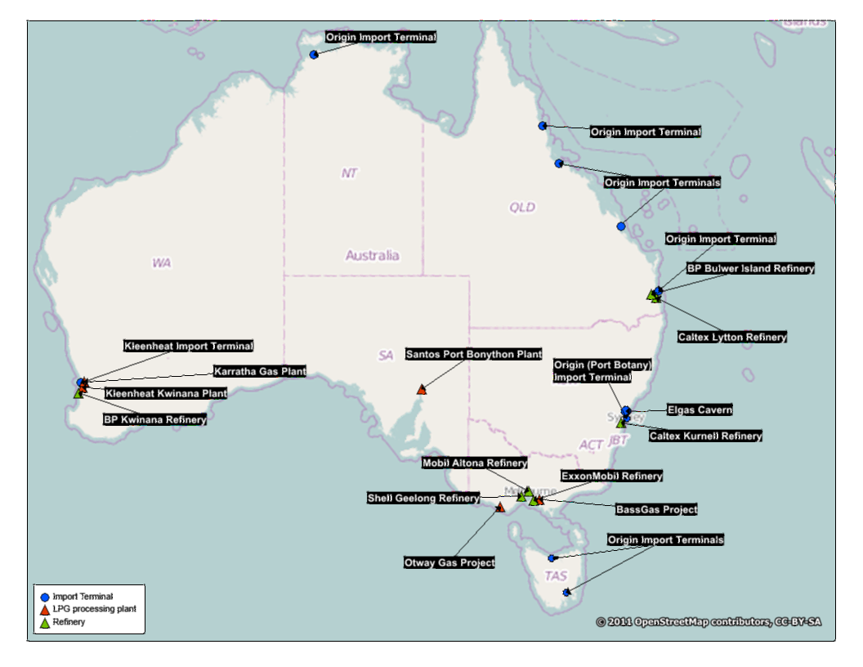

Distribution and supply network
Within Australia LPG is generally transported by road and supported by an extensive network of supply, storage and distribution infrastructure. This infrastructure is developed around the multiple uses of LPG and to meet the needs of different customers. Broadly, the multiple uses of LPG in Australia can be characterised into two main streams:
  - automotive, often referred to in the industry as ‘autogas’
  - non-automotive, often referred to in the industry as ‘traditional LPG’.

Automotive LPG
Automotive LPG may consist of a mix of butane and propane, or propane only. It is used as a fuel in the automotive sector. Automotive LPG is distributed in bulk using large road tankers to large customers such as service stations and other bulk automotive LPG customers.

Non-automotive LPG
Non-automotive LPG is predominantly propane and has a variety of different end uses, including for domestic uses (e.g. heating, hot water systems, and cooking), leisure uses (e.g. barbeque and camping), industrial and commercial (e.g. commercial cooking, industrial heating, and powering forklift vehicles).
Non-automotive LPG is generally supplied wholesale from a production facility or import terminal and transported in bulk using large tanker trucks to a depot where it is stored in a storage vessel for subsequent onward distribution (in some cases it could be transported directly to a large bulk customer).
Within non-automotive LPG, the two main methods of supply are:
  - bulk supply – the supply of LPG via tanker trucks which refill tanks installed permanently at the customer premises
  - cylinder supply – the supply of LPG to customers in pre-filled cylinders.
- Most depots have the ability to provide both bulk and cylinder services (although some smaller distributors only supply cylinder services).

Bulk LPG
Bulk LPG is supplied to residential and small to large commercial and industrial customers. Customers store LPG in tanks ranging from 190kg to 50 tonnes. Most of the demand comes from commercial and industrial customers, with smaller volumes derived from residential customers.
Bulk LPG is transported in bulk tanker trucks, ranging from a 5 tonne “Rigid” tanker truck to a 34 tonne “B-Double” tanker truck.

Cylinder LPG
Cylinder LPG is supplied in different sizes, including:
  - 9kg cylinders for leisure customers (e.g. for use with BBQs)
  - 15kg cylinders for forklift cylinder customers
  - 45kg cylinder for residential and some commercial/industrial customers.
The cylinders are serviced and re-filled at depots which often have cylinder testing, filling and refurbishment capabilities. Cylinders are then transported by flatbed trucks and/or utility vehicles to customers or agents. Supply to the end customer can be either directly or via an agent or dealer:
  - Under an agent model, the distributor sets the price, and the agent receives a commission for their delivery services.
  - Under a dealer model, the distributor sells the dealer a large quantity of cylinder non-automotive LPG, and the dealer sets a retail price for its own customers (in essence, the dealer is a customer of the distributor).
For leisure cylinders (e.g. 9kg), individual customers generally purchase and pick up cylinders from an outlet such as a hardware store or petrol service station. Empty cylinders can be refilled or (more commonly) swapped for full cylinders at these outlets. Some distributors, agents, or dealers may also retail LPG leisure cylinders from their depots. Large national retailers (such as national chains of hardware stores and petrol service stations) are the largest providers of leisure cylinders.

Areas of overlap
The ACCC’s starting point for delineating relevant markets to assess the competition effects of the proposed acquisition involves identifying the products actually or potentially supplied by the merger parties. The ACCC then considers the overlap between the merger parties’ products and whether other products constitute sufficiently close substitutes to provide a significant source of constraint on the merged entity.
Following its inquiries the ACCC considers that the parties to the proposed acquisition currently overlap (compete with each other) in the following activities on the east coast of Australia:
  - wholesale supply of LPG
  - distribution of non-automotive LPG
  - distribution of automotive LPG.

Market definition
Pending further information from interested parties, the ACCC’s preliminary view is that the relevant markets for assessing the competition effects of the merger are:
  - State-wide markets for the wholesale supply of LPG
  - Regional markets for distribution of non-automotive LPG in bulk
  - Regional markets for the distribution of non-automotive LPG in cylinders (this market is discussed together with the regional markets for the distribution of non-automotive LPG in bulk)
  - A national market for distribution of non-automotive LPG to large national customers
  - Markets for the supply of automotive LPG (the ACCC has not defined the geographical scope of these markets precisely, as discussed at [70] below).

State-wide markets for the wholesale supply of LPG
The ACCC’s preliminary view, based on its market inquiries to date, is that there are likely to be state-wide markets for the wholesale supply of LPG.
However, the ACCC has also considered whether a broader east coast wholesale market is more appropriate.
The ACCC’s market inquiries to date suggest that LPG may be economically transported across states and regions, depending on regional prices. For example, some market participants have submitted that in some instances distributors have found it more economical to transport LPG from a refinery in Victoria to its operations in New South Wales, than to purchase LPG from a New South Wales source. However, other market participants indicate that there are limits on the economics of such bulk overland transport, suggesting there may be state-based markets rather than an east coast market.
The ACCC’s market inquiries indicate that the wholesale LPG price differs between states on the east coast, at least in part due to differences in the supply and demand conditions in each state. This tends to support the existence of state-based markets.
The ACCC recognises that such state-based markets are unlikely to be defined precisely by official state boundaries. For example, northern New South Wales is more likely to be supplied by sources in Brisbane rather than the more distant Sydney.

Regional markets for distribution of non-automotive LPG in bulk and in cylinders
The ACCC’s preliminary view, based on its market inquiries to date, is that there are likely to be regional markets for the distribution of non-automotive LPG in bulk and in cylinders.

Product dimension
- As explained above at [44-51], non-automotive LPG can be supplied in bulk or various types of cylinder, and to a variety of customer segments.
- The ACCC considers that it is appropriate for the purposes of this assessment to consider all cylinder forms and sizes to be in the same market:
  - Demand side substitutability between cylinder sizes is likely to be limited for most users (e.g. a user of a 15kg forklift cylinder cannot readily switch to a 9kg leisure cylinder).
  - However, market inquiries indicate there is supply side substitutability between cylinder sizes. There are variations between cylinder types and their filling methods. However, cylinder distributors normally supply a range of cylinders, and the transport mechanisms are similar between cylinder types.
The ACCC has considered whether the distribution of non-automotive LPG in bulk is in the same market as the distribution of non-automotive LPG in cylinders, or whether there are separate markets. The ACCC’s market inquiries to date suggest they could be in separate markets:
  - Supply side substitution is limited because distributors of cylinder LPG cannot readily switch to distributing bulk LPG. They may lack the scale to justify purchasing and running bulk LPG tanker trucks, and may also need to invest in additional storage. There are also additional health and safety requirements, and additional costs related to handling, training and compliance, for bulk supply. However, the ACCC recognises that several of the smaller distributors (Supagas, Renegade, United Gas and Direct Gas) have established sufficient scale over time to distribute bulk LPG.
  - Supply side substitution from bulk to cylinder LPG distribution may be easier than from cylinder to bulk. However, the ACCC understands that distributors typically start their business by supplying cylinder LPG and then expand into supplying both cylinder and bulk LPG.
  - Demand side substitutability between bulk and cylinder LPG is limited for many customers. Large customers cannot use cylinders due to the small size, and many small customers would not use enough LPG to justify the substantial cost of installing an on-site tank to receive bulk distribution. Some large cylinder or small bulk customers may be able to switch between the two forms of distribution, but market inquiries suggest these are a relatively small minority.
- Although distribution of non-automotive LPG in bulk and cylinder are likely to be in separate markets, the ACCC considers it appropriate to assess both markets together. The key distributors and their respective market positions are generally the same in both markets, the distribution networks are similar and there are overlaps in the entry requirements for each market.

Geographic dimension
Market inquiries suggest distributors of non-automotive LPG compete in regional markets, based around the location of depot facilities. As explained above at [41], non-automotive LPG is typically distributed to customers from a depot or dealer. The ACCC understands from its market inquiries that the geographical reach of a distributor, its agent, or a dealer, depends mostly on the location of the depot facility and how far non-automotive LPG could be economically transported from that depot. Market inquiries suggest the economic delivery range is around 100km from a depot, although this can be extended by the use of dealers to distribute cylinder LPG further afield.
However, the ACCC’s market inquiries to date indicate that it is appropriate to consider the distribution of non-automotive LPG to large national customers in a separate market from other LPG customer segments. This market is discussed below.

National market for distribution of non-automotive LPG to large national customers
The ACCC’s preliminary view, based on its market inquiries to date, is that there is likely to be a separate national market for the distribution of non-automotive LPG to large national customers.
The ACCC’s market inquiries to date suggest there is a separate market for distribution of non-automotive LPG to large customers with a nationwide business. Such customers may have a need for various non-automotive LPG products, including bulk and cylinder LPG. This customer segment prefers a distributor with a comprehensive national distribution network, with both regional and metropolitan coverage. That is, a distributor currently operating in one region or several regions may not necessarily be able to service a large national customer if it does not have a comprehensive national network.

Markets for the supply of automotive LPG
The ACCC considers automotive LPG and non-automotive LPG to be in separate product markets:
  - While non-automotive LPG can sometimes be used in place of automotive LPG, automotive LPG is not a substitute for non-automotive LPG (butane is not safe for use in non-automotive applications).
  - The distribution models for automotive LPG differ from the distribution models for non-automotive LPG.
Given that market inquiries have raised few concerns in relation to automotive LPG, the ACCC has not defined the geographical or functional scope of these markets for this Statement of Issues.
The ACCC invites comments from market participants on its proposed definition of the relevant markets. In particular market participants may wish to comment on:

- Are the relevant markets identified by the ACCC the appropriate markets for the competition assessment of the proposed acquisition (in product, functional and geographic terms)? Please provide an explanation for your response.

- Is it economical to transport LPG between states (e.g. to Queensland from wholesale supply points in Victoria or New South Wales)? If so, please discuss the costs and benefits of doing so, and provide examples of a distributor who has transported LPG in this manner.

- How difficult is it for a distributor of non-automotive LPG only in cylinders to begin distributing in bulk, and vice versa?

- If a small but significant, non-transitory increase in the price of non-automotive LPG (of 5 or 10 per cent) occurred in a regional area, would distributors from elsewhere begin distributing in that region? If so, from how far would such supply be likely to come? What are the factors relevant in determining this distance (e.g. the size of the depot, the population density, the road network, whether the LPG is in bulk or cylinder)?

- Should distribution of non-automotive LPG to large national customers be considered in a separate market? Why or why not? If so, what aspect of this distribution is different from distribution of non-automotive LPG to other customers?

Statement of issues
For the purposes of this Statement of Issues, the issues in this matter are divided into three categories, 'issues of concern', 'issues that may raise concerns' and 'issues unlikely to pose concerns'.

Issues of concern

Competition for the distribution of non-automotive LPG (in bulk and cylinder) in regional markets
The ACCC’s preliminary view is that the proposed acquisition is likely to result in a substantial lessening of competition in the distribution of non-automotive LPG on the east coast of Australia, particularly in certain regional markets.
The ACCC has considered both horizontal and vertical effects.

Horizontal effects
The ACCC’s preliminary view is that, by aggregating two of the three largest distributors of non-automotive LPG, the proposed acquisition has the potential to lessen competition by:
  - enhancing the ability and incentive of the merged entity to raise prices and/or reduce service levels in the distribution of non-automotive LPG
  - increasing the likelihood or stability of co-ordinated conduct
  - increasing barriers to entry (to new entrants) and expansion (by existing rivals) in the distribution of non-automotive LPG.
This section sets out a number of factors relevant to the ACCC’s preliminary assessment of whether the proposed acquisition is likely to substantially lessen competition in these markets. These factors include the level of concentration in the market, barriers to entry and expansion by competitors, and the extent to which customers may have countervailing power due to the ability to credibly threaten to bypass the merged entity or switch to an alternative distributor in the event that the merged entity raises prices or reduces the level of service.

Market concentration
The major distributors of non-automotive LPG (in both bulk and cylinder forms) are Elgas, Kleenheat and Origin. These major distributors operate on a national basis, and have extensive agent and/or dealer networks in metropolitan and regional areas (although some market participants have suggested that Origin has a smaller presence in some rural areas).
There are several smaller distributors of non-automotive LPG (in both bulk and cylinder forms), the largest of these being Supagas, Renegade, United Gas and Direct Gas. Some smaller distributors such as Air Liquide Australia only distribute cylinder LPG, due to the larger capital requirements to establish bulk storage and transport facilities. The ACCC understands from its market inquiries that these distributors do not operate on a national level; they tend to focus on particular metropolitan and/or major industrial areas, with coverage in relatively few regional or rural towns.
- The ACCC’s market inquiries indicate that Elgas and Kleenheat are two of the three largest distributors of non-automotive LPG in bulk and cylinder forms in each state or territory on the east coast. Together, the largest three distributors have around 90 per cent of the non-automotive LPG in each state or territory on the east coast (for bulk and cylinder LPG). The proposed acquisition would therefore lead to a substantial increase in market concentration. More specifically:
  - Taking the east coast as a whole, the proposed acquisition would reduce the number of major suppliers from three to two. The same is true in each state or territory.
  - The merged entity would be the largest distributor of cylinder non-automotive LPG in all eastern states except Tasmania. In New South Wales and Victoria, the merged entity would be the largest distributor by a significant margin, with over 60% market share in each state.
  - The merged entity would be the largest distributor of bulk non-automotive LPG in New South Wales (followed closely by Origin), and Victoria (followed by Origin, and then Supagas). In Queensland, South Australia and Tasmania, the largest distributor would continue to be Origin.
- The ACCC is concerned that the proposed acquisition would lessen competition for the distribution of non-automotive LPG in bulk and in cylinders by removing the competitive constraint between the merger parties. In a range of regional markets, the proposed acquisition would create a very large market leader with a degree of market power that is unlikely to be sufficiently constrained by its smaller existing competitors. Indeed, there are regions in which Elgas and Kleenheat are the only two distributors.
- In regional markets where the proposed acquisition would reduce the number of competitors from three to two, there may also be an increased risk of co-ordinated conduct.
- Map 2 below illustrates that Elgas and Kleenheat have an extensive network of depots on the east coast of Australia. Origin’s depot network is also quite extensive, but it has a lesser presence in some parts of New South Wales and Victoria (as illustrated in Map 3 below). Supagas and Renegade, who have the highest market shares amongst the smaller LPG distributors, have a more limited network of depots.
Map 2: Location of depots owned by the largest five LPG distributors (by volume per state) on the east coast
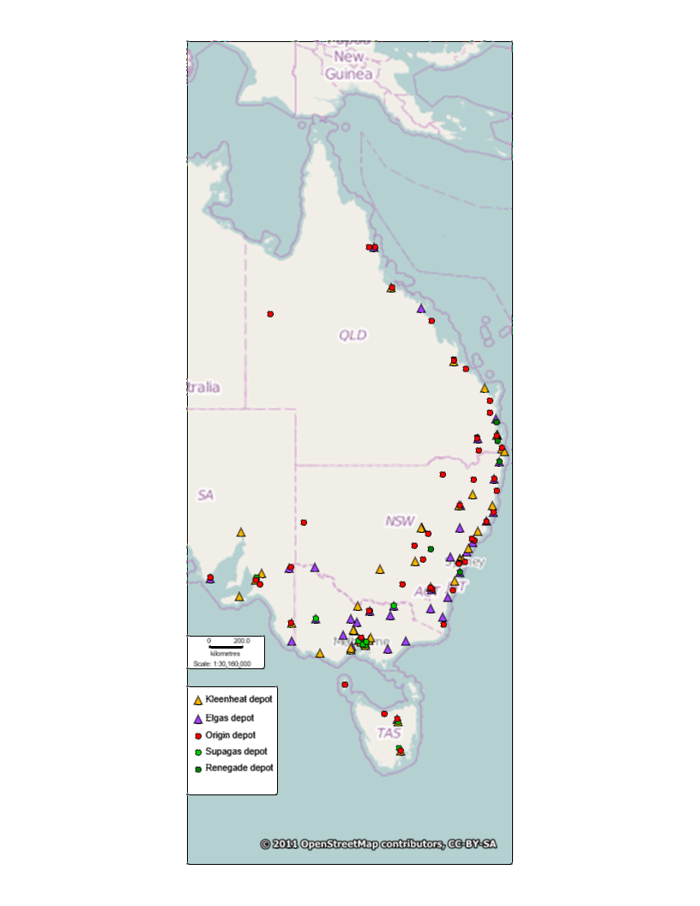
Map 3: Location of depots owned by the largest five LPG distributors (by volume per state) in New South Wales and Victoria
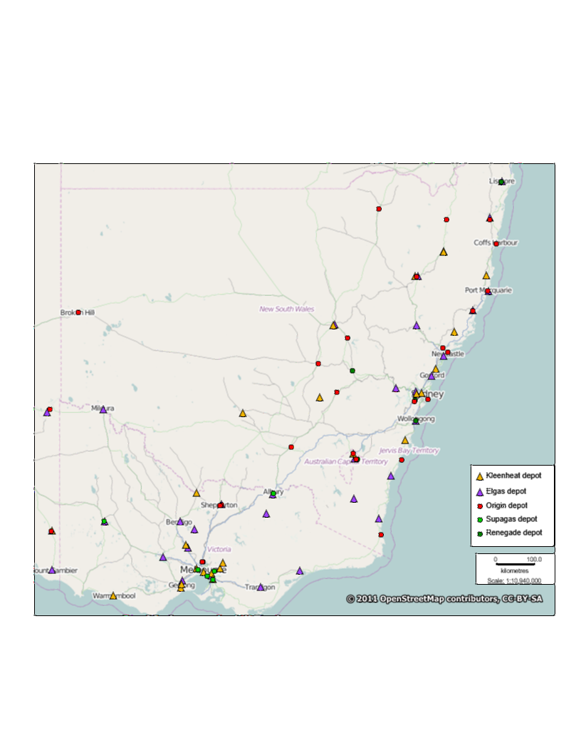
- As such, the proposed acquisition is likely to combine the two most extensive distribution networks on the east coast. It is also likely to reduce the number of distributors in at least some regional markets from:
  - three to two, in regions where there is only Elgas, Kleenheat and Origin
  - two to one, in regions where there is only Elgas and Kleenheat.
- Broadly, the ACCC’s market inquiries to date have indicated that the regions of most concern are likely to be in the Mallee, south west and north east of Victoria, where Elgas and Kleenheat currently compete, and are the only distributors present with depots.
- The ACCC’s market inquiries also indicated that there are some regions of concern where Elgas, Kleenheat, and Origin are the only major distributors present, and in which the merged entity is likely to be significantly larger than Origin post-acquisition. The areas identified by market participants include:
  - Northern country Victoria (around Bendigo, Shepparton and Echuca)
  - Australian Capital Territory
  - Illawarra, Central Tablelands, Hunter and Mid North Coast in New South Wales.

Barriers to entry and expansion
- The ACCC’s preliminary view is that there are high barriers to entry and expansion for the distribution of bulk or cylinder LPG. In particular, a significant barrier to a competitor entering a new region is the need to achieve a critical mass of customers to be able to compete effectively and profitably with incumbents. This barrier is compounded by the presence of a small number of customers in areas that are not densely populated.
- Market participants have identified several barriers to entry and expansion.
- Entrants require access to a source of LPG at prices that allow the new entrant to be competitive with incumbents. This access may be diminished as a result of the proposed acquisition by removing an alternative wholesaler for a smaller or new entrant LPG distributor (discussed further at [94]).
- Entrants face high capital, including sunk, costs relative to the potential gains in the market. These include capital required to establish a depot and distribution network in a new region, including investment in land and buildings, a transport fleet (ranging from large tanker trucks to utility vehicles) and a base load of cylinders. While some of these capital costs may be able to be mitigated in the early stages (e.g. by renting cylinders or contracting out the provision of haulage services), market participants report that it typically takes several years of operation before a new depot becomes profitable.
- The economies of scale arising from the high fixed costs in the industry would render small scale entry unprofitable. A new entrant would need to be confident it could win a significant customer base from the incumbent(s).
- Entrants also face strategic barriers due to the threat, whether real or perceived, that large incumbent distributors may undercut any potential new entrant on price in response to new entry. Such strategic barriers could be exacerbated in certain regions where the proposed acquisition would result in a significant increase in Elgas’ market share.
- Market participants have raised issues with the difficulty of inducing some customers to switch suppliers. This customer ‘stickiness’ exacerbates the barriers to entry described above. In particular, the ACCC understands:
  - A large portion of customers (including dealers and bulk LPG customers, especially larger customers) are on long-term contracts. Given such contracts are due for renewal at different times they may impede a new or expanding distributor seeking to build critical mass.
  - Some market participants have submitted that, in some rural areas, there are only a limited number of businesses which are suitable to act as a dealer for a LPG distributor (e.g. a hardware store).
  - Bulk customers tend to have tanks installed by their distributor, with the installation cost recovered over the term of an initial contract. Switching distributors requires removing the existing tank and installing a new one. While the new distributor often pays for this removal and installation, it must recover this cost in the price it offers to the customer. This may be a barrier to switching, given the incumbent has already recovered the cost of its own tank.
  - In addition, the ACCC understands that the ownership of cylinders often remains with the distributor. Dealers (and some other customers) wishing to switch distributors may be required to return these (some of which may be held by third parties) before switching.
- While there is evidence of recent entry and expansion in the form of Supagas and Renegade, the ACCC notes that it has taken these distributors a long time to expand into new areas (e.g. Renegade has taken from 1997 to 2014 to expand from Sydney into the regions shown on Map 2). The ACCC’s preliminary view is that new entry or expansion would not be sufficiently timely to defeat an exercise of market power by Elgas in one or more regional markets following the proposed acquisition.

Countervailing power of customers
- The ACCC’s market inquiries also indicate that customers of non-automotive LPG (either end users or dealers) do not generally have countervailing power. In particular:
  - Customers generally lack the scale to bypass the major distributors by sourcing directly from a production or an importation facility. Such facilities generally require an offtake arrangement at volumes far larger than most dealers or end users need.
  - The very largest industrial customers might theoretically be able to sponsor entry of an alternative distributor into their region, but it is unclear whether this could be feasible in the absence of a very large price increase by the incumbent(s).

Vertical effects
As discussed above, Elgas, Kleenheat and Origin are the only vertically integrated participants in the non-automotive LPG industry in Australia (in that they have wholesale facilities and also operate as distributors). While Kleenheat engages in some wholesale supply on the east coast (as suggested by some market participants, discussed below at [113-114]), the extent of Kleenheat’s wholesale activity on the east coast is unclear.
However, some market participants are concerned that the proposed acquisition would further strengthen Elgas’ vertical integration on the east coast by virtue of its increase in downstream market share. In particular, market participants have raised concerns about the ability and incentive of Elgas, given its strong position in the wholesale market in New South Wales to foreclose rivals in downstream markets or raise wholesale prices to them. If so, this may limit those rivals’ ability to compete in downstream LPG markets (i.e. the distribution of non-automotive LPG in bulk and/or cylinder in regional markets). The ACCC notes that the larger the market share of Elgas in downstream markets, then potentially the stronger is its incentive to foreclose rivals, as it will receive a higher proportion of the foreclosed player’s customers. As discussed above, the proposed acquisition would give Elgas a considerable increase in market share.
The ACCC invites comments from market participants on the likely competition effects of the proposed transaction in relation to the distribution of non-automotive LPG (bulk and cylinder) in regional markets.
In particular market participants may wish to comment on the following:
- Are there other distributors which distribute, or could distribute, non-automotive LPG in the regions referred to by the ACCC as those in which competition concerns are most likely to arise as a result of the proposed acquisition? If so, who are these distributors and where do they operate?

- How difficult would it be for existing smaller distributors (e.g. Supagas, Renegade, United Gas, Air Liquide and Direct Gas) to expand their operations to distribute non-automotive LPG to the regional markets referred to by the ACCC as areas in which competition concerns are most likely to arise as a result of the proposed acquisition? How much would the price have to increase for such smaller distributors to enter these regional markets?

- What are the steps in setting up a depot to distribute non-automotive LPG (cylinder and/or bulk)? What are the set up costs, and the fixed and variable ongoing costs? How much of these costs could be recovered upon exit?

- Are there any licensing and/or approval requirements for setting up a new depot? If so, please describe the process and how difficult it is to obtain a licence/approval.

- How much volume of non-automotive LPG would a new depot have to sell for it to be profitable?

- Please give any examples of unsuccessful and successful attempts at new entry and/or expansion by an existing distributor. Why was the attempt unsuccessful (e.g. not enough customers, price response by incumbents) or successful (e.g. won enough customers, successfully competed on price and/or service)?

- To what extent can customers bypass the merged entity? Could customers (e.g. very large industrial customers) source non-automotive LPG directly from an existing wholesale supply point, or sponsor downstream entry/expansion by another wholesaler?

- Please comment on Elgas’ ability and incentive to foreclose its competitors in the downstream markets, before and after the proposed acquisition. What other wholesale supply options would be available to downstream distributors? Would these options be sufficient to constrain Elgas?

- Have any distributors experienced difficulties in obtaining wholesale supply from the Elgas Cavern? What were the reasons for these difficulties?

Competition for the distribution of non-automotive LPG to national customers
The ACCC’s preliminary view is that the proposed acquisition is likely to result in a substantial lessening of competition for the distribution of non-automotive LPG to large national customers in Australia.
- The ACCC is concerned that the proposed acquisition would reduce the level of competition for the distribution of non-automotive LPG to national customers by merging the only two competitors that can serve this market.
Some market participants have submitted that to be able to compete for large national contracts, a distributor requires facilities to be located close to the footprint of the customers’ sites. Elgas and Kleenheat are said to be the only distributors that meet these criteria (and possibly Origin, but to a much lesser extent, as discussed below at [101]).
For example, market participants have submitted that only distributors with sufficient national coverage in their distribution networks have succeeded in winning contracts to distribute LPG leisure cylinders to major national outlets such as Bunnings, Masters, Caltex and 7-Eleven. The ACCC understands that approximately 80% of all leisure LPG cylinders are retailed from an outlet of a major national hardware or petrol service station chain.

Market concentration
- The ACCC’s market inquiries indicate that, at the national level, the merger parties may be the only distributors, or two of the only three distributors (if Origin is considered a competitor in this market), of non-automotive LPG to large national customers.
The ACCC notes that while Origin operates on a national basis, some market participants do not consider it to be an effective competitor in this market. In particular, Origin is said to lack presence in certain areas. For example, Origin generally has a lesser presence in Western Australia (as a whole) and in some rural areas on the east coast.
The majority of market participants do not consider that smaller distributors (such as Supagas, Renegade, United Gas and Direct Gas) have the capability to compete for these contracts due to their lack of national reach in their distribution networks.

Barriers to entry and expansion
- The ACCC is investigating whether the potential for new entry (or expansion by Origin) is likely to be sufficient to prevent a substantial lessening of competition arising in this market from the proposed acquisitions.
- The ACCC’s market inquiries suggest the following factors make new entry or expansion by existing distributors unlikely:
  - The significant capital requirements to establish a large footprint of depots capable of servicing all areas of a large customer’s national operations. The capital requirements for establishing a single depot are discussed above at [88]. Elgas and Kleenheat have the most comprehensive national networks of depots. Competitors seeking to match these networks would need to establish depots across Australia, which would be likely to take several years. Such competitors would also need to access a competitive source of LPG for each location.
  - In addition, in order to service leisure customers with national outlets, some market participants suggest it is necessary to establish large scale automated or semi-automated filling plants to be competitive on cost. High volume contracts may require specially configured trucks and loading/unloading facilities, which would require further investment to establish. A distributor would need to have sufficient volume to justify the investment in these facilities.
  - The ACCC notes that Kleenheat distributes to national customers that are also owned by Wesfarmers (such as Bunnings and Coles Express). Other potential entrants would not have the benefit of corporate relationships with key customers.

Countervailing power of customers
- The ACCC’s market inquiries suggest that, while large national customers may have a higher degree of countervailing power than other types of customers, there are some factors which tend to limit the countervailing power of large national customers of non-automotive LPG.
Large national customers may be able to sponsor entry of an alternative large distributor (such as Origin) for their non-automotive LPG requirements. For example, a large national retailer of leisure cylinders could sponsor new entry by committing to a contract with a potential or existing distributor with a national distribution network. Such a contract could give the potential new entrant (or expanded competitor) the incentive to make the necessary investments in semi-automated or automated filling systems for leisure cylinders.
However, distributors in this market would also need an extensive national network of depots with sufficient throughput to be viable. As discussed above, such a network would be costly and time-consuming to create. The ACCC’s preliminary view is that large national customers would be unlikely to assist potential distributors to make such large investments, for the purpose of obtaining a lower price for leisure cylinders.
Market inquiries to date suggest it is unlikely that a national customer would be willing to unbundle its national contracts to bypass the merged entity, unless the merged entity attempted a very significant exercise of market power (such as a large and sustained increase in prices or equivalent degradation of supply terms).
The ACCC invites comments from market participants on the likely competition effects of the proposed transaction in relation to the distribution of non-automotive LPG to large national customers in Australia.
In particular, market participants may wish to comment on the following:
- Other than the merger parties, are there any other distributors who could successfully bid for a contract to distribute non-automotive LPG to a customer with nation-wide LPG needs? If so, please given any examples of a national contract they have won or have bid for in the past.

- How important is it to have automated or semi-automated cylinder filling equipment to service a large national customer?

- Could a large national customer bypass the merged entity for the distribution of non-automotive LPG by sponsoring new entry or expansion by an existing distributor?

- Could a large national customer, such as a hardware or petrol retailing chain, contract with a range of different distributors across Australia to fulfil its needs (instead of a single nation-wide provider) if the price offered by the nation-wide providers were to increase?

Issues that may raise concerns

Competition in state-based markets for the wholesale supply of LPG
The ACCC’s preliminary view is that the proposed acquisition has the potential to result in harm to competition for the wholesale supply of LPG in state-based markets.
The ACCC is particularly focusing on New South Wales, given the extent of concerns raised by market participants in relation to the competition effects of the proposed acquisition in that state. Some market participants have raised concern that the proposed acquisition may lessen the ability of distributors to access wholesale LPG on competitive terms.
- Access to a competitive supply of wholesale LPG is critical for non-integrated distributors to be able to compete effectively. These distributors do not have their own production or importation facilities, nor do they have the necessary scale to invest in such facilities (which would require very large capital investment). As a consequence, they are reliant on the major wholesalers.
As discussed above (under ‘industry background’ at [23-40]), wholesale supply on the east coast is available from:
  - Origin’s import terminals and the BP refinery in Queensland
  - Elgas and Origin’s import terminals in Sydney (including the large Elgas Cavern)
  - Victorian oil refineries and various supply points linked to Bass Strait sources
  - Santos in South Australia.
Although Kleenheat does not itself produce LPG or operate import facilities on the east coast, market participants have indicated that Kleenheat has at times provided wholesale supply of LPG to smaller downstream distributors. Some smaller distributors have indicated to the ACCC that when they have been unable to source LPG directly from production or import facilities due to lack of scale, Kleenheat had been willing to resell LPG it had obtained in the wholesale market. Kleenheat is therefore viewed as a possible alternative wholesale supplier. To the extent Kleenheat is an alternative wholesale supplier, the proposed acquisition would remove it from the market.
These concerns are particularly evident in New South Wales where there are relatively few wholesale supply sources and Elgas has a significant market position due to the size of the Cavern. Given the high cost of transporting LPG interstate by road, the ACCC’s market inquiries suggest that any further aggregation of Elgas’ market position in New South Wales may leave customers of wholesale LPG vulnerable to price increases in that state. The ACCC’s market inquiries indicate that distributors value the ability to choose between wholesale supply options for security of supply, and are therefore concerned that the proposed acquisition may remove a potential wholesale supply option. However, the ACCC is unclear on the extent that Kleenheat is a current and potential future wholesale supplier in New South Wales.
The ACCC invites comments from market participants on the likely competition effects of the proposed transaction in relation to the wholesale supply LPG in state-wide markets, particularly in New South Wales.
In particular market participants may wish to comment on the following:
- How would the removal of Kleenheat affect other distributors’ ability to access wholesale LPG, particularly in New South Wales? Please give examples of any distributors who currently purchase wholesale LPG from Kleenheat on the east coast, or have done so in the past.

- If the proposed acquisition would remove a wholesale supply option for downstream distributors, to what extent could other remaining wholesale supply options meet their supply needs? Please comment on Origin’s Port Botany facility and the feasibility of transporting LPG by road from interstate.

Issues unlikely to pose concerns

Supply of automotive LPG
The ACCC’s market inquiries to date have raised very few competition concerns which specifically affect the supply of automotive LPG. In downstream markets, Kleenheat has only a very small share of the supply of automotive LPG on the east coast of Australia, estimated at less than 3 per cent. Kleenheat also does not have any significant concentration of shares in any states or territories.
The ACCC’s preliminary view is, therefore, that the proposed acquisition would be unlikely to substantially lessen competition in any relevant automotive LPG market.
The ACCC welcomes any comments regarding its preliminary findings in relation to the supply of automotive LPG.
The ACCC invites comments from market participants on the likely competition effects of the proposed transaction in relation to automotive LPG-related markets.
In particular, market participants may wish to comment on the following:
- Do you consider Kleenheat to be a significant supplier of automotive LPG on the east coast, either at the wholesale or downstream levels?
- Will the proposed acquisition result in any substantial lessening of competition in the supply of automotive LPG?

ACCC's future steps
The ACCC will finalise its view on this matter after it considers market responses invited by this Statement of Issues.
The ACCC now seeks submissions from market participants on each of the issues identified in this Statement of Issues and on any other issue that may be relevant to the ACCC's assessment of this matter.
Submissions are to be received by the ACCC no later than 26 June 2014. The ACCC will consider the submissions received from the market and the merger parties in light of the issues identified above and will, in conjunction with information and submissions already provided by the parties, come to a final view in light of the issues raised above.
The ACCC intends to publicly announce its final view by 24 July 2014. However the anticipated timeline may change in line with the Merger Review Process Guidelines. A Public Competition Assessment for the purpose of explaining the ACCC's final view may be published following the ACCC's public announcement.

Kleenheat owns and operates an LPG extraction plant in Perth (the Kwinana plant).

