

Public Competition Assessment

15 December 2014

Peregrine Corporation - acquisition of 25 BP Australia petrol retail sites in South Australia

Introduction
- On 8 May 2014, the Australian Competition and Consumer Commission (ACCC) announced its decision not to oppose Peregrine Corporation’s (Peregrine):
- proposed acquisition of 16 BP Australia (BP) petrol retail sites in metropolitan Adelaide
- completed acquisition of nine BP sites in regional South Australia,
subject to a divestiture undertaking accepted by the ACCC pursuant to section 87B of the Competition and Consumer Act 2010 (the Act) (the undertaking).
- The ACCC decided that Peregrine’s acquisition of the 25 BP sites, together with the undertaking and also two ‘swap’ agreements with other retailers (together, the Acquisition), would not be likely to have the effect of substantially lessening competition in any relevant market in contravention of section 50 of the Act.
- The ACCC also announced on 8 May 2014 that it would oppose the related proposed acquisition by Peregrine of Caltex Australia’s retail petrol station site in the Adelaide suburb of Fullarton (the Fullarton Acquisition). The ACCC decided that the proposed acquisition by Peregrine of this site would have or be likely to have the effect of substantially lessening competition in the relevant local market in contravention of section 50 of the Act.
- The ACCC made its decisions on the basis of information provided by the merger parties and information arising from its market inquiries. This Public Competition Assessment outlines the basis on which the ACCC reached its decisions, subject to confidentiality considerations.
- In this Public Competition Assessment, where relevant, the Acquisition as originally proposed by Peregrine (i.e. before the undertaking and not including the sites Peregrine is acquiring in return for divesting some of the BP sites) is referred to as the Original Acquisition.

Public Competition Assessment
- To provide an enhanced level of transparency and procedural fairness in its decision making process, the ACCC issues a Public Competition Assessment for all transaction proposals where:
- a merger is opposed
- a merger is subject to an enforceable undertaking
- the merger parties seek such disclosure
- a merger is not opposed but raises important issues that the ACCC considers should be made public.
- This Public Competition Assessment has been issued because Peregrine Corporation’s acquisition of 25 BP Australia petrol retail sites in South Australia is subject to a court enforceable undertaking, and the related Fullarton Acquisition was opposed by the ACCC.
- By issuing Public Competition Assessments, the ACCC aims to provide the public with a better understanding of the ACCC's analysis of various markets and the associated merger and competition issues.
- Each Public Competition Assessment is specific to the particular transaction under review by the ACCC. While some transaction proposals may involve the same or related markets, it should not be assumed that the analysis and decision outlined in one Public Competition Assessment will be conclusive of the ACCC’s view in respect of other proposed acquisitions, as each matter will be considered on a case-by-case basis.
- Public Competition Assessments outline the ACCC’s principal reasons for forming views on a proposed acquisition at the time the decision was made. As such Public Competition Assessments may not definitively identify and explain all issues that the ACCC considers arise from a proposed acquisition. Further, the ACCC’s decisions generally involve consideration of both non-confidential and confidential information provided by the parties and market participants. In order to maintain confidentiality, Public Competition Assessments do not contain any confidential information or its sources.

The parties

The acquirer: Peregrine Corporation
- Peregrine is a South Australian convenience retailer. Its operations include a fuel retailing business in South Australia operated under the business name ‘On the Run’ as well as other businesses such as Smokemart and GiftBox. Many On the Run service station sites also supply other goods and services such as takeaway food (including franchises such as Subway, Brumby's Bakeries and Oporto), car wash facilities, dog wash facilities and the sale of SA lotteries products.
- At the time of the ACCC’s decision, Peregrine operated 94 service stations in South Australia (including nine regional BP sites that Peregrine had already acquired from BP as part of the Acquisition, as mentioned below at paragraph 16), 78 of which were in metropolitan Adelaide. Of the 78 service stations in Adelaide:
- Mobil Oil Australia Pty Ltd (Mobil) supplied fuel to 29, which were branded 'On the Run' for fuel and convenience stores
- BP supplied fuel to the remaining 49, which were branded BP on the 'forecourt', with 'On the Run' convenience stores on site.
- Peregrine does not engage in the wholesale supply of fuel to any other retailers.

The vendor: BP Australia
- BP is a vertically integrated refiner-wholesaler of petrol, diesel and automotive liquefied petroleum gas (LPG). It is engaged in the refining, transportation and marketing of petroleum and lubricant products. BP refines crude oil at its Kwinana refinery in Western Australia. On 2 April 2014 BP announced that it intends to cease refining operations at its Bulwer Island refinery in Brisbane, Queensland by mid-2015.
- Prior to the ACCC’s review of the Acquisition, BP supplied fuel to approximately 1,400 service stations around Australia. Of these, BP owned and operated 225 sites in metropolitan areas and BP’s subsidiary – Reliance Petroleum (Centrel Pty Ltd) – operated (and continues to operate) approximately 250 sites in regional areas. The remaining service stations supplied by BP were (and remain) independently owned and typically sell fuel under the BP brand.
- At the time of the ACCC’s decision, BP had 16 company owned and company operated sites in metropolitan Adelaide (all of which were to be acquired by Peregrine as part of the Acquisition). BP had also recently completed the sale to Peregrine of nine company owned and operated sites in regional South Australia as part of the Acquisition. The ACCC’s decision considered the competitive impact of all aspects of the Acquisition - the proposed acquisition of the 16 Adelaide sites, and the completed acquisition of the nine regional sites.
- BP also owns and operates three truck stop service stations (dedicated facilities on major trucking routes) in South Australia which are not part of the Acquisition. Other than these truck stop sites, following the Acquisition BP would have no company owned and operated sites remaining within South Australia.
- BP also supplies fuel on a wholesale basis to four independent dealers (other than Peregrine) in metropolitan Adelaide. One of these dealers operated nine BP-branded sites in Adelaide at the time of the ACCC’s decision (see paragraph 48 below), and the other three operated a single site each. Supply to these independent dealers was not affected by the Acquisition.

Caltex Australia
- Caltex Australia Petroleum Ltd (together with its related bodies corporate, Caltex) is a vertically integrated refiner-wholesaler of petrol, diesel and LPG. It owns the Kurnell refinery in Sydney and the Lytton refinery in Brisbane, and owns or operates 15 fuel terminals located across Australia.
- Caltex supplies petrol, diesel and LPG on a wholesale basis to customers including its own retail sites, Woolworths, and independent fuel retailers. Caltex has a national network of approximately 1900 branded or co-branded retail service station sites, including 631 sites that are co-branded with Woolworths.
- At the time of the ACCC’s decision, Caltex set the prices at 21 fuel retail sites in metropolitan Adelaide. These sites were operated (and prices at these sites were set) independently of the 33 Caltex/Woolworths sites in Adelaide, which are operated by Woolworths.

Industry background
- As described above, Peregrine is a retailer of fuel in South Australia, while BP is both a retailer and wholesaler of fuel in South Australia.
- This section provides background information about the wholesale and retail aspects of Australia’s petrol industry. While other automotive fuel products (diesel, LPG) are sold in South Australia, the ACCC’s review focused primarily on the retailing of petrol. This is discussed further under ‘market definition’ (paragraph 79 below).

Petrol wholesale
- Wholesale supply of petrol is sourced from either domestic refineries or from product imported via port terminals. The two broad categories of wholesale market participants are:
- Refiner-wholesalers: BP, Caltex, Mobil and the Shell Company of Australia Ltd (Shell). These companies supply petrol which has been produced in domestic refineries, bought from other refiner-wholesalers through ‘buy-sell’ transactions, or imported.
- Independent wholesalers: including Neumann, Ausfuel (now both owned by Puma Energy), United Petroleum (United) and Liberty. These companies source petrol from Australian refiner-wholesalers and in some cases from overseas refineries.
- Refiner-wholesalers and independent wholesalers are the main distributors of petrol in the wholesale sector to a number of other companies including:
- their company owned and operated retail sites, franchisees and commission agents
- independent retailers (such as Peregrine), both branded and unbranded
- independent wholesalers
- independent distributors and/or end-users such as mines and large commercial entities.

Petrol retail
- Service station sites supply fuel to retail customers (individuals and businesses). There are a range of different ownership structures of service stations broadly falling into the following categories:
- supermarket-operated sites (Coles Express and Woolworths)
- refiner-wholesaler company owned and operated sites (BP and Caltex)
- refiner-wholesaler franchisee and commission agent sites (BP and Caltex)
- refiner-wholesaler branded but independently operated sites
- independently owned and/or operated sites (not refiner-wholesaler branded) - from large independent chains (e.g. United, Neumann) to single-site operations.
- Each refiner-wholesaler has direct control over the board price at its company owned and operated sites. Caltex sets the board price of petrol and diesel at its commission agent sites and also has the ability to exert a substantial degree of influence over the board price of petrol and diesel at some Caltex branded sites through the provision of price support.
- At independent sites (including refiner-wholesaler branded but independently owned and operated sites), the site owner/operator is responsible for setting the board price of petrol and diesel, not the refiner-wholesaler.

Price Cycles
- Price cycles are a prominent feature of retail petrol prices in Australia’s largest cities. They are the outcome of the pricing policies of the petrol retailers.
- The price cycle has two distinct phases:
- a relatively sharp increase in prices, generally over one to three days (the restoration phase)
- a more prolonged phase of decreasing prices over the rest of the cycle (the discounting phase).
- In 2012 and 2013, price cycles in each Australian city generally moved independently of each other. This pattern is illustrated in Figure 1.
Figure 1: Illustration of price cycle: daily average retail regular unleaded petrol prices in the five largest Australian cities: June 2013
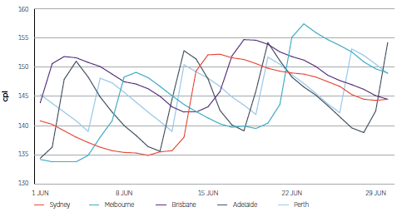

Restoration phase behaviour
- The restoration phase is generally initiated by one or two of the major retailers substantially raising prices at several retail sites in a city (or in some cases all of their retail sites in that city) and waiting for other retailers to respond. If other retailers respond to this move with similar increases, then the increased price usually spreads across the retail networks within a city.
- Some retailers follow shortly after the leader (or ‘first mover’) raises prices; others ‘lag’ further behind. This is because there is a (short-term) incentive for individual retailers to delay their price response during the restoration phase of the price cycle, thereby gaining a temporary price advantage and temporarily increased sales. The risk from delaying is that the first movers will abandon their attempt to increase prices, and return to pre-restoration discounted prices. The longer the delay in other retailers following an attempted restoration, the greater the risk that those first movers will abandon their attempt. The ACCC refers to an abandoned attempt at a restoration, where prices revert to the pre-restoration attempt levels, as a ‘failed restoration’.
- During the restoration phase, retailers tend to adjust prices across a broad number of sites within a city within a short space of time. In the vast majority of cases, prices tend to be restored to the same or a similar price point across competitors and across different local areas within a city.

Discounting phase behaviour
- In contrast, the discounting phase involves a slower process of competitors undercutting and matching each other’s prices.
- During the discounting phase, the rate at which retailers reduce their prices from the restoration price tends to vary on a site-by-site basis depending on factors that include the prices of nearby competitor sites. This has the result that during the discounting phase a retailer will often have different prices at its different sites across a city.

Transparency of retail prices
- Site-level petrol prices are highly transparent amongst retailers. As well as prices being visible to observers at each site’s physical location, many retailers also receive regular information about their competitors’ prices via the Informed Sources Oil Pricewatch service. This service involves subscribers submitting their own prices and in return receiving information on competitors’ prices as frequently as every 15 minutes.
- Most of the major petrol retailers in Adelaide, including BP, Peregrine and Caltex, are subscribers to the Informed Sources service. Other petrol retailers who do not subscribe to Informed Sources monitor prices by physically observing the board prices of their competitors.
- The ACCC has instituted court proceedings against Informed Sources and five petrol retailers alleging that they contravened section 45 of the Act. The ACCC alleges that the information sharing arrangements between Informed Sources and petrol retailers, through the service provided by Informed Sources, allows those retailers to communicate with each other about their prices, and that these arrangements had the effect or likely effect of substantially lessening competition in markets for the sale of petrol in Melbourne. The ACCC alleges that the arrangements increased or were likely to increase retail petrol price coordination and cooperation, and decreased or were likely to decrease competitive rivalry.

Other industry participants

Woolworths
- Woolworths operates a diverse range of business interests, including supermarkets, liquor retail outlets and retail fuel sites. All Woolworths-owned retail fuel sites are co-branded as Caltex/Woolworths or Caltex/Safeway. As at April 2014, there were 631 co-branded sites in Australia, of which Woolworths owned 500 and Caltex owned the remainder. Woolworths controls the pricing at all Caltex/Woolworths and Caltex/Safeway branded sites. Caltex is the exclusive wholesale fuel supplier to all Caltex/Woolworths and Caltex/Safeway branded sites.
- Caltex/Woolworths retail fuel sites accept discount fuel shopper dockets received by consumers when they shop at a Woolworths supermarket.
- At the time of the ACCC’s decision, Woolworths operated 33 retail fuel sites in Adelaide, all branded Caltex/Woolworths.

Coles and Shell
- In 2003 Coles and Shell entered into an alliance agreement under which Coles leased a number of service stations from Shell and operated them under ‘Coles Express’ branding.
- On 21 February 2014, Shell announced the sale of its Geelong refinery and its retail service stations to Swiss oil company Vitol S.A. As a result of the sale, Coles now leases its ‘Coles Express’ branded service stations from Vitol S.A.
- Coles sets the price for fuel at all of its sites and obtains its supply of fuel products exclusively from Vitol S.A. through its subsidiary company Viva Energy Australia.
- Coles Express outlets accept discount vouchers received by consumers when they shop at a Coles supermarket. Coles branded fuel discount vouchers can also be redeemed at some independent Shell service stations across Australia (these service stations are not operated by Coles).
- At the time of the ACCC’s decision, Coles Express operated approximately 630 fuel retail sites across Australia; 29 of these sites were located in Adelaide.

Agostino
- The Agostino Group (Agostino) is an independent, BP-branded fuel retailer. At the time of the ACCC’s decision, prior to the Acquisition, Agostino operated 11 sites in South Australia, including nine in metropolitan Adelaide. All Agostino sites are supplied by BP and accept the BP fuel card.

United
- United is an independent Australian-owned oil company with wholesale and retail operations. At the time of the ACCC’s decision, United operated eight retail sites in metropolitan Adelaide.

Nemer
- At the time of the ACCC’s decision, the Nemer family operated eight independent sites in metropolitan Adelaide. Those sites acquire their fuel from, and are branded, Liberty.

Andrash
- Andrash Pty Ltd (Andrash) is an independent fuel retailer that operated six sites in metropolitan Adelaide at the time of the ACCC’s decision. Andrash’s sites are supplied by Mogas and affiliated with the Mogas fuel card.

The transaction
- The Original Acquisition consisted of:
- the proposed acquisition by Peregrine of 16 BP owned and operated petrol retail sites in metropolitan Adelaide
- the completed acquisition by Peregrine of nine BP sites in regional South Australia.
- A complete list of sites to be acquired by Peregrine as part of the Original Acquisition (the Target Sites) is at Attachment A.
- During the course of the ACCC’s review of the Original Acquisition, the ACCC was informed of ‘swap’ agreements between Peregrine and two other retailers, which were related to arrangements to address the ACCC’s competition concerns.

Swap agreement 1
- In return for divesting three sites to Caltex (full details of these divestments are provided below at paragraphs 66 and 67), Peregrine proposed to acquire the following sites from Caltex:
- Caltex Fullarton - 390 Fullarton Road, Fullarton, South Australia
- Caltex Tanunda - 212 Murray Street, Tanunda, South Australia
- Caltex Mt Gambier - 29 Penola Road, Mt Gambier, South Australia
- Caltex Irymple - Cnr Fifteenth Street and Karadoc Avenue, Irymple, Victoria
- Caltex Berri - Sturt Highway, Berri, South Australia.
- Of these sites, only Caltex Fullarton is located in Adelaide.

Swap agreement 2
- In return for divesting BP Mile End to Agostino (full details of this divestment are provided below at paragraph 66), Peregrine proposed to acquire the following sites from Agostino (both in Adelaide):
- BP Fitzroy - 20 Main North Road, Thorngate, South Australia
- BP Surrey Downs - 664 Golden Grove Rd, Surrey Downs, South Australia.
- Other than the Fullarton Acquisition, the ACCC considered that the other proposed acquisitions outlined above at paragraphs 55 and 57 would be unlikely to have the effect of substantially lessening competition in any relevant market in contravention of section 50 of the Act. The Fullarton Acquisition is considered in greater detail below at paragraphs 148 to 158.

Review timeline
- The following table outlines the timeline of key events in this matter.
Date | Event
15-May-2013  20-Jun-2013  24-Sep-2013  06-Dec-2013  13-Dec-2013  24-Dec-2013  02-May-2014  08-May-2014 | ACCC commenced review under the Merger Process Guidelines.  Closing date for submissions from interested parties.  ACCC timeline suspended to allow the merger parties to provide further information. Former proposed decision date of 26 September 2013 delayed.  ACCC timeline recommenced following receipt of further information from merger parties.  Former proposed decision date of 19 December 2013 delayed at merger parties' request to allow them to provide further information to the ACCC.  ACCC commenced review of the Fullarton Acquisition.  Further information received. ACCC timeline recommenced.  ACCC announced it would not oppose the Acquisition subject to a section 87B undertaking accepted by ACCC.  ACCC announced it would oppose the Fullarton Acquisition.

Market inquiries
- The ACCC conducted market inquiries in relation to the Acquisition with a range of industry participants, including competitors, industry bodies and other interested parties. Submissions were sought in relation to the substantive competition issues.
- In reaching its decision on the Fullarton Acquisition, the ACCC made use of information gathered during market inquiries in relation to the Acquisition, as well as further information that was gathered specifically in relation to the Fullarton Acquisition.

Statement of Issues
- The ACCC did not publish a Statement of Issues in relation to its review of the Acquisition or its review of the Fullarton Acquisition.
- The ACCC took this approach because it received a substantial amount of information during market inquiries, and remained in contact with market participants throughout the course of the review. In the circumstances, the ACCC considered that a Statement of Issues would not be likely to provide significant new information, and would involve an unnecessary extension of the time taken by the review.
- The merger parties were made aware that the ACCC would be making a final decision without releasing a Statement of Issues. The merger parties were made aware of and provided with multiple opportunities to respond to issues and concerns arising from market inquiries and other analysis conducted by the ACCC.

Undertaking
- On 24 February 2014 Peregrine offered a draft court enforceable undertaking pursuant to section 87B of the Act. The undertaking was given by Peregrine to address the ACCC’s competition concerns in certain local markets for the retail supply of petrol.
- Peregrine’s undertaking required Peregrine to divest the following sites that Peregrine acquired from BP:
- BP Elizabeth Vale – Cnr Main North & Hogarth Roads, Elizabeth Vale (to Caltex).
- BP Mile End - 95 Henley Beach Road, Mile End (to Agostino).
- BP Westbourne Park – 427 Goodwood Road, Westbourne Park (to Caltex).
- The undertaking also required Peregrine to divest one of its existing petrol stations — On the Run South Plympton — 445 Marion Rd & Cross Rd, South Plympton (to Caltex) to address concerns associated with the proposed acquisition of BP Mitchell Park.
- The ACCC concluded that the divestment of these businesses by Peregrine addressed the ACCC’s competition concerns associated with the original Acquisition. The ACCC further concluded that the divestments required by the undertaking did not themselves raise any competition concerns. Accordingly the ACCC accepted the undertaking given by Peregrine on 8 May 2014.
- The relevance of the undertaking to competition concerns identified by the ACCC in relation to the Acquisition is discussed in the competition analysis section of this document.
- However, the undertaking did not address the ACCC’s competition concerns associated with the Fullarton Acquisition.

Future with and without the acquisition
- Section 50 of the Act prohibits acquisitions of shares or assets that would have the effect or be likely to have the effect of substantially lessening competition in any market. In determining whether a proposed acquisition is likely to have the effect of substantially lessening competition pursuant to section 50 of the Act, the ACCC considers the likely future state of competition by comparing the likely future with the proposed acquisition and the likely future without the proposed acquisition.
- In this case, BP submitted that it would continue to own and operate the Target Sites in the absence of the Acquisition.
- The ACCC conducted market inquiries and carefully considered publicly available information, as well as extensive confidential information provided by the parties, to test this submission.
- Based on the information available to it at the time, the ACCC formed the view that in the future without the Acquisition, BP would continue to own and operate the Target Sites for the foreseeable future. In this respect, the ACCC accepted BP’s submission that the appropriate 'without' position was a continuation of the status quo. However, as discussed in greater detail below at paragraphs 87 to 93, the ACCC did not accept that this necessarily meant that BP’s historic pricing and competitive behaviour in Adelaide would continue unchanged.
- The ACCC was provided with no evidence to suggest that Caltex would cease to operate Caltex Fullarton in the absence of Peregrine’s proposed acquisition of that site. Accordingly, the likely future without the proposed acquisition was Caltex’s continued operation of Caltex Fullarton.

Competition analysis: the Acquisition
- The ACCC considered whether the Acquisition would be likely to have the effect of substantially lessening of competition by eliminating BP as a competitor, and increasing the number of petrol sites under Peregrine’s control. This question was relevant to competition between the fuel networks that occurs on an Adelaide-wide basis, as well as to local competition between individual sites.

Market definition
- The ACCC considered the competitive effect of the Acquisition in the following markets:
- The market for the retail supply of petrol in Adelaide (the Adelaide market).
- Local markets for the retail supply of petrol in areas surrounding each of the Target Sites (the local markets).

Product dimension
- As noted above at paragraph 22, three types of fuel products are commonly sold at retail service stations in South Australia: petrol (including regular unleaded, premium unleaded and ethanol blends), diesel and LPG.
- For the purpose of considering the Acquisition, the ACCC did not consider it necessary to form a definitive view as to the specific product dimension of the relevant retail markets. For simplicity, this Public Competition Assessment discusses the effect of the Acquisition in the context of retail markets for the supply of petrol only. The ACCC considers that most of the issues discussed in this document apply equally to the retail sale of diesel and LPG.

Geographic dimension
- The ACCC considers that competition between petrol retailers in Adelaide occurs at two geographic levels:
- across Adelaide (the Adelaide market)
- in particular local markets in Adelaide.
- Competition in the Adelaide market relates to rivalry between Peregrine and other retailers (such as Caltex/Woolworths and Coles Express) that occurs on an Adelaide-wide basis. An aspect of competition that occurs in the Adelaide market is the behaviour of retailers during the restoration phase of the petrol price cycle. As described above at paragraph 34, during the restoration phase, retailers tend to adjust prices across a broad number of sites within Adelaide at the same time. In the vast majority of cases, prices tend to be restored to the same level (or close to the same level) across competitors and across different local areas within Adelaide. However, local factors may also have an effect on competition in the restoration phase by influencing the timing of restorations at individual sites.
- Competition in local markets relates to rivalry among sites located close to each other, in particular local areas or along particular stretches of road. During the discounting phase of the petrol price cycle, most petrol retailers set prices at each individual site that they operate (the ‘base site’) by reference to prices of their nearby rivals (known as ‘marker’ sites). Each base site has its own list of marker sites. The markers for a site are typically relatively close to that site. This reflects localised competition that is particularly important in the discounting phase.
- As a result of this localised aspect of competition:
- during the discounting phase a retailer will often have different prices at its different sites across Adelaide
- changes in the price at a site tend to be correlated more closely with changes in the price at other nearby sites than with other sites in other parts of Adelaide
- prices differ between regions (petrol sites in some regions of Adelaide are, on average, more expensive than petrol sites of the same brand in other regions of Adelaide).
- In identifying the relevant geographic scope of local retail markets, the ACCC examined the geographic substitution possibilities in relation to each of the Target Sites. In considering each local market the ACCC took account of detailed information including:
- the identity of the marker sites used by BP to set prices at the Target Site
- the identity of the marker sites used by Peregrine and other competitors to set prices at their nearby sites
- traffic flow information relating to the area around the Target Site, and roads on which the Target Site was located
- direct evidence provided by the merger parties and other market participants showing the extent to which particular sites respond competitively to the actions of the Target Site, or other nearby sites
- price data for individual sites.
- As a result of this process, the ACCC concluded that for some Target Sites, local competition occurs between proximate competitor sites in all directions from the Target Site. For other Target Sites, competition can be particularly strong along the typical routes of travel of potential customers and is closest between competitor sites located on the same road.
- For this reason, the ACCC did not consider it appropriate or necessary to define precise geographic boundaries for individual local markets for the purpose of categorising all nearby sites as either ‘in’ or ‘out’ of that local market. Instead, the ACCC considered that different sites were likely to be substitutes for the Target Site to varying degrees, based on their geographical location and other aspects of their price and non-price product offer.

Competitive behaviour of BP in the local and Adelaide markets
- During the course of its review, the ACCC received submissions from the merger parties that BP was not a particularly effective competitor, and as a result the Acquisition would not substantially lessen competition in any market because Peregrine would continue to be constrained in all markets by other more effective competitors such as Caltex/Woolworths, Coles Express and various independents. In support of this submission, the merger parties stated the following:
- BP’s prices in Adelaide had been higher on average across the course of the price cycle than many other operators in Adelaide, including Peregrine
- BP had historically been either the leader or a ‘fast follower’ of restorations in Adelaide’s petrol price cycle.
- The ACCC tested these submissions by analysing a data set of 16 months of detailed Adelaide petrol prices. While the ACCC’s analysis showed a number of exceptions to the general pattern, it was mostly consistent with the general tenor of the submissions outlined above at paragraphs 87(a) and 87(b). That is, the ACCC accepted that BP:
- tended (in general) to lead attempted price restoration, or quickly follow another operator’s attempted restorations
- occasionally discounted prices at its sites before their markers, but more often followed the markers
- did not always discount as deeply as some other Adelaide petrol retailers at the bottom of the price cycle
- had average petrol prices that were more expensive than many other Adelaide petrol retailers, including Peregrine.
- However, the ACCC did not accept that this was sufficient to demonstrate that removing BP from the market would have no competitive impact, for the following reasons.
- First, the ACCC understands that many consumers associate the BP brand with premium petrol, and that many consumers consider that BP has a higher quality petrol offer than other brands. In these circumstances, BP need not be the cheapest petrol retailer in Adelaide to have a meaningful competitive impact.
- Second, the ACCC did not accept that past behaviour was necessarily indicative of how BP would behave in the future without the Acquisition. The ACCC explored whether, without the Acquisition, BP’s behaviour in Adelaide would have continued to evolve in response to developments in BP’s commercial position and the local competitive environment.
- Third, in the context of local market analysis, price is only one factor among many that determine how important that site is to local competition. Other relevant factors include:
- the size and product offering of the site, including the extent of its non-petrol offering
- the number of, and brands of, competitors to that site in the local market
- the location of the site relative to its competitors, especially in the context of local geographic features such as major thoroughfares, or likely destinations for commuters such as commercial districts or major employment hubs
- the demographics of the local area.
- For these reasons, the ACCC considered BP's historic pricing behaviour to be relevant but not determinative in assessing the likely effect on competition of the Acquisition.

Barriers to entry
- The ACCC considered that barriers to entry in petrol retail in metropolitan Adelaide were high. The availability of suitable land was the primary barrier to the emergence of new market entrants, or the expansion of existing participants into a new location. In this context, ‘suitable land’ incorporates both the physical attributes of a site (such as size and location) as well as its zoning.
- Market participants told the ACCC that their ability to expand into a new area was limited unless existing sites were available for purchase in that area. Further, they said that the few ‘greenfield’ sites that did become available were typically located on the outskirts of Adelaide.
- As well as land availability, the size and extent of other investments required to enter into petrol retailing are often large and non-recoverable. The ACCC understands these costs to include those relating to site preparation, development, and fit-out activities, which in many cases require the construction of expensive and specialised infrastructure (particularly fuel storage tanks, which are also expensive and time consuming to decommission).
- Market participants also told the ACCC that there were high regulatory barriers associated with establishing a new petrol retail site.
- The ACCC also understands that some existing retailers with a limited presence in Adelaide are deterred from expanding their operations into other parts of Adelaide by the credible threat of an aggressive strategic response by well-resourced incumbent operators.
- In relation to the Adelaide market, the barriers to entry of a new retail chain to replace the competition lost from the exit of BP would be significantly higher than the barriers described above to establishing a single site.
- For these reasons, the ACCC considered that entry on a sufficient scale to constrain the merged entity in a timely fashion was unlikely. The key source of competitive constraint in each market following the Acquisition was therefore likely to be the existing competitors in each area.

Impact of the Acquisition on local markets
- The Acquisition would change the market structure of local markets across Adelaide by removing a chain – BP company owned and operated sites – in its entirety, and by increasing the number of petrol stations under Peregrine’s control.
- In local markets surrounding each Target Site, the ACCC considered whether those changes would enable Peregrine to unilaterally increase prices (including by reducing the extent of its discounting during the discounting phase of the cycle), or implement an equivalent reduction in the non-price aspect of the petrol offer, at:
- the Target Site, and/or;
- Peregrine sites near the Target Site.
- This was more likely in local markets where the Target Site and existing Peregrine sites were close competitors to each other, and where there would be few close competitors to Peregrine-operated sites following the Acquisition.
- The ACCC viewed sites as close competitors to each other where they:
- were close in geographic space, including where they were located across the road, or on the same major road
- were close in product space, such as where the sites were of a similar size or quality, had similar branding, or otherwise competed for the same types of customers.
- The ACCC also took account of documents or examples of petrol retailers’ behaviour where they indicated that particular sites were or were not close competitors.
- Based on the above, the ACCC concluded that (in the absence of the undertaking) the Acquisition would have the effect, or be likely to have the effect of substantially lessening competition in local markets surrounding the following Target Sites:
- BP Elizabeth Vale
- BP Mile End
- BP Mitchell Park
- BP Westbourne Park.
- The undertaking given by Peregrine addressed the ACCC’s competition concerns in relation to local markets surrounding each of these sites. These sites are now discussed in turn.

BP Elizabeth Vale
Figure 2: Map of area surrounding BP Elizabeth Vale
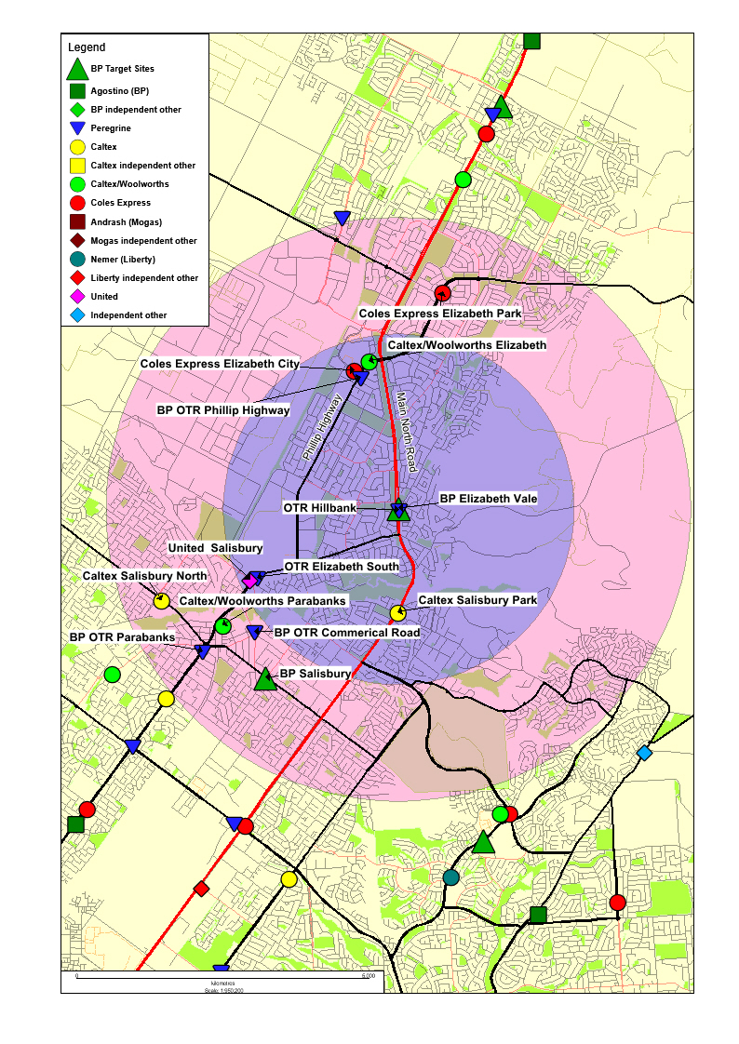
- The Target Site, BP Elizabeth Vale, is on the northbound side of Main North Road, which is a major thoroughfare through Adelaide’s northern suburbs with three lanes in each direction.
- The ACCC formed the view that the acquisition by Peregrine of BP Elizabeth Vale would have the effect, or be likely to have the effect, of substantially lessening competition in the local market surrounding the Target Site.
- BP Elizabeth Vale is directly opposite an existing Peregrine site – OTR Hillbank – on the same road. The two sites are so closely located as to allow a customer of one site to compare prices with the site on the other side of the road, which imposes potential competitive discipline on both sites.
- Based on this information, the ACCC’s market inquiries and the ACCC’s review of pricing data available to it, the ACCC considered that OTR Hillbank and BP Elizabeth Vale were particularly close competitors.
- While there are other petrol stations on Main North Road to the north and the south of BP Elizabeth Vale, all but one of those sites (Caltex Salisbury Park to the south), are more than 5km from the Target Site. The ACCC considered these to be weak competitive constraints, compared to the direct competitive constraints between the Target Site and OTR Hillbank. If it had acquired BP Elizabeth Vale, Peregrine would have had two of three sites on Main North Road in the Elizabeth/Hillbank area. The only competitor remaining in this part of the Main North Road would have been Caltex Salisbury Park.
- Traffic flow data available to the ACCC suggested that much of the traffic along Main North Road in the vicinity of BP Elizabeth Vale continued north or south along that road. Having regard to this information, and other information received during its market inquiries, the ACCC considered that competitors located off Main North Road (on parallel or cross roads) were unlikely to be close substitutes for the Target Site and OTR Hillbank.
- For these reasons, the ACCC concluded that the extent of competition provided by the remaining competitors on and off Main North Road would be insufficient to constrain Peregrine if it had acquired BP Elizabeth Vale. Accordingly, the ACCC considered that the acquisition of BP Elizabeth Vale by Peregrine would (in the absence of the undertaking given by Peregrine) have the effect, or be likely to have the effect, of substantially lessening competition in the local market surrounding the Target Site.
- Peregrine’s undertaking required Peregrine to divest BP Elizabeth Vale to Caltex. As noted above at paragraph 112, Caltex already owned the nearby Caltex Salisbury Park site approximately two kilometres to the south of the Target Site on Main North Road. As a result of acquiring BP Elizabeth Vale, Caltex would own two sites on the same side of the road, in the near vicinity of each other. However, the ACCC considered that Caltex Salisbury Park was not as close a substitute for BP Elizabeth Vale as OTR Hillbank.
- In light of this, and noting in particular the fact that the two sites facing each other across the road would continue to be owned by separate owners, the ACCC concluded that Caltex’s acquisition of BP Elizabeth Vale would not have the effect, or be likely to have the effect, of substantially lessening competition in the local market.

BP Mile End
Figure 3: Map of area surrounding BP Mile End
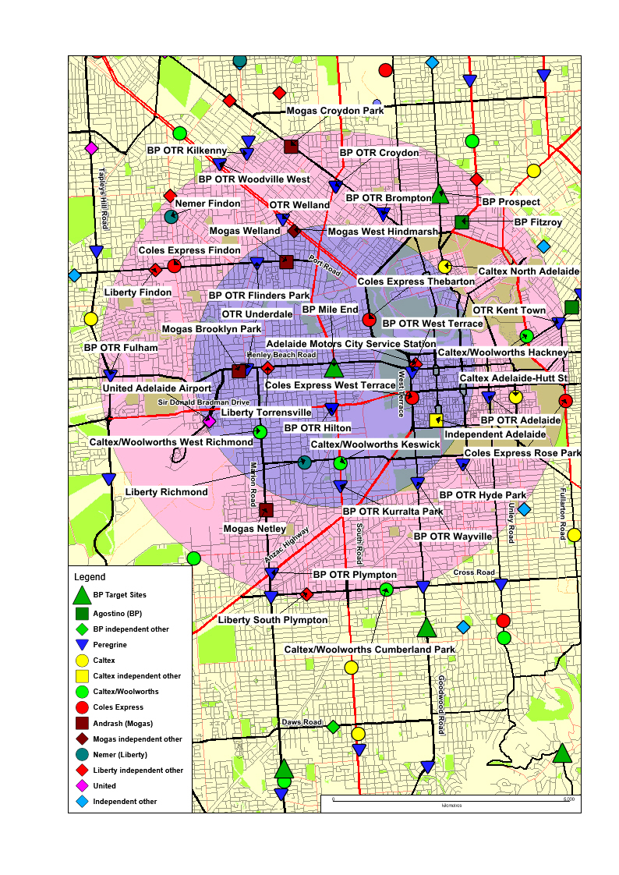
- The Target Site, BP Mile End, is located approximately 2km west of the CBD, in the suburb of Mile End. It is situated at the intersection of two arterial roads - Henley Beach Road (which runs east/west) and South Road (which runs north/south), each of which have multiple lanes in both directions.
- The ACCC’s market inquiries, analysis of traffic flows and other information available to the ACCC suggested that the closest substitutes for BP Mile End were likely to be other sites in the vicinity of the Target Site on either South Road or Henley Beach Road, rather than sites on parallel roads or intersecting streets.
- If it had acquired BP Mile End, Peregrine would have operated:
- four of the six sites in a span of approximately 5km along Henley Beach Road from the western edge of the CBD to Tapleys Hill Road (the other two being operated by Liberty and Mogas)
- two of the three sites on South Road in the 3.2km between Henley Beach Road and Anzac Hwy, the other being operated by Caltex/Woolworths. This Caltex/Woolworths site would be the only non-Peregrine site for more than 5km from BP Mile End in either direction along South Road.
- Further, the ACCC considered that the current closest substitutes to BP Mile End came from four pre-existing Peregrine sites located in the vicinity of the Target Site.
- For these reasons, the ACCC considered that the acquisition of BP Mile End by Peregrine would (in the absence of the undertaking given by Peregrine) have the effect, or be likely to have the effect, of substantially lessening competition in the local market surrounding the Target Site.
- Peregrine’s undertaking required Peregrine to divest BP Mile End to Agostino. The ACCC considered that the acquisition of BP Mile End by Agostino would not raise competition concerns as Agostino did not operate any sites on Henley Beach Road, or on South Road, or in the nearby area surrounding the Target Site.

BP Mitchell Park
Figure 4: Map of area surrounding BP Mitchell Park
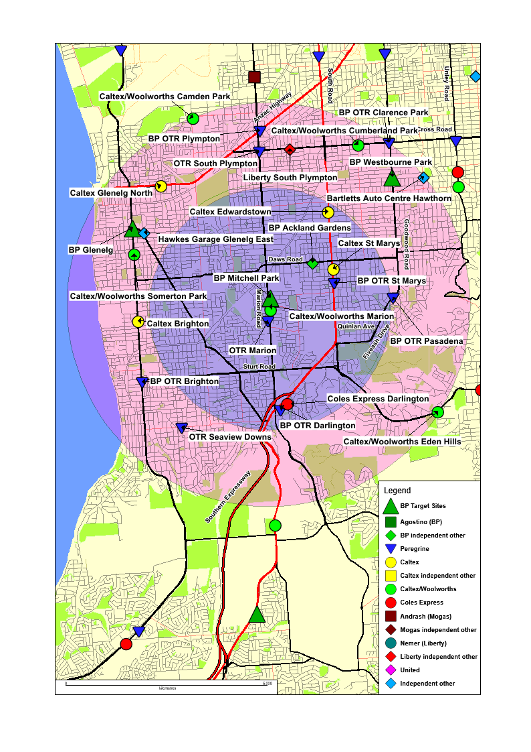
- The Target Site, BP Mitchell Park, is located on the north-eastern corner of the intersection of Marion Road and Quick Road, approximately 10km southwest of the CBD in the suburb of Mitchell Park. Marion Road is a major thoroughfare for commuters heading north/south, with two lanes of traffic in each direction divided by a median strip.
- Based on market inquiries and other information available to it, the ACCC formed the view that BP Mitchell Park was a close competitor to an existing Peregrine site – OTR Marion. These sites are in close proximity to each other on opposite sides of Marion Road and react to each other’s competitive behaviour.
- Further, traffic flow data and other information provided to the ACCC during the course of its review suggested that as Marion Road is a major thoroughfare, the strongest competitors for sites on Marion Road were likely to be other sites on Marion Road, rather than sites on parallel or intersecting streets. Peregrine already operated three of the five petrol stations on Marion Road in a 7km stretch between Anzac Hwy and the beginning of the Southern Expressway. If it had acquired the Target Site (and in the absence of the undertaking given by Peregrine) this would have increased to four out of five sites.
- For these reasons, the ACCC concluded that Peregrine’s acquisition of BP Mitchell Park would (in the absence of the undertaking given by Peregrine) have the effect, or be likely to have the effect, of substantially lessening competition in the local market surrounding the Target Site.
- Peregrine’s undertaking required Peregrine to divest its nearby OTR South Plympton site to Caltex. OTR South Plympton is approximately 4km to the north of the Target Site, on the same side of Marion Road, at the intersection with Cross Road.
- The ACCC considered that Peregrine’s undertaking addressed its competition concerns in this local market. When considered together, Peregrine’s acquisition of BP Mitchell Park and divestment of OTR South Plympton would:
- not change the number of Peregrine owned sites on Marion Road; and
- not change the number of operators on Marion Road, as the loss of BP would be offset by the introduction of Caltex (which did not previously operate a site on Marion Road).
- Peregrine’s divestment of OTR South Plympton does not directly address the loss of competition that would come from Peregrine owning both the BP Mitchell Park site and its nearby existing site – OTR Marion. However, this competition concern was alleviated somewhat by the presence of Caltex/Woolworths Marion (which is situated between BP Mitchell Park and OTR Marion, on Marion Road). Accordingly, the ACCC did not consider that the acquisition of BP Mitchell Park would have the effect, or be likely to have the effect of substantially lessening competition in the relevant local market (when considered together with Peregrine’s undertaking to divest OTR South Plympton).
- The ACCC considered that the acquisition of On the Run South Plympton by Caltex would not raise competition concerns. In particular, while it operates two sites on the parallel South Road, Caltex did not operate any sites on Marion Road.

BP Westbourne Park
Figure 5: Map of area surrounding BP Westbourne Park
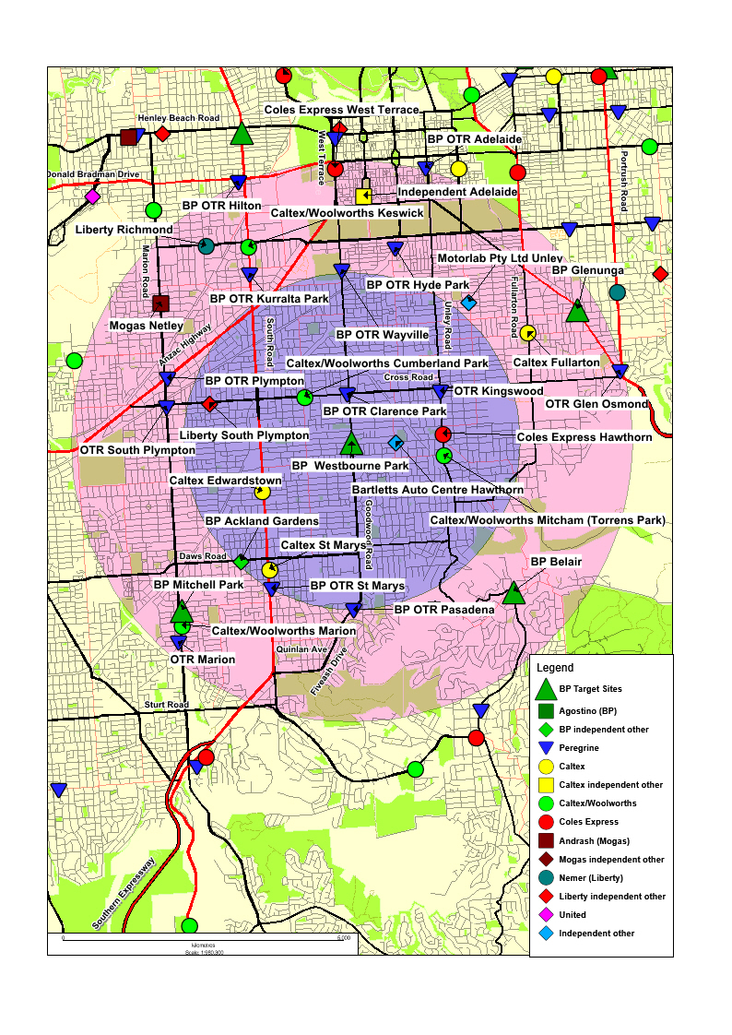
- The Target Site, BP Westbourne Park, is located at the intersection of Goodwood Road and Angas Road, approximately 5km south of Adelaide’s CBD. Goodwood Road is a main arterial road for traffic between Adelaide’s CBD and its southern suburbs. It has two lanes of traffic in each direction. Goodwood Road continues into Fiveash Drive to the south, and continues into West Terrace to the north.
- Based on its market inquiries and other information available to it, the ACCC understands that BP Westbourne Park is a close competitor to three existing Peregrine sites along Goodwood Road / Fiveash Drive - BP OTR Wayville, BP OTR Clarence Park and BP OTR Pasadena.
- The ACCC further considered that competitor sites on parallel roads, or intersecting streets, were unlikely to be close substitutes for BP Westbourne Park or other sites on Goodwood Road. In reaching this view, the ACCC had regard to traffic flow information provided to it during the course of its review which demonstrated that traffic in this area primarily flows along the length of Goodwood Road. Only a minority of Goodwood Road motorists also drive past petrol stations on perpendicular streets such as Cross Road.
- Had Peregrine acquired BP Westbourne Park, it would have operated four sites in a row along Goodwood Road, and five out of six sites in approximately a 9km span between the West Terrace / Port Road intersection in the north of Adelaide’s CBD and the intersection of Fiveash Drive and Quinlan Avenue in the suburb of Pasadena. The only competitor to Peregrine on that section of road would be Coles Express West Terrace, in the CBD.
- In light of the above, the ACCC considered that by increasing the concentration of Peregrine-operated sites along Goodwood Road, and removing BP as a competitor on that road, Peregrine’s proposed acquisition of BP Westbourne Park would (in the absence of the undertaking given by Peregrine) have the effect, or be likely to have the effect of substantially lessening competition in the local market surrounding the Target Site.
- Peregrine’s undertaking required Peregrine to divest BP Westbourne Park to Caltex. The ACCC considered that the acquisition of BP Westbourne Park by Caltex would not raise any significant competition concerns. While Caltex had some sites on the parallel South Road, it did not already operate any sites on Goodwood Road.

Other local markets
- The ACCC also considered the likely competitive impact of Peregrine acquiring each of the other BP sites that were part of the Acquisition (including the sites in regional South Australia). In respect of each of these acquisitions the ACCC formed the view that there would remain sufficient competition in the local markets to constrain Peregrine’s behaviour following the Acquisition.

Impact of the Acquisition on the Adelaide market
- As mentioned above at paragraph 101, the Acquisition would change the total competitive constraint being imposed on Peregrine in Adelaide in two ways:
- it would remove a competitor – company owned and operated BP sites – in its entirety.
- it would increase the number of sites under Peregrine’s control.
- Table 1 below summarises the impact of the Acquisition on the structure of the Adelaide market.
Table 1 – Adelaide market shares (by site numbers)
 | Without the Acquisition |  | With the Acquisition
Retailer | Sites | Market share | Sites | Market share
Peregrine | 78 | 33% | 93 | 39%
BP | 16 | 7% | - | -
Woolworths | 33 | 14% | 33 | 14%
Coles | 29 | 12% | 29 | 12%
Caltex | 21 | 9% | 23 | 10%
Agostino | 9 | 4% | 8 | 3%
Nemer | 8 | 3% | 8 | 3%
United | 8 | 3% | 8 | 3%
Andrash | 6 | 3% | 6 | 3%
Other (independents) | 30 | 13% | 30 | 13%
Total | 238 | 100% | 238 | 100%
- Table 1 illustrates that Peregrine was already the largest petrol retailer in Adelaide prior to the Acquisition (when considered by number of sites). The Acquisition would further increase its size. Following the Acquisition, Peregrine would operate approximately 39 per cent of all petrol station sites in Adelaide, nearly three times as many as its nearest rival.
- The ACCC considered unilateral effects and coordinated effects theories of harm to ascertain whether the Acquisition would be likely to have the effect of substantially lessening competition in the Adelaide market.

Coordinated effects
- Concerns about coordinated effects arise because mergers and acquisitions can enhance the ability and incentive of firms in a market to act in their mutual interest (e.g. by not competing aggressively). Coordinated effects rely on either an explicit communication between the parties or tacit conditioning of firms through their repeated market interactions over time.
- The main theory of harm considered by the ACCC in respect of the Adelaide market was whether the Acquisition could increase the likelihood, effectiveness and/or stability of coordinated conduct, particularly in the restoration phase of the petrol price cycle. The ACCC considered whether it might have effects such as:
- reducing the risk faced by Peregrine or another retail petrol network when initiating or following an attempted restoration. The proposed acquisition would result in one less competitor which might undermine an attempted restoration (through not restoring prices, or a delay in restoring prices). This may, for example, lead to fewer failed restorations, restorations of a greater magnitude, and/or restorations earlier in the petrol price cycle (such that prices might not be as low for as long at the end of the discounting phase)
- making it easier for major retail networks to establish a common focal point for a restoration price (especially if Peregrine's restoration price acts as the focal point). This may lead to fewer failed restorations and/or restorations of a greater magnitude
- increasing the presence of Peregrine, giving it a greater ability to lead and enforce a coordinated outcome by punishing those who deviate. This may lead to fewer failed restorations and support the effects described in a. and b. above.
- The ACCC considered that, prima facie, the loss of a competitor such as BP may make coordinated conduct more likely, effective and/or stable. In assessing this theory of harm, the ACCC considered whether the increased likelihood of effective and stable coordinated conduct would be of sufficient magnitude to be meaningful in the context of competition in the Adelaide market.
- The ACCC concluded that the Acquisition was not likely to make coordinated effects substantially more likely or effective, despite the increased size of Peregrine. In reaching this conclusion, the ACCC took into account the totality of the relevant factors applying in this particular case, including the following:
- Prior to the Acquisition BP was only the fifth largest petrol retailer in Adelaide by number of sites, and the sites being acquired by Peregrine as part of the Acquisition only amount to approximately 7 per cent of the total sites in the Adelaide market.
- Following the Acquisition, a number of multi-site operators would compete with Peregrine, including Coles Express, Caltex/Woolworths, Caltex, and four independent chains – Agostino, Nemer, United and Andrash. Despite their smaller size, some of these independents have historically had more aggressive pricing than BP.
- While Peregrine has previously demonstrated an ability to lead the price restoration phase of the petrol price cycle, the Acquisition would be unlikely to enhance this ability substantially.
- As described above at paragraph 88, BP has historically tended to lead attempted price restorations, or quickly follow another operator’s attempted restorations. As noted above at paragraph 91, the ACCC did not accept that past behaviour was necessarily indicative of how BP would behave in the absence of the Acquisition. For this reason, the ACCC also considered whether BP’s behaviour may change in the future in the absence of the Acquisition. However, in this case the ACCC concluded that it was unlikely that BP would be transformed into an operator that was likely to disrupt co-ordination sufficiently to lead to failed restorations, or limit the magnitude of a successful restoration, in the absence of the Acquisition.

Unilateral effects
- The ACCC considered whether the Acquisition would have the potential to result in a substantial lessening of competition in the Adelaide market as a result of unilateral effects. Mergers have unilateral effects when they remove or weaken competitive constraints in such a way that the merged firm’s unilateral market power is increased. That is, the ACCC considered whether, as a result of the Acquisition, Peregrine would have found it profitable to raise prices or reduce service levels across Adelaide, even given the expected competitive response of other market participants to such a price increase.
- The ACCC concluded that the Acquisition would not have the effect, or be likely to have the effect, of substantially lessening competition in the Adelaide market on the basis of unilateral effects. In reaching this conclusion, the ACCC had particular regard to the continued existence of a number of other significant retail chains in Adelaide following the Acquisition along with the other factors outlined above at paragraph 145, which the ACCC considered would be sufficient to constrain any unilateral attempt by Peregrine to raise prices across Adelaide.

Competition analysis: Caltex Fullarton
- Consistent with its consideration of the Acquisition, the ACCC considered the competitive effect of the Fullarton Acquisition in the Adelaide market and the local market surrounding Caltex Fullarton.
- While the ACCC did not consider that the acquisition of this single site would have the effect, or be likely to have the effect, of substantially lessening competition in the Adelaide market, it concluded that the acquisition of Caltex Fullerton would be likely to substantially lessen competition in the local market relevant to that site. On that basis, the ACCC opposed the Fullarton Acquisition.

Impact of the Acquisition on the local market
- Caltex Fullarton is located approximately four kilometres to the southeast of the CBD. It is on the eastern (southbound) side of Fullarton Road (which runs north to south) on the corner of Fisher Street. Fullarton Road is a main local road, with two lanes of traffic in each direction.
- The geographically closest retail petrol station to Caltex Fullarton is BP Glenunga which Peregrine proposed to acquire as part of the Acquisition.
- Figure 6 below contains a map showing Caltex Fullarton and its surrounding area.
Figure 6: Map of area surrounding Caltex Fullarton
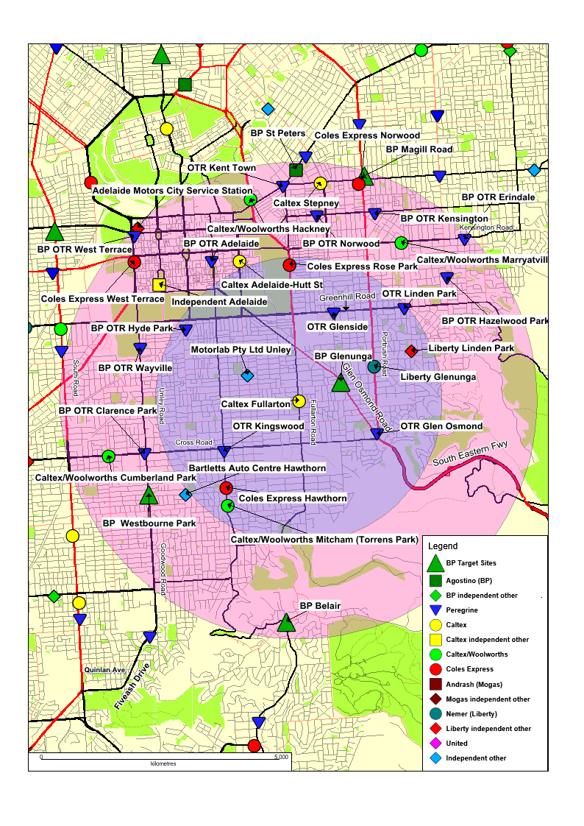
- Based on its market inquiries and other information available to it (including information about the competitive reactions of local sites to each other’s pricing behaviour and submissions made by Peregrine to the ACCC about the competitive impact of the Acquisition), the ACCC concluded that:
- BP Glenunga and Caltex Fullarton are close competitors to each other.
- Two other nearby sites – OTR Glen Osmond and Liberty Glenunga (each of which are in prominent locations on nearby main roads) - are also close competitors to BP Glenunga and Caltex Fullarton, especially for local traffic.
- The ACCC considered that Peregrine’s proposed acquisition of Caltex Fullarton, when considered in light of its acquisition of BP Glenunga as part of the original Acquisition, would result in Peregrine operating three out of four retail petrol station sites which would otherwise be each other’s closest competitors.
- Peregrine also already has a significant presence in the broader area around Caltex Fullarton. The Fullarton Acquisition, when considered together with the acquisition of nearby BP sites as part of the Acquisition, would give Peregrine seven out of 13 sites within a 3km radius of Caltex Fullarton, and 17 out of 35 sites within a 5km radius.
- In addition to Liberty Glenunga, the ACCC noted the presence of other more geographically distant competitors such as Coles Express Rose Park, Caltex/Woolworths Hackney and Caltex Adelaide (Hutt St), each to the north of Caltex Fullarton. However, the ACCC considered that these more geographically distant sites were not as close competitors to the sites discussed above at paragraph 153 as those sites are to each other.
- Further (and in contrast to the ACCC’s view on the effectiveness of BP as a competitor discussed above at paragraphs 88 and 145(d)), the ACCC considered that Caltex Fullarton was likely to be an effective competitor to the nearby Peregrine sites in the absence of the Fullarton Acquisition.
- For the reasons outlined above, the ACCC considered that the Fullarton Acquisition would have the effect, or be likely to have the effect, of substantially lessening competition in the local market.

Conclusion
- On the basis of the above, including taking into account the undertaking given by Peregrine and accepted by the ACCC, the ACCC formed the view that the acquisition of 25 BP Australia petrol retail sites in South Australia by Peregrine Corporation would not have the effect or be likely to have the effect of substantially lessening of competition in any relevant market in contravention of section 50 of the Act.
- However, Peregrine’s share of the Adelaide market has increased significantly as a result of the Acquisition and other recent acquisitions and site openings. Given the prominence of Peregrine in the Adelaide market, any further proposed acquisitions of petrol stations in Adelaide by Peregrine would be reviewed carefully by the ACCC.
- For the reasons outlined above at paragraphs 153 to 158, the ACCC formed the view that the Fullarton Acquisition would have the effect, or be likely to have the effect, of substantially lessening competition in the local market surrounding that site.

Attachment A – list of Target Sites
Adelaide metropolitan sites | Address
BP 2GO Modbury | 931 North East Road, Modbury, SA
BP 2GO O'Halloran Hill | 131 Main South Road, O'Halloran Hill, SA
BP Connect Belair | 1 Main Street, Belair, SA
BP Connect Elizabeth Vale | Cnr Main North & Hogarth Roads, Elizabeth Vale, SA
BP Connect Glenelg | 66 Brighton Road, Glenelg, SA
BP Connect Glenunga | 303 Glen Osmond Road, Glenunga, SA
BP Connect Golden Grove | Cnr Helicon Dve & The Golden Way, Golden Grove, SA
BP Connect Mile End | 95 Henley Beach Road, Mile End, SA
BP Connect Mitchell Park | 843 Marion Road, Mitchell Park, SA
BP Connect Prospect | 70 Prospect Road, Prospect, SA
BP Connect Salisbury | 105 Park Terrace, Salisbury, SA
BP Connect Westbourne Park | 427 Goodwood Road, Westbourne Park, SA
BP Connect Munno Para | 43-45 Main North Road, Smithfield, SA
BP 2GO Magill | 257 Magill Road, Trinity Gardens, SA
BP Connect Southern | 131 Main South Road, Morphett Vale, SA
BP Connect Paralowie | Cnr Port Wakefield and Bolivar Roads, Paralowie, SA
South Australian regional sites | Address
BP McRitchie Whyalla | 21-33 McRitchie Cresc, Whyalla, SA
BP Kingston Roadhouse | 1 Princes Hwy, Kingston SE, SA
BP Two Wells | Old Port Wakefield Road, Two Wells, SA
BP Port Pirie | 328 Senate Road, Port Pirie, SA
BP Loxton | Cnr Bookpurnong Tce and French Rd, Loxton, SA
BP Coonalpyn | 1 Poyntz Terrace, Coonalpyn, SA
BP Kapunda | 1 Milfred St, Kapunda, SA
BP Kadina | 19 Frances Terrace, Kadina, SA
BP Nuriootpa | Cnr Tanunda and New Roads, Nuriootpa, SA

For the purpose of this Public Competition Assessment, ‘Peregrine Corporation’ (Peregrine) refers to Shahin Enterprises Pty. Ltd. (ACN 008 150 543) and each of its related bodies corporate and trusts controlled by the Shahin family which are engaged in petrol retailing in South Australia, including companies using the brand ‘On the Run’.
In July 2012, Caltex announced that it would close its Kurnell refinery in the second half of 2014 and convert it into an import terminal
The ACCC understands the terms “discounting phase” and “restoration phase” have been commonly used in the industry to refer to the stage where prices decrease and increase respectively.
Source: ACCC calculations based on Informed Sources data, drawn from Monitoring of the Australian petroleum industry—Report of the ACCC into the prices, costs and profits of unleaded petrol in Australia, 2013.
Full public register entries for the Acquisition, and the Fullarton Acquisition are available at http://registers.accc.gov.au/content/index.phtml/itemId/1178072/fromItemId/751043 and http://registers.accc.gov.au/content/index.phtml/itemId/1178130/fromItemId/751043 respectively.
Ethanol blends are not sold in significant quantities in South Australia.
See ACCC Merger Guidelines 2008, Section 4.
In this and other maps presented in this Public Competition Assessment, the blue circles are of radius 3km and the pink circles are of radius 5km. These circles are provided for scale only, and do not represent the geographic extent of local markets.
This table presents information based on the number of sites held by each fuel retailer in Adelaide. During the course of its review, the ACCC also received confidential information and estimates about the volumes of fuel sold by each operator in Adelaide. The ACCC is not able to provide the volume information in this Public Competition Assessment. However, the ACCC notes that Peregrine’s market share when considered by volume is smaller than when considered by sites. Conversely Woolworths and Coles both have higher market shares when considered by volume than they do when considered by number of sites.
The ‘With the Acquisition’ columns in Table 1 also take into account the effect of the proposed acquisitions by Peregrine of Caltex and Agostino sites outlined above at paragraphs 55 and 57.
Figures in this row are based on estimates by Peregrine.
Column does not add to 100% due to rounding.

