

Statement of Issues
19 December 2013

Woolworths Limited – proposed acquisition of Lindisfarne Cellars

Introduction
- Outlined below is the Statement of Issues released by the Australian Competition and Consumer Commission (ACCC) on the proposed acquisition by Woolworths Limited (Woolworths) of Lindisfarne Cellars (proposed acquisition).
- A Statement of Issues published by the ACCC is not a final decision about a proposed acquisition, but provides the ACCC’s preliminary views, drawing attention to particular issues of varying degrees of competition concern, as well as identifying the lines of further inquiry that the ACCC wishes to undertake.
- In line with the ACCC’s Merger Review Process Guidelines (available on the ACCC’s website at www.accc.gov.au/processguidelines) the ACCC has established a secondary timeline for further consideration of the issues. The ACCC anticipates completing further market inquiries by 17 January 2014 and anticipates making a final decision on 13 February 2014. However, the anticipated timeline can change in line with the Merger Review Process Guidelines. To keep abreast of possible changes in relation to timing and to find relevant documents, market participants should visit the Mergers Register on the ACCC's website at www.accc.gov.au/mergersregister.
- A Statement of Issues provides an opportunity for all interested parties (including customers, competitors, shareholders and other stakeholders) to ascertain and consider the primary issues identified by the ACCC. It is also intended to provide the merger parties and other interested parties with the basis for making further submissions should they consider it necessary.

Background
- The ACCC commenced its review of the proposed acquisition on 10 October 2013.

The parties

The Acquirer: Woolworths Limited
- Woolworths Limited (Woolworths) is an Australian and New Zealand retailer. Its operations include supermarkets, petrol, liquor, general merchandise stores, hardware and home improvement.
- Woolworths operates a number of Beer Wine Spirits (BWS) bottleshops in Tasmania.

The Target: Lindisfarne Cellars
- Lindisfarne Cellars is a bottleshop located within a neighbourhood shopping strip at 189A Derwent Avenue, Lindisfarne. It trades under the Duncan’s Liquor banner.

The transaction
- Woolworths proposes to acquire the bottleshop business of Lindisfarne Cellars, including the liquor off-licence. After the proposed acquisition, Lindisfarne Cellars would cease to trade under the Duncan's Liquor banner and would be converted by Woolworths to a BWS bottleshop.

Market inquiries
- The ACCC commenced market inquiries regarding the proposed acquisition on 10 October 2013. The closing date for submissions was 28 October 2013. The ACCC has received information from a range of interested parties and is now calling for further information to assist with its investigation.

Industry background

Retail sale of packaged liquor in Tasmania
- The retail sale of takeaway packaged liquor in Tasmania is undertaken by a number of different liquor retailers, including bottleshops owned and operated by Woolworths under the BWS brand and independent bottleshops.
- Independent bottleshops may be affiliated with a particular banner or banner group such as Big Bargain Bottleshop, Thirsty Camel, Duncan’s Liquor or 9/11. Banner groups typically provide their affiliated bottleshops with a number of services, including:
- a marketing brand and signage;
- access to advertising and promotional activity of the banner group; and
- the ability to purchase stock at a wholesale level through the banner group.

Liquor licensing in Tasmania
- Liquor licensing is regulated in Tasmania at the state level. There are five types of liquor licence in Tasmania:
- off-licence;
- general licence;
- club licence;
- on-licence; and
- special licence.
- Relevant to the proposed acquisition, an off-licence authorises the sale of liquor for consumption off the licensed premises. This licence is usually issued to bottleshops. The proposed acquisition of Lindisfarne Cellars involves the acquisition of an off-licence.
- Under a general licence, liquor may be sold over the counter at hotels, taverns and clubs for consumption on and off the premises. Clubs with a club licence may sell takeaway packaged liquor to a member of the club or guest.
- An on-licence is confined to the sale of liquor for consumption on the premises, such as at nightclubs, bars and restaurants.
- A special licence is subject to particular conditions specified in the licence, such as the sale of liquor to attendees at a particular event during a given timeframe.

Future with and without the proposed acquisition
- Section 50 of the Act prohibits mergers or acquisitions that would have the effect or be likely to have the effect of substantially lessening competition in a market. In assessing a proposed acquisition pursuant to section 50 of the Act, the ACCC considers the effects of the acquisition by comparing the likely future competitive environment if the acquisition proceeds (the “with” position) to the likely future competitive environment if the acquisition does not proceed (the “without” position) to determine whether the proposed acquisition is likely to substantially lessen competition in any relevant market.
- The ACCC’s preliminary view is that without the proposed acquisition, Lindisfarne Cellars would continue to operate as an independent bottleshop not owned by Woolworths, either under the current ownership or under the ownership of another independent operator. Therefore, it is likely that the bottleshop would continue to operate as an independent competitor in the local market, absent the proposed acquisition.
The ACCC invites interested parties to comment on what would be likely to occur in the event that the proposed acquisition does not proceed. In particular, the ACCC is interested in whether the bottleshop would continue to operate under current ownership or whether it would be attractive to another buyer who would use it to compete with BWS and other local market participants.

Competition analysis
- The ACCC is considering the extent of competition and whether the proposed acquisition would be likely to result in a substantial lessening of competition by replacing the competition provided by Lindisfarne Cellars with an offer from Woolworths that is already available locally.

Area of overlap
- The key area of competitive overlap between the parties to the proposed acquisition is the retail supply of packaged liquor for off-premises consumption. Woolworths operates a bottleshop (BWS Eastlands) in the nearby suburb of Rosny, which is around 4km by road (or 2.5km in a straight line) from Lindisfarne Cellars. This is the closest BWS to Lindisfarne Cellars. There are other BWS bottleshops in the Hobart area and more widely across Tasmania.

Market definition

Local retail liquor market
- The ACCC’s preliminary view is that the geographic dimension of the market for the retail sale of packaged liquor for off-premises consumption includes the local area within 3-5km of Lindisfarne Cellars east of the Derwent River, but does not extend west of the river. This market includes the area:
- north of the Tasman Highway on the eastern side of the Derwent River, which includes the suburbs of Rose Bay, Lindisfarne, Geilston Bay and Risdon Vale; and
- south of the Tasman Highway on the eastern side of the Derwent River, which includes the suburbs of Montagu Bay, Warrane, Mornington, Rosny and Bellerive.
- The location of Lindisfarne Cellars and other bottleshops to the east of the Derwent River are shown in Map 1.
Map 1: Map of local area
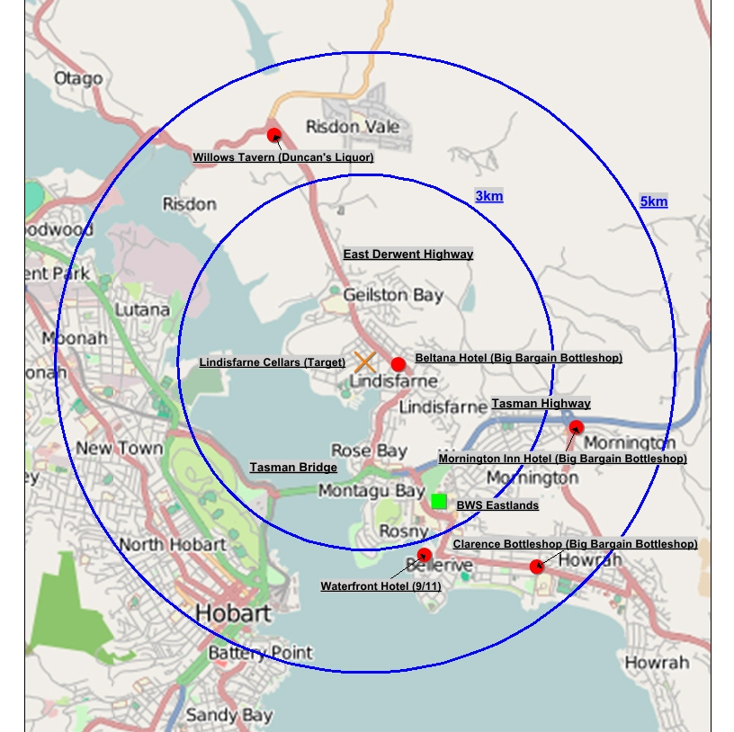
- Market definition is purposive and depends on the specific facts and evidence of the merger under investigation. In identifying the geographic dimension of the relevant market, the ACCC seeks to identify the geographic location of suppliers that would be sufficiently close substitutes for the products supplied by the merged firm so as to defeat a hypothetical exercise of market power.
- In forming its preliminary view on the geographic market, information available to the ACCC shows that Lindisfarne Cellars draws most of its sales from customers residing in Lindisfarne and nearby suburbs east of the Derwent River. The ACCC’s preliminary view is that the Derwent River is a natural barrier that delineates the geographic field of rivalry.
- The ACCC recognises that substitution possibilities between different locations vary by degrees. Some bottleshops located across the Tasman Bridge on the western side of the Derwent River are likely to be substitutes for Lindisfarne Cellars for some customers to some degree. However, this does not necessarily mean that Lindisfarne residents would consider alternative bottleshops in those locations to be close substitutes for Lindisfarne.
- While some local residents commute to and from the Hobart CBD or surrounding areas west of the Derwent River for employment or other purposes, market feedback suggests the extent of customers potentially switching their demand to bottleshops west of the river in response to a hypothetical exercise of market power would be limited and insufficient to consider them in the same geographic market as Lindisfarne.
- More generally, information available to the ACCC indicates that Lindisfarne residents value the convenience of being able to shop for liquor close to where they live. This suggests that bottleshops located close to Lindisfarne Cellars are likely to be closer substitutes than those located further away. This is despite the fact that some residents may choose to travel outside their local area for a number of different purposes.
- These factors are consistent with market inquiries that indicate the closest field of rivalry is between bottleshops within 3-5 kilometres of Lindisfarne Cellars on the eastern side of the river, but not including bottleshops within 3-5 kilometres of Lindisfarne that are on the western side of the river.

State-wide retail liquor market
- Consistent with previous matters, the ACCC is also considering the competition effects of the proposed acquisition in the market for the retail supply of packaged liquor for off-premises consumption in Tasmania.

Wholesale liquor market
- The ACCC is also considering whether the proposed acquisition raises any competition concerns in the market for wholesale procurement and supply of packaged liquor in Tasmania.

Conclusion on market definition
- On the basis of its market inquiries to date, the ACCC’s preliminary view is that the following markets are relevant to the proposed acquisition:
- the retail supply of packaged liquor for off-premises consumption within 3-5km of Lindisfarne Cellars on the eastern side of the Derwent River (the local market);
- the retail supply of packaged liquor for off-premises consumption in Tasmania (the state-wide retail market); and
- the market for the wholesale procurement and supply of packaged liquor in Tasmania (the wholesale market).
The ACCC invites comments from market participants on the ACCC’s proposed definition of the relevant markets. In particular, interested parties are invited to comment on:
- to what extent are locations to the south of the Tasman highway close substitutes for Lindisfarne?
- to what extent are locations across the Tasman bridge close substitutes for Lindisfarne?
- what are the reasons for your views?

Statement of Issues
- For the purposes of this Statement of Issues, the issues in this matter are divided into two categories, 'issues of concern' and 'issues unlikely to pose concern'.

Issues of concern – local market
- The ACCC is considering the extent of competition and whether the proposed acquisition would be likely to result in a substantial lessening of competition by replacing the competition provided by Lindisfarne Cellars with an offer from Woolworths that is already available locally.
- The ACCC’s preliminary view is that the proposed acquisition is likely to result in a substantial lessening of competition in the local market for the retail supply of packaged liquor. The ACCC is particularly concerned that the proposed acquisition would result in:
- an increase in market concentration through the horizontal aggregation of market shares;
- the removal of Lindisfarne Cellars as one of the closest competitors to BWS Eastlands; and
- a loss of competitive tension and loss of choice available to consumers.

Market concentration
- Market concentration is a relevant but not determinative part of the ACCC’s competition assessment in this matter. The ACCC’s inquiries indicate that Woolworths is the largest supplier of takeaway packaged liquor in the local market by revenue, followed by Lindisfarne Cellars as the second largest supplier.
- Some market participants have indicated that Woolworths’ share of the market by revenue is approximately 45 per cent and would increase to approximately 60 per cent if the proposed acquisition were to proceed, with Woolworths controlling the two largest bottleshops (BWS Eastlands and Lindisfarne Cellars) in the local market.

Removal of Lindisfarne Cellars as one of the closest competitors to BWS Eastlands
- The ACCC is considering the closeness of competition between competing firms in the local market to determine which firms exert the most competitive constraint on one another. If a proposed acquisition involves firms that are considered to be close rivals, then competition concerns are more likely to be raised if this rivalry would be lost as a result of a proposed acquisition.
- The ACCC’s preliminary view based on market inquiries to date is that Lindisfarne Cellars, Beltana Hotel and BWS Eastlands are the three closest competitors for Lindisfarne residents. These competitors are all situated on, or near to, the main north-south arterial route that facilitates travel to and from the large Eastlands Shopping Centre, drawing a significant number of customers from Lindisfarne. The Eastlands Shopping Centre generates foot traffic for BWS Eastlands (which is part of the shopping centre complex, and situated immediately adjacent to the main building).
- In particular, the ACCC’s inquiries indicated Beltana Hotel is a close competitor with Lindisfarne Cellars, given its location (less than 1km from Lindisfarne Cellars), similar number of stock keeping units, and a comparable range.
- Market feedback suggests that Willows Tavern would place very limited competitive constraint on the merged firm. It provides a limited offer given it is a small bottleshop with a strong focus on convenience sales servicing the local Risdon and Risdon Vale area. In addition, unlike Lindisfarne and Rosny, Risdon (in which Willows Tavern is located) does not have a shopping strip or shopping centre to generate foot traffic. Its ability to pose a strong competitive constraint on the merged firm is therefore likely to be limited.
- The ACCC’s preliminary view is that the Mornington Inn Hotel is not as close a competitor to Lindisfarne Cellars for Lindisfarne residents as the Beltana Hotel and BWS Eastlands. While there is some competitive overlap, the Mornington Inn Hotel generally draws customers from a different area since it is located further away on Cambridge Road and not on the main north-south arterial route.
- As to the Clarence Bottleshop and Waterfront Hotel, they are located even further away from Lindisfarne Cellars and are therefore distant market participants. They also do not benefit from the foot traffic generated by the Eastlands Shopping Centre in the same way as BWS Eastlands.
- In light of the above, the ACCC’s preliminary view is that the closest competition in the local market is between Lindisfarne Cellars, Beltana Hotel and BWS Eastlands. Accordingly, the proposed acquisition would reduce the number of close competitors from three to two.

Loss of competition and loss of choice available to consumers
- Market inquires to date indicate that Lindisfarne Cellars is a meaningful and effective competitor in the local market with a differentiated offer that is valued by customers. With the acquisition, the competitive tension and differentiated offer provided by Lindisfarne Cellars would be removed.
- Lindisfarne Cellars competes on price, range and service. Market inquiries suggest that its prices are competitive with other local bottleshops and that it offers the advertising and promotional activity of the Duncan’s Liquor banner group. Advertising is conducted online and in the local newspaper.
- The promotional products under the Duncan’s Liquor banner would continue to be available in the local market from Willows Tavern (Duncan’s Liquor). However, as indicated above, the ACCC’s preliminary view is that Willows Tavern’s location, size and product range reduces the extent to which its presence in the local market alleviates the competitive harm resulting from the proposed acquisition.
- Lindisfarne Cellars offers a variety of beer, wine and spirits, some of which are sourced locally in Tasmania. It has the ability to stock specific products on a local basis to satisfy customer preferences, as well as stocking regular products that can be found in most liquor stores.
- Lindisfarne Cellars offers a high level of service with a strong focus on building relationships with local residents. As an independent operator, it has a high degree of flexibility in being able to tailor service at a local level to meet individual customer and community needs.
- The ACCC’s preliminary view is that Lindisfarne Cellars provides a meaningful competitive and differentiated price and non-price offer that would be removed from the local market if the proposed acquisition proceeds. This would mean a loss of competitive tension and loss of choice for consumers. Woolworths would not replicate this differentiated offer. Instead, Woolworths would replace the Lindisfarne Cellars offer with that of BWS which is already available in the local market.

Barriers to new entry
- Market inquiries indicate that Woolworths is unlikely to be constrained in the local market by the threat of new entry. There are high barriers to entry for the retail supply of packaged liquor in the local market, including the need for a liquor licence and access to a suitable site in order to operate a commercially viable bottleshop.
- The requirement to obtain a liquor licence from the Tasmanian liquor licensing authority to sell packaged liquor in Tasmania constitutes a regulatory barrier to entry. Interested parties suggest that the granting of a new off-licence in the local market would be unlikely, taking into account that it may not be in the best interest of the community as there are already a number of bottleshops in the local area.
- Interested parties submit that suitable sites for establishing a bottleshop are scarce as it is important to establish a bottleshop in close proximity to areas that generate a high level of foot traffic, such as close to existing shops, in order to improve the likelihood of successful new entry. As such it is most likely that a potential new entrant would be faced with having to redevelop an existing retail site.
The ACCC invites comments from market participants on the likely competition effects of the proposed acquisition. In particular, interested parties are invited to comment on:
- market concentration and the extent to which Woolworths’ share of the local market would increase as a result of the proposed acquisition;
- the extent to which Lindisfarne Cellars is a vigorous and effective competitor in the local market, having regard to price (e.g. regular shelf prices and promotional activity) and non-price factors (e.g. range and service) and any harm to competition that would result from its removal as a competitor;
- the degree of competitive constraint provided by other competitors on each of Lindisfarne Cellars and BWS Eastlands, including by Willows Tavern, Beltana Hotel, Clarence Bottleshop, Waterfront Hotel, and any other relevant competitors;
- the extent to which customers value the differentiated offer provided by Lindisfarne Cellars and the loss of choice that would result if the proposed acquisition were to proceed;
- the existing height of barriers to entry, including with reference to liquor licensing, access to suitable sites, and other relevant barriers; and
- whether the proposed acquisition would raise barriers to entry, having regard to the proposed establishment of a second BWS bottleshop in the local market.

Issues unlikely to pose concerns
- Based on market inquiries to date, the ACCC’s preliminary view is that the proposed acquisition would be unlikely to have the effect of substantially lessening competition in the state-wide market for the retail supply of packaged liquor or the wholesale market for the procurement and supply of packaged liquor in Tasmania. The acquisition of a single bottleshop would result in only a small increase in Woolworths’ share in both of these markets.
The ACCC invites comments from interested parties on the likely competition effect of the proposed acquisition on the state-wide retail market and the wholesale market.

ACCC's future steps
- The ACCC will finalise its view on this matter after it considers market responses invited by this Statement of Issues.
- The ACCC now seeks submissions from market participants on each of the issues identified in this Statement of Issues and on any other issue that may be relevant to the ACCC's assessment of this matter.
- Submissions are to be received by the ACCC no later than 17 January 2014. The ACCC will consider the submissions received from the market and the merger parties in light of the issues identified above and will, in conjunction with information and submissions already provided by the parties, come to a final view in light of the issues raised above.
- The ACCC intends to publicly announce its final view by 13 February 2014. However the anticipated timeline may change in line with the Merger Review Process Guidelines. A Public Competition Assessment for the purpose of explaining the ACCC's final view may be published following the ACCC's public announcement.

