Federal Court of Australia

Queensland Nickel Sales Pty Ltd v Queensland Nickel Pty Ltd (in liq) (No 3) [2022] FCA 564
File number(s): | QUD 257 of 2021
Judgment of: | DOWNES J
Date of judgment: | 17 May 2022
Catchwords: | CORPORATIONS – application for leave to proceed against company in liquidation pursuant to s 471B Corporations Act 2001 (Cth) – proposed proceeding relates to challenges to entitlement of former trustee to indemnity from trust assets – whether utility in granting leave to bring this proceeding where liquidators have sought directions in separate proceeding in relation to proposed payments from trust assets – where more efficient and cost-effective to have challenges sought to be raised in this proceeding addressed in the other proceeding – leave refused but with costs reserved  PRACTICE AND PROCEDURE – application for interlocutory injunction restraining the company in liquidation from dealing with cash at bank until final determination of this proceeding – where parties negotiated and agreed upon consent order after hearing of application which enabled access to funds for certain purposes – where process proposed whereby parties can negotiate and agree upon further payments pending determination of separate proceedings – where parties raised no objection to that proposed process – application dismissed but with costs reserved
Legislation: | Corporations Act 2001 (Cth) s 471B, Sch 2 s 90-15  Federal Court of Australia Act 1976 (Cth) s 37M(1)(b)  Trusts Act 1973 (Qld) s 96
Cases cited: | Queensland Nickel Sales Pty Ltd v Queensland Nickel Pty Ltd (in liquidation) (No 2) [2022] FCA 225
Division: | General Division
Registry: | Queensland
National Practice Area: | Commercial and Corporations
Sub-area: | Corporations and Corporate Insolvency
Number of paragraphs: | 21
Date of hearing: | 9 May 2022
Counsel for the Applicants: | Mr P Dunning QC w/ Mr M Karam, Mr K Byrne and Mr A Choy
Solicitor for the Applicants: | Alexander Law
Counsel for the Respondent: | Mr A Pomerenke QC w/ Mr N Derrington and Mr S Walpole
Solicitor for the Respondent: | HWL Ebsworth Lawyers

ORDERS
 |  | QUD 257 of 2021
BETWEEN: | QUEENSLAND NICKEL SALES PTY LTD (ACN 009 872 566)  First Applicant  QNI RESOURCES PTY LTD (ACN 054 117 921)  Second Applicant  QNI METALS PTY LTD (ACN 066 656 175)  Third Applicant
AND: | QUEENSLAND NICKEL PTY LTD (IN LIQUIDATION) ACN 009 842 068  Respondent

order made by: | DOWNES J
DATE OF ORDER: | 17 MAY 2022

THE COURT ORDERS THAT:

- The interlocutory applications filed 10 March 2022 and 14 March 2022 are dismissed.
- The proceeding is dismissed.
- The issue of costs is reserved until the determination of proceeding QUD235/2021.

Note: Entry of orders is dealt with in Rule 39.32 of the Federal Court Rules 2011.

REASONS FOR JUDGMENT
DOWNES J:

Introduction
- Two interlocutory applications were set down for hearing on 9 May 2022.
- The first of these, which I will describe as the leave application, was filed on 14 March 2022 and is an application brought pursuant to s 471B Corporations Act 2001 (Cth) for leave to proceed against the respondent, which is a company being wound up in insolvency pursuant to an order of the Supreme Court of Queensland dated 27 February 2017. That leave is sought nunc pro tunc as this proceeding was commenced on 9 August 2021 without such leave having been obtained.
- The leave application is the second attempt by the applicants to obtain leave pursuant to s 471B of the Act. The first application, which related to a version of a statement of claim which had been filed on 9 August 2021, was dismissed at a hearing on 11 March 2022: Queensland Nickel Sales Pty Ltd v Queensland Nickel Pty Ltd (in liquidation) (No 2) [2022] FCA 225.
- The other application, which I will refer to as the injunction application, was filed on 10 March 2022. It seeks an interlocutory injunction restraining the respondent from:
transferring, encumbering or otherwise dealing with the property in the QN Bank Account Trust, including any cash at bank and the sum of $102,884,346.26 received by Queensland Nickel Pty Ltd (In Liq) on or about 5 July 2021 from Mineralogy Pty Ltd in payment of the judgment of the Court of Appeal on 25 June 2021 in proceeding CA7119 of 2020, until the final determination of this proceeding and Federal Court Proceeding QUD235/21 (including any appeals therefrom).
- After the hearing of the applications, an alternative form of draft orders was provided to the parties by my chambers in both this proceeding and in QUD235/2021 and, subject to changes to timetabling and issues being raised about the hearing date and the length of the hearing, no additional submissions were received which raised any specific objection to these draft orders. Orders were then made in QUD235/2021 (a copy of which appears in Annexure A to these reasons).
- For the following reasons, both applications (and this proceeding) will be dismissed on the basis that costs are reserved.

The case advanced in QUD235/2021
- By originating application which was accepted for filing on 15 July 2021, the liquidators of the respondent and the respondent seek certain directions in proceeding QUD235/2021. The directions are sought pursuant to s 90-15 of the Insolvency Practice Schedule of the Act and s 96 of the Trusts Act 1973 (Qld).
- That application contains the following definitions (which I will adopt in these reasons):
- Judgment Sum means the sum of $102,884,346.26 paid by Mineralogy Pty Ltd to Queensland Nickel Pty Ltd (in liq) (QNI) in satisfaction of the judgment of the Queensland Court of Appeal delivered on 25 June 2021, any further payment made in respect of interest on that sum, and any interest earned by QNI on that sum.
- Judgment Enforcement Standstill Arrangement means the agreement made between the Plaintiffs and Mineralogy Pty Ltd, QNI Metals Pty Ltd and QNI Resources Pty Ltd by correspondence on 28 June 2021 and 2 July 2021 to hold the Judgment Sum in the bank account of QNI maintained by the Liquidators and not to disburse it until the Expiry of the Judgment Enforcement Standstill Arrangement.
- Expiry of the Judgment Enforcement Standstill Arrangement means the earliest to occur of the following events:
  - the time for the filing of an application for Special Leave to Appeal against the orders made by the Queensland Court of Appeal on 25 June 2021 in proceeding 7119/20 (the QCA Orders) expires without an application being filed;
  - an application for Special Leave to Appeal against the QCA Orders is dismissed;
  - an application for Special Leave to Appeal is granted against the QCA Orders, but an appeal proper to the High Court of Australia is dismissed; or
  - an application for Special Leave to Appeal is granted against the QCA Orders and an appeal before the High Court of Australia results in Order 3 of the QCA Orders being set aside or reversed.
- Trust Assets means the Judgment Sum and all other assets of QNI held by it as trustee for QNI Metals Pty Ltd and QNI Resources Pty Ltd.
- The directions sought in QUD235/2021 include the following (in summary):
- A direction that the liquidators and QNI are justified in refusing to pay to Queensland Nickel Sales Pty Ltd (QNS) the Judgment Sum, or any part thereof, until at least such time as it is established (if ever), during or following the completion of the steps contemplated below and any further steps in the winding up of QNI, that QNI holds a surplus of Trust Assets over:
  - liabilities (both present and future) for which it claims a right of indemnity or exoneration out of the Trust Assets; and
  - the liquidators’ costs, expenses and remuneration approved under Part 3 of the Insolvency Practice Schedule.
- A direction that, upon the Expiry of the Judgment Enforcement Standstill Agreement as a result of the occurrence of any of the events in paragraphs (i), (ii), or (iii) of the definition:
  - the liquidators would be justified, in paying from the funds of QNI, the liabilities that QNI has incurred under the Litigation Funding Agreement made between the liquidators, QNI and Vannin Capital Operations Limited dated 13 September 2016, being a priority debt within the meaning of s 556(1) of the Act;
  - the liquidators would be justified in paying to themselves, from the funds of QNI, the remuneration approved under Part 3 of the Insolvency Practice Schedule, being a priority expense within the meaning of s 556(1) of the Act;
  - the liquidators would be justified in taking steps to ascertain the outstanding claims by creditors in the liquidation of QNI, obtaining proofs of debt in respect of such claims, and adjudicating those claims; and
  - the liquidators would be justified in paying from the funds held by QNI in respect of any proof of debt of a creditor which they have admitted (or where the decision has been varied by way of appeal so as to admit the claim), such amount as is admitted, following the expiry of any relevant time allowed for an appeal against that adjudication.
- The originating application in QUD235/2021 stated that it was intended to serve a copy of it upon Mineralogy Pty Ltd, QNI Metals Pty Ltd, QNI Resources Pty Ltd and QNS. The last three of these companies are the applicants in this proceeding, and they are referred to in an order of Lee J dated 16 July 2021 made in QUD235/2021.
- The first named company, Mineralogy Pty Ltd, is also referred to in the order dated 16 July 2021 in QUD235/2021, and it appeared during the hearing of the applications on 9 May 2022.

The case sought to be advanced in this proceeding
- The case which the applicants seek leave to advance in this proceeding, and for which leave is sought nunc pro tunc pursuant to s 471B of the Act, is contained in a draft statement of claim which was attached to an outline of submissions handed up by the applicants’ senior counsel at the hearing on 11 March 2022 and which became exhibit 1 in that hearing. It seeks to challenge the continued retention by QNI of the Trust Assets.
- The proposed proceeding for which leave is sought is summarised in the applicants’ submissions as follows:
The proceeding concerns competing entitlements to trust property in the sum of at least $151,029,918.85.
QNI retains the trust property as former trustee. It claims a right of indemnity against the trust of approximately $155.5 million to $175.5 million. QNI refuses to surrender the trust property on the basis of an alleged shortfall in the trust of $4.5 million to $24.5 million.
The applicants are respectively the current trustee and beneficiaries of the trust property. They dispute the alleged shortfall on the basis that approximately $103 million of liabilities claimed by QNI have been satisfied or otherwise provided for. The applicants' proposed claim asserts that the remaining indemnity of $52.6 million to $72.6 million claimed by QNI comprises liabilities which were not reasonably incurred and thus cannot be recovered from the trust property. No shortfall exists in the circumstances and QNI is not permitted to retain the trust property in preference to the applicants.
(footnotes omitted)
- If leave is granted, the applicants propose to seek certain relief in this proceeding including (in essence):
- a declaration that QNI holds the Trust Assets, including the Judgment Sum, on constructive trust for QNI Metals Pty Ltd and QNI Resources Pty Ltd subject to the right of QNI to indemnity or exoneration from the Trust Assets for expenses properly and reasonably incurred in its capacity as trustee, such trust having arisen on or with effect from 3 March 2016;
- a declaration that the right of QNI to indemnity or exoneration from Trust Assets does not attach, on the basis that they were not properly or reasonably incurred as trustee, in respect of certain identified liabilities as well as “any other such expenses found not to have been properly or reasonably incurred”; and
- an order that, subject to QNS not taking steps which would destroy, diminish or otherwise jeopardise any residual right of security held by QNI in the Trust Assets, QNI transfer the Trust Assets, including the Judgment Sum, to QNS forthwith, to be held on trust by QNS for QNI Metals Pty Ltd and QNI Resources Pty Ltd.

Overlap of issues in the two proceedings
- The overlap between the issues which are likely to arise in QUD235/2021, and the proposed proceeding for which leave is sought, is self-evident.
- That is because the plaintiffs in QUD235/2021 seek directions from this Court that they would be justified in paying certain amounts from the Trust Assets. They also seek a direction that they are justified in refusing to pay to QNS (the first applicant in this proceeding) the Judgment Sum or any part thereof until (in effect) such time as it is established that there is no shortfall in the Trust Assets to meet liabilities and the liquidators’ approved costs, expenses and remuneration.
- Conversely, the applicants seek leave to claim in this proceeding that, while QNI has a right to indemnity or exoneration from the Trust Assets for expenses properly and reasonably incurred in its capacity as trustee, it does not attach on the basis that the expenses were not properly or reasonably incurred. The applicants also seek leave to pursue an order for the transfer of the Trust Assets to QNS.

Lack of utility of two proceedings being on foot
- At the hearing of the leave application, senior counsel for QNI accepted that the applicants will have a right to be heard as interested parties in QUD235/2021. It was submitted that “they will be able to complain about the reasonableness of [QNI’s] and the liquidators’ costs and expenses in that forum”. It was also submitted that, because of this, there is a lack of utility in leave being granted to the applicants to bring their proposed proceeding and that this alone is capable of disposing of the leave application. This submission has strong merit.
- Senior counsel for the applicants addressed the utility argument by submitting that, as presently constituted, QUD235/2021 would not dispose of all of the issues that are raised in the proposed proceeding for which leave is sought. It was also submitted that “all of these controversies should be resolved in the one hearing”. I agree with this submission.
- Taking into account the consent order which the parties agreed upon in QUD235/2021 after the hearing of the applications (a copy of which appears at Annexure B to these reasons), the following is apparent from the evidence adduced on the applications and from the submissions of the parties:
- Having regard to its history, the liquidation of QNI needs to be finalised as soon as possible. Not only is that in the interests of all parties in this proceeding, but it is also in the interests of creditors of QNI. The applicants appeared to accept this through the oral submissions of their senior counsel during the hearing of the applications.
- The liquidators of QNI seek directions in QUD235/2021 to enable them to take steps to finalise the liquidation. These directions bring into play the issue of whether QNI is entitled to pay from, and retain, the Trust Assets.
- The applicants wish to challenge the entitlement of QNI to pay from, and retain, the Trust Assets on certain identified bases as appears from the draft statement of claim. It assists the Court and enables fair notice to be given to the liquidators of QNI for the precise grounds of opposition to the orders in QUD235/2021 to be identified by the applicants, and the draft statement of claim provides this precision to an extent (subject to the prior identification of all expenses which will be challenged at the hearing of that proceeding).
- The applicants wish to apply for orders which arise from their challenge to the orders sought in QUD235/2021 including an order that the Trust Assets be transferred to the new trustee. It does not appear that their application for these orders will add significantly to the scope of the legal or factual issues to be addressed in QUD235/2021.
- The scope of the challenges sought to be raised by the applicants in this proceeding and the orders sought by them, and the answers which QNI raises to those challenges, are matters which can be encompassed within the final hearing of QUD235/2021 through the orders contained in Annexure A without causing any significant delay to the determination of that proceeding and any consequent delay to the finalisation of the liquidation. This has the consequence that the overall dispute between the parties can be resolved as quickly, inexpensively and efficiently as possible: cf s 37M(1)(b) Federal Court of Australia Act 1976 (Cth).
- Pending resolution of QUD235/2021 and to meet the concerns raised by the applicants through their injunction application, the orders in Annexure A provide a process which enables the liquidators of QNI to access the Trust Assets to make any payments which are considered necessary to be made prior to judgment. It would be expected that, upon notification by them of a proposed payment from the Trust Assets in accordance with that process, any objection will only be taken if there is a proper basis to do so. The process in paragraph 1 of the Order made yesterday in QUD235/2021 (Annexure A) provides an appropriate middle ground to protect the interests of both sides in the interim with any disputes about proposed payments being able to be referred to the Court at short notice. As the parties were able to negotiate and agree upon the payment of certain funds to the liquidators as reflected in the consent order in QUD235/2021 (Annexure B), the proposed process is unlikely to be onerous and no specific objection was taken to it by any party.

Conclusion
- The leave application and injunction application will be dismissed, along with this proceeding, but with costs reserved until the determination of QUD235/2021.

I certify that the preceding twenty-one (21) numbered paragraphs are a true copy of the Reasons for Judgment of the Honourable Justice Downes.

Associate:

Dated: 17 May 2022

Annexure A

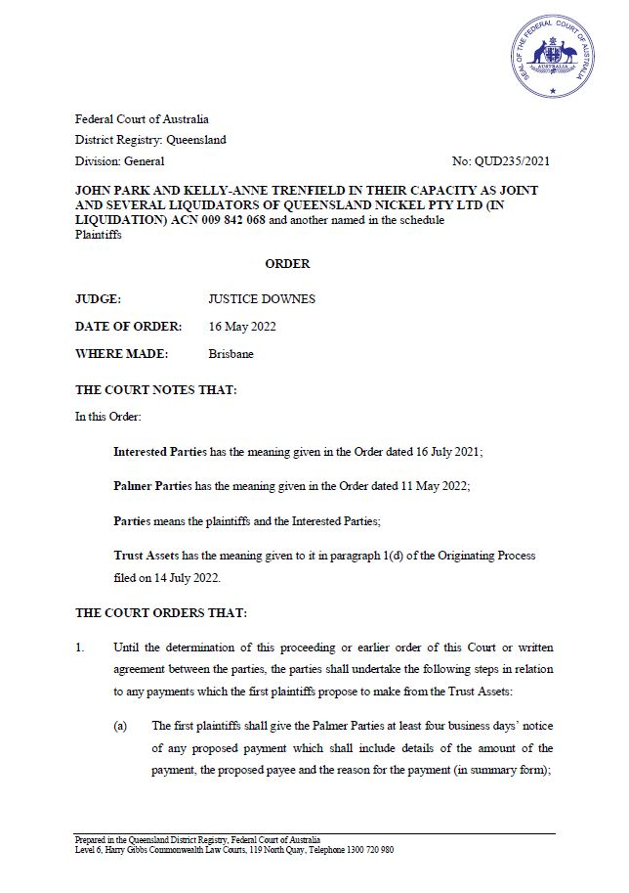
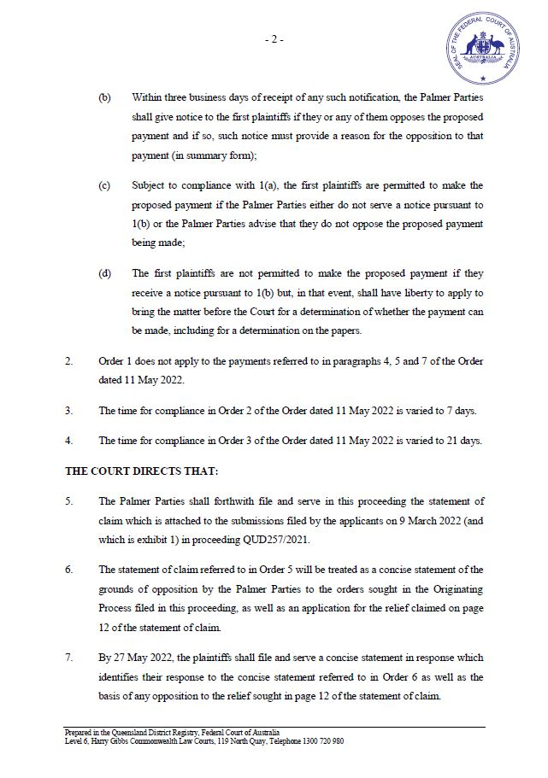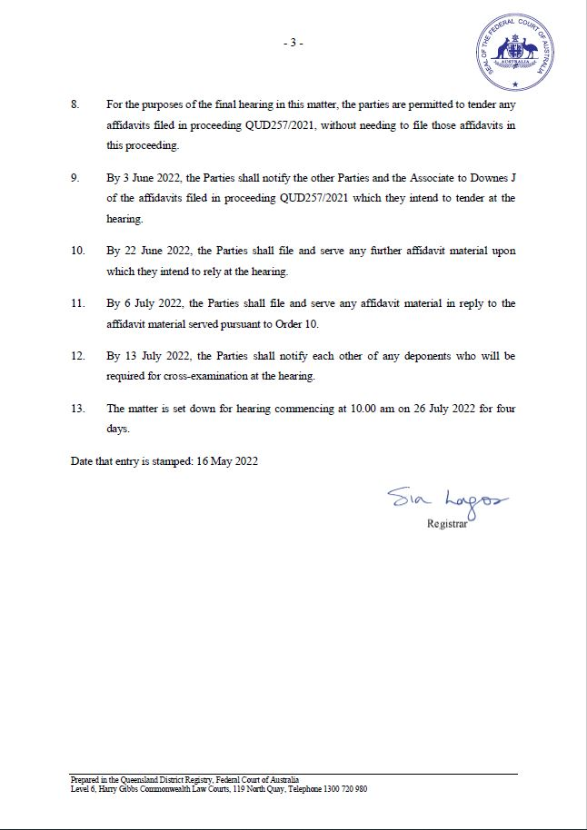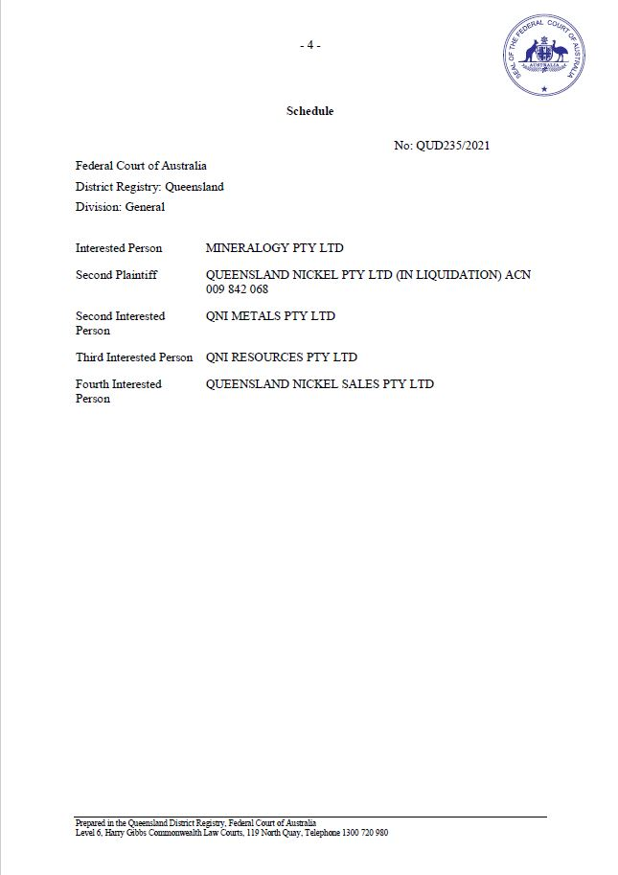

Annexure B



