FEDERAL COURT OF AUSTRALIA

Stillwater Pastoral Company Pty Ltd v Stanwell Corporation Ltd [2024] FCA 1382
File number: | QUD 19 of 2021
Judgment of: | SARAH C DERRINGTON J
Date of judgment: | 4 December 2024
Catchwords: | COMPETITION – misuse of market power – where applicant alleges respondents took advantage of substantial market power in the National Electricity Market (NEM) – where respondents engaged in late rebidding in the NEM – whether respondents took advantage of substantial market power to spike the spot price of electricity with the expectation or intention that other market participants would be unable or unlikely to respond competitively (Short-notice Rebidding) – whether respondents’ conduct contravened s 46 of the Competition and Consumer Act 2010 (Cth) (CCA)  COMPETITION – misuse of market power – defining the relevant market for purposes of s 46 of the CCA – design of the NEM – whether relevant market wider than Queensland region of the NEM  COMPETITION – misuse of market power – whether respondents had a substantial degree of market power within meaning of s 46 of the CCA – competing economic approaches to assessment of substantial market power – nature of constraints within the NEM on substantial market power – “aggregated” market power – whether respondents together had a substantial degree of market power within meaning of s 46(2) of the CCA  COMPETITION – misuse of market power – whether respondents took advantage of their market power – where applicant alleges respondents engaged in Short-notice Rebidding in reliance on trading strategy with the purpose of deterring or preventing other market participants from engaging in competitive conduct – where applicant relied on thirteen examples of alleged Short-notice Rebidding to prove its case (Sample Intervals) – whether respondents engaged in Short-notice Rebidding in any of the Sample Intervals – whether alleged purpose established on the evidence  CROWN – immunity – where respondents government owned corporations within meaning of Government Owned Corporations Act 1993 (Qld) (GOCA) – whether respondents “related” within meaning of s 4A of the CCA – whether State of Queensland a “company” within s 4A(4) of the CCA – whether respondents “emanations of the Crown” – whether GOCA confers on the shareholding ministers or the State of Queensland control of the respondents  EVIDENCE – inferential reasoning in civil cases – where one respondent called no witnesses on issue of alleged conduct – whether Jones v Dunkel inference ought be drawn – where relevant possible witnesses former employees
Legislation: | Acts Interpretation Act 1901 (Cth) ss 22, 22(1)  Competition and Consumer Act 2010 (Cth) ss 2, 2A, 2B, 4, 4A, 4A(1), 4A(3), 4A(4), 4A(5), 9, 45(8AA), 46(1), 46(1A), 46(1AA), 46(2), 46(3), 46(3A), 46(3B), 46(3C), 46(4), 46(6A), 46(7)  Competition and Consumer Amendment (Misuse of Market Power) Act 2017 (Cth) Sch 1  Competition Policy Reform Act 1995 (Cth) s 81  Corporations Act 2001 (Cth) s 9  Evidence Act 1995 (Cth) s 140(2)  Hydro-Electric Commission Act 1944 (Cth) s 15  National Electricity Law  Trade Practices Act 1974 (Cth) ss 4A(4), 4A(5), 46(3), 50  Competition Policy Reform (Queensland) Act 1996 (Qld) Pt IV  Electricity Act 1994 (Qld) s 257  Government Owned Corporations Act 1993 (Qld) ss 13(c), 16(b), 75, 76, 77, 78, 80(2), 83, 84, 88, 114, 115, 117, 154  National Electricity (South Australia) Act 1996 (SA)  Federal Court Rules 2011 (Cth) r 22.06  National Electricity Rules Chs 3, 10, cll 3.1.4, 3.4.1, 3.8, 3.8.1, 3.8.3A, 3.8.6, 3.8.7A, 3.8.19, 3.8.22, 3.8.22A, 3.8.22A, 3.9.1, 3.9.4, 3.9.6, 3.13.4  Government Owned Corporations (Generator Restructure) Regulation 2011 (Qld)  Explanatory Memorandum, Competition and Consumer Act (Competition Policy Review) Bill 2017 (Cth)  Explanatory Memorandum, Trade Practices Legislation Amendment Bill 2008 (Cth)  Explanatory Memorandum, Competition and Consumer Amendment (Misuse of Market Power) Act 2017 (Cth)  Sherman Act 15 USC §§ 1, 2
Cases cited: | Air New Zealand Ltd v Australian Competition and Consumer Commission [2017] HCA 21; 262 CLR 207  Australian Competition and Consumer Commission v Australia and New Zealand Banking Group Ltd [2015] FCAFC 103; 236 FCR 78  Australian Competition and Consumer Commission v Australian Egg Corp Ltd [2016] FCA 69; 337 ALR 573  Australian Competition and Consumer Commission v Cement Australia Pty Ltd [2013] FCA 909; 310 ALR 165  Australian Competition and Consumer Commission v Colgate-Palmolive Pty Ltd (No 4) [2017] FCA 1590; 353 ALR 460  Australian Competition and Consumer Commission v Flight Centre Travel Group [2016] HCA 49; 261 CLR 203  Australian Competition and Consumer Commission v Olex Australia Pty Ltd [2017] FCA 222  Australian Competition and Consumer Commission v Pfizer Australia Pty Ltd [2018] FCAFC 78; 356 ALR 582  Australian Competition and Consumer Commissioner v Baxter Healthcare Pty Ltd (No 2) [2008] FCAFC 141; 170 FCR 16  Australian Competition and Consumer Commissioner v Metcash Trading Ltd [2011] FCA 967; 198 FCR 297  Australian Gas Light Company v Australian Competition and Consumer Commission [2003] FCA 1525; 137 FCR 317  Australian Securities and Investments Commission v Australian Lending Centre (No 3) [2012] FCA 43; 213 FCR 380  Australian Securities and Investments Commission v Hellicar [2012] HCA 17; 247 CLR 345  Bass v Permanent Trustee Co Ltd [1999] HCA 9; 198 CLR 334  Boral Besser Masonry Ltd (now Boral Masonry Ltd) v Australian Competition and Consumer Commission [2003] HCA 5; 215 CLR 374  Briginshaw v Briginshaw [1938] HCA 34; 60 CLR 366  BrisConnections Finance Pty Ltd (recs and mgrs apptd) v Arup Pty Ltd [2017] FCA 1268; 252 FCR 450  Chief Executive Officer, Aboriginal Areas Protection Authority v Director of National Parks [2024] HCA 16; 98 ALJR 655  Claremont Petroleum NL v Cummings [1992] FCA 446; 110 ALR 239  CMIC Group Ltd v AIG Group Ltd [2022] NSWSC 999  Communications, Electrical, Electronic, Energy, Information, Postal, Plumbing & Allied Services Union of Australia v Australian Competition and Consumer Commission [2007] FCAFC 132; 162 FCR 466  Dowling v Dalgety Australia Ltd [1992] FCA 27; 34 FCR 109  Eastern Express Pty Ltd v General Newspapers Pty Ltd (1991) 30 FCR 385  Eastern Express Pty Ltd v General Newspapers Pty Ltd (1992) 35 FCR 43  Europemballage and Continental Can v Commission [1973] 1 ECR 215  Henderson v Queensland [2014] HCA 52; 255 CLR 1  Jones v Dunkel [1959] HCA 8; 101 CLR 298  Kuhl v Zurich Financial Services Australia [2011] HCA 11; 243 CLR 361  Launceston Corporation v The Hydro-Electric Commission [1959] HCA 12; 100 CLR 654  Marriner v Australian Super Developments Pty Ltd [2016] VSCA 141  Mason v MWREDC Ltd [2011] FCA 1512; 199 FCR 151  Masters Home Improvement Pty Ltd v North East Solution Pty Ltd [2017] VSCA 88; 372 ALR 440  McFarlane v Insignia Financial Ltd [2023] FCA 1628  Melway Publishing Pty v Robert Hicks Pty Ltd [2001] HCA 13; 205 CLR 1  Natwest Australia Bank Ltd v Boral Gerrard Strapping Systems Pty Ltd (1992) 111 ALR 631  New Aim Pty Ltd v Leung [2023] FCAFC 67; 410 ALR 190  NT Power Generation Pty Ltd v Power & Water Authority [2002] FCAFC 302; 122 FCR 399  Paul Dainty Corporation Pty Ltd v National Tennis Centre Trust (1990) 22 FCR 495  Queensland Wire Industries Pty Ltd v Broken Hill Proprietary Co Ltd [1989] HCA 6; 167 CLR 177  Re Queensland Co-operative Milling Association Ltd (1976) 8 ALR 481  Re Tooth & Co Ltd and Tooheys Ltd (1979) 39 FLR 1  Rural Press Ltd v Australian Competition and Consumer Commission [2003] HCA 75; 216 CLR 53  Seven Network Ltd v News Ltd [2009] FCAFC 166; 182 FCR 160  Singapore Airlines Ltd v Tapobrane Tours WA Pty Ltd [1991] FCA 808; 33 FCR 158  Sita Qld Pty Ltd v State of Queensland [1999] FCA 793; 164 ALR 18  Stanwell Corporation Ltd v LCM Funding Pty Ltd [2021] FCA 1430; 157 ACSR 401  Superannuation Fund Investment Trust v Commissioner of Stamps (SA) [1979] HCA 34; 145 CLR 330  Townsville Hospitals Board v Townsville City Council [1982] HCA 48; 149 CLR 282  Universal Music Australia Pty Ltd v Australian Competition and Consumer Commission [2003] FCAFC 193; 131 FCR 529
Division: | General Division
Registry: | Queensland
National Practice Area: | Commercial and Corporations
Sub-area: | Economic Regulator, Competition and Access
Number of paragraphs: | 766
Date of hearing: | 3-7 June 2024, 10-14 June 2024, 24-28 June 2024, 1-5 July 2024, 8-11 July 2024, 15-19 July 2024, 22 July 2024, 12-13 August 2024, 15-16 August 2024
Counsel for the Applicant: | Mr L W L Armstrong KC with Ms D M Bampton, Mr J R Green, Mr B O’Connor and Mr S H Snow
Solicitor for the Applicant: | Piper Alderman
Counsel for the First Respondent: | Mr S Doyle KC with Mr P Franco KC, Ms M Y Barnes, Ms J Menzies and Mr M Paterson
Solicitor for the First Respondent: | MinterEllison
Counsel for the Second Respondent: | Mr M Hodge KC with Mr D Roche SC, Ms F Y Lubett, Ms C Schneider and Ms S Marsh
Solicitor for the Second Respondent: | Herbert Smith Freehills

ORDERS
 |  | QUD 19 of 2021
BETWEEN: | STILLWATER PASTORAL COMPANY PTY LTD ACN 101 400 668  Applicant
AND: | STANWELL CORPORATION LTD ACN 078 848 674  First Respondent  CS ENERGY LTD ACN 078 848 745  Second Respondent

order made by: | SARAH C DERRINGTON J
DATE OF ORDER: | 4 DECEMBER 2024

THE COURT ORDERS THAT:

1. The Common Questions to be determined at the Initial Trial be answered as follows:
Common Question 1
At all times during the Conduct Period, was the relevant market for the purposes of s 46 of the Competition and Consumer Act 2010 (Cth) (CCA) the market as pleaded in paragraph 22 of the Statement of Claim (Market)?
Yes.
Common Question 2
During the Conduct Period, did Stanwell have a substantial degree of power in the Market within the meaning of s 46(1) of the CCA?
No.
Common Question 3
During the Conduct Period, did CS Energy have a substantial degree of power in the Market within the meaning of s 46(1) of the CCA?
No.
Common Question 4
During the Conduct Period, for the purposes of s 46(2) of the CCA, did Stanwell and CS Energy together have a substantial degree of power in the Market?
No.
Common Question 5
During the Conduct Period, did each of Stanwell and CS Energy engage in Short-notice Rebidding in relation to the electricity they offered for dispatch in the Queensland Region of the National Electricity Market in any and if so in which of the alleged ATIs?
No.
Common Question 7
If the answer to Common Questions 2, 3 or 4 and to Question 5, is yes, did Stanwell and/or CS Energy, by engaging in the Short-notice Rebidding, take advantage of their market power?
Unnecessary to answer but No.
Common Question 8
If the answer to Common Question 7 is yes, did Stanwell and/or CS Energy take advantage of their market power for the purpose of deterring or preventing a person from engaging in competitive conduct in the Market?
Unnecessary to answer but No.
Common Question 11
If the answer to Common Question 8 is yes, did this constitute a contravention of s 46 of the CCA?
Unnecessary to answer but No.
2. The proceeding be dismissed.
3. The matter be adjourned to a date in March 2025 for the determination of costs.

Note: Entry of orders is dealt with in Rule 39.32 of the Federal Court Rules 2011.

REASONS FOR JUDGMENT
SARAH C DERRINGTON J:
INTRODUCTION | [1]
THE LIST OF COMMON ISSUES OF LAW OR FACT | [12]
THE EXPERT EVIDENCE | [14]
THE SAMPLE INTERVALS | [36]
Sample intervals which include Callide C – a preliminary issue | [36]
The pleadings | [40]
Findings on the basis of assumptions | [43]
The evidence | [48]
Methodology for choosing the ATIs | [59]
The Profiles | [82]
DESIGN OF THE NATIONAL ENERGY MARKET | [96]
The National Electricity Market | [98]
Particular Features | [98]
Key market events during the Conduct Period | [110]
Undisputed facts relating to dispatch | [116]
The National Electricity Rules | [142]
SECTION 46 OF THE CCA | [159]
WHAT IS THE RELEVANT “MARKET”? | [166]
DID STANWELL AND CS ENERGY HAVE A SUBSTANTIAL DEGREE OF MARKET POWER IN THE MARKET WITHIN THE MEANING OF SECTION 46(1) OF THE CCA? | [199]
Economic and legal principles pertaining to substantial market power | [200]
Barriers to entry | [225]
Market power - heft | [228]
Ability to set a high price | [247]
Ability and incentive | [270]
Other constraints | [285]
DID STANWELL AND CS ENERGY TOGETHER HAVE A SUBSTANTIAL DEGREE OF POWER IN THE MARKET WITHIN THE MEANING OF S 46(2)? | [304]
Were Stanwell and CS Energy related within the meaning of s 4A? | [304]
Is section 4A enlivened? | [308]
The State as a holding company or body corporate | [311]
The GOCA | [327]
THE IMPUGNED CONDUCT | [348]
Did the alleged trading strategy exist? | [352]
Inferential reasoning | [357]
Components of the alleged strategy | [364]
Initial timing of rebid | [365]
“Lateness”, “expecting or intending” certain consequences | [368]
The documentary evidence | [416]
Stanwell’s strategy documents | [419]
CS Energy’s strategy documents | [437]
Stanwell’s training documents | [452]
CS Energy’s training documents | [468]
Miscellaneous CS Energy documents | [474]
The lay witnesses | [476]
Did Stanwell and CS Energy engage in the conduct in any and if so which of the alleged ATIs? | [487]
An overview of NEM-vis | [491]
Profile 1 | [516]
Sample Intervals 1, 2, 3 | [517]
Sample Interval 1 | [517]
Sample Interval 2 | [543]
Sample Interval 3 | [560]
Profile 1 and Profile 4 | [574]
Sample Intervals 4 and Sample Intervals 10 &11 | [574]
Sample Intervals 4 & 10 | [574]
Sample Interval 11 | [594]
Profile 2 | [607]
Sample Intervals 5 & 6 | [607]
Sample Interval 5 | [607]
Sample Interval 6 | [616]
Profile 3 | [629]
Sample Intervals 7, 8 & 9 | [629]
Sample Interval 7 | [629]
Sample Interval 8 | [645]
Sample Interval 9 | [657]
Profile 5 | [665]
Sample Interval 12 | [665]
Profile 6 | [682]
Sample Interval 13 | [682]
The strategy is not established | [705]
DID STANWELL AND/OR CS ENERGY TAKE ADVANTAGE OF SUBSTANTIAL MARKET POWER? | [713]
The legal and economic principles | [715]
The evidence | [731]
PURPOSE | [748]
DISPOSITION | [764]
SCHEDULE: GLOSSARY OF TERMS

INTRODUCTION
1 Queensland summers are hot and sultry. Demand for electricity is high and tends to peak in the afternoons when many Queenslanders turn on air-conditioners to make the late afternoon heat tolerable. Summer is the season during which Queensland electricity-generating firms (Generators) can maximise gross revenue. For that reason, at least two Generators, Stanwell Corporation Ltd ACN 078 848 674 and CS Energy Ltd ACN 078 848 745, the Respondents, have developed trading strategies to maximise gross revenue during the summer months. In broad terms, the strategies employed by Stanwell and CS Energy encourage their electricity traders to cause the electricity price to spike when the traders observe certain trends in the course of each Spot Market Trading Day. Those trends include forecast high temperatures, higher than forecast demand, low flow from interstate interconnectors, price volatility, and aggressive bidding by competitor firms. A Trading Day is a 24-hour period commencing at 04:00 and finishing at 04:00 the following day. Price spikes may be caused by Generators changing the quantity of electricity available for dispatch within ten pre-determined price bands, within one or more of the forty-eight 30-minute Trading Intervals (TI) by which a Trading Day is divided (Rebidding). If a Generator is able to cause a price spike in a TI, the effect will be to increase the Spot Price for that TI – being the time weighted average of the dispatch prices for each of the six five-minute Dispatch Intervals (DI) within the TI. The Generator that causes the price spike may, but not always, benefit from the price spike through a significant increase to its own revenue, at least for so long as the price spike endures, which is typically very short-lived. All Generators who have been dispatched in a given TI within their geographic region are paid the Spot Price. Those who make the very cheapest offers benefit from an elevated Spot Price.
2 Thursday 18 February 2016 was a typical summer day in Queensland. Traders were provided with information throughout the day by the Australian Energy Market Operator (AEMO), particularly in relation to forecast demand, pre-dispatch forecast prices, and actual prices for prior TIs. At 15:00, the 30-minute pre-dispatch price forecast for the 30-minute TI ending at 15:30 was $55.20MWh. For the TI ending at 16:00, the AEMO forecast was $299.95MWh. Having noticed the significant change in the pre-dispatch price forecast, CS Energy “rebid” at 15:26 to move 250MW previously offered from one of its generating units (referred to in some evidence as Dispatchable Unit Identifiers, or DUIDs) from the $299.95 price band to the $13,800 price band. In the next DI (being DI1 in the TI ending 16:00), CS Energy moved 250MW from the $13,800 price band to the $0 price band for DI2 of that TI. The effect of the rebid was to reduce supply in the mid-tier price bands and force the National Energy Market Distributor Equation (NEMDE) to look for additional supply in the higher price bands. In DI1, being the DI ending at 15:35, the price spiked to $12,700.30MWh. That elevated price was therefore the dispatch price for DI1, as compared with the pre-dispatch forecast of $299.95MWh. That had the consequence of causing the Spot Price (or Trading Price) for the TI ending at 16:00 to be $2,143.40, as compared with $172.93 in the previous TI.
3 The foregoing is a high-level overview of the conduct about which the Applicant complains. Stillwater Pastoral Company Pty Ltd ACN 101 400 668, the Applicant, sues on its own behalf and on behalf of a group comprising the various categories of consumers of electricity in the Queensland Region of the National Energy Market (QRNEM) during the period between 20 January 2015 and 20 January 2021 (Claim Period). In broad terms, the Court was asked to interrogate 13 examples, similar in many respects to the rebid scenario just described, and which are referred to as Affected Trading Intervals #1 - #13 (ATIs). The 13 ATIs (together, the Sample Intervals) were, it seems, chosen by Stillwater’s expert, Dr Shaun Ledgerwood. The Sample Intervals are a subset of 353 ATIs, identified by Dr Ledgerwood, during which the impugned conduct was said both to have taken place and to have had a quantum effect on the Spot Price in the relevant ATI. The 353 ATIs were identified from amongst the 571,392 DIs during the period from 1 January 2012 to 6 June 2017 (Conduct Period), the latter date being when a Ministerial Direction under s 257 of the Electricity Act 1994 (Qld) was issued to Stanwell, restricting the maximum price of its rebids.
4 At the heart of the claim is the allegation that the two largest Generators in the QRNEM, being the State-owned corporations, Stanwell and CS Energy, contravened s 46 of the Competition and Consumer Act 2010 (Cth) (CCA). Stillwater contends that each of Stanwell and CS Energy enjoyed advantages, relative to other potential suppliers of wholesale electricity in or into the QRNEM, that translated to a substantial degree of market power for each of them. The other Generators offering supply into the QRNEM during the Conduct Period included AGL, Alinta Energy, Arrow Energy, Callide Power Trading (CPT), Ergon Energy Queensland, InterGen, Origin Energy, Rio Tinto and Shell. Stillwater alleges that, during the Conduct Period, the Respondents took advantage of that market power, for the purpose of deterring or preventing other Generators from engaging in competitive conduct, by their conduct comprised of two elements, which is described as Short-notice Rebidding. The two elements said to comprise Short-notice Rebidding are:
(i) the placing by the Respondents of rebids that repriced, to very high prices, volumes of electricity that formerly had been offered at much lower prices – “economic withholding”; and
(ii) the delaying of placing rebids until just before a bidding “window” closed (gate closure – on average 67 seconds prior to commencement of the next DI), such that other Generators had either no opportunity to respond, or insufficient opportunity to adjust their own generation rates and rebids in such a way as would have prevented the Respondents from achieving very substantial net revenue gains from their rebidding conduct.
5 The scope of this trial (Initial Trial) was confined to the question of whether either, or both, of the Respondents contravened s 46 of the CCA. Questions of causation or quantification of loss have been deferred. Central to the issue of whether the Respondents contravened s 46 is an understanding of what it means to “engage in competitive conduct” in the National Electricity Market (NEM), or a relevant subset thereof, the QRNEM. The word “competition” is not defined in the CCA, but is well understood (as used throughout the CCA) in a commercial or economic sense best described by reference to its aim, mechanism, and effect. The views of the Trade Practices Tribunal, expressed in 1976 in Re Queensland Co-operative Milling Association Ltd (1976) 8 ALR 481 (Re QCMA), remain important to understanding what is meant by “competition” in the context of Australian competition law. The Tribunal said, at 511:
… “[C]ompetition” is such a very rich concept (containing within it numbers of ideas) that we should not wish to attempt any final definition which might, in some market settings, prove misleading or which might, in respect to some future application, be unduly restrictive. Instead we explore some of the connotations of the term.
6 The Tribunal continued:
Competition may be valued for many reasons as serving economic, social and political goals. But in identifying the existence of competition in particular industries or markets, we must focus upon its economic role as a device for controlling the disposition of society’s resources. Thus, we think of competition as a mechanism for discovery of market information and for enforcement of business decisions in the light of this information. It is a mechanism, first, for firms discovering the kinds of goods and services the community wants and the manner in which these may be supplied in the cheapest possible way. Prices and profits are the signals which register the play of these forces of demand and supply. At the same time, competition is a mechanism of enforcement: firms disregard these signals at their peril, being fully aware that there are other firms, whether currently in existence or as yet unborn, which would be only too willing to encroach upon their market share and ultimately supplant them.
(Emphasis added.)
7 In Rural Press Ltd v Australian Competition and Consumer Commission [2003] HCA 75; 216 CLR 53 at 73, Gummow, Hayne, and Heydon JJ drew attention to the importance of the views and practice of those within a particular industry, “not only on the question of achieving a realistic definition of the market, but also on the question of assessing the quality of particular competitive conduct in relation to the level of competition”.
8 There was no dispute that the NEM is an “energy-only” market. There is no separate “capacity market” to ensure that Generators’ fixed costs and investments in capacity are remunerated. Thus, the only source of remuneration for costs associated with generation is the revenue earned from the dispatch of electricity or the provision of ancillary services. Accordingly, transiently high spot prices are required to ensure that Generators can recover both their variable and fixed costs, including higher costs generation that is primarily used during peak periods of demand. This feature of the NEM was expressly acknowledged by the Australian Energy Market Commission (AEMC) in 2012 when considering whether major Generators were exercising substantial market power with the purpose or effect of increasing wholesale spot and contract prices such that a change to the National Electricity Rules (NER) was warranted. The AEMC said (AEMC, Draft Rule Determination – Potential Generator Market Power in the NEM, 7 June 2012, at i) (AEMC Draft Determination 2012):
Efficient wholesale prices, averaged over time, can be expected to be at the level required to recover the cost of building new generation or transmission capacity to satisfy growth in consumer demand. The Commission acknowledges that prices above this level for a sustained period of time may be more than is necessary to compensate for the various costs and risks borne by generators. If a generator(s) is able to increase average wholesale spot or contract prices above an efficient level for a sustained period of time, those prices are likely to flow through to retail prices and increase the costs to electricity consumers.
However, wholesale prices will not reflect an efficient level at every moment in time and variations in price are an outcome of the dynamic conditions of supply and demand in the NEM. In order to be useful in a real world setting, particularly in the context of a sector like electricity that requires ‘lumpy’ non-divisible capital investments, a time dimension needs to be recognised.
In addition, for short periods of time, transient but significant increases in the wholesale price of electricity may occur. A generator’s transient ability to significantly increase prices for short periods should not be considered a basis for a rule change unless that power is exercised to such an extent or with sufficient frequency that it causes long term average prices to be above the efficient level for a sustained period of time.
(Emphasis added. Citations omitted.)
9 This is the broad context in which the present proceeding arises.
10 By Order of the Court dated 29 April 2024, a List of Common Issues articulates the questions of facts or law that are common to the claims of Stillwater (as lead applicant) and the group members, and which were to be determined at the Initial Trial.
11 The scope of the Initial Trial was narrowed further by Order of the Court dated 19 December 2022 which directed that Stillwater nominate the Sample Intervals from amongst the 353 ATIs. The Sample Intervals were examined during this Initial Trial.

THE LIST OF COMMON ISSUES OF LAW OR FACT
12 The List of Common Issues was settled by the parties. With cross references to the Third Further Amended Statement of Claim (3FASOC), that list is as follows:
The relevant “Market” for the purposes of s 46
1. Common Question 1: At all times during the Conduct Period, was the relevant market for the purposes of s 46 of the CCA the market as pleaded in paragraph 22 of the SOC (Market)? [SOC, [22]]
Substantial degree of power in the Market
Market power of each Respondent
2. Common Question 2: During the Conduct Period, did Stanwell have a substantial degree of power in the Market within the meaning of section 46(1) of the CCA? [SOC, [34]]
3. Common Question 3: During the Conduct Period, did CS Energy have a substantial degree of power in the Market within the meaning of section 46(1) of the CCA? [SOC, [41]]
Market power of each Respondent by reason of s 46(2)
4. During the Conduct Period, were Stanwell and CS Energy “related” within the meaning of s 4A of the CCA? [SOC, [7], [42(a)]]
5. Common Question 4: During the Conduct Period, for the purposes of s 46(2) of the CCA, did Stanwell and CS Energy together have a substantial degree of power in the Market? [SOC, [42(b)], [43]]
6. During the Conduct Period, did each of Stanwell and CS Energy, individually, by reason of s 46(2) of the CCA, have a substantial degree of market power in the Market? [SOC, [43]]
The Conduct
Common Question 5: During the Conduct Period, did each of Stanwell and CS Energy engage in Short-notice Rebidding in relation to the electricity they offered for dispatch in the QRNEM in any and if so in which of the alleged ATIs?
7 – 21. In relation to each Sample Interval did Stanwell and/or CS Energy as the case may be
a. submit a Short-notice Rebid? [SOC, [44(a)]]
b. time the Short-notice Rebid expecting and intending, or in circumstances where Stanwell and/or CS Energy can reasonably be inferred to have expected and intended, that by reason of the lateness of the rebid, competing Generators would be impacted in any of the ways pleaded in paragraphs 44(b)(i),(ii) or (iii) of the SOC? [SOC, [44(b)]]
c. submit the Short-notice Rebid in circumstances not materially different from:
i. the circumstances existing when Stanwell and/or CS Energy’s Timely Offer was made; or
ii. the circumstances existing when a Timely Offer could have been but was not made? [SOC, [44(c)]]
Taking advantage of market power

Common Question 7:
22. If question 20 above is answered in the affirmative, did Stanwell, by engaging in Short-notice Rebidding in relation to any and if so which of the Sample Intervals relating to it, take advantage of its substantial degree of power in the Market? [SOC, [51]]
23. If question 20 above is answered in the affirmative, did CS Energy, by engaging in the Short-notice Rebidding in relation to any and if so which of the Sample Intervals relating to it, take advantage of its substantial degree of power in the Market? [SOC, [51]]
Proscribed purpose

Common Question 8:
24. If the answer to question 22 above is affirmative, did Stanwell, in any and if so which of the Sample Intervals, take advantage of its substantial degree of power in the Market for the purpose of deterring or preventing competing Generators from engaging in competitive conduct in the Market (Proscribed Purpose)? [SOC, [53(a)]]
25. If the answer to question 23 above is affirmative, did CS Energy, in any and if so which of the Sample Intervals, take advantage of its substantial degree of power in the Market for the Proscribed Purpose? [SOC, [53(b)]]
Contravention of s 46

Common Question 11:
26. If the answer to question 24 above is in the affirmative, did Stanwell contravene s 46 of the CCA? [SOC, [53(a)]]
27. If the answer to question 25 above is in the affirmative, did CS Energy contravene s 46 of the CCA? [SOC, [53(b)]]
13 On 2 November 2023, the parties filed an extensive Statement of Agreed Facts (SAF).

THE EXPERT EVIDENCE
14 The Court was assisted in answering these questions by five experts, who gave evidence in two “hot tubs”, following the preparation of joint expert reports in two expert conclaves facilitated by Counsel appointed by the Court. The first conclave focussed on the economic theory and principles relevant to the issues in the case (Economic Conclave). It produced the Joint Experts’ Report Conclave No 1 – Economic Experts dated 26 April 2024 (JtEcER). The second conclave focussed on the structure and operation of the electricity market, particularly the NEM (Electricity Market Conclave). It produced the Joint Experts’ Report Conclave No 2 – Electricity Market Experts dated 29 April 2024 (JtEMER).
15 Stillwater engaged Dr Ledgerwood, a Principal of the economic consulting firm, The Brattle Group. Dr Ledgerwood holds a Doctor of Philosophy, Master of Arts, and Bachelor of Arts, all in Economics, from the University of Oklahoma and a Juris Doctor from the University of Texas. Prior to joining The Brattle Group, he worked as an economist and attorney in the Office of Enforcement for the Federal Energy Regulatory Commission (FERC). His more than 30-year career has focussed on issues related to regulation and competition in energy markets. Dr Ledgerwood has had wide experience testifying as an expert witness in the Federal Courts of the United States and in Canadian Courts. As an Adjunct Professor at the University of Oklahoma Department of Economics, College of Law, and Price College of Business, he has taught undergraduate and graduate courses in microeconomic theory, law and economics, regulation, anti-trust, and contractual and tortious remedies. He also served as an Affiliated Faculty member at the Georgetown University Public Policy Institute. Dr Ledgerwood is widely published.
16 In these proceedings, Dr Ledgerwood has provided the following reports:
(a) the First Ledgerwood Report dated 4 October 2022 (1LedgerwoodR);
(b) the Second Ledgerwood Report dated 21 November 2023, updated by a Report dated 20 March 2024 (2LedgerwoodR);
(c) an analysis of the Hypothetical Monopolist test dated 28 March 2024 entitled, “Brattle note – Ledgerwood Figures for the Conclave Questions”; and
(d) the Fourth Ledgerwood Report dated 13 June 2024 (4LedgerwoodR).
17 Dr Ledgerwood participated in both the Economic Conclave and the Electricity Market Conclave and contributed to both the JtEMER and the JtEcER.
18 The two other participants in the Economic Conclave were Mr Euan Morton and Mr Derek Holt.
19 Mr Morton was engaged by Stanwell. He is a Principal at Synergies Economic Consulting and holds a Bachelor of Economics (Hons I), Bachelor of Commerce, and Bachelor of Laws (Hons) from the University of Queensland. He was admitted as a Solicitor of the Supreme Court of Queensland in 1991. Mr Morton has been appointed as an expert and to numerous expert panels including: the Expert Panel for the COAG Energy Council, 2015 Review of Governance Arrangements for Australian Energy Markets; the Expert Panel for Ministerial Council on Energy 2005 Report on Energy Access Pricing; and as an Independent Expert for NER, 2001. He has been a Member of the Competition and Consumer Law Committee of the Law Council of Australia. Mr Morton has had over 30-years’ experience preparing expert reports relating to competition matters, particularly in the energy sector, and in providing expert evidence.
20 In these proceedings, Mr Morton has provided the following Reports:
(a) Report of Euan Morton dated 28 February 2024 (1MortonR); and
(b) Supplementary Report of Euan Morton dated 6 June 2024 (SuppMortonR).
21 Mr Holt is a Partner of AlixPartners UK LLP. He holds a Master of Science with Distinction from the London School of Economics, an honours degree in economics and finance from McGill University in Montreal, Canada, and a postgraduate Diploma with Merit in Competition Economics from King’s College London. Mr Holt has practised as an economist for over 28 years, acting as an expert and economic advisor in the fields of competition litigation and economic regulation. He has appeared as an expert witness before the High Court of England and Wales, the Competition Appeal Tribunal, the Competition and Markets Authority of the United Kingdom, the Swedish Patent Court, the South African Competition Tribunal, the Hong Kong Competition Tribunal, and the European Commission.
22 In these proceedings, Mr Holt has provided the Expert Report of Derek Holt dated 23 February 2024 (Holt Report).
23 Dr Ledgerwood has had an extensive and impressive career as an economist. He has been particularly focussed throughout his career on issues of anti-competitive conduct and market manipulation. In his 2015 co-authored book, Gary Taylor, Shaun Ledgerwood, Romkaew Broehm and Peter Fox-Penner, Market Power and Market Manipulation in Energy Markets: From the California Crisis to the Present (Public Utilities Reports, Inc. 2010) at 8, Dr Ledgerwood et al, “build on the seminal work of … [Ledgerwood], creating a framework that helps categorize different types of market manipulation …”: see, Ledgerwood, Shaun D, “Screens for the Detection of Manipulative Intent (SSRN, December 2010). Chapter 9 of Market Power and Market Manipulation (at 189) proposes a diagnostic framework to expand “the traditional physical-goods market power conceptual model into one that more naturally incorporates the role of short-term information and financial products”. The authors (at 189) posit that the framework “helps to resolve a tension in the literature, often noted by economist experts such as Professor Pirrong [Bauer College of Business, University of Houston], between market power-based and fraud-based manipulations”. In his 2010 paper (at 2), Dr Ledgerwood attributed to Professor Pirrong what he referred to as “[e]ntrenchment in the literature of the perception that the execution of a ‘market-based manipulation’ requires traditional market power”. This apparent difficulty was picked up, and expanded upon, in Market Power and Market Manipulation (at 196), where in the context of an act of economic withholding by a seller, the authors say:
A successful market-power-triggered manipulation therefore requires that the seller must have the ability to thwart [competitive pressures to return the price to competitive levels] to prevent this participation from occurring, such as by taking advantage of size, entry barriers, or through implementing other restraints of trade – the hallmarks of traditional monopoly power.
Contrast this with the seller who dumps uneconomic volumes of product into the market at sub-competitive prices. Absent arbitrage opportunities … other sellers are not positioned to stop this behaviour and may be driven out of business if it is allowed to persist. Whereas the exercise of market power requires (and is in part defined by) the ability to prevent other sellers from participating in the market and thus thwart the effect of the exercise on the price, the reaction of other sellers to uneconomic trading faces no such immediate resistance. This means that successful manipulations triggered by uneconomic trading can be executed by firms with much smaller market concentrations than traditional anti-trust economics would deem relevant. The ability to make such sales profitably is not a function of market power, but rather of the willingness of the actor to absorb losses in the primary market …
(Emphasis added.)
24 More recently, in Shaun D Ledgerwood, James A Keyte, Jeremy A Verlinda, and Guy Ben-Ishai, “The Intersection of Market Manipulation Law and Monopolization under the Sherman Act: Does it Make Economic Sense?” (2019) 40 Energy Law Journal 47 (2019 ELJ article), Dr Ledgerwood and his co-authors (at 65), drew a distinction between “traditional market power acquired through some form of market dominance or through some ephemeral market power acquired circumstantially, such as when a generator is ‘pivotal’ in hours when system constraints bind”. As the authors explain, the Sherman Act (15 USC §§ 1-7) is often the source of private causes of action for manipulative acts. The Sherman Act is a close analogue of s 46 of the CCA although it is by no means in identical terms. Section 1, however, requires proof of collusion, whereas s 2 does not (at 49). Section 2 requires proof of “market dominance within a well-defined product and geographic market” in order to establish an abuse of monopoly power (at 56). The authors observe, consequently, that “the ephemeral nature of the distortions that are typically produced by such behaviour seems less suited to causes of action under Section 2 of the Sherman Act” (at 66).
25 The reason for setting out in some detail these features of Dr Ledgerwood’s academic writings is to attempt to shed light on some of the economic opinions expressed by Dr Ledgerwood during the Initial Trial which appeared both contrary to economic orthodoxy and contrary to his own previously expressed statements of economic principle. It is tolerably clear that, from about 2010, Dr Ledgerwood has felt unease with his perception that competition law, at least in the United States, does not deal adequately with cases of the type with which we are presently concerned, and which he described continually throughout the Initial Trial as “conduct cases”. He has posited a new approach to the detection of market-manipulation cases and has advocated for courts, and legislators, to adopt his approach. That has not yet happened. It is unfortunate that he did not clearly articulate his theory and debate it with the other economic experts. Rather, he strained existing orthodoxy by commencing with the result he wished to achieve and then constructed a theoretical framework by which that result would be achieved. This was most obvious when Dr Ledgerwood disavowed the appropriateness in this case of the “classic” test for substantial market power, which he and his co-authors had adopted in Market Power and Market Manipulation (at 13), because “it loses all meaning” in what he described as a “conduct case”.
26 That led Dr Ledgerwood to a theory that the competitive process compels Generators to increase output to sell at higher prices and that a responsive Rebid was “competitive” only if it might thwart, abate or mitigate a price spike. This was not through any malicious intent. It is clear that Dr Ledgerwood considered the behaviour of Stanwell and CS Energy to be obnoxious – as to which reasonable minds may differ. But, as Senior Counsel for Stanwell put it, Dr Ledgerwood’s approach emerged as one more akin to that of a prophet or an evangelist than that of an independent expert economist.
27 For these reasons, there are many instances where I have been compelled to reject Dr Ledgerwood’s opinion and have generally preferred the orthodox opinions expressed by Messrs Morton and Holt. Both gave considered and thoughtful evidence. Their reports were thorough and compelling. Both were prepared to make concessions where appropriate and to explain the limits of their evidence and of their expertise.
28 The participants in the Electricity Market Conclave, in addition to Dr Ledgerwood, were Dr Ian Rose and Mr Daniel Price.
29 Dr Rose is an Associate Partner at Ernst & Young. He holds a Bachelor of Electrical Engineering (Hons), Master of Engineering Science in Electrical Engineering from the University of Queensland, a Doctor of Philosophy in Electrical Engineering from the University of Waterloo, Canada, and a Graduate Certificate in Management from the Mount Eliza Business Management School in Victoria. Dr Rose is a Fellow of the Institution of Engineers Australia; a Life Member of the Institute of Electrical and Electronic Engineers, New York; a Member of the International Council on Large Electric Systems (CIGRÉ), Paris; and was a Member of CIGRÉ Australian Panel APC5 Committee – Electricity Markets and Regulation from 2000 to 2022. Dr Rose spent the first half of his career working primarily for the Queensland Electricity Commission, commencing in 1972, then for Queensland Generation Corporation (Aust Electric) from 1995 to 1999, before embarking on his consulting career. Dr Rose was involved in developing an energy management system for Queensland to manage the Queensland electricity grid from a new control centre in Brisbane. That centre became the Northern Control Centre for the NEM. Dr Rose has had extensive experience providing expert advice on a range of large electrical projects across Australia and has given expert evidence in disputes concerning transmission upgrades, marginal loss factors, bidding rules, transmission constraints, coal supplies, and power station operation.
30 In these proceedings, Dr Rose provided the following reports:
(i) Response to the First Ledgerwood Report dated 28 February 2023 (1RoseR);
(ii) Second Expert Report of Dr Ian Rose dated 26 February 2024 (2RoseR); and
(iii) Supplementary Report of Dr Ian Rose dated 28 May 2024 (SuppRoseR).
31 Mr Price was engaged by CS Energy. He is the co-owner and Managing Director of Frontier Economics Pty Ltd based in Melbourne, a position he has held since 1999. Mr Price holds a Bachelor of Agricultural Economics from the University of Sydney. Prior to commencing his consulting career, Mr Price had over 30 years’ experience in Australian energy reform design and implementation, including: as a principal economist at the New South Wales Electricity Commission (in which role he worked on the development and reform of the NEM Rules from 1988 until 1992); as a senior economics consultant at London Economics (advising on fundamental energy market design and reform in several countries, and reviewing the early trial of the NEM); as lead advisor to the Queensland Electricity Reform Unit (overseeing the entry of Queensland into the NEM); and as a consultant with Frontier Economics, to the NSW Market Implementation Group. He has provided advice to the Tasmanian, Western Australian, and South Australian governments on a variety of energy issues within those States.
32 In these proceedings, Mr Price has provided the following reports:
(i) Response to Ledgerwood Report dated 28 February 2023 (1PriceR);
(ii) Second Report of Daniel Price dated 26 February 2024 (2PriceRiceR); and
(iii) Supplementary Report of Daniel Price dated 25 March 2024 (SuppPriceR).
33 Despite Dr Ledgerwood’s primary field of expertise being economics, he also gave evidence as an expert in the operation of electricity markets, and more particularly, in relation to the operation of the NEM as relevant to the issues in these proceedings. His knowledge of electricity markets has been acquired largely in the context of his involvement in matters involving anticompetitive and manipulative market behaviour, including in relation to regulatory issues. The vast majority of his experience relates to energy markets in the United States, of which he readily agreed most are “capacity” markets rather than “energy-only” markets. His prior Australian experience was in assisting the Western Australian electric regulator with the development of screens to detect anticompetitive behaviour in its future capacity market design.
34 Dr Ledgerwood conceded that, prior to these proceedings, he had had no experience with the operational aspects of the NEM. Despite his obvious diligence in attempting to get across the minutiae of this extremely complex market, he was at a significant disadvantage as compared with Dr Rose and Mr Price, both of whom had been intimately involved with the NEM since its creation. As an example, Dr Ledgerwood sought to identify the impugned rebids as exercises in economic withholding creating what he referred to as an “artificial scarcity”, whereby no capacity is in fact withheld, merely repriced. As Stanwell submitted, in one sense, every price band above the lowest is an economic withholding in one sense, but the design of the NEM is that this can and should occur. As Mr Price put it, when asked about the difference between his opinions and those of Dr Ledgerwood:
It's not a dispute between me and Dr Ledgerwood. It’s a dispute between the whole National Electricity Market design and the agencies and governments whose market it is and Dr Ledgerwood. All I’m doing is reflecting the design of the market as it has been operating for 30 years. The market Dr Ledgerwood is talking about is not ours.
(Emphasis added.)
35 Where Dr Ledgerwood’s opinions were based on assumptions about matters material to the operation of the NEM, both in relation to the physical aspects of the market and in relation to the operation of the Spot Market, which differed from those of Dr Rose and Mr Price, I had much greater confidence in the opinions of the latter and accept their evidence.

THE SAMPLE INTERVALS

Sample intervals which include Callide C – a preliminary issue
36 The methodology used by Dr Ledgerwood to identify the ATIs, from which Stillwater selected the Sample Intervals will be discussed shortly. Ultimately, in the First Ledgerwood Report, and the Second Ledgerwood Report, Dr Ledgerwood identified 352 ATIs. This number was revised in his later Report to 353, with 113 attributed to Stanwell and 311 to CS Energy, less the number of ATIs in which both Respondents were implicated (2LedgerwoodR at [1433]).
37 There is, however, a preliminary issue which concerns how many of the ATIs should in fact be attributed to CS Energy. This issue arises from the circumstances relating to the ownership and control of the Callide C power station. By the 3FASOC, Stillwater asserts that, during the Conduct Period, CS Energy owned or controlled the output of the Callide C. That contention is relied upon by Stillwater in support of its allegation that CS Energy (and CS Energy together with Stanwell) had a substantial degree of market power (3FASOC at [35]).
38 CS Energy submitted that when the rebids wrongly attributed to it are removed, the number of ATIs which concern CS Energy is reduced from 311 to 200. In relation to ADIs attributed to CS Energy, the number reduces from 363 to 235.
39 Callide C is located in Biloela, south-west of Gladstone, Queensland. It is one of two power plants that comprise Callide Power Station (Callide B and Callide C). Each of Callide B and Callide C have two generating units (referred to as CALL_B1 and CALL_B2, and CPP_3 and CPP_4, respectively).

The pleadings
40 CS Energy disputed that it owned or controlled Callide C. By its Amended Defence and Further Amended Defence (CSE FAD), it maintains Callide C is owned and operated by an unincorporated joint venture company between a wholly owned subsidiary of CS Energy (Callide Energy Pty Ltd) and another, entity, IG Power (Callide) Ltd (IGPC), the latter being a subsidiary of InterGen. It also asserts that, during the Conduct Period, electricity generated by Callide C was traded by another joint venture company, CPT, via separate bidding processes by each owner.
41 In response to the 3FASOC, CSE FAD pleads the arrangement of entities involved in the ownership structure of Callide C in the following way:
[35] As to paragraph 35 of the Statement of Claim, the Second Respondent:
(a) denies the allegations in subparagraph (a) and says further that:
(i) during the Conduct Period the Second Respondent directly or indirectly owned or controlled some or all of the Nameplate Capacity of the following Generating Systems:
CSE  Generating System | Generating units DUID |  | 2012 | 2013 | 2014 | 2015 | 2016 | 2017
Scheduled and Semi-Scheduled Generating Systems (MW)
Callide C |  | CPP 3  CPP 4 | 950 | 900 | 900 | 900 | 900 | 900
Callide B |  | CALL B 1  CALL B 2 | … | … | … | … | … | …
…
…
(iii) during the Conduct Period:
(1) Callide Energy Pty Ltd (Callide Energy), a wholly owned subsidiary of the Second Respondent, and IG Power (Callide) Ltd (IGP) were 50/50 participants in an unincorporated joint venture which owned and operated Callide C (including the two generating units CCP_3 and CPP_4;
(2) Callide Power Trading Pty Limited (CPT) was a 50/50 joint venture company owned by Callide Energy and IGP;
(3) CPT was (and is) the Registered Participant for CPP_3 and CPP_4; and
(4) CPT traded the electricity generated from Callide C on the basis of bids submitted by each owner;
…
(Emphasis in original.)
42 Relevantly, in its Reply to CSE FAD, Stillwater admits, at [8], that CPT was a joint venture company owned by Callide Energy and IGPC, and that it was the Registered Participant for the two Callide C generating units CPP_3 and CPP_4 throughout the Conduct Period, but otherwise denies CS Energy’s plea of the joint ownership of Callide C and joins issue with respect to the structure of ownership and control of Callide C pleaded by CS Energy. It has not pleaded an alternative structure, but alleges that CS Energy was the operator of Callide C during the Conduct Period.

Findings on the basis of assumptions
43 For the purpose of preparing the First and Second Ledgerwood Reports, Stillwater instructed Dr Ledgerwood to assume that CS Energy owned or controlled Callide C. However, for the purpose of the Economic and Electricity Market Conclaves, Stillwater instructed him to adopt an alternative assumption, namely that Callide C was, in fact, owned and operated in the manner articulated by CS Energy. In the Fourth Ledgerwood Report (4LedgerwoodR at [80]), Dr Ledgerwood corrected Figure SDL9, noting:
The First Callide C Assumption assumes that CS Energy owned or controlled the output of Callide C.
The Alternative Callide C Assumption assumes that CS Energy was responsible only for the offers identified in Exhibit SB-3 as being triggered by instructions submitted by Callide Energy; and owned or controlled 50% of the capacity of Callide C.
*InterGen owns both Millmerran Energy trader and IG Power (Callide) (IGPC).
44 In its oral opening submissions, Stillwater submitted that it was unnecessary for the Court to make findings in relation to the ownership and control of Callide C as part of the Initial Trial. Senior Counsel for Stillwater submitted that it “[did] not consider that [it was] a useful deployment of [the Court’s] time for this trial to be taxed with the issues about how to treat Callide C”, and that the Court should assume that the structure of ownership or control of Callide C is as set out in the evidence tendered by CS Energy. This submission was put on the basis that “there’s a wider issue that we would need to deal with down the track” and so Stillwater “wishes to reserve its rights”. The nature and import of the “wider issue” were not explained. To the extent that Stillwater submitted there is “another round of factual problems” that have been identified, these were not elaborated upon either in oral or written submissions. It is relevant to observe that Stillwater has been on notice of CS Energy’s position since the filing of the Second Further Amended Statement of Claim on 20 March 2023 and cannot be said to have been taken by surprise by CS Energy’s position. Discovery and particulars have been provided, on 14 April 2023 and 28 June 2023 respectively, and interrogatories have been answered, on 21 February 2024. Two affidavits of Mr Stephen Beauchamp, affirmed on 22 February 2024 (First Beauchamp Affidavit) and 1 March 2024 (Second Beauchamp Affidavit), attesting to the manner in which Callide C’s output was traded as between Callide Energy and IGPC, have been filed and served. Mr Beauchamp was not required for cross-examination. A Notice to Admit Facts in relation to Callide C was served on 25 March 2024. Stillwater disputed all but two of the facts in the Notice to Admit.
45 CS Energy addressed the issue at some length in its written closing submissions and in closing addresses. As CS Energy submitted, Stillwater’s proposal to proceed on the basis of an assumption was unsatisfactory, not least because, as I have already said, the ownership and control of Callide C is one of the material facts pleaded by Stillwater in support of its allegation that CS Energy had a substantial degree of market power throughout the Conduct Period. It is basal to Common Question 3. There is also a plea of aggregated market power between the Respondents, the success or otherwise of which depends on their respective degrees of individual market power.
46 Further, the Court has been invited (3FASOC at [44(b)]) to infer from, inter alia, the “frequency” of the rebids made by CS Energy, that CS Energy timed the Short-notice Rebids “intending” to prevent or deter competing Generators from responding in a timely way. Absent a finding as to whether CS Energy, or in fact some other entity, made the several rebids on which that plea was founded, the Court is not in a position to draw any inference as to the frequency of those rebids. As CS Energy submitted, the effect of the impugned analysis in the Second Ledgerwood Report (the allegedly erroneously attribution of rebids) is understood as follows:
(a) for the 45 ATIs identified in Annexure A, 61 ATIs in Annexure B and 10 ATIs in Annexure B1 to CSE FAD, the impugned rebids of CS Energy include rebids of Callide C generating units that were made by InterGen, not CS Energy;
(b) when rebids wrongly attributed to CS Energy are omitted, then:
(i) the total number of ATIs involving CS Energy reduces from 311 to 200 (a difference of 111 ATIs); and
(ii) the total number of ADIs alleged against CS Energy is reduced from 363 to 235 (a difference of 128 ADIs).
47 It would be an astonishing proposition for the Court to proceed to make critical findings of fact, upon which significant aspects of Stillwater’s case rest, based on no more than an assumption that the structure of ownership and control of Callide C is as set out in the evidence tendered by CS Energy. Were the Court to do so, there would be nothing to prevent Stillwater from re-running significant components of the Initial Trial. There would be no issue estoppel.

The evidence
48 Stillwater admits that CPT was a 50/50 joint venture company owned by Callide Energy and IGPC and that CPT was (and is) the Registered Participant for CPP_3 and CPP_4.
49 Despite [289] of the SAF, which states, as pleaded in [35(a)(iii)(1)] of CS Energy’s Amended Defence, “Callide Energy Pty Ltd (Callide Energy), a wholly owned subsidiary of CS Energy, and IG Power (Callide) Ltd (IGPC) were 50/50 participants in an unincorporated joint venture which owned and operated Callide C”, Stillwater has denied that plea. It did not apply for leave to withdraw the admission (Federal Court Rules 2011 (Cth) r 22.06). Nevertheless, Stillwater pleads that during the Conduct Period, CS Energy was the operator of Callide C on behalf of the joint venture.
50 As to that allegation, the evidence demonstrates first, that Callide Energy, IGPC and Callide Power Management Pty Limited (CPM) entered into a Joint Venture Agreement dated 11 May 1998 (as amended) (CPP Joint Venture). It did not appear to be controversial that IGPC was part of the InterGen Group of companies. The recent spate of decisions in this Court concerning the administration of IGPC makes that proposition unarguable.
51 Secondly, Callide Energy and IGPC appointed two main corporate vehicles in relation to the CPP Joint Venture, one of which was CPM. The rights of Callide Energy, IGPC, and CPM are set out in the CPP Joint Venture. Relevantly for present purposes, pursuant to the CPP Joint Venture:
(a) each of CS Energy and IGPC held a 50% interest (cl 2.4);
(b) each of CS Energy and IGPC had an undivided entitlement to use a proportion of the generation of the capacity of the Power Station, in the proportion of that Participant’s interest (cl 2.8);
(c) CPM was appointed the Manager of the CPP Joint Venture to manage “Joint Venture Activities”, which included the operation of Callide C (cl 3.1);
(d) an Operation and Maintenance Agreement dated 11 May 1998 (as amended) was entered into (cl 3.4) pursuant to which CPM, as agent for the joint venture Participants, engaged CS Energy as the Operator to operate and maintain Callide C; and
(e) a Station Services Agreement dated 11 May 1998 (as amended) was entered into (cl 3.5) between CS Energy and CPM (also as agent for the joint venture Participants) to provide certain station services required for, inter alia, the operation of Callide C. Pursuant to cl 62, Sch 2 specified the services to be supplied, which included the transport of coal, procurement of ignition oil, the supply of water for various purposes, the provision of various chemicals, the provision of various facilities, and disposal and removal of waste.
52 Pursuant to the Operation and Maintenance Agreement the subject of cl 3.4, relevantly:
(a) “Station Owners” are defined to mean Callide Energy Pty Limited ACN 082 468 746 and IG Power (Callide) Ltd ABN 53 082 413 885 together, and each of them is a “Station Owner”;
(b) “InterGen Australia” means IG Power (Callide) Ltd ABN 53 082 413 885 a Station Owner;
(c) the Operator (CS Energy) was prohibited, inter alia, from describing itself as agent or representative of the Manager or the Station Owners (cl 2.5);
(d) provision was made for liaison with and flow of information between the Operator and InterGen Australia at all times (cl 16.5);
(e) the services provided under the Operation and Maintenance Agreement pursuant to cl 6.3, as set out in Schedule 3, included:
(i) operating, maintaining, and repairing the Facility in accordance with the standards and requirements of the Operation and Maintenance Agreement;
(ii) providing the skills and resources necessary for the provision of the Services;
(iii) optimising the effective life of the Facility;
(iv) undertaking reviews of and (where appropriate) updating the methods of operation and maintenance employed having regard to, inter alia, world best practice;
(v) performing routine maintenance and testing of plant and equipment;
(vi) co-operating with the Manager, the Station Owners and Callide Power Trading Pty LTD ACN 082 468 710 and all Authorities;
(vii) maintaining operating and maintenance records for plant and equipment;
(viii) reporting on the performance of the Facility and providing forward projections on operations and maintenance;
(ix) providing all engineering required to operate and maintain the Facility including long term asset management; and
(x) maintaining sufficient personnel, expertise, and resources and using best endeavours to maximise returns to the Station Owners.
53 Although CS Energy was the contractual operator of Callide C, having been engaged by the Manager of the CPP Joint Venture, it was the “operator” only within the confines of the Operation and Maintenance Agreement. None of the services specified within the scope of that agreement, or the Station Services Agreement, resemble the functions to be carried out by CPT and by which the Station Owners were able to bid their generation into the NEM. For these reasons, CS Energy did not control the whole of the generating capacity of Callide C as alleged in [24] and [35] of the 3FASOC.
54 The other corporate entity was CPT which, pursuant to cl 6.1 of a Shareholder Agreement between Callide Energy and IGPC dated 11 May 1998 (as amended) (CPP Shareholder Agreement), was appointed the exclusive agent for Callide Energy and IGPC (at the time, named Shell Coal Power (Callide) Ltd), in accordance with the terms of a Market Trader Agreement (Sch 8 to the CPP Shareholder Agreement), entered into by each Participant with CPT (see Recital D of the Market Trader Agreement) to sell each of their shares of electricity in accordance with the terms of that agreement. The requirement for trading guidelines was established pursuant to the Market Trader Agreement (cl 5.2). Clause 5.3 provided that such guidelines must, inter alia, “state whether the Station Owner has adopted a Common Trading Strategy or a Differential Trading Strategy”. Relevantly, cl 7.2 of the Market Trading Guidelines provided:
There are two trading regime options available to the owners, Common Trading and Differential Trading.
Differential Trading
Differential Trading is the default trading option. The Owners bid their generation into the NEM on different terms through the Bidding System, where neither Owner is permitted to see the other Owner’s bid. Further, the Owners agree that Available Plant Capacity is to be dispatched into the NEM based on Differential Trading as the normal trading condition, except for those instances where Common Trading is implemented as described below.
Under differential trading the revenue for each owner is split according to the following rules:
1. When the Power station is operating at or below minimum load, 50% for each owner;
2. When the power station plant capacity is bid inflexible, for example where a fixed load is required for testing, 50% for each owner.
3. When the unit is above minimum load the portion for each owner is determined by the individual owner’s bids. (refer to settlements section for detail)
Common Trading
Where both owners agree that Common Trading is to be implemented, CPT will offer bids to AEMO directly through the AEMO web-portal in accordance with pre-agreed templates as detailed in attachment 1. The Common Trading regime has not been used to date and is not expected to be used under normal circumstances. Under Common Trading revenue will be apportioned 50% to each owner.
(Emphasis added.)
55 The manner in which the Market Trader Agreement and the Trading Guidelines were operationalised in practice was explained by systems engineer, Mr Beauchamp, in his two affidavits. Between approximately 2004 and 2012, Mr Beauchamp held various IT roles with InterGen (Australia) Pty Ltd (First Beauchamp Affidavit at [7]). In around 2009, he was seconded from InterGen to CPT on a full-time basis to develop the CPT Offer System (COS) (First Beauchamp Affidavit at [7]). As described by Mr Beauchamp, at [10]:
COS is an automated system utilised by CPT for submitting energy offers to AEMO. In the usual course, each offer to AEMO requires the following inputs:
(a) an “Owner offer” submitted by Callide Energy to CPT through COS in relation to Callide Energy’s share of Callide C;
(b) an “Owner offer” submitted by IGPC to CPT through COS in relation to IGPC’s share of Callide C; and
(c) an “availability profile” submitted by either CPT personnel or unit operators which contain the unit limits of each of the generating units of the Callide C power station (CPP_3 and CPP_4).
56 Mr Beauchamp deposed that, on or about 18 August 2022, he accessed the COS production database and extracted the historical data relevant to the Conduct Period (at [13]). That data showed whether CS Energy or IGPC issued CPT with instructions for any given rebid at a particular point in time (at [19](e)). As explained in the Second Beauchamp Affidavit, at [7], some “[o]perator availability” rebids were triggered by CPT personnel or unit operators.
57 The COS data was used, together with other public data, to assist Mr Price to compile the Nem-vis visualisation tool (2PriceR at [76]-[77]), which is discussed further below. In Nem-vis, rebids submitted by CS Energy to CPT through COS are shown with a green border. Rebids submitted by IGPC to CPT through COS have a purple border. Operator availability rebids have an orange border (2PriceR at [93](d)).
58 As I have already observed, Mr Beauchamp’s evidence was unchallenged. I accept that CPT traded the electricity generated from Callide C on the basis of bids submitted by each owner and that, consequently, for the purpose of this proceeding, the number of ATIs referable to CS Energy is 200 and the number of ADIs referable to it is 235.

Methodology for choosing the ATIs
59 A significant attack was mounted by Stanwell and CS Energy on the manner in which Dr Ledgerwood selected the ATIs as described in the First Ledgerwood Report. That report responded to a Letter of Instructions (Ledgerwood Instructions) from the solicitors for Stillwater dated 19 September 2022. Dr Ledgerwood was first briefed on 3 February 2022 with, inter alia, Stillwater’s Further and Better Particulars of the Statement of Claim dated 25 August 2021, the data referred to in those Particulars, and the Amended Statement of Claim dated 27 September 2021 (ASOC) as background information, pending the provision of “the scope of your assignment and your specific instructions in due course”. The Ledgerwood Instructions noted that the Court-ordered timetable required his report to be filed 4 days later, by 4:00pm on 23 September 2022 but that an extension until 14 October 2022 had been requested from the Court.
60 I pause to observe that I was troubled about the approach to soliciting Dr Ledgerwood’s opinion, given the sequencing of the various letters of instructions, his ultimate approach to the selection of the ATIs, and the theory he adopted in impugning the conduct. Nevertheless, all parties adopted what has been accepted by the Full Court as the provision of “a final letter of instructions, containing the final form of the questions to be answered by an expert, to be prepared shortly before an expert report is finalised”: New Aim Pty Ltd v Leung [2023] FCAFC 67; 410 ALR 190 at [87] (Kenny, Moshinsky, Banks-Smith, Thawley and Cheeseman JJ). In what was a novel case, however, the process skirted very close to what the Full Court identified as an inversion of the process – using the expert’s specialised knowledge in order to identify the questions that should have been asked and the assumptions that should have been given. As Lee J said in BrisConnections Finance Pty Ltd (recs and mgrs apptd) v Arup Pty Ltd [2017] FCA 1268; 252 FCR 450 at [71], and with which the Full Court agreed, at [89]:
The integrity of the expert evidence process and the independence of experts is best facilitated by transparency in what is being asked of experts prior to, or at the time, they are forming their opinions and, if the questions need to change because they are misdirected, a record being made by way of supplementary instructions as to what has changed.
61 I do not say it occurred in this case, but attempts to shield the actual instructions given to an expert witness, and perhaps also to shield draft opinions, give little comfort to a Court which expects to be able to rely on expert evidence given honestly, dispassionately, and impartially.
62 The Ledgerwood Instructions sought Dr Ledgerwood’s expert opinion on three questions:
Q1. In your opinion, what is the appropriate methodology for assessing whether the Respondents (or either of them) engaged, during the Conduct Period, in conduct of the kinds described in the ASOC as Late Rebidding and Early Spiking:
(a) at all; and
(b) if it occurred (and subject to paragraph 15 below) – in a manner indicating an exercise of market power residing in the Respondents or either of them?
Q2. Having regard to your answer to Question 1, what is your opinion as to whether the Respondents (or either of them) did engage, during the Conduct Period, in conduct of the kinds described in the ASOC as Late Rebidding and Early Spiking:
(a) at all; and
(b) if they did (and subject to paragraph 15 below) – in a manner indicating an exercise of market power residing in the Respondents or either of them?
Q3. If the Respondents (or either of them) did engage in conduct of the kinds described in the ASOC as Late Rebidding and Early Spiking, please identify, for each Respondent, the Trading Intervals in which such conduct occurred.
(Emphasis added.)
63 Paragraph 15 of the Ledgerwood Instructions relevantly reads:
We note that the three questions above concern only your assessment of the Trading Intervals that in your opinion suggest conduct of the kinds described in the ASOC as Late Rebidding or Early Spiking that warrant further investigation as potential exercises of market power … we expect that we will later make a request for a further expert report or reports opining on whether any conduct identified in this first report:
15.1 has had any and if so what impact on Spot Prices (or other ‘downstream’ prices) in the market; and
15.2 reflects the exercise of market power by either Respondent.
(Emphasis added.)
64 Relevantly, the ASOC pleaded, at [30], that during the Conduct Period, each of Stanwell and CS Energy engaged in a trading strategy, described as Late Rebidding, which had certain features. Amongst those features were that “shortly prior the commencement of either the … fifth or sixth” DI of the “Targeted Trading Interval”, Stanwell or CS Energy made a withholding rebid (ASOC at [30](e)). The ASOC pleaded that “by reason of the late submission of the Rebid” competing Generators could not respond quickly enough to be instructed to dispatch electricity (ASOC at [30](f)).
65 In response to a request for particulars of Stillwater’s methodology used to identify the impugned TIs, by letter dated 25 August 2021 (Particulars of ASOC), Stillwater said, inter alia, that:
(a) with respect to Late Rebidding – “a screen was performed to identify the Trading Intervals in which a Rebid was made by Stanwell and/or CS Energy withholding large volumes of generation capacity to higher price bands, within 5 minutes of Dispatch Interval 6”; and
(b) with respect to Early Spiking - “a screen was preformed to identify the Trading Intervals in which a Rebid was made by Stanwell and/or CS Energy withholding large volumes of generation capacity to higher price bands, within 5 minutes of Dispatch Interval 1”.
(Emphasis added.)
66 The screens applied to the data set were described Part IIC of the First Ledgerwood Report. Dr Ledgerwood identified “two essential elements common to both the Late Rebidding and the Early Spiking strategies”. These were described at [45]:
(a) First, on the occasions when these trading strategies were put into effect, one or other or both of the Respondents submitted one or more bids that withheld capacity (that is, caused capacity that had previously been offered at a low price to be offered at a high price).
(b) Second, the Respondents submitted the withholding bid close to the start of the dispatch interval for which the withholding bid caused the dispatch price to be elevated, thereby limiting the ability of competing generators to mount a competitive response to the withholding.
(Emphasis added.)
67 It is observed that Dr Ledgerwood apparently broadened the scope of Stillwater’s methodology as described in the Particulars of ASOC beyond a period of “within 5 minutes” of DI6 or DI1 to a period described by him as “close to the start of the dispatch interval for which the withholding bid caused the dispatch price to be elevated”, a period which he considered to be 15 minutes (1LedgerwoodR at [36(c)]).
68 In order to test for the conduct described in the ASOC, Dr Ledgerwood applied eight screens to a data set sourced from publicly available data from the AEMO Market Management System Data Model comprised of all bids submitted by the Respondents during the Conduct Period (1LedgerwoodR at [19], [24]). The screens removed:
(1) all rebids not associated with Stanwell and/or CS Energy (at [50]);
(2) all rebids for TIs where the Trading Price was greater than or equal to $8,000MWh and all rebids for the first and last DIs of a TI where the Trading Price was greater than or equal to $8,000MWh in the prior and subsequent TI respectively (at [51]);
(3) all rebids and DI combinations in which the Queensland dispatch price was less than twice the New South Wales dispatch price (at [52]);
(4) all rebids that were not either D-5, D-10 or D-15 rebids for at least one DI (at [53]);
(5) all combinations of rebids and DIs that, aggregated over all Stanwell D-5 bids for the DI did not withhold a positive quantity and all Stanwell D-10 and D-15 rebids for the DI, and to CS Energy D-5, D-10, and D-15 rebids for the DI (at [54]);
(6) all DIs where the dispatch price in the preceding DI was less than $0MWh (at [55]);
(7) all combinations of rebids and DIs for which the dispatch price elevation was less than $600MWh (at [56]); and
(8) all combinations of rebids and DIs for which the dispatch price elevation is greater than the dispatch price (at [57]).
69 It is important to observe that Dr Ledgerwood was asked only about the conduct of Stanwell and CS Energy. As he said during cross-examination, he had not been asked to assess the conduct of any other market participant during the Conduct Period. It is therefore not possible to know whether, had these screens been applied to any other market participant, the extent to which similar conduct attributable to those others may have been similarly impugned.
70 By the screens applied to all rebids in the Conduct Period by Stanwell and CS Energy, Dr Ledgerwood identified 2,006 rebids that were not eliminated by any of the screens. From those 2,006 rebids, Dr Ledgerwood identified 352 TIs for which the rebids were effective (at [60]). The number was subsequently amended to 353. It was from those 353 TIs that the 13 Sample Intervals were chosen.
71 I consider it more probable than not that Dr Ledgerwood himself chose the Sample Intervals. He equivocated on that question over the course of his cross-examination. On one occasion, he said that he had chosen the Sample Intervals as “good examples of the behaviour … that we have picked up in the screens”. On another occasion he said, “we did not select the sample intervals”. On yet another occasion, Dr Ledgerwood said he “made recommendations with respect to the sample intervals”. Nothing of any great moment turns on these contradictory statements, except to the extent that no clear explanation for why these particular 13 intervals were chosen ever really emerged. Dr Ledgerwood denied that they were intended to be statistically representative of the ATIs, saying they were “just … representative examples”. I infer that they were the “best” examples of the application of Dr Ledgerwood’s theory to the conduct of which he disapproves.
72 Dr Ledgerwood opined (1LedgerwoodR at [14]) that:
Each of the 352 trading intervals had elevated dispatch prices that were influenced by withholding bids submitted by the Respondents. The fact that I was able to identify these intervals using the screens described in Section II of my report suggests that Respondents engaged in the conduct of the kinds described in the ASoC in a manner indicating an exercise of market power.
73 In cross-examination, Dr Ledgerwood was careful to maintain that, at the stage when the First Ledgerwood Report was written, he was not asserting that the withholding bids identified by the screens caused the subsequent price spike, merely that the latter was proximate to the former. Dr Rose made the point that in some years within the Conduct Period, “there is up to eight months between two five-minute intervals that have been identified. So it’s a very long period to sit waiting, if you have got market power”.
74 Stanwell criticised Dr Ledgerwood’s approach on the basis that, inter alia, he did not identify conduct satisfying the pleaded conduct by scrutinising Stanwell’s rebid reasons in the context of the NEM and the applicable regulations. Rather, any rebid that passed the screens has been identified as having been made with the alleged state of mind and in the absence of a timely material change in circumstances. Mr Price said (1PriceR at [17]):
The approach Ledgerwood uses to come to his conclusions involves focussing on bidding in the spot market, which is just one aspect of market behaviour. He considers only snapshots in time and does not consider the way the market actually operates and the rules that govern the market.
75 CS Energy’s criticisms were similar. It was put to Dr Ledgerwood in cross-examination that the majority of the screens did not, and could not, identify the behaviour that had been pleaded, rather they were directed at identifying an outcome. Dr Ledgerwood agreed that only screens 1, 5, and 6 were concerned with behaviour.
76 Both Dr Rose and Mr Price pointed out that the screens could not accommodate circumstances leading up to the rebid, nor could they have regard to the rebidding activities of other market participants, who were engaged in similar conduct. Being applied ex post facto, the screens rather assumed that a trader would know when the rebid would become effective, that there would be price elevation of above $600MWh, and that price separation from New South Wales would occur. None of these factors could be known to a trader at the time of submitting a rebid.
77 Further, as was observed by Dr Rose, six of the eight Sample Intervals which concern Stanwell were during the period when the carbon tax was in force. Stanwell had to recover that impost. He also observed that all of the Sample Intervals occurred in the Queensland summer in Queensland’s peak period. Many were outliers, occurring for example, on 29, 30 and 31 December, when several generating units are typically offline for maintenance, and it is a period of “drought and record temperatures”. Similarly, Mr Price observed that 73% of the impugned TIs occurred in the top decile of demand for the relevant calendar year (1PriceR at [16]). Dr Ledgerwood was clear that, by Screen 2, he did not screen for periods of “actual scarcity” by reference to very high demand, as may be created by such environmental conditions, although he opined that “it doesn’t seem correct to impugn a rebid that is made in that environment”.
78 Ultimately, what became clear in the course of Dr Ledgerwood’s evidence was that he had designed the screens in such a way as to capture the conduct that he considered to be egregious. That was made clear by Dr Ledgerwood where he said (2LedgerwoodR at [1101]):
The screens used in the First Ledgerwood Report were designed to focus only on instances when the Respondents submitted successful withholding rebids (i.e., ones which produced an elevated price) in such a way as to limit the opportunity of other market participants to rebid in response to the withholding. The screens did this by capturing only withholding rebids submitted approximately 15 minutes [FN 492: That is, in the last three gate closure windows before dispatch] or less before dispatch in a DI that resolved with an elevated dispatch price. The screens excluded any rebids that were submitted more than 15 minutes before dispatch.
79 I have already alluded to the difference between the Particulars of ASOC and Dr Ledgerwood’s decision to screen out rebids that occurred more than 15 minutes before the relevant DI. He was not able to explain how he had arrived at 15 minutes as the outer limit of the time period in which it would be legitimate to make a withholding rebid, other than to say that, after the passing of 15 minutes, “[y]ou have now given three intervals for rebids if you go to a D-20. That’s plenty of time”. He continued:
I don’t recall from the standpoint of characterisation of late rebidding and early spikings as to whether they specified 15 minutes. But I know that, in my own logic, the basis for using the short-notice rebids made sense and so that’s what I used.
80 Dr Ledgerwood conceded that in settling on 15 minutes, he did not take into account the performance characteristics of other Generators in the NEM. He also conceded that the time taken for a trader to rebid would vary according to relevant circumstances.
81 In settling on $600 as the relevant price elevation level, Dr Ledgerwood conceded that he was not comparing actual dispatch price with a counterfactual dispatch price had the withholding rebid not been made, or been made earlier than D-15. Rather, he screened to identify a $600 or greater difference between the pre-dispatch forecast price and the actual dispatch after the rebid. As CS Energy submitted, that was “not comparing apples with apples”. Dr Ledgerwood maintained that the “unbiassed measure of what the dispatch price is going to be prior to the rebid being put into the market is the pre-dispatch price. So we are comparing the dispatch price and the pre-dispatch price with the screen”. The difficulty with that comparison was elucidated by reference to ATI#12, which was a D-15 rebid. As was apparent from Dr Ledgerwood’s Figure ATI 12.3 in the Second Ledgerwood Report, the pre-dispatch forecast immediately prior to the rebid was $199.99. Immediately after the rebid had been made, it was $310.10. The “zero-minute” pre-dispatch forecast had resettled at $199.99. The difference between pre-dispatch price forecast and post rebid pre-dispatch price forecast not being $600 or greater, Dr Ledgerwood’s screen would not have captured this ATI. Dr Ledgerwood described such an outcome as “absurd”. Dr Ledgerwood accepted that he knew the NEMDE pre-dispatch algorithm differed from the algorithm used for the actual dispatch price but could not explain why he adopted prices using different algorithms. He denied that he was using different algorithms.

The Profiles
82 Having identified the 353 ATIs by the application of his eight screens, Dr Ledgerwood developed six “profiles”, which were designed to illustrate the range of timings of the various rebids (2LedgerwoodR at [140]). In cross-examination, Dr Ledgerwood said that he developed the Profiles before classifying the ATIs by reference to the Profiles. This made the basis for the selection of the Sample Intervals rather more opaque. The Profiles move from straightforward “no-notice” (or D-5) rebids to increasingly more complex rebids and out to D-15 rebids. Senior Counsel for Stillwater explained in opening submissions that this was deliberate “because part of the purpose of the selection of the Sample Intervals is, to put it bluntly, to test the limits of the legal rules that apply for resolving the dispute between the parties”. Each of the Sample Intervals falls within one of the six profiles.
83 Profile 1 is comprised of four Sample Intervals – ATI#1, #2, #3, and #4 – which share common characteristics. Dr Ledgerwood identifies those (2LedgerwoodR at [196]) as:
a. first, either one or both of the Respondents submitted withholding rebids very close to, or after, the start of the TI. As a result, AEMO did not prepare any pre-dispatch forecasts for DIs of the TI that reflected the Respondents’ withholding rebids until those withholding rebids had first been used in dispatch for a DI of the TI;
b. second, the rebids withheld a sufficiently large amount of capacity sufficiently quickly that AEMO calculated an elevated dispatch price the first time those rebids were used in dispatch; and
c. third, the rebids did not give rise to elevated dispatch prices in later DIs (unless the Respondents submitted additional withholding rebids).
84 Dr Ledgerwood explained that, consequently, there was no opportunity for other participants to rebid in response so as to influence the dispatch price in the ADI (2LedgerwoodR at [197]).
85 The ATIs in Profile 2 differ from those in Profile 1 in that the rebids caused an elevated dispatch price in a subsequent DI that was not associated with any additional withholding rebid. Dr Ledgerwood explained that the TIs in Profile 2 have the following three features (2LedgerwoodR at [477]):
a. first, either one or both of the Respondents submitted withholding bids very close to, or after, the start of the TI. As a result, AEMO did not prepare any pre-dispatch forecasts for DIs of the TI that reflected the Respondents’ withholding bids until those withholding bids had first been used in dispatch for a DI of the TI;
b. second, the rebids withheld a sufficiently large amount of capacity sufficiently quickly that AEMO calculated an elevated dispatch price the first time those rebids were used in dispatch;
c. third, the rebids also gave rise to elevated dispatch prices in at least one later DI without the Respondents submitting additional withholding rebids.
86 Consequently, explained Dr Ledgerwood, there was no opportunity for other participants to rebid in response in time to influence the dispatch price in the first ADI (2LedgerwoodR at [478]).
87 Sample Intervals 7, 8, and 9 fall within Dr Ledgerwood’s Profile 3. They are said to share the following characteristics (2LedgerwoodR at [607]):
a. first, either one or both of the Respondents submitted withholding rebids close to, or after, the start of the TI. As a result, AEMO prepared either:
i. one pre-dispatch forecast for DIs of the TI that reflected the Respondents’ withholding rebids (if the rebids were submitted in the T–10 gate closure window); or
ii. no pre-dispatch forecasts (if submitted in a later gate closure window);
before those withholding rebids were first used in dispatch for a DI of the TI;
b. second, the rebids withheld a sufficiently large amount of capacity sufficiently quickly that AEMO calculated an elevated dispatch price either the first time those rebids were used in dispatch (if the rebids were submitted in the T–10 gate closure window) or the second time those rebids were used in dispatch (if the rebids were submitted later than the T–10 gate closure window).
88 The consequence of this combination of factors was said to be that there was only one gate closure window in which other participants could respond in time to influence the dispatch price in the ADI (2LedgerwoodR at [608]).
89 Sample Intervals 10 and 11 are included in Profile 4. Dr Ledgerwood explains that the ATIs in Profile 4 have the following three features (2LedgerwoodR at [744]):
a. first, either one or both of the Respondents submitted withholding bids close to, or after, the start of the TI. As a result, AEMO prepared either:
i. one pre-dispatch forecasts for DIs of the TI that reflected some of the Respondents’ withholding rebids (if the earliest rebids were submitted in the T–10 gate closure window); or
ii. no pre-dispatch forecasts (if the earliest rebids were submitted in a later gate closure window);
before those withholding rebids were first used in dispatch for a DI of the TI.
b. second, either one or both of the Respondents submitted further withholding bids in the gate closure window following the gate closure window in which the earliest withholding rebids had been submitted.
c. third, the rebids withheld a sufficiently large amount of capacity sufficiently quickly that AEMO calculated an elevated dispatch price either the first time the earliest of those rebids were used in dispatch (if the earliest rebids were submitted in the T–10 gate closure window or the second time those rebids were used in dispatch (if the earliest rebids were submitted later than the T–10 gate closure window).
90 Consequently, there was only one gate closure window for other participants to rebid in response to the earliest rebid, but no opportunity to rebid in response to the later rebid in time to influence the dispatch price in the ADI (2LedgerwoodR at [745]).
91 Sample Interval 12 is the only Sample Interval in Profile 5. Dr Ledgerwood explained that the ATIs in Profile 5 have the following features in common (2LedgerwoodR at [832]):
a. first, either one or both of the Respondents submitted withholding rebids close to, or after, the start of the TI. As a result, AEMO prepared either:
i. two pre-dispatch forecasts for DIs of the TI that reflected the Respondents’ withholding rebids (if the rebids were submitted in the T–15 gate closure window); or
ii. one pre-dispatch forecast for DIs of the TI that reflected the Respondents’ withholding rebids (if the rebids were submitted in the T–10 gate closure window); or
iii. no pre-dispatch forecasts (if submitted in a later gate closure window);
before those withholding rebids were first used in dispatch for a DI of the TI;
b. second, the rebids withheld a sufficiently large amount of capacity sufficiently quickly that AEMO calculated an elevated dispatch price either:
i. the first time those rebids were used in dispatch (if the rebids were submitted in the T–15 gate closure window); or
ii. the second time those rebids were used in dispatch (if the rebids were submitted in the T–10 gate closure window); or
iii. the third time those rebids were used in dispatch (if the rebids were submitted later than the T–10 gate closure window).
92 Dr Ledgerwood explained that, in combination, these features meant that there were two gate closure windows for other participants to rebid in response to the Respondents’ withholding rebids in time to influence the dispatch price in the ADI (2LedgerwoodR at [833]).
93 Sample Interval 13 is the only Sample Interval included within Profile 6. The ATIs in Profile 6 comprise those where the first ADI has D-15 rebids and either D-10 or D-5 rebids (or both). Dr Ledgerwood explained the features of the TIs in Profile 6 as follows (2LedgerwoodR at [876]):
a. first, either one or both of the Respondents submitted withholding bids close to, or after, the start of the TI. As a result, AEMO prepared either:
i. two pre-dispatch forecasts for DIs of the TI that reflected some of the Respondents’ withholding rebids (if the earliest rebids were submitted in the T–15 gate closure window); or
ii. one pre-dispatch forecast for DIs of the TI that reflected some of the Respondents’ withholding rebids (if the earliest rebids were submitted in the T–10 gate closure window); or
iii. no pre-dispatch forecasts (if the earliest rebids were submitted in a later gate closure window);
before those withholding rebids were first used in dispatch for a DI of the TI.
b. second, either one or both of the Respondents submitted further withholding bids in one or both of the two gate closure windows immediately following the gate closure window in which the earliest withholding rebids had been submitted.
c. third, the rebids withheld a sufficiently large amount of capacity sufficiently quickly that AEMO calculated an elevated dispatch price either the first time the earliest of those rebids were used in dispatch (if the earliest rebids were submitted in the T–15 gate closure window), or the second time those rebids were used in dispatch (if the earliest rebids were submitted later than the T–10 gate closure window), or the third time the earliest of those rebids were used in dispatch (if the earliest rebids were submitted later than the D–10 gate closure window).
94 Dr Ledgerwood explained that in combination, these features meant there were two gate closure windows for other participants to respond to the earliest of the Respondents’ rebids, and either one gate closure window, or no opportunity at all, to rebid in response to the later withholding rebids in time to influence the dispatch price in the ADI (2LedgerwoodR at [877]).
95 Whether Stanwell and/or CS Energy engaged in Short-notice Rebidding as pleaded in [44] of the 3FASOC in each of the Sample Intervals is the subject of Common Question 5 and is examined below.

DESIGN OF THE NATIONAL ENERGY MARKET
96 Stillwater submitted that the Court, in this Initial Trial, was being called upon to apply the principles of Australian competition law in a “very peculiar context”, being the NEM:
The [NEM] is aptly called ‘peculiar’, indeed it is probably unique. Certainly it is difficult to imagine a close analogue. There is no other market of which the Applicant is aware, that features a commodity able to be transported immense distances virtually instantaneously, where the commodity cannot be stored, and where supply and demand must, for a variety of immutable reasons, be kept in extremely close balance on a constant, real-time basis.
…
… [T]he most significant aspects of the market structure are the prescribed arrangements by which wholesale generators bid to supply (dispatch), and then are remunerated for supplying, electricity into the grid. The market in this respect too is very fast moving. A dispatch price is set anew for each 5-minute dispatch interval within a 30-minute trading interval, for each of the several ‘Regions’ of the national market, and the weighted average of the six dispatch prices within a trading interval becomes the Spot Price paid to all generators in the Region, for all dispatch by them during that trading interval.
(Emphasis in original.)
97 It is necessary to outline the design and operation of the NEM, and the relevant regulatory background and framework, to ground the analysis of the impugned conduct that follow.

The National Electricity Market

Particular Features
98 The NEM is a wholesale spot market for the sale of electricity. It commenced in 1998. The NEM also consists of a transmission grid for transporting energy supply to customers. The grid moves electricity via high voltage power lines to industrial energy users and local distribution networks. Energy retailers complete the relevant supply chain by purchasing electricity from the NEM and packaging it with transmissions and distribution network services for sale to residential, commercial and industrial energy users.
99 As explained by Mr Price, electricity markets such as the NEM are “not like most markets for other goods and services”. Electricity is not readily storable, demand and supply conditions can change rapidly, and materially, over a short period of time and, in the short-term, demand is largely unresponsive to Spot Prices (2PriceR at [511]). The NEM was designed to set a price that reflects the marginal value of meeting demand as closely as possible (NER cl 3.9.1(a)(7)).
100 Dr Rose explained that the NEM design incorporates a gross pool market (2RoseR at [2.2]). The market is based on bids in respect of each generating unit to supply electricity in different “price bands” for each 5-minute DI. A separate price is determined for each of the 5 NEM regions (Regions). The Regions can broadly be equated with various physical State boundaries, being New South Wales (including the Australian Capital Territory), Queensland, South Australia, Tasmania and Victoria. There are interconnectors that link the Regions together. Victoria, for example, has interconnectors in New South Wales, Tasmania, and South Australia. Queensland, however, connects only to New South Wales, and then only to the other Regions via New South Wales.
101 Prices are capped at a maximum amount per megawatt hour for each financial year period. That market cap increases in accordance with the consumer price index each year, but the market floor price remains unchanged.
102 Dr Rose explained further that there are different categories of generation in the NEM, including base, intermediate, and peaking Generators (2RoseR at [2.10]-[2.14]). The gross pool market needs to “achieve a stable relationship between different categories of generation in order to deliver stable, long-term pricing, while accepting large, short-term variations in price during demand, supply and network contingencies” (2RoseR at [2.8]).
103 An important feature of the NEM is that it is an energy-only market. Consequently, as has been recognised by both the Australian Competition Tribunal and the Competition Market Authority in the United Kingdom, the only way that Generators are able to recover their fixed costs is if the Spot Price rises above operating costs (HoltR at [1.4.25]). Mr Morton contrasted energy-only markets with capacity markets, in which participants receive “two forms of payment, one for the energy produced and another for the level of generation capacity offered” (1MortonR at [2.3.5]). He explained that this type of market “requires an administered solution that estimates the required capacity in order to achieve an outcome”. He also noted that this form of market “sees customers bearing the risk of decisions made by the entity responsible for determining the amount of capacity that is required” (1MortonR at [2.3.5]).
104 In the NEM, the Market Price Cap (MPC) prevents the market price from rising to a level that permits the recovery of fixed costs for all Generators at times of scarcity. Mr Price explained that this is known as the “missing money” problem for energy-only markets (2PriceR at [555]). It reflects, as explained by Mr Morton, the “risk that efficient generators do not recover their fixed costs of operation, because the market prices are not sufficient to cover total … generator costs”. If price spikes did not occur, the “missing money” problem would be more acute (2PriceR at [555]; 1MortonR at [2.3.15]-[2.3.27]). Mr Price referred to a paper by the late Professor Alfred E Kahn of Cornell University, titled “The Adequacy of Prospective Returns on Generation Investments under Price Control Mechanisms” (2002) 15(2) The Electricity Journal 37, 39-40, in which Kahn identified that prices “need to rise to a very high level for short periods of time to permit cost recovery, and that without the ability for them to do so, investment would be discouraged with the inevitable outcome being extended loss of supply”. Mr Price observed that the MPC prevents the price rising to the market value. This means there is an insufficient economic signal for generation to enter the market to provide output at the time of scarcity (2PriceR at [564]-[565]).
105 Dr Rose explained that the action of rebidding was contemplated in early market design and was subsequently implemented, being essential to the operation of a gross pool market. He noted that following consultation in 1997, the Australian Competition and Consumer Commission (ACCC) decided that rebids would be accepted “for any reason up to the time of dispatch” on the condition that monitoring was carried out regularly (Applications for Authorisation of the National Electricity Code, 10 December 1997). At the same time, the ACCC commented that a Generator which rebid to withdraw capacity as a strategy to force an increase in spot prices “has to drive the price sufficiently high to make revenue earned for less production (and higher price) greater than the revenue that could have been earned with the higher production (and lower price)” (2RoseR at [4.9], [4.29]).
106 Price spikes are therefore an essential feature of the NEM. This was identified by one of the first major reviews of the NEM, the Parer Review: Warwick Parer, Towards a Truly National and Efficient Energy Market (Council of Australian Governments, December 2002). The Parer Review identified that price spikes “provide important price signals”, particularly on the demand side, and also for new investment (2PriceR at [568]). Mr Price noted that similar views had been expressed by the ACCC in its submission to the Parer Review (2PriceR at [569]):
Price spikes are therefore seen as a necessary feature of the market. It is the prospect of price spike occurring that should cause retailers and customers to enter into forward contracts with retailers to limit their risk against high prices. It is these contracts that in turn create the revenue stream that enables investments in peaking and reserve plant to be financed: (ACCC, Reforming Australia’s Energy Markets (Submission to the COAG Energy Market Review, May 2002) 79).
107 Mr Price explained that, recognising that price spikes “play a necessary role in permitting costs recovery for Generators” in the NEM, Generators can behave strategically “to trigger the spikes in certain conditions” that are beyond the control of individual Generators. These conditions include particularly high demand days (often caused by weather conditions), the availability of Generators that may be off-line because of an unplanned outage or maintenance, other Generators bidding their capacity at high prices, or interregional network constraints. As will become apparent during the discussion of the Sample Intervals, the conditions identified by Mr Price were endemic to them. In the face of “conditional scarcity”, Generators have an opportunity to bid above short-run marginal costs for a short period of time in order to recover their fixed costs (2PriceR at [571]; 2RoseR at [4.21]). Mr Price also observes that when such circumstances arise, Generators frequently engage in experimentation to test the sensitivity of prices to bids and risk potential for significant financial loss from reducing output while having no effect on price (2PriceR at [573]).
108 Rebidding is not the only way Generators seek to take advantage of times of extremely high (or extremely low) demand. Generators also engage in “shadow bidding” whereby they attempt to increase their price “without reducing volume by bidding up to a level just below that of the next generator in price”, being the next in the bid stack, after having seen the previous day’s rebid published by AEMO. This conduct, too, is permitted under the NER (2RoseR at [4.2]).
109 It is significant that the AEMC also recognises the importance of price volatility is a necessary and inherent feature of the NEM. In 2013, in its Potential Generator Market Power in the NEM, Final Rule Determination (26 April 2013) at 24, the AEMC stated:
Indeed, absent of any intentionally anti-competitive conduct by a dominant generator, profit maximising behaviour as manifested by bidding prices above [short run marginal costs (SRMC)] is behaviour that is expected and displayed by a generator with some unhedged capacity in a workably competitive market.

Key market events during the Conduct Period
110 Dr Rose, Mr Price, and Mr Morton drew attention to several disruptive market events that occurred, particularly in Queensland, during the Conduct Period.
111 The first event to which Dr Rose referred was a negative trend in demand and energy from 2010 to 2015, which he attributed to the “effect of energy efficiencies initiated by the Commonwealth Government and the lingering effects of the Global Financial Crisis” (2RoseR at [3.22]).
112 The second disruptor referred to by Dr Rose was the introduction of the Queensland Gas Electricity Certificate (GEC) scheme which commenced in January 2005 and ended with the commencement of the Commonwealth carbon tax on 1 July 2012. The GEC scheme “mandated that a minimum proportion of Queensland electricity be produced by gas-fired generation”. This resulted in a rapid increase of gas Generators with a corresponding negative effect on coal-fired Generators (2RoseR at [3.23]).
113 Dr Rose and Mr Morton both referred to the impact of the Commonwealth carbon tax in the period from 1 July 2012 to 1 July 2014. For the first three years of the carbon tax scheme, emitters were charged $23 per tonne of carbon dioxide equivalent emitted. From 2012, wind, small-scale and large-scale photo-voltaic (PV) began replacing base load plant, which “fundamentally altered the supply-demand balance of the NEM” (1MortonR at [3.3.19]). Both noted that six of the eight Sample Intervals involving Stanwell were within the carbon price period, as were almost 50% of all ATIs (2RoseR at [3.24]; 1MortonR at [3.3.18]-[3.3.19]).
114 Similarly, Dr Rose, Mr Morton, and Mr Price referred to the significant withdrawal of capacity from the NEM either because of the closure of coal-fired power stations (over 5000MW, including 680MW from Queensland between 2012 and 2013) or through significant mothballing of Queensland Generators, including one Tarong unit from November 2012 to March 2016, another Tarong unit from December 2012 to July 2014 and Swanbank E from December 2014 to November 2017 (2RoseR at [3.25]; 1MortonR at [3.3.20]-[3.3.29]; 2PriceR at [603]).
115 Dr Rose also drew attention to the introduction of the National Electricity Amendment (Bidding in Good Faith) Rule 2015, which is discussed below, albeit that it only applied to one of the Sample Intervals (2RoseR at [3.26]).

Undisputed facts relating to dispatch
116 The AEMO employs forecasting and monitoring tools to track electricity demand, Generator bidding behaviour and network capability to determine which Generators should be dispatched to generate electricity. That exercise is repeated in 5-minute DIs in each Region. The cheapest bids are dispatched first. More expensive bids are subsequently dispatched progressively until the volume of electricity produced is sufficient to meet demand. The highest priced offer required to meet demand determines the price of electricity in the respective DIs within each Region.
117 There is no dispute between the parties as to how the dispatch of electricity occurs in the NEM. The following summary (see [118]-[137] below) of the features most important for understanding these proceedings is drawn from the SAF at [150]-[189].
118 Clause 3.4.1(a) of the NER required AEMO to establish and operate a spot market as a mechanism for:
(1) balancing electricity supply and demand;
(2) acquiring market ancillary services; and
(3) setting a Spot Price for electricity at each regional reference node and market connection point for each TI and ancillary service prices at each regional Reference node for each DI.
119 All electricity traded in the NEM had to be bought and sold through the centralised Spot Market operated by AEMO, unless otherwise exempted.
120 The Spot Price for electricity dispatched by Generators to the NEM was determined by the process of bidding, rebidding and Central Dispatch set out in cl 3.8 of the NER.
121 Generators were required to make a dispatch offer in respect of their Scheduled generating units and Semi-Scheduled generating units for each TI by 12:30 on the day preceding the commencement of the Trading Day for the dispatch offer being made.
122 At any point prior to acceptance of a dispatch offer by AEMO at 12:30 the day preceding the day to which the dispatch offer relates, a Generator could submit a dispatch offer and amend that dispatch offer (Preliminary Dispatch Offer). Dispatch Offers (including Preliminary dispatch offers), inter alia:
(a) were submitted by a Scheduled Generator or a Semi-Scheduled Generator to AEMO relating to the dispatch of a Scheduled generating unit or a Semi-Scheduled generating unit in accordance with cl. 3.8.6 of the NER;
(b) could contain up to 10 price bands, meaning a MW quantity specified in a dispatch offer as being available for dispatch at a specified price;
(c) were required to specify for each of the 48 TIs in the Trading Day:
(i) an incremental MW quantity for each price band specified in the dispatch offer; and
(ii) the total MW quantity available for dispatch across all nominated price bands (referred to as Maximum Available Capacity or “MAXAVAIL”); and
(d) were required to specify an up ramp rate and a down ramp rate to enable AEMO to understand how quickly the Generator could respond to dispatch requirements.
123 The value of the market floor price was set by cl. 3.9.6(b) of the NER at minus $1,000 per MWh. The value of the MPC was calculated by the AEMC by 28 February each year (commencing in 2012) to take effect on and from 1 July that year pursuant to clause 3.9.4 of the NER and was:
(a) $12,500 per MWh (effective 1 July 2011);
(b) $12,900 per MWh (effective 1 July 2012);
(c) $13,100 per MWh (effective 1 July 2013);
(d) $13,500 per MWh (effective 1 July 2014);
(e) $13,800 per MWh (effective 1 July 2015); and
(f) $14,000 per MWh (effective 1 July 2016).
124 AEMO used a dispatch algorithm for the purpose of Central Dispatch and pricing, including to forecast the dispatch outcomes for the following Trading Day, taking into account multiple factors in the Central Dispatch process, including:
(a) dispatch offers, dispatch bids and market ancillary service offers;
(b) constraints, including due to availability and commitment or, in the case of Semi-Scheduled generating units, identified by the unconstrained intermittent generation forecast;
(c) non-scheduled load requirements in each Region;
(d) power system security requirements;
(e) network constraints;
(f) intra-regional losses and inter-regional losses;
(g) constraints consistent with dispatch bid and dispatch offer data;
(h) current levels of dispatch generation, load and market network services;
(i) constraints imposed by ancillary services requirements;
(j) arrangements designed to ensure pro-rata loading of tied dispatch bid and dispatch offer data;
(k) ensuring that as far as reasonably practical, in relation to an AEMO intervention event, the number of affected participants and the effect on Interconnector flows was minimised; and
(l) the management of negative settlements residue.
125 The dispatch algorithm is created by software called the NEMDE. The NEMDE has been developed in accordance with cl 3.8.1(d) of the NER and used by AEMO to ensure, among other things, the Central Dispatch process maximises value of spot market trading subject to various constraints. The dispatch algorithm seeks to minimise the overall cost of supplying electricity to meet demand, having regard to factors such as:
(a) the price-quantity offers submitted by Generators in their dispatch offers and bids submitted by retailers and large direct customer loads; and
(b) power system technical characteristics and constraints (for example, thermal and stability limits on transmission lines).
126 The dispatch algorithm stacks the dispatch offers and rebids from the cheapest to the most expensive (a “bid stack”) and “solves” the equation automatically for the lowest-priced services required to meet demand every five minutes, having regard to prevailing power system constraints, the technical parameters of the Grid, technical and performance characteristics, the availability and ramp rates of generating units and the technical characteristics of load across all five Regions of the NEM, with that order used to forecast the dispatch outcomes (on a Trading Interval basis) for the following Trading Day’s trade. AEMO provides Generators with instructions to dispatch electronically via AEMO’s automatic generation control system, shortly after the commencement of each DI to which the dispatch instruction relates, and does not require a Generator to manually cause its generating units to dispatch.
127 Prior to dispatch, AEMO published a forecast of certain market information for each Region of the NEM, including the forecast demand, aggregate generation available for dispatch, the projected surplus or deficit of generation (including for Frequency Control Ancillary Services (FCAS)), forecast Spot Prices, and the timing and location of possible network constraints.
128 As soon as possible after 12:30 and no later than 16:00 on the day before the commencement of the next Trading Day, AEMO published to all market participants:
(a) a pre-dispatch schedule for the next Trading Day;
(b) forecast Spot Prices that assumed that demand in the QRNEM varied from that forecast in AEMO’s base case scenario by between -500MW to +1,000MW (AEMO sensitivity forecasts); and
(c) in accordance with cl 3.13.4(f) of the NER, the aggregate scheduled energy generation (in MW) from all dispatchable generating units and the overall surplus or deficit of generation, but not the forecast dispatch levels or generation capacity for each Generator.
129 Once a dispatch offer was accepted by AEMO at 12:30 the day preceding the day to which the dispatch offer relates (ie when the dispatch offer took effect), the nominated price bands in a dispatch offer were required to remain fixed.
130 After 12:30 on the day before the commencement of the Trading Day for the dispatch offer in question, Generators were permitted to submit rebids, in which the Generator could change, amongst other things, the capacity offered in some or all price bands from the capacity offered in the dispatch offer, but could not change the prices offered in each band. Rebids:
(a) were made for a Trading Interval;
(b) could be made at any time after 12:30 on the day before the commencement of the Trading Day for the dispatch offer in question;
(c) could be made in response to market conditions, including actual and pre-dispatch prices in the NEM;
(d) could not alter a Generator’s nominated price bands;
(e) could be made to vary (among other things):
(i) available capacity; and
(ii) ramp rates;
(f) could only affect a DI if they were the current bid as at the time AEMO commenced a processing run for the relevant 5-minute DI, being on average 67 seconds before a DI started; and
(g) were subject to:
(i) an obligation to provide a brief, verifiable and specific reason for any rebid together with the time at which the event(s) or other occurrence(s) adduced by the relevant Generator as the reason for the rebid, occurred (NER cl 3.8.22); and
(ii) from 1 July 2016, the additional obligation with respect to any rebid made within the period beginning 15 minutes before the commencement of the Trading Interval (from 1 July 2016, defined in the NER as the Late Rebidding Period) to make a contemporaneous record in relation to the Rebid, which must include a record of the material conditions and circumstances giving rise to the rebid, the Generator’s reasons for making the rebid, the time at which the relevant event(s) or other occurrence(s) occurred and the time at which the Generator first became aware of the relevant event(s) or occurrence(s) (NER cl 3.8.22A).
131 The NER allowed for the potential for unforeseen events and forecasting errors by allowing Generators to rebid to meet any change in circumstances. Matters to which a Generator could have regard when considering a rebid included:
(a) price, including:
(i) actual dispatch prices and Spot Prices in the NEM;
(ii) forecast dispatch prices and Spot Price in the NEM, including those in the AEMO sensitivity forecasts; and
(iii) the effect, or lack thereof, on the forecast or actual dispatch price of an earlier rebid by the Generator;
(b) demand, including:
(i) actual demand in the NEM;
(ii) forecast demand in the NEM; and
(iii) for those periods when the interconnectors are constrained, actual and forecast demand in the QRNEM;
(c) generation, including:
(i) actual generation in the NEM;
(ii) forecast generation in the NEM;
(iii) plant outages and configuration;
(iv) actual generation of the Generator's own generating units; and
(v) target generation of the Generator's generating units (as set by the Generator, and by AEMO);
(d) inter-regional electricity flows, including:
(i) net exports of electricity between different regions;
(ii) actual interconnector flows;
(iii) forecast interconnector flows;
(iv) actual interconnector limits;
(v) forecast interconnector limits;
(vi) transmission outages; and
(vii) intra-regional electricity flows;
(e) actual and forecast weather conditions, including temperature and humidity;
(f) system frequency;
(g) FCAS;
(h) AEMO market notices; and
(i) the variable costs of generation (such as fuel costs).
132 If a Generator made a rebid that moved electricity from a lower price to a higher price, the bid stack would automatically be reassessed by the dispatch algorithm and dispatch instructions issued accordingly.
133 A competing Generator – that had previously offered to dispatch electricity at a lower price than the (increased) dispatch price – would automatically be dispatched (subject to any generating unit, network, or power system constraints) without:
(a) making any further rebid; or
(b) taking steps to manually “turn on” its generating unit.
134 After the start of a Trading Day at 04:00, AEMO published to all market participants updated pre-dispatch schedules, taking into account any valid rebids. On average eight seconds after a DI started, AEMO issued dispatch instructions to Scheduled and Semi-Scheduled Generators for that DI (as a target for Generators for the end of that DI), progressively scheduling production to meet demand for each DI in a Tl.
135 Dispatch instructions were not based solely on bids and demand but took into account factors such as network conditions, the actual performance of generating units as reported by Supervisory Control and Data Acquisition (SCADA) data prior to the real time dispatch (RTD) run, as well as FCAS.
136 All Generators could vary their dispatch offers (excluding price bands) prior to dispatch by submitting rebids, including to withdraw capacity from lower price bands, and increase capacity in higher price bands, in the hope of achieving a higher Spot Price (a “price-volume trade-off”).
137 Generators were not privy to the rebids made by other Generators until the day after the Trading Day to which such rebids related.
138 Rebid reasons must be assigned a category by the trader who makes the rebid:
P – a physical change;
A – an AEMO forecast or dispatch change;
F – a commercial or financial change; or
E – a rebid to address an error.
139 Dr Rose explained the role of “pre-dispatch (PD)” and of “PD sensitivities” (sensitivity forecasts), both of which have been referred to above. PD forecasts are released approximately every five minutes for 5-minute PD (5MPD) for each DI in the next hour, and every 30 minutes for 30-minute PD (30MPD) for each TI until the end of the next Trading (or Market) Day. Dr Rose explained that the AEMO PD software relies on accurate weather forecasts to attempt to provide accurate forecasting of demand based on weather and typical customer usage patterns (2RoseR at [2.74]). He observed, however, that PD is unreliable at predicting demand even a short time ahead and is even more unreliable in predicting volatile price outcomes (2RoseR at [2.73]-[2.74]). Dr Rose also explained that the effect of rebids on PD is incorporated into PD algorithms but, importantly, the effect of fast start inflexibility profile (FSIP) generation is not included in 30MPD outcomes, only in 5MPD outcomes (2RoseR at [2.79]). This was not something of which Dr Ledgerwood was aware when he prepared the First and Second Ledgerwood Reports.
140 PD sensitivities, as explained by Dr Rose, predict the changes to PD prices and interconnector flows after applying pre-defined offsets to the demand forecast used in the base case (2RoseR at [2.82]). The regional demand offsets applied to each Scenario ID by AEMO, as at March 2021, is shown in Table 1 of the Second Rose Report (at 15-16).
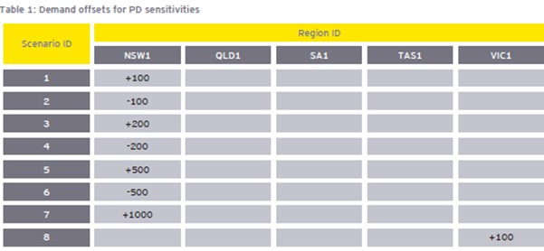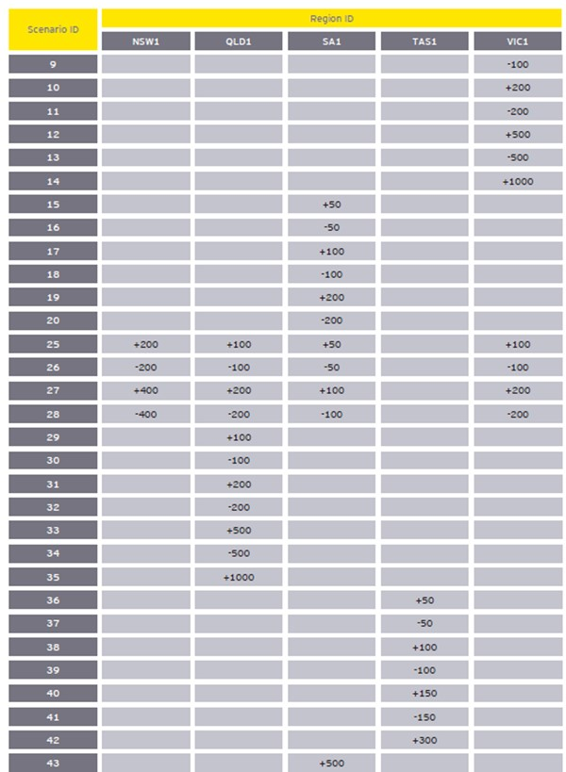
141 Dr Ledgerwood considered the PD sensitivities to be of limited value in predicting the impact of withholding on the dispatch price “because the latter often depends on the interplay between ramp down and ramp up rates (and FSIP constraints), none of which is captured in AEMO’s sensitivities” (4LedgerwoodR at [17]). The differences of opinion as to what may or may not be shown by these data sets simply reinforced the complexity faced by traders in assessing whether or not to place a rebid and the unpredictability and uncertainty involved in that process.

The National Electricity Rules
142 The NEM is governed by and subject to the NER, which are made under the National Electricity Law (NEL) (enacted by the Schedule to the National Electricity (South Australia) Act 1996 (SA)) and have the force of law. As at the commencement of the Conduct Period, the objective of the NEL was:
… [T]o promote efficient investment in, and efficient operation and use of, electricity services for the long term interests of consumers of electricity with respect to–
(a) the price, quality, safety, reliability and security of supply of electricity; and
(b) the reliability, safety and security of the national electricity system.
143 In December 1997, the Australian Competition and Consumer Commission (ACCC) authorised the National Electricity Code (NEC), the predecessor to the NER. In the lead up to that authorisation, arguments had been made for and against restrictions on rebidding (Trade Practices Commission (TPC) Determination – 10 December 1997 (1997 Determination)). In the TPC’s draft Determination, it proposed requiring that r 3.8.22 be amended to “prohibit all rebidding of MW quantities within three trading intervals prior to dispatch” (1997 Determination at 62). Ultimately, the TPC rejected that proposal, noting its concerns with imposing restrictions which might include “distortions to the market, imposing costs on the market, introducing inequities in the treatment of generating plants, and introducing perverse incentives regarding demand side participation”. Its solution was to require market monitoring (1997 Determination at 69).
144 Similarly, between 2000 to 2001, the National Electricity Code Administrator (NECA), the predecessor to the Australian Energy Regulator (AER), sought variation to the rebidding rules under the NEC. By the Amendments to the National Electricity Code: Changes to Bidding and Rebidding Rules – Final Determination (4 December 2002) (2002 Final Determination), the ACCC, in varying the rebidding rules to require that bids and rebids are made “in good faith”, stated (at ix):
Significant price spikes have been observed in the spot market [that] appear to have been in part the result of a strategic withdrawal of capacity, increasing year average prices significantly. There is a concern about the ability of generators to affect spot prices and the relative lack of competitive generator response witnessed …
[…]
… [I]t remains important that the market design does not unnecessarily facilitate the exercise of market power. The rebidding provisions are important to enable the market to respond efficiently to evolving conditions. However, the present provisions are also open to abuse.
(Emphasis added.)
145 In considering the NECA’s application to institute the “good faith” variation to the rebidding rules, the ACCC noted (at 7):
Concerns have been raised that generators are able to take advantage of rebidding to obtain financial benefits from price spikes. NECA claims that the inflationary impacts of price spikes on the spot price is detrimental to the operation of the market. NECA argues that because price spikes arise suddenly and are short term in duration, competitive responses are rare.
(Emphasis added.)
146 Again, the ACCC rejected any change to the rebidding rules that would include a prohibition on “economic withholding” observing that such a prohibition would “significantly change the nature of bidding in the pool” and that “restrictions on the ability to rebid … could lead to less efficient outcomes and potentially higher prices” (2002 Determination at [5.1.1]-[5.1.2]). Instead, it approved a requirement that bids and rebids be made in good faith. The ACCC emphasised that “[r]ebidding is a key element of the market design because it allows the market to balance supply and demand efficiently to ensure demand is met by efficiently priced supply” (emphasis added), but at [4.4.1], endorsed
the intent of the good faith clause because the design of the electricity market auction relies on information being submitted by generators that reflects their true intentions relating to bids and rebids. If accuracy of data being submitted by participants cannot be relied upon, serious questions about the market design and its workability may need to be addressed.
There is a net public benefit associated with the improved accuracy of forecasts and the Commission believes that this provision may have a dampening effect on gaming behaviour in the NEM.
(Emphasis added.)
147 The ACCC concluded, at [4.4.1], that “Restrictions on rebidding could produce a wedge between actual and competitive price outcomes, leading to less efficiency and inefficient dispatch of generation” which it observed was “clearly not in the long-term interest of the market” (emphasis added).
148 The NER contains various provisions designed to regulate the appropriateness of Generators’ offers, bid and rebids for dispatch. A contravention of s 46 of the CCA, however, does not depend on breaches of the NER. Nevertheless, it is useful to set out the relevant provisions of the NER to understand the conduct complained of within the regulatory context.
149 Many versions of the NER were in force during the Conduct Period (Versions 47-92) (SAF at [141]-[142]). At all times during the Conduct Period, rebidding was permitted in accordance with cl 3.8.22 of the NER (SAF at [143]). For the majority of the Conduct Period, Versions 69 and 78 (which are, relevantly, in materially the same terms) contained the rules relating to rebidding. The relevant provisions are set out below. Significant changes were introduced by Version 82, which covered the period from 1 July 2016 to 28 September 2016. The two subsequent versions relevant to the Conduct Period, Version 87 (current from 15 December 2016 to 31 December 2016) and Version 92 (current from 30 May 2017 to 30 June 2017) do not differ materially from Version 82.
150 Only one of the Sample Intervals post-dates the 1 July 2016 amendments, being ATI#12 on 31 December 2016.
151 The background to the changes introduced in mid-2016 was explained in the ‘State of the energy market, May 2017’ (May 2017 Report). At [1.8], “[o]pportunistic bidding by large generators” was canvassed as a cause of market volatility. Previous annual ‘State of the energy market’ reports had similarly identified a likely causal relationship. Paragraph 1.8 of the May 2017 Report stated:
Opportunistic bidding by large generators has caused periods of spot market volatility in Queensland for several years, typically during summer. In summer 2014-15, for example, Generators periodically rebid large volumes of capacity from low to very high prices late in a trading interval, typically on days of high energy demand and when import capability on transmission interconnectors was constrained. By rebidding late in a trading interval, other generators lacked time to respond by ramping up their output. Given the settlement price is the average of the six dispatch prices forming a trading interval, a price spike in just one dispatch interval can flow through to very high 30 minute settlement prices.
[…]
In 2015-16, the AER engaged closely with wider rule change processes focusing on the integrity of bidding behaviour in the NEM. The reforms, relating to bidding in good faith and generator ramp rates, came into effect in July 2016.
The rebidding reforms strengthen the requirement for generators to have genuine intent to honour their bids. To do so, they:
- prohibit offers, bids and rebids that are false, misleading or likely to mislead
- require rebids to be made as soon as practicable after a generator or market participant becomes aware of the changed material conditions or circumstances that prompted the rebid
- require participants to maintain a contemporaneous record of the circumstances surrounding late rebids.
(Citations omitted. Emphasis added.)
152 In broad terms, the amendments: proscribed misleading rebids, rather than simply requiring rebids to be made “in good faith”; introduced the concept of a “late rebidding period” (defined in Chapter 10 of Versions 82-92 of the NER as, “[i]n respect of a trading interval, the period beginning 15 minutes before the commencement of the trading interval”; and require participants to complete a contemporaneous record in relation to a rebid made during a “late rebidding period".
153 The relevant differences between Version 78 (and its predecessors), on the one hand, and Versions 82 (and subsequent), on the other hand, are shown in square brackets below (“[]”), which denote those clauses appearing in Versions 82 (and subsequent), but not Version 78.
3.8.22 Rebidding
(a) Prices for each price band that are specified in dispatch bids, dispatch offers and market ancillary service offers are firm and no changes to the price for any price band are to be accepted under any circumstances.
(b) Subject to clauses 3.8.3A, 3.8.7A, 3.8.19(a) and 3.8.22A, a Scheduled Generator, Semi-Scheduled Generator or Market Participant may submit a rebid to vary:
(1) its available capacity, daily energy constraints, dispatch inflexibilities and ramp rates of generating units, scheduled network services and scheduled loads; and
(2) the response breakpoints, enablement limits and response limits of market ancillary services,
previously notified in a dispatch offer, a dispatch bid or a previous rebid.
(c) A Scheduled Generator … must provide:
…

(2) to AEMO, at the same time as the rebid is made:
(i) a brief, verifiable and specific reason for the rebid; and
(ii) the time at which the event(s) or other occurrence(s) adduced by the relevant Generator … as the reason for the rebid, occurred;

(3) to the AER, upon written request, in accordance with guidelines published by the AER from time to time under this clause 3.8.22 and in accordance with the Rules consultation procedures, such additional information to substantiate and verify the reason for a rebid as the AER may require from time to time.

[(3) to the AER, upon written request, in accordance with guidelines published by the AER, such additional information to substantiate and verify the reason for a rebid (including any record made under paragraph (ca)) as the AER may require from time to time.]
…
[(ca) A Scheduled Generator … who makes a rebid during a late rebidding period must make a contemporaneous record in relation to the rebid, which must include a record of:

(i) the material conditions and circumstances giving rise to the rebid;
(ii) the Generator’s or Market Participant’s reasons for making the rebid;
(iii) the time at which the relevant event(s) or other occurrence(s) occurred; and
(iv) the time at which the Generator or Market Participant first became aware of the relevant event(s) or other occurrence(s).]

(d) The AER must provide information provided to it in accordance with paragraph (c)(3) to any Scheduled Generator … that requests such information, except to the extent that the information can be reasonably claimed to be confidential information.
…
3.8.22A Variation of offer, bid or rebid
(a) A Scheduled Generator … must make a dispatch offer, dispatch bid or rebid in relation to available capacity and daily energy constraints in good faith.
(b) In paragraph (a), a dispatch offer, dispatch bid or rebid is taken to be made in good faith if, at the time of making such an offer, bid or rebid, a Scheduled Generator … has a genuine intention to honour that offer, bid or rebid if the material conditions and circumstances upon which the offer, bid or rebid were based remain unchanged until the relevant dispatch interval.
(c) A Scheduled Generator … may be taken to have contravened paragraph (a) notwithstanding that, after all the evidence has been considered, the intention of the relevant Generator … is ascertainable only be inference from:
(1) the conduct of the relevant Generator … ;
(2) the conduct of any other person; or
(3) the relevant circumstances.

[3.8.22A Offers, bids and rebids must not be false or misleading
(a) A Scheduled Generator … must not make a dispatch offer, dispatch bid or rebid that is false, misleading or likely to mislead.
(a1) For the purposes of paragraph (a), the making of a dispatch offer, dispatch bid or rebid is deemed to represent to other Generators … through the pre-dispatch schedules published by AEMO that the offer, bid or rebid will not be changed, unless the Generator … becomes aware of a change in the material conditions and circumstances upon which the offer, bid or rebid are based.
(b) Without limiting paragraph (a), a dispatch offer, dispatch bid or rebid is deemed to be false or misleading if, at the time of making such an offer, bid or rebid, a Scheduled Generator …:
(1) does not have a genuine intention to honour; or
(2) does not have a reasonable basis to make;
the representations made by reason of paragraph (a1).
(b1) In any proceeding in which a contravention of paragraph (a) is alleged, in determining whether a Scheduled Generator … made a dispatch offer, dispatch bid or rebid that was false, misleading or likely to mislead, a court must have regard to the market design principle set out in clause 3.1.4(a)(2).
(c) A Scheduled Generator … may be taken to have contravened paragraph (a) notwithstanding that, after all the evidence has been considered, the false or misleading character of the dispatch offer, dispatch bid or rebid (including either of the matters referred to in subparagraphs (b)(1) and (2)) is ascertainable only be inference from:
(1) other dispatch offers, dispatch bids or rebids made by the Generator … or in relation to which the Generator … had substantial control or influence;
(2) other conduct (including any pattern of conduct), knowledge, belief or intention of the relevant Generator …
(3) the conduct (including any pattern of conduct), knowledge, belief or intention of any other person;
(4) information published by AEMO to the relevant Generator … or
(5) any other relevant circumstances.
(d) A rebid must be made as soon as practicable after the Scheduled Generator … becomes aware of the change in material conditions and circumstances on the basis of which it decides to vary its dispatch offer or dispatch bid.
(e) In any proceeding in which a contravention of paragraph (d) is alleged, in determining whether the Generator … made a rebid as soon as practicable, a court must have regard to:
(1) the market design principle set out in clause 3.1.4(a)(2); and
(2) the importance of rebids being made, where possible, in sufficient time to allow reasonable opportunity for other Market Participants to respond (including by making responsive rebids, by bringing one or more generating units into operation or increasing or decreasing the loading level of any generating units, or by adjusting the loading level of any load) prior to:
(i) the commencement of the trading interval to which the rebid relates; or
(ii) the commencement of any dispatch interval within that trading interval.
and may have regard to any other relevant matter, including any of the matters referred to in sub-paragraphs (c)(1) to (5).]
154 Under either iteration of the NER between Version 78, and Versions 82 (and subsequent), breach of the good faith requirement, or the making of a misleading rebid, could give rise to liability to a civil penalty.
155 Relevantly, in respect of the post-1 July 2016 versions of the NER, in considering any breach of cl 3.8.22A(d) for the purposes of civil penalty proceedings, a court is directed to have regard to: the market design principle in cl 3.1.4(a)(2) and the importance of rebids being made, where possible, in sufficient time to allow a reasonable opportunity for other market participants to respond prior to the commencement of the TI to which the rebid relates or the commencement of any DI within that TI (cl 3.8.22A(e)).
156 The “Market design [principle]” in cl 3.1.4(a)(2) of Versions 69 and 78 of the NER referred only to “maximum level of market transparency in the interests of achieving a very high degree of market efficiency”. Version 82 of the NER (subsequently maintained in Versions 87 and 92) was expanded as follows:
(2) maximum level of market transparency in the interests of achieving a very high degree of market efficiency, including by providing accurate, reliable and timely forecast information to Market Participants, in order to allow for responses that reflect underlying conditions of supply and demand.
(Emphasis added.)
157 The remaining design principles to which effect is given in Chapter 3 of all hitherto mentioned versions of the NER are:
(a) (1) minimisation of AEMO decision-making to allow Market Participants the greatest amount of commercial freedom to decide how they will operate in the market;

(Emphasis added.)
…
(3) avoidance of any special treatment in respect of different technologies used by Market Participants;
(4) consistency between central dispatch and pricing;
(5) equal access to the market for existing and prospective Market Participants;
(6) market ancillary services should, to the extent that it is efficient, be acquired through competitive market arrangements and as far as practicable determined on a dynamic basis. Where dynamic determination is not practicable, competitive commercial contracts between AEMO and service providers should be used in preference to bilaterally negotiated arrangements;
(7) the relevant action under section 116 of the National Electricity Law or direction under clause 4.8.9 must not be affected by competitive market arrangements;
(8) where arrangements require participants to pay a proportion of AEMO costs for ancillary services, charges should where possible be allocated to provide incentives to lower overall costs of the NEM. Costs unable to be reasonably allocated this way should be apportioned as broadly as possible whilst minimising distortions to production, consumption, and investment decisions; and
(9) where arrangements provide for AEMO to acquire an ancillary service, AEMO should be responsible for settlement of the service.
(b) This Chapter is not intended to regulate anti-competitive behaviour by Market Participants which, as in all other markets, is subject to the relevant provisions of the Competition and Consumer Act 2010 (Cth) and the Competition Codes of participating jurisdictions.
158 Having established the regulatory background relevant to the conduct in question, it is appropriate to turn to the statutory context within which Stillwater alleges breach by the respondents.

SECTION 46 OF THE CCA
159 Section 46 is concerned with the misuse of market power. At the time in question, it provided, relevantly:
46 Misuse of market power
(1) A corporation that has a substantial degree of power in a market shall not take advantage of that power in that or any other market for the purpose of:
(a) eliminating or substantially damaging a competitor of the corporation or of a body corporate that is related to the corporation in that or any other market;
(b) preventing the entry of a person into that or any other market; or
(c) deterring or preventing a person from engaging in competitive conduct in that or any other market.
[…]
(1A) For the purposes of subsections (1) and (1AA):
(a) the reference in paragraphs (1)(a) and (1AA)(a) to a competitor includes a reference to competitors generally, or to a particular class or classes of competitors; and
(b) the reference in paragraphs (1)(b) and (c) and (1AA)(b) and (c) to a person includes a reference to persons generally, or to a particular class or classes of persons.
(2) If:
(a) a body corporate that is related to a corporation has, or 2 or more bodies corporate each of which is related to the one corporation together have, a substantial degree of power in a market; or
(b) a corporation and a body corporate that is, or a corporation and 2 or more bodies corporate each of which is, related to that corporation, together have a substantial degree of power in a market;
the corporation shall be taken for the purposes of this section to have a substantial degree of power in that market.
(3) In determining for the purposes of this section the degree of power that a body corporate or bodies corporate has or have in a market, the court shall have regard to the extent to which the conduct of the body corporate or of any of those bodies corporate in that market is constrained by the conduct of:
(a) competitors, or potential competitors, of the body corporate or of any of those bodies corporate in that market; or
(b) persons to whom or from whom the body corporate or any of those bodies corporate supplies or acquires goods or services in that market.
(3A) In determining for the purposes of this section the degree of power that a body corporate or bodies corporate has or have in a market, the court may have regard to the power the body corporate or bodies corporate has or have in that market that results from:
(a) any contracts, arrangements or understandings, or proposed contracts, arrangements or understandings, that the body corporate or bodies corporate has or have, or may have, with another party or other parties; and
(b) any covenants, or proposed covenants, that the body corporate or bodies corporate is or are, or would be, bound by or entitled to the benefit of.
(3B) Subsections (3) and (3A) do not, by implication, limit the matters to which regard may be had in determining, for the purposes of this section, the degree of power that a body corporate or bodies corporate has or have in a market.
(3C) For the purposes of this section, without limiting the matters to which the court may have regard for the purpose of determining whether a body corporate has a substantial degree of power in a market, a body corporate may have a substantial degree of power in a market even though:
(a) the body corporate does not substantially control the market; or
(b) the body corporate does not have absolute freedom from constraint by the conduct of:
(i) competitors, or potential competitors, of the body corporate in that market; or
(ii) persons to whom or from whom the body corporate supplies or acquires goods or services in that market.
(3D) To avoid doubt, for the purposes of this section, more than 1 corporation may have a substantial degree of power in a market.
(4) In this section:
(a) a reference to power is a reference to market power;
(b) a reference to a market is a reference to a market for goods or services; and
(c) a reference to power in relation to, or to conduct in, a market is a reference to power, or to conduct, in that market either as a supplier or as an acquirer of goods or services in that market.
[…]
(6A) In determining for the purposes of this section whether, by engaging in conduct, a corporation has taken advantage of its substantial degree of power in a market, the court may have regard to any or all of the following:
(a) whether the conduct was materially facilitated by the corporation’s substantial degree of power in the market;
(b) whether the corporation engaged in the conduct in reliance on its substantial degree of power in the market;
(c) whether it is likely that the corporation would have engaged in the conduct if it did not have a substantial degree of power in the market;
(d) whether the conduct is otherwise related to the corporation’s substantial degree of power in the market.
This subsection does not limit the matters to which the court may have regard.
(7) Without in any way limiting the manner in which the purpose of a person may be established for the purposes of any other provision of this Act, a corporation may be taken to have taken advantage of its power for a purpose referred to in subsection (1) notwithstanding that, after all the evidence has been considered, the existence of that purpose is ascertainable only by inference from the conduct of the corporation or of any other person or from other relevant circumstances.
160 As Senior Counsel for Stillwater submitted, s 46 is directed at protecting consumers and the competitive process. The Explanatory Memorandum to the Competition and Consumer Amendment (Misuse of Market Power) Bill 2017 (Cth) (EM) notes, at [1.13], that “[t]he objective of section 46 is to prevent firms from engaging in unilateral conduct that harms the competitive process”. It is intended to “target anti-competitive conduct” (EM at [1.17]). The amendment to s 46 introduced by the Misuse of Market Power Bill “prohibits a corporation that has a substantial degree of market power in a market from engaging in conduct with the ‘purpose, effect or likely effect’ of substantially lessening competition in particular markets”.
161 In Boral Besser Masonry Ltd (now Boral Masonry Ltd) v Australian Competition and Consumer Commission [2003] HCA 5; 215 CLR 374 at [260], McHugh J drew attention to s 2 of the CCA which declares that its object “is to enhance the welfare of Australians through the promotion of competition and fair trading and provision for consumer protection”. His Honour observed that the “Parliament has determined that it is in the interests of consumers that firms be required to compete because competition results in lower prices, better goods and services and increased efficiency”. As had previously been observed by Mason CJ and Wilson J in Queensland Wire Industries Pty Ltd v Broken Hill Proprietary Co Ltd [1989] HCA 6; 167 CLR 177 at 191, “[t]he object of s. 46 is to protect the interests of consumer interests, the operation of the section being predicated on the assumption that competition is a means to that end”.
162 In Boral, McHugh J cautioned, at [261], that courts called upon to apply s 46 must do so with the object of the section in mind.
While conduct must be examined by its effect on the competitive process, it is the flow on effect that is the key – the effect on consumers, not the effect on other competitors. Competition policy suggests that it is only when consumers will suffer as a result of the practices of a business firm that s 46 is likely to require courts to intervene and deal with the conduct of that firm.
163 His Honour had previously observed, at [206], that:
… competition by its nature is deliberate and ruthless and competitors injure each other by seeking to take sales from one another. A rational business firm seeks to maximise profit and to increase its share of the market. However, the very nature of such conduct is detrimental to other competitors in the market and may cause some of those competitors to leave the market.
164 Section 46 requires the Court to answer four questions: Boral at [262]. First, what was the relevant market in which the conduct occurred? Secondly, did the alleged contravenor have a substantial degree of market power, in other words, was there an absence of a sufficient level of competition to constrain it from engaging in the conduct? Thirdly, did the alleged contravenor take advantage of that market power? Fourthly, did the alleged contravenor engage in the conduct for one of the prescribed purposes; in this case, for the purpose of deterring or preventing competing Generators from engaging in competitive conduct in the market?
165 Section 46(3) recognises that market power is a matter of degree. The statute directs the Court’s attention to the extent to which a contravenor’s conduct is constrained by its competitors, or potential competitors, or its suppliers or customers. It is therefore necessary to identify precisely the conduct about which complaint is made. In this case, the conduct complained of is Short-notice Rebidding – defined broadly as economic withholding and delaying the placing of rebids until 15 minutes, or less, before gate closure, expecting and intending that other Generators would be unable to respond competitively.

WHAT IS THE RELEVANT “MARKET”?
166 The “Market” was pleaded at [22] of the 3FASOC in the following terms:
During the Conduct Period, the relevant market for the purpose of section 46 of the CCA was the market for the wholesale supply of electricity:
(a) to the Regional Reference Node in the QRNEM; and
(b) to the QRNEM through the Interconnectors.
(Market).
Particulars
The Market excludes supply of electricity that is not connected to the Grid. It was a feature or characteristic of the Market that from time to time the interconnectors between the QRNEM and the New South Wales region of the NEM reached their maximum capacity (became constrained or bound) so that further supply into the QRNEM from Dispatch Units located outside the QRNEM was not possible. The QRNEM during these periods became price-separated from the New South Wales region of the NEM.
These periods of interconnector binding were able to be predicted by Generators with some (but not perfect) confidence, and in many instances were caused or kept in place by Stanwell’s and/or CS Energy’s Short-notice Rebids.
(Emphasis in original.)
167 The Economic Conclave was agreed that market definition is part of the framework for, and a preliminary step towards, assessing market power (JtEcER at [28]).
168 Three different markets were posited by participants in the Economic Conclave in their individual reports. Dr Ledgerwood originally defined the market as comprising “each of the 9,211 dispatch intervals within the Conduct Period where the QRNEM was a separate market” (2LedgerwoodR at [30]), being when the transmission constraints between New South Wales and Queensland are binding such that price separation occurs. He opined that in those circumstances “each region is in a different geographic market” (2LedgerwoodR at [930]). Dr Ledgerwood’s corresponding position was that, if transmission constraints between New South Wales and Queensland, for example, are not binding, then “the two regions effectively are in the same geographic market” (2LedgerwwodR at [929]).
169 Mr Holt’s opinion was that the relevant market is “wider than the QRNEM, and at least includes inflows from NSW into Qld” (HoltR at [1.4.16]).
170 Mr Morton adopted the broadest approach to defining the Market. It was his opinion that the Market is “the dispatch of electricity on the wholesale spot market and the sale of electricity on the contract markets in the NEM, and electricity produced from behind-the-meter-sources and demand management responses within the operational area of the NEM” (1MortonR at [5.5.1]).
171 The relevance of correctly identifying the market in which there is alleged to have been a misuse of market power was highlighted by Mr Holt (HoltR at [2.2.3]), quoting the economist Professor Massimo Motta, who wrote that “the definition of the market (both from its product and geographical points of view) is a preliminary step towards the assessment of market power” (Massimo Motta, Competition Policy: Theory and Practice (Cambridge University Press, 2004), 101). Motta emphasised, “[s]ince market definition is instrumental only to the assessment of market power, the relevant market should not be a set of products, which ‘resemble’ each other on the basis of some characteristics, but rather the set of products (and geographical areas) that exercise some competitive constraint on each other” (Motta, 102) (emphasis added).
172 The identification of the relevant “market” turns on the geographical, functional, temporal, and product dimensions of that market: Australian Competition and Consumer Commission v Flight Centre Travel Group [2016] HCA 49; 261 CLR 203 at [66]-[67] per Kiefel and Gageler JJ. The principles applicable in determining the relevant “market” for the purposes of s 46 are well settled. Nevertheless, on the facts of this case, the applicability of those principles was challenged by Dr Ledgerwood. In particular, Dr Ledgerwood asserted that there were “special principles” relevant to electricity markets. He opined that “one must place special importance on the [b]inding of a constraint”.
173 From an orthodox perspective, market definition is, in the first place, purposive. In Air New Zealand Ltd v Australian Competition and Consumer Commission [2017] HCA 21; 262 CLR 207, Gordon J said, at [58]:

The first step is to identify “precisely what it is that is said to have been done in contravention of the section”. As has been rightly said in the Federal Court of Australia, the court begins with the problem at hand and asks “what market identification best assists the assessment of the conduct and its asserted anti-competitive attributes”. Identifying a market is a “focussing process” which is “to be undertaken with a view to assessing whether the substantive criteria for the particular contravention in issue are satisfied, in the commercial context the subject of analysis.
(Citations omitted. Emphasis in original.)
174 The Economic Conclave was largely agreed that the objective of market definition is to “identify the competitive constraints and rivalry faced by the supplier of the product under consideration”. Messrs Morton and Holt explained that this required identification of “the market forces that reduce the possibility of sustainably raising prices above competitive levels or otherwise engaging in anti-competitive conduct” (emphasis added). Dr Ledgerwood disagreed with the inclusion of the word “sustainably” insofar as it suggests that actions which cause a price spike lasting only one DI would fall outside the relevant market forces contemplated (JtEcER at [29]). Dr Ledgerwood explained his opinion about transitory price increases in the following terms:
Over [a] long timeframe, in considering competition that might be appropriate but, in conduct cases, looking at the matter from that perspective, loses the fact that those intermittent, or if somebody wants to call them transitory price increases, those are the manifestation of the behaviour that’s problematic. If you try to ignore those, what you are essentially saying is that those anti-competitive acts, if they are found to be so, can never be viewed as being anti-competitive or problematic.
175 This opinion inverted the task required of a court in determining whether there has been anti-competitive conduct.
176 Secondly, a “market” is usually understood as “the field of actual and potential transactions between buyers and sellers amongst whom there can be strong substitution, at least in the long run, if given a sufficient price incentive”: Re QCMA at 517. As was said by the Competition Tribunal in that case:
… [I]n determining the outer boundaries of the market we ask a quite simple but fundamental question: If the firm were to “give less and charge more” would there be, to put the matter colloquially, much of a reaction? And if so, from whom? In the language of economics the question is this: From which products and which activities could we expect a relatively high demand or supply response to price change, i.e. a relatively high cross-elasticity of demand or cross-elasticity of supply?
177 The point was also made by the Trade Practices Tribunal in Re Tooth & Co Ltd and Tooheys Ltd (1979) 39 FLR 1 at 38-39 per Deane and Keely JJ:
First, and most generally, we seek to identify the area or areas of close competition of relevance for the applications.
Second, such competition may proceed not just through the substitution of one product for another in use (substitution in demand) but also through the substitution of one source of supply for another in production or distribution (substitution in supply). The market should comprehend the maximum range of business activities and the widest geographic area within which, if given a sufficient economic incentive, buyers can switch to a substantial extent from one source of supply to another and sellers can switch to a substantial extent from one production plan to another. In an economist’s language, both cross-elasticity of demand and cross-elasticity of supply are relevant.
Third, there is the matter of time perspective. It is plain that the longer the period allowed for likely customer and supplier adjustments to economic incentives, the wider the market delineated. In our judgment, given the policy objectives of the legislation, it serves no useful purpose to focus attention upon a short-run, transitory situation. We consider we should be basically concerned with substitution possibilities in the longer run.
(Emphasis added.)
178 Chief Justice Mason and Wilson J put it this way in Queensland Wire Industries at 187-188:
The analysis of a s. 46 claim necessarily begins with a description of the market in which the defendant is thought to have a substantial degree of power. In identifying the relevant market, it must be borne in mind that the object is to discover the degree of the defendant’s market power. Defining the market and evaluating the degree of power in that market are part of the same process, and it is for the sake of simplicity of analysis that the two are separated … After identifying the appropriate product level, it is necessary to describe accurately the parameters of the market in which the defendant’s product competes: too narrow a description of the market will create the appearance of more market power than in fact exists; too broad a description will create the appearance of less market power than there is.
(Emphasis added.)
179 Thirdly, the market should not be defined in a way that is artificial, contrived, or does not accurately and realistically describe and reflect the interactions between participants in the alleged market. In Australian Competition and Consumer Commission v Australia and New Zealand Banking Group Ltd [2015] FCAFC 103; 236 FCR 78 (ACCC v ANZ) at [138], the Full Court of the Federal Court (Allsop CJ, Davies and Wigney JJ) observed that the premise of the proposition that a market definition must be based on fact, as expressed by French J in Singapore Airlines Ltd v Tapobrane Tours WA Pty Ltd [1991] FCA 808; 33 FCR 158 at 174, is:
that it has economic and commercial reality. It must accordingly not be artificial or contrived. Economists frequently construct economic models to analyse complex commercial or economic events or scenarios. But a model is unlikely to be a useful analytical tool if based on unrealistic assumptions that materially depart from the real world facts and circumstances involving commercial behaviour in which the events to be analysed occur. A court should be loath to accept or act on a market definition which is an artificial construct that does not accurately or realistically describe and reflect the interactions between, and perception and actions of, the relevant actors or participants in the alleged market, that is, the commercial community involved.
(Emphasis added.)
180 Messrs Morton and Holt expressed views that accorded with the overarching premise expressed in this passage. Dr Ledgerwood remained unclear as to what was meant by “commercial context of the environment” (JtEcER, Dr Ledgerwood at [35]).
181 Fourthly, whilst it is acknowledged that there may be sub-markets within any given market in which competition is especially close or immediate (in this case, perhaps in Queensland once the interconnectors are bound), the question of market power requires consideration of power in the market, not a sub-market. In Australian Competition and Consumer Commissioner v Metcash Trading Ltd [2011] FCA 967; 198 FCR 297 at [179], Emmett J said:
The question of market power requires consideration of market power in the relevant market, not market power in some sub-market. However, the delineation of sub-markets can be useful as pointing to a particular characteristic or structural dimension of the market that throws light in how the market works, once the market has been defined.
182 In Singapore Airlines, at 181-182, French J drew attention to the circumstances where markets are separated “according to functional levels which relate to categories of purchase (eg wholesale and retail sales)” and observed that “because such categories are relatively transitory phenomena, it has been suggested that they are not an appropriate basis for defining markets, but may support identification of sub-markets”.
183 As has already been observed above, in the Second Ledgerwood Report, Dr Ledgerwood identified a market that comprised only the 9,211 DIs across the Conduct Period in which the interconnectors were bound northwards and the dispatch price in Queensland was twice that of New South Wales.
184 Dr Ledgerwood’s inversion of the approach to identifying anti-competitive conduct infected his opinion of what constituted the relevant market. His approach was to identify the individual 5-minute DIs in which a price spike occurred. He identified that, on each of those occasions, the interconnector was bound northwards, and there was price separation between Queensland and New South Wales. Having undertaken this exercise, by the application of his screens, Dr Ledgerwood arrived at the conclusion, albeit a somewhat artificial one, that those circumstances amounted to a field of rivalry in which other electricity Generators were unable to compete in the same 5-minute DI. The identification of an event (the binding of the interconnectors) that occurred in only 1.6% of all the DIs within the Conduct Period cannot be described as anything more than a transient or infrequent action, contrary to principle and authority (Re Tooth at 38-39).
185 The focus on only the particular 5-minute DI also neglected to consider what occurred in the following DIs – being, as Mr Morton put it, “a swift and highly competitive response” (1MortonR at [5.6.40]) consistent with a properly operating market. Further, Dr Ledgerwood’s written opinion disregarded the fact that rivalry occurs throughout the NEM before an impugned rebid takes place, and that any rebid must take place before gate-closure. As such, as Stanwell submitted, it is an artifice to say that after the interconnectors become bound, further rivalry is limited. That is because the interconnectors only bind after the NEMDE has resolved the dispatch targets, interconnector limits, and interconnector flows simultaneously in response to the rivalry that has already occurred through the placing of the bids and any rebids.
186 Further, for the vast bulk of the Conduct Period, the interconnectors were not bound. Dr Ledgerwood identified they were bound north in 28,638 DIs (just over 5% of all DIs in the Conduct Period) (JtEcER Fig SDL 1). In his oral evidence, Dr Ledgerwood accepted that the binding of the interconnectors occurred infrequently and transiently and that, for the remaining 95% of the time, “when the interconnectors are not bound any Generator throughout the NEM could supply Queensland up to the limits of the interconnector”.
187 In reaching his initial conclusion, and as I have already adverted to, Dr Ledgerwood contended that there were “special” principles to be applied in the case of electricity markets, but ultimately could not articulate any such principles other than to say, “one must place special importance on the [b]inding of a constraint”.
188 In the JtEcER, Dr Ledgerwood performed what he described as a “hypothetical monopolist test” (HMT) to support his proposed market definition. This was, in part, to answer the observations of Messrs Morton and Holt that such a test, together with a “SSNIP test”, was one approach to determining the boundaries of the relevant market (Metcash at [247]-[248]).
189 As was explained by the Economic Conclave, the HMT “is based on a hypothetical situation of a monopolist focussing on pricing constraints arising from substitutes to the focal product in the focal geographic area”. It “focuses on the ability of a hypothetical monopolist to profitably sustain increased prices, because the objective is to identify the potential sources of competitive constraints from outside the candidate relevant market (to determine whether it should be widened) rather than from inside it” (JtEcER at [39]). In determining the boundaries of the relevant market, the Economic Conclave explained that “this may include the small-but-significant non-transitory increase in price (SSNIP) test”. This was explained at [40]. To summarise, the SSNIP test involves: first, considering the smallest market for the focal product; secondly, assuming the existence of a hypothetical monopolist in this candidate market, asking whether a 5%-10% price increase above competitive levels would be profitable for a sustained period. If the answer is “yes”, this means that the hypothetical monopolist does not lose a sufficiently high proportion of its sales to make the price increase unprofitable. Therefore the market includes the closest substitutes of the focal product, and the relevant market has been defined. Alternatively, if the answer is “no”, the candidate market widens to include the closest competitor and one must once again determine whether a 5%-10% price increase would be profitable.
190 Ultimately, Dr Ledgerwood accepted that the test he performed was not done in accordance with the well-established approach of applying a 5-10% increase above competitive levels to assess whether that would be profitable on a sustained basis. Despite Dr Ledgerwood’s opinion to the contrary, the test he did perform was of little utility. In any event, both Messrs Morton and Holt agreed that applying the HMT or SSNIP in the circumstances of this case would be challenging and neither had attempted to do so. Mr Holt said (JtEcER at [84]):
In short, the actual evidence is that increases in prices cannot be sustained over time in QLD (which is the key question that the HMT and SSNIP test seek to address) due to electricity supplies via the QLD/NSW interconnectors, such that the market should be defined more broadly to at least include NSW.
191 In his oral evidence, Dr Ledgerwood resiled from his initial opinion that the Market comprised the 9,211 DIs in the Conduct Period when the interconnectors were bound, and instead propounded a single market across all DIs in the Conduct Period, comprising the supply of electricity to the QRNEM, including the quantity supplied over the interconnectors and regardless of price separation. His attempts to re-characterize his written opinion as consistent with his oral testimony were unpersuasive.
192 Importantly, Dr Ledgerwood’s initial opinion had consequences for the way he came to characterise what constituted competitive responses within the market. It meant that he did not turn his mind to nationally occurring circumstances which included: when the interconnectors were bound northward, they could and did flow southward, so when Queensland-based Generators were dispatched to satisfy demand in other States they were competing with Generators NEM-wide; when the interconnectors were bound and flowing northward, the NEMDE had dispatched a Generator from outside the QRNEM to satisfy part of the demand in Queensland, affecting the dispatch price in Queensland; in 12.4% of the occasions when the interconnectors were bound northward, a southern Generator was the marginal supplier (2RoseR at [8.8], [8.13]); when the interconnectors were bound flowing northward, interstate competitors could affect the Queensland price by increasing the New South Wales price and causing the interconnectors to unbind (JtEcER at [91(c)], [281]); the FCAS market operated nationally and could contribute to setting the dispatch price.
193 Ultimately, despite Dr Ledgerwood’s equivocation as between the Second Ledgerwood Report and his oral evidence, he appeared driven to accept Mr Holt’s opinion – that the relevant market comprises the wholesale supply of electricity to the QRNEM, including electricity generated outside Queensland flowing through the interconnectors from New South Wales (HoltR at [1.4.15], [2.6.10]; JtEcER at [105)]. Nevertheless, it was clear that it was not an opinion with which he was comfortable. In his rebuttal on this topic, Dr Ledgerwood said (JtEcER at [151]):
I further note that by tying the frequency of price separation to the definition of the Relevant Market, Mr Holt and Mr Morton have simply made a convenient assumption that infrequent price spikes cannot possibly be the result of the exercise of a substantial degree of market power, which provides a basis for them to avoid the direct analysis of the Respondents’ Short-notice Rebidding behaviour. This (incorrect) assumption would allow for Generators with a substantial degree of market power to behave anti-competitively, as long as they only do so infrequently.
194 I do not accept Dr Ledgerwood’s interpretation of the evidence given by Messrs Holt and Morton on this topic.
195 The remaining question is to resolve the difference of opinion between Messrs Holt and Morton as to the breadth of the relevant market. Mr Morton considered that the product dimension of the relevant market included electricity generated that is not sold through the wholesale market but is otherwise substitutable for it, as well as demand management responses (2MortonR at [5.3.1]). Mr Morton explained that the Spot Market for wholesale electricity is the mechanism used by AEMO to coordinate the physical supply of and demand for electricity (2MortonR at [5.3.2]). He noted that a buyer of wholesale electricity is not limited to purchasing that electricity on the wholesale Spot Market and may instead use the contract market. Both markets, he opined, are essential for the practical operation of the NEM (JtEcER at [121]-[122]). Mr Morton candidly acknowledged, however, that he had very limited access to information about Stanwell’s (or anyone else’s) contract position. Mr Morton also observed that behind-the-meter-generation is a close substitute for Generators operating in the wholesale energy market and so thought it appropriate to include them as part of a single product dimension (2MortonR at [5.3.15]). Although including demand management responses, Mr Morton acknowledged that demand responsiveness was limited during the Conduct Period (2MortonR at [5.3.16]).
196 Whilst acknowledging that his definition of the relevant Market did not explicitly include the broader factors included by Mr Morton, Mr Holt nonetheless agreed that they were relevant features to consider whether any individual firm in the relevant market has substantial market power (JtEcER at [111]).
197 Although Stanwell urged that Mr Morton’s opinion be accepted as conceptually correct, it did not contend that it made any difference in the context of the facts of this case to broaden the market definition beyond that arrived at by Mr Holt, and with which Dr Ledgerwood ultimately concurred.
198 For these reasons, the answer to Issue 1 and to Common Question 1 is “Yes”. The relevant market for the purpose of assessing whether or not Stanwell and/or CS Energy had substantial market power during the Conduct Period is the wholesale supply of electricity to the QRNEM, including inflows from other regions of the NEM.

DID STANWELL AND CS ENERGY HAVE A SUBSTANTIAL DEGREE OF MARKET POWER IN THE MARKET WITHIN THE MEANING OF SECTION 46(1) OF THE CCA?
199 Stillwater pleads (3FASOC at [34] and [41]) that each of Stanwell and CS Energy had a substantial degree of market power during the Conduct Period by reason of the following matters, in summary:
(1) there were high barriers to entry of new Generators and to the expansion of the production capacity of existing Generators in the Market (3FASOC at [25]-[27]).
(2) Stanwell and CS Energy had physical advantages over their competitors being:
(a) generating capacity was derived from numerous generating units;
(b) lower costs of production such that they could offer supply at lower prices;
(c) ownership or control of a greater number of dispatch units and generation capacity than any competing Generator;
(d) ramp rates for each generating unit that was predictable or broadly predictable to all Generators supplying into the Market.
(3FASOC at [28]-[29] and [35]-[36])
(3) the economic consequences were such that:
(a) Stanwell and CS Energy were able to submit low offers for high volumes that ensured, or made it likely that, at most or all levels of forecast demand in the QRNEM, the NEMDE would result in Stanwell and/or CS Energy being instructed to dispatch in any TI for which it submitted a bid, allowing Stanwell and/or CS Energy to do so while maintaining financial viability;
(b) by reason of their ramp rates, and ownership or control of a greater number of generating units, Stanwell and/or CS Energy were generally able to ramp up their generation volume more quickly than could competing Generators, apart from one another.
(3FASOC at [30]-[31] and [37]-[38])
(4) there were no other constraints, or alternatively only limited constraints, on Stanwell and/or CS Energy’s engaging in Short-notice Rebidding during the Conduct Period because of their size, ability to offer high volume at low prices, and typical receipt of the most (or second most after one another) direct financial benefit (from ES revenues) from any increase in the Spot Price, and less risk to Stanwell and/or CS Energy in engaging in Short-notice Rebidding.
(3FASOC at [32]-[33] and [39]-[40])

Economic and legal principles pertaining to substantial market power
200 In approaching the economic evidence given on this topic, I am conscious of the direction given to trial judges by the Full Court in Universal Music Australia Pty Ltd v Australian Competition and Consumer Commission [2003] FCAFC 193; 131 FCR 529 (Universal Music (FC)) at [163] that, although the words of s 46 involve economic concepts and so the application of the statute to the facts of a particular case may be informed by economic evidence or argument, it is the language of the statute which defines the task. Thus, to the extent that the statutory language conflicts with economic theory, the Court is bound to apply the statute. Nevertheless, as was recognised by McHugh J in Boral at [287]:
Market power is an economic concept and should be given its ordinary meaning. As Professors Krattenmaker, Lande and Salop point out:
“When economists use the term ‘market power’ or ‘monopoly power’ they usually mean the ability to price at a supracompetitive level.”
201 Messrs Morton (1MortonR [6.2.4] and [6.3.1]) and Holt (HoltR [3.2.2]-[3.2.3]) were agreed that the test of substantial market power was defined in the economics literature as reflected, variously but similarly, in the excerpts from their respective reports below:
In economics, market power is defined as the ability to profitably raise price above marginal cost. Any firm with a downward-sloping demand curve will have market power. However, not all market power warrants antitrust concern. Antitrust enforcement is warranted if market power is significant and durable. Significant means prices not only exceed marginal cost, but long run average cost so that the firm makes economic profits. Durable means that the firm is able to sustain its economic profits in the long run. These requirements for significance correspond to the definition of monopoly power by the courts: JR Church and R Ware, Industrial Organisation: A Strategic Approach (2000) 603.
The ability of a firm (or a group of firms acting jointly) to raise price above the competitive level without losing so many sales so rapidly that the price increase is unprofitable and must be rescinded: William M Landes and Richard A Posner, ‘Market Power in Anti-trust Cases’ (1981) 93 Harvard Law Review 937, 100.
The ability to price profitably above the competitive level is referred to as market power: Dennis W Carlton & Jeffrery M Perloff, Modern Industrial Organization (4th ed, 2015) 32.
The ability of a firm or group of firms to raise price, through the restriction of output, above the level that would prevail under competitive conditions and thereby to enjoy increased profits from the action: Bishop and Walker, The Economics of EC Competition Law: Concepts, Application and Measurement (3rd ed, Sweet & Maxwell, 2010) 52.
The ability of firms to raise price above the competitive level for a sustained period: Jonathan B Baker and Timothy F Bresnahan, ‘Economic Evidence in Antitrust: Defining Markets and Measuring Market Power’ in Paolo Buccirossi (ed), Handbook of Antitrust Economics (MIT Press, 2008).
(Emphasis added.)
202 In Market Power and Market Manipulation at 8, Dr Ledgerwood et al describe the goal of the book as being,
… to discuss the development and evolution of methods to determine whether and why electric markets are not working properly and how to distinguish between acceptable and unacceptable market behaviours be they the exercise of market power or fraud-based manipulation.
203 In Chapter 2, at 13, the authors say:
Though the precise definitions of the term “market power” vary somewhat among economists, agencies, and courts, the economic concept of market power is well-established: it is the unilateral ability to raise prices without losing profits.
(Emphasis added.)
204 Stillwater submitted that Messrs Morton and Holt had inappropriately focussed on an ability to raise prices sustainably or profitably with the consequential risk of failing to analyse properly the behaviour alleged to have undermined competition and its effects. Stillwater referred to Professor Steven Salop’s observations in, “The First Principles Approach to Antitrust, Kodak, and Antitrust at the Millenium” (2000) 68 Antitrust Law Journal 187 at 191:
Market definition and market power should be evaluated in the context of the alleged anticompetitive conduct and effect, not as a flawed filter carried out in a vacuum divorced from these factors. The first principles approach fulfils this goal because it is centred on a direct evaluation of the competitive effects of the conduct. It does not proceed by relying on imperfect and indirect proxies for market power, which then are used as proxies for the likelihood of anticompetitive effects. Only by analyzing market power and market definition as part of and in reference to the economic analysis of the alleged anticompetitive conduct and its market effects can logic and consistency be maintained and errors be avoided. Similarly, only in this way can relevant markets properly be defined.
(Emphasis added.)
205 This submission was somewhat at odds with the approach taken by its own expert, Dr Ledgerwood, who used a series of proxies for market power including: the binding of the interconnectors and subsequent price separation and ramp rates – arguably in the form of a “type” of HMT – to assess the scope of the “market”; maximum outputs and maximum ramp rates to assess “market power”; and a pivotal supplier test, or analogue thereof, to determine whether the market power was “substantial”. None of these proxies was particularly compelling and often made little sense in the context of the practical operation of the NEM.
206 Nevertheless, in large measure, the views ultimately expressed by all three of the economic experts accorded with the uncontroversial position in Australian competition law that the definition of substantial market power is generally considered to be that stated by Mason CJ and Wilson J in Queensland Wire Industries at 188 (and restated by Gleeson CJ and Callinan J in Boral at [136]):
… the ability of a firm to raise prices above the supply cost without rivals taking away customers in due time, supply cost being the minimum cost an efficient firm would incur in producing the product.
(Emphasis added.)
207 In the same case, Dawson J said, at 200:
The term “market power” is ordinarily to be taken to be a reference to the power to raise price by restricting output in a sustainable manner … But market power has aspects other than influence upon the market price. It may be manifested by practices directed at excluding competition such as exclusive dealing, tying arrangements, predatory pricing or refusal to deal … The ability to engage persistently in these practices may be as indicative of market power as the ability to influence prices. Thus Kaysen and Turner define market power as follows:
“A firm possess market power when it can behave persistently in a manner different from the behaviour that a competitive market would enforce on a firm facing otherwise similar cost and demand conditions.” (Kaysen and Turner, Antitrust Policy (1959), p.75)
(Citations omitted. Emphasis added.)
208 The passage from Dawson J’s judgment was cited with approval by the majority of the High Court (Gleeson CJ, Gummow, Hayne and Callinan JJ) in Melway Publishing Pty v Robert Hicks Pty Ltd [2001] HCA 13; 205 CLR 1 at 21, who then said:
The notion of market power as the capacity to act in a manner unconstrained by the conduct of competitors is reflected in the terms of s 46(3). Such capacity may be absolute or relative. Market power may or may not be total; what is required for the purposes of s 46 is that it be substantial.
209 Similarly, in Boral, McHugh J said, at [287] and [293]:
Firms only have a substantial degree of market power when they can persistently act in a way over a reasonable time period unconstrained by the market's forces of supply and demand. Firms that do not have “the power to raise price above cost without losing so many sales as to make the price unsustainable” do not have market power.
…
The concept of “market power” in s 46 shows that the section is not concerned with a one-second snapshot of economic activity. Market power can only be determined by examining what a firm is capable of doing over a reasonable time period. Whether a firm has market power – whether it has the ability to act unconstrained by competition, whether it can raise prices above competitive levels – requires an examination of the existing structure and the likely structure of the market if competitors are removed or prices rise to supra-competitive levels. Such an analysis requires an examination of the business structure and practices of the alleged offender and its competitors, their market shares and the barriers to entry (if any) into the market.
(Emphasis added.)
210 In Australian Gas Light Company (AGL) v Australian Competition and Consumer Commission (Loy Yang) [2003] FCA 1525; 137 FCR 317 at [456], French J drew a distinction between “transient market power” and “persistent but intermittent” market power. The main issue in Loy Yang was whether the acquisition of Loy Yang A Power Station by AGL was likely to have the effect of substantially lessening competition in any relevant market within the meaning of s 50 of the now repealed Trade Practices Act 1974 (Cth) (TPA).
211 In considering the meaning of “competition”, French J, at [349], referred to the Competition Tribunal’s decision in Re QCMA at 188-189, where it regarded “rivalrous market behaviour” as “the expression of competition”, noting that it “is a process rather than a situation”. His Honour went on to state, at [350]-[351]:
Competition in a market is not assessed by a snapshot view of a participant behaviour at a particular time. The theatre of competition is a theatre of real actors and shadow actors. The shadows are cast by the potential for new entry. The competitive process is informed by the rivalry of potential participants. Competition so understood is conceptually distinct from the idea of the market and the elements of market structure which may constrain or facilitate it…
The word “substantial” in “substantially lessening competition” is another term requiring qualitative judgment which suggests that the use of analogues such as “large” or “weighty” would misdirect … A description of the kind of judgment required by the word “substantially”, which appears recently to have been approved in the High Court, is that the effect of the acquisition be “meaningfully relevant to the competitive process” – [Rural Press Ltd at [41]]. It is also relevant to the present case to bear in mind that in determining whether the acquisition is likely to have the effect of substantially lessening of competition, the Court will give little, if any, weight to short term effects readily corrected by market processes – Universal Music Australia Pty Ltd v Australian Competition and Consumer Commission (2003) 201 ALR 636 at [242].
(Emphasis added.)
212 In Universal Music (FC), the Court had observed earlier in the judgment, at [150]:
As we see the position, in the light of Boral, it is necessary for a court considering a case brought under s 46 of the Act to determine, as a threshold point, whether the relevant corporation has a substantial degree of power in the relevant market. This requires attention to the whole of the evidence relating to the market and the conduct of its participants. It is not legitimate for a court to base a finding of substantial market power simply upon incidents of abuse of power in that market. Almost all participants in a market have a degree of power, which may on occasions be abused. The power of the abuser may or may not be substantial, within the meaning of s 46(1).
(Emphasis added.)
213 What the Full Court identified as an illegitimate approach was reflected in Dr Ledgerwood’s approach to the facts of this case. As he opined on numerous occasions throughout his evidence, there could be no remedy for what he considered to be egregious behaviour by Stanwell and CS Energy unless the behaviour was categorised as anti-competitive. In other words – a remedy was, in his opinion, required, and he sought to fit the impugned conduct within the framework of s 46 in order to ground a remedy.
214 Despite the extract from Dr Ledgerwood’s co-authored book cited above, in the circumstances of this case, Dr Ledgerwood eschewed the proposition that what is described as the “traditional” or “classic” definition of substantial market power was the appropriate test to apply. In particular, Dr Ledgerwood disagreed that the following three matters were relevant to the assessment of whether a firm has a substantial degree of market power (and also with the way in which the evidence should be interpreted as relevant to those matters).
215 First, Dr Ledgerwood disavowed the relevance of profitability. In his opinion, profitability above the cost of capital could only result from “the exercise of substantial market power to cause persistent price increases. As such, it was not relevant in a case such as this where the substantial degree of market power is alleged to have been exercised in relation to Short-notice Rebidding (JtEcER at [161]). The opinion expressed in the JtEcER was difficult to reconcile with paragraphs in the Second Ledgerwood Report where the converse appeared to be expressed. In that Report, at [88], Dr Ledgerwood stated, “[t]he ability of the monopolist to obtain a profitable price-volume trade-off is a prerequisite for its successful exercise of market power”. Similarly, at [990], he said, “the successful exercise of market power requires that it should be profitable”.
216 Secondly, Dr Ledgerwood disavowed that it was necessary to evidence that prices exceed long-run marginal costs (LRMC) over a sustained period (JtEcER at [162]). In Section VII of his Report, which deals specifically with “Substantial degree of market power”, Dr Ledgerwood expressed his opinion in this way (2LedgerwoodR at [972]):
From an economic perspective, a market participant holds a “substantial degree” of market power if it can materially increase the market price through economic withholding.
217 In cross-examination, Dr Ledgerwood’s analysis was revealed to be based on his reasoning that if a long-run benchmark was applied to determine whether somebody has substantial market power, it would not be possible to say that individual price spikes are contrary to law. This, however, was an example of commencing the required analysis with the desired result, rather than commencing with the principle.
218 On the basis of Dr Ledgerwood’s opinion, Stillwater argued that persistent but intermittent market power can, if established, support a finding of substantial market power, relying on Loy Yang. Similar to the facts of this case, the relevant behaviour involved the successful implementation of a particular bidding strategy throughout the summer months of 2000-2001. That strategy involved opportunistic rebidding by the electricity generator operator, Loy Yang A Power Station, by which it regularly repriced its capacity into higher price bands to spike the price in the Victorian Region of the NEM.
219 Although French J found that Loy Yang had successfully implemented the strategy as alleged, his Honour did not find that such conduct evidenced the existence of substantial market power. His Honour said, at [456]:
In my opinion the market tactics here being discussed assume the character of something that looks less like the exercise of market power than moderately well informed betting on the market. The latter characterisation is reflected in the observation of ACCC expert, Professor Frank Wolak of Stanford University, who described a competitive electricity market as “… ‘an extremely complicated non-cooperative game with a very high-dimensional strategy space’ …”. There is no doubt that LYPM did affect spot prices and forward contract prices by reason of its bidding strategy in summer 2000-2001. I am not satisfied that it has adopted that as a general strategy subsequently or that such a strategy could be relied upon, at the level of confidence necessary for commercial decision-making, to work in conditions other than those which fortuitously came together in that summer … No doubt, as Victoria’s largest generator, it is in a position opportunistically to respond to supply/demand imbalance in very short time intervals and if all the variables are in the right place, to affect both spot and forward contract prices. The question is whether the existence of such opportunities and the fact that it responds to them from time to time reflects the existence of market power. There is here a distinction to be drawn between what was referred to as “transient market power” and “persistent but intermittent” market power. It may also be that that distinction is able to be reflected in the concept of temporal sub-markets and what is elsewhere described as the inter-temporal variation of market power.
(Emphasis added.)
220 In the result, French J did not accept that “inter-temporal market power” caused by periods of high demand when a Generator might opportunistically bid to increase the Spot Price “reflects more than an intermittent phenomenon”. Nor was he prepared to accept that it reflects “a long run phenomenon having regard to the possibilities of new entry through additional generation capacity and the upgrade of interconnections between regions”. His Honour said, “[i]t does not amount to an ongoing ability to price without constraint from competition” (Loy Yang at [493]).
221 Thirdly, whilst accepting that contractual positions affect the incentive to exercise market power in the Spot Market (at least in the short term), the evidence suggested to Dr Ledgerwood that Stanwell and CS Energy’s rebidding strategies experienced generally positive exposure to the Spot Market after accounting for their contract positions. Dr Ledgerwood explained that the below Figure SDL 11 (JtEcER at [335]) shows that, with one exception (being ATI#5), the Respondents’ contemporaneous analyses of their net contract positions during the Sample Intervals was that they were net long to the Spot Price. He concluded, therefore, that Stanwell and CS Energy “had the incentive to use their substantial degree of market power to engage in Short-notice Rebidding”, albeit that was tempered by other factors independent of their ability to use that power, including by their contract positions (JtEcER at [336]).
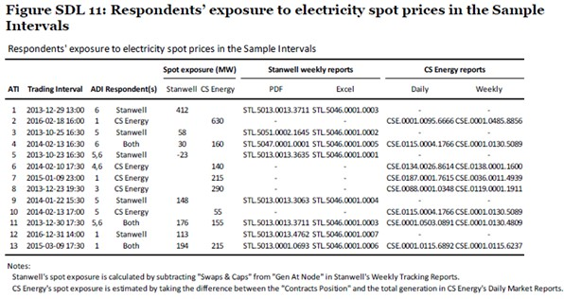
222 Ultimately, Dr Ledgerwood’s articulation of the economic approach relevant to assessing whether Stanwell and CS Energy had substantial market power was identified to be a three-step process. Step one involved determining whether Stanwell and CS Energy had market power (based on market share) (2LedgerwoodR, Section VI). This was done first, by identifying that their share of total capacity (by sheer number of generating units and generation capacity) was greater than that of other market participants and, secondly, that Stanwell and CS Energy had a “superior ability” to ramp down multiple generating units than all other market participants together could ramp up (2LedgerwoodR at [30], [972]). Step two involved the application of what was described as “a type of pivotal supplier screen” (2LedgerwoodR at [975]) to determine whether Stanwell or CS Energy had the ability to elevate the price to a level of their choosing in a given DI prices to a level of their choosing, and independently of the price at which other market participants were offering (thereby indicating substantial market power) (2LedgerwoodR, Section VII). In conducting the test he did, Dr Ledgerwood concluded (at [986]-[987]) that his analyses,
show that each of the Respondents (and the Respondents jointly) had the ability to cause elevated dispatch prices more often than any other participant in the QRNEM, and that their withholding rebids (in the Sample Intervals) coincided with very high average market prices.
My conclusion therefore is that each of the Respondents (and the Respondents jointly) had a substantial degree of market power.
223 Step three was then to consider the Respondents’ ability and economic incentive to engage profitably in Short-notice Rebidding in the Sample Intervals (2LedgerwoodR, Section VIII). It is not until this step, opined Dr Ledgerwood, that profitability and sustainability become relevant (2LedgerwoodR at [979]).
224 There was no judicial authority or economic analysis before the Court where a similar approach had been taken. Nothing turns on that. Stillwater submitted that Dr Ledgerwood’s approach was “transparent and appropriate to investigate the issues in dispute” and that, in any event, he had proceeded in “an entirely orthodox and appropriate way”. Regardless, the question before the Court remains the same: does the evidence establish, consistent with orthodox economic and legal principles, that the Respondents had substantial market power?

Barriers to entry
225 As was explained by Mr Holt, barriers to entry are a “third line of defence” in respect of substantial market power. Despite some time being devoted to this issue during the Initial Trial, it became one of relative insignificance. Indeed, the parties were agreed that: Generators were required to obtain regulatory approvals to register as a Generator, and to construct new generating units; new generating units required significant capital expenditure; and during the Conduct Period, there were no new large dispatchable generating units built in the QRNEM – some, however, were built elsewhere or were proposed and “committed” in the QRNEM during the Conduct Period (SAF at [269]).
226 The evidence was, however, that there were no material barriers to entry (1MortonR at [6.4.56]). Mr Morton described the NEM, and in particular the Queensland and New South Wales Regions, as being in a state of “cyclical oversupply” during the early part of the Conduct Period, which was then exacerbated by the growth of behind-the-meter solar generation (1MortonR at [3.2.25], [5.3.13]-[5.3.15]). Mr Holt explained in cross-examination, “it’s not a barrier to entry that people are not entering when returns are low, there is just no desire for entry. Who is going to invest when expected returns fall below the cost of capital?”
227 There were, however, two significant constraints on the market power possessed by Stanwell and CS Energy, albeit not properly described as barriers to entry. As Mr Morton identified (2MortonR at [6.4.8]), the first is the significant regulatory constraints comprised of the regulatory supervision of the AER, the prospect of administered pricing, the NER and potential rule changes, and the oversight and direction of their Shareholding Ministers (Government Owned Corporations Act 1993 (Qld) (GOCA) ss 114 and 115; 1MortonR at [6.4.8]-[6.4.20]). The second constraint can be described as “market and operational constraints” (1MortonR at [6.4.21]-[6.4.44]). This included the: inherent complexity and uncertainty of trading activities; bidding behaviour and market power of other Generators; limited prospects for future cost reduction in relation to the aging technology of the power stations; changes to the national electricity grid; technical limitations; ramp rates of alternative technologies; physical limitation associated with large coal-fired power stations; carbon tax liabilities; inability to earn revenue outside the NEM; regulatory constraints on volume of emissions; risk of increases in costs of coal and freight; risk of disruptions to supply of coal and water; plant outages; complexity and uncertainty in operating coal-fired power stations; and physical limitations associated with large coal-fired power stations, including the need to keep generating at minimum level to avoid shut downs and restarts.

Market power - heft
228 There is no dispute that Stanwell and CS Energy were the largest Generators in the QRNEM by number of generating units and generation capacity. The SAF records (at 55-57) that, during the Conduct Period, Stanwell generated between 32.19% and 37.29% of all electricity supplied into the QRNEM and that CS Energy generated between 25.56% and 30.82%.
229 CS Energy accepted that during the Conduct Period, it also had a significant theoretical generating capacity of approximately 4,000MW, however in reality, that varied greatly during the Conduct Period because of, inter alia, scheduled maintenance, unscheduled outages, and ambient operating conditions.
230 However, as Gleeson CJ and Callinan J observed in Boral, at [137], a large market share may, or may not, give power. As had been observed by Mason CJ and Wilson J in Queensland Wire Industries at 189, to which their Honours referred, s 46(3) of the now-repealed TPA was designed to achieve an approach similar to that adopted by the Court of Justice of the European Communities (European Court), particularly in the case of Europemballage and Continental Can v Commission [1973] 1 ECR 215. In that case, the European Court recognised, at 248, that “a dominant position in the market for light metal containers for canned meat and fish cannot be decisive”. Chief Justice Mason and Wilson J said, “[a] large market share does not necessarily mean there is a substantial degree of market power”.
231 Stanwell’s and CS Energy’s ramp rates were also identified by Dr Ledgerwood as an important physical characteristic in establishing market power. That was because of his thesis that, “[t]he Respondents’ ability to ramp down multiple DUIDs simultaneously across their large generation fleets, combined with the relative inability of other participants to ramp up to replace the output withheld, increased the likelihood that a price elevation would occur” (2LedgerwoodR at [968]).
232 Dr Ledgerwood undertook a comparison of size, output, and ramp rates. These were shown in Figures 14 and 15 of the Second Ledgerwood Report as shown below.
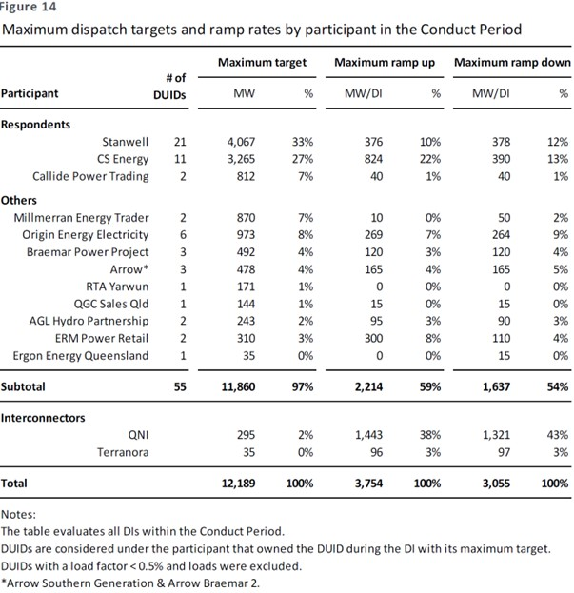
233 Dr Ledgerwood explained (2LedgerwoodR at [958]) that Figure 14,
reports a “non-coincident sum” – that is, I find the maximum output figure for each DUID, in whatever DI that occurs, and then I find the maximum ramp up figure in whatever DI that occurs, and similarly with the ramp down figure. I then sum those maxima across the DUIDs in the fleet of each participant.
(Citations omitted.)
234 He explained further that he analysed these factors using only those intervals where there was price separation and the QRNEM price was at least twice the NSWRNEM price. Figure 15 shows the results of this analysis, limited to the 9,211 DIs (2LedgerwoodR at [961]).
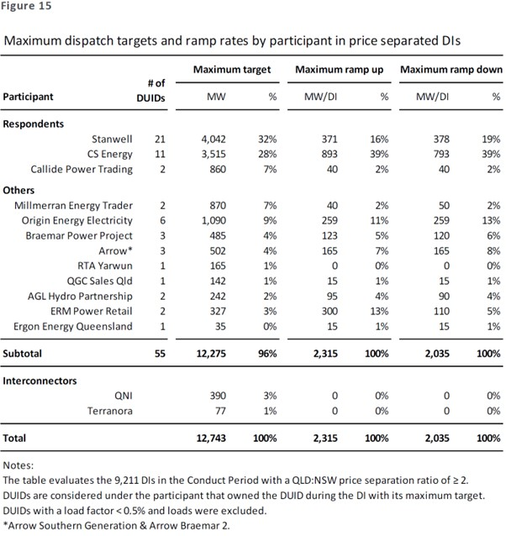
235 Dr Ledgerwood explained (2LedgerwoodR at [962]) that Figure 15,
shows that each of the Respondents owned or operated many more DUIDs, and had a greater ability to ramp down by submitting withholding bids for multiple units simultaneously than did their competitors (other than the other Respondent). In aggregate, Stanwell and CS Energy were the largest and second largest participants, respectively, in the QRNEM, measured by maximum output. Figure 15 also confirms that CS Energy and Stanwell (respectively) were the largest and second largest market participants with respect to the upward and downward ramping capabilities of their fleets.
(Citations omitted.)
236 There is an overarching difficulty with the analysis presented by Dr Ledgerwood in respect of the “heft” he seeks to demonstrate in Figures 14 and 15 – even as subsequently adjusted in Figures SDL 5 and SDL 6 in the JtEcER – and with his analysis of “ability to raise prices” (discussed below); namely, it was applied to a market (being the 9,211 DIs), which he ultimately conceded was not the appropriate market. He also conceded that the 9,211 DIs were not a representative sample of the 571,392 DIs in the Conduct Period.
237 Mr Morton did not accept the validity of the market shares presented in Figures 14 and 15 because they were based on the 99th percentile of non-coincident values (1MortonR at [6.5.43]-[6.5.47], [7.3.5(c)], [7.3.15]-[7.3.18]; JtEcER at [177]). Mr Morton posited that, even if he accepted Dr Ledgerwood’s propositions as to the assessment of market power, that analysis was limited by his: failure to acknowledge the contract position of the Respondents or other NEM Generators; adopting a low value of minimum plant generation levels; not acknowledging the limitations of using non-coincident sums; not acknowledging the lack of plant availability at times (including due to mothballing); not acknowledging aggregate ramp rates of competitors; and not acknowledging competition between Stanwell and CS Energy. (1MortonR at [7.3.5]).
238 Further, Figures 14 and 15 overstated Stanwell’s position in respect of the number of generating units operated by it during the Conduct Period. The figures included: four Collinsville units, which were returned to Ratch by Stanwell on 1 July 2012 (SAF at 76); two Tarong units, which were placed in cold storage between November 2012 and February 2016, and December 2012 and July 2014, respectively; and Swanbank E, which was placed in cold storage between December 2014 and November 2017.
239 As Dr Ledgerwood conceded in cross-examination, the use of non-coincident sums reflected the maximum values that were at any time achieved by Stanwell (and, by analogy, each other Generator), rather than their ordinary operations over the Conduct Period.
240 Mr Morton also observed that, even if the figures were accepted at face value, Figures 14 and 15 do not suggest that Stanwell’s power was substantial (1MortonR at [7.3.21]). This was for two reasons. First, CS Energy’s maximum ramping up capacity was more than double Stanwell’s ramping down capacity. Secondly, six combinations of competitors, as a pair, could exceed Stanwell’s ramping down ability with their cumulative ramping up capacity (1MortonR at [7.3.22]). Generators with open cycle gas turbines such as Origin, ERM (Shell) and Arrow could (together) achieve the same ramp capacity with far fewer generating units. Mr Morton demonstrated there was very little correlation between either ramp down capacity or share of registered generation capacity, and the number of high-priced rebids. Mr Morton explained, by way of example, that InterGen, with approximately 10% of registered generation capacity, was involved in more high-price rebids (131) than Stanwell (113), despite Stanwell having approximately three times the registered generation capacity of InterGen (SuppMortonR at [3.3.9]). This is illustrated in Figure 35 below.
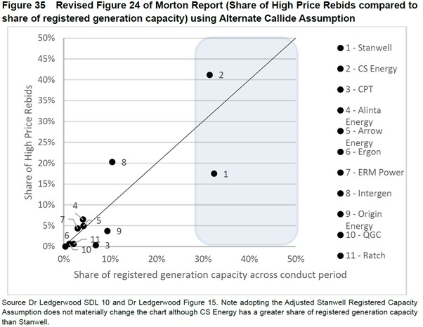
241 To address the concern about the use of non-coincident values, Dr Ledgerwood “performed the same analyses using the average of coincident values”. Having done so, Dr Ledgerwood said, “[t]he market share and ramp results continue to show Stanwell and CS Energy as the largest or second largest Market Participants by total capacity and ramp rates, as shown … in Figure SDL5 and Figure SDL6” (JtEcER at [177]). It was Dr Ledgerwood’s opinion that “[p]rovided that the ramp rates (and variations across DIs) are taken into account, these shares of total and ramping capacity provide a reliable indicator of a Generator’s ability to increase prices by withholding capacity” (JtEcER at [178]).
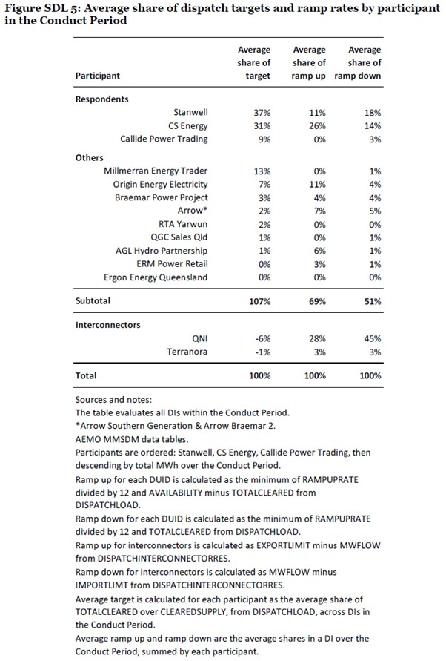

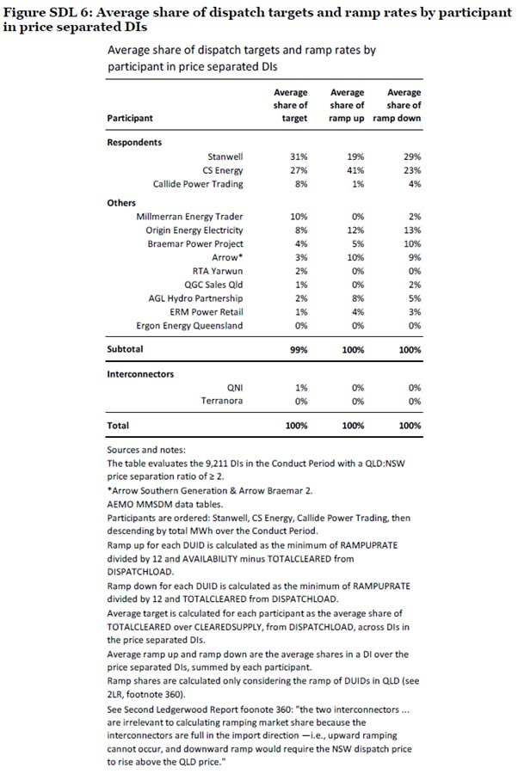
242 As was submitted by Stanwell, there are several conceptual flaws in the theoretical analysis undertaken by Dr Ledgerwood in seeking to identify the ramp rate advantage said to be held by the Respondents. First, as was accepted by Dr Ledgerwood in cross-examination, the ramp rate evidence is purely hypothetical. He himself described it as a “thought experiment” and “not indicative of real-world market conditions in each particular interval”. The Figures identify DIs in which the price could spike, but do not consider whether it would be economically rational for either of the Respondents to engage in economic withholding in any given interval. No account is taken of the Respondents’ underlying contract position. Nor was any there any analysis on the distribution of electricity generation across time for either of Stanwell’s or CS Energy’s generating units which would inform their utilisation rate and therefore any potential relevance of maximum output values (JtEcER, Mr Holt at [181]). As has already been observed, no account was taken of the generating units that were offline during the Conduct Period.
243 As Mr Holt said in the JtEcER at [180], “Generators face a trade-off between price and volume (the higher the bid price, the lower the probability of their generation portfolio being highly utilised), and in a competitive and uncertain environment where demand is volatile”. There was also no evidence that either Stanwell or CS Energy, nor any other Generator, had ever repriced all of their capacity above minimum load up to the price cap or to the top price band.
244 Further, the Figures were based on calculations at an individual DI basis. Dr Ledgerwood said that he “re-solved dispatch in each DI once for each market participant in turn, after first adjusting that market participant’s bids to move the capacity actually offered at various prices to price band 10” (4LedgerwoodR at [29]). In other words, Dr Ledgerwood restricted his analysis to the 5-minute interval in which capacity is withheld, without considering any subsequent competitive response in the next 5-minute, or any subsequent, DI. There is an artificiality in this analysis that makes it difficult to accept.
245 The artificiality is exacerbated by the exclusion of the interconnectors when calculating the shares of ramping capabilities. Mr Holt observed that excluding the interconnectors by focussing on instances of price separation, during which ramp up was impossible, assumes that interconnector capacity constraints are foreseeable, which is unlikely given the volatility in the interconnector systems ([HoltR at [3.5.29]). Further, he noted that excluding ramp up from the interconnectors assumes that volumes were not lost to the interconnectors due to late rebidding. He explained, “[i]f the Interconnectors take volumes, then the degree to which any withdrawal leads to higher prices will be reduced – with generating units moving up the merit order to a lesser extent than would be the case otherwise” (HoltR at [3.5.30]).
246 Given Dr Ledgerwood’s approach to answering the question of whether the Respondents had substantial market power, he did not assert that the analyses he undertook to produce Figures 14 and 15 and Figures SDL 5 and 6 answered that question. In cross-examination he said, “Something more was needed”. That was his reason for deploying the pivotal supplier test discussed in the Second Ledgerwood Report at Section VII, which is discussed below.

Ability to set a high price
247 Stillwater contended, in reliance on Stanwell’s and CS Energy’s ability to deploy their “heft” to “materially increase price through economic withholding”, that they had substantial market power (2LedgerwoodR at [972]). It submitted that Stanwell and CS Energy were able to use their large generating capacities, ramp rates, number of DUIDs, and greater shares of dispatch, to engage in Short-notice Rebidding with greater confidence, and at lower risk, than competing Generators.
248 Stillwater sought to establish the significance of the Respondents’ alleged ramp rate advantage by a “pivotal supplier” analysis. This analysis was illustrated in Figure 16 of the Second Ledgerwood Report.
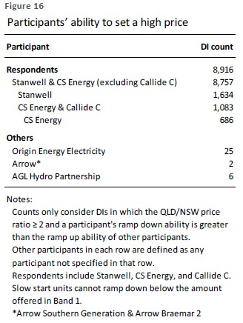
249 Dr Ledgerwood explained that, in his analysis of whether the Respondents possessed substantial market power, he examined “whether each Respondent (or the Respondents considered together) or any other participant unilaterally could raise the market price to levels of their choosing” (2LedgerwoodR at [973]). He did this by,
notionally decreasing the output of all of the relevant DUIDs simultaneously at their maximum rates in DIs when the interconnectors were bound, and allow all other participants’ DUIDs to ramp up at their maximum rates. For the Respondents, I then artificially increase other participants’ abilities to ramp up to see how much additional ramp would be needed to counter the Respondents’ rapid ramping down. I then examine actual market outcomes to determine whether the 417 DIs identified in the First Ledgerwood Report corresponded with higher prices in the QRNEM.
250 Dr Ledgerwood was candid that this test was designed to test only the ability to raise prices, not the incentive to do so. In cross-examination, Dr Ledgerwood conceded that he had not analysed price spikes of less than $600 and was forced to “accept that others have – others have placed withholding rebids proximate to price spikes. That’s what the screens are finding”.
251 Mr Price was critical of Dr Ledgerwood’s analysis (JtEMER at [698]ff). He identified the following problems with the assumptions on which the analysis was based. First, as both Mr Price and Dr Rose had identified, during the Conduct Period, it was common for Generators with minimum loading levels to offer no capacity in Band 1, opting instead for Band 2. This phenomenon is apparent in Sample Intervals 2-6 and 8-12. Secondly, fast-start generating units that were already operating were included. Dr Ledgerwood’s analysis, therefore, ignored any fast-start Generator that could respond within a very short time frame, such as Wivenhoe (JtEMER at [700]). The analysis, as illustrated by Figure 16, also used quantity bands that were not adjusted for maximum availabilities (maxavail). The practical reality, however, is that quantity offered above maximum availability is ignored by the NEMDE.
252 Further, beyond the theoretical, the analysis did not consider the profitability of being “pivotal”, either in terms of the volume that would be lost in order to create the price spike, or the impact on the contract position. Stanwell called two of its traders, Mr Adam William Branson and Mr Andrew Graham Jenkins, to give evidence at the Initial Trial. Both also filed affidavits in these proceedings on 3 May 2024 (the Branson Affidavit and the Jenkins Affidavit). As that evidence demonstrated, and which was not challenged, Stanwell’s traders did not treat all of Stanwell’s generation above the minima, as assumed by Dr Ledgerwood, as available for price-volume trade-offs. They were instructed to, and generally did, use only the generation which was in excess of Stanwell’s contract position (its dispatch margin) (Branson Affidavit at [107] and [127]). The analysis also treated each DI in isolation, rather than across a TI or a Trading Day, as would occur in practice and, as has already been observed earlier, it was based on a hypothetical trading practice that had never occurred.
253 Mr Price sought to address some of these difficulties and re-ran Dr Ledgewood’s analysis correcting for them. His results were shown in Figure 3 of the JtEMER:
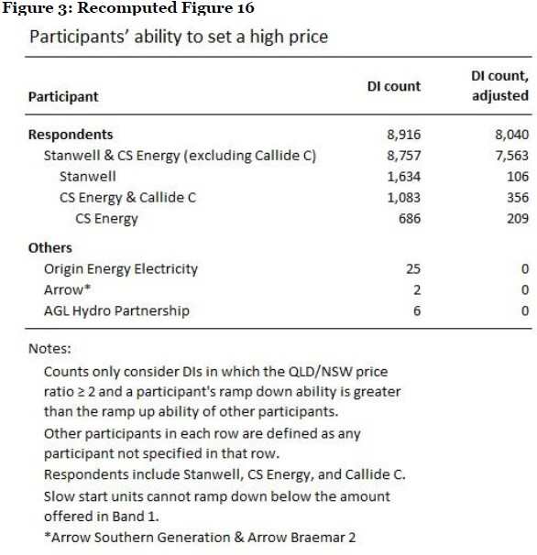
254 In cross-examination, Dr Ledgerwood agreed with the basis of Mr Price’s assumptions. He did not accept the numbers as recomputed with the corrected assumptions saying, “I can’t stand by Mr Price’s numbers … [b]ecause Mr Price’s results are logically implausible”.
255 Even if one were to accept Dr Ledgerwood’s analysis as shown in Figure 16, that analysis had identified that Stanwell was pivotal, in the sense he had described, in fewer than 0.3% of the 571,392 DIs over the Conduct Period, and CS Energy in 0.12% of the DIs over the Conduct Period. Mr Price’s analysis reduced Stanwell’s ability to cause a price spike from 1634 DIs to 106 DIs (~0.02%) and CS Energy’s ability to do so from 686 DIs to 209 DIs (~ 0.04%).
256 Dr Ledgerwood rejected the proposition put to him by Senior Counsel for CS Energy that he could not accept Mr Price’s numbers because they had destroyed Stillwater’s case. Dr Ledgerwood maintained it was still significant that “it’s the essential ingredient of the heft, the might as I called it, that the respondents had more ability to do that than other market participants”. Ultimately, Dr Ledgerwood maintained that he had conducted a “valid exercise” whilst accepting that it was not reflective of what happened in the “real world”. In cross-examination, he said:
There is a test that’s applied to each market participant. It’s the same test in every DI. Either somebody passes the test or they don’t pass the test with a pass being you are pivotal. Counting that up across the 9211, what you see is the respondents are pivotal a significant number of times. Other market participants aren’t. I take meaning from that, from the standpoint of – that the respondents, even given the assumptions of this, which I think are conservative and finding substantial market power, the respondents have substantial – a substantial degree of market power.
257 As to what was happening in the “real world” at the relevant time, of the 209 DIs in which CS Energy remained pivotal on Mr Price’s revised version of Figure 16, 70 of those DIs occurred across only four days (25, 27, 28 and 29 January 2013), being days on which CS Energy experienced severe technical, coal supply, and plant availability issues. According to Mr Price, CS Energy would have been “extremely unlikely to rebid in a manner that results in the ramping down its entire fleet as much as possible during these periods” (JtEMER at [705(a)]).
258 Dr Ledgerwood re-ran adjusted assumptions through the NEMPY dispatch model (Gorman, N et al, “NEMPY: A Python package for modelling the Australian dispatch procedure” (2022) 70 Journal of Open Source Software 3596) so as to directly address the concerns about fast start generating units and maximum availability raised by Mr Price. Dr Ledgerwood explained that the NEMPY model replicates the results of the NEMDE process with a high degree of accuracy (4LedgerwoodR at [45]). He did so on a subset of the 9,211 DIs, because NEMPY did not have the data for all 9,211 DIs. The subset of 5,955 DIs represented approximately 1% of the DIs across the Conduct Period.
259 As to the adjusted assumptions, Table 4 adopted the assumption that quantities in Band 2 represent minimum generation if the Band 1 quantity is zero, and assumed that any capacity offered at or below $0MWh is minimum generation (4LedgerwoodR at [46]). Table 6 took what was described as a “more realistic approach to minimum generation” by calculating minimum generation in percentage terms as the 5th centile of the target MW divided by the 99th centile (4LedgerwoodR at [54]-[55]).
260 The new analysis did not test whether a Generator could be a price setter at the market cap, as had been done for Figure 16. Rather, it considered whether a Generator could lift the price by at least $600MWh but without the need also to be a price setter.
261 The result of this analysis is shown in Table 4 of the Fourth Ledgerwood Report.
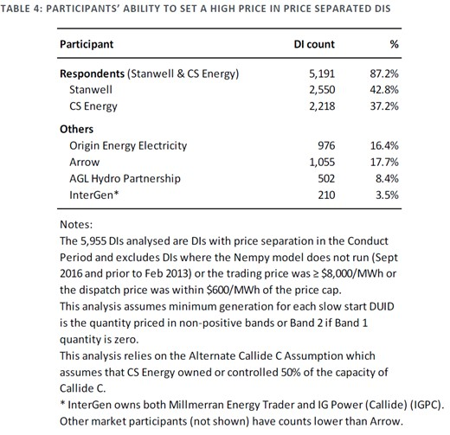
262 Table 6 of the Fourth Ledgerwood Report was described by Dr Ledgerwood as a repeat of the NEMPY run, albeit with a “more realistic minimum generation assumption”, which he had described in Table 5 (see [291] below).
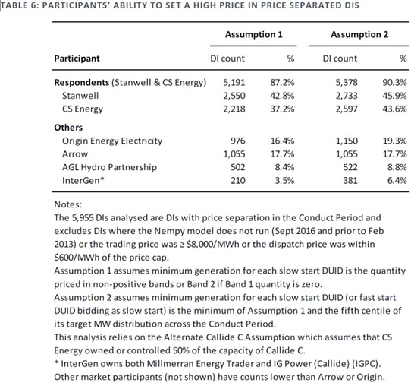
263 Dr Ledgerwood said that “[t]able 6 confirms that both Respondents together are able to cause price spikes in 90% of the price separated DIs. Stanwell could set a high price in 46% of DIs, while CS Energy could do so in 44% of DIs. By comparison, other market participants only had this ability in 19% of DIs or less” (4LedgerwoodR at [56]).
264 Dr Ledgerwood conceded that this latter analysis could not be described as a traditional pivotal analysis but maintained it was analogous. The analysis did not test whether either, or both, of the Respondents’ generation was necessary to serve total demand. Dr Ledgerwood opined that the analysis “confirms the conclusions reached in the Second Ledgerwood Report [at 979]: each Respondent individually often had the ability to set a high dispatch price, and could do so far more often than other market participants” (4LedgerwoodR at [50] and [56]). Despite this opinion, in oral evidence, Dr Ledgerwood said that having taken account of Mr Price’s analysis, it was “better, but still not correct”.
265 Although the analysis represented by Tables 4 and 6 may well show that both Respondents together are able to cause price spikes of at least $600 more often than other Generators in the 5955 price separated DIs, that analysis does not advance the answer to the question of whether the Respondents had substantial market power. It did not purport to test for the profitability of behaving in the way posited by Dr Ledgerwood, nor did it take any account of the unrealistic prospect that Generators would behave in such a manner.
266 More significantly, Dr Ledgerwood conceded in cross-examination that, even on his own analysis and including all of Callide C’s capacity, CS Energy was pivotal in only four of the eight Sample Intervals with which it was involved (ATI##4, 6, 10, and 11). He disavowed any suggestion that the lack of correlation was significant, saying, “[a]gain, the pivotal analysis was designed to show something different. I don’t – I didn’t marry the two up or at least I didn’t pay attention to marrying the two up”. This quite surprising response raised yet further questions about why the particular Sample Intervals had been chosen.
267 I am unable to place any reliance on Dr Ledgerwood’s use of his pivotal supplier test as supporting his conclusion (2LedgerwoodR at [987]) that each of the Respondents (and the Respondents jointly) had a substantial degree of market power. The incidence of the Respondents’ ability to spike the prices, even on Dr Ledgerwood’s initial numbers, was too insignificant to be considered “substantial”.
268 It would be contrary to established authority to accept the results of such a highly theoretical analysis, which “materially [departs] from real world facts and circumstances involving commercial behaviour” (ACCC v ANZ at 108), as a basis for concluding that Stanwell and/or CS Energy had substantial market power. I reject Dr Ledgerwood’s contrary conclusion.
269 Having concluded that the Respondents had substantial market power, the next step in Dr Ledgerwood’s analysis was to assess whether they had, either individually or together, the ability and incentive to exercise their substantial degree of market power by submitting withholding bids shortly before or during the DIs.

Ability and incentive
270 At this point in his analysis, Dr Ledgerwood conceded, consistent with orthodoxy, that the “successful exercise of market power requires that it should be profitable” (2LedgerwoodR at [990]). He continued, “[t]he profitability (or, at least, potential profitability) of this price-volume trade-off is therefore a requirement for the ability and incentive to engage profitably in economic withholding”. Nevertheless, in the JtEcER at [161], Dr Ledgerwood maintained that evidence of a firm’s profitability above the cost of capital over a period was not relevant in the context of a case such as this where “a substantial degree of market power is alleged to have been exercised in relation to Short-notice Rebidding”. Further, he did not consider that it is necessary to establish that prices exceed LRMC over a sustained period. In contrast, both Messrs Holt and Morton, also at [161], considered profitability above the cost of capital over a period to be relevant and, at [162], that it is necessary to consider whether prices exceed LRMC over a sustained period.
271 Mr Holt emphasised three important elements of the definition of substantial market power: first, a firm exercising substantial market power leads to higher prices and lower output; secondly, that the increase in price must be profitable (including that it can be sustained over time); thirdly, that the market power is exercised relative to the benchmark of the outcome under conditions of reasonably effective competition (HoltR at [1.4.18]).
272 As to the third element, Mr Holt explained that, in models of perfect competition, the competitive pricing benchmark is equal to short-run marginal cost (HoltR at [1.4.22]). However, due to a firm’s fixed or sunk costs in most markets, firms must price above short-run marginal costs in order to recover those costs. Consequently, LRMC are a better guide to the competitive benchmark because they allow for firms to recover their fixed costs, which includes a return on capital employed (HoltR at [1.4.22]). Mr Holt also highlighted the important fact, which has already been discussed in the context of the design features of the NEM, being that the NEM is an energy-only market. There is no separate capacity market to ensure that Generators’ fixed costs and investments in capacity are remunerated (HoltR at [1.4.24]). The only way for Generators to recover both variable and fixed costs, including higher cost generation that is mainly used during periods of peak demand, is through transiently high Spot Prices. Price spikes were also required to offset periods of time when prices were very low, or even negative (HoltR at [1.4.25]). Mr Price expressed a similar opinion (1PriceR at [38]). This is an important consideration in the circumstances of this case, involving as it does, and as Stillwater submitted, a “peculiar” market.
273 In light of these factors, Mr Holt opined that the approach to substantial market power in an energy-only market is properly based on the ability of a Generator (or a group of Generators) to increase average annual wholesale prices to a level that exceeds LRMC and sustain prices at that level. This opinion reflects the definition adopted by the AEMC in the AEMC Draft Determination 2012 at 20 (HoltR at [3.3.6]).
274 In terms of estimating the two key components of wholesale prices and LRMC, Mr Holt said (HoltR at [1.4.27]):
(a) As regards wholesale prices, there are several approaches including a time-weighted approach and a volume weighted approach (which weights the spot price each half hour in the year by volume of energy dispatched). In my view, a volume-weighted average is more appropriate than a time-weighted average because it accounts for the wholesale supply of electricity by generators and therefore reflects more accurately the revenues generated by this activity.
(b) There are several approaches to estimating LRMC. These include the Greenfields (or stand-alone) approach, the average incremental cost (“AIC”) approach, and the Perturbation approach. I have considered all three variations of these cost estimates and note that the results are consistent across the three methodologies, suggesting the method for calculating LRMC is not determinative of the outcome.
275 Mr Holt analysed volume-weighted average spot prices in the QRNEM through the Conduct Period as well as estimates of LRMC for Queensland Generators under each of the three methodologies. He explained that the analysis shows that, across the Conduct Period for which National Energy Resources Australia (NERA) has produced estimates of LRMC, each of the three methodologies resulted in the average volume-weighted Spot Prices being below LRMC for Queensland Generators (HoltR at [3.5.46]). He observed that his findings were consistent with those of Paul Simhauser, who compared LRMC calculated according to “new entrant costs as represented by coal plant (1999-2005) and combined cycle gas turbine plant (2006-2018)”, albeit at a national level, citing Simhauser, Paul, “Missing Money, Missing Policy and Resource Adequacy in Australia’s National Electricity Market” (Cambridge Working Papers in Economics, 15 August 2018, 1840) (HoltR at [3.5.47]).
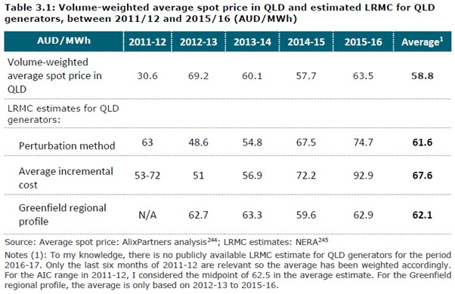
276 Mr Holt explained that this analysis revealed that average volume-weighted spot prices in Queensland were above the highest estimate of LRMC in only one of the five years from 2011/12 to 2015/16. In his opinion, this “is not consistent with any hypothesis that prices in QLD have been sustained above the competitive level” (HoltR at [3.5.52]).
277 Stillwater submitted there were material errors in this analysis. First, the table only calculated the average Spot Price to mid-2016, despite Mr Holt’s having the pricing data to mid-2017 (the end of the Conduct Period). Had that data been included, the volume-weighted average Spot Price in Queensland over the Conduct period would have been shown to be $66.90, higher than two of three estimates of LRMC calculated by Mr Holt. Mr Holt explained that he did not have the estimated LRMC for that year, and he had limited his comparison to those years in which had all the data. He identified several variables that he would have wanted to interrogate and was clear that, “[t]he information that I have that is consistent and comparable clearly indicates that all sorts of spot prices are, on average, lower than long-run marginal costs”.
278 Stillwater submitted that, regardless of whether or not Mr Holt’s approach was correct, which it rejected, the fact that average prices were higher than an estimate of LRMC was of no assistance because Stillwater’s allegations of Short-notice Rebidding do not concern “average” prices, nor are the averages specific to any particular Generator. In other words, the analysis says nothing about whether or not CS Energy or Stanwell were pricing above their own marginal costs.
279 In his oral evidence, Dr Ledgerwood said he did not disagree with the idea of a competitive benchmark, but he disagreed both as to what that benchmark was, and with its being necessary to exceed the benchmark sustainably. The competitive benchmark Dr Ledgerwood arrived at was $600MWh above the dispatch price (4LedgerwoodR at [29]). In his oral evidence, he explained that this threshold corresponded with a $100 increase in the Spot Price, which he thought was “large enough so that it would more than compensate a generator for its short-run marginal costs”. He said he did not perform “any sort of significance test on that. That’s just math”. After being pressed further on how he had arrived at $600, Dr Ledgerwood referred to Mr Price’s evidence that Mount Stuart had a $350MWh cost, which although to him that “sound[ed] high … to my knowledge, $600MWh should be sufficient to pay for any unit’s marginal cost”. Dr Ledgerwood, therefore, appears to have landed at a competitive benchmark that was at least higher than short-run marginal costs, but was still not prepared to accept LRMC as the appropriate benchmark.
280 In Market Power and Markert Manipulation, Ledgerwood et al at 13, defined sell-side market power, relevantly, as “[t]he ability of an individual supplier or group of suppliers to profitably [recognising both ability and incentive] maintain [because focussing only on price increases could lead to the false impression that the firm does not have market power, because the current price level already reflects the exercise thereof] prices above competitive levels for a significant [noting that given the unique nature of power markets, a significant period of time might be as short as several dispatch periods during adverse market conditions] period of time” (emphasis added). This understanding of market power was at the heart of Dr Ledgerwood’s 2019 ELJ article in which he and his co-authors explained why traditional ant-trust law was perhaps not apt for what they described as “ephemeral market power”.
281 In the present case, as to the element of sustainability, Dr Ledgerwood said:
DR LEDGERWOOD: My point about this is that, in a conduct case, you have to think about the timeframe in which the conduct occurs. If one is asking the question: over the course of a seven-year period is long-run marginal costs relevant to whether somebody can spike the price to $10,000, $12,000, or whatever it might be, the context of that, looking at that over the course of time, it loses all meaning. What you have to look at as a competitive benchmark is not whether they can do this repeatedly over time. You have to look at the specific incidence and ask the question: is this something that allows the market participant to raise prices significantly above marginal costs and is that due to their substantial market power? The answer here is, yes, the substantial market power allows them to do this only because – well, in this case, because they are using short-notice rebidding.
282 In describing similar conduct in Market Power and Market Manipulation at 193, Ledgerwood et al said:
… the act of withholding could be viewed as an intentional sacrifice of profit on the untraded units (a form of intentional, seemingly uneconomic behavior as the trigger) to cause a price change (the nexus) to benefit the profitability of the remaining units purchased or sold (the target). However, as we discussed above, such behavior is better analyzed using traditional antitrust tools, for they are best designed to evaluate the cause and effect of market power when its scope is confined to the primary market. Further, as we will discuss below when considering uneconomic trading, withholding produces a price change that benefits the actor on a stand-alone basis in the primary market, thus inducing an immediate competitive response from other participants on the same side of that market.
(Emphasis in original.)
As the authors explain in the footnote to that paragraph, “the exercise of market power is therefore unsustainable in the absence of entry barriers or other types of exclusionary behavior, for natural competitive forces otherwise thwart the price movement that is necessary for the behavior to succeed” (emphasis added).
283 Stillwater submitted that the Court should prefer Dr Ledgerwood’s more recent opinion; namely, that it was unnecessary in a case such as this to assess the rebidding behaviour and the consequent effect on price with regard to competitive benchmarks or the ability to sustain prices above a competitive level over time. It submitted that, “the fact that average prices may or may not have been above or below an estimate of long-run marginal costs is of no moment at all in a case concerned with allegations of the strategic deployment, on specific occasions, of a market power that takes its character from the peculiarly ‘time fragmented’ nature of the market in question”. Dr Ledgerwood had made this approach plain in cross-examination:
MR HODGE: … Can you tell me if you agree with this though Dr Ledgerwood. What you are introducing is saying we shouldn’t apply a long-run benchmark in determining whether somebody has substantial market power because, if we do that, we won’t be able to say that individual price spikes are against the law. That’s what you are saying it boils down to, doesn’t it?
DR LEDGERWOOD: I am saying that, yes.
284 As is apparent from Dr Ledgerwood’s testimony, he was determined to characterise the conduct, which he considered to be egregious, by reference to a remedial framework premised on orthodox concepts of substantial market power. Dr Ledgerwood’s approach cannot be reconciled with orthodoxy or principle. For that reason, I reject it.

Other constraints
285 Stillwater pleads that there were no other constraints on Stanwell’s and CS Energy’s engaging in Short-notice Rebidding because the risk of their so doing was less than the risk to competing Generators (apart from one another) (3FASOC at [32] and [39]). This was said to be because even if Stanwell and/or CS Energy forfeited some supply volume, and therefore some energy sales revenue, it was still likely to be required to dispatch large volumes during the targeted TI such that:
- the loss of energy sales revenue was only a portion of Stanwell’s and/or CS Energy’s overall loss for the targeted TI;
- that portion of lost revenue was likely to be smaller portion than a smaller Generator would have placed at risk by Short-notice Rebidding; and
- the loss of revenue on foregone volume was likely to be mitigated or exceeded by a gain of energy sales revenue from the higher Spot Price achieved as a result of the Short-notice Rebid, in respect of residual supply over the targeted TI.
286 There was, however, no evidence to support any of the hypotheses.
287 It was uncontroversial that, as baseload Generators, Stanwell and CS Energy dispatched large volumes of electricity. The corollary of that seeming advantage, however, is that both were required to continue generating at minimum load even if prices were in the negative band (2RoseR at [2.11]). Mr Holt’s evidence was that prices were below $24MWh for 10% of the Conduct Period (HoltR at [2.6.4]).
288 Stanwell and CS Energy had no greater ability than any other Generator to ensure they were instructed to dispatch. The NEMDE algorithm operated to dispatch all Generators in the bid stack in merit order to ensure supply met demand. All Generators were aware of the parameters of the algorithm. As to volume, despite its generating capacity, Stanwell’s evidence was that it was constrained by its contract position to risk only its dispatch margin (Branson Affidavit at [75(d)], [107], [127]-[128]; Jenkins Affidavit at [43a], [97b]). I infer that the position of CS Energy, and indeed that of all other Generators in the Market, was constrained in one way or another by their contract positions.
289 Stillwater relied, in part, on an analysis done by Dr Ledgerwood which purported to show that the output the Respondents would need to sacrifice to cause a price elevation was much lower, as a percentage of the output that they were producing before withholding, than for other Generators. Figure 19 purported to demonstrate that the Respondents could generally cause a price spike by sacrificing 10% or less of their output, whereas smaller market participants would generally need to sacrifice 20% or more (2LedgerwoodR at [38], [992]).
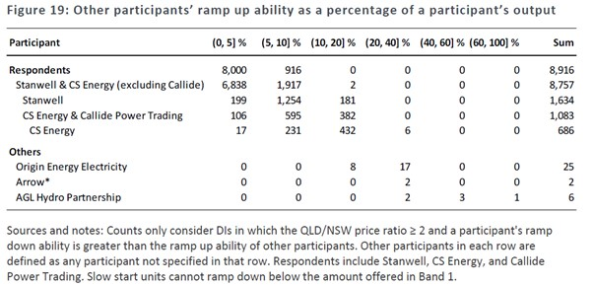
290 Figure 19 is another highly theoretical exercise which, in addition to incorporating the false assumptions that had been criticised by Mr Price in respect of Figure 16 (as an “expansion of the analysis” in Figure 16 (2LedgerwoodR at [991])), took no account of the contract positions of Stanwell or CS Energy, and was divorced from any evidence of the rebids actually made by the Respondents and smaller Generators, or the percentage of generation they needed to sacrifice in order to elevate the price. In cross-examination, Dr Ledgerwood conceded that it was possible that smaller Generators may have been able to cause a price elevation with as little as 2.6% of capacity, but agreed he had not looked at “what we actually see as a result of the … dispatch process”.
291 In the Fourth Ledgerwood Report, Dr Ledgerwood described “[developing] a more realistic approach” to minimum generation across the Conduct Period and also calculated minimum generation on percentage terms as the 5th centile of the target MW divided by the 99th centile (4LedgerwoodR at [53]). Table 5, set out below, shows Stanwell ramping down to 38-50% of generation (sacrificing 50%-62%) and CS Energy ramping down to 39%-59% (sacrificing 61%-41%) while some smaller Generators only needed to ramp down to 65%-85% of generation, sacrificing much less (35%-15%).
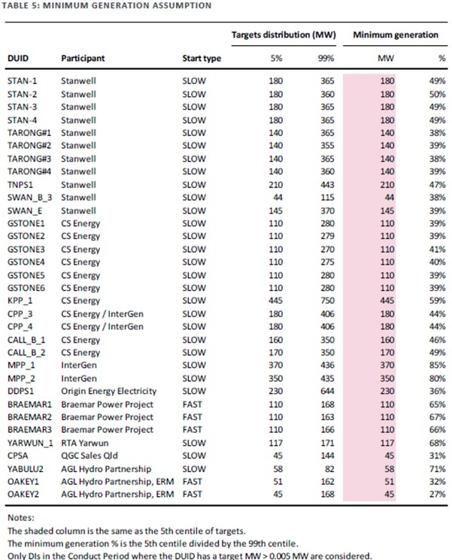
292 Dr Rose’s and Mr Morton’s analysis, however, showed that smaller Generators made rebids of the kind impugned at least more often than Stanwell, on a year-by-year analysis. Table 2 of Mr Morton’s Supplementary Report is illustrative.
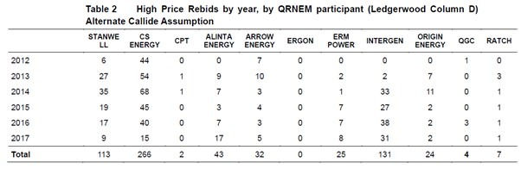
293 Regardless of the number of times various Generators engaged in economic withholding to achieve a price spike, there was no evidence by which one could assess the proportion of lost revenue likely to be put at risk by a smaller Generator as compared with Stanwell and/or CS Energy. That was the relevant counterfactual.
294 Stillwater alleged that the risk to Stanwell and CS Energy of lost revenue on foregone volume was likely to be mitigated or exceeded by a gain of revenue from the higher Spot Price achieved as a result of the Short-notice Rebidding over the targeted TI such that they were unconstrained, or at least less constrained than other Generators from engaging in economic withholding to achieve a price spike (3FASOC at [32]). Again, there was no evidence to support the allegation.
295 In the Second Ledgerwood Report, Dr Ledgerwood produced Figure 20, which he described as showing for each Respondent, and for each DI, “the net financial benefit that resulted from ramping down (and therefore selling less output) but selling the reduced output at a higher price” (2LedgerwoodR at [997]).
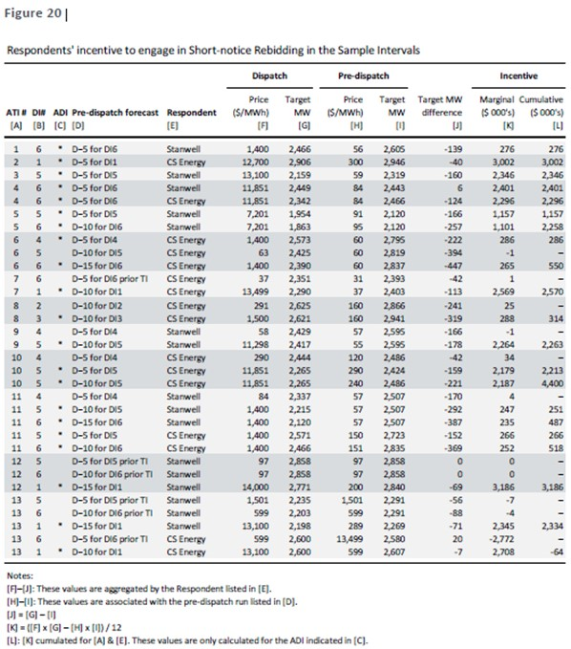
296 Figure 20, in fact, shows the gross revenue achieved in each of the Sample Intervals, not “net financial benefit” or profit. Dr Ledgerwood explained that it shows “[t]he marginal incentive is small (and sometimes negative) in intervals that are not ADIs, because there is no price elevation or only small price elevation (i.e., an unfavourable price-volume trade-off)” (2LedgerwoodR at [998]). His explanation rather contradicted his conclusion confirming his hypothesis that Stanwell and CS Energy often had the ability to raise prices “to a level of their choosing” (2LedgerwoodR at [975], [979]).
297 Several observations may be made about the usefulness of this evidence. First, there is no comparator table with respect to competing Generators by which one can assess whether, and if so, to what extent, other Generators’ loss on volume foregone was mitigated or exceeded by a gain in revenue from a higher Spot Price. Secondly, the intervals that are not ADIs are not intervals during which the conduct did not occur. They are intervals that did not pass all of Dr Ledgerwood’s screens. To that extent, they tend to disprove the thesis. Thirdly, to the extent that the calculations go only to gross revenue, and not profitability – because no account has been taken of either Stanwell’s or CS Energy’s contract position (nor their marginal costs, be they short or long-run) – it is impossible to assess the extent of the risk borne by Stanwell and CS Energy, let alone the extent of their risk relative to that of other Generators in the market.
298 Presumably to buttress its plea of absence of material constraints on Stanwell’s and CS Energy’s “Short-notice Rebidding behaviour”, Stillwater also pleaded that, during the Conduct Period, it was persistently the case that Stanwell and CS Energy were not constrained, or only constrained in a limited way, by the conduct of competitors or potential competitors or customers from responding to opportunities to engage in Short-notice Rebidding. This was because it took those opportunities and, by doing so, caused Spot Prices to be materially higher in some TIs (being the ATIs) than would otherwise be the case (3FASOC at [33] and [40]). Stillwater said the absence of constraint was to be inferred from:
1. The characteristic and number of occasions on which Short-notice Rebidding by either of Stanwell or CS Energy had a material effect on the dispatch price for a DI in a TI – being the ATIs; and
2. The circumstance that the bidding behaviour ceased after 6 June 2017, being the day on which Stanwell was issued with the Direction.
299 As to the latter, no evidence was led in relation to the Respondents’ conduct throughout 2017. The latest impugned rebid alleged against Stanwell was on 31 January 2017, and as against CS Energy, on 31 March 2017, over four months before the Ministerial Direction was issued (2LedgerwoodR, Appendix K). No attempt was made to explain how the behaviour of Stanwell and CS Energy in the summer months of 2017 might have changed based on a Direction not issued until June of that year. Further, the Direction applied only to Stanwell, not to CS Energy. In any event, the Direction did not prevent Stanwell from engaging in “late” rebidding; it prevented Stanwell from bidding above $65MWh. If capacity was moved from the negative $0MWh price band to the $65MWh price band just before gate closure, that would still be captured by Stillwater’s pleaded definition of the impugned conduct.
300 The evidence as described above shows, however, that there were in fact very few occasions on which Short-notice Rebidding by Stanwell and/or CS Energy had a material effect of the dispatch price during the Conduct Period. Figure I of the JtEcER shows that, in Stanwell’s case, there were 32 such occasions, and in the case of CS Energy (once those attributed to Callide C are removed), 129 such occasions, out of 571,392 DIs. Further, almost all Generators made rebids of the kind impugned by Stillwater over the Conduct Period (SuppRoseR, Table 12; 2PriceR at [45]-[46], [451]-[452]; JtEcER, Figure SDL 10). Nearly half of those “High Price” rebids were made by Generators with less than 20% of installed capacity in Queensland and less than 20% of the cumulative ramp down capacity (1MortonR at [10.3.15(a)]). The rebids made by InterGen and Origin, both of which had a smaller market share and ramp down capacity than Stanwell at least, were successful in elevating the price more often than those made by Stanwell. Further, as Table 2 above demonstrates, there was no year during the Conduct period in which Stanwell engaged in the conduct more than other Generators. The statistical insignificance of the number of occasions on which it is alleged that Stanwell and/or CS Energy were successful in spiking the price is overwhelming evidence that the price spikes were transient in nature and are incapable of supporting an inference that either Stanwell or CS Energy had substantial market power during the Conduct Period.
301 During the Conduct Period, neither Stanwell nor CS Energy had a substantial degree of power in the Market within the meaning of s 46(1) of the CCA.
302 The answer to Issue 2 and to Common Question 2 is “No”. During the Conduct Period, Stanwell did not have a substantial degree of power in the Market within the meaning of s 46(1) of the CCA.
303 The answer to Issue 3 and to Common Question 3 is “No”. During the Conduct Period, CS Energy did not have a substantial degree of power in the Market within the meaning of s 46(1) of the CCA.

DID STANWELL AND CS ENERGY TOGETHER HAVE A SUBSTANTIAL DEGREE OF POWER IN THE MARKET WITHIN THE MEANING OF S 46(2)?

Were Stanwell and CS Energy related within the meaning of s 4A?
304 Stillwater’s primary submission was that the Court need not be troubled by s 46(2). It submitted:
The s 46(2) question does not arise but if it did it is a short one. Indeed it might perhaps be said that the main relevance of s 46(2) is to save the Court and the parties the bother of needing to expend energy on this arid question, since on any view the Respondents had substantial power in aggregate.
305 Nevertheless, Stillwater submitted that, for the purpose of s 46(2) of the CCA, Stanwell and CS Energy are “related” within the meaning of s 4A of that Act, on the basis that they are alleged to be subsidiaries of the same “holding company”, being the State. At [7] of the 3FASOC, Stillwater pleads:
The State of Queensland is the owner of all shares in both CS Energy and Stanwell, pursuant to the GOCA. Pursuant to section 4A(4) of the CCA, a holding company is a reference to a body corporate of which another body corporate is a subsidiary. The State of Queensland is the holding company of both CS Energy and Stanwell. By reason of section 4A(1) of the CCA, CS Energy and Stanwell are subsidiaries of the State. Pursuant to section 4A(5) of the CCA, subsidiaries of a holding company are deemed to be related to each other.
306 Section 46, including s 46(2), was repealed entirely by the Competition and Consumer Amendment (Misuse of Market Power) Act 2017 (Cth) (Sch 1). The new iteration of that s 46(2) is now s 46(3), which is not materially different from its predecessor.
307 Prior to its repeal, s 46(2), provided:
If:
(a) a body corporate that is related to a corporation has, or 2 or more bodies corporate each of which is related to the one corporation together have, a substantial degree of power in a market; or
(b) a corporation and a body corporate that is, or a corporation and 2 or more bodies corporate each of which is, related to that corporation, together have a substantial degree of power in a market;
the corporation shall be taken for the purposes of this section to have a substantial degree of power in that market.

Is section 4A enlivened?
308 Section 4A(1) operates to deem a body corporate to be a subsidiary of another body corporate in certain circumstances:
(1) For the purposes of this Act, a body corporate shall, subject to subsection (3), be deemed to be a subsidiary of another body corporate if:
(a) that other body corporate:
(i) controls the composition of the board of directors of the first-mentioned body corporate;
(ii) is in a position to cast, or control the casting of, more than one-half of the maximum number of votes that might be cast at a general meeting of the first-mentioned body corporate; or
(iii) holds more than one-half of the allotted share capital of the first-mentioned body corporate (excluding any part of that allotted share capital that carries no right to participate beyond a specified amount in a distribution of either profits or capital);
…
309 Section 4A(3) provides, relevantly:
(3) In determining whether a body corporate is a subsidiary of another body corporate:
(a) any shares held or power exercisable by that other body corporate in a fiduciary capacity shall be treated as not held or exercisable by it;
(b) subject to paragraphs (c) and (d), any shares held or power exercisable:
(i) by any person as a nominee for that other body corporate (except where that other body corporate is concerned only in a fiduciary capacity); or
(ii) by, or by a nominee for, a subsidiary of that other body corporate, not being a subsidiary that is concerned only in a fiduciary capacity;
shall be treated as held or exercisable by that other body corporate;
…
310 Sections 4A(4) and (5) of the CCA provide guidance on how s 46(2) applies to holding companies and subsidiaries. Relevantly, those sections state:
(4) A reference in this Act to the holding company of a body corporate shall be read as a reference to a body corporate of which that other body is a subsidiary.
(5) Where a body corporate:
…
(c) is a subsidiary of the holding company of another body corporate;
that first-mentioned body corporate and that other body corporate shall, for the purposes of this Act, be deemed to be related to each other.

The State as a holding company or body corporate
311 The character of the relationship between governments and government-owned corporations in Australia has been the subject of much jurisprudence. Defining such a matter with precision is particularly important in a market context, where, among other reasons, any exemption granted in favour of government owned corporations from legislative market controls may facilitate a competitive advantage over private enterprises otherwise subject to those controls.
312 It is plain that both Stanwell and CS Energy are bodies corporate for the purpose of s 4A(4) and (5). They are, in fact, government owned corporations within the meaning of the GOCA, pursuant to s 5 of that Act. Whether or not they are “related”, however, depends on whether they are subsidiaries of the State, and whether the State is a “body corporate” and “holding company” for the purpose of s 4A(4).
313 In Stanwell Corporation Ltd v LCM Funding Pty Ltd [2021] FCA 1430; 157 ACSR 401 at [2], Beach J concluded that both of Stanwell and CS Energy were “related bodies corporate”, stating:
Each of Stanwell and CS Energy are Queensland electricity Generators, the shares in which are wholly owned by the State of Queensland. Consequently, they are government owned corporations within the meaning of s 5 of the Government Owned Corporations Act 1993 (Qld) and accordingly, for the purposes of s 4A of the Competition and Consumer Act [(2010) (Cth)], related bodies corporate.
314 With respect to his Honour, I have reached a different conclusion. I have done so having had the benefit of detailed written and oral submissions on a point that was squarely raised in these proceedings. In Stanwell v LCM Funding, his Honour was concerned with satellite litigation involving the question of whether the litigation funding scheme operated by LCM Funding to fund this proceeding constituted an unregistered “managed investment scheme” as defined in s 9 of the Corporations Act 2001 (Cth). The relatedness, or otherwise, of Stanwell and CS Energy was immaterial to that question. Consequently, his Honour does not appear to have had the same advantage as have I in considering the application of s 4A to Stanwell and CS Energy for the purposes of s 46(2).
315 First, as a matter of plain reading of s 4A(4), the State of Queensland is not a “company” of any kind. Such a finding is supported by the decision in Paul Dainty Corporation Pty Ltd v National Tennis Centre Trust (1990) 22 FCR 495. The matter concerned a question of whether three State instrumentalities were related corporations for the purposes of s 4A(5), the predecessor to s 4A(4) as then enacted in the TPA. In rejecting that the corporations were related, Woodward, Northrop and Sheppard JJ (at 523) rejected the argument that the Crown was a holding company.
In our view there is no substance in the respondents’ submission that they are all “related corporations” within the meaning of s 47(8) and (9) of the Trade Practices Act. They are said to be so because they are all “subsidiaries of the Crown, which is a body corporate”. But s 4A(5) of the Act limits the meaning of “related corporations” in such a way that the three instrumentalities could only satisfy the description if the Crown were to be a holding company for the purposes of the Act. This would be a very strange conclusion, which could only be even remotely arguable if the three entities were held to be true emanations of the Crown, which we believe they are not.
(Emphasis added.)
316 Sections 4A(4) and (5) of the TPA provided:
(4) A reference in this Act to the holding company of a body corporate shall be read as a reference to a body corporate of which that other body corporate is a subsidiary.
(5) Where a body corporate:
(a) is the holding company of another body corporate;
(b) is a subsidiary of another body corporate; or
(c) is a subsidiary of the holding company of another body corporate;
that first-mentioned body corporate and that other body corporate shall, for the purposes of this Act, be deemed to be related to each other.
317 Stillwater submitted that, having been decided before the 1995 introduction of s 2B into the CCA by the Competition Policy Reform Act 1995 (Cth), Paul Dainty was no longer good law. Section 2B as inserted by s 81 of the Reform Act provides, relevantly, that Pt IV of the CCA binds the Crown in right of each of the States “so far as the Crown carries on a business, either directly or by an authority of the State” (emphasis added).
318 As Stillwater submitted, the TPA did not apply to State government businesses under the shield of the Crown. That was not, however, the reason for the conclusion reached by the Full Court. Rather, the Full Court reasoned that the respondents, in the provision of their commercial services, were not operating under that shield (at 521). The Full Court referred to the decision in Townsville Hospitals Board v Townsville City Council [1982] HCA 48; 149 CLR 282 where, at 288-289, Gibbs CJ said:
… many functions formerly regarded as matters of private concern are now carried out by instrumentalities of government and the question whether the functions in question are traditionally or peculiarly governmental is likely to be increasingly unhelpful in deciding whether the body formed to carry out those functions enjoys the privileges and immunities of the Crown … The answer to the question must in the end depend upon the intention to be derived from the statute under which the body in question is constituted.
319 In Superannuation Fund Investment Trust v Commissioner of Stamps (SA) [1979] HCA 34; 145 CLR 330, to which the Full Court in Paul Dainty also referred, Stephen J, at 342, observed that “ministerial or other control in the exercise of [a body corporate’s functions, established under an Act was] a most significant factor, albeit no more than a factor, in determining whether in the exercise of that function the [body corporate] is to be treated as if it were the Crown in right of the Commonwealth”.
320 The insertion of s 2B by the Reform Act did no more than enact the existing law as it had been described and applied in Paul Dainty. I reject the submission that Paul Dainty is no longer good law. Nor does Stillwater’s reliance on Sita Qld Pty Ltd v State of Queensland [1999] FCA 793; 164 ALR 18 at [20]-[23] advance its position. That case was concerned solely with the “Schedule version” of Pt IV enacted by the Competition Policy Reform (Queensland) Act 1996 (Qld) (Competition Act), which materially amended references to a “corporation” by substituting “person”, which expression included a body politic. To the extent that Stillwater submitted that ss 4A(4) and (5) achieve the same effect as the Schedule version of Pt IV of the Competition Act, that submission too must be rejected. The CCA does not include within the definition of “corporation” a “body politic” (s 4).
321 The rejection of those submissions does not, however, resolve the issue. The question remains – are Stanwell and CS Energy emanations of the Crown?
322 In NT Power Generation Pty Ltd v Power & Water Authority [2002] FCAFC 302; 122 FCR 399, Finkelstein J, in considering the scope of “an emanation of the Crown” said, at [126]:
If the Crown is able to control the activities of the corporation (whether directly, by instruction or direction, or indirectly, pursuant to a power to remove those in control of its operations otherwise than for misconduct or incapacity) the corporation will usually be the alter ego of the Crown. So in every case where the question arises it is necessary to examine the nature and degree of control that the Crown exercises over the corporation. If the corporation is subject to the same control as a governmental department it is likely to be the alter ego of the Crown. If the corporation is largely free of ministerial control then it is unlikely to be the Crown’s alter ego.
(Emphasis added.)
323 This is the very factor on which Stephen J placed importance in 1979 in Superannuation Fund Investment Trust, well before the amendments to the TPA which Stillwater submitted make a material difference. In their book, Liability of the Crown (4th ed, 2011), P W Hogg and P J Monahan, at 466-467, explain the “control test” by reference to Townsville Hospitals Board:
For the purpose of the control test, control means de jure control, not de facto control. It is the degree of control that the minister is legally entitled to exercise that is relevant, not the degree of control that is in fact exercised. The question is therefore resolved by an examination of the corporation’s empowering statute, and does not involve an assessment of the actual relationship between the corporation and the government. The clearest example of de jure control is where a minister actually heads the corporation. Another clear example is the case where there is a statutory requirement of the approval of a minister or of the cabinet for important transactions. Such matters as the power to appoint directors and to supply funding, although they may provide opportunities for de facto control of the corporation’s activities, are not sufficient by themselves to establish de jure control.
(Citations omitted. Emphasis added.)
324 The importance of recourse to the empowering statute was emphasised most recently by Jagot J in Chief Executive Officer, Aboriginal Areas Protection Authority v Director of National Parks [2024] HCA 16; 98 ALJR 655 at [301]:
… to determine if a body is a servant, agent, manifestation, alter ego, or emanation of the Crown and has the benefit of any immunities of the Crown, the necessary focus is the statute establishing and conferring functions on that body … It must clearly appear from the body’s enabling statute (or otherwise) that the legislature intended that the body have any such immunities.
325 In discussing the indicia of control in this context, White J, in Australian Competition and Consumer Commission v Australian Egg Corp Ltd [2016] FCA 69; 337 ALR 573 at [97] said:
The determination of whether an entity is part of the Crown as executive is to be made by reference to the legislation by which the body is established or governed and, in particular, the legislative intention, the activities which it undertakes and the nature and extent of the governmental or ministerial control over the body. In Inglis v Commonwealth Trading Bank (1969) 119 CLR 334, Kitto J said at 338:
“The question is … what intention appears from the provisions relating to the respondent in the relevant statute: is it, on the one hand, an intention that the Commonwealth shall operate in a particular field through a corporation created for that purpose; or is it, on the other hand, an intention to put into the field a corporation to perform its functions independently of the Commonwealth, that is to say otherwise than as a Commonwealth instruction, so that the concept of a Commonwealth activity cannot realistically be applied to that which the corporation does?”
(Emphasis added.)
326 Applying the “control test” as directed by the authorities, the question – put simply – is whether the GOCA confers on the State such a degree of control over CS Energy and Stanwell that they are, in substance, emanations of the State thereby rendering the State a holding company and a body corporate, of which Stanwell and CS Energy are subsidiaries for the purpose of s 46(2). As I have already foreshadowed, contrary to the view reached by Beach J in Stanwell v LCM Funding, I do not consider that Stanwell and CS Energy are related bodies corporate for the purposes of s 4A of the CCA.

The GOCA
327 Stanwell and CS Energy were corporatised under the GOCA in 1997 (GOCA s 13). This was consequent upon a redesign of the Queensland Government’s government owned electricity generation sector in July 2011, which reduced three government owned corporations (Stanwell, Tarong Energy Corporation Limited and CS Energy) to two, being Stanwell and CS Energy (see Government Owned Corporations (Generator Restructure) Regulation 2011 (Qld)). Both of their “shareholding ministers” are the GOC Minister and portfolio Minister of the GOC (GOCA s 78). Stanwell’s and CS Energy’s core business was and remains operating electricity generation plants to sell and trade in electricity within the NEM.
328 Pursuant to ss 78 and 80(2) of the GOCA, the shareholders of any GOC hold the shares on behalf of the State, with the State remaining the beneficial owner. CS Energy submitted that the deeming provision in s 4A(1)(a)(iii) is directed to whoever holds the shares in a company (in this case, the shareholding ministers) rather than the beneficial owner. CS Energy contended that circumstance precluded it from being considered a subsidiary of the State. Stillwater submitted there was a fundamental flaw with that proposition, being that s 4A(3) of the CCA relevantly provides:
(3) In determining whether a body corporate is a subsidiary of another body corporate
…
(b) subject to paragraphs (c) and (d), any shares held or power exercisable:
(i) by any person as a nominee for that other body corporate (except where that other body corporate is concerned only in a fiduciary capacity);
…
shall be treated as held or exercisable by that other body corporate.
329 Stillwater submitted that the shareholding ministers are “nominees” for the State within the meaning of this subsection. As CS Energy submitted, however, the GOCA does not appoint the shareholding ministers as nominees for the State. Were they nominees for the State, it would be expected that they would be directors of any GOC, something expressly excluded by s 83 of the GOCA.
330 Turning then to what can be discerned from the GOCA as to whether Stanwell and CS Energy are emanations of the Crown.
331 First, s 154 states expressly that a GOC (in this case, Stanwell and CS Energy) do not represent, and have never represented, the State. Under the GOCA, both are public companies limited by shares under, and are governed by, the Corporations Act: GOCA ss 75, 76. As CS Energy submitted, that adoption of a corporate structure points away from the Court finding the Respondents to be emanations of the Crown. Relevantly, in Launceston Corporation v The Hydro-Electric Commission [1959] HCA 12; 100 CLR 654 (Dixon CJ, Fullagar, Menzies and Windeyer JJ), the Court observed, at 662, regarding the effect of s 15 of the Hydro-Electric Commission Act 1944 (Cth):
… the particular enumeration of powers in s 15(2) suggests strongly that the opening words are not concerned with the character of the commission as a servant of the Crown … We regard the words in question as having the same general purpose as the words “in the interests of the State” in s 15(2)(a), viz. as indicating that the powers conferred upon the commission are to be exercised for the good of the State of Tasmania. This conclusion is supported in some degree by the use of the words “the State” rather than the words “the Crown”.
332 Secondly, as both respondents submitted, Stanwell and CS Energy enjoy wide autonomy in their commercial activities as provided for under the GOCA. Consistent with its broad focus to facilitate State oversight (but not to provide de jure control), there is a suite of provisions under the GOCA that facilitate GOCs to operate independently from the State, despite being government owned. For example, s 16(b) of the GOCA provides the following:
Principle 2 – Management autonomy and authority
The elements of this principle are that––
- each GOC will have a board of directors;
- the board will be required to use its best endeavours to ensure that the GOC meets its performance targets;
- the board will be given the autonomy and authority to make commercial decisions within areas of responsibility defined by the corporatisation framework;
- existing detailed controls over management decision making will be replaced with strategic monitoring procedures;
- the role of Ministers in relation to the GOC will be clearly defined;
- Ministerial reserve powers will be required to be exercised in an open way;
333 Section 83 of the GOCA also states as follows:
Ministers not directors etc.
(1) A GOC’s shareholding Ministers are not to be treated as directors of the GOC or any subsidiary or proposed subsidiary of the GOC.
(2) A Minister does not incur civil liability for an act or omission done or omitted to be done honestly and without negligence under, or for the purposes of, this Act in relation to a GOC or a subsidiary or proposed subsidiary of a GOC.
(3) A liability that would, apart from subsection (2), attached to the Minister attaches instead to the State.
(4) This section has effect despite the Corporations Act.
334 Further, s 88 states:
Role of board
The role of a GOC’s board includes the following matters––
(a) responsibility for the GOC’s commercial policy and management;
(b) ensuring that, as far as possible, the GOC achieves, and acts in accordance with, its statement of corporate intent and carries out the objectives outlined in its statement of corporate intent;
(c) accounting to the GOC’s shareholders for its performance as required by this Act and other laws applying to the GOC;
(d) ensuring that the GOC otherwise performs its functions in a proper, effective and efficient way.
335 Section 88 above must be read with s 117, which states:
GOC and board not otherwise subject to government direction
Except as otherwise provided by this or another Act, a GOC and its board are not subject to direction by or on behalf of the Government.
336 Section 45(8AA) of the CCA also points against Stillwater’s argument. It provides that the section does not apply to or in relation to a concerted practice if the only persons engaging in it are, relevantly, “the Crown in right of a State or Territory and one or more authorities of that State or Territory”. As stated in the Explanatory Memorandum to the Bill, at [3.30], s 45(8AA) was inserted in 2017 by the Competition and Consumer Act (Competition Policy Review) Bill 2017 (Cth), to make clear that “although the Crown can engage in market activities through government authorities, the Crown and its authorities cannot benefit from the exemption for related bodies corporate”.
337 The GOCA, by s 77, also distinguishes a GOC from an “exempt public authority” under the Corporations Act, relevantly defined in s 9 as a body corporate which is either “a public body” or “an instrumentality or agency of the Crown in right of the Commonwealth, in right of a State or in right of a Territory”.
338 Moreover, despite their corporatisation, which allows for, inter alia, the State “to provide strategic direction to [Stanwell and CS Energy]”, that direction only allows the State to “[set] financial and non-financial performance targets and community service obligations”: GOCA s 13(c). That cannot be likened to the degree of control that was described in NT Power at [126]. Shareholding ministers are permitted but not required to approve general meeting resolutions (GOCA s 84), and neither the State nor the shareholding ministers head Stanwell or CS Energy. Their power to issue directions to the board of either GOC can only be exercised where “the shareholding Ministers are satisfied that, because of exceptional circumstances, it is necessary to give the direction in the public interest” (GOCA s 115).
339 It is apparent that the GOCA does not confer on the shareholding ministers, or the State, a degree of control over either corporation sufficient to ground any finding that they are emanations of the State: NT Power at [126].
340 I am fortified in my conclusion by the legislative context and the authorities which have considered it. In Bass v Permanent Trustee Co Ltd [1999] HCA 9; 198 CLR 334 (Gleeson CJ, Gaudron, McHugh, Gummow, Hayne and Callinan JJ), the High Court addressed, inter alia, the effect of s 22(1) of the Acts Interpretation Act 1901 (Cth), which provided that, subject to any contrary intention, a reference to a person included a body politic. That provision was applied to the predecessor to s 2A of the CCA, which dealt with the application of the CCA to the Commonwealth. At [22], the High Court set out its analysis in this way:
Although the rule of construction embodied in the Latin maxim expressio unius est exclusio alterius is not a rule of universal application, it is to be inferred from the precise specification in s 2A of the manner in which the Act “binds the Crown in right of the Commonwealth” that that section was intended to be a complete and exhaustive statement of the Act’s application to the Commonwealth. That being so, the specification in s 2A(2) that the Act is to apply to the Commonwealth “as it [it] were a corporation” leaves no room for it to apply on the further basis that, in ss 6(3) and 75B(1), the word “person” extends to the Commonwealth. Thus, the terms of s 2A indicate a contrary intention for the purposes of s 22(1)(a) of the Acts Interpretation Act so that the word “person” in ss 6(3) and 75B(1) does not extend to the Commonwealth body politic.
(Footnotes omitted.)
341 As both Respondents submitted, a finding that the State were a holding company for the purposes of the CCA would contravene the express limits of the statute’s application. That is also consistent with the reasoning of Greenwood J in Mason v MWREDC Ltd [2011] FCA 1512; 199 FCR 151 at 169-170, where His Honour, in considering the interplay between ss 2B and 22 of the Acts Interpretation Act, applied the “parity of reasoning” in Bass to confirm that s 2B constituted an “express limitation of the application of the Act”, in the same manner as s 2A.
342 For these reasons, I find that during the Conduct Period, Stanwell and CS Energy were not “related” within the meaning of s 4A of the CCA.
343 The answer to Issue 4 is “No”: During the Conduct Period, Stanwell and CS Energy were not “related” within the meaning of s 4A of the CCA.
344 Even if I am wrong in concluding that the State is not a body corporate and a holding company for the purposes of s 4A of the CCA, s 46(2) will only assist if market power has been found to be possessed by each Respondent which, when combined, amounted to a substantial degree of market power. I have already concluded that neither Stanwell nor CS Energy had substantial market power. They cannot therefore, by reason of s 46(2), individually or together, have a substantial degree of market power. To the contrary, they were competitors who provided a competitive constraint on one another in the market (see CCA 46(3)), and there was no evidence that one was able to take advantage of the other’s alleged substantial market power.
345 The answer to Issue 5 is “No”: During the Conduct Period, for the purposes of s 46(2) of the CCA, Stanwell and CS Energy together did not have a substantial degree of power in the Market.
346 The answer to Issue 6 is “No”: During the Conduct Period, Stanwell and CS Energy did not, individually, by reason of s 46(2) of the CCA, have a substantial degree of power in the Market.
347 The answer to Common Question 4 is “No”. During the Conduct Period, for the purposes of s 46(2) of the CCA, Stanwell and CS Energy together did not have a substantial degree of power in the Market.

THE IMPUGNED CONDUCT
348 Stillwater alleges that the Respondents engaged in a trading strategy, defined as “Short-notice Rebidding”, for the substantial purpose of deterring or preventing other Generators from submitting a responsive Rebid likely to result in a price-volume offset involving a net loss of revenue for Stanwell or CS Energy, and so deterring or preventing competing Generators from engaging in competitive conduct in the Market (3FASOC at [52]).
349 The impugned conduct, which is said to arise from the alleged trading strategy employed by both Stanwell and CS Energy, has three operative components (3FASOC at [44]):
1. Stanwell and CS Energy made rebids withholding capacity less than 15 minutes before the start of a “targeted” DI – Initial Timing of Rebid;
2. Stanwell and CS Energy made those withholding rebids “late” and did so expecting and intending that such “lateness” would prevent other Generators either from submitting responsive Rebids to suppress dispatch prices, or from switching on, synchronising or ramping up to offer substitution of supply at prices that would avoid elevated dispatch prices – “Late”, “expecting or intending” certain consequences;
3. Stanwell and CS Energy made the withholding rebids in circumstances that were not materially different from the circumstances existing when the initial dispatch offer, or the last offer prior to the impugned bid (whichever is later) was made, and the rebid reasons do not provide explanations consistent with competitive behaviour for the timing of the rebids – Absent any material change in circumstances.
350 The questions of whether, if the Respondents did engage in Short-notice Rebidding, they took advantage of a substantial degree of market power in so doing, and did so for the purpose proscribed by s 46(1)(c) of the CCA, is dealt with below, after the impugned conduct has been analysed by reference to each of the Sample Intervals.
351 The relevant pleading is as follows:
44. During the Conduct Period, each of Stanwell and CS Energy engaged in a trading strategy (Short-notice Rebidding) as follows:
(a) having earlier submitted one or more offers in respect of a TTI [Targeted Trading Interval], Stanwell or CS Energy (as the case may be) then submitted, between approximately one minute and 15 minutes before the start of the targeted Dispatch Interval (TDI), a Rebid (Short-notice Rebid) that shifted capacity from lower price bands to higher price bands (withheld capacity), with the effect of:
(i) reducing generation capacity offered in one or more price bands that (after adjustment for losses) were below the resulting dispatch price; and
(ii) increasing the generation capacity offered in a price band that (after adjustment for losses) was at or above the resulting dispatch price in the TDI;
Particulars
The said effects, if they were achieved in the TDI (such affected TDI being an Affected Dispatch Interval or ADI), could persist into one or more Dispatch Intervals, depending on the position of the ADI within the six Dispatch Intervals in the Trading Interval.
(b) Stanwell or CS Energy (as the case may be) timed the Short-notice Rebid expecting and intending, or in circumstances where Stanwell or CS Energy (as the case may be) can reasonably be inferred to have expected and intended, that by reason of the lateness of the rebid, competing Generators:
(i) would be unable or unlikely to submit a Rebid in sufficient time after the Short-notice Rebid to affect the dispatch price in the TDI (responsive Rebid); or
(ii) were unlikely to be able to switch on, synchronise or ramp up in sufficient time, or at sufficient volume, to be able to offer substitution of supply for the full volume of withheld capacity; or
(iii) if they were able to switch on, synchronise or ramp up in sufficient time, or at sufficient volume to be able to offer substitution of supply for the full volume of withheld capacity – were likely to offer that substituted supply at a price that would cause the dispatch price to be higher than it would have been but for the withholding of capacity.
Particulars
… The expectation of Stanwell and CS Energy (as the case may be) may be inferred from:
A. their familiarity with the operation of the National Electricity Rules;
B. their experience operating within the NEM;
C. their familiarity with and experience of the operation of the Dispatch Algorithm;
D. their access to the information available to Generators from AEMO;
E. their access to the information made publicly available by AEMO.; and
F. the circumstance that Stanwell and CS Energy timed their Short-notice Rebids for periods when it was likely that interconnector binding would occur, or that the Rebids would cause the Interconnectors to bind, or when the Interconnectors were already bound, so that the only Generators whose ramp ability might pose a risk to the success of the Short-notice Rebidding were other Generators located within the QRNEM.
… The intention of Stanwell and CS Energy as alleged may be inferred from the nature, frequency and effect of the Short-notice Rebidding (as to which, the Applicant refers to and repeats the particulars to paragraph 52 below).
As to paragraph 44(b)(iii), Stanwell or CS Energy (as the case may be) expected or intended, or can reasonably be inferred to have expected and intended that given the short notice of the Rebid, any competing Generators that were able to switch on, synchronise or ramp up sufficiently to be able to offer substitution of the full volume of withheld capacity were likely to offer that supply at a sufficiently higher price that:
A. the loss in ES revenue for Stanwell or CS Energy (as the case may be) from forgone volume;
B. would be less than the gain in ES revenue resulting from the increased Spot Price achieved through the Short-notice Rebid for Residual Supply that Stanwell or CS Energy (as the case may be) were nevertheless instructed to dispatch during the TTI.
The trade-off or offset between foregone volumes in (A) and higher prices achieved for remaining volumes described in (B) is referred to hereafter as the Price-Volume Offset or PV Offset.
(c) Stanwell or CS Energy (as the case may be) submitted the Short-notice Rebid in circumstances that were not materially different from:
(i) the circumstances existing when their initial Dispatch Offer for the relevant TTI, or last offer prior to the Rebid (whichever is later) (Timely Offer) was made; or
(ii) the circumstances existing when a Timely Offer could have been but was not made.
Particulars
… The absence of any material change in circumstances since the last opportunity for a Timely Offer in relation to the ADIs and ATIs is to be inferred from the circumstances that:
(i) rule 3.8.22 of the National Electricity Rules required that Generators provide to AEMO ‘brief, verifiable and specific’ reasons (BVS Reasons) for Rebids;
(ii) Stanwell and CS Energy (as the case may be) submitted BVS Reasons in respect of each of the Rebids, sometimes cross-referring to “trading logs” maintained by them;
(iii) for the reasons summarised in Annexure E (and further detailed in Section X.B of the Second Ledgerwood Report in relation to the Sample Intervals), the BVS Reasons (and where applicable trading log entries) for the Rebids associated with the ATIs do not provide explanations, consistent with competitive behaviour, for the timing of the Rebids withholding capacity.

Did the alleged trading strategy exist?
352 There was no direct evidence, documentary or otherwise, of the alleged trading strategy. Stillwater submitted nevertheless that sufficiently strong inferences arose on the evidence to prove the existence of the strategy. CS Energy submitted that the absence of documentary evidence capable of supporting the existence of the alleged strategy should be assessed against the extent of the discovery, which included standard discovery in relation to each of the Sample Intervals, and which ran to over 370,000 documents discovered by CS Energy. Stillwater has raised no issue in relation to the adequacy of CS Energy’s discovery. CS Energy submitted that based on what the documentary evidence did show, and the objective features of the NEM, the Court could not find that the alleged trading strategy existed. Stanwell also submitted that, despite having had the benefit of extensive disclosure, cross-examination of lay witnesses, and a lengthy trial, Stillwater has uncovered no evidence that Stanwell had the alleged trading strategy.
353 I have taken these matters into account in weighing the strength of the inferences I have been asked to draw. Those inferences are said to be available from three sources.
354 First, in opening submissions, Senior Counsel for Stillwater submitted that the Court would be able to draw the relevant inference from what strategy and training documents of the Respondents do exist.
355 Secondly, Stillwater pleaded that the existence of the strategy can be inferred from “the nature, frequency and effect of the Short-notice Rebidding” itself (3FASOC at [44]).
356 Thirdly, the strategy could be proved by an analysis of each of the Sample Intervals and, in particular, as to the timing of the rebids relative to the emergence of any materially different circumstances since the previous offer or rebid had been made. In substance, Stillwater submitted that the timing of each impugned rebid gives rise to a reasonable inference that they were timed with the expectation and intention that competing Generators would not have sufficient time to make a responsive Rebid, or to switch on, synchronise or ramp up to offer substituted supply, or – if they were able to switch on, synchronise or ramp up – were likely to offer substituted supply at a price that would still cause a higher dispatch price. It was pleaded that the reasons associated with those rebids do not provide explanations consistent with competitive behaviour with respect to their timing.

Inferential reasoning
357 The principles relevant to the drawing of inferences are well settled. They were summarised by the Victorian Court of Appeal in Masters Home Improvement Pty Ltd v North East Solution Pty Ltd [2017] VSCA 88; 372 ALR 440 at 446 in the following terms:
The principles, relating to the drawing of inferences in civil cases, are well established. First, any inference must be based on facts established by admissible evidence. Secondly, the process of reasoning must constitute a valid inference, as distinct from speculation or guesswork. Thirdly, and importantly, where the inference is drawn in favour of the party which bears the burden of proof in the case, the conclusion must be ‘the more probable inference’ from those facts. In other words, the inference drawn by the judge must be reasonably considered to have a greater degree of likelihood than any competing inference. Fourthly, in determining whether an inference is to be drawn as a matter of probability, the tribunal of fact is not required to consider each primary fact, established by the evidence, in isolation.
(Emphasis added, citations omitted.)
358 Whether or not an inference is available “depends upon a practical and reasonable assessment of the evidence as a whole”: Australian Competition and Consumer Commission v Olex Australia Pty Ltd [2017] FCA 222 at [481]. This requires the Court to consider “the combined weight of all the relevant established facts rather than by considering each fact sequentially and in isolation from the other facts”: Marriner v Australian Super Developments Pty Ltd [2016] VSCA 141 at [75].
359 The burden of establishing sufficient primary facts from which a relevant inference could reasonably be drawn rests upon Stillwater. As was observed by Gageler J in Henderson v Queensland [2014] HCA 52; 255 CLR 1 at [89]:
Generally speaking, and subject always to statutory modification, a party who bears the legal burden of proving the happening of an event or the existence of a state of affairs on the balance of probabilities can discharge that burden by adducing evidence of some fact the existence of which, in the absence of further evidence, is sufficient to justify the drawing of an inference that it is more likely than not that the event occurred or that the state of affairs exists. The threshold requirement for the party bearing the burden of proof to adduce evidence at least to establish some fact which provides the basis for such a further inference was explained by Kitto J in Jones v Dunkel [(1959) 101 CLR 298 at 305]:
“One does not pass from the realm of conjecture into the realm of inference until some fact is found which positively suggests, that is to say provides a reason, special to the particular case under consideration, for thinking it likely that in that actual case a specific event happened or a specific state of affairs existed.”
(Emphasis added.)
360 Whether or not an inference is available must be determined with due regard to the gravity of the matters alleged (involving, as they do, alleged contraventions of the CCA and, by reason of the particulars of the claim, also of the NER, both of which attract civil penalties): s 140(2)(c) of the Evidence Act 1995 (Cth). This requires the Court to “feel an actual persuasion” as to the occurrence or existence of the alleged fact: Briginshaw v Briginshaw [1938] HCA 34; 60 CLR 366 at 361. As the Full Court said in Communications, Electrical, Electronic, Energy, Information, Postal, Plumbing & Allied Services Union of Australia v Australian Competition and Consumer Commission [2007] FCAFC 132; 162 FCR 466 at [31]-[32]:
Even though he spoke of the common law position, Dixon J’s classic discussion in Briginshaw v Briginshaw (1938) 60 CLR 336 at 361-363 of how the civil standard of proof operates appositely expresses the considerations which s 140(2) of the Evidence Act now requires a court to take into account. Dixon J emphasised that when the law requires proof of any fact, the tribunal must feel an actual persuasion of its occurrence or existence before it can be found. He pointed out that a mere mechanical comparison of probabilities independent of any belief in its reality, cannot justify the finding of a fact. But he recognised that:
“No doubt an opinion that a state of facts exists may be held according to indefinite gradations of certainty; and this has led to attempts to define exactly the certainty required by the law for various purposes. Fortunately, however, at common law no third standard of persuasion was definitely developed. Except upon criminal issues to be proved by the prosecution, it is enough that the affirmative of an allegation is made out to the reasonable satisfaction of the tribunal. But reasonable satisfaction is not a state of mind that is attained or established independently of the nature and consequence of the fact or facts to be proved. The seriousness of an allegation made, the inherent unlikelihood of an occurrence of a given description, or the gravity of the consequences flowing from a particular finding are considerations which must affect the answer to the question whether the issue has been proved to the reasonable satisfaction of the tribunal. In such matters ‘reasonable satisfaction’ should not be produced by inexact proofs, indefinite testimony, or indirect inferences. Everyone must feel that, when, for instance, the issue is on which of two dates an admitted occurrence took place, a satisfactory conclusion may be reached on materials of a kind that would not satisfy any sound and prudent judgment if the question was whether some act had been done involving grave moral delinquency.” (Briginshaw 60 CLR at 361-362)
Dixon J also pointed out that the standard of persuasion, whether one is applying the relevant standard of proof on the balance of probabilities or beyond reasonable doubt, is always whether the affirmative of the allegation has been made out to the reasonable satisfaction of the tribunal. He said that the nature of the issue necessarily affected the process by which reasonable satisfaction was attained. And, so, he concluded that in a civil proceeding, when a question arose whether a crime had been committed, the standard of persuasion was the same as upon other civil issues. But he added, weight must be given to the presumption of innocence and exactness of proof must be expected (Briginshaw 60 CLR at 362-363).
(Emphasis added.)
361 It is well established that an unexplained failure by a party to call witnesses may (but also may not) lead to an inference that the uncalled evidence would not have assisted that party’s case, or may permit (but does not require) an inference to be more confidently drawn where a person presumably able to put the true complexion on the facts relied on as the ground for the inference has not been called: Jones v Dunkel [1959] HCA 8; 101 CLR 298; Kuhl v Zurich Financial Services Australia [2011] HCA 11; 243 CLR 361 at [63]; Olex at [483]. CS Energy submitted that there is no room for the drawing of any Jones v Dunkel inferences against CS Energy in the present case for the reason that there is no unexplained failure to call any witness. The evidence – which was unchallenged – was that none of the CS Energy traders who made the rebids which are the subject of the Sample Intervals was available to be called by CS Energy (Affidavits of Ms Jillian Liebenberg affirmed on 22 February 2024 and 13 June 2024 respectively). The affidavits depose to the death of one trader, the extended illness of the only trader still in the employ of CS Energy, and the resignation of all other traders who were involved in any of the Sample Intervals. Similarly, the affidavit of Mr Philip Ware affirmed on 31 May 2024 deposes to serious health reasons for not calling the only trader who remains employed by Stanwell, other than Messrs Branson and Jenkins.
362 As to former employees, courts have been reluctant to draw a Jones v Dunkel inference against a corporate party that does not call evidence from a former employee or officer. Although a party may be able to appeal to such persons by invoking “ancient loyalties and the companionship of past struggles” (Australian Securities and Investments Commission v Hellicar [2012] HCA 17; 247 CLR 345 at [254] (Heydon J)), it is more readily accepted to be unlikely, whatever a person’s previous position, that “he feels any allegiance or goodwill towards the company or its present management”: Claremont Petroleum NL v Cummings [1992] FCA 446; 110 ALR 239 at 259 (Wilcox J); Australian Securities and Investments Commission v Australian Lending Centre (No 3) [2012] FCA 43; 213 FCR 380 at [153] (Perram J); Australian Competition and Consumer Commission v Colgate-Palmolive Pty Ltd (No 4) [2017] FCA 1590; 353 ALR 460 at [579] (Wigney J); CMIC Group Ltd v AIG Group Ltd [2022] NSWSC 999 at [261] (Peden J); McFarlane v Insignia Financial Ltd [2023] FCA 1628 at [131]-[132] (Anderson J).
363 Similarly, I am not prepared to draw a Jones v Dunkel inference from the failure of Stanwell and CS Energy to call former traders. In any event, contrary to the effect of the rule in Jones v Dunkel, I do not consider that those witnesses would have been in a position to cast light on whether the inference for which Stillwater agitates should be drawn. As submitted by Stanwell, it is unlikely in the extreme that any trader could give specific evidence relating to a five-minute trade that occurred a decade, or longer, ago. Neither Mr Branson nor Mr Jenkins, who were called, could do so.

Components of the alleged strategy
364 Before turning to the evidence said to support the strategy, it is useful to understand the components of the strategy as pleaded in [44] of the 3FASOC in the context of the NEM.

Initial timing of rebid
365 The first operative component of the strategy is the allegation that the impugned rebids were made between approximately one minute and 15 minutes before the start of a targeted dispatch interval (3FASOC at [44(a)]).
366 There was no dispute that Stanwell and CS Energy submitted withholding rebids for the ATIs within 15 minutes before the rebid took effect. There is no evidence, however, that any rebid targeted an individual DI as was pleaded. Dr Ledgerwood accepted that Generators could only make rebids by reference to TIs.
367 Stanwell and CS Energy disputed that the rebids formed any part of the alleged trading strategy. Consistent with the regulatory framework, and as Stillwater submitted, “there is nothing per se objectionable in rebidding close to the start of a TI or a given DI. The Applicant’s case is not about rebidding or even late rebidding as such, but rather the deliberately late timing of rebids (or components of rebids)” (emphasis in original).

“Lateness”, “expecting or intending” certain consequences
368 The allegation as pleaded in [44(b)] of the 3FASOC is that a Short-notice Rebid was “timed” in such a way that certain consequences were “expected or intended”. The allegation is that the rebids were timed deliberately late such that it was expected or intended that other Generators: would be unable or unlikely to submit a responsive Rebid; were unlikely to be able to place themselves in a position to substitute the full volume withheld by the “late” rebid – so as to thwart a price spike; or, alternatively, if they were able to provide substitution, it would be at a price that would cause the dispatch price to be higher.
369 As the Respondents submitted, the objective features of the NEM tend to undermine Stillwater’s characterisation of the strategy. The following factors are particularly telling against the existence of such a strategy.
370 First, it was an agreed fact, and the evidence of Stanwell’s traders established, that Generators made, and could only make, rebids for TIs, not DIs (SAF at [168]). Dr Ledgerwood himself undermined the premise of his theory that traders were targeting particular DIs when he said,
I think that, in most cases, you would look at these and say the rebid was put into the market and it took time for the spike to develop. The fact is that it takes time then to ramp through what is in the existing bid stack given the bids that are there plus time to overcome any other rebids that might be made that add additional capacity to the stack.
371 Secondly, several of the impugned rebids in the Sample Intervals were structured to take effect across more than one TI. That factor is inconsistent with the pleaded conduct. For reasons that have been explained earlier, it was not possible for traders to predict whether or not their rebids would have an immediate, or indeed any effect at all, in causing a price spike. It is a long bow to draw that, absent any knowledge of the success or otherwise of a rebid, a trader would nevertheless expect or intend that his rebid would prevent or deter another Generator from responding – and from responding in the particular manner pleaded. It is also difficult to understand how, in the circumstances of the blind auction that is the NEM, Generators would not already be reacting in some way to the same market signals that have been available to all Generators across the Trading Day, such that a rebidding trader is simply “chancing his luck” that a price spike will occur, rather than being focussed on the response of others. It is uncontroversial that market participants did not receive any notice of any rebids made by other Generators at the time when those rebids were made. All market participants had available to them in “real time” pre-dispatch prices published to the market, and each Generator’s own private pre-dispatch targets, however unreliable that information may have been (2RoseR [4.36]-[4.38]).
372 Thirdly, as has already been explained, the NER permitted rebidding up until approximately 67 seconds before the end of a DI. In its determination relating to the 1 July 2016 amendments to the NER, the AEMC stated (AEMC, Final Rule Determination National Electricity Amendment (Bidding in Good Faith) Rule 2015, 10 December 2015, at ii):
Rebidding by participants, including rebids made very close to the time of dispatch, is a necessary component of the market … The dynamic process of participants learning and reacting to the actions of their competitors, and to the inherent volatility of the system, is an important part of a well-functioning market.
However, problems arise when deliberately late rebids are systematically used by some participants to withhold information from the market. Systematic distortions to price outcomes will decrease confidence in the forward information provided to the market.
(Emphasis added.)
373 The AEMC expressed the view that the “current rules do not set adequate boundaries on the ability of some participants to influence price outcomes to the detriment of others” but continued (at v):
However, the Commission also recognises that the issues have not manifested until recently or at all in some regions of the NEM, and that the resulting price outcomes may be a function of market structure … While it is not guaranteed that the changes will put an immediate stop to the conduct of concern, they area proportionate response to the issue, and ought to make it easier for the AER compared to the current arrangements to take enforcement action in respect of deliberately late rebidding. At the same time, they should not prevent rebidding in legitimate pursuit of commercial interests.
(Emphasis added.)
374 Consequently, despite Dr Ledgerwood’s strongly held opinions about the illegitimate character of the impugned conduct, on its face, the conduct was not different from that which had been considered at some length in 2015 and which was recognised by the AEMC as being important to the way the NEM operates as a matter both of commercial reality and necessity. It is Stillwater’s position, however, that the impugned conduct transgressed the limit of legitimately pursuing commercial interests.
375 Establishing where the line was crossed between “deliberately late rebidding” and “rebidding in legitimate pursuit of commercial interests” proved somewhat elusive. At one point in his oral evidence, Dr Ledgerwood put it this way:
The trader just learned about this new information. Is that something that you would, you know, create a valid reason for the rebid, and that’s really what the analysis is designed to do in my discussion - is to try to look around when the rebid was made and say, “All right. Let’s put it all in context to see whether this is something that, indeed, was something that was just a last minute thing when they said, ‘Yes, there’s new information’, or was it something that was part of a longer-term understanding of the opportunity to do this at the last minute so that it becomes more likely to create a spike[?]”
376 Nevertheless, when asked by Senior Counsel for CS Energy:
MR HODGE: … Do you think that the respondents in any of the sample intervals would have lacked the commercial incentive to make one of these withholding rebids if they were making it 15 minutes earlier than they actually did so?
DR LEDGERWOOD: … I can’t hypothesise about that.
377 At other points in his evidence Dr Ledgerwood appeared to suggest that all other Generators ought to have been given up to 15 minutes notice of Stanwell or CS Energy’s intention to make a withholding rebid to allow other Generators to “mount a competitive response”. Dr Ledgerwood appeared to have arrived at this conclusion on the basis that there were more no-notice rebids than D-10 rebids, and then still fewer D-15 rebids picked up by his screens. In cross-examination, Dr Ledgerwood was unable to identify anywhere in his various reports where he had stated that he had arrived at his opinion based on his observation of the pattern of D-5, D-10, and D-15 rebids. His explanation was unenlightening:
Counsel, I’m just stating that – the fact is I talk about this in multiple places from the standpoint of both the economics of how this works, the information economics of how this works, as well as the game theory of how this would work from the standpoint of the first mover-advantage. So, as part of that, you would expect that there would be more no-notice rebids that would be successful than short-notice 10 and than short-notice 15. It is just a natural fact and, indeed, we see that in the data.
378 Stillwater’s case is predicated on there being relevant delay in placing a rebid if it was not made very shortly after a change in material conditions and circumstances relevant to the rebid. A rebid was taken to have been made in good faith (cl 3.8.22A) if a Scheduled Generator “has a genuine intention to honour that offer, bid or rebid if the material conditions and circumstances upon which the offer, bid or rebid were based remained unchanged until the relevant dispatch interval” (emphasis added). Having made a rebid, a Generator was required to provide AEMO a “brief, verifiable and specific” reason (limited to 64 characters) for the rebid and the time at which the event or occurrence cited as the reason for the rebid took place. This summarises the regulatory framework that applied to 12 of the 13 Sample Intervals (excluding ATI#12).
379 Again, as has already been discussed earlier in this judgment, during the Conduct Period, the Bidding in Good Faith Rule was changed on and from 1 July 2016 to proscribe the making of an offer, bid or rebid that was false or misleading (cl 3.8.22A). An offer, bid or rebid was deemed to be a representation that the offer, bid or rebid would not be changed unless the Generator becomes aware of a change in the material conditions and circumstances upon which the offer, bid or rebid were based (cl s.8.22A(a1)). A rebid was required to be made as soon as practicable after the Generator becomes aware of the change in material conditions and circumstances which leads it to vary its prior offer or bid (cl s.8.22A(d)). Any Generator who made a rebid in the “late rebidding period”, being 15 minutes before the end of TI, was required to keep a contemporaneous record of the reasons for the rebid. In considering any breach of the clause, for the purposes of civil penalty proceedings, a court is directed to have regard to: the market design principle in cl 3.1.4(a)(2) and the importance of rebids being made, where possible, in sufficient time to allow a reasonable opportunity for other market participants to respond prior to the commencement of the TI to which the rebid relates or the commencement of any DI within that TI. The new regulatory framework applied only to one SI, ATI#12.
380 The NER of course require that a rebid be made as soon as practicable after traders become aware of a material change. However, the evidence was that, whilst sometimes it was possible for rebidding decisions to be made very quickly, that was not always the case (2PriceR at [52(b)]; Branson Affidavit at [68], [69], [74]; Jenkins Affidavit at [36], [41]). The evidence given by Mr Branson and Mr Jenkins was that once a change in material conditions was detected, a trader must then consider whether to rebid, and if so, how. Traders make rebidding decisions by reference to an array of “real time”, and regularly changing, market data across the entire NEM. This includes data in relation to demand, generation availability and interregional electricity flows. Other information unique to each Generator – such as technical and operational characteristics of plant, contract positions and other commercial considerations – also weigh on rebidding decisions (2PriceR [49]-[63]; Brandon Affidavit at [75]; Jenkins Affidavit at [43]). As CS Energy submitted, the fact that Generators often required time to make rebidding decisions is a point central to Dr Ledgerwood’s thesis about Short-notice Rebidding. As he explained, “the more information that they have, the longer in time they have to consider the potential ramifications of rebidding the better able they are to make that decision”. Mr Price explained (2PriceR at [52(b)]):
Participants often leave rebidding until just before the dispatch interval. This is the moment in time that participants have the best available information about market conditions and the state of their own plant and so can make the best assessment of the most profitable bid for them. This highly iterative process in the NEM allows participants to observe price and dispatch outcomes and also each other’s behaviour over time. After a dispatch interval, participants can adjust their position to optimise their position over time.
381 Whilst accepting that the more information a participant has, the better able they are to make a decision in response to a rebid, Dr Ledgerwood nevertheless speculated that traders were “looking around during the day for the right moment to try to spring that trap”. He could not explain, however, how, on the one hand, his thesis required market participants to be given up to 15 minutes “notice” of a rebid by Stanwell or CS Energy such that market participants had enough information to make a competitive response, whilst on the other hand, an assessment of evolving market conditions over a similar period of time by Stanwell’s and CS Energy’s traders in the Sample Intervals was an illegitimate delay. This was yet another of the several instances of illogicality that attended Dr Ledgerwood’s theory on which Stillwater’s case was predicated.
382 I accept Mr Price’s opinion that a Generator’s legitimate pursuit of its commercial interests may necessarily result in some delay to the making of a rebid, which is caused by the time taken to assess all of the circumstances known at the time and to construct the rebid. That does not mean, however, that the delay is “deliberate” in the sense alleged by Stillwater.
What is meant by a “responsive Rebid”?
383 The allegation against the Respondents is, in essence, that by deliberately rebidding late, they could thwart a responsive Rebid. The term “responsive Rebid” is defined to mean “a rebid [made] in sufficient time after the Short-notice Rebid to affect the dispatch price in the TDI” (3FASOC at [44(b)(i)]). By “affect the dispatch price” it is clear from [52] of the 3FASOC, and the evidence at the Initial Trial, that what was being referred to was an abatement of any price spike likely to be caused by the Short-notice Rebid. In other words, a rebid that increased, or reinforced an increase to, the dispatch price is not contemplated by the pleading to be a responsive Rebid.
384 In that context, the alleged strategy is predicated on there being only two possible competitive responses to a withholding rebid, both with the object of mitigating the price spike: the first, to rebid capacity from higher price bands into lower price bands; the second, to rebid fast start generating units to move them from FSIP mode into normal mode (with or without also rebidding their capacity into lower price bands). Dr Ledgerwood said that he thought of “other suppliers wanting to get online and increase their output to take advantage of the price spike as being a competitive response”.
385 There was, however, no evidence that competing Generators did, or were likely to, respond in either of those two ways. As was made plain, Generators could respond to being made aware of an upcoming forecast increase in dispatch price in other ways. For example, Generators could rebid to support or reinforce the price spike by moving capacity themselves from lower price bands to higher price bands.
386 Whilst Dr Ledgerwood conceded that was so, he described such as an “anti-competitive” response. Dr Ledgerwood’s opinion was that any withholding bid was anti-competitive, and that the pro-competitive response was to add supply to the market.
387 It was put to Dr Ledgerwood in cross-examination that there was nothing to support his theory that, with more time, it was more likely that competitors would make rebids to introduce additional supply; rather, the converse was in fact true – competitors were more likely to make their own withholding bids. Dr Ledgerwood was not prepared to accept that proposition, even when presented with the analysis of what had in fact happened in various ATIs, in particular in ATI##1, 6, 7, and 10 (JtEcER, Mr Holt at [351]). Rather, he said that “by looking at the ATIs and by looking at ADIs specifically, what we are seeing are examples of where there was an insufficient competitive response” (emphasis added). It is important to appreciate from that evidence that Dr Ledgerwood was focussed on what constituted a competitive response in one ADI (that is, a 5-minute interval). This exceptionally confined view of when a competitive response ought to be expected was criticised by all other members of both the Economic Conclave and the Electricity Market Conclave.
388 Alternatively, Generators could choose to do nothing in advance of an anticipated price spike, being content to benefit from the likely increase to the Spot Price in the Trading Interval, with or without responding further by submitting “pile-in” rebids after the price spike has occurred). As Stanwell submitted, such a response is unaffected by the timing of the impugned rebids. Every Generator puts in a daily bid, allocating its capacity across a range of prices which reflect its own decisions about what is in its own best commercial interests. Having made those bids (and/or any rebids), they will be taken into account by the NEMDE and so provide a “response” that is available to all capacity repricing rebids, regardless of the period of “notice” given for any particular rebid. The nature and extent of the response depends on where other generating units offered their capacity relative to Stanwell or CS Energy. The response could involve online generating units ramping up, or offline units coming online and ramping up.
389 Dr Rose and Mr Price gave evidence as to what happened in practice. Dr Rose said:
Earlier on when we were talking about – or there was discussion about rebidding to defeat the price spike, I had never heard of that. No-one who was acting commercially ever wants to defeat a price spike. They will rebid in such a way as to try to avoid defeating a price spike and that means being very cautious about rebidding at all.
…
The other point I would make is that if a generator – we have talked a lot about the ramp up rates, if generators wanted to, they could invoke their high ramp rates but they don’t want to do that because that will also cause – defeat the price spike. So there is a lot of commercial interest involved which cause generators to be cautious about plunging in and defeating the price spike.
390 Similarly, Mr Price said:
If they really wanted to take account of a price spike and defeat it, well, they would bid a high ramp rate and a low price. But that’s not what you see. That’s because that is the day on which they make money.
391 Tellingly, Dr Ledgerwood was unable to say with any certainty that competitive responses were in fact prevented, at least by D-10 and D-15 rebids. As he said, “[i]t is impossible to prove something that didn’t happen”. At its highest, Dr Ledgerwood’s evidence was that “a competitive response becomes more likely the more time that is – the more notice that is given” (emphasis added). Dr Ledgerwood’s screens did not purport to test for whether a rebid prevented a competitive response.
392 Mr Holt was asked in cross-examination whether, if given more notice of an upcoming price spike, competing Generators would rebid their capacity into lower price bands. Mr Holt’s evidence was that, although such a response was at least possible, it was merely one of three alternative responses that rival Generators might provide – the two other possible responses, as discussed above, were to make a reinforcing rebid or to choose not to react.
393 It was also put to Mr Holt in cross-examination that competing Generators, who are assumed to be profit maximising, have “nothing to gain by not responding to the forecast spike in dispatch price and, ultimately, spot price for the trading interval”. Mr Holt disagreed. He explained that it is reasonable to expect that, by the time a withholding bid was made, a rival Generator would have already formed its own view as to the price at which it was willing to dispatch its capacity. As CS Energy submitted, this assessment would be reflected in the rival Generator’s existing bid. In that context, notice of an elevated dispatch price which was higher than earlier forecasts, but still lower than the price at which the rival Generator had bid its capacity, would not necessarily cause the rival Generator to change the price at which it was prepared to offer its output. Rather, the extent to which notice of a future elevated dispatch price would cause a rival Generator to reprice its own capacity would depend upon that Generator’s own commercial and operational considerations, including plant characteristics, fuel availability, and start up and marginal costs. Mr Holt also observed that whether a pre-dispatch price signal would in fact translate into an actual price spike was a matter on which there is “a lot of uncertainty” and in such circumstances, it was possible that a rival Generator might choose to “stand firm” and not react to a forecast elevated dispatch price. Alternatively, Mr Morton suggested, “[t]hey may perceive an opportunity to drive the price still higher again because they know that one of their competitors is not going to exert a competitive constraint that they perceived before that commitment”.
394 Similarly, Mr Price (with whom Dr Rose agreed), said:
Dr Ledgerwood often talks about the so-called first mover advantage. In fact, in many ways it is a first mover disadvantage because they are the ones who are taking the heat on output. And that’s why you get the pile-in. It is 100 per cent certain that you are going to get that price if you get dispatched and so that's really kind of what they're looking for as well. Because what it will do, as Dr Ledgerwood has said, it will elevate the whole trading interval price. So even if the dispatch interval price following the pile in reduces they still get the benefit of the elevation trading interval price. So it is much more certain for them as compared to trying to defeat the price which makes no commercial sense.
395 I am unable to accept that the only competitive response from participants in the NEM was to rebid in an attempt to mitigate or abate a price spike.
Inferring expectation or intention
396 Stillwater alleged that Stanwell and CS Energy rebid in the manner they did, according to the alleged trading strategy, with the “expectation or intention” that there would be three consequences: first, other Generators would be unable or unlikely to submit a responsive Rebid; secondly, other Generators would be unable or unlikely to offer sufficient substitution in sufficient time to thwart a price spike, or thirdly, if other Generators were able to offer substituted supply, that substitution would of itself elevate the dispatch price.
397 As to the first two consequences, Stillwater pleaded (3FASOC at [44]) that Stanwell’s and CS Energy’s “expectation” could be inferred from: their familiarity with the operation of the NER; their experience operating within the NEM; their familiarity with and experience of the operation of the NEMDE; their access to information available to Generators from AEMO; their access to the information made publicly available by AEMO; and that they timed their Short-notice Rebids for periods when it was likely that either interconnector binding would occur, the Short-notice Rebids would cause the interconnectors to bind, or the interconnectors were already bound (emphasis added).
398 It should be observed that all these factors apply equally to all other Generators operating within the NEM. It was not contended that Stanwell and/or CS Energy had any special advantage with respect to their knowledge, access to information, or experience.
399 It was uncontroversial that, at the time of placing a rebid, a trader does not know if the rebid will lead to any price spike at all, let alone whether a price spike will occur in a particular DI. So much was accepted by Dr Ledgerwood in cross-examination. Moreover, the objective features of the NEM discussed above, coupled with the various responses available to a competing Generator on becoming aware of a rebid tell against there being any expectation on the part of Stanwell or CS Energy that they would prevent or deter a responsive Rebid.
400 Stillwater pleaded that Stanwell’s and CS Energy’s “intention” could be inferred from the nature, frequency and effect of the Short-notice Rebidding. This plea was particularised (3FASOC at [52(b)]) as follows:
The consequences referred to in 44(b)(i) and (ii) above were particularly pronounced on occasions when the Short-notice Rebid was made within approximately 5 minutes before the commencement of a TDI (No-notice Rebid). On such occasions, other Generators had no opportunity to submit a responsive Rebid prior to the commencement of the relevant TDI.
As to the frequency of the Short-notice Rebidding, the Applicant refers to the First Expert Report of Dr Shaun Ledgerwood dated 4 November 2022 (First Ledgerwood Report) and the Second Ledgerwood Report.
As to the effect of the Short-notice Rebidding, the Applicant refers to Sections H.7 and H.8 below.
401 The pleading therefore directs particular attention to the D-5 or “no-notice” rebids as those that best describe the nature of the rebids. That is despite the fact that the alleged trading strategy is said to include D-15 and D-10 rebids as leading to the same consequences – the inability or unlikelihood of a responsive Rebid, or the unlikelihood of an offer of full substitution (3FASOC at [44(b)(i) and (ii)]). If the number of ATIs attributed to Stanwell and CS Energy was reduced by omitting any D-10 or D-15 rebids, the percentage of DIs in the Conduct Period affected by the impugned conduct becomes even less significant.
402 As was submitted by CS Energy, Stillwater has not attempted to prove the frequency with which the alleged trading strategy was implemented. All that has been established is the number of occasions on which rebids made by Stanwell and/or CS Energy “passed” each of Dr Ledgerwood’s screens. It is therefore not possible to draw any conclusion as to how frequently the alleged strategy was implemented.
403 Similarly, as CS Energy submitted, no evidence has been adduced of the effect, or likely effect, of the impugned rebids.
404 Dr Ledgerwood referred to three matters in support of his view that more time prior to a rebid’s taking effect would likely lead to fewer or lower price spikes.
405 First, he pointed to the fact that his screens identified a pattern of fewer D-15 rebids, and still fewer D-10 rebids, and fewer again D-5 rebids. Dr Ledgerwood could not explain what factors, other than timing, might have played in the formation of this pattern. For example, it could not be known what particular role, if any, the “pile-in” phenomenon played in its formation, nor the role of ramping constraints in the existing bid-stack, or myriad other factors.
406 Secondly, he placed emphasis on what he saw as the “first mover advantage”. Dr Ledgerwood described a rebidding market participant as having “an inherent advantage over other market participants because other participants will not know of the rebids’ existence until after they are processed by AEMO and results are published” (2LedgerwoodR at [1071]). The difficulty with this so-called advantage, however, is that a participant can never be sure that it is the first-mover as the only rebidding generator; others may have already made a withholding bid. As has already been referred to, it was Mr Price’s opinion that this can be a significant disadvantage “because they are the ones taking the [hit] on output”. In any event, the simple fact that someone has “moved first” says nothing about how other market participants will respond.
407 Thirdly, in the context of Dr Ledgerwood’s view of economic theory, and as is discussed below, the response by market participants said to be prevented or deterred by “deliberately late” rebidding, that of a rebid to abate or mitigate a price spike, is not necessarily one that is hindered by shortness of time. Contrary to Dr Ledgerwood’s view, it cannot be assumed that an economically rational competitor of Stanwell and/or CS Energy would rebid in such a manner.
408 Dr Ledgerwood said that he did not, for any interval, analyse whether the timing of the rebid caused the price spike which was observed. Nor did Dr Ledgerwood analyse whether, if the impugned rebids had been made earlier, competing Generators would, or were likely to, have responded in a way which would have prevented or abated an elevated dispatch price. In particular, he conceded that he did not consider the counterfactual dispatch prices which would have been observed if the impugned rebids had been made earlier. He looked only at circumstances in which the impugned rebids were not made at all (2LedgerwoodR at IX). Dr Ledgerwood said (2LedgerwoodR at [1295]):
In particular, I have not analysed the possibility that the Respondents might have submitted withholding rebids that did not constitute Short-notice Rebidding. I have not done so because … I consider that the constituent elements of Short-notice Rebidding I have addressed in this report were essential to the effect that the Short-notice Rebidding had on dispatch prices in the Sample Intervals. Without those elements, the Respondents either would not have been able to cause elevated dispatch prices, or would have lacked the commercial incentive to do so.
409 A further difficulty which emerged in cross-examination was that, in comparing the number of D-15, D-10, and no-notice rebids, Dr Ledgerwood’s attention was confined to the TI in which the rebid was made. He did not take into account rebids that took effect in the following TI. He agreed that, logically, most of the no-notice rebids picked up by his screens were within the ATI, because they took effect immediately, and were therefore categorically “proximate in time to a price spike”. There was no evidence of whether, having been given 15 minutes notice of the withholding rebids in the Sample Intervals, other Generators considered, but chose not to, mount a responsive Rebid.
410 Of course, traders did not in fact receive notice of rebids at the time when they were made. The only “real time” information available to them which was capable of signalling that a rebid had been made was the pre-dispatch prices published to the market and each Generator’s own pre-dispatch targets which were issued privately to each Generator. It was notorious that a pre-dispatch price could not be regarded as a reliable predictor of the actual dispatch price. This was particularly so, “in times of low available supply relative to demand, usually at or near high demand periods” (2RoseR at [2.74], [2.76]).
411 Absent the reasons why Generators did not respond to a D-15 or D-10 rebid, it is impossible to draw any conclusion as to whether the timing of the rebid was the factor that prevented the competitive response. Dr Ledgerwood was himself unable to draw such a conclusion. When asked in cross-examination:
MR HODGE: … Do you agree this with me: that you have no idea, for any of the sample intervals, whether the elevated dispatch prices would have been caused if the impugned rebids had been made 15 minutes earlier that they were?
DR LEDGERWOOD: I do not have that information, no.
412 For these reasons alone, it is difficult to place any reliance on Dr Ledgerwood’s opinion to the extent that it was based on the comparative numbers of no-notice, D-10 and D-15 rebids.
413 Further, Dr Ledgerwood was unable to articulate an economic or legal principle as to why 15 minutes was the critical “notice”, period other than to assert it was “just the economic theory of the longer that traders have to respond the more able they will be to mount an effective response”. That explanation, however, does not ground the particular 15 minute notice period in economic theory – indeed, if a rebid had been made 16 minutes before gate-closure, it would not have been impugned by Stillwater. In his oral evidence, Dr Ledgerwood appeared ultimately to agree that when a rebid was made, it was intended to take effect immediately, but may or may not do so depending on the existing bids in the bid stack. Having therefore accepted that a D-15 rebid would not necessarily take effect in the next DI, it was impossible for him to explain why a D-15 rebid should be impugned, but not a D-20, or earlier, rebid.
414 As to the third possible consequence expected or intended by the Respondents’ alleged trading strategies – being that, if competing Generators were able to switch on, synchronise or ramp up in sufficient time or at sufficient volume to offer substituted full volume of withheld capacity, their offer of substituted supply would increase the dispatch price – no evidence was led to support such an inference.
415 For these reasons, there is no basis for inferring that Stanwell or CS Energy traders expected or intended that, by delaying their rebids, other Generators would be unable or unlikely to respond in what Stillwater alleges is the only competitive manner.

The documentary evidence
416 As has already been said, Stillwater also relied on the documents disclosed by Stanwell and CS Energy to prove the existence of the alleged strategy. At least as concerned Stanwell, it relied on five categories of documents: those referring to an intention to seek better net revenue from trading and to encourage volatility in the Spot Market (and thereby encourage higher prices in the contract market); those describing the price-volume trade-off; those referring to the objective of “influencing competitor behaviour”; those referring to new entrants; and those referring to the intra-regional transmission constraint. The latter category is not relevant to Stillwater’s pleaded case.
417 Stillwater submitted that the documents relied upon evidence the existence of “active strategies”, “trigger strategies”, “strategic bidding”, or “commercial bidding”. It was said that the emphasis of these strategies was “to increase spot prices … spot volatility … to drive demand for hedge contracts … [and] to drive up the price in the hedge contracts”. From these documents, Stillwater submitted that the Respondents’ motive, to increase both the physical prices and the forward prices of electricity, was obvious. Coupled with three documents that made references to timing, albeit differently in each one, Stillwater contended the inference that the trading strategy included “deliberately late” rebidding was open. It was contended such an inference was strengthened by the instructions given, at least to the CS Energy traders, to take care in reducing to maintaining written records of matters relating to rebids or possible breaches of the NER.
418 Stillwater nevertheless conceded that the documents, whilst “nonetheless informative”, were “anodyne”.

Stanwell’s strategy documents
419 As concerns Stanwell, Stillwater pointed to a “Marketing & Trading Integrated Spot & Contract Strategy Quarter 1, 2012” (M&T Strategy). The objectives of the M&T Strategy were fourfold: to optimise gross margin to ensure sustainability; to stimulate the forward curve to create business value; to influence competitor behaviour; and to actively manage the strategy.
420 Two strategies were developed. First, the Physical Strategy, which was concerned with ensuring sustainable returns. This strategy was subdivided into the “default strategy”, which was to be used every day except for days when activation of the second sub-strategy, the “trigger strategy” (elsewhere referred to as an “active trading strategy”) was facilitated. Stillwater submitted that it was the trigger strategy that was being deployed in the ATIs. That strategy was “designed to impact physical prices, forward prices and influence competitor behaviour through a changed dispatch profile in response to the identification of favourable / conducive market conditions”. Such favourable conditions were identified to be:
- The identification of a forecast or actual change in supply / demand balance, away from that which had previously been reasonably anticipated (e.g. through changes in Predispatch or changes from the Short Term Forecast).
- This condition may be satisfied by:
- A forecast reduction in the reserve plant margin to <=25%;
- High price sensitivities, forecast or actual, due to changes in supply/demand balance which may prove beneficial to total portfolio gross margin optimisation;
- Demand, forecast or actual demand considered to be high (E.g. above 8,000MW in QLD or 20,000MW across QLD+NSW);
- Intra-day supply changes such as the loss of a large unit in QLD;
- Other at the discretion of the duty trader.
- Identification of competitive bidding behaviour by other significant Generators.
- Aggressive bidding by one or more of CS Energy, InterGen, etc in Qld and/or a combination of 2 or more inclusive NSW Generators identified through bid analysis.
- A binding constraint or set of constraints which may provide opportunity for short or long term optimisation of portfolio gross margin.
- In addition to either forecast or actual transmission constraints, the binding of either import or export limit on QNI would satisfy this condition.
- Heavily bound Central to Southern constraints in conjunction with SW constraints.
421 The second strategy referred to in the M&T Strategy was the Contract Strategy, which was concerned with managing the volume committed to hedging contracts.
422 Stillwater drew particular attention to that part of the document dealing with Price/Volume Trade-off and to what was said to be the purpose of rebidding; namely to “improve Stanwell’s gross margin by trading dispatched volume for an increased price outcome when generating above Stanwell’s contract position”, and to the limits of the strategy. Stillwater submitted that it was “a frank summary of the conduct and purposes … [alleged]”, which it described, in Dr Ledgerwood’s terms, as “the late, opportunistic, price-gouging rebid”. Quite apart from that interpretation of the document, however, the relevant section emphasised that any rebidding must be logged to include brief price/volume trade off rationale, and that rebids must comply with the NEL, in particular, the requirement that rebids must be made in good faith.
423 Stillwater was also critical of the reference in the document to an objective of Stanwell’s integrated strategy being “to influence competitor behaviour”. Stanwell submitted that this statement of objective did not have the sinister connotation attributed to it by Stillwater of deterring or preventing competitive behaviour. Stanwell submitted that if it were able to show competitors that commercial returns would be improved if other Generators made price-volume trade-offs (through the increase to Spot Prices and the prices of forward contracts), competitors might do the same to the benefit of all. Some credence can be given to this submission from the evidence that Stanwell and CS Energy paid particular attention to one another’s apparent price-volume trade-offs and also to those of other Generators, in particular InterGen.
424 In a similar vein, Stillwater drew attention to a presentation entitled “2014/15 Energy Trading Strategy” dated 20 May 2014, which was included in a bundle of documents for an Audit and Risk Management Committee Meeting. Stillwater drew particular attention to two slides in the presentation, headed “Maintaining Market Influence: Protecting against new entrants” and “Maintaining Market Influence: Protecting against new entrants – Swanbank E”, respectively. The first slide referred to targeting “price levels in spot and contracting to prevent competition from new build or behaviour change from other gens, customers, or increased priority on interconnection”. The second slide concerned Stanwell’s plans for Swanbank E, including putting it into cold storage from Quarter 4 in 2014, which in fact occurred. The plans for Swanbank E set out on the slide were said to represent Stanwell’s “pre-emptive response to potential competitive pressures from new build proponents”. Whilst it may be accepted that Stanwell was concerned with “influencing its competitors” in a variety of ways across its business as a whole, nothing in those documents comes close to the trading strategy alleged.
425 The second document comprised the PowerPoint presentation slides for the “Marketing and Trading: Integrated Spot & Contract Strategy Presentation – January 2012”. In short, the slides summarised the M&T Strategy. Particular attention was drawn to the slide that identified two main challenges for Stanwell: “Make money now (SPOT)” and “Make money in the future (CONTRACT)”. Attention was also drawn to parts of the presentation where reference was made to:
- the biggest driver of annual revenue;
- drivers of higher returns in forwards;
- supply/demand factors as at Q410;
- the description of the default strategy, together with reference to its implementation in accordance with the Rules and supported by a strong culture of compliance;
- the trigger strategy and observations to enact the strategy;
- constraint management, including by reference to a map showing inter- and intra-regional connectors; and
- relevance of volatility.
426 The third relevant document also comprised a PowerPoint presentation titled “Marketing & Trading: Constraints and Interregional Settlement Residues February 2012”. Particular attention was drawn to the statement that: “Electricity prices are our biggest profit driver. A $1MWh increase in contract price adds $30 million to our annual revenue”. Stillwater also drew attention to the following statements within the slide deck:
- Recent volatility has been caused by constraints rather than demand/supply imbalance.
…
- Through our bidding strategy, we have facilitated several 5min price spikes to $12,500 and half hour intervals at $2,000, and as these constraints have bound most days, maximum and average prices have been higher than forecast. This volatility has helped support the forward curve price.
…
- Powerlink have identified this weakness in their Transmission Network some years ago and are constructing a parallel feeder from Calvale to Stanwell to alleviate this constraint, due to be completed 2013/2014.
427 The third dot point above was said to be significant because slides later in the deck explained that, most of the time, the Central West region can be supplied from the south through the Calvale to Stanwell (855) and Calvale to Wurdong (871) interconnector, but if this can be made to bind, then electricity has to come into the Central West from the Northern region, which is more expensive. Stillwater’s allegation was that part of Stanwell’s strategy was to use the intraregional constraint to drive the spike in the dispatch price and the Spot Price.
428 The fourth document was an agenda and index to a board pack for the Executive Leadership Team Meeting on 4 June 2012. Stillwater drew attention to the agenda item relating to options for cold storage at the Stanwell Power Station. It also placed emphasis on the analysis of the forward curve movement and the three “[k]ey points to note from the analysis”, which related to spot volatility and its effect on contract price movements. Stillwater submitted that the “incentive” for the Stillwater strategy were “pretty clear”.
429 Several of the documents relied upon by Stillwater were not dissimilar to those already discussed, being simply more recent iterations of the strategy documents with little, if any, material change to the substance of the documents. These included the “Market & Trading: Integrated Spot & Contract Strategy – Quarter 3, 2012” and the “Marketing & Trading: Integrated Spot & Contract Strategy – Quarter 3, 2013”. As to the latter document, some emphasis was placed on the expanded rationale for the strategy and the explanation when to, and how much volume to band shift. Stillwater pointed to one of approximately 600 Weekly Tracking Reports disclosed by Stanwell as an example of how the strategy is monitored. The particular document was the Weekly Tracking Report for 25 December 2013 to 31 December 2013, which recorded:
Higher demand for the last few days in Dec due to warm weather.
Swanbank E tripped on Sun 29th causing a 5min MPC spike. Other spot price volatility was caused by SCL strategic bidding.
Qld forward prices increased on the back of solid spot prices.
430 Stillwater took the Court to three similar documents:
- Weekly Tracking Report for 17 October 2013 to 23 October 2013: “SCL strategic bidding also caused two 5min prices at $1500 on Mon 21st”;
- Weekly Tracking Report for 24 October 2013 to 30 October 2013: “Two 5min prices at $13,100 resulted in a max price of ~$2,230 on Fri and Sat. These and other smaller spikes throughout the week have been caused by SCL strategic bidding”; and
- Weekly Tracking Report for 15 November 2013 to 21 November 2013: “SCL strategic bidding on Thu 21st caused a 5min MPC spike, adding over $185K to Gross Margin for that half hour”.
431 Two further documents were emphasised by Stillwater. he first was an “M&T weekly report” set out in an email dated 1 November 2013. It recorded, relevantly:
Fairly interesting week with two 5min price spikes of $13,100 occurring on Friday (25th) and Saturday (26th), both occurrences occurred due to strategic bidding by Stanwell in response to changing sensitivities, QNI flow and changes in competitor’s generation. For the vast majority of the time price has been flat, supressed by thousands of MW’s bid at the low $50’s in both QLD and NSW.
On the competitor front gas fired generation appear to be taking advantage of abundant gas supplies to suppress price …
432 The second was a similar report dated 24 January 2014, which recorded, relevantly:
Hot weather on Monday, Tuesday and Wednesday brought some volatility back into the QLD market.
Monday had one price spike above $10,000, Tuesday had four spikes >$10,000 and Wednesday had three spikes above $10,000 with a couple of $1500 prices as well.
Thursday also had one spike > $10,000 before the rain set in. Most of the time the price was between $50 & $60 and was only spiking due to Generators shifting volume to high price bands for short periods.
Encouragingly CS Energy, Arrow (Braemar 2), InterGen (Callide C) & ourselves were actively bidding volume to higher price bands across these days to obtain these spikes.
433 The Court was also taken to several strategy documents from 2015 and 2017. The first being the “Energy Trading & Commercial Strategy: Integrated Spot & Contract Strategy – Quarter 1, 2015”. Stillwater placed emphasis on the following:
- that even the default strategy was intended to increase spot prices and volatility;
- the discussion of “Forward Market activity” and the charts which look at “Bid stack volatility”,
which Stillwater submitted means “something like spot price volatility compared to futures prices … [a]nother proxy for the hedge contract phenomenon”;
- the statement that:
The clear rationale behind the overall Q115 strategy is to reinstate the risk premium retailers and short sellers place on the QLD curve. In the event that we do achieve the desired effect throughout the period Trading will be looking to hedge the book out as far as is possible given risk limits and market appetite.
434 The “Energy Trading & Commercial Strategy: Integrated Spot & Contract Strategy – Quarter 1, 2016” and the “Energy Trading & Commercial Strategy: Integrated Spot & Contract Strategy – Quarter 2, 2017” were in materially similar terms.
435 Stillwater sought to emphasise the very clear continuity of strategy throughout the Conduct Period and submitted that the various trading strategies that specifically identified Stanwell’s power to influence competitors, and the need to do so to achieve its corporate aims, lend particular force to the inference it urged the Court to draw. The document which came closest to being the “smoking gun” was a “Daily Market Summary Report” dated 26 October 2013, relating to ATI#3. Relevantly, it recorded:
Friday saw a MPC spike of $13,100 at DI 16:25, due to the withdrawal of 430MW in response to changed predispatch sensitivities and QNI binding north. This resulted in a half hour average for PE 1630 of $2,233 and helped lift the average price to $102.30. Due to the price spike occurring late in the half hour period, there was little opportunity for other participants to respond, however CS Energy did run 1 Wivenhoe Unit up to 240MW and load up Gladstone Power Station, but missed the half hour price.
436 Whilst it is tolerably clear that this document records the successful implementation of Stanwell’s trading strategy, it does not support the existence of the alleged trading strategy. There is no suggestion that there had not genuinely been a material change in circumstances, nor that the rebid had been deliberately delayed, simply that it had occurred (permissibly) late in the half hour period. Whilst it may be obvious that the later a rebid is made, the less time others have to respond, here CS Energy did have time to respond, albeit not in the only way that Dr Ledgerwood considered to be competitive.

CS Energy’s strategy documents
437 The first document was described as CS Energy’s “Tactical Marketing Plan”, for Quarter 4 2012, dated 8 October 2012 (Plan Q412). Stillwater pointed to the following elements in the Plan Q412 as evidence of strategy as pleaded against CS Energy:
- the stated purposes of the paper being to:
- outline CS Energy’s bidding profile and anticipated dispatch for the quarter;
- outline CS Energy’s planned response to a change in market conditions to optimise gross margin; and
- outline the forward contract strategy that will be enacted in response to outcomes in the spot market.
- the synopsis of the paper being: “year to date … gross margin is above budget … [t]he quarter 4 tactical plan has been developed to optimise gross margin, however without pool price volatility the gross margin will not be significantly above budget”.
- the description of the market outlook for the coming quarter.
- the statement of the tactical bidding plan which included the circumstances in which the daily bid will be adjusted: Qld demand forecast greater than 8,000MW, or combined Qld and NSW demands forecasts are greater than 20,000MW; Qld’s available supply reduced significantly below forecast due to non-CS Energy plant outages; extreme temperature events forecast; a particular intra-State connector binds or other transmission events occur; pre-dispatch sensitivities indicate higher than anticipated pool prices, whereby a reduction in spot exposure would improve gross margin (emphasis added).
- The reference to implementing bidding strategies to manage its contract position.
438 As was submitted by CS Energy, nothing in this document suggests that it is any part of CS Energy’s strategy to engage in Short-notice Rebidding with the expectation and intention that a Short-notice Rebid would stymie competitors from submitting a responsive Rebid, offering substitution, or offering supply at a sufficiently high price to achieve a Price-Volume Offset for CS Energy.
439 The third document was an email dated 10 December 2013 headed, “Q1 2014 Tactical Plan Presentation”. The email described the Q1 2014 Tactical Plan as “full of holes”. Relevantly, Stillwater pointed to the subheading within the body of the email that read, “Other random thoughts not covered in the strategy”. To the extent that one or more of the author’s “random thoughts” might have included conduct that was anti-competitive in respect of some, but not all competitors, three things can be said. First, the strategy being criticised had been in place for two years by that time. Secondly, it is not the strategy that has been pleaded against CS Energy. Thirdly, the strategy was not changed to include any of the author’s “random thoughts”. It is therefore of no assistance to Stillwater in proving the alleged strategy as pleaded.
440 The fourth document was a “Market Risk Committee Memorandum” dated 18 December 2013 on the subject of “Energy Markets Tactical Plan”, and which attached a PowerPoint presentation titled “Quarter 1 2014 Tactical Plan” dated December 2013. Stillwater pointed to the following statements within that document:
- the tactical plan had considered, inter alia, “[t]he forward contract strategy that will be enacted in response to outcomes in the spot market”.
- influential factors analysed included, “[r]eview of commercial bidding opportunities to identify conditions which may drive high sport prices”.
- identification of “[b]ottom up analysis indicates extreme prices are possible when demand exceeds 8,300MW”.
- identification that, “Current quarter bidding behaviour demonstrates … [p]otential for higher prices when demand exceeds 7,750 MW” and “QNI is binding when demand exceeds 6,600MW”.
- “Energy and QNI constraints are expected to be the key drivers of higher spot prices during Q114 so commercial bidding at moderate levels of demand will be key to delivering gross margin target”.
- commercial bidding options include,
- price MWs into higher price bands during sensitive periods;
- target specific periods when gas peakers typically don’t operate.
- “Circumstances which will instigate this type of response include, but not limited to:
- Forecast temperatures and demand levels above predefined thresholds – daily bid profile
- QNI binding leading to spot price separation
- Change in Queensland generation eg loss of unit or commercial bidding by other participants
441 Again, nothing in this PowerPoint presentation said anything about Short-notice Rebidding with the expectation and intention in respect of competitors that is pleaded against CS Energy. Significantly, what is apparent from the presentation is that CS Energy is conscious of a key risk, being that competitors increase generation, which – in the event of lower demand – will negatively impact CS Energy’s ability to maintain dispatch targets and deliver the target gross margin.
442 The fifth document was the “Q3 2014 Tactical Plan: Site PresentationsAug/Sept 2014”. Stillwater drew attention to this document being one of the few that identifies the SRMC for each of CS Energy’s dispatch units. The presentation identified the following three factors as limits to CS Energy’s control of price risk: weather, behaviour of other bidders, and Government policy. Stillwater also drew attention to the observation that low contract prices led to a decision to take more risk and “[adopt] [a commercial bidding] strategy”, which in turn, resulted in increased pool prices and increased appetite for forward contracts and higher contract prices.
443 There is no doubt that this presentation describes the strategy to increase market appetite for hedge contracts, and higher priced hedge contracts. That, however, is not the pleaded strategy.
444 The sixth document was the “Q117 Tactical Plan: Energy Markets” dated October 2016. Attention was drawn to a series of contract scenarios for the purposes of working out appropriate bidding strategies. Nothing was said about Short-notice Rebidding. The only references to competitors were in the context of identifying market risks, where Stanwell’s dispatch profile was rated as a moderate risk, and where the Stanwell profile is compared against CS Energy in a variety of scenarios to test sensitivity of market outcomes to changes in demand and base load supply. There is nothing in this document to assist Stillwater in establishing the existence of the pleaded strategy.
445 Something approaching an equivalent “smoking gun” with respect to CS Energy’s documents, was said to be the seventh document, a handwritten note said to date to January 2013. The first page read:
Don,
Please punch hard on this. Min Load 50-100MW>swapcaps at around 10.30/11.00pm
bid 10 mins prior to interval rather than early. Price balance at [value of lost load (VOLL)] for that hour.
446 Following the page bearing that note is another page showing a graph of Stanwell’s bidding over the Trading Day of 10 January 2013, captured at 04:00 on 11 January 2013. Handwritten notes below the graph read:
- Don, could you please see whether we can take better advantage of this if QNI/DC link binding north and we can pull to get VOLL as nothing between their <35 & <VOLL bids. Second day in a row they have done this. Again, pull just before interval.
- Please focus on sensitivities and gross margin.
- Our carveout has been extended. Keep an eye on dispatch margin.
- Do pump run to top up dam if prices below $70/MW as we used WPS today to generate.
- Have a good one.
447 As to the first page, its assistance to Stillwater’s case is not clear. Generators must bid for a TI, not a DI. An instruction to bid 10 minutes early has the consequence that other Generators will receive at least one updated forecast from AEMO for the TI. Such an instruction cannot be construed as an instruction to deter or prevent a competitive response from other Generators. So far as the second page is concerned, it shows no more than that CS Energy is regularly studying its competitors’ behaviour. In particular, CS Energy is examining Stanwell’s daily bid profile, and has observed that the bid profile was the same two days running. There is no evidence of any rebidding on the face of the chart.
448 Seventh was a “Physical Trading – Weekly Trading Strategy” for the week commencing 5 January 2014. Attached to that document was a hand-written note, authored by “MP” which read, inter alia,
- if Braemar or other units come off and > 200 long remove MWs to see if [we] can get ramp rate spike.
Steve H wants us to take every opportunity.
- No baseline prepared. Henry G has prepared strategy – if possible design a baseline based on new DM in strategy.
If time does not permit preparing a baseline just extend current baseline or day at a time so that Monday day trader can prepare as he will have some help.
I have already bid Sat Sunday
MP. 4/1/14.
449 Stillwater submitted that the words relevant to its case were in the first dot point. It is clear that the words are evidence of a strategy to try to spike the price to leverage ramp rate issues. They are not, however, evidence of any other strategy.
450 Eighth was the PowerPoint presentation for the “Summer Strategy: Q1 2013” dated 19 December 2012. Stillwater pointed to the following matters within the presentation:
- A statement that, “[e]ffective commercial bidding in Q1 results in an increased appetite for contracts and an improved contract price”;
- A chart in relation to “Market Price Setting Mechanism (illustrative)” which explains how the market price is set, who is likely to set prices at different price bands, which notes in particular that “[g]enerally only CS Energy, Stanwell and InterGen have volume priced at” $12,900;
- A statement that, “[t]he objective of the summer strategy is to increase the appetite for contracting and lift in the contract prices”, and a comment on the financial effect in a $1 movement in the contract price; and
- A statement that, “[a] commercial bidding strategy also has the potential of delivering an earnings outcome a further $5M below the expected outcome at budget pool price levels”.
451 Stillwater criticised the imprimatur given by the above strategy to try to make money at opportunistic points in time. Again, this is not the pleaded strategy.

Stanwell’s training documents
452 The training document relied on by Stillwater in support of its case against Stanwell was the “Spot Trading Compliance Manual” said to be dated 1 July 2011. As would be expected from such a document in the “Introduction” section, Key Risk Areas” (item 2), which included compliance by spot traders with the NEL and NER, noted in particular:
(a) good faith making of generation dispatch offers;
(b) notification of scheduled capacity;
(c) advising ramp rates to the [AEMO];
(d) inflexible bidding;
(e) rebidding; and
(f) power security obligations.
453 That section of the Compliance Manual continued:
In addition, there are a number of areas that are of particular concern to the AER and therefore represent a higher compliance risk to Stanwell. When trading you should be aware of these areas and exercise particular caution to ensure you follow the processes and procedures Stanwell has in place to assist you to comply with your legal obligations.
These areas are:
(a) submitting a rebid that modifies a previous rebid (i.e. a “rebid on a rebid”);
(b) trading behaviour (in particular rebidding) on days were [sic] the price in a trading interval or trading intervals exceeds, or is likely to exceed, $5,000 (under the NER, the AER is required to publish a report where the spot price exceeds $5,000);
(c) bidding a ramp rate below the minimum ramp rate;
(d) inflexible bidding;
(e) trading behaviour during constraint periods; and
(f) non-conformance with dispatch instructions, including generating without a target.
454 Spot traders were instructed to pay special attention to the following policies:
(a) this Manual (which is section 10 in the Legal and Regulatory Compliance Manual);
(b) Trading Risk Management Policy;
(c) Trading Compliance Program;
(d) Spot Trading Compliance Procedure;
(e) Legal and Regulatory Compliance Policy.
455 Section 1 was headed “STANWELL’S REQUIREMENTS OF SPOT TRADERS”. Pursuant to this section, and prior to being authorised to trade in the NEM, all new spot traders are required to:
(a) read this Manual in its entirety;
(b) read chapters 3 and 4 of the NER in their entirety;
(c) clarify with the NEM Regulation Liaison or Manager Market Operations any matters dealt with in the Manual or chapters 3 and 4 of the NER that they do not understand;
(d) complete and review the answers to the tutorial questions set out in Schedule 6 of this Manual; and
(e) participate in a formal spot trading compliance session conducted by an external legal training provider or where appropriate internal legal training provider.
New spot traders must not trade in the NEM unless they have done each of the things described in paragraphs 1(a) to 1(e) and the Manager Market Operations has formally authorised them to trade.
(Emphasis in original.)
456 Section 2 was headed “OVERVIEW – NER, AER, NON-COMPLIANCE” and, unsurprisingly, summarised the compliance obligations of, and the effect of non-compliance with, the NER and the AER.
457 Section 3 was headed “GENERATION OF DISPATCH OFFERS” and set out the main technical obligations under the NER emphasising, in particular, the “good faith” requirement.
458 Section 4, 5 and 6 dealt with, and were headed, “NOTIFICATION OF SCHEDULED CAPCITY”, “ADVISING AEMO OF RAMP RATES”, and “INFLEXIBLE BIDDING”, respectively.
459 For present purposes, Stillwater drew particular attention to Section 7, headed “REBIDDING”. That section set out the technical parameters within which a rebid is permitted, the prohibition on rebidding to change the price bands specified in the relevant offer, the requirement to give a “brief, verifiable and specific reason” for the rebid, together with the time of the relevant event, and a reiteration of the “good faith” requirement. At item 7.2, the following was stated:
Essentially, you must be able to show that you became aware of some material change in circumstances between the original dispatch offer or rebid and the new rebid.
460 Section 8 was concerned with, and was headed, “POWER SECURITY OBLIGATIONS”.
461 There were six Schedules to the Compliance Manual. Schedule 1 is headed and contained the “Rebidding Guideline”. Stillwater drew specific attention to the following paragraph:
4. Maintaining Appropriate Records
…
These records will be critical in responding to any concerns the AER may have about your rebidding activity and will be the key documentary evidence of your intention in making a rebid. It is therefore essential that you keep an accurate and clear record of your reason for making a rebid.
(Emphasis in original.)
462 Schedule 2 is headed and concerned “Enforcement” and explained, in particular at item 3, that anyone contacted by the AER must cooperate. It details the AER’s investigative powers, including the power to obtain a search warrant.
463 Schedule 3 is headed and contained “Guidelines – privilege and document preparation”. Stillwater drew particular attention to the following statements within the Guidelines:
- Item 2 – Any communication you make (including emails) that deals with a breach or potential breach of the NER may damage Stanwell or you personally if the breach is investigated by the AER or ends up in court.
- Item 3 – If you are about to make a document which deals with a potential breach of the NER, you must contact the Legal Unit to ensure that legal professional privilege can apply to the document where relevant (emphasis in original).
- Item 4 – You should take care with any method of recording any information in a material form … You should take particular care about any communication in which you discuss your intentions in relation to making a rebid.
- Item 5 – Private jokes, for example in emails, which admit or suggest that our organisation or a person has messed up or done something contrary to the NER can be devastating in court and you can be forced to disclose them.
- Item 6 – Even deleting emails from your desktop will not prevent a court getting access to them. They remain on your hard drive until they are overwritten. This can take years. You should never delete or destroy any material which is relevant to an investigation or a court case once it has commenced or even when it is being contemplated (emphasis in original).
- Item 7 – You should take care when talking to a person about an incident for which Stanwell may be liable. You should also avoid an unintended admission of liability …
- Item 8 – (b) DO always think carefully before creating a document. Does it admit any fault? How would you feel if it were read in open court? (c) DO routinely review and delete old and unnecessary data from your PC (but see below about the position once an investigation or court case has commenced or is contemplated) (emphasis in original).
464 Schedule 4 is headed and sets out “Guidelines – AER search powers”.
465 Schedule 5 is headed and outlines the “Spot Trading Non-Compliance Handling Plan”, which, inter alia, required spot traders to report complaints made about Stanwell’s conduct, or the conduct of any third-party involving Stanwell, which may be in breach of the law, to the NEM Regulation Liaison.
466 Schedule 6 contained a series of, and is headed, “Tutorial Questions”. Stillwater was concerned in particular with Question 8. That question reads as follows:
It is a weekday in late November. AEMO’s predispatch forecast had predicted average temperatures, demand and spot prices. However, by 10.00am temperatures are significantly higher than forecast and the trader receives indications that the QNI is constrained. AEMO’s predispatch forecast is now predicting much higher levels of demand and spot prices.
At 10.30am Alex lodges a rebid for Cape Power Station, shifting capacity for all units from lower price bands to higher price bands.
Which of the following is the best course of action:
(a) Submit the reason “1030F Price Volume Trade Off” and make a similar entry in the traders’ logbook;
(b) Submit the reason “1030F Change market conditions” and note “increased price and QNI constrained” in the traders’ logbook;
(c) Submit the reason “1030A PD Forecast Price and Demand Increase SL” and note in the traders’ logbook “10:30 PD Forecast Price and Demand increased from 10:00. QNI also constrained. Opportunity for price volume trade off”.
(d) Submit the reason “1030P Network Constraint” and note in traders’ logbook “Observed QNI constrained by x MW”.
…
(c) is the correct answer.
Where there is more than one reason for the rebid, the brief, specific and verifiable reason given to AEMO should relate to the most significant event (in this case the AEMO predispatch forecast) and you should include the note SL to indicate that there is a full explanation of all relevant events leading to the rebid in the traders’ log. The traders’ log should record the times of the predispatch forecasts that the trader had regard to when deciding to rebid.
467 Stillwater criticised the question and answer on the basis that there was no explanation of why there was a half hour delay. Several observations can be made about that criticism. First, whilst there is clearly a half hour period between the trader noticing the increase in temperatures above forecast and the constraint to the QNI, and placing the rebid, it is not at all clear from the scenario that the trader becomes aware of AEMO’s higher predispatch forecast at 10:00am. Secondly, the tutorial questions appear to be directed at entry level spot traders. As option (c) was the only answer with a rebid reason categorised as “A” (see [138] above), it is relatively clear that the question was not testing the issues that might have arisen in such a scenario in any particular depth. Thirdly, given there is no mention of DIs in the relevant tutorial scenario, it is relatively plain that the scenario had nothing to do with Short-notice Rebidding, nor can it be reasonably suggested that the question was designed to encourage any type of “late” rebidding practice. Fourthly, the evidence given by Mr Jenkins as to the time it might take to make a rebid, after: creating it by using Stanwell’s bidding software, “Optimiser”; ensuring the rebid as formulated would still cover Stanwell’s contract position; and then transferring the bid to the Next Generation Trading System (NGTS) (or ‘Nuggets’) for submission of the rebid to AEMO, suggests that a half hour delay is not necessarily unusual or unwarranted.

CS Energy’s training documents
468 The first training document relied upon by Stillwater to support its case against CS Energy was the “CS Energy Procedure for: National Electricity Rules – Spot Trading Compliance Program – CS-Gov-8” (amended September 2012), now obsolete. As would be expected of a document of that type, drafted by CS Energy’s lawyers, the document describes the regulatory regime and the key compliance obligations. In particular, it emphasised the requirement that dispatch offers be made in good faith and the meaning of that obligation. It provided fairly detailed guidance on rebidding and the parameters within which a rebid is permitted. It also emphasised the requirement to provide “a brief, verifiable and specific reason” for the rebid and the time at which the event giving rise to the need to rebid occurred. The document highlighted the penalties that could be imposed on individual traders, as well as on CS Energy.
469 Stillwater drew particular attention to a number of statements in the document that were said to support its case theory. One was the assertion that, “[y]ou are permitted to rebid for financial or commercial reasons, provided that all rebids are made in good faith” (emphasis in original). Stillwater acknowledged that was correct as far it went, but “does beg the question about the timing”. Stillwater also drew particular attention to the following passage:
The binding of a constraint is a legitimate reason to rebid. Put simply, if an offer or rebid is made on the assumption that a constraint is not binding, the fact that the constraint is now binding (or threatening to bind) is a material change that would justify a rebid.
…
However, it is important to recognise that the market’s response to a constraint may be dynamic. Your rebid may prompt a reaction from other Generators, which may in turn necessitate a further rebid by you. You can make a further rebid in this situation. The material change that underpins the second rebid is not the constraint continuing to bind, but the subsequent change in market conditions.
470 Stillwater submitted that this guidance suggests to traders that you can always point to something that is going to have changed in the market, which makes a mockery of compliance with the technical requirements of the NER. It was submitted that the posited “scenario of spiking the price and then pumping volume into subsequent dispatch intervals at a much lower price is just an aspect of gaming the system” and so would not be recognised by s 46 as permissible competitive behaviour. The scenario, however, makes no reference to Short-notice (or late) Rebidding. Further, the document emphasises the good faith requirement and distinguishes between when a rebid would be legitimate, and when it would not.
471 Stillwater also sought to make something of the observations in the document to take care about reducing to writing communications in relation to making rebids or possible breaches of the rules, and being aware of legal professional privilege.
472 What is very clear from the document is that its focus in on compliance with the NER. No breach of the NER is alleged against CS Energy. The document does not assist Stillwater.
473 The second document relevant to training was a recording of a telephone conversation, apparently between two unidentified people, in which one was at pains to emphasise that the conversation not be recorded. The document was said to evidence that traders “took … to heart” the guidelines in the Compliance Manual about caution with creating records of conversations that may indicate there had been a breach of the NER. However, no evidence was adduced that the conversation was preceded by any suggestion that either person was contemplating breaching the NER, let alone proposing to engage in Short-notice Rebidding.

Miscellaneous CS Energy documents
474 Two further documents discovered by CS Energy were said to support Stillwater’s case. The first, an email dated 27 October 2013, in which the author observed that “big price spikes” were being caused by Stanwell’s rebidding to VOLL and the QNI binding north. The author asks,
In future what are our options?
Ensure QNI remains unbound at all times or until we want it to be (will cost coal). Stanwell running at lower loads could cause Higher Callide B+C and PGS dispatch (coal consumption).
475 The second document was an “Energy Markets Report: March 2015” apparently given to the Market Risk Committee Meeting on 17 April 2015. Stillwater sought to draw comfort for its case from the slide headed “Physical Market Update”, which noted:
Spot Prices
- Average pool price for March was significantly above budget due to several days of high demand in Queensland caused by hot weather, notably 5 March.
- The high price events that occurred in March were generally coincident with the Queensland NSW Interconnector (QNI) reaching its northerly flow limit for prolonged periods, resulting in Queensland setting its own price without competing with lower cost generation from other National Electricity Market (NEM) regions.

The lay witnesses
476 Mr Branson was the trading manager at Stanwell throughout the Conduct Period. Every trader in the spot team reported to Mr Branson (Branson Affidavit at “AWB-1”). He deposed that he did not delay making rebids, nor did he observe other Stanwell traders so doing (Branson Affidavit at [137]). He did not demur from that position in cross-examination. When asked about whether the advice to traders to try and make sure they put in rebids as late in time as possible in order to maximise the chances of getting a price spike, Mr Branson responded: “No. Part of the rules are you have to bid as soon as practicable”. Further, he proffered, “[i]f I delayed, the opportunity [for a price-volume trade-off] might disappear because they were only fleeting” (Branson Affidavit at [110]).
477 Senior Counsel for Stillwater put to Mr Branson that a trader could really point to anything at any given point in time to justify a rebid and wait until the last convenient opportunity to make the rebid. Mr Branson was unequivocal in his response:
The strategy was to actively analyse the market and see what was happening and when there was a change that was material enough that you thought you could change your bid to make a better impact on our portfolio, then you would decide to make the change, but whether those material changes happened, you couldn’t then hold off and make your bid later. Like, when you saw an event, you had figured out what you needed to do and you could put the bid in, you had to do it as soon as you possibly could.
478 Similarly, Mr Jenkins, who was the duty trader who made the impugned rebid in ATI#12 deposed that he did not deliberately delay any rebids in order to limit the opportunity for competing Generators to respond (Jenkins Affidavit at [103]). His oral evidence was to the same effect. It was put to him by Senior Counsel for Stillwater that he had decided by 13:04 that he wanted to put in a rebid, as evidenced by the screenshot he had taken, but deliberately delayed until 13:15 before submitting the rebid. Mr Jenkins denied this was so and, in re-examination, explained the process by which he made the impugned rebid and therefore the time it took, in comparison with others that had been made more quickly.
479 It was not put to Mr Branson or Mr Jenkins that they re-bid with the intention of preventing or deterring a responsive Rebid, or even that a responsive Rebid would have made a price spike less likely. Mr Branson, however, readily accepted that: very short-term spikes in the dispatch price promoted an appetite for higher-priced hedge contracts; Stanwell’s prospects of stimulating volatility in the dispatch price were enhanced by moving volumes of electricity to higher price bands; that on days of high demand, such behaviour increased the chance of causing the interconnectors to bind; that one of the considerations was the ability of other Generators to ramp up to offer substitute volume, which was a function of time; and therefore the less time that other Generators had to ramp up the more likely it was that Stanwell would succeed in achieving a higher dispatch price.
480 Mr Branson deposed that “a rebid made by another Generator … could either counteract or alternatively magnify the impact of my rebid” (Branson Affidavit at [118]). Mr Branson also observed that, where an opportunity for a price volume trade off “was possible”, “[e]very other unit in the market could change its bids to try and take advantage of the opportunity too” (Branson Affidavit at [110]). In cross-examination, he explained that whether competitor behaviour was influenced by Stanwell’s bidding strategy depended on their risk profile. It is apparent that traders are not privy to the risk profiles of other Generators.
481 When pressed as to the increased risk for fast-start Generators created by a “history of spiking a price for only one or maybe two dispatch intervals”, Mr Branson responded:
Yes. But, likewise, the rest of the year, when the price was well below any sustainable price, as I said before, Q1, summer-time, was a critical time because it was when demand was higher. The rest of the time, Stanwell was struggling to make a profit. So Q1 was when that would encourage – part of influencing competitor behaviour was to get the large Gen-tailers to buy contracts. If they refused to buy contracts then we couldn’t sell our product and couldn’t make a sustainable return.
482 Similarly, Mr Jenkins readily agreed in cross-examination that the less time other Generators had to ramp up the more likely it was that Stanwell would succeed in being able to achieve a higher dispatch price in a given dispatch interval and this phenomenon was well-recognised among the Stanwell spot traders.
483 Stillwater submitted that this evidence was significant. Both traders gave consistent evidence that the less time other Generators had to ramp up, the more likely it was that a higher dispatch price for the TI would be achieved. Both acknowledged that it was “obvious” and “well recognised”.
484 Stillwater submitted that the Court should be sceptical of Messrs Jenkin’s and Branson’s evidence that they did not deliberately delay their rebid. The Court was invited to reject their respective denials for the reasons that: traders were exposed to the risk of personal fines; Stanwell has previously been the target of enforcement action by AER; and the sheer volume of information coming across traders’ desks meant it was “possible to find some data point that had changed from a previous value” and “nominate that change as the prompt” to make a Short-notice Rebid.
485 I reject those submissions. First, the civil penalties available to the AER in respect of breaches of various provisions of the NER, including breach of the “good faith” rebidding requirement and of the later proscription on misleading offers, bids and rebids are severe. The applicable penalty at the time for individual traders included a potential fine of up to $1 million for individual traders (cl. 3.8.22A(d) of the NER). It seems inconceivable that Mr Jenkins and Mr Branson would deliberately expose themselves to such a risk. Secondly, the mere fact that Stanwell has previously attracted the ire of the AER cannot, without more, impugn the characters of Mr Jenkins and Mr Branson.
486 Moreover, Mr Branson and Mr Jenkins impressed me as straightforward, honest witnesses who were doing their best to answer the questions put to them directly and truthfully. They did not shy away from conceding that it was well understood that price spikes were more likely to be “successful” if rebids were made later in a TI. I accept their evidence that they did not deliberately delay making rebids.

Did Stanwell and CS Energy engage in the conduct in any and if so which of the alleged ATIs?
487 Issues 7 – 21 of the List of Common Issues require determination of whether, relevantly, in respect of each Sample Interval, Stanwell and/or CS Energy, as the case may be:
(a) submitted, between approximately one minute and 15 minutes before the start of the Affected Dispatch Interval, a Rebid (Short-notice Rebid) that shifted capacity from lower price bands to higher price bands, with the effect of:
(i) reducing the generation capacity offered in one or more price bands that, after adjustment for losses, were below the resulting dispatch price in the Affected Dispatch Interval; and
(ii) increasing the generation capacity offered in a price band that (after adjustment for losses) was at or above the resulting dispatch price in the Affected Dispatch Interval?
[SOC, [44(a)]]

(b) timed the Short-notice Rebid expecting and intending, or in circumstances where Stanwell and/or CS Energy can reasonably be inferred to have expected and intended, that by reason of the lateness of the rebid, competing Generators would be impacted in any of the ways pleaded in paragraphs 44(b)(i), (ii) or (iii) of the SOC? [SOC, [44(b)]]
(c) submitted the Short-notice Rebid in circumstances not materially different from:
(i) the circumstances existing when Stanwell and/or CS Energy’s initial Dispatch Offer for the Targeted Trading Interval, or last offer prior to the Short-notice Rebid (whichever is later) (Timely Offer) was made; or
(ii) the circumstances existing when a Timely Offer could have been but was not made?
[SOC, [44(c)]]
488 The questions are therefore directed at whether the evidence available in relation to each Sample Interval supports the inferences which Stillwater asks the Court to draw as to the Respondents’ expectation and intention in, admittedly, submitting a rebid between approximately one to 15 minutes before the start of the ADI, on the basis that the circumstances at the time of the rebid were not materially different from the last Timely Offer made by Stanwell, or CS Energy, as the case may be.
489 Stillwater submitted the Court should reject the rebid reasons given in respect of each Sample Interval and, instead, prefer Dr Ledgerwood’s opinion, that there is “no economic rationale” for the relevant rebid in any of the Sample Intervals “other than [Stanwell and/or CS Energy] taking advantage of its substantial market power to prevent a competitive response” (2LedgerwoodR at [1124]).
490 I observe at this point that this form of wording was adopted by Dr Ledgerwood in respect of his conclusions for each ATI. It was put to him in cross-examination that his method purported to exclude all other possible explanations for the rebids. He agreed that “from the standpoint of the economics of the plant, it was meant to analyse all the information that [he] had available at the time”. It became apparent throughout the course of the Initial Trial that the information Dr Ledgerwood had available to him may have been insufficient to enable to him to proffer such an unqualified opinion.

An overview of NEM-vis
491 In undertaking this analysis, the Court has been assisted by the visualisation tool, “NEM-vis”, developed by Mr Price, that was used throughout the Initial Trial. In broad terms, NEM-vis enabled the Court, with the assistance of the expert witnesses, to interrogate each ATI in an extraordinary level of detail. Mr Price explained the visualisation of the data in his Second Report. Where relevant, Dr Price took a “State of Origin” approach to the colours chosen: Queensland data is shown in red, New South Wales data is in blue.

492 The first relevant example is of a “Month View” (2PriceR Fig 3):
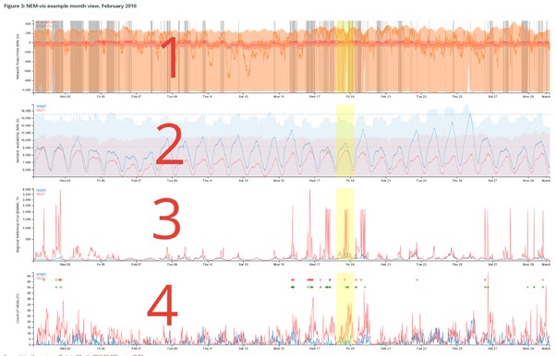
493 In this view, Panel 1dispalys data relating to the interconnector between the Queensland and New South Wales regions. In particular, it shows: network transfer limits in MW, indicated by shaded areas; network flows in MW indicated by lines corresponding to the colour of the interconnector; and periods in which all interconnectors flowing into the selected region are simultaneously binding, indicated by vertical grey bands (2PriceR at [83(a)]).
494 Panel 2 illustrates data relating to demand and Generator availability in the Queensland and New South Wales regions. In particular, it shows: regional demand in MW, indicated by lines with a corresponding colour for the region; maximum demand in the relevant calendar year in MW, represented by horizontal dotted lines corresponding to the colour of the region; and regional Generator availability in MW, indicated by shaded areas (this is the aggregate availability of scheduled and semi-scheduled generation in each region, presented at the DI level) (2PriceR at [83(b)]).
495 Panel 3 presents the data relating to Spot Prices in the Queensland and New South Wales regions. In particular, Regional Reference Price data in $MWh are indicated by lines and is presented at the TI level, ie: the NEM settlement price (2PriceR at [83(c)]).
496 Panel 4 displays the data relating to rebidding activity in the Queensland and New South Wales regions. In particular, it shows: a count of rebids made in each TI at the TI level, ie, for each 30 minute increment); instances in which Dr Ledgerwood’s methodology would identify ATIs relating to CS Energy and/or Stanwell (indicated by red circles near the top of the chart, with the x-value of these circles identifying the point in time at which an ATI is identified); and instances in which Dr Ledgerwood’s methodology would identify ATIs for other Generators, if it were applied to all Generators (indicated by green circles, with the x-value of the circles representing the point in time in which the methodology identifies an ATI for other portfolios) (2PriceR at [83(d])).
497 The next example is a “Day View” (2PriceR Fig 5).
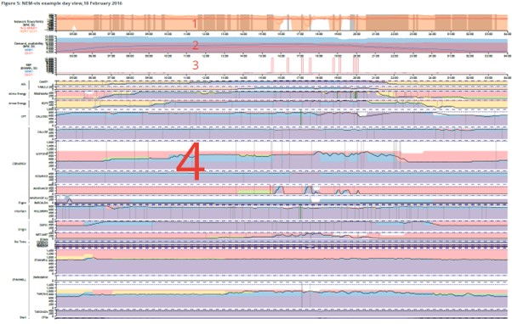
498 Panel 1 of the Day View shows the data relating to the interconnectors between the Queensland and New South Wales regions (2PriceR at [85(a)]).
499 Panel 2 displays the data relating to demand and Generator availability in the Queensland and New South Wales regions (2PriceR at [85(b)]).
500 Panel 3 shows the data relating to the Spot Price in the Queensland and New South Wales regions, although at this level, it is shown at DI level, which are averaged over the TI before being used in the NEM settlement process (2PriceR at [85(c)]).
501 Panel 4 illustrates the data relating to bid quantities and bid events at each power station. In particular, each sub-panel represents a station, or a collection of DUIDs grouped by portfolio. The y-axis of the sub-panels is in MW and the data is presented at the DI level, ie, 5-minute intervals. Within each sub-panel:
- the dotted line at the top indicates the aggregate of the station’s DUIDs’ registered capacity in MW, at the time;
- the dashed line at the top indicates the aggregate of the station’s DUID’ maximum registered capacity in MW, at the time;
- the black line indicates the aggregate actual output of the station, in MW, of each station over the course of the Trading Day;
- the shaded areas show the aggregate quantities, in MW, offered by each station at different price bands (non-inclusive), being: Market Floor (-$1,000-$0 (purple)); $0-$50 (blue); $300-$2,000 (yellow); $2,000-$10,000 (orange); $10,000 to Market Cap (red); and
- vertical lines indicate the time at which a rebid is made for one or more of the dispatch units within a station aggregation, being: grey (rebids not identified by Dr Ledgerwood’s methodology); red (events identified by Dr Ledgerwood’s methodology relating to Stanwell or CS Energy); or green (application of Dr Ledgerwood’s methodology to other portfolios).
(2PriceR at [85(d)]).

502 The next relevant example is the “Trading Interval” view (2PriceR Fig 7).
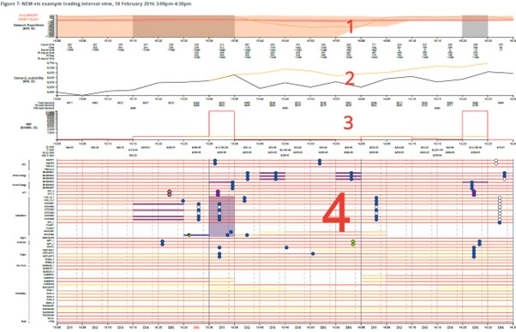
503 As Mr Price explains, this view can be configured to show up to eight TIs on either side of the selected TI and can be configured to shoe pre-dispatch outcomes at different points in time in the lead up to, and after, each DI. DIs within each TI are labelled DI1 through DI6 at the base of the chart (2PriceR at [90], [92]).
504 Panel 1 shows the data relating to the interconnectors in the Queensland and New South Wales regions. It also includes 5-minute pre-dispatch information relating to interconnectors. The values show, in descending order, the import limits in MW in each DI (ie, imports into Queensland); interconnector target flows in MW in each DI (where flows above zero are into the selected region, and flows below zero are flows out of the selected region); export limits in MW in each DI; and equivalent import limits, flows and export limits as published in pre-dispatch forecasts for the configured pre-dispatch interval (2PriceR at [93(a)]).
505 Panel 2 displays the data relating to demand and Generator availability in the Queensland and New South Wales regions. The values show, in descending order, total demand in each DI, 5-minute pre-dispatch forecasts of total demand for the configured pre-dispatch interval; and 30-minute pre-dispatch forecasts of total demand for the relevant TI of the configured pre-dispatch interval (2PriceR at [93(b)]).
506 Panel 3 displays the data relating to the Spot Prices in the Queensland and New South Wales regions. The values show, in descending order: the DI price (5 minute); the TI Price (30 minute); a 5-minute pre-dispatch forecast DI price (5 minute); and a 30-minute pre-dispatch forecast TI price (30 minute) (2PriceR at [93(c)]).
507 Panel 4 displays the data relating to individual generating units. Each row shows:
- output in MW as indicated by horizontal lines that range from yellow to red, representing graduations in output from low to maximum capacity (with no line meaning no output);
- indicators of marginality (being when, for example, a DUID contributes to setting the price in Queensland) indicated by black lines shown under the output line;
- timing of rebids made for each generating unit, represented by coloured circles, and with the circle’s position, relative to the x-axis, indicating the time of the rebid. The relevance of the colour in the circles is as follows: blue (rebid changes one or more aspects of a Generator’s offer within the period shown on the chart); grey (rebid does not change any aspect of a Generator’s offer within the period shown on the chart, or affects unrelated bid components); green (rebid changes one or more aspects of a Generator’s offer within the period shown on the chart and the rebid is one in which capacity is moved from below to above the current dispatch price); black quadrant (bid identified by Dr Ledgerwood’s methodology); red border (rebid did not apply because it was superseded by a rebid made shortly afterwards); green border (CS Energy rebid of Callide C); purple border (InterGen rebid of Callide C); and orange border (Callide C Operator rebid of Callide C);
- any DIs identified by applying Dr Ledgerwood’s methodology to Generators in addition to Stanwell and CS Energy are indicated by a shaded purple area.
(2PriceR at [93(d)]).
508 NEM-vis has interactive components built into the TI View (2PriceR at [94]). These components enable visualisation of rebid information as a “pop-up”, a TI “portfolio view”, flow, limit, and pre-dispatch information about a particular interconnector, and pre-dispatch information published within that DI. Dropdown menus also allow for the selection of the number of TIs to show before and after the selected TI.
509 Hovering the cursor over an ADI (purple shaded area) brings up the following information: the date and end-time of the ATI; the date and end-time of the ADI; the 5-minute dispatch price of the ADI; the previous DI price; the minimum of adjacent region prices (in the case of Queensland, the New South Wales price); the TI price; the previous TI Price; the following TI Price; and a section for each timing of rebid that affects the ADI (2 PriceR at [96]). An example of how this information is displayed is shown below (2PriceR Fig 6):
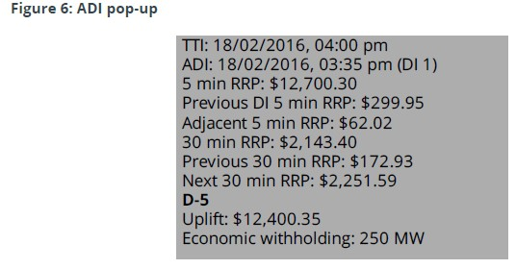
510 Hovering the cursor over a rebid reveals a pop-up that contains information about the dispatch unit, bid metadata, bid content, changes since a previous bid, and output information. An example of such a pop-up is shown below (2PriceR Fig 8):
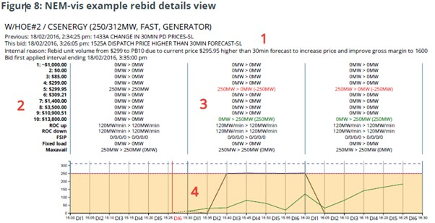
511 Mr Price explains that Label 1 of Figure 8 displays the following information:
- the name of the generating unit (W/HOE#2), its participant ID (CSENERGY, not necessarily the same as the unit’s portfolio), registered capacity (250MW), maximum capacity (312MW), start type (FAST) and dispatch type (GENERATOR, alternatives are LOAD or NOT DISPATCHED);
- “Previous” refers to the metadata about the preceding bid;
- “This bid” sets out metadata about the bid in question, including the time it was made and the rebid reasons;
- “Internal reason” refers to, where available, the internal rebid reasons for CS Energy and Stanwell sourced from Appendix E to the 3FASOC;
- “Appendix E”, if included, refers to Stillwater’s assertions regarding CS Energy’s and Stanwell’s rebid reasons;
- “Bid first applied” identifies the DI in which the bid first applied.
(2PriceR at [97(a)]).
512 Label 2 sets out on the left the labels for the data in the centre panel, including in relation to price bands, ramp rate, FSIP, fixed load, and maxavail (2PriceR at [97(b)]).
513 Label 3 is the data corresponding with the descriptions in Label 2 and shows: the volume of capacity moved from one price band (red) to another (green) (2PriceR at [97(c)-(d)]).
514 Label 4 shows output information in relation to the unit and bid in question, in particular: the y-axis values are in MW; the horizontal dotted purple line indicates the unit’s registered capacity and the horizontal dashed black line indicates the unit’s maximum capacity; the solid black line indicates the actual output of the unit as measured at the beginning of each 5-minute period; the dotted black line indicates the target output of the unit from the NEMDE; the shaded orange area represents the ability of the unit to ramp up or down; and the green line shows 5-minute pre-dispatch forecasts for the unit’s load for the selected pre-dispatch interval (2PriceR at [97(e)]).
515 Each of the Sample Intervals are analysed below, taking into account the opinions of the expert witnesses, the lay evidence (where available), and the data retrieved through NEM-vis.

Profile 1
516 This Profile is concerned with four Sample Intervals where the rebids took effect immediately, the withholding rebid having been submitted in the D-5 gate closure window for the ADI.

Sample Intervals 1, 2, 3

Sample Interval 1
517 Stillwater submitted that the direct evidence available to the Court, being the contemporaneous documents, the rebidding of CS Energy leading up to the ATI, the impugned rebid, the piling-in and the rebid reasons, lead to the comfortable inference that CS Energy’s purpose was to prevent or deter competition in Sample Interval 1.
518 Other evidence is also relevant to the appropriate inference to be drawn. That evidence includes that relating to what Mr Price termed “System conditions”, which refers to matters such as weather, demand, generator availability, and interconnector constraints (2PriceR at [4.3.2]) and “Trading and operations”, which includes Trading Day conditions generally and evidence of what had happened in prior TIs (2PriceR at [4.3.3]). These are all matters which are referred to in the Respondents’ documents as being relevant to Stanwell’s and CS Energy’s strategies, and which were referred to by Messrs Branson and Jenkins in their evidence, which was not challenged in this respect. I have identified the System conditions and Trading and operations matters that were relevant to each Sample Interval.
519 The following facts are not in dispute between Stillwater and CS Energy.
Date: | 18 February 2016
Relevant Respondent(s): | CS Energy
Affected Trading Interval: | Ending 16:00 (between 15:30 and 16:00)
Affected Dispatch Interval: | DI1 of TI ending 16:00
Time of impugned rebid: | 15:26:05 (DI6 of TI ending 15:30)
Dispatch Price: | $12,700.30MWh
Capacity (MW) rebid: | 250MW from the $299.95MWh price band to the $13,800MWh price band
Rebid reason: | 1525A DISPATCH PRICE HIGHER THAN 30MIN FORECAST – SL
Trader log entry: | Rebid unit volume from $299 to PB10 due to current price $295.95 higher than 30min forecast to increase price and improve gross margin to 1600 GPS fully dispatched.
520 Mr Price reports the following circumstances as relevant to the System conditions that pertained on this day. February 2016 was a period of oppressive humidity between 1-4 February and 16-22 February. On 18 February 2016, the temperature reached 32.6 degrees Celsius in Brisbane.
521 February 2016 saw multiple periods of high Queensland demand (over 8,000MW), with annual peak demand of 9,158MW occurring on 1 February 2016. There was price volatility between 15-20 February 2016. The ATI occurred shortly before the time of peak demand (8708MW) at 16:45.
522 During February 2016, and on 18 February in particular, there were frequent adjustments to availability and capacity in different price bands by Generators to account for changes in ambient conditions and resulting generator capabilities. On 18 February, several power stations in Queensland were running at limited capacity, or not running for technical reasons.
523 The interconnectors connecting Queensland and New South Wales were binding into Queensland intermittently and frequently during February 2016 and were binding intermittently for much of the day on 18 February.
524 Dr Ledgerwood’s Figure ATI 2.9 also showed that the interconnectors had been forecast to bind for the ATI, and in fact had bound in the three DIs prior to the impugned rebid (2LedgerwoodR at [351]).
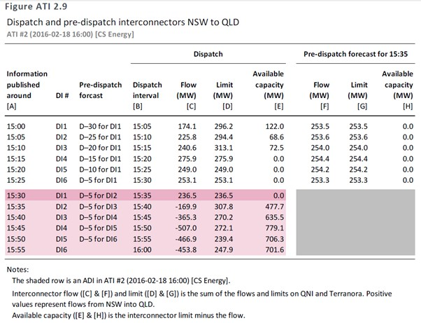
525 Dr Ledgerwood agreed in cross-examination that the re-bid did not cause the interconnector to bind. Nevertheless, he maintained that CS Energy kept the interconnector bound by its rebid, and whether the interconnector became unbound immediately thereafter, as it did, was not relevant because, in his words, “what mattered is that the interconnector bound or remained bound as of the time of the price spike … the ultimate purpose of economic withholding is to create a price-volume trade-off, that price volume trade-off happened in DI1”.
526 Mr Price reports the following matters relevant to Trading and operations. On 18 February 2016, there were eight periods of price volatility commencing with ATI#1, followed by seven between 16:30 and 20:30. There were periods of less volatility between 06:30 and 10:00 and in the 14:30 TI (around $300MWh). Subject to seven generating units that were off-line or operating at reduced capacity across the QRNEM, all others were online and available. Wivenhoe started the day with all capacity from both units bid at the MPC and, at 13:37:19, rebid to make 250MW available at $299.95MWh until 15:00. It extended this availability period until 16:30.
527 18 February was forecast to be a high demand day. Prices started at 07:00 at $299.91, when demand was almost 7,000MW. Several rebids were made from 07:00 onwards: 07:00 TI: 307MW (InterGen); 09:00 TI: (also relating to 09:30, 10:00, 10:30 TIs) 76MW for Callide C and Millmerran (InterGen); 9:30 and 10:00 TIs: 120MW (CS Energy); 10:30 TI: 25MW (InterGen); 11:00 TI: 78MW (InterGen); 12:00 TI: 25MW for Callide C and Millmerran (InterGen); 12:30 TI: 43MW for Callide C and Millmerran (InterGen); 14:00 TI (also relating to 14:30 and 15:00 TIs): 100MW (into a $299.91 price band) for that TI; 14:00 TI: 46MW for Callide C for that TI and attempted to reprice Millmerran but missed gate closure (InterGen); 14:30 TI: 133MW for Callide C and Millmerran for that TI (InterGen).
528 These occurrences are illustrated in the screenshot below of the NEM-vis Day View for 18 February 2016.
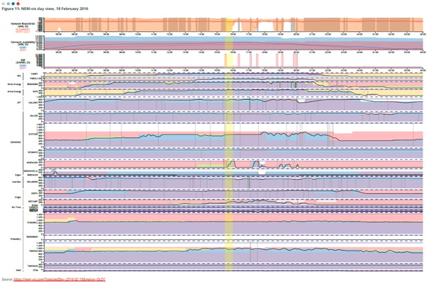
529 As to the timing of the rebid, and CS Energy did not dispute, it was to apply to two TIs – that ending at 16:00 and the next ending at 16:30. It is, therefore, not possible to conclude, accepting the premise of sub-question 7(b) of Issue 7, that at the time the Short-notice Rebid was made, competing Generators would have been impacted by the “lateness” of the rebid. Whether or not the rebid took effect immediately was not within CS Energy’s control; it was a matter determined by the application of the algorithm (the NEMDE) to the existing bid stack. Had the rebid not taken effect immediately, competing Generators would have had as many as nine DIs in which to respond and for which the rebid could not have met the description of a Short-notice Rebid.
530 As set out above, the rebid reasons cited “Dispatch price higher than 30 min forecast – SL”. The trader Log recorded – “Rebid unit volume from $299 to PB10 due to current price $295.95 higher than 30min forecast to increase price and improve gross margin to 1600 GPS fully dispatched”.
531 Dr Ledgerwood concluded (2LedgerwoodR at [1124]):
Based on the rebid explanation, the associated trading log, and the circumstances in which the rebid was made, in my opinion, there is no economic rationale indicated for CS Energy’s submission of its rebids in the D-5 gate closure window for DI1, other than it taking advantage of its substantial market power to prevent a competitive response.
532 In arriving at this conclusion, Dr Ledgerwood relied primarily on the dispatch and pre-dispatch information published by AEMO, including as to demand, interconnector status, output targets and both forecast and actual dispatch prices.
533 In relation to ATI#1, Dr Ledgerwood was challenged as to whether he had taken into account the dispatch instructions that had been given to Wivenhoe #2 and the possibility that the rebid had been made in response to a combination of low dispatch instructions and the technical limitations of the plant. Dr Ledgerwood rejected the premise, noting that it would have been a relatively simple matter for the trader to have logged physical limitations if that were in fact the case.
534 Approximately one minute before this rebid was submitted, all market participants received the information that the dispatch price for the DI ending at 15:30 was $299.95. At that same time, all market participants were aware that the 30MPD price for the current TI ending at 15:30 was $55.20, and that the 30MPD for the following TI ending at 16:00 was $299.91.
535 Dr Ledgerwood assumed that the reference to the “30 minute forecast” in CS Energy’s rebid reasons was a reference to AEMO’s 30-minute pre-dispatch forecasts, which are published every hour and half hour. The most recent such forecast prior to the rebid had been published at approximately 15:01 and contained a 30-minute pre-dispatch forecast for the TI ending 16:00 (ATI#1) of $299.91. Dr Ledgerwood observed that this was a similar figure to the prior four and subsequent five pre-dispatch forecasts around the rebid as shown in his Figure 25:
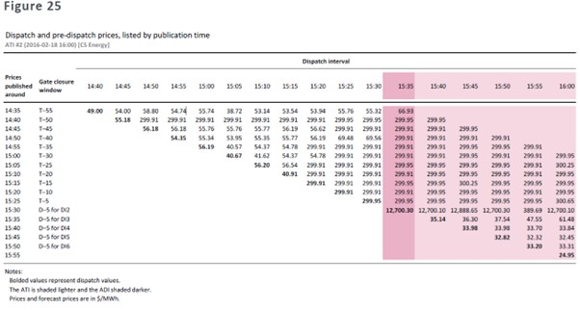
536 Dr Ledgerwood interpreted the rebid reasons to mean that the trader was referring to a 4-cent increase in the forecast dispatch price between the 30MPD price forecast of $299.91 published at 15:01 and the dispatch price of $299.95 published a minute before CS Energy’s rebid (2LedgerwoodR at [1120]).
537 Mr Price disagreed with that interpretation (2PriceR at [154]). His view was that it was likely the trader was referring to the 30-minute pre-dispatch price for the TI in which the rebid was made, being the TI ending 15:30. Mr Price thought it unusual to suggest that the dispatch price of a DI within the TI ending 15:30 should be compared to a forecast of a TI price for a TI ending 16:00. In his experience, it is normal practice to compare DI prices to forecasts of TI prices in which the DIs occur.
538 In my view, Mr Price’s interpretation is more logical. What is apparent from the evidence is that, in the relevant TI, the trader had observed three intervals of low prices ($41.62, $54.37, $54.78), followed by two DIs in which the dispatch price had settled at $299.91. In that same 10-minute period, the trader could observe that the interconnectors had bound, and demand had increased from 8,553MW to 8,568MW. These were the actual numbers available to the trader. It is more probable that a trader would be comparing actual numbers for DIs within the TI with those forecast for that TI.
539 A second reason for the rebid was posited by Mr Price which related to dispatch instructions given to Wivenhoe 2 to dispatch 14MW in the 15:30 interval, which would have required it to operate in “rough running range”. This second reason did not feature at all in the trader’s rebid reasons, nor in the log. I am not prepared to speculate as to whether or not this instruction played any part in the trader’s decision to place the rebid.
540 I conclude that the rebid was made in response to the evident change in market conditions in the 10 minutes prior to the trader’s rebid. There is nothing to suggest that the trader delayed in placing the rebid. The trader accumulated two consecutive data points in relation to increasing prices and demand (at 15:20 and 15:25), before immediately placing the rebid at 15:26. There is nothing to suggest that the trader knew or expected that any one of the other market participants would (a) know of the rebid, and/or (b) be prevented from also placing a rebid in response to the changing market conditions, let alone that the rebid was deliberately designed to prevent a competitive response.
541 Further, the evidence showed that several Generators made “pile-in” rebids in the TI ending 16:00, including AGL, InterGen, Origin, and Arrow. Although these were not responsive Rebids in the sense articulated by Dr Ledgerwood, they were nevertheless rebids that can reasonably be inferred to have been made in response to CS Energy’s, rebid given the reasons cited by the other Generators included: that the 15:30 dispatch price was higher than the 30 minute forecast; that the Queensland dispatch price was higher than forecast; and that there had been an un-forecast price spike.
542 In respect of Issue 7, the answers are, in relation to Sample Interval 1:
7(a) – No.
The evidence establishes that CS Energy submitted, between approximately one minute and 15 minutes before the start of the Affected Dispatch Interval, a rebid that shifted capacity from lower price bands to higher price bands, with the effect of:
(i) reducing the generation capacity offered in one or more price bands that, after adjustment for losses, were below the resulting dispatch price in the Affected Dispatch Interval; and
(ii) increasing the generation capacity offered in a price band that (after adjustment for losses) was at or above the resulting dispatch price in the Affected Dispatch Interval,
but the evidence does not establish that the rebid targeted the Affected Dispatch Interval or was made in furtherance of the trading strategy pleaded in [44] of the 3FASOC to rebid to target Dispatch Intervals.
7(b) – No.
7(c) – No.

Sample Interval 2
543 The following facts are not in dispute between Stillwater and Stanwell.
Date: | 29 December 2013
Relevant Respondent(s): | Stanwell
Affected Trading Interval: | Ending 13:00 (between 12:30 and 13:00)
Affected Dispatch Interval: | DI6 of TI ending 13:00
Time of impugned rebid: | 12:52:24 (DI5 of TI ending 13:00)
Dispatch Price: | $1,400MWh
Capacity (MW) rebid: | 320MW identified as economic withholding, moved to price bands above $1,400MWh
Rebid reason: | 1251A CHANGE IN QUEENSLAND PD PRICE
Trader log entry: | Change in QLD Predispatch price over the rest of the day, Moved volume to higher PBs on Swan E Tarong, Stanwell and TN. NB

544 Stillwater submitted that, in rebidding shortly before gate-closure for DI6, Stanwell’s purpose was to prevent or deter other Generators from being able to respond to the rebid in a manner likely to defeat the positive price-volume trade-off Stanwell was hoping to achieve. It submitted that there was no material change to market conditions that would justify the withholding of 320MW at 12:52.
545 Dr Rose identified the following System conditions relevant to Sample Interval 2 (2RoseR at Chapter 11). The 29th was the hottest day of December 2013 in Brisbane, with a temperature of 40.4 degrees Celsius recorded at Amberley. The morning of 29 December (09:00 TI - 10:00 TI) showed lower demand than the 30MPD forecasts from the start of the day, after which time demand increased above the 30MPD forecasts. From midnight until the beginning of the 13:00 TI, the 30MPD forecast rose from 6,372MW (forecast during the 09:30 TI) to 6,593MW (during the 13:00 TI, and forecast by AEMO a few seconds after the start of the impugned TI).
546 Two Tarong units had been mothballed for 12 and 11 months of the year, respectively. At the start of the Trading Day, up to and including the ADI ending 13:00, seven coal or gas generating units owned by other Generators (including all but AGL) were online. In the following TI, another three generating units began to come online.
547 The 30MPD forecasts released from 13:00 the previous day indicated potential volatility on 29 December, with multiple forecasts indicating the Queensland spot price could be $249MWh during the evening. Forecast prices in Queensland were higher than New South Wales indicating the interconnector could bind.
548 Dr Ledgerwood’s Figure ATI 1.12 showed that the interconnectors were forecast to be bound throughout the whole of the prior TI and in DI1-DI5 of the ATI and were in fact so bound except in DI2 of the ATI (2LedgerwoodR at [253]).
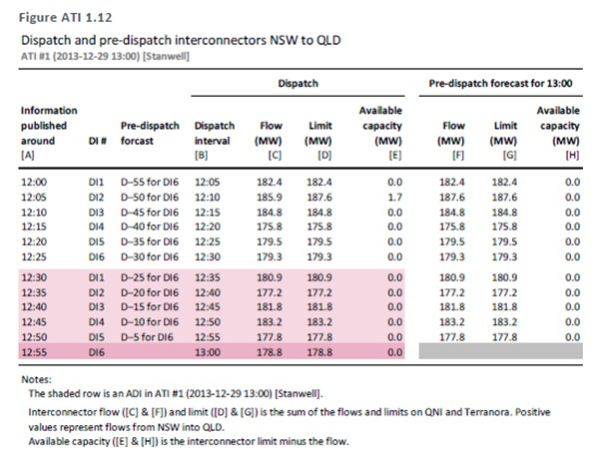
549 The following matters were relevant to Trading and operations. This ATI fell within the period when the carbon tax was in force; coal-fired Generators were paying approximately $20MWh for carbon taxes as compared with combined cycle gas turbine Generators that were paying in the range of $8MWh for carbon taxes. 29 December 2013 was a Sunday falling between Christmas and New Year. The trader was working from home.
550 The 30MPD price sensitivities released at approximately 12:30 contained prices as high as $1,400MWh for the 13:00 TI. The 5MPD forecast at the beginning of the 12:30 DI for the 12:30 DI (released soon after 12:25:01) showed a price of $67.03MWh, as compared with the previous 5MPD forecast of $56.15MWh for the 12:25 DI. The 12:30 DI forecast the binding of the interconnector in the 12:30 DI. The 5MPD forecasts released after the 13:00 TI forecast prices rising to a peak of $2,003.56MWh for the DI ending 16:05.
551 Stanwell’s impugned rebid was complicated:
(a) SWAN_E – withdrew 130MW from $45MWh to price bands between $1,500MWh and $13,100MWh, with a ramp down capability of 55MW per DI;
(b) TARONG#1 and TARONG#3 – withdrew a combined 160MW from price bands between $49MWh and $1,500MWh to $13,100MWh with a combined ramp down capability of 40MW per DI;
(c) TNPS1 – withdrew 70MW from $45MWh to $13,100MWh (ramp down capability of only 30MW per DI so cannot change by more than 30MW); and
(d) withdrew, with respect to STAN-1 and STAN-4, a combined 200MW from $56MWh to price bands between $100MWh and $290MWh, with a combined ramp down capability of 60MW per DI. Because the actual dispatch price was $1,400MWh, however, the rebid had no impact on price, and so was not impugned by Stillwater.
552 In view of the complexity of the rebid, there is nothing surprising about the time taken for the rebid to be placed. In his oral evidence, Mr Jenkins explained the elements of rebidding and the reasons for some rebids happening almost instantaneously whilst others take longer. There is nothing on the evidence to suggest that the trader delayed in the placing of the rebid in this ATI. The mere fact that it was placed shortly before gate closure for DI6 is insufficient to draw that inference. With the exception of Swanbank E, the rebid repriced capacity for several hours (and for at least 49 DIs for six of the eight affected generating units).
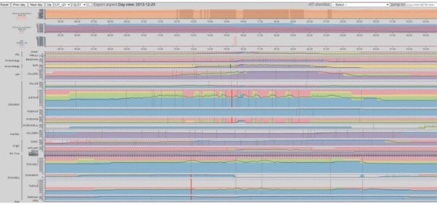
553 Stillwater submitted that the NEM-vis Day View for 29 December 2013, extracted above, shows there was no significant price volatility over the course of the day with a price spike in the ATI, and another for the TI ending at 16:00. The latter was much more significant. The price spiked in the later TI ending 16:00 at $13,004.97.
554 Stillwater’s criticism of the rebid reasons was based on Dr Ledgerwood’s conclusion that the 5MPD forecasts and dispatch prices for ATI#2 were relatively low and stable and had been since approximately 55 minutes prior to the start of the ADI. This was shown in Dr Ledgerwood’s Figure ATI 1.4:
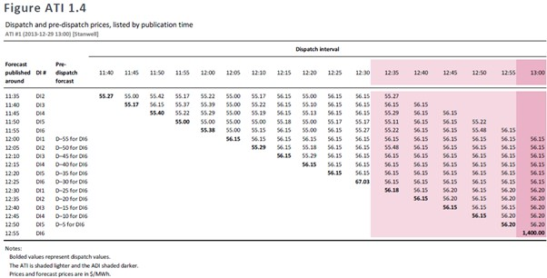
555 Stillwater accepted in its written submissions that there was “literally” a change in the pre-dispatch prices, consistent with the pre-dispatch price referred to in the rebid reasons but submitted that the de minimis change was not one that would rationally cause a Generator to economically withhold 320MW. The acceptance of that submission depends, in part, on accepting Stillwater’s contention that the traders were referring to the 5MPD forecasts ending with the ATI. It is tolerably clear, however, that the rebid reasons were not referring to the 5MPD forecasts, given the express reference to changes in the 30MPD forecast “for the rest of the day”. Dr Ledgerwood appears to have accepted that, at the time of the rebid, there would be no further relevant 5MPD forecasts. Despite having access to the 30MPD forecasts, Dr Ledgerwood does not appear to have considered them. His analysis did not go beyond the ATI itself. As Dr Rose explained, the higher prices forecast for the rest of the day appeared in the 30MPD forecasts published at 11:30:44, 12:00:44 and 12:31:29 (2RoseR at [11.32]). This was shown in Dr Rose’s Table 19:
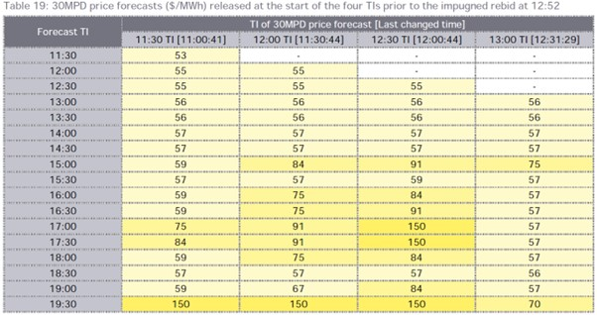
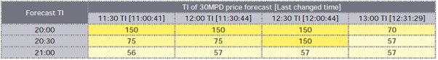
556 Although the higher prices forecast at 12:00:44 had largely disappeared by the time the forecast at 12:31:29 was released, the price sensitivity data published at around 12:35 was predicting a forecast price in ATI#2 of $1400MWh if there were an additional 1000MW of demand in Queensland (2RoseR at [2.84]; SuppRoseR, Table 2).
557 Stillwater’s criticism of this rebid depends on denying a trader the opportunity to undertake the multifactorial assessment of all data points available to him and to craft the bid appropriately, in this case across multiple generating units, and having regard to the corporate imperative. The structure of the rebids across several TIs is strong evidence against Stillwater’s submission that the trader was seeking to implement Short-notice Rebidding. To the contrary, and as Stillwater submitted, the rebid evidences the trader’s implementation of Stanwell’s “active trading strategy”. It is reasonable to infer that the trader had identified several pre-conditions to its implementation, among them the binding of the interconnectors, an increase in forecast demand, rebidding by Stanwell’s competitors in at least the previous two TIs, as well as the increase in forecast prices.
558 In DI6 of the ATI, there were two “pile-in” rebids, by Origin and Arrow respectively.
559 In respect of Issue 8, the answers are, in relation to Sample Interval 2:
8(a) – No.
The evidence establishes that Stanwell submitted, between approximately one minute and 15 minutes before the start of the Affected Dispatch Interval, a rebid that shifted capacity from lower price bands to higher price bands, with the effect of:
(i) reducing the generation capacity offered in one or more price bands that, after adjustment for losses, were below the resulting dispatch price in the Affected Dispatch Interval; and
(ii) increasing the generation capacity offered in a price band that (after adjustment for losses) was at or above the resulting dispatch price in the Affected Dispatch Interval,
but the evidence does not establish that the rebid targeted the Affected Dispatch Interval or was made in furtherance of the trading strategy pleaded in [44] of the 3FASOC to rebid to target Dispatch Intervals.
8(b) – No.
8(c) – No.

Sample Interval 3
560 The following facts are not in dispute between Stillwater and Stanwell.
Date: | 25 October 2013
Relevant Respondent(s): | Stanwell
Affected Trading Interval: | Ending 16:30 (between 16:00 and 16:30)
Affected Dispatch Interval: | DI5 of TI ending 16:00
Time of impugned rebid: | 16:15:38 (DI4 of TI ending 16:30)
Dispatch Price: | $13,100MWh
Capacity (MW) rebid: | 633MW (723MW was moved to price bands between $12,350MWh to $13,100MWh, but Dr Ledgerwood only identifies 633MW as ‘economic withholding’ which was moved to $13,100MWh)
Rebid reason: | 1610A CHANGE IN QLD PREDISPATCH PRICE
Trader log entry: | Change in Qld Predispatch Price. 5 minute predispatch has been regularly changing in Price the last half hour, alternating between late $50’s and $85 / MWh. Moved MW on Stanwell Units, TI, TN and Swan E to higher Price bands to support higher prices. NB
561 Stillwater submitted that, the rebids were “no notice” rebids made late in the TI, just prior to the gate closure for DI5, with the consequence that competitors had no ability to respond to the rebid in a way that could impact on the dispatch price for DI5. The rebids, however, changed the offers for both DI5 and DI6.
562 Dr Rose identified the following System conditions relevant to Sample Interval 3 (2RoseR at Chapter 12). Temperatures were above average for the month of October and Brisbane Airport Station received its lowest October rainfall on record since 1994. Demand was forecast to be fairly flat across the Trading Day. Expected demand did not move consistently up or down and actual demand was not consistently higher or lower than forecast.
563 Between the start of the market and the ADI, flow from the interconnector had been at or near the northward limit for about half an hour (2RoseR at Fig 33). From about 15:00, actual flow northwards increased steadily before hitting its limit in DI2 (but without causing a price elevation) and again in DI5 (the ADI).
564 The following matters were relevant to Trading and operations. The 5MPD forecast in the lead up to the impugned rebid showed some expectation of prices up to $85MWh for the DIs within the 16:30 TI. However, actual prices in the lead-up to the rebid remained at around $60MWh.
565 Stanwell’s impugned rebid was not straightforward:
(a) a combination of STAN-1 STAN-2 STAN-3 and STAN-4 shifted 480MW from price bands between $52.98MWh and $290MWh to price band of $13,100MWh;
(b) SWAN_E shifted 100MW from $44.99MWh price band to between $12,350MWh and $13,100MWh;
(c) TARONG#1 shifted 90MW from price bands between $52.98 and $65 to price bands between $12,495MWh and $13,100MWh;
(d) TNPS1 shifted 53MW from $44.99MWh price band to price bands between $12,499.99MWh and $13,100MWh; and
(e) DDPS1 rebid adding 5MW to its $0.01MWh price band.
566 Dr Ledgerwood’s Figure ATI 3.3 shows that pre-dispatch forecast prices were predominantly low, at around $60.00MWh, although he conceded there were “a few forecasts at around $85.00MWh at D-35 from DI5” (2LedgerwoodR at [397]).
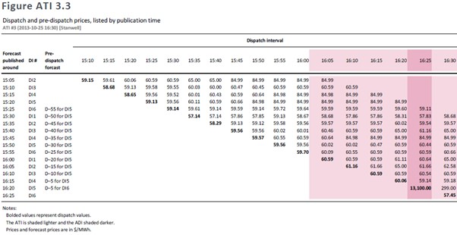
567 Dr Ledgerwood accepted that the rebid reason was consistent with the 5-minute forecasts generally but maintained that the rebid could have been made earlier on the basis of those forecasts. Dr Ledgerwood was, however, focussed only on the forecasts leading up to the ADI. As is shown in Table 4 of the Supplementary Rose Report, the sensitivity forecast for the 16:30 TI published at around 16:04 showed potentially greater volatility.
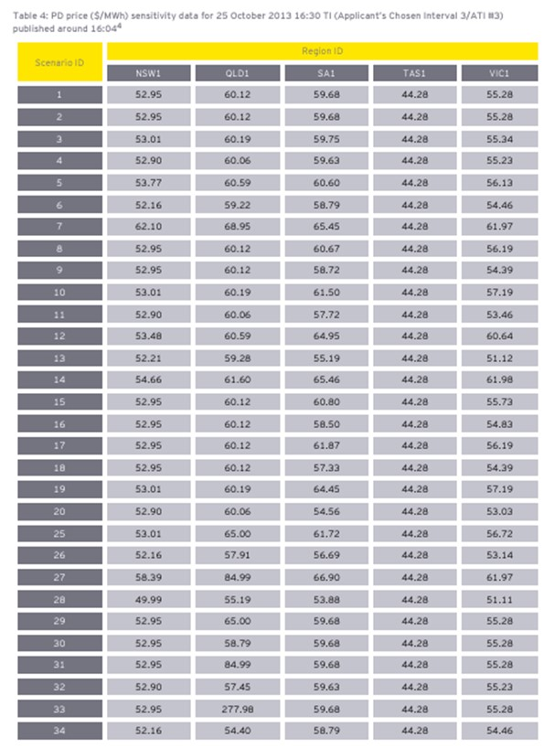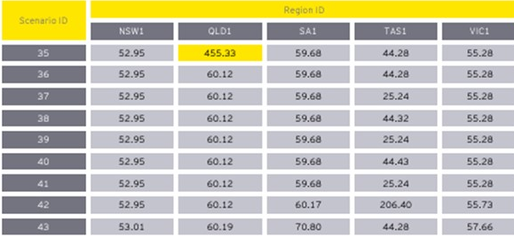

568 In fact, in the half hour prior to the rebid, the forecast price for DI5 had varied between $57.83 and $84.99. No 5-minute forecast up to the point of the rebid was the same. This is consistent with the trader’s reasons – “5 minute predispatch has been regularly changing in Price the last half hour”. Dr Rose opined that it was well known that prices fluctuating to this extent is indicative of price separation (JtEMER at [433]). Whilst the term “alternating” was perhaps not entirely appropriate to describe the “varying” prices, I am not persuaded that too literal an approach to interpretation should be given to the choice of word in this context. Further, it is implausible that the trader would have fixed upon the trend in pre-dispatch prices for the lone DI at 16:25. This was self-evidently not the case given the rebids affected multiple TIs.
569 As to whether the rebid was delayed, it was Mr Branson’s evidence, albeit not in relation to this ATI specifically, that generally, he might watch a trend emerging in the AEMO data to see if it continued before deciding to rebid (Branson Affidavit at [69]). That evidence was not challenged. In any event, it is consistent with Dr Ledgerwood’s thesis as to the need for notice to be given to competitors.
570 With respect to this ATI, Dr Ledgerwood accepted that prices had fluctuated, and that the interconnector was close to binding. He rejected the legitimacy of the rebid reasons, however, on this basis:
I realise that the trader could have been looking at many, many things – and I have heard about sensitivities and all of this other stuff – we do have the rebid reason that says they were looking at prices vacillating between $55 and $85. There is so much information that one could look at on an ex post basis in an electricity market and say, “Yes. This could be a factor, that could be a factor.” The reality is that we know what is. What is, is that a no-notice rebid was placed in DI4 and a price spike emerged in DI5 and we have the rebid reason as given and that’s true in every ATI. Sometimes it’s more true; sometimes it’s not. But here, very clearly, the question is, you know, given the nature of the rebid reason, was withholding 663 megawatts from seven units likely to produce a price spike given there was no notice given to the market and the answer is apparently yes.
(Emphasis added.)
571 It is reasonably clear that, had the price not spiked in DI5, Dr Ledgerwood could not have maintained his conclusion. His conclusion that the reasons were disingenuous and that the rebid lacked a valid alternative economic rationale depended on a price spike being achieved immediately in the next DI. That conclusion appears implausible given that the rebid was not targeted at the lone DI ending at 16:25 but applied to multiple TIs. The trader was express in the log that the rebid was to “support higher prices”. That reason is entirely consistent with Stanwell’s “active strategy”. Nothing on the evidence, however, establishes that Stanwell engaged in Short-notice Rebidding. Further, to the extent that Stillwater contended that the rebid could have been made earlier, that is not its case. Its case requires that the trader deliberately delayed submitting the rebid, such that it should have been made earlier. That has not been established.
572 In any event, consequent upon the new forecasts in DI5 in response to the rebids, pile-in rebids were made by CSE in relation Wivenhoe 2 and Braemar 6, albeit, once again, not ones that Dr Ledgerwood would accept as competitive.
573 In respect of Issue 9, the answers are, in relation to Sample Interval 3:
9(a) – No.
The evidence establishes that Stanwell submitted, between approximately one minute and 15 minutes before the start of the Affected Dispatch Interval, a rebid that shifted capacity from lower price bands to higher price bands, with the effect of:
(i) reducing the generation capacity offered in one or more price bands that, after adjustment for losses, were below the resulting dispatch price in the Affected Dispatch Interval; and
(ii) increasing the generation capacity offered in a price band that (after adjustment for losses) was at or above the resulting dispatch price in the Affected Dispatch Interval,
but the evidence does not establish that the rebid targeted the Affected Dispatch Interval or was made in furtherance of the trading strategy pleaded in [44] of the 3FASOC to rebid to target Dispatch Intervals.
9(b) – No.
9(c) – No.

Profile 1 and Profile 4

Sample Intervals 4 and Sample Intervals 10 &11

Sample Intervals 4 & 10
574 Sample Intervals 4 and 10 occur on the same Trading Day in consecutive TIs. They are considered together, albeit they have different profiles. Dr Ledgerwood places Sample Interval 4 in Profile 1, whereas Sample Interval 10 is in Profile 4, characterised by the first ADI having both no-notice and D-10 rebids.

Sample Interval 4 |  | Sample Interval 10
The following facts are not in dispute between Stillwater, Stanwell and CS Energy. |  | The following facts are not in dispute between Stillwater and CS Energy.
Date: | 13 February 2014 | Date: | 13 February 2014
Relevant Respondent(s): | Stanwell and CS Energy | Relevant Respondent(s): | CS Energy
Affected Trading Interval: | Ending 16:30 (between 16:00 and 16:30) | Affected Trading Interval: | Ending 17:00 (between 16:30 and 17:00)
Affected Dispatch Interval: | DI6 ending 16:30 | Affected Dispatch Interval: | DI5 ending 16:55
Time of impugned rebid: | Stanwell: 16:20:59  CS Energy: 16:20:28  Callide C: 16:19:29 | Time of impugned rebid: | CS Energy: 16:45:22  Callide C: 16:42:45
Dispatch Price: | $11,850.95MWh | Dispatch Price: | $11,850.95MWh
Capacity (MW) rebid: | Stanwell: 190MW was moved to the highest price band at $13,100MWh and is the quantity that Dr Ledgerwood identifies as ‘economic withholding’.  CS Energy: 518MW was moved to the highest price band at $13,100MWh and is the quantity that Dr Ledgerwood identifies as ‘economic withholding’. | Capacity (MW) rebid: | 518MW was moved to price bands above $11,850MWh, and therefore is the quantity that Dr Ledgerwood identifies as ‘economic withholding’.
Rebid reason: | Stanwell: 1619A MATERIAL 5 MIN DEMAND V 30 MIN PD 1630-SL  CS Energy: 1616A MPP_2 OFFLINE QNI BINDING NORTH-SL  Callide C: 1618A MPP_2 OFFLINE QNI BINDING | Rebid reason: | CS Energy: 1641A MPP_2 OFFLINE QNI BINDING NORTH-SL  Callide C: 1642A MPP_2 OFFLINE QNI BINDING
Trader log entry: | Stanwell: Rebalanced SPS due to demand for 1620 DI being 250MW higher than what is forecast for the 1630TI, indicating that conditions are more sensitive than expected therefore rebid to place upward pressure on price as per strategy.  CS Energy: GPS units rebid. Moved MW from PB5 to PB10. CB2 rebid moved MW from PB3 to PB10. Made FCAS unavailable on all units. MPP_2 offline and QNI northern headroom low/binding.  Callide C: N/A | Trader log entry: | CS Energy: GPS units rebid. Moved MW from PB5 to PB10. CB2 rebid moved MW from PB3 to PB10. Made FCAS unavailable on all units. MPP_2 offline and QNI northern headroom low/binding.  Callide C: N/A
575 The System conditions identified by Dr Price and Dr Rose included that 13 February was another hot day, around 29 degrees Celsius from 11:00-14:30. However, by the time of the impugned rebid, the temperature had dropped by about 20 degrees Celsius. Demand was 7,266MW in ATI#4, which was relatively high (in the top 4% of demand for that year) (2PriceR at [160]; 2RoseR at [13.2]).
576 A unit at Callide C power station had tripped the previous night, causing the withdrawal of 420MW. Early on the morning of 13 February, Millmerran 2 tripped, reducing capacity by a further 426MW (2PriceR at [160]; 2RoseR at [13.9(a)]). A Darling Downs station was operating at approximately 50% capacity, a further reduction of 240MW (2PriceR at [160]). The NEM-vis Day View screen shot below illustrates many of these matters.
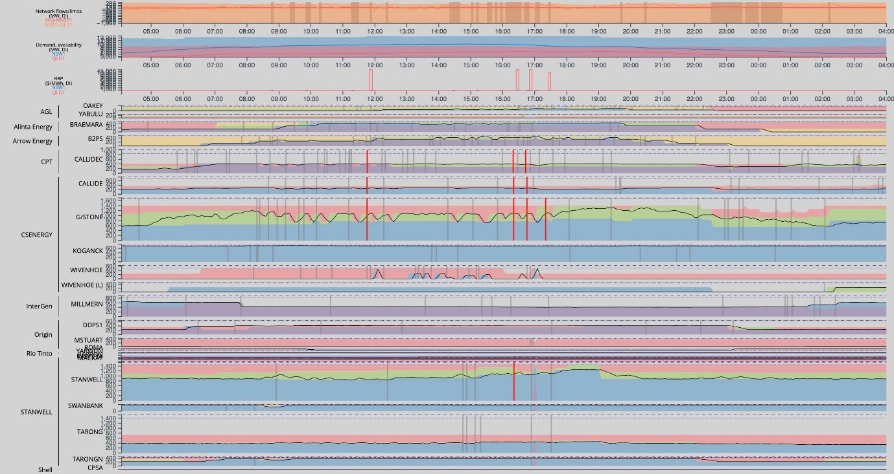
577 As to matters relevant to Trading and operations, Mr Price observed that, in addition to demand being high and there being considerable loss of capacity, there had been an earlier price spike of $11,850MWh during the DI ending 11:55. In relation to ATI#10, of course, the price had spiked in the immediately preceding TI, being ATI#4. All market participants monitor the dispatch data across the NEM 5 minutes after each DI and could observe that CS Energy had been engaged in “saw toothing” (frequently rebidding at higher and then lower prices) throughout the day.
578 In addition to these matters, Dr Rose noted that: from the 15:35 DI until the 16:55 DI, the Queensland dispatch price was always significantly higher than the New South Wales dispatch price, suggesting the price could elevate much higher; 30MPD price forecasts on this day and the previous day gave some strong indications for high prices in the 16:30 TI and 17:00 TI; and, in addition to the 11:55 price spike, there had already been six other DIs with prices in excess of $250MWh, and an expectation of increasing demand through the afternoon.
579 Dr Ledgerwood opined that the most likely rationale for the Respondents’ rebids in relation to ATI#4 (at 16:20:59 by Stanwell and at 16:20:28 by CS Energy) “was to cause an elevated dispatch price, while precluding a competitive response” (2LedgerwoodR at [1145]).
580 In relation to the rebids relevant to ATI#10, by CS Energy at 16:45:22, Dr Ledgerwood similarly opined that “CS Energy’s most likely rationale for its rebid withholding of 113MW and then 405MW prior to DI5 was to cause an elevated dispatch price, while precluding a competitive response” (2LedgerwoodR at [1192]).
581 It is perfectly plain that the rationale for the rebids in both ATI#4 and ATI#10 was to cause an elevated dispatch price, consistent with the trading strategies of both Stanwell and CS Energy. Indeed, CS Energy’s contemporaneous Daily Market Report described 13 February 2014 as one that had presented “opportunities to utilise Gladstone’s high ramp rates to bring some price volatility into the QLD spot market”.
582 As to ATI#4, the trader log for Stanwell is clear that the rebid was submitted “to place upward pressure on price as per strategy”. The event cited was that actual demand in the 16:20 DI was 250MW higher than the 30-minute forecast for the 16:30 TI (2RoseR at [10.7]). The change in demand was verified by a screen shot taken contemporaneously by the trader who submitted the rebid (B1644) and subsequently by Dr Rose (2RoseR at [13.7]-[13.8], [13.15]) and Dr Ledgerwood, who also observed that the pre-dispatch forecasts for DI6 did not predict the increase. (2LedgerwoodR at [1134]). Stanwell’s rebid was submitted within two minutes of the time cited in the rebid reasons, and around five minutes after the actual demand referred to in the reasons was published.
583 CS Energy’s log referred to MPP2 being offline and the QNI binding north. Dr Ledgerwood was critical of these reasons as not reflecting “new information”. That was because MPP2 had been offline since about 07:48 when it tripped and became unavailable for dispatch. Each market participant receives from AEMO information about the actual generation output of each generating unit shortly after the start of each DI. However, market participants have no information as to how long a generating unit is likely to be offline. It is, therefore, reasonable to assume that traders might be monitoring, after each DI, whether MPP2 was still offline. Any update as to whether MPP2 was still offline or had come back online is new information. Dr Ledgerwood eventually conceded as much.
584 The data shows that, in the hour prior to the start of ATI#4, both the QNI and the Terranorra interconnector had been binding intermittently for periods of up to 10 minutes. Prior to that, with the exception of two 5-minute periods, the QNI had been unbound since 14:40.
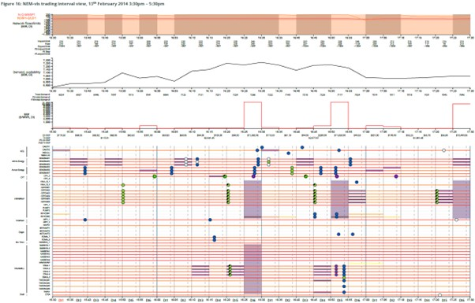
585 At 16:05, the market could see that the interconnectors had again started to bind. They remained bound for the 15 minutes prior to CS Energy submitting its rebid at 16:20. Just prior to that rebid, the market was notified of an un-forecast increase in QRNEM demand of 92MW. In the JtEMER at [143], Mr Price opined that he considered the impugned rebid was made in circumstances that were materially different from those which existed when the initial dispatch offer for the relevant ATI, or the last offer prior to the identified impugned rebid was made. Dr Rose arrived at a similar conclusion (JtEMER at [148]).
586 Dr Ledgerwood’s concern with the Respondents’ behaviour was made pellucid in his response to Q17 in the JtEMER at [220] where he said the following:
While the reasons provided by each Respondent could be construed to describe the market conditions that were present at the time, those reasons do not justify the use of no-notice rebids and the substantial quantities of output withheld by the Respondents through their rebids.
(Emphasis added.)
587 This opinion is held notwithstanding that there was no non-compliance with the NER, that rebidding in the last 5 minutes of a DI was permitted, and in the face of the concession that there was a material change in market conditions.
588 As to ATI#10, the circumstances were similar to those of the immediately preceding TI. There was “new information”, just prior to the entry of the rebid, that MMP2 had still not come back online. Further, and as can be seen in Figure 16 of the 2PriceR reproduced above, the status of the QNI had changed to binding and was forecast to remain bound throughout ATI#10. In fact, at 16:35, the QNI became unbound, before binding again 5 minutes later. CS Energy’s rebid came within 2-5 minutes after the publication of that change in circumstances regarding the QNI. In addition, in the approximately 25 minute period between CS Energy’s rebids of Callide C, Callide B and Gladstone in ATI#4 (the ATI#4 rebids) and, subsequently, in ATI#10, there had also been an increase in pre-dispatch prices from between $119.50MWh to $149.50MWh – when CS Energy made the ATI#4 rebids – and $239.95MWh to $289.99MWh, when CS Energy made the ATI#10 rebids. That this particular circumstance is not expressed in the rebid reasons is of little moment in the circumstances where there are character limitations on the reasons and the trader’s logs are not expected to contain every factor considered by a trader in the lead up to making a rebid.
589 Stillwater submitted that the CS Energy (and, by analogy Stanwell’s) conduct was only rational if the responses of potential competitors could be constrained, so that the withheld supply could not be wholly substituted at a price that was low enough to prevent the positive price-volume trade-off. It submitted that the constraint was explicitly achieved by means of CS Energy (and/or Stanwell) using its ability to ramp down faster than the alternative suppliers, who might have bid at those “low enough” prices, could ramp up. The purpose in the timing of the rebid was to limit that time for alternative supply to disrupt its objective of forcing the NEMDE to dispatch at a sufficiently high price to assure a positive price-volume trade-off.
590 This submission ignores, however: that Stanwell and CS Energy made rebids in all DIs, and not necessarily to take effect immediately; that its strategy documents make no mention of comparative ramp rates and the role that might play in rebids; and that although it was hoped that rebids would place upward pressure on prices, price spikes were not foreseeable, particularly in periods of extreme volatility.
591 More importantly, in respect of ATI#4, the submission ignores the rebids made by competing Generators within the late-rebidding period and those made for the following TI, in particular by Arrow Energy and ERM Power removing a total of 125MW to lower price bands, citing as the rebid reasons that the Queensland dispatch price was higher than forecast (2RoseR at [13.32]-[13.35]). Mr Price observed that a number of flexible Generators were available to operate to meet higher prices (2PriceR at [167]). In particular, he noted that AEMO instructed Oakey and Townsville Power Stations to start during ATI#4 but, for reasons that are not apparent, they did not. He opined, however, that, given the market conditions on that day, it is plausible that competing Generators made informed decisions not to operate, rather than simply being “caught off-guard” and unable to respond to the impugned rebids in time. Similarly, in ATI#10, rebids were made by competing Generators, including within the late rebidding period and in the TI immediately following ATI#10 by AGL, Arrow, and InterGen.
592 In respect of Issue 10, the answers are, in relation to Sample Interval 4:
10(a) – No.
The evidence establishes that Stanwell submitted, between approximately one minute and 15 minutes before the start of the Affected Dispatch Interval, a rebid that shifted capacity from lower price bands to higher price bands, with the effect of:
(i) reducing the generation capacity offered in one or more price bands that, after adjustment for losses, were below the resulting dispatch price in the Affected Dispatch Interval; and
(ii) increasing the generation capacity offered in a price band that (after adjustment for losses) was at or above the resulting dispatch price in the Affected Dispatch Interval,
but the evidence does not establish that the rebid targeted the Affected Dispatch Interval or was made in furtherance of the trading strategy pleaded in [44] of the 3FASOC to rebid to target Dispatch Intervals.
10(b) – No.
10(c) – No.
10(d) – No.
The evidence establishes that CS Energy submitted, between approximately one minute and 15 minutes before the start of the Affected Dispatch Interval, a rebid that shifted capacity from lower price bands to higher price bands, with the effect of:
(i) reducing the generation capacity offered in one or more price bands that, after adjustment for losses, were below the resulting dispatch price in the Affected Dispatch Interval; and
(ii) increasing the generation capacity offered in a price band that (after adjustment for losses) was at or above the resulting dispatch price in the Affected Dispatch Interval,
but the evidence does not establish that the rebid targeted the Affected Dispatch Interval or was made in furtherance of the trading strategy pleaded in [44] of the 3FASOC to rebid to target Dispatch Intervals.
10(e) – No.
10(f) – No.
593 In respect of Issue 16, the answers are, in relation to Sample Interval 10:
16(a) – No.
The evidence establishes that CS Energy submitted, between approximately one minute and 15 minutes before the start of the Affected Dispatch Interval, a rebid that shifted capacity from lower price bands to higher price bands, with the effect of:
(i) reducing the generation capacity offered in one or more price bands that, after adjustment for losses, were below the resulting dispatch price in the Affected Dispatch Interval; and
(ii) increasing the generation capacity offered in a price band that (after adjustment for losses) was at or above the resulting dispatch price in the Affected Dispatch Interval,
but the evidence does not establish that the rebid targeted the Affected Dispatch Interval or was made in furtherance of the trading strategy pleaded in [44] of the 3FASOC to rebid to target Dispatch Intervals.
16(b) – No.
16(c) – No.

Sample Interval 11
594 The following facts are not in dispute between the parties.
Date: | 30 December 2013
Relevant Respondent(s): | Stanwell and CS Energy
Affected Trading Interval: | Ending 17:30 (between 17:00 and 17:30)
Affected Dispatch Interval: | DI5 of TI ending 17:30  DI6 of TI ending 17:30
Time of impugned rebid: | Stanwell: 17:13:43 (DI3 of TI ending 17:30)  CS Energy: 17:18:27 (DI4 of TI ending 17:30)
Dispatch Price: | DI5: $1,400MWh  DI6: $1,400MWh
Capacity (MW) rebid: | Stanwell: 543MW was moved from price bands at $56.20MWh or below to the $13,100MWh band, and 90MW was moved from the $1,500MWh price band the to $13,100MWh price band. 543MW is the quantity that Dr Ledgerwood identifies as ‘economic withholding’ by Stanwell.  CS Energy: 90MW was moved to the $49.53MWh price band, and 670MW was moved to the $1,400MWh and $13,000MWh price bands. 670MW is the quantity that Dr Ledgerwood identifies as ‘economic withholding’ by CS Energy.
Rebid reason: | Stanwell: 1703A CHANGE QLD DEMAND 1730TI PD1730VPD1630 SL  CS Energy: 1718A INTERCONNECTOR CONSTAINT-QNI BINDING-SL
Trader log entry: | Stanwell: PD released at 1703(PD1730) has higher fcast for QLD demand for 1730 TI than PD at 1630. DATETIME LASTCHANGED PD QLD Demand 30/12/2013 17:30 30/12/2013 16:01 1630 6683.62 30/12/2013 17:30 30/12/2103 17:01 1730 6890.29 DELTA 206.67  CS Energy: GPS units moved out to PB9 due to QNI binding and SCL moving MW’s out to higher price bands. Predispatch showing $150 plus prices.
595 Mr Price identified that System conditions relevant to this ATI included that, although it was a Monday in the end-of-year holiday period, demand was still in the top 5%, peaking at 7,108MW 10 minutes prior to ATI#11 (2PriceR, Chapter 9). Since demand was not forecast to be in the top 1%, a number of peaking Generators were off-line, and others were operating at reduced capacity. Nevertheless, as Dr Rose observed, the Bureau of Meteorology had forecast extreme weather conditions, so all market participants would have been aware of the potential for demand changes (2RoseR, Chapter 16).
596 Further, part of the Terranorra interconnector was offline, requiring Terranorra to export around 75MW from Queensland to New South Wales for most of the day, effectively reducing supply in Queensland. The QNI was binding for limited periods between 13:00 and 19:00 (2PriceR at [415]-[416]). Queensland prices were moderately higher than New South Wales prices. Consequently, there was uncertainty as to whether small changes in Queensland supply or demand would result in either higher or lower prices. All market participants would have observed the potential for further price separation (2RoseR at[16.8]- [16.9]). There was therefore the potential for a competitive response by any Generator to maintain or increase Queensland price (2PriceR at [9.3.2]; 2RoseR at [16.8]-[16.9]).
597 Mr Price observed that, as to Trading and Operation conditions, there were two periods of volatility in Queensland during the Trading Day. The first was at the TI ending 14:30, when prices were around $300MWh, and the second was in this ATI#11. Prices were otherwise fairly stable at around $55MWh for most of the day.
598 Stillwater submitted that there was no material change in market conditions that justified the rebids by either Stanwell or CS Energy. Stanwell justified its rebid on the basis of a higher demand forecast published at the start of the Sample Interval, as compared with that published an hour earlier. CS Energy justified its rebid on the basis of Stanwell’s withholding rebid and the binding of the QNI at the time.
599 Stanwell submitted its impugned rebid at 17:13:43, repricing 633MW (only 543MW was detected by Dr Ledgerwood’s screens) in six different bid profiles for eight different generating units across multiple TIs.
600 CS Energy submitted its impugned rebid at 17:18:27 repriced 250MW from price bands of less than $250.01MWh to $1,400MWh, 570WW from price bands of $1,400MWh or less up to $13,100.00MWh, and 90MW to a lower price band of $49.53MWh.
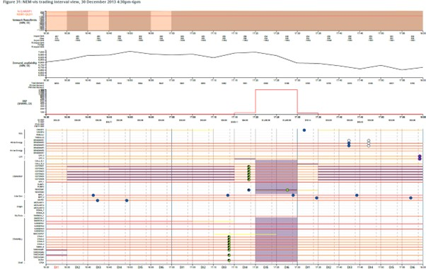
601 As to Stanwell’s rebid reasons, Dr Ledgerwood accepted in cross-examination that there was an increase in forecast demand for the ATI consistent with the trader’s reasons. He also accepted that the interconnectors bound from DI1 in ATI#11. He accepted that these factors may mean conditions were more conducive to a price-volume trade-off, but not that there was an economically rational reason for Stanwell’s rebid. He maintained that the relevant question “is the timing of that rebid and when it affected dispatch”.
602 Stanwell’s rebid was submitted approximately 10 minutes after the updated demand data appears to have been noticed by the trader, at 17:03. It was a complicated rebid. As Stanwell submitted, the time taken to identify the material changes in the data, analyse the consequences thereof, prepare, assess and submit the rebid is consistent with the time taken in relation to ATI#12. Evidence about that process was given by Mr Jenkins and is considered below (see [675] below). That evidence supports a similar conclusion with respect to this Sample Interval, namely that there is no evidence of any deliberate delay.
603 It is uncontroversial that competitors had one clear DI following Stanwell’s rebid to respond to the first price spike, and two clear DIs in which to respond to the second price spike (2LedgerwoodR at [791]). The only competitor to respond was CS Energy in DI4.
604 As to CS Energy’s rebid reasons, Dr Ledgerwood accepted in cross-examination that the increase in pre-dispatch forecast prices above $150.00MWh was information that had been made available to the market approximately three minutes before CS Energy submitted its rebid. Mr Price observed that CS Energy’s most recent prior offers for the TI, made at 15:22:59 for GSTONE 1-6, and at 14:12:52 for W’HOE#1, were made at a time when the QNI was not forecast to be binding in the TI (JtEMER at [175]). The rebid was, therefore, made in circumstances that were materially different from those that pertained at the time of the previous offers (JtEMER at [174]-[175]). There is no evidence to support a finding that the rebid was delayed, deliberately or at all.
605 Ultimately, Dr Ledgerwood accepted that rebidding involved a “multifactorial” assessment of multiple data points over a Trading Day and the evidence showed there were at least two reasons for CS Energy’s rebids – the binding of the QNI (which, at the time of CS Energy’s last prior offer before the impugned rebid, was not forecast to have been bound), and the “recent information” received of a 260% increase to forecast prices for DI5 and DI6 of the ATI. To the extent that Dr Ledgerwood characterised the conduct in ATI#11 as the Respondents acting “jointly”, or having a combined effect (2LedgerwoodR at [1353(k)]), his opinion is irrelevant to the case pleaded by Stillwater. No allegation of concerted practice has been alleged against the Respondents.
606 In respect of Issue 17, the answers are, in relation to Sample Interval 11:
17(a) – No.
The evidence establishes that Stanwell submitted, between approximately one minute and 15 minutes before the start of the Affected Dispatch Interval, a rebid that shifted capacity from lower price bands to higher price bands, with the effect of:
(i) reducing the generation capacity offered in one or more price bands that, after adjustment for losses, were below the resulting dispatch price in the Affected Dispatch Interval; and
(ii) increasing the generation capacity offered in a price band that (after adjustment for losses) was at or above the resulting dispatch price in the Affected Dispatch Interval,
but the evidence does not establish that the rebid targeted the Affected Dispatch Interval or was made in furtherance of the trading strategy pleaded in [44] of the 3FASOC to rebid to target Dispatch Intervals.
17(b) – No.
17(c) – No.
17(d) – No.
The evidence establishes that CS Energy submitted, between approximately one minute and 15 minutes before the start of the Affected Dispatch Interval, a rebid that shifted capacity from lower price bands to higher price bands, with the effect of:
(i) reducing the generation capacity offered in one or more price bands that, after adjustment for losses, were below the resulting dispatch price in the Affected Dispatch Interval; and
(ii) increasing the generation capacity offered in a price band that (after adjustment for losses) was at or above the resulting dispatch price in the Affected Dispatch Interval,
but the evidence does not establish that the rebid targeted the Affected Dispatch Interval or was made in furtherance of the trading strategy pleaded in [44] of the 3FASOC to rebid to target Dispatch Intervals.
17(e) – No.
17(f) – No.

Profile 2

Sample Intervals 5 & 6

Sample Interval 5
607 The following facts are not in dispute between Stillwater and Stanwell.
Date: | 23 October 2013
Relevant Respondent(s): | Stanwell
Affected Trading Interval: | Ending 16:30 (between 16:00 and 16:30)
Affected Dispatch Interval: | DI5 of TI ending 16:30  DI6 of TI ending 16:30
Time of impugned rebid: | 16:16:48 (DI4 of TI ending 16:30)
Dispatch Price: | DI5: $7,200.98MWh  DI6: $7,200.98MWh
Capacity (MW) rebid: | 70MW was moved to price bands between $12,350MWh and $12,50MWh, and 786MW was moved to the highest price band at $13,100MWh. Dr Ledgerwood identifies the sum of this (856MW) as ‘economic withholding’.
Rebid reason: | 1615A CHANGE IN QNI LIMIT DISPATCH GREATER THAN PREDISPATCH
Trader log entry: | QNI Northern limit in Dispatch greater than in Predispatch. Moved volume to higher price bands on Stanwell Swan E, Kareeya. NB
608 Sample Interval 5 involves rebids made by Stanwell, where the resulting price spike lasted for two DIs. They included, therefore, both D-5 and a D-10 rebids. It was submitted at 16:16:48, in DI4, repricing 865MW in 11 different bid profiles for nine generating units across multiple TIs, including for some TIs that occurred in the past.
609 Relevant matters to System conditions identified by Dr Rose in respect of this day included the following factors. Temperatures were high for October, but not extreme. The QNI had been bound at or near the northward limit for approximately five hours, prior to the ADIs. Forecast demand decreased from a high of 6,920MW (as at 13:00:19) to 6,666MW (as at 15:01:44), but in the hour preceding the impugned interval, forecast demand again increased and actual demand in the TI was 30MW higher than in the most recent forecast for the 16:30 TI (2RoseR, Chapter 14).
610 The rebid did not apply to all of Stanwell’s online units. All competing Generators were online when the rebid was made.
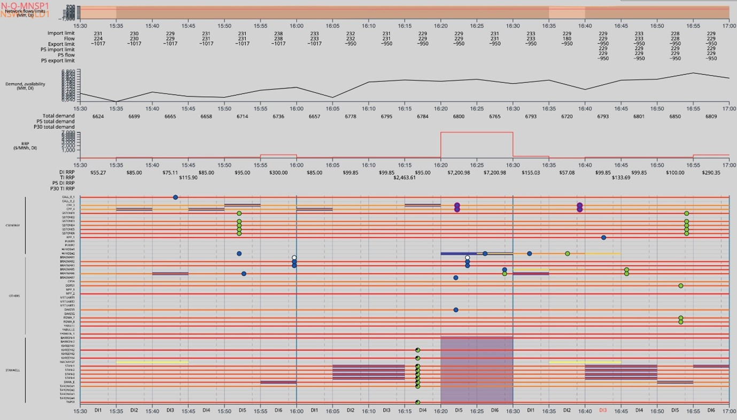
611 The event cited in the rebid reasons and in the trader’s log was a change in the actual QNI limit, being greater than pre-dispatch forecasts. The reasons do not specify which pre-dispatch forecasts the trader was referring to. Nevertheless, at the time cited in the reasons, 16:15, the QNI was binding north on its limit of 229MW. In the immediately preceding 5MPD forecast, the limit and flow for the first ADI were both 228MW, but the 30MPD forecast for the ATI had been a flow on the QNI and northern limit of 172MW.
612 The evidence showed that the QNI had been binding for 40 minutes before the rebid was made. Dr Rose opined that the trader would have been able to observe through the 5-minute SCADA data published by AEMO that Loy Yang A had reduced output by around 200MW in the previous two DIs. This made it likely that the interconnectors would unbind (2RoseR at [14.10]). He noted also that Eraring Generators had also reduced output by around 140MW since 15:35, with the same likelihood that Queensland Generators would be dispatched at higher levels and flows towards Queensland would no longer bind and cause price separation. It was his opinion that the scale of Stanwell’s withholding was commensurate with the scale of movement in generation output from other Generators within the NEM (2RoseR at [14.10-14.11]). Dr Rose’s evidence was reinforced by his oral evidence. He said, “traders know that there’s more going on south of the – in the southern part of the country than there is in Queensland at any given time and these matters are equally material, if not more so”. This opinion was reinforced by Mr Branson’s evidence in relation to the primary information displayed on traders’ screens, which included the data relating to every Region within the NEM.
613 Stanwell submitted that this rebid may have been partly inadvertent. This was for three reasons. First, it is the only rebid out of the eight samples where Stanwell ramped down below its contract position and therefore had to pay, rather than receive, the high price it had caused or contributed to. Secondly, the trader’s log is incomplete in that it referred to repricing Stanwell, Swanbank and Kareeya but did not mention Tarong and Tarong North, which were affected by the rebid. Third, and most peculiarly, it repriced capacity in TIs already past. Considering the complexity of the rebid, it would have been illogical for the trader to put so much effort into compiling a rebid with so many different changes in various TIs up to 2.5 hours beforehand. It was Mr Price’s view that the trader “[j]ust blew a fuse or something”.
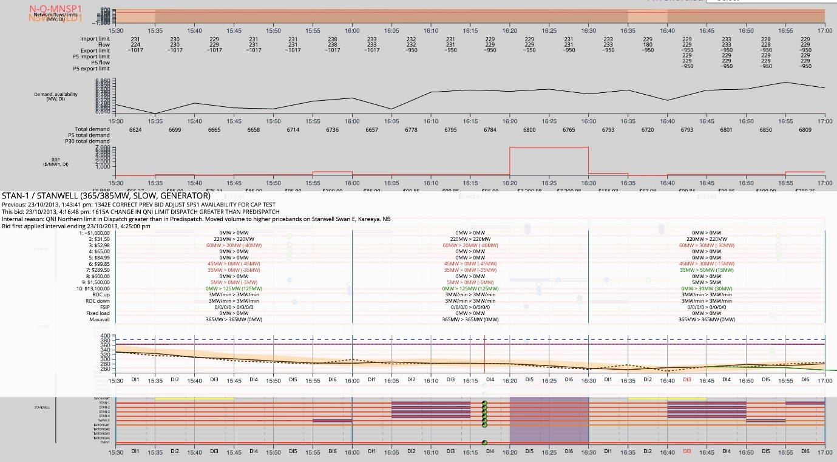
614 Whatever the explanation for the curious rebids, nothing about it supports Stillwater’s submission that Stanwell’s purpose was to prevent or deter competitors from making rebids to avoid or dampen a price spike. I accept Stillwater’s submission that the motivation behind the rebid may have been to spike the dispatch price, increase the ultimate Spot Price and the future price of hedging contracts, but in the peculiar circumstances of these rebids, it is difficult even to draw that conclusion. In any event, as a DI5 rebid, competitors had at least one DI in which to rebid, had they thought it advantageous to do so. None did. As Stanwell submitted, it was not demonstrated that it was in anyone else’s commercial interests to do so. On the contrary, had Arrow been able in DI5 to dispatch capacity offered at $455.00MWh by Braemar 5 and 7, as suggested by Stillwater, whilst its output would have been higher (281MW as compared with 173MW), its revenue would have been 90% lower ($10,500 as compared with $104,000).
615 In respect of Issue 11, the answers are, in relation to Sample Interval 5:
11(a) – No.
The evidence establishes that Stanwell submitted, between approximately one minute and 15 minutes before the start of the Affected Dispatch Interval, a rebid that shifted capacity from lower price bands to higher price bands, with the effect of:
(i) reducing the generation capacity offered in one or more price bands that, after adjustment for losses, were below the resulting dispatch price in the Affected Dispatch Interval; and
(ii) increasing the generation capacity offered in a price band that (after adjustment for losses) was at or above the resulting dispatch price in the Affected Dispatch Interval,
but the evidence does not establish that the rebid targeted the Affected Dispatch Interval or was made in furtherance of the trading strategy pleaded in [44] of the 3FASOC to rebid to target Dispatch Intervals.
11(b) – No.
11(c) – No.

Sample Interval 6
616 The following facts are not in dispute between Stillwater and CS Energy.
Date: | 10 February 2014
Relevant Respondent(s): | CS Energy
Affected Trading Interval: | Ending 17:30 (between 17:00 and 17:30)
Affected Dispatch Interval: | DI4 of TI ending 17:30  DI6 of TI ending 17:30
Time of impugned rebid: | CS Energy: 17:11:21 (DI3 of TI ending 17:30)  Callide C: 17:11:20 (DI3 of TI ending 17:30)
Dispatch Price: | DI4: $1400MWh  DI6: $1400MWh
Capacity (MW) rebid: | 550MW moved to the $1,400MWh price band, 60MW was moved to the $8,500MWh price band, and 15MW was moved from the $13,100MWh price band to lower price bands. The net quantity of 595MW was moved from lower price bands to higher PBs, and therefore is the quantity that Dr Ledgerwood identifies as ‘economic withholding’.
Rebid reason: | CS Energy: 1708A INTERCONNECTOR CONSTRAINT QNI CLOSE TO BINDING-SL  Callide C: 1710A QNI CLOSE TO BINDING
Trader log entry: | CS Energy: Rebalance GPS unit due to QNI close to binding (34MW)  Callide C: N/A
617 In this Sample Interval, CS Energy repriced 160MW of its share of both Callide C units (80MW per unit) from the negative $1,000MWh price band to the $13,100MWh price band, 60MW of both Callide B units (30MW per unit) from the $29.85MWh price band to the $8,500MWh price band, and 75MW from each of Gladstone 2, 3, 4, 5 and 6 units from price bands under $150.01MWh to its $1,400MWh price band. It also rebid 35MW at each Gladstone unit down from the $13,100MWh price band to its $,1400MWh price band.
618 Mr Price pointed to the following matter as relevant System conditions for this day. 10 February 2014 was very warm and muggy, particularly in the evening (2PriceR, Chapter 6). There had been two days of the month where demand exceeded 8,000MW. On 10 February, demand peaked at 7,041MW in the DI ending 16:50. Demand in the first ADI was 6,991MW and, in the second ADI, 6,781MW.
619 Several Generators were unable to generate at their normal capacity for a variety of reasons. The QNI bound into Queensland in three DIs, two of which are associated with ATI#6. Mr Price opined that the substantial loss of capacity meant that the remaining Generators were faced with the equivalent of an 8,000MW demand day (2Price R at [246]).
620 CS Energy’s rebids first took effect in DI4, when the price rose to $1,400MWh. The price then fell to $63.43MWh in DI5, before again rising to $1,400MWh in DI6 (2LedgerwoodR at [548], [558], [570]).
621 As to matters concerning Trading and operations on the day, Mr Price noted that pre-dispatch price forecasts had been relatively steady for the day leading up to ATI#6, at around $50-$60MWh. CS Energy’s stock of coal was at 79%, below its target of 80%. Mr Price commented that a constraint on CS Energy’s primary energy source would increase the marginal value of its stock of coal, which in turn, increases the value of its electricity.
622 In the prior TI, several Generators, including Arrow, CS Energy, and Alinta made capacity repricing rebids.
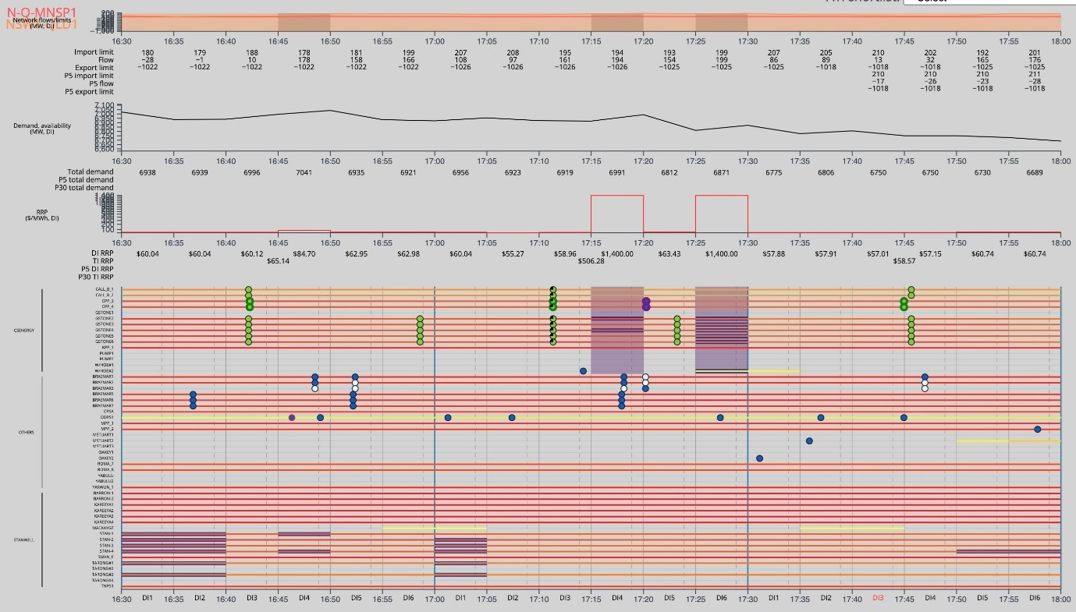
623 The rebid reasons cite the QNI being “close to binding”. The trader log entry noted that the remaining capacity on the QNI had reduced to 34MW. That was not in dispute. All market participants received information, approximately one minute before CS Energy submitted its rebids, that that the level of unused capacity on QNI had reduced from 111MW in the prior DI to just 34MW in DI3 of the ATI. In this respect, there can be no serious suggestion of any delay on the part of the trader. Dr Ledgerwood accepted as much.
624 Dr Ledgerwood did not accept that the QNI was “particularly close to binding”. He could not, however, give evidence as to whether CS Energy traders would take the same view. Nor could express a view as to the point at which he would describe the QNI as close to binding. Dr Ledgerwood opined, nevertheless, that it was the rebids which caused the QNI to bind. It was also not in dispute that, in DI4, the QNI started to bind. However, it was not necessarily the rebids which caused the QNI to bind. It was also not in dispute that, in DI4, demand in the QRNEM increased by 72MW. It was put to Dr Ledgerwood in cross-examination that that alone would have been sufficient to close the gap of 34MW on the QNI. Indeed, he accepted such an increase in demand “could cause” the QNI to bind. Further, at the time of CS Energy’s prior rebids of Callide C and Callide B (at 16:42:10), and Gladstone (at 16:58:36), the pre-dispatch information indicated that the unused capacity on the QNI in the DI ending at 17:15 would be between 109MW and 168MW (JtEMER at [536]). There is no basis for rejecting the trader’s explanation at the time of the rebids that they were a response to tightening market conditions and were a rational response for a profit maximising entity.
625 To the extent that Stillwater sought to rely on the recording of a phone call earlier in the day between two CS Energy employees, which appeared to reveal that CS Energy was not facing material operating constraints on that day, the evidence is irrelevant to the actual circumstances faced by the trader later in the day and his response to those changing circumstances.
626 I accept, as submitted by CS Energy, that the most likely explanation for CS Energy’s rebid is that referred to in the trader’s reasons, namely the tightening of market conditions and reduction in remaining capacity on the QNI. There is no evidence that CS Energy’s rebids were made late, let alone deliberately late in accordance with the alleged trading strategy.
627 Further, relevant to this Sample Interval, Alinta made a “pile-in” rebid for Braemar 1 for the 17:30 TI, citing the $1,400MWh dispatch price (2PriceR at [265]).
628 In respect of Issue 12, the answers are, in relation to Sample Interval 6:
12(a) – No.
The evidence establishes that CS Energy submitted, between approximately one minute and 15 minutes before the start of the Affected Dispatch Interval, a rebid that shifted capacity from lower price bands to higher price bands, with the effect of:
(i) reducing the generation capacity offered in one or more price bands that, after adjustment for losses, were below the resulting dispatch price in the Affected Dispatch Interval; and
(ii) increasing the generation capacity offered in a price band that (after adjustment for losses) was at or above the resulting dispatch price in the Affected Dispatch Interval,
but the evidence does not establish that the rebid targeted the Affected Dispatch Interval or was made in furtherance of the trading strategy pleaded in [44] of the 3FASOC to rebid to target Dispatch Intervals.
12(b) – No.
12(c) – No.

Profile 3

Sample Intervals 7, 8 & 9

Sample Interval 7
629 The following facts are not in dispute between Stillwater and CS Energy.
Date: | 9 January 2015
Relevant Respondent(s): | CS Energy
Affected Trading Interval: | Ending 23:00 (TI between 22:30 and 23:00)
Affected Dispatch Interval: | DI1 of TI ending 23:00
Time of impugned rebid: | 22:20:16 (DI5 of TI ending 22:30)
Dispatch Price: | $13,499MWh
Capacity (MW) rebid: | 120MW was moved to the highest price band at $13,500MWh and is the quantity that Dr Ledgerwood identifies as ‘economic withholding’.
Rebid reason: | 2219A INTRA REGIONAL CONSTRAINT-QNI ALMOST BINDING NORTH -SL
Trader log entry: | revised gps distribution to remove 30MW/unit to enable units to run back to 3 mills around 2230 – QNI 50MW from binding north
630 CS Energy’s rebids relevant to this Sample Interval were submitted at 22:20, being in DI5 of the TI prior to the ATI. The rebids were made for both the TI ending 22:30 and the following TI, repricing a total of 120MW for its Gladstone 2, 4, 5, and 6 generating units from the $22.40MWh price band to the $13,500MWh price band. Despite the rebids, it continued to offer a total of 640MW at prices of $22.40MWh or less.
631 The System conditions identified by Mr Price (2PriceR, Chapter 7) as relevant to this day included that the weather that day was hot and muggy and, at the time of the ATI, demand was approximately 1,000MW below the maximum demand for the day, which was 7,238MW as at 16:40. About 1,650MW of usual capacity was not operating – several Generators were either not available at all or were operating at reduced capacity. The QNI had bound intermittently over the course of the day, particularly between 15:30 and 21:00.
632 In his oral evidence, Dr Ledgerwood described identical rebids for consecutive TIs as “matching rebids”, although this was not a concept that appeared in any of his reports and the importance of the concept to his overall theory was never entirely clear.
633 Although the rebids took effect in DI6 of the prior TI, there was no elevation to the price until DI1 of the next TI (2PriceR at [7.3.3]).
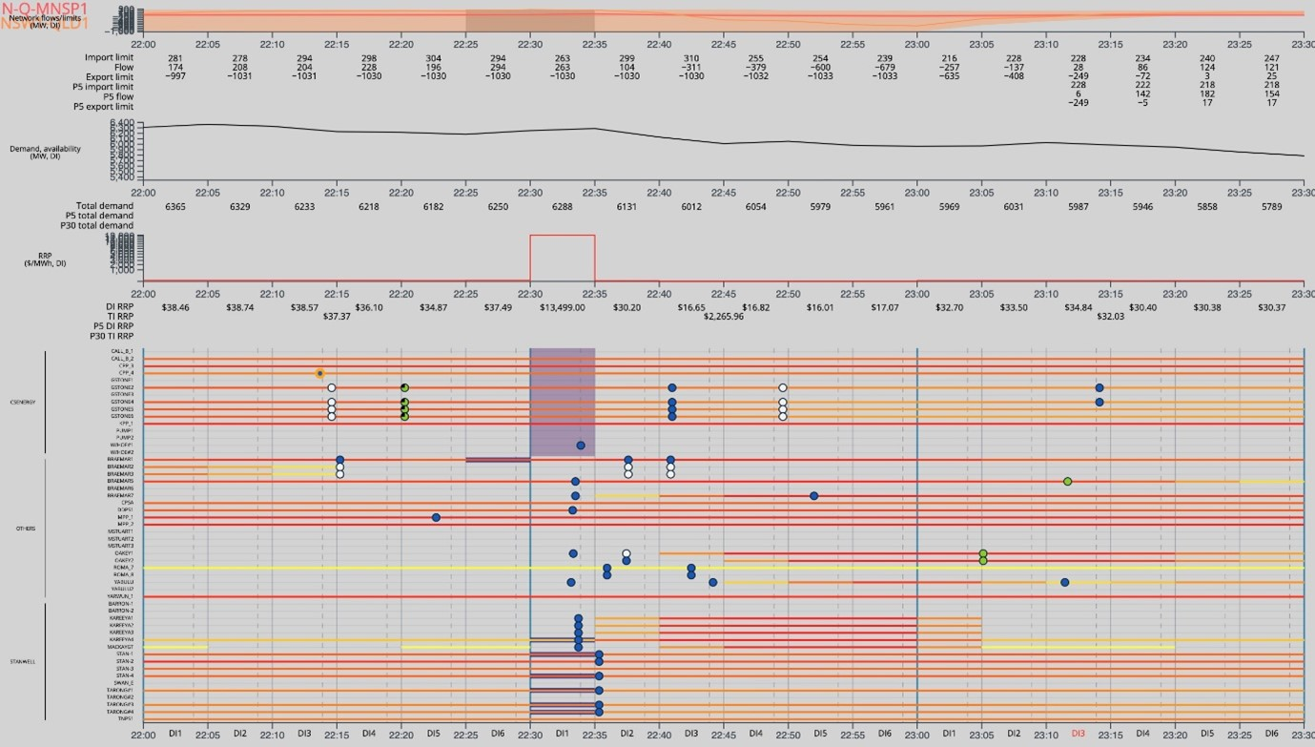
634 Mr Price observed in relation to matters relevant to Trading and operations that there had been one period of volatility on the day, which was at the time of the ATI. Several Generators made capacity repricing rebids in the TI immediately prior to ATI#7 including the Callide C Operator, Alinta Energy, CS Energy, and InterGen. Mr Price also observed that Queensland demand was materially under forecast in the 5MPD forecast at the time of the rebid (JtEMER at [547]). AEMO’s price forecast was predicated on, inter alia, falling demand for the ADI of around 23MW, but outturn demand increased by 38MW (JtEMER at [547]).
635 Two reasons were given for the rebids. The first was that the QNI was “almost binding north”. The second was explained in the trader log entry as being to “remove 30MW/unit to enable units to run back to 3 mills”.
636 The evidence showed that, 20 minutes before the rebids were submitted, the northerly limit of the QNI was 287MW and the northerly flow was 55MW. In the next DI, the northerly limit reduced slightly to 281MW and the northerly flow increased to 174MW. Immediately prior to the rebid, market participants were notified that the unused capacity on the QNI had reduced to just 70MW.
637 Stillwater challenged the first of these reasons on the basis that, for 55 minutes before the rebids, the 5MPD information indicated that the QNI may bind, or may be close to binding, in the ATI. Dr Ledgerwood said (2LedgerwoodR at [1164]):
Figure 33 shows information somewhat consistent with the CS Energy rebid explanation and trading log entry, albeit that the gaps at D-10 and D5 are larger than 50MW. However, the chart also shows that the available capacity on a forecast basis was near zero between D-55 and D-25. It is therefore difficult to identify the phenomenon to which CS Energy is referring.
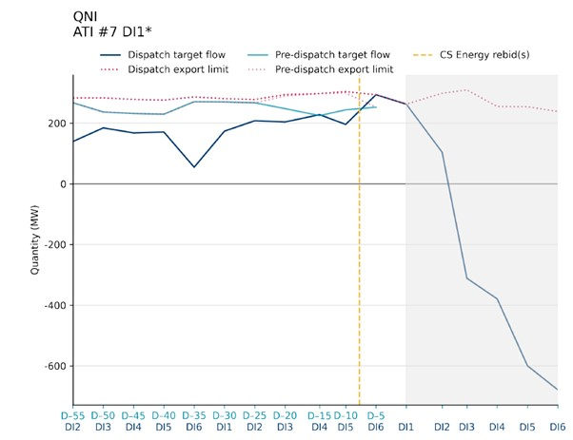
638 Figure 33 above showed available capacity on a forecast basis. It was put to Dr Ledgerwood that the trader may have been referring to actual limit and flow information, rather than mere forecasts. Dr Ledgerwood agreed that “we don’t know what the trader was looking at”.
639 So far as actual limit and flow information was concerned, the evidence shows that, for the 20 minutes prior to CS Energy’s rebids, the actual remaining capacity on the QNI had been trending downwards and, in the DI ending 22:20 immediately prior to the rebids being submitted, market participants were notified that unused capacity on the QNI had reduced to 70MW.
640 Dr Ledgerwood did not consider the second reason referred to by the trader, namely CS Energy’s desire to run back the mills for the Gladstone generating units. Mr Price explained that the operation of coal mills is, in his experience, “co-optimised with operation of generation to ensure efficient operation of power stations. As generation is reduced, the operation of mills is typically reduced (or vice versa)” (2PriceR at [332]). Mr Price’s evidence was that CS Energy started the Trading Day of 9 January 2015 with a bid for the day that reflected Gladstone Power Station reducing output at the start of the 22:30 TI (at 22:00), and further reducing output from 23:00, and again further at midnight, as shown in the NEM-vis extract below (2PriceR at [332]).
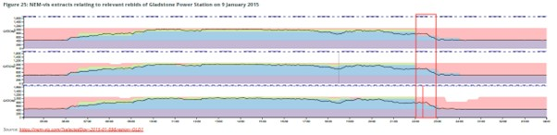
641 Mr Price explained that this was a normal pattern of bids and operations by Gladstone Power Station and aligns with usual reductions in demand. Mr Price observed that the above plan was changed slightly at 18:28:45, when CS Energy made a rebid for Gladstone Power Station, repricing 60MW from high price bands into its $22.40MWh price band for the 19:00 TI until the 23:30 TI. This rebid delayed Gladstone’s winding back for the evening. The impugned rebid had the effect of reversing this change (2PriceR at [332]-[334]).
642 Dr Ledgerwood was unable to comment on the proposition that the reason for CS Energy’s rebid was to reinstate the original operational plan to reduce generation and run back the mills at the Gladstone units from around 22:30. He said he had not considered any of the earlier rebids, and so was unable to comment. Rather, his focus was on the DI in which the price elevation occurred. He then looked backwards to ascertain what the pre-dispatch information was for that DI, albeit in circumstances where traders cannot target a DI but, rather, bid for one or more TIs. This was a further example of Dr Ledgerwood’s failure to take account of what happens as a matter of operational reality in the NEM.
643 Mr Price pointed to additional matters that suggested that CS Energy did not anticipate the price spike in the ADI as a result of its impugned rebid. First, CS Energy’s rebid of Wivenhoe at 22:33 indicated it was having technical issues and was not synchronised to start up quickly. Secondly, in the days before 9 January, the price had been spiking in the late evening around the same time as ATI#7. However, CS Energy’s bidding behaviour at around those times did not suggest its rebids were associated with any of the price increases (2PriceR at [337]-[339]).
644 In respect of Issue 13, the answers are, in relation to Sample Interval 7:
13(a) – No.
The evidence establishes that CS Energy submitted, between approximately one minute and 15 minutes before the start of the Affected Dispatch Interval, a rebid that shifted capacity from lower price bands to higher price bands, with the effect of:
(i) reducing the generation capacity offered in one or more price bands that, after adjustment for losses, were below the resulting dispatch price in the Affected Dispatch Interval; and
(ii) increasing the generation capacity offered in a price band that (after adjustment for losses) was at or above the resulting dispatch price in the Affected Dispatch Interval,
but the evidence does not establish that the rebid targeted the Affected Dispatch Interval or was made in furtherance of the trading strategy pleaded in [44] of the 3FASOC to rebid to target Dispatch Intervals.
13(b) – No.
13(c) – No.

Sample Interval 8
645 The following facts are not in dispute between Stillwater and CS Energy.
Date: | 23 December 2013
Relevant Respondent(s): | CS Energy
Affected Trading Interval: | Ending 19:30 (between 19:00 and 19:30)
Affected Dispatch Interval: | DI3 of TI ending 19:30
Time of impugned rebid: | 18:59:32 (DI6 of TI ending 19:00)
Dispatch Price: | $1,500MWh
Capacity (MW) rebid: | 1,100MW was moved to the $13,100MWh price band and is the quantity that Dr Ledgerwood identifies as ‘economic withholding’.
Rebid reason: | 1858A INTERCONNECTOR CONSTRAINT – QNI BINDING IN 30 MIN PD - SL
Trader log entry: | Rebid units at GPS1-6 180MW PB6 all other volume to PB10 W/hoe1+2 move to PB10 to increase price and gross margin to 1900
646 This Sample Interval involved CS Energy repricing a total of 1,100MW from its Gladstone and Wivenhoe generating units from price bands of $1,400MWh or less to its highest price band of $13,100MWh.
647 Relevant to System conditions, 23 December 2013 was another hot and humid day, however demand was moderate, peaking at 6,826MW in the DI ending 17:30 (2PriceR at Chapter 8). In the ATI, demand was around 6,650MW (2PriceR at [366]). At around 09:00, the Millmerran Power Station tripped, removing around 850MW of capacity in Queensland in five minutes. This was followed at 09:05 by a reduction in available capacity for Callide C Power Station by InterGen for technical reasons. It remained unavailable until 20:00 (2PriceR at [369]). A number of other coal-fired units were unavailable for a variety of reasons, reducing available capacity by a further 2,500MW (2PriceR at [370]). The Terranorra interconnector was forced to export around 60MW from Queensland to New South Wales for most of the day and it and the QNI were binding for a substantial portion of the period between 13:00 and 20:30.
648 The rebids were submitted at 18:59 and were for the two TIs ending at 19:30 and 20:00 respectively. The former TI is the ATI for Sample Interval 8. The rebids first took effect in the DI commencing at 19:05, but the price spike did not occur until five minutes later, in the DI commencing at 19:10.
649 Stillwater submitted that the rebid reasons, particularly those in the trading log, demonstrate that this is another example of a rebid submitted by CS Energy to increase price and gross margin. Of itself, that is unarguable. It is plain on the face of the log and consistent with CS Energy’s strategy documents.
650 Stillwater also submitted that the forecast to which the trader was presumably referring was the most recent 30MPD forecast published at 18:31, approximately 28 minutes before the rebids were submitted. Further, Stillwater pointed to the fact that the interconnector had been binding for at least 45 minutes prior to the rebids having been made, as shown in Figure 34 of the Second Ledgerwood Report.
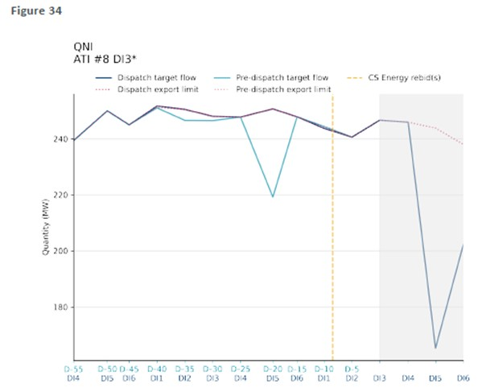
651 Stillwater submitted that, because the QNI had been binding for a substantial period of time prior to the rebids, the binding of the interconnector was not “new news” and, therefore, could not be characterised as a material change in circumstances.
652 In cross-examination, Dr Ledgerwood accepted that, at 18:31 when the relevant 30MPD information was published, the market received two different forecast in relation to the status of the QNI for the TI ending at 19:30. The first was the 30MPD forecast, which has already been referred to above and which forecast the QNI to be binding in that TI. The second was the 5MPD information for the same TI which, contrary to the 30MPD information, indicated that the QNI would be bound only for DIs 1, 2, and 3, but would remain unbound thereafter. This can be observed in the NEM-vis screenshot below.
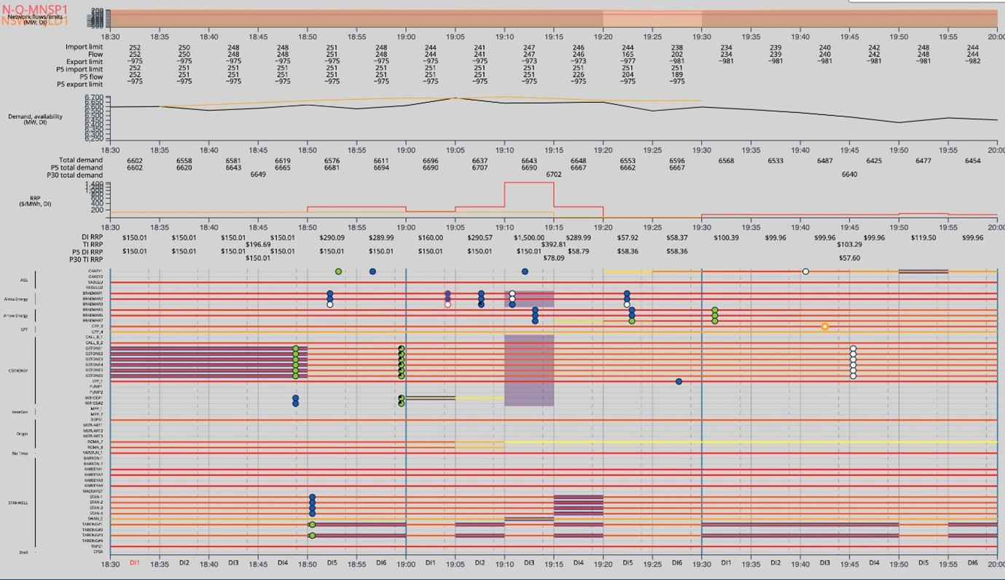
653 Dr Ledgerwood also accepted that, every five minutes in the TI ending 19:00, the market received a revised forecast in the form of updated 5MPD information for the QNI. At 18:55, approximately four minutes before submitting its rebid, the new 5MPD information forecast that the QNI would in fact be bound for the whole of the TI ending at 19:30 and for the next TI ending at 20:00. He questioned, however, why the trader did not cite the 5MPD forecast, rather than the 30MPD forecast.
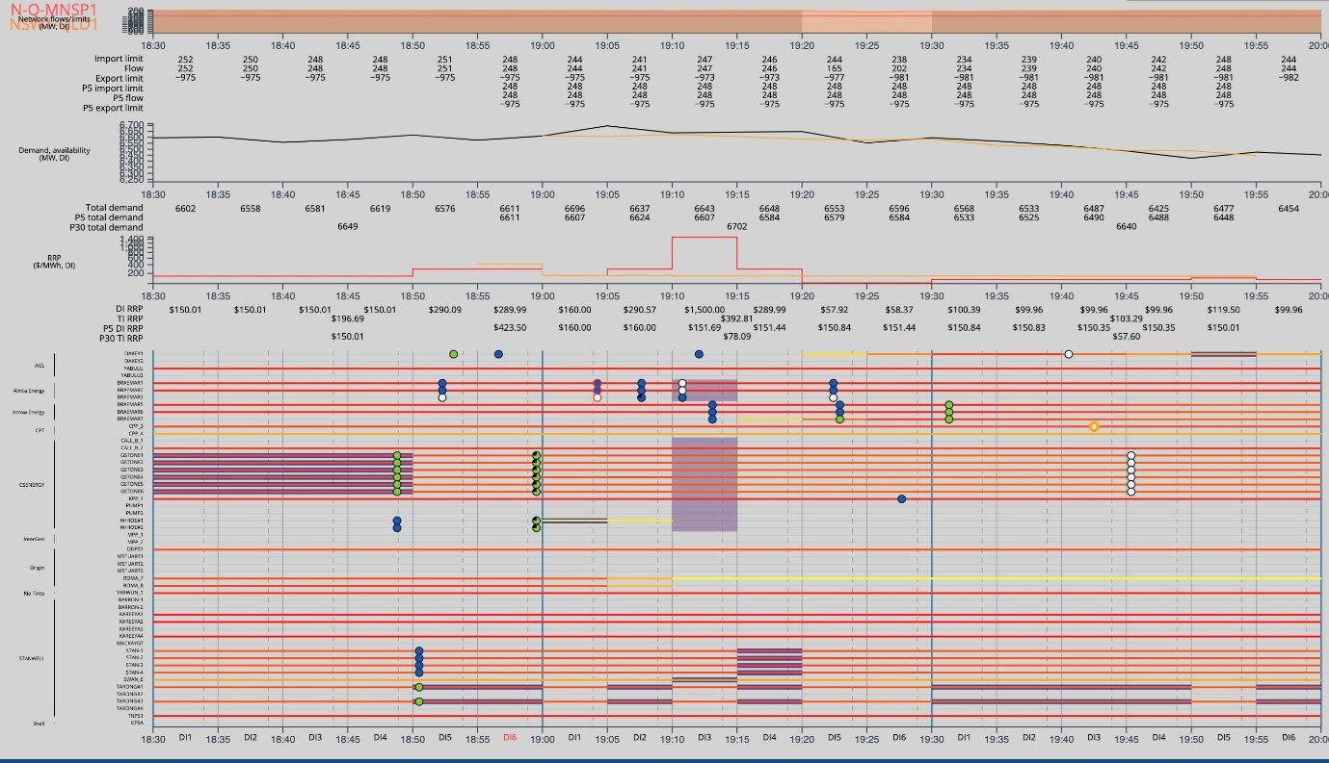
654 One interpretation of the rebid reasons is, however, a simple statement that the QNI will be binding in 30 minutes according to the pre-dispatch forecast (which might just as easily be a reference to the 5MPD as to the 30MPD forecast). Another interpretation, posited by CS Energy, is that in light of the most recent 5-minute information, the 30-minute forecast referred to in the reasons looked accurate. What is tolerably clear is that, at the time when the trader made the rebid, there was indeed “new information” forecasting the binding of the QNI for the whole of the two TIs for which the rebids were placed. In those circumstances, the reasons are objectively accurate and were submitted without delay.
655 There is no evidence, contrary to Dr Ledgerwood’s opinion, that the rebid was placed so as to deter or prevent a competitive response. To the contrary, there is evidence that market participants took the opportunity to respond in the one available gate closure window, between when the rebids first took effect, but prior to the price spike. One such response was made by Alinta’s rebidding of all of Braemar 3’s 161MW capacity from its $451.06 price band to its $12,115.81 price band.
656 In respect of Issue 14, the answers are, in relation to Sample Interval 8:
14(a) – No.
The evidence establishes that CS Energy submitted, between approximately one minute and 15 minutes before the start of the Affected Dispatch Interval, a rebid that shifted capacity from lower price bands to higher price bands, with the effect of:
(i) reducing the generation capacity offered in one or more price bands that, after adjustment for losses, were below the resulting dispatch price in the Affected Dispatch Interval; and
(ii) increasing the generation capacity offered in a price band that (after adjustment for losses) was at or above the resulting dispatch price in the Affected Dispatch Interval,
but the evidence does not establish that the rebid targeted the Affected Dispatch Interval or was made in furtherance of the trading strategy pleaded in [44] of the 3FASOC to rebid to target Dispatch Intervals.
14(b) – No.
14(c) – No.

Sample Interval 9
657 The following facts are not in dispute between Stillwater and Stanwell.
Date: | 22 January 2014
Relevant Respondent(s): | Stanwell
Affected Trading Interval: | Ending 15:30 (between 15:00 and 15:30)
Affected Dispatch Interval: | DI5 of TI ending 15:30
Time of impugned rebid: | 15:12:09 (DI3 of TI ending 15:30)
Dispatch Price: | $11,298MWh
Capacity (MW) rebid: | 105MW was moved to the $11,000MWh price band, and 230MW was moved to the $12,000MWh and $13,100MWh price band. The latter (230MW) is the quantity that Dr Ledgerwood identifies as ‘economic withholding’.
Rebid reason: | 1510A CHANGE IN CALLIDE C GENERATION SL
Trader log entry: | Callide C generation decreased to 480MW by 1500 and has now increased up to 546MW as seen at 1510. Adjusted portfolio to obtain PV tradeoff.
658 Stanwell’s rebid, submitted at 15:12:09 in DI3, applied only for the remainder of the TI. It caused a price spike in DI5.
659 As to System conditions, relevantly (2RoseR, Chapter 15), demand for the ADI was 8,416MW. There had been thunderstorms across the south-east region throughout the day. Demand increased by about 170MW in the 55 minutes before DI5; forecast demand for DI5 also increased by about 145MW from the D-55 5MPD forecast (JtEMER at [378]). The interconnectors had been fluctuating throughout the day but had available capacity in both dispatch and the 5MPD forecasts (JtEMER, Dr Ledgerwood at [378]-[379]; Dr Rose at [380]).
660 As to factors touching on Trading and operations, the day had been volatile. The Trading Day fell within the carbon tax period. There had been significant rebidding by Queensland Generators in the TI prior to the impugned rebid. There were three occasions prior to the rebid when prices exceeded $250MWh. That continued after the ADI. These features can be observed in the NEM-vis screenshot below.
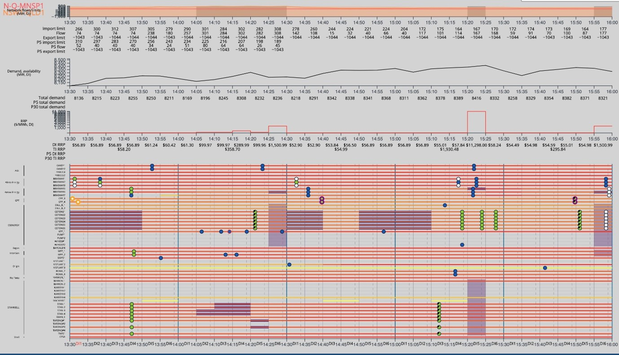
661 Dr Ledgerwood considered that Stanwell deliberately chose the timing of the rebid to prevent a market response in the first DI following the rebid (JtEMER at [380]). Contrary to that thesis, as Dr Rose opined, there was no price increase in the next DI because the QNI did not bind northward in that DI. Following the rebid, prices were forecast to increase to $11,000MWh in DI6 and then return to $57MWh at the commencement of the next TI (JtEMER at [381]). However, in DI4 at 15:18:32, CS Energy rebid six Gladstone generating units and pre-dispatch price forecasts increased further for DI5 and DI6 (JtEMER, Dr Rose at [381]-[383]).
662 Stillwater submitted that, although the rebid reasons were factually accurate, as agreed by both Dr Ledgerwood and Dr Rose (2LedgerwoodR at [1178]; 2RoseR, Table 39), that “does not detract … from the fact that the log clearly records that the rebids were made to achieve a price volume trade-off”. So much can be accepted. It is plain on the face of the reasons that the trader was trying to achieve a price volume trade-off, consistent with Stanwell’s strategy and its incentive as a profit maximising firm. The log does not, however, provide evidence that Stanwell was engaged in Short-notice Rebidding. Stanwell’s rebid was submitted at 15:12:09, approximately two minutes after the trader observed Callide C’s generation at 15:10. The rebid applied across several generating units, albeit only for a short period. There is no evidence of delay.

663 Further, the timing of the rebid meant that competitors had the opportunity to respond if they wished to do so. Despite the increased price signal for DI5 of $10,990MWh, the only rebid made in response was a further capacity repricing rebid by CS Energy which put further upward pressure on price, considered by Dr Ledgerwood to be indicative of an anti-competitive response. As Stanwell submitted, there is a “simple” and perfectly rational reason for competitors not responding to the forecast increase in price for the ATI – all Generators were online and all stood to gain by the increase in the Spot Price.
664 In respect of Issue 15, the answers are, in relation to Sample Interval 9:
15(a) – No.
The evidence establishes that Stanwell submitted, between approximately one minute and 15 minutes before the start of the Affected Dispatch Interval, a rebid that shifted capacity from lower price bands to higher price bands, with the effect of:
(i) reducing the generation capacity offered in one or more price bands that, after adjustment for losses, were below the resulting dispatch price in the Affected Dispatch Interval; and
(ii) increasing the generation capacity offered in a price band that (after adjustment for losses) was at or above the resulting dispatch price in the Affected Dispatch Interval,
but the evidence does not establish that the rebid targeted the Affected Dispatch Interval or was made in furtherance of the trading strategy pleaded in [44] of the 3FASOC to rebid to target Dispatch Intervals.
15(b) – No.
15(c) – No.

Profile 5

Sample Interval 12
665 The following facts are not in dispute between Stillwater and Stanwell.
Date: | 31 December 2016
Relevant Respondent(s): | Stanwell
Affected Trading Interval: | Ending 14:00 (between 13:30 and 14:00)
Affected Dispatch Interval: | DI1 of TI ending 14:00
Time of impugned rebid: | 13:15:39 (DI4 of TI ending 13:30)
Dispatch Price: | $14,000MWh
Capacity (MW) rebid: | 110MW moved to the $14,000MWh price band being the quantity which Dr Ledgerwood identifies as ‘economic withholding’
Rebid reason: | 1314A QLD DEMAND GREATER THAN FORECAST SL
Trader log entry: | When comparing PD run at 1230 and 1330, Qld demand has changed significantly, up to 150MW. See attached screenshot.
666 This Sample Interval is the only sample interval in Profile 5, which comprises TIs where the first ADI has only D-15 rebids.
667 In Sample Interval 12, Stanwell repriced 110MW across units at Stanwell and Tarong power stations for four TIs (2 hours) from the commencement of ATI#12. Having submitted its rebid, Stanwell was instructed to ramp down 3MW in DI5 and ramp up 2MW in DI6 of the prior TI. Dr Ledgerwood’s evidence was that other market participants would only have been able to observe the effect of the withholding rebids in pre-dispatch information published at the commencement of DI5 and DI6 of the prior TI. Nevertheless, that was a notice period of 10 minutes, or 2 DIs during which time competitors had the opportunity to respond. As Dr Rose explained, competitors would “have been aware … within a few seconds after 13:20:00 … that 5MPD price had risen … they could decide to rebid from that moment onwards if that would have been advantageous to them” (2RoseR, Chapter 17).
668 As to relevant System conditions, the day was hot with demand rising steadily throughout the day. Actual demand in the ADI was 7,741MW. The QNI had been forecast to be bound in the prior TI and in the ADI. Stanwell did not dispute as much.
669 At the time when the rebid was made, the D-10 pre-dispatch price forecast rose from $199.99MWh to $310.10MWh. All but one (being Arrow) of the competing Generators was dispatching at least one unit at that time. The D-5 pre-dispatch forecast returned to $199.99MWh.
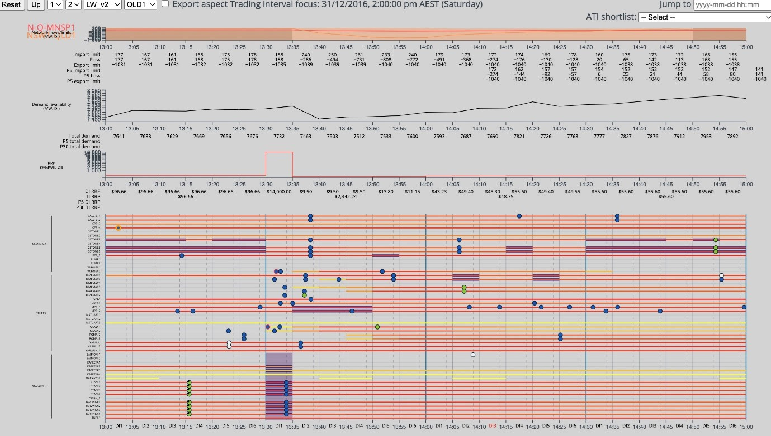
670 The evidence did not suggest that competitors were anxious to respond to Stanwell’s rebid. Three rebids were made between the time of Stanwell’s rebid and the price spike. One was made by AGL at 13:23:01 for Oakey 2 citing price sensitivities published at 13:04. It was therefore neither consequent upon nor responsive to Stanwell’s rebid. The second was a plant rebid by InterGen of Millmerran at 13:28:57, and so is irrelevant to this rebid. The third was made by Origin at 13:25:56 for Roma 7 and 8, which each submitted a rebid in DI6 for Sample Interval 12 moving a combined 60MW to the price floor, relevantly citing as the rebid reason the network constraint equation, “N^^Q_NIL_B1” (2RoseR at Table 53). Although Dr Ledgerwood considered this to be a responsive Rebid, Stanwell submitted it was not, given that the constraint equation cited manages the voltage collapse limit in the case of a trip at Kogan. It is unnecessary for me to resolve this disagreement. In any event, although it took 18 minutes for Roma 7 and 8 to synchronise in response to their dispatch instructions (because of their FSIP profiles), they were dispatching at MAXAVAIL by the end of ATI#12 and were paid at the elevated Spot Price for the TI.
671 Despite this being a Sample Interval with the longest period available to competitors in which to respond “competitively” to abate or reduce the price spike, there is no evidence that competitors engaged in such behaviour.
672 Stillwater submitted that the rebid was made deliberately late. As it observed, Stanwell’s own bid audit report identified it as a “late rebid”. That is not surprising. The NER define rebids made within 15 minutes of the end of a TI as “late”. It does not assist, however, with establishing that the rebid was “deliberately” late, as is Stillwater’s claim. Stillwater submitted further that, recognising a day of high demand, Mr Jenkins executed a rebid in order to attempt a price-volume trade-off – that was Stanwell’s motive. It submitted that the short notice provided to the rest of the market, and the absence of any real change in market conditions, each support Stillwater’s contentions as to the purpose for which the rebid was made – to deter or prevent other Generators from engaging in competitive conduct. As I have already found, the evidence does not establish that Stanwell, or its traders, had any such purpose. That Stanwell’s motive was to achieve a positive price-volume trade-off was not disputed.
673 Stillwater placed weight on the screenshot taken by the trader, Mr Jenkins, at 13:04:35, which is the time he said he identified the material change in circumstances, being the increase in forecast demand, and when he first considered making a rebid.
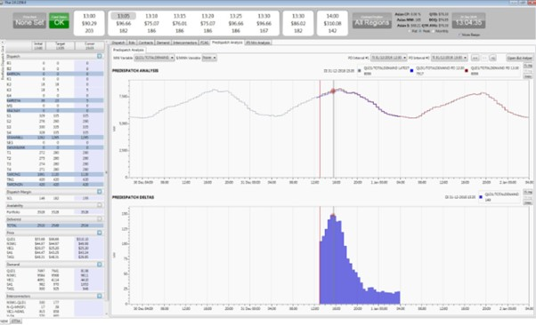
674 It was put to Mr Jenkins in cross-examination that the screenshot was evidence that he had decided at that point to rebid, and that, based on evidence of other rebids being made within a minute or two of his becoming aware of a change in circumstances, he had deliberately delayed for approximately 11 minutes in the “hope that [he] would be able to stop other Generators from being able to ramp up in time in order to negate the price volume trade-off” he was hoping to achieve. Mr Jenkins adamantly disagreed. It was not put to Mr Jenkins that he expected or intended that competing Generators would be unable to respond to the rebid in either of the various ways pleaded in [44(b)] of the 3FASOC.
675 In the Jenkins Affidavit, and in his oral evidence, Mr Jenkins explained that having noticed the change in forecast demand, he then needed to decide whether to make a price-volume trade off. He explained that this was a more complex rebid than the others that had been shown to him in the course of his cross-examination. He described the time taken to use “Optimiser”, an in-house Stanwell application that enables traders to construct a bid or change a bid giving them information on contract positions at certain prices (Jenkins Affidavit at [43]). Having done that, the traders use another application called NGTS. The bid created using Optimiser is placed into NGTS and submitted to AEMO using NGTS. The rebid reasons are recorded in NGTS, which automatically creates a time stamp of that occurrence. In this case, the reasons were recorded at 13:14. He said that rebid reasons should have identified the relevant time as 13:04, but the only way to change the time in NGTS was to do so manually, which he did not do (Jenkins Affidavit at [80]). In cross-examination, Mr Jenkins was asked to explain the time taken for this rebid compared with the much shorter time taken for that made at 13:33. He said:
The purpose of the second rebid was very clear to me. I knew exactly what I had to do. It’s a situation that I have a strategy in place for whereas the first rebid, you know, I was assessing over a two-hour period, as in the length that the rebid was in the market, it ran from 1400 to 1600. It was more of a decision making process as to whether or not it would be a price volume trade-off.
676 I accept that Mr Jenkins did not deliberately delay making the impugned rebid in Sample Interval 12, either at all, or for the purpose as pleaded by Stillwater.
677 Stillwater submitted further that, in any event, there were no real changes in market conditions to justify the rebid. It submitted that although the forecast demand for 15:30 had changed by a relatively small amount (149MW), that does not explain why a rebid had to be made had 13:15:39 to take effect from 13:30.
678 The screenshot above shows, in the top right-hand quadrant, the increasing gap between the AEMO forecast demand between 13:05 and 17:00. The bottom-right hand corner shows the pre-dispatch delta and the size of the change forecast by 15:35. It was put to Mr Jenkins in cross-examination that given it was already high demand day, with a predictable pattern of increasing demand, there was nothing about a revised upward demand forecast for the 15:30 TI that had anything to with the rebid as made. Mr Jenkins observed that the demand forecast for the 13:30 TI had also increased. It is evident from the screenshot that the increase to the delta up to the 15:30 TI was substantial. It was also still unpredictable. The NEM-vis screenshot above shows that, although the interconnector had been bound since 12:55, it was forecast to unbind at 13:35 and remain unbound until 14:50.
679 Further, it would be naive to assume that Mr Jenkins made the rebid solely on the basis of the information present in the screenshot he captured at 13:04:35, even though it provided the primary basis of his “brief, verifiable and specific” reasons for the rebid, as required. As both Mr Jenkins and Mr Branson said in their written and oral evidence, traders have access to myriad sources of data, which – coupled with their experience of trading in the NEM – inform their decisions to rebid (Branson Affidavit at [75]; Jenkins Affidavit at [43]). As Mr Jenkins said in his oral and affidavit evidence, he has no recollection of making this rebid (Jenkins Affidavit at [25]). That is not surprising – it was on News Years’ Eve almost eight years ago. His evidence is based only on the documents that he has been able to revisit, and his experience. Had he been interrogated about the reasons for this rebid in January of 2017, no doubt much more could have been recalled.
680 I am satisfied that the change in forecast demand was a material change in circumstances which justified the rebid in relation to ATI#12.
681 In respect of Issue 18, the answers are, in relation to Sample Interval 12:
18(a) – No.
The evidence establishes that Stanwell submitted, between approximately one minute and 15 minutes before the start of the Affected Dispatch Interval, a rebid that shifted capacity from lower price bands to higher price bands, with the effect of:
(i) reducing the generation capacity offered in one or more price bands that, after adjustment for losses, were below the resulting dispatch price in the Affected Dispatch Interval; and
(ii) increasing the generation capacity offered in a price band that (after adjustment for losses) was at or above the resulting dispatch price in the Affected Dispatch Interval,
but the evidence does not establish that the rebid targeted the Affected Dispatch Interval or was made in furtherance of the trading strategy pleaded in [44] of the 3FASOC to rebid to target Dispatch Intervals.
18(b) – No.
18(c) – No.

Profile 6

Sample Interval 13
682 The following facts are not in dispute between the parties.
Date: | 9 March 2015
Relevant Respondent(s): | Stanwell and CS Energy
Affected Trading Interval: | Ending 17:30 (between 17:00 and 17:30)
Affected Dispatch Interval: | DI1 of TI ending 17:30
Time of impugned rebid: | Stanwell: 16:44:28 (DI3 of TI ending 17:00)  CS Energy: 16:50:37 (DI5 of TI ending 17:00
Dispatch Price: | $13,100MWh
Capacity (MW) rebid: | Stanwell: 120MW was moved to the $13,499MWh price band, which is the quantity that Dr Ledgerwood identifies as ‘economic withholding’ by Stanwell.  CS Energy: 60MW was moved to the $13,500MWh price band, which is the quantity that Dr Ledgerwood identifies as ‘economic withholding’ by CS Energy.
Rebid reason: | Stanwell: 1643A CHANGE IN 5 MIN PD QLD PRICE DI 1640 VS 1645 HRS  CS Energy: 1650A INTERCONNECTOR CONSTRAINT-QNI BINDING NORTH-SL
Trader log entry: | Stanwell: Change in 5 min PD Qld price DI 1640 vs 1645 hrs Stan volume bid to PB10. NB  CS Energy: remove 20MW/unit from G1,3,4&6 to 1730
683 Dr Price referred to the following matters relevant to the System conditions pertaining to Sample Interval 13 (2PriceR, Chapter 10). March 2015 was an exceptionally warm month in the Brisbane metropolitan region. On 9 March 2015, the maximum temperature was 31.6 degrees Celsius, with “oppressive” humidity in the morning and evening.
684 Queensland’s annual peak electricity demand occurred four days earlier on 5 March, peaking at 8,892MW. On 9 March, demand reached 8,193MW. Both peaks occurred at around 17:00. Most Generators were online and available by early afternoon, notably except for Barcaldine, Mt Stuart, and Townsville. Several power stations were running at limited capacity, including seven CS Energy units and three Stanwell units.
685 The Terranorra interconnector was forced to export approximately 70MW from Queensland to New South Wales for most of the day (2PriceR at [475]). Both the Terranorra interconnector and the QNI were binding intermittently, but for extended periods between 5:30 and midnight.
686 Matters relevant to Trading and operations identified by Dr Price included that prices on 9 March were elevated from early in the day, and pre-dispatch prices were also elevated. During higher demand periods, certain competing Generators – Arrow, Alinta, and AGL – all had capacity that was available immediately, but was offered at prices exceeding $10,000MWh.
687 Demand increased steadily over the day, reaching 8,000MW at about 16:10 and peaking at 8,193MW at 16:50, just prior to the ATI.
688 Stanwell, CS Energy, Alinta, and Arrow made numerous repricing bids from 08:00 onwards. Prices were elevated, in part, due to the rebidding behaviour prior to the ATI by those four Generators.
689 These features are shown in the NEM-vis screenshot below.
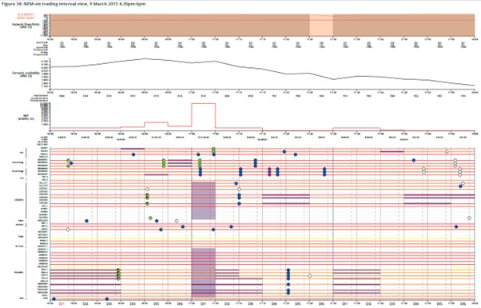
690 Stanwell’s rebid was a D-15 rebid, made in DI3 of the prior TI, but just after gate closure for DI4. It therefore could not take effect until DI5. Its rebids for the ATI, and the prior TI were identical. Stanwell moved 120MW across four generating units from the $289.00MWh price band to the $13,499.00MWh price band.
691 In the D-10 gate closure window for the ADI, CS Energy submitted its rebids. It moved 60MW across three generating units from the $45.30MWh price band to the $13,500MWh price band.
692 The dispatch price for DI5 of the prior TI was $1,501MWh. It dropped back to $599.49MWh in DI6, before spiking at $13,100.00MWh in DI1 of the ATI.
693 Stillwater submitted that the lateness of the rebids, and the absence of any real change in the market conditions that might suggest that the rebid was made other than to spike the price, demonstrated that Stanwell’s and CS Energy’s purpose in submitting the rebids was to prevent competitors from responding in a way that may avoid or dampen a price spike.
694 As to Stanwell, Stillwater submitted that the market conditions at the time did not justify or explain its rebid. Contrary to the reasons given by the trader, Stillwater submitted that there was “a real consistency between actual dispatch prices and forecast dispatch prices in the lead up to the ADI”. It pointed to Figure 44 in the Second Ledgerwood Report in support of this submission.
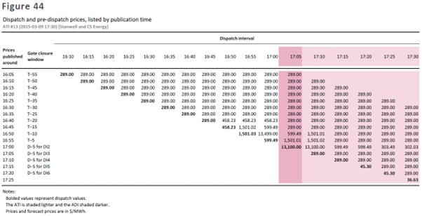
695 The rebid reasons cite the change in material circumstance at 16:43, being the change in the 5MPD price for DI1 as between 16:40 and 16:45. The 16:40 pre-dispatch data for DI1 was showing a price of $289.00MWh for every DI in the coming hour. That data was published at 16:35:28 (2RoseR, Table 57). The 16:45 data was published at 16:40:29 (2RoseR, Table 57). By this time, the data was showing a price increase to $458.23MWh in the next three DIs. Circumstances had changed. The change was verifiable and has been verified by both Dr Ledgerwood and Dr Rose. There is no evidence that AEMO was troubled by the reasons. Even if Stillwater is correct that the conditions had not changed sufficiently materially to justify the rebid, that would only go so far as to establish that Stanwell was executing its strategy to put upward pressure on prices to produce a positive price-volume trade-off. That is not sufficient to establish that Stanwell timed its rebid for the purpose of preventing or deterring a competitive response.
696 Despite Stillwater’s submission to the contrary, I do not accept that the rebid was deliberately delayed. It was made within four minutes of the publication of the data at 16:40:29. Further, as has already been seen, competitors had at least two DIs in which to respond. CS Energy did so, with its rebid taking effect in the ATI, reinforcing Stanwell’s rebid.
697 Despite the pre-dispatch data released at 16:55:30 for the ADI, forecasting a price of $1,501.01MWh, no rebids (apart from one plant rebid) were made in DI6.
698 The market became aware of the price spike to $13,100MWh at 17:00:29 (2RoseR Table 57). Within five minutes of the release of that data, there were four rebids (including two pile-in rebids). The pile-in rebids were by AGL (for Yabulu 1) and Alinta (for Braemar 5 to 7). The other rebids, which repriced generating unit capacity, were by AGL (for Oakey 1 and 2) and by Alinta (for Braemar 1 to 3).
699 The market became aware, at 16:50:29, that the pre-dispatch forecast for the first two DIs in the ATI had increased from $289.00MWh (as at the 5MPD forecast for those DIs published at 16:35:28) to $599.00MWh and $1,501.01MWh, respectively (2RoseR at Table 57). CS Energy submitted its rebid at 16:50:37 (in DI5 of the prior TI), repricing 60MW across three generating units from the $45.30MWh price band to the $13,500.00MWh price band, in respect of the ATI only. In the circumstances, I do not accept that there was any delay in the timing of the rebid.
700 CS Energy’s reasons for the rebid cite the QNI binding north at 16:50. A further comment in the trader log recorded, “wiv2 price cap moved to [MPC] as sufficient MW in GPs to cover caps + swaps” (2PriceR at [484]). Stillwater submitted, in reliance on Dr Ledgerwood’s opinion, that there was no economic rationale for CS Energy’s impugned rebid because the interconnector had already been bound for the previous half hour.
701 I accept that the QNI had been bound for that period of time and was forecast to continue to be bound until 17:25. It is, however, tolerably clear that the binding of the interconnectors was not the only reason for the rebids. The trader would have been well aware of the increased 5MPD forecasts released at 16:50:29. It was Dr Price’s opinion that CS Energy’s rebid reflected the economically rational action of pricing scarce capacity to reflect its value (2PriceR at [506]). For so long as the interconnector remained bound, supply would remain scarce.
702 Nevertheless, it was Dr Ledgerwood’s opinion that CS Energy’s rebids were made in a way “to where they will affect dispatch soon enough – closely enough to the rebids such that other market participants wouldn’t be able to see their effect”. The difficulty with accepting that opinion, however, is that other market participants did have the opportunity to respond – an updated pre-dispatch forecast price of $1,501.01MWh was published 16:55:30 (2RoseR at Table 57). A reason for the lack of response was suggested by Dr Price (2PriceR at [456]):
In my view, there is no apparent reason why competitors did not respond during this dispatch interval, other than, in this instance, that they chose, for their own commercial and/or technical reasons not to adjust their position any further. That is, it appears reasonably likely that the competitive response by competing Generators, such as AGL and Alinta, to the rebids made by CS Energy and Stanwell for ATI #13 was not to rebid but to operate at the expected prevailing price.
703 There is no evidence to support the submission that either Stanwell’s or CS Energy’s impugned rebids with respect to ATI#13 were timed with the intention or expectation of preventing or deterring a competitive response from other market participants.
704 In respect of Issue 19, the answers are, in relation to Sample Interval 13:
19(a) – No.
The evidence establishes that Stanwell submitted, between approximately one minute and 15 minutes before the start of the Affected Dispatch Interval, a rebid that shifted capacity from lower price bands to higher price bands, with the effect of:
(i) reducing the generation capacity offered in one or more price bands that, after adjustment for losses, were below the resulting dispatch price in the Affected Dispatch Interval; and
(ii) increasing the generation capacity offered in a price band that (after adjustment for losses) was at or above the resulting dispatch price in the Affected Dispatch Interval,
but the evidence does not establish that the rebid targeted the Affected Dispatch Interval or was made in furtherance of the trading strategy pleaded in [44] of the 3FASOC to rebid to target Dispatch Intervals.
19(b) – No.
19(c) – No.
19(d) – No.
The evidence establishes that CS Energy submitted, between approximately one minute and 15 minutes before the start of the Affected Dispatch Interval, a rebid that shifted capacity from lower price bands to higher price bands, with the effect of:
(i) reducing the generation capacity offered in one or more price bands that, after adjustment for losses, were below the resulting dispatch price in the Affected Dispatch Interval; and
(ii) increasing the generation capacity offered in a price band that (after adjustment for losses) was at or above the resulting dispatch price in the Affected Dispatch Interval,
but the evidence does not establish that the rebid targeted the Affected Dispatch Interval or was made in furtherance of the trading strategy pleaded in [44] of the 3FASOC to rebid to target Dispatch Intervals.
19(e) – No.
19(f) – No.

The strategy is not established
705 There is no dispute that Stanwell and CS Energy are for-profit entities which, as economically rational actors, seek to be profit-maximising. The documents disclosed by Stanwell and CS Energy, and the oral testimony of Messrs Branson and Jenkins, reveal that both Stanwell and CS Energy employed strategies by which, inter alia:
(a) they deliberately pursued higher revenue for the electricity they sold in the NEM, whether though the Spot Market or via hedging contracts; and
(b) the express purpose of seeking a price-volume trade-off, as described by Stanwell, was to “optimise Stanwell’s position in real time with consideration to the long term profitability on the company”, and by CS Energy, to seek “to increase the appetite for contracting and lift in the contract prices”.
706 The documents demonstrate that the strategies developed by Stanwell and CS Energy were directed at attempting to make profit in the summer months, when conditions were ripe to do so: that is, when there was: high demand; price volatility; extreme temperature events forecast; competitor plant outages; interconnector binding and/or other transmission constraints. As has been seen, each of the Sample Intervals manifest most, if not all, of these characteristics. As is made plain in the documents of both Stanwell and CS Energy, absent the implementation of these strategies in Quarters 1 and 4 of the calendar year in Queensland, budgeted gross margins to cover short-run and long-run marginal costs were at risk. That means the ability of Stanwell and CS Energy to maintain their electricity plants to continue generating would also be at risk.
707 There was no evidence capable of supporting an inference that Stanwell and CS Energy deliberately delayed making rebids in the manner pleaded by Stillwater. Stillwater explained, however, that that was not really surprising. It submitted that, given the penalties under the NER for contraventions of the rebidding rules, “more explicit descriptions of the Respondents’ tactics are unlikely to be reduced to writing”. In closing addresses, Senior Counsel for Stillwater urged that the Court:
… can and should infer that an unwritten but obvious and actual element of the active or trigger strategy from Stanwell, or the commercial strategy described in the CS Energy documents, was to place a bid sufficiently soon before it was likely to take effect in dispatch that other Generators were not likely to be able to respond in such a way as to prevent the rebidding respondent from procuring a sufficient spike in the dispatch price to achieve both the immediate revenue outcomes that the respondent wanted and that second outcome of the volatility impacts on the contract market.
708 The submission that Stanwell and CS Energy had “secret” strategies, which just happened to be identical, was not pleaded. Nor can it be sustained. It is a wholly unrealistic proposition to posit that, throughout the Conduct Period, both Stanwell and CS Energy had identical, unlawful, strategies which were communicated orally and never reduced to writing, lest the AER become aware of such strategies.
709 Moreover, an examination of the Sample Intervals, informed by the expert evidence, and the evidence of Mr Jenkins in respect of ATI#12, does not suggest that Stanwell and CS Engaged in Short-notice Rebidding as pleaded. There was no evidence of deliberate delay in submitting the rebids in any of the Sample Intervals, let alone of the alleged expectation or intention, and the evidence supported the content of the rebid reasons.
710 The answer to Issue 20 is “No”: Stanwell and CS Energy did not engage in the trading strategy alleged in [44] of the 3FASOC, referred to as Short-notice Rebidding.
711 That being so, Issue 21 does not arise for determination.
712 The answer to Common Question 5 is, therefore, “No”. During the Conduct Period, neither of Stanwell nor CS Energy engaged in Short-notice Rebidding in relation to the electricity they offered for dispatch in the QRNEM in any of the alleged ATIs.

DID STANWELL AND/OR CS ENERGY TAKE ADVANTAGE OF SUBSTANTIAL MARKET POWER?
713 Assuming a finding that Stanwell and CS Energy had substantial market power, which I have found they did not, Stillwater contended that Stanwell and CS Energy, in engaging in the impugned conduct, took advantage of that market power. Stillwater pleaded that, because of various “advantages” held by the Respondents (number of generating units, low production costs coupled with generation capacity, ramp rate advantages, status as major suppliers into the NEM), they had either greater ability or incentive, or otherwise less risk, to engage in Short-notice Rebidding (3FASOC at [46], [49]). It pleaded that the Short-notice Rebidding was “materially facilitated” by or otherwise undertaken “in reliance on” market power (3FASOC at [47]-[48]).
714 Stillwater contended that, by those various advantages referred to above, the Respondents’ were better able to take the risk of, and to successfully execute, Short-notice Rebidding, which rebidding was “materially facilitated” by substantial market power. They, therefore, had the ability and the incentive to use their market power in the way they did. Stillwater submitted further that the Respondents had no legitimate business rationale for engaging in the conduct: rather, it “was opportunistic and the Respondents deliberately created an artificial scarcity of generation capacity at lower prices in order to significantly increase the Spot Price”.

The legal and economic principles
715 As Stillwater submitted, the requirement in s 46 that a firm “take advantage” of a substantial degree of market power is an objective concept that is satisfied by establishing the “use” of the market power. There is no requirement to add a gloss to the language and attempt to show that the conduct was reprehensible, predatory, unfair, deceitful, actuated by hostile intent, or intended to punish anyone. So much was made clear by the High Court in Queensland Wire Industries (Mason CJ and Wilson J at 190-191, Deane J at 193-194, Dawson J at 202, Toohey J at 213-214).
716 Section 46(6A) of the CCA provides a non-exhaustive list of factors which a Court may take into account in determining whether a corporation has taken advantage of its substantial market power. Prior to the enactment of s 46(6A) in 2008, each of these factors had been identified as relevant to the question of “taking advantage” and had been considered in the jurisprudence. The factors include:
(a) whether the conduct was materially facilitated by the corporation’s substantial degree of power in the market – Melway at [51]; Rural Press at [50], [53]; Australian Competition and Consumer Commission v Cement Australia Pty Ltd [2013] FCA 909; 310 ALR 165 at [1905]-[1910] (Greenwood J);
(b) whether the corporation engaged in the conduct in reliance on its substantial degree of power in the market – Natwest Australia Bank Ltd v Boral Gerrard Strapping Systems Pty Ltd (1992) 111 ALR 631 at 637 (French J); Rural Press at [56];
(c) whether it is likely that the corporation would have engaged in the conduct if it did not have a substantial degree of power in the market – Queensland Wire Industries at 192; Dowling v Dalgety Australia Ltd [1992] FCA 27; 34 FCR 109 at 144 (Lockhart J); Natwest at 636; Melway at [44], [46]; Rural Press at [51]; NT Power at [174]; Seven Network Ltd v News Ltd [2009] FCAFC 166; 182 FCR 160 at [522] (Mansfield, Dowsett and Lander JJ); Cement Australia at [1911];
(d) whether the conduct is otherwise related to the corporation’s substantial degree of power in the market – Dowling at 144.
717 Stillwater placed considerable emphasis on the circumstance that s 46(6A) was introduced in 2008, following the High Court’s decision in Rural Press. As such, it was faintly suggested that some of the authorities decided prior to the amendment needed to be treated with care. The Senate Economic References Committee Inquiry into the effectiveness of the TPA, subsequent to the High Court’s decision, recommended that the TPA be amended to address the Inquiry’s concern that (Explanatory Memorandum to the Trade Practices Legislation Amendment Bill 2008 (Cth) at [1.38]):
In Rural Press, the High Court had endorsed a “take advantage test” which inquires whether a corporation could have undertaken the conduct in question without possessing a substantial degree of market power.
718 The Explanatory Memorandum to the Bill introducing s 46(6A) also noted, at [1.38] and [1.40]:
The Senate Inquiry considered that this test focuses on a corporation’s physical or business capacity to engage in conduct rather than its rationale or intent for doing so. The Inquiry found that the test appeared to result in a situation where corporations may use their market power to engage in proscribed conduct with impunity, so long as they could also engage in that conduct in the absence of market power.
…
Consistently with the Senate Inquiry’s recommendation, the Bill amend the Act [to introduce the four factors in s 46(6A)].
719 It was, however, not entirely clear what change s 46(6A) was said to have made to the substantive law that was of consequence to Stillwater’s case. As has already been observed (see [716] above), it provides a non-exhaustive list of factors to which a Court may have regard. The subsection expressly states that it does not limit the matters to which the Court may have regard. Those factors reflect the existing jurisprudence and, if anything, were confirmatory of the existing law.
720 Further, it is clear from decisions subsequent to the amendment that s 46(6A) was not intended to alter the meaning of “taking advantage”. Notably, in Australian Competition and Consumer Commission v Pfizer Australia Pty Ltd [2018] FCAFC 78; 356 ALR 582 at [457]-[465] (Greenwood, Middleton and Foster JJ), the Full Court expressly relied on the earlier authorities of Queensland Wire Industries, Melway, Rural Press, and Cement Australia in considering the principles relevant to s 46(6A). The Full Court cited Greenwood J’s statement of principle in Cement Australia, at [463]:
The question, put simply, is whether a firm profitably could have engaged in the conduct in question in the absence of a substantial degree of power in the relevant market. Because that question involves a hypothetical construct it must be answered by applying an objective test but one which takes into account the legitimate business reasons identified by the firm for engaging in the conduct.
(Emphasis added.)
721 Similarly, in Seven Network, the Full Court said, at [975]:
In our opinion, the trial judge was right to conclude that the High Court’s reasoning in [Rural Press] establishes the test to be determined is whether the corporation which is alleged to have contravened s 46, on a counter-factual assumption that it lacked a substantial degree of market power which it enjoyed, could have done what it is asserted that it did.
(Emphasis added.)
722 Stillwater submitted that the test for taking advantage is a “low bar”. It is clear, however, that more than “some rational connection” between the alleged market power and the impugned conduct is required. Section 46 requires not merely the co-existence of market power, conduct, and proscribed purpose, but a connection such that the firm whose conduct is in question can be said to be taking advantage of its power. This involves a causal connection between the conduct alleged and the pleaded market power. In Melway, Gleeson CJ, Gummow, Hayne and Callinan JJ said, at [67]:
As Dawson J explained, in Queensland Wire, market power means capacity to behave in a certain way (which might include setting prices, granting or refusing supply, arranging systems of distribution), persistently, free from the constraints of competition. This is the generally accepted meaning of the concept, and it is reflected clearly in the provisions of s 46(3). Barriers to entry into a market by competitors are a common reason for the existence of market power. They could exist, as in the present case, because of technological factors, or they might result, for example, from legislation which gives a statutory monopoly. Freedom from competitive constraint might make it possible, or easier, to refuse supply and, if it does, refusal to supply would constitute taking advantage of market power. But it does not follow that because a firm in fact enjoys freedom from competitive constraint, and in fact refuses to supply a particular person, there is a relevant connection between the freedom and the refusal. Presence of competitive constraint might be compatible with a similar refusal, especially if it is done to secure business advantages which would exist in a competitive environment.
(Emphasis added).
723 As Greenwood J explained in Cement Australia, at [1904], although it is correct to characterise “taking advantage of substantial market power” as meaning materially the same thing as the “use of that power”, what is important is the “manner” of that use, subject to the clarification by Gleeson CJ, Gummow, Hayne and Callinan JJ in Melway at [51]:
Dawson J’s conclusion that BHP’s refusal to supply QWI with Y-bar was made possible only by the absence of competitive conditions does not exclude the possibility that, in a given case, it may be proper to conclude that a firm is taking advantage of market power where it does something that is materially facilitated by the existence of the power, even though it may not have been absolutely impossible without the power. To that extent, one may accept the submission on behalf of the ACCC, intervening in the present case, that s 46 would be contravened if the market power which a corporation had, made it easier for the corporation to act for the proscribed purpose than otherwise would be the case.
724 What emerges from that passage is that a company will have taken advantage of substantial market power where:
(a) it engaged in conduct in which it could only engage because it had substantial market power; or
(b) it was materially facilitated in engaging in the conduct by its substantial market power, even though it was not absolutely impossible without it.
725 As Stanwell submitted, given that the purpose of s 46 is to preserve competition in the market, “something more than competition, something more than even ill-considered competition or aggressive competition, is required before s 46 is offended” (Eastern Express Pty Ltd v General Newspapers Pty Ltd (1991) 30 FCR 385 at 406). This point was not disturbed on appeal, but the Full Court observed further, albeit in relation to predatory pricing (Eastern Express Pty Ltd v General Newspapers Pty Ltd (1992) 35 FCR 43, Lockhart and Gummow JJ at 72 (Eastern Express (FC))), “[t]his Court should be vigilant to ensure that its jurisdiction is not invoked to interfere with normal and legitimate competitive pricing activities in the relevant market”.
726 This passage is important. It directs the Court’s attention to the relevant market, which in this case is the “peculiar” market of the NEM. It is important to be cognisant of the manner in which that market operates, and in particular, the context in which the impugned conduct has arisen. That context includes the NER (in particular, the rebidding rules). As has already been outlined earlier in this judgment, those rules are important to enable the market to respond efficiently to evolving conditions. Even though there have been concerns expressed about “[o]pportunistic bidding by large Generators” at various points in time, the NER, even following their amendments in July 2016, retained an emphasis on achieving “a very high degree of market efficiency” and recognised that it would not always be possible for rebids to be made in sufficient time to allow a reasonable opportunity for other market participants to respond (cl 3.8.22A(e)) (emphasis added).
727 Consistent with the approach in Pfizer and Seven Network set out above, both Messrs Morton and Holt approached the question of whether Stanwell and CS Energy “used” their substantial market power by applying the counterfactual, and interrogating whether Stanwell and CS Energy “could not have successfully executed the impugned rebids if they did not have substantial market power” (JtEcER at [307] and [316]). Dr Ledgerwood accepted that he had not identified an express test for whether an entity had taken advantage of substantial market power, nor did he consider whether a firm could profitably have engaged in Short-notice Rebidding absent a substantial degree of market power. Dr Ledgerwood said that “by the time I got to the discussion in sections VIII through XI, I had determined already that they had a substantial degree of market power so I didn’t consider the alternative”.
728 Nevertheless, Stillwater submitted that the Court ought also to take into account whether there is a legitimate business rationale for the conduct at issue. In Boral, at [170], Gaudron, Gummow and Hayne JJ cited, with approval, the observations of the trial judge, who said:
If the impugned conduct has a business rationale, that is a factor pointing against any finding that conduct constitutes a taking advantage of market power. If a firm with no substantial degree of market power would engage in certain conduct as a matter of commercial judgement, it would ordinarily follow that a firm with market power which engages in the same conduct is not taking advantage of its power.
(Emphasis added.)
729 Stillwater also drew attention to an article by Dr Philip Williams AM, former Professor of Law and Economics at the University of Melbourne and recently appointed Commissioner of the ACCC. In his paper, “The Counterfactual Test in s 46” (2013) 41 Australian Business Law Review 93, after reviewing the decisions in Queensland Wire, Melway, Boral, and Safeway, Williams says, at 100:
The language of “legitimate business reasons” in both Australia and the United States jurisprudence refers to the source of profit that motivated the conduct that is at issue. If the source of the profit is economic efficiency that creates real value for society (as the Privy Council accepted in Clear) then the reasons for the conduct are legitimate and the conduct is not reliant on market power. However, if no legitimate reasons are offered (as in Queensland Wire) then a court is likely to infer that none exist and that the conduct is contingent on market power.
(Emphasis added.)
730 What is, or is not, a legitimate business reason will necessarily be market specific; in this case, specific to the NEM.

The evidence
731 Messrs Morton and Holt agreed that the following factors were relevant to an assessment of whether Stanwell and CS Energy (separately) used their substantial power to make the impugned rebids in the ATIs (JtEcER at [309]-[317]):
(a) whether Stanwell and CS Energy were able to sustain higher Spot Prices for sustained periods through Short-notice Rebids (price-cost test);
(b) whether there was evidence of Stanwell and CS Energy earning supra-competitive profits (profitability);
(c) whether Stanwell and CS Energy had the ability to act independently of other Generators in the market (independence);
(d) whether any other market participants other than Stanwell and CS Energy successfully engaged in similar behaviour with non-trivial frequency (similar conduct by others);
(e) whether Short-notice Rebids foreclosed firms from the market (foreclosure of others);
(f) whether there are other contextual reasons unrelated to substantial market power for the conduct (for example, demand and supply, information available to each Generator, changes in expectations regarding rivals Generator bids, costs of increasing output) (market context).
732 As to the price-cost factor, Mr Holt’s analysis discussed earlier shows that no Queensland Generators, including Stanwell and CS Energy, have been able to sustain prices above competitive levels during the Conduct Period, nor even to sustain prices that would enable recovery of forward-looking capital and operating costs (JtEcER at [349]). It was Mr Holt’s opinion, albeit with which Dr Ledgerwood disagreed, that it was not relevant to focus on transitory price increases, whether or not attributable to Short-notice Rebids, in the context of an energy-only market, and where volume weighted spot prices over the Conduct Period fell below LRMC (JtEcER at [349]).
733 As to profitability, and as I have already observed, Dr Ledgerwood did not consider whether Short-notice Rebidding would be profitable absent substantial market power. What evidence there was as to the profitability of CS Energy (and by analogy, Stanwell) was inconsistent with any hypothesis that prices are high relative to costs during the Conduct Period (JtEcER at [350]). In respect of CS Energy, Dr Holt’s evidence was that its return on underlying capital employed was either negative or below 8% (JtEcER at [350]). Similarly, Mr Morton’s evidence was that Stanwell’s actual revenue over the Conduct Period was materially below its assessed efficient cost. He opined (JtEcER at [273]),
[t]he difference between notional spot market revenue and assessed efficient cost was greater still. In combination with the assumption that Stanwell is a profit maximising entity, this provides support for the proposition that Stanwell did not have or use substantial market power over that period.
734 Messrs Morton and Holt agreed that, if Stanwell and CS Energy had substantial market power, and it was profitable to exercise it by Short-notice Rebidding, they would have engaged in it more frequently. Mr Holt said:
… if they did have substantial market power, and they were in a position to exercise that through short-notice rebids frequently to the point where that led to profitable increases in prices above the benchmark, then I can’t see any potential reason that would be credible as to why you would not do that and the only one that I think I have heard is sort of a notional link to, you know, volatility in the longer-term and contract pricing.
But that doesn’t provide any basis to say you would prefer not to exercise substantial market power when you could otherwise have profitably done so in order to avoid a price spike on the basis that avoiding price spikes would somehow give you long-term benefit in terms of contract pricing. If anything, it’s the reverse. More volatility and higher average expected future prices would tend to increase your future contract position. So the only potential argument I’ve heard that sort of tries to say, “Well, why is the substantial market power not being exercised in the short-term due to a long-term consideration?” It actually goes the other direction.
735 The issue of frequency was explored by a document prepared by Stanwell (J58) (set out below, with cross-references to the underlying data omitted), which analyses the data underlying Dr Ledgerwood’s Figure 16 and his Tables 4 and 6 – the pivotal Generator analyses.
ATI# | DI applicable to making the rebid or its asserted effect | Stanwell only  (Figure 16) | Stanwell only  (Table 4) | Stanwell only  (Table 6)
ATI#2 (rebid) | 12:55 on 29/12/2013 | No | No | No
ATI#2 (affected) | 13:00 on 29/12/2013 | No | No (CSE was) | No (CSE was)
ATI#3 (rebid) | 16:20 on 25/10/2013 | No | No | No
ATI#3 (affected) | 16:25 on 25/10/2013 | No | No | No
ATI#4 (rebid) | 16:25 on 13/12/2014 | No | No | No
ATI#4 (affected) | 16:30 on 13/12/2014 | No (CSE and CPT together were) | Yes (as were 4 others) | Yes (as were 4 others)
ATI#5 (rebid) | 16:20 on 23/10/2013 | No | No | No
ATI#5 (affected 1) | 16:25 on 23/10/2013 | No | No (but 3 others were) | No (but 3 others were)
ATI#5 (affected 2) | 16:30 on 23/10/2013 | No | No (but 2 others were) | No (but 2 others were)
ATI#9 (rebid) | 15:15 on 22/01/2014 | No | No | No
ATI#9 (affected) | 15:25 on 22/01/2014 | No | Yes (as were 4 others) | Yes (as were 4 others)
ATI#11 (rebid) | 17:15 on 30/12/2013 | No | No | No
ATI#11 (affected 1) | 17:25 on 30/12/2013 | No | No (CSE was) | No (CSE was)
ATI#11 (affected 2) | 17:30 on 30/12/2013 | No (CSE and CPT together were) | No (CSE was) | No (CSE was)
ATI#12 (rebid) | 13:20 on 31/12/2016 | No | No | No
ATI#12 (affected) | 13:35 on 31/12/2016 | Yes | No | No
ATI#13 (rebid) | 16:45 on 09/03/2015 (in the gate closure period for 16:50) | No | Yes (as were 3 others) | Yes (as were 4 others)
 | 16:50 on 09/03/2015 | No | Yes (as were 6 others) | Yes (as were 7 others)
ATI#13 (affected) | 17:05 on 09/03/2015 | No | No | No

736 The table was shown to Dr Ledgerwood during cross-examination. He did not dispute its accuracy. As set out in the table, the data showed that Stanwell was only said to have the ability to set a high price because of its substantial market power three times in the eight Sample Intervals: in the ADIs for ATI#4 and ATI#9, and in the DIs in which the rebid for ATI#13 was made and which it affected. On each occasion, three or more other competing Generators were also able to set a high price (in ATI#4 and ATI#9 – four; in ATI#13 – 11). Stanwell submitted this was not consistent with the conduct having been “materially facilitated”, by Stanwell’s substantial market power. Stanwell submitted that, if it did not have substantial market power at the time it engaged in the impugned conduct, or at the time it is said to have affected the dispatch price, it cannot be said to have taken advantage of that market power.
737 As to independence, Mr Price’s analysis of ATI#1, ATI#7, and ATI#10 shows the number of Generators who made pile-in rebids following the price spikes (2PriceR at [141], [284], [209]). His analysis of ATI#6 shows a rebids by Arrow and Alinta (2PriceR at [265]). Mr Holt’s opinion, based on this analysis, was that the price spikes were transitory and often reverted to very low prices in the next TI (JtEcER at [352]). This, he opined, was consistent with rivals “being able to respond to market conditions and defeat any attempt to raise prices persistently over a sustained period of time” (JtEcER at [352]). Similarly, Mr Morton observed that any Short-notice Rebidding was met with a swift and effective competitive response by Stanwell’s competitors (JtEcER at [360(b)]; 1MortonR at [11.4]). This meant, he opined, “that Stanwell was unable to sustain high prices for sustained periods” (JtEcER at [360(b)]). The ability of Stanwell to engage in Short-notice Rebidding was, therefore, unrelated to substantial market power (JtEcER at [360]).
738 Similar conduct was engaged in by almost every other Generator. The evidence showed that, of the eleven Generators that competed against Stanwell and CS Energy (including one another), nine engaged in high-priced rebidding causing price spikes (2RoseR at Table 8, [9.14]). Figures 34 to 47 in the Supplementary Morton Report demonstrate the absence of correlation between the making of high-priced rebids and the features pointed to by Dr Ledgerwood – ramp down percentage and registered generation capacity, share of registered generation capacity, registered generation capacity over last 18 months of the Conduct Period, ramp down capacity, portion of ramp down capacity across the Conduct Period, and portion of QENEM average ramp down capacity – as advantages for Stanwell and CS Energy. For example, Figure 42 demonstrates, inter alia, that InterGen has more sole participant high-priced rebids than Stanwell, despite having less than one-third of its registered generation capacity and less than one-third of Stanwell’s ramp down capacity (SuppMortonR at [3.6.6]). Similarly, Figure 44 shows that InterGen had more sole participant high-priced rebids in the final 18 months of the Conduct Period than Stanwell and CS Energy combined (SuppMortonR at [3.6.10]). Mr Morton observed further that InterGen had only around 5% of ramp down capacity, which “clearly shows that ramp down capacity was not a requirement to engage in Short-notice Rebidding” (SuppMortonR at [3.6.12]).
739 Dr Rose’s analysis in fact demonstrated that Stanwell was one of the “less successful” Short-notice rebidding participants. Table 13 of the Second Rose Report presented the number of TIs after removing the dispatch price elevation filter (1LedgerwoodR at [56]) and including all bids from all Generators (2RoseR at [9.12]). He observed that, once the price elevation screen was removed, Stanwell’s Short-notice Rebidding caused a price elevation for 16% of the occasions that met the criteria for Table 13. This compared with 24% for CS Energy, 31% for CPT, 10% for Alinta, 11.5% for Arrow, 13% for ERM, 24% for InterGen, and 21.4% for Origin (2RoseR at [9.14]). Dr Rose said, “[t]his shows that SCL did not generally cause price elevation associated with a Short-Notice Rebid” (2RoseR at [9.14]).
740 Mr Morton and Dr Holt agreed that the pervasiveness of the impugned conduct by Generators other than Stanwell and CS Energy, none of which was alleged to also have substantial market power, indicates that the conduct cannot be causally related to substantial market power (JtEcER at [353] and [360(a)]).
741 I accept Stanwell’s submission that it is the antithesis of substantial market power that an entity said to have it is unable to exercise it to its own advantage, in absolute or proportionate terms, as much as its smaller competitors. In Melway, the fact that Melway had adopted its segmented distribution system before it had secured its position of market dominance was fatal to the argument that it had taken advantage of its market power by maintaining this distribution system (Melway at [68]). Similarly, the fact that all Generators, regardless of type or size, engaged in the same conduct as is alleged against Stanwell and CS Energy is fatal to the contention that the impugned conduct constituted taking advantage of market power.
742 The pervasiveness of other Generators’ engagement in the impugned conduct also supports the proposition that the Respondents’ substantial market power did not foreclose firms from the relevant market. There was, in any event, no evidence that competitors suffered harm such as lower sale volume, loss of market share or profits due to the conduct.
743 I have already drawn attention to the importance of market context when assessing whether or not substantial market power has been used (Eastern Express (FC)). Mr Holt opined that, in order to assess whether the Short-notice Rebids represent the exercise of substantial market power, “one would have to account for the complexity of the market, developments in the demand and supply balance, expectations of market participants based on observations of bidding behaviour” (JtEcER at [356]). Mr Price’s and Dr Rose’s observations and explanations of the context relevant to each ATI have been discussed earlier in relation to each of the Sample Intervals.
744 On the basis of Mr Price’s analysis, it was Mr Holt’s opinion that there was no evidence that CS Energy used its substantial market power to make the Short-notice Rebids in the ATIs (JtEcER at [357]). Mr Morton reached the same conclusion in respect of Stanwell (JtEcER at [362]).
745 Dr Ledgerwood concluded, in respect of each of the ATIs, that there was no economic rationale for any of the rebids made by Stanwell and CS Energy. Stillwater submitted that, far from being economically efficient, “the Respondents’ Short-notice Rebidding significantly increased the price paid by purchasers of wholesale electricity, whether they purchased electricity on the Spot Market or entered into hedging arrangements”. Not only was there no evidence led to support this submission. The evidence of the economic experts was to the contrary.
746 The evidence does not establish that either Stanwell or CS Energy took advantage of any market power they were contended to have, either in the QRNEM as a whole, or in the subset 9,211 DIs that were analysed by Dr Ledgerwood.
747 The answer to Common Question 7 is “No”. Even if I had been satisfied that Stanwell and CS Energy had substantial power in the Market and had engaged in Short-notice Rebidding, Stanwell and CS Energy, in engaging in Short-notice Rebidding, did not take advantage of their market power.

PURPOSE
748 Section 46(1)(c) proscribes taking advantage for the purpose of deterring or preventing a person from engaging in competitive conduct in any market. As has already been explained, Stillwater contended that a responsive Rebid was one that would abate a price spike and which was likely to result in a net loss in spot revenue for Stanwell and/or CS Energy. That was the only response that Stillwater considered to be competitive.
749 In Australian Competition and Consumer Commissioner v Baxter Healthcare Pty Ltd (No 2) [2008] FCAFC 141; 170 FCR 16 at [317], Dowsett J, albeit in dissent in the result, considered the phrase “deterring or preventing” and concluded that the combined effect of the words included “persuading a person to decide to withdraw from, not to enter or not to compete in a market, as well as making it difficult or impossible for that person to do so”. The Full Court adopted this formulation in Pfizer at [475].
750 There was no suggestion that Short-notice Rebidding would persuade a competing Generator to withdraw from, or not to enter, the market. At its highest, Stillwater’s case was Stanwell and CS Energy are said to have taken advantage of their substantial market power to engage in Short-notice Rebidding (being the alleged trading strategy) for the substantial purpose of deterring or preventing other Generators from submitting a responsive Rebid – that is, making it difficult or impossible for a competitor to submit a rebid that might abate a forecast price spike within a 5-minute period within one TI – that is, a rebid likely to result in a price-volume offset involving a net loss of revenue for Stanwell and/or CS Energy.
751 Stillwater acknowledged that it had no direct evidence of the proscribed purpose. It asked the Court, instead, to infer the purpose from the “nature”, “frequency” and “effect” of the implementation of the alleged trading strategy (3FASOC at [52(b)]). The proscribed purpose pleaded in [52] is more limited than the trading strategy as pleaded in [44(b)]. By [52], Stillwater alleges the Respondents engaged in Short-notice Rebidding for the substantial purpose of deterring or preventing a responsive Rebid, rather than also that of preventing or deterring other Generators from switching on, synchronising, or ramping up in sufficient time to offer total or partial substitution as pleaded in [44(b)(ii)] and [44(b)(iii)]. The infelicity in the pleading is of no consequence in the present case, where the evidence is insufficient to establish that Stanwell and/or CS Energy had the proscribed purpose of preventing other Generators from submitting a responsive Rebid, or indeed of preventing any other type of competitive response.
752 The “nature” of the Short-notice Rebidding was said to be as pleaded in [44(b]) of the FASC (3FASOC at [52]). As against the inference Stillwater asked the Court to draw was the direct testimony from Mr Branson and Mr Jenkins that the rebids were not made for the alleged purpose, coupled with contemporaneous records explaining the reasons for the rebids. That evidence has been discussed above (see [380] above). As I have already found, Stillwater has been unable to prove the existence of the alleged trading strategy (see [705] above). The allegation of the proscribed purpose, therefore, fails at the first hurdle.
753 Further, and has been discussed in the context of whether the Respondents took advantage of any substantial market power, the “frequency” of the rebids does not support Stillwater’s case (see, eg, [735] above). Stillwater was unable to prove the frequency of the impugned conduct across the Conduct Period – it did no more than identify, through Dr Ledgerwood’s screens, categories of rebids for investigation. As Dr Ledgerwood said, “[t]here is not an analysis of what actually went on in these different screen trips”. Further, as emerged during the Initial Trial, some of those screens identified rebids made for plant and financial rebids, which were irrelevant to the case sought to be made against the Respondents. Their inclusion casts doubt on the reliability of the numbers put forward by Stillwater from which any inference is sought to be drawn.
754 The “effect” of the Short-notice Rebidding was pleaded, somewhat circuitously, to have been that the dispatch price for the ADIs was higher than it would have been but for the Short-notice Rebidding, as was the Spot Price paid in the ATIs (3FASOC [45] as particularised in [64] (and assuming the reference in [64] to [45(b)] should read [45(a)]) and [65] as particularised in [45(b)]).
755 Stillwater submitted that the inference as to “effect” can be drawn from the fact of the timing of the rebids, considered with the “inadequacy of … reasons” for the rebids, relative to the alleged price spikes. That inference is not open. As CS Energy submitted, Dr Ledgerwood’s screens selected only for proximity to a price spike. They could not, and did not purport to, select for intention.
756 Stillwater led some evidence of a counterfactual price, which it submitted was relevant to purpose, for the reason that it identifies that the Respondents had the incentive to engage in the impugned conduct. In Figure 51 of the Second Ledgerwood Report, Dr Ledgerwood compared the price spikes in the ADIs with a counterfactual proxy price calculated in NEMPY.
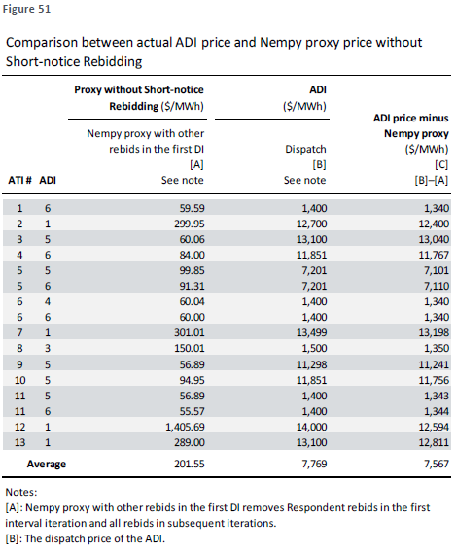
757 Dr Ledgerwood explains (2LedgerwoodR at [1279]) that
Figure 51 shows that, on average across the 16 ADIs in the Sample Intervals, the dispatch price was $7,567/MWh higher than the most reliable proxy for the price that AEMO would have calculated in the ADIs without Short-notice Rebidding. I therefore conclude that the Impact of Short-notice Rebidding on the dispatch prices of the ADIs was an increase of $7,567/MWh on average.
758 As Stanwell submitted, however, this evidence is of little assistance. First, it adopts a “no transaction” approach, where no rebids were made at all, rather than a scenario where they were made earlier in time. Secondly, in ADIs where rebids were made by both Respondents, it removed the rebids made by each of the Respondents. It was therefore not possible to assess the consequence of a rebid made by one of the Respondents alone in those particular ATIs.
759 I readily accept that Stanwell and CS Energy traders “hoped” that they would be able to cause price spikes over the summer period in accordance with their respective strategies, in order to improve price-volume trade-offs and increase contract prices. That was their purpose in engaging in “late” rebidding. But a hope is not the same as an intention or an expectation. Still less does it equate with a purpose of making it “difficult or impossible” for other Generators to compete in the NEM. Engaging in profit-maximising behaviour is not a proscribed purpose. The evidence is that other Generators did compete, just not necessarily in the way that Dr Ledgerwood considered to be the only legitimate form of competitive conduct.
760 Section 46(7) of the CCA also does not assist Stillwater. Although it provides that an inference as to purpose may be drawn from the conduct itself, the alleged conduct in this case is not capable of supporting the inference.
761 The evidence established that, throughout the Conduct Period, price spikes were an intended and ubiquitous feature of the NEM, anticipated and expected by traders, Generators, retailers, and the AER. Although rebids were submitted by Stanwell and CS Energy “late”, in the sense that they were submitted 15 minutes before the conclusion of a TI, such rebids were neither prohibited by the NER, nor was there any evidence that they were targeted at deterring particular responses by competitors. The spread of the timing of the rebids across the Sample Intervals is sufficient to dispel such an assertion. Further, as was conceded by Dr Ledgerwood, at the time of rebidding, a trader does not know whether another Generator has already made its own rebid, or might make such a rebid within the same 5-minute period as its own rebid. The trader cannot know, therefore, whether it is the “first mover”.
762 Nor can a trader have any insight into another Generator’s economic incentives for responding in any particular way to a high-priced rebid. It may be in that Generator’s interests to do nothing; it may be unable to do anything; it may decide to pile-in. It is, therefore, difficult, if not impossible, to attribute to a trader an intention to thwart the effect of a competitor’s rebid when he is flying blind as to his competitor’s position in any event. Moreover, at the time of rebidding, the trader is unaware of the precise manner in which the NEMDE will dispatch the bid stack, the actual demand required for the particular DI, or any other unforeseen constraint that may arise for that DI. There is a compelling reason for traders to wait to make withholding bids until shortly before the rebid was to take effect – to minimise the risk involved in the rebid being unprofitable. The closer it comes to the time of a rebid taking effect, the more confidence a trader has in the forecasts. Consequently, the trader can do no more than engage in what French J described in AGL (Loy Yang) at [456] as “moderately well informed betting”.
763 The answer to Common Question 8 is “No”. Even if the Court had been persuaded that Stanwell and CS Energy had engaged in the strategy pleaded in [44] of the 3FASOC and took advantage of their substantial degree of power in the Market, it has not been proved that, by engaging in Short-notice Rebidding, Stanwell and CS Energy had the proscribed purpose of deterring or preventing other Generators from engaging in competitive conduct.

DISPOSITION
764 For the reasons given, the answers to the Common Questions to be determined at this Initial Trial are as follows:
Common Question 1: At all times during the Conduct Period, was the relevant market for the purposes of s 46 of the CCA the market as pleaded in paragraph 22 of the SOC (Market)?
Yes.
Common Question 2: During the Conduct Period, did Stanwell have a substantial degree of power in the Market within the meaning of section 46(1) of the CCA?
No.
Common Question 3: During the Conduct Period, did CS Energy have a substantial degree of power in the Market within the meaning of section 46(1) of the CCA?
No.
Common Question 4: During the Conduct Period, for the purposes of s 46(2) of the CCA, did Stanwell and CS Energy together have a substantial degree of power in the Market?
No.
Common Question 5: During the Conduct Period, did each of Stanwell and CS Energy engage in Short-notice Rebidding in relation to the electricity they offered for dispatch in the QRNEM in any and if so in which of the alleged ATIs?
No.
Common Question 7: If the answer to Common Questions 2, 3 or 4 and to Question 5, is yes, did Stanwell and/or CS Energy, by engaging in the Short-notice Rebidding, take advantage of their market power?

Unnecessary to answer but No.

Common Question 8: If the answer to Common Question 7 is yes, did Stanwell and/or CS Energy take advantage of their market power for the purpose of deterring or preventing a person from engaging in competitive conduct in the Market?

Unnecessary to answer but No.

Common Question 11: If the answer to Common Question 8 is yes, did this constitute a contravention of section 46 of the CCA?

Unnecessary to answer but No.
765 Given the answers to the Common Questions, the proceeding must be dismissed.
766 The parties seek to be heard on the question of costs. The matter will be adjourned until March 2025 for a hearing on costs, unless the parties are able to agree orders.

I certify that the preceding seven hundred and sixty-six (766) numbered paragraphs are a true copy of the Reasons for Judgment of the Honourable Justice Sarah C Derrington.

Associate:

Dated: 4 December 2024

Schedule – Glossary of Terms
Term | Definition
AEMC | Australian Energy Market Commission
AEMO | Australian Energy Market Operator
ATI | Affected Trading Interval
Claim Period | 20 January 2015 to 20 January 2021
Conduct Period | 1 January 2012 to 6 June 2017
DI | Dispatch Interval
Dispatch price | Price for electricity in a wholesale electricity market that is necessary to provide the energy capacity needed to match demand in a five-minute 'dispatch period'
Dispatch price forecast | The forecasted dispatch outcomes for a Trading Day in terms of estimated dispatch price, based on the AEMO based on the Dispatch Algorithm
DUID | Dispatch Unit Identifier
FCAS | Frequency Control Ancillary Services, used to manage reductions or injections of energy into the grid, when required
LRMC | Long-run marginal cost of production
MW | Megawatts
MWh | Megawatts per hour
NEM | National Energy Market
NEMDE | Complex algorithm used by the AEMO to assist in its balancing of supply and demand
NEMPY | Publicly available open-source model of AEMO’s dispatch process, designed for modelling the dispatch procedure of the NEM, and co-optimising energy and FCAS markets
NEM-vis | An interactive software platform developed by the parties to the proceeding to demonstrate the circumstances and effect of the conduct in question in the context of the Affected Dispatch Intervals
NSWRNEM | New South Wales Region of the National Energy Market
QRNEM | Queensland Region of the National Energy Market
Ramp down | How quickly dispatchable generation from power plants can decrease whilst still remaining operational (not shutting down)
Ramp rate | Common metric in power generation that expresses how quickly power output changes over time
Ramp up | How quickly dispatchable generation from power plants can increase
Spot Price | Price at which electricity can be bought or sold for immediate delivery
SRMC | Short-run marginal cost of production
TIs | Trading Intervals

