FEDERAL COURT OF AUSTRALIA

Australian Competition and Consumer Commission v Pacific National Pty Limited (No 2) [2019] FCA 669

File number(s): | VID 864 of 2018
Judge(s): | BEACH J
Date of judgment: | 15 May 2019
Catchwords: | COMPETITION – acquisition involving Queensland rail terminal – Acacia Ridge Terminal including the Brisbane Multi User Terminal – access to terminal – acquisition producing vertical integration – discrimination against new entrants by vertically integrated operator – ability to discriminate – incentive to discriminate – reasonable perception of ability and incentive to discriminate – barriers to entry heightened by such acquisition – availability of alternative terminals – Brisbane Multimodal Terminal at Port of Brisbane – standard gauge terminal at Bromelton, Queensland – narrow gauge terminal at Tennyson, Queensland – Inland Rail Project – prospect of new entry – efficiencies from vertical integration – elimination of double marginalisation – intermodal and steel rail interstate linehaul services – market definition – defining market by reference to end users with no ready substitutable services for rail services – two economic conditions supporting definition by reference to end users – capacity to price discriminate amongst users – no capacity for profitable arbitrage – interstate market(s) – north-south interstate market – east-west interstate market – Queensland market – non-bulk steel – bulk steel – competition in the relevant market(s) – substantial lessening of competition – meaning of “likely” – real chance – standard of proof of counterfactual – contravention of s 50 of the Competition and Consumer Act 2010 (Cth) – undertaking proffered by the acquirer – terminal services subcontract – provisions having likely effect of substantial lessening of competition – comparison of factual and counterfactual scenarios – alternative causation case – contravention of s 45(2) of the Competition and Consumer Act 2010 (Cth)
Legislation: | Competition and Consumer Act 2010 (Cth) ss 2, 4(1),(4), 4G, 45(1),(2),(3), 46, 50(1),(3),(6), 76, 87B  Rail Safety National Law (South Australia) Act 2012 (SA) Sch, ss 50, 52(3)  Rail Safety National Law (Queensland) Act 2017 (Qld) s 4
Cases cited: | Air New Zealand Ltd v Australian Competition and Consumer Commission (2017) 262 CLR 207  Australian Competition and Consumer Commission v Cement Australia Pty Ltd (2017) 258 FCR 312; [2017] FCAFC 159  Australian Competition and Consumer Commission v Flight Centre Travel Group Pty Ltd (2016) 261 CLR 203  Australian Competition and Consumer Commission v Metcash Trading Ltd (2011) 198 FCR 297  Australian Competition and Consumer Commission v Metcash Trading Ltd (2011) 282 ALR 464  Australian Competition and Consumer Commission v Pacific National Pty Ltd [2018] FCA 1221  Australian Gas Light Company v Australian Competition & Consumer Commission (No 3) (2003) 137 FCR 317  Boral Besser Masonry Ltd v Australian Competition & Consumer Commission (2003) 215 CLR 374  NT Power Generation Pty Ltd v Power and Water Authority (2004) 219 CLR 90  Queensland Wire Industries Pty Ltd v Broken Hill Proprietary Co Ltd (1989) 167 CLR 177  Re Application by Chime Communications Pty Ltd (No 2) (2009) 257 ALR 765  Re Queensland Co-operative Milling Association Ltd (1976) 8 ALR 481  Stirling Harbour Services Pty Ltd v Bunbury Port Authority (2000) ATPR ¶41-752; [2000] FCA 38  Universal Music Australia Pty Ltd v Australian Competition and Consumer Commission (2003) 131 FCR 529
Date of hearing: | 19 to 23, 26 to 29 November 2018, 12, 13, 19 and 20 February 2019
Date of last submissions: | 25 February 2019
Registry: | Victoria
Division: | General Division
National Practice Area: | Commercial and Corporations
Sub-area: | Economic Regulator, Competition and Access
Category: | Catchwords
Number of paragraphs: | 1613
Counsel for the Applicant: | Mr PD Crutchfield QC, Mr A McClelland QC, Ms C Van Proctor, Ms S Forder, Ms A Muhlebach and Mr D Preston
Solicitor for the Applicant: | DLA Piper Australia
Counsel for the First to Fourth Respondents: | Mr NC Hutley SC, Dr RCA Higgins SC, Mr A Barraclough and Mr B Lim
Solicitor for the First to Fourth Respondents: | Clayton Utz
Counsel for the Fifth to Eighth Respondents: | Mr CA Moore SC, Mr DJ Roche and Mr A D’Arville
Solicitor for the Fifth to Eighth Respondents: | Ashurst Australia
Counsel for the Interested Person: | Mr N De Young
Solicitor for the Interested Person: | Gilbert + Tobin

ORDERS
 |  | VID 864 of 2018
BETWEEN: | AUSTRALIAN COMPETITION AND CONSUMER COMMISSION  Applicant
AND: | PACIFIC NATIONAL PTY LIMITED (ACN 098 060 550)  First Respondent  HV RAIL PTY LTD (ABN 26 615 302 111)  Second Respondent  QUEENSLAND LH CO PTY LTD (ACN 620 979 768) (and others named in the Schedule)  Third Respondent
QUBE HOLDINGS LIMITED
Interested Person

JUDGE: | BEACH J
DATE OF ORDER: | 15 MAY 2019

THE COURT ORDERS THAT:

- Within 14 days of the date hereof, each party file proposed minutes of orders and short submissions (limited to 3 pages each) addressing:
  - the necessary undertaking to be given by the Pacific National parties;
  - orders disposing of this proceeding;
  - costs; and
  - any confidentiality issues or restrictions.
- Until further order, these reasons not be made available to or published to any person save for the parties’ legal advisors, Qube Holdings Limited’s legal advisors and senior staff members and commissioners of the ACCC.
- Liberty to apply.

Note: Entry of orders is dealt with in Rule 39.32 of the Federal Court Rules 2011.

REASONS FOR JUDGMENT
[Redacted version]
BEACH J:
- This case concerns competition questions involving the ownership and operation of a Queensland rail terminal known as the Acacia Ridge Terminal (ART). It concerns the competition consequences of a vertical merger rather than a horizontal merger and so has engaged economic theory on vertical integrations. The ART is a significant facility in terms of rail linehaul services provided in relevant interstate and Queensland markets. Specifically, the case concerns arrangements between the first respondent, Pacific National Pty Limited (PN P/L), and its related bodies corporate (collectively PN), and the fifth respondent, Aurizon Holdings Limited (AHL), and its related bodies corporate (collectively Aurizon), affecting the supply of intermodal freight and bulk steel rail linehaul services to various end-users for whom transportation by road or sea was not an economically effective substitute. The arrangements that were entered into in July 2017 involved:
  - the sale of the ART owned by Aurizon to PN;
  - the granting, so the ACCC says, to PN of operational control of the standard gauge terminal at the ART regardless of whether the ART sale completed; and
  - exclusive negotiations between PN and Aurizon in relation to the sale of Aurizon’s Queensland intermodal business (QIB), with a subsequent agreement for sale, although that transaction has not proceeded with PN and the QIB has now been sold to Linfox Australia Pty Ltd (Linfox).
- According to the ACCC, the effect of these arrangements was that Aurizon would cease to provide rail linehaul services and PN would gain control of the ART that new entrants need to use to compete to supply rail linehaul services in Queensland and on relevant interstate routes. According to the ACCC, the effect of the arrangements was that PN would be the only provider of rail linehaul services in Queensland, and one of only two providers of rail linehaul services on relevant interstate routes. In essence, the ACCC alleges that these arrangements were likely to have or would be likely to have the effect of substantially lessening competition in the relevant market(s) in contravention of ss 45(2)(a) and 50 of the Competition and Consumer Act 2010 (Cth) (CCA).
- It is said that the harm to competition was both immediate and likely to be enduring. It is said that the closure of Aurizon’s interstate intermodal business (IIB) resulted as a direct consequence of these arrangements. Further, and as a consequence, there are now or are likely to be increased barriers to entry through PN’s control of the ART, which are likely to foreclose the real prospect of new entry in the foreseeable future.
- Now the ART and its significance is central to these proceedings. Currently, it is owned by Aurizon. It contains two terminals: the Brisbane Multi User Terminal (BMUT), which is connected to the standard gauge network and the Queensland Terminal, which is connected to the narrow gauge network. The ART is not an open access terminal.
- The ACCC’s case is that the ART is an important strategic asset for a new operator wishing to provide interstate rail linehaul services and within Queensland. On its case, there are no sufficiently viable alternative terminals available that would support new entry on the relevant routes. It is said that this was recognised by both PN and Aurizon in litigation between them about the control of the ART between 2003 and 2006 (Pacific National (ACT) Limited v Queensland Rail [2006] FCA 91). I might say that reference to that authority has not been useful to me in the present case, which needs to be decided on the present evidence concerning a comparison of the likely competition futures with and without either the acquisition of the ART or the alleged infringing provisions of a terminal services subcontract that I will identify in a moment.
- PN and Aurizon have both used the BMUT as a terminal for their interstate rail linehaul services. But since the closure of Aurizon’s IIB, only PN operates from the BMUT. Aurizon has used the Queensland Terminal for its intrastate rail linehaul operations, and it is intended that the purchaser of the QIB, Linfox, will continue to do so with Aurizon’s assistance.
- The ACCC says that PN and Aurizon (and now Linfox with Aurizon’s assistance) are the only providers in the market for the supply of rail linehaul services over long distances in Queensland. Further, prior to December 2017 when Aurizon closed its IIB, PN and Aurizon were two of only three providers of rail linehaul services in the market or markets for the supply of such services over long distances between interstate locations, with the other provider being SCT Logistics (SCT). The only providers in relation to such services now are PN and SCT.
- The background to this present structural position is briefly the following.
- From April 2017, Aurizon conducted a sale process for the ART, the IIB and the QIB. In May 2017, Aurizon received six non-binding offers for parts or all of that business. It invited PN, Qube Holdings Ltd and three other bidders to make binding bids by 4 August 2017.
- On 20 July 2017, PN made a pre-emptive binding bid for the ART. Following subsequent negotiations, on 27 July 2017 the boards of PN P/L and AHL each resolved to authorise the entry into of a package of agreements which were then executed on 28 July 2017 including:
  - a Business Sale Agreement (ART BSA), pursuant to which the sixth respondent (Aurizon Operations) and the seventh respondent (Aurizon Terminal) agreed to sell, and the second respondent (HV Rail) agreed to buy, the ART (ART acquisition);
  - a Terminal Services Subcontract (TSS) between PN P/L and Aurizon Operations pursuant to which PN P/L was appointed as operator of the BMUT in place of Qube Logistics (Qld) Pty Ltd from 1 December 2018; Qube Logistics (Qld) Pty Ltd at the time had its own terminal services subcontract with Aurizon (Qube TSS); Qube Logistics (Qld) Pty Ltd is a subsidiary of Qube Holdings Ltd; for convenience I will refer to the holding company and/or its subsidiaries as “Qube”;
  - a Commitment Deed pursuant to which PN P/L was to pay Aurizon Operations a bid bond of $10 million in consideration for Aurizon Operations granting PN P/L exclusive preferred bidder status in relation to the possible sale of the QIB; and
  - an Agreement for Ongoing Commercial Arrangements (AOCA) between PN P/L and Aurizon Operations under which PN agreed to pay the sum of $30 million.
- On 11 August 2017, Aurizon Operations and the eighth respondent Aurizon Property Pty Ltd (Aurizon Property), PN P/L and the third and fourth respondents Queensland LH Co Pty Ltd (Queensland LH) and Queensland PUD Co Pty Ltd (Queensland PUD) (being two PN entities) executed a Business Sale Agreement under which the PN entities agreed to acquire the QIB (QIB acquisition) for a payment of $20 million, against which the Commitment Deed payment would be offset.
- On the same day, Aurizon resolved to close the IIB, and this closure was announced on 14 August 2017. In December 2017, Aurizon closed the IIB.
- On 12 February 2018 and 15 March 2018, Aurizon announced that it would close the QIB if it was not able to gain ACCC approval for the QIB acquisition. Following the granting of an interlocutory injunction by me on 13 August 2018 requiring Aurizon to continue to operate the QIB (Australian Competition and Consumer Commission v Pacific National Pty Ltd [2018] FCA 1221), Aurizon entered into an agreement to sell the QIB to Linfox.
- Now the ACCC’s case at the start of the trial had the following elements.
- First, it was said that PN P/L and AHL had made a contract or arrangement or arrived at an understanding with each other on or about 28 July 2017 (the principal understanding) containing the following provisions:
  - From at least 1 December 2018, PN would have operational control of the ART including the standard gauge BMUT, by a PN entity acquiring the ART or, if the acquisition did not proceed, by a PN entity being appointed to operate the BMUT, so that a PN entity would have substantive responsibility for and control of the BMUT including responsibility for loading and unloading trains, storing containers, and overseeing and co-ordinating the provision of locomotives to rail operators, and input into future decision making regarding allocation of capacity at the BMUT to other rail operators (the control provision). As consideration, PN would pay to Aurizon $200 million, of which $30 million was a non-refundable upfront payment, and $170 million was payable if PN acquired the ART.
  - Aurizon would negotiate exclusively with PN in relation to the sale of Aurizon’s QIB for a defined exclusivity period, in return for PN paying a substantial fee, refundable only in limited circumstances (the exclusivity provision).
  - If the QIB was not acquired by PN, Aurizon would cease to provide rail linehaul services in the market for the supply of the relevant services over long distances in Queensland and would close the QIB (the QIB provision).
- It was said that each of these provisions had the purpose, or would be likely to have the effect, of substantially lessening competition in one or more markets for the supply of rail linehaul services between relevant interstate locations to end users for whom road services or sea services were not adequate substitutes (Interstate markets) or within Queensland (Queensland market) and that each of PN and Aurizon had thereby contravened s 45(2)(a)(ii) (as then in force).
- Second, it was said that each of the respondents had contravened s 45(2)(b)(ii) (as then in force) and s 45(1)(b) (as currently in force) by giving effect to one or more of the said provisions of the principal understanding.
- Third, it was said that by entering into the TSS relating to the BMUT on 28 July 2017, PN P/L and Aurizon Operations had made a contract containing provisions that had the purpose, or would be likely to have the effect, of substantially lessening competition in each of the Queensland market and Interstate markets in contravention of s 45(2)(a)(ii) (as then in force). Further, it was said that AHL was knowingly concerned in Aurizon Operations’ contravention of s 45(2)(a)(ii) (as then in force).
- Fourth, it was said that the acquisition by HV Rail of the ART whether pursuant to the ART BSA or otherwise, would contravene s 50 because it would be likely to have the effect of substantially lessening competition in each of the Queensland market and Interstate markets.
- But towards the end of the trial, the ACCC abandoned its case concerning the making of and the giving effect to the principal understanding. Further, in relation to its case concerning the TSS, it abandoned the purposive element of its s 45(2)(a)(ii) case and now only relies upon the effect or likely effect aspect. Further, it has abandoned its case concerning the giving effect to the TSS. Accordingly, all that needs to be considered for present purposes is the s 45(2)(a)(ii) case concerning the making of the TSS relating to its effect or likely effect including the accessorial case, and the s 50 case concerning the ART acquisition.
- Let me now summarise the case that the ACCC closed with.
- The ACCC says that PN as the proposed owner of the ART and operator of the BMUT will be or is likely to be the dominant supplier of rail linehaul services on the North-South and East-West interstate routes and one of two suppliers on the North Coast Line (NCL). I will elaborate later on what I precisely mean by the interstate routes and the NCL.
- In the future in which PN acquires the ART, PN will own the only terminal that a new entrant rail operator needs to use to economically supply rail linehaul services to, from or within Queensland. It is said that PN’s control of the ART would allow PN to limit or deny access to the ART by competing rail operators.
- In the alternative, where there is no ART acquisition but the TSS is in force, PN will have substantial operational control of the BMUT, being the only terminal which a new entrant rail operator could economically use to supply rail linehaul services on interstate routes that begin or end in Queensland. It is said that this control would allow PN to provide services to a potential new entrant in a way that would place that entrant at further substantial competitive disadvantage to PN.
- Further, in both scenarios it is said that PN will have, and be reasonably perceived by new entrants to have, the ability and incentive to discriminate against a potential new entrant. The ACCC says that in acquiring the ART, or operating the BMUT under the TSS, PN will gain the ability and have the commercial incentive to deter others from entering and commencing the supply of rail linehaul services, thereby materially raising barriers to entry. Accordingly in the future with the ART acquisition or the TSS, the ACCC says that it is highly unlikely that a potential new entrant would commence operating rail linehaul services on any interstate route.
- But contrastingly, the ACCC says that in the future without the ART acquisition and the TSS, neither the ART nor the BMUT will be controlled by PN, barriers to entry will not be increased, and there is a real chance that Qube or another potential new entrant will commence supplying rail linehaul services on interstate routes in competition with PN.
- Let me elaborate further on the ACCC’s case concerning the ART acquisition and its s 50 case.
- The ACCC says that the ART acquisition would or is likely to substantially lessen competition in contravention of s 50.
- The ACCC says that PN’s ownership of the ART and the control that it will confer will materially increase barriers to entry. Potential new entrants who might otherwise consider commencing supply of rail linehaul services will either know that PN will have the ability and commercial incentive to use its control of the ART to deter others from entering the relevant market(s) or reasonably perceive that to be the case. Potential new entrants will know that the ART is very different to other terminals in Australia. The ACCC says that unlike the position in Melbourne and Sydney, the ART does not face competition from other interstate intermodal terminals in Queensland. Potential new entrants will know that without access to the ART they cannot sustainably commence operating rail linehaul services on any interstate route in the foreseeable future. Further, the ACCC also says that potential new entrants’ reasonable perceptions of PN’s ability and incentive will have the effect of deterring those potential new entrants from making the substantial investment required to commence supplying rail linehaul services.
- Further, not only does the ACCC say that the consequence of PN’s ownership of the ART is that it is highly unlikely that any new entrant will commence supplying rail linehaul services on any interstate route beginning or ending in Queensland, but it says that the best evidence of that is that Qube says it will not enter if PN owns the ART. Accordingly it says that if a well-resourced, experienced operator like Qube will not enter in these circumstances, it is highly unlikely that other potential new entrants will consider doing so. I will discuss in detail later the probative value and reliability of Qube’s evidence on this aspect.
- Further, the ACCC says that there are some beneficial freight owners (BFOs) or freight forwarders acting on their behalf who acquire rail linehaul services over long distances, and for whom road services provided for intermodal freight and bulk steel linehaul (road services) or sea services provided for intermodal freight and bulk steel linehaul (sea services) do not provide an effective substitute (relevant users). For the purposes of my reasons, the term “relevant users” includes freight forwarders because freight forwarders stand in the market effectively on behalf of BFOs who are relevant users. And if a freight forwarder has no effective substitute for the use of rail linehaul services, this may reflect the fact that the BFO for whom they are arranging transport has no such substitute. So, and to be clear, references to freight forwarders as relevant users are references to those freight forwarders in their capacity as an intermediary acting on behalf of a BFO, and such relevant users that are not BFOs but are freight forwarders in this respect include Austrans, K&S and McColl’s.
- In respect of the relevant users, the ACCC says that a new entrant seeking to commence supplying rail linehaul services on an interstate route would be one of only two competitors to PN (the other being SCT) for the supply of such services on interstate routes. It says that increasing the barriers to entry would preclude such new entry and therefore leave those relevant users with only two potential suppliers of rail linehaul services on interstate routes being PN and SCT, with PN the dominant supplier.
- Now the respondents in summary have raised four matters in response to the ACCC’s s 50 case, including rebutting the suggestion that potential entrants might be deterred from entering if the ART acquisition proceeds.
- First, the respondents say that the ACCC’s market definitions confining the markets to relevant users are not justifiable economically or supported by the evidence. Further, on the respondents’ market definition there is no material competition or likely competition differences in the future with the ART acquisition as compared with the future without the ART acquisition. Therefore, so the respondents say, the ACCC case fails at that point. I would note that the respondents contend that for a market to be defined not only by the usual dimensions of product, functional level and geography but also by a subset of end users, economic theory requires the two Hausman pre-conditions to be satisfied, that is, the likely potential for feasible price discrimination between end users and no profitable arbitrage opportunity available between end users; what this all means will become apparent later.
- Second, the respondents say that PN would have no ability to discriminate given the form of undertaking that it now offers to the Court. But the ACCC says that that view is not shared by Qube or supported by Dr Kuypers, the ACCC’s expert witness, and would not be shared by potential new entrants.
- Third, the respondents say that PN would not discriminate or be likely to do so. On their case, if PN did so it would breach s 46. But the ACCC says that that contention is commercially unrealistic, is not supported by any evidence, and is not supported by any available construction of s 46. Further, the ACCC says that the evidence establishes that in the highly complex operations of an intermodal terminal, a terminal operator routinely makes a number of individual decisions that could have a discriminatory effect on another rail operator. And in many cases, decisions of that nature would be almost impossible to detect or prove in terms of a s 46 breach or otherwise.
- Further, the ACCC says that the respondents’ position on these matters fails to take into account that the co-ordinational complexities of a multi-user terminal offer ample opportunities for differential treatment of users by a terminal owner or operator. Those complexities require the terminal owner to make decisions on a day to day basis about the operation of the terminal. At the same time this creates material difficulty for any user of the terminal in detecting or establishing the causes of, or the terminal operator’s reasons for, decisions leading to such differential treatment. The ACCC says that these matters would be understood or reasonably perceived by a potential new entrant as creating an insurmountable risk to investing its capital and reputation in a new intermodal business.
- Fourth, the respondents say that PN is unlikely to have an incentive to discriminate because a new entrant would not gain [Redacted] or more of its business in competition with PN. But the ACCC says that in circumstances where PN is the dominant supplier of rail linehaul services on interstate routes, it is highly unlikely, and PN could have no certainty, that less than that percentage of a new entrant’s business would be won in competition with PN. Therefore, so the ACCC says, it is commercially implausible to suggest that PN would refrain from discriminating on this basis, or that a potential new entrant might perceive that it would so refrain.
- Generally, the ACCC says that if PN did not acquire the ART, the heightened barriers to entry brought about by PN’s ownership and control of the ART would not exist. Potential new entrants seeking to supply rail linehaul services in the Interstate markets using the ART would not confront PN’s ownership and control of that essential asset. They would have the opportunity to enter such markets if it were profitable for them to do so, and using the ART under the ownership of Aurizon, Qube or a third party owner which was not the dominant supplier of rail linehaul services as PN is.
- Let me now turn to the other part of the ACCC’s case concerning its assertion that the entry into of the TSS contravened s 45. The TSS contains provisions under which PN has been appointed to carry out certain services relating to the BMUT and granted associated rights.
- There are two aspects to the ACCC’s case.
- The first aspect of the ACCC’s case is that it says that the entry into of the TSS creates barriers to new entry, and gives rise to the same types of issues that I have just referred to in relation to the ART acquisition. The ACCC says that the appointment of PN to provide services under the TSS puts PN, the dominant supplier of rail linehaul services on the interstate routes, in substantial control of operations at the BMUT, in circumstances where PN stands to lose business to any new entrant which might commence supplying those rail linehaul services in competition with it. According to the ACCC, PN will have, and will be reasonably perceived by a new entrant to have, the ability and incentive to use its position under the TSS to deter new entry. Moreover, potential entrants’ perception of that fact will deter them from entering. The ACCC says that the best evidence of this is Qube’s evidence that it will not enter if PN controls the ART under the TSS. And the ACCC says that if Qube will not enter, it is highly likely that no other potential entrants will do so either.
- Now I would note at this point that I have received considerable evidence regarding the proper interpretation of the TSS. This includes assertions from witnesses who claim to be closely familiar with the BMUT as to how they say that the TSS will operate. But the interpretation of the TSS is a matter for me. But in approaching that task, I am entitled to have and have had regard to the commercial and operational context in which the TSS is to be applied. That context has informed me on matters such as the extent to which the TSS addresses, or fails to address, the types of opportunities for discrimination that are said by the ACCC to arise as a result of the complex workings of an intermodal terminal. But of course that context cannot be used to contradict the words chosen by the parties to express the terms of the TSS, nor to narrow the scope of the TSS to become something less than that expressed in the document executed by the parties. Now I also accept that a proper commercial interpretation of the particular terms of the TSS only determines the question whether the TSS does objectively confer on PN the ability to discriminate against new entrants. It does not necessarily determine the question as to whether new entrants will perceive that PN will, by means of its appointment under the TSS, have the ability and incentive to discriminate against them. And in this respect the ACCC relies on the evidence of the Qube witnesses, with Qube being a potential new entrant. It is said that Qube is in an atypical position in that it has had the opportunity to review the terms of the TSS which would normally remain confidential as between PN and Aurizon. But having done so, Qube has determined that it would not commence providing rail linehaul services whilst the TSS is in place. Now another new entrant would not have the opportunity to scrutinise the TSS. They would have to make their decisions based on the knowledge that Qube had been replaced by PN as the operator of the BMUT. So, they would not know the particular terms of the TSS. And they would not know PN’s views as to how the TSS would operate in practice. But the ACCC says that such a new entrant could be expected to reach at least the same conclusion as Qube, which is that PN as operator of the BMUT would have the ability and incentive to discriminate against them.
- Accordingly, so the ACCC says, the consequence of PN’s operation of the BMUT under the TSS is that a potential new entrant would be highly unlikely to commence supplying rail linehaul services on the relevant routes.
- The second aspect of the ACCC’s case concerning the TSS is that the entry into of the TSS on 28 July 2017 brought Aurizon’s sale process to an end, and on the ACCC’s case gave operational control of the ART to PN. It is said that this result then precluded potential purchasers of Aurizon’s QIB and IIB from acquiring those businesses. Consequently, as at 28 July 2017, the QIB was likely to be shut down if it was not sold to PN. And it says that this would have occurred had I not restrained Aurizon from giving effect to its plan to close the QIB. The ACCC also says that as at 28 July 2017 the IIB was likely to be shut down because there was no bidder who was likely to acquire it on a standalone basis.
- Accordingly, so the ACCC says, without entry into of the TSS the sale process would have likely continued, and there would have been a real chance that a participant in the sale process other than PN would have acquired the ART, the IIB and/or the QIB, and commenced supplying rail linehaul services on interstate routes and in Queensland. Further, it says that even if the acquirer did not commence supplying these services, barriers to entry in the relevant markets would have been reduced by reason of the new ART owner having a strong incentive to earn revenue from providing open access to the ART, unlike PN.
- For the reasons that follow, the ACCC has not established its s 45 case. As to its s 50 case, it would have established its case in the absence of an undertaking. But a suitable undertaking has now been offered to the Court.
- As to the ACCC’s case concerning the TSS and the alleged contravention of s 45(2)(a) (as then in force), it has not made out its case and the relevant claims will be dismissed. The first aspect of its case concerning the TSS is not made good on my analysis of the relevant provisions of the TSS, and particularly with Aurizon (or a non-PN entity) owning the ART, that is, on the scenario of the future without the ART acquisition. Moreover, in my view the ACCC has not on the evidence been able to succeed based upon the perceptions of Qube or any other new entrant. The second aspect of its case concerning the TSS fails because of an impermissible causation analysis that is not justified by the proper approach to s 45(2)(a) (as then in force). But even if such a causation analysis was permissible, it fails in any event.
- As to the ACCC’s case concerning the ART acquisition and the alleged contravention of s 50, but for PN’s new undertaking given to the Court unconditionally on the last day of the trial, which is now to be considered as part of the future with the ART acquisition scenario, the ACCC would have made good its case. But with the undertaking now given unconditionally, no contravention of s 50 is established with the undertaking, which I accept.
- For convenience, I have divided my reasons into the following sections:
  - The relevant transactions ([51] to [80]);
  - Some relevant concepts ([81] to [143]);
  - Market definition – Primary facts ([144] to [368]);
  - Market definition – Secondary analysis ([369] to [537]);
  - The ART ([538] to [753]);
  - Lay witnesses – reliability ([754] to [774]);
  - Discrimination – Ability and incentive ([775] to [937]);
  - The prospect of new entry ([938] to [1005]);
  - The TSS – Section 45(2)(a) ([1006] to [1252]);
  - ART acquisition – Section 50 ([1253] to [1426]);
  - Proposed undertaking ([1427] to [1609]);
  - Conclusion ([1610] to [1613]).

THE RELEVANT TRANSACTIONS
- At this point let me recount some of the background relevant to the transactions under consideration.
- In February 2017, Aurizon initiated Project Eyre, being an assessment of market interest in the sale or shutdown of, or joint venture to own and operate, its intermodal business including the ART, the QIB and the IIB.
- On or about 20 March 2017, Aurizon prepared a plan for the sale of its intermodal business and assets titled “Project Eyre – Soft Market Testing – Logistics Plan”. The document identified key target bidders, and stated that the target bidders had been identified by Aurizon and UBS taking into account previous expressions of interest, likely and credible interest in a whole of business acquisition or joint venture, and competitive and ACCC considerations. PN was not identified as a target bidder, but was identified as one of a number of parties whose inclusion was to be discussed “post first phase of soft market testing”, including a face to face meeting proposed for early April.
- Aurizon’s preference was for a “clean” exit from the whole of its intermodal business. In an internal strategy submission dated 4 April 2017 for provision to the Aurizon Executive Committee on 11 April 2017, Aurizon referred to PN as one of the bidders who had not been prioritised due to Aurizon’s preference for a “whole of business solution”. The report included the following statements concerning PN:
  - “very interested in participating in [the] process”;
  - “strong interest in parts of business, included stating preparedness to pay an amount “approaching total Intermodal book value [$177m] for Acacia Ridge””; and
  - “proposed to receive an [information memorandum] allowing them to put forward bid on terminals and QLD business”.
- In April 2017, Aurizon provided an information memorandum to PN and other parties in respect of the whole or parts of its intermodal business, a version of which is in evidence and was received inter-alia by Qube on or about 13 April 2017.
- Throughout April 2017, there was continued engagement between Aurizon and PN. In an email from Mr George Lippiatt, head of strategy and corporate development at AHL, to Mr Andrew Harding, managing director and chief executive officer of AHL, on 5 April 2017, Mr Lippiatt provided Mr Harding with “talking points” for upcoming meetings with PN. The email recorded that:
  - Global Infrastructure Partners (GIP) (a PN shareholder) had made several approaches to Aurizon and UBS over the previous two months “driven by interest in Acacia Ridge and concern about sale of Aurizon Intermodal maintaining the current 3 player market”;
  - GIP “believe they could likely acquire majority of business if Aurizon made decision to shut down (i.e. PN/GIP want to incentivise us to exit market rather than sell”;
  - Aurizon’s focus was on a “whole of business transaction”;
  - Aurizon intended to “bring [PN] into the process in April so they can bid on Acacia Ridge/Forrestfield and QLD”, but “remains focused on whole of business transaction – our preference remains to consider a whole of business sale, and for that reason we won’t contemplate a decision to shut down/break-up until we’ve finalised our strategic process and sale process”; and
  - “based on our work we believe PN could value component parts of the business at a value that exceeds that of the whole”.
- On 28 April 2017, UBS, on behalf of Aurizon Operations, wrote to PN inviting it to put forward an indicative proposal for Aurizon’s intermodal business. The invitation recorded Aurizon’s preference for a “clean whole of business exit through the Sale Process” and that any proposal received from PN would be considered against criteria that (inter alia) it “provides a clean exit and whole of business solution for Aurizon Intermodal, either by itself or when combined with other actions or proposals”.
- On or about 2 May 2017, representatives of PN expressed interest to representatives of Aurizon in acquiring the ART and the QIB and confirmed that PN would not seek to acquire the IIB.
- On 9 May 2017, Mr Robert Stewart (a director of PN and managing partner of GIP) recorded in an internal email to GIP that:
  - GIP and PN had been “interacting with Aurizon [about the Aurizon business and the fact that it is losing money] since they announced their review”;
  - Aurizon was “focused on two preferred options for the business”:
    - “sale of business as a whole (complicated because it loses money)”;
    - “[d]ivestment of pieces and shut-down of the balance of the business”;
  - PN was seeking to “assist Aurizon in a “sale of pieces and shut-down” scenario”.
- On 12 May 2017, Qube lodged a non-binding indicative proposal to acquire the entirety of the intermodal business for $240 million excluding certain land at Aurizon’s Forrestfield site in Western Australia.
- On 16 May 2017, PN submitted an indicative proposal to acquire the ART and the QIB for $175 million and to provide Aurizon with haulage services for its interstate customers in the event the IIB was shut down.
- By mid-May 2017, Aurizon had received six nonbinding indicative bids in respect of the intermodal business:
  - two indicative offers from Qube and Oaktree for the whole of the intermodal business, including the ART, the QIB and the IIB;
  - two indicative offers from Genesee & Wyoming and PN for the QIB and ART only; and
  - two indicative offers from the Australian Rail Track Corporation (ARTC) and Charter Hall for the ART.
- On 25 May 2017, Mr Lippiatt presented a board paper to the AHL board of directors dated 22 May 2017 titled “Submission No: S17 – 529 for Decision, Title: Freight Review Outcomes: Intermodal” which recommended that the AHL board of directors resolve to move forward with four participants in the sale process (Qube, PN, Genesee & Wyoming and the ARTC), with binding bids to be received by August 2017.
- On 19 June 2017, UBS sent letters on behalf of Aurizon Operations to PN, Qube and the ARTC inviting them to make binding bids in respect of the intermodal business by 4 August 2017.
- On 17 July 2017, in a meeting between representatives of Qube, Aurizon and UBS, Mr John Digney of Qube stated that although Qube remained an interested bidder and was intending to submit a binding bid, the intermodal business may only be worth around $165 million.
- On 20 July 2017, PN made Aurizon a binding offer to acquire the ART. The offer did not include a bid for the QIB, but stated that PN was “confident that it will be in a position to provide an offer for [the QIB] by Friday 4 August 2017”.
- From 21 July 2017, Aurizon and PN engaged in negotiations in relation to the possible sale of the ART by Aurizon to PN. In negotiating the terms of that sale, the parties negotiated the terms of a package of draft documents which comprised draft versions of each of the transaction documents, which I have referred to earlier and also below.
- In the period from or about 25 July 2017, the board of each of AHL and PN P/L considered the arrangements contemplated by those draft documents.
- In a board paper dated 25 July 2017 titled “Submission No: S17-576 for Decision, Title: Project Eyre – Progress Update”, the management of AHL recommended that the board of AHL should resolve:
  - to accept the PN P/L offer for the ART and to delegate authority to the managing director and the chief executive officer to finalise and execute binding transaction documents on the terms proposed by PN P/L; and
  - that if AHL did not receive binding offers for the IIB and the QIB by 4 August 2017, the IIB and the QIB should be shut down.
- On 27 July 2017, AHL’s board held a meeting, at which the board noted management’s recommendation in a board paper dated 27 July 2017 titled “Submission No: S17-616 for Decision, Title: Project Eyre – PN Acacia Ridge Binding Offer”. The recommendation was to shut down the QIB and the IIB unless Aurizon received an acceptable offer for the intermodal business. AHL’s board resolved to consider all options including shutdown of the IIB on 11 August 2017 in light of any binding offer from PN for the QIB. AHL’s board also resolved:
  - to accept the PN P/L binding offer (as subsequently negotiated) for the ART; and
  - to approve the delegation of authority to certain Aurizon executives to execute the transaction documents described below.
- On 27 July 2017, PN P/L’s board resolved:
  - to delegate to a sub-committee the approval of the bid price related to the ART and a “commitment deed” in relation to the QIB, and any subsequent changes to that bid price, which price was to be up to a maximum of $230 million in proceeds to the vendor, excluding stamp duty and transaction costs; and
  - to authorise any member of the sub-committee to execute agreements related to the ART and the said Commitment Deed in accordance with the bid price approved by the sub-committee.
- On 28 July 2017, Aurizon and PN entered into the following agreements:
  - the ART BSA;
  - an AOCA that I have referred to earlier;
  - the Commitment Deed; and
  - the TSS.
- As I have said, the ART BSA was a written agreement entered into between Aurizon Operations, Aurizon Terminal, HV Rail and PN P/L, which took effect on 28 July 2017. Under the ART BSA, Aurizon Operations and Aurizon Terminal agreed to sell, and HV Rail agreed to buy, on the terms set out therein, the business comprising the operation of the ART and the leasing of the freehold premises on which the ART was located, and assets associated with that business, for a purchase price of $170 million, as adjusted in accordance with the terms of the ART BSA. The ART BSA has not been terminated, and remains in effect. The completion of PN’s acquisition of the ART in accordance with the ART BSA, that I have referred to as the ART acquisition, is subject to the satisfaction or waiver of certain conditions, including a condition that PN P/L have received competition clearance for the ART acquisition by a particular date, which can be waived by all parties and by any one of several means identified in the ART BSA, including competition clearance from me. Clause 5.1(a)(i) provides as follows:
5.1 Conditions Precedent
(a) Regulatory approvals
Subject to clause 5.4(a), the obligations of the parties with respect to Completion are conditional on the satisfaction or waiver in accordance with clause 5.2 of the following regulatory conditions:
(i) (Competition law) the occurrence of one of the following events:
(A) the Buyer has received, by the End Date, competition clearance for the acquisition of the Business and the Assets whether by way of:
(aa) written notification from the Australian Consumer and Competition Commission (ACCC) to the effect that either:
(a) based on the information provided by the Buyer to the ACCC, the ACCC does not propose to intervene in the acquisition by the Buyer of the Business and the Assets pursuant to section 50 of the Competition and Consumer Act 2010 (Cth) (whether or not the notification also states that the ACCC reserves its position if other material information emerges); or
(b) based on the information provided by the Buyer to the ACCC and the acceptance by the ACCC of written undertakings provided or agreed to be provided to the ACCC, the ACCC does not propose to intervene in the acquisition by the Buyer of the Business and the Assets pursuant to section 50 of the Competition and Consumer Act 2010 (Cth) (whether or not the notification also states that the ACCC reserves its position if other material information emerges);
(bb) authorisation of the acquisition of the Business and the Assets is granted by the Australian Competition Tribunal under Part VII of the Competition and Consumer Act 2010 (Cth) and no application has been for judicial review of the decision of the Tribunal within the prescribed period; or
(cc) the Federal Court of Australia declared or makes orders to the effect that the acquisition of the Business and the Assets by the Buyer will not contravene section 50 of the Competition and Consumer Act 2010 (Cth);
(a Competition Clearance); or
(B) either party has received, within 10 Business Days prior to the End Date, written notice from the other party that that party considers that the acquisition by the Buyer of the Business and the Assets will not contravene section 50 of the Competition and Consumer Act 2010 (Cth).
- Let me say something further concerning the AOCA and the other agreements. The AOCA was a written agreement between Aurizon Operations and PN P/L, which took effect on 28 July 2017. Pursuant to cl 3 of the AOCA, PN P/L was to pay Aurizon Operations $30 million within 7 days of 28 July 2017 subject relevantly to PN P/L and Aurizon Operations entering into a TSS in the form contained in schedule 2 to the AOCA within 7 days of 28 July 2017. According to the ACCC, the payment of $30 million was intended and understood by Aurizon and PN to operate as a non-refundable “break fee” regarding PN’s acquisition of the ART.
- The Commitment Deed was a written agreement between Aurizon Operations and PN P/L which took effect on 28 July 2017. Pursuant to cl 4.1 of the Commitment Deed, PN P/L was to pay Aurizon Operations a bid bond of $10 million within 7 days of the commencement of the Commitment Deed, in consideration of Aurizon Operations negotiating with PN P/L in relation to the possible sale of the QIB on an exclusive basis for a period of up to 14 days in accordance with the term of that Deed. Pursuant to cl 4 of the Commitment Deed, the bid bond of $10 million was not refundable, except in limited circumstances.
- The TSS was a written contract or arrangement between PN P/L and Aurizon Operations, which took effect on 28 July 2017. The terms of the TSS were substantially the same as the terms set out in schedule 2 to the AOCA, and PN P/L and Aurizon Operations entered into the TSS pursuant to cl 3 of the AOCA.
- On or about 28 July 2017:
  - PN P/L paid $30 million to Aurizon Operations pursuant to clause 3 of the AOCA, and Aurizon Operations accepted that payment; and
  - PN P/L paid $10 million to Aurizon Operations pursuant to cl 4.1 of the Commitment Deed, and Aurizon Operations accepted that payment.
- Between 28 July 2017 and 11 August 2017, pursuant to cl 4.1 of the Commitment Deed, PN and Aurizon exclusively negotiated the terms on which PN would acquire the QIB from Aurizon. On 11 August 2017, Aurizon Operations, Aurizon Property, Queensland LH, Queensland PUD and PN P/L entered into a written agreement titled “Business Sale Agreement” (the QIB BSA), which took effect on 11 August 2017. Pursuant to cl 2.1 of the QIB BSA, Aurizon Operations and Aurizon Property agreed to sell the QIB to Queensland LH and Queensland PUD in accordance with the terms of the QIB BSA.
- Following the entry into of the above arrangements:
  - on 11 August 2017, a sub-committee of the board of AHL, comprising Mr Timothy Poole, Chairman of AHL, and Mr Harding, resolved to shut down the IIB;
  - on 14 August 2017, AHL announced to the ASX that it would close the IIB; and
  - in December 2017, Aurizon closed the IIB.
- On 12 February 2018 and 15 March 2018, Aurizon announced that it would close the QIB if it was not able to gain ACCC approval for the QIB acquisition by PN. Such approval was not forthcoming and accordingly the QIB acquisition by PN did not proceed. Given that Aurizon threatened to close the QIB in such circumstances, on 18 July 2018 the ACCC applied for an interlocutory injunction seeking to prevent the closure of the QIB, which injunction I granted on 13 August 2018 as I have already said. The QIB has since been sold to Linfox.

SOME RELEVANT CONCEPTS
- Let me at this point say something concerning market definition, competition and barriers to entry by way of introduction only before I get into the evidence relevant to the application of these concepts. An appreciation of the detailed evidence that I will later lay out will be facilitated by setting out this conceptual framework at the outset. I will discuss more focused legal issues relating to ss 45 and 50 later in my reasons.

(a) Market definition
- The following general propositions do not appear to be in doubt. Let me begin by distinguishing the use of “market” as a concept from its use as something more tangible such as the sphere of actual or potential rivalry between traders.
- First, at a conceptual level a market is an economic tool used to analyse asserted anti-competitive conduct. It is a conceptual framework to analyse competitive processes and market power. But it is to be used and applied having regard to the text and context of the statutory provision which gives rise to the relevant inquiry in the first place. If the question is whether conduct is caught by a particular statutory provision, the concept of a market must be informed by the context in which the question is posed (Air New Zealand Ltd v Australian Competition and Consumer Commission (2017) 262 CLR 207 (Air New Zealand) at [57], [58] and [62] per Gordon J).
- Second, so to accept context and the reason why one is posing the question in the first place is not to deny that a detailed examination of the facts are all important when dealing with questions of market definition. As Nettle J said in Air New Zealand Ltd at [39], market definition involves a fact intensive exercise centred on the commercial realities of the market and competition citing EI de Pont de Nemours and Co v Kolon Industries Inc 637 F 3d 435 at 442 (4th Cir, 2011).
- Third, as McHugh J said in Boral Besser Masonry Ltd v Australian Competition & Consumer Commission (2003) 215 CLR 374 (Boral Besser) at [247]:
Section 4E does not define what a market is for the purposes of the Act. But it makes clear that the parameters of the market are governed by the concepts of substitution and competition. The inclusion of the terms “substitutable” and “competitive with” in s 4E also means that market definition must be determined in accordance with economic principles. The terms of the Act have economic content and their application to the facts of a case combines legal and economic analysis. Their effect can only be understood if economic theory and writings are considered.
(Citations omitted.)
- Fourth, there is no one correct answer to market definition. As was pointed out by McHugh ACJ, Gummow, Callinan and Heydon JJ in NT Power Generation Pty Ltd v Power and Water Authority (2004) 219 CLR 90 at [68]:
The Act is seeking to advance the broad goal of promoting competition. Certain provisions of the Act, particularly in Pt IV, necessarily turn to a significant degree on expressions which are not precise or formally exact. One example is “market”: there can be overlapping markets with blurred limits and disagreements between bona fide and reasonable experts about their definition, as in this case. Other examples are “substantial”, “competition”, “arrangement”, “understanding”, “purpose” and “reason” (which need only be a “substantial” purpose or reason: s 4F). It is not appropriate to subject the application of this type of legislation to a process of anatomising, filleting and dissecting in the fashion advocated by PAWA.
(Citation omitted.)
- Fifth, to be competitors, parties must be rivals or constrain each other in respect of the relevant acquisition or supply of goods or services. Parties constrain each other if they supply substitutable goods or services to the same class of customers or if they would do so given a sufficient price incentive (Re Queensland Co-operative Milling Association Ltd (1976) 8 ALR 481 (QCMA) at 517). The sphere of that actual or potential rivalry or what has been described as competition is sometimes referred to as the market; see generally Australian Competition and Consumer Commission v Flight Centre Travel Group Pty Ltd (2016) 261 CLR 203 (Flight Centre Travel) at [66] to [70] per Kiefel and Gageler JJ. Indeed, to have relevant rivalry in relation to relevant goods or services, including their ready substitutes on the demand side and on the supply side, whether in terms of their type or supply source and depending upon the cross-elasticity of demand and the cross-elasticity of supply, presupposes the context in which such rivalry occurs. The rivalry is not in the ether. The space where it occurs is usually given the label of “market”. Its dimensions are also geographic (the geographic area of supply and acquisition), functional (the level of the distribution chain at which the supply and acquisition occurs) and temporal but with one qualification. If one is talking about the temporal aspect, one is usually referring to the long run anyway in assessing substitution possibilities on either the demand side or the supply side, with any shorter timeframe moving into the realm of a conceptual discussion of sub-markets as QCMA explains.
- Sixth, let me at this point say something more on the question of substitutability.
- The product and geographic boundaries of a market are partly defined by considering the products and geographic sources of supply that are substitutable for the relevant good or service in question (s 4E).
- Substitution may occur on the demand side or on the supply side. And substitutability itself is a question of degree. Demand side substitution occurs where buyers will switch their patronage from one firm’s product to another, or from one geographic source of supply to another, if given a sufficient price incentive. Supply side substitution occurs where sellers adjust their production plans in response to a sufficient price incentive, substituting one product for another in their output mix, or substituting one geographic source of supply for another. And the greater the degree of substitutability on the demand side or the supply side the greater the degree of competition between the suppliers of the relevant goods or services.
- The “hypothetical monopolist” test or what is sometimes known as the “SSNIP” test can be used to assess substitution possibilities on the demand side. The question posed is whether a hypothetical monopolist supplier could profitably impose a small but significant non-transitory increase in price (so the SSNIP acronym) say between 5-10%, for the supply of the relevant product or service, but holding constant the terms of sale of all other products and services. The SSNIP being considered is relative to the prices that would prevail but for the merger. The thought experiment, whether built upon detailed data of the relevant variables or assessed more qualitatively, starts with the hypothetical monopolist supplier and the product or service in issue to define the product and geographic market; the test does not assist concerning defining the functional dimension. The question is then posed as to whether a SSNIP could be profitably imposed. If not, the next best substitute on the demand side is added to the market definition. The new market is then tested with the SSNIP test. If a SSNIP could be profitably imposed, then you have your market definition. If not, you again add the next best substitute to your market definition and test again, and so on. The idea is to find the smallest area (product and geographic) over which the hypothetical monopoly supplier can impose the SSNIP which then provides the boundaries of the market as Yates J discusses in Australian Competition and Consumer Commission v Metcash Trading Ltd (2011) 198 FCR 297 at [247] to [251].
- But it should go without saying that the hypothetical monopolist test or SSNIP test is only a conceptual aid to assist in market definition, nothing more. And as I say, it is a test looking at demand side (product or geographic) substitutability rather than supply-side substitutability.
- Further, the functional dimensions of a supply chain are generally considered to be economic complements rather than substitutes. Where a firm that is not vertically integrated engages in significant transactions at a particular level of the supply chain (e.g. manufacture, wholesale or retail), that level will ordinarily constitute a separate functional level of the market.
- Finally on this aspect, it is not in doubt that although s 4E refers to substitutability, it is not necessarily the defining feature for identifying a market, as Kiefel CJ, Bell and Keane JJ said in Air New Zealand, in analysing QCMA, at [25] and [26]:
The Tribunal did not say that substitutability will be the defining feature of a market in every case…
This is not to suggest that substitutability may not be an important, or even a decisive, factor in market definition in some cases, just as barriers to entry may be. It is rather that concepts such as market and cross-elasticity of supply and demand provide no complete solution to the definition of a market, as Dawson J observed in Queensland Wire Industries. Much will depend upon the context in which the question arises. The exercise of market definition needs to take into account the conduct in question and its effects, and the statutory terms governing the question.
(Original emphasis; citations omitted.)
- Seventh, the definition of a market does not require satisfaction of any size, value or other de minimis threshold. There may be both a wider and a narrower area of rivalry. But if the narrower area itself constitutes a market, then it is power and conduct in that area that is to be examined. So, provided that the identified area of rivalry is not trivial, a market can be identified.
- Eighth, as McHugh J pointed out, the “views and practices of those within the industry are often most instructive on the question of achieving a realistic definition of the market” (Boral Besser at [257]). And in this regard, as he said, the “internal documents and papers of firms within the industry and who they perceive to be their competitors and whose conduct they seek to counter is always relevant to the question of market definition”. So, what market actors do or do not do can inform market definition. Further, what market actors perceive others to be doing or not doing or what they could do, which perceptions may inform their own actions, can also inform the question of market definition.
- Ninth, not only is there no one correct answer to market definition as I have said, but as Deane J in Queensland Wire Industries Pty Ltd v Broken Hill Proprietary Co Ltd (1989) 167 CLR 177 (Queensland Wire) at 196 explained:
…The economy is not divided into an identifiable number of discrete markets into one or other of which all trading activities can be neatly fitted. One overall market may overlap other markets and contain more narrowly defined markets which may, in their turn, overlap, the one with one or more others. The outer limits (including geographic confines) of a particular market are likely to be blurred: their definition will commonly involve assessment of the relative weight to be given to competing considerations in relation to questions such as the extent of product substitutability and the significance of competition between traders at different stages of distribution…
- Moreover, there may be sub-markets. Accepting, as one must, that within a market there may be demand-side substitutability and supply side-substitutability, there may be even more narrowly defined markets (sub-markets) within the broader market where, as QCMA explained it, there may be “discontinuity in substitution possibilities” (at 514) particularly in the short term so that only a closer and more immediate set of substitutes are relevant. So, sub-markets may be a useful conceptual tool “in registering the short-run effects of change”.
- To conclude at this point and drawing together some of the themes that I have just discussed, I would note the observations of Kiefel and Gageler JJ in Flight Centre Travel at [69] and [70] that:
…(b)ecause the economy is not divided into an identifiable number of discrete markets into one or other of which all trading activities can be neatly fitted”, the identification and definition of a market for particular services will often involve “value judgments about which there is some room for legitimate differences of opinion”. Identifying a market and defining its dimensions is “a focusing process”, requiring selection of “what emerges as the clearest picture of the relevant competitive process in the light of commercial reality and the purposes of the law”. The process is “to be undertaken with a view to assessing whether the substantive criteria for the particular contravention in issue are satisfied, in the commercial context the subject of analysis”. “The elaborateness of the exercise should be tailored to the conduct at issue and the statutory terms governing breach”. Market definition is in that sense purposive or instrumental or functional.
The functional approach to market definition is taken beyond its justification, however, when analysis of competitive processes is used to construct, or deconstruct and reconstruct, the supply of a service in a manner divorced from the commercial context of the putative contravention which precipitates the analysis…
(Citations omitted.)

(b) The relevance of price discrimination to market definition
- One concept that was much debated before me concerned the potential for price discrimination to justify defining markets by reference to a subset of end users. The issue arose because of the way in which the ACCC has defined the relevant market(s) by reference to end users for whom road or sea was not a ready substitute for rail. In other words the market(s) were defined not just by product and location but by the identity or characteristics of targeted buyers. Now this is not an impermissible approach, but there are complications. The question of the possibility or reality of price discrimination comes into play and the necessary conditions for that to occur. Now the ACCC sought to side-step such matters and to inject as much flexibility as it could into the functional and focusing approach discussed in Air New Zealand at [57], [58] and [62] by Gordon J. Now the ACCC’s approach is all very well, but one cannot completely step away from the theory that has been developed concerning this question. Let me discuss the theory first, and I will discuss the facts later and the ACCC’s attempt to finesse itself out of the theoretical difficulties, which attempt I must say has been successful.
- Professor Jerry Hausman et al explained the relevant theory in the following terms (Hausman J, Leonard G and Vellturo C, “Market Definition Under Price Discrimination” (1996) 64 Antitrust Law Journal 367 at 369).
- Price discrimination affects market definition when the hypothetical monopolist would have the ability to distinguish infra-marginal customers from marginal customers. If the hypothetical monopolist has the ability to identify the infra-marginal customers, it will have the incentive to charge customers different prices depending on their willingness to pay for the product. In particular, the hypothetical monopolist could charge each customer a price above the competitive price, just below the customer’s maximum willingness to pay for the product, that is, a price just below where the customer would no longer buy the product. Thus, even though the hypothetical monopolist may not find it profitable to raise price 5% above the competitive level uniformly across all its customers, it may find it profitable to raise price 5% to some of its customers. So, if the hypothetical monopolist could profitably raise price to a subset of its customers, these customers constitute a separate relevant market. If, on the other hand, profitable price discrimination against the subset of customers is not feasible, the subset does not define a separate relevant market. Accordingly the question is whether a hypothetical monopolist could profitably price discriminate.
- Now in terms of terminology I should note here what is meant by a marginal customer and an infra-marginal customer. Take the SSNIP test or the hypothetical monopolist test that I have just been discussing. If say in response to a 5% increase in price a customer would switch to another product or would purchase less of the product, then they would be described as a marginal customer. If, however, the customer did not switch and would not have purchased less despite the price increase, then they would be described as an infra-marginal customer.
- Now for feasible price discrimination to occur, such that the relevant subset of the hypothetical monopolist’s customers or potential customers can be treated as a separate relevant market, two conditions must be satisfied (Hausman at 370 and see also Baker JB, “Market Definition: An Analytical Overview” (2007) 74 Antitrust Law Journal 129 at 151).
- The first condition is that the hypothetical monopolist is able to identify the customers to whom price can be increased.
- As Hausman explains, the necessity for this first condition is obvious. If you cannot identify customers who are willing to pay a price above the competitive level, you cannot sensibly price discriminate let alone profitably.
- I should say now that PN’s and Aurizon’s central attack on the ACCC’s case concerning market definition sought to show that this first condition had not been satisfied or proven.
- The second condition is that the product or service in question could not be profitably arbitraged by customers of the hypothetical monopolist.
- And again, as Hausman explains, the necessity for this second condition is also self-evident. Assume for the moment the converse position that arbitrage was possible. The customer receiving the product or service from the hypothetical monopolist at the “low” price could have the incentive to resell the product or service to a customer who receives the “high” price from the monopolist. So, the resellers would be competing with the monopolist. Consequence? That competition would just drive prices back to the competitive level, and would make the price discrimination self-defeating. Hence the necessity for the second condition: no opportunity for profitable arbitrage.
- Now given the nature of the services in the present case, PN and Aurizon were not able to show that the condition of no opportunity for profitable arbitrage was not satisfied.
- Further, various regulatory guidelines in Australia and overseas confirm that market definition may be appropriately undertaken by reference to the identity or characteristics of targeted buyers if the two conditions that I have discussed above are satisfied; see the ACCC’s Merger Guidelines (November 2008, but updated to include the Harper reforms) at [4.36], the Merger Assessment Guidelines (UK) jointly published by the Competition Commission and the Office of Fair Trading (September 2010) at [5.2.28] to [5.2.30], and the Horizontal Merger Guidelines (US) jointly published by the US Department of Justice and the Federal Trade Commission (August 2010) at sections 3 and 4.1.4.
- Now generally speaking the question before me so far as PN and Aurizon were concerned at least did not so much involve a challenge to the above theories, but rather their application. And putting to one side the ACCC’s attempts to side-step the theory, the ACCC also had to engage with its application. The application gave rise to the following questions.
- Has PN individually negotiated prices or could it? Does this enable it to be demonstrated that the first condition applies? In other words, can it or does it identify the infra-marginal customers so that it can profitably price-discriminate? Has it price discriminated in the past? Is there evidence of PN charging a different price to cost ratio for the same service? But I do accept, and so did Dr Williams, what Hausman said (at 372) that “even if price discrimination is not being practiced currently in the proposed market, it may be feasible once the proposed market is under the control of the hypothetical monopolist. Thus, the feasibility of price discrimination by the hypothetical monopolist must often be determined by verifying the necessary conditions for price discrimination”.
- But what about the situation where customers cannot be identified with certainty in order to price discriminate? Hausman discussed this question in the following terms.
- If customers do not differ in their end uses, the hypothetical monopolist will generally not be able to perfectly identify the inframarginal customers who have high willingness to pay. Often it is suggested that, in the course of serving customers, producers learn about their customers’ preferences over various alternative products and, therefore, are able to infer which customers have high willingness to pay for a given product. Thus, the argument goes, the hypothetical monopolist could make educated guesses about which customers would accept a price increase. However, customers have the incentive to disguise their preferences precisely because they want to avoid becoming targets for higher prices. Thus, any assessment by a producer of a customer’s willingness to pay will involve substantial uncertainty. Like any guess, this guess can be wrong. A sufficient number of wrong guesses can make the attempt to price discriminate unprofitable. In many cases only a small percentage of wrong guesses is required before an attempt at price discrimination becomes unprofitable.
- In the case where the monopolist cannot perfectly identify the customers to target, the targeting must be correct in a large percentage of cases or the price discrimination attempt will fail to be profitable. This burden increases for products that exhibit high fixed costs and low marginal costs. Thus, it is insufficient to argue that some inframarginal customers exist (or even that inframarginal customers constitute a majority of purchasers) and that the hypothetical monopolist could raise price to them. This argument is based on the assumption that the hypothetical monopolist can perfectly identify the inframarginal customers. Without such an assumption one cannot decisively conclude that such a group of inframarginal customers indeed corresponds to a relevant market for antitrust analysis.

(c) Competition
- I have discussed market definition. But the matter can be approached from another way, which is to focus on and identify where the competition is or is likely to be. Competition may be viewed in the following way, as QCMA explains (511 to 512).
- First, it is a process and not a situation. Indeed it is a dynamic process, with its dynamics affected, inter-alia “by market pressure from alternative sources of supply and the desire to keep ahead”, including devising new products, new technology, new cost efficiencies and the like.
- Second, it “expresses itself as rivalrous behaviour”. And that rivalrous process and the relevant conduct in question must be analysed in the commercial setting in which it occurs.
- Third, whether and the extent to which firms compete is dependent upon market structure. As explained in QCMA at 512:
…Nevertheless, whether firms compete is very much a matter of the structure of the markets in which they operate. The elements of market structure which we would stress as needing to be scanned in any case are these:—
(1) the number and size distribution of independent sellers, especially the degree of market concentration;
(2) the height of barriers to entry, that is the ease with which new firms may enter and secure a viable market;
(3) the extent to which the products of the industry are characterized by extreme product differentiation and sales promotion;
(4) the character of “vertical relationships” with customers and with suppliers and the extent of vertical integration; and
(5) the nature of any formal, stable and fundamental arrangements between firms which restrict their ability to function as independent entities.
Of all these elements of market structure, no doubt the most important is (2), the condition of entry. For it is the ease with which firms may enter which establishes the possibilities of market concentration over time; and it is the threat of the entry of a new firm or a new plant into a market which operates as the ultimate regulator of competitive conduct.
- Fourth, effective competition is characterised by the situation that no one seller or group of sellers acting in concert has the power to choose its level of profits by giving less and charging more. So, effective competition requires both “that prices should be flexible, reflecting the forces of demand and supply, and that there should be independent rivalry in all dimensions of the price-product-service packages offered to consumers and customers”. Further, a situation of effective competition may exist where inter-alia rival sellers, whether existing or new entrants, keep in check such power of the seller(s) to give less and charge more.
- Fifth, let me say something about the concept of “workable competition” as distinct from effective competition.
- The concept of “workable competition” was developed in the recognition that perfect competition was “not a reliable basis for normative appraisal of actual markets”, with the concept of workable competition being “an attempt to indicate what practically attainable state of affairs are socially desirable in individual capitalistic markets” (Sosnick SH “A Critique of Concepts of Workable Competition” (1958) 72 Quarterly Journal of Economics 380). Sosnick discussed various individual performance, conduct and structural attributes designed to assist in applying the concept. But ultimately its questionable utility and vagueness was reflected in his statements (for example at 382 and 411) discussing degrees of workability and the qualitative and quantitative imprecision in the formulation, measurement and weighing of the various criteria and the relevant standard for the assessment.
- Professor Maureen Brunt also discussed the concept in her article “‘Market Definition’ Issues in Australian and New Zealand Trade Practices Litigation” (1990) 18 Australian Business Law Review 86 at 100 in the following terms:
The phrase “workable competition” is not susceptible to precise, universally accepted definition but usually carries two connotations: first, that the concept of competition must be of a process that is practically achievable in commercial reality; and secondly, that it must be a reliable mechanism for achieving good economic performance– in short, efficiency and progressiveness constrained by market forces…
- The Australian Competition Tribunal in Re Application by Chime Communications Pty Ltd (No 2) (2009) 257 ALR 765 stated at [36] and [37] (Finkelstein J presiding):
Much of the literature on workable competition was analysed by S H Sosnick in his paper “A Critique of Concepts of Workable Competition” (1958) 72 Quarterly Journal of Economics 380. Sosnick suggests a large number of characteristics that will determine whether a market is workably competitive. Scherer and Ross (at 53–4) have divided them into structural, conduct and performance categories as follows:
Structural criteria:
- The number of traders should be at least as large as scale economies permit.
- There should be no artificial inhibitions on mobility and entry.
- There should be moderate and price-sensitive quality differentials in the products offered.
Conduct criteria:
- Some uncertainty should exist in the minds of rivals as to whether price initiatives will be followed.
- Firms should strive to attain their goals independently, without collusion.
- There should be no unfair, exclusionary, predatory, or coercive tactics.
- Inefficient suppliers and customers should not be shielded permanently.
- Sales promotion should be informative, or at least not be misleading.
- There should be no persistent, harmful price discrimination.
Performance criteria:
- Firms’ production and distribution operations should be efficient and not wasteful of resources.
- Output levels and product quality (that is, variety, durability, safety, reliability, and so forth) should be responsive to consumer demands.
- Profits should be at levels just sufficient to reward investment, efficiency, and innovation.
- Prices should encourage rational choice, guide markets toward equilibrium, and not intensify cyclical instability.
- Opportunities for introducing technically superior new products and processes should be exploited.
- Promotional expenses should not be excessive.
- Success should accrue to sellers who best serve consumer wants.
The point we draw from Sosnick’s work, as is made evident by Scherer and Ross, is that determining whether competition is “workable” involves an analysis of empirical data regarding the structure and dynamics of a market and its participants.
Perhaps the best shorthand description of workable competition is to envisage a market with a sufficient number of firms (at least four or more), where there is no significant concentration, where all firms are constrained by their rivals from exercising any market power, where pricing is flexible, where barriers to entry and expansion are low, where there is no collusion, and where profit rates reflect risk and efficiency.
- But Scherer and Ross have explained (Scherer FM and Ross D, Industrial Market Structure and Economic Performance (3rd ed, Houghton Mifflin Company, 1990)) that there are problems with the concept and use of the said criteria. As they said (at 54):
Critics of the workable competition concept have questioned whether the approach is as operational as its proponents intended. On many of the individual variables, difficult quantitative judgments are required. How price sensitive must quality differentials be? When are promotional expenses excessive, and when are they not? How long must price discrimination persist before it is persistent? And so on. Furthermore, fulfilment of many criteria is difficult to measure. For instance, to determine whether firms’ production operations have been efficient, one needs a yardstick calibrated against what is possible. Finally and most important, how should the workability of competition be evaluated when some, but not all, of the criteria are satisfied? If, for example, performance but not structure conforms to the norms, should we conclude that competition is workable, since it is performance that really counts in the end? Perhaps not, because with an unworkable structure there is always a risk that future performance will deteriorate. If stress is placed on performance, what conclusion can be drawn when performance is good on some dimensions but not on others? Here a decision cannot be reached without introducing subjective value judgments about the importance of various dimensions. And as George Stigler warned with characteristic irony, embarrassing disagreements may result:
To determine whether any industry is workably competitive, therefore, simply have a good graduate write his dissertation on the industry and render a verdict. It is crucial to this test, of course, that no second graduate student be allowed to study the industry.
- Chime went on to discuss the notion of “effective competition” in the following terms (at [38]):
There are some economists who speak of “effective competition”. For example, Shepherd ((1997) at 18) describes effective competition as requiring internal and external conditions. The internal conditions are: (a) a reasonable degree of parity among the competitors; and (b) a high enough number of competitors to prevent effective collusion among them to rig the market. The external condition is easy entry. Effective competition denotes the idea that firms should be subject to a reasonable degree of competitive constraint from actual and potential competitors as well as from customers.
- The ACCC also advanced in Chime an “effective competition” model which I find attractive. Effective competition is more than the mere threat of competition and requires that competitors be active in the market, holding a reasonably sustainable market position. Further, it requires that over the long run prices are determined by underlying costs rather than the existence of market power although a party may hold a degree of market power from time to time. Further, it requires that barriers to entry are sufficiently low and that the use of market power will be competed away in the long run, so that any degree of market power is only transitory. Further, it requires that there be independent rivalry in all dimensions of the price/product/service package. Finally, it does not preclude one party holding a degree of market power from time to time, but that power should pose no significant risk to present and future competition.
- There is also another model of non-perfect competition known as the “contestable market” model. As the theory goes, as explained in Chime at [40]:
… it is not the internal structure of the market that affects competition. Rather, an incumbent firm will be forced to deliver the optimal allocation of resources provided it is possible for a competitor to enter the market without any sunk costs (that is there are no barriers to entry) and leave the market without incurring any losses (that is where “hit and run” entry and exit are possible). A perfectly contestable market is not perfectly competitive but, according to its proponents, will nonetheless produce an economically efficient outcome.
- But as Chime explained, to focus on potential competition may divert attention from the state of actual competition. Accordingly, the utility of the contestable market model has been queried.
- For present purposes, it is convenient for me to proceed utilising the ACCC’s “effective competition” model as the conceptual framework.

(d) Barriers to entry
- It is convenient to look at barriers to entry in two ways. The first way is to consider the question of structural barriers based on exogenously determined market characteristics. Structural barriers are based on cost structures, such as economies of scale, switching costs, demand characteristics such as preferences for differentiated products, access to information and legal restrictions such as patents, environmental regulations, exclusive government licences and tariffs.
- Barriers to entry may be a result of large economies of scale as Mason CJ and Wilson J explained in Queensland Wire. As they said (at 190):
Where the economies of scale in a market are such that the minimum size for an efficient firm is very large relative to the size of the market, it may be that potential competitors will be dissuaded from entering the market by the apprehension that only one firm would survive.
- Of course, there may be a lesser position with such a barrier. It may be that more than one firm can survive, yet the potential new entrant is dissuaded from entering because not enough demand is available (having been soaked up by the incumbents) for it to achieve the necessary economies of scale for it to effectively compete.
- The second way is to consider the question of strategic barriers or as McHugh J described it “barriers created by the practices and policies of incumbent firms” (Boral Besser at [295]), which in one sense may be considered to be endogenous. He went on to elaborate, in the context of considering whether price-cutting or indeed pricing below cost was a strategic barrier to entry.
- Strategic barriers include limit pricing and general entry deterrence, advertising, targeted innovation, product proliferation, expansion of capacity, predatory responses to entry and any other targeted action that would raise a rival’s costs.
- Now whether talking about structural barriers or strategic barriers, consequential variations in both market share and market concentration over time as entry occurs must be examined as Chime pointed out.
- Further, any assessment of the effect of barriers to entry in a forward-looking sense must include an assessment of the current structural and behavioural characteristics of the market and firms at issue, and of how past conduct has shaped this structural and behavioural environment.
- Further and more generally, as Chime discussed at [52] to [54], there is considerable controversy about the proper definition of entry barriers. Joe Bain focuses on factors that permit already established firms to raise price above cost without attracting entry (Bain JS Barriers to New Competition: their character and consequences in manufacturing industries (Harvard University Press, 1956)). Contrastingly, George Stigler treats as a barrier only those costs that a new entrant must incur in order to establish itself but which are not (or have not been) incurred by the incumbents. Undoubtedly the evidence one looks for to identify barriers to entry will depend upon the approach you take.
- In “Ease of Entry: Has the Concept Been Applied Too Readily?” (1987) 56 Antitrust Law Journal 41, Professor Richard Schmalensee explained the practical differences between the two approaches (at 43):
Stigler’s followers tend to look at what an entrant must do to become established … and to find that those are more or less the same things that established firms had to do to become established firms. Looking at the two identical lists inclines one to say, “Gee, there aren’t any barriers”. The analysis of lists tends to assume away the possibility — real in some cases, I would argue — that, while the same things must be done, they are done on different terms by an entrant than by an incumbent. The entrant faces a different competitive environment when building a reputation, than an incumbent firm did…
Bain’s followers, on the other hand, tend to find a lot of barriers in practice. Followers of Bain tend to look at established firms as they exist in place, not to focus on the process they had to go through to get there. Many of Bain’s followers, for instance, tend to consider the need to raise a lot of capital to be necessarily a barrier to entry because it is hard to raise, say, $200 million quickly — even though of course, established firms also had to raise $200 million.
- Schmalensee pointed out that most modern economic writing at the time he was writing followed Bain in focusing on factors that prevented potential competition from serving to erode profits. But such writing also follows Stigler in measuring profits properly by considering investments incumbents needed to make when they first entered.
- Schmalensee also makes one other point that is worth noting concerning scales of economy (at 48):
Scale economies are also discussed in many of the recent opinions where entry is an issue. Scale economies are usually measured by the minimum market share a firm needs to be fully efficient…
The basic scale economies story is that if an entrant would have to add a lot to market capacity in order to be efficient, that entrant has to think there is some danger that the price after a big capacity addition would be below the price beforehand and, thus, has to be nervous about coming onto the market. You could call this sensible concern whatever you want, but it will certainly slow entry.
There are two problems here. The first is that scale economies have been difficult for economists to measure. It tends to be difficult to obtain evidence or testimony that cannot be easily attacked on the question of how large a firm must be to be efficient. This is particularly true when scale economies arise in marketing or distribution. One doesn’t find in internal documents good evidence on how large you have to be to be efficient in any particular industry, because it’s not a question that comes up very often, except possibly in the minds of potential entrants.
It is similarly difficult to establish how important it is to be large enough to be fully efficient. That is, if you have to have a ten percent market share to be efficient, what is the penalty you pay if you have only a one percent market share? Is it a tenth of a percent of costs or twenty percent of costs? This is a critical question. It also turns out, as a matter of what you can prove, to be a very difficult question.
The second problem in dealing with scale economies is that it is difficult to interpret the estimates…
- I have finished with the theory for the moment. Now let me turn to the facts. And to begin, it is necessary to set out some primary facts relevant to market definition. I will deal with the secondary analysis concerning market definition later.

MARKET DEFINITION – PRIMARY FACTS
- The markets identified by the ACCC focus on the area of alleged potential competitive harm from the ART acquisition and the allegedly infringing provisions of the TSS. Accordingly, they are defined by reference to particular BFOs and freight forwarders acting on their behalf who acquire rail linehaul services and lack an effective substitute for those services. According to the ACCC its identification of these markets in this way involves an orthodox application of legal and economic principle. I doubt that characterisation. The ACCC says that I should not be diverted by PN’s suggestion that it is necessary for me to be satisfied of certain theoretical pre-conditions before accepting a market defined by reference to a particular subset of BFOs or freight forwarders. It says that there is no legal foundation for such a suggestion. The ACCC accepts that the factual matters addressed by the theoretical preconditions proposed by PN have some relevance to my analysis of whether the relevant conduct would substantially lessen competition, but it says that they should form no necessary part of my process of market definition. The ACCC’s submissions have a seductive quality to them. But as a matter of economic theory I do not consider that the relevant pre-conditions suggested by PN can be so easily dismissed.
- As I have already said, the process of market definition begins with the problem at hand. Here the problem is the possibility that the ART acquisition and the provisions of the TSS may harm competition in the supply of rail linehaul services. The concern arises because of the effect of the relevant conduct in reducing the number of suppliers of rail linehaul services on interstate routes and in Queensland, whether because the ART acquisition would limit the prospect of new entry into the supply of rail linehaul services on the North-South or East West corridors, or because the TSS was likely to limit that prospect and to bring about a situation where Aurizon’s QIB was closed. The concern relates specifically to the supply of rail linehaul services to BFOs or freight forwarders acting on their behalf who acquire such services over long distances, and for whom road services and sea services do not provide an effective substitute, which I have defined as relevant users. The concern arises because the absence of an effective substitute for some or all of the rail linehaul services supplied to the relevant users means that competition in the supply of such services to relevant users is different to competition in the supply of other rail linehaul services to other users being BFOs or freight forwarders which are not relevant users.
- Having regard to this concern, the ACCC submits that the market definitions that will best assist the analysis in this case are:
  - on interstate routes, either a separate North-South market and East-West market (together, the Interstate markets), or a single Interstate market, in each case for the supply of rail linehaul services to relevant users over long distances; and
  - in Queensland, a single Queensland market for the supply of rail linehaul services over long distances between terminals between Brisbane and Cairns on the NCL.
- In proposing these markets, the ACCC relies on the evidence of BFOs and freight forwarders as to the availability of effective substitutes for rail linehaul services, and Dr Williams’ secondary economic overlay. Before proceeding further it is necessary to introduce a number of concepts which are not in dispute and which have been conveniently described by the ACCC.

(a) Intermodal freight and steel
- “Intermodal freight” is freight that is packed in containers or pallets, which allow the freight to be transferred between modes of transport such as road, rail and/or sea without the freight itself being handled. A wide variety of products can be transported as intermodal freight, including food, beverages, finished steel products and household and personal effects.
- “Bulk steel” comprises steel products that are directly loaded onto, and unloaded from, trains or trucks, as opposed to steel products which are transported in a container and which are not separately unloaded from a train or truck. The latter is intermodal steel. Bulk steel products are typically raw steel products, such as coil steel, plate steel and beams, being products which either need to be processed further before resale or are to be supplied for use in manufacturing processes or construction projects. As bulk steel is not transported in containers or pallets, it is not intermodal freight.
- Intermodal freight and bulk steel can be distinguished from freight known as “bulk freight”, which generally refers to large quantities of homogenous, loose commodity products such as coal, minerals and agricultural products where they are not containerised. I should say now that the present proceeding does not concern the transport of any form of “bulk” freight, except to the extent that “bulk” freight is on occasion transported in containers, in which case it constitutes “intermodal” freight.

(b) Relevant railway infrastructure
- This proceeding concerns the standard gauge interstate railway network that connects Queensland to other States, the narrow gauge railway network within Queensland, and a dual track section of railway track that runs from near the ART to Fisherman Island at the Port of Brisbane.
- The railway networks that are relevant to this proceeding are either narrow or standard gauge. Locomotives and rail wagons (together referred to as rolling stock) can generally only be used on either narrow or standard gauge railway lines. However, it is possible for sections of a railway to be dual gauge; that is, to be built such that there are more than two parallel rails on the track, placed in a way that enables both standard gauge and narrow gauge rolling stock to use the track.
- The relevant railway network for the rail linehaul services interstate is a standard gauge network, which runs from the southern entrance of the ART, via Sydney to Melbourne, and through to Kalgoorlie in Western Australia (interstate routes). This network is owned or operated under long term lease(s) by the ARTC.
- Within Queensland, railway lines are almost exclusively narrow gauge railway lines. Three parts of the Queensland railway network, each of which are owned by Queensland Rail (QR), are relevant to this proceeding being the following:
  - The NCL, which is a narrow gauge railway line that runs along the coast between Brisbane and Cairns, and various destinations in between.
  - The dual gauge section of railway track that runs from the border of the ARTC network at the southern entrance to the ART to Fisherman Island at the Port of Brisbane, where it terminates (dual gauge section). The dual gauge section shares part of the narrow gauge passenger network between the ART and the Dutton Park passenger station, where it diverges to run parallel to the electrified narrow gauge metropolitan railway lines to Cleveland.
  - The narrow gauge metropolitan network in and around Brisbane.
- The use of different gauges between the interstate routes and within Queensland means that freight travelling by rail into Queensland and then north beyond Brisbane must be transferred from the standard gauge network to the narrow gauge network. Freight travelling by rail from within Queensland to Brisbane and then interstate must be transferred from the narrow gauge network to the standard gauge network.

(c) The Acacia Ridge Terminal
- The ART is a rail terminal located in Queensland, approximately 16 km from the Brisbane central business district. I will briefly describe it at this point but will discuss it in more detail later. The ART contains two terminals, being:
  - the BMUT, which is a standard gauge terminal that connects to the standard gauge interstate network; and
  - the Queensland Terminal, which is a narrow gauge terminal that connects to the narrow gauge network within Queensland.
- The BMUT and the Queensland Terminal are connected by a dual gauge railway line, and serviced by marshalling yards and associated siding and facilities.
- The ART facilitates the movement of intermodal freight and bulk steel into, out of and within Queensland, as it connects to both the standard gauge interstate network from the south and the narrow gauge rail network to the north, leading to the NCL.
- The ART also facilitates transhipment of intermodal freight from standard to narrow gauge and vice versa, whether by rail, in which case trains can be broken up and shunted from the Queensland Terminal to the BMUT and vice versa, or by road, in which containers are transported by truck between the two terminals.
- The ART is located near to rail sidings, depots, distribution centres and warehouses that are owned or operated by major customers of the rail operators which use the ART, including logistics companies and freight owners.
- It would seem from the evidence that capacity at the ART could be expanded in a cost-effective manner to cater for foreseeable demand for use of the ART in the short to medium term.
- As I have indicated earlier, currently the ART is owned by Aurizon. Further, some services concerning the BMUT were subcontracted out to Qube under the Qube TSS which expired on 30 November 2018. The Qube TSS has now been replaced by the TSS with PN. The TSS does not apply to the Queensland Terminal.

(d) Movement of intermodal freight and bulk steel within Australia
- Intermodal freight and bulk steel can be transported by one or more of road, rail and, in some cases, sea. In some cases, transport providers deal directly with the party seeking transport for their freight, and in other cases a freight forwarder organises transport on behalf of that party. As should be apparent, the present proceeding concerns transport of intermodal freight and bulk steel by rail.
- Intermodal rail terminals play an important role in the transport of intermodal freight because they are the location at which intermodal freight is transferred from road transport to rail transport (or vice versa), and at which numerous other significant ancillary services are provided. They are also important in relation to rail transport of bulk steel, as trains carrying bulk steel may need to travel through such a terminal in order to reach nearby loading or unloading infrastructure.

Modes of transport
- The movement of intermodal freight and bulk steel within Australia, which I will refer to as domestic freight, involves the physical movement of cargo by one or more of rail, road, and, in some cases, sea. In this regard, rail transport involves the movement of freight using a rail network, and can be combined with the use of a second mode of transport, usually road, for some legs of the journey. Road transport involves the movement of freight using vehicles travelling by road. It is also used in conjunction with other modes of transport, to transport freight on the first and last leg of a journey. Coastal shipping is used for transport between mainland ports and Tasmania. There is limited coastal shipping between mainland ports, but coastal shipping has in some instances been used to move freight between the east and west coasts of Australia.
- The movement of intermodal freight within Australia predominantly occurs using rail and/or road, with sea used to a smaller extent. The movement of bulk steel within Australia predominantly occurs using rail, but road and sea services are used to a small extent.
- The movement of intermodal freight by rail typically involves three distinct stages. The first stage is the use of a truck to collect freight from the origin point nominated by the customer, and the transport of that freight by road to a terminal where it is loaded onto a train. The second stage is the transport of that freight by train from the terminal (the terminal of origin) to a terminal near to the customer’s nominated destination point (the destination terminal), where it is unloaded from the train. The third stage is the use of a truck to collect the freight from the destination terminal and deliver it to the destination point nominated by the customer. These services can be described collectively as “pick-up and delivery” services (PUD services).
- In the case of bulk steel, the design of steel plant infrastructure means that for a given route the freight task may only involve the supply of rail linehaul services. That is, it may not require or involve any PUD services. For example, this occurs where bulk steel can be loaded directly onto trains waiting at rail infrastructure at a steel manufacturer’s facility (being the point of origin for that freight), and unloaded at rail infrastructure at another of the manufacturer’s facilities (being the point of destination for that freight).
- The movement of intermodal freight by road can occur in two ways.
- In some cases, the process is similar to that described above. The truck collects the freight from the customer, and transports it to a depot or terminal. At the depot or terminal, the freight is loaded on to a truck that is suitable for transporting intermodal freight over long distances. The freight is transported by truck from the depot/terminal of origin to a depot or terminal near to the customer’s nominated destination point, where the freight is loaded onto a truck that is suitable for transporting intermodal freight over shorter distances. And the truck transports the freight from the destination depot/terminal and delivers it to the destination point nominated by the customer. Such services are also referred to as PUD services.
- But in other cases, it may not be necessary for the freight to be taken to some or all of the depots or terminals referred to. That is, a truck may collect the freight from the customer’s nominated origin point and transport it directly to the customer’s destination point, without the need to attend any depot or terminal. Alternatively, a truck may collect the freight from the customer’s nominated origin point and transport it directly to the destination depot/terminal without attending a depot/terminal of origin or collect the freight from the depot/terminal of origin and transport it directly to the customer’s destination point.
- The movement of freight by sea occurs in the same way as described in relation to rail freight above, except that the freight is transported to and from a terminal for loading onto, and is transported between terminals by, a ship, rather than a train.
- Now for each of rail, road and sea transport, the long-distance leg of the freight task, that is, the leg between terminals in the case of rail or sea, or if road services are used the transport leg which does not involve PUD services, is referred to as the “linehaul” component of the freight task. The service of supplying this component of the task is referred to as a “linehaul” service. In these reasons I have referred to linehaul services supplied by road as road services, and linehaul services supplied by sea as sea services. References to rail services are solely to rail linehaul services, and not to any metropolitan, local or other form of rail services. Further, for each of rail, road and sea transport, the terminals at which freight is transferred from one mode of transport to another are referred to as “intermodal terminals”.
- Now there are broadly speaking up to three participants involved in the transport of intermodal freight or bulk steel being:
  - freight owners, which I have already referred to as BFOs, which are the ultimate owners of the freight to be transported;
  - freight forwarders, which are businesses which organise the entire movement of the freight, from its point of origin to its point of destination, on behalf of the BFO; and
  - linehaul providers, who operate the rail linehaul service, road service or sea service used to transport the BFO’s freight.
- BFOs often contract with a freight forwarder to arrange the movement of intermodal freight, but in some instances contract directly with a rail operator. The freight forwarder often operates one or more of the transport modes themselves (for example, they may operate the PUD services, and in some cases also rail linehaul services or road services), and otherwise acquires from another operator any transport services that they do not themselves provide. In some cases the freight forwarder’s service includes the service of packing freight into containers, and in other cases this task is undertaken by the BFO. The freight forwarder is, in this sense, an intermediary between the BFO and the transport provider.
- If a BFO requires transport for a volume of intermodal freight that is less than a full container load (FCL being a “full container load”, and LCL being “less than a full container load”), a freight forwarder may combine that freight with other freight. This allows the freight forwarder to increase container utilisation, and thereby decrease the unit costs of transporting the freight, compared to transporting less than a FCL. This process is referred to as consolidation. If a freight forwarder does this, they may transport the freight from the BFO’s point of origin to an intermediate facility (such as its own depot) for consolidation before the freight is further transported as described above, and then to another intermediate facility to separate a BFO’s consolidated freight from other freight (referred to as deconsolidation), before the BFO’s freight is transported to the destination point.
- BFOs who require the transport of bulk steel currently deal directly with the provider of the relevant linehaul services; at present they do not otherwise use the services of freight forwarders. The only two such BFOs in Australia are BlueScope Steel Ltd (BlueScope) and Liberty OneSteel (Liberty). Both BlueScope and Liberty are parties to an agreement with Asciano Services Pty Ltd and PN P/L (together, the Steel Rail Linehaul Provider), known as “Steel Link”, which expires in December 2021. Under the Steel Link agreement, the Steel Rail Linehaul Provider is responsible for the provision of rail linehaul services and related services to BlueScope and Liberty on interstate routes. With few exceptions, all of the interstate rail linehaul services for BlueScope’s and Liberty’s freight is provided under this agreement. [Redacted]

(e) Rail operators

Pacific National
- PN P/L and its related bodies corporate, which I have previously defined as PN, provide rail linehaul services on interstate routes and between terminals on the NCL. PN is the largest provider of rail linehaul services in Australia by revenue and volume of freight transported. When PN supplies rail linehaul services for intermodal freight, it principally supplies those services to freight forwarders, such as Toll and Linfox, rather than directly to BFOs. When PN supplies rail linehaul services for bulk steel, it supplies those services directly to BlueScope and Liberty.
- When PN provides rail linehaul services on interstate routes to or from Queensland:
  - for intermodal freight, PN’s trains travel to and from the BMUT, where they are unloaded and loaded; and
  - for bulk steel, PN’s trains use the standard gauge track through the ART to travel to a nearby siding where the steel is unloaded and other services are provided.
- Since Aurizon’s closure of the IIB in December 2017, PN has been the only rail operator to use the BMUT.
- When PN provides rail linehaul services on the NCL for intermodal freight, PN’s trains travel to and from the narrow gauge terminal located at Tennyson (Tennyson terminal), where they are unloaded and loaded. Freight from far north Queensland to be moved interstate by rail is also transported by truck between the Tennyson terminal and the ART and vice versa for freight moving from interstate to far north Queensland.
- PN does not provide road services or sea services or, generally, PUD services.

Aurizon
- Aurizon is and was a vertically integrated rail linehaul operator and freight forwarder. As I say, Aurizon presently owns the ART.
- At all relevant times until December 2017, Aurizon operated the IIB that provided rail linehaul services for intermodal freight on interstate routes. Through its IIB, Aurizon also participated in competitive processes for the awarding of contracts to provide such services for bulk steel. The opportunity for the IIB to expand into providing steel haulage services was identified in information memoranda issued to potential bidders for Aurizon’s IIB as part of its sales process for that business. When Aurizon provided rail linehaul services on interstate routes to or from Queensland, Aurizon’s trains travelled to and from the BMUT, where they were unloaded and loaded.
- Up to 14 January 2019 Aurizon owned the QIB. Through that business, Aurizon supplied rail linehaul services between terminals on the NCL to freight forwarders and BFOs. Aurizon offered BFOs a full freight solution, including both rail linehaul services on the NCL and PUD services, and in some cases also services to consolidate and deconsolidate BFOs’ freight. When Aurizon provided rail linehaul services on the NCL, Aurizon’s trains travelled to and from the Queensland Terminal. Aurizon was the only rail operator that used the Queensland Terminal. Of course, Linfox has now replaced Aurizon given the sale of the QIB from Aurizon to Linfox. I will elaborate on the current arrangements shortly.
- Aurizon does not provide road services or sea services.

SCT Logistics
- At all relevant times SCT was and it continues to be a vertically integrated rail operator and freight forwarder, operating rail linehaul services for intermodal freight on interstate routes, and also providing associated PUD services. SCT supplies services directly to BFOs, and does not generally deal with other freight forwarders.
- In December 2014, SCT sought access to the BMUT, but was refused access by Aurizon on the basis that the BMUT was capacity constrained. Until January 2017, SCT provided intermodal services between Melbourne and Brisbane under a “hook and pull” arrangement with Aurizon.
- In January 2016, Aurizon gave SCT 12 months’ notice of its intention to cancel the hook and pull arrangements it had previously agreed with SCT. As a result, SCT constructed its own intermodal terminal at Bromelton to service customers on the Melbourne to Brisbane corridor. That terminal opened in January 2017.
- Historically the majority of the intermodal freight SCT has transported was non-containerised. SCT principally provides rail linehaul services using a fleet of louvered vans (also referred to as “wagons”), although SCT’s terminals have container handling facilities and SCT provides container haulage on both the North-South and East-West corridors.
- When SCT provides rail linehaul services for intermodal freight on interstate routes, its trains travel to and from a standard gauge intermodal terminal at Bromelton.
- SCT does not operate any rail linehaul services on narrow gauge railways within Queensland.

(f) Linfox acquisition
- As I say, Aurizon has now sold the QIB to Linfox. Following the Linfox acquisition, Linfox will not undertake its own rail linehaul operations. Rather, Aurizon will provide Linfox with a hook and pull service and some terminal and maintenance services under a separate, 10-year commercial take or pay contract with Linfox. Both parties have early termination rights after five years. Aurizon will continue to own its Queensland locomotive fleet, although Linfox has been given an option to acquire these locomotives after five years. In this regard, the following evidence has been given by Mr Ian Strachan, president – intermodal of Linfox.
- On 12 October 2018, Aurizon and Linfox entered into the following agreements:
  - A Business Sale Agreement to transfer ownership of the QIB, excluding Aurizon’s fleet of locomotives and certain other assets relating to rail haulage services, to Linfox once completed.
  - A Hook/Pull and Maintenance Services Agreement under which Aurizon will provide Linfox with rail haulage services for the QIB. Under that agreement, Aurizon will provide locomotives (which are retained by Aurizon) to pull wagons (which would then be owned by Linfox) to carry out the rail haulage required for the QIB. That is described as Aurizon providing the hook and pull of the wagons of the QIB. Under that agreement, Aurizon also provides Linfox with the requisite rail infrastructure access rights so that the wagons can be hauled under Aurizon’s rail operator accreditation for the purposes of the rail safety legislation. Aurizon will also provide maintenance services in respect of Linfox’s wagons. Under the Hook/Pull and Maintenance Services Agreement, Linfox has an option to purchase Aurizon’s QIB fleet of locomotives at the end of the term of the agreement.
  - A RIM Services Agreement under which Aurizon will provide Linfox with rail infrastructure manager services (for the purposes of the rail safety legislation) at various terminal locations used by the QIB for a period of five years from completion of the QIB sale or until Linfox obtains the requisite regulatory accreditations.
  - Three Terminal Services Agreements under which Aurizon will provide terminal services to Linfox at the Aurizon terminals at Townsville and Mt Miller and at the Queensland Terminal for a period of five years from completion of the QIB sale, with a further two five-year periods at Linfox’s option.
  - A Transitional Services Agreement under which Aurizon will provide Linfox with information technology services on a transitional basis following completion of the business sale.
- Aurizon and Linfox also agreed on executable forms of the agreements in respect of real property interests held by Aurizon which will be signed on completion of the business sale. These include leases over the business sites at Townsville, Emerald, Rockhampton and Mackay and a licence over certain areas (including the freight distribution centre) located at the ART.
- According to Mr Strachan, Linfox’s acquisition of the QIB is important because it facilitates Linfox’s entry into Queensland, an area where Linfox has had a very limited presence to date. That is, Linfox can enter Queensland having acquired existing customers and the necessary network of properties to underpin Linfox’s entry.
- As a result of the transactions with Aurizon, according to Mr Strachan Linfox will obtain:
  - a national footprint to compete with other national competitors like Toll, i.e. by offering a national end-to-end freight forwarding service;
  - the ability to undertake services into and out of Far North Queensland;
  - the opportunity to compete for and win new freight forwarding customers and other contract logistics opportunities in Queensland; and
  - access to terminals and other facilities including the ART in Queensland.
- Further, according to Mr Strachan, in respect of the Aurizon/PN transaction and at all times during the negotiations which resulted in the Aurizon/Linfox transaction, he was aware that PN may become the owner of the ART (i.e. the Queensland Terminal and the BMUT). He was also aware that if PN did not become the owner of the ART, it may provide certain terminal services at the BMUT under a terminal services subcontract with Aurizon.
- Now in terms specifically of the ART, Mr Strachan gave evidence that in relation to the Queensland Terminal Linfox has executed a terminal services agreement and freight distribution centre licence with Aurizon which enable Linfox to access relevant parts of the ART as part of its operation of the QIB and to receive certain services from Aurizon, such as the loading and unloading of trains, shunting and container storage. Such arrangements specifically contemplate that Aurizon will novate these arrangements to PN in the event that Aurizon sells the ART to PN. Mr Strachan understands that this will also require PN’s consent to the novation and that PN has agreed to give its consent. Such arrangements also contemplate novation if the ART is sold to another party.
- Further, in relation to the BMUT Linfox has a rail linehaul agreement with PN under which Linfox freight carried by PN can access the BMUT. For the term of Linfox’s rail linehaul agreement with PN, Mr Strachan said that he was not presently concerned about the TSS between Aurizon and PN. Given the said arrangements described in the previous paragraph, and given that the Queensland Terminal is separate from the BMUT, according to Mr Strachan the provision of terminal services by PN at the BMUT would not affect Linfox’s access to or use of the Queensland Terminal.
- So, according to Mr Strachan’s evidence, irrespective of the ownership of the ART or whether PN provides terminal services at the ART, he considers that the Aurizon/Linfox transaction enables Linfox to enter Queensland in a material way and conduct a Queensland intermodal business.
- I have set out more than is necessary at this point in terms of market definition, but it is convenient to do so now so that I do not have to return to the detail later.

(g) Supply and pricing of rail linehaul services
- PN and Aurizon adopt different contractual arrangements for the supply of rail linehaul services to freight forwarders and directly to BFOs.
- PN’s contracts with customers seeking rail linehaul services for intermodal freight consist of standard terms and conditions, a rate card which identifies the rates to be charged for the relevant rail linehaul services, and in some instances, a rail haulage agreement (RHA) (sometimes referred to as a “partnership agreement”) that generally have a term of 3 to 5 years and contain terms and conditions specific to the customer.
- PN has five categories of rate cards that apply nationally: one rate card offers PN’s standard prices, and the other four rate cards each offer different levels of discounts off PN’s standard prices. PN applies different rates cards to different customers, based principally on the volume of freight that the customer transports. The particular prices that a customer pays under any one rate card depend on the size of the container, the volume being shipped, the origin-destination pair of the route over which the freight is shipped, the direction of travel and the day of the service. In addition to these five rate cards, PN also applies specialised rate cards for customers with particular freight types, such as removalists, and customers transporting automotive and/or express freight.
- Approximately 80% of PN’s customers receive services under a rate card and PN’s standard terms and conditions without an RHA, leaving approximately 20% of PN’s customers having an RHA. Customers with an RHA generated 55% of PN’s intermodal freight volume in the 2018 financial year.
- In addition to the arrangements described above, there are also occasions when PN provides customers, usually freight forwarders, with rate assistance for a particular tender. PN does this by entering into a commodity rate agreement (CRA). A CRA is an agreement negotiated between PN and its customer under which PN agrees to provide transport for a specific freight task or tasks at a specific rate (a “commodity rate”) that is lower than the rate that would otherwise apply under the arrangements described above. That commodity rate is negotiated between PN and its customer. If the customer is successful in winning the tender, the commodity rate applies to the particular freight task won under that tender in relation to which PN agreed to offer the commodity rate. That freight task is defined, and hence the application of the commodity rate is limited, by reference to one or more of the following factors: the routes over which transport is to be provided; the nature of the freight to be carried; and the identity of the BFO whose freight is to be carried. So, for example, if PN offered a freight forwarder commodity rates to help it to win work to carry particular volumes for a particular BFO on particular routes, and the freight forwarder won that tender, the freight forwarder would pay PN the relevant commodity rates for that particular volume on those particular routes. But the commodity rates would not apply to any other volumes or routes carried for that particular BFO, or to freight carried for other BFOs. CRAs require the customer to identify the commodity rate code when seeking to use that rate.
- Most CRAs apply to customers who have an RHA, and have the effect of modifying the rates payable under the RHA in relation to the particular business the subject of the relevant tender. However, PN has also entered into CRAs with customers, such as removalists, who are not a party to an RHA. The particular prices that a customer pays under any one CRA depend on the size of the container, the volume being shipped, the origin-destination pair of the freight being shipped, and the day of the service.
- In the period from 1 October 2016 to 30 September 2018, PN had at least 650 CRAs in place in relation to services provided on the North-South corridor.
- Aurizon has supplied rail linehaul services including as part of its freight forwarding services, on both a contracted and uncontracted basis. For uncontracted customers, Aurizon supplied rail linehaul services in these contexts in accordance with its standard terms and conditions. For contracted customers, Aurizon supplied such services in these contexts in accordance with its standard terms and conditions and rates agreed between Aurizon and the customer. The rates that applied to a particular customer could be either scheduled rates or negotiated rates. Scheduled rates are rates set out in one of four separate schedules of rates – one schedule contains “standard” rates, one contains rates specific to removalists, and the two other schedules contain rates at two different level of discounts from the standard rates. The selection as to which scheduled rates apply to a particular customer depends on whether the customer is contracted or uncontracted, the volume of freight they wish to have transported and, in the case of removalists, the nature of that freight. However, contracted customers who have been prepared to make a volume commitment to Aurizon and/or to do so on a desirable corridor where Aurizon had linehaul capacity, could generally negotiate lower rates with Aurizon. In some other cases high volume customers could receive rail linehaul services at costed rates, which could be significantly lower than the scheduled rates.
- In addition, further charges, discounts, rebates, rate review mechanisms and sign-on payments for contracted customers have been negotiated between Aurizon and the customer, and additional fees could be added for particular contracted and uncontracted customers depending on the nature of the service they required.

(h) The role of intermodal rail terminals
- Generally speaking, the following activities take place at the ART and other intermodal terminals:
  - freight forwarders or BFOs deliver intermodal freight for loading onto a train, which are stored until they are loaded onto trains;
  - trains arrive at the terminal, and are allowed to enter the terminal from the connecting rail network under the management of train controllers who manage the terminal’s interface with the provider of access to the connecting network;
  - trains are unloaded using equipment such as forklifts and gantry cranes, and freight is moved from the train to the ground (for later relocation), a waiting truck, another train or a storage area;
  - the unloaded containers are, if not directly loaded onto another train or truck, stored;
  - if the terminal is a dual gauge terminal, freight may be moved from a standard gauge train to a narrow gauge train and vice versa;
  - trains are subject to safety checks;
  - wagons may be stored for periods of time;
  - trains undergo a level of servicing, including wagon checks or repairs, locomotive fuelling, and locomotive provisioning, which involves supplying the rail operator with water, fuel and sand required for the locomotive;
  - damaged or unsafe wagons are removed from trains;
  - trains are reconfigured, meaning that they are broken up and reassembled into different length trains; for example, trains may need to be reconfigured into smaller lengths if they would otherwise be too long to use the terminal or particular infrastructure at the terminal; this involves attaching and detaching locomotives, uncoupling and stowing wagons, and shunting (that is, pushing or pulling) wagons;
  - trains are loaded;
  - trains are allowed to exit the terminal on to the connecting rail network, under the management of train controllers who manage the terminal’s interface with the provider of access to the connecting network;
  - freight forwarders or BFOs collect intermodal freight for delivery to its final destination; and
  - the track and loading equipment at the terminal undergo maintenance.
- Because of the wide range of activities conducted at a terminal, rail operators, freight forwarders, BFOs and road operators providing services to freight forwarders or BFOs each “use” a rail terminal. Rail operators use a terminal for operating, servicing and loading or unloading trains. Freight forwarders, BFOs and their road operators use a terminal for delivering and collecting freight in the course of providing PUD services.
- In order to use a rail terminal, a rail operator requires:
  - access to capacity on the rail network that connects to the terminal – rail capacity is allocated in the form of a “train path”, which is the right granted by the relevant track owner to run a train of specified maximum length and weight from an origin to a destination at a specified time; and
  - access to capacity at the terminal – terminal capacity is allocated in the form of a “terminal window”, which is a defined period of time during which a train can occupy rail tracks within a terminal for loading and unloading, train storage and, potentially, provisioning.
- Obviously a rail operator needs to obtain terminal windows and train paths that align, in the sense that the train path must allow the train to arrive at and depart from the terminal within its terminal window. But not all capacity is “equal”. And differing train paths and terminal windows will have different attractiveness to a rail operator’s customers, different operating efficiency and cost implications, and differing interconnectivity with other networks.
- From the perspective of a rail operator, the fundamental task of any intermodal rail terminal, and the commercial objective of a rail operator, is to allow rail operators to load containers on to, or unload containers from, trains and trucks at the terminal in an efficient and timely manner. It is important to rail operators that they can provide a cost-effective and competitive rail haulage offering, which requires the following things:
  - First, that they be able to obtain terminal windows of adequate quality to enable them to compete with other rail providers. For instance, a rail operator requires windows that align with relevant train paths, are at an appropriate time of day to allow the operator to meet their own customers’ needs, and are of an appropriate duration to allow them to load, unload and provision their locomotives. As has been stressed in the evidence before me in the present case, an important consideration for interstate departures from Queensland is to avoid the train being held up on the outskirts of Sydney during peak passenger periods, when restrictions are imposed on freight trains operating in the Sydney network.
  - Second, that the terminal windows allocated to the operator are in fact made available to the operator on a day to day basis in accordance with that allocation.
  - Third, that trains that are not running to timetable, that is, that are running early or late, are serviced quickly and efficiently.
  - Fourth, that services at the terminal are provided quickly and efficiently, including that loading occurs according to the loading plan provided by the rail operator.
- Further, where a terminal is operated by a rail operator which uses the terminal, it is important to other rail operators that:
  - they receive service quality and pricing that is comparable to that which the terminal operator applies in relation to its own rail operations;
  - the terminal is operated safely, and that safety requirements are implemented in a pragmatic and non-discriminatory way; and
  - their confidential information is protected, and not able to be used by the terminal operator to assist them in their own rail business.
- Further, in selecting a freight forwarder for a freight task and, where relevant, in selecting rail as the freight mode of choice, a BFO usually obtains a commitment from the freight forwarder that the BFOs freight will arrive at its destination according to schedule. As a result of its obligations to the BFO, the freight forwarder will have regard to a range of services provided at an intermodal rail terminal, including the following:
  - the time by which they must deliver goods to the terminal in order for those goods to be loaded on to a particular train (the “cut-off time”);
  - whether the train can depart on time;
  - the time it takes for a truck to enter the terminal, deliver or collect freight, and leave the terminal (referred to as the “truck turnaround time”);
  - whether containers are damaged whilst at the terminal; and
  - the time that their freight is available for collection at its destination (known as “freight availability”).
- Let me briefly turn to some other matters.
- The distance between a freight forwarder’s facility or a BFO’s origin or destination and a rail terminal can also be important to a freight forwarder or BFO. The greater the distance of the rail terminal to or from the customer, the greater the cost of transporting freight or bulk steel between the terminal and the relevant BFO’s point of origin or destination. If use of a particular terminal requires travelling a longer distance than would be involved with use of a different terminal, the associated increased costs may affect a BFO’s decision as to whether to use road services or rail linehaul services. That cost may eliminate a competitive advantage a freight forwarder might otherwise obtain from being located in the vicinity of a particular terminal.
- Further, intermodal terminals can be, and in the case of the ART are, also significant in relation to rail transport of bulk steel, to the extent that a steel manufacturer such as BlueScope may co-locate their facilities with the terminal in order to facilitate unloading near to the point of delivery.
- In relation to the supply of rail linehaul services for the transportation of bulk steel, it is estimated that in the 2016 financial year PN supplied all, or almost all, of the rail linehaul services on interstate routes and that no such services for the transportation of bulk steel were provided on the NCL.
- Mr Andrew Maszczak, intermodal linehaul manager – Queensland of AHL gave evidence that BlueScope, Liberty and Austube Mills engage PN to transport bulk steel between Queensland and other states by rail linehaul.
- These customers each have private sidings, which connect with the ART but are not within the ART itself, each with its own portion of track leading directly into its warehouse. The sidings are connected to the ART through a series of dual gauge tracks owned by Aurizon and referred to as “Estoban Roads”. The “Estoban Roads” eventually connect up with the single standard gauge track referred to as the “Interstate Main Line”, through which freight enters and departs Queensland.
- Mr Maszczak gave evidence that rolling stock cannot travel from the Interstate Main Line to the Estoban Roads without going through the BMUT. However, the rolling stock can bypass the loading bay at the BMUT by travelling via New Crane Rd No. 3 or the standard gauge marshalling yard.
- Mr Anthony Cranley of BlueScope gave evidence that, in principle, all BlueScope steel sent by rail with a final destination in Queensland passes through the BMUT. He gave evidence that the process for delivering steel into Queensland is as follows. First, a train carrying BlueScope’s freight enters the interstate zone in the ART along the standard gauge lines. The train is then moved into a marshalling area where it is split up into parts (known as rakes) with each rake comprising a differing number of wagons. The rakes that contain BlueScope products are then shunted into the Gay Street terminal at the ART, where BlueScope has two rail sidings. BlueScope staff then remove the product from the wagons and transfer it into BlueScope’s warehouse at Gay Street for coiled steel, or place it on the ground in an outdoor storage area, for black steel, being raw steel from the steel-making furnace. The empty wagons are then shunted out of the BlueScope siding and the next rake is shunted in. Steel coils with a weight of greater than 16 tonnes, known as “jumbo coil” may be shunted by PN to Orrcon (a BlueScope subsidiary which manufactures welded pipe and tube, with a siding at Salisbury which is 7 km from the ART). Some jumbo coil is shunted on rail wagons and some is loaded onto a specially-configured truck to be delivered to a nearby facility. Coated coil from Port Kembla or Western Port is loaded into the warehouse at Gay Street. From there it is sent a short distance (2 km) by truck to the nearby BlueScope service centre, or to customers directly.

(i) The transport of intermodal freight and bulk steel using rail linehaul services
- Let me focus in on the question of the transport of intermodal freight and bulk steel using rail linehaul services, although I have touched on this earlier.
- Freight forwarders or BFOs consider a wide range of factors when deciding whether to acquire those rail linehaul services, or to acquire road services or sea services instead. For some BFOs and freight forwarders, having regard to the characteristics of their freight, the transport they require and the routes over which they require it, neither road services nor sea services are an effective substitute for rail linehaul services. These BFOs and freight forwarders include [Redacted], some of which have been Aurizon’s customers. Those BFOs and freight forwarders have previously obtained material benefits from competition between PN and Aurizon in relation to the supply of the relevant rail linehaul services, in the form of lower prices and improved service quality.
- Now I accept that there is demand in Australia for the supply of North-South rail linehaul services, East-West rail linehaul services and Queensland rail linehaul services:
  - North-South rail linehaul services are rail linehaul services supplied interstate and over long distances between terminals in Queensland, New South Wales and Victoria.
  - East-West rail linehaul services are rail linehaul services supplied interstate and over long distances (putting to one side Queensland for the moment):
    - between terminals in Western Australia and terminals in one or more of New South Wales, Victoria and South Australia; and
    - between terminals in South Australia and terminals in one or more of Western Australia, New South Wales and Victoria.
  - Queensland rail linehaul services are rail linehaul services supplied over long distances between terminals between Brisbane and Cairns on the NCL.
- Now BFOs requiring rail linehaul services or, if applicable, freight forwarders acting on behalf of such a BFO, usually consider a variety of factors specific to each BFO’s needs in deciding whether to acquire a rail linehaul service. Those factors include the following:
  - The total cost of using the rail linehaul service, any required PUD services, and any costs to the BFO that are associated with use of those services arising due to internal processes such as inventory management, for example, business costs relating to the need to maintain inventory, or the fact that particular stores only have limited off shelf storage.
  - The total cost of using road services or sea services instead of a rail linehaul service, any required PUD services, and any associated internal costs of the type just referred to.
  - The BFO’s requirements about delivery, including speed of delivery, frequency of delivery and the degree to which the BFO requires a time- or date- specific delivery window.
  - Whether the attributes of the freight being transported, including the volume, weight, perishability, number of products to be transported or other characteristics of the relevant freight, leads the BFO to favour a particular transport mode.
  - The appropriateness of any relevant schedules, flexibility in the departure time and the effect of service interruptions like breakdowns or flooding.
  - The ability of a rail linehaul service, a road service and/or a sea service to meet the BFO’s needs for reliable delivery, including guaranteed capacity for high volumes of freight.
  - The origin and destination of the transport service the customer requires, and the distance of a suitable terminal or port from the origin and destination points for the freight. For example, the greater the distance between the rail terminal and the customer’s origin or destination point, the greater the cost of PUD services. These increased costs may reduce or eliminate a freight forwarder’s competitive advantage having regard to the location of its existing facility, and can affect the choice between rail linehaul services and road services.
  - Whether the BFO has invested in or is otherwise effectively tied to using particular infrastructure that is specific to a particular mode of transport, for example, rail sidings or delivery docks that are not suitable for receiving freight from the types of trucks used for long distance transport.
  - Safety considerations.
  - Environmental concerns.
- Further, in the case of bulk steel, the freight solution may be considered on a “whole of task” basis. That is, mode decisions may not be made on a route by route basis. Rather, the task may be considered as a whole and the preferred overall modal solution selected, notwithstanding that the chosen mode (i.e. rail) may be more expensive on some (typically, shorter) routes.
- Further, a number of factors can lead BFOs or, if applicable, freight forwarders acting on their behalf, to acquire a rail linehaul service or a road service, rather than a sea service, notwithstanding that sea services can be cheaper than road services or rail linehaul services. These include the following factors:
  - The location of ports relative to the points of origin and destination may mean that delivery by sea services involves additional handling and delivery costs compared to rail linehaul services or road services.
  - Sea services are typically less frequent than rail linehaul services. There are no regular services of the kind that are often needed by BFOs and freight forwarding customers (e.g. a daily or twice-weekly service), which means that a higher volume of freight must be shipped at any one time. Those higher volumes may exceed a BFO’s demand for transport. But even if they do not, the need to transport greater volumes on a single service could increase inventory management costs.
  - The availability of sea services is less reliable than road services or rail linehaul services. Sea services are provided by international container vessels, and so their availability depends on shipping lines having capacity to take containers for domestic legs of their journeys.
  - Door to door transit time is generally longer, meaning that it takes longer to transport freight using sea services than it does using rail linehaul services.
  - Sea is not suitable for certain goods, such as steel grades which may rust.
  - Unlike road services and rail linehaul services, it is not possible to guarantee the price of sea services on a long-term basis. Rather, the pricing of sea services is volatile, particularly when chartered opportunistically.
- Further, a number of factors can lead BFOs or, if applicable, freight forwarders acting on their behalf, to acquire a rail linehaul service rather than a road service. These include the following factors:
  - Overall cost: rail linehaul services are more cost effective than road services over longer distances. Customer evidence tends to support the importance of cost as a main factor in choice of services.
  - Volume: rail linehaul services may better accommodate the transportation of larger volumes than road services, and may be scaled up without as much investment.
  - Safety: rail linehaul services have a lower interaction with the public, given that they run on a fixed line. Heavy vehicles on the road may pose a particular danger to the public particularly, for example, in far north Queensland where road access is limited.
  - Environmental concerns: rail linehaul services create less road traffic and air pollution than do road services.
  - Time: rail linehaul services may be quicker over longer distances than road services, although this may not be true for shorter and medium distances.

(j) North-South rail linehaul services
- At all relevant times until December 2017, Aurizon, PN and SCT supplied North-South rail linehaul services in relation to intermodal freight, and PN also supplied and Aurizon competed to supply those services in relation to bulk steel; for the moment let me use the expression “North-South” to embrace rail linehaul services between Brisbane, Sydney and Melbourne in any combination.
- In relation to intermodal freight, the approximate shares of supply of Aurizon, PN and SCT for the 2016 financial year, that is, prior to Aurizon’s closure of its IIB, estimated on the basis of twenty-foot equivalent units (TEUs) transported were:
  - Aurizon: [Redacted];
  - PN: [Redacted]; and
  - SCT: [Redacted].
- In the 2016 financial year PN supplied all of the North-South rail linehaul services for bulk steel.
- Since December 2017, PN and SCT supplied, and continue to supply, North-South rail linehaul services. Following Aurizon’s closure of the IIB:
  - PN continues to supply all North-South rail linehaul services for bulk steel; and
  - PN’s and SCT’s share of supply of North-South rail linehaul services for intermodal freight are estimated at around [Redacted] respectively.
- Now I agree with the ACCC that the evidence establishes that as a result of the factors set out above, there are some BFOs requiring transport of intermodal freight or bulk steel between cities serviced by North-South rail linehaul services, or if applicable freight forwarders acting on their behalf, who acquire North-South rail linehaul services, and for whom road services and sea services do not provide an effective substitute for North-South rail linehaul services (relevant N-S users).
- Evidence was led before me as to the following non-exhaustive examples of BFOs and freight forwarders who are relevant N-S users.

BlueScope
- BlueScope, a steel manufacturer, uses North-South rail linehaul services provided by PN to transport bulk steel and finished steel products on routes originating at Port Kembla in New South Wales and Western Port in Victoria, and terminating at Port Kembla, Western Port, Brisbane, Melbourne and Newcastle. [Redacted]
- [Redacted]
- [Redacted]
- [Redacted]
- [Redacted]
- [Redacted]
- [Redacted]
- [Redacted]
- [Redacted]
- [Redacted]
- [Redacted]
- [Redacted]
- [Redacted]
- [Redacted]
- [Redacted]
- [Redacted]
- [Redacted]
- [Redacted]
- [Redacted]
- [Redacted]
- [Redacted]
- [Redacted]
- [Redacted]
- [Redacted]
- [Redacted]
- [Redacted]
- [Redacted]
- [Redacted]
- [Redacted]
- [Redacted]
- [Redacted]
- [Redacted]
- [Redacted]
- [Redacted]
- [Redacted]
- [Redacted]
- [Redacted]
- [Redacted]
- [Redacted]
- [Redacted]
- [Redacted]
- [Redacted]
- [Redacted]
- [Redacted]
- [Redacted]

Woolworths
- Woolworths, a grocery retailer, uses rail linehaul services for approximately [Redacted] of its secondary freight from Melbourne to Brisbane due to a mix of safety, service, cost, and corporate and community objectives. The cost to move that freight by road can be [Redacted] more expensive than rail. [Redacted]
- [Redacted]
- [Redacted]
- [Redacted]
- [Redacted]
- [Redacted]
- [Redacted]

Metcash
- Metcash, a grocery wholesaler and retailer, transports freight from its distribution centre in Laverton to Queensland using rail linehaul services, [Redacted]

Wridgways
- Wridgways, a removalist, uses North-South rail linehaul services between Brisbane, Sydney, and Melbourne. [Redacted]

Allied Pickfords
- Allied Pickfords, a removalist, uses rail for [Redacted] of its interstate freight tasks, [Redacted]

K&S
- Mr Paul Sarant, managing director of K&S, a freight forwarder, gave evidence that ultimately it was up to the client what mode of transport they would run. K&S uses North-South rail linehaul services. [Redacted]
- [Redacted]

Austrans
- Austrans, a freight forwarder of ambient goods, that is, those that can be transported at room temperatures, uses North-South rail linehaul services between Melbourne and Brisbane. [Redacted]

Orica
- Orica, a provider of explosives and blasting systems, transports approximately [Redacted] of sodium cyanide per annum from Brisbane to Kalgoorlie. It relies on North-South rail linehaul services for the north-south leg of this route. [Redacted]

McColl’s
- McColl’s Transport, a transport company, regularly uses North-South rail linehaul services to transport bulk chemicals, [Redacted]
- [Redacted]

Nature of competition in the supply of North-South rail linehaul services to relevant N-S users
- Prior to the closure of Aurizon’s IIB, Aurizon and PN were each other’s closest competitors in relation to the supply of North-South rail linehaul services to relevant N-S users. SCT was not as close a competitor to those businesses as they were to each other. In particular, SCT did not generally deal with freight forwarders, and SCT’s louvered wagons were not suitable for most customers who sought to transport containerised freight. Further, SCT did not appear to be a proactive or realistic supplier of rail linehaul services to some of the relevant N-S users. [Redacted]
- PN has contended that PN and Aurizon were not close competitors, but rather offered substantially differentiated services. The implication of this is that PN would be unlikely to lose significant volumes of business to a new supplier of the North-South rail linehaul services. But in my view the suggestion that PN and Aurizon were not close competitors is inconsistent with the customer evidence and Aurizon’s perceived activities evident in PN’s internal documents. Indeed, before the closure of Aurizon’s IIB, customers could and did switch between using Aurizon and using PN, and obtained advantages by doing so. The following examples were given in the evidence.
- [Redacted]
- [Redacted]
- [Redacted]
- [Redacted]
- [Redacted]
- Further, following the closure of Aurizon’s IIB, PN and SCT are each other’s only competitors in relation to the supply of North-South rail linehaul services to the relevant N-S users. But some of the factors identified above in relation to SCT persist. Further, since Aurizon’s closure of the IIB, several relevant N-S users have been charged higher rates by PN and experienced other concerns in relation to supply of North-South rail linehaul services. [Redacted]

(k) East-West rail linehaul services
- At all relevant times until December 2017, Aurizon, PN and SCT supplied East-West rail linehaul services in relation to intermodal freight, and PN also supplied and Aurizon competed to supply those services in relation to bulk steel; for the moment let me use the expression “East-West” to embrace rail linehaul services between Melbourne, Adelaide and Perth in any combination or Sydney, Adelaide and Perth in any combination, putting to one side Brisbane for the moment.
- In relation to the supply of East-West rail linehaul services to transport intermodal freight, the approximate shares of supply of Aurizon, PN and SCT for the 2016 financial year, being prior to Aurizon’s closure of its IIB and estimated on the basis of TEUs transported, were as follows:
  - Aurizon: [Redacted];
  - PN: [Redacted]; and
  - SCT: [Redacted].
- In the 2016 financial year PN supplied all of the East-West rail linehaul services for bulk steel.
- Since December 2017, PN and SCT have supplied, and continue to supply, East-West rail linehaul services. Following Aurizon’s closure of the IIB:
  - PN continues to supply all East-West rail linehaul services for bulk steel; and
  - PN’s and SCT’s share of supply of East-West rail linehaul services for intermodal freight is estimated at around [Redacted] respectively.
- As a result of the factors that I have previously discussed, there are some BFOs requiring transport of intermodal freight or bulk steel between cities serviced by East-West rail linehaul services or, if applicable, freight forwarders acting on their behalf, which acquire East-West rail linehaul services, and for whom road services and sea services do not provide an effective substitute for East-West rail linehaul services (relevant E-W users). Let me give the following examples.
- [Redacted]
- [Redacted]
- [Redacted]
- [Redacted]
- [Redacted]
- [Redacted]
- [Redacted]
- [Redacted]

Nature of competition between suppliers of East-West rail linehaul services
- Prior to the closure of Aurizon’s IIB, Aurizon and PN were each other’s closest competitors in relation to the supply of East-West rail linehaul services to relevant E-W users.
- SCT competed with Aurizon and PN, but was not as close a competitor to those businesses as they were to each other, for the reasons discussed earlier.
- Customers could and did switch between using Aurizon and using PN, and obtained advantages by doing so. For example, when Austrans was dissatisfied with the turnaround times offered by PN, it switched to using Aurizon to supply East-West rail linehaul services. [Redacted]
- [Redacted]
- Following the closure of Aurizon’s IIB, PN and SCT are each other’s only closest competitors in relation to the supply of East-West rail linehaul services to relevant E-W users. [Redacted]

(l) Queensland rail linehaul services
- Given the considerable narrowing of the ACCC’s case by the time of closing addresses, it is not necessary to discuss Queensland rail linehaul services in as much detail as I would otherwise need to. But I need to discuss such services given the ACCC’s case concerning the TSS.
- At all relevant times, Aurizon and PN supplied and continue to supply Queensland rail linehaul services. But following completion of the Linfox acquisition, Linfox and Aurizon will together and under the arrangements that I have previously discussed supply Queensland rail linehaul services, in addition to PN. [Redacted]
- As a result of the factors identified above, there are some BFOs requiring transport of intermodal freight or bulk steel between locations serviced by Queensland rail linehaul services, or if applicable freight forwarders acting on their behalf, which acquire Queensland rail linehaul services, and for whom road services do not provide an effective substitute for Queensland rail linehaul services (relevant Queensland users). The following examples can be given.
- BlueScope uses Queensland rail linehaul services for approximately [Redacted] of steel deliveries north of Gladstone, all of which are finished steel products; there is no bulk steel transported on the NCL. [Redacted]
- Target, a retailer of general merchandise, apparel, food and confectionary, uses Queensland rail linehaul services provided by Aurizon to transport freight to stores in far north Queensland, except where rail services are unavailable, such as during floods.
- [Redacted]
- [Redacted]
- [Redacted]
- [Redacted]
- [Redacted]
- [Redacted]
- [Redacted]
- [Redacted]
- [Redacted]
- [Redacted]
- [Redacted]
- [Redacted]
- [Redacted]

Nature of competition in the supply of Queensland rail linehaul services
- Prior to entry into of the relevant transactions, there were two rail providers of Queensland rail linehaul services, namely, Aurizon and PN, each with about 50% of the market.
- PN and Aurizon were each other’s closest competitors in relation to the supply of Queensland rail linehaul services to relevant Queensland users. Customers can and do switch between using Aurizon and using PN, and obtain advantages by doing so, as illustrated by the following examples.
- [Redacted]
- [Redacted]
- [Redacted]
- [Redacted]
- [Redacted]
- [Redacted]

(m) Materiality
- There is no legal or economic principle that permits the interests of the relevant users to be disregarded based on any such threshold. But the relevant users are, on any view, material. The following examples may be given.
- [Redacted]
- [Redacted]
- [Redacted]

(n) Competition more generally
- [Redacted]
- Further, PN’s and Aurizon’s own evidence and documents support the proposition that PN and Aurizon were, and regarded each other as, competitors in relation to the supply of rail linehaul services.
- Mr Jakab of Aurizon admitted under cross-examination that PN and Aurizon were in close competition for the provision of rail linehaul services in Queensland.
- Further, internal Aurizon documents referred to Aurizon seeking to win the business of PN’s key customers, and recorded concerns as to whether Aurizon could sell parts of its intermodal business to PN due to competition concerns. [Redacted]
- Further, PN’s Board Paper dated 19 July 2017 concerning the ART acquisition provided that “given PN’s strong position in interstate intermodal operations, PN would face challenges getting regulatory clearance in relation to the acquisition of the east west interstate operations of [Aurizon]”.
- Further, internal PN documents identify and analyse Aurizon as a competitor, including a slide pack prepared for the PN Board’s annual strategy day on 27 February 2018, which was presented apparently by the CEO of PN, and included the following slide recording PN’s success in increasing market share, winning volume and winning customers from Aurizon following the closure of the IIB:
[Image redacted]
- The inference to be drawn from this slide is that PN had by 27 February 2018 won business from customers who had previously dealt with Aurizon, including customers it considered to be “key” customers. That inference was drawn by Mr Stewart, who I have referred to earlier and who was a member of the intended audience for the board presentation. The inference is supported by internal PN documents in April 2018 which note that PN’s market shares have increased from 63% to 78% on the East-West corridor and from 66% to 80% on the North-South corridor since Aurizon’s closure. I agree with the ACCC that such an inference is not displaced by the observations made by Mr Patrick Smith, an expert witness called by PN whose evidence I will discuss later, in relation to his own interpretation of this slide, or by the evidence of Mr Adam of PN regarding the basis on which the figures in this slide were calculated.
- Further, in evidence were various emails between PN and its customers recording PN offering commodity rates to freight forwarders in order to assist the freight forwarder to win business involving rail linehaul services that were presently supplied by Aurizon. Conduct by which a supplier reduces its own price in order to win business from another supplier is, of course, a strong indication that the first supplier considers itself to be in competition with the second supplier.
- Further, internal modelling undertaken by both Aurizon and PN assumed that PN would capture a significant proportion of Aurizon's interstate volumes in the event that Aurizon closed its IIB. For example, a PN board briefing paper from January 2018 contains modelling that assumed that PN would capture 40% of Aurizon’s interstate volumes, and Aurizon modelling contained in a board paper dated 12 June 2017 assumed that 60% of Aurizon volumes would transition to PN trains. Such high forecasts of the extent to which customers would move volumes from Aurizon to PN confirm that Aurizon and PN considered themselves to be in direct competition with each other.
- Let me say something further about the question of competition between PN, Aurizon and SCT.
- PN and Aurizon also competed, and PN continues to compete, with SCT in relation to the supply of rail linehaul services on the North-South and East-West corridors. But whilst SCT was a competitor of and a competitive constraint on PN and Aurizon in relation to their supply of rail linehaul services on interstate routes, it was not as close a competitor of Aurizon and PN in relation to the supply of rail linehaul services to the relevant North-South and East-West users as Aurizon and PN were to each other. As I have indicated, the evidence of some customers is that to some extent SCT is not capable of meeting their needs, has previously declined to engage in discussions about SCT supplying some or all of the rail linehaul services they need, or does not actively seek to supply them with such services. [Redacted]
- It is now necessary to engage in a secondary analysis of the primary facts and to draw some conclusions.

MARKET DEFINITION – SECONDARY ANALYSIS
- I accept that market definition can commence with a consideration of the harm said to be caused by the allegedly anti-competitive conduct. In the present case the ACCC says that the ART acquisition and provisions of the TSS are likely to substantially lessen competition in relation to the supply of North-South, East-West and Queensland rail linehaul services such as to cause harm to users of those services who cannot readily switch to using road or sea services, and so have no effective economic alternative (relevant users). The ACCC’s case is that the harm arises in relation to the relevant users in relation to their acquisition of North-South and East-West rail linehaul services, and Queensland rail linehaul services. The ACCC says that it is necessary to identify the product, functional and geographical dimensions of the market(s) in which that harm is said to occur. For the moment I am prepared to proceed within that conceptual matrix.
- In summary, the ACCC contends that it is appropriate to identify the following markets:
  - First, the supply of North-South and East-West rail linehaul services to the relevant N-S and E-W users in separate North-South and East-West markets, or in a single combined market.
  - Second, the supply of Queensland rail linehaul services to the relevant Queensland users in a separate Queensland market.
- I would say now that I accept the ACCC’s identification of such markets (the relevant markets) save as to the inclusion of the transport of bulk steel. In this respect I have not accepted Mr Morton’s analysis and nor have I accepted the necessity to establish the Hausman pre-conditions. I will discuss both of these matters later.
- For ease of reference, in terms of what follows I will use the following definitions. “North-South Rail Services” refers to North-South rail linehaul services provided to relevant N-S users. “East-West Rail Services” refers to East-West rail linehaul services provided to relevant E-W users. “Queensland Rail Services” refers to Queensland rail linehaul services provided to relevant Queensland users.

(a) Intermodal freight (non-bulk steel)
- Let me first deal with the question of rail linehaul services concerning intermodal freight and then I will turn to bulk steel.
- The products in relation to which harm is said to arise are North-South, East-West Rail Services and Queensland Rail Services. The suppliers and the purchasers of those services are as described earlier.
- Assessing whether the product dimension of the relevant markets is limited to the supply of the relevant rail linehaul services to the relevant users requires assessing the opportunities for substitution in demand and supply.

Demand-side substitution
- Demand-side substitution exists where suppliers of the relevant product are constrained by the supply of another product or products. The analysis of demand-side substitution can be undertaken by applying the “hypothetical monopolist test”. So one asks, as I have said, whether a hypothetical monopolist who supplied the relevant product would find it profitable to impose a small but significant non-transitory increase in price (SSNIP), in the order of 5 to 10%, in relation to that product. If, in response to the price rise, customers would switch to acquiring other products (e.g., from rail linehaul services to road services), and so render the price increase unprofitable, those other products ought to be included in the relevant market.
- In the present case, the rates at which the relevant rail linehaul services are or have been acquired are or have been frequently negotiated between PN or Aurizon and their customer, that is, the freight forwarder or BFO to whom the services are supplied. There is significant scope for negotiation of both the rates offered under a contract or RHA, and of further “commodity” rates that PN may offer on an ad hoc basis to assist customers to win a particular tender. The rates offered to a particular freight forwarder or BFO vary depending on factors such as the particular volume, freight type, container size, route and exclusivity commitments associated with a particular transport task. As a result of these arrangements, rates may vary between freight forwarders and between the BFOs (even between BFOs using the same freight forwarder), and among the individual freight tasks of a particular BFO. I agree with the ACCC that this customisation means that the assessment of demand-side substitution cannot meaningfully proceed on the assumption that customers of rail linehaul services are a generic class. Rather, in the same way that PN’s and Aurizon’s price determination is individualised having regard to the particular characteristics of individual customers and freight tasks, the assessment of demand-side substitution possibilities should have regard to those particular characteristics.
- For this reason, as the ACCC correctly contends, some more familiar economic models of supply and demand are of limited utility for analysing the relevant markets. Under such familiar models, suppliers have limited ability to price discriminate. This means that if a supplier chose to increase prices by 5% or 10% for one customer, it would need to extend this price rise to all customers. The need to extend a price increase to all customers may, in certain circumstances, lead to such a loss in sales as to make such a price increase unprofitable. But in the relevant markets, it seems that PN and Aurizon both set different prices for different customers, or for different tasks for the same customer, that vary across a wide range of considerations. It also seems that whilst PN and Aurizon have various rate cards, a significant proportion of customer volumes are charged at individually negotiated prices. Consequently, price discrimination is not unusual in the relevant markets, and price increases (or lesser discounts) may be targeted at individual customers.
- In such circumstances, there is some utility in having regard to economic bargaining theory in order to understand the manner in which negotiations for the supply of the rail linehaul services may occur. Dr Philip Williams explained that economic theory considers such negotiations as involving a bargaining over surplus. The “surplus” is the extra value generated by an activity compared to not engaging in that activity, net of any extra costs associated with the activity. So, for example, the surplus from transporting intermodal freight or bulk steel using rail linehaul services is the benefit, net of costs, of transporting those products using rail linehaul services, compared to a situation where those products could not be transported to its customers using other modes. Bargaining over surplus refers to bargaining as to the allocation of the surplus between the customer and their supplier, that is, as to how much of the surplus each of them can keep.
- Let me say at this point that Dr Williams was an expert economist called by the ACCC. Dr Williams is an economist at Frontier Economics. He has given advice on the economics of access and regulatory issues, as well as competition litigation. Dr Williams also provides economic advice to clients in the areas of trade practices, valuing damages, intellectual property and contractual disputes. He has given expert evidence in numerous competition cases in Australia and New Zealand. Dr Williams holds a Masters in Economics from Monash University and a PhD from the London School of Economics. Prior to joining Frontier Economics, from 1978 to February 2002, he was a full-time academic economist at the University of Melbourne. He gave evidence with his customary skill and provided incisive economic analysis which I found to be very helpful. In what follows I have drawn from his evidence. Let me return to discussing economic bargaining theory.
- Where a customer has a choice between using rail linehaul services and road services, the surplus available to them from using road services will constrain their negotiations with a supplier of rail linehaul services: that supplier must offer terms that at least leave the customer with the same surplus they could achieve by using road services, or else the customer will use road services instead. Where road services generate a particularly high surplus, it may be difficult or impossible for a supplier of rail linehaul services to negotiate terms that provide a comparable surplus to that available by using road services. This may prevent the supplier of rail linehaul services from reaching a bargain with the customer, and may also mean that the availability of rail linehaul services exerts little or no constraint on the supplier of road services when dealing with that customer. The same applies, in reverse, where rail linehaul services generate a particularly high surplus. However, where a customer’s surplus from rail linehaul services and road services is comparable, the suppliers of each service will be closely constrained by each other.
- These possibilities can be represented graphically, as Dr Williams helpfully indicated, as follows:
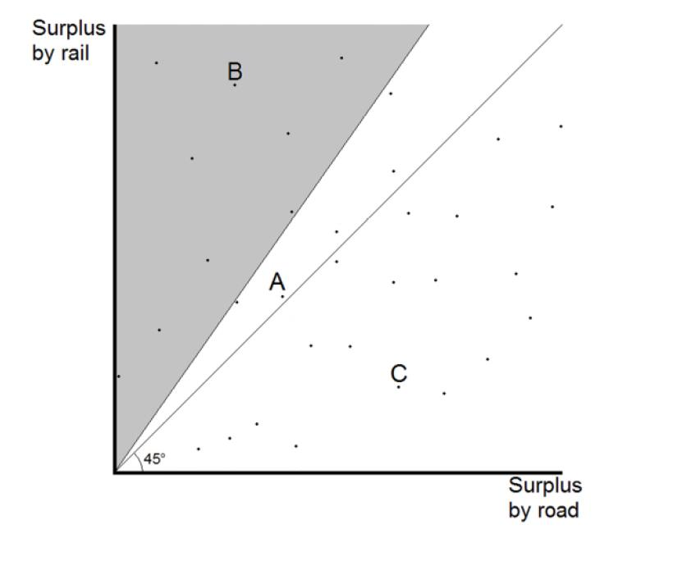
- In this graph, the surplus available to a particular customer requirement using rail is measured on the vertical axis; whilst the surplus available from using road is measured on the horizontal axis. Each individual customer haulage requirement will represent a point in the 2-dimensional space set out in the diagram. This means, for instance, that a customer with a haulage requirement at:
  - point A, on the 45 degree line, represents a customer for whom the surplus available from road and rail linehaul services is comparable; suppliers of those services will be closely constrained by each other when dealing with this customer;
  - point B represents a customer whose surplus from rail linehaul services is materially higher than their surplus from road services; suppliers of rail linehaul services will not be closely constrained by suppliers of road services when dealing with this customer; and
  - point C represents a customer whose surplus from road services is greater than the surplus available from rail linehaul services; suppliers of road services will not be closely constrained by suppliers of rail linehaul services when dealing with this customer.
- Applying the hypothetical monopolist test will produce different results in relation to these different types of customers: a hypothetical monopolist supplying rail linehaul services could not profitably increase prices (i.e. impose a SSNIP) to customers at point A, since those customers could readily switch to road services, and so defeat the price increase. However the monopolist could profitably increase prices for customers at point B, for whom the surplus from rail linehaul services is materially greater than that from road services. This is because a SSNIP would not appropriate the surplus that those customers obtained from rail linehaul services to such an extent that would prompt them to switch to using road services; a hypothetical monopolist could substantially increase prices to customers at point B before that switch occurred. Any customers falling within the shaded area in the graph above would be in a similar position; for all such customers, the surplus from rail linehaul services is materially greater than that from road services, such that a hypothetical monopolist would find it profitable to impose a SSNIP in relation to those customers.
- This assessment of demand-side substitutability indicates that the markets in this proceeding should include customers who fall within the shaded area on this graph, that is, customers who, because of the nature of their freight task, obtain a materially greater surplus from rail linehaul services than road services, such that they cannot readily move to an alternative service. This is because these are the customers likely to be harmed by the provisions of the TSS, and by the ART acquisition.
- Dr Williams has identified from the primary evidence several relevant N-S users who should, in relation to particular freight tasks, be included in the relevant market definition for North-South Rail Services supplied on routes in each direction between Brisbane, Sydney and Melbourne.
[Table redacted]
- I accept his evidence and analysis in that respect.
- Dr Williams further notes that some of the other tasks of these freight forwarders and BFOs on this corridor should not be included in the relevant market. [Redacted]
- Dr Williams has identified several relevant E-W users who should, in relation to particular freight tasks, be included in the relevant market definition for East-West Rail Services supplied on routes in each direction between Perth, Adelaide, Sydney and Melbourne.
[Table redacted]
- Again I accept his evidence in this respect.
- Further, Dr Williams has identified that several relevant Queensland users should be included in the relevant market definition for Queensland Rail Services, that is, for services on routes in each direction between Brisbane and Cairns on the NCL.
[Table redacted]
- [Redacted]
- Again, I have no reason to doubt Dr Williams’ analysis.
- It is also appropriate to consider whether relevant users could switch to using sea services rather than rail linehaul services. Dr Williams observed that there may be certain freight and routes for which sea services are a viable and reasonably close substitute for rail linehaul services, but there were some users for which sea services were not an effective substitute for rail linehaul services.
- Dr Williams also concludes that the markets to be defined for the purpose of this proceeding should be limited to those rail linehaul services for which sea services do not offer an effective constraint on the pricing of the relevant rail linehaul services.
- Accordingly, Dr Williams’ view was that the appropriate product dimension is the supply of rail linehaul services over long distances for which neither road services nor sea services provide an effective substitute. I agree, save that unlike Dr Williams I would not include rail linehaul services relating to the transportation of bulk steel.

Supply-side substitution
- Substitution in supply refers to the situation where suppliers of the products other than the relevant product, that is, here, other than rail linehaul services, can readily and without substantial investment begin producing the relevant product. If this is the case, both products should be included in the relevant market, because suppliers of that product constrain the supply of the relevant product. Opportunities for supply-side substitution are to be distinguished from opportunities for new entry by parties which are not incumbents, which may require substantial investment in new assets.
- In my view there is no evidence that suppliers of services other than rail linehaul services can switch to supplying rail linehaul services, such as would warrant expanding the scope of the product market.

Functional dimension
- The functional dimension of a market refers to the level in the production chain at which products, in the present case services, are traded.
- In the present case, the functional dimension of the market is limited to “above rail” service, that is, the service of providing transport by trains as distinct from the “below rail” service of making railway lines available for that service. That above and below rail operations occur in separate functional markets is well established, including in relation to railway operations that use the ART.
- Further, and for completeness at this point, although I would note that in the future with the ART acquisition, PN may become vertically integrated, I have not considered that any relevant market definition issue arises by reason of that fact. Now although in some cases the inevitability of vertical integration because of its overwhelming efficiency may justify collapsing two otherwise separate functional levels, we are not in that area of debate in the present case (cf the scenario discussed by the Australian Competition Tribunal in Re Fortescue Metals Group Ltd (2010) 271 ALR 256 at [1035] to [1047] (Finkelstein J presiding)).

Geographic dimension
- The geographic dimension of a market refers to the geographical area in which production and trade of a particular product occur.
- Dr Williams observes that there is no necessarily right or wrong way to draw the geographic boundaries of the relevant markets in this matter. However, he observes that it is appropriate for the relevant markets to be defined to encompass:
  - services travelling in both directions on any particular route (i.e. from point a to b and point b to a); and
  - more than one route within a corridor, that is, where a corridor on a particular axis involves more than two terminals, to encompass transport between more than one pair of terminals; so, for example, on the corridor between Brisbane and Melbourne, to encompass routes between Brisbane and Sydney, and between Sydney and Melbourne.
- Dr Williams observes that the boundaries to particular corridors are somewhat arbitrary, and that different witnesses in this proceeding describe the relevant corridors in different terms. But he has proceeded on the basis that there is:
  - a North-South corridor which encompasses transport between Brisbane, Sydney and Melbourne;
  - an East-West corridor which encompasses transport between Melbourne, Adelaide and Perth (although the inclusion of routes between Sydney, Adelaide and Perth could also be justified); and
  - a North Queensland corridor which encompasses routes in both directions between Brisbane and Cairns on the NCL.
- In doing so, Dr Williams has adopted the description of Mr Jakab, Vice President – Intermodal of AHL, concerning the North-South and East-West corridors, noting that it is different from the description provided by Mr Adam of PN under which routes between Sydney or Brisbane and Adelaide are included in the North-South corridor, and routes between Sydney and Perth are included in the East-West corridor.
- Dr Williams identifies that in some cases it may be relevant to identify a market involving transport on more than one corridor, for example, in circumstances where services on both corridors were commonly purchased together, or where an operator achieved significant economies of scope from operating on both corridors. However, he considers that those features are not sufficiently present in the evidence in this proceeding to warrant identifying a single market encompassing services on more than one of the corridors he identifies.
- Dr Williams concluded that it is appropriate to identify the following markets being:
  - a market for the supply of North-South Rail Services for the transport of intermodal freight over long distances to BFOs (and freight forwarders) for whom neither road services nor sea services provides an effective substitute for rail linehaul services;
  - a market for the supply of East-West Rail Services for the transport of intermodal freight over long distances to BFOs (and freight forwarders) for whom neither road services nor sea services provides an effective substitute for rail linehaul services; and
  - a market for the supply of Queensland Rail Services for the transport of intermodal freight over long distances to BFOs (and freight forwarders) for whom neither road services nor sea services provides an effective substitute for rail linehaul services.
- I agree with Dr Williams’ approach to market definition, although the respondents have made some criticisms which I will address later, and would make two further observations.
- First, whilst it is appropriate to identify that rail linehaul services on interstate routes are supplied on a North-South corridor and an East-West corridor, the boundaries of those corridors, and hence geographic market definitions which rely on them are, as Dr Williams observes, somewhat arbitrary. As the ACCC says, whilst Dr Williams relied on Mr Jakab’s description of those boundaries to identify the geographic dimension of the interstate markets, he could also have legitimately relied on the slightly different view of Mr Adam. A further alternative would have been to identify the relevant geographic dimensions to reflect the perspective of customers who purchase the relevant rail linehaul services. Such customers, when purchasing a service to Western Australia, may consider themselves to be purchasing a service from any of Queensland, New South Wales or Victoria to Western Australia, and not two separate services, for example, a service from Brisbane to Perth, not one service from Brisbane to Melbourne, and another from Melbourne to Perth.
- However, as the ACCC points out, the differences in these approaches have only a marginal effect on market definition, as shown in the following table that it provided:
Approach to defining the geographical scope of the relevant service | Services included in the North-South market | Services included in the East-West market
By reference to services provided on corridors described by Mr Jakab | Services between Brisbane, Sydney and Melbourne | Services between Melbourne, Perth and Adelaide
By reference to services provided on corridors described by Mr Adam | As for Mr Jakab, but:  ● also including services between: Sydney and Adelaide; and Brisbane and Adelaide; and  ● not including services between Sydney and Melbourne that form part of an East-West service as described in the entry at right. | As for Mr Jakab, but also including services between Sydney and Perth.
By reference to customers’ perspective | As for Mr Jakab, but not including services between Brisbane, Melbourne and Sydney that form part of an East-West service as described in the entry to the right. | As for Mr Jakab, but also including services between:  ● Queensland and either South Australia or Western Australia; and  ● NSW and either South Australia or Western Australia
- Second, as Dr Williams observes, in some circumstances it may be appropriate to identify a single market that encompasses transport services provided on more than one corridor. There are a number of factors which could suggest that rail linehaul services on the North-South and East-West corridors howsoever defined are supplied in a single market including the following:
  - both PN and SCT and no other suppliers supply both North-South and East-West rail linehaul services;
  - Qube, a potential new entrant, considers that it could achieve more efficient unit costs if it operated both North-South and East-West rail linehaul services, and that it is important to its ability to compete with PN that it establish a national offering, and not an offering limited to providing services on limited routes; and
  - BFOs or freight forwarders can purchase North-South and East-West rail linehaul services under a single national arrangement.
- Accordingly, a legitimate alternative to identifying two separate North-South and East-West markets is to consider that the supply of rail linehaul services to relevant users on interstate routes occurs in a single interstate market.
- In summary, I agree with the ACCC that it is appropriate to identify and apply the following market definitions, but excluding as I have said rail linehaul services involving the transportation of bulk steel.
- In relation to the supply of North-South Rail Services and East-West Rail Services, the supply of those services occurs either:
  - in two separate markets: a market for the supply of North-South Rail Services to relevant N-S users (North-South market) and East-West Rail Services to relevant E-W users (East-West market) (together, the Interstate markets); or
  - in a single market for the supply of North-South Rail Services and East-West Rail Services to relevant users (the Interstate market).
- And as to the precise definition of North-South or East-West corridors, nothing turns on whichever approach one takes. I am content to proceed with Dr Williams’ selection from the menu.
- The supply of Queensland Rail Services occurs in a market for the supply of such services to relevant Queensland users (Queensland market).

(b) Mr Morton’s analysis
- The ACCC’s approach to market definition is to be preferred to that adopted by Mr Euan Morton. Mr Morton’s conclusions that rail linehaul services are supplied in the same market as road services and that there is no need in this case to identify markets by reference to any particular subset of customers is problematic in various respects.
- Mr Morton was an expert economist called by PN. Mr Morton is a principal economist at Synergies Economic Consulting. He advises on a range of economic issues relating to infrastructure and economic policy, with a particular expertise in the transport sector. He led the first review of Queensland Rail’s access undertaking at the Queensland Competition Authority. Mr Morton holds a Bachelor of Commerce, Bachelor of Law (Hons) and Bachelor of Economics (Hons First Class) from the University of Queensland. His written evidence was meticulously prepared and I found his evidence helpful in informing my own analysis, albeit that I have not accepted some of his conclusions.
- First, I agree with the ACCC that Mr Morton’s starting point obscures the particular harm at issue.
- Mr Morton began his identification of the product dimension of the relevant markets by considering the “product” provided by PN, being intermodal rail linehaul services. Accordingly, his starting point was not the subject of the harm said to arise from the relevant conduct, that is, the particular rail linehaul services supplied to relevant users who acquire and have no substitutes for PN’s rail linehaul services, but rather a much broader category being all intermodal rail linehaul services supplied by PN. By taking this approach, he commenced his analysis at a level of generality that does not focus on the position of particular customer types who might be affected by the relevant conduct.
- Second, there are shortcomings in Mr Morton’s application of the hypothetical monopolist test, which is the first of two bases on which he concludes that road and rail linehaul services should be considered in the same product market.
- Mr Morton founded his conclusion that rail and road linehaul services are supplied in the same market in part on the basis of an application of the hypothetical monopolist test. In applying that test, Mr Morton considered the impact of a 5% price increase on intermodal rail linehaul services, applying an elasticity estimate of -1.656, which Mr Morton described as the “long-run own-price elasticity of rail carriage of inter-capital non-bulk” freight. Mr Morton took the elasticity estimate from a paper by Mr David Mitchell (Mitchell, D (2010), Australian intercapital freight demand: An econometric analysis, Proceedings of the 10th Australasian Transport Research Forum, Canberra, 29 Sept-1 Oct 2010, p.14, Table 7). Mr Morton concluded from his analysis that a 5% price increase would not be profitable on the North-South route or the NCL.
- But there are difficulties with Mr Morton’s application of the hypothetical monopolist test.
- Mr Morton’s focus on rail linehaul services generally rather than on those services supplied to relevant users has the same disadvantages as identified above. In particular, due to the individually tailored nature of negotiations between suppliers of rail linehaul services and BFOs (or freight forwarders acting on their behalf), a hypothetical monopolist provider of such services would be able to raise prices for (or lower discounts) for the relevant users without also needing to raise prices (or lower discounts) for other acquirers of such services. By conflating both sets of users together into a single hypothetical monopolist test, a SSNIP that may be profitable for the relevant users might be found to be unprofitable if it had also been offered to all users of rail linehaul services. To the extent that a provider of such services could raise prices (or lower discounts) to the relevant users in isolation of other users of such services, Mr Morton’s hypothetical monopolist test does not address the significant competition concern raised by the ACCC.
- Further, there are doubts as to the reliability of results produced by applying elasticity estimates of the nature Mr Morton relied on. As Mr Morton himself said concerning the application of published elasticities: “you take elasticities and what they tell you with a grain of salt”.
- Further, it is debatable whether the particular elasticity estimate Mr Morton used (-1.656) was the most appropriate estimate that he could have selected from the Mitchell paper. It was lower (i.e. “more negative”) than the arguably more appropriate alternatives in that paper. The estimate Mr Morton selected is an estimate of cross-price elasticities for aggregate Australian intercapital non-bulk freight, produced using a logit functional form. Mr Morton said that “I thought I selected the lowest reasonable one that I could”. But the author of the Mitchell paper had also calculated more specific elasticity estimates for transport over different length distances, using the logit function, which produced estimates of -0.926 for short distance routes, - 1.151 for medium distance routes and -0.778 for long distance routes (see Table 10). Having regard to the definitions of “short” and “medium” distances, it would have been more appropriate to rely on the elasticity estimates for those distances when considering a hypothetical monopolist. The distances covered by those estimates are more relevant to the rail linehaul services on the North-South corridor and the NCL, which Mr Morton was considering. And those elasticity estimates for those particular distances were closer to zero (i.e. “less negative”) than the estimate of -1.656. All else being equal, an elasticity estimate closer to zero such as the short and medium distances estimates in the Mitchell paper could be expected to produce a lower reduction in volumes than a “more negative” estimate. This could result in the hypothetical monopolist test showing that a SSNIP would be either profitable, or would be less unprofitable, than shown by Mr Morton’s analysis.
- Further, Dr Williams said that there were reasons to doubt the reliability of the estimates in the Mitchell paper, including because they produced paradoxical results. He stated that “it’s my opinion that one shouldn’t rely on any of the numbers at all”, although I must say here that I thought Dr Williams’ views partly reflected a more general philosophical position that did not enthusiastically embrace a quantitative analysis based upon contestable elasticity estimates.
- In summary, Mr Morton’s hypothetical monopolist test analysis does not assist in providing a secure foundation for Mr Morton’s conclusion that rail and road services are supplied in the same product market.
- Third, Mr Morton’s hypothesis that PN’s rail prices are “priced off road”, which is the second of his two bases for concluding that road and rail services should be considered in the same product market, also has its difficulties.
- Mr Morton concluded that rail prices are priced off road costs in part because of what was said to be a high statistical relationship between rail prices and road costs. But there are problems with his statistical analysis. During the hearing, Dr Williams explained that Mr Morton found a high degree of correlation merely because some of the data points used in his regression analysis contained a lot more containers than other data points. Mr Morton in some respects agreed with Dr Williams’ criticism. He said the following during one of the concurrent evidence sessions:
DR WILLIAMS: So you would agree with me, would you, that because of this aggregation, you’re going to find a high degree of correlation between your road price and your rail price for these 95 aggregated consignments merely because some consignments have a lot more containers in them than do others.
MR MORTON: That is possible. I’m not a statistician. But what I have, subsequent to the conferral and some of these issues arising, had the analysis redone on the basis of each individual customer and freight forwarder combination and it’s true the results aren’t quite as strong but they’re still very statistically strong results. So what Dr Williams observed is correct. [Redacted]
- Further, Mr Morton’s analysis suggests that the proposition regarding the pricing of rail prices off road costs is not correct in relation to PN’s own pricing. Mr Morton hypothesised that PN’s “standing offer”, being its pricing under its rate cards, “was essentially priced at or at a slight discount to or around … what PN thought the price of road would be”. Mr Morton acknowledged that he could not prove that that is what PN does. Indeed, PN did not lead evidence from those responsible for setting PN’s prices as to the validity or otherwise of Mr Morton’s hypothesis. But in considering this hypothesis, Mr Morton presented in Figures 41 and 42 of his report, graphs plotting PN’s “actual prices” for rail services, that is, the prices charged for particular rail linehaul services, as distinct from the prices shown in its price schedules, compared to PN’s prices under its rate cards.
[Image redacted]
[Image redacted]
- These graphs illustrate that PN consistently charges prices below what Mr Morton hypothesises is PN’s view of the road equivalent price (depicted by the orange line in each graph), and at times at prices substantially below including prices that are less than 50% of that road price. Mr Morton agreed that the variety of rates charged by PN indicated that PN engages in price discrimination. Accordingly, on Mr Morton’s analysis, PN charges a variety of rates, which contradicted his hypothesis that there is a high statistical relationship between rail and road equivalent prices.
- Significantly, if Mr Morton’s analysis of PN’s rail prices in Figure 41 of his report could be relied upon, it would demonstrate that there are a large number of customers that pay prices for rail linehaul services substantially below those needed to compete with road prices. One potential reason behind this observation is that something other than road prices is constraining providers of rail linehaul services when setting prices for these customers. Consistent with the evidence of actual market participants in this matter, a constraining force on PN when providing certain rail linehaul services for some customers is the existence of another rail operator.
- In summary, I am not inclined to place much weight on Mr Morton’s conclusion that “rail prices off road”, especially in relation to the relevant users. So, the second of Mr Morton’s two bases for concluding that road and rail linehaul services are supplied in the same market is not secure.
- Fourth, there are various difficulties in Mr Morton’s conclusion that there is no need to define markets by reference to a particular subset of customers.
- Mr Morton’s first justification for rejecting the proposition that it may be appropriate to define the markets in this proceeding by reference to a subset of customers was that there have been “pronounced swings” in the share of rail and road transport on the relevant corridors over time, suggesting that a “high” proportion of rail traffic is able to move between rail and road. But this observation does not support Mr Morton’s conclusion that there is no need in this case to define markets by reference to a subset of customers. Mr Morton and the other expert economists accepted that for the purpose of market definition, it is not appropriate to disregard the interests of customers who may be “captive” to rail on the basis that they constitute a small percentage (less than 10%) of total volumes on a particular corridor. Therefore the fact that a “high proportion” of customers may be able to switch modes does not of itself say anything about the position of any particular subset of customers which may not be able to switch modes, and in relation to which the hypothetical monopolist test might show that a SSNIP would be profitable. I have already discussed problematic aspects of Mr Morton’s own application of the hypothetical monopolist test.
- Mr Morton’s second justification for rejecting the proposition that it may be appropriate to define the markets in this proceeding by reference to a subset of customers, was his view that rail prices are largely set by pricing off road. I have difficulty with that proposition for the reasons discussed earlier. He also said that only a small proportion of freight on the relevant corridors could be considered to be rail advantaged, and that those cargoes frequently switched between road and rail. Mr Morton used rail advantaged to mean cargo for which rail transport was less constrained by competing modes, such as road, but which was not captive to rail. The proportions of rail advantaged cargo he identified were, for the North-South corridor, 7.1% northbound and 4.9% southbound, and, for the NCL, 5.7% northbound and 8.5% southbound. But I agree with the ACCC that there are two difficulties with Mr Morton’s analysis in this respect.
- The first difficulty, as the ACCC correctly identified, relates to Mr Morton’s process for identifying rail advantaged cargo, which involved Mr Morton identifying cargoes in relation to which the difference between road and rail prices was 1.5 or more times the average difference in those prices. In the case of the North-South corridor, this led him to conclude that road is only a less effective constraint on rail when the price of rail is discounted in the order of 37.5% compared to road prices, and (excluding bulk steel) only in relation to the “industrial inputs” commodity group. He undertook a similar analysis in relation to the NCL. But in identifying the rail advantaged cargoes, Mr Morton focused only on the price differential paid for that cargo, and some technical aspects of the cargo (i.e. the features of the “industrial products” he identified). He did not look at any other price or non-price factors identified by relevant users, such as environmental or safety related benefits of rail linehaul services compared to road services. Further, he acknowledged that his concept of “rail advantaged” customers was a technical concept, and not an economic concept. Further, he did not, as Dr Williams did, conduct his analysis from the perspective of any particular BFOs or freight forwarders who acquire rail linehaul services, but formed his views based on information from PN’s perspective. [Redacted] Accordingly, there is doubt regarding the reliability of Mr Morton’s analytical process and the results it produced. Those results are likely to significantly understate the extent to which cargoes are likely to be rail advantaged, and to which road services are unlikely to be an effective substitute for transport of those cargoes by rail. Further, the extent of the difference in the price of road and rail linehaul services may not be an appropriate basis for determining whether road and rail are substitutes for each other for given sets of cargoes. For instance, a rail customer may still not switch to road in response to a SSNIP on rail prices even where the price of rail is significantly less than 37.5% lower than the price of road. The appropriate analysis for determining substitutability between road and rail for particular cargoes involves asking whether a user of rail linehaul services is likely to switch away from rail to road in response to a SSNIP for rail linehaul services.
- The second difficulty relates to Mr Morton’s conclusion that rail linehaul services provided to customers requiring transport of rail advantaged cargoes did not need to be assessed as a separate market because transport of the relevant cargoes frequently switched between rail and road. Mr Morton appeared to base this conclusion on evidence of PN’s experience contesting business to supply rail linehaul services for certain industrial products that had been served by road in the past. Again, Mr Morton did not consider the evidence of any particular BFOs or freight forwarders on this issue. Further, he did not attempt to apply the hypothetical monopolist test in relation to the supply of rail linehaul services for those cargoes. Without such an analysis, Mr Morton’s assertion does not carry much weight.
- Mr Morton’s third justification for rejecting the idea that it may be appropriate to define the markets in this proceeding by reference to a subset of customers was his view that there are material constraints on PN applying targeted price increases to rail advantaged cargoes, such that it is unlikely that PN could profitably apply a SSNIP specifically to these cargoes. The constraints Mr Morton referred to were the commercial necessity for PN to maintain a standard tariff, the limited visibility PN has as to products carried in containers, and the potential for BFOs to use a freight forwarder rather than buying rail linehaul services from PN directly. This third justification has its difficulties. First, any suggestion that PN cannot or would not engage in tailored pricing for rail advantaged freight due to a commercial necessity to maintain a standard tariff is undermined by Mr Morton’s own analysis demonstrating that PN’s prices do not reflect its standard tariff, but rather vary materially below that tariff. It is not the case that PN relies solely on “stated prices”, being uniform prices available to all customers, or all customers within particular pre-designed categories such as prices advertised for tickets to particular cinema screenings or public transport tickets. Rather, its prices vary materially beneath the prices in its standard rate cards. Second, the idea that PN has limited visibility into what is carried in containers on its trains such as to limit its ability to tailor pricing to particular cargoes has its difficulties as I will address in a moment. Third, the idea that BFOs could avoid tailored pricing by using a freight forwarder to arrange rail linehaul services for rail advantaged cargoes may be problematic to the question of market definition as explained below. Moreover, as explained below, the key means by which PN engages in tailored pricing is by the use of commodity rates. The only way that a BFO can obtain the benefit of a commodity rate is if its freight forwarder requests such a rate, and such a request requires the freight forwarder to disclose the identity of the BFO.
- Accordingly, a BFO using a freight forwarder for rail advantaged cargoes could still be subject to pricing that reflected its lack of effective substitutes for rail linehaul services, either because it paid PN’s standard rates for its particular freight forwarder, or because it received only the tailored commodity rate that PN was prepared to offer if the freight forwarder did in fact request a commodity rate (i.e. a tailored rate that reflected its lack of effective substitutes for rail linehaul services).
- In summary, I do not consider that Mr Morton’s analysis is sufficient to undermine Dr Williams’ analysis or my conclusions on market definition that I have set out earlier.

(c) The preconditions proposed by PN
- PN has strongly pressed the argument that for it to be appropriate to define the relevant markets by reference to BFOs and freight forwarders for whom road services and sea services are not a substitute for rail linehaul services, two conditions must be satisfied.
- First, the condition must be satisfied that suppliers can identify and target “captive” customers, that is, customers for whom road and sea are not a substitute for rail, with higher prices.
- Second, the condition must be satisfied that profitable arbitrage must not be possible, that is, the non-captive customers must not be able to resell the product to the captive ones, or purchase it on their behalf.
- Now the implication from the necessity to show these two conditions is that they are, of course, sufficient to enable anti-competitive price discrimination amongst customers, such as to justify a market definition focused on a subset of customers for whom there are no ready substitutes.
- Further, PN says that for anti-competitive price discrimination to be profitable, it must be successful in a large percentage of cases. That is particularly so in industries such as the carriage of freight by rail where fixed costs are high (as a percentage of total costs) and so an attempted price increase that fails will result in customer loss. In those industries, so PN says, any failed attempts to discriminate will result in a relatively large loss of margin.
- PN says that for price discrimination to be rational, suppliers must therefore be able to identify and target captive customers and also avoid arbitrage, with a high degree of accuracy. PN says that those requirements are not satisfied in the present case. Let me begin by setting out its submissions concerning each matter.

Ability to identify and target captive customers
- PN says that it is not able to identify and target captive customers at all, let alone with the required high degree of accuracy. PN says that it predominantly contracts with freight forwarders, not BFOs. In this regard it makes the following points.
- First, PN’s contracts with freight forwarders specify standard rates that apply to all cargo that PN carries for the freight forwarder, regardless of the identity of the BFO or the nature of the BFO’s cargo. Those standard rates apply for 12 months (in the case of rate cards) or three to five years (in the case of RHAs). Accordingly, under its commercial arrangements, PN cannot increase its standard rates for any particular BFO or particular type of cargo.
- Second, freight forwarders typically give no guarantee as to the quantity of its customers’ freight that will be carried by rail. They can choose to forward any or all of their customers’ freight by other modes, such as road. As a result, if at any point a freight forwarder considers that the rates that PN charges are not competitive with the cost of transporting relevant freight by road, it can choose to transport that freight by road rather than by rail with PN.
- Third, the standard rates are typically structured as follows. There is a different set of standard rates for each origin-destination pair. For each origin–destination pair, there is then a cascading rate structure of the following kind:
  - “base rates” that vary depending on the size of the container;
  - “base tonnes”; each container size has a “base tonne” amount, which is the weight of the freight that can be carried for the base rate; and
  - “rates per additional tonne”; if the BFO seeks to include more than the applicable “base tonnes” in a container, it pays an additional fee.
- PN says that this standard rate structure is available to a freight forwarder for all of its customers’ freight. As a result, the standard rates charged typically do not vary according to the particular characteristics of the freight forwarder customer’s freight that PN carries.
- Further, it says that any attempt to increase its standard rates to take advantage of any BFOs for whom road and sea are not a substitute for rail is likely to be unprofitable. That is because for many BFOs road is a substitute for rail. If PN were to increase its standard rates it would risk causing those customers to respond by moving their cargo to road, which would likely result in a net loss of profit.
- Consequently, so PN says, road operators constrain PN, even in respect of BFOs for whom carriage by road is not a substitute for carriage by rail.
- Now the ACCC’s response to this was to refer to the CRAs which are agreements that PN enters into with freight forwarders in certain circumstances that provide discounts off PN’s standard rates. But PN says that for PN even to consider offering a CRA, the customer must have a RHA, it must be tendering for a particular contract (and win that contract), and the contract must be for full container loads. Whether PN grants a CRA will then depend on a range of factors, such as the volume to be carried, the corridor on which the freight is to be carried and the incumbent service provider.
- PN says that it cannot know with the required degree of accuracy whether BFOs would switch their cargo from rail to road (or sea) if PN refused to agree to a CRA (or offered a smaller discount in a CRA). BFOs’ willingness to transport cargo by rail, road or sea depends on a range of factors, including:
  - the total cost of transport to the BFO, including the cost of road, rail or sea services, any PUD costs and costs arising from the differences between each mode of transport due to internal processes such as inventory management;
  - requirements about delivery, including speed of delivery, frequency of delivery and the degree to which the BFO requires a time or date specific delivery window;
  - whether the attributes of the freight being transported, including the perishability, fragility, volume or weight of the freight, leads the BFO to favour a particular mode;
  - flexibility in the departure time and the implications of service interruptions like breakdowns or flooding;
  - the ability of each mode of transport to meet the BFO’s needs for reliability of delivery, including guaranteed capacity for high volumes of freight;
  - the distance between the freight pick-up origin and a suitable terminal or port and between the freight delivery destination and a suitable terminal or port;
  - whether the BFO has invested in or is otherwise effectively tied to using particular infrastructure that is specific to a particular mode of transport, for example, rail sidings or delivery docks that are not suitable for receiving freight from the types of trucks used for long distance transport;
  - safety considerations; and
  - environmental considerations.
- Further, it says that some BFOs have a range of different types of cargo, and their willingness to use road and/or rail may vary considerably from one type to another. Coles, for example, transports goods that range from dry goods to chilled and frozen goods, and from fresh produce to liquor. Its willingness to use rail rather than road or sea may vary for each such category of goods and for goods within each category.
- Further, PN says that to predict a BFO’s willingness to use road (or sea) rather than rail, PN would need to understand each of the factors referred to above for each of the BFO’s goods, as well as the relative weight that the BFO places on those factors. But PN says that it does not. It says that there is no evidence that BFOs provide all of that information to freight forwarders, let alone evidence of freight forwarders passing the information on to PN.
- Indeed, PN says that it would make no commercial sense for freight forwarders to pass that information on to PN. Their interest is in maximising the discount that PN will provide, either to win the relevant tender over other freight forwarders, or to improve their own margins by retaining part or all of the discount for themselves. Success in that endeavour turns upon opacity and not transparency.
- Further, PN says that even if freight forwarders did understand each of the factors referred to above for each of their BFO customers and the relative weight the BFOs placed on them, and passed that information on to PN, the information would still be unlikely to allow PN to profitably price discriminate. That is because the factors referred to and the importance that BFOs place on them may change over time, in response to changing individual or market conditions. For example, prices of road and sea freight vary. Similarly, the importance of speed and frequency of delivery can change for BFOs over time. Accordingly, even if PN understood a particular BFO’s willingness to use rail rather than road or sea and on the basis of that information refused to offer a discount or offered a smaller discount in a CRA, the BFO’s willingness to use rail may soon change, which would lead it to switch to road or sea. This could occur at any point in the 12 month term of the CRA since CRAs do not involve volume commitments by the BFO or the freight forwarder, rendering the price discrimination unprofitable.

Possibility of arbitrage
- PN also says that there is a small number of BFOs with whom PN contracts directly. Approximately 10% of PN’s revenue nationally is derived directly from BFOs, and in Queensland PN’s customers are almost entirely freight forwarders. PN says that it is unlikely to be able to accurately predict those customers’ willingness to use road rather than rail for the reasons I have referred to. But even if it could do so, if PN sought to raise prices to those BFOs, the BFOs could instead contract with a freight forwarder and thereby obtain the benefit of standard rates PN offers under its rate cards or a RHA. This would defeat an attempt to target and increase prices to BFOs.

Analysis
- I accept that the ability of providers of North-South Rail Services, East-West Rail Services and Queensland Rail Services (collectively or partly, Rail Services), which I have defined in terms of rail linehaul services provided to users who have no relevant substitutes, to be able to identify and negotiate different terms for the supply of services to the relevant users is relevant to assessing the extent to which the ART acquisition and provisions of the TSS are likely to substantially lessen competition in the relevant markets.
- But the proposition that a market may be defined by reference to a subset of customers only when PN’s two theoretical preconditions for price discrimination are satisfied may be going too far. A market is an area of close competition or a field of rivalry between firms. It is a field of actual and potential transactions between buyers and sellers amongst whom there can be strong substitution, at least in the long run, if given a sufficient price incentive. Moreover, as I have already explained, market definition is purposive. It is undertaken to facilitate the analysis of the conduct at issue, and the potential harm said to flow from it. As I have said based on the case law, market definition is therefore a focusing process, which involves value judgments about which there is some room for legitimate differences of opinion. And the same facts may well give rise to the identification of more than one market. In that context I am not necessarily required to satisfy myself of particular preconditions, such as those identified by PN, before identifying a market by reference to a particular subset of customers.
- Now PN’s preconditions may be justified as a matter of high economic theory, but there is no requirement that I necessarily need be satisfied of those preconditions in order to define markets by reference to a subset of customers in the present proceeding.
- Further, it is not necessary to prove that providers of rail linehaul services target different customers for price increases in order to establish that competition for some customers is different to that for others. In this case, the nature of competition to supply rail linehaul services is not in the form of targeting price increases above standard rates for particularly vulnerable customers. Instead, as the evidence shows, competition often occurs via PN offering individually-tailored discounts to freight forwarders to win the business of particular BFOs, where the level of discount varies depending on the competitive options these BFOs have available to them. Those BFOs with more attractive outside options in negotiation processes are able to extract better discounts. As the ACCC points out, the principal concern in this matter is that the relevant users do not view transport by road or sea as a compelling alternative or outside option for some or all of their freight tasks. And as the ACCC points out, if there is any reduction in competition for the supply of Rail Services, which the ACCC asserts is likely to follow the ART acquisition and/or the TSS (a contestable assertion of course), the extent of any discounts the relevant users are able to extract from PN or any other provider of the relevant services will be reduced.
- Further, it is not necessary that a provider of Rail Services perfectly knows the maximum amount each relevant user would be prepared to pay for Rail Services in order to be able to tailor a price to them. The setting of different prices for different groups of customers is common in many market settings even if the provider of services does not precisely know the maximum amount each individual customer is prepared to pay for their services.
- Let me begin by saying something about PN’s pricing.
- The particular means by which PN prices rail linehaul services is important to the competition analysis of the relevant conduct. If PN supplied rail linehaul services to freight forwarders and BFOs at a uniform price, there may be no scope for the price of Rail Services to relevant users to increase as a result of the relevant conduct. That is, if PN charged freight forwarders and BFOs for whom road and/or sea services are a substitute for rail linehaul services the same prices as it charges the relevant users, then the availability of road and/or sea services to some businesses might, under certain circumstances, apply some level of competitive constraint on PN’s pricing of rail linehaul services, including to relevant users. This would be the case if PN relied solely on stated prices, being uniform prices available to all customers, or all customers within particular pre-designed categories, such as prices advertised for tickets to particular cinema screenings or public transport tickets. An example of a uniform price available to all customers would be “all tickets $10”. An example of a uniform price available to all customers within a particular category would be “adult tickets $12, pensioners’ tickets $8, children’s tickets $5”. However, the evidence establishes two important matters. First, PN engages in considerable negotiation in relation to its prices. Further, there is substantial variation in PN’s prices for rail linehaul services that involves price discrimination. Accordingly, PN’s pricing for the relevant services supplied to the relevant users is not necessarily limited by any constraint arising from a reliance on stated prices which might reflect the availability of effective substitutes by way of rail linehaul services that are not supplied to relevant users.
- As I have already indicated PN’s pricing has the following features.
- PN prices rail linehaul services for intermodal freight by reference to a range of different rate cards, with different rate cards offered to different customers depending on the volume of freight to be transported, and in some cases the nature of the customer’s business. For example, PN has dedicated rate cards for removalists, and for customers transporting automotive and/or express freight.
- For some customers PN enters into a separate RHA, such that a customer is supplied pursuant to negotiated terms and not solely pursuant to a rate card and PN’s standard terms. Pricing under RHAs can be further adjusted by the use of CRAs. CRAs are negotiated agreements that PN enters into from time to time usually with freight forwarders who have an RHA. PN offers to enter into CRAs in circumstances inter-alia where a freight forwarder is seeking to win work from a particular BFO. The effect of a CRA is that PN agrees to provide a discount on the rates that would otherwise apply for rail linehaul services under the freight forwarder’s RHA in relation to particular work for a particular BFO. As I have said, the discount under the CRA is referred to as a “commodity rate”. When PN offers to enter into a CRA with a freight forwarder, the commodity rates it offers are specific to the particular work that the freight forwarder is seeking to win, that is, specific to the particular BFO, routes and freight the subject of the particular opportunity. Freight forwarders seek commodity rates in order to make their offering to a particular BFO more competitive with other potential modes or providers of transport.
- Mr Adam of PN has given evidence that in FY18, customers with a RHA generated 55% of PN’s intermodal freight volume. However, Mr Adam has also given evidence regarding PN’s supply of rail linehaul services and associated pricing in a “typical” week. Based on that data, in a “typical” week 62% of the aggregate expenditure of PN’s customers on all rail linehaul services supplied on the North-South corridor during that week was supplied at commodity rates and 76% of the aggregate expenditure of PN’s customers on north-bound rail linehaul services supplied on the North-South corridor was supplied at commodity rates.
- Since commodity rates are specific to particular parcels of work for particular BFOs, it follows that any one freight forwarder may have several commodity rates in place at the one time. For instance, Mr Strachan of Linfox could not identify the number of commodity rates Linfox has entered into with PN, but identified that there were “quite a few”, and more than 20. Several examples of CRAs are in evidence.
- Once a CRA is in place, PN provides a freight forwarder with a particular code to use when they book a rail linehaul service which is issued in respect of particular rail linehaul services. By using that code, the freight forwarder can claim the commodity rate on the particular services to which it applies.
- Significant information is disclosed to PN by a freight forwarder seeking a commodity rate. Importantly, the identity of the BFO is disclosed to PN at the time that the freight forwarder seeks to negotiate a commodity rate under a CRA, as are the characteristics of the relevant freight task. This can include information on matters such as whether and/or by whom the freight task is currently or may in future be supplied (and whether it is or may be supplied using rail linehaul services or an alternative transport mode), the level of competition in relation to the freight task, the routes over which the BFO seeks rail linehaul services, the volume, weight and nature of the freight to be transported, the nature of the freight for which the BFO seeks transport (although the nature of the freight may be obvious to PN such that it does not need to be identified to PN by the BFO) and the length of the relevant contract with the BFO. It can also include further information about the particular circumstances of an individual BFO, the details of which are not necessarily communicated by email, but which the evidence establishes can be material to PN’s decision whether to offer a discount under a CRA. In addition to granting commodity rates by granting a discount off a freight forwarder’s standard rates from PN, there is also evidence that PN tailored its prices for a particular BFO by committing to forego an annual increase in its rates, and thereafter cap its annual price increase to no more than 1% per year for two subsequent years.
- Further, PN makes a decision as to whether and what commodity rate it will apply in relation to a particular freight task, having regard to matters including but not limited to the matters addressed in information provided by the freight forwarder. A key basis on which PN offers, or declines to offer, commodity rates is PN’s assessment of whether such rates are necessary in order for the freight forwarder to win the work in competition with Aurizon or SCT. The evidence also shows that PN considers matters concerning price and non-price factors, such as its own view of the costs incurred by an alternative supplier of rail linehaul services, and the BFO’s willingness to pay for rail linehaul services.
- The commodity rates granted by PN are highly tailored. PN’s decision whether or not to grant a commodity rate, and the value of the rate granted, is not a decision which is applied uniformly to all rail linehaul services provided to the freight forwarder for the relevant BFO, but rather is tailored by reference to particular routes and direction of freight (including whether the service involves forward or backhaul on that route), the nature of the freight (e.g. whether it is ambient or temperature controlled), the nature of the PN service to be used to provide the relevant rail linehaul service, and the container size to be used. The evidence shows that even the prices charged to a freight forwarder for rail linehaul services provided to one BFO may vary by reference to some or all of these matters.
- In my view the fact that PN can and does tailor its pricing to particular BFOs and freight tasks demonstrates that PN has the ability to adjust its pricing to reflect the strength of the competitive constraints it faces in relation to the supply of particular rail linehaul services for a particular BFO. It can now and may in the future be able to grant lower discounts, withhold discounts altogether, or increase prices where BFOs or freight forwarders acting on their behalf have less compelling outside options available to them, including for those BFOs who have no effective substitute for the use of rail linehaul services.
- The respondents suggest that in the future with the relevant conduct, PN will not be able to tailor its charges for rail linehaul services supplied to relevant users to reflect the different competitive options they have relative to those customers for whom road or sea services are an effective substitute for rail linehaul services. But I reject this.
- Freight forwarders already can and do approach PN for commodity rates for particular BFOs and particular rail linehaul services. The ACCC’s evidence includes many examples of emails between PN and freight forwarders which contain both requests for commodity rates, and PN’s responses to them. The evidence also discloses that there are also many oral communications to similar effect. Mr Adam of PN gave evidence that such requests for commodity rates were “reasonably frequent in terms of all of the customers that we had with rail haulage agreements”.
- Further, when freight forwarders request a commodity rate, they provide information to PN on and relevant to PN’s assessment of the competitive landscape PN faces. Further, PN brings its own information and commercial judgment to bear in deciding whether to offer a commodity rate, and what level of discount it will offer. The evidence shows that this includes, for example, PN’s:
  - knowledge of the freight type being carried such as the type of product and whether it is a “high value” product;
  - its perception of a BFO’s willingness to pay;
  - its knowledge of the operating modes of other providers of rail linehaul services; and
  - its assessment of the competitiveness of PN’s rates on a particular corridor.
- Further, PN is well placed to apply its own information and judgment in this process. It is a well-experienced operator on each of the interstate routes and the NCL, and has familiarity with the demand for rail linehaul services on those routes and the nature of the business of many, if not all, of the users of those services. PN utilises FreightWeb, an electronic system for freight forwarders to inquire about or order rail linehaul services. In some instances, customers can make a booking only through FreightWeb. When booking through the portal, the customer must include details such as a description of the freight, the weight and its packaging. This system allows PN the benefit of a large repository of information collected in the course of its business, relating to the use of rail linehaul services on the interstate routes and the NCL, and the nature of the freight moving in the containers.
- Further, PN’s own internal documents evidence the importance it places on understanding the commercial and competitive environment that influences that demand, including the particular circumstances of individual BFOs, as well as freight forwarders. This is demonstrated, for example, by the following slide:
[Image redacted]
- The evidence shows that the information available to PN is sufficient to enable it to tailor prices in response to the competitive environment it faces. Now PN may not be able to tailor its prices perfectly to match its customers’ willingness to pay, or able in all cases to tailor its prices to customers without risk of missing the mark i.e. pricing higher than a customer will tolerate and losing the customer, or pricing lower than a customer would tolerate and forgoing margin. But PN can and does engage in significant tailoring of its prices, notwithstanding the fact that it lacks perfect information, faces uncertainty, and cannot perfectly tailor its prices to match its customers’ willingness to pay.
- Further, the evidence does not establish that PN faces crippling deficiencies in information or judgment that prohibit it from engaging in tailored pricing. As Dr Williams observed, it is sufficient to facilitate tailored pricing that PN understands in a “rough sort of way” the matters relevant to its pricing, for example, what it would cost the BFO to have cargo carried by road or sea, the speed and time constraints of the BFO and its intended delivery and arrival points. The fact that PN may not have perfect information about all relevant matters, and may need to make an educated guess having regard to the information presented by a customer or BFO, is simply a routine feature of commercial negotiations. Similarly, the fact that a relevant user may only present information that advanced its interests would not prevent PN from using tailored pricing, and is also a routine feature of commercial negotiations. Suppose, for example, as the ACCC contended, that a freight forwarder requested a commodity rate for a BFO which said it was seriously considering the use of road services on a particular route. If PN was aware that that BFO had rarely used road services on that route in the past, it would be well placed to make its own assessment as to the credibility of that information. In the same way as the evidence shows that PN does not always accept unquestioningly the information presented to it in support of a request for a commodity rate, it could be expected to assess any such information critically having regard to its own interests in future. The presence of some uncertainty in that process is not an insurmountable obstacle to tailored pricing.
- Further, PN has suggested that it would not be able to engage in tailored pricing to relevant users because the cost and risk of losing the relevant user’s business if it misjudged the price that a relevant user was prepared to accept would deter PN from attempting tailored pricing in the first place. PN says that this situation arises because its business faces high fixed costs and low marginal costs, such that it has strong incentives to generate additional volume, and a strong disincentive to bear the risk that it might price “too high”, and hence risk losing that volume. But at present, PN can and does engage in tailored pricing through the use of commodity rates, notwithstanding whatever risk it may face of losing business if it misjudges the price that the relevant user would be prepared to pay. It can be expected to continue to do so in future.
- Now PN contends that it predominately contracts with freight forwarders, not BFOs. It has standard rates that apply to all cargo that it carries for each freight forwarder, regardless of the identity of the BFO or its willingness to switch from rail to road or sea. PN argues that any attempt to increase its standard rates to take advantage of any BFOs for whom road and sea are not a substitute for rail is likely to be unprofitable. That is because, for many BFOs, road is a substitute for rail. If PN were to increase its standard rates, it would risk causing those customers to respond by moving their cargo to road, which would likely result in a net loss of profit. PN argues that it is therefore constrained by competition from road operators in respect of the prices that it charges to carry all BFOs’ freight, even if a particular BFO might not view road or sea as a substitute for rail.
- To justify that there are many BFOs for which road is not a substitute for rail, PN relies upon Mr Morton’s analysis. But there are problems with his analysis as I have discussed earlier.
- Now Aurizon states that the evidence of industry participants also indicates that road operators compete vigorously with rail. In any case, Aurizon says that even if there is some small minority of BFOs for whom road services and sea services do not provide an effective substitute, it is not possible to provide a service only to those BFOs.
- But in my view the evidence is clear that PN, through its charges to freight forwarders, charges different BFOs different rates for rail linehaul services. Moreover, freight forwarders do negotiate individually-tailored discounts off standard rates for rail linehaul services for particular BFOs. And PN charges different rates for different BFOs. Moreover, the real question is whether the ART acquisition or the relevant provisions of the TSS are likely to substantially lessen the ability of relevant users to negotiate discounts for Rail Services, that is, rail linehaul services to relevant users, whether directly or through their freight forwarder in a way that is likely to lead them to face poorer terms and conditions including price for those Rail Services.
- It seems to me that the conditions for competition in the supply of the Rail Services to relevant users are different to those concerning supply of rail linehaul services to other BFOs and freight forwarders, such that the potential harm from the relevant conduct arises for the relevant users in a way that it would not arise for those other users. I agree with the ACCC that for the purposes of market definition, no further inquiry into PN’s preconditions is necessary or desirable.
- Of course, PN’s proposed preconditions have some relevance to the analysis of whether relevant conduct would have the likely effect of substantially lessening competition.
- Let me now deal with the possibility of arbitrage to defeat tailored pricing.
- PN suggests that the relevant users would be able to defeat any attempt by PN to engage in tailored pricing by themselves engaging in arbitrage. It says that they could do this by acquiring Rail Services through a freight forwarder, and thereby hide behind that freight forwarder, obtain the benefit of the rates PN made available to that freight forwarder, and avoid any tailored pricing by PN. But I agree with the ACCC that this suggestion is not realistic.
- The key means by which PN engages in tailored pricing is through the use of commodity rates. Accordingly, BFOs which use a freight forwarder do not necessarily pay for Rail Services at the particular rates agreed in the freight forwarder’s RHA, but in many cases also obtain a further discount off that rate through the use of commodity rates under CRAs. Commodity rates are specific to particular freight tasks and particular BFOs, and vary by express reference to a range of factors, as I identified earlier. In order to obtain a commodity rate for particular Rail Services to be supplied to a BFO, a freight forwarder must identify the relevant Rail Services and BFO. Accordingly, a relevant user seeking to engage in arbitrage by using a freight forwarder could either decline to seek a commodity rate, or seek a commodity rate and be offered a discount (if any) that reflected the competitive constraints PN faced in the supply of the relevant Rail Services. In either scenario, the relevant user would receive higher pricing than a BFO which had effective substitutes for rail linehaul services. Accordingly, a relevant user could not defeat PN’s tailored pricing by using a freight forwarder, because simply using a freight forwarder would only give them access to the freight forwarder’s standard rates. They could not expect to receive a discount off those rates unless they allowed the freight forwarder to disclose their identity and seek a commodity rate. If they did not allow the freight forwarder to seek a commodity rate, they would pay a higher price than they would otherwise (i.e. absent the relevant conduct), because they would not obtain a commodity rate. If they did allow a freight forwarder to seek a commodity rate, they would still obtain a higher price than they would otherwise (i.e. absent the relevant conduct), because any commodity rate they received could be expected to be tailored to their circumstances (as is PN’s practice), including the reduced competitive constraint PN faced as a result of the relevant conduct.
- Further, the idea of arbitrage through use of a freight forwarder is not realistic in relation to all relevant users. For example, the relevant users include [Redacted], a removalist. There is similarity between the services supplied by a freight forwarder and a removalist, to the extent that both businesses provide an end to end transport solution by means of a combination of their own transport services, and transport services they acquire from a third party such as Rail Services. In order for a removalist to engage in “arbitrage”, they would need to either persuade a freight forwarder to supply them with solely Rail Services (and not the PUD services which a freight forwarder typically supplies), such that the removalist could continue operating their own transport services either side of the relevant Rail Services, or acquire Rail Services from another freight forwarder as part of a freight forwarding service, which would involve the removalist effectively outsourcing its core business to a freight forwarder, such that the removalist became in substance a booking agent for the freight forwarder. There is no evidence to suggest that removalists have entered into such arrangements in the past, and it is unrealistic to suggest that it might be commercially feasible for them to do so in future.
- Let me finally deal with two other points concerning PN’s pre-conditions.
- First, PN has sought to suggest that Dr Williams’ evidence supports PN’s case, particularly as it relates to the question as to PN’s ability to tailor its pricing. But I agree with the ACCC that what the transcript reveals is that PN put a series of commercially unrealistic propositions to Dr Williams, and he responded in a way that identified that fact. For example, when propositions were put to Dr Williams that PN would need to know very specific information in order to engage in tailored pricing, he responded in a way that identified his reservations about the particular proposition put to him. He said, in relation to whether PN would need to know the cost of road or sea services available to a particular BFO, “Not exactly”, “they would need to have some idea, probably” and PN would need to know “in a rough sort of way”. In relation to whether PN would need to know what, if any, factors other than price are relevant to a BFO’s choice of transport, he said that PN would need to have a “rough idea” of particular matters and that “in a rough idea these factors would be relevant”. He identified that the asserted variability in the competitive price of road transport and the accompanying change in volumes of freight transported by either road or rail put to him would happen “over quite long periods of time”. He identified that the spectre of PN being in a state of uncertainty as to these matters including the willingness of a particular BFO to pay for PN’s services is something that will exist “in any negotiation”, and will be “just as significant as in any negotiation”. But he did concede that “[t]he more information you have the – the better you’re able to engage in fine degrees of price discrimination”. I agree with the ACCC that the transcript of Dr Williams’ evidence must be read in its entirety. What Dr Williams was saying was that you would not need the complete and precise information asserted by PN in order to engage in tailored pricing.
- Second, as the ACCC correctly points out, the first of PN’s proposed preconditions, that the hypothetical monopolist is able to identify the customers to whom price can be increased, is not to be confused with the hypothetical monopolist test. As I have said, that test can be used in the analysis of demand-side substitution that is undertaken for the purpose of product market definition. Contrastingly, PN’s first proposed precondition is a simple question as to the feasibility of identification of the relevant users. But the hypothetical monopolist test asks whether a hypothetical monopolist who supplied the particular service at issue would find it profitable to impose a SSNIP in the order of 5 to 10% in relation to that service. If, in response to the price rise, customers would switch to acquiring other services in sufficient numbers so as to render the price increase unprofitable, those other services ought to be included in the relevant market. But this test assumes that the hypothetical monopolist could apply a SSNIP to the relevant users in relation to the relevant services, and asks whether that SSNIP would be profitable. Moreover, satisfaction of the hypothetical monopolist test does not require me to be satisfied that PN could have in the past, or could at present, implement a SSNIP to the relevant users. PN has not been in the past, and is not at present, a monopolist supplier of Rail Services in any of the relevant markets. As such, its past and present experiences have no bearing on the hypothetical monopolist test, notwithstanding that they are relevant to the analysis of whether the relevant conduct would substantially lessen competition.

(d) Bulk steel
- Now the ACCC has included bulk steel products within its product definition for rail linehaul services.
- Principally the ACCC has relied on the evidence of Dr Williams who considers that to treat bulk steel and intermodal freight as being in the same product market is appropriate on the basis that the alleged competitive harm that is said to arise in this proceeding arises similarly in relation to the supply of Rail Services to customers who use those services for intermodal freight and customers who use them for bulk steel.
- The ACCC also says that the following factors also point towards considering Rail Services for bulk steel and intermodal freight to be part of a single product market.
- First, both intermodal freight and bulk steel are transported by rail to the BMUT.
- Second, intermodal freight and bulk steel are carried in wagons, and are capable of being, and in some cases are, transported on the same train (i.e. a train carrying both intermodal freight and bulk steel), including when transported to the BMUT.
- Third, to date the only two potential suppliers who have demonstrated an interest in supplying Rail Services for bulk steel are PN and Aurizon, both of whom are (or were) also suppliers of Rail Services for intermodal freight; the opportunity for the Aurizon intermodal business to expand into providing steel haulage services was also identified in information memoranda issued by Aurizon’s bankers to potential bidders for Aurizon’s intermodal business.
- Fourth, PN, the only current supplier of Rail Services for bulk steel, organises its business such that the same part of the business supplies Rail Services for both bulk steel and intermodal freight (whereas a separate part of PN’s business supplies rail transport for coal); similarly, before its recent restructure, the same PN business unit supplied Rail Services for both bulk steel and intermodal freight, and separate business units supplied rail transport for coal and other bulk products.
- Fifth, BlueScope purchases Rail Services for bulk steel and for finished steel products (a type of intermodal freight) under the one contract (i.e. the Steel Link contract).
- Further, it says that there are material areas of overlap between the relevant users who use Rail Services to transport intermodal freight, and those who use them to transport bulk steel, and between the Rail Services they acquire. [Redacted] Further, most of the relevant users obtain Rail Services which depend on use of the ART, whether to load, unload, deliver and collect containers (as in the case of intermodal freight), or as a means by which bulk steel can be transported to relevant sidings adjacent to the ART. Bulk steel products, for example, interact with the ART by transiting through the ART and being held for periods in the marshalling yards at the ART, with “rakes” (sections of wagons) being moved into the BlueScope siding to be unloaded. Further, the rail corridors over which Rail Services are provided are the same for intermodal freight and bulk steel. Further, the essential characteristics of the service associated with transporting intermodal freight and bulk steel are identical. The customer’s freight is loaded on to a wagon and transported by train to its destination. Unlike bulk freight, neither intermodal freight (such as containerised freight or chemicals transported in tanks) or bulk steel is poured into wagons, or otherwise transported loose by the Rail Services provider.
- Further, the ACCC says that its position is supported by the evidence of Dr Williams. Dr Williams was asked by the ACCC to consider “to what extent, if any, are bulk steel rail haulage services supplied in the same product market to that in which intermodal rail linehaul services are supplied”. In his expert statement, Dr Williams stated in relation to North-South Rail Services that he believed the relevant markets in this matter included a:
market for the supply of North-South Rail Services for the transport of intermodal freight and steel over long distances to BFOs (and freight forwarders) for whom neither Road Services nor Sea Services provides an effective substitute for Rail Services (the North-South Market).
- He defined similar markets for East-West Rail Services and Queensland Rail Services in the following terms:
a market for the supply of East-West Rail Services for the transport of intermodal freight and steel over long distances to BFOs (and freight forwarders) for whom neither Road Services nor Sea Services provides an effective substitute for Rail Services (the East-West Market); and
a market for the supply of Queensland Rail services for the transport of intermodal freight and steel over long distances to BFOs (and freight forwarders) for whom neither Road Services nor Sea Services provides an effective substitute for Rail Services (the Queensland Market).
- Dr Williams’ process for defining relevant markets began by identifying an “initial candidate” market. He then considered whether there were substitutes in demand and supply for those products contained in the initial candidate market that would prohibit a supplier of those services from profitably implementing a SSNIP. In other words, the SSNIP analysis of substitutability came after the initial candidate market had been identified.
- Dr Williams described why he believed intermodal freight and steel should be in the same product market as follows:
In my opinion the product dimension of the initial candidate market should consist of the transport of intermodal freight and steel over long distances for which Road Services do not provide an effective substitute for Rail Services. I include the transport of intermodal freight in the same market as the transport of steel because transport of both kinds of freight in accordance with the precept of Professor Baker that it would almost never be appropriate to begin by disaggregating more narrowly than the specific products that are purchased by the buyers alleged to have been harmed by the conduct under review. As my examples illustrate, the transport of both bulk steel and intermodal freight provide examples of freight tasks for which road is not an effective substitute for rail and for which (for that reason) the impugned conduct may result in increased prices.
- Now Dr Williams did not place intermodal freight and steel in the same product market because those products were similar to each other. He also did not place them in the same product market because they were carried in the same kind of container or on the same type of wagon. He did so because they shared the same common feature, that is, their transportation is for BFOs who require rail transportation and for whom road transportation is not an effective substitute and therefore could be harmed by the transaction.
- Dr Williams also appeared to believe that nothing would be gained from analysing intermodal freight and steel in separate markets. In this respect, regarding whether the relevant markets should include both intermodal freight and bulk steel, he stated that:
Agree. This is a matter of judgment. In my opinion, to treat intermodal freight in a separate market from bulk steel would mean that one would be repeating material for each separate market for no particular analytical gain.
- Now in my view relevant users transporting bulk steel do not have identical requirements to relevant users transporting only intermodal freight. But the ACCC says that this is not a reason to exclude Rail Services for bulk steel freight from the market in which Rail Services for intermodal freight are required. In fact, so the ACCC says, there is significant variation between the requirements of relevant users requiring transport of solely intermodal freight. This reflects the range of different industries using Rail Services such as removalists, meat producers, chemical producers, freight forwarders, steel manufacturers, grocery manufacturers and wholesalers, for example, who are the relevant users. Indeed, a continuum of differences exist across various aspects of needs within that group. [Redacted]
- Therefore, so the ACCC says, the existence of differences between the characteristics of Rail Services supplied for bulk steel and intermodal services is not, of itself, a sufficient reason to warrant identifying two separate product markets.
- Further, the ACCC has given additional reasons why intermodal freight and steel should be considered in the same product market. Those reasons include the supply-side substitution of the transport by rail of bulk steel, whereby this service is easier to provide for an existing rail services supplier of intermodal freight than for a new entrant.
- [Redacted]
- I reject the ACCC’s case in this respect. The allegation that the services of carrying bulk steel by rail and intermodal freight by rail are supplied in the same market should be rejected for various reasons.
- First, the ACCC’s case is based on analytical convenience, not on the two services being substitutable or otherwise competitive with one another. Dr Williams’ reason for including those services in the same market is not that they are substitutes or otherwise competitive with one another, but rather analytical convenience. As he said in the joint report:
…to treat intermodal freight in a separate market from bulk steel would mean that one would be repeating material for each separate market for no particular analytical gain.
- In my view mere analytical convenience is not a proper basis for finding that two products are supplied in the same market. Market definition involves the recognition and use of an economic tool or functional concept related to market power, constraints on power and the competitive process which is best adapted to analyse the asserted anti-competitive conduct. And although it is correct to say that a market is a notional facility, it is not fictional or contrary to fact. It is one that accommodates rivalrous behaviour involving sellers and buyers. And s 4E treats substitutability as an important driver of the rivalrous behaviour accommodated by a market, in so far as the act of switching or substitution marks the conclusion of that rivalry.
- Second, even if it were permissible to define a market on the basis of mere analytical convenience, that would not be appropriate in this case. There are considerable differences in the competitive constraints that exist in respect of the carriage by rail of intermodal freight and bulk steel. Steel trains are heavier and run at a slower pace compared with intermodal freight, and fall within a different tier of variable track access prices under the ARTC access agreement, such that there are separate train paths for steel trains and intermodal trains. Further, substitution possibilities are different. Compared to most intermodal freight, bulk steel can less readily be carried by road, and can more readily be carried by sea. Further, the nature of negotiations between suppliers and their customers are different. [Redacted] Further, there is a range of entities that may be interested in, and capable of successfully bidding for, contracts to carry bulk steel.
- Third, and in any event, the carriage by rail of intermodal freight and bulk steel are not substitutable or otherwise competitive with one other. Customers seeking to have intermodal freight carried by rail will not consider the carriage of bulk steel to be a substitute (or vice versa). The two are not demand-side substitutes. And nor are they supply-side substitutes. As Dr Williams explained, two products will only be supply-side substitutes where suppliers can switch from producing one of the products to producing the other without any significant expenditure:
[t]he substitution in supply relevant to the market definition should not be confused with substitution in supply in the form of new entry to the market. The former refers to switching production that is relatively rapid and does not require any significant expenditure on the acquisition of assets, whereas the latter is likely to take longer and is likely to require significant expenditure on the acquisition of assets. As Motta states:
Note that there are several conditions that should be fulfilled for supply substitutability to widen the relevant market in particular, switching production must be easy, rapid and feasible. The producer of another good must already have the skills and assets required to produce the product under consideration, it should not incur considerable sunk costs, and any barriers to entry must be surmountable in a rapid and relatively cheap way.
(Emphasis added.)
- The ACCC adopts the same view in its Merger Guidelines. At [4.24] it is said: “[t]he ACCC will treat one product as a supply-side substitute for another in cases where all (or virtually all) of the capacity for producing that product could profitably be switched to supply an effective substitute to the other product quickly and without significant investment in response to a price increase”. And at [4.25] it is said: “[f]or some products, only a proportion of total supply capacity could feasibly be switched quickly and at minimal cost (for example, because firms producing this product use different technologies). In these cases, the capacity that could be switched will be considered as potential new entry when conducting the competition analysis rather than included in the market definition”.
- PN currently supplies rail linehaul services to BlueScope and Liberty under a tri-partite National Rail Freight Distribution Agreement dated 20 July 2012 (referred to earlier as Steel Link). The vast majority of bulk steel carried pursuant to Steel Link is carried in specialised wagons on dedicated steel trains that suppliers of intermodal freight services do not own. Carriers of intermodal freight other than PN would therefore need to incur significant expenditure in order to start carrying bulk steel. [Redacted]
- The two products are not substitutes in supply. In particular, although both intermodal freight and bulk steel are carried on wagons, and those wagons travel on train tracks, that is where the similarities end. Bulk steel is carried on trains which are dedicated for that purpose, and they utilise specialised wagons which are filled in a different way to an intermodal container. Further, for a supplier to move from supplying intermodal freight services to supplying bulk steel services it would require very significant capital expenditure.
- Finally, Dr Williams justifies analysing bulk steel in the same product market as intermodal freight on the basis that both services are affected by the same conduct. But there is no justification for grouping together products simply because they are affected by the same conduct.
- In summary I do not accept the ACCC’s market definition case concerning the transport of bulk steel.

(e) A broader market?
- Now I raised with the parties in closing addresses that it might be possible to define a broader market, not limited by reference to the relevant users, for long distance rail linehaul services between capital cities for intermodal freight, with a substantial lessening of competition in that broader market arising from the effect of the relevant conduct on relevant users.
- The ACCC submitted that my postulated approach would involve an orthodox and appropriate application of the relevant principles. The ACCC accepted that the fact that a substantial lessening of competition occurs in part of a broader market rather than across an entire market does not preclude it from amounting to a substantial lessening of competition in the broader market for the purposes of ss 45 or 50. And the ACCC said that my approach was a useful means by which to test its submissions as to the harm which would be likely to be suffered by the relevant users, irrespective of whether a broader or a narrower market definition is adopted. It says that the outcome of the competition analysis is the same whichever approach is adopted.
- Notwithstanding the ACCC’s embracing of my suggestion, for the reasons set out earlier I have determined that the relevant markets in which to assess the effects on competition of the conduct at issue are:
  - a market for the supply of North-South Rail Services for the transport of intermodal freight over long distances to BFOs (and freight forwarders) for whom neither road services nor sea services provides an effective substitute for rail linehaul services;
  - a market for the supply of East-West Rail Services for the transport of intermodal freight over long distances to BFOs (and freight forwarders) for whom neither road services nor sea services provides an effective substitute for rail linehaul services; and
  - a market for the supply of Queensland Rail Services for the transport of intermodal freight over long distances to BFOs (and freight forwarders) for whom neither road services nor sea services provides an effective substitute for rail linehaul services.
- But I do not have a difficulty with collapsing markets (a) and (b) into a single Interstate market. To do so does not significantly change the analysis or the result. Further, and for completeness, Aurizon says that the ownership and operation of the ART cannot have any relevant competition consequences for market (b). But even assuming this to be correct, that proposition does not take it far, as markets (a) and (c) may still be affected, or indeed the composite of markets (a) and (b) into a single Interstate market may still be affected.
- Finally on this topic, and if I need to say so, the markets that I have identified provide an appropriate conceptual framework within which to address the ACCC’s competition concerns. The ACCC says that competition in these markets is affected by the following matters.
- First, road services and sea services are not an effective substitute for rail linehaul services. This means that to the extent that the relevant conduct has the likely effect of reducing the number of suppliers of rail linehaul services to relevant users, whether because the ART acquisition would limit the prospect of new entry into the supply of North-South Rail Services or East-West Rail Services, or because the TSS was likely to limit that prospect and to bring about a situation where Aurizon’s QIB was closed, that effect is not alleviated by the availability of road services or sea services to those relevant users.
- Second, prices for Rail Services are substantially negotiated. As I have said, although PN uses a number of standard rate cards, the actual prices it charges to freight forwarders for providing particular Rail Services to particular BFOs can and do vary substantially from the prices contained in its standard rate cards. The variation arises as a result of PN’s use of commodity rates. When deciding whether and to what extent to offer a commodity rate, PN has particular regard to the competitive constraints it faces in relation to the supply of Rail Services for a particular BFO, including the alternative options available to the relevant BFO. The fact that prices are substantially negotiated means that it is appropriate to approach the competition analysis having regard to economic bargaining theory, as I have explained earlier. This means that to the extent that the relevant conduct brings about any lessening of competitive constraint, that lessening could be expected to be reflected in tailored pricing to the relevant users via the use of commodity rates.
- So much for market definition. Let me now turn to discussing the ART and its significance in more detail.

THE ART
- The ART is a significant terminal in south east Queensland which is strategically located. In my view it is the only terminal which provides a viable option in the short to medium term, say three to five years, to support the provision of North-South Rail Services, East-West Rail Services and Queensland Rail Services by a new entrant on the scale required to conduct a sustainable business.
- Ownership of the ART provides the owner with unfettered commercial and operational control of the BMUT. The operation of the BMUT is complex and involves a vast number of moving parts, many of which are critical to the effective performance of a rail operator utilising it. As I have already indicated, until December 2017, Aurizon and PN used the BMUT in relation to the provision of Rail Services on interstate routes, and until December 2018, Qube provided services at the BMUT pursuant to the Qube TSS.
- The following features of the ART are significant to an entrant or potential new entrant.
- The first significant feature is that its location is in close proximity to BFOs and freight forwarders whose freight is transported through the ART, which enables the quickest, most efficient and cost-effective movement of freight to or from the ART.
- The second significant feature is that it is a dual gauge terminal. This provides the ability to move containers between narrow and standard gauge railway lines within a single facility, which can be more cost effective than transporting containers between two separate terminals in order to move containers between narrow and standard gauge railway lines.
- Now it is the ACCC’s case in respect of the ART acquisition that at the time at which the ART acquisition could be expected to be completed being no earlier than from the first half of 2019, the inability or a potential new entrant’s reasonable perception of inability to obtain open and non-discriminatory access to the ART will be a significant barrier to entry in one or more of the relevant markets.
- The ART is one of only four intermodal terminals in south east Queensland. The ACCC contends that open and non-discriminatory access to the ART is important to potential new entrants in the relevant markets, due largely to its location and the fact that it is a dual gauge terminal that at least as at 28 July 2017 enabled transhipment.
- The ACCC says that the best evidence of the significance of the ART is the perceptions of market participants including PN and Aurizon themselves. I tend to agree.
- PN’s and Aurizon’s own contemporaneous documents demonstrate that as at 28 July 2017, they regarded ownership of the ART as a significant advantage for a rail operator in the relevant markets.
- In the PN presentation titled “Market Workstream Intermodal – Strategy” dated 27 January 2017, PN analysed the position of its competitors and in analysing Aurizon it stated under strengths, “Ownership of the Brisbane (Acacia Ridge) Freight Terminal”.
- Further, the Intermodal Information Flyer provided by Aurizon to Qube on 30 March 2017 as part of the sale process advertised the ART as being a “[s]trategically located asset” being the “primary interface between standard and narrow gauge rail networks”. Additionally, an Intermodal Information Memorandum dated April 2017 provided by Aurizon to Qube described the ART as being “strategically located at the Queensland end of the proposed Inland Rail route”, and strategically located within the “heart of Brisbane’s south western industrial corridor enabling direct access to a surrounding catchment attractive customers”.
- Further, an Aurizon board paper prepared by Messrs George Lippiatt, Andy Jakab, Dan Kearney and Craig McGrath titled “Freight Review: Intermodal” endorsed by the managing director and CEO Mr Andrew Harding on 12 June 2017 described the ART as a “highly strategic intermodal (& logistics) terminal asset which acts as “the gateway to QLD””. Further, Mr Jakab as Vice President – Intermodal of Aurizon gave evidence that at the time that board paper was prepared, he saw the significance of the ART as related to its location relative to BFOs in the Queensland market compared to other available terminals, for example, Bromelton, and the fact that it was a standard gauge and narrow gauge interface.
- Further, PN’s recognition of the strategic importance of the ART in the provision of intermodal and steel rail line haul services also formed the premise of its bid for the ART. For example, its board papers in respect of the relevant decision to bid for the ART referenced the ART’s “highly desirable location and footprint” and potential to amalgamate narrow- and standard-gauge operations as well as the ART’s role as the “primary interface between the interstate standard gauge rail network and the QLD narrow gauge network”. In addition, Mr Stewart as Manager Partner of GIP and a director of PN gave evidence that the ART was the asset that PN was most interested in, with the QIB as the “second prize”.
- Accordingly, at least as at 28 July 2017, it is not in doubt that both Aurizon and PN regarded the ART’s location vis-à-vis BFOs and freight forwarders and the ability to tranship from the ART as significant advantages of the terminal.
- Further, Mr Jakab’s evidence as to the superiority of the location of the ART for BFOs in the Queensland market is supported by BFOs. [Redacted]
- Further, Mr Nacey of Qube estimated that the majority of current interstate volumes at the ART originate from or are destined for a catchment area of up to 15 km from the ART. He gave evidence that the major freight forwarders including K&S, Toll and Linfox all have facilities located near the ART.
- Now none of these witnesses were significantly challenged on these points in cross-examination. None were asked if they would continue to use the Rail Services if the relevant provider operated out of an alternative terminal or a new site, or in Mr Nacey’s case whether in his opinion a BFO or freight forwarder would do so. None were asked further detail about the cost implications of this. I agree with the ACCC that in circumstances where it is the respondents asserting that alternative terminals could provide a sufficient base for a new entrant to sustainably provide the Rail Services in competition with PN, the absence of substantial evidence from potential new entrants, freight forwarders, BFOs and the like on this aspect is not without its significance. On the evidence before me I do not doubt that the ART is a superior location to any other alternative terminal, including a new site, for potential new entrants, BFOs and freight forwarders.
- Further, I do not consider that the expert evidence of Mr Ivan Hill of Urbis, a witness called by the Aurizon respondents, is of much assistance. Mr Hill gave expert valuation evidence about the value of the Port of Brisbane location compared to the value of the ART location for “Logistics” businesses generally, as opposed to those involved in the intermodal and steel rail linehaul market, or the rail linehaul market, or indeed any other relevant sub-category of logistics. But whilst Mr Hill observed that a higher proportion of “Logistics” businesses are located in the Brisbane Multimodal Terminal (BMT) precinct than in the ART precinct, his category of “Logistics” businesses was too broad such that his conclusion was not useful. As the ACCC submitted, his category of “Logistics” businesses included, for example, the large number of IMEX focused businesses in the vicinity of the BMT for whom the use of Rail Services may be wholly or substantially irrelevant. Such businesses would not be customers of a potential new entrant provider of Rail Services, and there would be no advantage to a new entrant from the fact that the BMT was located near to them. Mr Hill also considered that the precinct in which the BMT is located is, overall, a “superior” location for a “Logistics” business than the precinct near the ART. But Mr Hill’s view on this point could not overcome the fact that many BFOs and freight forwarders who would be potential customers of a new entrant rail provider were located in close proximity to the ART. Proximity to the ART is valuable to Qube, freight forwarders and BFOs, irrespective of Mr Hill’s views.
- I will return to discuss the function and operation of the ART later. But for the moment let me focus on alternative terminals.

(a) Alternative terminals
- Let me begin by stating in summary a number of my conclusions before getting into the detail.
- First, for a potential new entrant into the Queensland market, the only potential options in respect of narrow-gauge accessible terminals are the ART, the PN-owned Tennyson terminal, the BMT and a new (as yet unbuilt) terminal.
- Second, for a potential new entrant into the Interstate market(s), the only potential options in respect of standard-gauge accessible terminals are the ART, the SCT-owned Bromelton terminal, the BMT and a new (as yet unbuilt) terminal.
- Third, none of these alternative terminal options nor any combination of them would both realistically be available to a new entrant to use in the next three to five years and would offer comparable benefits to those of the ART.
- Fourth, it cannot be seriously asserted, as the ACCC has pointed out, that a potential new entrant into the Queensland market, as at 28 July 2017, would have been granted open and non-discriminatory access to the PN-owned Tennyson terminal or would be so granted in the next three to five years.
- Fifth, a potential new entrant into the Interstate market(s), as at 28 July 2017 or in or after the first half of 2019, would not have been granted open and non-discriminatory access to the SCT-owned Bromelton terminal and would not be so granted in the next three to five years.
- Accordingly, in my view the real dispute between the parties on the question of alternative terminals is whether a potential new entrant into one or more of the relevant markets would be granted open and non-discriminatory access to the BMT, would construct its own terminal, or would obtain access to a new but as yet unbuilt terminal. Was that likely as at 28 July 2017 (a date relevant to the s 45 case) or in or after the first half of 2019 (a date or timeframe relevant to the s 50 case)?
- Let me deal with the relevant possibilities in turn.

The Brisbane Multi-modal Terminal (BMT)
- The BMT at the Port of Brisbane is owned by the State of Queensland. It is leased and operated by Port of Brisbane Pty Ltd (PBPL). The BMT is located approximately 24 km east of the Brisbane CBD, approximately 35 km from the ART, and approximately 34 km from the Tennyson terminal. It is currently primarily used for IMEX freight travelling to or arriving via the Port of Brisbane, that is import and export volumes. The BMT is a dual gauge terminal, but at present it is used exclusively for narrow gauge rolling stock. On the evidence before me the BMT is not, and has never been, used for transporting domestic intermodal freight to any significant degree.
- I agree with the ACCC that the BMT is not a commercially realistic alternative to the ART for a new entrant seeking to supply Rail Services on interstate routes or on the NCL, for the following reasons.
- First, the BMT is not located near the freight forwarders or BFOs which operate from the vicinity of the ART, or other potential customers of Rail Services. This has a number of cost implications for the freight provider and also the BFO. These may include higher cost PUD services or additional track access charges, compared to the costs incurred by a rail provider which used the ART. In my view these costs are likely to be material, and would make a new entrant less cost competitive than an incumbent user of the ART. There is also evidence that freight forwarders do not consider the BMT to be a commercially realistic alternative to the ART, due to its location.
- Second, the BMT is only likely to be able to accommodate trains of up to a maximum of 900 metres in length. Accordingly, a new entrant rail provider will not be able to run trains of a comparable length to the 1200 to 1500 metre trains that PN runs on interstate routes, and which are accommodated at the ART, unless those trains are broken up and reconfigured part-way through their journey to the BMT.
- Third, a rail operator seeking to offer Rail Services on interstate routes would need to acquire train paths from QR to allow it to use the dual gauge section of railway track that runs from the border of the ARTC network at the southern entrance to the ART to Fisherman Island at the Port of Brisbane, where it terminates to reach the BMT. But a significant number of factors go into a decision as to whether QR will grant an “Authority to Travel” on that section of its network, including technical issues such as the impact of the proposed travel on existing scheduling, the dimensions of the proposed service, the impact on any level crossings and track circuits, the ability of a 900 metre train to respond at the necessary signalling distance, the extent of any additional maintenance burden for the underlying track, and community concerns. It is problematic whether QR would give an Authority to Travel for a 900 metre train between ART and BMT. Given the number of factors involved and the fact that QR appears not to have ever given an Authority to Travel for a regular service between ART and BMT of a 900 metre train, it is difficult for me to conclude that it is likely to give such an approval.
- Indeed, let me elaborate on some of the more detailed evidence given on this aspect. Mr Brett Smith, manager business operations, south, of QR, gave evidence that in order for an operator to run a 900 metre long train between the ART and the BMT, the operator would first need to submit a request for Authority to Travel and a conceptual operating plan. A conceptual operating plan requires sufficient detail to fully describe the train services and method of operation including scheduling, route, rolling stock and train configurations. If the train the operator seeks to run is similar to existing services, the time and complexity of the technical assessment of the conceptual operating plan will be reduced. A conceptual operating plan must be approved from both a technical and commercial perspective before QR will grant Authority to Travel.
- Currently, the maximum length of trains running to the BMT is 706 metres. To Mr Smith’s knowledge, QR has never authorised a regular service between the ART and the BMT of a 900 metre long train. In his experience QR would not decline to grant the request merely based on the length of the train. However, such a proposal would raise the following technical issues:
  - whether the services sought by the rail operator can be accommodated within existing timetabled services;
  - the dimensions (height and width) and operating characteristics of the rolling stock of the proposed train, assessed against the physical limitations in the track between the ART and BMT;
  - whether the 900-metre-long train would block level crossings or hold down other track circuits (because the longer the train, the greater time it takes to pass clearance points, track circuits, points and crossings, which will have an impact on the signalling sequence seen by other rail traffic, and hence their ability to adhere to their timetable);
  - whether the train has the capability of stopping within QR’s existing signalling system (as a general rule, the longer the train, the heavier it is and the longer it will take to stop);
  - the extent of the additional maintenance burden on QR (because a longer train may be heavier and therefore exert more tractive effort on the rail track, and over time this can cause the rail track to move; this effect is particularly pronounced if the service is regularly moving along track with a steeper grade, such as in the Morningside area located between the ART and BMT); and
  - community concerns (e.g. that diesel engines may be louder and that level crossings may be blocked for longer).
- Mr Gregory Rooney, general manager, rail management centre and operations, of QR, gave evidence that irrespective of the length of the train, it is highly unlikely that QR could approve a proposed service between the ART and the BMT during the “core peak period” in the Brisbane metropolitan timetable, being between 7.30 am to 8.30 am, and 5.00 pm to 6.00 pm weekdays. If Authority to Travel was sought to run a service during the shoulder period, being the times either side of 6.00 am to 9.00 am and 3.30 pm and 6.30 pm on weekdays, it is a possibility that the service could be approved to run during ‘small windows’ that might be available in the timetable, although there is still very limited capacity at this time. Mr Rooney gave evidence that it is QR policy that a delayed train is not to disturb the operation of passenger trains, which may result in delayed trains scheduled for the shoulder period being forced to dwell outside of the network.
- Now it may be accepted that the maximum length of trains operating on the Dual Gauge Section may be dictated by the longest loop on the route, being the Clapham crossing loop at 720 metres. But Mr Rooney gave evidence that given that the Clapham crossing loop is 3 km from the ART, his team would be unlikely to allow any usage of the loop. Any Authority to Travel granted in response to a request is likely to be granted on the basis that there is a clear route for the train(s) directly from the ART to the BMT. If necessary, the train(s) would be held outside the metropolitan network until such a time as a direct route is available.
- Now the constraints that I have just described would materially disadvantage a new entrant, who in my view would need to run 1500 metre trains on the North-South corridor in order to be commercially viable and competitive with PN. It is not in doubt that using smaller trains would substantially increase operating costs, placing the new entrant at a substantial competitive disadvantage to PN. I agree with the ACCC that it would not be commercially viable to operate using 900 metre trains on the North-South corridor.
- Let me elaborate further by reference to some expert evidence.
- Dr Timothy Kuypers was an expert economist called by the ACCC. He is a Special Advisor at HoustonKemp Economists and has over 25 years of experience in the economic analysis of markets, business strategy and policy contexts working for access seekers, access providers, a regulator and advisory firms. For the past 13 years, Dr Kuypers has specialised in the rail industry. He is currently an Independent Director of the Rail Industry Safety and Standards Board and an Independent Member of the Metro Trains Melbourne Board Safety Committee. Between 2005 and 2016, he held a number of senior executive roles with Asciano. These roles included Group General Manager Access and Regulation as well as a number of senior operational roles focusing on safety. Dr Kuypers holds a BA (Hons) in Economics and Politics from the University of Sheffield, a Masters in Economics from Carleton University and a PhD in Economics from University College London. I found his evidence helpful in informing my own analysis.
- Dr Kuypers gave evidence about the practicality of splitting trains. He considered the case of all PN steel trains which have to travel between Morandoo, in Newcastle, and Brisbane. In order to split a 1500 metre train without impacting the main line he said that one would need a 1500 metre track and a 750 metre track plus shunting neck. Alternatively, a train with distributed power, i.e. with locomotives located at intermediate points throughout the length of the train, would require a minimum 1500 metre track. Dr Kuypers was unaware of splitting having ever been allowed on this route. He considered it to be very unlikely that ARTC, the network owner, would allow the loops and main line to be used for train splitting and stowage (the second half of the train would need to wait in the loop until its network path was available). He considered such approval unlikely because use of the loops and the main line for splitting a train would have a negative impact on network capacity (as the main line and loop are tied up for at least that duration) and that it would increase the risk of delays. Dr Kuypers considered that there could be safety issues for the relevant personnel on the ground undertaking decoupling and train safety checks as well as because existing signalling systems may not be designed for shunting activities. Dr Kuypers also considered that destinations between Telerah, New South Wales and Acacia Ridge were not suitable for splitting. Rather, splitting would have to occur at Newcastle, with the operator of the multiple shorter trains destined for the BMT wearing the associated increased costs of track access, labour, fuel and maintenance. He gave evidence that track access costs tends to make up 30% of the total cost of the operating cost of a train. By way of example, he demonstrates that running split trains for a steel service between Newcastle and Brisbane would involve an increase of 8% in access fees alone (the per train kilometre charge being doubled).
- Fourth, and more generally, a new entrant seeking to use the BMT to support the supply of Rail Services for domestic freight would face significant uncertainty as to whether, on what terms and at what scale such use might be permitted. PBPL’s long-term strategy is to develop and facilitate IMEX trade-related growth at the Port of Brisbane. Consistently with this I would note that the voluntary undertaking governing access to the BMT does not require that access be granted for purposes unrelated to the objective of growing trade through the Port of Brisbane. Indeed the PBPL board has previously made strategic decisions with that IMEX focus in mind. In that context, a proposal to use significant capacity at the BMT for domestic intermodal freight for any material period, or to lease land or buildings at the BMT for non-IMEX activities would appear to be in tension with such a focus and objective.
- Fifth, there is limited terminal capacity available at BMT. Moreover, I agree with the ACCC that there is less capacity than has been estimated in the report of Mr Michael Scanlan. Mr Scanlan was a rail expert called by Aurizon. Mr Scanlan is a consultant (Specialist Advisor – Rail) at Balance Advisory and has over 40 years’ professional experience in the rail industry, including 32 years with Queensland Rail across a range of roles. These roles included Group General Manager (Passenger Services), Group General Manager (Network Access), General Manager Operations (Coal and Minerals) and General Manager Business Development (Coal and Minerals). In these roles Mr Scanlan, inter-alia, was responsible for state-wide capacity management and timetabling. Mr Scanlan holds a Bachelor of Engineering (Mechanical) from the Queensland University of Technology, a Post Graduate Diploma in Management (Public Stream) from Central Queensland University and a Master of Business Administration from the University of Queensland. Mr Scanlan had a great depth of experience in the rail industry and I found his evidence of assistance.
- Mr Scanlan’s estimate is attended by significant uncertainty. Moreover, the capacity that he identifies as existing at the BMT is of inferior quality to the capacity used by PN at the ART. Mr Scanlan purports to identify that there is adequate capacity available at the BMT for use by a new entrant operator. However, Dr Kuypers considers that the capacity Mr Scanlan identified is materially inferior to that which PN and SCT use at the ART and Bromelton terminal, such that any rail provider seeking to use it to compete with PN and SCT would be at a material disadvantage. Dr Kuypers further identifies that Mr Scanlan’s capacity estimate ignores key constraints on and so overstates the capacity likely to exist at the BMT, and is otherwise attended by significant uncertainty.
- Sixth, as the ACCC points out, there are further external constraints on the use of the BMT generally. In particular, trains travelling to or from the BMT via the North-South Corridor would need, effectively, to cross through metropolitan Brisbane from ART to the BMT, and share parts of the dual gauge section with other freight and passenger services. But as I have said, QR is highly unlikely to approve any freight service to travel on its metropolitan network between the ART and BMT during the core peak period of around 7.30 am to 8.30 am, and 5.00 pm to 6.00 pm on weekdays. Further, because QR must give priority to passenger trains, if a freight train is allocated a train path at or on the cusp of the peak period generally, being between 6.00 am to 9.00 am and 3.30 pm and 6.30 pm on weekdays, and is delayed such that it is projected to miss its window, it is likely that it would be held back and forced to dwell somewhere outside the Brisbane metropolitan network until the next available train path could be found that would not disturb passenger services, being at least until the end of the core peak period. This would expose a new entrant rail operator to considerable operational risk of delays, which could result in freight not being made available to customers at the time expected. Further, there would be a risk of missing their windows at the BMT and their rail paths for onward services. Further, the infrastructure for freight rail access to the BMT has significant limitations. For example, as the ACCC has pointed out, there are constraints based on structure clearances, which decrease the permissible axle loads for trains using the BMT.
- Seventh, Dr Kuypers expressed the view, which I have no reason to significantly doubt, that it would be materially more costly for a rail operator seeking to provide Rail Services on interstate routes into and out of Queensland to use the BMT rather than the ART. There is the need for the provider’s trains to travel the additional distance of approximately 34 km from the ART to the BMT rather than terminating at the ART. Further, there is the need for the provider to run shorter trains than it could run if using the ART. Further, there is the need for freight that is unloaded at the BMT to be transported from the BMT to customers located at or near the ART.
- Dr Kuypers has estimated that using the BMT rather than the ART would increase a new entrant’s operational costs by in the order of 40% or more for interstate Rail Services transporting bulk steel, and 19% or more for interstate Rail Services transporting intermodal freight. In my view that estimate is not unrealistic.
- Indeed, the Aurizon respondents’ evidence supports the proposition that several of the largest key customers of Aurizon’s QIB and IIB are located in the vicinity of the ART. Further, the evidence of the ACCC’s witnesses, including those whose freight is transported using the ART, is that the need to travel the extra distance to the BMT would cause them to incur significant additional costs compared to using the ART. Moreover I do not consider that the additional travel time that causes those costs comprises only a relatively small percentage of the total time involved in providing Rail Services.
- Now as I have already indicated, the Aurizon respondents have filed an expert report by Mr Hill, a valuer and expert on the Queensland property market, titled “Industrial Market Study”. Mr Hill observes that a higher proportion of “Logistics” businesses are located in the BMT precinct than in the ART precinct. But his category of “Logistics” businesses is broad. It includes, for example, the large number of IMEX focused businesses in the vicinity of the BMT, for whom the use of Rail Services may be wholly or substantially irrelevant. Such businesses would not be customers of a potential new entrant provider of Rail Services, and there would be no advantage to a new entrant from the fact that the BMT is located near to them. Mr Hill also considers that the precinct in which the BMT is located is a superior location for a “Logistics” business than the precinct near the ART. But whatever his opinion, the reality is that many BFOs and freight forwarders who would be potential customers of a new entrant rail provider are located in close proximity to the ART. For that reason, proximity to the ART is valuable to Qube, freight forwarders and BFOs despite Mr Hill’s secondary opinion.
- [Redacted]
- Eighth, let me elaborate further on the capacity question.
- Mr Keyte, chief operating officer of PBPL, endorsed statements made on behalf of PBPL in a document entitled “Port of Brisbane Response to the Inquiry into National Freight Supply Chain Priorities” a submission dated 28 July 2017 addressed to the Minister for Infrastructure and Regional Development, which raised the following issues in respect of the capacity available at the BMT:
3.5 Rail Access and Capacity
... The current freight line to the port shares the same corridor as a number of Brisbane’s metropolitan passenger rail services (the Metro). The potential to maintain and/or grow rail freight using this line is constrained as a result of the increasing frequency of passenger rail services. The result is Australia’s poorest performing freight rail share at less than 3% of intermodal freight. Without significant improvements to the existing line and/or the development of a new dedicated freight rail corridor, productivity will decline due to increased road congestion, transport costs will increase and these factors could potentially constrain trade growth through the Port of Brisbane.
… Containerised rail export potential through the Port of Brisbane is predominantly primary products (e.g. meat, grain and cotton) but, due to rail capacity / infrastructure constraints, the volume of such trade is presently restricted as is the potential to carry imported products by rail.
The key rail constraints are:
- Passenger volume growth in, and conflicts with, the Brisbane metropolitan network especially the impact of passenger timetables moving to 15 minute intervals (passenger trains are given priority over freight under State government Legislation)
- Restrictive axle-loading limits that reduce freight train load capacity/ payload Existing restrictions on freight train lengths
- Seasonal fluctuations in demand for agricultural bulk rail services (e.g. Reductions in grain train sets)
- Restrictions on larger locomotives and the inability to carry 9’6” ‘high cube’ containers on the western line due to restrictive tunnel clearances
- Restrictions on bulk coal movements resulting from the limitation of range crossing infrastructure / path slots (that would open up exports through Brisbane from the Surat Basin), and conflict with non-coal traffic…
(Citations omitted.)
- In order to overcome these issues, it was PBPL’s strategic vision to see the creation of a dedicated or segregated freight rail corridor to the BMT which also links with the “Inland Rail Project”. [Redacted]
- Further, on any view PBPL is unlikely to grant permission for a new entrant into the relevant markets to use capacity at the BMT or to lease land and buildings at the BMT in relation to domestic freight that does not meet the relevant IMEX trade criteria for any more than a short term of 12 months only.
- Mr Keyte was cross-examined extensively about such matters. He was adamant that even when PBPL briefly contemplated putting in a bid for the ART as part of the sale process, it never contemplated accepting domestic intermodal freight at the BMT. Its focus was on IMEX freight only. He gave evidence as follows:
Now, if someone did want to bring trains into the BMT to supply domestic services, then provided that didn’t interfere with your import-export services, you wouldn’t have an objection to that, correct?---The only time we wouldn’t have an objecti[on], if it was – objection is if it was short-term.
Yes?---If it’s a long-term investment, it doesn’t meet other criteria that we have to assess under that voluntary access undertaking.
And that’s – if I understand that, it’s because of a concern that if you made longer-term commitments that might interfere with something that you wanted to use the terminal for in the sphere of import-export?---Yes. The BMT is a long-term strategic asset for the port - - -
Yes?--- - - - designed to attract export and import cargo across our facility.
Yes?---And we’re required – any facility we develop or business we develop down there to have under the land use plan requirement, a 75 per cent threshold of trade activity through that facility.
Yes. Well, I understand that, but if somebody was using it, I think you said this, on, for example, a short-term basis - - -?---Yes.
- - - you wouldn’t have an objection to them doing that, provided it didn’t interfere with your import-export activities; correct?---Providing it was absolutely short-term, less than 12 months, and there was a valid reason for needing that service.
Yes. When you say less than 12 months, is that because you don’t want to enter into longer-term commitments that might interfere? Is that the concern?---We’re only – we are only allowed to issue permits up to 12 months for short-term activities at the port that don’t comply with the requirements of ..... plan.
When you say that, you mean – you are talking about existing policies that - - -?---This is a policy, but it’s also – it’s also part of our governance - - -
Yes?--- - - - for issuing of leases.
Yes. So – and that’s a concern about long-term commitments?---Yes, absolutely.
Yes. Now, if there was a shorter term operation that utilised some additional capacity of the BMT, you wouldn’t have a difficulty with that, presumably?---No, we don’t have a difficulty with short-term uses to - - -
Yes?--- - - - utilise the capacity.
Yes. And when I say “short-term”, if – it might be that it could be ongoing, provided you’re not entering into long term commitments, and it didn’t interfere with your import/export activities?---We – we – we have some policy rules where we can’t roll over a permit just continuously. You know, so you can’t issue a 12-month permit and then reissue it 12 months again later and continuously do that. That – that breaks some of our internal policy requirements. But we would do something up to 12 months if it meets the criteria set out in the voluntary access undertaking that’s feasible to do.
- This evidence is unsurprising within the context of the policies governing PBPL, particularly given that the PBPL does not view the BMT as a revenue-generating asset but rather a strategic asset to promote trade growth for IMEX freight.
- Indeed, Mr Keyte gave evidence that he would be unlikely to even seek board approval, let alone State government approval, for a relaxation of the relevant trade criteria. It would be inconsistent with all of the PBPL strategies adopted over the previous eight years to grow import/export freight.
- Now it was put to Mr Keyte that at an earlier s 155 examination he said that PBPL would contemplate allowing domestic freight through the BMT “if there was a good solid business case” for it. But he clarified that this merely meant considering the application. He did not in terms say that PBPL would agree to seek approval for a waiver of the trade criteria. Moreover, such evidence is not directly inconsistent with a short-term limitation on granting such a request. Moreover, in cross-examination, Mr Keyte stated as follows:
Mr Moore: Mr Keyte, you said to Ms Muhlebach that:
If there was a good solid business case for domestic cargo to come through the BMT, we wouldn’t say no.
Correct?---We wouldn’t say no to having the conversation. That’s correct.
Well, it’s not more than having – saying no to having the conversation. You wouldn’t say no to that business. That’s what you were telling Ms Muhlebach, weren’t you?---No, in line 15 I said we would always have the conversation. So we wouldn’t say no that we wouldn’t assess it, and it would then fall into the criteria of –set out under our land use plan and our voluntary access undertaking.
Yes, and when you said, “If it’s for the better of the logistics chain and supply chain we could contemplate doing it,” that’s more than just considering it, isn’t it?---No, we say the word “contemplate”. We – we contemplate lots of things, and we will contemplate it. That doesn’t mean that we will do it or take it any further than that.
Mr Keyte, there really isn’t any good reason providing it’s not interfering with import/export not to do it, is there?---I believe there is. So understanding the size of domestic freight that happens at Acacia Ridge and our terminal being only three and a half hectares, I can’t see any reason why we would contemplate doing domestic cargo.
Yes. What you were suggesting here when you were being asked about this was you didn’t anticipate the demand for it, and if there was such demand it would be something that you would welcome; correct?---We say if it’s for the betterment of the logistics supply chain, we would – we would welcome it. We have a target to try and get a dedicated rail freight connection, but we don’t believe that will assist the case for that.
Yes. Mr Keyte, I suggest to you that you would, in fact, offer this freight activity if somebody knocked on the door and asked for it to be made available?---I can’t agree with that because I’ve said that we would assess and use all of the rules and the strategies we have in place to make that assessment. So that doesn’t mean that we would agree to do it.
- Further, Mr Keyte stated that he found it hard to see what such a compelling business case would be, particularly given PBPL’s long-term strategic focus on investing in other growth options than operating a rail terminal.
- I have little reason to doubt Mr Keyte’s evidence. Although the BMT is profitable, and whilst PBPL would clearly wish to expand the use of the BMT, Mr Keyte was clear that it would not do so at the expense of its long-term strategic goals, which related to trade growth rather than operating an intermodal rail terminal.
- Moreover, as the ACCC points out, there is no evidence before me that even if PBPL were to request a relaxation of the relevant trade criteria, the Queensland government would be receptive. Further, the time frame in which the Queensland government would make such a decision is unclear. I am not able to say that the Queensland government would make a favourable decision in the time frame that is relevant to me in terms of the competition context.
- Based on the evidence before me, in my view there is no real chance that any potential new entrant would receive permission from PBPL to use the BMT as a base for providing the Rail Services in the short to medium term.
- Further, and as I have already said, in any event even if it were possible to use the BMT, a potential new entrant operating from that terminal would be at a commercial disadvantage in all of the relevant markets to rail operators using the ART.
- First, as I have said, for a potential new entrant in the relevant markets, the evidence is that the ART is in a preferable location to the BMT for both BFOs and freight forwarders in the relevant markets.
- Second, for a potential new entrant in the Interstate market(s) the following should be observed.
- Mr Nacey has given evidence that it would not be commercially viable to operate using 900 metre trains on the North-South corridor. This evidence is consistent with the evidence of Mr Adam of PN that given the fixed costs of running a train, PN tries to maximise the length of the trains that they run. Further, and as should be apparent from my earlier discussion, it is also consistent with the evidence of Dr Kuypers, who calculates that there are additional costs of running multiple shorter trains to deliver the same volume of freight to the BMT as to the ART.
- Third, as I have said, I cannot be satisfied that QR would grant approval for a train of 900 metres or more to use the dual gauge section to access the BMT, let alone the circumstances in which it would do so regardless of the maximum length of train allowed at the Clapham crossing loop.
- Fourth, I cannot be satisfied that a potential new entrant would be able to obtain sufficient interstate train paths from the BMT to run a sustainable and competitive business offering the Rail Services, as the trains must traverse a single stretch of dual gauge track that is used for trains moving in both directions, and it has to pass through the Brisbane network which means that it is impacted by peak periods and congestion.
- Mr Scanlan’s assessment of the available train paths relies on speculative assumptions to the effect that a rail operator would be granted approval by various third parties to use those train paths, that connecting train paths would be available at the relevant times on the Sydney metropolitan network, and that some existing capacity on the ARTC rail network can be shifted to ensure capacity for the relevant train paths, and does not take sufficient account of the likelihood of delays impacting upon the available train paths.
- Further, despite the ACCC identifying these issues with Mr Scanlan’s nominated train paths, the respondents have not sought to update Mr Scanlan’s evidence by re-running the relevant methodological calculation to identify the available train paths more accurately.
- And even if I was satisfied that Mr Scanlan’s nominated train paths were available, the southbound paths in this respect cluster at times that differ significantly both from those that were operated by PN and Aurizon, and by SCT. Dr Kuypers infers from the consistency of arrival and departure times across all three operators, using two different terminals, that these are market driven time preferences for arrival and departure, such that Mr Scanlan’s nominated train paths would be less-preferred by market participants. Mr Scanlan, on the other hand, says that this is just custom and customer preferences would depend on the nature of the freight in question, for example. But I cannot conclude that this difference is immaterial.
- For the above reasons, I do not consider that the BMT would relevantly be a viable alternative to the ART in the short to medium term.

Bromelton
- The standard gauge terminal at Bromelton is owned and operated by SCT. It is used solely by SCT to service its own rail freight comprising palletised freight loaded into louvred wagons and containers on flat bed wagons. The Bromelton terminal is located approximately 74 km south of Brisbane, 50 km south of the ART and 65 km from the Tennyson terminal. It was purpose-built by SCT.
- In my view the Bromelton terminal would not be a commercially realistic alternative to the ART for a new entrant seeking to supply Rail Services on the NCL, as it does not accommodate narrow gauge operations. Moreover, the Bromelton terminal would not be a commercially realistic alternative to the ART for a new entrant seeking to supply Rail Services on interstate routes. First, it does not operate on an open access, multi user basis. Accordingly, a new entrant rail operator could not be assured of reliable access to it on any scale. Second, unlike the ART, it is not located near to freight forwarders or BFOs. Now this is less important for SCT, which generally does not supply rail services to freight forwarders. But such an issue would be likely to make use of the Bromelton terminal significantly less cost-competitive than use of the ART for a new entrant who sought to supply freight forwarders in competition with PN. Third, the Bromelton terminal does not have any narrow gauge track and so does not facilitate transhipment from interstate to intrastate rail networks. Fourth, the Bromelton terminal lacks the equipment and scale to manage larger volumes of containers efficiently. And it has insufficient yard infrastructure to enable marshalling of multiple 1500 metre trains.
- Let me elaborate on some of the evidence.
- [Redacted]
- Mr Smith, an expert called by PN, expressed the view that SCT would have an incentive to provide access to a new entrant at its Bromelton terminal. But this evidence is speculative. There is little hard evidence to suggest that SCT would provide access to any other provider of Rail Services on the NCL or on interstate routes. Further, his evidence assumes that Bromelton would be a commercially viable alternative for a new entrant. But in my view Bromelton is not a commercially realistic alternative for a party wishing to commence supplying Rail Services on the NCL or on interstate routes.
- I do not need to linger further discussing SCT’s Bromelton terminal. In my view it is not a viable alternative to the ART in the short to medium term.

The Tennyson terminal
- The narrow-gauge Tennyson terminal is owned and operated by PN. It is located approximately 10 km from the ART and approximately 9 km from the Brisbane CBD.
- In my view the Tennyson terminal would not be a commercially realistic alternative to the ART for a new entrant seeking to supply Rail Services on interstate routes. It does not accommodate standard gauge operations. Further, the Tennyson terminal is owned and operated by PN, and is not operated on an open access basis. Accordingly, a new entrant seeking to provide Rail Services could not be assured of reliable access to that terminal to provide Rail Services to support a business on any scale, and could not use that terminal to transfer freight from narrow to standard gauge rolling stock.

Greenfield development
- Now Mr Smith has expressed the view that investment in a new terminal facility could represent a credible alternative for new entry. But in my view there is considerable speculation inherent in his evidence.
- The development of a greenfield terminal may not be a commercially realistic alternative to the ART for a new entrant seeking to supply Rail Services on interstate routes in the short to medium term. And I say this notwithstanding that SCT previously developed a greenfield terminal to establish its business supplying Rail Services predominantly to BFOs. First, there are some issues with suitable locations for a greenfield development. Second, the optimal location and substantial expansion opportunities of the ART may render development of such a greenfield site commercially unviable in the short to medium term, particularly for a new entrant which, unlike SCT, sought to develop a business supplying substantial services to freight forwarders as well as BFOs. Further, any such investment would be likely to involve substantial sunk costs which, when combined with other factors, represent a significant barrier to entry for a new entrant provider of Rail Services.
- In my view greenfield entry, where the potential new entrant underwrites its own entry by constructing a new terminal from which to base its operations, is problematic in the short to medium term.
- Moreover, I agree with the ACCC that the SCT’s development of a terminal at Bromelton is not an appropriate comparator.
- First, SCT only constructed the Bromelton terminal after it was given notice that it could no longer continue to engage in its hook and pull arrangements with Aurizon through the ART, in circumstances where SCT was refused access to the ART by Aurizon.
- Second, SCT’s entry into the North-South corridor was underpinned by pre-existing customer relationships and volumes by reason of SCT’s established East-West operation and its hook and pull arrangement with Aurizon North-South. But the conditions of SCT’s entry are not analogous to those now confronting a potential new entrant.
- Third, SCT’s business model, whilst still providing some competitive tension to PN, and when it operated in the Interstate market(s) Aurizon, focuses on BFOs. Accordingly, choosing a location close to freight forwarders was not as significant a factor as it would be to a potential new entrant.
- In any event, I also agree with the ACCC that even if a potential new entrant were prepared to enter the relevant markets on the basis that it constructed its own new terminal at an unknown location, there is a real chance that doing so would still leave the potential new entrant at a material competitive disadvantage because of the substantial sunk costs involved and the fact that there may be little guarantee that such a terminal would suit the needs of BFOs and freight forwarders in advance of its construction.
- The respondents have asserted that a potential new entrant could access an as-yet-uncompleted new terminal constructed by another entity to supply the Rail Services. One suggestion was that this may be a terminal constructed by ARTC on land it purchased at Bromelton, apparently for this purpose.
- But in my view there is no significant probative evidence before me to support any inference that a potential new entrant could access such a terminal in the short to medium term. Any such terminal has not yet been constructed. Indeed there is no evidence that construction of such a terminal has even been approved, let alone when it would be operational. Moreover, there is no evidence about what terms of access would be offered to a potential new entrant or at what cost.
- Further, an ARTC terminal constructed at Bromelton would also face many of the limitations identified in respect of the SCT-owned Bromelton terminal including distance from BFOs and freight forwarders, and from any connection with the narrow-gauge rail network.
- In the context of a greenfield development, let me now expand on what has been described in evidence before me as the Inland Rail Project.
- The Inland Rail Project involves an upgrade of existing railway lines and construction of new railway lines for freight between Melbourne and Brisbane. It is currently proposed to enter Queensland at a point west of Toowoomba and approach Brisbane from the west, joining the existing railway line just south of the ART. A map of the proposed Inland Rail route and more detail on the project is provided in the PBPL submission which I have previously extracted, the “Port of Brisbane Response to the Inquiry into National Freight Supply Chain Priorities” dated 28 July 2017, at page 19:
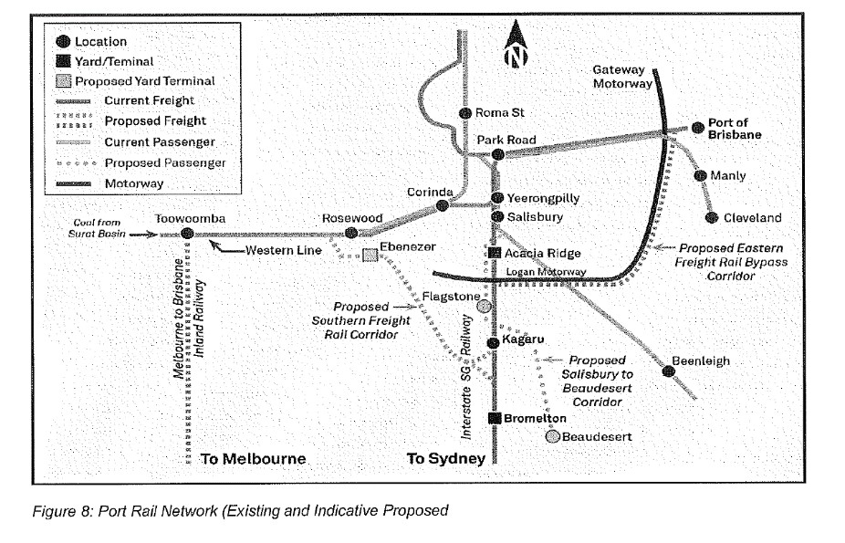
- The most cogent evidence for when the Queensland parts of the Inland Rail Project will be completed came from Mr Keyte, who estimated that it would take ten years from the date of trial i.e. the end of 2028.
- Now as a result of the Inland Rail Project having been approved, it is likely that new terminals will be constructed in South-East Queensland, which could potentially include a terminal constructed by the ARTC at Bromelton. But as I have indicated, there is no evidence that the locations, size, nature, proposed ownership or access regime, or any other relevant aspects of any such terminals have been confirmed. Further, and in any event, no such terminals are likely to be built within the short to medium term of three to five years.
- Now Mr Keyte did give evidence about various limitations on the ART itself, including road congestion and ultimately capacity limitations. And he did not expect the ART to have a life expectancy beyond 10 years from the date of trial. Further, he expected to see another terminal or terminals being developed during the construction phase of the Inland Rail Project, whether that be by the ARTC at Bromelton, Greenbank or Ebenezer.
- But in my view this evidence merely confirms that as at 28 July 2017 and now, the ART is the main terminal for relevant purposes and would likely remain so for at least the next three to five years.
- Mr Keyte also gave evidence that no alternative terminals at Bromelton, Ebenezer or Toowoomba were current alternatives as at the date of giving evidence. He stated:
HIS HONOUR: But to be clear, if I was defining the medium term as being three to five years - - -?---Yes.
- - - would any of those be alternatives to Acacia Ridge?---In three to five years?
Yes?---Toowoomba certainly not. Ebenezer highly unlikely. That’s just undeveloped land. Bromelton I – I don’t know what ARTC’s plans are. If they were able to accelerate inland rail in this part in Queensland – because Queensland is behind the other two states – then they may be an alternative in three to five years.
- This evidence about Bromelton being developed is speculative. Mr Keyte also gave evidence that a fair assumption would be that ARTC would not start construction on a terminal at Bromelton until the relevant part of the Inland Rail Project was assured to be completed. Mr Keyte gave evidence as follows:
HIS HONOUR: … I suppose my assumption was that ARTC wouldn’t develop any terminal at Bromelton until such time as the inland rail terminal had been completed. Is that a fair assumption or not?---Your Honour, I think – I think it’s fair, but I would use the term that inland rail was assured to be completed.
Yes?---I would – would assume that they – if they knew for sure that inland rail was under construction, then terminals would also be constructed to be open at the same time.
All right. I’m just trying to work out whether it’s a realistic possibility that somebody would look at the Acacia Ridge terminal to be used first before, say, another terminal had been developed at Bromelton, or to use whatever is coming through from the inland rail?---Yes, your Honour. So – so inland rail is – is gazetted to be completed at Acacia Ridge, which means that in our context Acacia Ridge is the rail terminal for inland rail.
Yes?---And we believe inland rail is some 10 years away, but we don’t think Acacia Ridge has a life expectancy beyond that 10 years. As I said, I think other terminals will evolve during the construction phases of inland rail.
- Further, there is no evidence that ARTC would or could accelerate the Inland Rail Project in Queensland from an estimated completion date in 2028 such that it would be willing to commercially take on the risk of incurring the significant cost of constructing a new terminal prior to completion of the project. And I say this even though I have before me a letter from the Honourable Michael McCormack MP, Deputy Prime Minister and Minister for Infrastructure and Transport at the time, and Senator the Honourable Mathias Cormann, Minister for Finance at the time, to the Chairman of ARTC dated 14 May 2018 which states:
[Redacted]
- In my view in light of the uncertainty about the alignment of aspects of the Inland Rail Project, it is unlikely that ARTC will seek to accelerate any terminal part of the Inland Rail Project or sink more money into developing the Bromelton site as a matter of urgency.
- [Redacted]
- In my view there is no real chance that a potential new entrant could obtain open and non-discriminatory access to such a terminal, or be in a competitive position by reason of having done so, in the short to medium term.

Summary
- In summary, I cannot be satisfied that any potential alternative terminals or sites to the ART would be or would be likely to be available for a potential new entrant to commence a sustainable business providing Rail Services in the relevant markets as at 28 July 2017 or at or from the first half of 2019, or would be or would be likely to be available in the short to medium term from those dates.
- First, there is no other terminal or combination of terminals that would both be available to a new entrant to use and that would offer comparable benefits to those of the ART.
- Second, it would not be realistically open to a new entrant rail provider seeking to operate Rail Services on interstate routes to adopt in the short to medium term the approach used by SCT and build its own facility or access a new as yet unconstructed terminal built by another entity.
- Third, as a result, a new entrant would be at a material competitive disadvantage if it sought to use another terminal or combination of terminals in order to supply such Rail Services in competition with PN and SCT in relation to interstate routes, or with PN and Linfox (with the assistance of Aurizon) within Queensland. And I agree with the ACCC that this position is not only consistent with the weight of the evidence adduced before me, but consistent with the view of the only potential new entrant any of the parties called to give evidence, Qube. Mr Nacey gave evidence that the ART is the only viable interstate intermodal terminal in Queensland due to the proximity of BFOs and freight forwarders and the dual gauge rail infrastructure, enabling transhipment for interstate and Queensland intrastate freight. I accept his evidence in this respect at least.
- Accordingly, absent open and non-discriminatory access to the ART, it is unlikely that any potential new operator would enter the relevant markets.

(b) The operation of the ART
- To this point I have been discussing alternatives to the ART. Let me now turn to the operation of the ART and discuss this in more detail than I have done so far.
- Mr Andrew Maszczak gave evidence concerning the operation of the ART in his role as Aurizon’s Queensland Intermodal Linehaul Manager. In that role, he has been responsible for the rail linehaul component of Aurizon’s QIB, as well as for the overall management of all rail operations at the ART. This includes:
  - preparing plans and policies governing rail operations at the ART, such as the BMUT protocols and track utilisation plans;
  - ensuring that all Aurizon employees, subcontractors, and other users of the ART comply with applicable safety and security protocols throughout the terminal, and responding to any incidents and breaches of protocol which may occur;
  - being responsible for the conduct of the rail component of the QIB, which involved, inter-alia, overseeing the shunting of Aurizon trains within the ART yards and terminals, ensuring that there were appropriately qualified locomotive drivers to move rolling stock around the ART, and liaising with other Aurizon terminals along the NCL to ensure the effectiveness of all Aurizon rail operations along that rail corridor;
  - having direct accountability for the conduct of Aurizon’s yard supervisors and terminal controllers;
  - coordinating between the rail and road components of the QIB; and
  - dealing with any issues which had been escalated to him by Aurizon’s onsite terminal managers, including safety, operational and personnel matters.
- Although Mr Maszczak was briefly cross-examined, most of his evidence was not challenged. And on the challenged aspects, I nevertheless found him to be a reliable witness. It is necessary to give an extensive description of his evidence concerning the ART and its operations to better appreciate my later discussion concerning the ACCC’s case concerning PN’s ability and incentive to discriminate against new entrants/users whether as the owner of the ART or under the TSS if Aurizon remains the owner or some other non-PN entity acquires the ART.

Layout of the ART
- The ART is located around 16 km south of Brisbane, in the suburb of Acacia Ridge.
- The ART sits on a single large block and is divided into two main sections: the narrow gauge terminal being the Queensland Terminal and the dual gauge BMUT.
- The Queensland Terminal connects to the narrow gauge rail network owned by QR within Queensland. That narrow gauge rail network is used to transport intermodal freight to and from destinations within Queensland.
- The BMUT connects to a standard gauge rail network which is used to transport intermodal freight between Queensland and other Australian states. Freight enters and departs Queensland via a single standard gauge track referred to as the “Interstate Main Line”, which runs between Brisbane and the Queensland / New South Wales border. QR owns the part of the Interstate Main Line which is north of the Queensland / New South Wales border, and leases the portion of it which runs directly south of the BMUT to the Queensland / New South Wales border to the ARTC. ARTC, in turn, controls the portion of standard gauge track south of Queensland, as well as most parts of the standard gauge rail network running south and west of the border into other capital cities.
- In addition to the two terminals, there are currently three freight customers who have private “sidings” or warehousing facilities which connect directly to the ART, but are not within the ART itself. These customers are BlueScope, Liberty (at the site labelled “Austube Mills”) and SCT. There are two additional sidings, labelled “One Steel” and “Spar Australia Ltd” respectively. However, these sidings are not currently in use. All three operational sidings are located east of the ART, behind the Queensland Terminal. Of these customers BlueScope, Liberty and Austube Mills each engage PN to transport bulk steel between Queensland and other states by rail linehaul, SCT is a multi-modal logistics company and Spar is a chain of retail convenience stores. Private sidings are connected to the ART through a series of dual gauge tracks owned by Aurizon and referred to as “Estoban Roads”.
- In addition to these Aurizon-owned Estoban Roads, customers generally own and operate a smaller portion of track, continuing on or branching off from the Estoban Roads and going directly into their private warehouses. These tracks are a combination of dual gauge, standard gauge and narrow gauge tracks. Some of the customer-owned tracks are named, for example, the “Palmers Loop”, whilst others are not.
- The Estoban Roads (dual gauge) link up to the other tracks at the Queensland Terminal (narrow gauge) and the BMUT (a combination of dual gauge and standard gauge), and allow locomotives to haul wagons directly from the arrival and departure roads and marshalling yards at either terminal into the customers’ private sidings, where customers load and unload their own wagons.

Interactions between operations at the Queensland Terminal and the BMUT
- Although the Queensland Terminal and the BMUT are located next to each other, there is a wire fence running along most of the adjoining perimeter, separating the two terminals. The only rail tracks which cross between the BMUT and the Queensland Terminal are:
  - Estoban Rd No. 1;
  - Estoban Rd No. 2, which splits further into Estoban Rd No. 3 and Estoban Rd No. 4 near the adjoining boundary of the BMUT and the Queensland Terminal; and
  - a narrow gauge shunting road.
- Generally, the only time operations at the BMUT will affect operations at the Queensland Terminal and vice versa is where:
  - a standard gauge train is shunted from the BMUT across to the private sidings on the narrow gauge side of the terminal, via the Estoban Roads discussed above; or
  - narrow gauge rolling stock is shunted between the BMUT and the Queensland Terminal, via a narrow gauge road.
- Rolling stock cannot travel from the Interstate Main Line into the steel customers’ sidings without going through the BMUT. However, the rolling stock can bypass the loading bay at the BMUT by travelling to the Estoban Roads using New Crane Rd No. 3 or the standard gauge marshalling yard.
- In all other cases, the operations at each terminal are conducted separately, by separate groups of staff, although all rail operations at both terminals are overseen by Mr Maszczak.
- Generally speaking, it is only rail operations staff employed by Aurizon and PN working on-site (e.g. shunt staff and train drivers) who can move freely between the Queensland Terminal and the BMUT either on foot or in a vehicle. All other staff and vehicles (including delivery trucks) travel between the Queensland Terminal and the BMUT by first going out of the relevant terminal on to Lysaght St (in the case of the Queensland Terminal) or Kerry Road (in the case of the BMUT), driving around the block using public streets, and then driving back in to the other terminal. The length of that trip, by car, is approximately 5 to 10 minutes, depending on traffic. Qube staff did not move between the Queensland Terminal and the BMUT, as they only operated at the BMUT.
- Both intrastate and interstate passenger services run along the boundary of the loading bay at the BMUT, along the Interstate Main Line. Standard gauge freight trains travelling between the BMUT (or north of the BMUT) and New South Wales join that line. Narrow gauge freight trains which travel north to Queensland destinations do not join that line. The Interstate Main Line does not otherwise interact with operations at the ART except for the level crossing or for shunting purposes.

Dual gauge functionality
- The ART is a dual gauge terminal, which means that it can accommodate both standard gauge and narrow gauge rolling stock.
- Generally speaking, what is colloquially referred to as a “train track” consists of two parallel pieces of steel track, supported by sleepers. The distance between the two pieces of parallel track determine whether it is considered a “standard gauge” track (1,435 mm) or a “narrow gauge” track (1,067 mm). Narrow gauge tracks are used throughout Queensland. Standard gauge tracks are used throughout most of the rest of Australia, including for rail travelling south of the BMUT down to New South Wales and Victoria. Rolling stock is designed specifically to operate on one of either a standard gauge or narrow gauge track, and cannot be used on the other type of track.
- Dual gauge tracks are effectively standard gauge tracks with a third steel track inserted between the two existing tracks, to make up a narrow gauge track nesting inside the standard gauge one. This is shown in Figure 1 below.
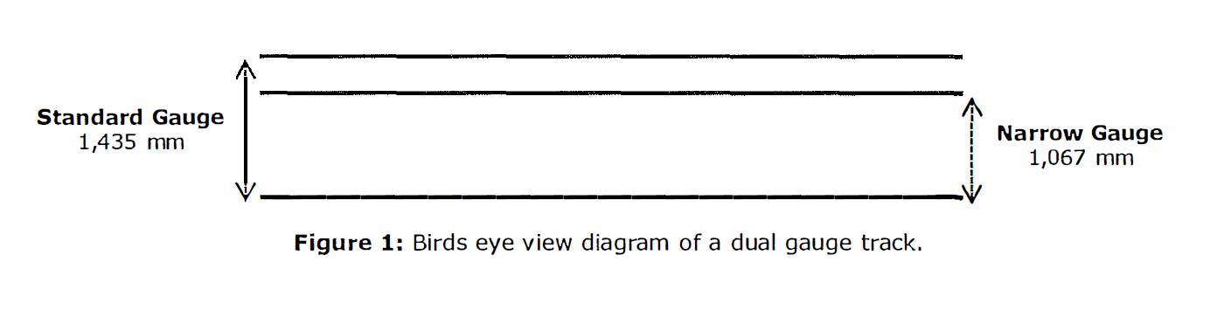
- Dual gauge tracks are:
  - two of the loading roads within the BMUT loading bay;
  - two of the holding roads at the BMUT;
  - all of the Estoban Roads; and
  - most of the maintenance roads in the north-east part of the BMUT.
- At the BMUT, dual gauge tracks have two main purposes.
- First, standard gauge tracks can accommodate heavier loads than narrow gauge tracks. This means that customers wishing to transport steel will predominantly import steel from the southern states to Queensland, using a standard gauge track. However, these customers also occasionally wish to transport freight between their private sidings and other parts of Queensland, which use narrow gauge tracks. The ART, therefore, must be able to provide both standard gauge and narrow gauge tracks directly from the terminal to the private sidings. It is more cost-effective to build a single dual gauge track than to build separate narrow and standard gauge tracks, because a dual gauge track allows you to build one length of “road” with three steel tracks rather than two separate “roads” with a total of four steel tracks.
- Second, whilst most freight does not need to be moved between standard and narrow gauge tracks, which is known as transhipment, dual gauge tracks can assist in transhipment where it is required. When Mr Maszczak started his role as Queensland Intermodal Linehaul Manager in October 2017, Aurizon was still operating a small number of interstate services to and from the BMUT. This continued until around December 2017. During this period, the existence of dual gauge tracks allowed him to take freight containers which arrived at the Queensland Terminal on narrow gauge rolling stock, shunt the rolling stock into the dual gauge loading bay at the BMUT, and then transfer the containers by forklift directly from the narrow gauge rolling stock onto standard gauge rolling stock, which would be waiting on a nearby track in the loading bay. The alternative to this process is to transfer the containers from the narrow gauge rolling stock on to trucks, and drive them from the Queensland Terminal to the BMUT. A single B-double truck can carry the same volume of freight as a single rail wagon; being approximately three TEUs.

The Queensland Terminal
- The Queensland Terminal is located at 69 Lysaght St, and is split into eight main parts:
  - the front gate, reception and administration building;
  - the cross dock facility (or consolidation warehouse);
  - the vehicle servicing area and wash bay;
  - the provisioning facility;
  - the storage area;
  - the narrow gauge marshalling yard;
  - the loading bay; and
  - the Queensland Main Line, which connects to the QR network and is used by trains to enter and leave the Queensland Terminal.
- Currently, the only party operating at the Queensland Terminal is Aurizon, which owns the terminal and performs all relevant services at the terminal. Aurizon also operated some road-only freight services from the QIB, which transported intermodal freight throughout South East and South West Queensland.
- Aurizon provided two main types of services as part of the QIB. First, there were “end to end” or “pick-up and delivery” services, which involves picking up freight from a customer's designated point of origin (e.g. a warehouse in Brisbane) and delivering it to a rail terminal by road, transporting that freight by rail linehaul between rail terminals along the NCL, and once the freight has arrived by train, trucking it to the customer’s final destination (e.g. a retail store in Cairns), previously defined as PUD services. Second, there were “terminal to terminal” services, which involves only the transportation of freight between two terminals via rail linehaul.

The BMUT
- The BMUT is located on Kerry Road, and is split into six main parts:
  - the front gate and administration building (including the “Cabin” described below);
  - the loading bay (occasionally marked on maps as the “container terminal”);
  - the standard gauge marshalling yard;
  - holding roads, on which unused rolling stock may be stored;
  - the provisioning facility;
  - a wagon and locomotive maintenance yard; and
  - the Interstate Main Line.
- The loading bay at the BMUT operates in a similar manner to the Queensland Terminal’s loading bay. It is a large flat concrete area (referred to as a “hard stand”) approximately 68,000 square metres in area, on which there are a small number of lighting towers. At any given time, there are also usually stacks of intermodal containers placed around the hard stand, in preparation for loading or storage. To the west of the hard stand is a loading road, called “A Track”. To the east of the hard stand are six shunting roads, two of which are used as part of the loading bay, and the remaining six of which comprise the holding roads.
- The names and specifications of the shunting roads are as follows.
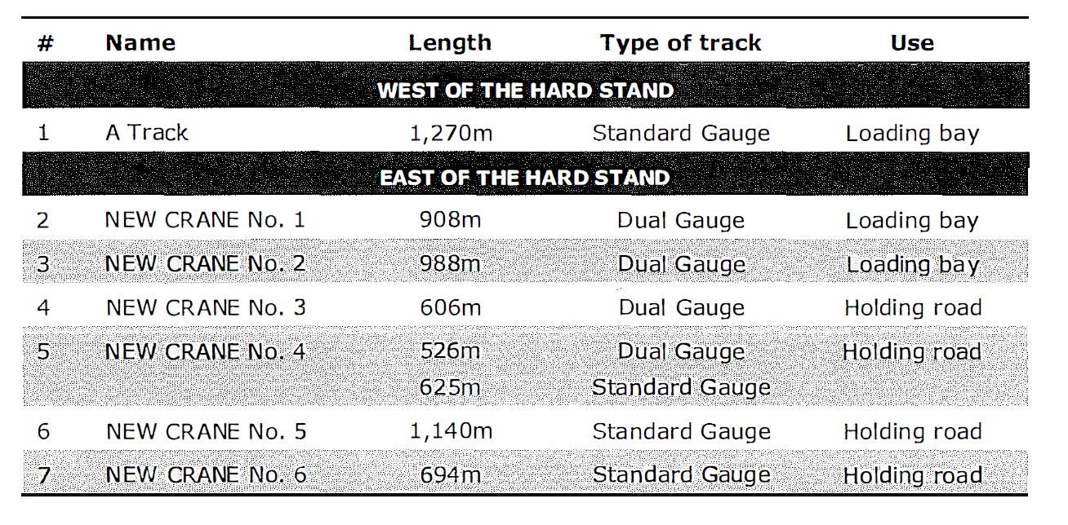
- The significance of the length of these shunting tracks is that they determine whether a train can be moved in a single piece, or if it must be split up and shunted across multiple tracks, such as what is done at the Queensland Terminal at Shed 1 and Shed 2. All trains will generally need to be split up and shunted unless they have been allocated to A Track. This makes A Track more advantageous than loading bays New Crane Rd No. 1 or New Crane Rd No. 2 in terms of how quickly a train can be moved in and out.
- Further, a train at New Crane Rd No. 2 is potentially further disadvantaged as a reach stacker is required to load and unload a parked train whereas on other tracks such as New Crane Rd No. 1 forklifts can also be used to load and unload trains.
- Finally on the shunting roads, Mr Maszczak said that a delay of a train on one of the new crane roads is not necessarily going to affect a train coming in and out of A Track.
- The BMUT does not have a cross dock facility or consolidation warehouse, as freight transported at the terminal is generally in full container loads. It also does not have a wash bay, as this process is completed off-site.

Relevant parties
- Prior to December 2018, the main parties involved in operations at the BMUT were:
  - Aurizon, the owner of the terminal, which is still the case;
  - PN, the rail operator which runs rail linehaul services to and from the terminal, which is still the case;
  - Qube, to whom Aurizon had subcontracted the performance of some terminal services (now replaced by PN under the TSS); and
  - QR and ARTC, the rail infrastructure owners / operators of the networks to which the BMUT is connected, which is still the case.
- The relationships between these parties have been governed by various contractual arrangements. In particular:
  - Aurizon, as terminal owner, has a contract with QR which allows the BMUT to connect to the ARTC network, via the QR network.
  - PN has an access agreement with ARTC under which it is allocated certain time slots, that is, “train paths” during which it can operate its services along tracks owned or operated by ARTC. These paths are set out in an ARTC “Master Train Plan” (MTP), which also records the train paths allocated to all other services operating on the ARTC network. MTPs are revised by ARTC around twice per year, and are what determines the scheduled arrival and departure times which need to be accommodated by Aurizon and PN at the BMUT. This is because trains travelling south of the BMUT must utilise the ARTC network to reach New South Wales, and so a train cannot enter or leave the BMUT without also having permission from ARTC to travel on that section of track. Aurizon had an equivalent arrangement with ARTC when it was operating the IIB.
  - PN and Aurizon operate under a Terminal Services Agreement (TSA), under which PN agrees to pay various fees to Aurizon for access to, and use of, the BMUT. In turn, Aurizon also has obligations under the TSA to provide various services to PN, all essentially directed at ensuring that PN is able to effectively operate its contracted rail operations out of the BMUT.
  - Up to December 2018 Aurizon and Qube operated under the Qube TSS, under which Aurizon had subcontracted to Qube the performance of some of the services. Qube has now been replaced by PN under the TSS.

Freight operations at the BMUT
- The process for transporting freight from the BMUT to and from other states in Australia is governed by the Brisbane Multi-User Terminal Protocols (the Terminal Protocols).
- The Terminal Protocols are contained in a document which is prepared by Aurizon, and users of the Terminal are required to comply with those protocols. For example, PN is required to comply with the Terminal Protocols developed by Aurizon under the TSA. Qube was also required to comply with the Terminal Protocols under its TSS with Aurizon.
- The key differences between freight operations at the BMUT and those at the Queensland Terminal are as follows:
  - no consolidation services are performed at the BMUT;
  - Qube, in accordance with its TSS was responsible for the loading and unloading of wagons at the loading bay and some associated services; and
  - PN, as the rail operator at the BMUT, is responsible for the shunting and provisioning of its own trains.
- Aurizon was also responsible for the shunting and provisioning of its own trains at the BMUT when it still operated interstate services.
- Although PN is responsible for provisioning its own locomotives, Aurizon is responsible under the TSA for making sure that the provisioning facility at the BMUT is stocked with the necessary materials. The fuel provided at the provisioning facility is supplied by BP under a contract with Aurizon, and the sand is likewise supplied by South Pacific Sand under a contract with Aurizon. Water at the facility is supplied through the usual utilities used in other parts of the terminal. PN provides its own oil for its locomotives when required.

Aurizon’s role at the BMUT
- The services and operations which are currently performed by Aurizon at the BMUT include:
  - determining which trains will be permitted to use the BMUT and providing access to the BMUT for users;
  - the allocation of arriving and departing trains to tracks within the BMUT, in accordance with the ARTC’s scheduled arrival and departure times and the terminal’s Track Utilisation Plans, which I will elaborate on in a moment;
  - the control of train and rolling stock movements into, around, and out of the BMUT;
  - the general coordination of movements and tasks at the BMUT, to ensure operations are running to plan and trains are, to the extent possible, “on path” (i.e. running in accordance with their scheduled train paths);
  - the development and implementation of various safety management systems, including isolation and lock out procedures;
  - the general maintenance of terminal facilities, including the performance of any serious maintenance work; and
  - the maintenance of security at the BMUT, including the maintenance of the security systems and boom gates, and engagement of relevant security staff.

Track Utilisation Plans
- In accordance with the Terminal Protocols, Aurizon is responsible for the preparation of a Track Utilisation Plan for the BMUT. The Track Utilisation Plan is a document which sets out when each track at the terminal will be utilised by which trains. This includes the allocation of trains to each of the three tracks within the loading bay.
- Typically, the Queensland Intermodal Linehaul Manager is the individual responsible for the creation of Track Utilisation Plans. Since December 2017, the BMUT has been operating without a formal Track Utilisation Plan, as the terminal only needs to accommodate a single rail operator – PN. Under the process until December 2018, PN, Aurizon and Qube simply operated according to PN’s scheduled arrival and departure times as set out in the ARTC MTP, and agreed on the allocation of trains to different tracks on a fairly informal basis.
- With respect to the BMUT, the Track Utilisation Plan was prepared by the Queensland Intermodal Linehaul Manager looking at the scheduled arrival and departure times which ARTC had allocated to each rail operator in its MTP, and then determining the most efficient way to accommodate all the tasks and movements within the terminal required to meet those fixed times. For example, when Aurizon was still operating its interstate intermodal business, this meant accommodating the arrival and departure times for both PN and Aurizon services.
- Because train services operate on the same schedule each week, Aurizon only needed to create one plan for each of Monday through to Sunday. As a general matter, the Track Utilisation Plan would be prepared each time there was a new MTP, and would then not change again unless and until it was triggered by changes to the scheduled arrival and departure times for relevant train services. These changes may be triggered by ARTC issuing a new MTP (around twice per year), by general issues such as daylight savings (which results in a mismatch between timing in Queensland vis-à-vis the southern states), or ad hoc requirements on the part of the rail operator. The Track Utilisation Plan may also be changed if it becomes apparent to the owner of the terminal (who is responsible for the Track Utilisation Plan) that things may be done more efficiently.
- Each time Mr Maszczak made ad hoc changes to the Track Utilisation Plan in the period between October and December 2017, he circulated it to the relevant personnel at Aurizon, PN and Qube for their agreement. That was because the plan required the cooperation of all three parties to be achieved. However, if there were differing views about the plan, Mr Maszczak considered that he, as the decision-maker on behalf of Aurizon, had the final decision-making authority. That is because Aurizon is the owner of the facility, and PN is the user of the facility. Moreover, at the time Qube was a subcontractor of Aurizon in providing those services to PN. Apparently, this was also the process undertaken by previous Queensland Intermodal Linehaul Managers when a new Track Utilisation Plan was created. Mr Maszczak did not recall any significant disputes arising in relation to any of the “ad hoc” changes to the Track Utilisation Plan prepared by him.
- Further, at the beginning of each day, there was a daily operations meeting, where representatives from Qube, PN and Aurizon met to discuss any variations that needed to be made to the Track Utilisation Plan, or any circumstances which might make it difficult to achieve the plan. This meeting generally took place between around 8.30 am and 9.00 am each day.
- Situations which might give rise to a change in the plan included:
  - a planned activity e.g. planned track maintenance by Aurizon on one or more tracks;
  - expected delayed arrivals of trains from the ARTC network, usually notified to Aurizon by ARTC;
  - rolling stock failure e.g. a locomotive or wagon being broken;
  - infrastructure failure e.g. a broken part of track or a signal fault;
  - a rail safety incident e.g. derailments or breaches of Aurizon’s safety protocols; or
  - issues associated with Qube’s then ability to perform the required services on the day (e.g. broken forklifts or staffing shortages).
- A second operational meeting was then held later in the day to discuss the day’s progress and any further changes which might need to be made to the plan. This meeting generally took place between around 2.00 pm and 4.00 pm each day, and is attended by the same individuals as the morning meeting.
- If, for whatever reason, Qube (prior to December 2018) wanted certain rolling stock to be moved during the day outside of the pre-agreed plan, it would need to first obtain approval from the Aurizon Yard Supervisor. If that permission was granted, Qube would then need to also obtain PN’s agreement and assistance to physically move the rolling stock to its new location, as Qube did not perform any rail operations itself.
- Under cross-examination, Mr Maszczak gave evidence that if Qube raised an issue at a daily operational meeting about its ability to perform services and wanted to change the track allocation in a day, “then no doubt there would be a reason given why they would like to do that”.
- Further, there are usually many movements of trains and train components around the BMUT in any one day. These movements are also often very closely interlinked, in that, for example, the ability of one train to be loaded on time will frequently depend on a previous train also operating to schedule so that it frees up space on the right track at the right time. For this reason, it was crucial to the overall functioning of the BMUT that all relevant parties (i.e. Aurizon, PN and then Qube) operated in accordance with the Track Utilisation Plan, and that permission was sought from Aurizon for any proposed departures from the agreed plan. This was particularly the case during the period when multiple rail operators (i.e. both PN and Aurizon) were running interstate services from the BMUT.

Safety management systems
- Aurizon is the accredited Rail Infrastructure Manager (RIM) for the sections of track and rail infrastructure which are within the boundaries of the ART. On either side of the boundary, QR is the RIM in respect of the Queensland network. The ARTC is the RIM in respect of the interstate network south of Queensland.
- Under applicable safety laws, all railway infrastructure must have an accredited RIM. The RIM is the person or company responsible for the overall control of the rail infrastructure, and for meeting various requirements under the safety legislation.
- As the RIM for the ART, Aurizon is responsible for developing and maintaining various safety protocols in respect of its “below rail” operations. In relation to the ART, Mr Maszczak’s primary focus was to ensure that the ART’s safety systems effectively interface with ARTC’s and QR’s safety systems, so that the various train networks could operate together in a safe and functional manner.
- The safety protocols at the BMUT are mainly concerned with the movement of equipment into and around the terminal, and include:
  - the requirement to only move or shunt a train with the permission of either the Yard Supervisor or the Terminal Controller, depending on where the shunt movement is occurring within the yard; and
  - isolation and lock out procedures, in which any sources of energy are physically isolated to avoid the potential for accidents or damage.
- In the case of rolling stock, isolation and lock out is performed by a PN or Aurizon employee physically placing locks at certain points on a track, so that the rolling stock cannot move beyond a certain point in the case of an accidental roll or slip. The key to the lock is then taken to the “Cabin” by an Aurizon employee, and the lock cannot be removed without the permission of the Yard Supervisor. An individual needs to conduct specific training before being able to apply lock outs under Aurizon’s safety protocols.
- PN, as the rail operator, is responsible for the safety and reliability of its rolling stock i.e. the locomotives and wagons. For example, under the TSA, PN is required to maintain its rail safety accreditation in order to continue using the ART. As part of this accreditation, PN must ensure that its rolling stock is fit to travel prior to any use including by having the safety of the wagon and locomotive(s) verified by an appropriately qualified PN employee.
- Aurizon has similar obligations under its current access agreement with QR in relation to its use of the QR network, and used to have similar obligations under its former access agreement with ARTC during the period in which Aurizon operated interstate services. PN also has similar obligations under its current access agreements with QR and ARTC in addition to its obligations under the TSA.
- To facilitate a rail operator’s compliance with its safety obligations, the Terminal Protocols provide for the conduct of train examinations by the rail operator on arrival to, and prior to departure from, the BMUT. A train examination involves a qualified rail operator employee walking around the length of a consist and visually and physically inspecting the rolling stock for any safety or reliability issues. Neither Aurizon or Qube (prior to December 2018) had any role in that safety inspection.
- Under the KPIs agreed between Aurizon and Qube, Qube was required to handover a train to PN for examination within a pre-agreed timeframe prior to its scheduled departure. This timeframe is typically 60 minutes prior to the train’s departure time. Qube’s then rate of “on time” handover (i.e. handover within the pre-agreed timeframe) was recorded in its monthly KPI reports. Once a train had been handed over, Qube ceased to have any involvement in the operations of that train.

The Yard Supervisor and Terminal Controller
- As discussed above, the movement of all trains into, around, and out of the BMUT is carried out in accordance with a Track Utilisation Plan, prepared by Aurizon. This is part of the safety responsibilities that Aurizon has as the RIM for the ART, as well as its role as the owner of the terminal more generally. The requirement for users and other operators at the BMUT to comply with Aurizon’s directions in relation to the movement of rolling stock is set out in the Terminal Protocols which are, in turn, made binding upon PN and Qube (prior to December 2018) by the TSA and TSS respectively.
- At the BMUT, the control of rolling stock movements into, around and out of the terminal is performed by two separate Aurizon employees, acting in the roles of Yard Supervisor and Terminal Controller respectively. The individuals performing these roles change day-to-day, on a rostered basis. Both roles require specific safety accreditations, which typically take between six to nine months to complete. The Yard Supervisor and Terminal Controller are also sometimes referred to interchangeably (particularly by non-Aurizon staff) as the “Yard Controller”.
- Both the Yard Supervisor and Terminal Controller are located in the “Cabin”, which is a room in the administration building which overlooks the BMUT and provides both individuals with direct line of sight of the terminal.
- In short, the Yard Supervisor is responsible for the movement of rolling stock within the standard gauge marshalling yard where there are no electronic signals, and the Terminal Controller is responsible for the movement of rolling stock in all other parts of the BMUT where there are electronic signals. Therefore, there can be no movement of rolling stock within the BMUT without the approval of one or both of the Yard Supervisor and the Terminal Controller.
- More specifically, the practice at the BMUT is that the Yard Supervisor’s responsibilities include:
  - meeting with representatives of Qube (prior to December 2018) and PN twice each day to discuss the Track Utilisation Plan;
  - confirming and granting permission to execute each scheduled movement of rolling stock;
  - generally staying in constant contact with PN and Qube personnel (prior to December 2018) throughout the day, to monitor progress and ensure the BMUT is functioning effectively;
  - approving any unscheduled movements of rolling stock or ad hoc changes to the Track Utilisation Plan outside of the two daily meetings; and
  - preparing the daily Aurizon Morning Report.
- At various points throughout train networks, there are electronic signals which direct trains to stop or go at those particular locations on the track. These signals are generally located at the start and end of a terminal (i.e. where trains arrive at, or exit, the terminal) and wherever there is an intersection between multiple tracks. The purpose of these signals is to divide train tracks into a number of separate sections, so as to ensure the safe and organised movement of trains between those sections.
- The practice at the BMUT which is in place is that the Terminal Controller is responsible for controlling the electronic signals which are within the boundaries of the BMUT. These include signals which allow trains to move in and out of the BMUT, around the loading bay, and in and out of the standard gauge marshalling yard.
- More specifically, the Terminal Controller’s responsibilities include:
  - setting the electronic signals which allow trains to enter and depart the BMUT in conjunction with the ARTC;
  - “setting roads” to allow rolling stock to be moved around sections of track where such signals are in operation (i.e. everywhere in the BMUT except the standard gauge marshalling yard), which includes both identifying the specific route by which rolling stock is to move from one section of track to another and setting the correct electronic signals required to facilitate that movement;
  - liaising with QR and ARTC to monitor the progress of all trains entering, leaving, or approaching the BMUT;
  - informing ARTC of any expected late departures from the BMUT into the ARTC network; and
  - liaising with the Yard Supervisor in relation to the movement of trains in and out of the standard gauge marshalling yard.
- Before each southbound train leaves the BMUT to enter the ARTC network, the relevant rail operator (i.e. PN) will ask the Terminal Controller to set the necessary signals, and the Terminal Controller will in turn contact ARTC to inform them of the train’s expected departure and confirm that the train has a clear path ahead. For a train to actually leave the BMUT, both the Aurizon Terminal Controller and the equivalent individual at ARTC must set their respective signals to give the train permission to go. If a train is delayed leaving the BMUT, Aurizon informs ARTC of this fact, and tells ARTC the reason for the delay. This liaising between Aurizon and ARTC is a crucial element of operations at the BMUT, as the interconnected nature of train paths means that one delayed train may have knock on effects impacting other trains throughout the ARTC network.

Qube’s role at the BMUT (pre December 2018)
- Under its TSS, Qube was required to perform various terminal services associated with the loading and unloading of wagons at the BMUT loading bay. Mr Maszczak explained them in the following terms.
- In general terms, the services performed by Qube at the BMUT under its TSS comprised the following.
- First, there was the service of checking that the consist list applies to an arriving train. This involves checking the intermodal containers which arrive on each service against a list prepared by the relevant rail operator (i.e. PN) to make sure that they are consistent and informing the rail operator of any inconsistencies so that the operator can decide what action, if any, is to be taken.
- Second, there was the service of loading and unloading freight for arriving and departing trains. This involves the physical movement of freight containers from storage spaces onto wagons, or from wagons to storage spaces, in accordance with a load plan prepared by the rail operator (i.e. PN), using heavy forklifts. Mr Maszczak gave evidence that it was within Qube’s discretion how it allocated its equipment (including forklifts and reach stackers) and to make decisions about what equipment was operational, serviceable or what needed repairs.
- Third, there was the service of reporting damaged containers to the rail operator. This involved sending an email or making a phone call to the rail operator (i.e. PN), informing them of any damaged containers be they damaged en route or during the loading and unloading process, but did not grant Qube authority to make any decisions about whether a container or any other part of rolling stock was safe to operate.
- Fourth, there was the service of arranging for the storage of containers in accordance with Aurizon’s directions. This usually involved a rail operator (e.g. PN) emailing Qube to request that a container be stored and, if the container complied with Aurizon’s standard storage requirements, Qube arranging for that storage in accordance with the BMUT Terminal Protocol. If the container did not comply with Aurizon’s standard storage requirements, Qube had to ask Aurizon for directions as to whether the container may be stored and, if so, how. The Aurizon individual responsible for approving non-standard container storage requests was the Regional Operations Lead for the ART.
- Because Qube’s responsibilities were in respect of the loading and unloading of containers, it was not involved in the management of trains transporting bulk steel, which was not containerised.
- Mr Maszczak also gave evidence on the following topics:
  - the allocation of arriving and departing trains to tracks within the BMUT;
  - the maintenance of its equipment and surrounding work area; and
  - the general safety and security of the terminal.

Allocation of arriving and departing trains to tracks within the BMUT
- It is Aurizon’s responsibility under the Terminal Protocols to create the Track Utilisation Plan which allocates arriving and departing trains to tracks within the BMUT, and to manage any changes to, or deviations from, that plan.
- As part of the process of creating a new Track Utilisation Plan, or agreeing ad hoc changes to an existing plan, Aurizon would seek Qube’s views about what should be contained in the plan. This may have involved, for example, asking Qube to nominate potential track allocations which it considered to be most efficient. The main purpose of this consultation was to ensure that Qube was physically capable of meeting the loading and unloading requirements of whatever Track Utilisation Plan was ultimately agreed between the parties.
- Further, the Terminal Protocols expressly provided that the Terminal Manager (i.e. Aurizon) was also to consult with the Rail Operator (i.e. PN) about any potential amendments to the Track Utilisation Plan. The Queensland Intermodal Linehaul Manager consulted PN about any potential changes to the Track Utilisation Plan before making them. As I have said, since Aurizon ceased operating its interstate services in December 2017, the process of track allocation has been conducted through conversations between PN, Aurizon and Qube (prior to December 2018) on a fairly informal basis.
- Mr Maszczak did not consider it accurate, as a matter of practice, to describe Qube as the party responsible for the allocation of arriving and departing trains to tracks within the BMUT. Rather, he considered that responsibility to be Aurizon’s, executed following consultation with both Qube and PN.

Maintenance of equipment and surrounding area
- As a matter of practice, the maintenance for which Qube was responsible at the BMUT was the maintenance of its own heavy lift equipment (i.e. forklifts) and of the facilities around the loading bay (i.e. the relevant section of concrete at the BMUT and the lighting towers in that section). As owner of the BMUT, Aurizon also had the right to also conduct its own maintenance of facilities at the loading bay, as required.
- In Mr Maszczak’s time as Queensland Intermodal Linehaul Manager, Qube had not performed any maintenance works on the tracks within the BMUT, or which would require the closure of any one or part of those tracks. That maintenance requires additional safety accreditation and is reserved to the terminal RIM. Decisions about track maintenance are Aurizon’s, as the terminal owner, alone.
- Further, as discussed above, PN is responsible for the safety and maintenance of its own rolling stock, and Qube played no role in determining whether that rolling stock was fit for travel.

General safety and security of the BMUT
- In relation to the general safety and security of the terminal, Qube was responsible for complying with the security and safety requirements set by Aurizon in the course of its own operations, for example, ensuring that its forklift drivers were inducted to Aurizon’s requirements. Other than any internal Qube policies which may have existed, Qube was not responsible for safety and security at the BMUT generally. Rather, Aurizon has that responsibility in relation to the overall safety of the terminal.
- Qube personnel also occasionally man the front boom gates at the BMUT. This is essentially a similar role to that of a parking attendant at a public car park, and is performed in accordance with security protocols set by Aurizon.

Trucks
- Further, Mr Maszczak accepted that Qube employees could assist truck containers when entering the BMUT to become compliant with the details in their system or could turn trucks away and that this decision was within Qube’s discretion as it was part of the arrangement between PN and Qube in terms of customers coming in and out of the BMUT. Mr Maszczak further accepted that if a truck was turned away or took time to become compliant this would not become part of the truck turn-around time calculation.

Performance reports
- Both Aurizon and Qube prepared a number of reports which tracked performance at the BMUT across different metrics, and over different periods.
- Under its TSS, Qube was required to provide Aurizon with a monthly report, showing its performance against agreed key performance indicators. These reports showed:
  - the number of lost time injuries and medically treated injuries which have occurred each month;
  - the volume of freight moved by Qube for each rail operator, measured by TEU and number of containers;
  - truck turnaround and container transaction times;
  - the rate of on time train handovers for each rail operator referred to above; and
  - the percentage of on time train arrivals for each rail operator.
- In addition to the monthly KPI reports, Qube was also required to provide Aurizon with daily storage reports, identifying all containers which had been stored at the BMUT.
- Further, Aurizon’s Yard Supervisor was responsible for preparing a daily report for the BMUT, identifying various matters, including:
  - all scheduled and actual train arrival and departure times, and the reasons for any delay;
  - the number of Qube forklifts on duty;
  - which locomotives have used the provisioning facility;
  - all lock outs conducted in accordance with Aurizon’s isolation and lock out procedures;
  - what has been stored across various parts of the BMUT; and
  - safety incidents or occurrences.
- These reports were called “morning reports”, as they were prepared by the Yard Supervisor at the beginning of each day, in relation to the previous 24 hour period. They were circulated daily to Aurizon management and finance staff, and were one of the resources Mr Maszczak used to adjudicate any complaints which had been made to him by PN or Qube in respect of the other’s performance.

Monthly review meetings
- Aurizon conducted two sets of regular monthly meetings, to review the performance of all operations at the BMUT and allow any issues to be raised.
- First, Mr Maszczak scheduled monthly meetings with Mr Noel Lupton, the Terminal Manager for Qube, to discuss Qube’s performance of its subcontracted services. This is the forum in which he would review Qube’s monthly KPI report and raise any concerns or queries he had in relation to Qube’s performance.
- Second, Aurizon also held monthly joint operations and safety meetings, where representatives of Aurizon, PN and Qube got together to discuss the overall operation of the BMUT and any safety issues which may have arisen. At these forums, PN was given an opportunity to raise any issues it may have had with Qube directly with Qube. Generally, these meetings were attended by the relevant shift supervisors for each business, being PN’s shift manager, Aurizon’s Regional Operations Lead, and Qube’s shift supervisor. If the senior managers (i.e. Mr Ian Boswell, Mr Lupton or Mr Maszczak) were in town at the time, they would also generally attend.

Transhipment of freight at the ART
- There are two main methods of transhipping freight between the Queensland Terminal and the BMUT: by rail, and by road.
- PN is currently the only rail operator at the BMUT. PN does not transport any freight into the narrow gauge Queensland Terminal. PN’s intrastate freight is railed to its Tennyson terminal, and then transported from Tennyson to the standard gauge tracks at the BMUT via road.
- Generally speaking, the following processes are involved in transhipping freight by rail from the Queensland Terminal to the BMUT:
  - identification of those narrow gauge wagons with freight which is to be transhipped to the standard gauge;
  - shunting of the narrow gauge wagons into the dual gauge transfer area being New Crane Rd No. 1 or New Crane Rd No. 2;
  - securing of the narrow gauge wagons in that dual gauge transfer area;
  - unloading of the freight from the shunted wagons;
  - placement of the freight on a pad area;
  - shunting of the empty narrow gauge wagons to a holding road;
  - shunting of standard gauge wagons into the dual gauge transfer area;
  - lifting of freight from the pad area onto the standard gauge wagons;
  - where the standard gauge wagons do not already form a full consist attached to a locomotive, either:
    - shunting of the standard gauge wagons onto a standard gauge consist ready to run as a service; or
    - shunting of the standard gauge wagons into the standard gauge yard until a service that is ready to run is marshalled.
- Within Aurizon, the processes described above are referred to as “putting freight to ground”. Each of the shunting movements described above must be authorised by the Aurizon Terminal Controller.
- An alternative process of transhipment by rail involves transhipping freight “wagon-to-wagon”. This process is essentially the same as putting freight to ground, except that the narrow gauge wagons are shunted onto the same dual gauge loading road as those standard gauge wagons onto which the freight will be placed. This allows the freight to be lifted off the narrow gauge wagons and directly placed onto the standard gauge wagons.
- Where freight is arriving from the south into the BMUT and is required to be transhipped by rail to the Queensland Terminal, the reverse of the process described above is followed.
- Transhipping freight by rail also involves, inter-alia:
  - preparing shunting and marshalling plans for incoming services, including planning to shunt and marshal together wagons for transhipping that are positioned at different intervals along the train;
  - arranging access to timetable windows to place narrow gauge wagons on the dual gauge tracks for transhipping. This is critical as dual gauge tracks are also used by other inbound and outbound services;
  - making necessary resources available, including a locomotive for the appropriate gauge, locomotive driver (often called “shunters”) and ground support in the transfer window;
  - sequencing conflicting rail movements to ensure they do not block the route from the narrow gauge to the dual gauge track, which is also used by other inbound and outbound narrow gauge services; and
  - various other planning to align timing for window allocation, train arrival, shunting and marshalling, and other steps to ensure that the activities can be completed to allow scheduled departure of the receiving service.
- Freight is also transhipped by road from the Queensland Terminal to the BMUT by trucks which travel from the Queensland Terminal in Lysaght Street via Bradman Street, Beenleigh Road, Boundary Road and Beaudesert Road, before turning into Kerry Road and arriving at the BMUT. This process involves freight being unloaded from a train at the Queensland Terminal before it is placed onto a truck. The forklift which removes the container from the wagon may place the container directly onto a waiting truck. Otherwise, the container is placed on a pad area before being placed onto a truck. On arrival at the BMUT, the freight is unloaded prior to being placed onto a train at the BMUT. This may involve the container being placed straight onto a wagon or onto a pad area before it is then placed onto a wagon.
- Where freight is arriving from the south into the BMUT and is required to be transhipped by road to the Queensland Terminal, the inverse of the process described above is followed.

Summary
- I have set out the operations of the ART in some detail and particularly the inter-play between Aurizon (as the owner of the ART) and Qube prior to December 2018 under the Qube TSS.
- I have done so because it is important to consider Aurizon’s role under the scenario where the ART acquisition does not proceed but the TSS is left in place with PN.
- The significance of Mr Maszczak’s evidence is that it demonstrates that with Aurizon remaining as the owner of the ART, neither Qube (before December 2018) nor PN now under their respective TSSs had or have any significant ability to discriminate or a real chance to discriminate in any meaningful anti-competitive sense. As the owner, Aurizon could readily discipline Qube’s behaviour under the Qube TSS before December 2018. It has the same power to discipline PN’s behaviour under its TSS. That conclusion also applies to any other owner who is a non Aurizon entity. Now I have at this point only focused on the question of ability to discriminate. I, of course, accept that the analysis concerning any incentive to discriminate is different and that PN now may have different incentives from Qube’s prior incentives under the Qube TSS.
- Let me now turn to the question more generally of the ability and incentive to discriminate. But before doing so it is convenient at this point to say something briefly about the reliability of the lay evidence.

LAY WITNESSES – RELIABILITY
- Now as to the lay witness evidence called by the parties, apart from the attack by the respondents on the reliability of the ACCC’s Qube witnesses, the case does not substantially turn on questions of credit. I have dealt with the parties’ criticisms concerning expert witnesses under particular subject categories in other parts of my reasons.

(a) ACCC’s lay witnesses

Mr Maurice James
- Mr James was the Managing Director of Qube. PN submitted that Mr James was not an impressive witness and that he prioritised Qube’s commercial objectives in the litigation over giving frank evidence.
- Now I agree with PN that Mr James’ evidence displayed a strategic emphasis consistent with Qube’s commercial objectives in the outcome of this litigation, but PN’s criticisms go beyond what is justified. Let me focus in on several issues.
- In his third affidavit on 13 November 2018 Mr James said that, despite the sale of the QIB to Linfox, Qube remained interested in acquiring the ART. Now by that time, the ACCC had produced to the parties on 2 November 2018 certain documents including a 25 September 2017 letter from Gilbert + Tobin, solicitors for Qube, to the ACCC in which they recorded Qube’s position that it “ha[d] no interest in acquiring Acacia Ridge as a standalone asset in circumstances where the rest of the proposed transaction proceeds”. PN says that Mr James did not advert to, or try to explain, in his third affidavit why Qube would be interested in the ART as a standalone asset when it had told the ACCC in September 2017 that it was not so interested. But for the reasons that I have explained later, on balance I think that these differences are reconcilable.
- Further, PN points out that in his oral evidence on 27 November 2018, Mr James volunteered an explanation suggesting that in September 2017, Qube was unaware of the PN TSA which committed PN to use the ART for a term of five years, and that the new knowledge of that contract explained Qube’s change of position: “we, at that time, believed there was a serious risk that if PN – that without a TSA agreement – and we had no knowledge of the TSA – that at that point in time there was a serious risk that there was no certainty that PN’s volumes would continue through the Acacia Ridge terminal”. I agree with PN that this particular explanation was suspect. Mr James accepted that, even if the TSA had not been executed, and Qube were to have acquired the ART, PN would have been practically compelled to enter into a TSA with Qube at least for the foreseeable period of five years, being the same as the term of the TSA. As PN points out, Mr James contradicted himself on this point, simultaneously accepting that the knowledge of the TSA made no practical difference to Qube’s real commercial assessment of the desirability of the ART, whilst denying that the TSA made no difference. Further, Mr James volunteered this explanation in a manner that was not responsive to any question, but rather anticipated a line of cross-examination about Qube’s change in position.
- In my view his particular explanation based on the PN TSA is not reliable. In September 2017, Qube was not concerned about a risk that PN might not use the ART for the foreseeable future of at least 5 years. Whatever its position about the ART was, that position had little to do with whether PN would remain a user of the ART, because that was assured. Moreover, his explanation does not appear in terms in his third affidavit, or indeed in any of his affidavits, all of which were sworn after Qube learned of the TSA in March 2018. And as I have said, the matter does not appear in the 25 September 2017 letter from Qube’s solicitors to the ACCC. Moreover, in relation to the matter not appearing in his affidavits, Mr James hardly gave convincing evidence.
- I have treated Mr James’ evidence on this aspect with some caution.
- More generally, Mr James’ state of mind has been deployed by the ACCC as the corporate mind of Qube to indicate Qube’s perceptions concerning conditions of competition, structure or actual or potential behaviour in relevant markets. But some of those perceptions appear to have been exaggerated. They were partly formed in consultation with Qube’s solicitors and in some respects for an apparent purpose consistent with defeating the various transactions the subject of this proceeding. Moreover, some of the opinions expressed by Mr James in his evidence were inconsistent with contemporaneous views expressed by Qube to the ACCC. They appear to have been opportunistically expressed from time to time to advance Qube’s commercial strategy, although I do accept of course that opinions can change given new information or changes in market structure or flowing from market dynamics.

Mr Ross Nacey
- Mr Nacey was the General Manager Commercial at Qube. PN submitted that Mr Nacey approached his evidence as an advocate for Qube and at times did not give frank and responsive answers to questions.
- PN described Mr Nacey as a “talking head” for Qube’s partisan interests in the litigation. It said that he repeatedly made and referred back to “points” he had advanced in his evidence. It is said that he gave long speeches to me on matters that he appeared to believe would serve Qube’s purposes. And it is said that he reacted with irritation to being shown the 13 July 2018 version of the proposed s 87B undertaking in cross examination: “I don’t know the history of how this came about, but this is an example of something that has happened as a result of my affidavits. So this is my third one, and it appears that every time I’ve raised an example, and this is a prime case of that, I say, ‘For example, you can do this or that’, another undertaking comes out and … tries to resolve that issue. I think it’s important to know that I’m just using examples. I’m not – you know, I … could go on a fair bit more than I have giving examples of that”. But as PN points out, Mr Nacey’s earliest affidavit in the proceeding, affirmed in August 2018, post-dated the July 2018 undertaking. He had simply been provided with and commented upon the June 2018 undertaking. PN says that such evidence reveals Mr Nacey’s view of the argumentative process in which he believed he was engaged. I am inclined to agree.
- Further, PN says that view was further exposed in Mr Nacey’s oral evidence. It is said that Mr Nacey was prepared to offer to me evidence on matters he knew little about, based on mere speculation and guesswork, if he considered that it would advance Qube’s cause. It is said that he would not even concede that his evidence was guesswork, insisting that it was “an approximation”.
- PN says that I should give little weight to Mr Nacey’s evidence, save where it is contrary to the commercial objectives of Qube. But I think that PN is stating the matter too highly. Having said that, I did not think that Mr Nacey’s evidence concerning the effect of the TSS and other matters was particularly compelling, and I will address this further as the occasion arises.

Other witnesses
- PN has made other criticisms of the ACCC’s lay witnesses, for example Mr Sarant and Mr Jeffrey Moore, but I do not think these criticisms amount to much. Mr Moore was the National Manager Processing and Logistics of BlueScope. He was honest and reliable. I also do not otherwise consider it useful to comment on the customer or other lay market witnesses. I have no reason to doubt the sincerity of any of their evidence.

(b) PN’s lay witnesses

Mr Andrew Adam
- Mr Adam was the President, Freight for PN. In my view he was a conservative witness who answered questions directly, succinctly, without evasion and who made reasonable concessions. He had prepared three affidavits which dealt with various issues in the proceeding, much of which evidence was left unchallenged in his cross-examination.

Mr Graham Moore
- Mr Graham Moore was the Head of Planning Freight for PN. He was a frank witness. Now the ACCC submits that Mr Moore’s evidence on terminal operations both at the ART and more broadly should be disregarded because he did not have any recent experience in managing operational matters as distinct from planning matters. But in my view the supposed distinction between planning and operational functions is not of the significance that the ACCC would give it, and I reject both the ACCC’s invitation and its attack. It is unlikely that an individual responsible for planning operations could fail to understand the operations they were planning. A planner must understand operations at both macro and micro levels making their perspective of greater, not lesser, weight. Moreover, in any event Mr Moore had experience in operational matters.
- Mr Moore was responsible for planning and coordinating all of PN’s intermodal interstate services and terminals nationwide and accountable for planning and logistical activities relating to PN’s steel, interstate and intrastate intermodal, and bulk products businesses. In this role, Mr Moore was responsible for managing the “Interstate and Steel live run and short-term Planning” team, which comprised the “Short Term Planning” and “Live Run” sub-groups. Mr Moore’s role in managing the Live Run sub-group gave him direct experience in managing terminal operations, including managing PN’s responses to any changes in external conditions. As its name suggests, the Live Run sub-group was tasked with responding in real time to any logistical issues that arose whilst a train was journeying between its origin and destination terminals. This included interacting with ARTC to seek ad hoc train paths and with terminal operators regarding variations to arrival and departure times due to unforeseen events or contingencies.
- Further, Mr Moore confirmed in cross-examination that he had daily contact with terminals and interacted with terminal personnel regarding PN’s train plans and operating protocols, he attended on the ART terminal precinct, witnessed first-hand the tasks undertaken by Aurizon, Qube and PN, and was involved in PN’s interactions with the road controllers and yard controllers at the ART, and he had direct experience in operating a terminal himself.

(c) Aurizon’s lay witnesses
- Aurizon called three lay witnesses.

Mr Andrew Jakab
- Mr Jakab was the Vice President – Intermodal of Aurizon. He was mostly reliable, but not completely.

Mr George Lippiatt
- Mr Lippiatt was the Head of Strategy and Corporate Development of Aurizon. He was frank, well prepared and reliable. I need say nothing further at the present point.

Mr Andrew Maszczak
- Mr Maszczak was the Queensland Intermodal Linehaul Manager for Aurizon. I have set out significant aspects of his evidence earlier and have no reason to doubt its reliability.

DISCRIMINATION – ABILITY AND INCENTIVE
- Let me set out the context for discussing the question of PN’s future ability and incentive to discriminate against new entrants, which is relevant to barriers to entry and the prospect of new entry which I will discuss later.
- The ACCC submits that in the future with the ART acquisition, PN would have complete control of the BMUT and a commercial incentive to deter others from entering the Interstate market(s) to supply Rail Services, by refusing a potential new entrant access to the BMUT, or offering them terms of use or otherwise providing terminal services in such a way that would place them at a competitive disadvantage to PN’s own business supplying Rail Services. Alternatively, the ACCC submits that at the very least, any potential new entrant would reasonably perceive that there was a real chance that PN would have that control and incentive to engage in that conduct, such that the potential new entrant would not be prepared to take the risk and enter the Interstate market(s).
- Further, the ACCC submits that in the future with the TSS but assuming no ART acquisition and where PN provides terminal services in respect of the BMUT, PN would have substantial operational or a similar form of control of the BMUT. Now although this would be incomplete, it would allow it to provide services on a day-to-day level to a potential new entrant in such a way as would place that entrant at a competitive disadvantage to PN, as well as deter others from entering the Interstate market(s), resulting in a real chance that PN would use its position under the TSS to deter new entry. Alternatively the ACCC submits that at the very least, any potential new entrant would reasonably perceive that there was a real chance that PN would have that control and incentive and so engage in that conduct, such that the potential new entrant would not be prepared to take that risk and enter the relevant markets.

(a) Some economic theory
- Now before proceeding further, it is useful to say something about the economic theories applicable to the question of discrimination in the context of a vertical merger.
- For this purpose, I have found PN’s economic framework to be the most useful in analysing the relevant issues as described by one of its experts, Mr Patrick Smith.
- Mr Smith was an expert economist called by PN. I found him to be highly skilled and very thorough in his written and oral evidence. Mr Smith is a partner at RBB Economics, a firm specialising in the economics of competition and regulation. He applies economics, econometrics and industrial expertise to competition policy, litigation and arbitration. Mr Smith has acted as an expert witness in investigations of mergers, whether horizontal or vertical, and abuse of market power inquiries, covering excessive pricing, price discrimination, margin squeezing and predation, as well as in the assessment of pricing, profitability valuation and damages estimation in the context of dispute resolution and international arbitration. Previously a chemical engineer, Mr Smith holds a BSc (Hons First Class) and MSc in Chemical Engineering from the University of Cape Town, and an MA (First Class) (Economics and Management) and an MSc (Economics for Development) from Oxford University. What I am about to describe draws upon his analytical framework and evidence.
- A common taxonomy of mergers distinguishes “horizontal” from “vertical” or, more generally, non-horizontal mergers.
- More precisely, economists define relationships between producers of substitutes, typically horizontal competitors within the same market, and producers of complements, typically firms in a vertical relationship. Economic theory explains that these two relationships are different from one another. This notion of substitutability is important to market definition, and is used as a tool to determine the boundaries of markets as I have indicated earlier.
- Two products are substitutes if an increase in the price of one leads to an increase in demand for the other. A price increase for one brand of beer might increase demand for another similar brand of beer. With substitutes the intuition behind unilateral effects analysis in mergers is clear. If a price rise by one brand was not profitable pre-merger, it may well be profitable post-merger, as some of the sales lost by the first brand would then be recaptured by the second. The merged entity is able to consider the recapture of these lost sales post-merger, although neither brand was able to do so independently pre-merger.
- By contrast, two products would be complements if an increase in the price of the first leads to a decrease in demand for the second. A price increase for left shoes would not only decrease demand for those left shoes, but also for right shoes. In this case a merger may lead to a fall in prices, reversing the logic in the case of substitutes.
- The ACCC Merger Guidelines also explain the likely effects of non-horizontal mergers, the more benign nature of non-horizontal mergers, and the greater scope for efficiencies of non-horizontal mergers relative to horizontal mergers. Non-horizontal combinations can enhance the competitiveness of the merged entity, providing the merged entity with a cost advantage, or allowing the merged entity to lower transaction costs for its customers, or to offer new (and possibly unique) combinations of products. These are pro-competitive outcomes. The guidelines draw on the importance of complementarity between the merging parties, as the driver of the analysis.
- Two results that commonly arise in the context of non-horizontal mergers are the internalisation of double marginalisation, and the manifestation of one monopoly profit theorem. The first relates to an efficiency commonly caused by non-horizontal mergers, the second relates to a result by which most non-horizontal mergers cannot result in an accretion in market power, or the ability to extract additional profits from customers.
- Mr Smith elaborated on the internalisation of double marginalisation in the following terms.
- The concept of internalisation of “double mark-ups”, often referred to as double marginalisation, is one of the sources of pro-competitive efficiencies that may arise in the context of a non-horizontal merger, as this often drives the incentive to create a lower-priced bundle.
- This result can be easiest to describe in terms of vertically related entities, although the underlying driver of this result is an economic complementarity, of whatever source, between the merging parties’ offerings.
- Pre-merger, an upstream firm will set a price to maximise profits, so that any further decrease in price, which would reduce its margins, and hence profitability per unit, would be balanced by an equal gain in profits that would be generated by an increase in sales volumes. When that upstream firm sells an intermediate good to a downstream firm, the downstream firm takes into account the upstream price when setting downstream prices. Downstream prices are then also independently set so as to maximise profits, again so that any further decrease in price, which would reduce its margins, and hence profitability per unit, would be balanced by an equal gain in profits that would be generated by an increase in sales volumes.
- Post-merger, the upstream subsidiary may now consider reducing its prices. As in the pre-merger scenario, this will reduce the upstream subsidiary’s margin, but will generate an offsetting gain in profits through an increase in the volume of goods sold by the upstream subsidiary. However, the upstream subsidiary can now also consider the impact on the downstream subsidiary that is its sister company. Not only will that downstream subsidiary benefit from the lower cost of intermediate products, but it will typically pass on some of those lower costs to its own customers, resulting in an expansion of its volumes of sales, and profitability. Although pre-merger, the upstream and the downstream firms are under separate ownership, and therefore the beneficial impact of a price decrease on each other’s sales is not taken into account, post-merger such mutually beneficial effects would be considered when setting upstream and downstream prices, possibly resulting in lower prices.
- Further, a potential result of non-horizontal mergers is that of “one monopoly profit”.
- Again, this may be explained most easily in the context of complementary products within a vertical supply chain. The one monopoly profit theorem holds that if a firm possesses market power (even monopoly power) in one market, for example in an upstream market, that firm is unlikely to be able to extract any more profits, or exert any more market power, by acquiring a downstream firm in a complementary (downstream) market.
- The intuition is that the upstream monopolist could already extract the maximum amount of profit pre-merger, and so there is nothing that the merger achieves in terms of augmenting this ability.
- In order to be sustained, any foreclosure argument must recognise and address the one monopoly profit principle. In the context of input foreclosure, this argument holds that a firm with upstream market power can use that market power to extract rents generated at the downstream level of the supply chain via its wholesale pricing, and can do so without recourse to foreclosure.
- There are three standard exceptions to the one monopoly profit principle, all of which concern ways in which a firm with market power at one level (e.g. upstream manufacturing) may be prevented, in the absence of foreclosure (i.e. pre-merger), from extracting the rents available at the other level (e.g. downstream in distribution).
- The first exception relates to variable input ratios. Downstream distributors may purchase some inputs from an upstream monopoly manufacturer of one product, whilst also purchasing other input products from suppliers without market power. If distributors are able to vary the ratio in which those different input products are used, the downstream distributors may choose to reduce their use of the monopolised input product, in favour of the competitively supplied input, to limit the scope of the upstream monopoly manufacturer to extract rents from the downstream distribution activity. In such a situation, there may be an incentive for the upstream monopoly manufacturer to foreclose downstream distributors in order to eliminate the constraint from the competitively supplied input.
- The second exception relates to heterogeneous product uses. An upstream firm with market power may be unable to fully extract rents where downstream distributors supply its products to different customer groups, which may each have a differing willingness to pay. If the good has a high value use and a low value use but the manufacturer supplies its distributor at a single price, then it must reflect the low value use if both customer types are to be served. This leaves the distributor to retain the additional margin on the high value use.
- The third exception relates to regulation. Price regulation might prevent a firm with market power extracting rents in its primary market.
- A further potential exception that has been referred to is only applicable in a dynamic context, which is that there may be an incentive to maintain existing monopoly power against the threat of entry. An integrated firm with upstream market power may have an incentive to foreclose downstream rivals in order to prevent those rivals from entering the upstream activity in the context of dynamic innovation, and thereby eroding the existing upstream market power.
- The one monopoly profit result is typically applied in mergers involving complementary activities.
- Now the theory seems to go that vertical restraints are less likely to harm competition.
- Many vertical restraints are substitutes, albeit in some cases imperfect ones, for perfect integration through vertical mergers.
- Similar intuition applies to agreements, or other arrangements that might exist between horizontal competitors, and agreements between firms in a vertical relationship. Agreements between firms that are competitors can often be anti-competitive. This is particularly likely to be true when the two firms both have market power. Anti-competitive effects are far less likely when agreements are between two firms in a vertical relationship. Agreements of this type can (and typically do) give rise to pro-competitive effects, even when one or both firms have market power.
- It is therefore often the case that in vertical relationships, both firms want the other firm to reduce prices. This has the effect of lowering prices to consumers and hence raising consumer welfare. In this situation, a vertical restraint imposed by one firm on the other may well be pro-competitive as it is likely to be designed to elicit a lower price from the other firm in the vertical relationship, which is precisely what consumers want. In other words, the vertical aspect of the relationship between firms tends to align the incentives of firms with those of society.
- Further, some vertical restraints can solve economic inefficiencies that may arise in supply and distribution. By way of example, economic inefficiencies can arise when the manufacturer of a product cannot appropriate all of the benefits of an investment that she makes. Suppose a manufacturer invests in training the retail staff that resell her product. It may be that this training allows these staff not just to sell the manufacturer’s product better, but may also allow them to sell the products of other manufacturers better. Since the manufacturer will not be able to capture the benefits of this training fully, she will tend to under-invest in training. This efficiency could be cured by the manufacturer selling her product through a distributor that stocks only her products.
- Vertical restraints can be used for anti-competitive purposes. In particular, vertical restraints can be anti-competitive when they are intended to reduce horizontal competition. Certain types of vertical restraints might be considered more likely to give rise to harm to competition. Specific types of vertical restraints can have as their object the restriction of competition. These include resale price maintenance, certain types of territorial and customer restrictions, restrictions on passive sales, restrictions on cross-supplies within a selective distribution system and restrictions on the suppliers’ ability to supply components to third parties. Other restrictions on competition by object can be brought about by:
  - agreements between competitors to fix prices, limit output or share markets;
  - agreements between competitors to reduce capacity;
  - information exchange designed to remove uncertainties concerning the intended conduct of the participating firms and facilitating, directly or indirectly the fixing of purchase or selling prices;
  - vertical restraints conferring an exclusive sales territory and protection of sales by other within the territory; and
  - vertical restraints imposing fixed or minimum resale prices on a dealer.
- The first three restraints refer to competitors in a horizontal relationship. The last two vertical restraints are restrictions by object. The common principle underpinning both restraints, and the rationale for their being explicitly identified as a restriction by object, is because they are highly likely to reduce horizontal competition.
- First, a vertical restraint can confer an exclusive territory to distributors, making it the only distributor allowed to supply their product within a region or territory defined by the agreement. This protects distributor’s sales from their rivals and thus impedes competition between distributors. Second, a manufacturer might insist that a product is sold at or above a certain price level. This may impede price competition between distributors by prohibiting them from reducing their prices to end-users in response to market conditions that might otherwise result in lower prices. By reducing competition amongst distributors, consumer welfare may be reduced.
- The ACCC Merger Guidelines recognise the greater potential for consumer benefits to arise from vertical, as opposed to horizontal mergers. The key focus then is on the likely effect of a given merger on competition.
- Recognising the pro-competitive potential of non-horizontal mergers, it is important to be able to distinguish those mergers that could create competitive harm from those that are benign or pro-competitive. The central focus in this regard must be on the effect on competition, and not the effect on competitors. Competition itself is typically harmful to competitors. In the simplest case price reductions harm competitors in that they reduce the ability of competitors to earn the same margins at historical prices.
- Strategies that result in an initial reduction in price, increase competition, at least in the short to medium run. Such conduct might include:
  - the offer of a new product, or group of products that was not previously available;
  - enhancement of reputation and branding; and
  - non-coordinated effects arising from asymmetric information exchange such as obtaining better information on rivals, so as to facilitate targeting their customers, products, or innovations.
- Whilst such strategies may harm competitors, the same could be said of any pro-competitive price reduction. In order to be harmful, price-reducing strategies must result in sufficient exclusion and cause a significant reduction in competition in the long run, which would outweigh the initial increase in the intensity of competition.
- According to Mr Smith, for this reason, such theories of harm should be treated with caution. Not only is the prosecution of such price-reducing strategies opposed to the objective of promoting competition, but the potential harm to competition depends on a future possibility, which itself is more uncertain than the immediate effects, and must be off-set against an initial increase in competition. In this way, these theories are different from the standard “horizontal” theories of harm, arising in the case of mergers of substitutes, in which the immediate effect is a reduction of competition, such as a price rise.
- When assessing the vertical implications of a proposed transaction, the following two potential competition issues should be explored.
- First, in respect of a downstream activity, a competitive concern might be that the proposed transaction could deprive downstream rivals from access to, or worsen their terms of access to, an upstream input from the merged entity. This is known as input foreclosure and could blunt the competitive constraint imposed by such downstream competitors on the merged entity. In the present case the ACCC has raised a concern of input foreclosure. Specifically, the ACCC claims that either the acquisition of the ART by PN or the TSS would result in the deterrence of potential entry in the provision of Rail Services in the Interstate market(s) and would be likely to have the effect of substantially lessening competition in the provision of Rail Services.
- Second, in respect of an upstream activity, a competitive concern might be that the proposed transaction could deprive upstream rivals of access to a sufficient distribution network or customer base downstream. This is known as customer foreclosure.
- The standard framework for the assessment of non-horizontal mergers takes into account three considerations:
  - The ability of the merged entity to engage in anti-competitive conduct.
  - The incentive of the merged entity to engage in anti-competitive conduct.
  - The effect of the merged entity's likely conduct on competition.
- Moreover, the focus of the analysis must be on the effect of the merger, and not on a non-merger-specific effect.
- As to ability, whilst the considerations of ability and incentive often overlap, within the context of an input foreclosure theory of harm, the consideration of ability typically concerns an assessment of the constraints that might prevent the merged entity from worsening the terms of access of a downstream rival or potential rival to an important upstream input. A key consideration will be what alternative upstream inputs are available. The consideration of ability may also take into account practical constraints on the merged entity, which might include buyer power or regulatory constraints.
- As to incentive, the incentive to engage in anti-competitive conduct will be informed by the likely profitability of the conduct, for the merged entity. The initial component of alleged input foreclosure, whereby the merged entity might worsen the terms of access of rivals to an important upstream input, is typically loss making for the merged entity. If it were profitable to worsen terms of access to downstream rivals, then the upstream firm should have worsened those terms, pre-merger. The assessment of incentive then turns on whether or not the second component of alleged input foreclosure, any resulting diversion of downstream activity from the impugned rival to the downstream part of the merged entity, is not only profitable, but moreover outweighs the losses of the initial component.
- Here it is again important to distinguish vertical theories of harm, such as input foreclosure, from horizontal theories of harm. The concern regarding horizontal mergers of close substitutes is that such a merger may result in an immediate incentive to raise prices. Not only is the change in incentives immediate, but a price rise is also immediately profitable. By contrast, a stylised example of vertical input foreclosure, involving an upstream firm with market power, which acquires a downstream firm, and then decides to cease supplying downstream competitors involves an initial profit sacrifice by the upstream division that is separate from (at least in incidence, if not in timing) any putative increase in profits by the downstream firm. As such, there is a separation of a decision to cease supplying downstream competitors (for which there is an immediate disincentive), and any resulting benefit to the downstream subsidiary. Accordingly, there is a balancing of effects that informs the overall incentive to engage in potentially anti-competitive conduct.
- In the case of pro-competitive motives arising from non-horizontal mergers, such as the efficiencies discussed above, which could include offering lower-priced bundles, offering one-stop shopping across a range of services, or offering new products or bundles that cannot be matched by rivals, the incentives to engage in this kind of pro-competitive strategy can be immediate, and profitable, and are again distinguishable from the types of efficiencies that might be anticipated in the context of horizontal mergers, which may be uncertain and depend on future cost cutting.
- As to the question of effect, the central consideration in the context of any competitive assessment concerns the impact on competition, and not the impact on rivals, per se. All price reductions by the merged entity, will adversely affect competitors in the sense that the latter will find it harder to make sales at the margins that prevailed prior to the price reduction. However, price decreases typically increase competitive intensity, by forcing competitors to try to compete more strongly to win that business back. A strategy reduces competition only where rivals respond by competing less intensively, either in the short term, or substantially in the longer term (e.g. where sufficient rivals exit the market, and cannot be replaced by potential entrants).
- I propose to proceed largely adopting the above economic framework as expounded by Mr Smith.

(b) PN’s ability to discriminate under the TSS
- Let me being with the more straight-forward part of the case.
- I do not consider that PN will have a meaningful ability to discriminate against any new user/entrant in the world with the TSS but no ART acquisition, let alone in a manner which produces a relevant likely competition consequence. I will explain my views later in a separate part of my reasons specifically discussing the TSS and its terms and effect or likely effect.

(c) PN’s ability to discriminate as the owner of the ART
- The ACCC says that PN’s ownership of the ART will give it complete commercial and operational control of the BMUT, including over whether, when and on what terms it will allow a third party to use the BMUT to operate Rail Services in competition with PN. I agree, in the absence of an appropriate undertaking. I should also say here that I am proceeding on the foundation of my earlier discussion that there is no relevant alternative terminal to the ART in the short to medium term at least that could be used by a potential new entrant. And, moreover, I am proceeding on the basis that a new entrant would need access to the BMUT to meaningfully compete with PN in the Interstate market(s) particularly the North-South market.
- For example, in the absence of an appropriate undertaking, PN could decide:
  - not to grant access to the BMUT;
  - to charge an increased price for such use;
  - to grant access only on terms that leave the potential new entrant at a competitive disadvantage; and
  - to refuse or inhibit any expansion of capacity of the BMUT in such a way that disadvantages a potential new entrant.
- In my view the substantial ability of the owner of the ART to refuse access to a potential new entrant is not in doubt in the absence of an appropriate undertaking.
- In elaboration, I have little doubt of the ability of PN as the owner of the ART, in the absence of an appropriate undertaking, to dictate the terms on which access is granted, including price. Indeed, one of PN’s key “investment highlights and acquisition rationales” in a Pacific National decision paper titled “Item 7: Acquisition of the Acacia Ridge Terminal” and dated 19 July 2017 was to protect PN against Aurizon imposing a 10% increase in the BMUT access charges upon the expiry of PN’s Terminal Services Agreement (TSA) on 30 November 2018. Mr Stewart gave evidence that he expected that Aurizon would impose up to three rate increases within the term of PN’s TSA. Mr Stewart clearly anticipated that PN, as the only user of the BMUT with significant countervailing power to Aurizon, would be unable to resist Aurizon’s unilateral decision to increase prices as owner of the ART. A potential new entrant would be even less likely to be able to resist such increases.
- Now PN says that I should find that if the ART acquisition proceeds, PN would not have the ability to discriminate against any access seeker at the ART. First, it says that it would be prevented from doing so by the prohibition on misuse of market power in s 46 of the CCA. Second, it has offered to the Court an undertaking that, if accepted, would also prevent any such discrimination. I reject the first point, but accept the second point.
- PN says that if PN were to own the ART, on the ACCC’s hypothesis it would have market power in the supply of terminal services at the ART. It says that using that power to discriminate against access seekers would risk contravening s 46. And each act of discrimination could expose PN to very large penalties under s 76. Such potential penalties would have a substantial deterrence effect.
- PN says that it is not a realistic possibility that PN for the sake of discriminating in ways that are in any event likely to be of no benefit to it would risk such penalties in a market that is obviously well scrutinised by the ACCC and participants such as Qube.
- Further, PN says that to be effective, the discrimination would need to occur regularly, over an extended period of time and on a scale that materially and consistently damages the access seeker’s business. It says that there is no realistic possibility that this could occur without detection. Accordingly, it says that the risk of penalties would far outweigh any benefit that PN would obtain from the conduct.
- I reject this argument. True it is that s 46 and the potential for substantial penalties may operate as a potential discipline on behaviour. But it would be appreciated that a s 46 case, even with its recent amendments, is difficult and expensive to get up, let alone in a timely timeframe. Moreover, in any event it may not be an answer to some of the behaviour under discussion. I do not see this potential deterrent effect as sufficiently ameliorating or removing the relevant ability to discriminate.
- But PN’s second point has greater force.
- PN has offered an undertaking to the Court that in my view would prevent it from engaging in discriminatory conduct. It contains a range of measures that would prohibit PN from engaging in discriminatory conduct, that would ensure that any discrimination could be detected, and that would provide any reasonable access seeker with confidence that it would not face any discrimination. I note that this undertaking has now been given unconditionally.
- I will return to the undertaking question in a separate part of my reasons. For the moment it is sufficient to say that I agree with PN that with the undertaking together with the ART acquisition, PN will not have the relevant ability contended for by the ACCC.

(d) PN’s incentives to discriminate as either the owner of the ART or under the TSS
- The ACCC submits that upon either the completion of the ART acquisition or the commencement of PN’s engagement to provide services under the TSS, PN would have or would be reasonably perceived to have the ability and incentive to operate the ART (or the BMUT, in the case of the TSS) in a way that favours its own provision of Rail Services in the relevant markets and disadvantages any other provider who may seek to use the ART to provide Rail Services in the relevant markets.
- It says that its position is supported by the evidence of Dr Williams, who gave evidence that if PN had operational control, PN would have an incentive to discriminate or foreclose against a competing user of the BMUT.
- Now it seems common ground between the parties that an assessment of whether a vertically integrated firm could have an incentive to foreclose a downstream rival involves a comparison of:
  - the costs associated with discrimination, for example, the upstream profits foregone from providing (and charging for) access revenue if PN denies or limits use of the ART by another operator; and
  - the benefits that flow from that discrimination, for example, the downstream additional profits PN’s rail business might earn from supplying Rail Services if a competing rail provider was denied access to the ART or provided with access on discriminatory terms.
- Dr Williams considered PN’s incentives to discriminate both as owner of the ART, and as the party appointed to provide the services under the TSS, by considering whether:
  - PN would have substantial market power in relation to its ownership of or role supplying services at the ART under the TSS;
  - an increase in price upstream i.e. an increase in the price of access to the ART would cause an increase in the price downstream for the supply of Rail Services; and
  - the increased profit PN would gain from increasing its profits downstream on Rail Services would more than compensate for the reduction in its upstream profit.
- Dr Williams concluded that these conditions were likely to be satisfied in relation to PN’s position following acquisition of the ART or its appointment to provide services under the TSS, such that PN was likely to have incentives to discriminate against another user. However, Dr Williams concluded that those conditions were not likely to be satisfied in relation to Aurizon or another person who might control the ART but not operate interstate Rail Services, or, for the foreseeable future, Qube. Of course I note that it could not be denied that if Qube ultimately operated a downstream business in the Interstate market(s) then it, on Dr Williams’ logic, might have the incentive to discriminate if it owned the ART in a potential world without the ART acquisition by PN.
- Now Mr Smith criticised Dr Williams’ analysis, essentially for engaging in his analysis at the level of principle, based on his familiarity with the evidence in this proceeding, rather than undertaking a detailed arithmetical exercise of the nature undertaken by Mr Smith himself. But I do not accept many of Mr Smith’s criticisms in this respect. But in any event, even if those criticisms were to be accepted, Mr Smith’s analysis in some respects was not inconsistent with Dr Williams’ conclusions.
- Mr Smith relied upon a quantitative analysis based upon a critical diversion ratio.
- Mr Smith considered PN’s incentives to discriminate by considering the margin PN might lose in foregone terminal access fees as a result of discriminating against another rail operator, and the margins it might gain in additional rail service revenues if the new entrant was excluded. He then calculated a “critical diversion ratio”, which he described as:
…the proportion of volumes gained by a new entrant that would have to be cannibalised from PN in order to create an incentive for PN to foreclose access to the ART.
- Alternatively expressed, Mr Smith’s critical diversion ratio identified the percentage of cannibalised volumes below which PN would have no incentive to discriminate, and above which it could be assumed to have an incentive to discriminate against a new user.
- Mr Smith calculated this critical diversion ratio to be [Redacted]. Now I should note that the concept of volumes cannibalised from PN encompassed the situation where a new entrant won business volumes that either PN was already transporting or volumes that PN would seek to win. So, “cannibalised” encompassed all volumes contested as between a new entrant and PN.
- Now I agree with the ACCC that Mr Smith’s evidence regarding the critical diversion ratio does not necessarily undermine Dr Williams’ conclusion that PN would have the incentive to discriminate against a competing rail operator which sought to use the ART.
- First, by using a critical diversion ratio analysis, Mr Smith effectively acknowledges that a vertically integrated firm can have an incentive to discriminate against downstream competitors, and when that incentive is likely to be strongest. So, a firm which is not vertically integrated cannot be expected to have any such incentive to discriminate as there would be no lost profits in downstream markets for it to trade-off against increased profits from providing access. To that extent, and as a matter of theory, Mr Smith’s analytical framework supports the ACCC’s case that if a business owned or operated the ART without supplying Rail Services using the ART, or supplying such services to a small extent, that business would, unlike PN, have little or no incentive to discriminate against other users of the ART, because it would compete with them to provide Rail Services to a limited extent, if at all. But I accept that to show a real chance of an incentive to discriminate by PN, the critical diversion ratio still needs to be addressed.
- Second, Mr Smith’s figure of [Redacted] may overstate the value of the critical diversion ratio in this instance, and as such may implicitly understate the level of benefits at which PN will have an incentive to discriminate. Let me explain.
- In considering the downstream benefits to PN of engaging in discrimination, that is, the additional margins earned on revenues from providing Rail Services that would otherwise be provided by the new entrant if PN did not engage in discrimination, Mr Smith had regard solely to margins earned on supplying Rail Services on the North-South corridor. But he did not consider any margins that a new operator might earn, and which could therefore accrue to PN as a result of its discrimination, if the new entrant provided the following two types of services.
- The first type of services involve the use of the ART which were not exclusively provided on the North-South corridor. For example, if a new entrant relied on use of the ART to provide a service from Brisbane to Perth, one of the benefits to PN of engaging in discrimination would be that it would stand to gain the further margin on that part of the trip that was not provided on the North-South corridor.
- The second type of services would not involve use of the North-South corridor, but which a new entrant might well commence providing if a new entrant obtained access to the ART and used that as a “foot in the door” to establish operations on other routes. For example, if the new entrant began operating a Rail Service between Sydney and Perth, following its entry into the North-South corridor in response to customer demand for a nationwide service PN may lose volumes and hence margins as a result; conversely it could stand to gain that margin as a result of discrimination.
- The fact that Mr Smith’s analysis does not take any such margins into account is material, because it means that Mr Smith understates the benefits to PN of engaging in discrimination, and therefore understates PN’s incentive to discriminate at the ART.
- Further, Mr Smith in calculating the downstream margin PN might stand to gain if it discriminated against a new operator, did not inquire into what the position might be if discrimination prevented or limited entry by a new operator whose business was focused on winning the inframarginal customers from whom PN earned a larger than average margin. So, Mr Smith’s critical diversion ratio might well understate the benefits to PN of engaging in discrimination and therefore understate PN’s incentive to discriminate at the ART. But as to this, the following evidence was given in the concurrent evidence session and I accept that the matter is not as clear as the ACCC would have it:
MR CRUTCHFIELD: And the experiment you conducted also doesn’t factor in lost revenue from inframarginal units in the downstream market, does it.
MR SMITH: So I’m not sure I understand, really, because inframarginal units when PN’s pricing – I mean, if we get back into the whole price discrimination debate, these are – these are averages, even, of what it’s – of what it’s losing. So there may be more and less marginal revenues than this, but this is an illustration of roughly what it is losing every container than an entrant would take. Now, if it’s – very quickly, I will try and be brief – but it is taking into account some of those inframarginal, because presumably a – or at least theoretically a potential entrant might take some marginal and some inframarginal units from it, so you don’t know quite where they would be in its pricing distribution.
MR CRUTCHFIELD: Of course. And I’m not being critical of you, Mr Smith. I’m just saying this thought experiment you’ve conducted has not had regard to inframarginal units that are lost to PN. Just put price to one side. But if a new entrant enters and uses the ART then there’s the potential for the knock-on effect that that new entrant will also take volumes from Pacific National, not directly through the ART, but from the mere fact of entry and from Sydney to Perth or other routes. As a matter of economic theory, that must be right. You agree?
MR SMITH: There might be other benefits to it. I was turned off by the point inframarginal, because I’ve used the average price here. It might well be that the only cannibalised road advantage to freight, in which case it would be a much lower figure than the bottom figure to the extreme right – bottom right-hand corner of table 3 above paragraph 209 – if it is – if it were the case that road advantage freight were priced more aggressively – and, indeed, it could be what we might call inframarginal, it could be non-road advantage freight that it gains and that might be at a higher price point.
MR CRUTCHFIELD: Well, I just want to make sure I’m not confused, Mr Smith. We’re talking – I think what you’re telling his Honour is there are two potential losses or factors that your thought experiment hasn’t taken into account, and they are, first, loss of units, inframarginal volumes – you agree – from the new entrant?
MR SMITH: I think I have taken into account inframarginal volumes, and I agree they might happen on different routes - - -
MR CRUTCHFIELD: Yes.
MR SMITH: - - - but that would again take – involve – I think every route is a similar type of calculation, you lose terminal service fees and you potentially gain rail revenues, but whether they’re marginal or inframarginal, I suppose I’m stuck on. Because if we get to something – now, I’m trying to be very, very quick – there’s a graph, if you ..... just on the distribution of prices, figure 8 and figure 9 above paragraph 220 - - -
MR CRUTCHFIELD: Yes.
MR SMITH: - - - and it would only take a millisecond to look at, but it’s either as a distribution of different prices and I can’t tell which – Mr Morton, perhaps, or Mr – Dr Williams might have looked at it in more detail – who are the rail advantage, who are the non-rail advantage. Which of these containers are likely to be lost to an unknown hypothetical entrant at some unknown point in the future? It’s difficult. I’ve taken an average of those because it is a binary decision and I assume they would have a similar profile, but that’s quite a strong assumption if they take all of the lower priced ones, then that number to the bottom right-hand corner of table 3 would be lower if they take some insight. So I assume they take ..... distribution, inframarginal and marginal volumes.
- Further, Mr Smith conducted his analysis on the assumption that the average prices for Rail Services that he used in his analysis would hold in the sense that the entry of a new entrant who competed with PN would not affect PN’s average prices. But there is little evidence as to whether or to what extent any such reduction might occur following new entry in future. As the ACCC points out, I cannot discount the possibility that such a price effect could arise as the result of new entry in an already concentrated industry, and could affect prices for Rail Services generally, not just the particular Rail Services that could be won or lost depending on whether PN engaged in discrimination. And such a price impact would, if it occurred, increase the benefits to PN from engaging in discrimination. PN would stand to gain not only the additional margin on services that would otherwise be supplied by the new entrant, but would also gain by preventing the negative price impact that might otherwise be associated with new entry. So in this respect Mr Smith’s analysis understates the benefits to PN from engaging in discrimination, and so understates the threshold for PN’s incentive to discriminate at the ART. In other words, his ratio is too high and a lower ratio may provide the relevant incentive.
- In my view, the actual critical diversion ratio may be lower than the figure of [Redacted] that Mr Smith identified.
- Mr Smith also concluded that “[a] hypothetical new entrant is unlikely to substantially cannibalise PN’s volumes, but rather to gain volumes from other operators, or other modes of transport”. He based this view on three propositions.
- The first proposition is that since rail operators compete with road operators (not just with each other), a new entrant might gain a substantial share of its volumes from non-rail operators (noting that Qube seeks to target volumes of freight from road).
- The second proposition is that if “rail operators are substantially differentiated, and in particular if PN and a hypothetical new entrant offer substantially differentiated services, then a new entrant is more likely to gain a substantial share of its volumes from other sources, including road”. In this respect, he described aspects of differentiation between PN’s and Aurizon’s Queensland businesses, and Qube’s “different vision” for supplying Rail Services as part of a broader integrated service.
- The third proposition is that if PN did not materially lose customers in response to SCT’s opening of its Bromelton Terminal, or gain them in response to the closure of Aurizon’s IIB, this may indicate that PN would not have an incentive to foreclose access to the BMUT. Mr Smith based the proposition that PN did not in fact lose or gain customers in this way on several event studies he undertook, from which he concluded that the opening of SCT’s Bromelton terminal, and the closure of Aurizon’s IIB were not associated with material effects on PN’s volumes on the North-South route, and that the closure of the IIB was not associated with a material change in PN’s average prices.
- But I tend to agree with the ACCC that the nature of the analysis undertaken by Mr Smith may differ from the type of analysis that PN might undertake in future if it sought to assess whether to discriminate against another operator. And the ACCC correctly points out that PN has not led any evidence to support the proposition that its decisions regarding whether or not it was in its interests to discriminate against another user would be made by reference to the type of analysis that Mr Smith has undertaken. It is likely that PN would need to assess whether it was in its interests to discriminate against another operator having regard to its commercial environment, the limited and uncertain information available to it about the new operator’s business, and the fact that both of those matters would be a function of time. PN would be unlikely to engage in the arithmetical exercises that Mr Smith has undertaken to conclude that the ratio is unlikely to be triggered. I agree with the ACCC that it is artificial to suggest that such a business would set a “no discrimination” strategy precisely up to the point where they estimated that the new entrant had cannibalised less than the critical diversion ratio from PN, and then switch to a “discrimination” strategy when they estimated that the new entrant had triggered Mr Smith’s low threshold.
- The commercial unreality of any suggestion that PN might set its strategy based on a critical diversion ratio is illustrated by the following example given by the ACCC. Suppose a new entrant commenced supplying Rail Services, and the first volumes it carried were volumes cannibalised from PN, for example, volumes previously carried by PN (such as a proportion of the volumes PN already carries for Qube), or volumes won in a competitive tender in which PN participated. And assume the critical diversion ratio would immediately be triggered. 100% of the new entrant’s volumes would have been cannibalised from PN, and PN would, on Mr Smith’s analysis, have an incentive to discriminate. But if the new entrant subsequently won a contract for much larger volumes which PN did not contest such as to reduce the new entrant’s cannibalisation below the critical diversion ratio, Mr Smith’s analysis would suggest that PN should reverse its strategy. But subsequent business won by the new entrant might change the position yet again. It is unrealistic to suggest that PN would set and reset its strategy in this way.
- Further, even if PN did undertake an analysis based on a critical diversion ratio, it is implausible to suggest that it might rely on the propositions identified by Mr Smith as suggesting that it would not be in its interests to discriminate against a new entrant.
- First, it could not be expected to take comfort from Mr Smith’s proposition that a new entrant seeking to win volumes from road might be expected to gain a substantial share of its volumes from non-rail operators. This proposition in no way points to the conclusion that those volumes would not be “cannibalised” from PN. PN competes to convert volumes from road to rail. Mr Smith accepted that a new entrant seeking to convert volumes from road to rail might do so in competition with PN, in a way that constituted cannibalising such volumes from PN. A new entrant which sought to win volumes from road would likely be competing with PN in so doing. And PN has not led evidence from any relevant PN executive that PN would not compete, or would only compete to a limited extent, with a new entrant to convert volumes from road to rail. Further, the incongruity of Mr Smith’s position that PN would not fear a potential new entrant who did not exceed the ratio is demonstrated by the following example.
- If a new entrant established itself to be of a similar size to that achieved by Aurizon in the Interstate market(s), it would haul approximately 73,000 TEUs at the BMUT per year. Assuming PN would be interested in competing to win these volumes, the new entrant would need to additionally win approximately 6 times this amount (approximately 438,000 TEUs per year) from other sources that PN was not interested in competing for in order not to trigger the critical diversion ratio. But to put this in perspective, the new entrant would have to win volumes totalling more than twice the total TEUs that PN sent along the Melbourne-Brisbane and Sydney-Brisbane routes in 2017 from other sources. It is incongruous to suggest that a new entrant provider of Rail Services would commence competing for over 85% of its rail freight volumes from sources that PN would not be interested in competing for.
- Second, PN could not be expected to rely on the fact that a new entrant might be differentiated to PN to support a conclusion that it was not in PN’s interests to discriminate against a new entrant. Of course there was and is differentiation between the services provided by PN, which supplies standalone Rail Services, and Aurizon and SCT, which operate Rail Services but also supply freight forwarding services. But customers switch between each of PN, Aurizon and SCT. And PN offers discounts in order to win volumes that might otherwise be carried by Aurizon and SCT. Given this switching of volumes, PN would be unlikely to consider that differentiation between itself and a new entrant would support a conclusion that a new entrant would not cannibalise PN’s volumes to an extent that triggered the critical diversion ratio. It is therefore unlikely that PN would rely on differentiation between itself and other operators as a basis on which to determine that it was not in its interests to discriminate against a new entrant.
- Third, Mr Smith used an econometric methodology to assess the magnitude of the changes in PN’s average prices charged for interstate intermodal freight transported on the North-South route from Melbourne and Sydney to Brisbane, following:
  - the entry of SCT onto the North-South route in January 2017 (following the opening of the Bromelton freight terminal); and
  - the exit of Aurizon from the interstate intermodal services from December 2017.
- In order to determine the effect of each of these events on the average monthly price per TEU charged by PN, he compared prices charged by PN before and after entry by SCT and exit by Aurizon. He did so by regressing the natural logarithm of PN’s average monthly price on a set of effect dummy variables. Specifically, these included:
  - a dummy variable equal to one from January 2017 onwards and equal to zero otherwise (the “Entry by SCT” dummy), which measured the effect of a once-off sustained change in intermodal volumes following the opening of the Bromelton terminal by SCT;
  - a dummy variable equal to one between September and December 2017 (the “Aurizon phase-out” dummy), which measured the effect of a decline in Aurizon’s volumes following its announcement that it would cease interstate intermodal services; and
  - a dummy variable equal to one from January 2018 onwards (the “Aurizon exit” dummy), which measured the effect of a once-off sustained change in volumes following Aurizon’s exit from the North-South route.
- The change in PN’s average price was captured by the coefficient estimate on the relevant effect dummy. Since prices were log transformed, the estimated coefficient on the relevant effect dummy could be interpreted as the expected percentage change in average price following the event in question.
- The regression model was estimated based on the average monthly price per TEU charged by PN for intermodal freight transported from Melbourne to Brisbane and from Sydney to Brisbane, respectively. The model was estimated using a panel fixed effects regression, which controlled for unobserved origin-specific effects.
- In addition to the effect dummies described above, each specification included controls for seasonality in PN’s pricing. Specifically, these included monthly or quarterly fixed effects to account for regular fluctuations in volumes in each year. He also included a specification that did not include any seasonality controls to test the robustness of the chosen specification.
- To ensure validity of the statistical results, he adjusted the standard errors of the coefficient estimates for possible dependence in the residuals. Specifically, he employed a non-parametric covariance matrix estimator which produced heteroscedasticity and autocorrelation consistent standard errors that were robust to general forms of spatial and temporal dependence.
- In regard to the volumes served by PN, he found that the opening of SCT’s Bromelton terminal was not associated with a material negative effect on PN’s non-bulk freight volumes on the North-South route, and that Aurizon’s exit from interstate intermodal services was not associated with a significant positive effect on PN’s non-bulk freight volumes on the same North-South route. He said that these results were consistent with Aurizon’s customers switching predominantly to SCT or other modes of freight transport following its exit. He said that this provided a further indication that a new entrant, in particular one with a similar business model to Aurizon, was unlikely to substantially cannibalise PN’s volumes, but rather to gain volumes from other operators, or other modes of transport, in particular road.
- Further, in regard to the average prices charged by PN, he found that the Aurizon exit from the North-South route was not associated with any significant change in the average prices charged by PN.
- According to Mr Smith, these event studies provide a further indication that the volumes of freight historically served by Aurizon do not appear to have substantially transferred to PN, but rather a substantial portion of these volumes appear to have transferred to other modes, likely including road transport.
- But Mr Smith’s event studies do not support the proposition that the critical diversion ratio would be unlikely to be triggered such that PN would be unlikely to have an incentive to discriminate. And contrary to the conclusions drawn from the event studies, PN did win business when Aurizon closed the IIB, and it can and does compete to win volumes from both Aurizon and SCT.
- Finally, Mr Smith further observed that there are several examples in which other terminal owners or operators have granted access to multiple users. He made this observation in support of his conclusion that a new entrant would be likely to target volumes of freight from other modes of transport (particularly road), which would significantly weaken PN’s foreclosure incentive. But under cross-examination, it appeared that Mr Smith had little familiarity with the examples of terminals that he used to support this observation. He was not able to say which of the examples he identified involved vertically integrated operators of domestic intermodal terminals that had multiple rail operators operating in that terminal, that is, the types of terminals most relevant to the present proceeding. I note at this point that Mr Nacey was not aware of PN operating any terminal on a multi-user basis that was used by a direct competitor. And he was not aware of any rail operator other than PN having access to the South Dynon terminal, which PN was required to operate subject to a regulated access regime. In these circumstances, I agree with the ACCC that little weight should be placed on Mr Smith’s observation.
- Further, Mr Graham Moore gave evidence that PN would not engage in discrimination against a new operator under the TSS, or if it owned the ART. But he conceded in cross-examination that the entry of a new rail operator could have the effect that PN would lose volumes from its own rail operations, and that he had not had regard to the impact of the loss of revenue from such lost volumes when forming his views about whether PN would engage in discrimination against a new entrant. So, Mr Graham Moore’s views may represent the view of PN’s likely conduct having regard solely to its operational position. But they ignore the commercial consequences to PN of new entry. His views are an unreliable guide to the incentives PN would actually face as a result of its position as owner of the ART or operator of the BMUT. I will return to his operational points later.
- Now although I accept that PN may have an incentive to discriminate, in some respects the ACCC’s case is over-stated. Let me address some points raised by PN that are not completely devoid of merit. The foundational assumption of the following points is that PN owns the ART and is not subject to an undertaking. Alternatively, the foundational assumption is that PN controls the BMUT under the TSS in the manner contended for by the ACCC, an assumption that I might say that I have rejected for the reasons that I will explain later.
- Let me first address whether discriminatory conduct by PN would cause inefficiency and disruption for PN’s own operations.
- The alleged forms of discrimination to which Dr Kuypers and Mr Nacey addressed their evidence were all forms of behaviour by PN which were said to be capable of causing delay to the on-time departure of Qube trains, or freight availability for Qube trains: e.g., allocation of a train to the New Crane Rd No. 1 track instead of the A Track thereby requiring shunting; inadequate provision of equipment for loading and unloading Qube trains; and making decisions in relation to the maintenance of track and safety requirements in a way that occasioned delay.
- But that evidence rested on an assumption that a competitor’s train departing late has absolutely no impact on PN’s operation. It is said that I should not accept the proposition that the BMUT could operate in such a two-speed fashion—on time for PN and delayed for Qube. The evidence establishes that delays to a competitor’s train may have serious knock-on effects for PN trains. PN is, and will for the foreseeable future be, the major user of the ART. Disruption at the ART will significantly affect PN. It is said that likely disruption to PN’s own services means that PN has no incentive to cause disruption to a competitor’s services.
- Now in cross-examination, Mr Nacey accepted the following relevant propositions:
  - 1500 m trains exceed the length of A Track and therefore are required to be moved in the course of being unloaded;
  - if a train needs to be shunted or moved to unload the train, then the track allocation plan anticipates and allows for time for that to occur, and time is built into the schedule to allow for slippages and the like so that not everything is done at the last minute;
  - the time that trains dwell on a particular line at the terminal is not primarily determined by how long it takes to unload and load a train, but is dictated by the appropriate train path south to Sydney.
- Therefore, the track allocation plan in place at the ART will accommodate any differences that there might otherwise be in the efficiency of the A Track compared to New Crane Rd No. 1. There is no reason why allocation to New Crane Rd No. 1 would cause delay to those trains.
- Mr Nacey also accepted the following propositions:
  - if a train is delayed, it can delay the system, although he did not appear to accept that it was likely that the ARTC would hold up a healthy train; and
  - if a train is delayed in its departure from the ART, then a train could be significantly delayed in coming back to the ART, and that delayed return creates operational difficulties for the ART.
- Such evidence undermines Mr Nacey’s assertion that “a competitor’s train departing late has absolutely no impact on [PN’s] operation”.
- Further, Mr Graham Moore’s evidence establishes that delays in the arrival or departure times of another rail operator’s train services would have an impact on the next train to depart from the BMUT, and that that next service would most likely be a PN service because PN is and is likely to remain the primary user of the BMUT. This could, in turn:
  - cause PN’s trains to be out of path and the need to seek an ad hoc path, resulting in further delay;
  - require out-of-roster crew changes because the train cannot reach the next depot within the current crew’s shift; and
  - cause the train to be late in reaching its destination terminal and therefore require alteration to the service and occupancy plans for that next and subsequent terminals.
- That would in turn lead to safety issues, cause considerable inconvenience and delays to PN’s customers and increase the likelihood of them deciding to transport their cargo by road.
- I agree with PN that there are disincentives to PN causing delay to the on-time departure of, say, Qube trains or freight availability for Qube trains.
- Further a significant aspect of the inconvenience to customers would be the congestion of trucks arriving to collect freight from the terminal. Now although neither Mr Nacey nor Dr Kuypers adverted to the notion in their affidavit evidence, Mr Nacey ventured in his oral evidence that PN could manipulate gate access in such a way that truck queues would affect only Qube customers and not also PN customers. The suggestion appeared to be that PN could allocate one of three gates to Qube, and the remaining two gates to PN and that that “enables them to keep their operation going … and providing a differential service to Qube” because “you could arrange it in such a way that Pacific National trucks wouldn’t be held up by Qube trucks”.
- But Mr Nacey’s evidence on this point was premised on his belief that “you could put 20 trucks on Kerry Road and not cause congestion at the gate”. But he was shown not to know the length of Kerry Road, or the length of a truck, and to have simply guessed the “20 trucks” without any foundation. Further, he ultimately accepted that the physical geography of Kerry Road meant that it was not possible for Qube trucks to queue without also causing “a huge backing up of traffic for Pacific National at [the] choke point” and that it would be “irrational” for PN to engineer such a situation.
- I agree with PN that if PN could, by discrimination, occasion inefficiency and disruption to Qube, that would also likely occasion some inefficiency and disruption to PN although perhaps not on the same scale.
- Let me next address the question of whether discriminatory conduct by PN would cause it reputational harm. PN says that for it to engage in discrimination against access seekers would inflict significant reputational harm upon PN. It says that reputational harm would accrue due to the contraventions of the law or any breaches of contract in relation to ability to discriminate; but I note that discrimination might occur without it being such a contravention or breach.
- It also says that reputational harm would also accrue as a result of the effect that PN’s conduct would have on freight forwarders and BFO users of the terminal. If PN were to cause delays in the arrival or departure of another operator’s trains, or delay the loading or unloading of cargo, this would mean that trucks arriving at the terminal would have to wait to be loaded or unloaded. This would quickly cause trucks to back up, which would in turn delay loading and unloading and further increase congestion at the terminal. Among the affected freight forwarders and BFOs would be PN’s own customers, in respect of which reputational harm would be suffered by PN.
- By contrast, so PN says, when Qube supplied terminal services at the ART, it was not a user of the ART. Consequently, it did not have the same incentive to ensure that the ART operated efficiently. Its primary incentive was to keep its costs low and was not to ensure that freight forwarders and BFOs could pick up and drop off cargo at the terminal efficiently and without delay.
- I agree with PN that there would be some disincentive to it in engaging in discriminatory conduct by reason of the potential reputational harm.
- Further, PN has relied upon its own corporate conduct to show that it has no such incentive or that such conduct is consistent with it perceiving that it has no such incentive.
- PN says that if PN had an incentive to discriminate against access seekers, the resulting revenue that it would generate from the discrimination would likely have been factored into its modelling of the revenue that it would earn from the ART. But it is not. PN’s bid was based on the ART being profitable as a stand-alone investment. There is no assumption of any anti-competitive dividend from gaining the ability to hinder rivals. This is a bold submission. First, the fact that no anti-competitive dividend was factored into the financials does not mean that it does not exist as icing on the cake. Second, one would not expect PN to expressly model or refer in writing to such a dividend.
- Further, PN makes reference to the fact that its contemporaneous documents disclose that it intended to improve services at the BMUT, not to discriminate against access seekers. A board paper dated 19 July 2017 shows that PN anticipated that it would be servicing third party trains, and that it would be able to improve freight availability and the proportion of trains that achieve handover within 15 minutes of scheduled departure time. Mr Adam explained in cross-examination that PN anticipated being able to do this by investing in the terminal, the equipment at the terminal, and better utilising labour resources. This was, of course, all laudable, but not necessarily the complete picture.

Summary
- On balance, I accept the ACCC’s case that PN as the owner of the ART and without any undertaking to discipline its behaviour would have an incentive to discriminate against a new entrant; a similar incentive would exist if PN controlled the ART under its TSS, which of course it does not as I will explain later. But I do accept PN’s points that there would be some downsides or disincentives in doing so if a new entrant was allowed access by PN and discriminatory conduct occurred during such access.
- On balance I am of the view that PN as the owner of the ART and without any undertaking would have greater incentives than disincentives to bar access to the ART to an actual or potential downstream competitor in the provision of Rail Services or to engage in opportunistic discriminatory behaviour to the extent that it perceived it could get away with it.
- Finally, I agree with the ACCC that a potential new entrant, including Qube, would not have the same incentive.
- Neither Aurizon, nor an alternative purchaser of the ART such as Qube, would have an incentive to foreclose a competing user of the ART, in contrast with PN. This is because without a downstream presence supplying North-South Rail Services, Aurizon or Qube could not recoup downstream profits to offset any lost profit associated with upstream discrimination.
- Further, even if Qube developed a business supplying North-South and East-West Rail Services, it would not have an incentive to discriminate in relation to its supply of access to the BMUT in the foreseeable future. Qube’s services are not intended to be offered for 3 to 5 years, and would initially commence as a small operation with a minor share. Qube would need to retain PN as the principal customer at the BMUT to provide it with ongoing revenues from its ownership of the ART. In these circumstances, it would not be profitable for Qube to seek to foreclose a competing operator. Accordingly, Aurizon, Qube, and by parity of reasoning any other purchaser of the ART aside from PN, would have a greater incentive than PN to allow third parties to use the BMUT on non-discriminatory terms.

(e) Reasonable perception of PN’s ability and incentive
- Now the above analysis has focused on whether PN would in fact have an incentive to discriminate against other users of the ART. But the ACCC submits that in any event, a potential new entrant would reasonably perceive that PN has the ability and incentive to discriminate, whether as a result of its ownership of the ART, or its position under the TSS. Let me elaborate on the ACCC’s arguments.

ACCC’s arguments
- The ACCC says that the relevant consideration when considering the perceptions of a new entrant is whether a potential entrant would reasonably perceive the risk of discrimination by PN to be real, and how they would respond to that risk.
- The ACCC says that from the perspective of potential providers of North-South and/or East-West Rail Services seeking to use the BMUT, PN’s ability and incentive to discriminate against such providers arises from the fact that PN is currently the sole user of the BMUT, and the largest provider of Rail Services in Australia (by revenue and volume of freight transported), as well as from the perception that it would have substantial operational control over the BMUT in the provision of terminal services and management of the BMUT.
- So the perceptions of potential new entrants would be along the following lines. PN would be a competitor of any potential new entrant. They would be competing for work. Any new entrant would perceive that PN has far more to gain from protecting its market share from competitors than from gaining revenue from those competitors. A new entrant would perceive that this incentive is even greater in the case of protecting revenue from BFOs who have limited supply alternatives. The question a new entrant would pose would be: why would it not be in PN’s best interests to make life as difficult as possible for the new entrant in this respect?
- The ACCC says that such an entity would only have to look around to perceive how unlikely it would be to even be granted access to the ART. Aurizon, after all, has previously refused access to the BMUT to SCT, a competitor, and to Qube, a potential competitor. PN does not currently provide access to any of its domestic intermodal rail terminals to a third party rail operator competing on the North-South or East-West corridors or within Queensland. Further, Mr Nacey is not aware of PN operating any terminal on a multi-user basis that is used by a direct competitor. And he is not aware of any rail operator other than PN having access to the South Dynon terminal, which PN is required to operate subject to a regulated access regime. In fact, when Mr Nacey was asked about the Adelaide freight terminal, he specified why it was different: Genesee & Wyoming, the other rail operator that uses that terminal, does not compete because it only provides rail linehaul services between Darwin and Adelaide where it is the sole provider of services.
- The ACCC says that nor is the TSS any different. The merest glimpse at terminal operations (at any terminal) discloses that a terminal services provider could do any number of things to delay or disadvantage a rail operator in the supply of Rail Services. Delays in loading and unloading are a prime example.
- The ACCC says that potential new entrants would not be in a position to review the TSS, and they would not have a detailed knowledge of the terms of the TSS in this respect. They would therefore need to make an assessment of PN’s ability that was much more impressionistic, and must less closely based on legal detail, than the assessment Mr Nacey has been able to make. The ACCC says that even to a prospective entrant not familiar with the terms of the TSS, it would be reasonably apparent that PN has the capacity as the terminal services operator at the BMUT to provide those services in a way that could disadvantage them.
- I would say now that I reject the ACCC’s so called perceptions case based upon the TSS. Indeed, when Qube personnel were ultimately pressed on the detail of how the TSS would facilitate discrimination against a new entrant, resort was had to the contention that what was significant was not what was in the TSS, but rather what was not in the TSS. Further, the ACCC unjustifiably downgraded the role and power of Aurizon in the world without the ART acquisition but with the TSS in place. Qube’s perceptions concerning the operation of the TSS were not reasonable perceptions. There are several reasons as to why they may have been exaggerated. First, Qube may be particularly risk averse. Second, Qube may want to buy the ART cheaply and unencumbered by the TSS if the ART acquisition does not go ahead. Accordingly its commercial objectives were aligned with giving evidence in support of not only the ACCC’s s 50 case, but also in support of the ACCC’s s 45 case.
- Now as to the ownership of the ART in the future with the ART acquisition, the ACCC says that PN would be reasonably perceived to have the incentive to operate the ART (as the owner) in a way that favours its own provision of Rail Services in the relevant markets. I agree.
- A potential new entrant seeking to establish a business supplying Rail Services in competition with PN could be expected to proceed carefully in circumstances where:
  - the cost of new entry is exceedingly high;
  - a potential new entrant would know that if it entered it would have no real choice but to use the ART; and
  - PN would be a very substantial and well-established competitor of the new entrant in relation to the supply of Rail Services.
- In those circumstances, there is a real chance that a potential new entrant would be deterred by its reasonable perception that PN would have the ability and incentive to discriminate against it as the owner of the ART, in the absence of any undertaking.
- The ACCC says that the best evidence of this comes from Qube, an actual potential new entrant. As the previous operator of the BMUT, Qube is intimately familiar with how the BMUT operates. Qube is in a good position to predict how the BMUT might operate, and how requests for and the provision of third party access might be addressed, if controlled by PN.
- Relevantly, Mr Nacey’s evidence was that he believes PN would have an incentive to seek to block access to the BMUT to a competitor. His assessment is that PN’s control of the ART (certainly as the owner) creates such significant risks that he could not recommend that Qube establish a business supplying North-South or East-West Rail Services if PN owned and controlled the ART, even if an undertaking were offered.
- Now I agree that Qube’s perceptions are reasonable concerning the ART acquisition in the absence of an undertaking. But in my view they are not reasonable in the future with both the ART acquisition and an undertaking.
- Further, I agree with the ACCC that the fact that PN may adopt a different view of its likely future behaviour is not to the point. It is Qube’s assessment of the risks arising from the ART acquisition, and their significance to its proposed business, which bears on the question whether the ART acquisition would substantially lessen competition. This is, of course, in the absence of an undertaking. As I say, I do not consider that Qube’s perceptions are reasonable with an undertaking.
- Further, I also accept that Qube’s evidence with respect to its perceptions of the implications of PN’s ownership and control of the ART, and the significance of that ownership for a proposal to establish a business that relied on using the BMUT, is illustrative of the perceptions which would be likely to be held by any potential rail operator seeking to commence interstate rail services using the BMUT, but in the absence of an undertaking.
- In the circumstances, I am prepared to accept that there is at least a real chance that a potential new entrant will be deterred from entering the relevant markets by reason of the ART acquisition, in the absence of an undertaking.
- Now at this point I need to say something about perceived barriers to entry.
- The notion of perceived barriers to entry can denote several things. Barriers may be both perceived and real. This is because the perception maps accurately onto the structural or strategic position in the market. Alternatively, barriers to entry may be perceived but not real. There are various possibilities. A genuinely held but mistaken perception may affect conduct, but it can be expected no longer to do so once corrected, if the person is acting rationally and in good faith. Alternatively, a perceived barrier to entry may be one that is not yet confirmed or defeated by events, and in that sense provisional or speculative. The significance of this latter kind of perception can be resolved by findings concerning likely effects.
- Some further observations should be made concerning perception.
- First, it will be relevant to consider whether the view is based on detailed analysis and knowledge. In Stirling Harbour Services Pty Ltd v Bunbury Port Authority (2000) ATPR 41-752; [2000] FCA 38, French J said at [72]:
…The most I can take from Shortland’s evidence is that there was a perception on his part, evidently reflecting that of the Group, that the provision of towage services in Bunbury was not viable except under an exclusive licence. That was a conclusion based upon what could best be described as a broad brush view of the market. It was not grounded upon any detailed analysis or knowledge. For that reason, it can be discounted. Nevertheless, it remains the perception of a potential competitor that there are high barriers to entry only able to be mitigated by an exclusive licence.
- Second, a widely-shared perception will tend to carry greater weight than an idiosyncratic one. In Stirling Harbour, French J said at [73] that “(d)espite the slender empirical foundation for Shortland’s broad perspective it was supported by that of another tenderer, Brambles Ltd”.
- Third, whether the perception as to likely future conduct arises from existing conduct within the industry may be relevant. So, for example, in testing whether conduct is likely to occur in the future, one should test whether it is occurring in the present. This is no more than plain vanilla reasoning by induction.
- Fourth, the genuineness and stability of the perception over time is relevant. This extends to the perception of a party opposed to a merger. Now the position taken in the ACCC Merger Guidelines (at [3.19]) in respect of merger parties is the following:
However, the ACCC will not take into account counterfactuals it considers have been manipulated for the purposes of making clearance more likely. Signs that a counterfactual may have been manipulated include:
- a change of policy or intention by the merger parties that occurs after the merger is proposed
- any course of action by the merger parties which cannot be demonstrated to be profit maximising and/or in the interests of shareholders (for example, refusing to sell the business to a strong competitor if the proposed merger does not proceed).
- By parity of reasoning, a perception asserted by a party opposed to a merger should be given lesser weight.
- Fifth, I agree with the respondents that it is incorrect as a matter of law to take an erroneous perception, if that be shown, of an incentive and ability to discriminate into account in determining whether conduct is likely to substantially lessen competition. The purpose of the CCA is to increase the welfare of Australians through the promotion of competition (s 2). Competition enhances welfare because it leads to economic efficiency. Taking a demonstrably erroneous perception into account in assessing whether conduct is likely to substantially lessen competition would not increase economic efficiency. To the contrary, it would prevent assets from being acquired by entities that can operate them most efficiently and therefore place the most value on them. It would decrease productive efficiency i.e. the production of goods at the minimum possible cost under existing technology. And if potential investors know that the price that they will obtain from the future sale of assets may be reduced by potential bidders’ erroneous perceptions, it would decrease the amount that they are willing to pay for those assets. This would then prevent capital flows from being directed to the places where they will be most effective, resulting in a reduction in allocative efficiency as well i.e. ensuring that resources are allocated, through price, to their highest-value use among all competing uses.
- Sixth, under ordinary market conditions, an entity’s perceptions of its competitors’ behaviour are informed by outward manifestations of their strategy through their conduct, and other market intelligence properly received through customers and the like. But here the circumstances are different. Qube has had access via the ACCC to commercial instruments it would never in the ordinary course see. It has received sophisticated legal advice from solicitors viewing those instruments through the prism of competition law and this proceeding. Perceptions driven by such factors are likely to have an element of artificiality about them, although this does not necessarily make them unreasonable.
- In the present case, Qube’s asserted perception based on its consideration of the TSS is artificial and not reasonable. Moreover its perceptions concerning the ability to discriminate in the scenario of the ART acquisition with an undertaking are not reasonable.
- Seventh, in any event, the views of Qube concerning the TSS or its views concerning the ART acquisition with an undertaking are not representative of the view of any other potential access seeker. Linfox says that it did not have any such concern when it acquired the QIB, even though it would need to access the ART and PN had agreed to acquire the terminal. And the ACCC has not called SCT, or any other entity whose perception might be relevant. Indeed, Qube is an outlier. And there is no widely-shared perception that lends greater weight to Qube’s idiosyncratic one.
- Let me now turn to discussing the prospect of new entry. I will return to the TSS later when I deal comprehensively with the ACCC’s s 45 case.

THE PROSPECT OF NEW ENTRY
- In my view a new entrant seeking to provide North-South, East-West or Queensland Rail Services would need to make substantial capital and other investments, obtain necessary accreditations and approvals, and enter into contractual commitments regarding access to relevant rail and terminal infrastructure. They would need to make such arrangements at considerable scale in order to achieve economies that would allow them to compete with incumbent rail operators. Moreover, there is a significant lead time and a long-term investment horizon associated with making these investments. In my view the combination of the sunk costs associated with these investments, and the importance of a new entrant achieving economies of scale, would have the effect that a new entrant seeking to provide North-South, East-West or Queensland Rail Services would face substantial barriers to entry.
- It is not in doubt that commencing supply of those Rail Services would require the following matters:
  - First, there is the necessity for rolling stock. Rolling stock is a long term investment which typically has a 25 year depreciation period. The cost of an individual locomotive is in the order of approximately AUD $5.5 million, and the cost of an individual wagon is in the order of approximately $140,000. There can be a lead time of approximately two years from ordering to commissioning and using rolling stock in Australia, which includes time for manufacturing, obtaining approvals to operate, shipping and commissioning of the rolling stock.
  - Second, it is necessary to have access to qualified maintenance services to undertake the regulated service programs that are required for the rolling stock and equipment, and access to maintenance facilities across the network.
  - Third, it is necessary to have rights to use train paths, which are allocated to rail operators by the relevant network owner, usually under a contracted “take or pay” arrangement. Further, premium paths, for example, paths at times that provide effective daily deliveries by freight forwarders, are in highest demand and provide a competitive advantage to a rail operator.
  - Fourth, it is necessary to have rights to access intermodal terminals, which are allocated in the form of terminal windows, in order to allow for the exchange of containers between Rail Services and road services.
  - Fifth, qualified, accredited drivers are necessary, and where relevant other personnel with relevant route specific knowledge.
  - Sixth, accreditations from relevant rail authorities and regulators to operate and transport freight on a rail network need to be obtained.
  - Seventh, the acquisition of or access to intermodal containers is necessary.
- There is a significant lead time, and a long-term investment horizon, associated with making the investments necessary to establish a business supplying Rail Services.
- Further, and contrary to the respondents’ contention, a new entrant would likely require access to the ART.
- Now PN says that the BMT at the Port of Brisbane is an alternative dual gauge terminal that could be used. SCT has also recently demonstrated that new terminals can be constructed quickly and efficiently. Within a 12 month period, SCT built terminals at Bromelton at a cost of $30 million and at Wodonga. PN says that that is well within the timeframe of “one to two years” considered in the ACCC’s merger guidelines to be an effective constraint, and well within the short to medium term comprising 3 to 5 years. Further, it says that with the Inland Rail Project, there is a very real chance of a new terminal being constructed at Bromelton. ARTC has already acquired a large site for that purpose that would be capable of handling large quantities of intermodal freight. For reasons that I have set out elsewhere, I have explained why these options are not feasible in the next 3 to 5 years.

(a) The likelihood of Qube entry
- Now the ACCC says that Qube is a new entrant which seeks to commence supplying Rail Services. Qube participated in Aurizon’s sale process for its intermodal business, and was preparing a binding offer for the ART, IIB and QIB at the time when PN made the pre-emptive bid which preceded its entry into the ART BSA and the TSS. It is not in doubt that Qube has substantial experience in intermodal terminal operations and in rail transport for IMEX freight.
- Mr James originally gave evidence that notwithstanding the closure of the IIB by Aurizon, Qube remained interested in acquiring the ART, absent the TSS with PN. However, given the closure of the IIB, Mr James considered that Qube entry would need to occur in a staged manner over 3 to 5 years. Further, even with the Linfox acquisition of QIB, Mr James said that Qube was still interested in acquiring the ART with possibly later entry into the Interstate market(s). Let me elaborate on some of the evidence given.
- Mr James’s evidence was that he saw the commercial opportunity for interstate intermodal services to be pursued as part of a national strategy and that without a national intermodal offering, Qube might find it difficult to compete with national volume-based pricing which could be offered by PN.
- Under cross-examination, Mr James was taken to a Qube Board Strategy paper dated 14 March 2017 and questioned about the bullet point which recorded the proposition “Possibly enter the interstate intermodal rail operations market”. Whilst Mr James conceded that as at March 2017 entry was considered to only be a possibility, it was also Mr James’ evidence that Qube only became aware of the fact that Aurizon was going to commence a sale process in mid-March 2017 and that Qube and Aurizon executives did not meet until 29 March 2017. I agree with the ACCC that nothing can be concluded from the equivocal nature of the statement contained in the Board Strategy paper.
- Further, Mr James was taken to a letter from Gilbert + Tobin to the ACCC dated 8 September 2017, in which it was stated that Qube “views entry into the interstate intermodal market on a greenfield basis unattractive and therefore highly unlikely if the proposed transaction proceeds”. It was put to Mr James that Qube’s position at that time was that without acquiring an established interstate intermodal business, Qube would be unlikely to enter the market. Whilst Mr James accepted that that proposition was valid at that point in time and also at present, he stated that there was a desire to enter in the future. But it was also Mr James’ evidence that Qube would not commence interstate intermodal operations if PN acquired the ART or operated the BMUT by virtue of the TSS.
- Further, Mr James gave evidence that the potential to acquire another business might lead Qube to acquire the ART, even without the QIB being available.
- Now a letter from Gilbert + Tobin to the ACCC dated 25 September 2017 contained the statement that “Qube has no interest in acquiring Acacia Ridge as a standalone asset in circumstances where the rest of the proposed transaction proceeds”. But Mr James explained that Qube no longer maintained that position, given the obligation held by PN under its TSA to utilise the ART. That is, in September 2017 Qube was concerned that PN might take its volume elsewhere.
- In the circumstances, the ACCC submits that the evidence of Mr James supports the propositions that:
  - Qube will not seek to acquire the ART if the TSS remains in place;
  - absent the TSS, Qube remains interested in acquiring the ART; and
  - Qube will pursue a strategy associated with an interstate intermodal business (initially, on the east coast of Australia) if it acquires the ART, even in the absence of the QIB.
- I must say that Mr James was cross-examined concerning his belated reference to and reliance upon the TSA held by PN. Some of his evidence was unsatisfactory, but I do not need to linger on this for the moment.
- Further, the ACCC says that even if I concluded that Qube would be unlikely to commence supplying interstate intermodal rail services in the short to medium term, the following two observations can still be made.
- First, in the event that an opportunity to acquire an existing customer base does arise, Qube would be in a position to pursue that opportunity. If PN acquires the ART, Qube would not be likely to pursue that opportunity.
- Second, the ACCC says that having regard to the likely effect of PN acquiring the ART, the same proposition may apply to any other party who might, at some point in the future, consider supplying interstate intermodal rail services, whether on a greenfield basis or by way of acquiring an existing business.

PN’s submissions
- At this point it is convenient to say something concerning PN’s submissions. Aurizon’s submissions raised similar themes.
- PN says that the ACCC’s alleged future without the ART acquisition is wrong. It says that Qube is not likely to enter the Interstate markets unless at least two conditions are satisfied:
  - Qube acquires an existing intermodal rail business; and
  - Qube acquires the ART.
- PN refers to the following evidence to support the proposition that the stated need for Qube to acquire an existing intermodal rail business before it can enter intermodal rail markets has a long history in Qube’s corporate strategy.
- On 13 April 2013, a Qube Logistics Board Report prepared by Mr Paul Digney noted that Qube had completed a feasibility study (against their current road model at the time) to establish a Melbourne to Sydney rail service using the QL Minto and Somerton terminals; the next step in the project was to assess potential customers and to gain mid to long term support.
- Further, as documented in the Minutes of Meeting of Directors of Qube Holdings Limited held on 14 November 2013, Qube perceived the fact that Coles “had put its business on road for the next 3 years” to be an impediment to the viability of a possible “Qube Express” service between Melbourne and Sydney. It noted that both Coles and Woolworths volumes were needed for the train service.
- Further, in a Qube Logistics Report prepared by Mr John Digney and dated February 2017, Qube considered the “strategic rationale” for acquiring the freight forwarder, Austrans, to include that “[i]t will build volume (double QL’s interstate rail volume), to support QL rationale to possibly operate its own interstate services in the future” and that “[i]t enhances QL’s ongoing consideration (if the opportunity arises) to acquire Aurizon Intermodal”.
- Further, on 14 March 2017, Minutes of Meeting of Directors of Qube Holdings Limited and a board presentation titled “Qube Strategy – 2017” show that Qube considered its strategy to “position” itself for “potential entry” into the interstate intermodal market, including in respect of Melbourne to Brisbane. In the board presentation the options that Qube identified for doing so all involved securing sufficient volumes to support entry: “Acquire or JV Aurizon interstate intermodal operations”, “Endeavour to acquire Aurizon Intermodal and merge with SCT”, “Organic Growth by starting services between Moorebank and Melbourne and Brisbane”.
- Further, in September 2017, Qube confirmed that it “views entry into the interstate intermodal market on a greenfield basis as unattractive”. Mr James accepted that entry “on a greenfield basis” referred to “entering the interstate intermodal market without having acquired an established interstate intermodal business”. Mr James accepted that Qube was and remains “highly unlikely” to enter the market without first acquiring an established interstate intermodal business.
- Further, in a meeting with the ACCC on 12 January 2018 Qube reiterated such a position by communicating the following:
  - Mr Muys stated that “Queensland and the ART are critical to any realistic entry for Qube - with them it’s possible, without them it’s not- it is as simple as that. Qube can’t enter with just the ART or some access undertaking, it needs to be with all the assets”.
  - Mr Nacey stated that “[t]he only time entry (to the market) works is when someone is able to underwrite and get scale quickly – greenfield entry doesn’t work. For example, Pacific National was underwritten by Xstrata and Rio Tinto when entering north. SCT got the divested assets as part of the Pacific National transaction (with Toll), and that gave it the scale to enter the market. The idea that there could be greenfield entry by Qube or anyone else is not consistent with the history”.
  - Mr Muys stated that “we need to consider what the world will look like if Aurizon isn’t able to sell but still chooses to close [presumably the IIB]. Qube’s view is that it will be more difficult because it wouldn’t get the volumes and contracts but it’s potentially viable. If Qube got the ART and Queensland, it could still pick up a national footprint, outsourcing the extra- it may take longer than 12 months but it is possible. Moorebank would have to play a part in that- it’s a critical part of Qube’s strategy for interstate intermodal”.
  - Mr Muys stated that “[w]e don’t see a world where Qube enters without getting its hands on Queensland and the ART. Without that scale, what other remedy would get the job done”.
  - Mr Muys stated that “Qube would definitely need Queensland for it to be interested in entering interstate. Without taking the Queensland business, there is no interstate strategy. It starts at Cairns, Townsville, Mackay, all the way through to Perth- it’s a full integrated national strategy”.
- PN says that in the future without the ART acquisition, Qube would not acquire an existing intermodal business or the ART.
- As to acquiring an existing intermodal rail business, the QIB has been sold to Linfox, so its acquisition by Qube is no longer possible. Further, there is no evidence that the only other candidate business, SCT, is for sale, and in any event, according to Mr James, it is not worth pursuing due to its owners’ unrealistic price expectations.
- As to acquiring the ART, PN says that Qube is not likely to acquire the ART. That is because Qube is not interested in acquiring the ART without the QIB. On 25 September 2017 as documented in a letter from Mr Muys of Gilbert + Tobin to Mr Tom Leuner, General Manager of Merger Investigations at the ACCC, Qube’s position was that it “has no interest in acquiring Acacia Ridge as a standalone asset in circumstances where the rest of the proposed transaction proceeds”. PN says that it would appear that nothing of substance has changed since then. PN says that in cross-examination Mr James suggested, for the first time, that Qube might now be interested in acquiring the ART as a standalone asset because it has learned of the existence of the TSA. But PN says that that evidence should not be accepted for the following reasons.
- First, the existence of the TSA makes no rational difference to the attractiveness of the ART to Qube. Mr James’ initial suggestion appeared to be that the TSA gave Qube some comfort that PN would remain a user of the ART and thereby support volumes and revenue for Qube as owner of the ART. But there was never any real doubt from Qube’s perspective that PN would remain a major user of the ART. Mr James accepted that even if the TSA had not been executed and Qube were to have acquired the ART, PN would have been practically compelled to enter into a TSA with Qube at least for the foreseeable period of five years, which is the same as the term of the TSA. The alternative was for PN to close its business.
- Second, Mr James learned of the TSA in March 2018. After that time, he swore three affidavits in the proceeding but never mentioned the supposed significance of the TSA. PN says that his oral evidence was calculated to overcome the difficulties for Qube’s case presented by their strong and repeated position that it needed both the ART and QIB, and the subsequent acquisition of the QIB by Linfox. PN says that that oral evidence was not a true reflection of Qube’s commercial intentions. It was, rather, designed to advance Qube’s strategic position in the litigation. It is said that I should give it no weight. Now I must say that PN’s submissions concerning Mr James’ belated reference to the TSA have some force.

Analysis
- Now in my view, Qube’s changing position over the past 18 months reflects its need to adjust its position to adapt to changing circumstances. During the initial sale process for Aurizon’s intermodal business, Qube expressed interest in acquiring the IIB, ART and QIB. Whilst Qube initially sought to acquire the IIB and QIB to acquire scale, the closure of the IIB did not prevent Qube from submitting an unsolicited bid for the ART, QIB and Stuart facility in Townsville. This was followed by the exploration of a potential joint venture with the ARTC between April and June 2018 and an offer to enter into a joint venture with PN in August 2018.
- Whilst the loss of potential freight volumes from the closure of the IIB and sale of QIB raise additional risks and uncertainties for Qube in relation to future entry into the interstate intermodal rail market, those events did not necessarily result in Qube forgoing its aspirations.
- Mr James’ evidence is that Qube remains interested in acquiring the ART and has a desire to enter in the future, but Qube is not interested in acquiring the ART as a standalone business opportunity.
- In my view the following evidence supports the continuing real prospect of entry by Qube if it could acquire the ART, but on the assumption that the TSS was not enforceable by reason of a s 45 contravention.
- First, affidavit evidence of Mr James prepared after the sale of the QIB confirms Qube’s continued desire to acquire the ART and to enter the interstate intermodal market. Mr James’ third affidavit refers to this in detail. Let me elaborate on this evidence, albeit that cross-examination clouded some aspects of it.
- Mr James was disappointed to hear of the Linfox acquisition because it had the effect of preventing Qube from acquiring the QIB. Qube had been prepared to pay Aurizon substantially more ($20 million) for the QIB than Linfox ($7.3 million), although their proposal was conditional on Qube also acquiring the ART and did not involve Aurizon continuing to operate a hook and haul service because Qube would have operated its own trains. If Qube had been able to acquire the QIB, that acquisition would have provided customer relationships and some volumes that could have assisted in supporting their commencement of interstate intermodal services.
- But despite the Linfox acquisition, Qube has remained interested in acquiring the ART and, if they were successful in doing so, Mr James would continue to pursue the strategy of Qube commencing intermodal services in the future. But ultimately, Qube’s intention in relation to the ART is not to own and operate it on a “standalone” basis. Mr James had always seen it as forming part of a strategy by Qube to expand their business into the supply of intermodal services, both interstate and within Queensland.
- Further, if Qube was able to acquire the ART, Mr James would now look to find a way to do so without the volumes that Qube would have been able to benefit from if it had acquired the IIB in 2017 or the QIB, either as part of the original sales process or subsequently.
- Mr James recognised that as market circumstances shift, Qube’s plans also need to evolve. For example, after Aurizon shut the IIB in late 2017, Mr James started to think about alternative approaches to commencing interstate services that did not rely upon the acquisition of those volumes.
- Mr James said that establishing domestic intermodal operations will be more difficult and is likely to take longer now, compared to if Qube was able to acquire the IIB or the QIB, because Qube will need to find another means for building volumes either through organic growth associated with the development of Moorebank and their existing Victorian and New South Wales volumes (being one of the options identified in the 2017 strategy document presented to the board on 14 March 2017) or through possible acquisition of one or more freight forwarding businesses (such as one of those identified in the 2017 strategy document). They might also be able to explore other new options. For example, it may be possible for Qube to enter a joint venture or to otherwise work with Linfox in relation to their new Queensland operations, which could also involve them working with Linfox at Moorebank, that could then provide some assurance around their volumes also.
- Mr James said that taking the various strategic options and uncertainties into account, if Qube acquired the ART, on the assumption of no TSS (a contestable assumption), Mr James’ view remains that 3 to 5 years is a reasonable timeframe for Qube to target in terms of commencing future intermodal services given that Qube would be looking to commence services without the benefit of the established volumes and assets that it would have obtained from acquiring the IIB or the QIB.
- Further, Mr James said that on 21 September 2018, Qube entered into an options agreement in respect of a potential terminal site at Beveridge in Victoria. The Beveridge site is 1,091 hectares (approximately 4.5 times the size of Moorebank) and Mr James considers that it would be potentially suitable for the development of a major Melbourne interstate intermodal terminal of similar scale to Moorebank. Beveridge could also provide a suitable terminating point for the Inland Rail Project. At this stage, the terminal arrangements for the Inland Rail Project in Melbourne have not been finalised. [Redacted]
- Second, Mr James’ evidence under cross-examination drew attention to the fact that Qube is not interested in acquiring the ART only as a standalone asset. But such evidence is not inconsistent with Qube acquiring the ART now with the intention of potentially starting an interstate intermodal business in say 5 years.
- Now at this point it is useful to set out some of the cross-examination of Mr James.
- When cross-examined on the contents of a letter from Qube’s solicitors to the ACCC dated 8 September 2017, Mr James gave the following evidence:
MR HUTLEY: Right. You refer to entry into the interstate intermodal market on a greenfield basis. See that?---Mmm.
That’s a reference to entering the interstate intermodal market without having acquired an established interstate intermodal business; correct?---Yes.
Right. So – and without such an acquisition, you considered it was highly unlikely to occur, that is, entry by Qube into such a business?---Yes.
Right. And you remain of that view, do you not?---I do.
- He later gave evidence:
But you told his Honour a moment ago that Qube would not enter without acquiring another business; correct?---That’s correct.
And there’s no business on offer, is there?---There could well be businesses on offer.
Which ones?---Toll Intermodal, some of the freight-forwarding businesses that we identified in that strategy paper that you took me to earlier, as potential opportunities to enter the market by acquiring freight-forwarding businesses, not necessarily acquiring interstate intermodal rail, which is what I understand you put to me.
I put to you acquiring interstate intermodal rail; correct?---Correct.
And you agreed that without you wouldn’t enter; correct?---Correct.
And that’s the case; correct?---No. What I’m saying is, no, I think you put to me – your Honour, can I just – I think you put to me without the acquisition of it.
Yes, without the acquisition of an interstate intermodal rail business; correct?---At that point in time, yes, and now.
And you said that you agreed that that maintains the position today; correct?---Correct today.
Right?---But not necessarily in the future.
That is a mere matter of speculation as to whether Qube might change its attitude somewhere off in the distant future; correct?---No, I think it has been articulated in our strategy papers.
- It is important not to blend two related but different concepts. It seems to me that Qube had moved to considering the purchase of the ART as a separate asset in the first instance, not as a stand-alone asset as such but as part of a strategy to later enter into the Interstate market(s) in the next 3 to 5 years. But it was still up in the air as to entry into of the Interstate market(s) and the timing thereof.
- Third, there is evidence before me of Qube’s continuing attempts to acquire the ART itself and through arrangements with other parties, including after closure of the QIB. I do not need to detail these further.
- Now the respondents have made much of Qube’s commercial interest in the outcome of the proceedings. But it must be appreciated that it is Qube’s commercial interest in entering the relevant markets that has underpinned its involvement in these proceedings. This is well demonstrated by the evidence before me.
- Let me deal with another point. I do accept that if Qube were to acquire the ART and consider commencing supply of interstate intermodal services without having first acquired an intermodal business, the prospect and timing of it commencing supply of those services would be uncertain to say the least. Qube estimated that even with the benefit of customer contracts from the QIB it would take at least 3 to 5 years to commence supplying Rail Services in the Interstate markets. Without those contracts it would take longer, with 3 to 5 years simply a target. Mr James’ affidavit evidence was to the effect that whether entry occurs at all appears to depend on whether Qube can somehow find additional volumes, acquire a freight forwarding business or enter into a joint venture with Linfox. In cross-examination, he accepted that Qube may need to acquire an established intermodal rail business, an even less likely prospect.
- Finally on this aspect it is worth making the following point. When undertaking a competition analysis concerning the ART, it is important to be clear as to the significance of the ART as an integer required to promote effective competition in the relevant markets, as opposed to being a profitable asset sought to be deployed to financially underwrite future entry into those markets. Unless the ART is a relevant competitive integer for entry, it is not directly relevant. Accordingly, the ART as a source of profit in the first instance to underwrite future and uncertain entry is not directly relevant to a competition analysis for a true potential entrant. In this context, the connection between the ART and entry into the relevant markets that Qube advances is peculiar to Qube. Qube has made it explicit that it wants the cash from the ART to underwrite its entry into the relevant markets. But that may not of itself give rise to a relevant competition issue. Otherwise, it would be permissible to identify any profitable commercial opportunity to support entry. As PN put it, assume that Qube and PN were competing to acquire the south-east Queensland McDonald’s franchising rights. Could Qube assert that PN should be prevented from acquiring those franchising rights because Qube wished the positive cashflow from them to underwrite entry into the intermodal rail linehaul services market and therefore acquisition of those franchising rights by PN would have the effect of preventing entry into that market?

(b) New entry into the supply of Rail Services to transport bulk steel
- Mr Morton for PN expressed the conclusion that if BlueScope and Liberty conclude that PN’s pricing is too high or that its service quality is insufficient under the current Steel Link contract, they can run a competitive tender process for the future provision of those services. Mr Morton concluded that a new entrant would be attracted to provide the services given the size of the contract both as to volume and value. But I am not convinced.
- Under cross-examination, it was put to Dr Williams that the potential value of the steel market in Australia might incentivise Aurizon to re-enter the market, and that such re-entry would be a form of supply-side substitution. In response, Dr Williams identified two different perspectives being that of new entry and that of supply side substitution. Dr Williams differentiated between the two on the basis that the first was affected by barriers to entry and the second by barriers to mobility. Dr Williams then explained that, ultimately, the two types of barrier assist in placing entrants on a spectrum from most likely potential entrant to least likely potential entrant.
- Dr Williams explained that when considering barriers to entry or mobility, the relevant consideration is the magnitude of the advantage that the incumbent has over the potential entrant. Whilst Dr Williams accepted the proposition that the size of the steel opportunity both in terms of volume and value was very large, he drew a distinction between people being interested in the contract, yet still being disadvantaged when compared to an incumbent.
- Ultimately, according to Dr Williams, when assessing the barrier to entry, the relevant consideration must be the size of the magnitude of the advantage that the incumbent has over a new entrant, and not the extent of interest that someone has in bidding for the contract. That is, even though a contract may attract interest from a number of potential suppliers given its value, the existence of significant incumbency advantages may ultimately offset any competitive constraint which potential entrants might otherwise have been able to apply.
- I agree with Dr Williams’ analysis on this aspect. I also agree that the acquisition of the ART by PN would provide PN with some incumbency advantages when compared to any potential entrant. These advantages arise by virtue of both the sunk costs and economies of scale associated with entry. They include rolling stock, containers, rail paths and terminal access.
- Let me at this point deal with another aspect concerning bulk steel. In his report, Mr Smith considered the effect of the TSA entered into between PN as terminal owner and Aurizon as user (Aurizon TSA) which comes into effect if PN acquires the ART under the ART BSA. Mr Smith expressed the view that in regard to bulk steel, following the ART acquisition and with the benefit of the Aurizon TSA there is a similar likelihood of entry in the factual and counterfactual. He concluded that notwithstanding the fact that only PN had previously transported bulk steel, the Aurizon TSA ensured that Aurizon and third parties remain potential entrants.
- But I agree with the ACCC that the Aurizon TSA does not enable me to conclude that it would facilitate entry for the supply of bulk steel rail services. Further, in reaching his conclusion in respect of this matter, Mr Smith’s evidence does not fully reflect a consideration of the following matters.
- First, the term of the Aurizon TSA is only 5 years and it does not provide for renewal, whereas the term of the current steel haulage contract held by PN (i.e. Steel Link) is approximately 10 years. This can be contrasted with the term of the current TSA between Aurizon as terminal owner and PN as user under which PN has a term of 5 years (commencing 28 July 2017), with two 5-year extensions at PN’s option.
- Second, the Aurizon TSA contains a capacity guarantee in favour of Aurizon which is expressed in terms of TEUs. But the Steel Link contract provides for rates to be calculated by reference to tonnes, rather than TEUs. Mr Smith did not disclose any calculation which enabled him to convert the bulk steel freight task to TEUs or otherwise enabled him to determine that the capacity guarantee is sufficient to enable Aurizon or any third party seeking to rely on the Aurizon TSA to fulfil the bulk steel freight task.
- Now under cross-examination Mr Smith accepted that the Aurizon TSA would only underpin the period referred to in that agreement. Further, whilst Mr Smith had not been instructed as to the likely timing of the next opportunity to tender for the right to supply bulk steel rail services, he appeared to assume that the contracts might require a term of around 10 years. In that context, Mr Smith put forward the proposition that new entry for the supply of bulk steel rail services would depend on propositions as to the ongoing existence of a right of access under the Aurizon TSA and that PN might not renew the Aurizon TSA. But given that there was no option to renew, Mr Smith appeared to accept that the former proposition would not be satisfied. Further, whilst Mr Smith did not address the latter proposition, PN as terminal owner would have an incentive not to agree to a renewal or extension of the Aurizon TSA. Doing so would jeopardise its ability to maintain its revenue stream under its current bulk steel haulage arrangements.
- [Redacted]
- [Redacted]
- [Redacted]
- [Redacted]
- [Redacted]

(c) Other new entrants
- Other than Qube, the ACCC did not expressly identify other potential new entrants in the relevant timeframe. I raised this matter with the ACCC’s counsel as part of my consideration of its amendment application. But the ACCC’s response to such a suggestion was that it did not matter. All that was necessary to show by the ART acquisition was that barriers to entry had been heightened to establish its s 50 case, so the ACCC contended. But to disembody the question of whether barriers to entry had been heightened from the question of whether there was potential for new entry in the relevant timeframe has its difficulties. One is usually addressing the former insofar as it impacts on or affects the likelihood of the latter. And indeed one is considering relevant competition consequences flowing from an increase in barriers to entry in the relevant timeframe. If there is likely to be none as there would be no new entry anyway, then the ACCC’s case theory based on a barriers to entry argument becomes more problematic. But having said that, I cannot rule out a real chance of new entry into the relevant markets of either Qube or another entity in, say, 5 years. Moreover, such potentiality could discipline PN’s behaviour now and in the short to medium term in terms of its pricing of Rail Services. But in any event, the undertaking that I will accept from PN substantially removes the increasing barriers to entry scenario in any event concerning the effect of the ART acquisition.

THE TSS – SECTION 45(2)(a)
- As I have said, on 28 July 2017, PN P/L and Aurizon Operations entered into the TSS. On the same day, PN P/L and Aurizon Operations entered into the AOCA, and PN P/L paid $30 million to Aurizon Operations pursuant to the AOCA. According to the ACCC, Aurizon Operations accepted that payment as a non-refundable deposit for the ART acquisition. I would note though that cls 3 and 4 of the AOCA are only expressed in terms that the $30 million is consideration for entry into by PN P/L of both the TSS and also the PN TSA. But the ART BSA also provides for a purchase price of $170 million. So if the ART acquisition goes ahead, PN would pay a total of $170 million together with the $30 million already paid under the AOCA, which $30 million would not be refundable in such a circumstance.
- Now the ACCC says that the making of the TSS including the impugned provisions would have been likely to have the effect of substantially lessening competition in one or more of the relevant markets for the following reasons.
- First, it says that the likely effect of the TSS is to confer operational control of the BMUT on PN from 1 December 2018 until up to 30 November 2033. It says that as the operator of the BMUT, PN would have the ability and incentive to discriminate against potential new suppliers of North-South and East-West Rail Services who sought terminal services at the BMUT. It says that the use of the BMUT is critical for new entrants into the Interstate markets.
- Second, it says that Qube reasonably perceives that PN could operate the BMUT in a way that favoured the provision of PN’s own Rail Services and disadvantaged any other provider who might seek to use the BMUT. Further, it says that any other potential new provider of North-South and East-West Rail Services, who would be aware of PN’s role as operator of the BMUT but would not be aware of any constraints imposed on PN by the terms of TSS, would also be likely to consider this to be a significant risk. In this regard the ACCC says that the TSS does not contain any or any sufficient constraints to prevent PN from engaging in discriminatory conduct.
- Third, the ACCC says that entry into of the TSS brought to an end Aurizon’s sale process. It says that the TSS was intrinsically linked to the sale process for the ART, in that it was the means by which PN paid a non-refundable deposit to Aurizon in respect of the sale of the ART. The ACCC says that once the ART was to be sold to PN, the QIB was likely to be shut down if it was not sold to PN. Indeed the ACCC says that this would have occurred had I not restrained Aurizon from giving effect to its plan to close the QIB. Further, the ACCC says that the IIB was likely to be shut down because there was no bidder who was likely to acquire it on a standalone basis.
- Generally, the ACCC says that the appointment of PN as the operator of the BMUT pursuant to the terms of the TSS was likely to substantially lessen competition in the interstate market(s) by increasing barriers to entry into, and foreclosing the real prospect of new entry into, the supply of the North-South and East-West Rail Services in the foreseeable future.
- The ACCC says that in the future without the TSS, the operator of the BMUT would be an entity other than PN. So, from the perspective of a potential new entrant seeking to use the BMUT, the BMUT would not be operated by its most significant competitor PN, being the largest supplier of Rail Services in Australia by revenue and volume of freight transported. Instead it would be operated by an operator without the commercial incentive to discriminate against new entrants.
- Further, in the future without the TSS, PN would not have entered into the ART BSA and the Aurizon sale process would likely have continued. The ACCC says that it is likely that as at 28 July 2017, another participant in that process such as Qube would have acquired the ART, the IIB and the QIB, or alternatively the ART on a stand-alone basis. Consequently, so the ACCC says, there is a real chance that the IIB and QIB would have continued to be operated in competition with PN and/or that the ART would be owned by an acquirer without the incentive to discriminate against new entrants.
- Sections 45(2) to (4) as in force on 28 July 2017 provided:
(2) A corporation shall not:
(a) make a contract or arrangement, or arrive at an understanding, if:
(i) the proposed contract, arrangement or understanding contains an exclusionary provision; or
(ii) a provision of the proposed contract, arrangement or understanding has the purpose, or would have or be likely to have the effect, of substantially lessening competition; or
(b) give effect to a provision of a contract, arrangement or understanding, whether the contract or arrangement was made, or the understanding was arrived at, before or after the commencement of this section, if that provision:
(i) is an exclusionary provision; or
(ii) has the purpose, or has or is likely to have the effect, of substantially lessening competition.
(3) For the purposes of this section, competition, in relation to a provision of a contract, arrangement or understanding or of a proposed contract, arrangement or understanding, means competition in any market in which a corporation that is a party to the contract, arrangement or understanding or would be a party to the proposed contract, arrangement or understanding, or any body corporate related to such a corporation, supplies or acquires, or is likely to supply or acquire, goods or services or would, but for the provision, supply or acquire, or be likely to supply or acquire, goods or services.
(4) For the purposes of the application of this section in relation to a particular corporation, a provision of a contract, arrangement or understanding or of a proposed contract, arrangement or understanding shall be deemed to have or to be likely to have the effect of substantially lessening competition if that provision and any one or more of the following provisions, namely:
(a) the other provisions of that contract, arrangement or understanding or proposed contract, arrangement or understanding; and
(b) the provisions of any other contract, arrangement or understanding or proposed contract, arrangement or understanding to which the corporation or a body corporate related to the corporation is or would be a party;
together have or are likely to have that effect.
- The ACCC alleges that PN P/L and Aurizon Operations both contravened s 45(2)(a)(ii) as then in force by making the TSS, because one or more of its provisions would have or been likely to have the effect of substantially lessening competition in one or more of the relevant markets. The ACCC also alleges that AHL was knowingly concerned in PN P/L’s and Aurizon Operations’ contravention of s 45(2)(a)(ii).
- Section 45(2) as then in force prohibited a corporation from entering a contract, arrangement or understanding if a provision of it would have been likely to have the effect of substantially lessening competition, in circumstances where “competition” was defined in s 45(3) as competition in any market in which the corporation that is a party to the contract or any related body corporate supplies services.
- Accordingly, the issue is whether a provision of the TSS would have been likely to have the effect of substantially lessening competition in a market in which PN P/L, Aurizon Operations or any related body corporate provides services, namely one or more of the relevant markets. Further, it need only be demonstrated that there is a real chance that such a provision would have this effect.
- Further, it is not necessary for a single provision of the TSS alone to have this effect. Section 45(4) as then in force provides that for the purposes of s 45, a provision of a contract will be deemed to be likely to have the effect of substantially lessening competition if it “and any one or more” of the other provisions of the same contract, and the provisions of any other contract to which the relevant corporation or a related body corporate is or would be a party, together have or are likely to have that effect.
- Further, unlike s 50(1), the focus of this test is at the time of the alleged contravention, such that it is not directly relevant whether in fact the entry into of the TSS has turned out to have that effect.
- Further, apart from the inclusive s 4(1) definition of “competition” that is not of significance in the present context and s 4G which states that a “lessening of competition” includes a reference to preventing or hindering competition, there is little further guidance in s 45 save for s 45(3) concerning the phrase “substantially lessening competition”. This may be contrasted with s 50(3) that at the least contains a non-exhaustive list of relevant factors in that context, although they are focused mainly on market structure. But of course competition can look at strategic behaviour as well as structural considerations.
- Further, in terms of substantially lessening competition, the lessening has to be meaningful or relevant to the competitive process. Moreover, that threshold does not require an impact on the whole market.
- I do not need to repeat what I said earlier in these reasons concerning competition or market definition. Clearly though, in the context of s 45 the relevant conceptual tool to use is a comparison between:
  - the likely future state of competition with the impugned conduct (the factual); and
  - the likely future state of competition without the impugned conduct (the counterfactual).
- Here the impugned conduct is the making of the TSS with the infringing provision(s).
- I will develop some of these principles further later.

(a) PN’s ability to discriminate under the TSS – ACCC’s case
- The ACCC says that regardless of whether PN owns the ART, the TSS has the effect of conferring on PN substantial operational or a similar form of control of the BMUT. It says that whilst this control is not as absolute as ownership, it would allow PN to provide services on a day-to-day level to a potential new entrant in such a way as would place that entrant at a competitive disadvantage to PN. Let me say for present purposes that if PN had such an ability under the TSS, then for the reasons that I have said earlier, it would have the correlative incentive. But the contestable issue is whether PN has or is likely to have such an ability under the TSS.
- Let me turn to analyse this question of such an ability in the context of the TSS and the ACCC’s case in this respect.

The relevant provisions of the TSS
- The ACCC says that there is no question that Aurizon, as the owner of the ART, bears ultimate responsibility for the supply of terminal services. But the ACCC says that PN, as the subcontractor under the TSS, has the responsibility to operate the BMUT.
- It says that the services PN is required to perform under the TSS will have an impact on the business of the rail operators to whom it provides those services, both in terms of what is said in the TSS, and what is not said in the TSS. Now it had to say the latter aspect given its own witnesses’ concessions on that aspect. Moreover, that latter aspect contains difficulties for it since s 45(2) refers to the effect of an infringing provision of the TSS, not its non-existence. But of course the effect of a provision must be considered in context, and so one can have regard to other things that are said or not said.
- Now the way in which one or more provisions of the TSS is said by the ACCC to expressly confer this day-to-day control on PN is as follows.
- First, reference is made to the provision that from 1 December 2018, Aurizon Operations would engage PN P/L to provide the “PN Services” at the BMUT for an initial term of 5 years, which term could be extended, at the option of PN P/L, for up to two further 5 year periods (cl 2). The phrase “Pacific National Services” is defined in cl 1.1 to mean the “Subcontracted Services” and any other services required to be undertaken by PN under the TSS. As a result of the operation of that definition, this included (cl 4 and Sch 1):
  - allocating trains arriving at the BMUT to a track for loading or unloading, checking the train is safe to unload and unloading containers from such trains, and loading containers taken from such trains on to road vehicles;
  - lifting containers from road vehicles for loading on to trains departing from the BMUT, and loading such trains;
  - where Aurizon has permitted storage of containers, arranging the storage in accordance with Aurizon’s directions;
  - overseeing and coordinating the provisioning process for locomotives;
  - undertaking general management services, including:
    - monitoring the condition and use of the BMUT, and equipment and certain improvements at the BMUT, and arranging associated repairs and maintenance;
    - ensuring the safety and security of the BMUT;
    - if requested by Aurizon Operations, preparing long term capacity plans for the BMUT and analysing the implications of any new application for access to the BMUT by a proposed rail operator; and
    - liaising with Aurizon’s marshalling yard supervisor in respect of the movement of rolling stock between the marshalling yard and other areas of the BMUT.
- Second, reference is made to the provision which is said to confer control of operations at the BMUT on PN in that it provided that (cl 3(a)) Aurizon Operations would ensure that PN P/L would have access to the BMUT sufficient to undertake the Pacific National Services, and that PN P/L would have “total responsibility for and control of the ingress and egress of people and vehicles” in identified areas of the BMUT in accordance with the TSS.
- Third, reference is made to provisions that provide for PN to have significant input into the management of the BMUT, engagement with rail operators using the BMUT, and input into the terms on which any rail operator would be allowed by Aurizon (or a subsequent owner of the BMUT) to use the BMUT, and, specifically, which provided the following:
  - Aurizon Operations and PN P/L would establish and convene a Management Board, comprising 2 members appointed by Aurizon Operations and 2 members appointed by PN P/L, which board would review, discuss or approve if required matters including variations to the services provided by PN P/L under the TSS and capacity plans for the BMUT, and would be required to make decisions by unanimous agreement, failing which either Aurizon Operations or PN P/L could refer the matter to dispute resolution under the TSS (cl 8.1);
  - PN P/L would hold monthly meetings at the BMUT with all rail operators using the BMUT (cl 8.2);
  - Aurizon Operations would not materially amend any TSA relating to use of the BMUT without first meeting with PN P/L to discuss matters related to that proposed amendment, and that if PN P/L and Aurizon did not agree on all issues relating to the amendment within 30 days, either party could refer the matter to dispute resolution under the TSS (cl 11.1);
  - if Aurizon Operations wished to enter into any new TSA in respect of which PN P/L would be required to provide the Subcontracted Services, Aurizon Operations would first meet with PN P/L to discuss matters related to that proposed new agreement, and that if PN P/L and Aurizon did not agree on all issues relating to the proposed new agreement within 30 days, either party could refer the matter to dispute resolution under the TSS (cl 11.2).
- Fourth, reference is made to a provision that, with limited exception, provides that disputes between Aurizon Operations and PN P/L relating to or arising out of the TSS could be resolved pursuant to the dispute resolution process established by cl 25 of the TSS, and could not be the subject of any court proceeding by either party (other than an application for injunctive or other interlocutory relief) until that process had been exhausted (cl 25).
- Fifth, reference is made to the provision that Aurizon Operations would novate its rights and obligations under the TSS to a purchaser of the BMUT (cl 22.2(c)).
- In summary, the ACCC says that the effect of the relevant TSS provisions is to confer operational control of the BMUT on PN, in that they would:
  - require PN to provide the Pacific National Services and confer control of the BMUT on PN for that purpose for a period of up to 15 years;
  - provide for PN to have significant input into the management of the BMUT, including the grant of rights to third parties to access the BMUT and future capacity planning;
  - provide for disputes arising under the BMUT to be resolved between PN and Aurizon, without the involvement of third parties, pursuant to the dispute resolution process established under cl 25 of the TSS; and
  - provide for the TSS to be novated to any third party purchaser of the TSS.
- On its face, the ACCC says that these provisions have PN providing a number of services that could delay a train or otherwise impact upon a BFO or freight forwarder’s view of the quality of the Rail Services provided by the relevant rail operator, and so impact upon the rail operator’s business.
- The ACCC has also made particular reference to the example of allocating a train to a track. So, sch 1, cl 2(a)(i) of the TSS provides:
Pacific National will during each month of the Term provide the relevant services outlined in paragraphs (A) to (D) below (Terminal Services) for the relevant specific Trains listed in the Timetable, and provided that no Train exceeds the maximum length specified for that Train in the Timetable:
A. Arrival of Train (for Arriving Trains only)
1) Pacific National allocates the Train to the relevant track for loading/unloading…
- The Oxford English Dictionary definition of “allocate” as a transitive verb includes: “To set aside or designate as being the special share or responsibility of a particular person, department, etc., or as being required for a particular purpose; to apportion, allot. Also: to make a distribution or apportionment of (something) among several recipients, responsible parties, etc.”.
- On its face, so the ACCC says, the relevant provision implies that the terminal services provider will decide, set apart or fix which track an arriving train is to be loaded and unloaded from.
- Now Mr Adam and Mr Graham Moore, two witnesses from PN with some awareness of the manner in which services are provided at the ART, each gave evidence on this matter which suggested, so the ACCC says, that this clause is narrower than the words of the clause suggest.
- But the ACCC says that during Mr Adam’s cross-examination, Mr Adam explained that he did not have first-hand knowledge of operational matters at the BMUT. When pressed, he stated that his understanding of matters was based on advice from his State Manager – Mr Nicholas McCauley, who is apparently responsible for service levels at the ART but was not called as a witness by PN.
- The ACCC also says that under cross-examination, Mr Adam maintained the view that the party supplying services under the TSS was not responsible for allocating trains to tracks for loading and unloading. Rather, all it did was implement the decisions which were made by Aurizon, as owner of the ART, with respect to the train allocation plan. He also rejected the proposition that the provider of services under the TSS had the ability to influence the departure time of trains, although he later accepted that problems with Qube’s service levels under the TSS were causing delays for PN trains.
- Mr Adam also rejected the proposition that under the Qube TSS, Qube had the power to make discretionary decisions which could affect the reliability of PN’s services to its customers. It was put to Mr Adam that notwithstanding the master plan, on a day to day basis track allocation was made by the company providing services under the TSS. But Mr Adam rejected this. He gave an example of the fact that in the three months to Christmas 2016, the Aurizon train went to A Track every day and the PN trains went to New Crane Rd No. 1 and New Crane Rd No. 2 every day.
- But the ACCC asserts that Mr Adam’s statement that in the event of the need for a change to the master plan on a given day, Qube would first speak to Aurizon is not persuasive. The ACCC says that this is indicative of Mr Adam’s attempt to deny any circumstance in which Qube, as service provider under its TSS, could make an independent decision.
- The ACCC also referred to the fact that PN put forward Mr Graham Moore as its principal witness regarding the operation of the ART, and in particular its principal witness refuting the proposition that PN would, as owner of the ART or operator of the BMUT under the TSS, be able to discriminate against other terminal users.
- Now Mr Graham Moore is Head of Planning Freight for PN, and is employed in PN’s North Sydney office. But the ACCC says that it became clear during Mr Graham Moore’s cross-examination that he did not have first-hand knowledge of many of the matters he deposed to regarding the operations at the ART, but rather relied on his conversations with those who did have such experience for the purpose of preparing his evidence. Mr Graham Moore gave evidence that his knowledge of matters to which he deposed in his affidavit came from information provided by PN’s manager of the ART, Mr Ian Boswell, who works for PN at the ART, and from others who, unlike Mr Graham Moore, are physically involved in the operations at the ART on an ongoing basis. The ACCC says that it appears from Mr Graham Moore’s evidence that Mr Boswell would have been well placed to give evidence as to how services are provided at the ART, based on his own personal knowledge drawn from his ongoing daily involvement on the ground at the ART. Alternatively, Mr McCauley, to whom Mr Boswell reports, might have been called. The ACCC says that there has been no explanation from PN as to why neither of these men were called. I agree and am prepared to draw any necessary Jones v Dunkel inference. But in my view such an inference takes the ACCC nowhere when one considers the terms of the TSS and the evidence in its totality.
- The ACCC says that Mr Graham Moore’s evidence reflected his vantage point as a planning executive. It says that his evidence was that what happens at the ART involves little more than the implementation of plans and the convening of meetings to develop new plans.
- The ACCC says that when asked his understanding of cl 2(a)(i)(A)(1) of Schedule 1 to the TSS, Mr Graham Moore began his answer with the words “In determining which track a train goes into, there’s an allocation plan that exists … there’s a predetermined position which is echoed by the terminal operator upon arrival. If there’s a variation to that, then the Aurizon train controller will advise PN of that”. Notably, according to the ACCC, although Mr Graham Moore was asked to comment on a clause which refers to PN actively engaging in a particular task (“Pacific National allocates …”), his answer focused on the existence of a plan which is not mentioned in the clause. The ACCC says that he referred to PN only as a passive echo of that plan, and a mere recipient of information from Aurizon should that plan change. When later asked again whether there may be circumstances where the operator under the TSS has to allocate a train to a track on a particular day, he gave evidence that “that never happens”. The ACCC says that if his evidence on this point were to be accepted as a description of how the TSS would operate in practice, the clear words of the TSS would be “stretched to breaking point” and that it is not open to me to take that course.
- Indeed, the ACCC says that Mr Graham Moore’s and Mr Adam’s evidence is not admissible to prove the true construction of the TSS. I agree. But in my view their evidence is relevant to provide a commercial context and understanding for how these provisions work in practice.
- Further, the ACCC relied heavily upon Mr Nacey, who it is said has the benefit of personal experience of operations at the ART over an extended period of time, and who gave evidence as to its operation. He said in evidence in chief:
And while Qube was the operator of the terminal, who made decisions about which operator was allocated to track A?---At – at a high level there’s a master train plan.
…
MR McCLELLAND: Yes. When Qube was the operator of the terminal, who decided who would be allocated to track A?---So – so Aurizon would complete a master train plan every six months in consultation with Qube and the rail operators, and that – on that train plan tracks would be – would be allocated. But on a weekly and a daily basis, generally Qube would interface with the rail operators and it could change because there could be a drain – a train could be delayed on the network. There could be track work somewhere on the network. There could be something happening in the terminal, something happening with the rail operator’s trains that made you want to change the tracks around. So master train plan is a guide and so, really, Qube was influential in those decisions. And they would be decided on a daily basis at the daily operations meetings - - -
Yes?--- - - - that we hold – held.
- He repeated this evidence under cross-examination:
MR MOORE: You recall that you gave some evidence about allocation of tracks between the A track and the new crane tracks at Acacia Ridge. Now, firstly, you will agree, won’t you, that the allocation of tracks is the subject of the track utilisation plan which is produced by Aurizon?---At present, yes.
Yes, and – thank you. And I’m asking you about the situation that pertained while Qube was - - -?---Yes.
- - - at the terminal and, at that time, your answer is yes. Thank you. Now, any changes to or departures from that train would have to be the subject of discussions with Aurizon; you agree?---No.
Well, Aurizon is the person responsible for determining which trains are on which tracks; you agree with that, Mr Nacey?---Aurizon put in place the master train plan.
Yes?---Which is completed every six months and - - -
Yes?--- - - - that – that allocates trains to track, and then there’s a – a further process that occurs on a weekly and daily basis which is run by Qube, and that’s in – particularly in daily operations meetings that Qube runs at 9 am and at 4 pm. And to give you a sense of how they work, they put a – a train plan up on a whiteboard, and they deal with any changes to track allocation in that environment. Now - - -
And that’s an environment with Aurizon?---Aurizon are obviously invited to attend, but, typically, they don’t. It’s something that’s handled by – by Qube with the rail operators.
Well, when you say, “Typically, they don’t,” presumably, you’re talking then – I don’t need to tackle you as when – whether Aurizon does or does not, but you’re talking then about a time when after Aurizon had ceased services, where Pacific National was the only user of the terminal?---No, there’s – there’s more than one sort of division of Aurizon. Obviously, Aurizon the rail operator would attend those meetings when they were running trains in there.
Yes?---But the people who – in the context of people who make decisions about track allocation, being the Aurizon people responsible for the Aurizon terminal, they didn’t attend.
Let’s take this in steps. Aurizon is entitled to attend those meetings; correct?---Yes.
And, ultimately, if Aurizon did not wish a train to move from one track to another track, that would be a matter for Aurizon; you agree with that?---Yes.
And, ultimately, the Aurizon yard supervisor could object to any change in trains from one track to another track?---It wouldn’t normally be the yard supervisor. The yard supervisor is somebody who is responsible for pretty low-level tasks. It would be the terminal manager, I would say, and – and he’s a person that actually lives in Townsville. So he - - -
Yes?--- - - - would – if he wanted to, he would need to dial into that meeting, and it’s a very – it’s – it’s conducted in the operational office so it’s – you know, the operation is occurring while this happens. So it’s – it’s not even – it’s not a meeting like you would normally have where you shut the door and you have ECs and – and telephone conferences. So – so the likelihood of a person who wants to make that decision getting in – coming into that meeting is low, and – and, generally, if they wanted to have any comment on that they would talk to Qube’s terminal manager on the phone prior.
If Aurizon was unhappy about decisions that were being made by Qube or by anyone who replaced Qube about which trains were allocated to which track, Aurizon would have the ultimate say about that; correct?---They would, but that - - -
Yes?--- - - - doesn’t happen.
- The ACCC says that this evidence was supported by the evidence of Mr Maszczak, who the ACCC says accepted that the terminal services operator could at a daily meeting advise, based on its ability to perform the services under the TSS, that there should be a change to the track allocation from the relevant plan. The ACCC says that no doubt the terminal owner would normally follow that advice.
- Now I would say at this point though that when read as a whole, Mr Maszczak’s evidence that I have referred to earlier does not substantially assist the ACCC. Indeed it demonstrates that the ACCC has overstated its case concerning the TSS and in an unsupported fashion has significantly diminished the role and control that the owner, Aurizon, would have over questions such as allocation in the scenario where the ART acquisition does not proceed.
- Further, the ACCC says that it is highly relevant that the allocation clause is based on the exact same clause that appears in the Qube TSS in this respect. I agree. The ACCC says that Mr Nacey’s and Mr Maszczak’s evidence of how it worked in practice is therefore relevant and admissible evidence of Aurizon’s objective intention of how the same clause would work with PN at the time it entered the TSS with PN. But even assuming this to be so in favour of the ACCC, this is all a two edged sword for the ACCC. I found Mr Maszczak to be a more reliable witness than Mr Nacey.
- Further, the ACCC says that PN has taken the position on a number of occasions, including during these proceedings, that PN’s role under the TSS will essentially be the same as the role that Qube filled under the Qube TSS. PN said in submissions to the ACCC in June 2018 that PN would, following expiry of the Qube TSS, “step into Qube’s shoes, offering the same services”. Mr Adam gave evidence that under the TSS, PN would provide “certain terminal services at the BMUT”, and that “Qube, on behalf of Aurizon, currently provides these same terminal services to PN at the BMUT”. The ACCC says that whilst this being post-contractual conduct is not strictly speaking admissible as evidence of PN’s intention at the time it entered the TSS, it does demonstrate that this new narrow construction whereby the word “allocate” means something other than its clear definition is a “recent invention”. But this submission is not justified. Indeed, Mr Maszczak’s evidence well supports PN’s position.
- Further, the ACCC says that a reasonable businessperson would in the context of the complexity of terminal operations have readily understood that the word “allocate” at least meant that the terminal services subcontractor, PN, would allocate trains to tracks in accordance with the master train plan where possible. But where it was not possible, whether because of cascading changes elsewhere in the system such as those caused by train delays, or an unexpected event such as flooding for example, PN would be the entity on the ground to make much of the day-to-day decisions about which train would be put onto which track. Now this is a more watered down position I must say. But in any event, the reality seems to be as Mr Maszczak described it in his evidence as to how both Aurizon and Qube prior to December 2018 relevantly interacted.
- The ACCC says that PN has the ability to impact upon the business of a rail operator depending upon which track it was allocated. It says that Mr Nacey, Mr Maszczak and Mr Adam all accepted that track allocation at the BMUT could result in at least two disadvantages to a rail operator. One disadvantage would flow from track length, requiring the train to be broken up, shunted and additional handling for loading and unloading. The second disadvantage would flow from distance, and requiring in the case of New Crane Rd No. 2, for trains to be loaded and unloaded with a reach stacker whereas trains on the other tracks could also be loaded and unloaded with forklifts. I note that the evidence suggests that the most advantageous track in terms of how quickly a train could be unloaded and loaded is the A Track, and the least advantageous is New Crane Rd No. 2.
- Further, the ACCC says that Mr Graham Moore’s evidence regarding allocation of trains is just one of many instances in which he sought to describe PN’s role under the TSS as involving simply the implementation or formation of plans, and in doing so to deny the proposition that PN would, as operator of the BMUT, be required to make discretionary decisions in real time about how trains were received, loaded and unloaded. For example, when asked whether PN routinely assigns more equipment to one train at a time than another, Mr Graham Moore replied that “it would depend on the plan that you have”. When asked whether, in the ordinary course of operations, there would be a need for PN to choose which train to unload, he answered “We would have a plan in regard to how we’re approaching the task completely”. When asked whether PN would have to make choices about deploying equipment, Mr Graham Moore said “No. It’s to a plan”. When asked about PN making discretionary decision in good faith, he responded “it’s about adherence to a defined plan”. When asked whether delays, which Mr Graham Moore agreed would affect the plans in place at the terminal, would require that the operator under the TSS make discretionary decisions, Mr Graham Moore replied: “they don’t – they mean that to achieve the task, you may have to change your plan”.
- But the ACCC says that at times during cross-examination, Mr Graham Moore agreed that the operator under the TSS “has to make discretionary decisions on the ground and has to make choices” in relation to where they deploy equipment, which unloading task it completes first, and which roads it unloads at first. He further agreed that as operator of the BMUT “you will always have the ability to have an effect on Qube [as a rail operator at the BMUT], as you can all users of a terminal”, and gave an example that if a reach stacker broke down over a train “then you’re going to impact on that train”.
- But when later asked whether he was saying that PN “has no ability to make discretionary decisions that could adversely impact upon Qube”, he said “in regard to the servicing of those trains, that’s correct”. So when asked by me how PN would respond to unforeseen events, and Mr Graham Moore gave the example of “where we have tracks flooded and then the trains arrive in different orders”, he responded that PN’s approach would be to “have the meeting that varies the plan, and it has to be agreed with Aurizon”.
- Now I would note at this point that the ACCC has criticised Mr Graham Moore’s evidence. But in fairness to him, in my view his evidence was largely consistent with Mr Maszczak’s evidence.

Would the same services be provided to a second rail operator?
- Now Aurizon submitted that because the TSS would require amendment to address multiple rail operators, it would be “a new world” and I could not be satisfied that the same clause would apply, particularly because “one of the things that [Aurizon], for example, will be very anxious to ensure, in any varied agreement …and the variation to the subcontracted services is precisely how train allocations would be done, that it would be … in a non-discriminatory way and matters of that sort and would make express provision in the amended contract for that”.
- But according to the ACCC, Aurizon’s submission was a “flight of fancy”. The ACCC says that the Qube TSS, on which the TSS is based, dealt with multiple operators simply by inserting a new schedule to address the services provided in respect of the second operator, and in exactly the same terms as the first (Sch 1, cl 2(a)(i) and Sch 6, cl 2(a)(i) of the Qube TSS). The ACCC says that no witness from PN or Aurizon gave evidence that if a second operator used the terminal, they would negotiate to amend the substance of the services provided in respect of that second operator, let alone how they would do so and the type of terms they would agree in that respect.
- Further, the ACCC says that in any event, drafting a sufficiently detailed agreement in advance and specifying precisely how the terminal services will be provided in every single scenario is an impossibility. The ACCC says that this is why the TSS (and the Qube TSS before it) contains a number of significant gaps, both in terms of the specifics of how tasks will be performed and in terms of what to do in an unexpected situation e.g. when a train is delayed. The ACCC says that no matter how good the drafter is, a contract like the TSS cannot dictate what to do regarding allocation in the face of unanticipated events such as the many ways in which a train could be delayed which could then have a cascading impact upon the operations at the BMUT. The ACCC says that in those situations, and in the face of the silence of the express provisions of the TSS, the terminal services subcontractor has an almost unlimited ability to act in a way that impacts upon the business of a rail services provider, subject only to the level of supervision to which it is subjected by the owner, a matter entirely within the owner’s control. But two observations should be made by me at this point. First, this submission is an overstatement. Second, the existence of the owner’s control to discipline the behaviour of PN is precisely one of the main problems for the ACCC on this part of its case.

Other ways of discriminating under the TSS
- The ACCC also says that there are other ways in which it might be possible for PN to discriminate against another rail operator under the TSS. It referred to the following evidence.
- Dr Kuypers gave evidence in relation to PN’s ability to use its position under the TSS to discriminate against other rail operators. Dr Kuypers’ evidence was that PN could provide services under the TSS in a way that discriminates against a particular Rail Services provider. The ACCC says that although an attempt was made to challenge Dr Kuypers’ evidence on the basis that he did not know whether specific examples of conduct could be undertaken at the BMUT, it says that the evidence established that it was possible to engage in the conduct described by Dr Kuypers without adversely affecting PN’s operations.
- Further, the ACCC says that Mr Maszczak’s evidence established the following matters. There are a number of ways in which Qube, as the terminal services operator at the BMUT, could become aware of the BFOs of containers transported to and from the BMUT and the rail operator of the train on which the containers are loaded and unloaded. Employees of the terminal services operator could turn trucks away, or if it chose to, had the ability to assist the trucks to become compliant and enter the terminal. The ACCC says that Mr Maszczak accepted that this was a matter within Qube’s discretion. Moreover, if a truck is turned away, it would not affect the turn-around time calculations or the performance of the KPIs under the TSS. Nor would delays in obtaining compliance for the purpose of entry into the BMUT and delivery of freight affect the performance of KPIs under the TSS. Further, it was entirely within the discretion of the terminal services operator to allocate its equipment, forklifts, reach stackers and to make decisions about what equipment it considers to be operational or serviceable or requiring repair. Further, a delay affecting a train on one of the New Crane Roads would not affect a train from entering or exiting the A Track. Further, the terminal services operator will put the relevant lock on the points in order to be in control of the isolation process. Further, there is no ability to move rolling stock through the set of points until the terminal services operator confirms that the tasks are completed and its staff are well away from the rolling stock. The terminal services operator decides when this has occurred and informs Aurizon that it is removing its isolation and the rolling stock is ready to be moved. Further, employees of the terminal services operator confirm that the containers on the train match the train lists, and make sure that trucks are allocated to the right spot efficiently and promptly. Further, the location at which containers are placed for loading and unloading will affect the efficiency of the loading and unloading process. That process is controlled by the terminal services operator.
- But even accepting all this to be so, it seems to me that with the existence and discipline of Aurizon’s presence, it is unlikely that PN could engage in a meaningful and concerted campaign to substantially discriminate against a new entrant, particularly where there are downsides and disincentives to PN in doing so.
- Further, the ACCC referred to the fact that Mr Graham Moore gave other evidence that PN would not discriminate against another rail operator if the TSS was in place. But it submits that Mr Graham Moore’s evidence to the effect that PN would not be able to engage in the types of discrimination identified by Dr Kuypers is overstated. First, it overplays the possibility of operational effects that could relatively readily be addressed by variations on what are currently routine practices. Second, the ACCC says that his evidence smothers with irrelevant detail the fact that the types of situations in which Dr Kuypers posits that discrimination can occur are situations which arise on a regular basis at the BMUT. Third, the ACCC says that in some instances his evidence is based on an interpretation of the TSS which to say the least is questionable.
- In my view the ACCC has overstated its case. Let me begin with an analysis of the terms of the TSS.

(b) Analysis – The terms of the TSS
- As I have said, the ACCC alleges that the following provisions of the TSS would give PN the ability to discriminate against access seekers:
  - cl 2.1, which provides that PN would supply the “Pacific National Services”;
  - cl 3(a), which concerns “ingress and egress of people and vehicles” in parts of the terminal;
  - cl 8.1, which concerns the establishment, meetings and decisions of a “Management Board”;
  - cl 8.2, which concerns monthly meetings between rail operators that use the BMUT;
  - cl 11.1, which concerns amendments to the TSS;
  - cl 11.2, which concerns entry into a new terminal services agreements;
  - cl 22.2(c), which concerns the novation by Aurizon of its rights under the TSS;
  - cl 25, which concerns the procedure for the resolution for disputes arising out of the TSS.
- But in my view none of those provisions would give PN the ability to discriminate in any meaningful sense against any access seeker at the BMUT, particularly with Aurizon as the owner. Let me deal with the principal terms and topics debated before me.

Subcontracted Services
- Clause 2.1 of the TSS provides that PN is engaged by Aurizon to provide the “Pacific National Services” in accordance with the TSS. “Pacific National Services” is defined in clause 1.1 as:
  - “the Subcontracted Services”; and
  - “any other services required to be undertaken by Pacific National under this Agreement”.
- Let me first address the Subcontracted Services.
- The Subcontracted Services are listed in Schedule 1 of the TSS and are essentially limited to:
  - “allocating” trains arriving at or departing from the BMUT to the relevant track and loading and unloading containers (cl 2);
  - arranging storage of containers in limited circumstances (cl 3); and
  - activities related to provisioning locomotives (cl 4).
- Now the ACCC has said that PN’s responsibility for “allocating” arriving trains to the relevant tracks would involve PN determining the tracks to which each train is allocated. But there are various problems with this submission.
- First, the obligation to allocate trains only applies in respect of the trains listed in Schedule 4 of the TSS. Clause 2(a)(i) refers to the services for “the relevant specific Trains listed in the Timetable”. Moreover, “Timetable” is defined in cl 1 to refer to “the times at which the Rail Operator’s Trains are scheduled to arrive at and depart from the Terminal as set out in Schedule 4”. Those trains are all PN trains. The TSS therefore does not impose any obligation in respect of any other party’s trains. For PN to supply servicers in respect of other users’ trains, an amendment to the TSS, or a new TSS, would have to be agreed.
- Second, contrary to the ACCC’s submissions, the TSS does not confer on PN the discretion to decide which track to allocate a train.
- Under cl 2(a)(i)A, PN is to allocate “the Train” to the relevant track. PN’s function does not in terms extend to selecting the relevant track. Rather, PN’s obligation to provide this service is predicated upon an identified relevant track and the allocation to be performed by PN is a physical allocation rather than a discretionary allocation.
- That construction is supported by the TSS read in its context, including the Terminal Protocols which are referred to in the TSS and therefore form part of the context. Clause 4.1, which deals with PN’s obligations, imposes both the obligation to carry out the Pacific National Services and to comply at all times during the Term with the Terminal Protocols.
- Clause 4.3.1 of the Terminal Protocols requires Aurizon, as Terminal Manager, to prepare a track utilisation plan which will identify planned occupancy of the Terminal and Marshalling Yard roads by users of the Terminal. The Track Utilisation Plan sets out when each track at the terminal will be utilised by which trains. Variation to the Track Utilisation Plan, including to accommodate any ad hoc requirements, is the responsibility of Aurizon.
- Now the ACCC submitted that the existence of the Terminal Protocols would be of scant comfort to a potential user of the BMUT for at least the following reasons:
  - There is no certainty for a rail services provider as to the content of the Terminal Protocols for the BMUT as the Terminal Protocols can be amended from time to time.
  - The Terminal Protocols confirm that Track Utilisation Plans for the BMUT may be varied on a day to day basis. And as Dr Kuypers explained, “the Terminal Protocols combined with KPIs provide a reasonable amount of operational flexibility” and would not prevent discrimination.
  - In any event, once Aurizon shut down the IIB and only one rail services provider (PN) was using the BMUT, the Track Utilisation Plans for the BMUT were abandoned.
- Further, it submitted that a construction of the TSS which confines PN’s ability to make track allocation decisions by reference to a requirement to adhere to Track Utilisation Plans which Aurizon’s own evidence shows are no longer used cannot survive scrutiny.
- But this all misses the main point. Aurizon can control these matters and would continue to do so as the owner of the ART. Perhaps with just PN, a level of informality might have crept in. But if there is a new entrant, Aurizon would essentially control the matter.
- Third, the terminal operator, Aurizon, is responsible for determining the track to which trains are allocated and does so in accordance with an Occupancy Plan that sets out when each track at the terminal will be utilised by which trains, including the allocation of trains to each of the three tracks within the loading bay. The service provider under the TSS then provides load lifting services in accordance with that Occupancy Plan. I agree with PN that accordingly, the “allocation” referred to in Schedule 1 means only giving instructions in accordance with Aurizon’s Occupancy Plan.
- Now Mr Nacey sought to give the impression that the Aurizon plan is effectively just a “guide” and that, on a day-to-day basis, Qube was influential in deciding which trains were allocated to which tracks. He then suggested that if PN were to provide terminal services at the BMUT, it could use this influence to ensure that other users’ trains were allocated to New Crane Rd No. 1 rather than A Track. Further, he suggested that PN may only allocate one forklift to New Crane Rd No. 1, which would lead to the user’s trains departing without a full load, or departing late and being “unhealthy” and kept in a “passing loop” and, ultimately, arriving at their destination 12 hours late.
- I must say that I did not find Mr Nacey’s evidence convincing.
- First, both Mr Adam and Mr Graham Moore gave evidence that even in the day-to-day operation of the terminal, the service provider under the TSS does not determine which trains are allocated to which tracks.
- Second, in any event, historically there has been very little variation in the relevant allocations at the BMUT. It occurs when there are events such as floods. Further, even if Mr Nacey was correct and Qube (and now PN) had some responsibility in respect of allocating trains to tracks, the possibility of using that role to discriminate under the TSS would arise quite infrequently.
- Third, even if it did arise, it could only happen with Aurizon’s permission. Aurizon is responsible for determining the track to which trains are allocated, and it would be unlikely to permit the provider of terminal services to favour one particular user of the terminal over another. Its commercial interest would be in maximizing the number of users of and container throughput at the terminal. Further, discriminating against any one user would likely constitute a contravention of Aurizon’s obligations under its Terminal Services Agreement with that user. I would also refer to the evidence of Mr Maszczak which I have set out earlier.
- Fourth, as to Mr Nacey’s contention which presumes that PN would only use one forklift on New Crane Rd No. 1, Mr Graham Moore explained the following. Plans need to be established to ensure that loading and unloading occurs in a way that meets the performance obligations in the TSS, and forklifts are allocated to tracks in order to meet that plan. Allocating three or four forklifts to one train on A Track would be a departure from the normal plan. It would only occur if a decision was made to strip all of the freight from the train onto the ground in order to make way for another train. Further, the BMUT is “not a large terminal” and five forklifts are more than adequate. If only one forklift were allocated to New Crane Rd No. 1, that would be noticeable. PN would therefore need to be able to explain to Aurizon why the allocation of its forklifts was appropriate. It has an obligation to Aurizon to carry out its services in an efficient manner.
- Fifth, even if PN were to allocate a user’s trains to New Crane Rd No. 1, that would not cause anything like the disadvantage Mr Nacey suggests. That is because, as PN correctly submitted:
  - loading cargo onto and unloading cargo typically takes more time when trains are at A Track than at New Crane Rd No. 1, due to the fact that some lifting equipment may need to travel the full length of the load face; load face on A Track is longer than the load face on New Crane Rd No. 1;
  - whilst trains on New Crane Rd No. 1 do need to be broken into two portions and therefore shunted for loading and unloading, any need for shunting to occur is built into the track allocation plan, and each user is responsible for shunting its own trains; and
  - shunting is necessary at most terminals. It is necessary whenever the load face of a track is less than 1,500 m. For example, at PN’s main terminal at Chullora, Sydney, there are five loading tracks that are approximately 640 m in length and four that are approximately 350 m in length. Indeed, Qube’s proposed terminal at Moorebank includes a track with a load face of 900 m.
- Now the ACCC also points to Mr Nacey’s direct experience at the ART as a reason to accept Qube’s evidence. According to the ACCC, Mr Nacey “has the benefit of personal experience of operations at the ART over an extended period of time”. But that is an overstatement. Mr Nacey conceded that he had not been involved in the day to day operations at the ART in recent years and that his recent knowledge of the terminal was based on having “been involved in some discussions in the last couple of years” with “operators of the terminal”. He also said that he had “had cause to look at the terminal quite recently and … talk about specific assets with the people that operate it”. Apart from that, Mr Nacey said that he had visited the ART “on a range of occasions between 2006 and 2010”.
- Sixth, the ACCC referred to a PN board paper of 19 July 2017 which stated that Aurizon trains were achieving handover within 15 minutes of departure at a level of 97%, compared to a level of 76% for PN. The ACCC suggested that this was evidence that a service provider under the TSS would be able to discriminate against another user. But as PN points out, there is a range of potential reasons for this difference in handover times that have little to do with discrimination. For example, the difference may be due to the relative sizes of the trains or whether they were at full capacity (and therefore the resources required to load and unload them), the time at which the trains were scheduled to depart, or the nature of the cargo that Aurizon and PN carried. Further, there has been no suggestion that Qube engaged in any discrimination when providing services to PN and Aurizon. The ACCC’s point concerning this board paper lacks substance. For completeness I should also say that the board paper referred to Qube allocating trains under the Qube TSS; but this was no more than a recital of analogous TSS provisions that I have already discussed.

Other services
- The ACCC says that the other services required to be undertaken are:
  - monitoring the condition and use of the BMUT, and equipment and certain improvements at the BMUT, and arranging associated repairs and maintenance;
  - ensuring the safety and security of the BMUT;
  - if requested by Aurizon, preparing long term capacity plans for the BMUT and analysing the implications of any new application for access to the BMUT by a proposed rail operator; and
  - liaising with Aurizon’s marshalling yard supervisor in respect of the movement of rolling stock between the marshalling yard and other areas of the BMUT.
- Let me deal with each of these four matters in turn.
- First, cl 4.4(a) of the TSS provides that PN will regularly monitor the condition and use of “Equipment” and “Improvements” (as defined) to ensure that:
  - they are safe, fit for their purpose, comply with all laws and only used in accordance with all laws; and
  - they are maintained and properly operational at all times subject only to reasonable downtime for repairs.
- Now Dr Kuypers has suggested that this would permit PN to discriminate against other users of the ART because PN could schedule a maintenance activity that could close one of the tracks, and allocate the available tracks only to PN thereby causing competitors’ trains to be delayed or cancelled. But I would reject this suggestion for the reasons given by PN.
- Clause 4.4(c) provides that in carrying out any repairs or maintenance, PN must use reasonable endeavours to minimise disruption to the services it supplies at the terminal. PN is therefore prohibited from engaging in any such discriminatory conduct.
- Further, cl 4.4(b) requires that before making “any material changes” to the “Equipment” or “Improvements”, PN must obtain the prior written consent of Aurizon. If PN were to start scheduling maintenance activity in order to delay or cancel competitors’ trains, Aurizon would likely refuse to provide that consent. More generally, Aurizon’s commercial interest would be to prevent any discriminatory conduct by PN in order to maximise throughput at the terminal.
- Further, even if the need for maintenance activity did provide some theoretical possibility for discrimination, there is no evidence of how often maintenance activity on “Equipment” and “Improvements” occurs, how long it typically takes, how disruptive it can be and whether it is capable of having a meaningful impact on another user’s business.
- Second, cl 4.6 of the TSS states that PN “will ensure the safety and security of the Terminal at all times”. Dr Kuypers has suggested that PN could, using safety as its justification, require additional handbrakes to be applied to a competitor’s train than to its own trains thereby increasing its competitor’s labour costs and cause delays.
- But under the Rail Safety National Law (ss 50 and 52(3) of the Schedule to the Rail Safety National Law (South Australia) Act 2012 (SA) as applied in Queensland by s 4 of the Rail Safety National Law (Queensland) Act 2017 (Qld)), the rail infrastructure manager (RIM) for a terminal is responsible for maintaining the safety of rail infrastructure and ensuring that the design, construction, or use of the terminal or other relevant activities relating to the terminal are done in a way that ensures the safety of railway operations. The role of an RIM involves developing and implementing a Safety Management System (SMS) that specifies the safety standards and procedures that apply to all aspects of terminal operations. Aurizon, as the RIM at the BMUT, has developed and maintains a SMS which specifies the safety standards for the ART rail infrastructure and ensures that those standards are met. Aurizon therefore has responsibility for the safety of the terminal, not PN.
- Further, if PN sought to use safety as a justification for engaging in discriminatory conduct towards another user, that would quickly be noticed by that user and notified to Aurizon, who would have an interest in putting an end to it. As is apparent, its interest would be in maximizing the number of users at the ART and therefore preventing any discriminatory conduct by PN. Moreover, Aurizon would have the ability to prevent such conduct. Clause 5.1 of the TSS provides that PN must comply with all reasonable directions from Aurizon relating to the safety of persons or property within the terminal. Clause 9(a) requires PN to comply with all “Aurizon Requirements”. Aurizon Requirements include any policies, rules, protocols, regulations or notices relating to use of the terminal enacted or published from time to time by any Governmental Authority or prepared or developed by Aurizon, or by any other entity with any control or authority in relation to all or part of the terminal. Aurizon also has step-in rights under the TSS. If PN is in default under the TSS and Aurizon reasonably believes that the default must be urgently remedied, or if Aurizon has a right to terminate the TSS, then Aurizon can take any action it considers appropriate to remedy the default, or mitigate the impact of the default.
- Third, cl 4.9 of the TSS provides:
If requested by Aurizon and subject to the cost being an Approved Expense, Pacific National will prepare a long term capacity plan for the Terminal, including an analysis of the implications of any new application for access to the Terminal by a proposed Rail Operator.
- Contrary to the ACCC’s assertion, this provision does not realistically enable PN to prevent or deter entry for three reasons.
- Clause 4.9 does nothing more than give Aurizon the option of engaging PN to prepare a capacity plan. It has no obligation to do so, or to adopt any plan that PN does prepare.
- Further, as I say, Aurizon’s commercial interest would be in maximizing the number of users at the ART. If PN prepared a capacity plan in a way that was designed to prevent or deter entry, Aurizon would quite rightly just reject it.
- Further, new entry would likely occur on a relatively small scale. And the evidence establishes that there is ample existing capacity to support such entry. Annual capacity of the BMUT is approximately 350,000 TEUs and there is currently 70,000 TEUs of excess capacity. There is likely to be excess capacity until 2025-2026, assuming no efficiency improvements are made. Moreover, a range of efficiency improvements can readily be made. For example, the terminal’s hours of operation could be increased, the hours that equipment is manned could be increased, the amount of space offered for storage of containers could be modified, and time slots for when customers must deliver or pick-up their containers could be introduced.
- Fourth, cl 4.10 of the TSS provides that:
(a) Pacific National will liaise as required with Aurizon’s Marshalling Yard supervisor in respect of all movements of Rolling Stock between the Marshalling Yard and other areas of the Terminal, to ensure the efficient and economical management and use of the Terminal;
(b) Pacific National will provide Aurizon with all relevant information necessary or desirable to assist Aurizon in assessing the utilisation levels of the Marshalling Yard from time to time; and
(c) Pacific National acknowledges that movement of Rolling Stock into the Marshalling Yard can only occur if there is sufficient capacity available in the Marshalling Yard, as determined by Aurizon’s Marshalling Yard supervisor from time to time.
- But this provision permits PN to do no more than liaise with Aurizon’s Marshalling Yard Supervisor. It does not provide PN with any ability to make any decision that could adversely affect another user. It simply requires PN to provide Aurizon with information to enable Aurizon to make decisions about its management of the terminal. Aurizon would be responsible for managing train movements to and from the Marshalling Yard, and each user would be responsible for the actual movement of its own trains into and out of that yard.
- Let me turn to another topic.

Clause 3(a) of the TSS – Ingress and egress of people and vehicles
- Clause 3(a) of the TSS provides:
Aurizon will ensure that Pacific National will have access to the Terminal during the term of this Agreement sufficient to undertake the Pacific National Services, and that subject to this Agreement, Pacific National will have total responsibility for and control of the ingress and egress of people and vehicles in the areas marked on the plan, of the Terminal in Schedule 2 (as amended by Aurizon and notified to Pacific National from time to time), from the Assumption Date.
- Now Mr Nacey suggested that PN might use its responsibility for the ingress and egress of vehicles to only permit Qube to enter the ART from one of the three gates at the BMUT, which would cause Qube’s trucks to back up on Kerry Road. Now I have referred to this issue earlier and would reject the suggestion.
- First, PN would not be able to engage in conduct of that kind. If it were to prevent Qube or another user from using any gate for no good reason, and thereby cause congestion along Kerry Road, Aurizon would simply direct it to cease doing so. As I say, PN is required to comply with all “Aurizon Requirements” under cl 9(a) of the TSS. It is also required to act in a competent, professional and efficient manner, failing which Aurizon can exercise its step-in rights.
- Second, even if PN could engage in conduct of that type, it would damage PN’s own business. If Qube’s customers’ trucks were to back up along Kerry Road, PN’s customers’ trucks would be prevented from entering the ART. As images of the area tendered in evidence demonstrate, there is no more than 120 metres from the ART gate to the intersection of Kerry Road and Postle St, and as the road from the ART nears that intersection it narrows considerably. It would take very few Qube customer trucks queued up on Kerry St to back up to reach that narrow point. And that could lead to a significant backing up of traffic for PN.
- Third, Mr Nacey’s theory assumed it to be true that a large number of Qube trucks could queue on Kerry Road without preventing PN’s customers from entering the ART. And this led him to say that “you could put 20 [Qube] trucks on Kerry Road and not cause congestion [for PN] at the gate”. But he had no idea of the length of trucks or the length of the road. His theory also led him to say that Qube trucks could double park in the parking bays near the entry to the ART on Kerry Road, despite the fact that double parking is illegal. Indeed, he gave earlier evidence that those bays were used by trucks that pull over “to do twist locks and other activities”, which would prevent them being used for queueing. I did not find Mr Nacey’s evidence on this whole question of the ingress and egress of vehicles to be at all satisfactory.

Clause 8.1 – the Management Board
- Clause 8.1 of the TSS provides for the establishment of a Management Board that consists of two members appointed by Aurizon and two by PN (cl 8.1(a)). The role of the Management Board is to review, discuss or approve after agreement:
  - reports prepared by PN under the TSS;
  - variations to the Subcontracted Services or the Aurizon Services;
  - (where relevant) any capacity plans provided by PN;
  - Approved Expenses; and
  - other matters reasonably requested by a member (cl 8.1(c)).
- All decisions of the Management Board must be unanimous (cl 8.1(g)). If a unanimous decision on any matter cannot be reached, the matter can be dealt with in accordance with the dispute resolution procedure in cl 25 (cl 8.1(h)); I note that there is an incorrect reference to cl 26, presumably a carry over from deliberately copying provisions of the Qube TSS.
- This provision confers no power on PN to engage in any discriminatory conduct towards any other user of the ART. No decision can be made by the Management Board unless both Aurizon representatives agree. And as I say, it would be contrary to Aurizon’s commercial interest to make any decision that would give rise to discrimination towards users of the ART other than PN.

Clause 8.2 – monthly meetings
- Clause 8.2 of the TSS provides that:
(a) Pacific National agrees to hold monthly meetings at the Terminal with all Rail Operators using the Terminal to discuss operational issues, and any other matters requested by the Rail Operator;
(b) Pacific National will decide whether it is appropriate to meet collectively with all Rail Operators, or whether separate meetings should be held with each Rail Operator;
(c) where relevant to a particular issue, Pacific National will also meet with other Users of the Terminal apart from Rail Operators; and
(d) Pacific National will advise Aurizon of the time of any scheduled meetings, the matters to be discussed at the meetings, and the proposed attendees at those meetings. Aurizon is entitled to attend at all meetings under this clause.
- But this provision confers no power on PN to engage in any discriminatory conduct towards any other user of the ART. It provides a forum by which rail operators can meet with and raise any concerns about PN’s performance, and for Aurizon to attend those meetings and ensure that PN is acting in accordance with its obligations under the TSS, including its obligation to act in a competent, professional and efficient manner.

Clauses 11.1 and 11.2 – new and amended terminal services agreements
- Clause 11.1 of the TSS provides:
(a) Aurizon will not amend a Terminal Services Agreement (Amendment) in any material respect without first meeting with Pacific National to discuss the Amendment, the reasons for the Amendment, the impact of the Amendment on this Agreement, and any other relevant issues.
(b) If Pacific National and Aurizon agree on the Amendment, and the impact of the Amendment on this Agreement, and on all other relevant issues, then the amended Terminal Services Agreement will be deemed to be a Terminal Services Agreement for the purposes of this Agreement, and Pacific National will be deemed to be aware of the terms of the Amendment. In addition, the parties will execute a variation of this Agreement to take account of any necessary changes agreed to them.
(c) If Pacific National and Aurizon do not agree on all issues relating to the Amendment within 30 days, then either party may give a written notice to the other specifying the dispute between the parties and requiring it to be dealt with under clause [sic] 26, and that notice will be a Dispute Notice, and that dispute will be a Dispute, for the purposes of clause [sic] 26.1.
- Clause 11.2 provides:
(a) Pacific National acknowledges that Aurizon may seek to increase the Subcontracted Services as a result of Aurizon entering into new terminal services agreements with rail operators, in which case (subject to this clause 11), Pacific National will be obliged to carry out such Subcontracted Services as a variation to this Agreement.
(b) If Aurizon wishes to enter into a further agreement in respect of which Pacific National is required to provide Subcontracted Services under Schedule 1 (New TSA), Aurizon will comply with the following procedure:
(i) Aurizon will meet with Pacific National to discuss the capacity at the Terminal, the proposed terms of the New TSA, the proposed variation to the Subcontracted Services as a result of the New TSA, any variations to the fees in Schedule 3, and any other relevant issues.
(ii) If the parties agree on all issues, then from the date of execution of the New TSA by Aurizon, the Subcontracted Services will be varied as agreed and the New TSA will be deemed to be a Terminal Services Agreement for the purposes of this Agreement.
(c) If Pacific National and Aurizon do not agree on any issue within 30 days from the meeting referred to in paragraph (b)(i) above, then either party may give a written notice to the other specifying the dispute and requiring it to be dealt with under clause [sic] 26, and that notice will be a Dispute Notice, and that dispute will be a Dispute, for the purposes of clause [sic] 26.1.
- The ACCC says in respect of these provisions that they would enable PN to delay or object to a request for access to capacity by a new rail operator on the basis of matters such as terminal capacity. But I reject this submission largely for the reasons given by PN.
- First, PN is required under the TSS to act reasonably and in good faith in any discussions or negotiations with Aurizon that relate to a potential new TSA. It is therefore prohibited from engaging in the type of conduct that the ACCC hypothesizes might occur.
- Second, PN has indemnified Aurizon in respect of any direct or indirect loss that may be incurred by Aurizon in connection with any breach by PN of the TSS. Conduct of the type asserted by the ACCC would likely expose PN to a substantial damages claim.
- Third, Aurizon would have considerable bargaining power in any negotiations concerning a new TSA. That is because if PN were to engage in the type of conduct that the ACCC asserts, that would likely constitute a material breach of the TSS. If PN were to commit a material breach of the TSS, Aurizon could terminate the TSS, which would deprive PN of the substantial benefits it expects to obtain from the agreement. It seems that PN considers that the value to PN of the TSS by reason of not having to pay terminal services fees is approximately $30 to $35 million, before the value of receiving improved services at the BMUT are taken into account.
- Fourth, if it were necessary for Aurizon to commence the dispute resolution procedure under cl 25 in respect of a new TSA, it would have a strong incentive to do so. To repeat, Aurizon’s commercial interest would be to maximise throughput at the terminal.

Clauses 22.2(c) and 25
- Clause 22.2(c) of the TSS states that Aurizon must novate its rights and obligations contained in the TSS to any third party purchaser of the terminal. It is unclear how this provision confers power on PN to engage in discriminatory conduct towards any other user of the ART. It does not. Likewise cl 25 does not confer any such power.

Summary
- In summary, the ACCC through the evidence of Dr Kuypers and Mr Nacey has offered various examples of how PN could discriminate under the TSS against other another rail user at the BMUT. But I would largely reject its case on this aspect for the reasons given above. Let me briefly run through again these examples by way of summary at this point adopting but adapting the helpful table provided to me by Mr Cameron Moore SC for Aurizon.

Example 1: PN could allocate a competitor’s trains to New Crane Rd No. 1 and New Crane Rd No. 2, rather than A Track
- I would reject the ACCC’s example for the following reasons. The TSS only relates to PN trains. In the event of a new entrant, there would be a new or revised TSS. Further, as I have said, the TSS does not confer on PN the discretion to decide which track to allocate a train. Aurizon is responsible for creating the Track Utilisation Plan, and is responsible for determining the track to which trains are allocated. Qube, as the previous TSS provider, did not determine the track to which trains were allocated. Further, Aurizon, as terminal owner, would have a commercial incentive to ensure that a new operator received good service at the BMUT. Further, any new operator would negotiate a new TSA with Aurizon. Concerns about track allocation could be specifically addressed through the TSA. The current TSA between Aurizon and PN includes as part of the contract the schedule of PN trains. The new TSA could guarantee a minimum number of times the new operator’s trains would be allocated to the A Track in the Track Utilisation Plan. Further any delay caused to the departure of a new operator’s trains would be likely to cause flow-on delay to PN.

Example 2: PN could allocate one gate to a competitor, leading to truck queues and delays for that competitor but not for its own customers
- I also reject this example. This conduct would breach the current TSS. Further Aurizon (as terminal owner) would have a strong commercial incentive to enforce PN’s compliance with the TSS. Further, this conduct would cause congestion along Kerry Road, damaging PN’s business and reputation in the process.

Example 3: for out of course trains (i.e. trains not running to timetable), PN could prioritise the loading and unloading of its own trains over that of its competitor
- I also reject this example. This conduct would breach the current TSS. Further, this concern could be specifically addressed through the new TSA and TSS. Further, Aurizon (as terminal owner) would have an incentive to enforce the TSS so as not to lose the revenue from the new operator. Further, this conduct would cause delays at the terminal. Queues of trucks would form at the entrance/exit to the BMUT, impacting PN customers as well as competitors’ customers. These delays would provoke complaints from the new operator and its customers to the terminal owner. Moreover, Dr Kuyper’s suggestion that delays around the terminal could be managed by calling ahead to non-PN customers and advising them to delay their arrival at the ART is not viable. PN does not communicate with its competitor’s customers. This suggestion would also be time-consuming and therefore costly for PN to implement, and unrealistically assumes that all trucks could be warned before they arrived at the BMUT. Further, delays at the terminal would also cause delays to PN’s trains.

Example 4: PN could close one of the tracks by scheduling maintenance activities for that track, and allocate PN trains to the remaining the available track, thereby causing a competitor’s trains to be delayed or even having to be cancelled
- I reject this example. This conduct would constitute a breach of the TSS. PN must use reasonable endeavours to minimise disruption to the services it supplies at the terminal. Further, before making any material changes to the equipment or improvements, PN must obtain Aurizon’s prior written consent. Further, this risk could be addressed specifically in the new TSA and TSS, which Aurizon would have a commercial incentive to enforce. Further, the delays caused to the competitor’s train would cause delays at the terminal and to PN’s own trains.

Example 5: under the guise of safety concerns, PN could require additional hand brakes to be applied to a competitor’s trains, which could increase labour costs and cause delays in the turnaround time of the competitor’s trains when compared to its own services
- I also reject this example. PN would not be so authorised or permitted. Under the Rail Safety National Law, the RIM for a terminal is responsible for maintaining the safety of rail infrastructure. As I have said, Aurizon is the RIM. Further, any attempt to use safety concerns as a pretext would provoke complaint from the user to Aurizon, who would take steps to ensure such conduct ceased. Further, the TSS provides contractual mechanisms for Aurizon to stop such conduct.

Example 6: PN could delay the unloading of its competitor freight by unloading to the ground first, instead of unloading directly onto a truck
- I reject this example. This conduct would constitute a breach of the TSS. If a truck was ready to be loaded, this conduct would be inefficient, and a breach. Further this risk could be addressed specifically in the new TSA and TSS. Further, this conduct would cause delays and costs to PN. It would require double handing of freight from train to ground, and then from ground to truck. Further, Dr Kuypers, who volunteered this example, did not know whether there was room at the BMUT for containers to be stacked up in this manner. Further, leaving containers on the ground would cause an obstruction at the terminal and make it more difficult for PN to locate and load customers’ containers onto waiting trucks. This would result in further inefficiency at the terminal and therefore additional cost to PN.

Example 7: PN could deliberately target a competitor’s freight, loading it last or incorrectly
- I also reject this example. This conduct would constitute a breach of the TSS. Further, this risk could also be addressed specifically in the new TSA and TSS. Further, this example would result in the same problems and inefficiencies as example 6. It would be likely to provoke immediate complaint from the customer and/or rail operator to Aurizon.

Example 8: PN could withdraw a reach stacker due to a fictitious urgent maintenance concern
- I reject this example. This conduct would also be likely to provide immediate complaint. Further, this conduct would constitute a breach of the TSS. Further, this risk could be addressed specifically in the new TSA and TSS. For example and if required by a new entrant, the TSA and TSS could specify that a particular number of reach-stackers be made available at the BMUT. Further, this sort of conduct would cause congestion and delays at the BMUT.

Example 9: PN could allocate most of the available forklifts to its own train and not to a competitor’s train
- I reject this example. This conduct would constitute a breach of the TSS. Further, this risk could be addressed specifically in the new TSA and TSS. The TSA and TSS could include requirements that a particular number of reach-stackers be made available to load and unload the new entrant’s trains. Further, if insufficient forklifts were allocated to a particular train and the new entrant’s train was delayed, this would likely cause knock-on delays at the terminal, including to PN’s own trains.

Example 10: PN could frustrate or delay the entry of a new user of the BMUT
- Finally, I agree with the respondents that this example was based on a misconstruction of the TSS, which assumed incorrectly that the TSS necessarily required litigation as part of the dispute resolution mechanism. It does not. Indeed the TSS provides a relatively efficient dispute resolution process. Further, if a resolution could not be reached, PN could be terminated. This would be a significant constraint on PN engaging in such behaviour.
- Finally, it is not irrelevant at this point to stress again the evidence given by Aurizon as to its TSS with Qube and how that operated. That evidence clearly informs the question of how Aurizon might or would interact with PN in terms of the TSS. I have referred to some of this evidence earlier when detailing Mr Maszczak’s evidence.
- The ACCC has concerns that PN under the TSS could use its position to discriminate against a competing rail operator who was also using the terminal. But based on his experience working at Aurizon, Mr Maszczak believes that if this discrimination were to happen at the BMUT, such discrimination would become very quickly apparent to the owner of the terminal, and the owner of the terminal would have strong reasons to take action to stop that discrimination. If, for example, under the previous arrangements under the Qube TSS, Qube were to start loading PN’s trains slowly, and therefore caused them to be delayed or to have to leave without all containers being loaded, this would almost certainly be immediately brought to the attention of Aurizon at one or more of the following times:
  - on the day, at the daily morning meeting, during which Qube would be asked by the Yard Supervisor to confirm that they can operate in accordance with the Track Utilisation Plan;
  - on the day, at the daily afternoon meeting, during which the Yard Supervisor would review the day’s progress, reconfirm the Track Utilisation Plan, and raise any delays with Qube;
  - on the day, through the regular informal checks-ins made by the Yard Supervisor with PN and Qube throughout the day;
  - on the day, when Qube is required to ask the Yard Supervisor and/or Terminal Controller for permission to move rolling stock outside of the agreed times;
  - on the day, by PN complaining directly to Aurizon;
  - before the train is scheduled for departure, when it is not handed over for examination on time;
  - before the train is scheduled for departure, when the Terminal Controller enquires as to the expected departure time of the PN train, so that he can liaise with QR and ARTC about incoming and outgoing traffic;
  - before the train is scheduled for departure, when the Terminal Controller does not receive a request from PN for a signal to be set for its service to depart at the scheduled time; and/or
  - the following day, when the delay is recorded in the Yard Supervisor’s daily Morning Report.
- In Mr Maszczak’s experience, PN’s superintendent, Mr Ian Boswell, would generally call him on his direct line as soon as he considered there to be an issue with Qube’s performance at the BMUT. In the past, PN’s concerns have generally revolved around perceptions that Qube may not be operating a sufficient number of forklifts, or have too many forklifts broken down. When this occurred, Mr Maszczak would call Qube’s terminal manager to discuss PN’s concerns and what plans Qube had to rectify any problems, and then communicate this back to PN. Mr Maszczak accepted that if this same situation were to arise again, Aurizon would not be able to conclude, simply from the complaint that Qube was not operating a sufficient number of forklifts, that it was discriminating against a rail operator. Further, Mr Maszczak said that if there was a perception that there was an insufficient number of forklifts, Aurizon would consult with Qube “in regards to how many forklifts they have, what was the condition and why is there insufficient number and what actions they would be taking to deal with that”.
- Further, as I have said earlier, it is likely that any problems with the performance of terminal services would be detected by Aurizon (or another owner of the terminal) almost immediately. Additionally, any trends of persistent or regular problems are likely to be detected through the monthly KPI reports and the daily storage reports, as any actions which resulted in containers being left behind would show up in a sudden spike in the number of containers being stored at the BMUT compared to earlier periods.
- Further, if Qube had caused delays to PN trains leaving from the BMUT for any reason, this would have raised concerns for Aurizon, for the following reasons.
- First, Aurizon has obligations to PN under the TSA which are enforceable directly by PN against Aurizon, regardless of what subcontracting arrangements are in place. In practical terms this meant that if PN had problems with how Qube was performing its services, it was in Aurizon’s interest to resolve the problems swiftly. Mr Maszczak did not consider it an option to respond to complaints raised by PN by simply saying that the services had been subcontracted to a third-party and so were out of Aurizon’s hands. Therefore, in his view, PN’s problems were also Aurizon’s problems.
- Second, if there were problems with consistent delays in PN’s train services, Mr Maszczak would also expect that the ARTC would place pressure upon PN to fix its on-time performance and that PN would, in turn, place pressure upon Aurizon to fix any service issues at the terminal.
- Third, Aurizon is required to inform ARTC of any expected delays in relation to trains leaving the BMUT, and of the reasons for those delays. A consistent pattern of delays is likely to result in complaints from ARTC. Any complaint by ARTC is likely to be taken very seriously by Aurizon, as the interconnectedness of rail operations means that Aurizon relies upon its good relationships with ARTC (and QR) to deal with any issues or difficulties which may arise in the course of day to day operations, such as delays or safety incidents.
- Fourth, due to the interconnected nature of train networks and train paths, a single delayed train is likely to have knock on effects on other operations, as follows.
- He gave evidence, and I have touched on this earlier, that the Track Utilisation Plan at the BMUT often requires multiple trains to use the same loading track on any given day, and some services will need to be split up across multiple tracks due to their length. Therefore, if one train is delayed in vacating its loading track(s), there is a risk that it would also delay one or more subsequent services which need to use that space afterwards. For this reason, if PN is the BMUT terminal services subcontractor, it would be difficult for PN to discriminate against a competing rail operator by delaying that operator’s trains without impacting on its own trains.
- Further, there is only limited space at the BMUT, and deliveries of freight are made on a constant, rolling, basis. Therefore, if there are too many containers left in the loading bay at any given time, either because they are being loaded too slowly or because they have missed their scheduled services and so need to be stored, this would begin to cause congestion problems for personnel and equipment needing to move around the terminal. For this reason, if PN is the BMUT terminal services subcontractor, these congestion problems would also affect its own operations.
- Further, there is only one interstate main line on which trains can enter and leave the BMUT. If a train is delayed, it will still need to be accommodated on that one track. Decisions about how to accommodate a delayed train on the ARTC network is entirely at the discretion of the ARTC, and cannot be controlled or predicted by Aurizon, PN or Qube. Apparently, as a general practice, ARTC will try not to delay “good” trains (i.e. trains running on time) to accommodate “bad” trains (i.e. delayed trains). But this cannot always be achieved. There may be a point, for example, where an inbound “good” train is scheduled to be on the same part of the ARTC network as an outbound “bad” train, and it would be more efficient overall (e.g. due to the relative lengths of the trains) to direct the “good” train to wait at a passing loop and allow the “bad” train to travel pass. Depending on the circumstances, this may cause the “good” train to also become “bad”.
- Further, the same set of rolling stock is generally used by a rail operator for both inbound and outbound services. Therefore, a delay in an outbound train leaving the BMUT may also result in that train being late to arrive back at the BMUT if it is not able to make up the lost time during turnaround at the other terminal, which may in turn cause it to be delayed again in leaving the BMUT, and so on. If this occurs, the problems identified above may be exacerbated. The potential for knock-on effects will be magnified the longer the effect of the original delay continues.
- More generally, each of the observations above in respect of the operations of the PN would apply equally if a new operator started to use the ART. Mr Maszczak would expect that Aurizon (as the owner of the ART) and the new operator would enter into a TSA such that Aurizon would be obliged to provide various services to the new operator, allowing the new operator to operate its contracted rail operations out of the BMUT efficiently.
- Mr Maszczak’s evidence concerning the Qube TSS and how Qube and Aurizon interacted fortifies my view that if Aurizon or another non-PN entity remains the owner, PN under the TSS would not have any significant ability to discriminate against a new entrant. Either it would have no such meaningful ability or its ability would be significantly constrained by Aurizon or any other non-PN entity owner.

(c) Perceived ability to discriminate
- In my view Qube’s asserted perception of PN’s ability to discriminate is, at its highest, based on artificial circumstances and not reflective of any reasonable perception likely to be held. Indeed, it emerged in cross-examination that Mr James’ evidence about the perceived ability of PN to discriminate was based on his having been given a “good look” at the TSS, which he accepted amounted to a careful study of the document, as well as second-hand briefings from Mr Nacey and Gilbert + Tobin. But Mr James accepted that he would never have seen the TSS in the real world, and that it is only the peculiarity of these proceedings that permitted him to see it. Moreover, in my view his asserted perceptions, even if genuinely held, are not reflective of any real commercial likelihood. And Mr James’ evidence was coloured by the fact that he had carefully studied a confidential document together with advice about that confidential document from commercial and legal advisers clearly interested in identifying, and strongly commercially motivated to identify, arguable areas of potential discrimination.
- Further, Mr James accepted in cross-examination that in all relevant respects PN is in the same legal position under the TSS as Qube was under the Qube TSS.
- Indeed, it is to be noted at this point that before Qube was aware of the TSS, Qube explained at length to the ACCC the limited control that the TSS conferred on Qube. In a context where Qube sought to persuade the ACCC that it needed to own the ART to support its supposed entry, it emphasised that it had very limited control as the provider of services under the Qube TSS. And its statements concerned the question of ability rather than incentive.
- Now the topic arose at the 12 January 2018 meeting with the ACCC. According to an ACCC file note of the meeting with the subject “Pacific National/Aurizon”, Qube’s solicitor said that there was a “need to appreciate the limited role that Qube has as the operator. The decisions about the trains and who comes in is not made by Qube”. In a follow-up letter to the ACCC dated 6 February 2018, Gilbert + Tobin elaborated on the nature and scope of Qube’s role. I must say that the ACCC’s heavy reliance upon Mr Nacey’s evidence concerning what PN had the ability to do under the TSS does not sit well with Qube’s solicitors’ letter to the ACCC dated 6 February 2018.
- The letter sets out in some detail Qube’s role at the ART under its then TSS with Aurizon.
- On p 2 the letter states:
Acacia Ridge
The following three key issues were raised in relation to Acacia Ridge at the Meeting:
1. the maximum capacity of the interstate terminal at Acacia Ridge – and work previously commissioned by Qube into expansion options;
2. the limited role which Qube performs as the operator at Acacia Ridge in relation to interstate freight (noting that Qube does not have any role in relation to the intrastate terminal); and
3. the recent experience of Qube in September 2016 whereby its request for rail access to Acacia Ridge was blocked by Aurizon.
Qube’s response to each of these issues is discussed below.
- On pp 3 and 4 the letter then states:
(c) Qube’s role at the interstate terminal at Acacia Ridge
Qube has provided terminal services to Aurizon at the interstate terminal (BMUT) at Acacia Ridge since July 2006 under a Terminal Services Subcontract Agreement (TSA) [sic, TSS]
Aurizon retains commercial management of the BMUT, including (but not limited to) receipt and approval of access applications, commercial dealings with customers and pricing for terminal services. The TSA preserves the right of Aurizon to manage the interstate terminal and to provide services to rail operators using the interstate terminal. Aurizon retains control of the scheduling of all trains and has specifically identified scheduling arrangements of the Aurizon and Pacific National trains passing through the interstate terminal in the attachments to the TSA. [sic, TSS]
Qube’s role under the TSA is therefore limited to operational activities associated with the loading and unloading of trains at the interstate terminal. Qube is subcontracted to provide only:
- container handling services, including arrival checks; and
- on-site loading and unloading services, including ensuring containers are promptly removed from wagons and lifting containers off road vehicle for loading onto wagons.
Qube has no role in managing requests for access, or in agreeing the terms of access, to the interstate terminal by users.
In performing its operational activities, Qube is also required to comply with the Brisbane Multi User Terminal Protocols fixed by Aurizon for the interstate terminal (Terminal Protocols). The Terminal Protocols set out procedures governing safety, track utilisation, loading and unloading of trains, shunting, maintenance and locomotive provisioning.
- I assume that Mr Nacey verified such instructions or had substantial input into the letter.
- It seems to me that this description of Qube’s position under its TSS does not sit well with how Mr Nacey portrayed PN’s ability under the TSS in evidence before me. There should be no mismatch in description. After all the TSS in each case is relevantly identical; indeed the TSS was deliberately copied over from the Qube TSS and hence explains the occasional cross-referencing infelicity.
- In my view the description in this letter is more consistent with PN’s and Aurizon’s case, and also Mr Maszczak’s detailed evidence. PN’s role under the TSS can be accurately described in the manner that Qube’s role has been described in this letter to the ACCC under the Qube TSS.
- Now Qube attempted to reconcile if not fudge the difference in its diverging views by pointing to the different incentives that it said PN would have compared with Qube. But that does not address the different descriptions of the activities performed under the respective TSSs. Before the ACCC flagged its concern about the TSS, Qube described those activities as limited, and involving no role in managing requests for access, or in agreeing the terms of access. This cannot be reconciled with the description Mr Nacey gives in his affidavit evidence of the core operational activities managed by the TSS service provider, involving capacity management and planning, master train planning, weekly train plans, and daily train operations management.
- Further, Qube did not know that Aurizon had entered a new TSS with PN until the ACCC published its statement of issues on 15 March 2018. That statement of issues raised a possible concern about PN’s entry into a new TSS (at [146]):
The ACCC is concerned that the Terminal Services Subcontract may provide Pacific National with the ability to engage in conduct that would discriminate against or frustrate access for an access seeker at the Acacia Ridge Terminal. Based on the concerns raised during market inquiries in relation to Pacific National’s proposed ownership of the terminal, the ACCC considers that the agreement to provide services may itself – for similar reasons – discourage entry into intermodal rail linehaul services.
The ACCC will consider the effect of the Terminal Services Subcontract on competition for the supply of intermodal rail services. The ACCC invites comment from market participants on the degree to which the services outlined above, which Pacific National would carry out under the Terminal Services Subcontract (regardless of who owned the Acacia Ridge Terminal) may affect a potential new rail operator wishing to access the terminal.
- Qube, through its lawyers, took up this invitation. On 3 April 2018, Gilbert + Tobin’s response to the Statement of Issues stated that “entering into the TSS clearly had the purpose and effect of substantially lessening competition in the relevant markets in contravention of section 45”. It described entry by Aurizon and PN as a “remarkable breach of s 45(2)(a)(ii) of the CCA”. Gilbert + Tobin elaborated on these concerns in subsequent communications with the ACCC, including in a letter from Gilbert + Tobin to an ACCC Commissioner dated 27 June 2018, in which Gilbert + Tobin urged the ACCC to seek interlocutory relief to preserve the QIB business.
- The evidence shows that Mr James and Mr Nacey received copies of the TSS via Gilbert + Tobin in June 2018. Further, when Gilbert + Tobin provided Mr James and a limited number of his Qube colleagues with the TSS in an email dated 15 June 2018, he explained that the agreements were provided to Mr James and the other recipients to enable them to “consider the impact of both agreements on the matters which are the subject of investigation by the ACCC, including the impact of each on Qube’s assessment of AR (either as an alternative bidder and/or entrant into the market as a rail operator and user of AR)”.
- As the respondents correctly point out and given this background, the views expressed by Qube about the impact of the TSS are unsurprising.
- In summary, I found the ACCC’s perceptions case concerning the TSS, predominately based upon evidence of the Qube witnesses, to be underwhelming. Further, the ACCC’s perceptions case concerning any other potential new entrant rises no higher.

(d) Concluding remarks – discrimination
- In summary, I reject the ACCC’s case concerning an ability to discriminate under the TSS. But let me add to what I have said by making the following more general points.
- First, if Aurizon remains the owner of the ART, it will not have any incentive to refuse access to a new rail operator. On the contrary, it will have a strong commercial incentive to attract and retain new business to the ART. Accordingly it will have a strong incentive to discipline PN’s behaviour.
- Second, the ACCC’s concerns must be assessed in the context that if a new rail entrant was contemplating entry, it would negotiate a terminal services agreement with Aurizon. But such a TSA would set out the nature of the services that Aurizon, as the terminal owner, would provide the new user. And as part of the process of negotiation of a TSA, any new rail entrant would negotiate matters such as a new track utilisation plan.
- Third, although the ACCC’s theory of discrimination turned substantially on an examination of the provisions of the TSS, that is not the form of the TSS which would likely apply if a new entrant did emerge. The TSS expressly provides for negotiations to vary the TSS in the event that Aurizon enters into a new TSA, with a right of termination of the TSS given to Aurizon if Aurizon forms the opinion, acting reasonably, that the matter in dispute is material, or could have a material impact on the operation of the ART. I agree with the respondents that in this context PN’s bargaining position is not that strong. PN’s need for the efficiency and cost savings generated by the TSS is much stronger than Aurizon’s need for PN to be the subcontractor. The subcontracted services are straightforward logistics services that a range of entities could supply. In my view Aurizon would ensure that any varied TSS supported the TSA it signed with a new rail entrant.
- Fourth, the services specified in the TSS themselves contain constraints. For example, Sch 1, cl 2(a)(i)(C)(1) provides that PN must “[e]nsure all containers are promptly removed from wagons after Train arrival at the Terminal”. That does not permit PN to delay unloading the train. Such a delay would be a failure to comply with PN’s obligations under the TSS.
- Fifth, if issues ever arose in practical respects, Aurizon could make more specific provision for steps that would be required to be taken under the Terminal Protocols, for example, timing, quality, absence of discrimination, and so on. PN would then be obliged to comply with those Terminal Protocols insofar as they concern the subcontracted services.
- Sixth, the ACCC’s response to many of the above points is that discrimination could be engaged in without any breach of the TSS, or at least without any detectable breach of the TSS. As the ACCC puts it, “The ACCC’s case is, in essence, that discrimination could be effected in ‘a death by a thousand tiny cuts’”. But this seems in some respects paradoxical, as the respondents contend. On the ACCC’s theory the acts of discrimination may be too tiny to be detected or proved, but yet they may be still significant enough to deter any new entrant.
- In summary, I reject the ACCC’s case concerning the TSS in terms of an ability to discriminate or a reasonable perception of an ability to discriminate.

(e) Substantial lessening of competition
- The ACCC contends that there are two distinct consequences of the TSS that assessed as at 28 July 2017 were likely to substantially lessen competition.
- As I have described above, the first consequence asserted by the ACCC is that the TSS would confer or would be likely to be perceived as conferring substantial operational control of the BMUT on PN. It is said that having actual operational control would enable PN to discriminate against potential entrants in the supply of Rail Services. Further, the perception by potential entrants that PN has the ability and incentive to discriminate would deter them from commencing the supply of Rail Services. The ACCC says that a new entrant would be unlikely to commit to the substantial investment required to commence the provision of Rail Services in relevant markets in circumstances where it was likely to reasonably perceive that PN would engage in discriminatory conduct. As is apparent, I would reject that part of its case.
- The alternative case put by the ACCC is that entry into the TSS resulted in the end of the sale process. And so from a comparison of the competitive state of the relevant markets in the future with and without the TSS, the ACCC says that there is a real chance that the TSS would have the effect of substantially lessening competition in both the Queensland market and the Interstate markets. Let me elaborate further on the ACCC’s submissions in this respect.

ACCC’s submissions – alternative case
- The ACCC says that in the future without the TSS, Aurizon would not have sold the ART to PN, and would have continued with the sale process or retained ownership of the ART.
- According to the ACCC, had Aurizon continued with the sale process for its intermodal business, there is a real chance that Qube would have finished preparing its binding bid for and acquired each of the ART, QIB and the IIB, and as a result commenced supplying Queensland, North-South and East-West Rail Services.
- If Qube owned the ART, it would not have the incentive to discriminate against other parties in relation to the grant of rights to use the BMUT or the manner in which it provided use of the BMUT. It would have a strong incentive to provide open access to the ART in order to derive revenue from other users of the terminal, including PN.
- Further, according to the ACCC, it is uncontroversial that there were other parties interested in acquiring the ART. If Qube was not the successful purchaser, the ART would likely have been acquired by another party. Like Qube, ARTC had made an indicative bid.
- Further, if ARTC or another third party acquired the ART, that third party would not have been a current supplier of Rail Services. Accordingly, it also would have had an incentive to maximise demand for the ART, and would have therefore encouraged new entrants (including Qube) to commence supplying Rail Services in each of the relevant markets so as to maximise demand for the ART. So, barriers to entry for a potential new entrant in any of the relevant markets would have been reduced or not increased.
- Further, even if the ART was not sold, the absence of the TSS would reduce barriers to entry for potential new entrants. Either Aurizon would act as terminal services operator at the BMUT or it would appoint a party other than PN to do so. In either case, barriers would be reduced in the future without the TSS.
- Further, the ACCC says that in the future with the TSS, Aurizon’s sale process in respect of its intermodal business including the ART, the QIB and the IIB ended for the following reasons:
  - first, the TSS was part of a package of agreements intended to operate interdependently;
  - second, the TSS was intrinsically linked to the sale process for the ART, in that it was the means by which a non-refundable deposit or “break fee” was paid to Aurizon in respect of the sale of the ART;
  - third, as at 28 July 2017, Aurizon’s acceptance of the PN offer and delegation of authority to its MD and CEO to finalise and execute the binding transaction documents including the TSS was predicated on shutting down the IIB, selling the ART to PN and entering a period of exclusive negotiation for the sale of the QIB to PN; and at that time, once the TSS was entered into, there was no realistic prospect of selling the QIB to any other purchaser (including Linfox) and accordingly, if it was not acquired by PN the likelihood was that it would be shut down.
- At the time the TSS was entered into on 28 July 2017, Qube was preparing a binding bid for Aurizon’s intermodal business which included the ART, QIB and IIB. Qube intended to use those assets to start supplying Rail Services on interstate routes and in Queensland. The fact that the sale process ended meant that Qube and any other prospective purchaser could no longer acquire the ART, and faced increased barriers to entering the Interstate markets.
- Further, as at 28 July 2017, PN had agreed to pay Aurizon an upfront fee of $10 million for the exclusive right to negotiate the sale of the QIB until 14 August 2017. It also says that Aurizon management had recommended the shutdown of the QIB if a binding offer from PN was not acceptable and Aurizon was unable to find another buyer.
- Further, the ACCC says that Qube had not expressed and did not have any interest in bidding for the QIB on a standalone basis if it was not also able to acquire or control the ART. Further, there was no other bidder for the QIB on a standalone basis. Accordingly, at the time of the entry into the TSS, the QIB was likely to be shut down if it was not sold to PN. Indeed, the ACCC says that this would have occurred had I not restrained Aurizon from giving effect to its publicly announced plan to close the QIB.
- The ACCC says that as at 28 July 2017 it was not contemplated by Aurizon, PN or Linfox that Linfox would acquire the QIB if it was not sold to PN. It is said that this is evidenced in a number of ways.
- First, Linfox had not engaged with Aurizon with a view to acquiring the QIB and there is no evidence that the Linfox acquisition was contemplated by any party (or Linfox) as at 28 July 2017. It was only after 13 August 2018 following my granting an injunction restraining Aurizon from closing the QIB that Linfox sought to engage with Aurizon about acquiring the QIB. In fact, as at 28 July 2017, PN was in negotiations with Linfox about providing the PUD services as part of PN’s bid for the QIB.
- Second, there was no real prospect that Aurizon would attempt to sell the QIB to any entity other than PN. And it did not attempt to do so prior to me granting an injunction in this proceeding. The ACCC says that as Aurizon’s board paper of 10 August 2017 made clear, Aurizon considered a shutdown of the QIB to be the “next best alternative” to selling the QIB to PN. This was Aurizon’s view during the period of exclusive negotiation with PN. Aurizon did not intend to, and did not, engage with any other prospective purchaser.
- Third, without control of the ART, there was no real prospect that any third party would seek to purchase the QIB. And it is clear that Aurizon’s intention from in particular its two announcements to the ASX was that it would close the QIB if it was not sold to PN.
- Further, the ACCC says that to have regard to the Linfox acquisition, which was not in contemplation at the time that the TSS was entered into, when assessing the likely effect of the TSS would be erroneous for three reasons.
- First, it is impermissible to adopt a hindsight analysis. The fact that the acquisition occurred means no more than that it was one possible or theoretical outcome. When assessing the likelihood of a particular outcome as at an earlier point in time, it is impermissible to engage in a hindsight analysis. But I would note that the fact that an outcome occurred is evidence that at the earlier time it was a realistic potential outcome.
- Second, the Linfox acquisition was not within the contemplation of any party or Linfox as at 28 July 2017.
- Third, the Linfox acquisition only became a possible outcome on 13 August 2018, by reason of my granting an interlocutory injunction restraining Aurizon from shutting down the QIB. Aurizon opposed the injunction on the basis that it was bound to shut down the QIB. The ACCC says that there is no doubt that without my intervention, the QIB would have been shut down. The ACCC points to the following evidence:
  - Aurizon’s public announcements on 12 February 2018, 15 March 2018 and 27 June 2018 demonstrated that it intended to close the QIB if it did not obtain ACCC approval for the transaction.
  - On 3 August 2018, the Aurizon board resolved to terminate the QIB BSA on 12 August 2018 and Mr Lippiatt made an affidavit in which he gave evidence that the business would be fully shut down by 31 January 2019. There was no suggestion that Aurizon would attempt to sell the QIB to any third party, including Linfox, during this period.
  - On 10 August 2018, at the hearing of the injunction application, Aurizon submitted to me that it had announced its decision to close the business, that customers understood that the business was likely to be closed and that Aurizon will not sell the QIB to a third party but will shut it down. Aurizon submitted that on any likely view of future events the QIB will be closed in any event. Aurizon submitted at the hearing of the injunction application that the reason for the shutdown of the QIB was that Aurizon had gone through the sale process and that it “didn’t get a lot of interest for the Queensland intermodal business”. Aurizon’s position was that its decision to shut the business was immutable and could not be revisited.
  - Further, prior to 13 August 2018 when the interlocutory injunction was granted, Aurizon had served notice on PN terminating the QIB BSA. It was only after the ACCC opposed the sale and sought orders restraining Aurizon from closing the QIB that I expressed the view that Aurizon could and should reassess its decision to shut down the QIB. Aurizon then did so. At no time prior to my granting the injunction restraining Aurizon from shutting down the QIB had Aurizon contemplated revisiting its decision to shut down the QIB if the sale of the QIB to PN did not proceed. The Aurizon board only revisited its decision to close the QIB on 25 August 2018.
  - Further, according to the ACCC, at no time prior to my granting the injunction had Linfox expressed any interest in acquiring the QIB if the PN sale did not proceed. The ACCC says that it was only on 17 August 2018 that Linfox for the first time expressed interest in the QIB. In doing so, Linfox noted Aurizon’s “disclosed intention to close the QIB”.
- Generally, the ACCC says that as at 28 July 2017, because the Linfox acquisition was not within the contemplation of any entity, the fact that it subsequently took place is not relevant to an assessment of any substantial lessening of competition as at the time the TSS was entered into.
- Further, the ACCC says that the TSS was part of a larger transaction documented in a suite of interdependent agreements following which as at 28 July 2017 Aurizon had decided to close the IIB.
- The ACCC says that Qube had also not expressed and did not have any interest in bidding for the IIB on a standalone basis if it was not also able to acquire control of the ART. It did not otherwise intend to commence supplying Rail Services on interstate routes because its commercial judgment was that open, non-discriminatory access to the BMUT was essential to the provision of those Rail Services, and that it would be too risky to commence supplying those services if PN had ownership or the operational control of the BMUT that the TSS gives to PN.
- Further, there was no other bidder for the IIB on a standalone basis, that is, without also acquiring the ART.
- In the circumstances according to the ACCC, upon entry into of the TSS, it was likely that Aurizon would close the IIB, leaving PN as the largest provider of North-South and East-West Rail Services, with SCT as the only other provider of those services.

Analysis
- Now the ACCC alleges that in the future without the TSS, Aurizon would be likely to have continued with the sale process of its entire intermodal business and, ultimately, a participant in the sale process or someone other than PN would have:
  - acquired and controlled the ART and also the QIB and/or the IIB, and commenced supplying Queensland, East-West Rail Services or North-South Rail Services; or
  - acquired and controlled the ART, and accordingly reducing or not increasing barriers to entry to a party commencing the supply of Queensland, East-West or North-South Rail Services.
- According to the ACCC, the reason why Aurizon would have been likely to continue with the sale process is that the TSS was “intrinsically linked” to the sale process for the ART. Accordingly, PN and Aurizon would not have entered the ART BSA if they had not entered into the TSS.
- In my view, the ACCC’s approach to identifying the counterfactual is incorrect.
- The proper approach to identifying the counterfactual is not to determine the significance of an offending provision to the parties’ commercial arrangements or to what arrangements they might have reached if not for that provision. It is to determine the likely effect of that provision on competition.
- But the ACCC engages in a different inquiry, namely, what would have happened to the dealings between Aurizon and PN if they were unable to come to consensus concerning the TSS. But that is not an inquiry into the state of competition with and without certain provisions. It is an inquiry into the implications of the entry into of an instrument containing various provisions for the parties’ commercial relationship.
- I agree with the submissions of Mr Noel Hutley SC for PN that if the ACCC’s approach was correct, on the ACCC’s case any provision of any agreement that PN and Aurizon entered into on 28 July 2017 could have substantially lessened competition if, without that provision, PN and Aurizon would not have entered into the ART BSA. For example, and as pointed out by PN, if Aurizon and PN would not have entered into the ART BSA unless they also agreed on the rent payable by PN under the TSA, the provision of the TSA governing rent could, on the ACCC’s analysis, prevent the ART being sold to Qube and, therefore, substantially lessen competition.
- As Mr Hutley SC points out, the ACCC’s approach to the counterfactual identifies the causative effect of a decision to enter into the suite of agreements executed on 28 July 2017. But it does not identify the likely effect of the relevant provisions of the TSS on competition.
- Section 45 is concerned with the effect, or likely effect, of provisions in agreements. A provision cannot contravene s 45 unless it can be demonstrated that a provision had the effect, or likely effect, of substantially lessening competition. In other words, it is necessary to identify the way in which the provision or group of provisions in an agreement adversely impacts or is likely to adversely impact competition.
- And to assess whether a provision is likely to have the proscribed effect on competition one conducts a comparison of the world with the provision and the world without the provision. This approach was described in Stirling Harbour Services Pty Ltd v Bunbury Port Authority (2000) ATPR ¶41-752; [2000] FCA 38 by French J in the following terms (at [113]):
It is critical to the applicants’ case under s 47 and s 45 that they show the conduct complained of on the part of the BPA and/or its successful tenderer has the purpose, or has or is likely to have the effect, of substantially lessening competition in the relevant market. In determining whether the proposed conduct has that purpose, effect or likely effect, the Court is not required to consider the present state of competition in the market against its projected state in the event the conduct occurs. It is rather a matter of considering the future state of competition in the market with and without the impugned conduct. This does not prevent reference to the present state of competition to illuminate the future state of the market where there may be a range of possibilities absent the impugned conduct.
(Citations omitted.)
- As the impugned conduct in the present context is the making of the TSS with the impugned provisions, a comparison is made as to the future state of competition with the impugned provisions as compared with the future state of competition without the impugned provisions. Now theoretically the future state of competition without the impugned provisions has two logical possibilities. The first possibility is still a TSS but without the impugned provisions. The second possibility is no TSS at all. Which possibility does one use? And what if only the second possibility is available on the evidence? The ACCC says that the second possibility can be used.
- In my view, the ACCC’s case is problematic in several respects. The ACCC’s alternative TSS case is not about the effect or likely effect of provisions of the TSS. Rather the ACCC alleges that without the TSS, PN would not have inter-alia entered into the ART BSA with Aurizon, and relevant assets would have been available for purchase by Qube. But that is not a case about any of the provisions of the TSS. That is a complaint about PN’s acquisition of the ART. So on that reasoning, any link in the chain which led to PN and Aurizon reaching an agreement for the sale of the ART could be said to have had the effect of lessening competition.
- In my view the ACCC’s approach is impermissible. It does not consider the effect of the impugned provision or provisions. Rather, it seeks to consider the effect of the entry into of the ART BSA, but temporally backdated so as to consider the effect as at July 2017. The ACCC’s case involves a “but for” inquiry. But the proper analysis is to consider the effect of the provisions in question. Section 45(2)(a) is not just about a “but for” factual inquiry. It also involves a normative competition causation inquiry focusing on the impugned provisions and their likely effect.
- Alternatively, at most I should compare what was likely to occur with the TSS with what was likely to occur without the TSS. But in asking what competition would look like without the TSS, I should assume away at most the impugned contract, and nothing more. I should not also assume away the ART BSA and the QIB agreement. Analysed in this way, the TSS cannot be said to have an anti-competitive effect by bringing the sale process to an end.
- Now Mr Philip Crutchfield QC for the ACCC has said that the ACCC’s analysis under s 45 is orthodox. The ACCC says that the future without the impugned provisions of the TSS is a counterfactual position where there is no TSS or ART BSA. Contrastingly, so the ACCC says, the impugned clause in Australian Competition and Consumer Commission v Cement Australia Pty Ltd (2017) 258 FCR 312; [2017] FCAFC 159 was an exclusivity provision that had been adopted in a series of agreements. The substantive terms of those agreements were not impugned and the agreements were not interdependent. It was possible to identify a “counterfactual position where the relevant contracts did not contain the impugned provisions (rather than the total loss of the contract(s) to a third party)” (Cement Australia at [507] per Middleton, Beach and Moshinsky JJ). That is, in the future without the impugned provision, the parties would have had a lawful agreement which did not contain the exclusivity clause. The relevant analysis in that case accordingly invited a simple comparison of a single agreement with and without the impugned exclusivity provision. But in the present case, so the ACCC says, the impugned provisions of the TSS comprise all of its operative and substantive provisions. What remains is nothing more than boilerplate provisions. So, according to the ACCC the assessment of the TSS without the impugned provisions is therefore an assessment without the TSS. It is also an assessment without the ART BSA because the agreements are interdependent. In my view Mr Crutchfield QC’s submissions have pushed the envelope. This is a characterisation, not a criticism.
- In summary, the ACCC’s “but for” extended factual causation analysis is not sustainable for the reasons I have set out. It is not justified by the text of s 45. It is not focused on the impugned provisions. And it transcends the boundaries of the relevant normative causation inquiry to be undertaken.
- But in any event, the ACCC’s alleged counterfactual is not supported by the evidence.
- As to the future without the TSS, even if I were inclined to go down the ACCC’s path and hypothesise what direction the commercial negotiations would have taken if the parties had not entered the TSS, the ACCC would be required to prove that entry into the TSS was critical for entry into the ART BSA, such that in the absence of the TSS the asset would not have been sold to PN, the IIB would not have been shut down, and the QIB would not have been sold to Linfox. But I agree with the respondents that the ACCC has failed to do this. The evidence does not support that conclusion. Rather, the evidence suggests that it is likely that a deal would still have been done with PN.
- Aurizon was prepared to be flexible on the size of the upfront payment it sought. Mr George Lippiatt, who led the negotiations for Aurizon, gave the following evidence:
I recall that I was very pleased to have negotiated the upfront payment of $30 million, particularly in light of the significant total consideration of $205 million being offered by PN (including the $5 million delay payment). At paragraphs 70 to 73 of my First Affidavit, I explained the analysis which indicated to me that the total consideration offered by PN for the acquisition of the AR Terminal exceeded the estimated value to Aurizon of alternative bids from ARTC and Qube, taking into account various factors such as the net benefit to Aurizon of shutting down the Interstate Business.
If, as at 26 July 2017, PN’s final position was to offer less than $30 million upfront I believe I still would have recommended to the Board that Aurizon enter agreements that otherwise contained the “key elements” described at paragraph 123 of my Second Affidavit (including total negotiated consideration of $205 million for the AR Terminal). I believe I would have made that recommendation whether or not the proposed agreements with PN also provided, as a condition of the upfront payment, for Aurizon to enter the PN TSS.
- This evidence is consistent with the contemporaneous business records. Aurizon was a motivated seller, and PN’s offer, even without an upfront payment, was materially better than the next highest offer.
- In an email to Mr Harding and Ms Bains dated 24 July 2017, Mr Lippiatt set out the Aurizon deal team’s value on Aurizon’s negotiating position. In that email, Mr Lippiatt noted under the heading “Risk Position Context”:
[t]here are not extensive examples of buyers taking ACCC risk and where there are precedents the break-fee payable is typically 1% of value in Australian transactions and 5% in US transactions, ie $2m-$10m at a $200m purchase price. However, we believe circumstances of an Acacia Ridge sale are different owing to (i) heightened ACCC interest and risk of delays and (ii) likely sale proceeds following an ACCC rejection could be materially lower (~25% lower sale price - $150m).
- Mr Lippiatt went on in the email to outline an initial negotiating position, in which Aurizon would seek a 15% to 20% break-fee ($30m to $40m), and a fall back negotiating position in which Aurizon would seek a 5% to 10% break-fee ($10m to $20m), which “would still be well above market”.
- Further, the affidavit evidence of Mr Stewart was that although he was not happy with the payment of a “break fee”, he negotiated an alternative arrangement with Aurizon whereby PN would pay $30 million up front, and would enter into the TSS and the TSA. Mr Stewart’s evidence identified that PN considered that there were a number of benefits to PN of entering into a new TSA, and a number of benefits from entering into a TSS. Mr Stewart’s evidence also identified a calculation of these benefits to PN, which Mr Stewart calculated as between $39 to $53 million (i.e. significantly more than the $30 million paid), as well as there being other benefits (including benefits from the TSA) which Mr Stewart did not calculate. Even the quantified benefits of the TSA alone ($18 million) were well within the range of $10 to $20 million that Mr Lippiatt said he wanted to obtain by way of an upfront fee, before considering the unquantified benefits. Mr Stewart did not consider the $30 million to be a “break fee”, but rather a payment for value exceeding that amount.
- I agree with the respondents that the evidence of Mr Lippiatt and Mr Stewart indicates that any question of what would have happened in the absence of the TSS is not as suggested by the ACCC. The evidence suggests that Aurizon would have accepted considerably less than $30 million, and that Mr Stewart considered there was substantial value from the TSA alone. That evidence does not suggest that the TSS was an essential aspect of any agreement. On the contrary, it suggests that any removal of the TSS would have prompted a different negotiation that was likely to produce a different amount. I agree with the respondents that on the ACCC’s alternative case, it needed to establish that PN would have refused to enter into a sale transaction without obtaining a TSS. But it failed to do so.
- Further, PN’s offer for the ART provided far more value to Aurizon than any other offer Aurizon had received. Even if PN had simply refused to pay any “break fee” as Aurizon had requested, and the parties had not developed the TSS and TSA as an alternative to a break fee, PN’s offer remained by far the most attractive offer so, ultimately, was likely to be accepted.
- Further, even if Aurizon had insisted on the break fee, PN may well have agreed to it. PN’s board had approved a bid of up to $230 million to acquire the ART. If PN paid the full break fee that Aurizon sought, the acquisition would still have cost less than $230 million. And PN would still have entered into the TSA, which provided value beyond that notified to the board when it approved spending up to $230 million on the ART. As Mr Stewart explained, the TSA provided additional value of $9 million to $18 million.
- Accordingly, even without the TSS, PN and Aurizon were likely to enter into an agreement for the sale of the ART.
- Let me dispose of one final point. Aurizon contends that a further factual problem with the ACCC’s case is that even if I accept that without the TSS, PN and Aurizon would not have reached agreement, the evidence establishes that ARTC, not Qube, was the next highest bidder. Further, as at 28 July 2017 (i.e. the date PN and Aurizon reached agreement), there was no offer on the table from Qube. Although on 12 May 2017 Qube had lodged a non-binding indicative proposal to acquire the Aurizon intermodal business for $240 million, Qube subsequently indicated to UBS in early July 2017 that, based on Qube’s due diligence and the updated financial information in relation to Aurizon Intermodal, its bid was likely to be approximately $165 million.
- Therefore, Aurizon says that even if I assume that the TSS was critical to the sale process, the likely outcome in that hypothetical world is that Aurizon would have reached an agreement with ARTC. In this scenario, the most likely outcome is that Aurizon would have shut down the IIB and either closed the QIB or sold the business to Linfox. And on the evidence before me, it is apparent that without the ART there is no prospect that Qube would have commenced the supply of Rail Services, or purchased the IIB or the QIB for that purpose.
- Now the ACCC suggests that the ARTC would not have purchased the ART, based on a letter dated 14 May 2018. But Aurizon says that it is unclear how this letter could be said to have a bearing on what the ARTC might have done in July 2017. Aurizon says that to the extent that the letter is said to be an instruction not to proceed further with terminal purchases, it is 10 months after the transaction in question. But Aurizon says that the letter does not support that contention in any event.
- Generally, Aurizon says that because Qube was not the underbidder, the ACCC has misstated the counterfactual world. Aurizon says that in reality, even if the ACCC’s case theory is otherwise correct, in the counterfactual Qube will not enter.
- But I am not inclined to agree with Aurizon’s submission on this aspect.
- On 12 May 2017, the ARTC made an indicative bid to acquire Aurizon’s terminal assets, including the ART.
- ARTC’s indicative bid to Aurizon was conditional on obtaining board and shareholder department approval. Page 14 of the bid stated:
ARTC is bound by the Commercial Freedoms Framework and as such, any Final bid or firm proposal is contingent to ARTC Board and Shareholder approvals.
- The indicative bid referred to a value range. Page 3 stated:
Based on the information provided, ARTC has developed a preliminary valuation range for these assets between $135m to $200m+. It believes this range is appropriate for this combination of assets on an exclusive and unencumbered basis.
(Original emphasis.)
- On 21 July 2017, ARTC’s board received a paper recommending approval:
for ARTC to make a binding bid for up to $235 million on 4 August 2017 for the acquisition of the following Aurizon Holdings Limited (Aurizon) terminals:
- Acacia Ridge Terminal, Brisbane Queensland
- Forrestfield Terminal, Perth Western Australia
- But other parts of the board paper suggest that it is reasonable to assume that there was a strong likelihood that ARTC would not have received Shareholder Department approval for a binding bid in July 2017.
- Further, in April 2018, Qube and ARTC discussed a potential joint venture bid for the ART. This progressed to a draft term sheet. But a letter from ARTC’s Shareholder Ministers to the Chairman of ARTC dated 14 May 2018 stated:
…Given the importance of this review [informing the Government’s consideration of Inland Rail intermodal terminals in Brisbane and Melbourne] we ask that ARTC restrict its work on this matter to providing only the assistance requested by Shareholder Departments.
- There is not a sufficient basis to conclude from the evidence that the ARTC retains any interest in acquiring the ART.
- In summary, I cannot say that in the counterfactual the ARTC rather than Qube would have purchased the ART. But in any event, for the reasons discussed earlier I reject the ACCC’s alternative case.

(f) The ACCC’s accessorial case
- The ACCC says that AHL’s knowing involvement in Aurizon Operations’ contravention of s 45(2)(a)(ii) is demonstrated by its knowledge of the essential facts constituting Aurizon Operations’ contravention. Those essential facts are said to be the entry into of the TSS with the consequence that the effect or likely effect of one or more of its provisions would be to substantially lessen competition.
- AHL’s involvement in the contravening conduct is said to be established by the decision making conduct of the board of AHL in approving with knowledge of the essential facts Aurizon Operations’ entry into the TSS. Prior to the entry into of the TSS on 27 July 2017, the board of AHL, the ultimate holding company of Aurizon Operations, had resolved to approve the delegation of authority to certain Aurizon executives to execute the TSS on behalf of Aurizon Operations.
- The ACCC says that I should infer from the likely consequences of giving operational control of the BMUT to PN, that is, that it would likely deter a new entrant in any of the relevant markets, that AHL knew of the relevant facts by which the provisions of the TSS would have the effect or likely effect of substantially lessening competition. Further, as one of the two largest suppliers of Rail Services in the relevant markets, it is said that AHL must have been aware of the way in which the TSS was likely to have that effect.
- Now given that there is no principal contravention, the ACCC’s accessorial case must also fail.
- But in any event I would reject the accessorial case even if the ACCC had made out its case against Aurizon Operations. It is not established that AHL had knowledge of the principal elements of the asserted s 45 contravention, and the ACCC’s inferential case to establish actual knowledge is tenuous to say the least. It is not sufficient to show merely the board resolution of AHL and its delegation. And its assertion of inferences from likely consequences is a stretch.
- There are no extant accessorial claims against Aurizon Terminal Pty Ltd and Aurizon Property Pty Ltd concerning s 45.
- In summary, both the ACCC’s principal case and accessorial case concerning s 45 are not made out.

ART ACQUISITION – SECTION 50
- Let me begin with some relevant principles and then I will turn to the parties’ arguments.
- The ACCC says that the ART acquisition would have the effect or be likely to have the effect of a substantial lessening of competition in any market and as such is prohibited by s 50(1). Section 50(1) provides:
(1) A corporation must not directly or indirectly:
(a) acquire shares in the capital of a body corporate; or
(b) acquire any assets of a person;
if the acquisition would have the effect, or be likely to have the effect, of substantially lessening competition in any market.
- There is no “acquisition” for the purposes of s 50 until all conditions precedent are satisfied or waived; s 4(4) elaborates on the reference to an acquisition, although not in relevant respects. No legal or equitable interest is conveyed until such satisfaction. Now HV Rail is to acquire the ART pursuant to the terms of the ART BSA. The ART acquisition is subject to the satisfaction or waiver of certain conditions, including a condition that PN P/L has received by a particular date competition clearance for the ART acquisition from the ACCC, the Australian Competition Tribunal or the Federal Court of Australia, by a means identified in the ART BSA. None of these conditions have been waived.
- The relevant time for assessing whether the ART acquisition would have the effect or be likely to have the effect of substantially lessening competition for the purposes of s 50(1) is the time at which the ART acquisition could be expected to be completed. Having regard to the condition precedent requiring that competition clearance be granted before the ART acquisition is completed, and the timetable in the current proceeding, it can be expected that such completion would occur by the end of this month assuming my decision to be treated as competition clearance, unless my decision was to be appealed. I raised with the parties whether if I permitted the acquisition to go ahead, PN sought a declaration to the effect of the condition precedent, but I was told that this was not necessary. Apparently the parties were prepared to treat my decision as competition clearance if, of course, it was in favour of the respondents.
- At this point let me say something on the question of competition and the concept of substantially lessening competition in the context of s 50.
- First, competition for the purposes of s 50 is not defined. However, as I have said earlier, it is generally accepted that competition is a dynamic process that expresses itself in rivalrous behaviour in a market.
- Second, in relation to determining whether the proposed acquisition would have the effect, or would be likely to have the effect, of substantially lessening competition, s 50(3) provides a non-exhaustive list of the factors that must be taken into account:
(3) Without limiting the matters that may be taken into account for the purposes of subsections (1) and (2) in determining whether the acquisition would have the effect, or be likely to have the effect, of substantially lessening competition in a market, the following matters must be taken into account:
(a) the actual and potential level of import competition in the market;
(b) the height of barriers to entry to the market;
(c) the level of concentration in the market;
(d) the degree of countervailing power in the market;
(e) the likelihood that the acquisition would result in the acquirer being able to significantly and sustainably increase prices or profit margins;
(f) the extent to which substitutes are available in the market or are likely to be available in the market;
(g) the dynamic characteristics of the market, including growth, innovation and product differentiation;
(h) the likelihood that the acquisition would result in the removal from the market of a vigorous and effective competitor;
(i) the nature and extent of vertical integration in the market.
- I should say now that I have considered all of these factors, although it is only necessary that my detailed discussion focus on some of them.
- Third, a lessening of competition includes both preventing and hindering competition (s 4G). Moreover, the focus of the inquiry is on the effect of particular conduct on the process of competition, not on individual competitors.
- Fourth, the concept of substantially lessening competition does not require a large or weighty lessening of competition, but only one that is meaningful and relevant to the competitive process. A short term effect readily corrected by market processes is not substantial in this respect. But a medium to long term effect not easily corrected may amount to a substantial lessening of competition.
- Fifth, in order to assess any competitive detriment which is likely to result from the proposed acquisition, it is useful to compare the future state of competition with the proposed acquisition against the future state of competition without the proposed acquisition. The likely future state of the market without the proposed acquisition is described as the counterfactual and the likely future state of the market with the proposed acquisition is described as the factual.
- Sixth, in contrast with s 45, s 50(1) does not prohibit only acquisitions that would have an effect or be likely to have an effect of substantially lessening competition in a market in which the acquiring corporation supplies services. On its face, s 50(1) prohibits acquisitions that would have an effect or be likely to have an effect of a substantial lessening of competition in any market in Australia, a State, a Territory or a region of Australia (s 50(6)).
- Seventh, let me say something on the question of “likely”. There is some doubt as to the application of the standard of proof required to demonstrate that a particular acquisition is “likely” to have the effect of substantially lessening competition in any market.
- Now in terms of the standard of proof overall, “likely” has been held to mean a real chance.
- In Australian Gas Light Company v Australian Competition & Consumer Commission (No 3) (2003) 137 FCR 317, French J noted that the phrase “would have the effect, or be likely to have the effect, of substantially lessening competition” appears various times in other provisions in Pt IV, and held that the formulation is intended to have the same construction throughout Pt IV; neither language nor policy mandated any variation. His Honour also said that if “likely” meant “more probable than not”, it would make the second limb of the phrase redundant given that the first limb, that is, conduct “would” have that effect, could also be proved on the balance of probabilities. His Honour accordingly said (at [343]) that:
…having regard to the statutory context provided by the other sections of Pt IV the correct construction is that “likely” refers to a significant finite probability or “a real chance” rather than “more probable than not”. Although there has been some divergence in the construction of “likely” in various provisions of the Act, the weight of authority supports the wider view.
- Expanding upon the “real chance” test, his Honour said (at [348]):
The meaning of “likely” reflecting a “real chance or possibility” does not encompass a mere possibility. The word can offer no quantitative guidance but requires a qualitative judgment about the effects of an acquisition or proposed acquisition. The judgment it requires must not set the bar so high as effectively to expose acquiring corporations to a finding of contravention simply on the basis of possibilities, however plausible they may seem, generated by economic theory alone. On the other hand it must not set the bar so low as effectively to allow all acquisitions to proceed save those with the most obvious, direct and dramatic effects upon competition. By the language it adopts and the function thereby cast upon the Court and the regulator in their consideration of acquisitions s 50 gives effect to a kind of competition risk management policy. The application of that policy, reflected in judgments about the application of the section, must operate in the real world. The assessment of the risk or real chance of a substantial lessening of competition cannot rest upon speculation or theory. To borrow the words of the Tribunal in the Howard Smith case, the Court is concerned with “commercial likelihoods relevant to the proposed merger”. The word “likely” has to be applied at a level which is commercially relevant or meaningful as must be the assessment of the substantial lessening of competition under consideration — Rural Press Ltd v Australian Competition and Consumer Commission (2003) 216 CLR 53 at [41].
- But to accept that the test is one of real chance has not removed all doubt concerning its application.
- The issue was reconsidered in Australian Competition and Consumer Commission v Metcash Trading Ltd (2011) 198 FCR 297. At first instance, Emmett J essentially concluded that the ACCC was required to establish on the balance of probabilities what the future state of the market would be, both with and without the proposed acquisition, and only then was the “real chance” test to be applied to assess whether competition would be substantially lessened. As he said (Australian Competition and Consumer Commission v Metcash Trading Ltd (2011) 282 ALR 464 at [145] to [146]):
Although I do not consider that the commission is required to show that, if the proposed acquisition proceeds, a substantial lessening of competition is more probable than not, I consider that the commission must establish, on the balance of probabilities, what the future state of the market will be, both with and without the proposed acquisition. That is, the commission must satisfy the court that its counterfactual is more probable than any competing hypothesis advanced to suggest that there is no real chance of competition being substantially lessened as a result of the acquisition: see for example AGL at [356].
In the present case, multiple counterfactuals are contended for by the commission. Accordingly, the commission is not entitled to succeed unless the court concludes:
- that it is more probable than not that one of the commission’s counterfactuals will come to pass if the proposed acquisition does not proceed; and
- that there is a real chance that, if the proposed acquisition does proceed, that would result in a substantial lessening of competition compared to the scenario in which one of those counterfactuals comes to pass.
- So his Honour concluded that the counterfactual had to be proved on the balance of probabilities.
- Now it was not strictly necessary for the Full Court to come to a concluded view on whether a double standard applied concerning the counterfactual and proving a substantial lessening of competition. That was because the primary judge found that even if the ACCC was only required to establish a real chance that its counterfactual would come to pass, it had not satisfied that lower standard in any event. But Yates J doubted the existence of a double standard for establishing the counterfactual and for proving a substantial lessening of competition and stated (at [227] to [229]):
If one accepts that the starting point is to draw a distinction between circumstances where an acquisition would have the effect of substantially lessening competition, established on the balance of probabilities, and circumstances where an acquisition would be likely to have that effect, established on the basis that there is a real chance that that would be so, it can be seen that s 50(1) itself imposes its own differential standards of proof, at least so far as the determination of competitive effect is concerned. The utility of imposing differential standards, as a matter of legislative policy, is not at all clear, given that contravention will always be established on the lowest threshold being satisfied. Nevertheless, if one is to proceed on that basis in the present case, then one question involving one evaluative judgment emerges: would the acquisition be likely to substantially lessen competition in the relevant market?
The answer to that question points to, and depends on, the interrelationship of all the facts, matters and circumstances which, in combination, define the future state of affairs that is characterised as being “likely”. If, for the purpose of satisfying the requisite legal standard, “likely” is taken to have the meaning of “a real chance”, then it is difficult to see why that standard should not apply to determine the existence and interrelationship of all those facts, matters and circumstances. If not, the possibility exists that different legal standards will intrude into inseparable elements of the calculus employed to detect change to the state of competition. As I have noted, a counterfactual is no more than an element of that calculus. Conceptually, it has no separate existence or purpose in the present context, other than as an aid to detect the existence and extent of change in the process of competition.
Moreover, in the continuum of fact-finding, there may not be a bright line between those facts that determine the future state of a market and those facts that determine the future state of competition in that market. Indeed, one can envision examples where the facts that show the likely future state of the market will be the very facts that are determinative of a finding about the likely future state of competition in that market. In those cases, can fact-finding be regulated by two different standards of proof? To require, in those cases, the adoption, if that be conceptually possible, of a higher standard for one purpose (to determine the state of the market) would be to obliterate the threshold to which the second limb of s 50(1) has subjected the impugned conduct.
(Original emphasis.)
- The following points can be synthesised from AGL and Metcash.
- First, the phrase “likely to have the effect” of a substantial lessening of competition requires only a real chance. There is no compelling reason why a test that is appropriate to determine the likely effect on competition in the context of s 45 should not also apply to s 50.
- Second, the standard of a real chance implicit in the concept of likely is to be understood at a level which is commercially relevant and meaningful. I am concerned with real commercial likelihoods, not with mere possibilities, however plausible they might be.
- Third, and importantly, the subject of the likelihood or real chance is singular in the sense that s 50 refers to the likely effect of substantially lessening competition and thus ultimately poses one question involving one evaluative judgment. In the present case, the application of s 50 turns on my satisfaction in relation to this single evaluative judgment, even though the exercise of determining whether the competitive effects of a transaction amount to a substantial lessening of competition involves multiple constituent inquiries, namely, identifying the futures with and without the transaction, identifying the effect on competition of each, and then making the relevant comparison leading to answering the one question that I have identified.
- In this regard, it is a distraction to ask what standards of proof apply at each of the atomised constituent steps involved in assessing competitive effects. I am inclined to follow Yates J’s approach in Metcash. Yates J identified the potential problem with atomising s 50 in the following terms: “a counterfactual is no more than an element of [the] calculus … [I]t has no separate existence or purpose … other than as an aid to detect the existence and extent of change in the process of competition” (at [228]). That led his Honour to doubt the adoption of different legal standards for individual elements of the test because to do so could obliterate the statutory standard, which posed one question involving one evaluative judgment with that one evaluative judgment to be assessed on the basis of a real chance.
- Now in this context, the ACCC is going too far in saying that it can necessarily establish a contravention of s 50 by proof of a real chance of the existence of a counterfactual and a real chance of a substantial lessening of competition in the sense that one real chance is compounded with another. Indeed, to apply s 50 on the basis of a real chance of a substantial lessening of competition built upon a real chance in the counterfactual may, depending upon how one does it, be erroneous. In doing so I would not have directed myself to the single statutory question and may have inappropriately reduced the probability inherent in the real chance to be assessed for the ultimate question.
- Now I accept that the ACCC does not necessarily need to prove its counterfactual on the balance of probabilities. But the magnitude of any real chance that it demonstrates in respect of the alleged future states will practically and ultimately affect the magnitude of the real chance that it is able to demonstrate in respect of the alleged effects on competition and whether that rises to the requisite level of a likely effect of substantially lessening competition. Considering both the counterfactual and the alleged competitive effects together, the evaluation required compositely is whether a real commercial likelihood of a substantial lessening of competition has been shown.

(a) The ACCC’s case
- Now as I have said, in order to assess whether the ART acquisition would be likely to have the effect of substantially lessening competition in a market, it is appropriate to compare the state of competition in the Interstate market(s) both “with” and “without” the ART acquisition, considered at the time at which the ART acquisition could be expected to be completed, that is, by the end of this month.
- The ACCC submits that there is a real chance that PN’s acquisition of the ART would have the effect of substantially lessening competition with respect to the supply of the Rail Services to relevant users in one or more of the Interstate market(s).
- In terms of the future with the ART acquisition, the ACCC submits the following.
- The effect of the ART acquisition will be to substantially increase the barriers to entry for a party to commence supplying Rail Services in the Interstate market(s) and, as a consequence, it is unlikely that any party will consider commencing to supply Rail Services in the Interstate market(s). Mr James’ evidence is that Qube would not commence interstate intermodal operations if PN acquired the ART. The ACCC says that Qube’s position is indicative of the likely perspective of any other potential entrant.
- As a result of the ART acquisition, so the ACCC says, PN will own and control the ART, including the BMUT, in circumstances where new entrants have no alternative terminal in the Brisbane area from which to provide Rail Services on interstate routes for at least the short to medium term.
- The ACCC says that PN will have the ability and incentive, or be reasonably perceived to have the ability and incentive, to discriminate against new entrants in the Interstate market(s). As a result, in the future with the ART acquisition, there is a real chance that new entry will be significantly less likely to occur and PN will not be constrained by any potential or actual entry.
- The ACCC says that the ART acquisition will confer control of the ART including the BMUT on PN, the dominant supplier of Rail Services on the North-South and East-West corridors. This raises barriers to entry relative to a future without the ART acquisition and those raised barriers bring about a lessening of competition in the relevant markets. The ACCC says that the significance of raising barriers to entry in this context is emphasised by the scale of PN’s operations, and the fact that it currently has only one competitor on the interstate routes. It is said that Qube’s evidence supports the ACCC’s case. But the ACCC says that Qube’s evidence is not the sum total of its case. The ACCC’s case is also about barriers to entry.
- Further, the ACCC says that competition need not depend on whether someone will actually enter, but also (and more importantly) on whether the conditions are such that the threat of them entering is real enough to regulate competitive conduct.
- The ACCC says that barriers to entry will be higher if the ART including the BMUT is in the hands of PN, compared to the hands of any other owner, whether Aurizon, Qube, Linfox, ARTC, or whichever other new entrant might be attracted by the prospect of lower barriers to entry and also wish to acquire the ART. The ACCC says that PN would face more constraints as a supplier of Rail Services if barriers were lower and the threat of entry was higher. It says that I do not need to be satisfied that Qube or any other particular entrant would definitely enter. It is enough that there is a real chance that any potential entrant would have a much better prospect of entering, such that PN would be more constrained by that prospect, in the future without the ART acquisition than in the future with the ART acquisition.
- In relation to the future without the ART acquisition, the ACCC submits the following.
- The ACCC says that the effect of the TSS should be disregarded for the purpose of the future without the ART acquisition analysis, on the basis that the making of the TSS contravened s 45 and therefore the TSS will be void and wholly or substantially unenforceable in the future without the ART acquisition. But I would say at this point that I disagree with the ACCC’s position on this.
- First, I have found that the TSS does not infringe s 45.
- Second, that being the case, the future without the ART acquisition does include the TSS. Now the ACCC says that the TSS would not have been executed without the proposed acquisition and that it was intended to operate interdependently with the ART BSA. But assuming that to be so, which is a contestable proposition as I have said earlier, takes the ACCC nowhere in terms of the s 50 case. That is because I am now looking forward for the purposes of s 50. And in the scenario today, and assuming a future without the ART acquisition, the TSS is now in place and operates.
- Third, this is of course a problem for the ACCC because in the scenario without the ART acquisition, but with the TSS in place, Qube says that it will not enter. So Qube will not enter either:
  - in the future with the ART acquisition; or
  - in the future without the ART acquisition but with the TSS in place.
- I will return to discuss the ramifications of this later. Let me return to how the ACCC is putting its case.
- The ACCC says that in the future without the ART acquisition, it is likely that Aurizon would either retain ownership of the ART or continue the sale process for the ART with another non-PN entity acquiring the ART. I agree.
- The ACCC says that in either case there is a real chance that:
  - the owner of the ART being either Aurizon or a third party would have the incentive to maximise utilisation of the ART with no countervailing consideration of that utilisation undermining revenue from interstate rail operations; and
  - barriers to entry would be low enough to enable new entry to occur.
- In respect of barriers to entry, the ACCC has of course relied upon Dr Williams’ evidence that the presence of substantial barriers to entry in the relevant markets have important implications for assessing the effects of the impugned conduct on competition. In particular, if the impugned conduct further deters entry when some entry is possible, it may well be the case that the markets will need to wait a long time before another potential entrant is willing to accept the risks associated with entry.
- So, Dr Williams observed that it is the height of the barriers that is critical for competition, as the barriers influence the possibility that market concentration could increase or decrease over time, regardless of whether or not one could identify a potential entrant.
- Dr Williams went on to conclude:
The ART Acquisition is likely to substantially lessen competition in the North-South Market. That market has been left highly concentrated with the exit of Aurizon and it has substantial barriers to entry. These barriers are likely to be raised further by the ability and incentive of Pacific National as the owner of the ART to discriminate against competitors in the North-South Market. The increase in barriers to entry to the North-South Market will have the likely effect of increasing concentration and increasing prices. These effects are not speculative because Qube has identified itself as a potential entrant that would be prevented from entering if Pacific National is the owner of the ART. My conclusion would be the same or stronger in the absence of the Undertaking, given that I have been instructed to assume that Pacific National would have the ability to discriminate against Rail Providers notwithstanding the Undertaking.
- As I say, the ACCC says that if the ART acquisition proceeds, PN will gain control of the ART. This will raise barriers to entry for other providers of Rail Services into and out of Queensland. With that control of the ART, PN would have as owner of the ART the ability and incentive to deny access or provide access on discriminatory terms.
- But the ACCC says that if the ART acquisition does not proceed, two things will happen. Either Aurizon will keep the ART or Aurizon will sell the ART to somebody else. Further, if PN does not control the ART including the BMUT, there will be:
  - increased competition to supply Rail Services; and
  - increased constraints on PN, creating increased competition in the supply of Rail Services.
- The ACCC says that if the ART acquisition does not proceed, barriers to entry will be materially lower than if the ART acquisition proceeds, irrespective of whether Aurizon decides in future to sell the ART or the outcome of that sales process.
- Let me turn now to discuss in more detail the ACCC’s case concerning the s 50(3) factors. As I have set out earlier, s 50(3) provides a non-exhaustive list of factors to be taken into account when considering the likely harm from the ART acquisition. Let me turn to the most relevant in the present context.

Effect of the ART acquisition on barriers to entry
- The ACCC says that a viable interstate rail linehaul business requires terminal facilities proximate to Brisbane. I agree. The ACCC submits that the two known interstate terminal locations at SCT’s Bromelton terminal and the BMT at the Port of Brisbane are not likely to be suitable for any new entrant. Those terminals are either not available for access for a new entrant or are significantly inferior to the ART, leaving any new entrant materially competitively disadvantaged. I agree with those submissions. Further, the ACCC says that it is unlikely that a terminal will be built on a greenfield site, including the undeveloped land at ARTC’s Bromelton site, in the short to medium term over the next 3 to 5 years, and likely not for 7 to 10 years. I also agree with those submissions for the reasons that I have discussed elsewhere.
- So the ACCC says that as a result of the ART acquisition, PN will own and control the ART including the BMUT in circumstances where there is no alternative terminal in the Brisbane area available to new entrants in the relevant timeframe. I agree.
- Therefore, so the ACCC says, the critical issue facing any new entrant is seeking to obtain access to the BMUT on terms that new entrants consider reasonable to permit investment to establish a business as a rail operator on interstate routes. In this context, so the ACCC says, the potential for discriminatory conduct by PN in relation to access represents a strategic barrier to entry that is introduced by the ART acquisition. The ACCC says that the terms of the ART BSA do not impose any obligation on PN as to whether or on what terms it allows rail operators other than PN to use the ART or, specifically, the BMUT. Moreover, it says that PN will not be subject to any regulatory regime governing those matters.
- Now I would say at this point that I agree with the ACCC so far as it goes and assuming that PN has not given a relevant undertaking. But the fact is that it has given a relevant undertaking or at least communicated its intention to do so. That substantially reduces the force of the ACCC’s concerns. Moreover and in any event, in reality the ACCC’s point is now reduced to focusing upon a hypothetical new entrant that it has not been able to identify. I say that because Qube will not even enter without the ART acquisition, because the TSS is now in place and I have rejected the ACCC’s s 45 case.
- Let me return to the ACCC’s case.
- As I have said, the ACCC says that comparing the futures with and without the ART acquisition reveals that the ART acquisition would be likely to raise barriers to entry, in that it would be likely to confer on PN an ability and incentive or perceived ability and incentive to discriminate against third party rail operators who sought to use the ART to supply North-South and East-West Rail Services. As a result, so the ACCC says, the ART acquisition has a real chance of deterring new entry, and therefore results in PN facing fewer competitive constraints in its supply of the relevant Rail Services to the relevant North-South and East-West users.
- Now the respondents have submitted that the ACCC’s concerns with respect to a PN-owned ART being likely to deter potential new entry are misplaced and that Linfox’s acquisition of the QIB in conjunction with rail operations provided by Aurizon on the NCL supports their contention. The respondents implicitly equate Linfox’s position with that of a new entrant seeking access to the BMUT. But I agree with the ACCC that as PN does not operate its own rail services from the Queensland Terminal, the situation for Linfox is different. The QIB utilises the Queensland Terminal within the ART, but not the BMUT. And no other party uses the Queensland Terminal. PN utilises its own terminal at Tennyson. As such, PN has much less scope to discriminate against Linfox. It does not have to weigh Linfox’s interests against its own on a daily basis. But in another sense, the point can be flipped back the other way as I will explain later.

Concentration in the market caused by the ART acquisition
- Now as the test for s 50 is forward looking from the likely transaction completion, the focus of the analysis must be on events from that time forward. But the ACCC says that whilst Aurizon closed its IIB in December 2017, being prior to the relevant time period in which the s 50 analysis is to be undertaken, the structure of the market(s) in mid 2019 is a direct consequence of that closure, which the ACCC submits was an inevitable consequence of the entry into of the various contractual arrangements by the respondents. Now that may be so, although I do not see where this really takes the ACCC given that I am to look forward and I do not consider the TSS to have contravened s 45.
- Now it is the ACCC’s case that notwithstanding the current very high levels of concentration in the supply of Rail Services in the Interstate market(s):
  - the barriers to entry will significantly increase as a result of the ART acquisition; and
  - as a consequence, the current high level of concentration will be more likely to remain than might otherwise be the case should the ART acquisition not proceed.
- As the ACCC points out, there are only two providers of Rail Services on the North-South and East-West corridors being PN and SCT. Dr Williams on certain assumptions calculated their respective shares of the supply of Rail Services (excluding bulk steel) on those routes as [Redacted]. Further, at least in respect of the North-South corridor, SCT’s offering is not as completely substitutable for that of PN.
- The ACCC says that if the ART acquisition occurs, the real chance that any new entrant (including Qube) would commence supplying North-South and East-West Rail Services would be likely to disappear and, in the case of Qube, would clearly disappear, resulting in the maintenance of the current market dynamics and structure for the foreseeable future. That is to be contrasted with the competitive constraint that would otherwise be imposed on PN by virtue of the threat of or actual new entry.

Nature and extent of vertical integration caused by the ART acquisition
- The ACCC says that in the future with the ART acquisition, PN will vertically integrate its rail operations on interstate routes with the operation of the ART. It says that this vertical integration will create a perception that PN’s incentives at the BMUT, together with its actual ability to give effect to those incentives, will ensure that its behaviour at the BMUT reflects the best interests of its own interstate rail operations, to the disadvantage of potential new entrants who require access to the BMUT in order to compete with PN’s interstate rail operations.
- Contrastingly, if Aurizon retains ownership of the ART in the future without the ART acquisition, it would operate it as a non-vertically integrated owner and would have an incentive to promote new entry and greater utilisation of the ART. Alternatively, if a new sale process was held, then the acquirer could be a non-vertically integrated infrastructure owner or a new rail linehaul player. In the case of the former, its incentives would be the same as Aurizon, and it would likely use its control over the ART to promote new entry into the Interstate market(s). In the case of the latter, the ACCC says that no evidence has been adduced to establish that an alternative acquirer of the ART would immediately (or even in the short term) commence supplying services in the Interstate market(s) upon completion of the acquisition. Accordingly, an alternative acquirer of the ART, being potentially a rail linehaul player, would have no incentive to discriminate against PN in at least the short to medium term, as the revenue from PN’s volume as the major user of the BMUT would be the main source of revenue for the acquirer. But there is a real chance, however, and so the ACCC says, that an alternative acquirer may at some stage in the future seek to commence supplying interstate Rail Services. Acquiring the ART would lower the alternate ART owner’s barriers to entry into the Interstate market(s). This lowering of barriers to entry would increase competitive constraints above those that would otherwise apply to PN in the future with the ART acquisition.
- Now it is convenient at this point to digress slightly and to say something further concerning vertical integration and the question of efficiencies.
- Mr Smith gave evidence that the ART acquisition will give rise to efficiencies resulting from vertical integration, emphasising in particular efficiencies resulting from the elimination of double marginalisation. But I agree with the ACCC that efficiencies should not directly impact on my assessment of whether the ART acquisition is likely to substantially lessen competition, and should not be directly taken into account in applying s 50 to the ART acquisition.
- It may be accepted that the outcome of competition may be to produce or conducive to producing productive, allocative and dynamic efficiencies. But to talk of the favourable benefits of competition is not the same thing as talking about competition itself and whether it will be enhanced by vertical integration or detracted thereby. To accept for the sake of the argument that vertical integration may produce allocative efficiency does not deny that the effect of the vertical integration may be to produce a lesser state of competition than the scenario where there is no vertical integration.
- But I agree with the ACCC that in any event there are difficulties with Mr Smith’s views. Whilst Dr Williams and Mr Smith both agree that vertical mergers may give rise to efficiencies from the elimination of double marginalisation, Dr Williams disagrees with Mr Smith that the ART acquisition by PN will result in these types of efficiencies. And the ACCC says that Mr Smith’s contention that the ART acquisition would eliminate inefficiencies resulting from double marginalisation should be rejected. Before proceeding further, let me re-iterate the theory that I have described earlier.
- As Mr Smith explained, the concept of internalisation of “double mark-ups”, often referred to as double marginalisation, is one of the sources of pro-competitive efficiencies that may arise in the context of a non-horizontal merger. Often this drives the incentive to create a lower-priced bundle. As he said, this result can be easiest to describe in terms of vertically related entities, although the underlying driver of this result is an economic complementarity of whatever source between the merging parties’ offerings.
- As he explained, pre-merger an upstream firm will set a price to maximise profits so that any further decrease in price, which would reduce its margins, and hence profitability per unit, would be balanced by an equal gain in profits that would be generated by an increase in sales volumes. When that upstream firm sells an intermediate good to a downstream firm, the downstream firm takes into account the upstream price when setting downstream prices. Downstream prices are then also independently set so as to maximise profits, again so that any further decrease in price, which would reduce the downstream firm’s margins, and hence profitability per unit, would be balanced by an equal gain in profits that would be generated by an increase in sales volumes.
- But as he explained, post-merger the upstream entity may now consider reducing its prices. As in the pre-merger scenario, this will reduce the upstream entity’s margin, but will generate an off-setting gain in profits through an increase in the volume of goods sold by the upstream entity. However, the upstream entity can now also consider the impact on the downstream entity that is now a related entity. Not only will that downstream entity benefit from the lower cost of intermediate products, but it will typically pass on some of those lower costs to its own customers, resulting in an expansion of its volumes of sales, and profitability. Although pre-merger, the upstream and the downstream firms are under separate ownership, and therefore the beneficial impact of a price decrease on each other’s sales is not taken into account, post-merger such mutually beneficial effects would be considered when setting upstream and downstream prices, possibly resulting in lower prices.
- As Massimo Motta explained it (Motta M, Competition Policy: Theory and Practice (Cambridge University Press, 2004) at 307 to 308):
…Suppose that a manufacturer relies on a retailer for selling to final customers, and that the former sells to the latter according to a constant unit price (linear pricing). Suppose also, for simplicity, that the retailer does not have any costs other than the wholesale price…
Both firms want to maximise their profit and in order to do so they both choose the monopolistic mark-up (margin) over their own cost: the upstream firm chooses the wholesale price w given its cost c, and the downstream firm as a result will choose p given its own cost, namely the wholesale price w (which is higher than c because the upstream firm has a margin). The result, however, of both firms adding their margin is that they end up with customers paying too high a price (buying too few units) with respect to what would be optimal from their joint point of view, that is from the point of view of the vertical chain (the sum of the profits made by the upstream and downstream firm).
If instead the two firms are under the same management, the final price p would be chosen so as to add only a mark-up over the cost c. Vertical integration – that is the merger of two firms – is efficient since it allows them to coordinate on the optimal outcome, or to “internalise” (control for) the externality that they impose on each other. The result after the correction for this externality is that not only firms but also consumers gain from the vertical merger…
- Now the ACCC’s arguments on this question are the following.
- First, the ACCC says that the elimination of double marginalisation could also be achieved in a future without the ART acquisition if an alternative acquirer were also to commence supplying Rail Services in the Interstate market(s). But I would note that clearly this would not be to the same extent. As the ACCC contended in other parts of its case, a new entrant including Qube would be starting from much lower volumes.
- Second, the ACCC says that it is not necessary for firms to vertically integrate in order to eliminate double marginalisation. A non-integrated upstream owner of the ART could also eliminate double marginalisation by adopting “non-linear” access charges that involve both a fixed component and a variable component per unit. There is nothing to prevent a non-integrated acquirer of the ART in a future without the ART acquisition from adopting this charging structure. Indeed, Aurizon currently charges PN both fixed and variable components in its charges for access to the ART. And the ACCC says that Mr Smith has not done any analysis to determine whether in a future without the ART acquisition an alternative acquirer of the ART would or would not set non-linear prices in a way that eliminates double marginalisation. I agree with the ACCC’s points.
- Third, the ACCC says that Mr Smith’s theoretical arguments have not been supported with evidence quantifying the reduction to PN’s rail linehaul prices that would result from the elimination of double marginalisation, or detailed lay evidence referring to the elimination of double marginalisation as a benefit of the ART acquisition. As Dr Williams questioned, “…is the real driver for the vertical merger the avoidness of double marginalisation or not? That’s really the issue. And … until this issue was raised by Mr Smith, it never occurred to me that double marginalisation would be driving this acquisition”. I tend to agree. Now to be fair, some PN documents do implicitly touch on such a benefit, but it could hardly be said that the elimination of double marginalisation was a principal driver of PN’s strategy.
- Fourth, the ACCC says that a vertically integrated downstream firm retains the discretion as to whether they pass on their cost reductions to their customers. In the present case the prices for Rail Services can be negotiated. Accordingly, the downstream firm’s decision of whether a cost reduction will be passed on to customers may depend on the attractiveness of the customers’ other options. One cannot be confident that PN will pass on such cost reductions to their customers who have less compelling outside options. I agree.
- Fifth, I should also note that Dr Williams gave some other evidence on this topic to the following effect:
So the theory is right, of course. It’s very well acknowledged. But the question as to its relevance here, it seems to me – and you can see the difference in the joint report – is that, in my opinion, it is of very little relevance in this particular case because it’s contingent upon there being a margin on marginal cost that the – sorry, that the price – the unit price that the downstream firm pays for the – access to the upstream input, if there’s no vertical integration, includes a price – a margin on the marginal cost; that – that is, to translate it into language of the people who are represented in this room, it assumes that at the moment Pacific National is paying a margin on marginal cost for every unit of access that it gets to the ART.
And as I understand, the charges that Pacific National is paying for access to the ART are principally fixed with respect to the amount of usage that it makes of the ART. So it won’t enter into the derivative of its costs with respect to quantity. That is, they’re fixed with respect to quantity, that the – its usage rather than variable. So that’s why I say in response to proposition 22 in the joint report that I agree with the proposition that double marginalisation is unlikely to cause inefficiency if without vertical integration the revenue accruing to the owner of the ART is predominantly fixed with respect to the use of input. What I mean by fixed is fixed with respect to changes in quantity; that is, whether it – whether it affects the derivative of total cost with respect to quantity.
- But Mr Smith disputed this aspect in the following terms:
…Having regard to marginisation, I again refer to the factual evidence. I thought that there is a fixed component, and a substantial variable component, and, moreover, Pacific National’s position is that on – on acquisition – obviously TSAs fall away. If you own the terminal you don’t have a TSA, so you don’t have that fixed nor variable component. So the variable component, necessarily, is a marginal cost. It comes into your accounting, and that’s quite substantial. I won’t go to the confidential numbers. Moreover, if you don’t have to bear that fixed component each year, it doesn’t have to get into your calculus ever. Now, the economic saying is that all costs are variably in the long run, but if there is an annually recurring charge, you know you are going to have to cover that. On your north-south route you’re going to have to price that in at some point over the year. If you suddenly lose that obligation that should effect your pricing incentives, given that many of these pricing incentives are not day to day, they are year on year contracts.
And, finally, PN claims that it will substantially reduce the costs. So, obviously, it will not pay anyone. It will take those costs inside, but those will be far lower than it pays at the moment, and substantially fixed. So I agree there will be a move – I think there’s a move from a part-variable part-fixed component to a much lower recurring fixed charge each year.
- I do not need to resolve this point, but if I need to say so I found Dr Williams’ position to be more compelling.
- In summary, the ACCC submits that it is unlikely that the ART acquisition will lead to the elimination of double marginalisation and give rise to corresponding efficiencies, and in any case this is not directly relevant to a substantial lessening of competition analysis under s 50. I agree with the ACCC’s submissions if only on the direct relevance question. Even if PN could establish relevant efficiencies from the elimination of double marginalisation, which in my view it has not done so in clear terms, to show that benefit would not show that there was not a substantial lessening of competition. Productive, allocative and dynamic efficiencies may be the fruits of competition, but producing allocative efficiency by the elimination of double marginalisation does not disprove a substantial lessening of competition flowing from the vertical integration even with the associated benefit flowing from the said elimination if it could be quantified and substantiated at a meaningful level.

Absence of countervailing power relevant to the ART acquisition
- The ACCC says that customers do not possess significant countervailing power to defeat price rises that affect relevant users. The ACCC referred to the following matters as examples.
- [Redacted]
- [Redacted]
- [Redacted]
- I agree with the ACCC that each of these examples are inconsistent with the proposition that these customers possess any material degree of countervailing power sufficient to defeat a SSNIP imposed by PN. But in my view this may be the case in either relevant futures.

Likelihood of PN significantly and sustainably increasing prices or profit margins due to the ART acquisition
- The ACCC submits that there is a group of customers for Rail Services for whom, in the event of a SSNIP, alternative linehaul services do not exist, either for the whole of their freight task or for a substantial part of their freight task. For these relevant users, PN will be able to grant lesser discounts (or withhold discounts altogether) and/or increase prices for the Rail Services as explained elsewhere. I agree with these submissions, although it may be said that this may be the case in either relevant futures.

Extent to which substitutes are available
- The ACCC says that the evidence demonstrates that relevant users have no realistic economic substitutes. I agree with these submissions and have discussed that matter elsewhere.
- The ACCC says that the lack of alternatives for relevant users will enable PN to:
  - increase the price it charges for the linehaul services provided to the relevant users whether directly or indirectly;
  - decrease the level of discounts offered to relevant users; or
  - continue to charge prices which it would not be able to if faced with actual, or the threat of, entry by a new supplier of rail linehaul services.
- And it says that this impact will be exacerbated in the case of those relevant users for whom delivery to any location other than the BMUT would involve significant additional cost or relevant users for whom SCT is not capable of meeting their needs.
- Now I agree with the ACCC concerning a lack of substitutes for relevant users. But in my view, if PN is allowed to proceed with the ART acquisition with an appropriate undertaking, PN’s powers in the respects just contended for by the ACCC will not be significantly enhanced, if at all, from the future without the ART acquisition.

Other s 50(3) factors
- I have not directly addressed the s 50(3)(a), (g) and (h) factors. But let me say the following. First, the actual and potential level of import competition is not directly relevant given the type of Rail Services I am considering. Second, no party directly addressed s 50(3)(g) being any relevant and substantial dynamic characteristics of the relevant markets. I have, of course, discussed elsewhere the possibility of new terminals in the relevant timeframe and service differentiation, but under other topics. Third, s 50(3)(h) is not directly relevant. The IIB has closed down and the QIB has been sold to Linfox. And the ART acquisition will not result in the removal of a competitor. Rather, the question has been whether it may deter new entry.

Conclusion as to effect of the ART acquisition
- In summary, the ACCC says that comparing the future state of competition with and without the ART acquisition demonstrates that the likely effect of the ART acquisition is that:
  - PN would have the ability and incentive, or perceived ability and incentive, to discriminate against third parties in favour of its own operations with respect to access to the BMUT;
  - it would materially raise barriers to entry for the supply of North-South and/or East-West Rail Services for any party contemplating entry into the market(s) for the provision of these services; and
  - as a result, it would be unlikely that Qube or any other party would commence supplying North-South or East-West Rail Services.
- It says that these factors would combine to materially reduce the competitive constraint on PN in the Interstate market(s) for the foreseeable future.
- Further, the ACCC says that PN would also face weak competitive constraint in relation to the supply of Rail Services to relevant users on either the North-South or East-West corridors (or both) from SCT or from road services or sea services. As a result, the relevant users would face little alternative but to continue to acquire those services from PN if PN increased the prices (or reduced the discounts) for North-South or East-West Rail Services, or decreased the quality of those services.
- Accordingly, so the ACCC says, there is a real chance that the ART acquisition will substantially lessen competition with respect to the supply of Rail Services to relevant users in one or more of the Interstate market(s). So, the ART acquisition would be likely to have the effect of substantially lessening competition in the Interstate market(s) and would contravene s 50(1).

(b) Analysis
- Before addressing at length some of the key issues, let me make the following points.
- First, concentration in the relevant markets is not likely to be higher in the counterfactual than in the factual.
- Second, although if PN were to own the ART it would have an ability and incentive to discriminate against any access seekers, this can be dealt with by a relevant undertaking that I will discuss in the next section. But query who those access seekers would be. Qube will not enter in the factual or counterfactual including the TSS. And no one else has been identified.
- Third, and related to the second point, if PN were to own the ART, access seekers would not have a reasonable perception that PN would have the ability and incentive to discriminate against them providing that a relevant undertaking was given.
- Fourth, I accept that barriers to entry in the absence of an undertaking may be heightened, but that may not be sufficient of itself to make out a s 50 case. Moreover, the undertaking ameliorates or gets rid of that concern.
- Let me turn to some specific matters.

Market concentration
- Now in the future without the ART acquisition but with the TSS, Qube would not start to supply interstate intermodal services. And in the future with the ART acquisition, Qube would not also start.
- Further, even if Qube acquired the ART without an intermodal business, the prospect of Qube commencing supply of interstate intermodal services would be quite unclear. Even with the benefit of customer contracts from the QIB, Qube estimated that it would take at least 3 to 5 years to commence supplying interstate intermodal services. But without those contracts it would take even longer. At best, 3 to 5 years could only be a “target”. But beyond that timeframe other alternative terminals to the ART may come on stream.
- Now the ACCC says that:
  - in the future with the ART acquisition, PN would be the larger of the two remaining suppliers of intermodal rail services in the Interstate markets;
  - in the future without the ART acquisition:
    - someone would have acquired the ART and commenced supplying Rail Services in the Interstate markets; or
    - Aurizon would have retained or someone other than PN would have acquired the ART and not commenced supplying such Rail Services, but this would in any event have reduced or not increased barriers to entry.
- But Qube is the only entity that the ACCC has identified as possibly acquiring the ART and commencing supply of Rail Services in the Interstate markets.
- Accordingly, in substance, the ACCC’s case in respect of market concentration concerning Rail Services in the Interstate markets is that:
  - in the future with the ART acquisition, PN and SCT would supply services in the Interstate markets; and
  - in the future without the ART acquisition, Aurizon would have continued with its sale process for the ART, and Qube would have acquired the ART and commenced supplying intermodal rail services in the Interstate markets.
- So, in terms of the market concentration question, the ACCC’s alleged future without the ART acquisition depends substantially on evidence from Qube. But I have viewed Qube’s position and evidence in relation to the litigation with some caution. Qube has been a driving force behind the development of the ACCC’s case theory and the commencement of this proceeding. It is not a disinterested entity. It is a commercial actor with commercial interests opposed to PN’s. And it is not unfair to say that Qube tailored its interactions with the ACCC strategically, in order to steer the regulatory process in directions favourable to it.
- But in any event I do not accept the ACCC’s alleged future without the ART acquisition. Qube would not enter even in that scenario because of the existence of the TSS.
- Now for completeness I should say that PN says that as to acquiring the ART in the future without the ART acquisition, Qube is not likely to acquire the ART because Qube is not interested in acquiring the ART without the QIB. But I cannot rule out the possibility that Qube may have still wished to acquire the ART without also securing an intermodal business, but only in the absence of the TSS. Qube may want the ART as an income producing asset without any intention to enter the intermodal business in the next 3 to 5 years due to the unavailability of a business of that character, although query whether such a desire in and of itself properly raises competition concerns.
- But if Qube were to acquire the ART and consider commencing supply of interstate intermodal services without having first acquired an intermodal business, the prospect of it commencing supply of those services and when would be speculative to some extent. Qube estimated that even with the benefit of customer contracts from the QIB, it would take at least 3 to 5 years to commence supplying interstate intermodal services. Without those contracts it would take longer, with 3 to 5 years simply a target. Mr James’ affidavit evidence was to the effect that whether entry occurs at all appears to depend on whether Qube can somehow find additional volumes, acquire a freight forwarding business or enter into a joint venture with Linfox.
- Further, a new terminal is likely to be built as a result of the Inland Rail Project in no later than 10 years. ARTC has already acquired land at Bromelton to build such a terminal. As Mr Keyte explained, new terminal(s) will be built during the course of construction of the project, and ARTC’s proposed terminal at Bromelton may be completed in as little as 3 to 5 years. So on any view there is a limited window in which any lessening of competition could occur.

Barriers to entry
- The ACCC says that the acquisition by PN of the ART would raise barriers to entry in the Interstate market(s) because PN would have the ability and incentive to discriminate against a potential provider of Rail Services that seeks access to the ART or PN would be perceived as having such an ability and incentive.
- Now PN says that it would not have the ability to discriminate in the future with the ART acquisition for two reasons.
- First, discrimination would likely contravene s 46 and, to be effective, would be required to occur on a scale that would easily be detectable and would require the knowledge and assistance of a range of PN employees.
- Second, PN has offered an undertaking to the Court that would preclude it from engaging in discriminatory conduct, which undertaking contains a range of measures that would likely ensure that any discrimination could be detected, and that would provide any reasonable access seeker with confidence that it would not face any discrimination.
- Now as I have already said I reject the first point and accept the second point.
- Further, PN says that it would not have any incentive to discriminate for the following reasons.
- First, discrimination of the kind that the ACCC hypothesises would cause damage to PN’s own rail business. It would cause delays to PN’s trains, create safety issues and lead to backed up trucks, inconvenience to its customers and reputational harm.
- Second, to be effective, the discrimination would need to occur regularly, over an extended period of time and on a scale that materially and consistently damages the access seeker’s business. That could not occur without detection and nor could it occur without the knowledge and assistance of a range of PN employees. PN says that the necessary premises for such discrimination depart from reality.
- Third, Mr Smith undertook an analysis and estimated that [Redacted] of a new entrant’s volumes would need to be taken from PN before it might be worthwhile for PN to seek to defend against that loss of volume by forgoing terminal profits. But PN says that it is unlikely that that would be the case. It says that Aurizon and PN were not close competitors. And even if Qube were to enter the Interstate markets, it would be a more distant competitor than Aurizon. Further, no other potential entrant has been identified by the ACCC.
- Fourth, PN would be cognisant of the likelihood that if it were to engage in discrimination of the kind the ACCC hypothesises, access seekers could build a new terminal or promote such a development.
- Now there is some force in PN’s points, but in my view it is likely that PN would have an incentive to discriminate. But this can be adequately addressed by the undertaking that I will require as I will discuss in the final section of my reasons.
- Further, and with the appropriate undertaking, the evidence does not support a finding that access seekers would reasonably perceive that PN would have an ability and incentive to discriminate. In terms of perception, let me elaborate further.
- First, Qube’s asserted views were exaggerated, and I suspect for their own strategic purposes so that they could acquire the ART cheaply. Qube witnesses said that they would perceive PN to have an ability and incentive to discriminate regardless of any undertaking in place, that is, even if discrimination was objectively wholly unlikely in any meaningful and sustained sense because of the undertaking. I consider that Qube’s perceptions were overstated and not reflective of a reasonable potential new entrant in the future world with both the ART acquisition and the undertaking.
- Second, Linfox gave evidence that it did not have any such concern when it acquired the QIB, even though it would need to access the ART and PN had agreed to acquire the terminal. I agree with Aurizon that Linfox’s purchase of the QIB provides some test for the ACCC’s theory. Mr Ian Strachan, the President of Intermodal for Linfox, said:
Based on my experience of Pacific National’s operation of rail terminals across Australia I do not believe that Linfox’s operation of the QIB is likely to be adversely affected if Pacific National acquires the Acacia Ridge Terminal and becomes the counterparty to the Linfox Acacia Ridge Arrangements…
- There is little basis to not accept the evidence of Mr Strachan, and no challenge was made.
- Further, and contrary to the ACCC’s position seeking to distinguish Linfox’s views, the fact that PN does not use the Queensland Terminal may make it easier, not harder, for PN to offer Linfox poor quality service at the Queensland Terminal. Unlike the BMUT, there is no risk that any delays by PN will have an adverse impact on PN’s own services.
- Third, the ACCC has not called SCT or any other entity whose perception might be relevant.
- Fourth and more generally, it is untenable to take an erroneous perception of an ability and incentive to discriminate into account in determining whether conduct is likely to substantially lessen competition.
- As I have said and again to accept PN’s submissions on this aspect, the purpose of the CCA is to increase the welfare of Australians through the promotion of competition. Competition enhances welfare because its consequence is economic efficiency, whether productive, allocative or innovative efficiency. Taking an erroneous perception into account in assessing whether conduct is likely to substantially lessen competition would not increase economic efficiency. To the contrary, it would prevent assets from being acquired by the entities that can operate them most efficiently and therefore place the most value on them. It would accordingly decrease economic efficiency. Moreover, if potential investors know that the price they will obtain from the future sale of assets may be reduced by potential bidders’ erroneous perceptions, it would likely decrease the amount that they were willing to pay for those assets. It would therefore prevent capital flows from being directed to the places where they will be most effective, resulting in a reduction in efficiency as well.
- Moreover, at least for any erroneous perception to be relevant it must be reasonable. But in the present context, Qube’s perceptions of the world with both the ART acquisition and the undertaking are not reasonable. Qube has had access to commercial instruments that it would not normally see in the ordinary course. And it has received sophisticated legal advice from expert competition lawyers viewing those instruments through the prism of competition law, and seeking to advance Qube’s strategic objectives. But perceptions driven by such factors are likely to be artificial. Qube’s views in my opinion are not a reliable indicator of the views any other potential entrant might have in the world with both the ART acquisition and the undertaking.

Other relevant constraints
- Further, other constraints could ameliorate any substantial lessening of competition if the ART acquisition went ahead, although not sufficiently in my view in the absence of an undertaking.
- First, PN would be constrained by the potential for access seekers to build a new terminal like SCT has done in Bromelton and PN itself considered doing at the Port of Brisbane.
- Second, the Inland Rail Project will likely be completed in no later than 10 years. Other terminals will be built during the course of construction of that project. ARTC has already acquired land to construct a terminal at Bromelton site. That new terminal in Bromelton may be completed within 5 years.
- I agree with the respondents that there is no realistic possibility that any lessening of competition could continue after the completion of the Inland Rail Project. And before then, the only potential entrant that the ACCC can identify is Qube. But as the respondents correctly contend, that is unsurprising given that barriers to entry are high in any event. But even if Qube were to enter, it would at best be targeting entry in 3 to 5 years. More generally, whether entry would occur in the window in which any lessening of competition could realistically occur is to some extent speculative.
- Let me further elaborate on these matters as they are not unimportant.
- In relation to the Inland Rail Project and the development of intermodal terminals in light of that project the evidence was as follows.
- On 24 November 2016, ARTC purchased 850 hectares of land at Bromelton. A press release of ARTC at the time stated the following:
Given the site’s strategic location and the intended scope for the area to see an intermodal logistics hub or ‘inland port’ to be developed over time – it was important we looked at the opportunity closely when the land became available.
The land is the only area on the eastern seaboard with current direct access to the interstate railway line between Melbourne and Brisbane. The site is also adjacent to B-double transport routes that are less than one hour’s drive from the Port of Brisbane and the Brisbane CBD.
…
There are no immediate plans by ARTC to develop the Bromelton site, but early planning for that process will start over coming months.
- In its “indicative proposal” for the purchase of the ART, ARTC stated:
Acquiring Acacia Ridge allows ARTC to commence development of its Bromelton site at the optimum time so that in the long term, migration of the interstate freight to Bromelton is made possible.
- On 24 July 2017, the Port of Brisbane made a submission to an inquiry into National Freight Supply Chain priorities. As part of that submission, Port of Brisbane referred to an expectation that there would be “new, more remote intermodal terminals in South East Queensland (e.g. at Bromelton, Ebenezer and Toowoomba)”.
- On 14 May 2018, a letter from the federal Minister for Infrastructure and Transport and the Minister for Finance stated:
We also share your enthusiasm for the Inland Rail Project and are delighted to be partnering with the ARTC on delivering this long-term economic investment for Australia, and wish to raise several matters regarding this project.
The letter went on to recognise the importance of intermodal terminals to the success of inland rail and to refer to various details of the development of the Inland Rail Project, including a discrete body of work with which the ARTC would be involved, to inform the government’s consideration of intermodal terminals in Melbourne and Brisbane.
- A strategy paper presented to the Port of Brisbane in August 2018 referred to the Inland Rail Project being a “catalyst for intermodal terminal developments throughout the east coast of Australia” and went on to say:
A key part of the scope of the MBIR business case assumes intermodal terminals in Melbourne and Brisbane as well as regional terminals would be established along the corridor via private investment.
That paper went on to refer inter-alia to various potential terminals in Toowoomba, Bromelton and Ebeneezer.
- Mr Keyte, Chief Operating Officer of the Port of Brisbane, also gave evidence about the matter. Mr Keyte summarised the Port of Brisbane’s expectations in respect of the Inland Rail Project as follows:
HIS HONOUR: I suppose my assumption was that ARTC wouldn’t develop any terminal at Bromelton until such time as the inland rail terminal had been completed. Is that a fair assumption or not?---Your Honour, I think – I think it’s fair, but I would use the term that inland rail was assured to be completed.
Yes?---I would – would assume that they – if they knew for sure that inland rail was under construction, then terminals would also be constructed to be open at the same time.
All right. I’m just trying to work out whether it’s a realistic possibility that somebody would look at the Acacia Ridge terminal to be used first before, say, another terminal had been developed at Bromelton, or to use whatever is coming through from the inland rail?---Yes, your Honour. So – so inland rail is – is gazetted to be completed at Acacia Ridge, which means that in our context Acacia Ridge is the rail terminal for inland rail.
Yes?---And we believe inland rail is some 10 years away, but we don’t think Acacia Ridge has a life expectancy beyond that 10 years. As I said, I think other terminals will evolve during the construction phases of inland rail.
- Let me say something further about Bromelton.
- At the time of considering the ART transaction, PN was also comparing the ART to the possibility of a new terminal at Bromelton.
- Further, there was evidence that Qube had also potentially planned for an intermodal terminal at Bromelton in the future. In March 2017 the Qube board approved a five year business plan. Part of that plan involved Qube creating or facilitating “Moorebank-type developments in Melbourne and Brisbane”. Mr James accepted that this was a reference to Qube developing an intermodal hub at Bromelton either at the ARTC site at Bromelton or elsewhere. But Mr James said that the plan was not to complete the terminal in 5 years, but rather that he would like to think that something would be on the ground in 5 years. In May 2017, Mr James referred to his expectation of an intermodal hub being built at Bromelton, and that the Inland Rail Project would see large intermodal terminals built at Melbourne and Brisbane to provide greater efficiency for local logistics, and that such terminals could be like the Moorebank terminal.
- The evidence before me demonstrates not only that the Inland Rail Project is being developed, but that it is likely to lead to the development of new intermodal terminals, particularly in the next 5 to 10 years.
- Further, the most recent example of a new entrant, SCT, secured the development of its service with a new terminal at Bromelton. It started its own terminal when apparently it was not able to get access to the ART.
- Now even assuming that entry by Qube was likely, in my view any such entry is likely to be no earlier than the next 5 years. And it may be that an alternative terminal would be constructed within as early as 5 years.
- Further, in the world with the ART acquisition, PN having made a significant investment in the ART may want to ensure that it remains as the main terminal in Brisbane and surrounds. Such a position may be threatened if any new entrant became disenchanted with the availability of access at the ART, and instead sponsored the creation of an alternative terminal at another location such as Bromelton. Such a perception may discipline its behaviour against discrimination, although not completely in the absence of an undertaking. Further, this risk is well apparent in the period prior to the commencement of the Inland Rail Project. Any support by another entity or entities for a new terminal elsewhere, or reports of difficulties obtaining proper access at the ART, may lead to government support for an alternative terminal.
- In summary, in my view the conduct of PN will be to some extent constrained by the possibility of new terminals although not sufficiently in my view in the absence of an undertaking.
- Further, the other competitive constraint on PN is SCT although I would not wish to overstate the level of such a constraint.
- SCT previously carried out intermodal operations by way of a “hook and pull” arrangement with Aurizon. After that arrangement ceased in January 2016, SCT constructed its own intermodal terminal at Bromelton, near Brisbane. It built that terminal at a cost of approximately $35 million but including approximately $10 million from the Commonwealth Government and commenced operations in January 2017.
- SCT is a competitor to PN. Following its entry to the market, SCT won significant volumes of work. When Aurizon announced its decision to exit the interstate market, Woolworths moved its Melbourne-Brisbane rail business to SCT and not to PN or any freight forwarder using PN. More generally, after Aurizon’s exit from the interstate market in 2017, some customers went to SCT despite SCT being a smaller operator than PN.
- The position of SCT is not altered by the ART transaction. It remains a competitive constraint on PN’s intermodal business to some significant extent.

Conclusion
- Let me make some final points.
- First, even if Qube were to own the ART and were to commence supply of interstate intermodal rail services, and commence supply of interstate intermodal services within the limited window in which the ACCC contends a lessening of competition could occur, Qube’s entry may not create conditions any more competitive than a future with the ART acquisition.
- Qube has not offered to give an undertaking under s 87B or otherwise to grant access to the ART to third parties. It could therefore refuse to grant access to the terminal altogether, including to PN once PN’s current TSA expires or grant access on unfavourable terms.
- Further, on the ACCC’s own case, as soon as Qube achieves significant market share in the North-South Rail Services market, it would have the same ability and incentive to discriminate that the ACCC alleges that PN has to discriminate. Indeed, even before Qube’s market share increased to the level required to discriminate profitably, Qube may have an incentive to discriminate against PN or any access seeker. That is because even if the discrimination is not immediately profitable, it would disadvantage PN or the access seeker and thereby increase Qube’s market share allowing Qube to achieve required scale more quickly.
- Second, in the future without the ART acquisition but with the TSS in place, Aurizon would still control PN’s behaviour and could prevent discrimination. But in the future with the ART acquisition, Aurizon of course would not act as a discipline on PN’s behaviour. But in that scenario, that is, in the future with the ART acquisition, that scenario also includes the discipline imposed by the undertaking, which I will discuss in the next section. And indeed there is even greater advantage in that scenario as the undertaking deals expressly with provisions concerning, inter-alia, capacity enhancements, which is not part of the scenario in the future without the ART acquisition.
- Third, in the world without the ART acquisition and assuming that Aurizon continued to own the ART, it would have:
  - no obligation to provide non-discriminatory access; and
  - no obligation to capacity expand or participate in a process directed to achieving such a result.
- But in the world with both the ART acquisition and the undertaking, PN would have such obligations. So in the factual as opposed to the counterfactual, potential new entrants are better protected.
- Indeed the difference between the two cases is also further heightened if in the counterfactual (i.e. no ART acquisition) Qube were to acquire the ART from Aurizon. Qube suggests that such an acquisition by it may be a precursor to entry into of the relevant markets. But in that scenario it would have no obligation to provide non-discriminatory access and no obligation potentially to capacity expand, unlike PN in the future with both the ART acquisition and the undertaking.
- Fourth, in the future without the ART acquisition, the TSS remains in place and as I have said does not give rise to any s 45 question. But in such a scenario, that is, where the TSS is in place, Qube has in my view definitively said that it will not enter. But what then is the ACCC’s case?
- The ACCC says that because Qube at least would not enter in that scenario, the substantial lessening of competition arises due to increased barriers to entry only. It is said that if I find that Qube’s reason for not entering is irrational and idiosyncratic, it follows that there remains the potential for a rationally acting new entrant to enter the Interstate market(s). But in some respects this is speculation. No one else has been realistically identified by the ACCC although I invited the ACCC to identify others. Moreover, the question of barriers to entry is not to be assessed in a vacuum. The question is whether realistically there are other potential entrants who may or would be likely to enter in the relevant timeframe absent the barrier or increased barrier to entry created by the acquisition. Raising barriers to entry does not necessarily establish a s 50 case. Having said that, I am inclined to accept Dr Williams’ evidence that raising barriers will more likely preserve the current high market concentration and act less as a discipline on PN’s behaviour because the threat of new entry is less. But that is all in the absence of an undertaking. With an undertaking and the ART acquisition I do not consider that there is likely to be any substantial lessening of competition comparing the likely relevant futures.
- Fifth, for completeness let me deal with another hypothetical. On my reasoning I have said that in the world without the ART acquisition the TSS will be in place. But let me assume that the TSS would not be in place because, contrary to my findings, it would contravene s 45.
- In that scenario it is a realistic possibility that Qube could acquire the ART.
- But in the future without the ART acquisition and assuming that Qube were to purchase the ART, Qube would then be vertically integrated and potentially provide Rail Services in competition with PN.
- Now the ACCC says that the difference between such a future and the future with the ART acquisition is that in the future without, there would be more competition than in the future with the ART acquisition. There would again be three competitors in the Interstate market(s) being Qube, PN and SCT, rather than just PN and SCT, although query the relevant timeframe for entry in respect of Qube.
- Further, on the ACCC’s case, Qube would not have an incentive to discriminate or foreclose a potential new entrant in the Interstate market(s) for the foreseeable future because it would not be profitable for it to do in circumstances where, as the new entrant operating on a smaller scale than PN, it would need to maximise revenue from PN’s use of the BMUT in order to underwrite its new entry.
- Now one would need to compare such a scenario against the scenario of the ART acquisition with the undertaking. But on balance I am inclined to the view that there would be more of a chance of competition in the scenario without the ART acquisition and without the TSS.
- But as I say, this is all a hypothetical thought experiment as the future without the ART acquisition includes the TSS with accordingly no entry by Qube.
- In summary, and because the future with the ART acquisition includes the undertaking which removes any significant ability of PN to discriminate, the ACCC has not made out its s 50 case. Let me now turn to discuss the undertaking in more detail.

PROPOSED UNDERTAKING
- PN has offered to the Court an undertaking that it says would prevent it from being able to engage in discriminatory conduct of the type the ACCC hypothesises would occur in the world with the ART acquisition. I have annexed the form of this undertaking to these reasons (the Undertaking). This adapts the form of the proposed s 87B undertaking previously offered to the ACCC and rejected by it.
- Before getting into the detail of the terms and adequacy of the Undertaking I should make the following observations.
- First, the ACCC contended that I have a broad discretion to make orders under s 23 of the Federal Court of Australia Act 1976 (Cth), but there is a real question as to my power to impose monitoring and enforcement obligations on the ACCC in relation to an undertaking accepted by the Court, as this would go beyond the ACCC’s statutory powers. The ACCC is established under Part II of the CCA. It has statutory powers as provided by the specific provisions of the CCA and other Commonwealth legislation. Under s 87B(1) the ACCC has the discretionary power to accept an undertaking in connection with a matter in which it has powers or functions under the CCA and to apply to the Court for orders in relation to that undertaking. This is the only express statutory power that the ACCC has to accept an undertaking in connection with a matter arising under s 45 or s 50. Now as I have said, the ACCC previously considered an undertaking offered by PN under s 87B on similar terms to the Undertaking. But it declined to exercise its discretionary power to accept that undertaking pursuant to s 87B.
- But the short answer to the ACCC’s point is that the Undertaking does not impose any monitoring or enforcement obligations on the ACCC.
- Second, the ACCC contended that PN was seeking an advisory opinion. Now when the Undertaking was originally offered to me it was put on a conditional basis. So, PN said that it was only to be offered if I found that the ART acquisition otherwise contravened s 50. But this was not satisfactory and the ACCC’s criticisms had some force. What in essence PN was seeking from me was first an advisory opinion as to whether the ART acquisition contravened s 50. If it did, PN then proposed to give the Undertaking. And if I then accepted the Undertaking, then there would be no s 50 contravention. So, in substance, the first step in this chain was an advisory opinion, as the ACCC rightly contended. I raised this matter with Mr Hutley SC, encouraging him to reconsider his position. After some resistance, PN offered the Undertaking unconditionally. This meant that the ACCC’s advisory opinion point fell away. It also meant that I could take the unconditional giving of the Undertaking into account as part of the future with the ART acquisition assuming that I was prepared to accept it, which I am.
- Third, the ACCC submitted that the Undertaking is akin to asking the Court to monitor the intricate and detailed contractual relations between parties to a commercial agreement on an almost daily basis, and to be available to do so at a moment’s notice because of commercial imperatives requiring, at times, rapid responses. It said that this is a high burden to place on the Court, which should be reluctant to undertake such obligations.
- My response to this is: not really. There are a few points to make. A similar submission was made by the ACCC to French J in AGL and rejected by his Honour. I see no good reason not to follow his Honour’s approach on this aspect. Further, the Court is not monitoring anything as such. The Undertaking and PN’s behaviour will be observed by market participants and in one sense monitored by them; further, there is the role of the expert(s) and auditor under the Undertaking. If anyone seeks to enforce any breach of the Undertaking, then of course that will be a matter for the Court. Moreover, if there is Court enforcement, this can in one sense be more direct than proceeding through the enforcement of a s 87B undertaking. Moreover, the Court’s powers to impose relevant sanctions for contempt are broad, carrying with them significant deterrence effect such as to realistically discipline behaviour both of PN and any officers or employees who may have potential accessorial exposure.
- Fourth, the ACCC led considerable evidence concerning perceived deficiencies with the Undertaking. I should say that I have carefully considered Dr Kuypers’ detailed criticisms of the prior proposed s 87B undertaking and those too of Mr Nacey, which criticisms I take to also apply to the Undertaking. But such criticisms are underwhelming so far as I am concerned.
- Their evidence is only opinion evidence at best and in most respects amounts to speculation.
- Further, these opinions hardly involve any scientific or technical complexity. I am well able to form my own commercial views based upon the primary evidence that I have heard. If there is any contentious subject matter where I ought to defer to expert opinion evidence, this is not one of them.
- Further, Mr Nacey’s views have been refracted through Qube’s strategic lens to the ART acquisition and its interests in defeating it such that the line of his views is considerably deflected from a truly straight line trajectory.
- Further, Dr Kuypers’ opinions on this aspect are entitled to respect. But when closely analysed, many of his criticisms of the Undertaking are flimsy or peripheral or both. I will discuss the relevant criticisms made by the ACCC based on Dr Kuypers’ evidence in a moment.
- Fifth, at the end of the trial the ACCC appeared to have been caught by surprise by PN’s unconditional offering of the Undertaking. But nothing turns on this. It has had adequate opportunity to deal with the substance of the Undertaking, which in my view it has done through detailed submissions and evidence concerning the earlier proposed s 87B undertaking(s).
- Let me now deal with the principal elements of the Undertaking before getting into the ACCC’s more detailed criticisms.

(a) The elements of the Undertaking
- It is appropriate to highlight the following matters.

Non-discrimination obligations
- First, cl 5.1 of the Undertaking requires that in owning, managing or operating the ART, PN comply with various “Access Conditions”, defined as the conditions listed in Sch 1 which include the following matters.
- PN must offer “Terminal Services” to any “Applicant” on terms no less favourable than those it supplies to any other “Terminal User”, including itself (cl 2(a)(i)). “Terminal Services” are defined to include loading and unloading of containers, storage of containers, movement of containers, locomotive provisioning, train scheduling, marshalling or shunting and any other associated services. “Applicant” means any person or other “Terminal User” that has submitted to PN a bona fide application seeking Terminal Services. “Terminal User” is defined to include a “Rail Haulage Operator” using the “Terminal”, defined as the ART comprised of the BMUT and the Queensland Terminal. “Rail Haulage Operator” is defined as an entity that operates trains for the purposes of transporting goods, including containerised freight by rail. Therefore, Terminal User includes PN.
- PN must not discriminate between Applicants and Terminal Users in offering and providing Terminal Services (cl 2(a)(ii)).
- PN must not engage in conduct that prevents or hinders a Terminal User conducting its business using Terminal Services supplied under a “Terminal Services Agreement” (as defined), including the supply of any services by the Terminal User to third parties (cl 2(a)(iii)).
- PN must not engage in conduct in relation to its management or operation of the ART that prevents or hinders a third party acquiring any services from, or supplying any services to, a Terminal User (cl 2(a)(iv)).
- In addition, the Undertaking expressly prohibits PN from engaging in discriminatory conduct in respect of storage of containers (see cls 5.3(a) to 5.3(c)), discriminatory conduct between users of the Terminal of the same class (cl 5.3(d)) and discriminatory conduct in favour of PN in the allocation of train schedules or yard space at the Terminal (cl 5.3(e)).
- Accordingly, the ACCC’s hypothesised discriminatory conduct would be prohibited by the Undertaking, and any breach of the Undertaking would be expected to attract contempt proceedings.

Pricing
- Second, the Undertaking imposes a cap on the access fees that PN can charge until 30 June 2019 (cl 5.2 and Sch 1, cl 5(b)). Thereafter, if or when PN proposed to increase its prices, any user could object to the proposed price increase and refer the matter to an “Independent Price Expert” being the person appointed under cl 10. The Independent Price Expert determines whether the increase is “reasonable and appropriate” having regard to principles listed in Sch 4, cl 3.4. Those principles include the interests of all users of the Terminal Services for which the proposed charges relate, including the extent to which the proposed charges reflect actual or likely use of the Terminal by different users, including use of facilities and equipment (Sch 4, cl 3.4(b)(vi)). Such principles also include the reasonableness and appropriateness of, and justification for, the existing charges for the supply of the Terminal Services (Sch 4, cl 3.4(b)(vii)).
- As in any long-term contract that provides for the resolution of pricing disputes by a third party, this gives the access seeker considerable bargaining power in respect of access fees and the confidence that it would not be required to accept any fee increases that were not reasonable or appropriate.

Reporting requirements
- Third, every six months PN must prepare and publish reports on its website that record its performance against key performance indicators (KPIs) for any services provided by PN to itself and any services provided to other Terminal Users (cl 8). Those KPIs include, inter alia:
  - whether trains are ready for departure on time, with the objective of 90% of trains departing the Terminal within 30 minutes of the scheduled departure time;
  - truck turnaround times, with the objective of trucks spending no more than 35 minutes on average at the Terminal picking up or delivering freight;
  - freight availability, with the objective of 80% of freight being available within one hour of the time that the train is made available to PN for unloading;
  - transaction times per container, with the objective that the time it takes to process a container from truck to ground, truck to train, train to truck and ground to truck is no more than 25 minutes on average;
  - load to train load plan, with the object of 80% of containers being loaded according to the operator’s train load plan; and
  - freight dwell time, with the objective of 95% of freight being picked up within the “free time”.
- Therefore, material differences between the services that PN supplies to itself and another user of the Terminal would have to be published by PN.
- Now the ACCC says that the KPIs are incomplete because they do not measure matters such as how often terminal windows are cancelled or containers are damaged. But there is no evidence of any terminal window being cancelled at the ART for maintenance or any other reason. In Mr Graham Moore’s experience it has never happened. Further, containers are all inspected before leaving the Terminal, and any damaged containers are reported. There is an air of unreality to the ACCC’s criticisms.

Independent audit
- Fourth, PN must appoint an “Independent Auditor” to report annually on its compliance with the Undertaking (cl 9.1). The Independent Auditor must, inter alia:
  - thoroughly audit PN’s compliance with the Undertaking (cl 9.7(b));
  - outline areas of uncertainty or ambiguity in the auditor’s interpretation of any obligations in the Undertaking (cl 9.7(c));
  - report any issues that arise in relation to PN’s compliance with the Undertaking (cl 9.5(d)(ii)); and
  - identify any recommendations to improve, inter-alia:
    - PN’s processes for reporting systems in relation to compliance with the Undertaking (cl 9.7(f)(iii));
    - the KPIs in Sch 3 (cl 9.7(f)(iv)); and
    - the requirements and obligations in the Undertaking to achieve the objectives of the Undertaking (cl 9.7(f)(v)).
- PN is required to facilitate this process (cl 9.15(c)(i)). Accordingly, there would be regular, independent scrutiny of PN, which would ensure that PN was complying with its obligation not to discriminate against any user of the ART.

Capacity allocation
- Fifth, the Undertaking provides that PN is not responsible for determining capacity allocation. If PN receives a request for access to the ART, and has not entered into a terminal services agreement with any other user at the time, it would have to appoint an “Independent Expert” to prepare a “capacity allocation protocol” (CAP) that will apply to the ART (cl 6.1). The Independent Expert’s CAP must not permit PN to favour any one user (including itself) over another (cl 6.3). And PN must then allocate capacity in accordance with that protocol (cl 6.2).
- Now the ACCC says, for example, that:
  - the obligation only applies in respect of the first user to access the ART;
  - the process for developing a CAP can take considerable time (according to Dr Kuypers, up to 289 days is possible); and
  - the Undertaking gives limited guidance to the Independent Expert for the preparation of the CAP.
- But the obligation to prepare a CAP only applies in respect of the first user to access the ART because, once a CAP is in place, any Terminal User or PN can apply to have it varied (see cl 6.13). In other words, once a CAP is in place, there is no need for a second one to be created. The first is simply amended if necessary in light of any later access applications.
- Further, Mr Nacey agreed that it takes years to plan for and commence supply of a new intermodal rail service. In that context, even if the ACCC were correct about the maximum possible time required to prepare a CAP, that would not likely prevent or impede successful entry.
- Further, detailed guidance about how to prepare the CAP is not required. The Undertaking expressly requires that the expert is independent and suitably qualified and does not favour PN over any other user. In those circumstances, it is not likely that any reasonable access seeker would be deterred from entry by this process.

Capacity expansion
- Sixth, there is a detailed process by which Applicants and Terminal Users can, in effect, request that PN expand the capacity of the Terminal and, if PN does not agree, request an Independent Expert to require that PN expand the capacity of the Terminal (see cls 6.22 to 6.44).
- Now Mr Nacey was critical of this process and said that there was no obligation on PN to increase the capacity on its own, it would take up to 12 to 18 months to determine whether the expansion works were going to occur and PN would not be obliged to pay for the expansion works.
- But new entry would likely occur on a relatively small scale and there is ample existing capacity to support such entry. Mr Graham Moore estimates that the annual capacity of the BMUT is approximately 350,000 TEUs, that there is currently 70,000 TEUs of excess capacity and that there will be excess capacity until 2025/2026, even without undertaking the many efficiency improvements that are available. Further, it takes years to plan for and commence supply of a new intermodal rail service, and even longer before any new service would reach a scale that would require an expansion of capacity at the BMUT. So even if the lead time for expanding capacity at the BMUT is 12 to 18 months, that would not prevent or impede successful entry. Further, there is no evidence about the likely costs of expansion works or the likely return that an entrant or existing service provider would earn on investment in those works. The notion that they would provide a material barrier to entry is speculative.

(b) The ACCC’s more detailed criticisms
- The ACCC says that the unconditional offer of the Undertaking does not address the fundamental flaws inherent in the Undertaking.
- The ACCC says that the Undertaking would be completely ineffectual due to deficiencies in the core obligations on PN, as well as inadequate and unworkable monitoring and compliance mechanisms. It says that access undertakings require stringent monitoring and enforcement by well-resourced and experienced regulators, and should be subject to periodic review and revision. It is said that it is not possible to replicate and enforce an effective access regime through an undertaking to the Court. Accordingly, it says that the Undertaking should not be accepted in an attempt to address the competition concerns arising from the major structural change that will result from the ART acquisition. It will be apparent from what I have said earlier that I would reject that submission. Indeed, the ACCC is overplaying its hand by suggesting (as I understood its submission) that it has unfettered control and dominance over whether an access undertaking should be accepted, that is, that such an undertaking can only be dealt with under s 87B but not otherwise under a mechanism exogenous to s 87B and not involving the ACCC.
- The ACCC says that the most significant issue is that PN’s obligations are not subject to active independent monitoring and enforcement. It says that critical independent roles which are supposed to ensure PN’s compliance with the Undertaking are to be filled by PN appointed third parties. Additionally, various protections are not included such as:
  - a process which applies if PN does not take steps to appoint an auditor;
  - prohibition of specific ‘non-independent’ relationships with the auditor;
  - oversight of the compliance Audit Report (see cl 9.7); under the Undertaking it is only provided to PN and the auditor, so third parties will not be aware of the report; and
  - a process to review the Undertaking over time; the requirements will be static for the term of the Undertaking and will not respond to changes in industry circumstances over time other than those that PN has an incentive to change by applying to the Court to suit its own interests.
- The ACCC refers to Mr Nacey’s evidence in relation to the originally offered s 87B undertaking and more generally any access undertaking of any kind to the effect that it would create such significant risks that he would not recommend that Qube establish a business supplying Rail Services in the future with the ART acquisition with such an undertaking. I have referred to Mr Nacey’s evidence earlier. As I say, it is unsurprising given Qube’s strategic objectives.
- Further, the ACCC says that the Undertaking will be ineffectual in addressing the ability and incentive of PN to discriminate, as well as new entrants’ perception of that ability and incentive. It says that the Undertaking cannot be relied on to effectively alter the future state of competition with the ART acquisition. In the future with the ART acquisition, and even with the Undertaking, barriers to entry would be materially higher and new entry into the Interstate market(s) would be unlikely, whether by Qube or any other new entrant.
- Further, in assessing whether the ART acquisition is likely to have the effect of substantially lessening competition in breach of s 50, the ACCC says that the future with is to be compared to the future state of competition without the ART acquisition. The ACCC says that this future without will be without the ART acquisition and the Undertaking, but with or without the TSS, depending on my findings in respect of the s 45 case concerning the TSS. As I have said, the future without will be with the TSS as there is no s 45 breach.
- The ACCC says that in a future without the ART acquisition and the Undertaking, and also without the TSS if it is found to contravene s 45, the ART would either be retained by Aurizon or sold to Qube or another non-vertically integrated third party. Aurizon or any such purchaser would have an incentive to encourage new rail operators to use the BMUT as competitors to PN and barriers to entry into the Interstate market(s) would be materially lower. In these circumstances, the threat of new entry for the supply of North-South and/or East-West Rail Services would constrain PN’s supply of Rail Services. Further, in this future, there is a real chance that Qube would commence supplying North-South and/or East-West Rail Services in competition with PN. Accordingly, the ACCC says that the ART acquisition would be likely to have the effect of substantially lessening competition and the Undertaking will not affect this conclusion. Now this scenario can be rejected as the future without does include the TSS, and Qube has said that it will not enter with the TSS.
- Further, the ACCC says that in the scenario where the TSS is held not to contravene s 45, the future without will be without the ART acquisition and Undertaking but with the TSS. But it says that to reach this conclusion regarding the TSS case, I must have found that the TSS does not increase barriers to entry because it does not confer a material degree of operational control on PN, and that the owner of the ART would retain and exercise (or threaten to exercise) significant control over terminal operations sufficient to constrain PN’s ability to discriminate against competitors seeking to use the BMUT. It says that if, contrary to its submissions regarding the TSS, there is a finding regarding the interpretation and limits of the TSS, this may negate or reduce the perception that under the TSS PN has the ability and incentive to discriminate against new entrants seeking access to the ART. But as I have said, even if it would, Qube has said that it will not enter with the TSS. It was quite definitive on at least that part of its strategy and evidence.
- In these circumstances, so the ACCC says, the comparison will be between: (a) a future with the ART acquisition which delivers control and the ability and incentive to discriminate despite the Undertaking and thereby materially increases barriers to entry; and (b) a future without the ART acquisition where the TSS is found not to deliver operational control or increase barriers to entry, and where an alternative owner of the ART with an incentive to facilitate entry to increase volumes at the ART is responsible for determining terminal access conditions and charges for a new entrant. Again, the ACCC says that the ART acquisition would be likely to have the effect of substantially lessening competition in the relevant markets.
- Let me now elaborate further on specific complaints made by the ACCC concerning the Undertaking and my evaluation thereof.

The Undertaking would not change PN’s underlying incentives
- The ACCC says that because the Undertaking imposes obligations on PN without altering the underlying market structure, PN is required to operate in a manner inconsistent with its own profit maximising incentives. This means that the Undertaking’s effectiveness is dependent on its ability to force PN to act contrary to its own interests.
- Now the ACCC accepts that where the Undertaking imposes an obligation on PN that is certain and not discretionary, then it may be effective even despite PN’s contrary incentives. But where the obligation is ambiguous, or where an exemption limits the scope of a requirement imposed on PN, PN will seek to maximise its profits and will act consistently with its own self-interest. The ACCC says that the Undertaking contains significant discretionary matters which cannot be avoided. Accordingly, PN would be incentivised to do everything in its power to frustrate the access sought by competing suppliers of Rail Services, without breaching the terms of the Undertaking.
- The ACCC says that significantly, the obligations on PN under the Undertaking either fail to address or give PN discretion over issues that are of critical importance to a potential competing third party rail operator seeking access to the ART. And PN has a clear incentive to exploit these shortcomings.
- But as to this, the ACCC has considerably exaggerated the so called “significant discretionary matters which cannot be avoided”, as is apparent from my specific discussion of relevant provisions of the Undertaking. Further, PN has an incentive to operate the ART in an efficient manner which maximises the throughput of the ART.
- Further, any breach of the Undertaking can attract the sanction of contempt of court, which potential consequence would discipline PN’s profit maximising incentives.

Limitations in the scope of the Undertaking
- The ACCC says that cl 5.1 of the Undertaking is the main clause imposing non-discrimination obligations on PN. It states that “Pacific National must in owning, managing or operating the Terminal comply with the Access Conditions set out in Schedule 1”.
- Schedule 1 provides various restrictions on the manner in which PN may offer and provide Terminal Services. Terminal Services are defined so as to be confined to services provided within the Terminal. As I have said, Terminal is defined at cl 17 of the Undertaking to mean “the Acacia Ridge Intermodal Terminal, comprised of the BMUT and the Queensland Terminal”, and BMUT is defined to mean “the Brisbane Multi-User Terminal, being the standard gauge terminal located at Acacia Ridge”.
- The ACCC says that as those definitions are not precise, PN is acquiring more than the (defined) BMUT and the Queensland Terminal in its proposed acquisition of the ART. Significantly, it is not clear that the marshalling yard is part of either the Queensland Terminal or the BMUT in these definitions, and may therefore be outside the scope of the Undertaking.
- The ACCC says that access to the marshalling yard is essential in order for a rail operator to use the BMUT. Access to the yards are required in order for trains to be shunted and stored whilst waiting to be loaded, unloaded, or released onto the network, particularly if assigned to New Crane Rd No. 1 and New Crane Rd No. 2. Steel trains need to move through the ART on standard gauge to be unloaded at BlueScope’s facility. In order for a new entrant to be able to provide steel services, it must be able to use the marshalling yard.
- Further, the ACCC says that the concept of Terminal Services does not clearly include the allocation of tracks within BMUT. Even if the allocation of tracks within BMUT for loading and unloading (and in particular, the allocation of A Track as opposed to New Crane Rd No. 1 and New Crane Rd No. 2) is not within the control of PN under the PN TSS, it would be within the control of PN as the owner of the ART. The Undertaking does not clearly impose non-discriminatory obligations upon PN about allocation of tracks.
- I would reject these arguments.
- It is clear that the marshalling yard forms part of the Acacia Ridge Intermodal Terminal. This is apparent from the inclusion of “marshalling” as a Terminal Service at paragraph (f) of the definition of Terminal Services.
- Further, Sch 1, cl 5(b) includes specific charges for the service of “Access to the Marshalling Yard”. PN says that this would be confirmed by the pro forma terminal services agreement to be published on PN’s website. So, an access seeker would be provided access to the marshalling yard in addition to the BMUT and/or Queensland Terminal.
- Further, it is true that “allocation of tracks” is not expressly stated to be a Terminal Service in the Undertaking. However, it is likely to at least be an associated right, benefit or privilege necessary or desirable to permit a Terminal User to receive all or part of the services offered by PN at the Terminal, or to fall within paragraph (g), being “any other services associated with, ancillary to, or provided in connection with the services specified in (a) to (f)”. Therefore, it, just as with marshalling, would be covered by the non-discrimination obligations, for example, in Sch 1, cl 2(a).

No guarantee of access to the BMUT
- The ACCC says that the Undertaking does not provide any guarantee that a third party who seeks to use the BMUT will in fact be granted access by PN.
- But Sch 1, cl 4(b) requires PN to negotiate in good faith for the provision of Terminal Services. Schedule 1, cl 4(c) then requires PN to provide an unsuccessful Applicant with a statement of reasons. Such reasons would reasonably be expected to include matters such as that there is insufficient terminal capacity to accommodate the access seeker’s access request or PN considered that the access seeker was not solvent or would not be able to meet its potential liabilities under a terminal services agreement.
- Further, on the ACCC’s submission PN would be obliged to grant access to an access seeker in the absence of a proper and reasonable basis for its application.
- I agree with PN that a guarantee of the kind suggested by the ACCC would be an unrealistic requirement for any terminal owner.

Terms of access under the Undertaking may still be discriminatory
- The ACCC says that even if access to the BMUT was granted, the Undertaking does not provide a third party with any assurance that access would be granted on non-discriminatory terms.
- The main non-discrimination obligations in the Undertaking are contained in cl 5 and in Sch 1. However, the ACCC says that key clauses in Sch 1 either provide discretion to PN as to how it must comply with the requirements or expressly allow for PN to discriminate against third parties. In particular:
  - Clause 2(a)(i) of Sch 1 provides that “Pacific National must offer Terminal Services to an Applicant on terms no less favourable than terms for Terminal Services offered to another Terminal User.” “No less favourable” does not mean the same terms. Aside from specific examples provided in cl 5.3, the Undertaking provides no basis upon which the terms offered to an Applicant are to be compared to those of another Terminal User.
  - Clause 3(d) of Sch 1 provides that “Pacific National must ensure that every Applicant can demonstrate, to Pacific National’s reasonable satisfaction, that the Applicant … has in place appropriate occupational health and safety standards and rail safety standards.” Having safety as an eligibility criterion is appropriate, however this clause allows PN discretion to decide (to its reasonable satisfaction) whether an Applicant has appropriate safety standards. PN could use this criterion to delay entry by not accepting an application on safety grounds, thereby forcing the Applicant to trigger the non-price dispute mechanism. Alternatively, it could use this clause to raise its potential rival’s costs by imposing higher safety-related standards on another user than it applied to itself.
  - Clause 6(a) of Sch 1 provides that “It is acknowledged that separate to the Undertaking, Pacific National is required to also comply with Rail Regulations.” Dr Kuypers has explained that PN’s ability to rely on rail regulations in the undertaking allows it to impose additional safety requirements (causing additional cost and delay) on its competitors, without breaching the undertaking.
  - Other obligations in Sch 1 impose behavioural standards on PN that nonetheless leave PN with significant discretion as to how it behaves, such as to “negotiate in good faith for the provision of Terminal Services”, “use all reasonable endeavours to maximise the use of the rail network”, and “use its best endeavours to accommodate Trains that present at the Terminal before or after the designated arrival time…”
- Each of the clauses identified above provide PN with discretion as to how it operates the ART:
  - to offer different terms to an Applicant based on the Applicant’s unique circumstances;
  - with respect to the safety requirements imposed on a future Applicant; or
  - in dealing with the requirements of trains that arrive at the ART before or after their designated arrival time.
- The ACCC says that operating the ART for multiple terminal users is a complex process, and an operator of the ART requires some level of discretion to be able to effectively deal with unforeseen circumstances, or conflicts between objectives. The complexity of the operations of the ART, and the need to exercise discretion on a regular basis in operational decisions provides the opportunity for PN to operate it in a discriminatory manner. This shows the inherent inability of any behavioural undertaking to remedy the anti-competitive effects of the ART acquisition. The consequence of the Undertaking allowing PN operational flexibility to deal with complex scenarios is that it provides PN with the ability to discriminate without breaching the Undertaking.
- Further, the Undertaking does not contain detailed operational constraints of the type which might be expected to be included in such an undertaking to limit discriminatory treatment of third parties, and which are included in the access arrangement for PN’s South Dynon terminal. In particular, the Undertaking does not include:
  - any standard form terminal services agreement or other guidance as to the terms on which a third party could expect to be required under a terminal services agreement; or
  - a terminal protocol governing the manner in which PN will operate the ART.
- The ACCC says that the failure to include these is likely to increase the scope for discrimination, and the time and expense involved in a third party seeking to raise concerns regarding discriminatory treatment.
- But as to the above concerns, the requirement that PN offer Terminal Services on terms that are “no less favourable” than the terms offered to another Terminal User is appropriate. PN should not be required to provide access to all Terminal Users on identical terms.
- Further, as the owner of the Terminal, it is appropriate that PN require an access seeker to have in place appropriate health and safety standards. It is not commercially realistic to suggest that PN would seek to impose additional safety obligations on an access seeker merely to increase its costs or to delay the granting of access to an access seeker to the Terminal. Moreover, an access seeker could commence a dispute under the non-price dispute resolution process if it suspected that PN was acting for a collateral purpose.
- Further, cl 6(a) of Sch 1 of the Undertaking states only that PN is required to comply with “Rail Regulations” (as defined). It does not permit it to unilaterally impose additional safety obligations on any other party.
- Further, the requirements under the Undertaking for PN to “negotiate in good faith”, “use all reasonable endeavours” and to “use best endeavours” are familiar phrases with well accepted meanings.
- Further, it is wrong to suggest that the Undertaking does not contain a standard form terminal services agreement. Schedule 1, cl 4(a)(iii) imposes an obligation on PN to publish on its website the terms and conditions on which Terminal Services are offered, that is, a pro-forma terminal services agreement.
- Further, it would be inappropriate for PN to prepare a terminal protocol setting out how it would operate the Terminal in advance of it owning the Terminal. Such a protocol can only be developed after PN is operating within the Terminal.
- I agree with PN that the ACCC’s criticisms in respect of the ‘discretionary’ terms of the Undertaking are of secondary significance.

The Undertaking is not clear how capacity would be reallocated to a new entrant
- The ACCC says that the Undertaking does not adequately address:
  - how capacity at BMUT would be allocated to a new entrant;
  - certainty as to what capacity is likely exist at the BMUT in future; or
  - what obligations PN would have to expand the capacity of the BMUT in order to accommodate a new entrant’s use of the BMUT.
- The ACCC says that the Undertaking does not define “capacity”, creating immediate scope for PN to limit the manner in which any obligations imposed on it are applied in practice to the BMUT. Putting that to one side, the ACCC says that the allocation of existing capacity at the BMUT under the Undertaking is dealt with by way of a CAP, defined above. But this mechanism is deficient for two reasons: first, a CAP’s existence depends upon a series of steps being undertaken, the first of which is PN determining that a new entrant has made a bona fide request for access; and second, there is no specified content of a CAP, and no template or standard form CAP provided, leaving a new entrant with only limited (and itself problematic) guidance on what the CAP may look like.
- The ACCC says that for a CAP to be prepared, PN must first determine that a new entrant’s request is bona fide. But the Undertaking provides no guidance on how a new entrant would establish its bona fides, or what factors PN must take into account when making such a determination. It is unclear whether a potential new entrant whose request for access was not considered bona fide would meet the definition of “Dispute Applicant”, which appears again to be in PN’s discretion necessary for it to engage the non-price dispute resolution process in an effort to challenge that determination.
- The ACCC refers to the fact that should the new entrant’s request for access be considered bona fide by PN, an Independent Expert is appointed to prepare a CAP. Clauses 6.4 to 6.12 of the Undertaking set out a process for the preparation of the CAP, which is to take up to 40 business days, following the appointment of the Independent Expert. But the ACCC says that the Undertaking is silent on the timeframe by which PN must then apply the CAP to the BMUT.
- The ACCC says that the evidence of Dr Kuypers is that a CAP is “the document which should deal with key issues” regarding the allocation of terminal windows, the characteristics of which “determine not only customer attractiveness but…are also a key driver of operational efficiency and costs”. Nevertheless, the Undertaking provides no form of CAP, and new entrants would not know how capacity would be allocated at the BMUT, or whether sufficient capacity would be allocated to them, until the preparation of the CAP, should such preparation even occur.
- For example, they would not know how much existing and future capacity was reserved for PN, or the nature, quality or priority of capacity that might be made available to them. The ACCC says that the Undertaking provides scope for the CAP to permit capacity to be allocated in a way that discriminates in favour of PN and against third parties, for example, to enable capacity to be reserved to protect PN’s customers against the consequences of PN’s trains running late, rather than being allocated to a third party.
- The ACCC says that the only guidance provided by the Undertaking on what may be expected in the CAP appears to afford scope for PN to favour its own services over those provided to a third party. The CAP must not permit PN to favour itself “except to the extent required…having regard to third party operational considerations”. But that phrase is undefined. It could include considerations of PN customers (who may be third parties for this purpose) – for example, if the allocation of a terminal window to another user would limit PN’s ability to service its train if running late, and thereby negatively affect its customers’ ability to collect freight at the nominated time, PN would appear to be entitled to favour its own services over the other user’s services. There is otherwise no relevant guidance on what the Independent Expert must take into account when preparing the CAP.
- The ACCC says that this issue is more than theoretical. It says that although PN asserts that it is incentivised to grant access, history shows that Aurizon previously refused SCT access to the BMUT on the basis that there was no capacity.
- I reject these criticisms.
- As to the above submissions, the requirement that PN receive a bona fide access application is not unusual. It ensures that real and not trivial applications are acted upon.
- Further, the CAP is to be prepared by an Independent Expert, being a person with qualifications and experience necessary to carry out the functions required under cl 6.
- Further, once a CAP has been finalised by the Independent Expert, PN would be required to immediately apply it at the Terminal. Clause 6.2 of the Undertaking imposes an express obligation to publish the CAP on its website and to allocate capacity at the Terminal in accordance with the CAP.
- Further, there is no need for a CAP until such time as a new access seeker starts operating services at the Terminal. Therefore, the requirement for a CAP to be prepared only arises once a bona fide access application is received. It would be difficult to identify every matter that may be relevant to such a protocol in advance. The Independent Expert is required to consult the CAP. Therefore, any access seeker will be provided with a copy of the draft CAP and will be able to provide comments to the Independent Expert on the draft CAP.
- Further, it is not correct to assert that the Undertaking provides scope for the CAP to permit capacity to be allocated in a discriminatory manner that favours PN. The CAP will be prepared by an Independent Expert. PN will be in no different a position than an access seeker insofar as PN can provide comments on the draft of the CAP to the Independent Expert. Further, cl 6.3 of the Undertaking provides that the CAP must not permit PN to favour itself or another person over any other person.

The Undertaking gives no certainty that capacity will be expanded to accommodate a new entrant
- The ACCC says that at some point, potentially in the next 3 to 5 years, expansion would likely be required in order to accommodate a new entrant at the BMUT as it expands its operations. However, the absence of an obligation on PN to accommodate third party demand in the Undertaking means that if such expansion or other works were required, the third party would have to “force” those works to be undertaken, at its own cost, in circumstances where PN had an incentive to prevent or impede the third party from using the BMUT.
- The ACCC says that no previous examples have been identified of any rail terminal or infrastructure in Australia being expanded to facilitate third party use without the terminal owner’s support. Further, it says that if a third party did seek to “force” such an expansion, it would face the following challenges:
  - To engage the capacity expansion clause of the Undertaking, the third party must either be an existing Terminal User, or be deemed by PN to have submitted a bona fide application seeking Terminal Services, in respect of which there are problems.
  - The process involved in requiring PN to expand the ART is extremely time consuming, and could take in excess of 200 business days to complete.
  - PN is not required to undertake any expansion:
    - which would require it to acquire or make use of third party land, notwithstanding that use of such land may well be required in order to cost-effectively expand the ART; or
    - if, despite its reasonable endeavours, it is unable to obtain necessary consents and approvals within the relevant time frame, in which case PN can cease any expansion process without reimbursing the third party’s costs.
- Importantly, so the ACCC says, PN is under no obligation to pay the costs associated with expanding the ART. If a third party does not agree with PN’s cost allocation, it must raise a specific dispute on this issue, which would involve further time and cost. The Undertaking requires the allocation of costs of the works to be agreed between PN and the third party. In circumstances where the third party and PN do not agree on the allocation of costs for the works, the allocation may be determined by the Independent Price Expert (the person appointed under cl 10). However, the Independent Price Expert is not required to undertake a de novo assessment of the allocation of costs. Instead, the Independent Price Expert begins with PN’s proposed allocation of costs (and does not consider the third party’s proposed allocation of costs) and makes a determination on whether that is reasonable and appropriate. So, according to the ACCC, such a starting point necessarily advantages PN’s position.
- Further, the ACCC says that the Undertaking provides that should an Independent Price Expert be engaged, and the scope of the works, or the estimated cost of the works, determined by the Independent Price Expert differs from PN’s scope or estimated cost by less than 10%, PN is not required to undertake the works in the manner determined by the Independent Price Expert. However, this clause does not require PN to actually carry out the works, notwithstanding the determination of the Independent Price Expert.
- As a result of these matters, the ACCC says that there is no certainty that any expansion works required to accommodate a third party would occur. And even if they did, there would be a delay of at least 12 to 18 months to determine whether they would occur, and no certainty about how long the construction process would take. The ACCC says that Mr Nacey gave evidence that he doubts whether Qube would be able to obtain the necessary customer support to enter the market with such a long lead time.
- I reject the ACCC’s criticisms.
- It is unlikely that a capacity expansion will be required in the next 3 to 5 years. Mr Graham Moore gave evidence that at the BMUT there is currently 70,000 TEUs of excess annual capacity and that some form of excess capacity will remain until 2025/2026, based on an assumption as to the site’s then current usage, operating model, customer offer and configuration. And after 5 years, other terminals may come on stream.
- Further, the ACCC assumes that only a new access seeker would require a capacity expansion in the future. Hence, PN would not be inclined to support any future capacity expansion. But this is an erroneous assumption. If demand for PN’s rail linehaul services increased, then it too may require a capacity expansion in the future. Moreover, the fact that terminals have not previously been expanded for third party use without owner support does not demonstrate anything other than the fact that there are likely to be good commercial incentives for a terminal owner to expand if there is a willing entrant asking them to do so.
- In any case, the Undertaking provides a clear process, supported by the presence of an Independent Expert, for the expansion of capacity at the ART.
- Further, it is reasonable that PN first receive a bona fide access application prior to it proceeding with the capacity expansion process outlined in the Undertaking.
- Further, even if capacity expansion is a time consuming process, Mr Nacey stated in evidence that it takes years to plan for and commence supply of a new intermodal rail service. A lead time of 12 to 18 months for capacity expansion would not prevent or impede successful entry.
- Further, it is reasonable that PN should not be required to acquire or obtain an interest in neighbouring land in order for it to expand the capacity of the Terminal (cl 6.43(b)). Similarly, PN should not be held to account, despite doing everything within its power, for decisions made or not made by third parties such as local governments, regarding any development or similar application made to facilitate a capacity expansion at the Terminal (cl 6.43(c)).
- Further, the ACCC’s assertions that PN has no obligation to pay the costs associated with expanding the ART is a distorted reflection of the Undertaking. PN need not pay the costs associated with undertaking the “Feasibility Assessment” (cl 6.34). Otherwise, the Undertaking provides for PN and an access seeker to reach agreement between themselves on the allocation of costs for undertaking a capacity expansion (cl 6.39). If PN and an access seeker cannot agree on the allocation of costs, then the Independent Price Expert may determine the issue. It is not correct that the Independent Price Expert is not required to consider an access seeker’s proposed allocation of costs. The “Expansion Dispute Notice” is required to set out both PN’s and the access seeker’s alternative proposed allocation of costs (Sch 4, cl 6.1(b)). The Independent Price Expert is required to determine whether PN’s proposed allocation of costs is reasonable and appropriate, having regard to the factors in cl 6.32 (Sch 4, cl 6.3(a)(i)). However, in making his determination the Independent Price Expert may “accept, reject or vary” PN’s proposed cost allocation (Sch 4, cl 6.3(a)(ii)). Nothing prevents the Independent Price Expert from making a determination that varies PN’s proposed cost allocation in such a way that it more closely resembles the access seeker’s proposed cost allocation.
- Further, there is nothing unusual about an entrant, for the benefit of whom a piece of infrastructure is being expanded, being required to share the cost of that expansion.
- Further, in relation to cl 6.42 of the Undertaking, this clause merely provides that PN is not required to undertake any “Works”, defined as any construction of improvements to the Terminal, “in the manner determined by the Independent Expert” where the difference in either the scope or estimated cost of the works when compared with the scope determined by PN is less than 10%. PN, however, is still required by cl 6.41(a) of the Undertaking to undertake the Works. The effect of cl 6.42 is to permit PN to undertake the Works in its preferred manner.
- Further, as Aurizon points out, there may be some benefit arising from the Undertaking which would not be present if Aurizon retained ownership of the ART, that is, that a capacity enhancement regime would exist, whereas that would not otherwise be the case. I reject the assertion of the ACCC that this perceived benefit is illusory.

The Undertaking allows for price discrimination against a new entrant
- The ACCC says that the Undertaking contains a mechanism by which charges for Terminal Services are published and may be disputed, but the mechanism is deficient in providing a new entrant non-discriminatory terms of access for at least the following reasons.
- First, the price dispute mechanism is engaged when the Independent Price Expert receives an objection notice from a Dispute Applicant. If no objection notice is received, PN can increase charges without constraint. Given the likely lead time for any new entrant to meet the definition of Dispute Applicant (that is, having a genuine direct or indirect economic interest in the terms and conditions of use of the Terminal), may extend to several years, there is nothing in the Undertaking to stop PN from significantly increasing charges whilst no Dispute Applicant exists to a point at which seeking access to the BMUT is economically unviable on price alone.
- Second, the price dispute mechanism applies to charges, which are fees payable to PN for a defined set of Terminal Services. These Terminal Services are services provided to rail operators, and as such, there is no mechanism in the Undertaking to limit or otherwise deal with fees or charges that PN may levy on other parties whose access to the Terminal may be necessary for a new entrant’s operation.
- Third, the Undertaking provides a ‘floor’ charge by way of the initial charges. It is only future price increases that are subject to the Independent Price Expert’s (problematic) consideration, meaning that the starting price floor may already be inconsistent with the “relevant considerations” that the Independent Price Expert must have regard to when determining whether a charge is reasonable and appropriate.
- Fourth, the Independent Price Expert is only required to determine whether PN’s proposed increase is reasonable and appropriate, having regard to a limited set of considerations. That is, it is not required to undertake a truly independent de novo assessment of prices, and its obligations carry the nebulous requirement of determining what is “reasonable and appropriate”. It relies on the information given to it by PN to make the assessment. It may be possible for PN to (for example) overstate terminal costs by allocating common costs with the effect of increasing the new entrant’s price of access.
- Fifth, the Independent Price Expert cannot impose a charge lower than PN’s charges in the current year. As such, the price dispute mechanism contains what Dr Kuypers refers to as a “ratchet mechanism” by which prices can only go up, not down. The effect of this is that should PN’s marginal costs decrease (for example, with efficiencies from new technologies), there is no mechanism or obligations for charges to correspondingly decrease. A competitor of PN using the Terminal may therefore be paying terminal services costs to PN that are greater than the costs actually incurred by PN, placing the competitor at a competitive disadvantage.
- Sixth, the Undertaking specifically allows for “multi-part pricing and price discrimination” where “the cost of providing the service is higher” or where doing so would “aid efficiency”. These principles, which the Independent Price Expert must have regard to, are not set out in detail. The evidence of Dr Kuypers is that the very nature of providing services to a third party rather than oneself has cost implications and might by that nature give rise to allowable charge discrimination. Further, the information asymmetry between PN’s, and its claims on costs and efficiencies, and the Independent Price Expert’s actual visibility on those costs and efficiencies gives no comfort to a new entrant that this principle would be applied fairly.
- As to these submissions I would make the following points.
- I agree with PN that it is erroneous to assert that PN can increase its access charges without constraint. PN must notify the Independent Auditor (the person appointed under cl 9) of any proposed price increase (Sch 4, cl 2.2(a)(ii)). The Independent Auditor may then request the Independent Price Expert to prepare a report regarding whether PN’s proposed price increase is reasonable and appropriate, having regard to defined considerations at Sch 4, cl 3.4 (cl 9.9). That report is to be prepared prior to when the proposed price increase would take effect. The report is provided to the Independent Auditor, the ACCC and PN. The Independent Price Expert may determine an alternative price if he/she forms the view that PN’s proposed price increase is not reasonable and appropriate, having regard to the considerations at Sch 4, cl 3.4 (Sch 4, cl 3.3(a)(i)). That alternative price then takes effect from the same date that the proposed price increase would have commenced.
- Further, the pricing provisions in the Undertaking only concern the prices of Terminal Services. I agree with PN that there is no requirement for the Undertaking to be broadened so that it covers any fees or charges which might be levied by PN on other parties.
- Further, there is no need for the initial access prices that PN has proposed to offer to be assessed. These prices reflect the arms-length prices that were previously negotiated by PN and Aurizon. In a sense, they already represent the market price for Terminal Services.
- Further, the Independent Price Expert’s task is not simply to determine whether a proposed price increase is reasonable and appropriate. The Independent Price Expert’s task is to determine whether a proposed price increase is reasonable and appropriate, but may in his/her determination accept, reject or vary the proposed price increase. The Independent Price Expert would only decide to vary a proposed price increase if he/she came to his or her own view as to the appropriateness of the price increase. The considerations to which the Independent Price Expert is to have regard are not limited although he or she must have regard to the enumerated principles in cl 3.4. The considerations are extensive and include the same pricing principles that the ACCC must have regard to when determining an access dispute under Part IIIA of the CCA.
- Further, although the Independent Price Expert cannot determine that PN’s access charge should decrease in a particular year, it is open to the Independent Price Expert to not allow any price increase for a year (or longer).
- Further, the fact that access charges may allow multi-part pricing or price discrimination is not open ended. It is only permissible if the cost of providing the service is higher or it aids efficiency. PN is also required to endure that any multi-part pricing or price discrimination is transparent (Sch 4, cl 3.4(c)), which is also consistent with the pricing principles set out in Part IIIA of the CCA.

No effective protection of confidential information
- The ACCC says that the Undertaking does not effectively protect the confidential information of third parties, and as a result there is a risk that PN could use information obtained from third parties in connection with their applications to use, or use of, the BMUT, to their detriment and to the advantage of PN’s own rail operations.
- Clause 7.1 of the Undertaking establishes that in the event of an access application by a third party, “Pacific National must establish a separate business unit (Acacia Ridge Terminal Business Unit) that will be responsible for the management and operation of the Terminal”.
- The ACCC says that this form of separation of the Acacia Ridge Terminal Business Unit (ARTBU) does not provide outcomes that are comparable to having a genuinely independent owner and operator of the ART making decisions about the Terminal. Despite the requirements of cl 7.3 that the ARTBU must deal with the PN intermodal business at arm’s length, its employees are PN employees, and are unlikely to forget that fact during their dealings with other parts of the PN business.
- The ACCC says that the ineffectiveness of the regime established by cl 7 is further illustrated by the following factors:
  - The proposed separation of the ARTBU is incomplete; the Undertaking does not require charges for Terminal Services to be set by the ARTBU, as PN itself retains the ability to set charges.
  - The lack of detail in the Undertaking to ensure effectiveness of the operational separation of the business unit, for example, by structuring the roles of the terminal unit management team in a way that incentivises them to engage in arm’s length dealings with the rest of the PN business, means that the Undertaking does not adequately safeguard the confidential information of third parties.
  - The Undertaking permits PN to disclose confidential terminal information of an access seeker or user in limited circumstances, including to senior managers or the boards of PN in the course of ordinary reporting functions. This raises two concerns. It is inherent in this that despite the supposed structural separation of the ARTBU, there will continue to be senior managers and board members of PN that will have managerial oversight over both the ARTBU, and PN’s intermodal business. Further, whilst this information is only disclosed in aggregated format, it is possible that this disclosure would give information about PN’s downstream competitors that PN is incentivised to act on.
  - Terminal managers also typically have a customer facing role at the Terminal as customers are dropping off and picking up freight at the Terminal, interacting with terminal management, which leads to further difficulty in maintaining the non-disclosure of confidential information through the ring-fencing obligations set out in cls 7.4 to 7.7 of the Undertaking. The interaction with customers provides a means by which information may be disclosed to customers about the performance or business of a rival rail operator. Such disclosure would not have to be a breach of the Undertaking provisions in order for it to be extremely damaging to the business of a new entrant.
- But it seems to me that the Undertaking imposes clear obligations which require the following:
  - PN is to establish the ARTBU, a separate body (cl 7.1) which will be responsible for “day to day operation and control of the Terminal” (cl 7.2).
  - The ARTBU is to keep confidential all information provided to it by a Terminal User or Applicant and not to make such information available to any PN personnel who are not engaged in certain defined activities (cl 7.4) or who are engaged in PN’s intermodal business (cl 7.5).
  - PN is only to use confidential information provided by a Terminal User or Applicant for a limited number of purposes (cl 7.6).
  - PN is to establish and maintain effective IT systems and security measures to safeguard confidential information provided to it by Terminal Users (cl 7.7).
  - PN is to implement an annual compliance education program for personnel involved in the day to day operation of the Terminal or PN’s intermodal business in respect of compliance with cl 7. Such program must also be given to any new employees within 30 days of their employment commencing (cl 7.13).
  - PN is to appoint a “Compliance Officer” who will be responsible for monitoring PN’s compliance with cl 7 (cl 7.12).
  - PN is to ensure that no employee who is engaged by the ARTBU directly reports to an employee of PN’s intermodal business (cl 7.18(a)).
  - PN is not to second or temporarily transfer any employee between the ARTBU and PN’s intermodal business (cl 7.18(b)).
  - PN is to ensure that no employee who has been engaged by the ARTBU and had access to the confidential information of a Terminal User or Applicant within the last 6 months is employed or engaged within 6 months with PN (cl 7.18(c)).
  - Finally, PN is to report any breach of cl 7 of the Undertaking to the Independent Auditor within 5 business days of becoming aware of the breach (cl 7.20).
- Further, as the ARTBU would form part of PN, it is not inappropriate for some information received by the ARTBU to be disclosed to senior managers and board members of PN or its holding company. In any case, cl 7.14(c) of the Undertaking imposes a clear obligation on PN to ensure that any information provided is in a form that does not disclose any commercially sensitive information of a Terminal User or Applicant. If information could not be provided in an aggregated or anonymised fashion, then the information could not be disclosed.
- Further, in order to establish this risk, the ACCC relies on the evidence of Mr Nacey that PN employees at the ART (being part of the ARTBU) deal with customers on a daily basis and that such employees might convey customer information to employees of PN’s intermodal business because both wear the “the same shirt” and “know who the boss is”. But this assumes that even though all PN employees at the ART (including forklift drivers and yard attendants) are required to carry out their work in accordance with the terms of the Undertaking (and are required to have been provided education on this by the Compliance Officer as per cl 7.13), these employees will nevertheless find ways to inform employees of PN’s intermodal business (who are also to receive such compliance education) of customer information, despite that such actions would have nothing to do with the day to day job of ARTBU employees. That is a remote possibility.

PN’s compliance with the Undertaking cannot be effectively monitored and enforced
- The ACCC says the Undertaking contemplates three main methods by which PN’s compliance would be monitored: (a) first, by independent audits; (b) second, PN self-reporting on its compliance with KPIs; and (c) third, by other potential terminal users identifying compliance issues and initiating dispute notices. But the ACCC says that each has shortcomings that diminish their effectiveness.
- The ACCC says that although the Undertaking requires PN to report on its performance against but not to comply with certain KPIs, the KPIs give no comfort that a new applicant would be treated equally to PN. The ACCC says that they are incomplete, for example, they do not measure matters such as how often terminal windows are cancelled, or containers are left behind or damaged. It says that they are crafted such that PN could comply with them despite providing itself with a higher quality service and a third party with a lower quality service, and may not reveal short-term discrimination such as discrimination causing delays to another user during a sensitive customer tender period. It says that they are to be calculated in a way that ignores a substantial volume of the services that PN would provide at the BMUT; for example, trains arriving late at the BMUT are excluded from the KPI calculations, which would exclude in the order of 56% of PN’s trains from the KPI calculations. And it says that there are no meaningful or timely consequences for PN if it fails to meet the KPIs.
- Further, the ACCC points to the fact that Mr Graham Moore gave evidence that PN would not discriminate against another rail operator if it acquired the ART and the Undertaking was in place. Further, he gave evidence that he had input into the KPIs adopted under the Undertaking (under cl 8 and Schedule 3), and he considered that they would be “effective”. But the ACCC says that in cross-examination, he revealed that he is not, in fact, familiar with how the KPIs under the Undertaking operate. When asked whether there is an obligation under the Undertaking requiring PN to comply with the KPIs, Mr Graham Moore answered “That’s correct. It is. We do have to comply with the KPIs”. However the Undertaking contains no such obligation: PN’s obligation is simply to report against the KPIs and to do so on an aggregated basis. Further, the express words of the Undertaking disclaim the possibility that the KPIs might be used as a mechanism to monitor whether PN is achieving the KPIs comparably in relation to its own rail operations and those of other rail operators. Rather, Schedule 3 states that the KPIs “will not be used to measure the performance of individual terminal users”. The design of the KPIs under the Undertaking is such that a new entrant wanting to see whether it is receiving a comparable quality service to that which PN is providing to itself will be none the wiser for reading PN’s reports against the KPIs.
- Further, the ACCC says that Mr Graham Moore agreed that the KPIs under the Undertaking suffered from many of the flaws that Dr Kuypers identified as being examples of how the Undertaking, and in particular the KPIs, would in fact permit PN to discriminate against another rail operator. Mr Graham Moore agreed that KPI 1, regarding trains being ready for departure, in practice would be satisfied if compliance was achieved in less than 80% of cases; he agreed that KPI 2, regarding truck turnaround times, would be ineffective in measuring instances where delays occurred and trucks were turned away from the terminal before entering the gate; and he agreed that PN could comply with KPI 3, regarding freight availability, even if PN achieved the identified target in less than 80% of cases. In addition, Mr Graham Moore agreed that there are matters that would be important to rail operators that are not addressed in the KPIs, such as how often containers are left behind or damaged.
- Further, the ACCC refers to cl 9.8 of the Undertaking which provides that:
In conducting an audit and preparing a report in accordance with clause 9.7, the Independent Auditor shall disregard any non-compliance with the Undertaking, including achievement of the KPI in Schedule 3, where such non-compliance is a result of Pacific National complying with a Rail Regulation or undertaking Works pursuant to clause 6 of this Undertaking.
- The ACCC says that Dr Kuypers has provided evidence that PN’s ability to rely on rail regulations in the Undertaking allows it to impose additional safety requirements, which cause additional cost and delay, on its competitors, without breaching the Undertaking. By requiring the Independent Auditor to disregard any non-compliance with the Undertaking that results from PN complying with a Rail Regulation, the ACCC says that that provides a significant situation in which PN has the ability to discriminate against other terminal users, and for which there is no independent auditing.
- Further, it is said that I cannot rely upon third parties effectively identifying contraventions of the Undertaking and then enforcing those contraventions through the specified price and non-price dispute processes.
- It says that an Applicant (as defined) or new entrant will have less information about PN’s actions than PN. This information asymmetry would prevent effective enforcement of the Undertaking by an Applicant or new entrant, especially for obligations that provide PN with flexibility as to how it must act. For example, a new entrant may have suspicions that PN has been discriminating in its treatment of the new entrant’s late running trains. But the new entrant is highly unlikely to have sufficient information to be able to pursue a concern that PN has not used its “best endeavours” to accommodate those trains as it is required to do in accordance with Sch 1, cl 6(b)(ii).
- Similarly, the ACCC says that any breach of the structural separation or ring-fencing requirements in cl 7 of the Undertaking would be very difficult to monitor or detect.
- Let me deal with each of these submissions in turn.
- Generally, I consider the ACCC’s submissions concerning the KPIs to be overstated and many of its criticisms to be of a theoretical concern rather than of practical significance.
- Further, the individual KPIs have clearly not been prepared with a view to permitting PN to provide discriminatory service levels. PN could only comply with the KPIs and report on such every 6 months if it were to provide the same level of service to all users of the Terminal.
- Further, the KPIs, and in particular Item 1 of Sch 3 (train ready for departure), are intended to be a meaningful measurement. By excluding late arriving trains, the KPI accurately measures whether on-time trains continue to depart on-time. To the extent that late arrivals tend to compound a train’s schedule, their inclusion in the measurement of the KPI will not accurately capture the timeliness of train departures.
- Further, there was nothing of substance in the ACCC’s criticism of the percentage set for KPI 5. The objective set is commercial and otherwise unremarkable.
- Further, it would seem inappropriate for an undertaking to impose a penalty on someone who has failed to comply with any KPIs included in the undertaking. Such issues should be dealt with in any terminal services agreements negotiated between the service provider and the access seeker.
- In any case, the ACCC’s criticisms regarding the nature of and compliance with the KPIs are relatively minor and are unlikely to affect the decision making process of any potential entrant.
- Further, the effect of cl 9.8 of the Undertaking is not to allow PN to impose additional safety requirements on its competitors. It just states that PN’s failure to comply with the Undertaking or any KPI is to be disregarded where the failure has arisen from PN’s compliance with a Rail Regulation or in undertaking capacity expansion works. In my view that is an unremarkable provision.
- Further, if PN were to impose additional safety requirements in a discriminatory manner that would constitute a breach of cls 5.1 (and Sch 1, cl 2(a)) and 5.3(d) of the Undertaking, potentially attracting a sanction.
- Further, as I have previously stated, the Undertaking includes a mechanism for PN to report on its own compliance (cl 8) and for the Independent Auditor to report independently on PN’s compliance (cl 9). Users are also able to request the Independent Auditor to undertake an ad-hoc compliance audit in accordance with cl 9 in relation to a specific complaint (cl 11.6).

Ineffective non-price dispute resolution
- The ACCC says that even if third parties are able to overcome the information asymmetry so as to pursue a likely breach of the Undertaking, the specified non-price dispute resolution process still allows PN to favour its own interests during the dispute process.
- The ACCC refers to the fact that the Undertaking sets out the process by which a non-price dispute may be resolved in cl 11 and Sch 5. Clause 11.2 sets out that this process applies to disputes “in relation to Pacific National’s compliance with: (a) Clause 5 – Access conditions affecting the Dispute Applicant; (b) Clause 6 – Terminal capacity; (c) Clause 7 – Access to and use of that Dispute Applicant’s ring-fenced Confidential Information (if any)”.
- The ACCC says that the process for non-price dispute resolution as set out in Sch 5 has requirements of the parties that are both unclear and subject to interpretation.
- First, Sch 5, cl 8 of the Undertaking defines a “Terminal Dispute” as a “bona fide commercial dispute…”. There is no guidance in the Undertaking about how someone would establish that there is a bona fide commercial dispute, or how PN should define the term. This requirement is unclear whether a dispute is capable of being referred to the non-price dispute resolution process in Sch 5.
- Second, there are a number of other requirements in the process set out in Sch 5 that requires PN to “undertake genuine and good faith negotiations” (cl 3(a)), to “use all reasonable endeavours” (cls 5(a) and 5(d)), to “take all steps within its power” (cls 5(b) and 6(b)) and provide “all reasonable assistance” (cls 4.1(d)(ii) and 5(d)(ii)). The obligations in these provisions are ambiguous which may lead to further disputes about interpretation and lead to PN acting on its incentive to circumvent its obligations.
- Further, the ACCC says that resolving the dispute involves cumbersome, time-consuming, costly and complex independent expert review and dispute resolution processes. It says that the non-price dispute resolution provisions in the Undertaking outline a process that takes time, expense and adds uncertainty about the ability of a new entrant to access and use the Terminal. It says that the non-price dispute resolution can be used by PN to delay a new entrant’s access to the Terminal by up to nine months.
- But as to these points I would note the following.
- It is incorrect to say that the non-price dispute resolution process is available only for disputes concerning cls 5, 6 or 7 of the Undertaking. Clause 11.2 of the Undertaking does not confine disputes to these clauses, but rather provides that disputes under cls 5, 6 or 7 are subject to the relevant process, “for the avoidance of doubt”.
- Further, the requirement that a dispute be a “bona fide commercial dispute” is a legitimate requirement which is designed to avoid the process being utilised for trivial issues. Again, phrases such as “undertake genuine and good faith negotiations”, to “use all reasonable endeavours”, “take all steps within its power” and to provide “reasonable assistance” are familiar phrases which have well accepted meanings.
- Further, the non-price dispute resolution process provides for a number of alternative means of dispute resolution with expert determination or arbitration available only if a dispute has not been resolved through one of the other mechanisms. Only if a dispute remains unresolved will the process potentially become protracted. In any case, given the long lead time associated with entry into the intermodal freight market, such delays are inconsequential. The ACCC’s criticisms of the non-price dispute resolution process are minor in nature and are unlikely to affect the decision making process of a potential new entrant.

Summary
- Drawing the relevant threads together, in my view the Undertaking provides a suitable and useful mechanism to ensure access to the ART by operators other than PN by reasons of, in summary, the following matters.
- First, it requires PN to publish a pro-forma terminal services agreement along with an application form and information in relation to access charges so that potential users can understand the obligations of each party prior to considering whether to apply for access.
- Second, it contains a compulsory mechanism for PN to abide by the terms of a CAP applicable to all users of the Terminal which has been prepared by an Independent Expert. Users may then seek variations to the protocol, to be determined by the Independent Expert.
- Third, it contains a compulsory mechanism for the expansion of capacity at the ART. Subject to any agreement with the access seeker, the determination of costs and other terms which apply in respect of that expansion is ultimately the subject of decision by an Independent Expert.
- Fourth, the Undertaking contains provisions requiring PN to keep users’ information confidential and to set up the ARTBU that is separate from the remainder of the PN haulage business. It contains restrictions on the ARTBU employees reporting to, being seconded to or working in the PN haulage business.
- Fifth, the Undertaking contains compulsory price and non-price dispute resolution mechanisms. Both are robust and lead to an ultimate determination by an Independent Expert. The Undertaking also allows a user to have the Independent Auditor carry out an ad hoc audit.
- Sixth, it contains various non-discrimination obligations on PN, including an obligation not to engage in conduct which prevents or hinders users from gaining access or providing services to their customers.
- Seventh, it contains various audit and compliance requirements. An auditor is appointed specifically to monitor PN’s compliance with the Undertaking and to take action in respect of any breaches.
- Eighth and more generally, if PN does not come to an agreement with a user, an outcome may be imposed by one of the processes set out in the Undertaking.
- Now as I have said, the ACCC complains that because the Undertaking is offered as an undertaking to the Court, that requires extensive supervision by me. But that is not correct. The Undertaking provides for obligations with which PN is required to comply. The threat of being found to have breached that Undertaking, which would be a contempt of court, is a powerful incentive for PN to comply. Further, a significant part of the Undertaking is the requirement that PN make its standard terminal services agreement terms available. Accordingly, once a terminal services agreement is entered into, the user has its usual contractual remedies.
- Let me now say something more generally.
- The ACCC says that the ability of a new entrant to gain access to the ART, the conditions under which they gain access, the capacity that is allocated, the confidentiality of the information provided in the course of their access application, and the ability of parties to resolve disputes efficiently are all important factors underpinning the likelihood of new entry in reliance on the Undertaking.
- But it points out that Mr Nacey considers that no form of undertaking by PN could adequately address and constrain PN’s ability and incentive to restrict, delay or prevent access to the ART by any third party. He considers that PN’s ability and incentive to restrict, delay or prevent access to the ART by any new entrant, both up front and in relation to day to day operations and servicing of customers, creates such significant risks for a third party such as Qube that he could not recommend that Qube establish a business supplying Rail Services in the relevant markets if PN owned and controlled the ART, even if the Undertaking was in place. Further, Mr Nacey is not aware of PN operating any terminal on a multi-user basis that is used by a direct competitor. He is also not aware of any rail operator other than PN having access to the South Dynon terminal, which PN is required to operate subject to a regulated access regime.
- Further, the ACCC says that Mr Nacey’s fears are consistent with the evidence given by Dr Kuypers. Dr Kuypers provided evidence during cross examination about gaps in the access undertaking at the South Dynon terminal such that the undertaking did not eliminate PN’s ability to discriminate. Dr Kuypers who was involved in developing the undertaking stated that the undertaking has gaps in relation to capacity allocation and “flexibility that the terminal owner has in terms of allocating capacity or determining available capacity and then allocating that capacity” and that “the terminal protocol combined with KPIs provide a reasonable amount of operational flexibility so that I wouldn’t say that they would be binding against discriminatory [conduct]”. The ACCC says that in light of this real-world example of the failings of undertakings of this kind, I should not lightly dismiss the concerns held by Mr Nacey about the Undertaking.
- Indeed, the ACCC submits:
[N]o undertaking, of any description, can remedy PN’s underlying incentive to act in its own best interests. An undertaking merely attempts to constrain the way in which that incentive can be exercised.
- Now I did not find Mr Nacey’s evidence to be convincing on this question. Following his cross-examination it became apparent that his views about the Undertaking follow from his general view that obligations set out in a contract or other written document cannot provide Qube with any substantial protection.
- But there are difficulties with Mr Nacey’s evidence in this respect. First, it is inconsistent with his expectation that other commercial operators will rely on the promises which Qube will make in respect of access to its Moorebank terminal. Second, his view amounts to the suggestion that the obligations contained in the Undertaking are meaningless and unlikely to be followed by PN. Following the evidence of Mr Graham Moore, it is clear that if the Undertaking is in place, PN considers that it will be obliged to comply with it. Third, Mr Nacey’s view is that PN will ignore the fact that a breach of the Undertaking may lead to contempt of court proceedings. But for PN to so ignore is inherently unlikely.
- For those reasons, Mr Nacey’s evidence about these matters is problematic to say the least. The Undertaking provides meaningful and substantial protection to users and potential users of the ART.
- Further, if the Undertaking were accepted, that would be an affirmative benefit of the ART acquisition going ahead, compared with the conditions of competition which would exist in the future without the ART acquisition.
- First, on the evidence, no equivalent would be in place were Aurizon to remain in control of the ART.
- Second, Qube has not offered to give an undertaking under s 87B to grant access to the ART to third parties if it was to acquire the ART. It could therefore refuse to grant access to the terminal altogether, including to PN once PN’s current terminal services agreement expires, or grant access on terms which the parties cannot enforce.
- Further, the role of the Independent Expert within the Undertaking is significant in constraining any discriminatory conduct by PN.
- Further, in respect of other terminals which PN operates, no detailed analysis has been undertaken of the reasons why other users may or may not wish to utilise PN terminals. Mr Graham Moore gave evidence that no party has made any request to use the South Dynon terminal. In light of that evidence, I agree with PN that it cannot be said that the South Dynon terminal is a “real-world example of the failings of undertakings of this kind”.
- More generally concerning the future with and without analysis:
  - with the ART acquisition, PN will provide the Undertaking, which imposes substantial access obligations on PN should a potential entrant ever come forward; and
  - without the ART acquisition, the owner of the terminal (whether Aurizon or another) will have complete discretion in respect of any new user, and the various obligations contained in the Undertaking discussed earlier will not apply.
- In my view that is a pro-competitive effect of the Undertaking whatever criticisms are made of it by the ACCC. Now I well appreciate the ACCC’s philosophical negativity concerning both structural and behavioural undertakings. Nevertheless, the approach of French J in AGL provides a persuasive precedent justifying my acceptance of the Undertaking.

CONCLUSION
- In summary I have rejected the ACCC’s s 45 case.
- As to the ACCC’s s 50 case, upon my acceptance of the Undertaking which I consider to be part of the future with the ART acquisition, I would reject that case as well.
- Now an interesting hypothetical arises as to whether, if I had not accepted the Undertaking, I would have found for the ACCC on its s 50 case. On balance, and not without some hesitation, I would have accepted its case. In the absence of the Undertaking, barriers to entry, real or reasonably perceived, would be heightened, particularly in relation to the supply of North-South Rail Services whether constituting a separate Interstate market or being part of the one Interstate market which also includes East-West Rail Services. On that basis I do not need to concern myself with Aurizon’s submission that the ART acquisition would not on any view affect the supply of East-West Rail Services. Now although Qube was not likely to enter in the factual or the counterfactual, the latter with the TSS, I could not rule out the realistic commercial chance of another potential new entrant emerging in the relevant timeframe. Further, the potential threat of such emergence could act as a discipline on PN’s present behaviour concerning the supply of North-South Rail Services. But given that I have accepted the Undertaking, I do not need to elaborate further. And nor do I need to hypothesise further concerning the effect on any market for rail linehaul services concerning bulk steel if I had not accepted the Undertaking.
- I will give the parties an opportunity to make submissions concerning final orders including on questions of confidentiality and costs.

I certify that the preceding 1613 (one thousand six hundred and thirteen) numbered paragraphs are a true copy of the Reasons for Judgment herein of the Honourable Justice Beach.

Associate:

Dated: 15 May 2019

ANNEXURE – PN UNDERTAKING
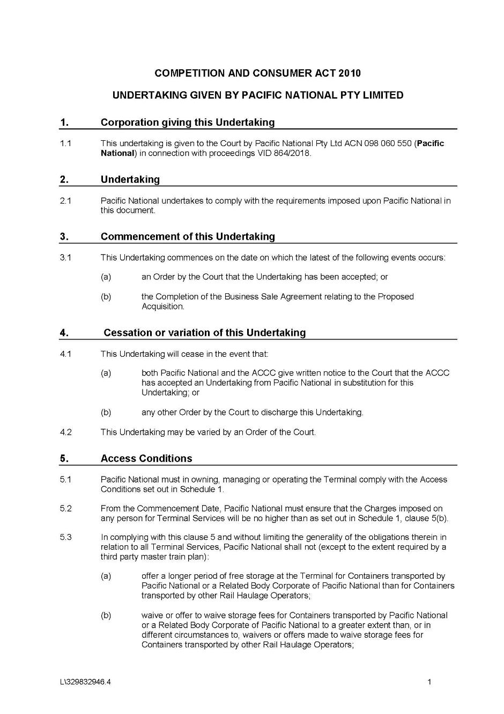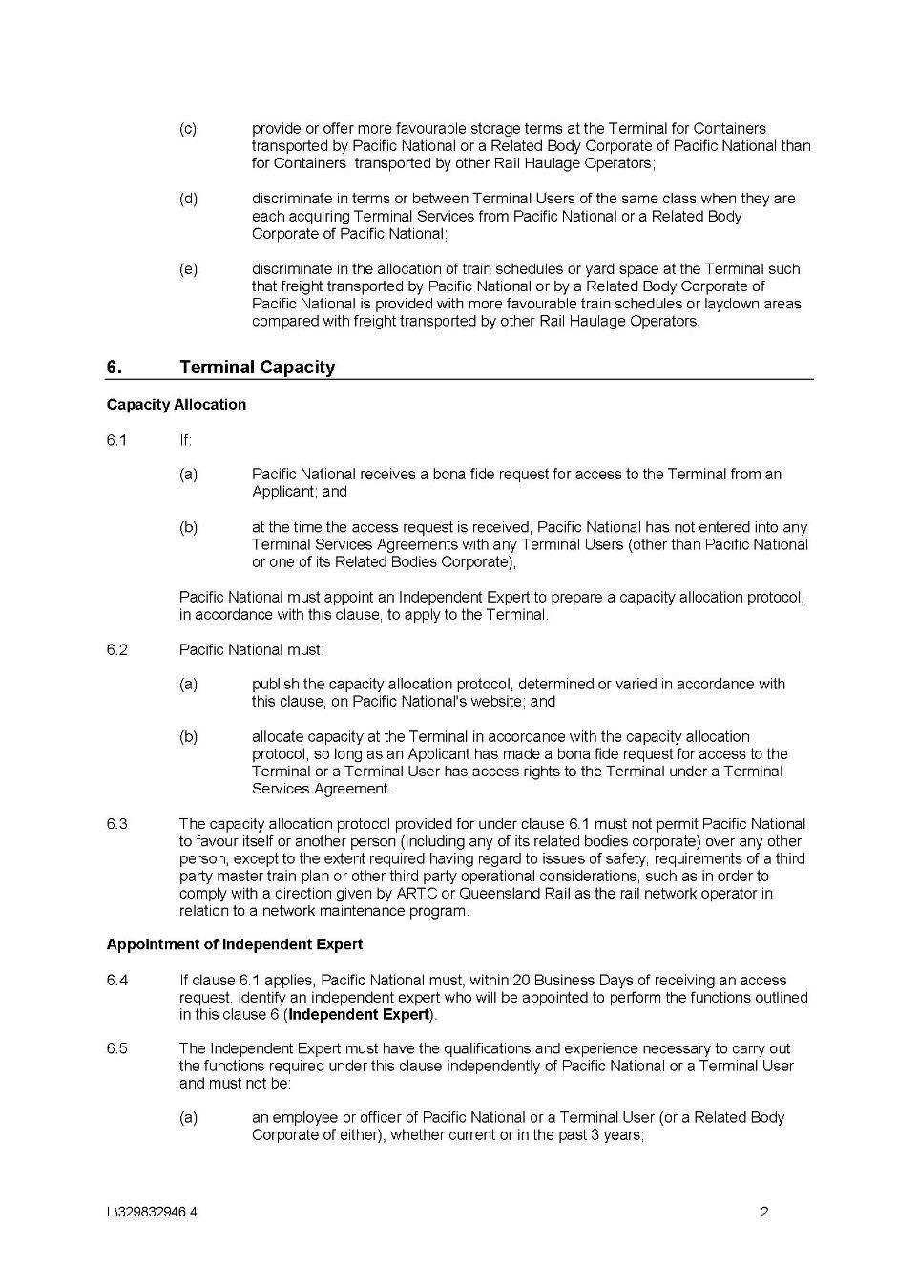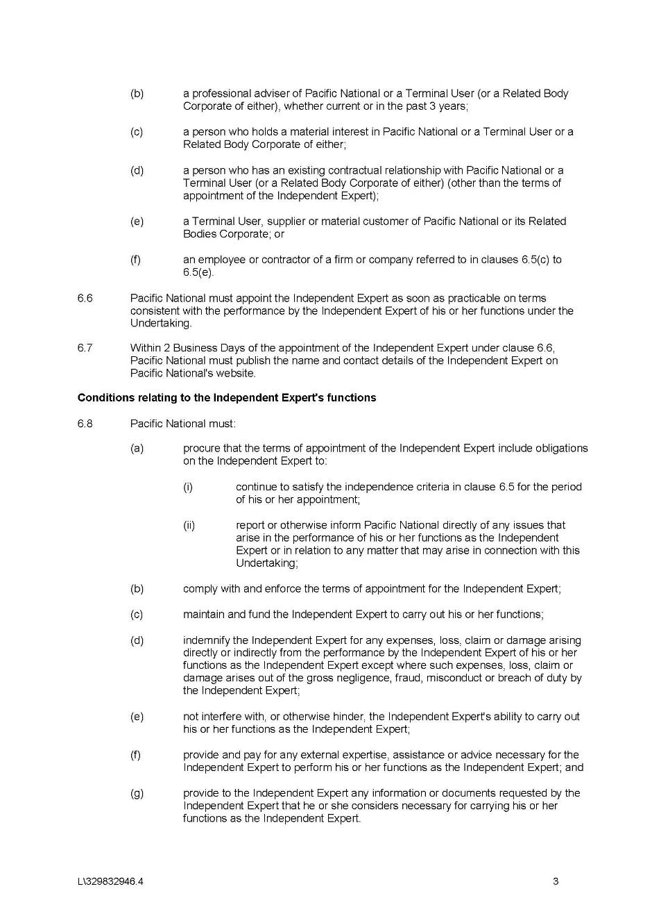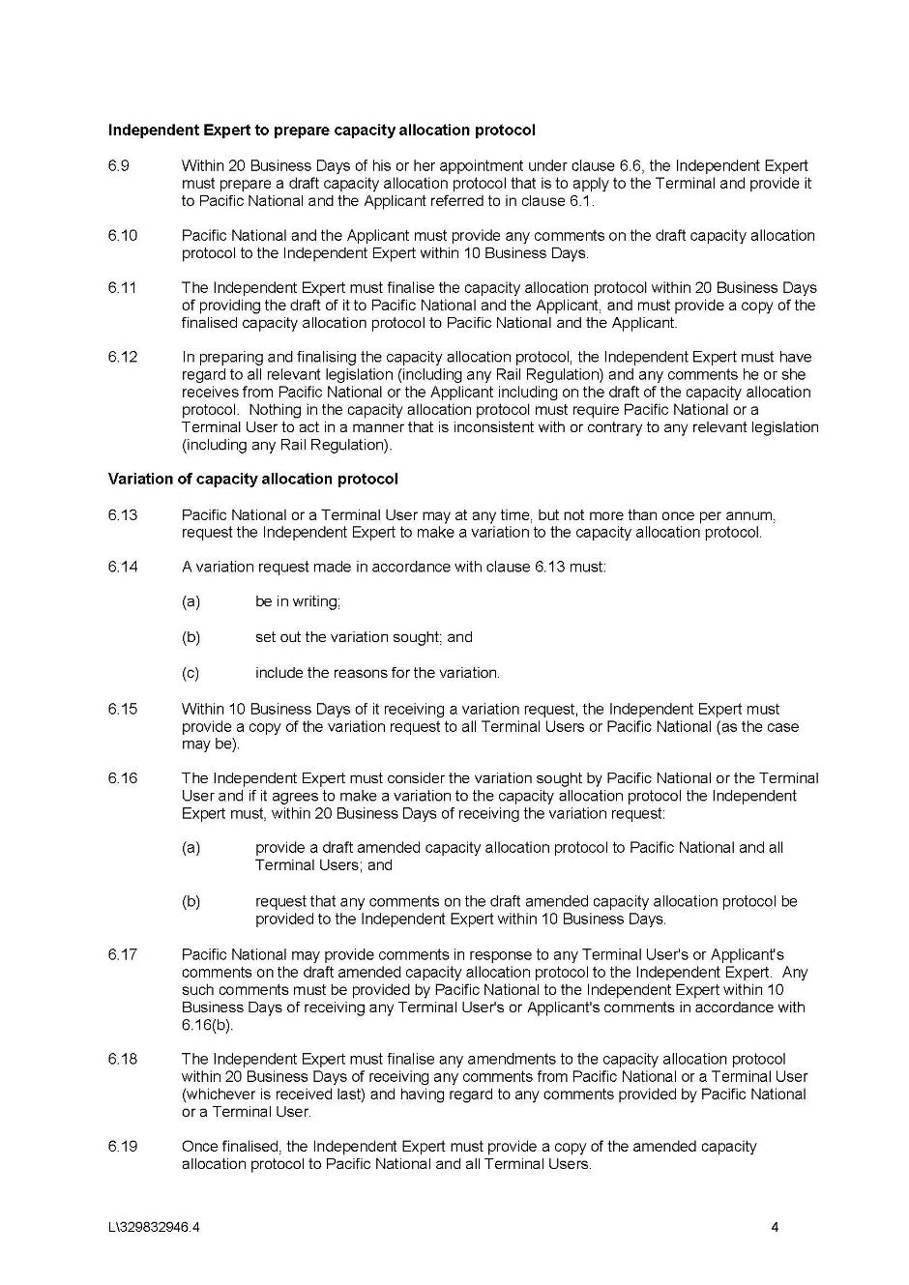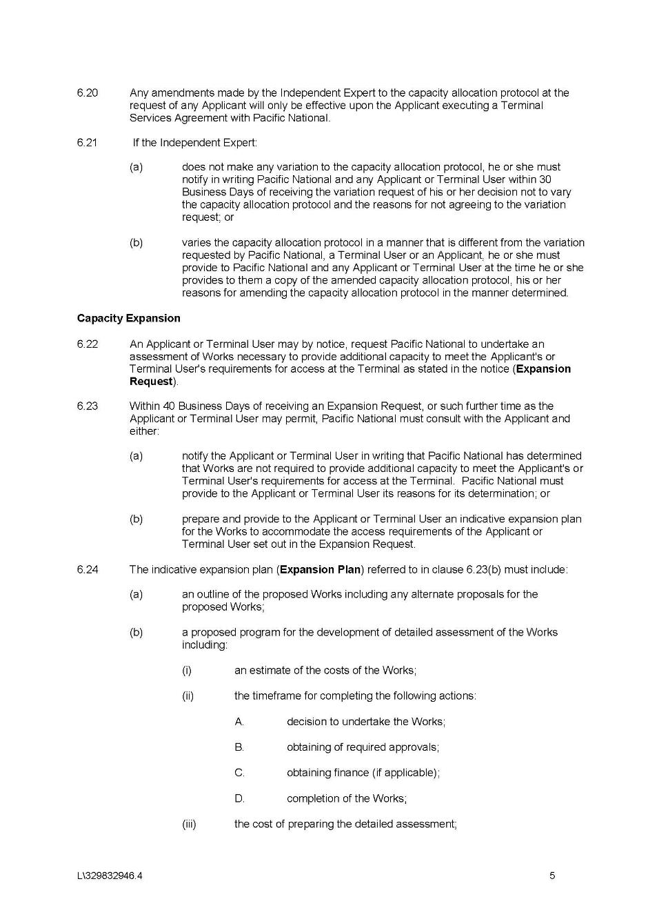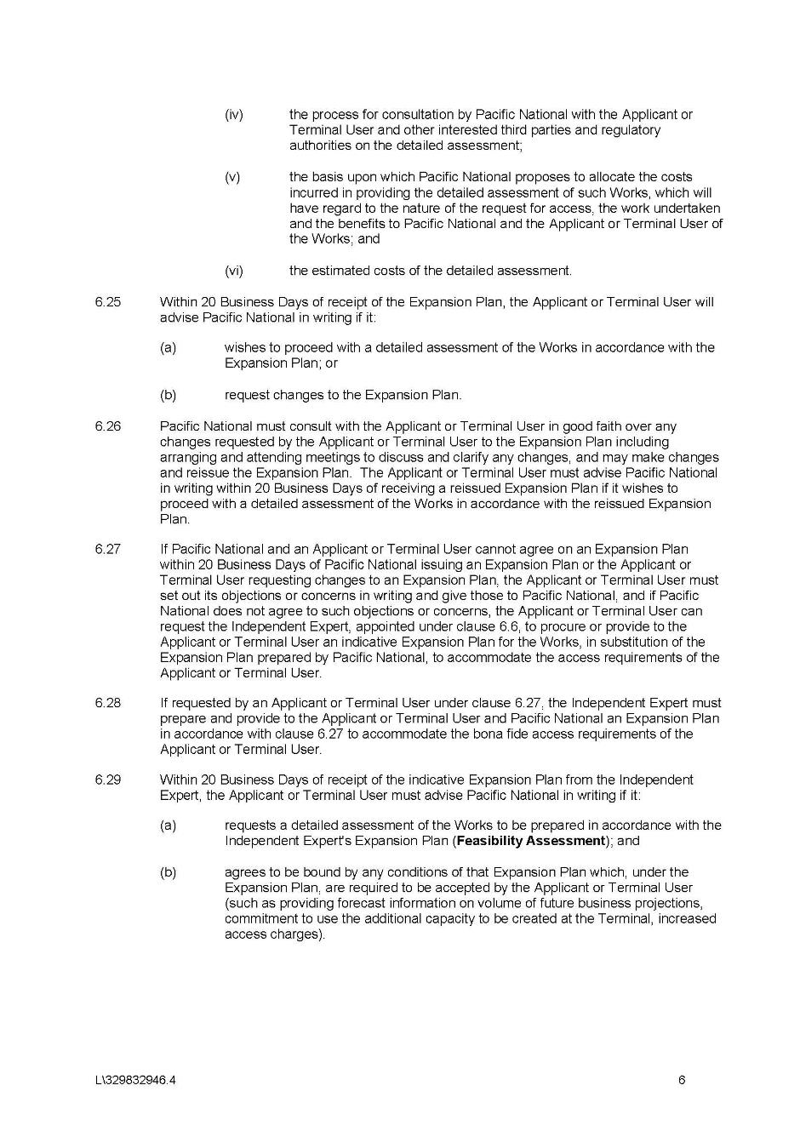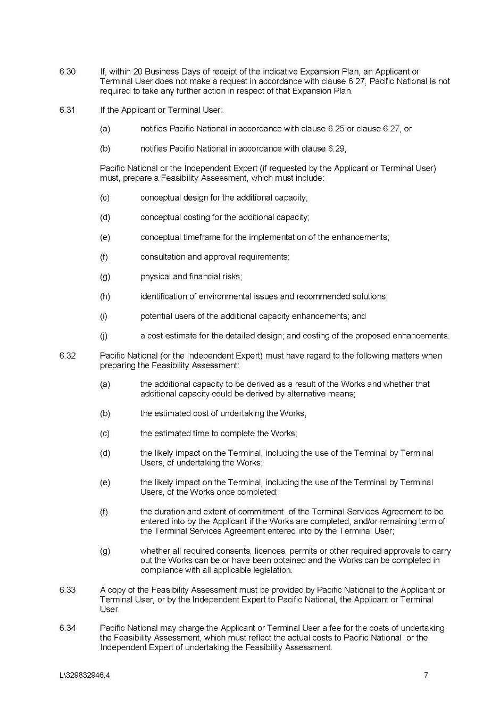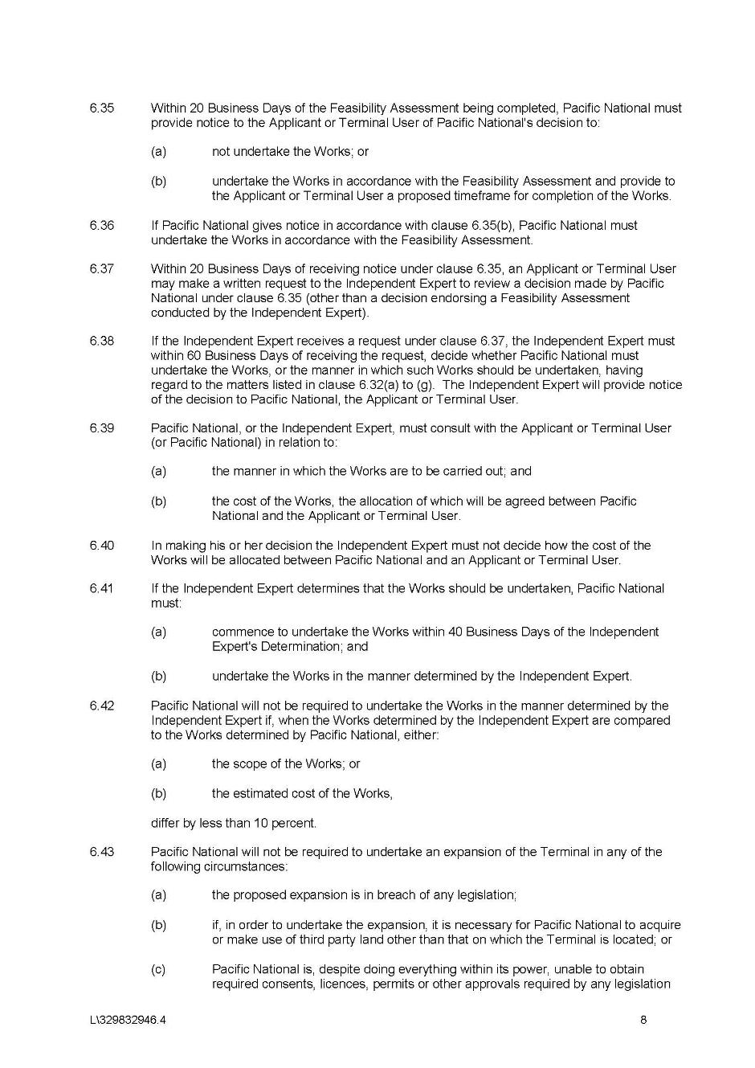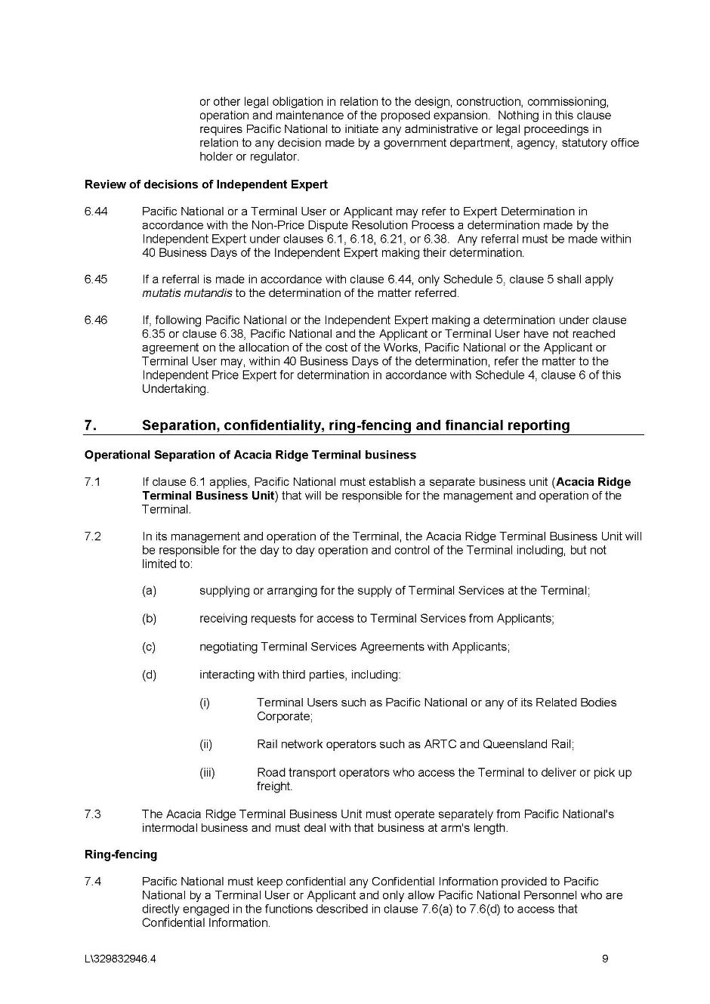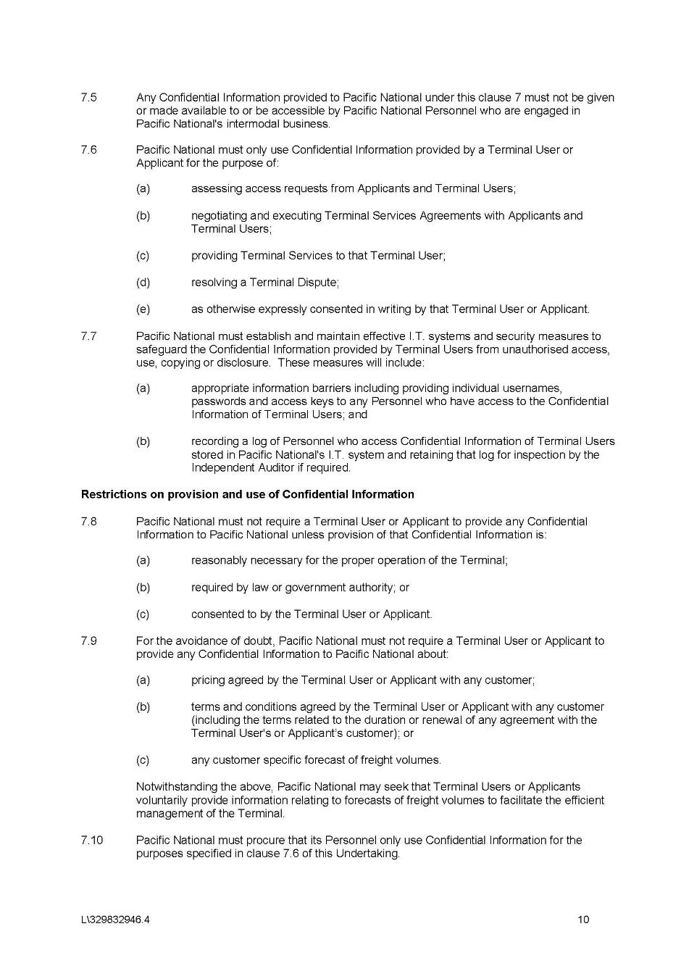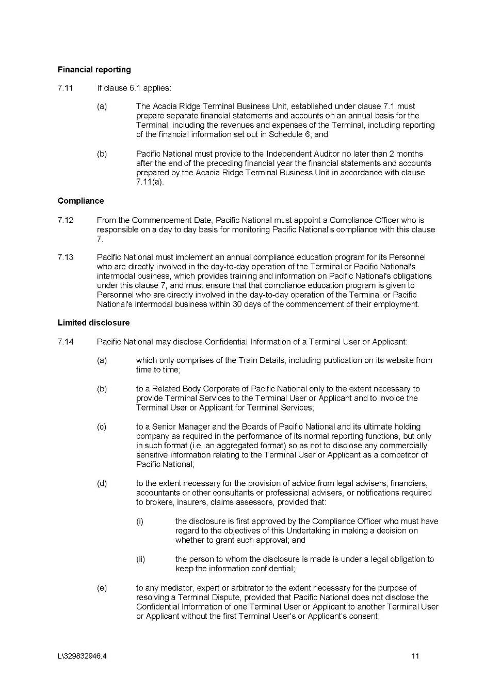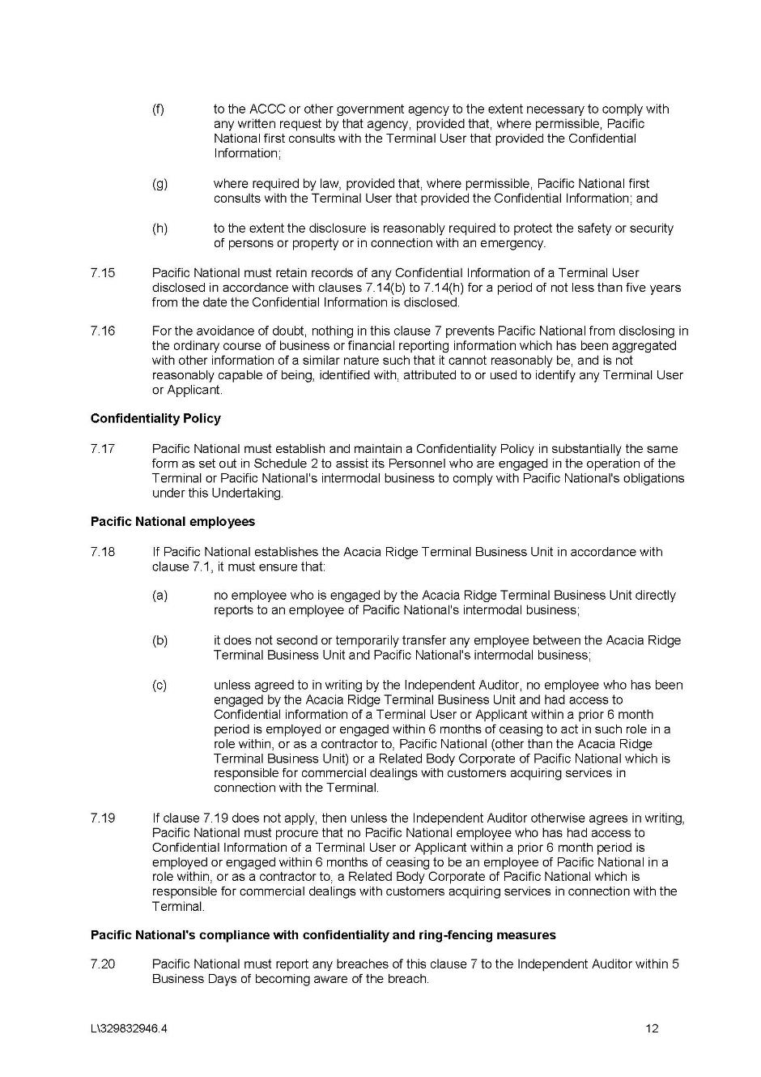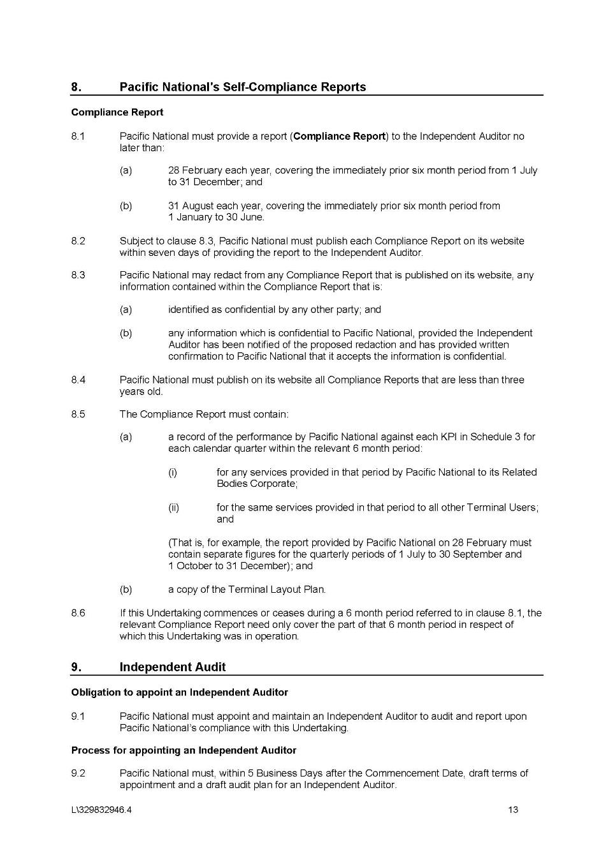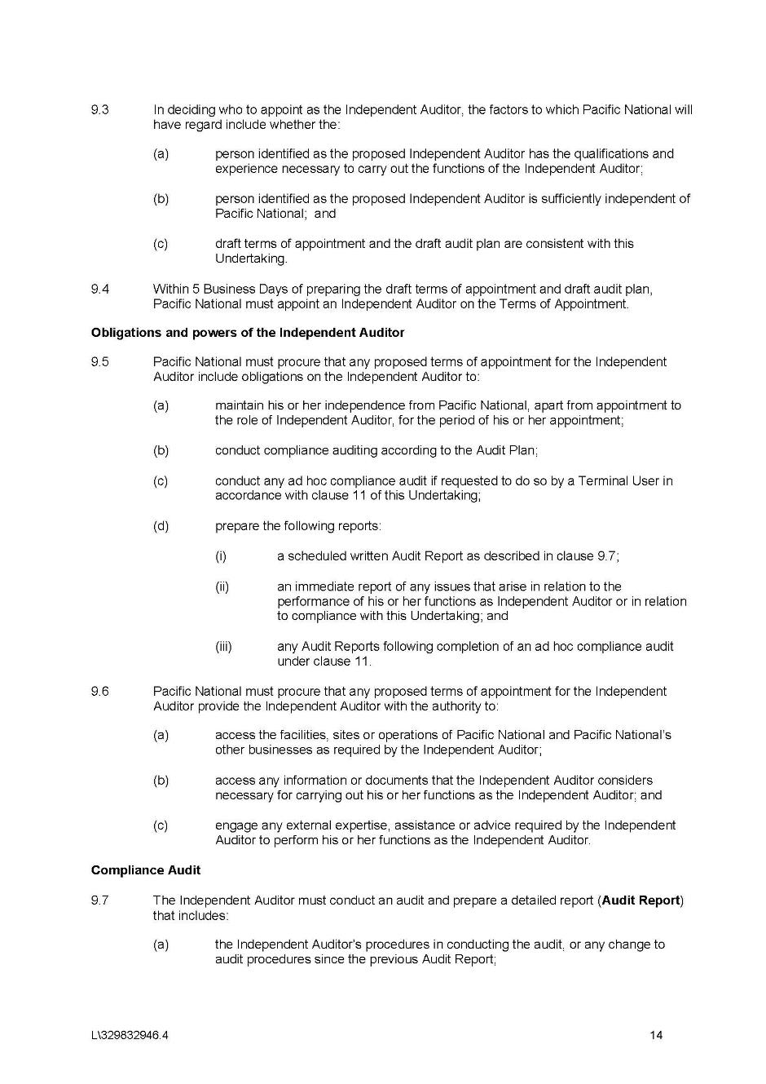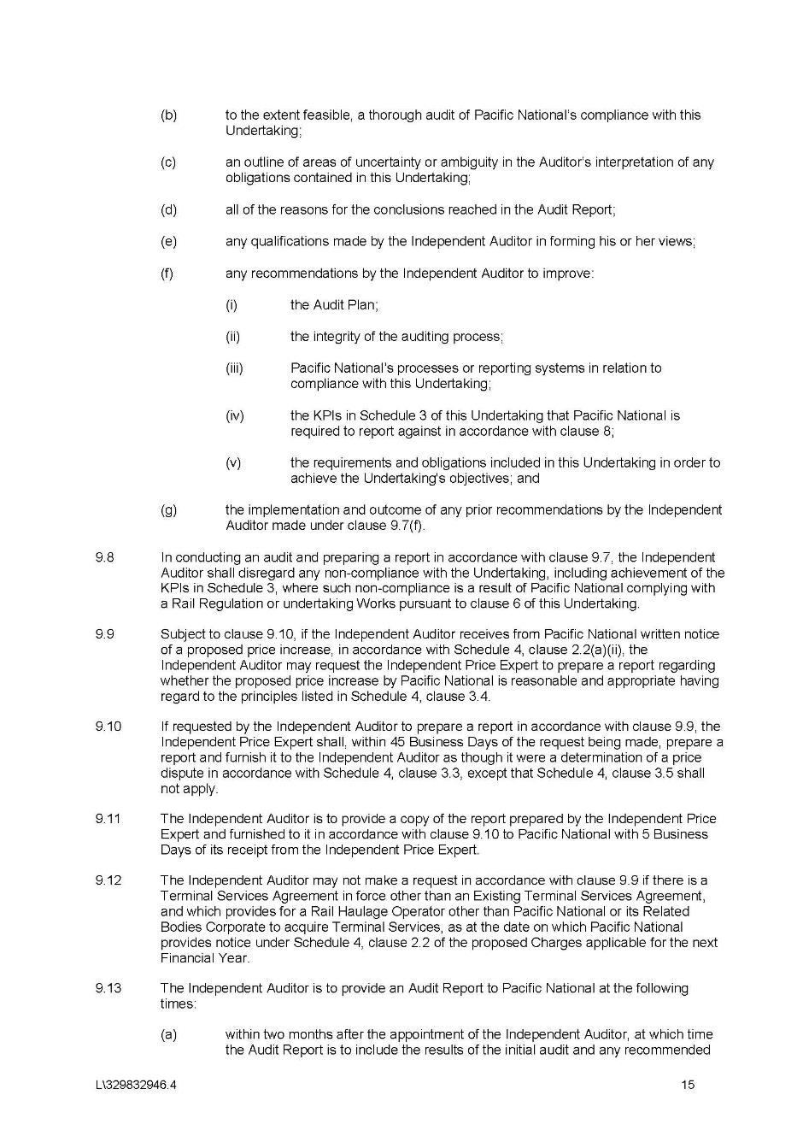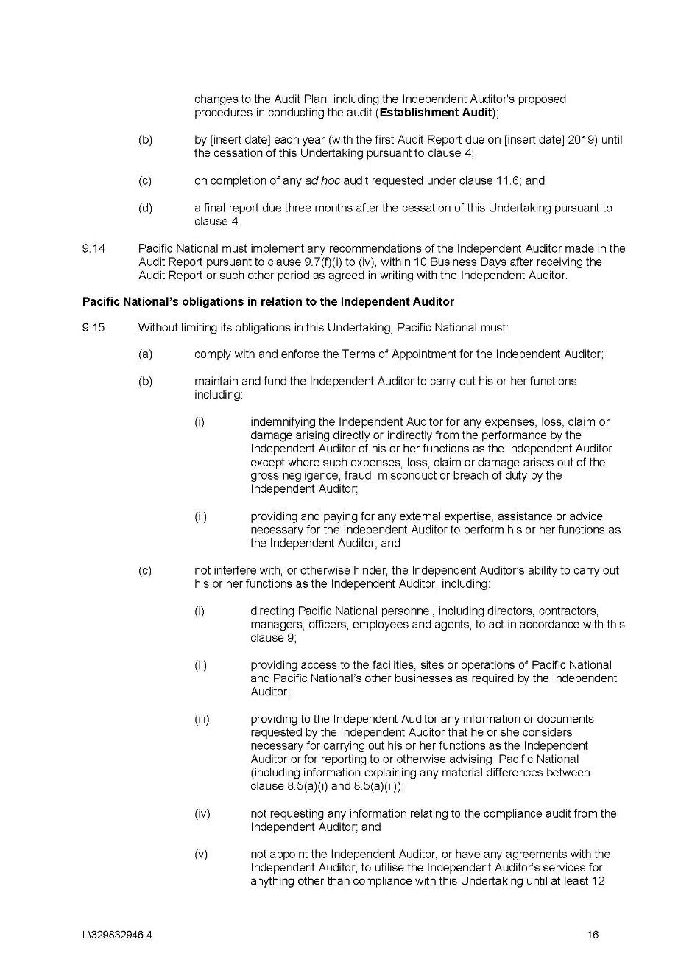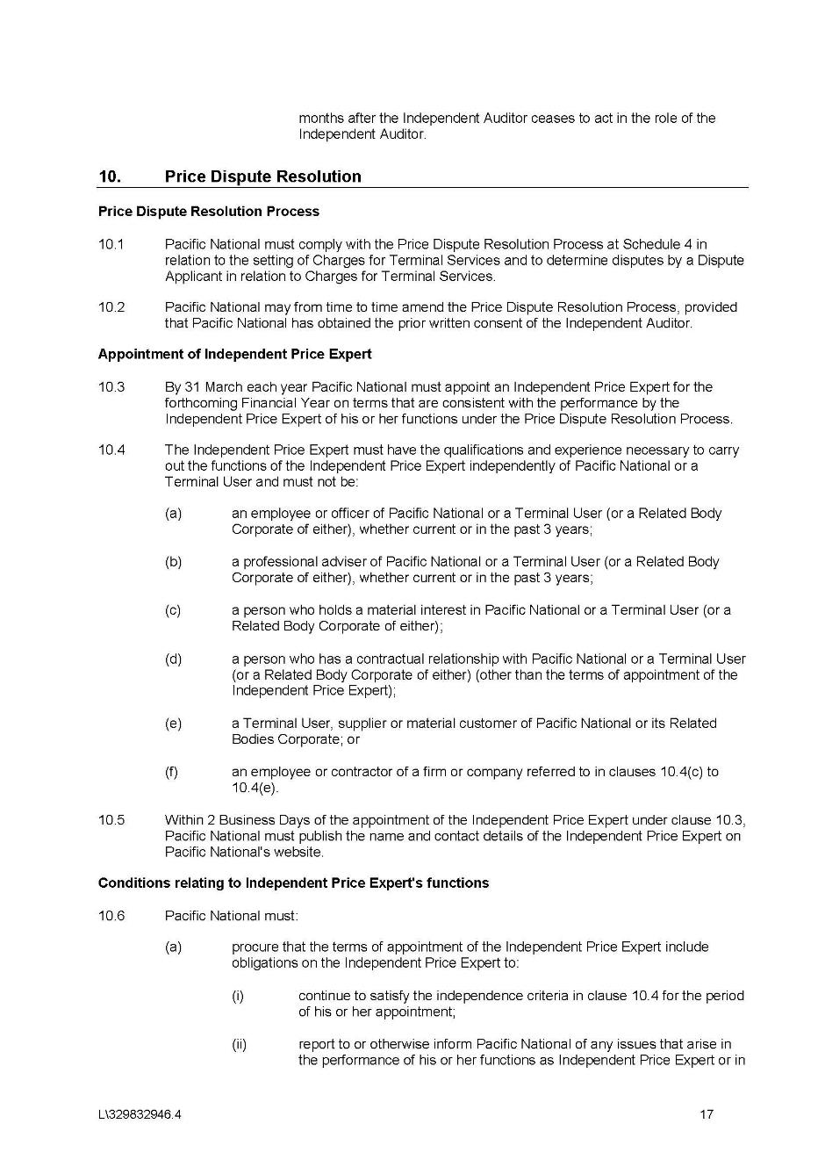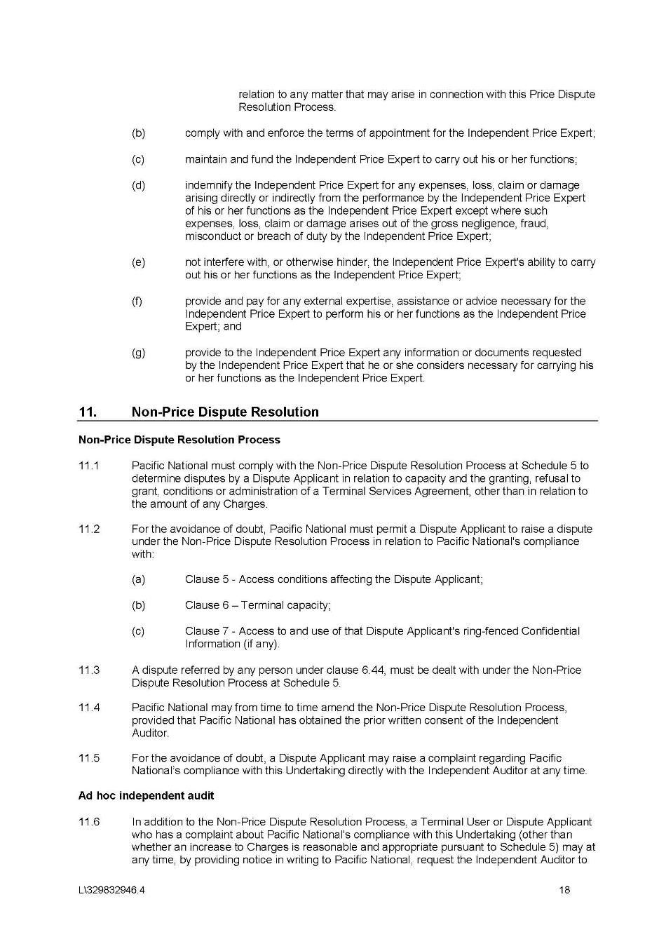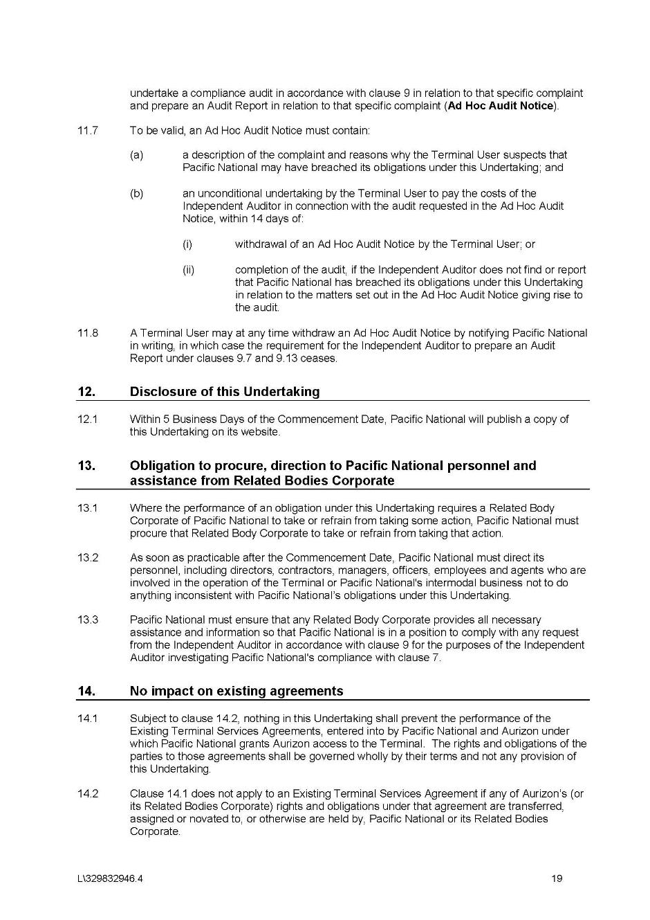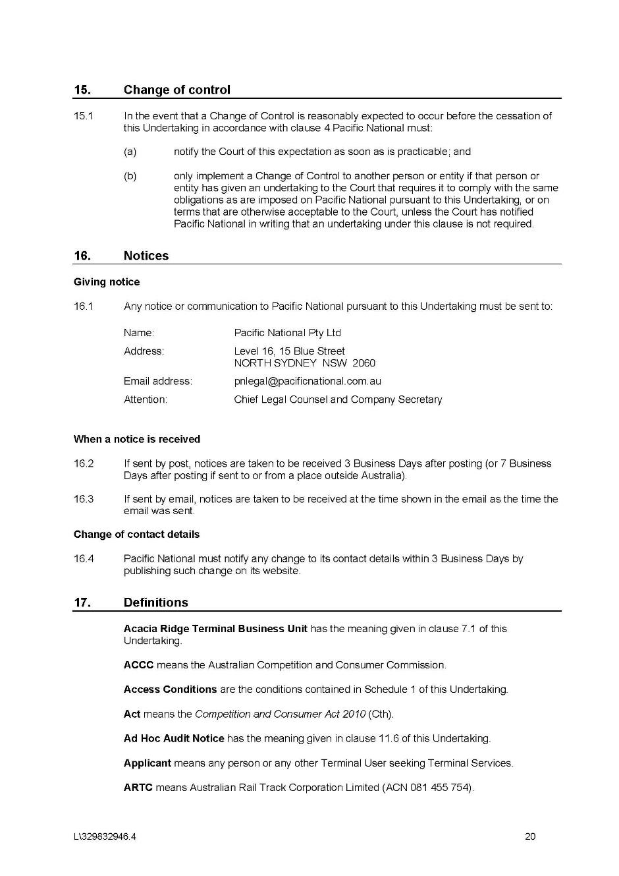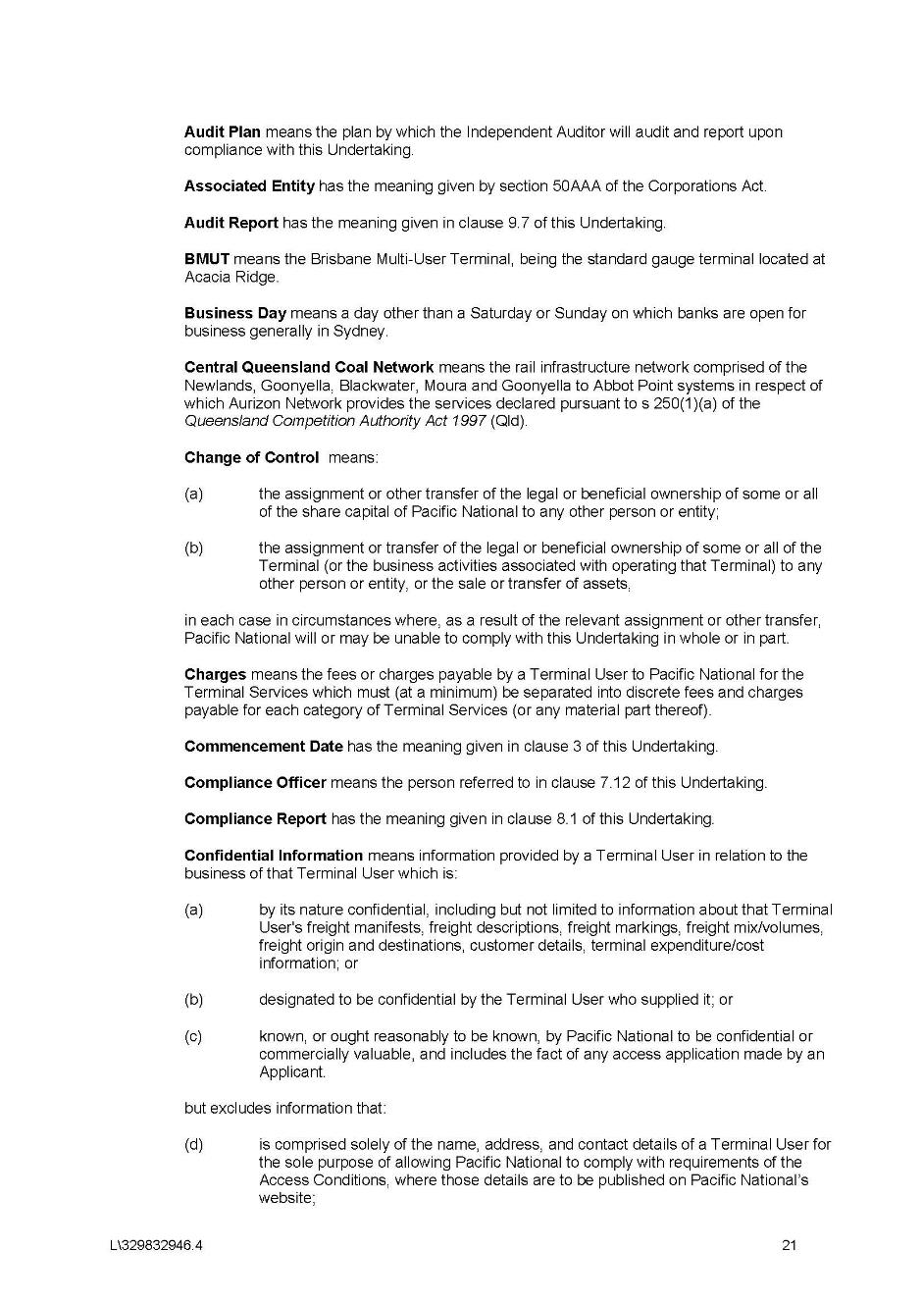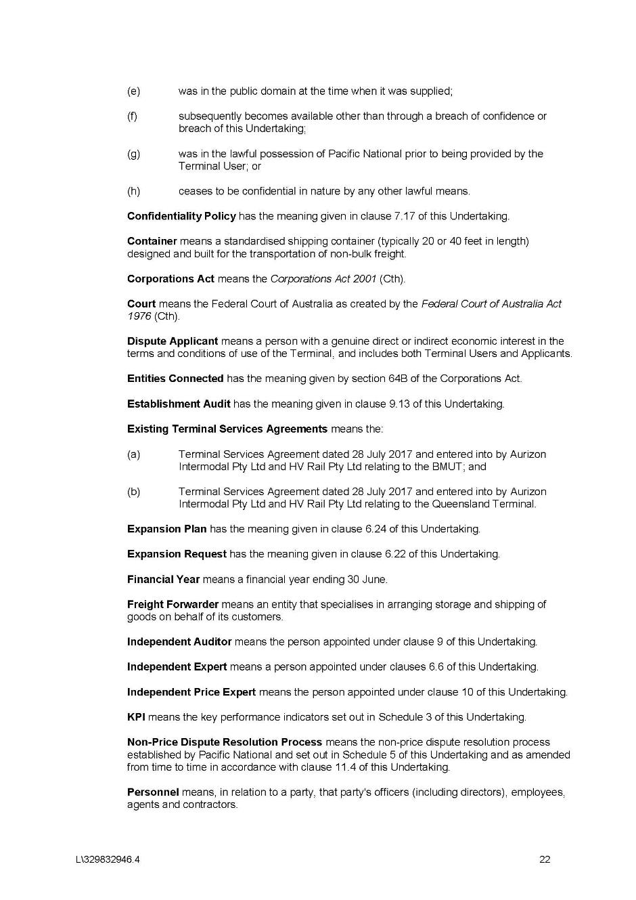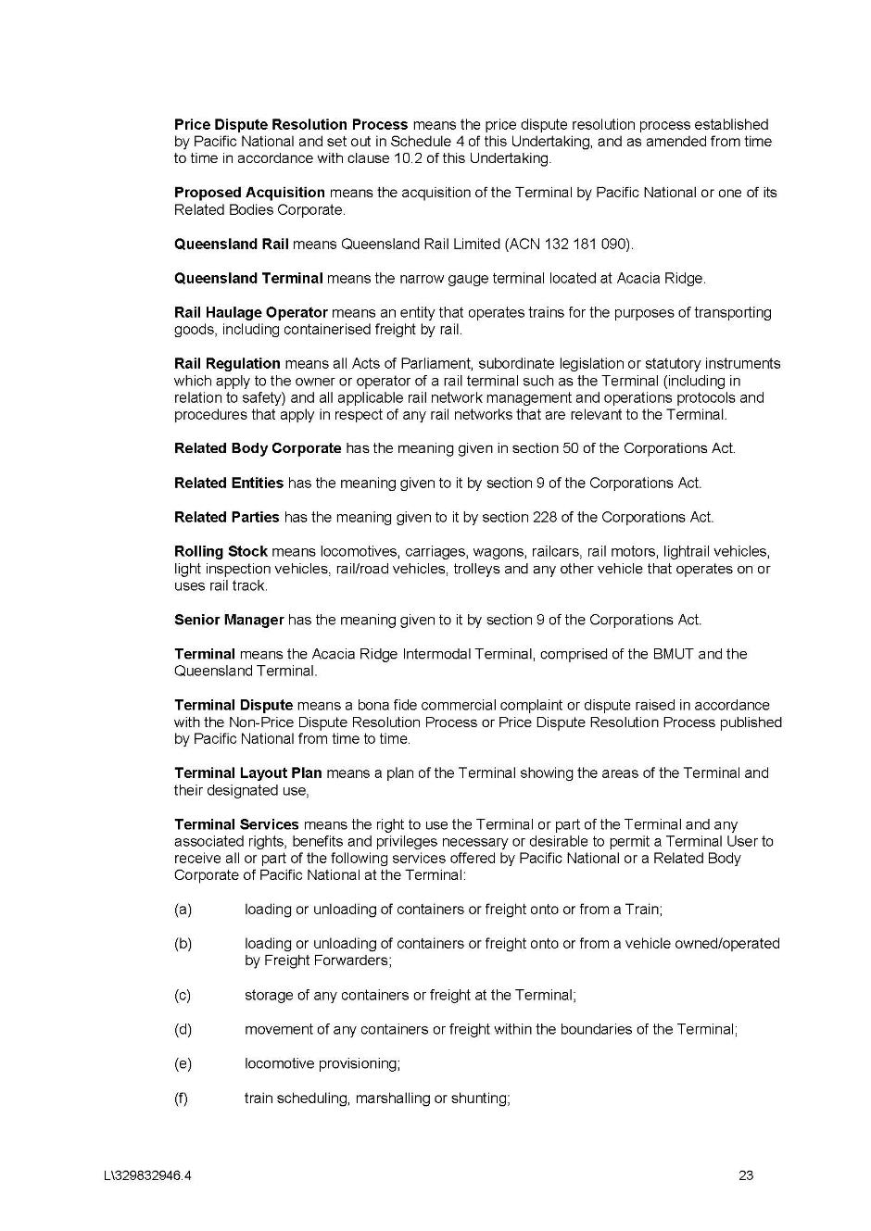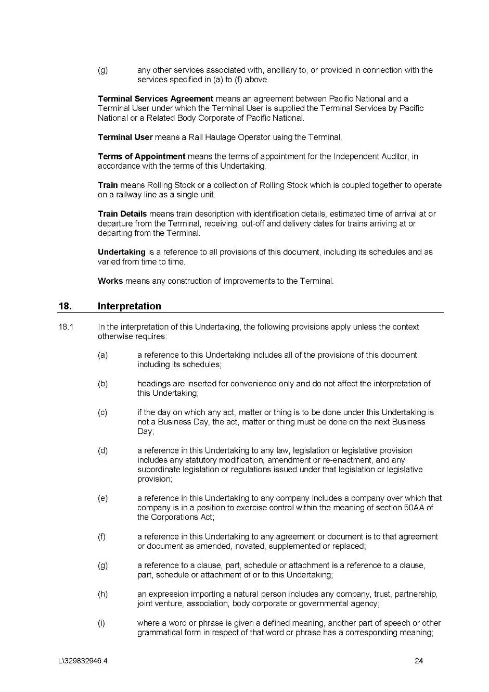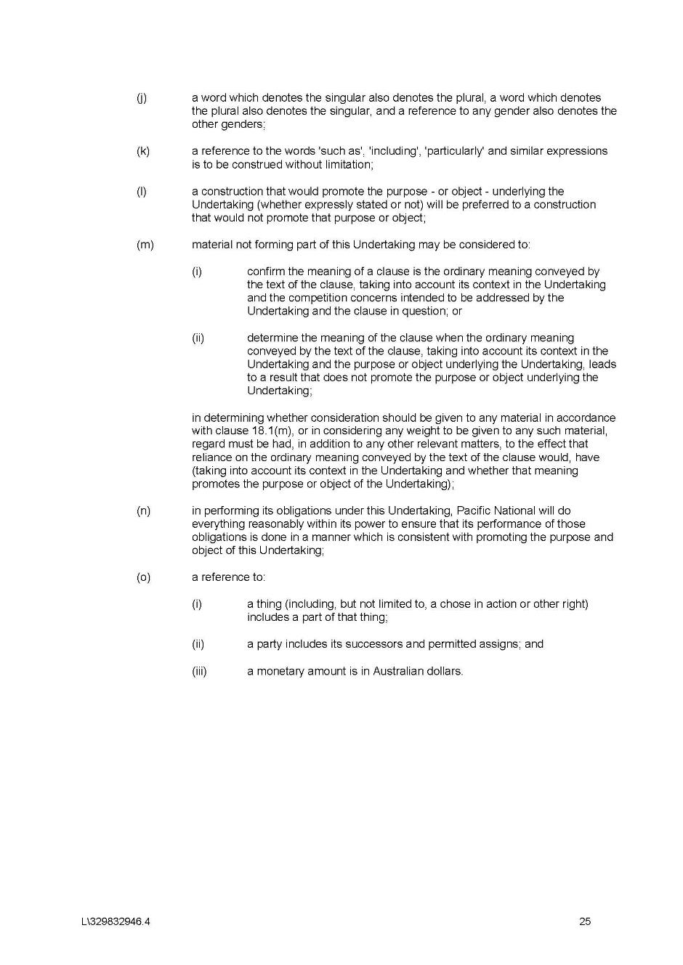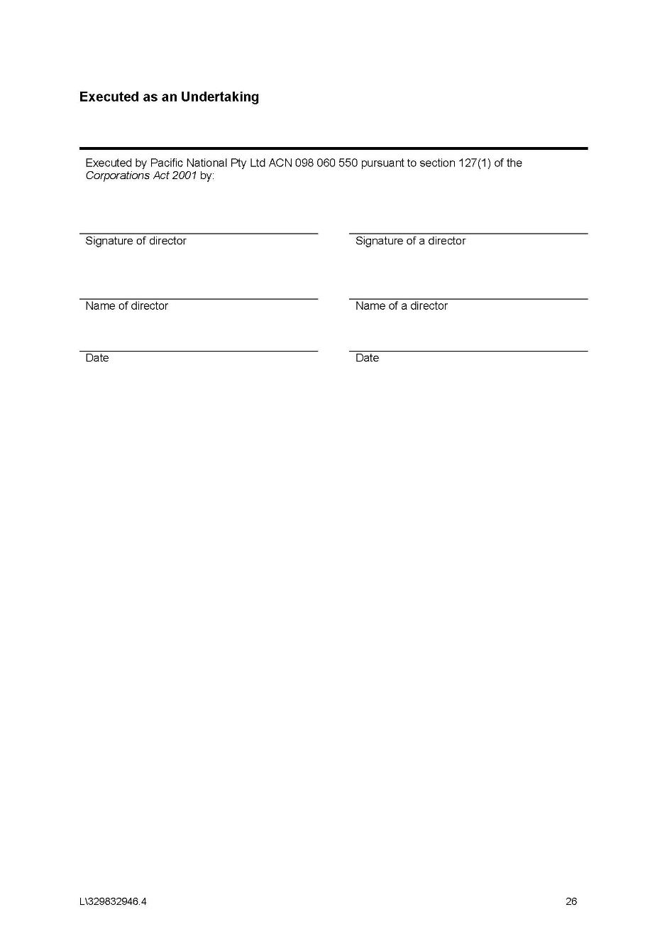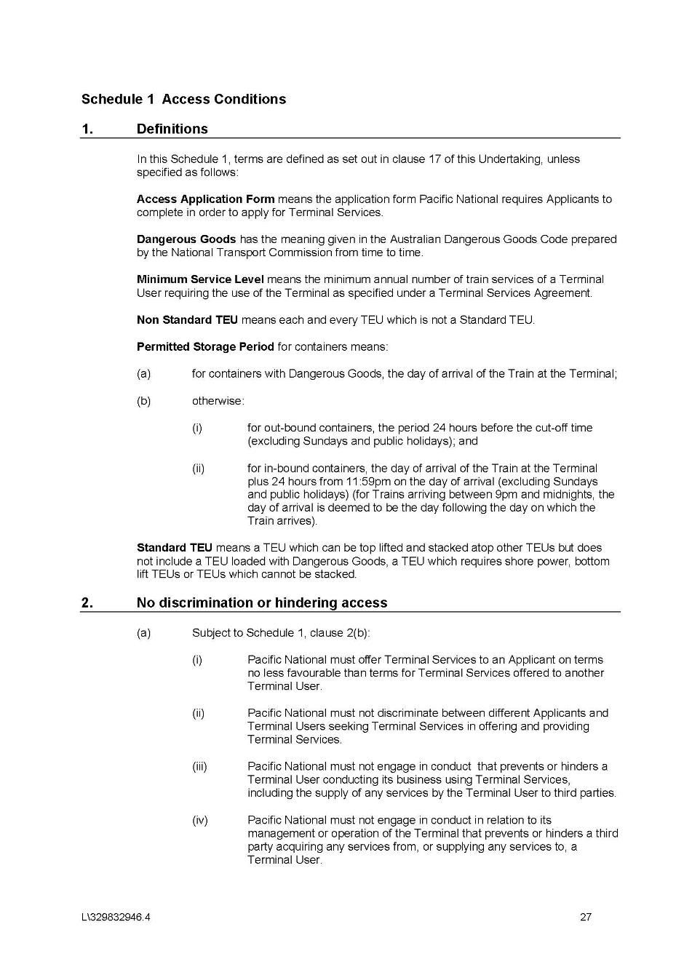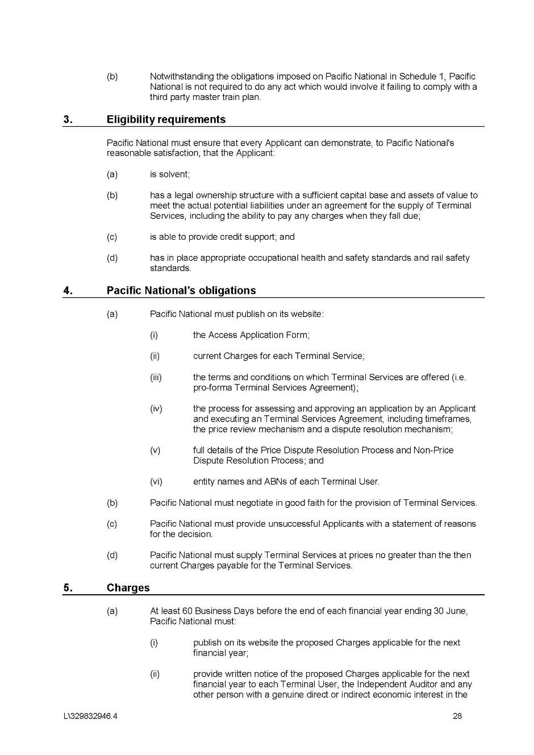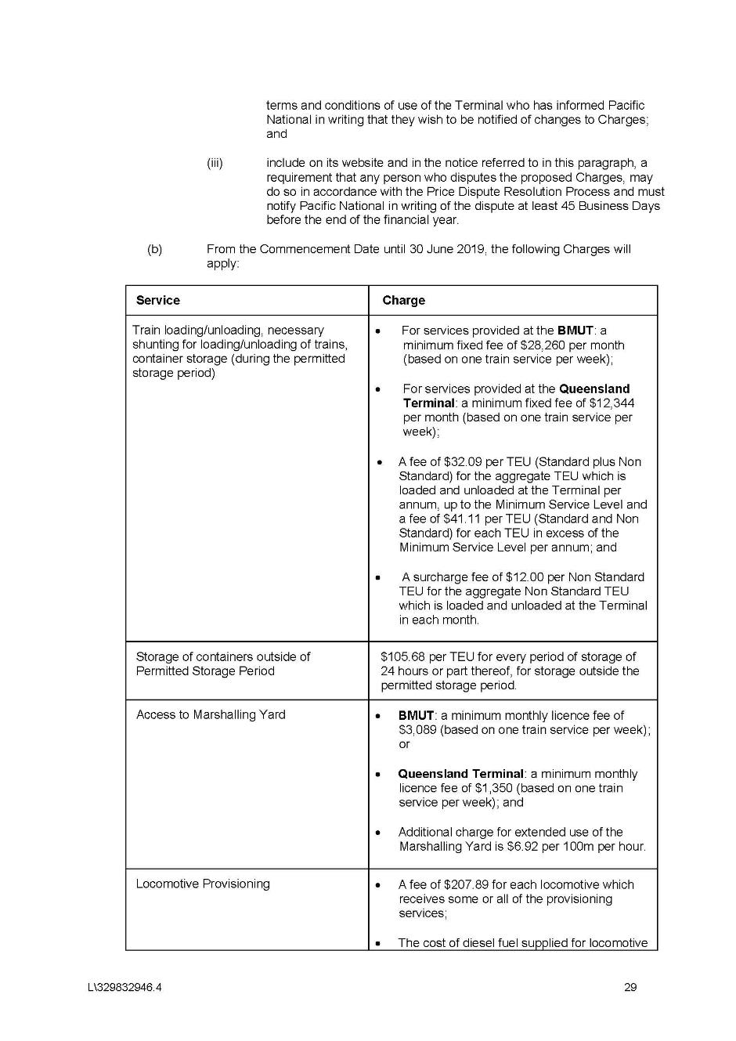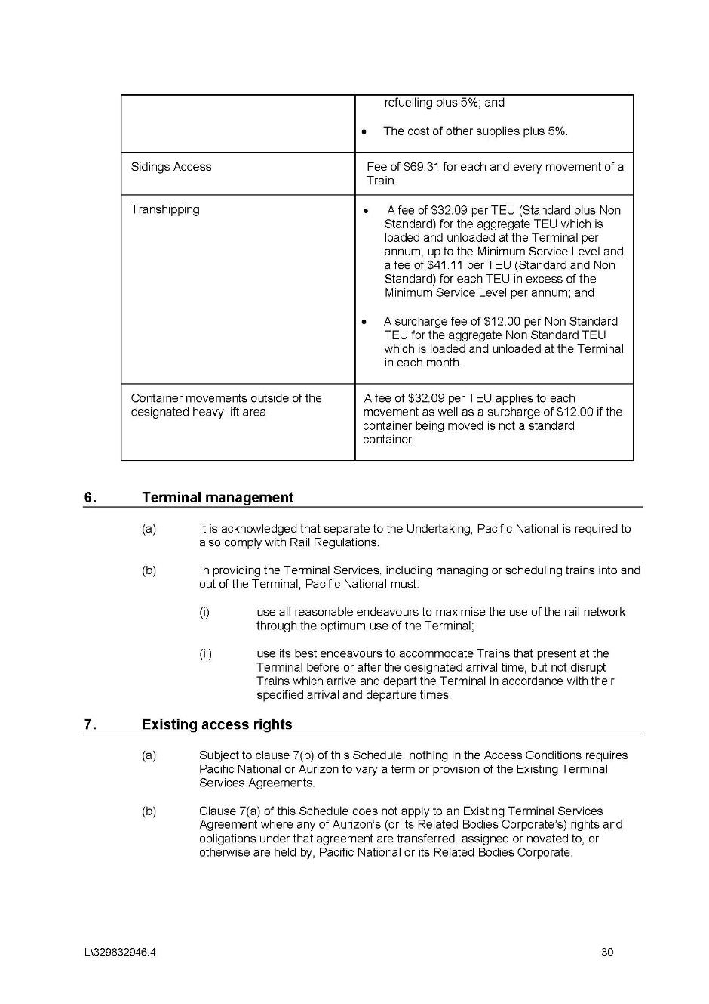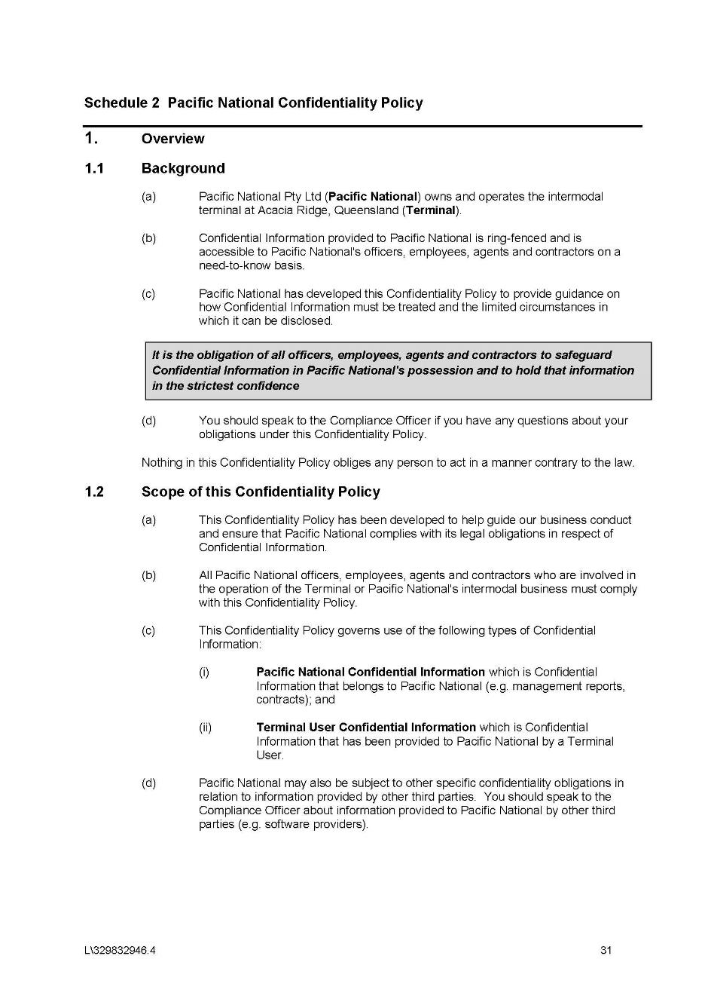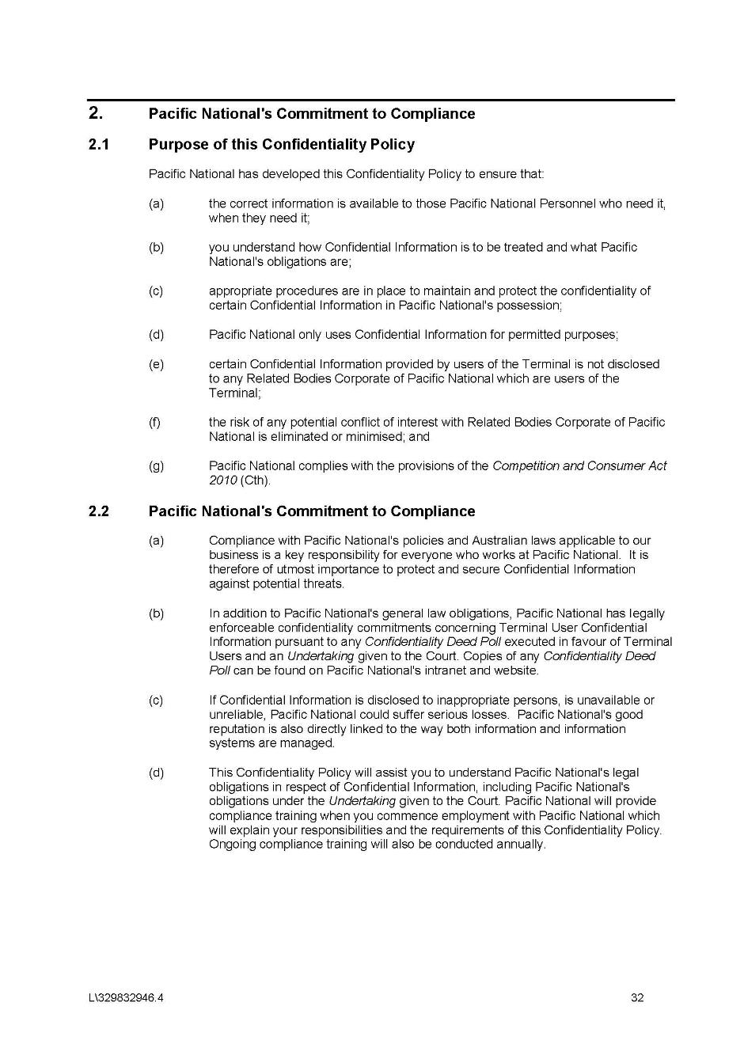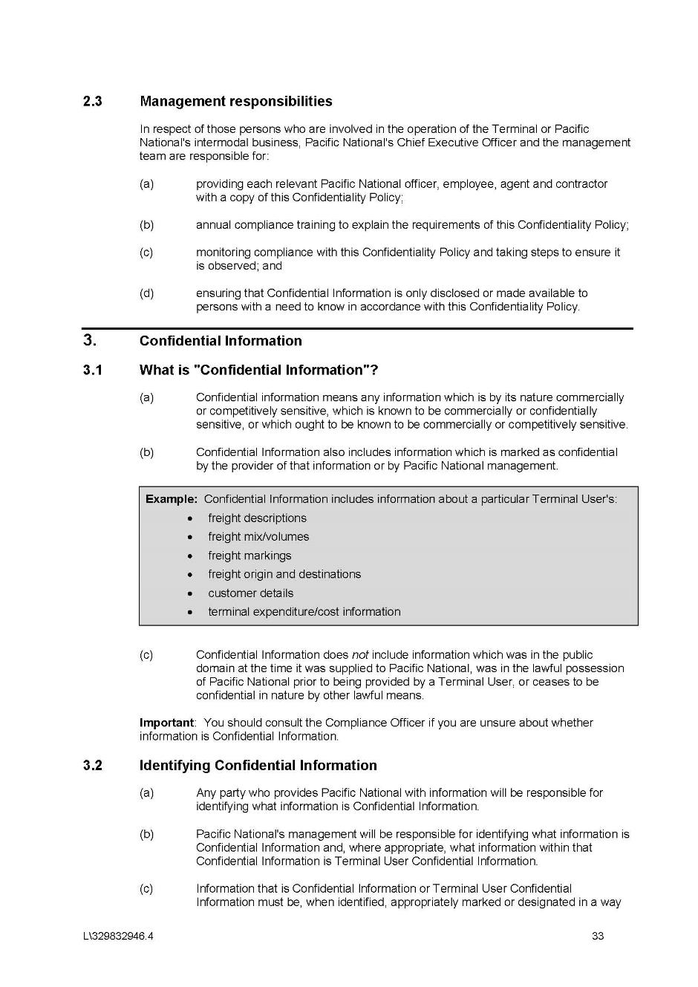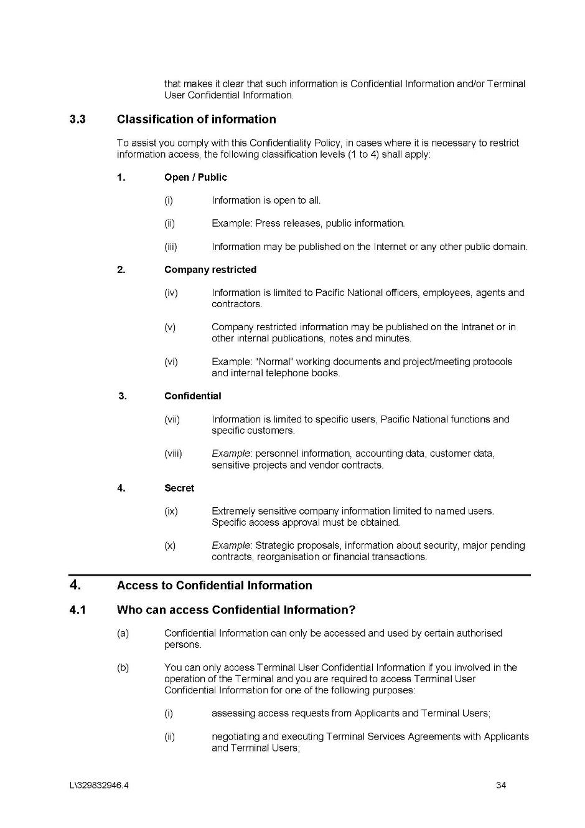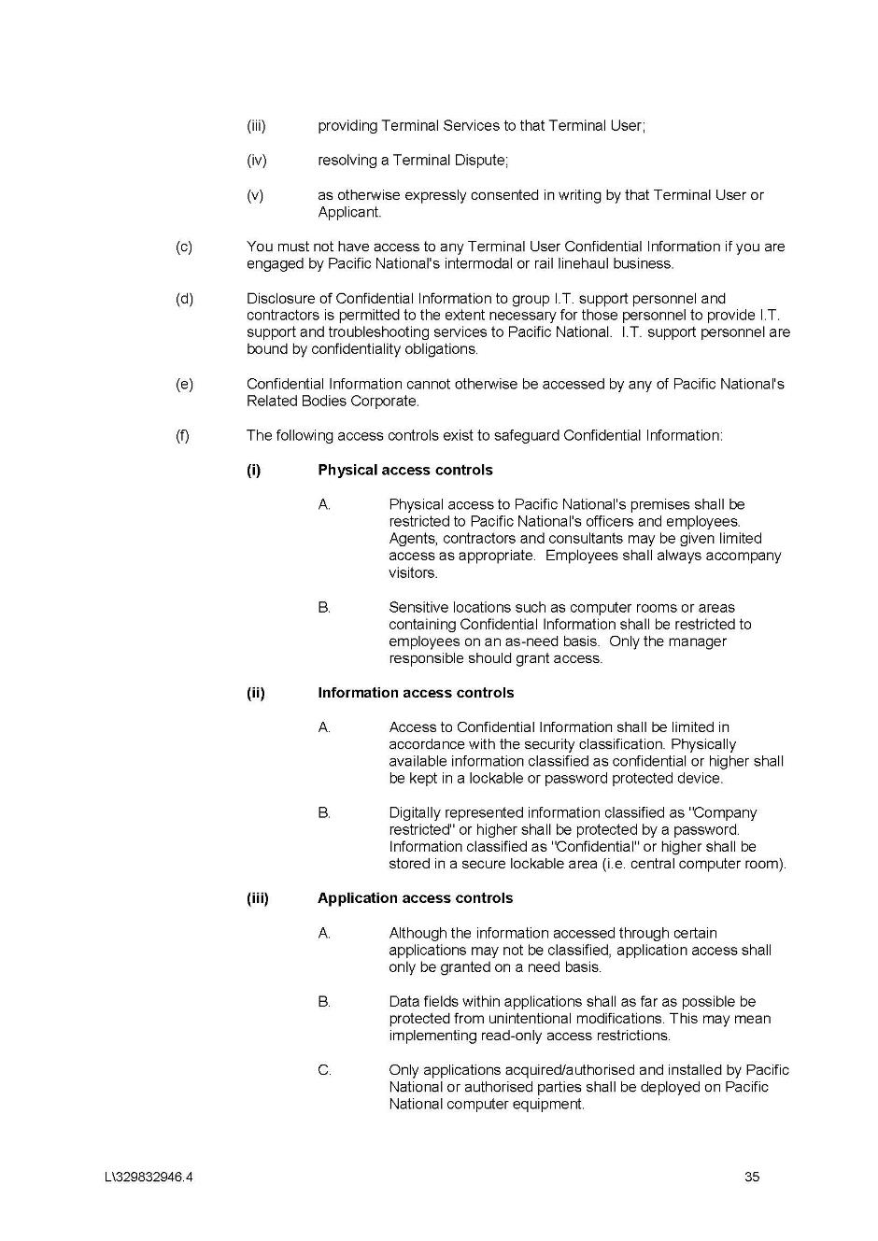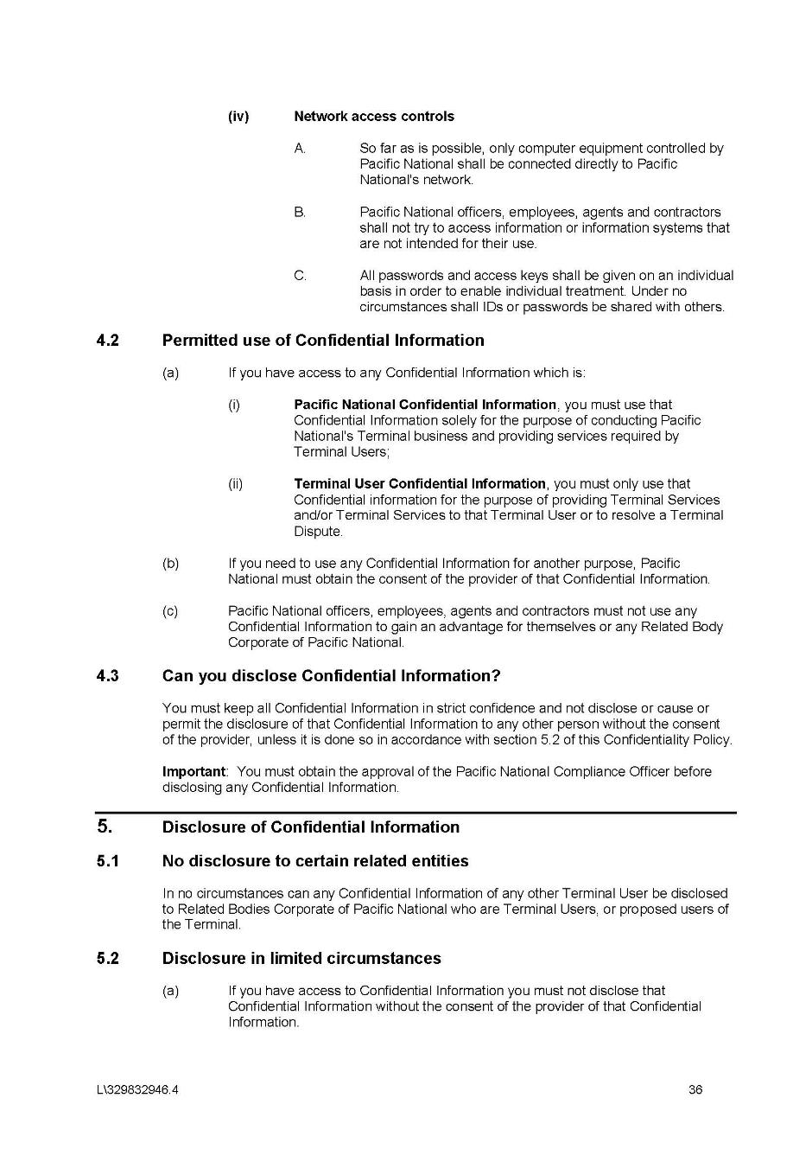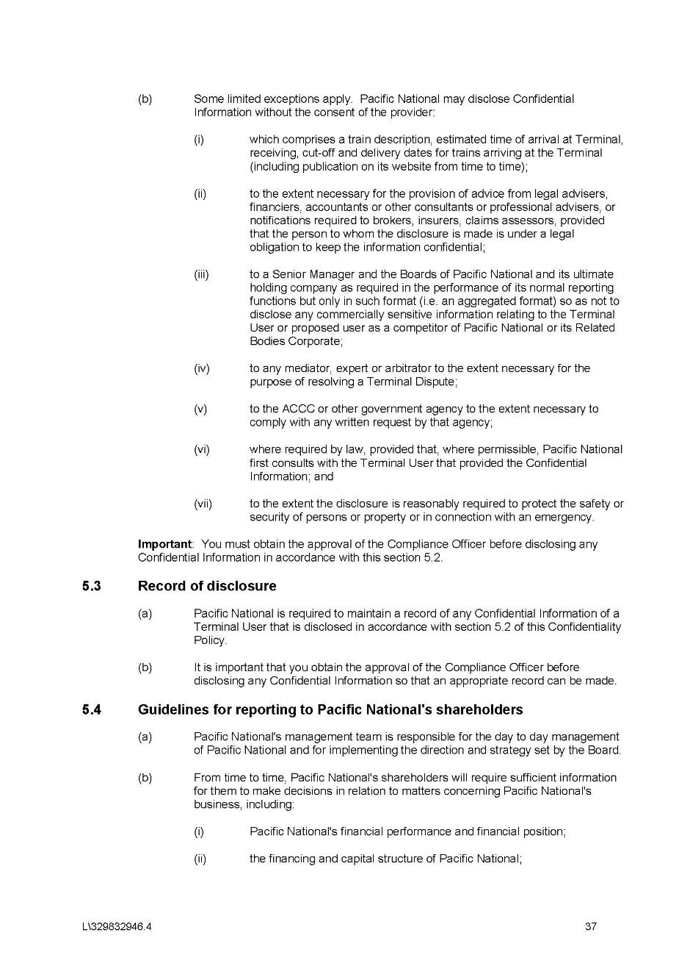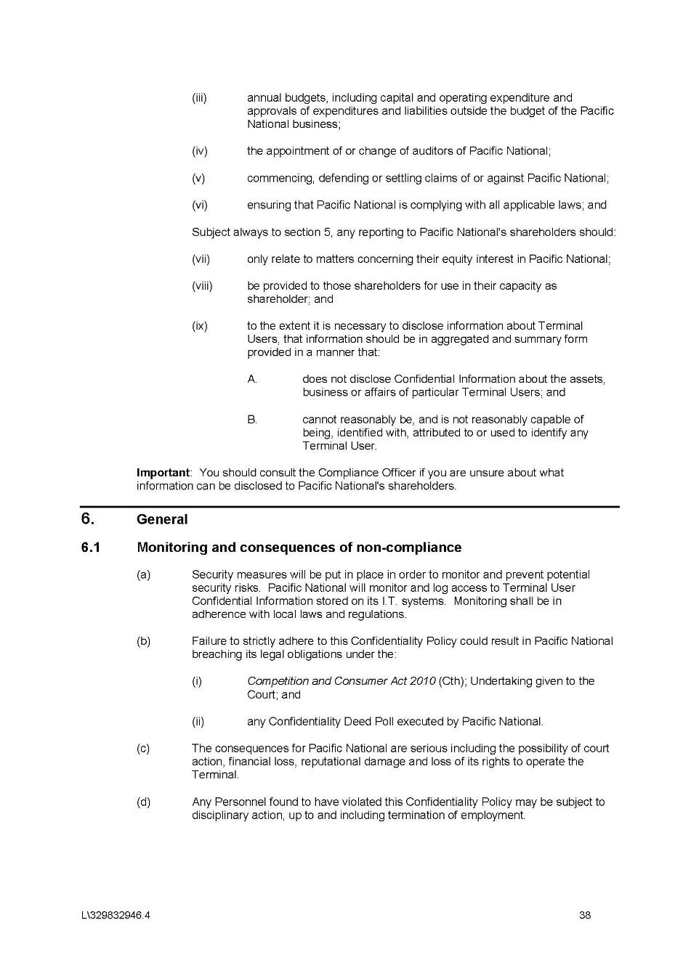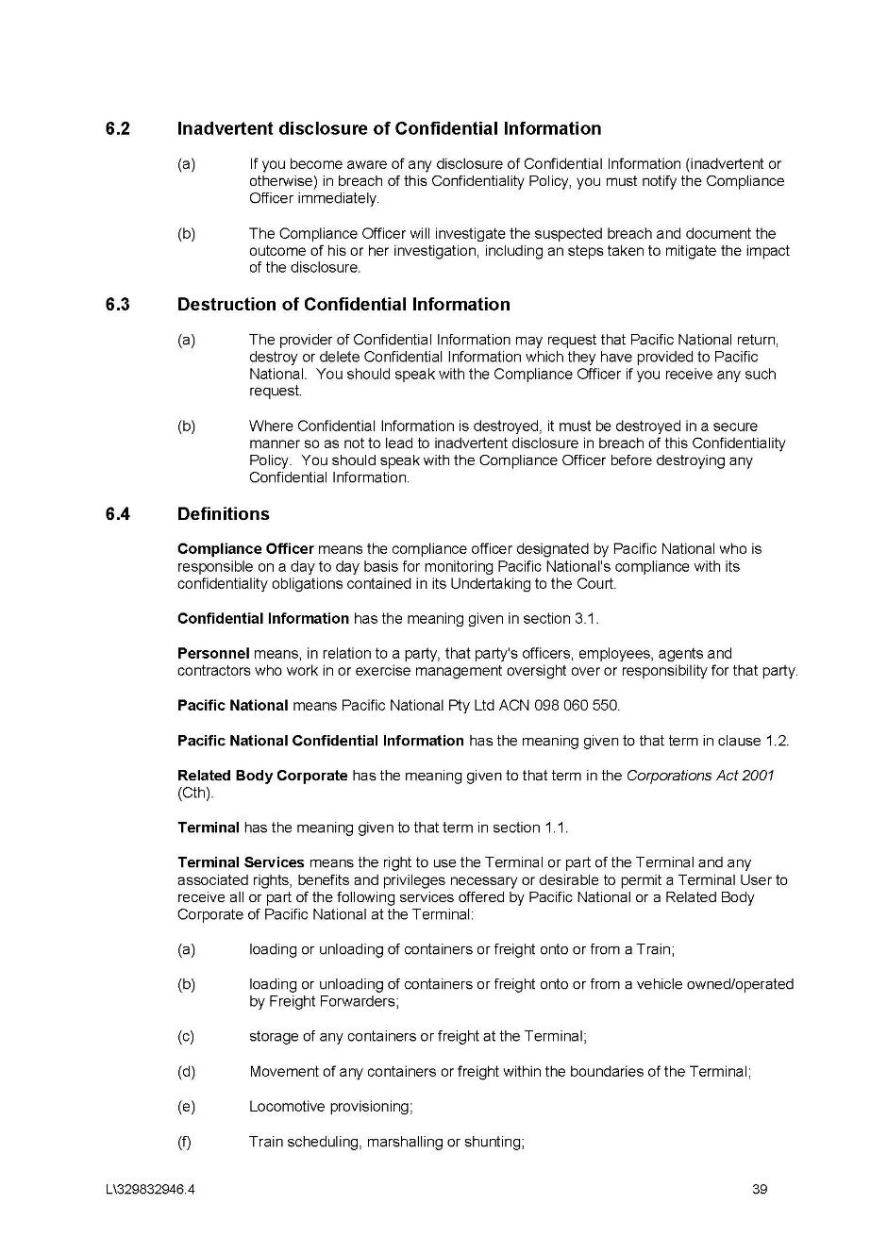
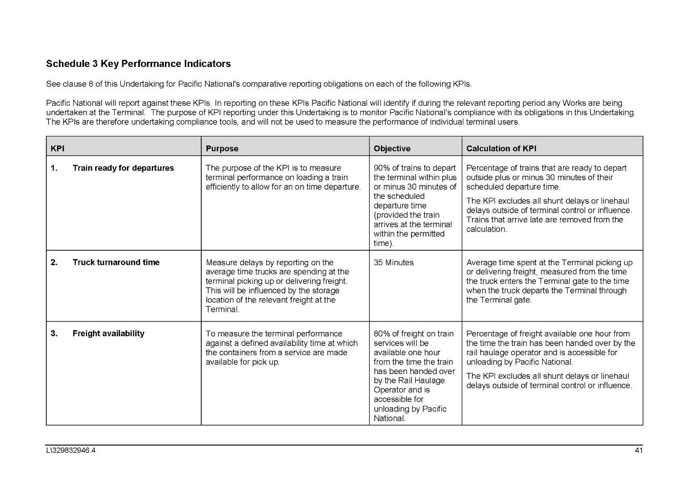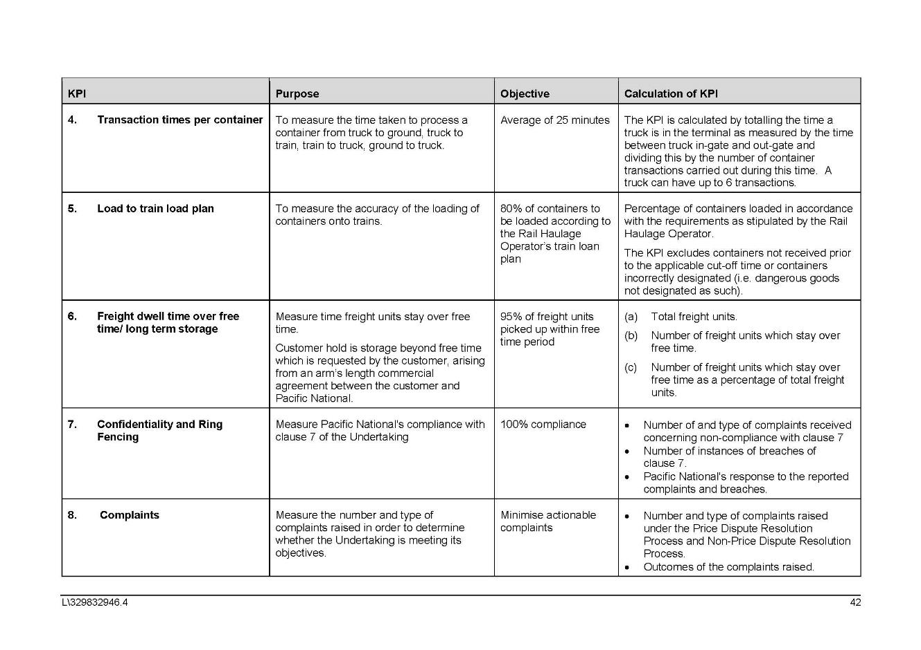
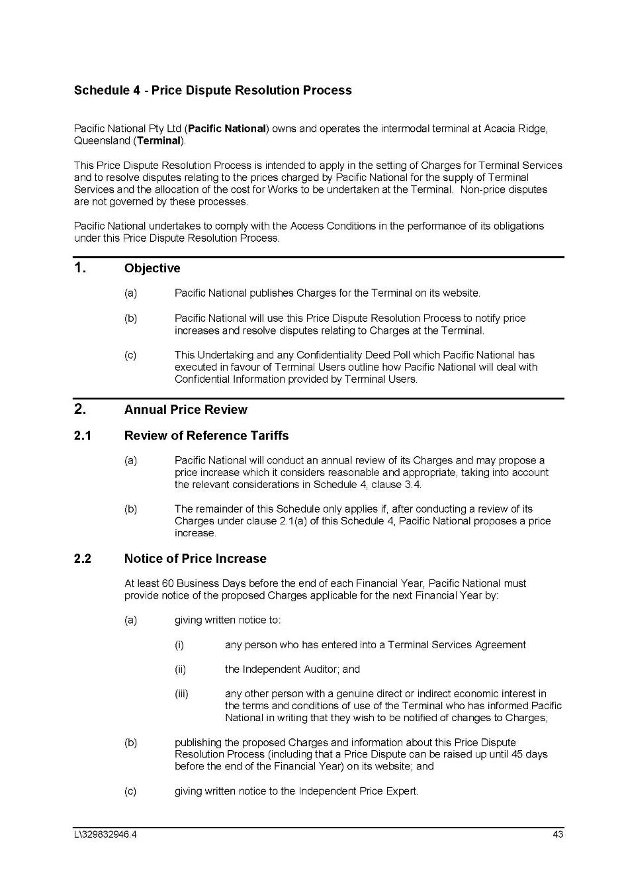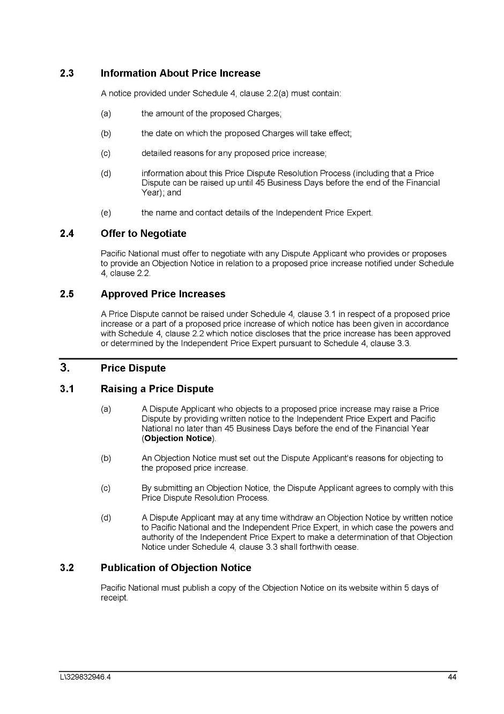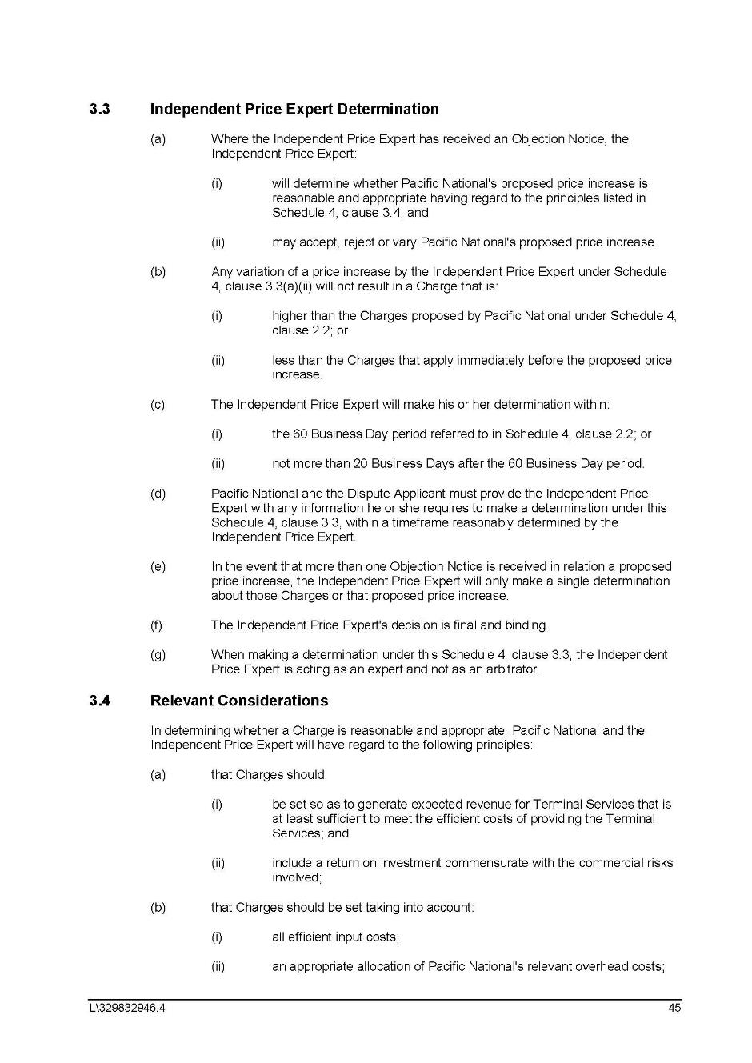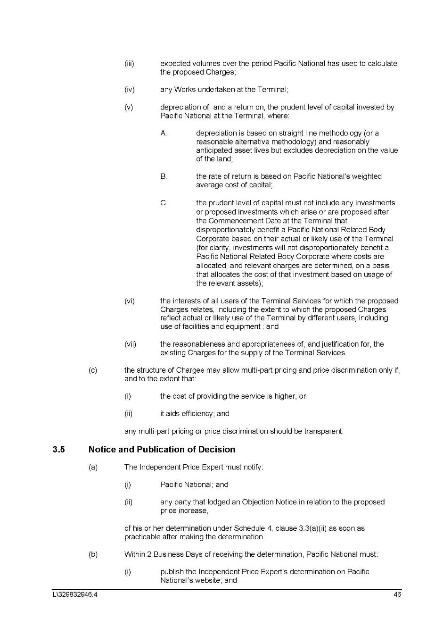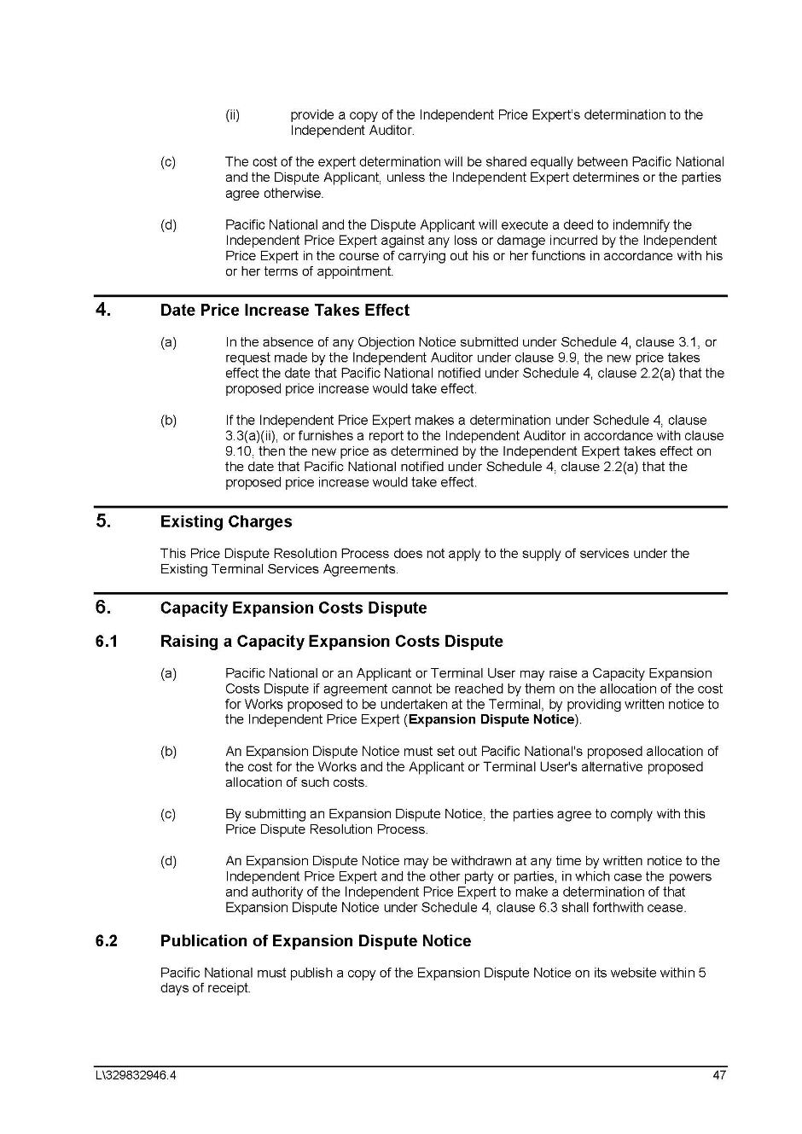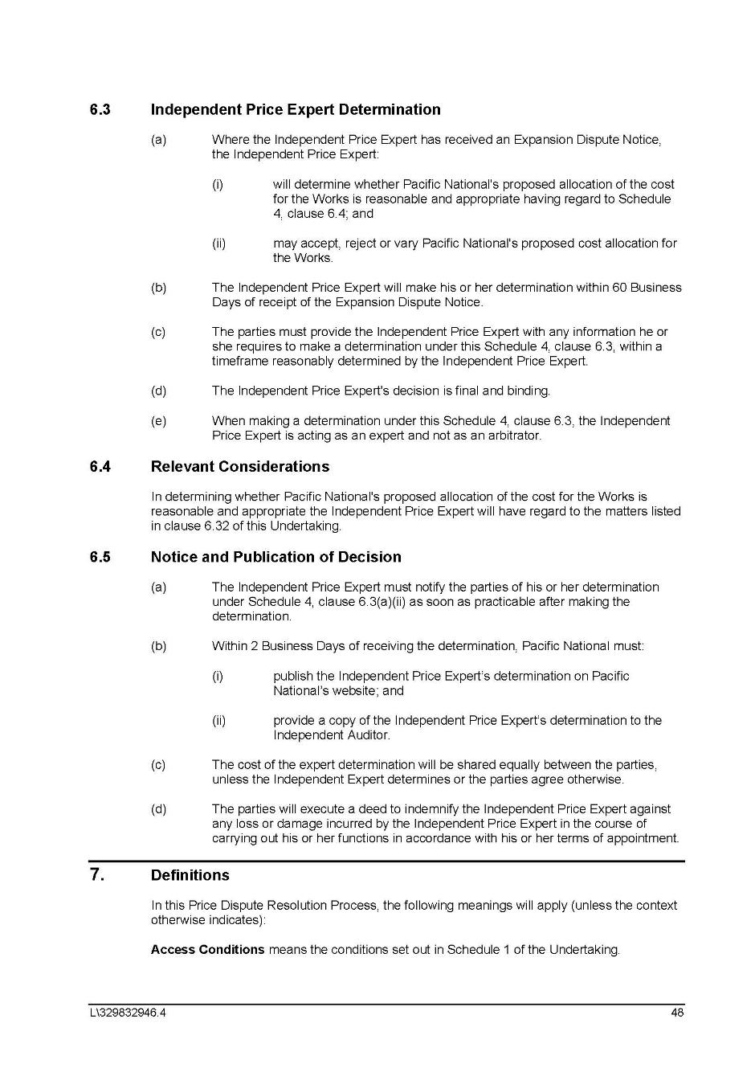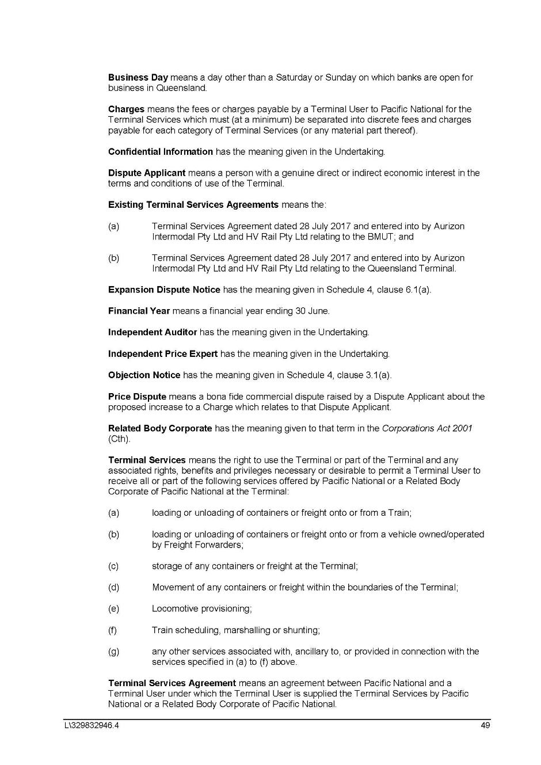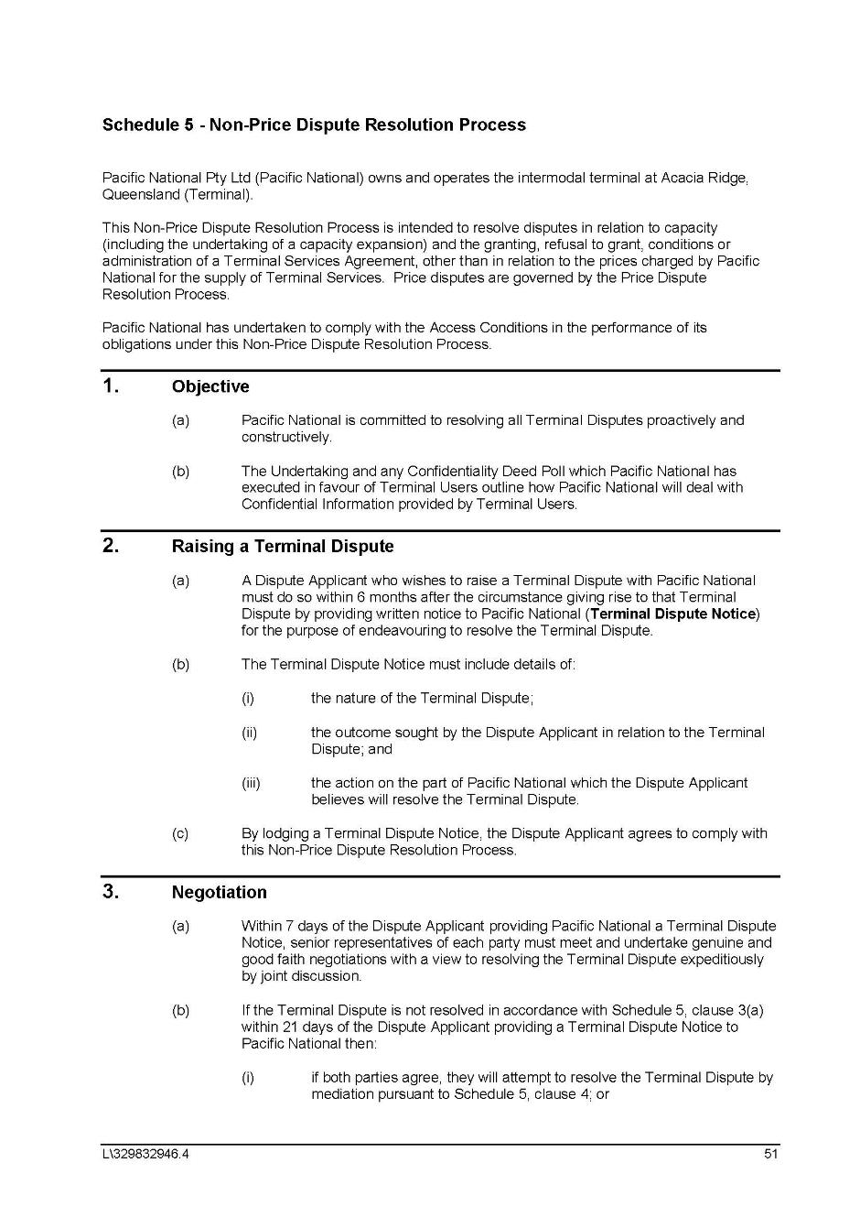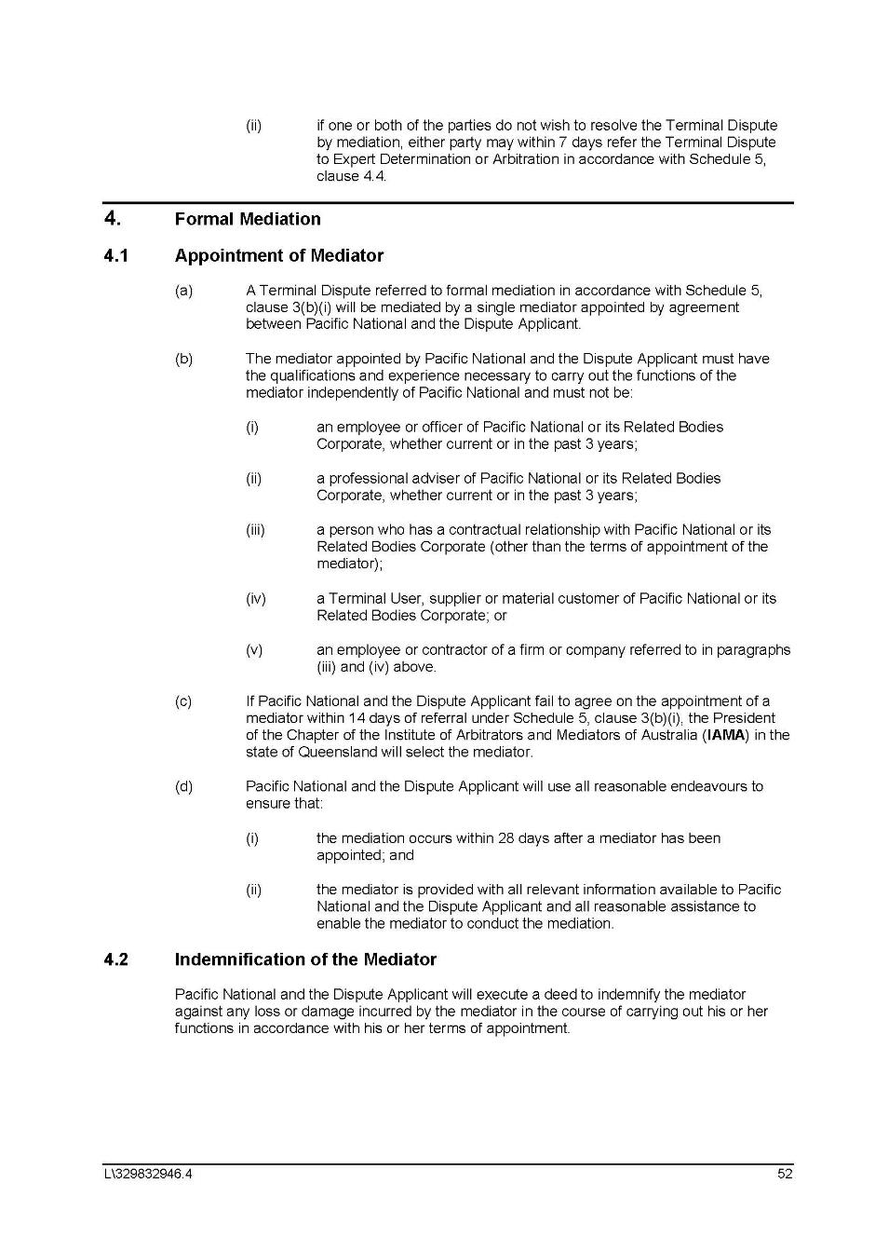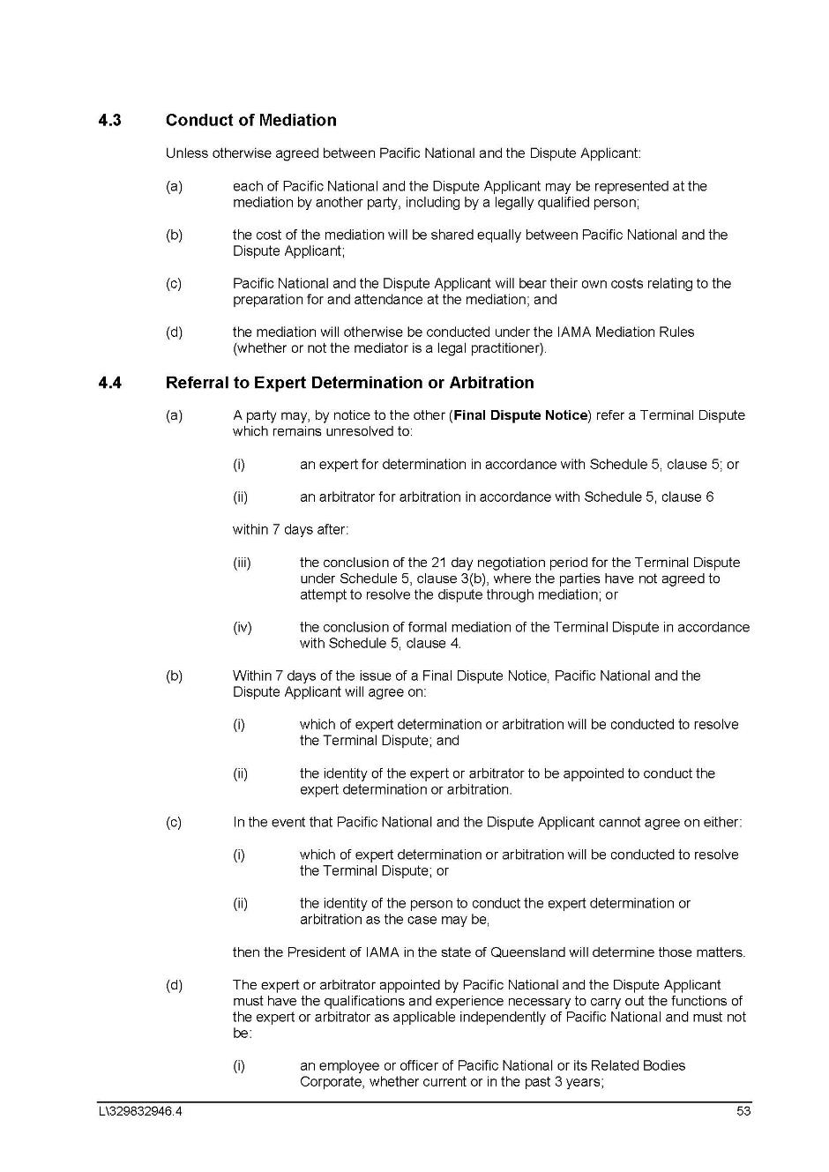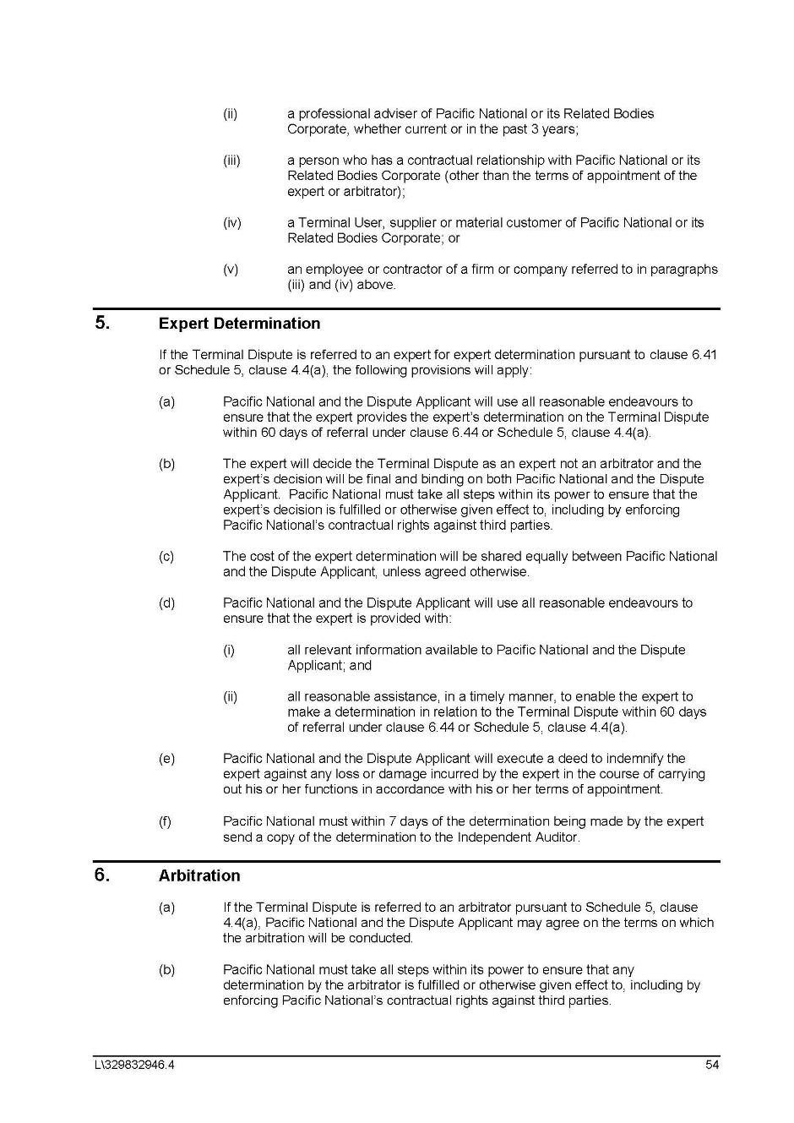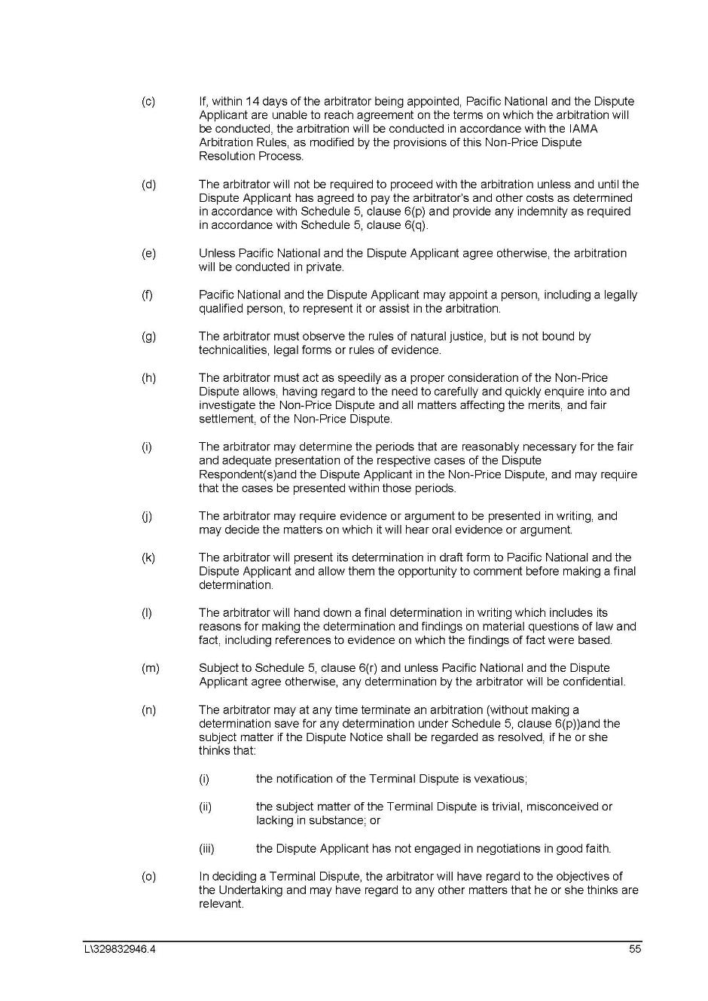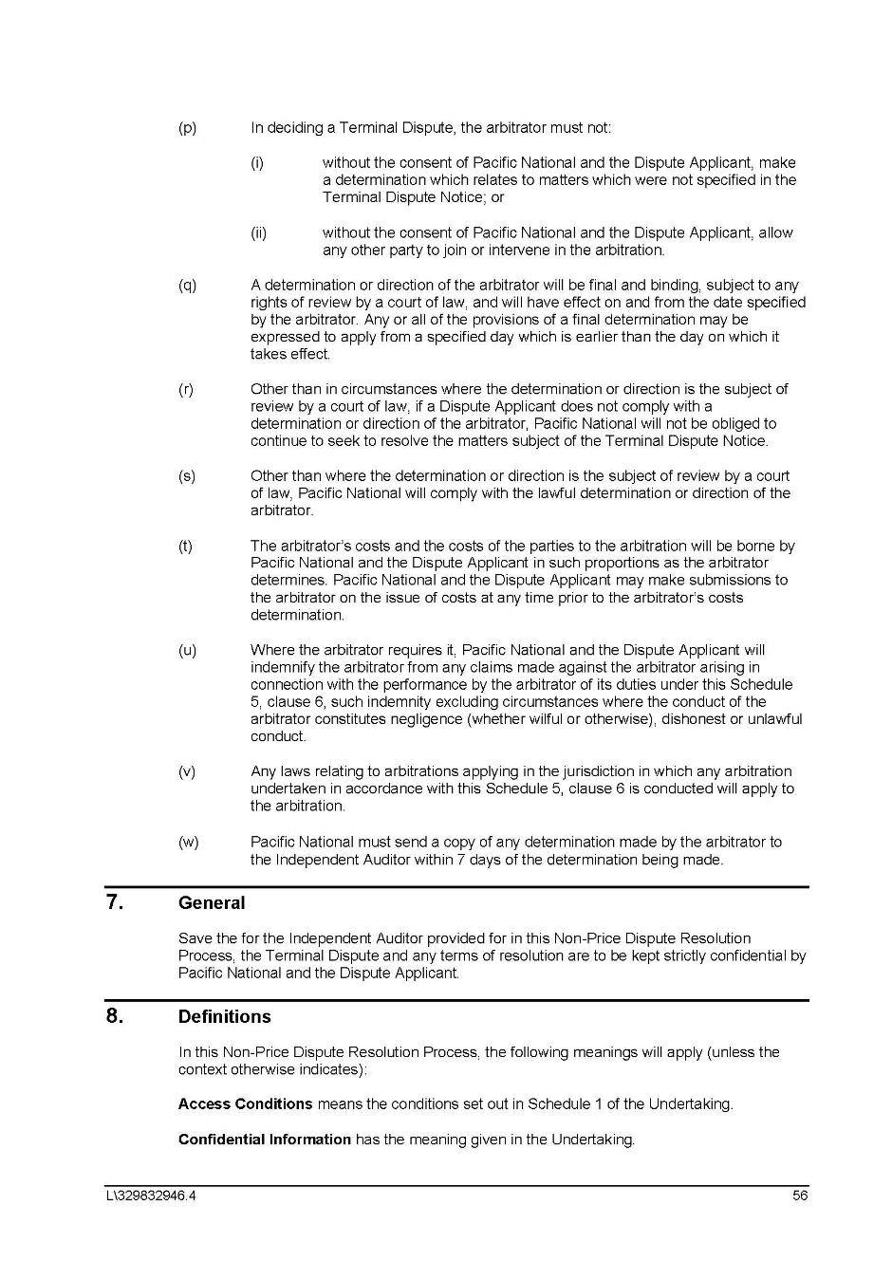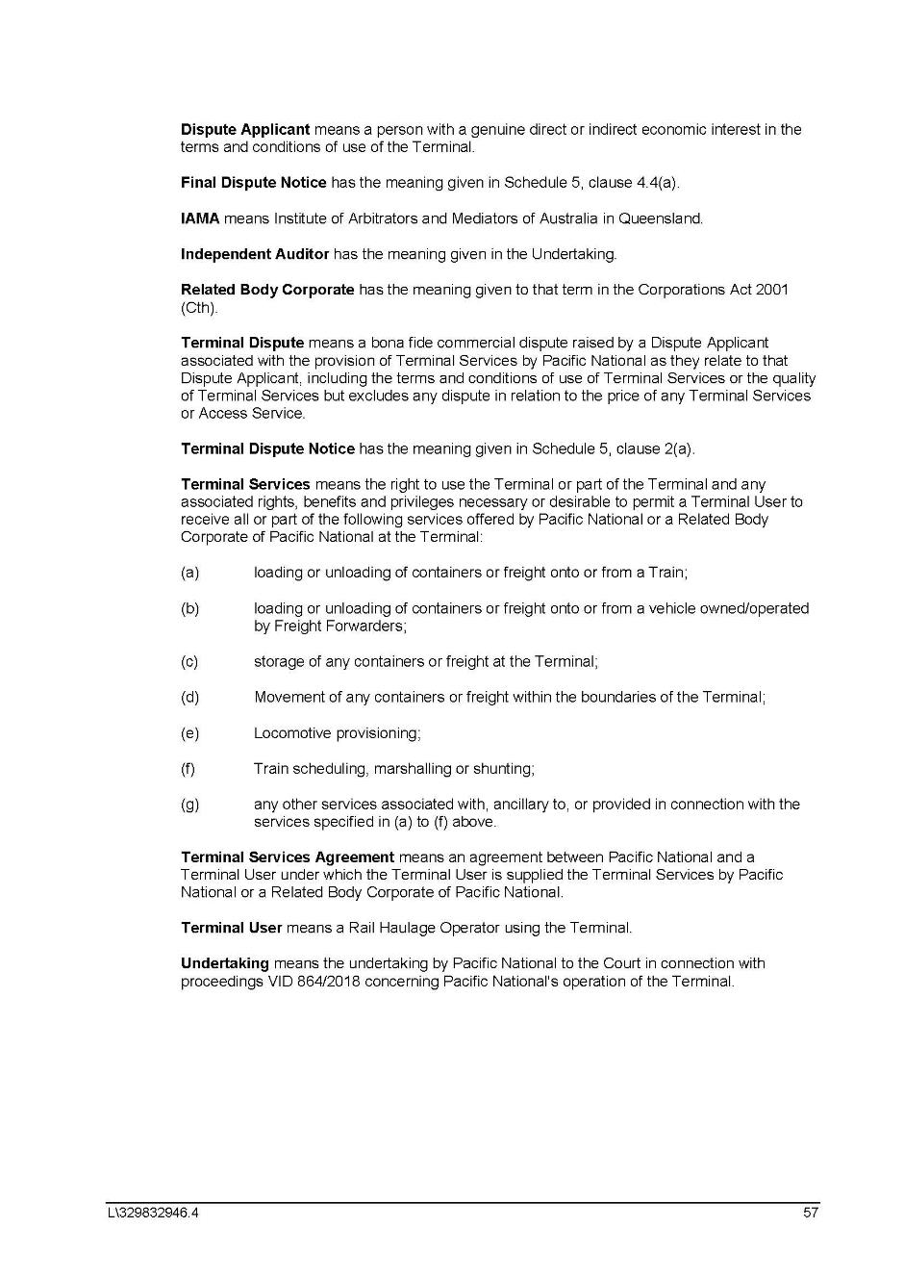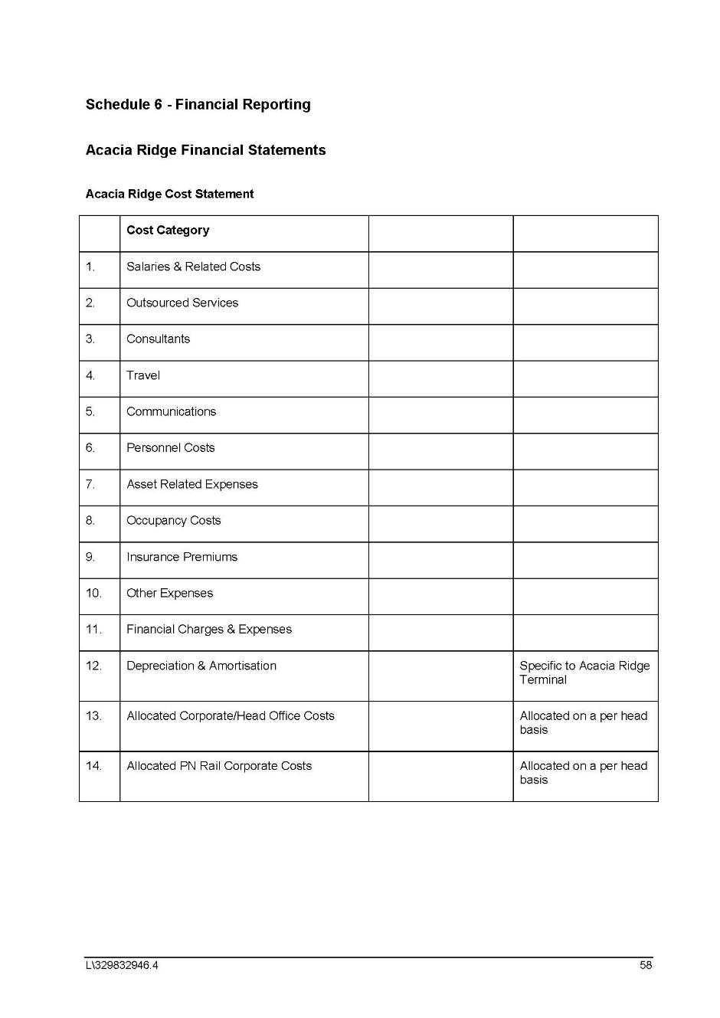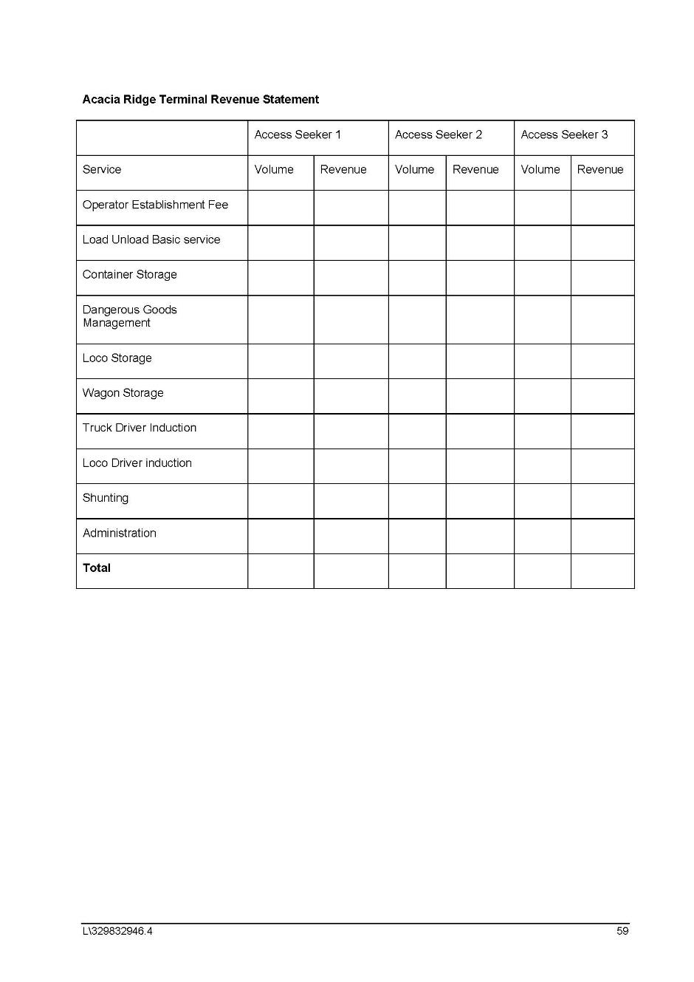

SCHEDULE OF PARTIES

 | VID 864 of 2018
Respondents
Fourth Respondent: | QUEENSLAND PUD CO PTY LTD (ACN 620 981 606)
Fifth Respondent: | AURIZON HOLDINGS LIMITED (ACN 146 335 622)
Sixth Respondent: | AURIZON OPERATIONS LTD (ACN 124 649 967)
Seventh Respondent: | AURIZON TERMINAL PTY LTD (ACN 145 991 555)
Eighth Respondent: | AURIZON PROPERTY PTY LTD (ACN 145 991 724)

