**+**

**History**

**A Brief History of Bedford Park**  
   
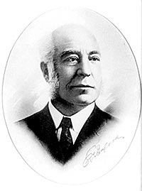In the early 1900’s, or before, the area now known as the Village of Bedford Park, was acres of flat prairie. In 1906, Corn Products Refining Company broke ground for a wet milling plant in this prairie land. By 1908 with the CPR factory taking shape, the company became concerned about housing for their foremen. By 1919 homes began to spring up and the foremen were able to buy the homes from the company which also financed the homes. Mr. E.T. Bedford was the president of Corn Products at the time and the village was named after him.  
   
In 1924, the Bedford Park Improvement Club was formed to establish a sense of local government. Paul Bishop was elected the first president. Regular elections were held and Carrie Downs , the “Lady Mayor” served the community many years. Police and fire service were provided on a volunteer basis throughout that time period. A two wheel horse cart was used by the Fire Department until 1951.  
Water service was provided through the Corn Products well system. The original  
one room school house “The Portable” was opened on 65th Street in 1925. Walker School would open at its current site on May 10, 1934.  
   
The Village of Bedford Park was incorporated in June, 1940. Henry C. Wahl was elected the first mayor. The boundaries included Corn Products Company and adjacent properties such as the Clearing Industrial District. The first Village meetings were held at Walker School and were moved to the Park District Community Building in 1951. The Village was established with a very strong industrial base and a small residential section. Through the 1960’s most of the residents worked at Corn Products. In 1940, the residential area consisted of 66th Street and 65th Place. Homes began to pop up on 66th Place and 65th Street in the late 40’s. Two Lustron homes were constructed in the late 1940’s. One of those homes remains today.  
   
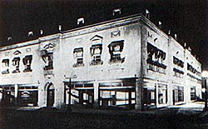The Village has a strong Park District and Library District that has served the community for a number of years. The Park District was formed in 1939 serving residents of Bedford Park and Bridgeview Gardens. A Community Building was opened in 1951. In addition to that building, the Park District has the Swanson Center facility in addition to excellent baseball fields, jogging and bike paths, a children’s pool, and playground facilities. The Library District was formed in 1962 and opened its’ first facility in 1963 at the former “pump house”. Corn Products donated land for a new facility in 1970 and that library facility opened in 1976.  
   
The Bedford Park Clearing Industrial Association has been a major part of the Village’s history. Industrial and commercial projects have been part of the industrial district since the 19th century. The Association provided police and fire protection for the area through the 1950’s. During the peak years in the 1950’s an estimated 40,000 people worked in the District. Major companies such as Corn Products, 3 M, Nalco, Cracker Jack, Viskase, Continental Can, CSX, the Belt Railroad, and Fed Ex have called Bedford Park home. The Bedford Park Midway Hotel Complex was developed by the Weglarz family beginning in the 1980’s. Today eight hotels with over 1600 beds reside in the complex. Commercial and retail development front Cicero Avenue and have become a major part of the business district. Logistics related businesses utilizing the Belt and CSX Railroad facilities have become an important part of the industrial area. The Association continues to play a major role in attracting new businesses to Bedford Park.  
   
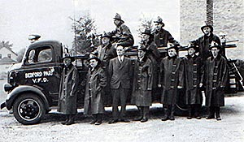The Village has developed excellent services for our business community as well as our residents. Our Water Department is the third largest user of Lake Michigan water in northern Illinois and sells water to many of the southwestern suburbs. The Administrative staff serves our 400 businesses in addition to our residents. The Fire Department has evolved from the original horse drawn cart to a 64 member staff with top rated HAZMAT and Paramedic staffs. The Police Department has 38 members and serves the community 24/7. Our Communications staff operates a state of the art facility. The Public Works Department maintains the Village’s facilities and ensures that transportation remains a vibrant part of the Village.  
   
During the early 21st Century, “Preserving the Past to Enhance the Future” became an important theme to the Village. A decorative fence was constructed in 2008 to enhance the residential area. The Village takes great pride in our past achievements and in the service we offer our residents and business community.  
   
For a more detailed history ask for “Chronicles of Bedford Park” by Elmay Swanson at the Library or the Village Hall.