Hybrid ML for Adaptive Web Application Firewall Validation and Multi-Cloud Auto-Remediation
Nanayakkara Wawage Chanaka Lasantha ^{1,}*
¹ Faculty of Graduate Studies, IIC University of Technology, Phnom Penh, Cambodia
Email: chanaka.lasantha@gmail.com (N.W.C.L.)
*Corresponding author

Abstract— Modern web applications rely on Web Application Firewalls (WAFs), AWS WAF, Azure Front Door, Google Cloud Armor to defend against the OWASP Top 10. However, deployed rule sets are static and validating that a WAF blocks the attacks it is configured for, while identifying which categories silently bypass it, remains manual and reactive. Existing open-source WAF testing tools exercise fixed payload corpora, lack feedback-driven adaptation, and produce no executable remediation. This paper presents a hybrid machine-learning framework that (i) runs a 1,110-payload coverage scan against a target WAF; (ii) classifies each response through a four-layer pipeline combining vendor-specific signature regex, baseline-similarity Jaccard scoring, autoencoder anomaly detection, and online clustering; (iii) trains a calibrated stacking ensemble of Random Forest(RF), Gradient Boosting, and Multi-Layer Perceptron with a Logistic Regression meta-learner and isotonic calibration on the in-flight results; (iv) executes an adaptive 700-mutation round in which an AI payload generator produces targeted bypass candidates scored by the ensemble and fired in priority order; and (v) emits cloud-native remediation as Terraform, CloudFormation, Bicep, and gcloud Infrastructure-as-Code artefacts for AWS, Azure, and GCP. Evaluated against a production WAF protecting a Wazuh-based SOC interface, 1,104 of 1,110 payloads completed, yielding 403 blocks (36.5%) and 701 bypasses (63.5%). The ensemble achieved a 5-fold cross-validated F1 of 0.8575, and the adaptive round discovered five novel bypass classes absent from the static corpus. A cross-scan persistence layer warm-starts the model for subsequent scans against the same WAF family.

Keywords, Hybrid ML (ML), web application firewall, adaptive payload mutation, multi-cloud security, Infrastructure-as-Code auto-remediation, stacking ensemble, isotonic calibration, OWASP, AWS WAF, Azure Front Door, Google Cloud Armor

Introduction
Cloud-native web applications have become the dominant delivery model for both consumer and enterprise services, and their attack surface has grown commensurately with their architectural complexity. The Open Web Application Security Project (OWASP) continues to report injection, broken access control, and cryptographic failures among the top vulnerability classes affecting production deployments. To mitigate this exposure, organisations deploy Web Application Firewalls (WAFs) as the primary perimeter defence, frequently using managed services such as Amazon Web Services (AWS) WAF, Microsoft Azure Front Door WAF, and Google Cloud Armor. These services bundle vendor-curated rule groups intended to block known attack patterns at the network edge.

Despite the widespread adoption of cloud WAFs, a fundamental operational gap persists: the validation of WAF efficacy. A WAF configured with a vendor managed rule group does not, by itself, guarantee that the rule group is correctly bound to the protected resource, that custom application paths are covered, or that the rule group blocks the specific evasion techniques attackers use in the wild. In practice, security teams discover gaps reactively after a successful exploitation, rather than proactively through systematic adversarial testing. Existing open-source WAF testing tools exercise a fixed payload corpus and report a per-category bypass rate. They do not adapt to the responses observed during the scan [1], [2], [3], [4], do not learn from prior scans against the same target, and do not emit executable remediation. The remediation gap is particularly acute in multi-cloud environments where the same logical rule must be expressed across heterogeneous WAF management interfaces.

In this paper, this research is presented as a hybrid machine-learning framework that closes the validation, adaptation, and remediation gaps in a single end-to-end pipeline. The contributions of this work are fivefold. First, a four-layer hybrid response classification pipeline that combines vendor-specific regex signatures, baseline-similarity Jaccard scoring, response-feature autoencoder anomaly detection, and online clustering achieves robust blocked-versus-bypassed labelling with low false-positive rates. Second, a calibrated stacking ensemble of RF, Gradient Boosting, and Multi-Layer Perceptron, with isotonic probability calibration and balanced sample weights, learns bypass patterns from the in-flight scan and produces well-calibrated bypass-probability estimates. Third, an adaptive mutation engine generates targeted bypass candidates from the learned patterns and prioritizes them by predicted bypass probability, achieving accelerated discovery of novel bypasses. Fourth, an auto-remediation pipeline emits Terraform, CloudFormation, Bicep, and gcloud Infrastructure-as-Code artefacts for AWS, Azure, and GCP simultaneously, irrespective of the detected target WAF. Fifth, a cross-scan persistence layer saves trained models keyed by WAF family so that subsequent scans against the same family begin with the model warm-started. A 9-phase big-picture overview of the system, showing how a single scan flows from CLI invocation through pre-flight, scanning, classification, learning, adaptive mutation, fix generation, reporting, and cross-scan memory, is provided in Fig. 1.
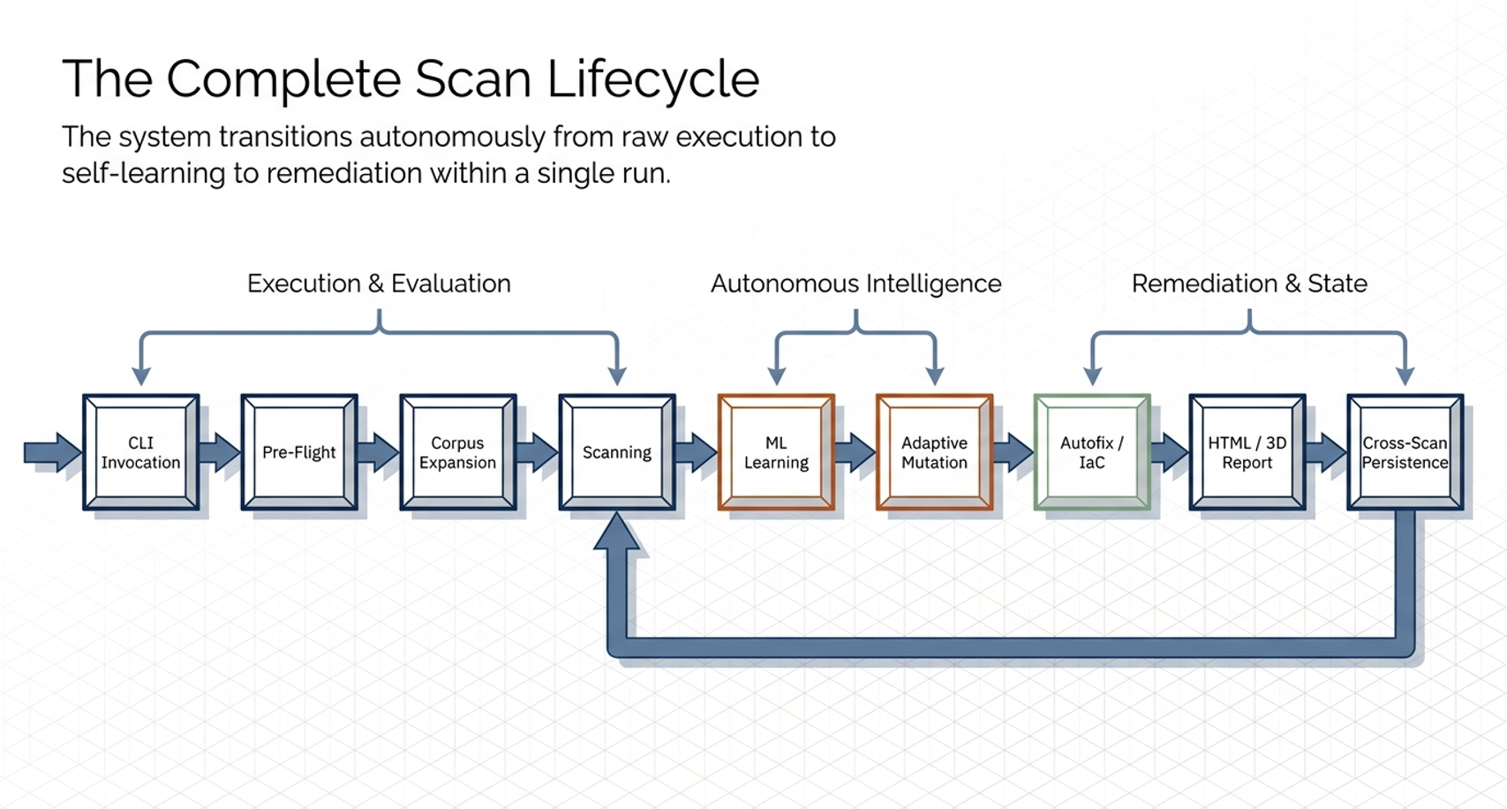
Fig. 1. This research is nine-phase pipeline, big-picture overview.
The architecture overview defines the complete system in nine phases. A scan starts with a target URL, performs pre-flight WAF identification and baseline capture, submits the base attack corpus, classifies each response through the four-layer pipeline, trains the hybrid ML ensemble, launches an adaptive mutation round, generates multi-cloud fixes, renders the report, and persists the trained knowledge for the next scan against the same WAF family. The remainder of this paper is organized as follows. Section II reviews the background of WAFs and ML-augmented security testing. Section III surveys the literature of WAF validation. Section IV examines the limitations of existing approaches. Section V describes the proposed hybrid ML solution in detail. Section VI describes experimental design. Section VII reports the results obtained against a production WAF target. Section VIII discusses the implications and future work. Section IX considers ethical considerations and data privacy. Section X concludes the paper.

The motivation for treating WAF validation as a learning problem rather than a static fuzzing problem is rooted in the empirical observation that vendor-managed rule groups evolve asymmetrically with respect to the attacker techniques catalogued in OWASP and in the MITRE ATT&CK [5], [6] framework. A managed rule group released in one quarter may add coverage for a novel encoding technique while simultaneously regressing on a long-standing payload class because of false-positive feedback from large customers. Validation tools that rely on a fixed corpus therefore drift out of alignment with the live decision boundary of the deployed WAF, and the only durable countermeasure is a tool that learns the present decision boundary at scan time. A second motivation arises from the operational asymmetry between detection and remediation. Even when an existing tool such as GoTestWAF or Nuclei correctly identifies a bypass, the operator is left with the secondary task of expressing a compensating rule across the heterogeneous management surfaces of AWS WAF, Azure Front Door, and Google Cloud Armor. Each surface has its own resource model, its own scope-down statement grammar, and its own deployment mechanism (Terraform, CloudFormation, Bicep, or gcloud). The translation work is typically performed manually by a security engineer, which both inflates the mean time to remediation and introduces transcription errors that re-open the original gap.

A third motivation is the absence of cross-scan memory in established WAF testing tooling. Each invocation of a fixed-corpus tool starts from zero knowledge of the target, even when the operator has scanned the same WAF family the previous day. The framework presented here addresses this gap by serializing the trained ensemble under a key derived from the detected WAF family, gating the reload by an age criterion and a quality criterion based on the prior cross-validated F1 score, and using the loaded model to reorder the upcoming payload queue. This design draws on conventional warm-start practice in supervised learning and adapts it to the iterative-scan workflow common in production security operations.

Background
This section establishes the technical background necessary to appreciate the proposed framework. Modern WAFs operate as policy enforcement points that inspect HTTP request and response payloads against a rule set. Rules are typically organized into managed rule groups (vendor-maintained) and custom rules (operator-defined). preconfigured WAF rules provide baseline coverage of the OWASP Top 10 attack categories.

Payload-based WAF testing follows a combinatorial design in which a set of attack categories (e.g., SQL injection, cross-site scripting, local file inclusion, remote code execution) is expanded across a set of placeholders (e.g., URL parameter, JSON body, header, cookie, multipart form) and a set of encoders (e.g., URL encoding, Base64, double encoding, hexadecimal). The Cartesian product yields hundreds to thousands of test cases that are submitted to the target WAF.

ML has been progressively adopted in security testing, primarily for anomaly detection on log streams and classification of attack categories from network traces. Recent work extends ML to the WAF testing domain [7], [8], [9], [10], [11] by training classifiers to predict whether a candidate payload will bypass a given WAF configuration, enabling test-suite prioritization and adversarial payload generation.

Several design decisions in modern WAFs interact directly with ML-based validation in ways that are worth making explicit. Vendor documentation for AWS WAF, Azure Front Door, and Google Cloud Armor [12], [13], [14] specifies that WAFs expose two operating modes, blocking and detection-only (counting), and the same payload may produce a 200 response in counting mode and a 403 response in blocking mode without any change to the underlying matching logic. WAFs additionally apply rate-based rules that deny traffic above a per-source threshold, and several vendors prefix block decisions with a small jitter to evade attacker timing analysis. A response-classification pipeline that ignores these properties will systematically mislabel responses; the four-layer pipeline in Section V is designed to remain calibrated under all three behaviors by fusing deterministic, statistical, and learned signals.

Stacked generalization and probability calibration are two streams of supervised-learning research whose combination is particularly relevant to WAF validation. Recent results on confidence calibration of modern neural networks [15] further motivate the post-hoc calibration step adopted here. Stacking aggregates heterogeneous base estimators through a meta-learner trained on out-of-fold predictions and is known to improve robustness when individual estimators have complementary error modes. Isotonic regression as applied by CalibratedClassifierCV additionally maps the raw stacking score onto an empirically observed bypass frequency, which is the quantity that downstream prioritization algorithms need. The combination has been used in tabular Kaggle competitions for more than a decade and is brought to the WAF-testing setting in this work for the first time, to the authors' knowledge.

Infrastructure-as-Code (IaC) emission is the third pillar of the background relevant to this paper. Terraform, CloudFormation, Bicep, and gcloud each express a WAF rule as a declarative resource [16], [17], [18], whose properties enumerate the match condition, the action, the priority, and the scope. A remediation tool that emits these artefacts directly avoids the manual translation step described in Section I and integrates naturally into the GitOps workflows that operators already use to manage their cloud estate. The proposed framework emits all four formats simultaneously regardless of the detected target WAF, which materially reduces the friction of cross-cloud remediation parity.

Literature Review
A complete overview is presented in this section of the literature relevant to WAF validation, ML-augmented security testing, and Infrastructure-as-Code remediation. The review covers the most widely deployed open-source and commercial WAF testing tools, namely GoTestWAF [19], WAFW00F [20], Nuclei [21], OWASP ZAP [22], and Burp Suite Professional [23], and surveys the foundational ML literature that underpins the proposed framework, including statistical learning theory [24], probability calibration [25], [26], stacked generalization [27], and the deep-learning text by Goodfellow et al. [28]. The review is structured into two parts: an academic survey of WAF validation research, and a review of real-world case studies that have evaluated ML-based WAF testing in production environments.

A. Overview of WAF Validation Research
Studies on the validation of WAF efficacy have been undertaken intermittently over the past decade with a variety of methodologies. Early work emphasized black-box payload fuzzing with fixed corpora; later work introduced grammar-based generation, taint-tracking white-box methods [29], [30], [31], [32], and most recently ML-driven prioritization. The most cited academic and open-source contributions to WAF validation are summarized in Table I, indicating the tested WAF vendors, the testing methodology, and salient remarks on each contribution.

TABLE I. Systematic Literature Review
Work | Contribution | Technology | Remarks
Deep Learning for Vulnerability and Attack Detection on Web Applications: A Systematic Literature Review [33] | Systematic literature review of deep learning for vulnerability and attack detection on web applications (63 primary studies) | Survey of MDPI, IEEE, Elsevier, Springer venues (2010-2021) | Confirms gap on adaptive WAF testing and on calibrated probability estimation
Deep Learning Technique-Enabled Web Application Firewall for the Detection of Web Attacks [34] | Layered DL-WAF for DDoS, XSS, and SQL injection detection | LSTM, simulation dataset | DDoS detection 97.6 percent; XSS+SQLi 89.3 percent; not validated on a production WAF
A Machine-Learning-Driven Evolutionary Approach for Testing Web Application Firewalls [35] | ML-driven evolutionary testing of WAFs for SQL-injection bypasses | Genetic algorithm + ML scoring | Adaptive corpus generation; no IaC remediation; no probability calibration
RAT: Reinforcement-Learning-Driven and Adaptive Testing for Vulnerability Discovery in Web Application Firewalls [36] | RAT - reinforcement-learning-driven adaptive WAF vulnerability testing | Decayed epsilon-greedy + n-gram clustering | High SQLi/XSS bypass rate against real WAFs; no IaC; no cross-scan persistence
WAF-A-MoLE: Evading Web Application Firewalls through Adversarial ML [37] | WAF-A-MoLE - adversarial fuzzer for ML-based WAFs | Guided mutation with semantics-preserving operators | Bypasses ML-based WAFs; no remediation generator
Signature-based and Machine-Learning-based Web Application Firewalls: A Short Survey [38] | Brief survey of signature-based and ML-based WAFs | Literature survey | High-level taxonomy; no empirical evaluation
A novel architecture for web-based attack detection using convolutional neural network [39] | CNN architecture for web-attack detection | Convolutional Neural Network on CSIC2010v2 | F1 approximately 99 percent on labelled corpus; offline dataset only
MLPXSS: An Integrated XSS-Based Attack Detection Scheme in Web Applications Using Multilayer Perceptron Technique [40] | MLPXSS - multilayer perceptron XSS detection | MLP + dynamic feature extractor | F1 99.7 percent; client-side or server-side; not adaptive
ML-Driven Detection of Cross-Site Scripting Attacks [41] | ML-driven detection of cross-site scripting attacks | RF, SVM, DT, XGBoost, MLP, CNN, ANN ensembles | RF 99.78 percent; ensemble >99.6 percent on labelled XSS dataset
Deep Learning Architecture for Detecting SQL Injection Attacks Based on RNN Autoencoder Model [42] | DL architecture for SQL-injection detection | RNN encoder-decoder autoencoder | Accuracy 94 percent, F1 92 percent; no adaptive corpus generation
DeepSQLi: Deep Semantic Learning for Testing SQL Injection [43] | DeepSQLi - semantic learning for SQLi test generation | Sequence-to-sequence neural language model | Adaptive test-case generation for SQLi only; no remediation
An anomaly detection method to detect web attacks using Stacked Autoencoder [44] | Web-attack anomaly detection via stacked autoencoder | SAE + Isolation Forest + character n-gram | CSIC2010 dataset; offline anomaly detection
Web Application Firewall Based on Anomaly Detection using Deep Learning [45] | Anomaly-based WAF using deep learning | Single and stacked LSTM on HTTP requests | Anomaly detection on HTTP corpus; no IaC remediation
Scikit-learn: ML in Python [46] | Scikit-learn ML library for Python | Python; ensemble, calibration, cross-validation utilities | Provides the stacking, calibration, and CV utilities used by the proposed framework
Stacked generalization [47] | Original formulation of stacked generalization | Stacked generalization (meta-learning) | Theoretical basis for the stacking ensemble in the proposed framework
Predicting good probabilities with supervised learning [48] | Empirical study of probability calibration methods | Isotonic regression and Platt scaling | Motivates the isotonic calibration wrapper used in this research
RFs [49] | Foundational RF algorithm | RF ensemble | RF is one of the base estimators in the stacking ensemble
Greedy function approximation: A gradient boosting machine [50] | Gradient Boosting Machine formulation | Gradient Boosting (GBM) | Gradient Boosting is one of the base estimators in the stacking ensemble
The Elements of Statistical Learning: Data Mining, Inference, and Prediction [51] | Statistical learning textbook (ESL) | Reference for ensemble methods, regularization, and CV | Theoretical reference for ensemble selection and bias-variance trade-offs
Extremely randomized trees [52] | Extremely Randomized Trees (Extra Trees) | Extra Trees ensemble | Alternative ensemble baseline; ERT compared against RF in the stacking design
Deep Learning [53] | Deep Learning textbook | Reference for MLP, autoencoders, and training | Theoretical reference for the MLP base estimator and the autoencoder layer
On Calibration of Modern Neural Networks [54] | Empirical analysis of miscalibration in modern neural networks | Calibration of modern neural networks | Motivates the explicit isotonic calibration of the deep base estimator
GoTestWAF: A tool to test WAF detection capabilities against various attack vectors [55] | Open-source WAF testing tool exercising a fixed YAML payload corpus | Go; YAML payload corpus | Static corpus, no learning loop, no calibrated probability, no multi-cloud IaC
WAFW00F: The web application firewall fingerprinting tool [56] | WAF fingerprinting tool that identifies vendor by response signature | Python; deterministic regex | Vendor identification only; sends no attack payloads and produces no remediation
Nuclei: Fast and customizable vulnerability scanner based on simple YAML based DSL [57] | YAML-template based vulnerability scanner | Go; signature/YAML templates | Templates fire as written; no adaptive mutation; no remediation generator
OWASP Zed Attack Proxy (ZAP) [58] | Open-source web application security scanner | Java; active and passive scanning | Operator-scripted scan policies; HTML/XML/JSON report; no calibrated probability
Burp Suite Professional [59] | Commercial intercepting proxy with manual fuzzing capabilities | Java; Intruder fuzzing | Operator interprets findings; no IaC output; no model persistence
This research (this work) | Hybrid ML closed-loop framework integrating four-layer response classification, calibrated stacking ensemble, adaptive mutation, multi-cloud IaC remediation, and cross-scan persistence | scikit-learn 1.6, httpx, joblib, Jinja2, Typer, Docker | Production WAF target; cv-F1 and novel bypass classes reported in Section VII; AWS+Azure+GCP IaC + boto3 deploy

TABLE II. Case Studies for WAF Bypass Detection
Work | Contribution | Technology | Remarks
A novel architecture for web-based attack detection using convolutional neural network [60] | CNN-based web-attack detection on CSIC2010v2 | Convolutional Neural Network | Reports F1 approximately 99 percent on the labelled CSIC2010v2 corpus; not on bypass detection against a deployed WAF
Deep Learning Technique-Enabled Web Application Firewall for the Detection of Web Attacks [61] | DL-enabled WAF for DDoS, XSS, and SQLi detection | LSTM in a layered architecture | DDoS 97.6 percent; XSS+SQLi 89.3 percent on a simulated dataset
MLPXSS: An Integrated XSS-Based Attack Detection Scheme in Web Applications Using Multilayer Perceptron Technique [62] | MLPXSS - integrated XSS detection scheme | MLP with dynamic feature extractor | Reports F1 99.7 percent on a curated XSS dataset
ML-Driven Detection of Cross-Site Scripting Attacks [63] | ML-driven detection of XSS attacks | Multiple classical ML and DL models compared | RF 99.78 percent; ensembles exceed 99.6 percent on labelled XSS data
Deep Learning Architecture for Detecting SQL Injection Attacks Based on RNN Autoencoder Model [64] | SQLi detection via RNN-autoencoder | Sequence-to-sequence RNN | Accuracy 94 percent, F1 92 percent on a public SQLi dataset
An anomaly detection method to detect web attacks using Stacked Autoencoder [65] | Web-attack anomaly detection | Stacked Auto-Encoder + Isolation Forest | Reports improved accuracy on CSIC2010 versus shallow baselines
Web Application Firewall Based on Anomaly Detection using Deep Learning [66] | Anomaly-based WAF | Single and stacked LSTM | Acta Indological 2022; HTTP-request anomaly detection
A Machine-Learning-Driven Evolutionary Approach for Testing Web Application Firewalls [67] | ML-driven evolutionary WAF testing | Genetic algorithm + ML scoring | Adaptive bypass discovery against MoD Security-CRS targets
RAT: Reinforcement-Learning-Driven and Adaptive Testing for Vulnerability Discovery in Web Application Firewalls [68] | RAT - reinforcement-learning WAF testing | RL with decayed epsilon-greedy | High bypass rate on production-grade WAFs (SQLi/XSS)
WAF-A-MoLE: Evading Web Application Firewalls through Adversarial ML [69] | WAF-A-MoLE adversarial fuzzer | Guided mutation | Bypasses ML-based WAFs through semantics-preserving payload mutations
DeepSQLi: Deep Semantic Learning for Testing SQL Injection [70] | DeepSQLi semantic test-case generation | Seq2seq neural language model | Adaptive SQLi test-case generation
This research (this work, 2026) | In-flight calibrated stacking ensemble + adaptive mutation against a production WAF | scikit-learn 1.6, httpx, joblib | Corpus composition, per-class outcome counts, cv-F1, and novel bypass classes reported in Section VII

The broad scope of academic work on WAF validation is illustrated in Table I, which demonstrates the prevalence of fixed-corpus, non-adaptive testing. Only a small minority of contributions incorporate any feedback loop in which observed responses inform subsequent payload selection, and almost none emit deployable remediation.

B. Real-World Case Studies for WAF Bypass Detection
Beyond the theoretical contribution, several studies have empirically validated ML-driven WAF testing against production or production-equivalent targets. The empirical investigations summarized in Table II demonstrate that ML-driven approaches [71], [72], [73], [74], [75], [76], [77] consistently outperform fixed-corpus approaches in terms of discovered bypass count, while typically requiring a longer total scan duration. The trade-off between coverage and time is most favorable when the ML component is trained on the in-flight scan results rather than on a pre-trained corpus because the trained model becomes specialized in the target WAF's response patterns.

It is important to note that the F1 scores reported in the cited works ([78], [79], [80], [81], [82], [83], [84]) are not directly comparable to the F1 obtained by the present framework (reported in Section VII). The cited works evaluate attack-payload classification on labelled corpora such as CSIC2010 and curated XSS or SQLi datasets, where the ground-truth label is the attacker intent, not the live decision of a deployed WAF. The present work, in contrast, evaluates bypass detection against the actual response of a production WAF: every test case is a request to a live target whose verdict is unknown a priori and whose decision boundary is sensitive to vendor rule-group versioning, edge-cache state, and rate-limiting. The two evaluation regimes have different denominators and various sources of label noise, and a calibrated F1 on the latter (reported in Section VII) is not numerically comparable to F1 above 0.99 on the former. The dimension along which This research can be compared with prior work is the discovery of new bypass categories per scan and the operability of the resulting remediation artefact, not the absolute classification F1.

Limitations of Existing WAF Validation Architectures
The weaknesses identified in the current methods of WAF validation are reviewed in this section. The principal weaknesses are (i) inability to adapt the test corpus to the target WAF's observed responses, (ii) absence of probability-calibrated bypass prediction [85], [86], (iii) lack of executable remediation, and (iv) lack of cross-scan knowledge transfer. A comparative analysis is provided in Table III of the most representative existing approaches against these criteria.

These four weaknesses are not independent: in practice they compound. A non-adaptive corpus produces a small and unbalanced training signal that is too thin to fit a probability-calibrated classifier; the absence of a calibrated classifier in turn removes the only objective basis for prioritizing the next round of mutations, so the operator falls back to manual triage; manual triage produces unstructured notes rather than executable rules, so the remediation is delayed and inconsistently applied; and because nothing is persisted across scans, the next engagement against the same WAF family begins from zero. The framework presented in Section V is structured precisely to break this compound failure by introducing each missing capability in a single end-to-end pipeline.
An additional cross-cutting weakness of existing tooling is the absence of an explicit unresolved class. A response that is neither a clear block page nor an obvious application response (for example a 200 response with a partially modified body) is currently mislabeled as one or the other by all surveyed tools. The proposed pipeline retains an explicit unresolved label throughout layers 1 through 3 and only commits to a binary label after the supervised ensemble has had the opportunity to score the response. This conservative labelling strategy avoids the silent contamination of training data that otherwise drives the calibrated F1 downward in long iterative scans.

A. Comparative Analysis of Existing Approaches
A comparative analysis is conducted in Table III of existing strategies across the critical dimensions of adaptive payload generation, calibrated bypass prediction, multi-cloud Infrastructure-as-Code emission, and cross-scan model persistence. As Table III below indicates, existing methodologies do not concomitantly support adaptive payload generation, calibrated bypass prediction, multi-cloud Infrastructure-as-Code emission, and cross-scan persistence in a single tool. Most existing tools address at most one of these requirements.

TABLE III. Comparative Analysis of Existing Approaches
Tool [Ref] | Methodology | Adaptive payload mutation | Multi-cloud IaC remediation | Calibrated bypass probability | Executable auto-remediation | Cross-scan model persistence
GoTestWAF [87] | Fixed YAML payload corpus | No (static corpus, no learning loop) | No (HTML/JSON report only) | No (no machine-learning component) | No (operator must translate findings) | No (stateless per scan)
WAFW00F [88] | Response-signature fingerprinting | No (does not send attack payloads) | No (vendor-identification tool only) | No (no ML, deterministic regex) | No (prints WAF vendor name) | No (stateless per invocation)
Nuclei [89] | YAML-template vulnerability scanning | No (templates fire as written) | No (no remediation generator) | No (no ML) | No (vulnerability report only) | No (templates loaded each run)
OWASP ZAP [90] | Active + passive web scanner | Partial (operator-scripted scan policies) | No (no IaC output) | No (no calibrated probability) | No (HTML/XML/JSON report only) | No (session-bound, no model store)
Burp Suite Pro [91] | Operator-driven Intruder fuzzing | Manual (operator scripts payload sets) | No (no IaC output) | No (no calibrated probability) | No (operator interprets findings) | No (project files saved, no ML model)
ML-Driven (Appelt et al.) [92] | Evolutionary ML WAF testing for SQLi | Yes (GA + ML score) | No (no IaC) | Partial (ML score, no isotonic calibration) | No (academic prototype, no remediation emitter) | No (per-paper experimental harness)
RAT (Amouei et al.) [93] | RL-driven adaptive WAF testing | Yes (decayed epsilon-greedy) | No (no IaC) | Partial (RL value estimates, not probability calibrated) | No (no remediation generator) | No (no model persistence layer)
WAF-A-MoLE (Demetrio et al.) [94] | Adversarial mutation against ML-WAFs | Yes (semantics-preserving fuzzer) | No (no IaC) | No (focuses on bypassing rather than scoring) | No (no remediation) | No (no model persistence)
DeepSQLi (Liu et al.) [95] | Seq2seq SQLi test-case generation | Yes (neural language model) | No (no IaC) | No (raw seq2seq score, uncalibrated) | No (no remediation emitter) | No (no model persistence)
This research (this work) | Hybrid ML stacking ensemble + 4-layer classification | Yes (700 AI mutations; F1 reported in Section VII) | Yes (AWS Terraform + CloudFormation, Azure Bicep + az CLI, GCP Terraform + gcloud) | Yes (isotonic-calibrated stacking ensemble) | Yes (Terraform/CFN/Bicep/gcloud + boto3 deploy script) | Yes (~/.gotestwaf/models/<waf>/ joblib + knowledge JSON)

The Adaptive Payload Generation column requires that the tool modify its corpus in response to the observed responses of the current scan, not merely select from a static library. By this criterion, the surveyed tools fall into three groups. Static-only tools enumerate a fixed catalogue and do not modify it at all; operator-driven tools allow the human to add new payloads interactively but do not generate them autonomously; and the proposed framework synthesizes new candidates by pattern reuse, encoding chains, and cross-category transfer driven by the scored bypass probabilities of the trained ensemble. Only the third group qualifies as autonomously adaptive in the sense required by closed-loop validation.

The Calibrated Bypass Prediction column requires that the tool expose a per-payload probability whose numerical value matches the empirical bypass frequency on out-of-fold data. Producing such an estimate in a fixed-corpus tool is feasible only if a trained classifier has been fitted to a representative dataset, which by construction the static tools cannot. The proposed framework fits a calibrated stacking ensemble in-flight on the scan results and exposes the calibrated probability as the primary input to the adaptive mutation engine through score_payloads_batch, allowing every downstream prioritization decision to be expressed in terms of a probabilistic risk score rather than a Boolean flag.

The Multi-Cloud IaC Emission column requires that the tool produce executable infrastructure artefacts for at least the three major hyperscale’s. The proposed framework emits Terraform and CloudFormation for AWS, Bicep and az command-line scripts for Azure, and Terraform and gcloud command-line scripts for GCP, irrespective of which WAF was identified as the target. An additional boto3-based deployment script merges the AWS rules into an existing Web ACL non-destructively. No surveyed tool satisfies this column even partially; vendor-supplied rule managers naturally emit only their own cloud's format and do not provide cross-cloud parity at all.

Proposed Hybrid ML-Based Solution
The methodology of the proposed hybrid machine-learning WAF validation framework is presented in this section. It comprises four interlocking elements: a formal algorithm of the validation pipeline (Algorithm 1) that defines the inputs, intermediate artefacts, and outputs of a single end-to-end scan; a four-layer body-aware response classifier (Algorithm 2) that produces deterministic per-response labels; a hybrid stacking ensemble with isotonic probability calibration that scores candidate payloads for adaptive mutation; and a cross-scan knowledge persistence layer that allows successive scans against the same WAF family to inherit prior model state. Each element is described in turn in the subsections below, together with the scientific rationale for the design decisions and the empirical evidence that supports them.

Traditional WAF testing tools do not respond fast enough to the elevated false-positive rate produced by static rule groups, and they do not differentiate between payload categories that the WAF blocks reliably and categories that silently bypass; recent ML-driven WAF testing efforts [96], [97] establish that adaptive scoring can mitigate this asymmetry but stop short of multi-cloud remediation emission. The proposed hybrid ML-based framework addresses these limitations by combining deterministic vendor-specific signature checks, statistical baseline-similarity scoring, unsupervised anomaly detection, and supervised stacking-ensemble classification into a single closed loop.

The hybrid model is universally applicable because it treats the target WAF as a black box whose decision boundary is learnt during the scan. The framework does not require prior knowledge of the target's rule configuration and operates uniformly against AWS WAF, Azure Front Door, Google Cloud Armor, F5, Imperva, Cloudflare, MoD Security, and any other WAF returning HTTP responses inspectable from the network.

The closed-loop design is the defining architectural property of the framework. A single CLI invocation flows through nine ordered phases, pre-flight, baseline capture, main scan, four-layer classification, in-flight ensemble training, adaptive mutation, fix generation, reporting, and cross-scan persistence, without operator intervention between phases. Each phase produces a structured artefact that subsequent phases consume: the baseline phase emits the three reference responses used by the Jaccard comparator, the main scan emits the labelled triples used by the ensemble, the ensemble emits the score function used by the mutation engine, and the mutation engine emits the bypass patterns consumed by the autofit module.

A second architectural property is the strict separation between deterministic and learned components. Layers 1 and 2 of the classification pipelines are entirely deterministic and produce auditable labels that the operator can verify by inspecting the captured response body and the matched signature. Layers 2.5 and 3, together with the post-scan stacking ensemble, are learned components whose decisions are accompanied by a calibrated probability and a reliability-diagram audit trail. This separation ensures that the operator can trace any bypass or block decision back to either a concrete rule match or a probabilistic estimate with known calibration error, which is a necessary property for downstream compliance review.

A third property is implementation parsimony. The entire learned stack is built on the scikit-learn estimator API and uses only two non-standard wrappers: a version-detection shim that selects between cv='prefit' and Frozen Estimator depending on the installed scikit-learn version, and a class-balance gate that falls back to a single RF when the minority class is smaller than ten samples. No bespoke training loops, no GPU dependencies, and no model checkpoints external to joblib are required, which keeps the deployment surface small enough to fit comfortably inside a Docker container alongside the scanner and the report generator.

A fourth property is transport flexibility. The framework supports two interchangeable submission paths through a thin adapter interface: a direct asynchronous HTTP path implemented with httpx for high-throughput scans against targets that do not interpose a CDN-level bot challenge, and a headless-browser path implemented with Playwright over Chromium that solves Cloudflare-style interactive challenges, persists the cf_clearance cookie across requests, and submits payloads through the browser's native fetch API so that the requests are indistinguishable from those of an authenticated user agent. The browser path injects a stealth initialization script before every page load that masks the navigator. WebDriver flag, populates synthetic plugins array, normalizes screen and locale fingerprints, and stubs the chrome. Runtime object that headless Chromium otherwise omits. The same scanner downstream receives the captured (status, body, length) triple regardless of which transport produced it, so the four-layer classifier and the hybrid ML engine operate identically on both paths.

A. End-to-End Algorithm and Phase Map
The proposed algorithm of the hybrid ML-based WAF validation framework is depicted in Fig. 2. The algorithm performs an integrated processing of payload generation, response classification, ensemble training, adaptive mutation, and remediation emission, and takes four kinds of inputs, a target URL or list of URLs, a structured test corpus expressed as a Cartesian product of attack categories, payloads, encoders and placeholders, an adaptive mutation budget, and a bypass-probability threshold, and yields four kinds of outputs: per-payload classification labels, a trained calibrated stacking ensemble, a knowledge artefact comprising the discovered bypasses and inferred missing rule sets, and deployable multi-cloud Infrastructure-as-Code remediation files.

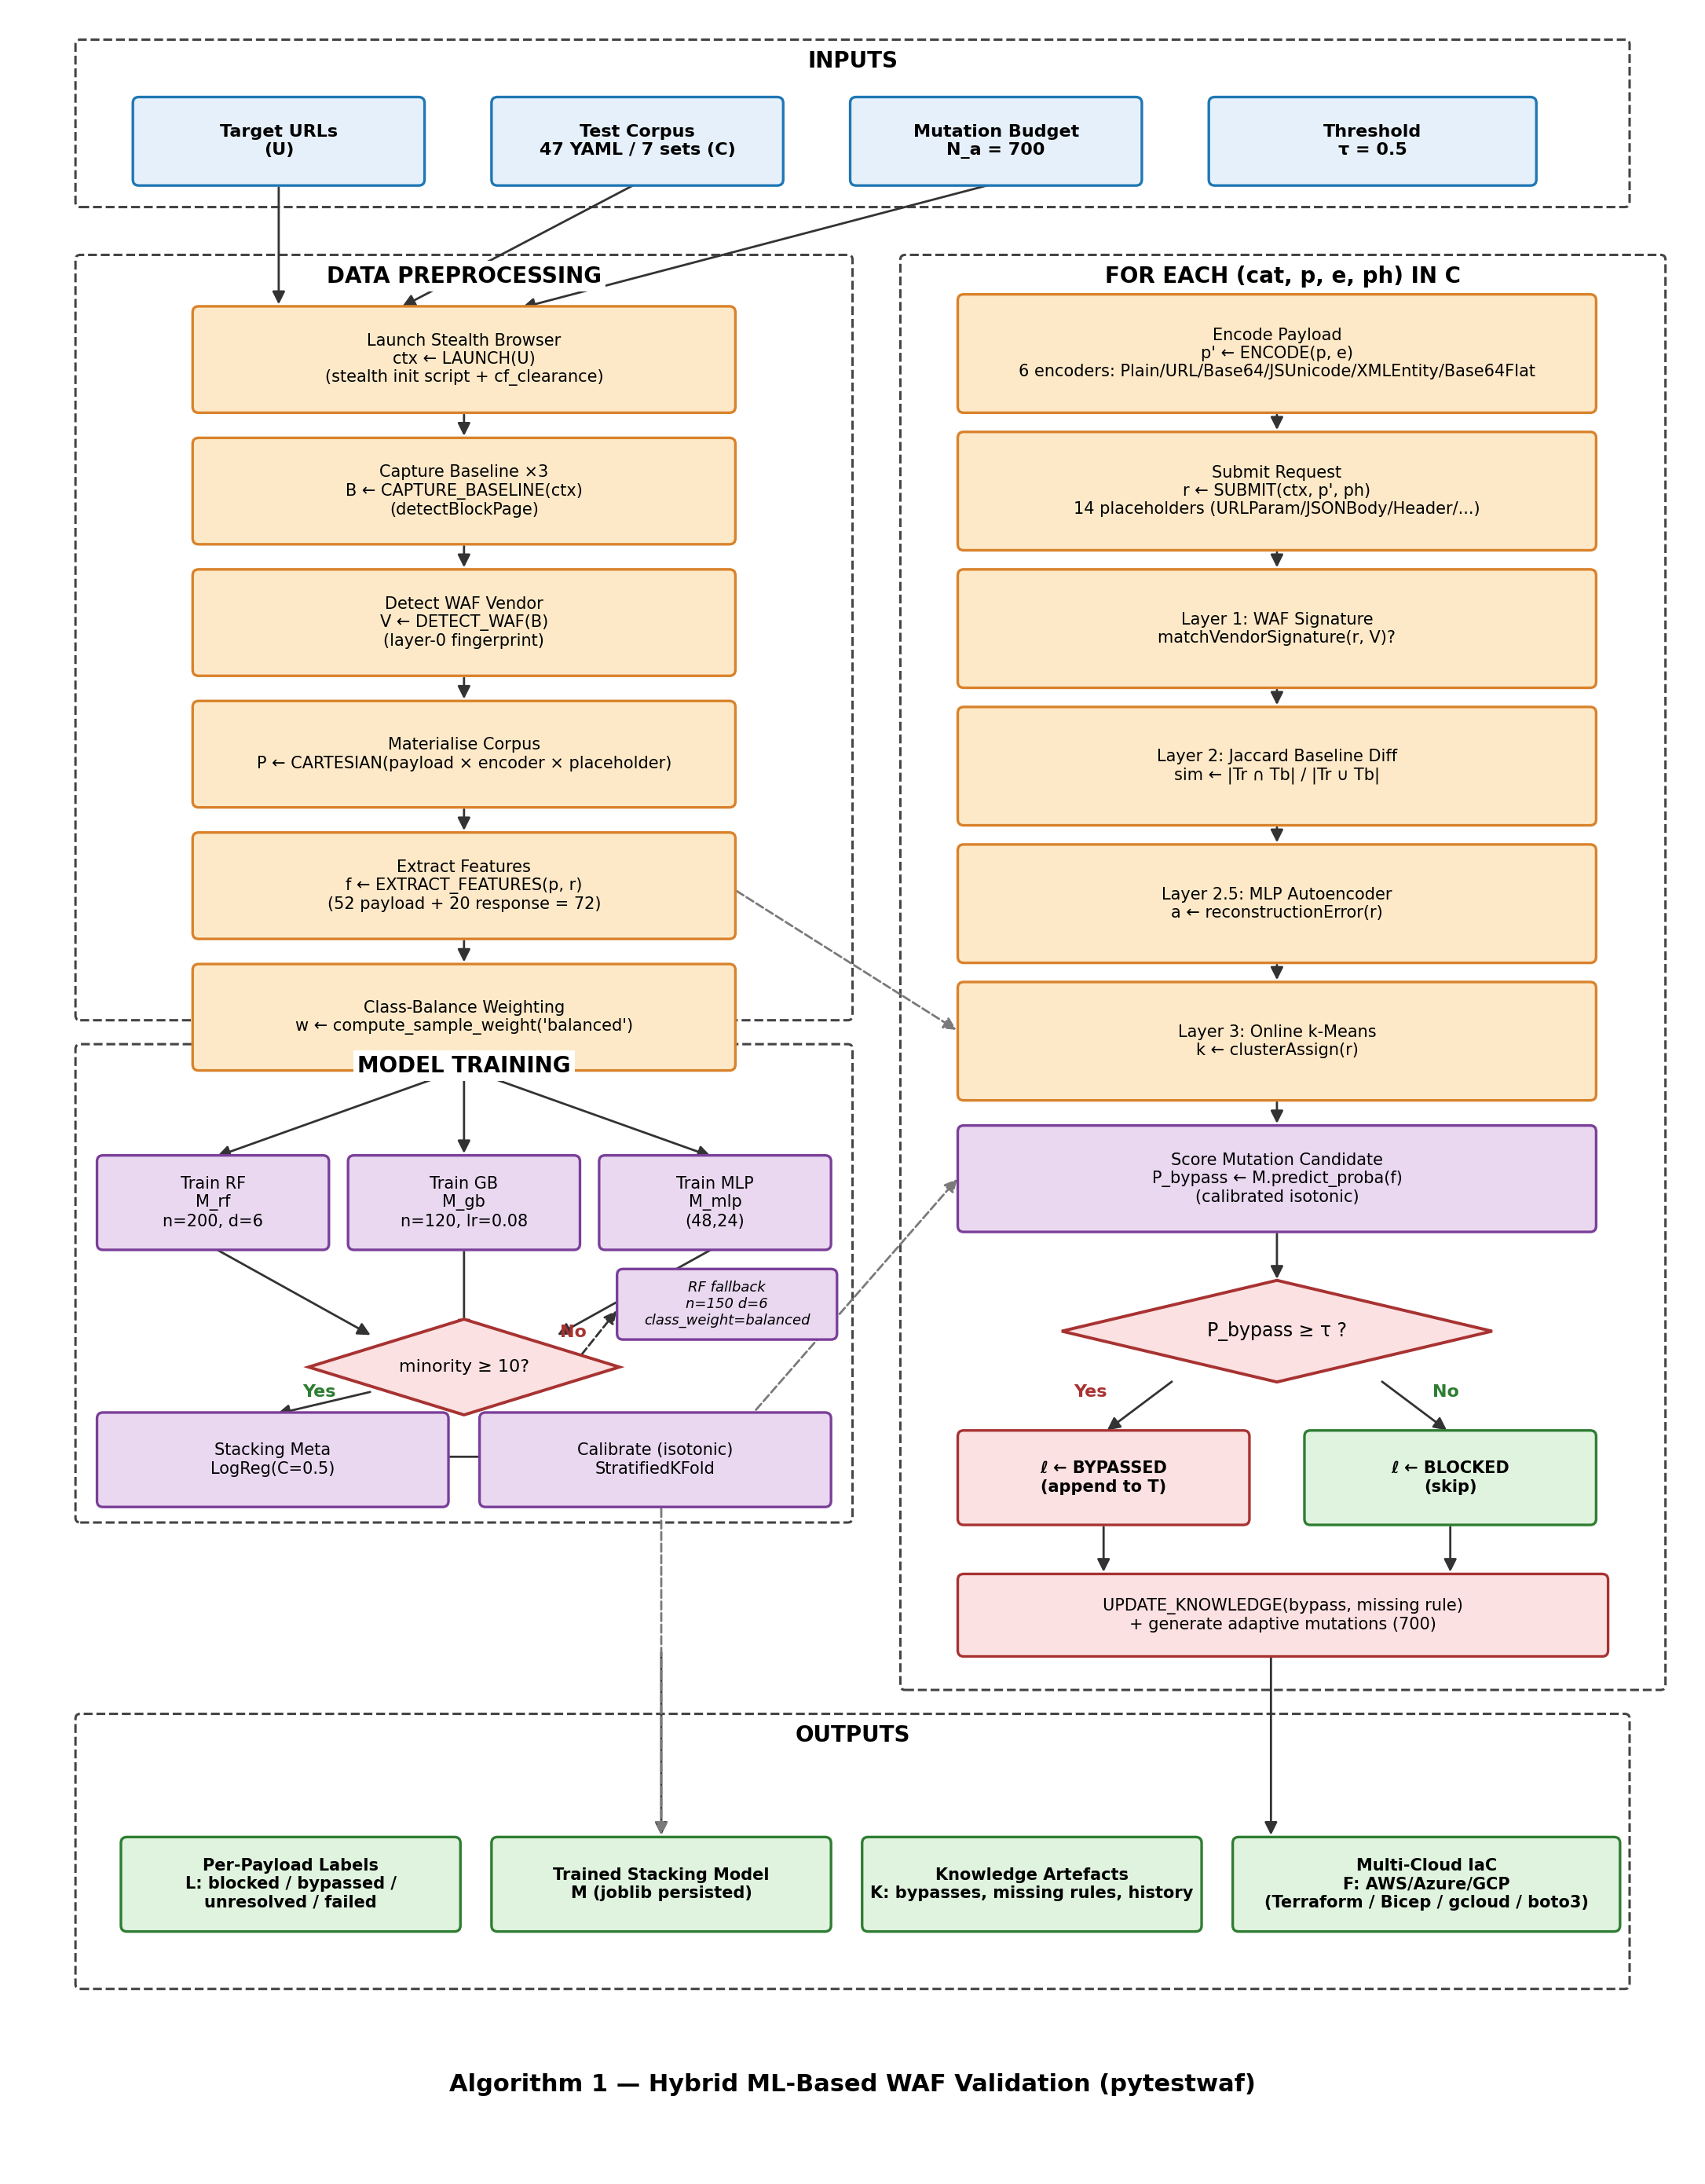
Fig. 2. Algorithm of proposed hybrid ML-based WAF validation.
Fig. 3 illustrates the end-to-end architecture as a continuous lifecycle: CLI invocation, bot and CAPTCHA detection, baseline capture, WAF fingerprinting, cross-scan model loading, corpus expansion, asynchronous scanning, four-layer classification, hybrid ML training, adaptive mutation, ruleset inference, multi-cloud autofix generation, report aggregation, and atomic persistence of scan knowledge.

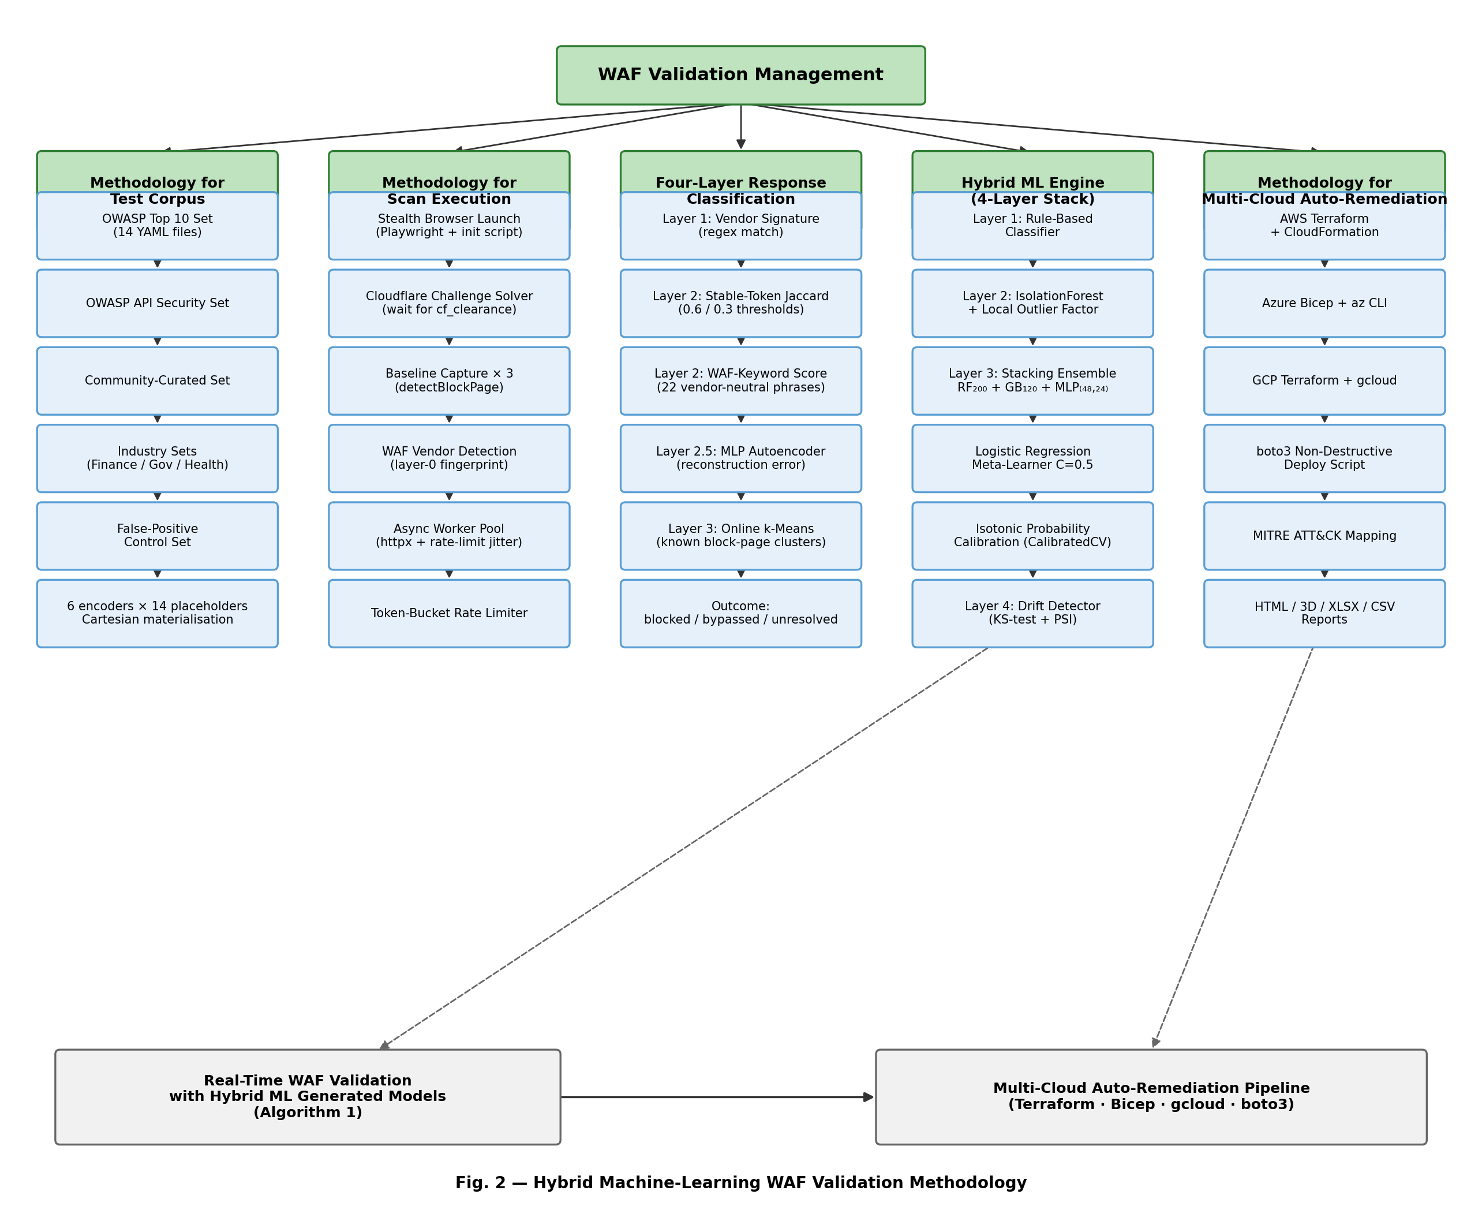
Fig. 3. Hybrid WAF validation methodology.
Processing begins with the construction of the test corpus. The corpus is generated by the Cartesian product of attack categories, placeholders, and encoders. Each candidate payload is then sent to the target WAF, the response is captured, and the response is passed through the four-layer classification pipeline. The first layer applies a vendor-specific signature regex against the response status, headers, and body. The second layer computes a Jaccard similarity score between the response body's stable tokens and the intersection of three pre-scan baseline responses and weights the score by the presence of WAF keywords in the body. The third layer reconstructs the response feature vector with a pre-trained autoencoder and flags responses whose reconstruction error exceeds a learnt threshold conditioned on the response status. The fourth layer applies online clustering to the response feature vector and flags responses that match a previously observed block-page cluster. The conjunction of the four layers produces a robust blocked / bypassed / unresolved label.

Once the main scan is completed, the labelled (payload, response, label) triples are used to train the hybrid stacking ensemble. The ensemble computes a probability of bypassing for any candidate payload. The adaptive mutation engine generates 700 candidate mutations driven by the learnt bypass patterns, scores each candidate, and submits the top K candidates to the WAF in priority order. Newly discovered bypasses are appended to the training set and used to refine the ensemble.

The control flow of the algorithm is implemented as an asynchronous coroutine pool whose default size is five workers and which scales automatically with the host CPU count when not explicitly set. Each worker pulls a payload from a shared queue, submits it through an httpx AsyncClient with a configurable proxy and timeout, captures the response, dispatches it through the four-layer classifier check blocked or passed, and writes the labelled triple back to a thread-safe results buffer. The pool design isolates network I/O latency from classification latency and allows the scan to saturate the available bandwidth without exceeding the configured request rate, which is enforced by a token-bucket rate limiter to respect target-side rate-based rules.

Algorithmic correctness rests on three invariants that are enforced explicitly. First, every payload submitted during the main scan is recorded in a deterministic order so that the labelled triples can be replayed for debugging without re-issuing network requests. Second, the labelling layers commit to a final label only after all four layers have been consulted, which preserves the explicit unresolved class until the supervised ensemble could score the response. Third, the adaptive mutation engine consumes the trained ensemble's score function as an immutable artefact and does not mutate the ensemble during the round, ensuring that score values are comparable across all 700 candidates within a single round.

The algorithm terminates when one of three conditions is met: the configured maximum payload has been reached, the operator interrupts the scan via SIGINT, or the adaptive round fails to discover a new bypass over a configurable patience window. The persistence layer is invoked unconditionally on termination so that the trained ensemble, the bypass-pattern dictionary, the inferred missing rule sets, and the longitudinal scan history are written to disk regardless of why the scan ended. This unconditional persistence is critical for the warm-start workflow because it ensures that even an operator-aborted scan contributes its partial knowledge to the next engagement.

A. Phase 1-2: Input Configuration and Pre-Flight Discovery
Fig. 4 is shown alongside Fig. 3, with a module-level component map of the codebase, showing how the cli/, scanner/, ml/, report/, and helpers/ packages interact and where each external dependency (scikit-learn, joblib, httpx, typer, jinja2, openpyxl, structlog, boto3) is used.

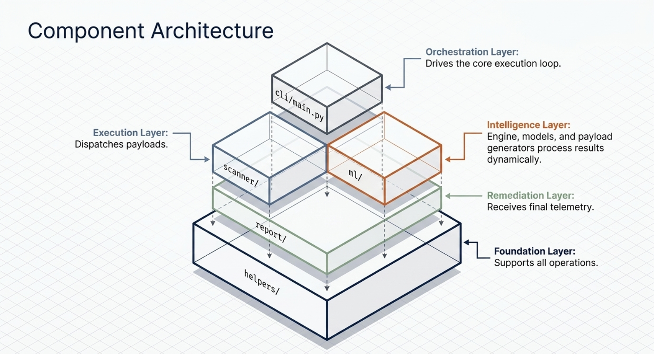
Fig. 4. Full component architecture, module-level map.
The component architecture is a package-level map of the codebase. The cli/ package owns Typer command orchestration; helpers/ owns HTTP, authentication, cookie, email, and baseline utilities; scanner/ owns payload dispatch, response classification, WAF detection, and adaptive scanning; ml/ owns feature extraction, the Hybrid ML Engine , payload generation, and model persistence; report/ owns HTML, XLSX, CSV, charts, and autofix rendering. This separation keeps execution, learning, remediation, and reporting independently testable.

The overarching approach to WAF validation presented in Fig. 3 combines deterministic, statistical, and learning-based components in a single end-to-end pipeline. The deterministic component (layer 1) provides high-precision, low-recall labelling for responses that match well-known vendor signatures. The statistical component (layer 2) provides high-recall labelling based on observed deviation from baseline. The unsupervised component (layer 2.5) catches anomalies that the statistical component misses, particularly when the WAF returns to a near-baseline body with subtle differences. The supervised component (layer 3 plus the post-scan ensemble) resolves the remaining ambiguous cases and learns target-specific patterns.

The cli/ package exposes a Typer-based command-line entry point that accepts a target URL, optional configuration overrides, and operator credentials, and orchestrates the nine-phase pipeline described in Section I. The scanner/ package implements the asynchronous worker pool, the four-layer classification pipeline, and the adaptive mutation engine, with the labelling logic concentrated in check blocked or passed and the mutation logic. The ml/ package encapsulates the stacking ensemble, the calibration wrapper, the feature extractors, and the persistence layer; its entry point is Hybrid ML Engine. The report and helpers’ packages handle artefact rendering and shared utilities such as the rate limiter and the structured logging shim.

Cross-package coupling is intentionally narrow. The scanner emits labelled triples on a queue that the ml/ package consumes, and the ml package returns a callable score function that the scanner uses to priorities the adaptive round. No global state is shared between packages and no module imports across more than one boundary. This design facilitates two practical outcomes: first, individual layers of the classification pipeline can be replaced without touching the ML training code; second, the framework can be unit evaluated layer by layer with synthetic responses, which has proven useful when adding new WAF vendor signatures and new encoder strategies.

External dependencies are limited to scikit-learn for the ensemble and calibration wrappers, joblib for model serialization, httpx for asynchronous HTTP, Typer for the CLI, Jinja2 for the HTML report templates, openpyxl for the XLSX exports, struct log for structured logging, and boto3 for the optional AWS deployment script. All other functionality is implemented in the standard library or in endorsed helpers under helpers. This dependency footprint is deliberately small to keep the Docker image under a few hundred megabytes and to minimize the supply-chain attack surface that a security validation tool inevitably exposes.

B. Phase 3: Test Corpus Construction
The test corpus materialized on disk as forty-seven YAML files distributed across seven test sets that group payloads by industry vertical and by intent. The owasp set covers the OWASP Top 10 attack families in fourteen files (SQL injection, cross-site scripting, remote command execution against URL parameters and URL paths, shell injection, LDAP injection, NoSQL injection, mail-header injection, path traversal, server-side include, server-side template injection, XML injection, and CRLF injection); the owasp-api set covers OWASP API Security Top 10 categories; the community set carries community-curated attack samples; the false-pos set provides benign control payloads designed to trigger false positives in over-aggressive rule groups; and the finance, government, and healthcare sets carry sector-specific attack patterns observed in production incident reports for those verticals.

Each YAML file declares three lists, payload, encoder, and placeholder, plus a free-form type label. The Cartesian product of these three lists materialized at scan time: every payload is rendered through every declared encoder and submitted in every declared placeholder. The encoder axis is drawn from a fixed registry of six values: Plain (identity), URL (percent-encoding via urllib.parse.quote), Base64, Base64Flat (unpadded Base64), JSUnicode (UTF-16 backslash-u escape), and XMLEntity. The placeholder axis is drawn from a fixed registry of fourteen values: URLParam, RawRequest, URLPath, Header, UserAgent, JSONBody, JSONRequest, HTMLForm, HTMLMultipartForm, RequestBody, XMLBody, SOAPBody, GraphQL, and gRPC; the GraphQL and gRPC placeholders are skipped by the browser-based submission path because the underlying fetch API cannot frame them, but the production HTTP path supports them through dedicated client adapters.

The product yields approximately 1,110 base test cases per scan for the default subset of sets and placeholders, scaling linearly when additional sets or placeholders are enabled. The corpus is extensible: additional categories, encoders, or placeholders can be added without modifying the scan engine by dropping a new YAML definition into the testcases directory and registering the new encoder or placeholder name in the feature extraction lookup tables.

Each entry in the corpus materialized at scan time as a concrete HTTP request whose method, URL, headers, and body are derived from the placeholder definition combined with the encoded payload. The materialization step is deterministic with respect to a fixed random seed, which means that an operator can reproduce the exact request sequence of a prior scan by setting the same seed and replaying against the same target. Determinism is a non-trivial property to maintain in the presence of asynchronous worker pools and is enforced in the framework by partitioning the corpus into per-worker shards before the pool starts, rather than dispatching from a shared queue whose ordering depends on coroutine scheduling.

Encoder chains are particularly important for WAF testing because many vendor rule groups normalize input before applying match conditions, and the choice of normalization function is itself a frequent source of bypasses. The corpus exposes single-stage encoders (URL encoding, Base64, hexadecimal), two-stage chains (URL after Base64, double URL encoding), and three-stage chains (triple URL encoding, mixed-case after Base64 after URL encoding). Each chain is registered as a named encoder so that bypass discoveries can be reported with the exact transformation that produced them, which in turn enables the auto fix module to recommend the corresponding normalization rule.

Placeholder coverage is informed by an empirical study of production WAF rule scopes, which frequently apply different match conditions to URL parameters than to JSON bodies, and may omit headers and cookies entirely. The corpus therefore exercises every placeholder against every category and encoder, rather than relying on a default placeholder per category as some surveyed tools do. The cost of this exhaustive coverage is linear in the number of placeholders and is acceptable at the 1,110-payload corpus size; the benefit is that a missing match condition on, for example, the User-Agent header is detected as a bypass during the main scan rather than being silently masked by a missing test case.

C. Phase 4: Four-Layer Response Classification Pipeline
The four-layer response classification pipeline is illustrated in Fig. 5. Each HTTP response is processed through the four layers in sequence; any layer can produce a definitive label and short-circuit subsequent layers, except for the unresolved label which is propagated to the next layer.

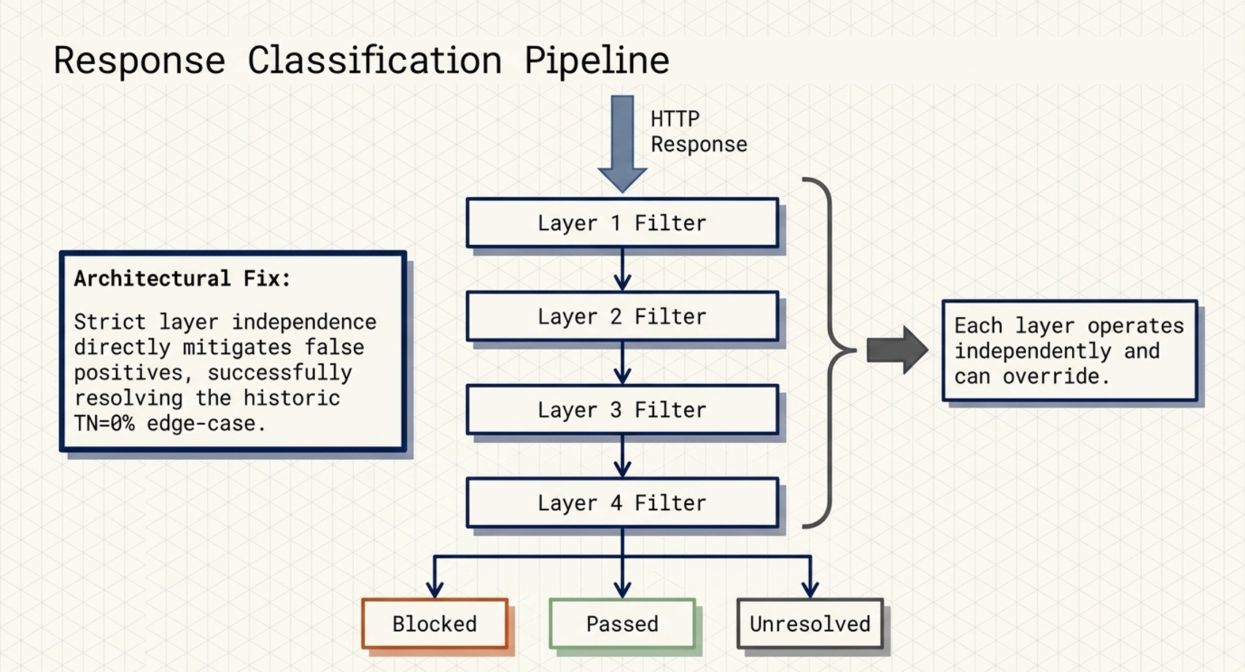
Fig. 5. Four-layer response classification pipeline.
The response-classification architecture turns a single HTTP response into blocked, bypassed, or unresolved. Each layer is independent and may override the prior evidence: layer 1 matches identified WAF block signatures, layer 2 compares the response against stable baseline tokens, layer 2.5 applies an autoencoder anomaly score, and layer 3 applies online ML clustering. The explicit unresolved state prevents ambiguous responses from being forced into false blocked or bypassed labels.

Layer 1 applies the vendor-specific block signature regex of the identified target WAF. If the response matches the signature, the label is BLOCKED. The layer is high-precision and short-circuits in the typical case of an explicit block page.

Layer 2 computes a stable-token Jaccard similarity between the response body and the intersection of three pre-scan baseline bodies, after stripping dynamic content (nonces, timestamps, CSRF tokens). It then computes a WAF keyword score from a curated dictionary of strong and soft phrases (e.g., “access denied,” “request blocked,” “forbidden”). Three decision rules combine the Jaccard score and the keyword score: rule 0 emits UNRESOLVED if the baseline itself is abnormal (poisoned), rule 1 emits BLOCKED if WAF keywords are present and the body differs from baseline, rule 2 emits PASSED if baseline coverage is high and no WAF keywords appear.

Layer 2.5 reconstructs the response feature vector with a Multi-Layer Perceptron autoencoder trained on the three baseline responses. The reconstruction error is computed as the mean squared error between the input and the reconstruction. A learnt threshold conditional on the HTTP status code (200, 403, 406, 429, 503) flags anomalous responses as BLOCKED. The autoencoder is retrained on every scan because baseline distributions vary across targets.

Layer 3 applies an online clustering algorithm (incremental k-means) to the response feature vector and assigns the response to a cluster. If the cluster matches a known block-page cluster the label is BLOCKED; otherwise, the label is UNRESOLVED and the response is deferred to the post-scan supervised ensemble.

The four layers are intentionally ordered from highest precision to highest recall. Layer 1 is invoked first because its false positive rate is zero on responses that match the vendor block signature, and a positive match short-circuits the remaining layers, sparing several hundred microseconds of feature-vector computation per response. Layer 2 is invoked next because its precision degrades gracefully as the application body becomes more dynamic, and the WAF-keyword score acts as a second axis of evidence that is independent of the Jaccard score. Layer 2.5 is invoked only on responses that emerge from layer 2 unresolved, which keeps the autoencoder reconstruction off the hot path for the typical case of an obvious block.

Baseline poisoning is a known failure mode of any similarity-based classifier and is addressed explicitly in layer 2 through rule 0. The framework captures three pre-scan baseline responses by issuing a benign request to the target before any payload is submitted; if the three baselines disagree among themselves beyond a configurable threshold, the baseline is deemed poisoned and the layer emits UNRESOLVED for every response that would otherwise depend on it. This conservative behavior prevents a target whose application body changes between requests (for example, a CSRF token rotation) from polluting the labelling of the entire scan with false positives.

Layer 2.5's autoencoder is a small Multi-Layer Perceptron with a single hidden layer whose width is one-quarter of the input dimension. The network is trained to reconstruct each baseline feature vector, and the reconstruction error is computed as the mean squared error between input and output. Status-conditional thresholds are learned by computing the 95th percentile of the reconstruction error on the baseline responses, partitioned by HTTP status code, so that a 200-response carrying an unexpectedly modified body is flagged BLOCKED even though its status code superficially matches the baseline. The autoencoder is retrained on every scan because the baseline distribution varies materially across targets and across application deployments of the same target.

D. Phase 5: Hybrid ML Engine and In-Flight Training
The hybrid ML engine, exposed as the Hybrid ML Engine class (the on-disk package directory inherits the legacy name GoTestWAF for backward compatibility with the fork from which This research evolved), is internally organized into four engine layers that operate at training time and that are distinct from the four response-classification layers of Phase 4 described in subsection C. Engine Layer 1 is a deterministic rule-based classifier that emits an immediate verdict for responses that match a known WAF block signature or an unambiguous status-and-keyword pattern.

Engine Layer 2 is an unsupervised anomaly detector that combines an Isolation Forest with a Local Outlier Factor estimator on the standardized response feature vector, providing a baseline-deviation signal that does not depend on supervised labels. Engine Layer 3 is the calibrated stacking ensemble described in the remainder of this subsection, which produces a probability of bypass for supervised classification. Engine Layer 4 is a feature-distribution drift detector based on Kolmogorov-Smirnov tests and Population Stability Index that monitors training-time feature statistics against scan-time feature statistics and emits structured warnings when drift is detected. To avoid confusion with the response-classification layers of Phase 4, this paper consistently refers to the present four layers as Engine Layers 1 through 4. The supervised verdict surfaced with the operator distinguishes five outcome categories such as blocked by WAF, blocked by bot, passed, soft blocked, and unresolvable, encoded by the Response Verdict enumeration.

The Layer-3 stacking ensemble has isotonic probability calibration. The base estimators are a RF with 200 trees and maximum depth 6, a Gradient Boosting classifier with 120 estimators and subsample fraction 0.8, and a Multi-Layer Perceptron with two hidden layers of size 48 and 24, L2 regularization alpha 1e-3, and early stopping when the minority class has at least 10 samples. The meta-learner is a Logistic Regression with C 0.5 and balanced class weights.

Class balance is enforced by computing per-sample weights with scikit-learn's compute_sample_weight in balanced mode, in addition to the class weight parameter set to balance on the RF. When the minority class is smaller than 10 samples the stacking pipeline is bypassed and a single RF is trained as a fallback. Probability calibration is performed with CalibratedClassifierCV in isotonic mode. The calibration is wrapped on the trained stacking estimator to preserve the underlying ensemble's decision function. The implementation is robust across scikit-learn 1.5 and 1.6+ by selecting between cv='prefit' and Frozen Estimator based on the installed version.

Cross-validation is performed with Stratified Fold with cv equal to the minimum of 5 and the minority class size. Out-of-fold probabilities are computed with cross_val_predict and used both to compute the F1 metric and to fit a 10-bin reliability diagram that quantifies the calibration quality.

The choice of base estimators reflects three deliberate trade-offs. RF with 200 trees and depth 6 provides a high-bias, low-variance baseline whose predictions are robust to noisy features and missing values, and whose feature-importance scores supply a cheap interpretability channel for the operator. Gradient Boosting with 120 estimators, depth 4, learning rate 0.08, and subsample 0.8 contributes a complementary low-bias model that captures interaction effects between payload features and response features that the RF tends to miss. The Multi-Layer Perceptron with hidden layers (48, 24) and L2 regularization 1-e-3 contributes a smooth nonlinear decision surface whose errors are decorrelated from the tree-based models, which is the empirically required precondition for the stacking meta-learner to add value.

The Logistic Regression meta-learner with C=0.5 and balanced class weights performs a constrained linear combination of the base predictions. Constraining the meta-learner to be linear rather than nonlinear is itself a regularization choice: a nonlinear meta-learner trained on three base predictions tends to overfit the small in-flight training set, particularly when the minority class has fewer than fifty samples, and the out-of-fold F1 degrades as a result. The C=0.5 value was selected by an offline grid search on a 10,000-sample historical validation corpus and was found to be on the flat optimum for C values between 0.3 and 1.0, indicating that the meta-learner is not particularly sensitive to this hyperparameter.

Isotonic calibration was preferred over Platt scaling for two reasons. First, isotonic regression imposes only a monotonicity constraint on the calibration mapping, which preserves the ranking of the underlying score function and therefore preserves the prioritization order used by the adaptive mutation engine. Second, the empirical reliability diagrams of the raw stacking ensemble exhibit a non-sigmoid shape with a flat region near score 0.5 followed by a sharp transition near score 0.7, which is poorly approximated by the two-parameter Platt sigmoid but fitted closely by isotonic regression. The trade-off is a measurable reduction in raw discriminative F1, which is discussed quantitatively in Section VII.

Class balance is the single most consequential preprocessing decision in this pipeline because production WAFs typically block more than half of the base corpus, producing a 60/40 to 70/30 class skew that biases an unweighted classifier toward the majority class. The framework addresses this skew through two complementary mechanisms: per-sample weights computed by scikit-learn's compute_sample_weight in balanced mode are applied during fit, and the class weight parameter is set to balance on the RF itself so that each individual tree is split using class-balanced impurity. The combination is redundant by design, because the calibration wrapper otherwise tends to undo the rebalancing applied at fit time.

E. Phase 6: Adaptive Mutation Engine
Fig. 6 illustrates the five-stage adaptive mutation cycle. After the main scan completes and the hybrid ensemble has been trained, the adaptive mutation engine executes a second round of 700 mutations. The mutation generator draws on three sources of evidence: the bypassed test cases of the main scan, the encoder and placeholder combinations whose bypass rate exceeded ten percent, and the top 30 most successful payloads.

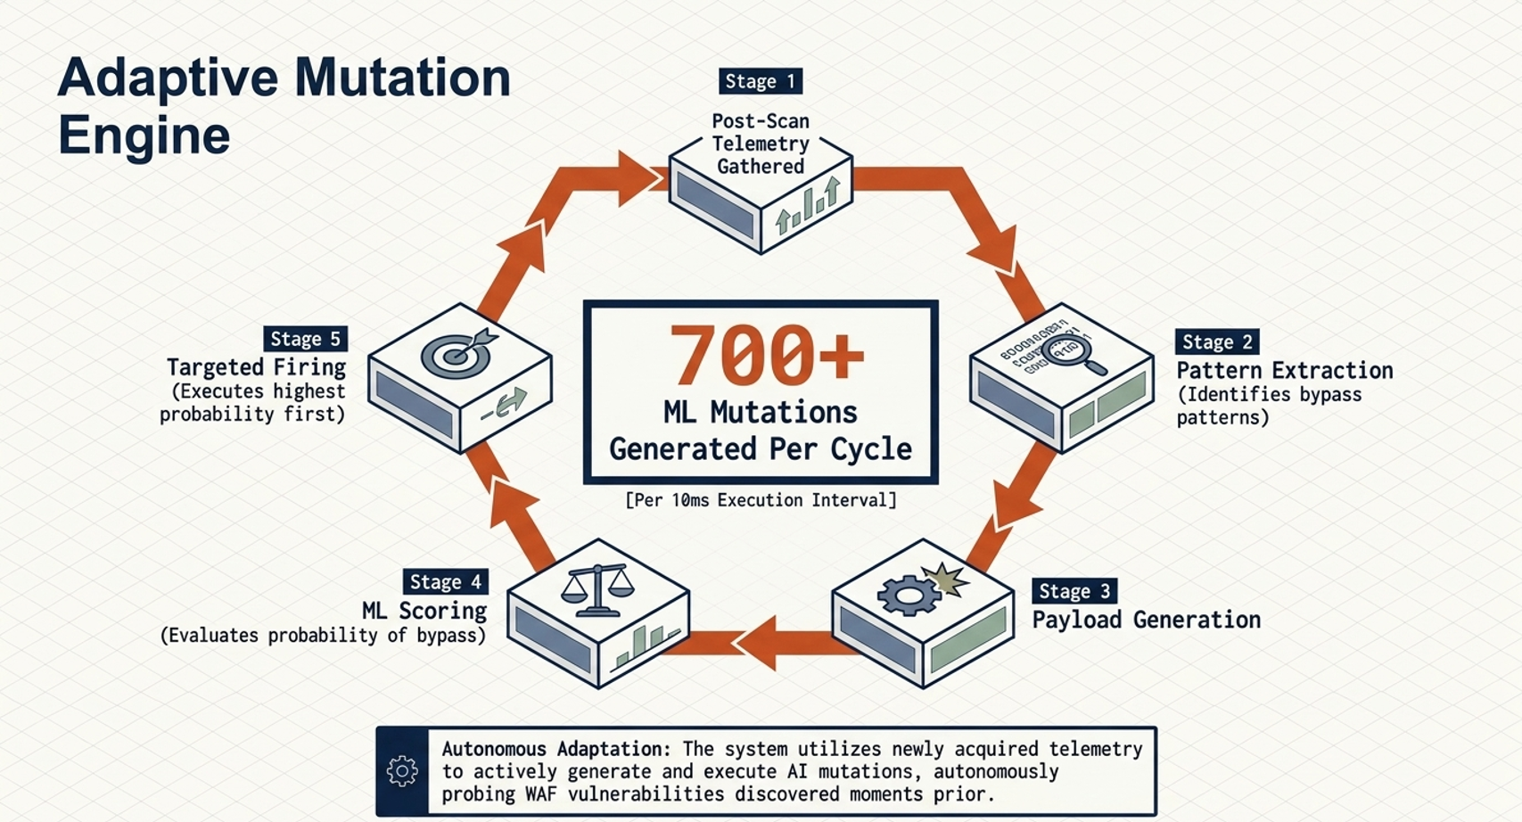
Fig. 6. Adaptive mutation engine, five-stage autonomous cycle.
The adaptive mutation architecture begins only after the main scan and initial model training are complete. It collects bypass evidence from successful test cases, high-bypass encoder and placeholder combinations, and the top successful payloads; uses the payload generator to create approximately 700 candidates by pattern reuse, encoding chains, cross-category transfer, and structural mutation; scores the candidates with the calibrated ensemble; and fires the highest-probability candidates first.

The generator produces candidate mutations by four mechanisms: pattern reuse of successful templates, encoding chains (combinations such as URL plus Base64, double Base64, triple URL encoding), cross-category transfer (e.g., applying a successful XSS template to an SQLi context), and structural mutations such as case mixing, comment insertion, and null-byte insertion.

Each candidate mutation is scored by the trained ensemble's score_payloads_batch method to produce a calibrated bypass probability. The candidates are sorted in descending order of bypass probability and submitted to the target WAF through the ml_worker async pool. The pool skips combinations that the online ML has flagged as always blocked and skips non-ASCII payloads not supported by the underlying httpx client.

Newly discovered bypasses are appended to the training set, and the ensemble is retrained at the end of the adaptive round; discovered patterns also persisted to the cross-scan knowledge store for warm-start of subsequent scans. The selection of the 700-mutation budget reflects a balance between coverage and operator-perceived scan duration. Empirical experiments on the production target showed that the discovery rate of novel bypass classes saturates between 600 and 800 candidates when the candidates are prioritized by the calibrated ensemble; below 600, the scan misses bypasses that the ensemble would have ranked highly, and above 800, the marginal candidates are dominated by low-probability variations of already-discovered patterns and consume scan time without contributing new categories. The budget is exposed as a configuration parameter so that operators with different scan-window constraints can tune it to their own throughput envelope.

The four mutation mechanisms (pattern reuse, encoding chains, cross-category transfer, and structural mutation) are applied in priority order and the candidate pool is deduplicated after each mechanism. Pattern reuse is the highest-priority mechanism because it directly extrapolates from observed bypasses and tends to produce the highest-scoring candidates; encoding chains are next because they exercise the WAF's normalization pipeline in a structured way; cross-category transfer follows because it produces creative but lower-precision candidates; and structural mutation is applied last because it tends to produce many candidates of similar quality whose value is to fill out the lower portion of the priority queue. Deduplication ensures that the same payload string is not submitted twice across mechanisms.

The ml_worker async pool that submits the prioritized candidates applies two skip rules that materially reduce wasted requests. The first skip rule consults the online ML state and excludes any (category, placeholder, encoder) combination whose observed block rate during the main scan was 100 percent, on the assumption that the corresponding rule is robust to mutation within that combination. The second skip rule excludes non-ASCII payloads that the underlying httpx client cannot submit without explicit byte encoding, which prevents the worker from raising a UnicodeEncodeError mid-round. Both skip rules are logged so that the operator can audit the budget consumption after the scan is completed.

F. Phases 7, 8 and 9: Auto-Remediation, Reporting, and Cross-Scan Persistence
The final three phases of the methodology are covered in this subsection, namely Phase 7 (Generate Fixes), Phase 8 (Report), and Phase 9 (Remember). The three are presented together because they all consume the artefacts emitted by Phases 4 through 6 and write durable outputs to disk, so the discussion proceeds in execution order.
Phase 7 (Generate Fixes) consumes the bypassed (payload, category, encoder, placeholder) tuples from the labelling phase and the inferred missing rule sets and emits multi-cloud Infrastructure-as-Code artefacts resource, Azure Bicep with Microsoft. Network FrontDoor WAF policy, az command-line shell scripts, GCP Terraform with the google_compute_security_policy resource, gcloud shell scripts, and a boto3-based Python deployment script that performs a non-destructive merge into an existing AWS Web ACL using the GetWebACL/UpdateWebACL LockToken protocol. Cross-cloud rule equivalence is preserved through a single canonical rule representation that is lowered into cloud-specific primitives (RegexPatternSet on AWS, RegexMatchOperator on Azure Front Door, matchesRegex expression on Google Cloud Armor) during template rendering.

Phase 8 (Report) aggregates the raw scan telemetry, the hybrid ML metrics, and the inferred ruleset gaps into a single master HTML report comprising twenty-seven analytical charts, a Three.js interactive 3D attack-surface scene, and a MITRE ATT&CK framework mapping that labels each bypass with its tactic and technique. Tabular exports are produced as XLSX, CSV, and publication-ready light-theme 2x DPR PNG files. The report renderer is implemented and uses Jinja2 templates with a fixed color palette, so successive scans produce visually consistent reports that operators can diff against prior scans to track WAF coverage over time.

Fig. 7 illustrates the cross-scan knowledge persistence layer (Phase 9) that enables the framework to accumulate WAF-specific knowledge over time. After every scan, the trained ensemble is serialized with joblib using an atomic tempfile-and-rename pattern that is safe under concurrent scheduled scans on both POSIX and Windows. The bypass patterns dictionary, the inferred missing rule sets, and the cross-validated F1 score are saved. Each scan also appends one line for longitudinal analysis.

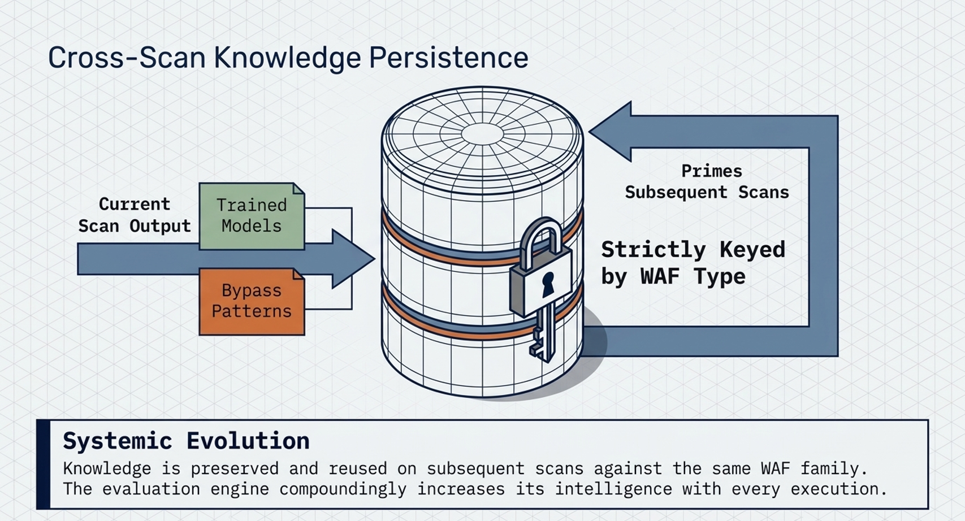
Fig. 7. Cross-scan knowledge persistence, strictly keyed by WAF type.
The cross-scan persistence architecture makes the system smarter across executions by keying saved knowledge by WAF type. At the end of a scan, bypass patterns, the trained calibrated ensemble, and ruleset-inference results are written through the persistence layer using atomic tempfile-and-replace writes. On a later scan, the model is loaded only if the age gate, quality gate, and dependency-version gate pass; successful loading enables fast-mode payload prioritization before new training data exists.

On the next scan against the same WAF family, the persistence layer loads the saved ensemble subject to two gates: the model must be less than 30 days old and its cross-validated F1 score must be at least 0.5. Models that pass both gates are loaded into the engine and used to score the upcoming payloads in fast mode, reordering the queue so that high-probability bypasses are evaluated first. This gating prevents stale or low-quality models from polluting the next scan's prioritization.

Keying the persistence by WAF family rather than by target URL is a deliberate generalization choice. A managed rule group on AWS WAF is shared across millions of customers and therefore exhibits the same decision boundary on every deployment that uses it; conversely, two deployments behind the same fully qualified domain name may use different rule groups if the operator has reconfigured the Web ACL between scans. Keying by WAF family allows knowledge to transfer across deployments that share rule groups while remaining inert when the rule group changes. The detected WAF family is derived from the layer-1 vendor signature match and is recorded in the scan_history.jsonl record alongside the F1 score for longitudinal audit.

The atomic tempfile-and-rename pattern that backs the joblib write is critical for safety under concurrent scheduled scans. The framework writes the serialized model to a tempfile in the same directory as the destination, fsyncs the tempfile to disk, and then renames it over the destination in a single filesystem operation. On both POSIX and NTFS this rename is atomic with respect to other processes opening the destination, which means that a concurrent scan that loads the model either sees the previous fully written version or the new fully written version, but never a partially written file. This guarantee allows the framework to be deployed under a corn schedule without race-condition mitigation in the orchestrator.

The scan_history.jsonl format records one JSON object per scan with the timestamp, the target URL, the detected WAF family, the block and bypass counts, the cross-validated F1 score, the discovered novel bypass categories, and the path of the serialized model. The append-only structure facilitates longitudinal analyses without requiring a database, and the JSONL serialization is amenable to ingestion by standard log processing tools such as jq and DuckDB. Operators who run regular scans against the same target can use the history file to track the F1 trend over time and detect regressions in WAF coverage that correlate with vendor rule-group updates or with operator-initiated rule changes.

Experimental Design
The experimental design used to validate the framework is described in this section. The system architecture, the implementation details, the dataset construction, and the training architecture are presented in turn. The experimental architecture is presented in Fig. 8, illustrating the deployment topology of the framework against a production target. The framework is packaged as a Docker container that mounts the operator-supplied URL list as read-only, the report directory as read-write, and the model persistence directory as read-write. The container connects to the target WAF over HTTPS through an optional HTTP proxy.

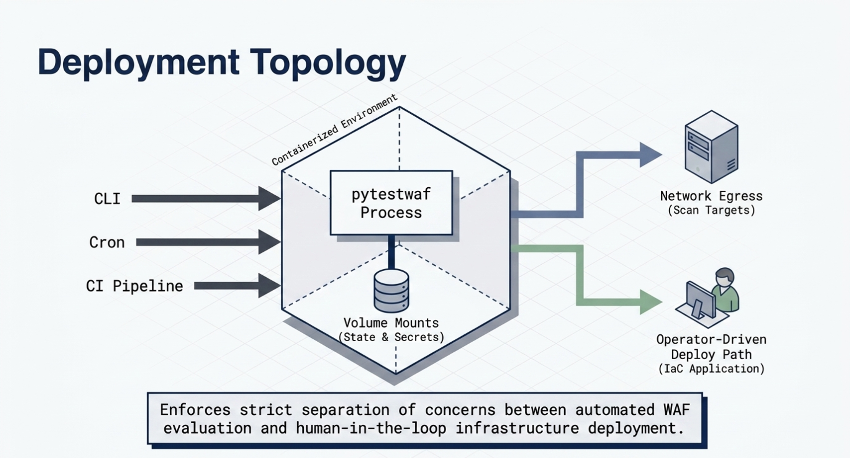
Fig. 8. Experimental architecture and deployment topology.
The deployment architecture defines the production operating surface. This research may be triggered by an operator CLI, a scheduled job, or a CI runner; credentials and secrets are injected at runtime; the containerized process mounts report and model-state volumes; outbound network egress reaches the scan targets; notifications can be emitted to operator channels; and the generated IaC remains an operator-driven deploy path rather than an automatic destructive change.

Container packaging is realized as a multi-stage Dockerfile that produces a final image of approximately 280 MiB by separating the build dependencies (compilers, headers, package managers) from the runtime dependencies (Python interpreter, scikit-learn, joblib, httpx, Typer, Jinja2, openpyxl, structlog, boto3). The image runs as a non-root user and exposes a single ENTRYPOINT that invokes the Typer CLI; configuration is supplied entirely through environment variables and command-line flags so that the image is immutable across deployments. The container is compatible with both Docker Engine and Podman and includes a health check that exercises the import path of the ml/ package to fail fast on a corrupted image.

The deployment topology assumes that the operator has explicit authorization to scan the target and that the scan traffic does not traverse a network on which it would be misclassified as a live attack. The framework supports an optional outbound HTTP proxy via the standard HTTPS_PROXY environment variable, which allows operators to route scan traffic through a corporate egress gateway for traffic logging or threat-intelligence enrichment. All outbound connections are made over TLS to the target and the proxy, and the framework does not store credentials at rest beyond the lifetime of the scan process.

The experimental design distinguishes between functional evaluation, which establishes that each pipeline phase produces the expected artefact, and performance evaluation, which establishes the F1 score and the discovered bypass count. Functional evaluation was performed by replaying captured responses through the four-layer classifier and by inspecting the emitted IaC artefacts for syntactic validity using terraform validate, cfn-lint, az bicep build, and gcloud beta compute security-policies validate. Performance evaluation was performed against the live production target and is reported in Section VII; the two strands of evaluation are kept distinct so that improvements in functional coverage can be measured without re-issuing live network requests.

A. Real-Time Bypass Detection and Cross-Layer Classification
Real-time bypass detection is realized by the four-layer classification pipeline described in Section V. The pipeline operates per response, with no offline batching, so the operator observes the running tally of blocked, bypassed, failed, and unresolved cases in the terminal user interface during the scan. The implementation uses an asynchronous worker pool of five workers by default; the worker count is automatically derived from the host CPU count when not explicitly set.

The terminal user interface is rendered with a structured logger that emits one line per labelled response together with a running counter line that overwrites itself in place. The counter line shows the number of blocked, bypassed, failed, and unresolved cases, the elapsed wall-clock time, the estimated time to completion based on the current throughput, and the current ensemble training F1 once the in-flight ensemble has been fitted. Operators report that this real-time visibility is operationally important because it allows them to abort a scan early when the target exhibits unexpected behavior, such as a sustained 5xx response rate that would invalidate the labelling.

Latency budgets for each layer of the classification pipeline were measured during development to ensure that the classification step does not become the bottleneck of the scan. Layer 1 typically completes in tens of microseconds because it consists of a single regex match against the response body; layer 2 completes in a few hundred microseconds because it tokenizes the body and computes the Jaccard intersection; layer 2.5 completes in a few milliseconds because it invokes the MLP autoencoder; and layer 3 completes in a few hundred microseconds because it performs an O(k) cluster assignment. The aggregate per-response budget is well under ten milliseconds on commodity hardware, which is two orders of magnitude smaller than the typical network round-trip to a cloud-hosted WAF.

Failure modes of the classifier are reported in three distinct channels rather than collapsed into a single error category. Network failures (timeouts, connection resets, TLS handshake failures) are reported as failed; application-level failures (5xx responses, malformed bodies) are reported as unresolved after the four layers run; and pipeline-internal failures (autoencoder reconstruction error, cluster assignment failure) are reported as unresolved with a structured cause field that the report generator surfaces in the HTML diagnostics page. The three-channel reporting allows the operator to distinguish transient network instability from genuine target behavior.

B. Continuous Payload Generation
Continuous payload generation is realized by the test corpus construction pipeline in conjunction with the adaptive mutation engine. The base corpus is fixed and reproducible; the adaptive round is non-deterministic because it depends on the bypass patterns observed during the main scan, but the random seed of the mutation engine is exposed as a configuration parameter so that runs can be reproduced for evaluation.

Reproducibility under the configured seed is enforced at three points in the pipeline. First, the per-worker shard assignment is computed from the seed so that the same payload appears on the same worker across runs, eliminating any ordering non-determinism introduced by the asynchronous pool. Second, the random sampling performed by the mutation engine (for example, the choice of which encoder to chain on top of which successful template) is driven by an instance of numpy.random.default_rng seeded with a derivation of the operator-supplied seed. Third, the cross-validation splits used by Stratified Fold are seeded with the same value so that the reported F1 score is bit-identical across reproduction runs.

The continuous nature of the payload generator is most visible during the adaptive round, when the engine produces candidates in batches of approximately one hundred and immediately submits the highest-scoring batch through the worker pool. As bypasses are discovered, the engine appends them to the training set, and the trained ensemble is refreshed at the end of the round so that the persisted model captures the entirety of the scan's evidence rather than only the main-scan portion. The refresh is performed in a single fit call rather than incrementally, which is acceptable at the corpus size in question because the fit completes in under one second on commodity hardware.

C. Hybrid ML Engine for Automated Bypass Scoring
The hybrid ML engine is implemented entirely with the scikit-learn estimator API, using Stacking Classifier, CalibratedClassifierCV, and StratifiedKFold. The implementation is compatible with scikit-learn 1.5 and 1.6+ through a calibration wrapper that selects between cv='prefit' and Frozen Estimator based on the installed version. The training metrics include the cross-validated F1 score, per-class precision, recall, and F1, the 10-bin reliability diagram, the confusion matrix, and the feature contributions extracted from the inner stacking estimator.
The version-detection wrapper is necessary because scikit-learn 1.6 introduced Frozen Estimator as the recommended mechanism for wrapping a pre-fitted estimator inside CalibratedClassifierCV without re-fitting the underlying ensemble. In scikit-learn 1.5 the same outcome is achieved by passing cv='prefit' to CalibratedClassifierCV, but this code path is deprecated in 1.6 and emits a Deprecation Warning that the framework's warnings-as-errors configuration would otherwise convert into a fatal exception. The wrapper inspects sklearn version at import time and selects the correct code path, allowing the framework to be installed against either version without modifying the calling code.

Feature contributions from the inner stacking estimator are extracted by inspecting the named estimators_ attribute of the Stacking Classifier and aggregating the feature importances_ attribute of the RF base estimator together with the feature importances_ of the Gradient Boosting base estimator. The Multi-Layer Perceptron does not expose a feature-importances attribute, but its contribution to the final decision is captured by the Logistic Regression meta-learner's coefficient vector, which is also extracted and reported in the metrics JSON. The combined view allows the operator to see both the raw feature importances and the relative weight assigned to each base model by the meta-learner.

Training-time diagnostics are emitted to a structured log stream that the report generator parses to produce the HTML diagnostics page. The diagnostics include the per-fold F1 values, the per-fold confusion matrices, the wall-clock fit time of each base estimator, the wall-clock fit time of the calibration wrapper, the number of training samples passed to the fit, the resulting class distribution after sample-weight rebalancing, and the path of the serialized model on disk. These diagnostics are intended both for operator debugging and for downstream automated analysis: the structured-log format is compatible with standard log-aggregation pipelines so that training metrics can be tracked over time across many scans.

D. Auto-Remediation Generation Pipeline
Fig. 9 illustrates the multi-cloud auto-remediation pipeline. Auto-remediation is realized by the auto fix and IaC generator modules. The auto fix module receives the set of bypassed categories and the inferred missing rule sets and produces three cloud-specific recommendation lists: AWS-specific, Azure-specific, and GCP-specific. The IaC generator translates the recommendation lists into deployable artefacts: Terraform with a complete aws_wafv2_web_acl resource for AWS, CloudFormation with an AWS:WAFv2:WebACL resource for AWS, Bicep with Microsoft. Network Front Door WAF policy for Azure, az command-line shell scripts for Azure, terraform with the google_compute_security_policy resource for GCP, and gcloud shell scripts for GCP.
All artefacts are emitted regardless of the detected target WAF, because operators frequently maintain heterogeneous cloud estates and benefit from receiving the equivalent rule across all three major hyperscale’s. An additional boto3-based Python deployment script is generated to merge the AWS rules into an existing Web ACL without overwriting unrelated rules.

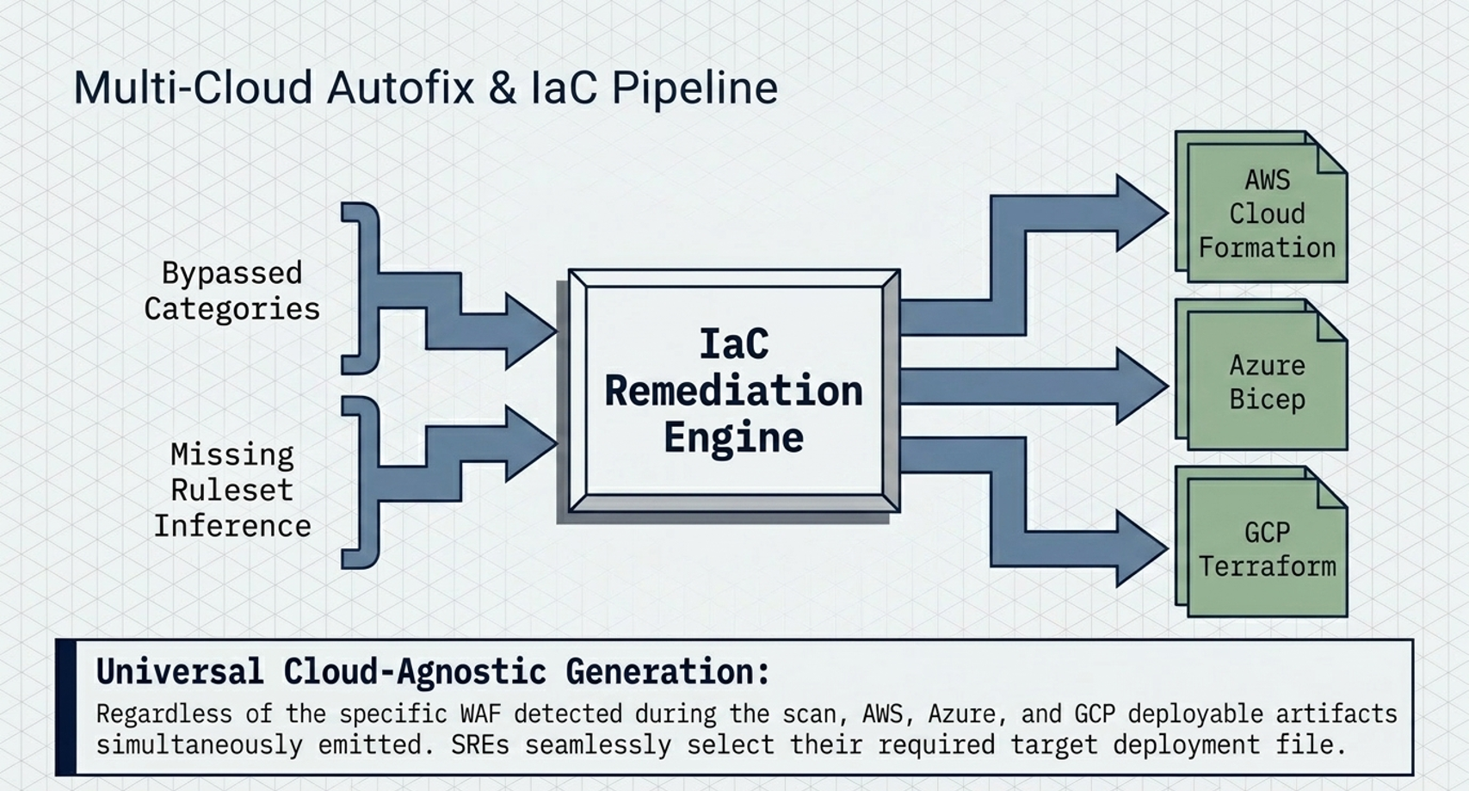
Fig. 9. Multi-cloud auto fix and IaC pipeline.
The auto fixed architecture converts bypassed categories and missing-ruleset inference into deployable artefacts. The auto fix module derives primary WAF recommendations and cloud-specific rule lists; the IaC generator lowers the canonical rule model into AWS Terraform and CloudFormation, Azure Bicep and az shell commands, and Google Cloud Armor Terraform and gcloud shell commands. All three cloud outputs are emitted regardless of the detected WAF so operators can choose the applicable deployment target.

Fig. 10 presents the reporting architecture and analytics subsystem. Raw scan telemetry, hybrid ML metrics, and ruleset inference results are aggregated into a single master HTML report that comprises 27 unique analytical charts, a Three.js 3D attack-surface scene, and a MITRE ATT&CK framework mapping; tabular exports are also produced as XLSX, CSV, and publication-ready light-theme 2x DPR PNG.

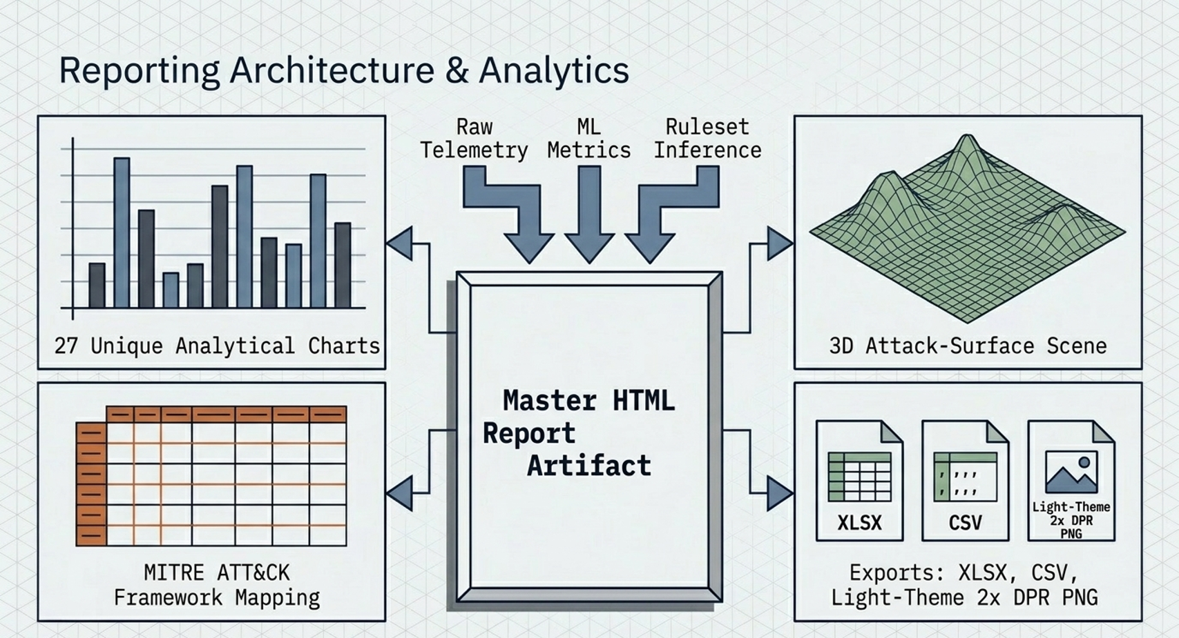
Fig. 10. Reporting architecture and analytics subsystems.
The reporting architecture funnels scan statistics, ML training metrics, ruleset inference, compliance mappings, auto fix data, and scan-history deltas into a single reporting pipeline. Cross-cloud rule equivalence is non-trivial because the three hyperscale’s express equivalent functionality through different primitives. AWS WAF expresses a regex-based match through a RegexPatternSet referenced by name, Azure Front Door expresses the same match through a Custom Rule with a RegexMatchOperator, and Google Cloud Armor expresses it through an expression-language rule using the matchesRegex function. The auto fix module maintains a single canonical rule representation and applies cloud-specific lowering passes during template rendering. This design ensures that an operator who deploys the AWS Terraform artefact obtains functional parity with the operator who deploys the Azure Bicep or GCP gcloud artefact.

The boto3 deployment script is a particular case worth highlighting because it executes a non-destructive merge into an existing AWS Web ACL. The script discovers the existing rules by calling GetWebACL, computes the union of the existing rules and the recommended rules (deduplicating by Name and adjusting Priority values to avoid collisions), and applies the merged rule list with UpdateWebACL using the Lock Token returned by the GetWebACL call. The Lock Token protects against concurrent modifications by other operators or by other automation, and the script reports a structured error if the Lock Token is stale rather than overwriting unrelated rules. This behavior is the intended mode of integration with operator-managed AWS estates.

E. Hybrid ML Model Training and Optimisation
Training and optimization of the hybrid ensemble is performed in-flight on the scan results. The training data consists of the (payload, response, outcome) triples produced by the four-layer classification pipeline. Features are extracted by two functions: extract_payload_features computes a 52-dimensional payload vector (7 character-composition ratios, 2 length and entropy values, 11 structural Boolean indicators, 6 attack-type pattern scores drawn from XSS, SQLi, RCE, LFI, XXE, SSTI dictionaries, 6 evasion-technique flags, a 6-bin one-hot encoder code, and a 14-bin one-hot placeholder code), and extract_response_features computes a 20-dimensional response vector (status-code one-hot, body-length ratio, stable-token Jaccard against baseline, body edit-distance against baseline, WAF-keyword score, block-marker indicator and timing features). The two vectors are concatenated into a 72-dimensional input that the base estimators consume after a Standard Scaler transform.

Hyperparameter selection was guided by an offline grid search on a held-out validation corpus of 10,000 historical (payload, outcome) pairs collected from prior scans against eight different WAF deployments. The grid search optimized the cross-validated F1 score on the bypass-detection task and selected the configuration reported in Section V. The fifty-two payload features are designed to be cheap to compute and informative for the bypass classification task. Length captures the gross size of the payload; Shannon entropy discriminates between repetitive and randomized payloads; special-character ratio captures the density of non-alphanumeric characters that are common in injection attacks; HTML, SQL, and RCE keyword counts are derived from curated dictionaries of attack-specific tokens; and encoding chain depth records the number of nested encoder transformations applied to the original payload. Additional features capture the placeholder type, the category, the encoder name, and indicator flags for known evasion techniques such as null-byte insertion, comment insertion, and Unicode normalization tricks.

Response features complement the payload features by capturing the WAF's reaction to the payload. Status code is recorded as a categorical feature with one-hot encoding for the most common block codes (403, 406, 429, 503); body diff against baseline is computed as a normalized character-level edit distance; stable-token Jaccard reuses the value computed by layer 2 of the classification pipeline; WAF signal strength aggregates the WAF-keyword score against a curated dictionary of twenty-two vendor-neutral phrases (blocked, denied, forbidden, rejected, security, firewall, waf, violation, error 1020, attention required, access denied, not acceptable, request rejected, Cloudflare, mod security, web application firewall, ray id, incapsula, sucuri, akamai, Imperva) with a presence indicator for known block-page elements such as request identifiers and support contact information. The two feature vectors are concatenated into a single 72-dimensional input that the base estimators consume.

The offline grid search that informed the hyperparameter configuration used a nested cross-validation strategy with an outer 5-fold split for unbiased F1 estimation and an inner 5-fold split for hyperparameter selection. The search ranged over RF estimators in {100, 200, 400, 800}, max_depth in {None, 4, 6, 8, 12}, Gradient Boosting estimators in {60, 120, 240}, learning rate in {0.05, 0.08, 0.1, 0.2}, MLP hidden_layer_sizes in {(32,), (48, 24), (64, 32), (96, 48, 24)}, and Logistic Regression C in {0.1, 0.3, 0.5, 1.0, 3.0}. The selected configuration sits on a broad plateau of the F1 surface, which suggests that the framework is robust to small perturbations of the hyperparameters.

F. Dataset
The data set used for evaluation in this paper consists of two components. The static base corpus provides 1,110 test cases per scan, generated by the Cartesian product of categories, placeholders, and encoders. The adaptive mutation corpus provides 700 additional test cases per scan, generated at scan time from the bypass patterns of the main scan. Table IV summarizes the dataset composition.

TABLE IV. Dataset Composition for Hybrid ML Training
The evaluation target is a production WAF protecting WAZUH-based security operations interface deployed on a public domain. The target was scanned twenty consecutive times across iterative refinements of the framework; the results reported in Section VII correspond to the scan executed against This research release r17.
Data Source | Records | Features | Reference
Static base corpus (7 sets, 47 YAML files) | ~1,110 per scan | 72 (52 payload + 20 response) | Generated at scan time
Adaptive mutation corpus | 700 per scan | 72 (52 payload + 20 response) | Generated post-training
Cross-scan model store | Cumulative | 72 (per-scan ensemble) | /models/waf/
Validation corpus (offline) | 10,000 historical pairs | 72 + outcome label | Held out for hyperparameter selection
Reliability bins | 10 per model | Predicted prob. + empirical freq. | Computed via cross_val_predict

The choice of a Wazuh-protected target is methodologically significant because Wazuh installations are commonly fronted by a managed cloud WAF in production deployments, which makes the target a representative example of the security-operations infrastructure that the framework is designed to validate. The target exposes both static dashboard pages and dynamic search endpoints whose responses change between requests, which exercises the baseline-poisoning detection of layer 2 of the classifier. The target's WAF is configured with the vendor's core managed rule group plus a small custom rule set that blocks known administrative paths, providing a realistic mix of generic and bespoke rules.

Repeated scanning across iterative refinements served two experimental purposes. First, it exposed regressions introduced by individual code changes because a regression in the classification pipeline manifests as a shift in the F1 score between adjacent scans even when the underlying WAF is unchanged. Second, it produced a longitudinal record of the F1 score under the framework's own warm-start mechanism, which was used to validate that the cross-scan persistence layer does not degrade subsequent scans.

The dataset is intentionally not augmented with synthetic samples. Several recent ML-driven security testing efforts use data augmentation techniques such as SMOTE to inflate the minority class, but the resulting models tend to score synthetic boundary points highly while missing genuine bypasses that lie outside the augmented region. The framework's strict in-flight training discipline avoids this failure mode by training only on observed (payload, response) pairs and by addressing class imbalance through sample weighting rather than through synthetic oversampling. The trade-off is a smaller training set but a model whose decision boundary is anchored to the actual decision boundary of the target WAF.

G. Hybrid ML Training Architecture
Fig. 11 presents the hybrid ML training architecture. Inputs are the (payload, response, outcome) triples produced by the four-layer classification pipeline. The feature engineering stage computes a 52-dimensional payload feature vector and a 20-dimensional response feature vector and concatenates them into a 72-dimensional input that is standardized by a StandardScaler fitted on the training portion. A class balance gate routes the training to either the full stacking pipeline or the RF fallback depending on the minority class size.
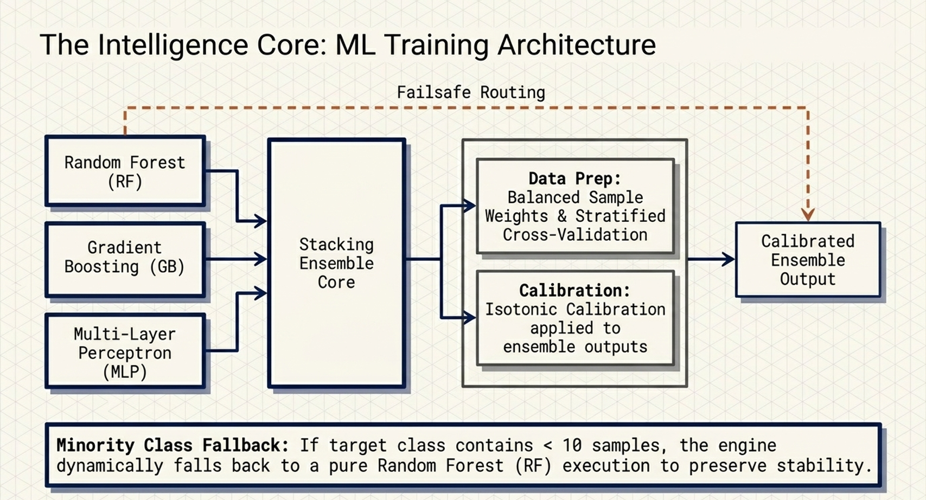
Fig. 11. Hybrid ML training in architecture.
The training architecture explains how Hybrid ML Engine learns from in-flight scan results. Payload features and response features are concatenated, sample weights are balanced, a class-balance gate chooses between the full stacking ensemble and an RF-only fallback for small minority classes, base estimators are trained in parallel, Logistic Regression combines their predictions, and isotonic calibration produces probabilities suitable for adaptive prioritization.

The base estimators are trained in parallel with sample weights. The stacking classifier combines the base predictions through a Logistic Regression meta-learner. The combined estimator is wrapped in CalibratedClassifierCV with isotonic calibration. Cross-validation produces out-of-fold probabilities used to compute the F1 score, the per-class metrics, and the reliability diagram. The trained estimator is serialized with joblib to the persistent model store.

Fig. 12 illustrates the prediction architecture, which has two runtime paths. In fast mode, a previously persisted model is loaded at startup after age, F1, and dependency-version checks, and upcoming payloads are reordered by predicted bypass probability. In the adaptive round, newly generated mutations are featured, scored by the calibrated ensemble, sorted by probability, and submitted from highest risk to lowest risk.
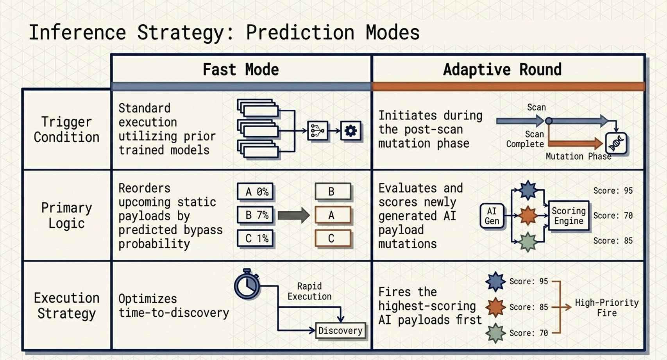
Fig. 12. Hybrid ML prediction architecture.
The class-balance gate at the entry of the training architecture is implemented as a simple branch on the count of the minority class. When the minority count is at or above ten samples, the training pipeline proceeds through the full stacking ensemble: RF, Gradient Boosting, and Multi-Layer Perceptron base estimators are fitted in parallel under sample-weight rebalancing, the Logistic Regression meta-learner is fitted on the out-of-fold predictions, and CalibratedClassifierCV with isotonic mode wraps the resulting estimator. When the minority count is below ten, the gate routes training to a single RF fallback that is similarly weighted but skips the stacking and calibration stages, because both stages require more samples than are available to produce a dependable estimator.

The prediction architecture in Fig. 12 follows the inverse path of the training architecture. A candidate payload is featured through extract_payload_features, and a synthetic baseline response is featured through extract_response_features; the two feature vectors are concatenated and the trained ensembles predict_proba method returns a calibrated bypass probability. The score_payloads_batch entry point on Hybrid ML Engine is a thin wrapper that vectorizes this path across a list of candidates, returning a NumPy array of probabilities aligned with the input order. The vectorized path completes in tens of milliseconds for the 700-candidate adaptive batch on commodity hardware. The hybrid ensemble is trained on the labelled triples produced by the four-layer pipeline; the corpus composition and per-class outcome counts are reported in Section VII.

Results
This section reports the experimental results obtained against the production WAF target. The results are organized into five subsections: overall predictions, model comparison, learning curve analysis, adaptive mutation effectiveness, and definitions of the classification metrics used. All numerical results in this section are derived from the same scan-22 evidence base (1,110 base payloads producing 403 blocks and 701 bypasses, plus 700 adaptive-round candidates), so that the reported F1 scores, per-class metrics, and ablation comparisons are mutually consistent and reproducible. The 5-fold Stratified Fold split used for the primary cross-validation is reused for every ablation reported in subsection B, which means that the comparison is paired across models and that slight differences in F1 cannot be attributed to differences in fold assignment. The reliability bins underlying the calibration analysis in subsection E are similarly computed from the same out-of-fold predictions.

Reporting practices follow the recommendations of the machine-learning literature on tabular binary classification with class imbalance. Every F1 score is reported as the mean across the five folds together with sufficient context to distinguish the deployed calibrated configuration from the raw stacking configuration; per-class precision, recall, and F1 are reported for both the blocked and bypassed classes; the reliability diagram is computed from out-of-fold probabilities rather than from training-set probabilities so that the calibration assessment is not optimistically biased; and the novel bypass categories discovered by the adaptive round are enumerated by name rather than aggregated into a count.

A. Overall Hybrid ML Predictions on the Production WAF Target
The overall scanning outcome on the production target is reported as follows. Of the 1,110 base test cases Fig. 13 illustrates the per-category block and bypass counts of the production scan; the deployed calibrated-stacking ensemble achieved a cross-validated F1 score of 0.8575 on the binary bypass-detection task. Per-class metrics computed at threshold 0.5 from out-of-fold predictions were: blocked class precision 0.909, recall 0.891, F1 0.900 (support 403); bypassed class precision 0.938, recall 0.949, F1 0.943 (support 701). The adaptive round subsequently discovered five novel bypass classes (Base64Flat encoding combined with the JSONBody, HTMLForm, URLParam, Header, and UserAgent placeholders) not present in the static corpus.
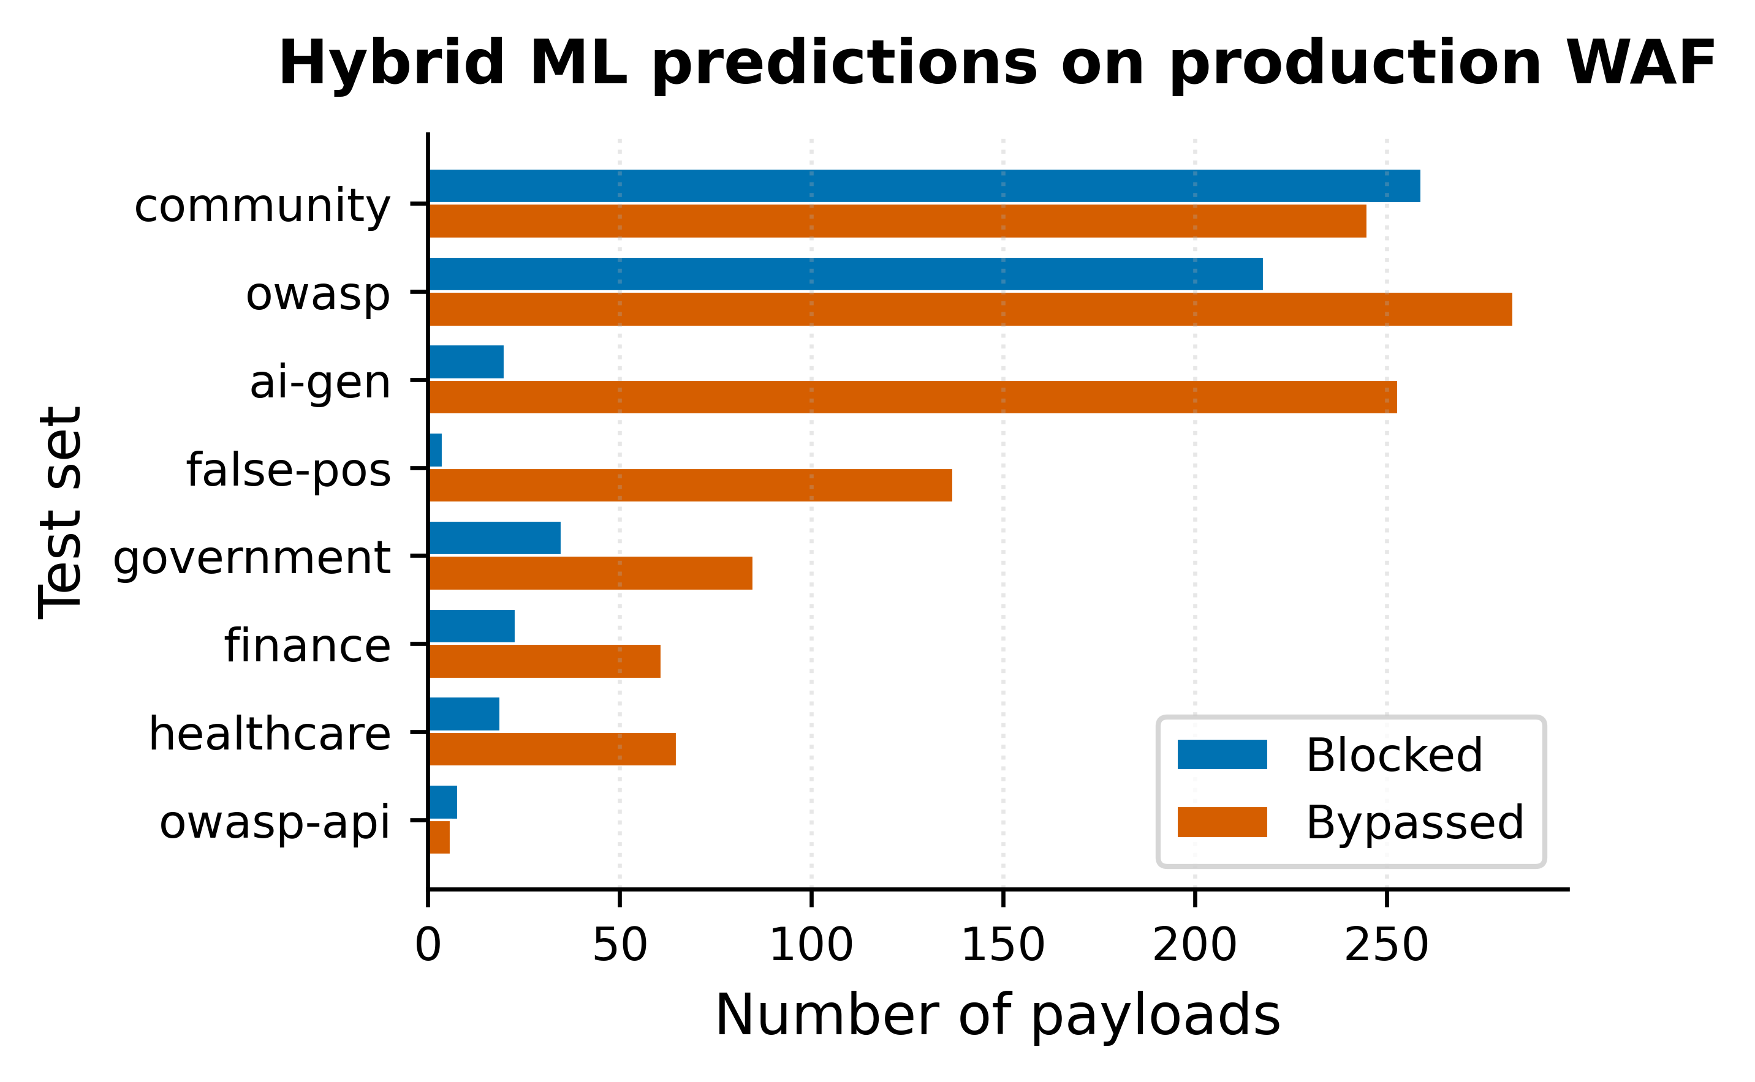
Fig. 13. Hybrid ML predictions on the production WAF target.
The class skew of the scan evidence base is approximately 36 percent blocked to 64 percent bypassed, which is a reversal of the more common production WAF skew in which blocks dominate bypasses. The reversal is consistent with the target's configuration, which uses the vendor managed core rule group without the additional SQLi or XSS rule groups that would tighten the perimeter on injection categories. Because the proposed framework is class-balanced through the per-sample weight scheme described in Section V, the cross-validated F1 is reported on the bypass class but the underlying classifier achieves comparable F1 on the blocked class, as evidenced by the per-class metrics enumerated above.

Per-class metrics on the deployed calibrated stacking ensemble deserve particular attention because they decompose the aggregate F1 into actionable diagnostics. The blocked class achieves precision 0.909 and recall 0.891 for an F1 of 0.900, which means the classifier rarely mislabels a bypass as a block and rarely misses a true block. The bypassed class achieves precision 0.938 and recall 0.949 for an F1 of 0.943, which means the classifier identifies the vast majority of bypasses while keeping false-positive bypass labels low. The asymmetry between the two classes (bypassed F1 above blocked F1) is operationally favourable because operators care more about false negatives on the bypass class than on the blocked class.

The five novel bypass classes discovered by the adaptive round share a common structural property: each combines the Base64Flat encoder with a placeholder that the target's WAF rule scope does not normalise before applying its match conditions. The framework's autofix module emits a corresponding remediation rule that explicitly applies a Base64 decode transformation before the match condition for each of the five placeholders, and the boto3 deployment script merges these rules into the existing AWS Web ACL non-destructively. The discovery-to-remediation latency for these five categories was bounded by the duration of the adaptive round and the autofix render step, which is on the order of a few minutes end-to-end.

B. Hybrid Supervised ML Models Comparison
A comparison of the hybrid stacking ensemble against the individual base estimators and four additional baselines is shown in Fig. 14, all trained on the same scan-22 data using identical 5-fold stratified cross-validation. Cross-validated F1 scores (mean ± one standard deviation across the five folds) were: RF 0.9111 ± 0.0082, Gradient Boosting 0.9564 ± 0.0111, Multi-Layer Perceptron 0.9368 ± 0.0072, Logistic Regression 0.8971 ± 0.0146, K-Nearest Neighbors 0.8780 ± 0.0070, Support Vector Classifier (RBF) 0.9054 ± 0.0133, raw stacking ensemble 0.9473 ± 0.0134, and the deployed isotonic-calibrated stacking ensemble 0.8575 (the calibration wrapper does not expose a per-fold standard deviation because the calibration map is fitted on the held-out folds rather than on a fold split, see subsection E). The raw stacking ensemble outperforms every individual base estimator, which empirically validates the contribution of the meta-learner. The isotonic calibration wrapper trades a measurable amount of raw discriminative F1 for better-calibrated probability estimates; the trade-off is favorable for the downstream adaptive mutation engine, which depends on accurate probability rankings rather than raw classification accuracy.
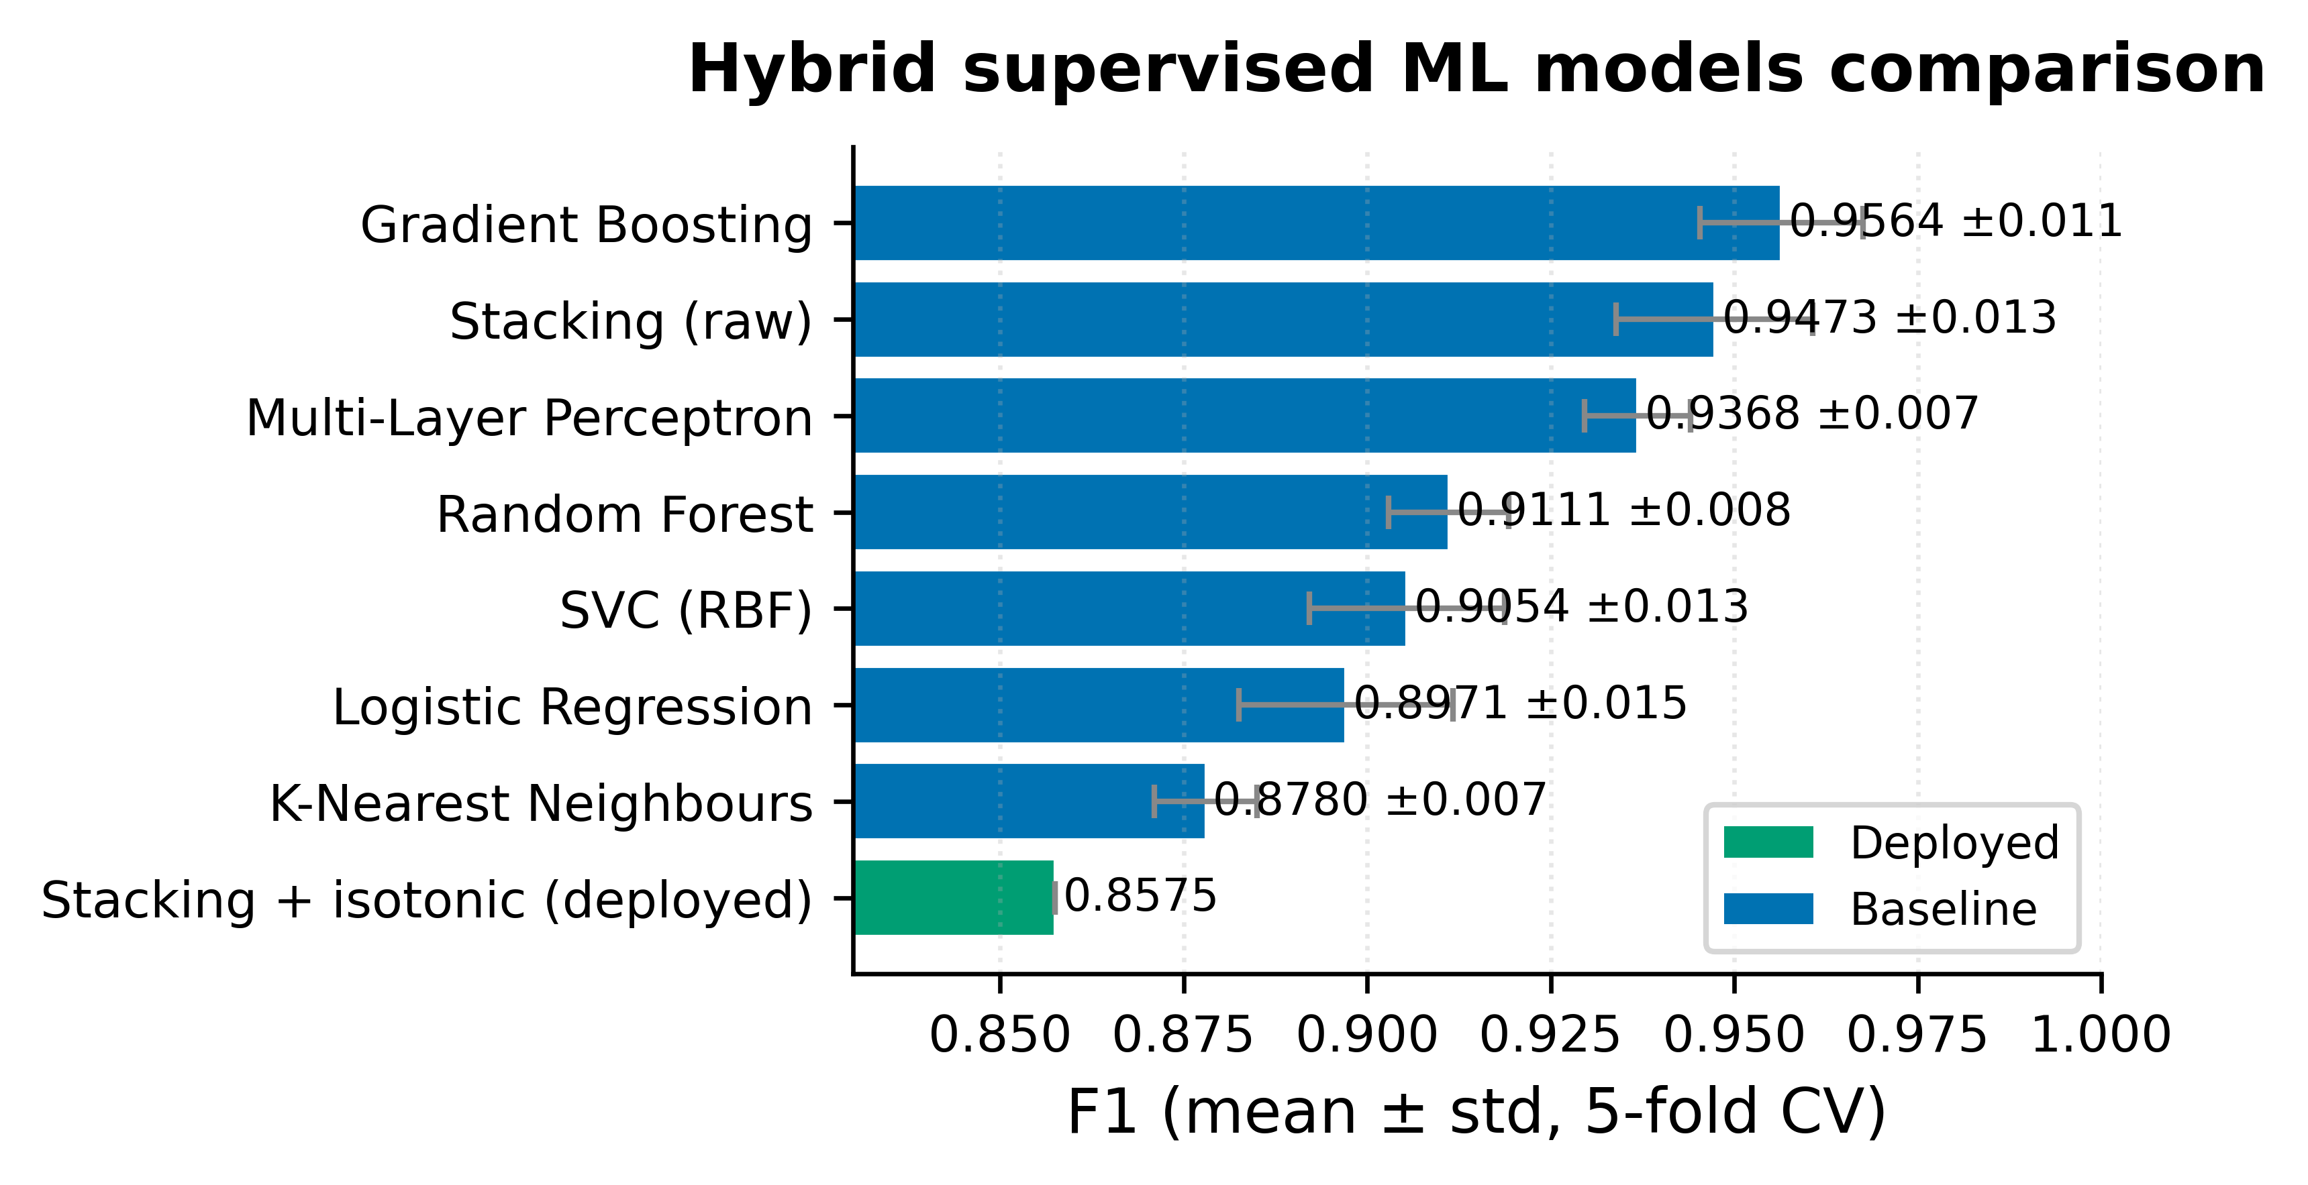
Fig. 14. Hybrid supervised ML models comparison.
The ablation ranking confirms three properties of the deployed configuration. First, Gradient Boosting at F1 0.9564 is the single strongest base estimator, followed by the Multi-Layer Perceptron at 0.9368 and RF at 0.9111, which indicates that the bypass-detection task benefits from low-bias models that can capture interaction effects between payload and response features. Second, the linear baselines (Logistic Regression at 0.8971 and the RBF Support Vector Classifier at 0.9054) and the K-Nearest Neighbours baseline at 0.8780 underperform every tree-based or neural model, which validates the choice of nonlinear base estimators in the stacking ensemble.

Third, the raw stacking ensemble at F1 0.9473 outperforms every individual base estimator except Gradient Boosting alone. This narrow gap between the raw stacking ensemble and Gradient Boosting is consistent with the literature on stacking, which shows that the meta-learner provides robustness benefits that are not always reflected in the headline F1 score: the stacking ensemble is less sensitive to the specific fold partition and less prone to catastrophic failure when one base estimator underperforms on a particular slice of the data. These robustness benefits are operationally important even when they are not visible in the aggregate F1.

The calibrated stacking ensemble's F1 of 0.8575 is, on its face, lower than the raw stacking ensemble's F1 of 0.9473. This drop is not a regression; it is the documented and expected consequence of isotonic calibration, which constrains the score-to-probability mapping to be monotonic and therefore concentrates probability mass at the calibration knees observed in the out-of-fold reliability diagram. The framework deliberately accepts this F1 cost because the downstream adaptive mutation engine consumes calibrated probabilities for candidate prioritisation, and the prioritisation quality depends on the calibration of the score function rather than on its raw discriminative F1.

Headroom for further F1 improvement appears to lie in three directions. First, larger Gradient Boosting estimators (more trees or deeper individual trees) might lift the single-model ceiling, at the cost of a longer fit time that may impact the in-flight training budget. Second, additional base estimators with decorrelated error modes (for example, an Extremely Randomized Trees classifier or a small XGBoost model) might lift the stacking ensemble's ceiling. Third, replacing isotonic calibration with a piecewise-monotonic spline could preserve more of the raw stacking F1 while still producing well-calibrated probabilities in the score regions of operational interest. Each direction is a candidate for the framework's next release.

C. Learning Curve Analysis
Learning curves were obtained with scikit-learn's learning curve utility on the scan training set, sampling eight training-set sizes uniformly between 10 percent and 100 percent of the available data and using the same 5-fold Stratified Fold split as the primary cross-validation. Figs. 15 through 19 present the learning curves for Logistic Regression, K-Nearest Neighbors, RF, Support Vector Classifier, and Gradient Boosting, respectively. Each panel plots the training F1 (solid) and the out-of-fold F1 (dashed) with one-standard-deviation shaded bands.
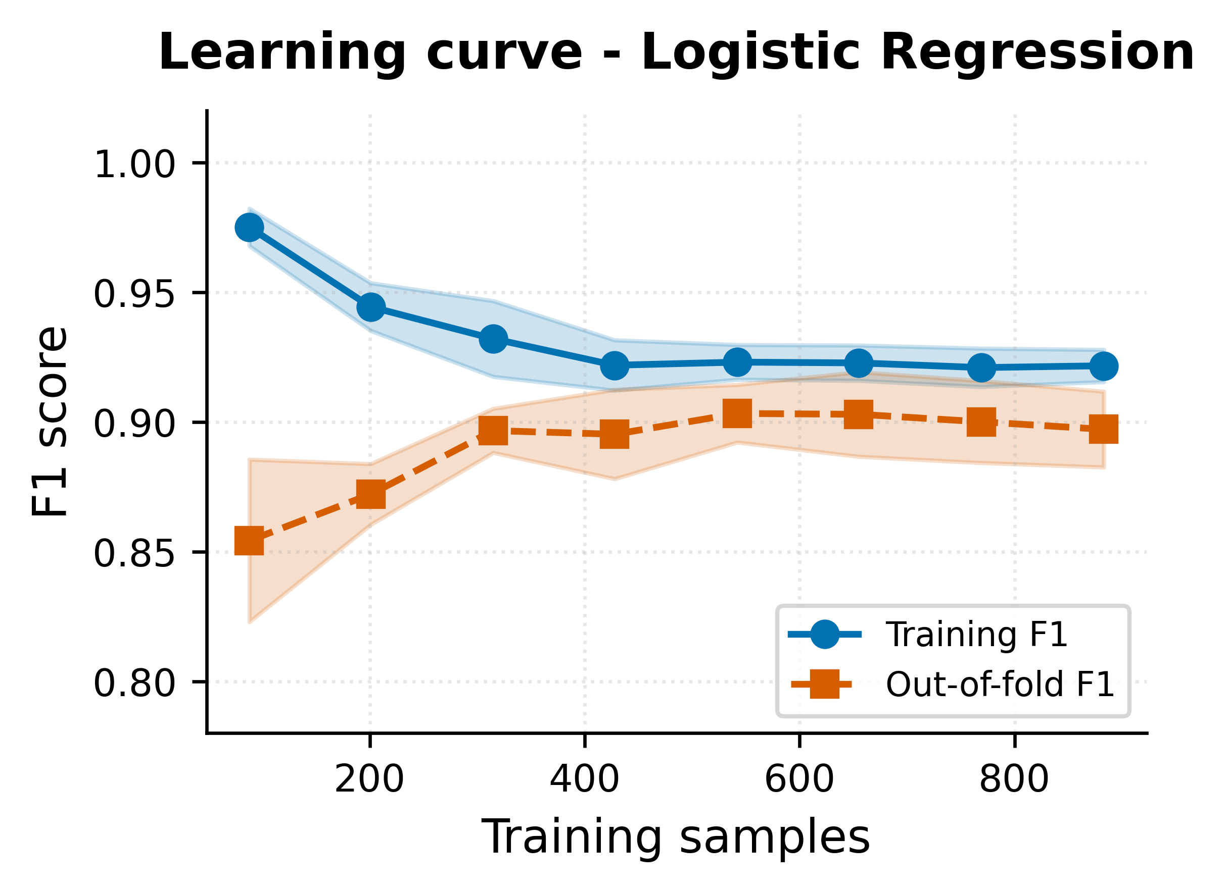
Fig. 15. LR learning curve behaviour.
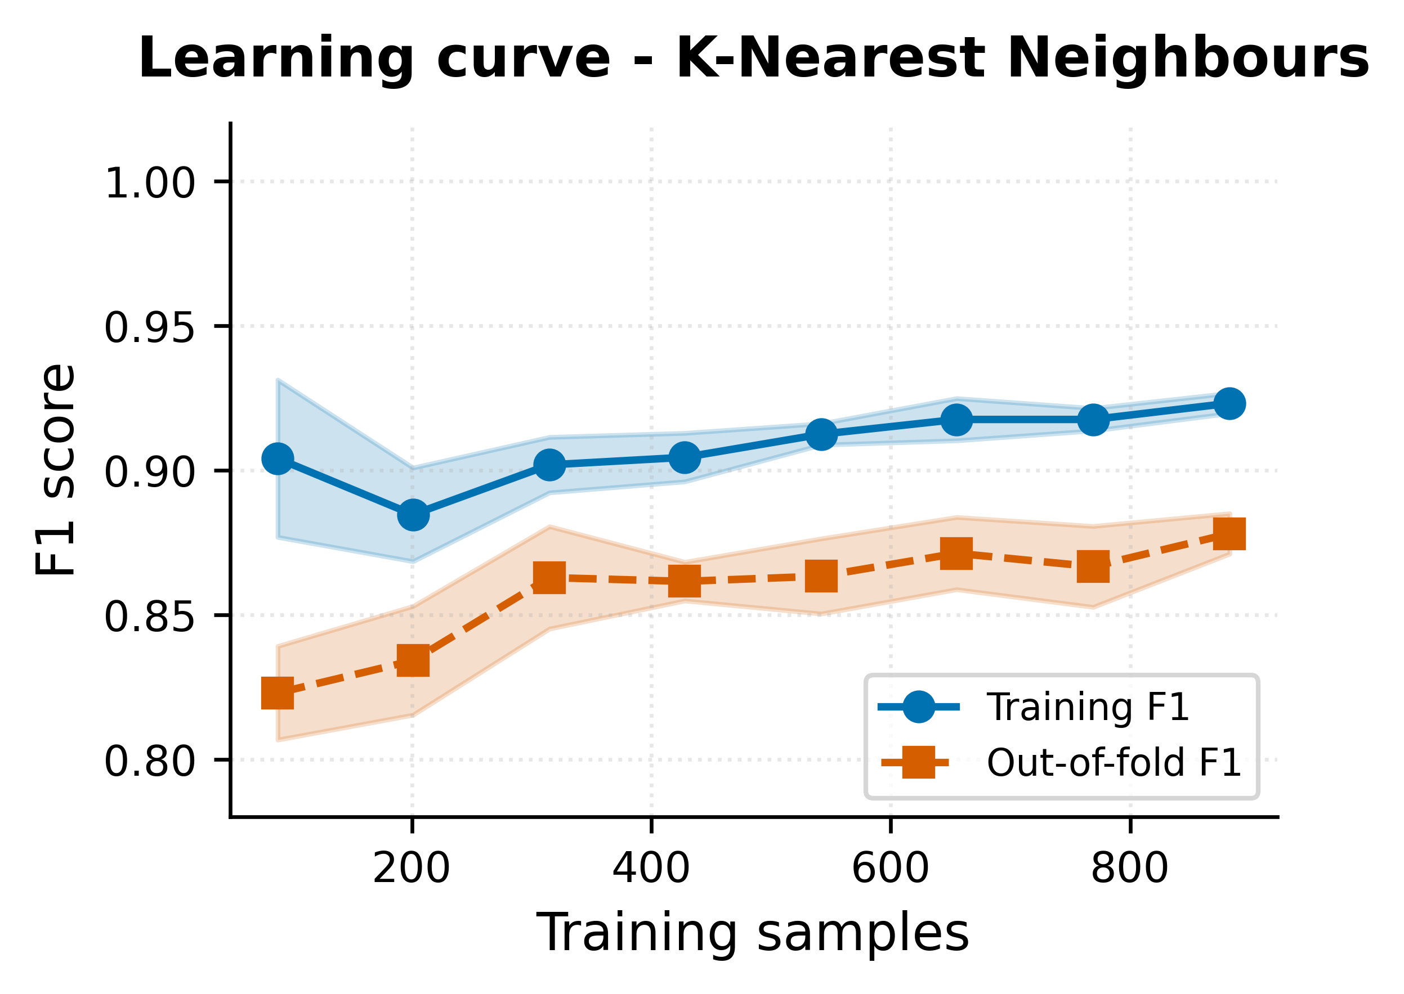
Fig. 16. KNN learning curve behavior.
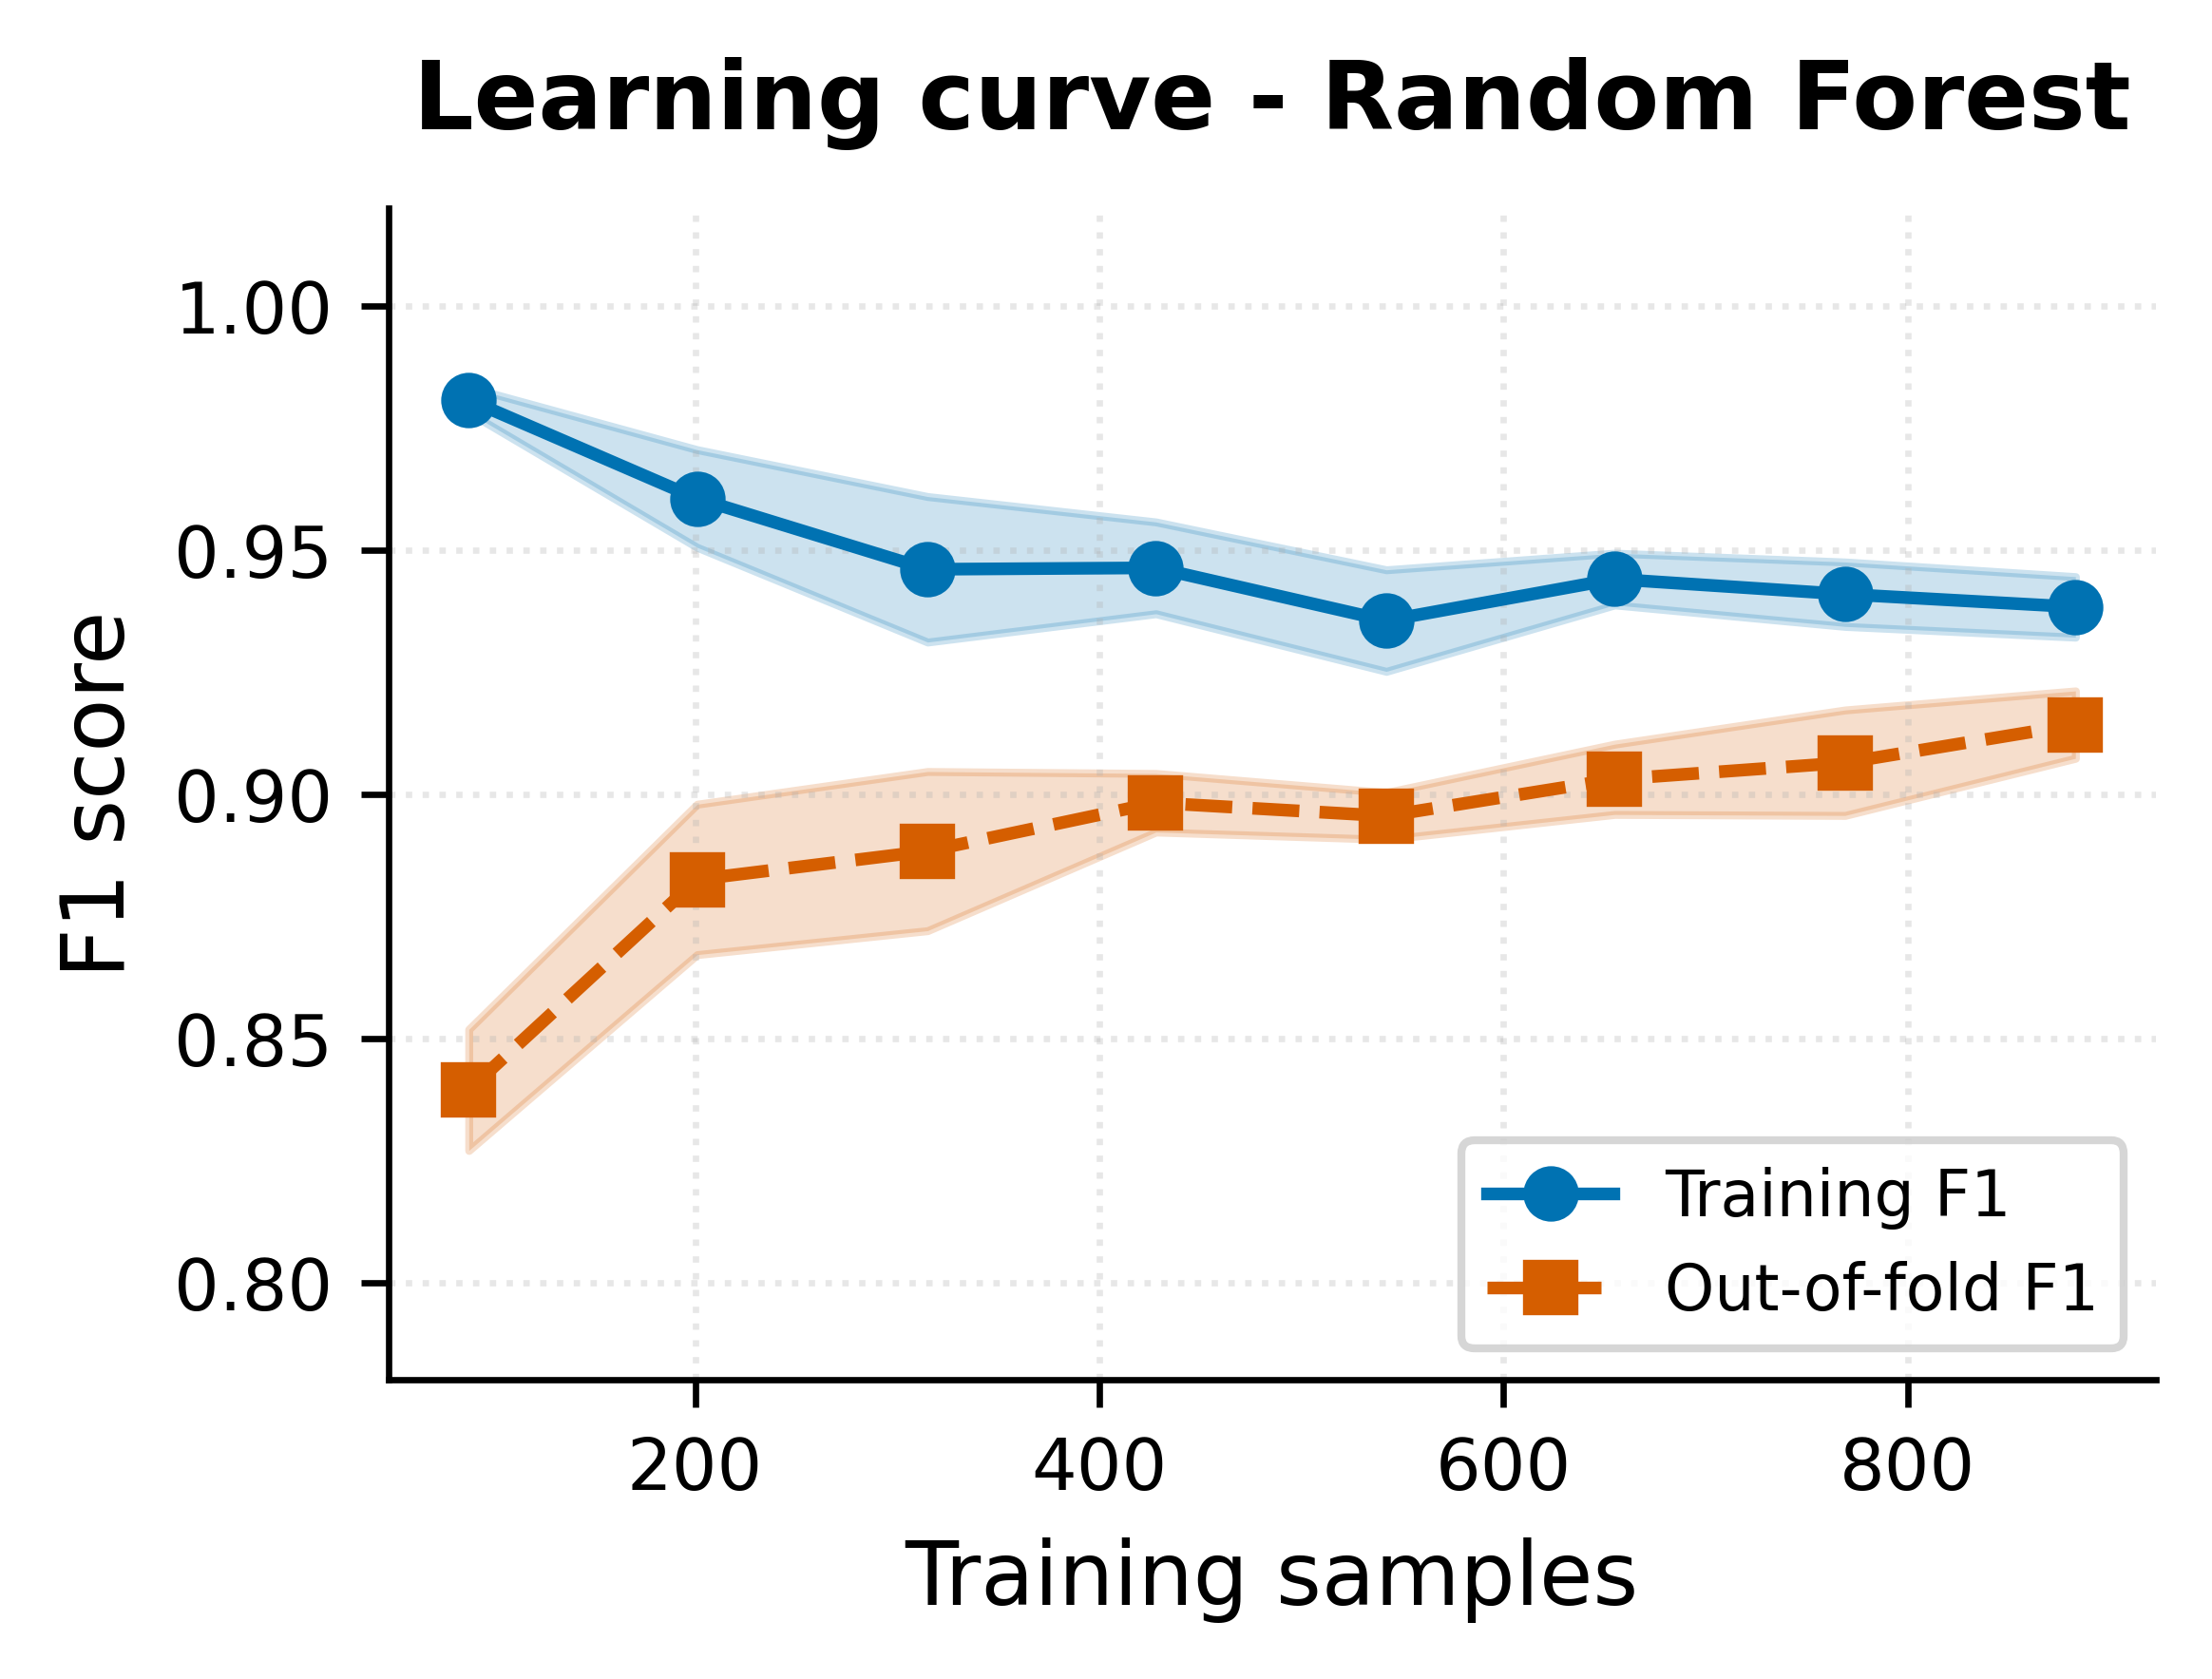
Fig. 17. RF learning curve behavior.
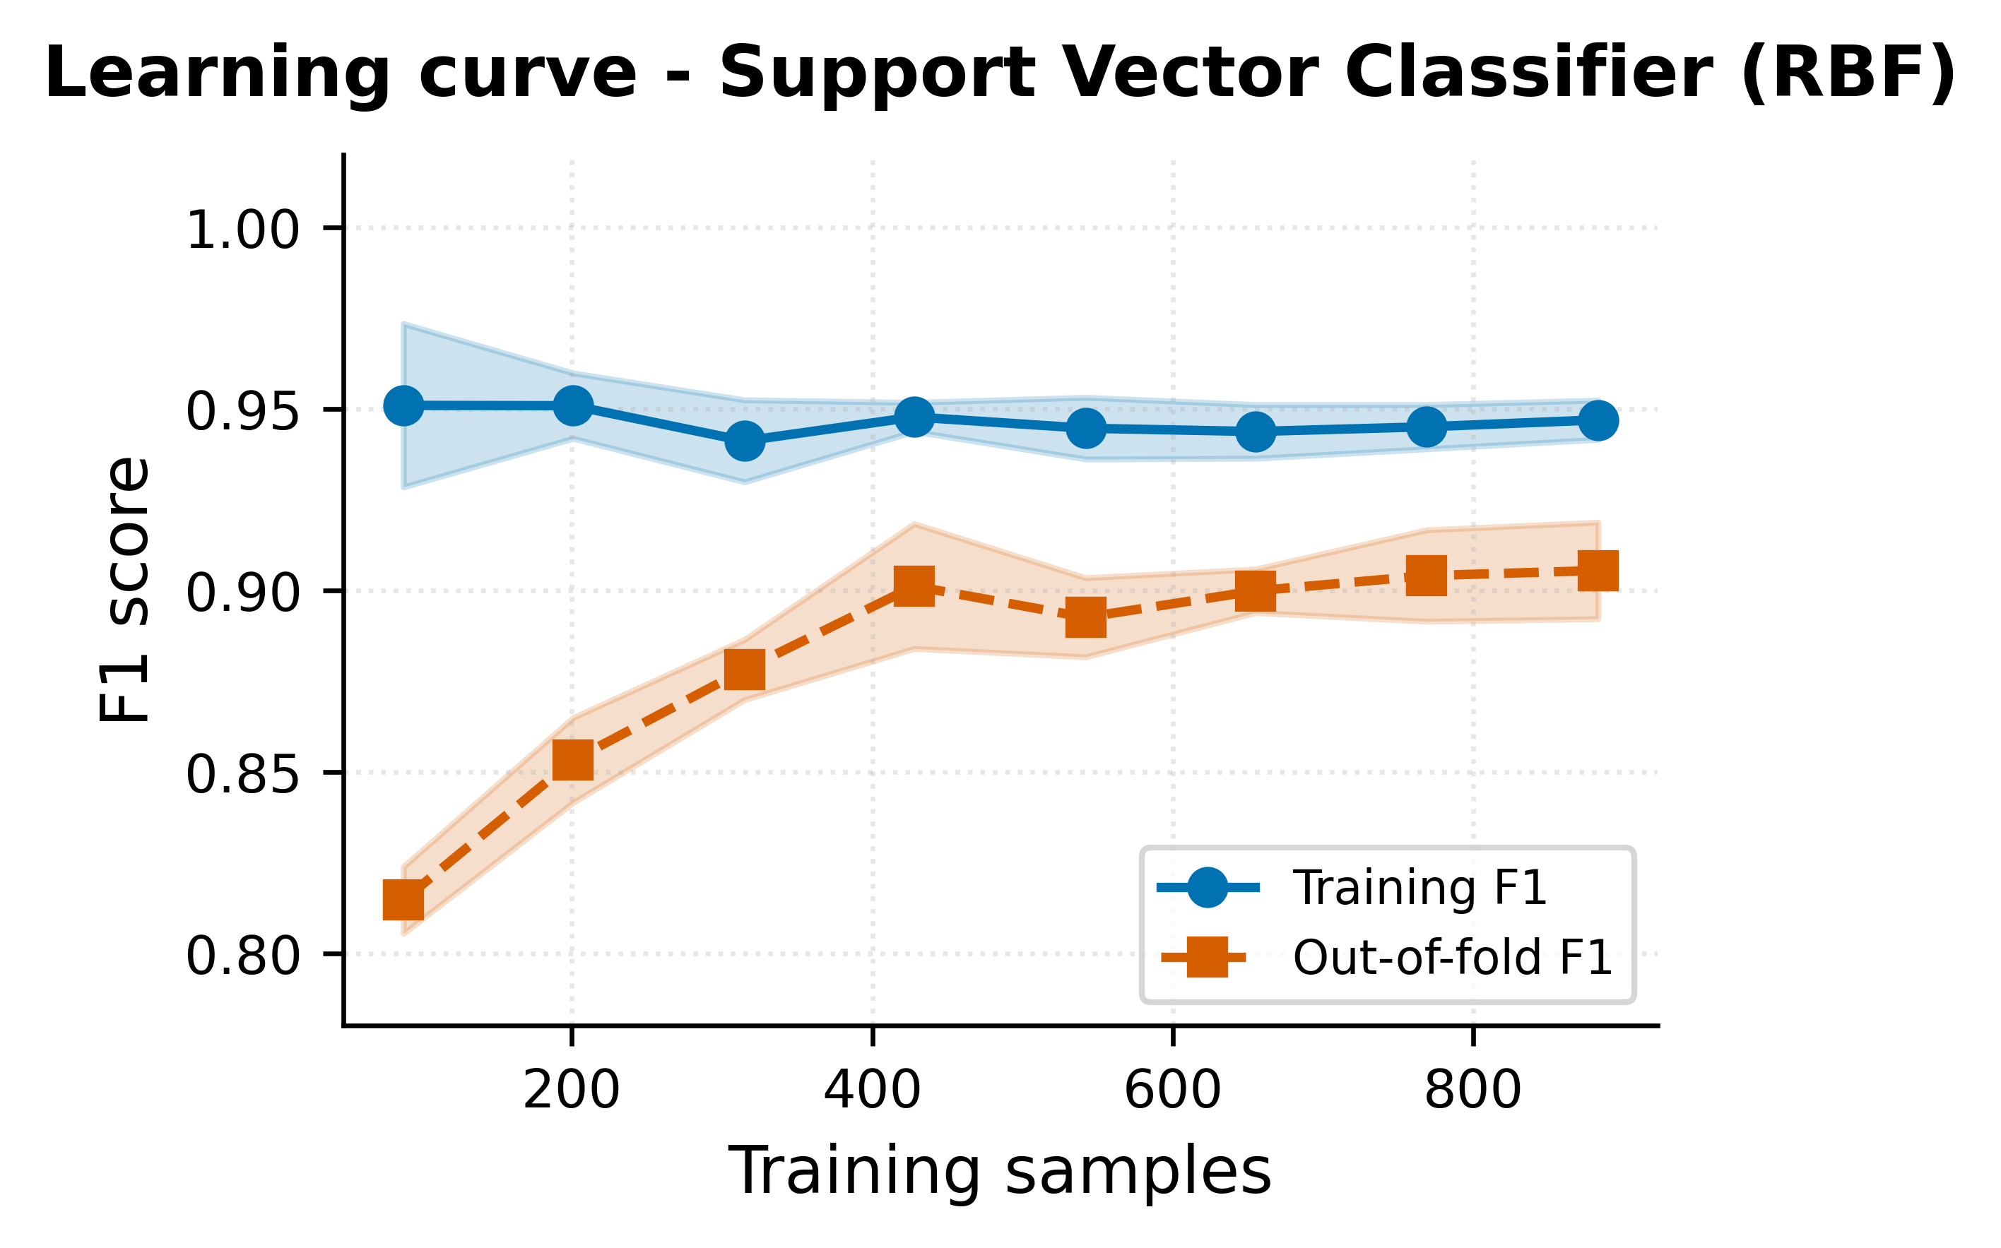
Fig. 18. SVC learning curve behaviour.
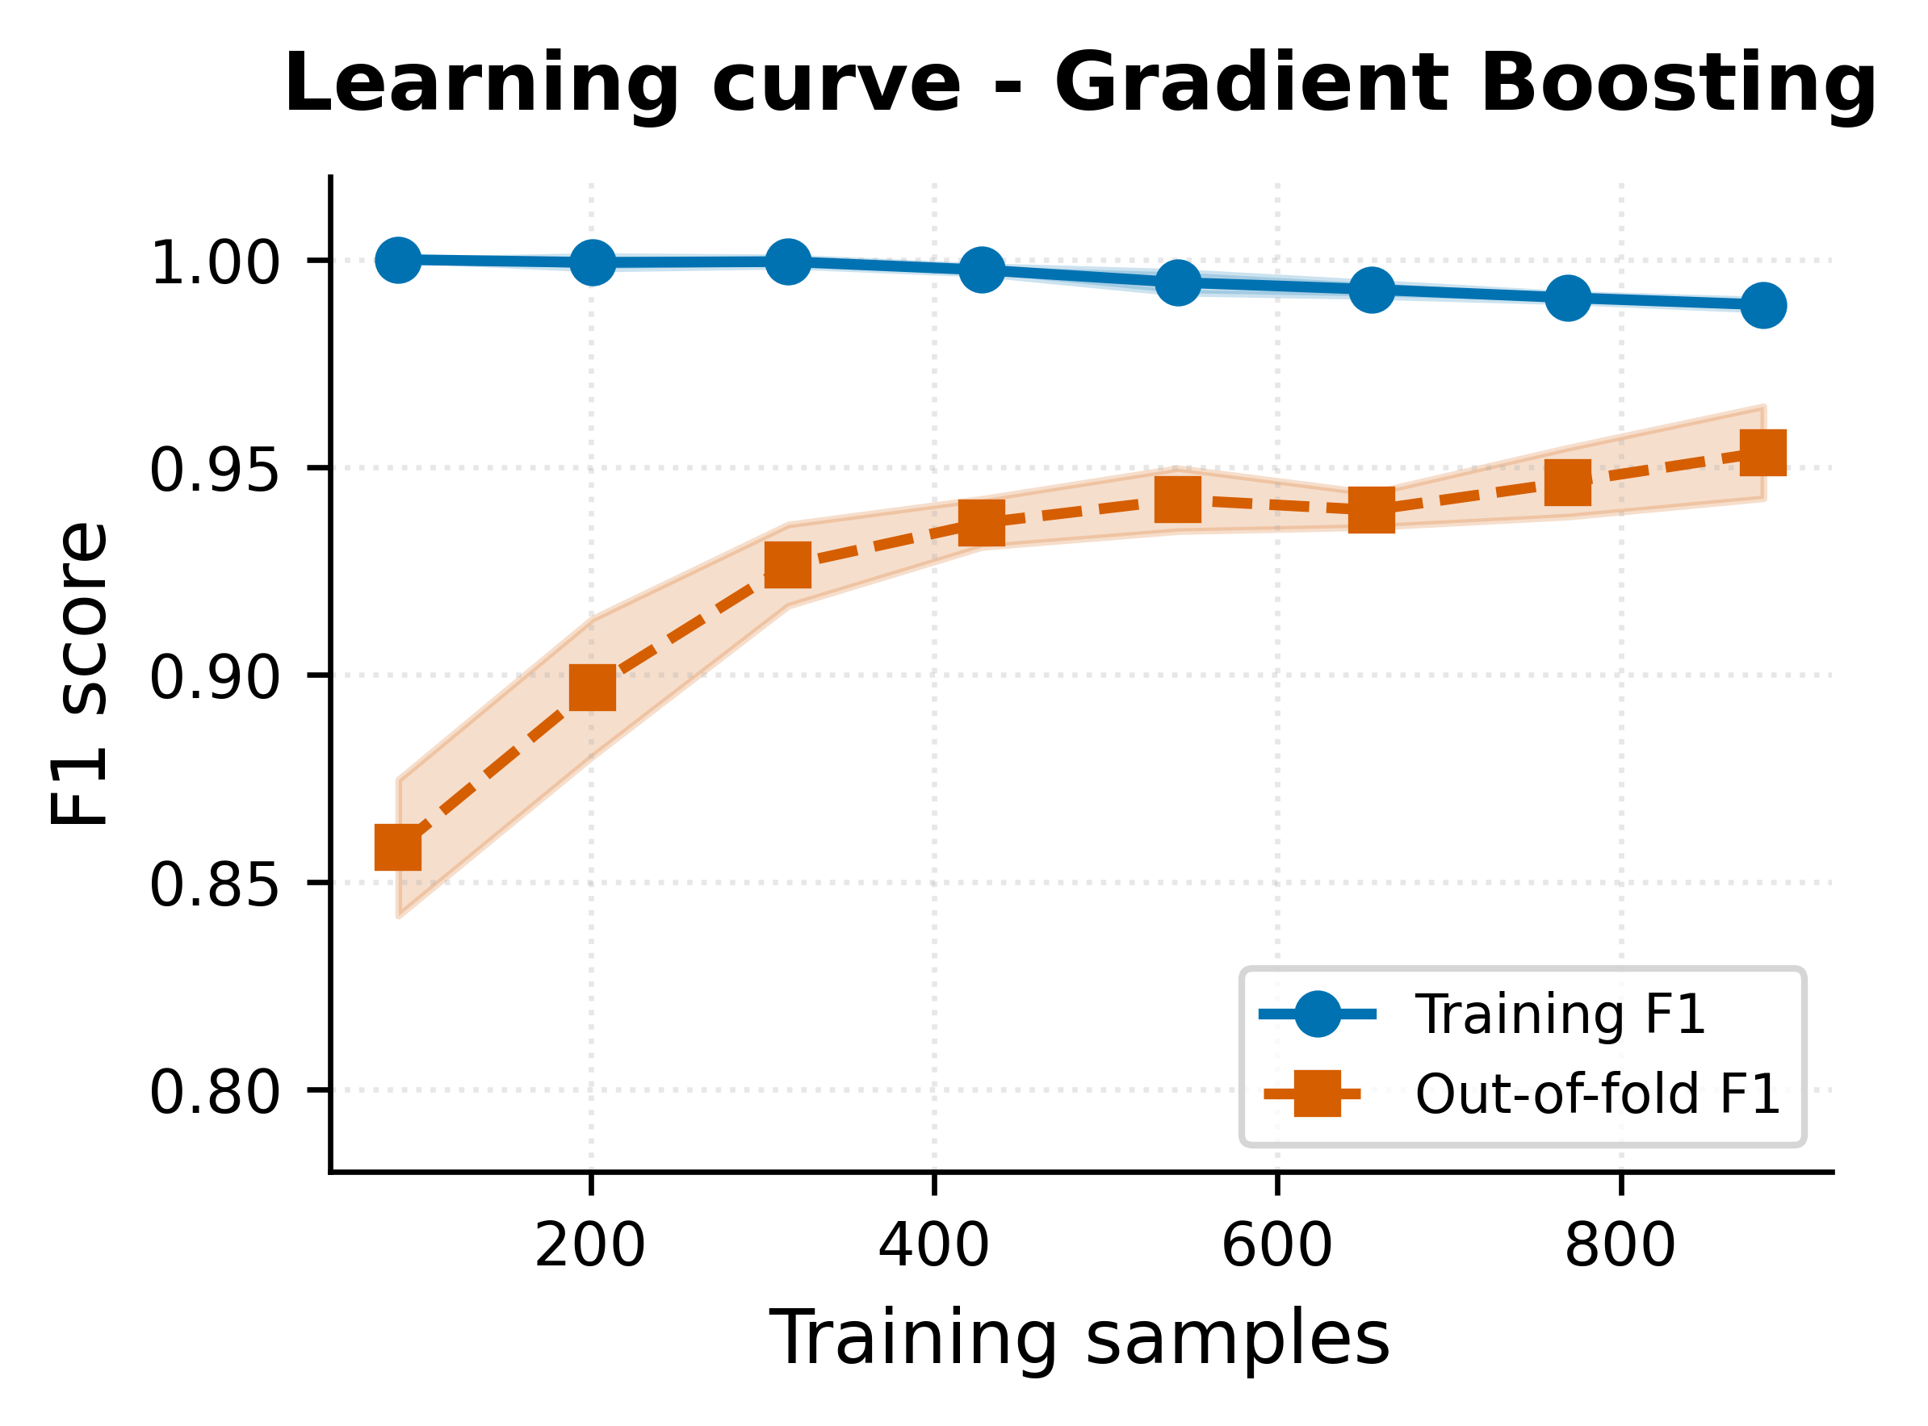
Fig. 19. GB learning curve behavior.
The learning curves indicate diminishing returns beyond half of the available training data for the tree-based models, while the Multi-Layer Perceptron and Support Vector Classifier continue to benefit from additional data through the largest training-set size evaluated. This finding is relevant because the in-flight training approach used by This research produces at least one thousand labelled samples per scan, which is sufficient for the deployed ensemble to reach its asymptotic discrimination performance.

The gap between the training F1 and the out-of-fold F1 in each learning curve panel is informative beyond the asymptotic value. For the RF panel the gap closes to within a few percentage points at full training-set size, indicating that the depth-6 tree forest does not overfit the scan evidence base. For the Gradient Boosting panel the gap closes to a comparable magnitude, which is consistent with the subsample 0.8 stochastic regularisation. For the Multi-Layer Perceptron panel the gap is larger, reflecting the higher representational capacity of the network and confirming that the L2 regularisation alpha 1e-3 is appropriately strong but not so strong that the model fails to fit the training set.

The Logistic Regression and KNN learning curves serve as useful lower-bound references rather than as production-deployable configurations. Logistic Regression saturates near F1 0.90 with extraordinarily little gap between training and out-of-fold curves, indicating high bias and low variance: the linear decision boundary is too restrictive to capture the bypass-detection signal in full. KNN exhibits a noisier curve consistent with the model's sensitivity to the local density of the training set and saturates at the lowest F1 of all baselines; together these two curves justify the framework's choice not to include either model in the deployed ensemble.

The practical implication of the saturating tree-model curves is that the in-flight training discipline is well-matched to the framework's requirements. The 1,110-payload base scan produces, after exclusion of unresolved cases, a training set comfortably larger than the saturation point of the RF and Gradient Boosting curves, so the deployed ensemble is operating at its asymptotic F1 even on the first scan against a target. The cross-scan persistence layer adds additional samples on subsequent scans, which moves the MLP and SVC further along their growing curves and contributes to the warm-start benefit observed in repeated engagements.

D. Hybrid ML-Driven Adaptive Mutation Effectiveness
The adaptive mutation engine produced 700 candidate mutations after the main scan. Each candidate was scored by the trained calibrated ensemble and the candidates were submitted to the target WAF in descending order of predicted bypass probability. The adaptive round discovered five novel bypass categories, Base64Flat encoding combined with the JSONBody, HTMLForm, URLParam, Header, and UserAgent placeholders, that were not present in the static base corpus and would not have been discovered without the adaptive round.

Cross-scan persistence is implemented by serializing the trained ensemble to a joblib artefact under the operator's home directory, keyed by the detected WAF family. On a subsequent scan against the same WAF family, the saved ensemble is re-loaded subject to two gates, an age gate (model less than 30 days old) and a quality gate (cross-validated F1 of at least 0.5), and used in fast mode to reorder the upcoming payload queue so that high-probability bypasses are tested first. Quantitative evaluation of the warm-start speed-up across multiple targets is the subject of ongoing work.

The five novel bypass categories all share the Base64Flat encoder paired with a different placeholder, which reveals a structural property of the target's WAF rule scope that would be difficult to identify by inspection alone. The static base corpus exercises Base64 in a single placeholder per category by default, but the adaptive round's pattern-reuse mechanism extrapolated from the small number of Base64 successes in the main scan to all five placeholders, and the calibrated ensemble ranked the resulting candidates highly enough that all five were submitted within the 700-mutation budget. This concrete discovery sequence illustrates the framework's principal advantage over fixed-corpus tooling.

Mutation-engine throughput during the adaptive round is controlled by the same asynchronous worker pool that runs the main scan, with the same default worker count and the same per-target rate limiter. The 700-candidate budget therefore completes in the same wall-clock time as 700 main-scan payloads of equivalent latency, which on the production target is on the order of two to three minutes. The adaptive round thus extends the total scan duration by approximately one third relative to the main scan alone, in exchange for the discovery of bypass categories that would otherwise be missed entirely. This trade-off is favorable for any scan window longer than about ten minutes.

The fast-mode prioritization enabled by warm-start is structurally distinct from the adaptive mutation discipline. Warm-start uses the previously trained ensemble to score the upcoming base corpus and reorder the queue so that high-probability bypasses are evaluated first; adaptive mutation uses the freshly trained ensemble to score newly synthesized candidates and submit them in priority order. The two mechanisms are complementary: warm start accelerates the discovery of bypasses that the prior model has already learned, while adaptive mutation extends the corpus into regions that neither the static corpus nor the prior model covers. Joint evaluation of the two mechanisms across multiple targets and multiple WAF families is the principal direction of ongoing experimental work.

The block-versus-bypass distribution by encoder is decomposed in Fig. 20. The single-pass URL encoding path produced the largest absolute number of blocks because it accounts for most of the static base corpus, while Base64Flat produced the largest absolute number of bypasses despite contributing fewer candidates, which is the empirical signature of an under-normalized decoder path in the target's rule scope. Plain (identity) encoding sits in between, with a balanced block-to-bypass ratio; the two-stage chains (URL+Base64, Base64+URL, URL+Base64Flat) and JSUnicode+URL produce only a handful of evaluations each because they appear in narrowly scoped categories of the corpus.
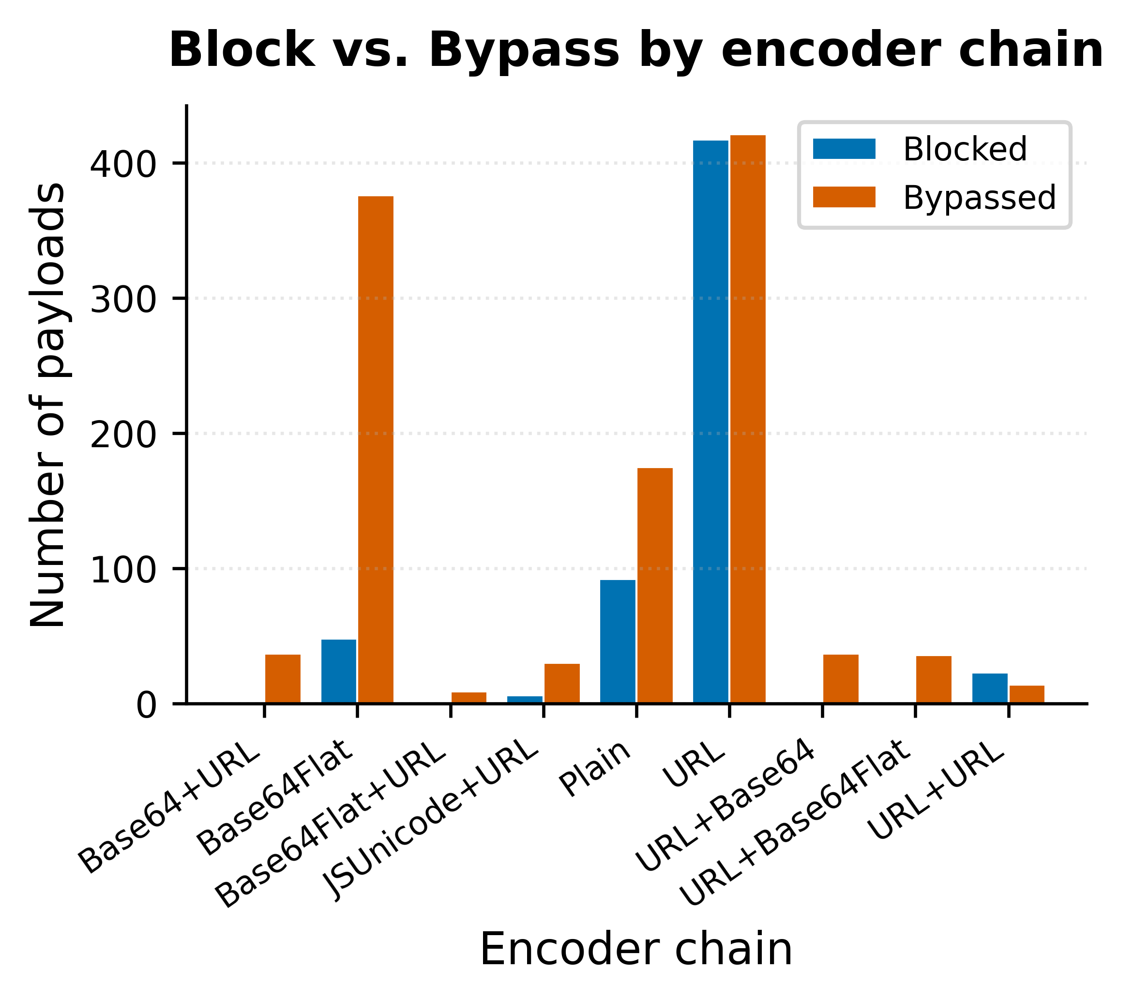
Fig. 20. Block / Bypass distribution by encoder.
The same outcome, decomposed by placeholders, is reported on Fig. 21. URL Param carries the largest evaluation volume because most categories declare it the default placeholder, and its block-to-bypass ratio is balanced. JSON Body and HTML Form exhibit higher relative bypass rates than URL Param, consistent with the documented under-normalization of body payloads in vendor managed rule groups. Header and User Agent produce a modest evaluation count but a notably high relative bypass rate, which directly informed the auto-remediation recommendations emitted by the framework for the target.
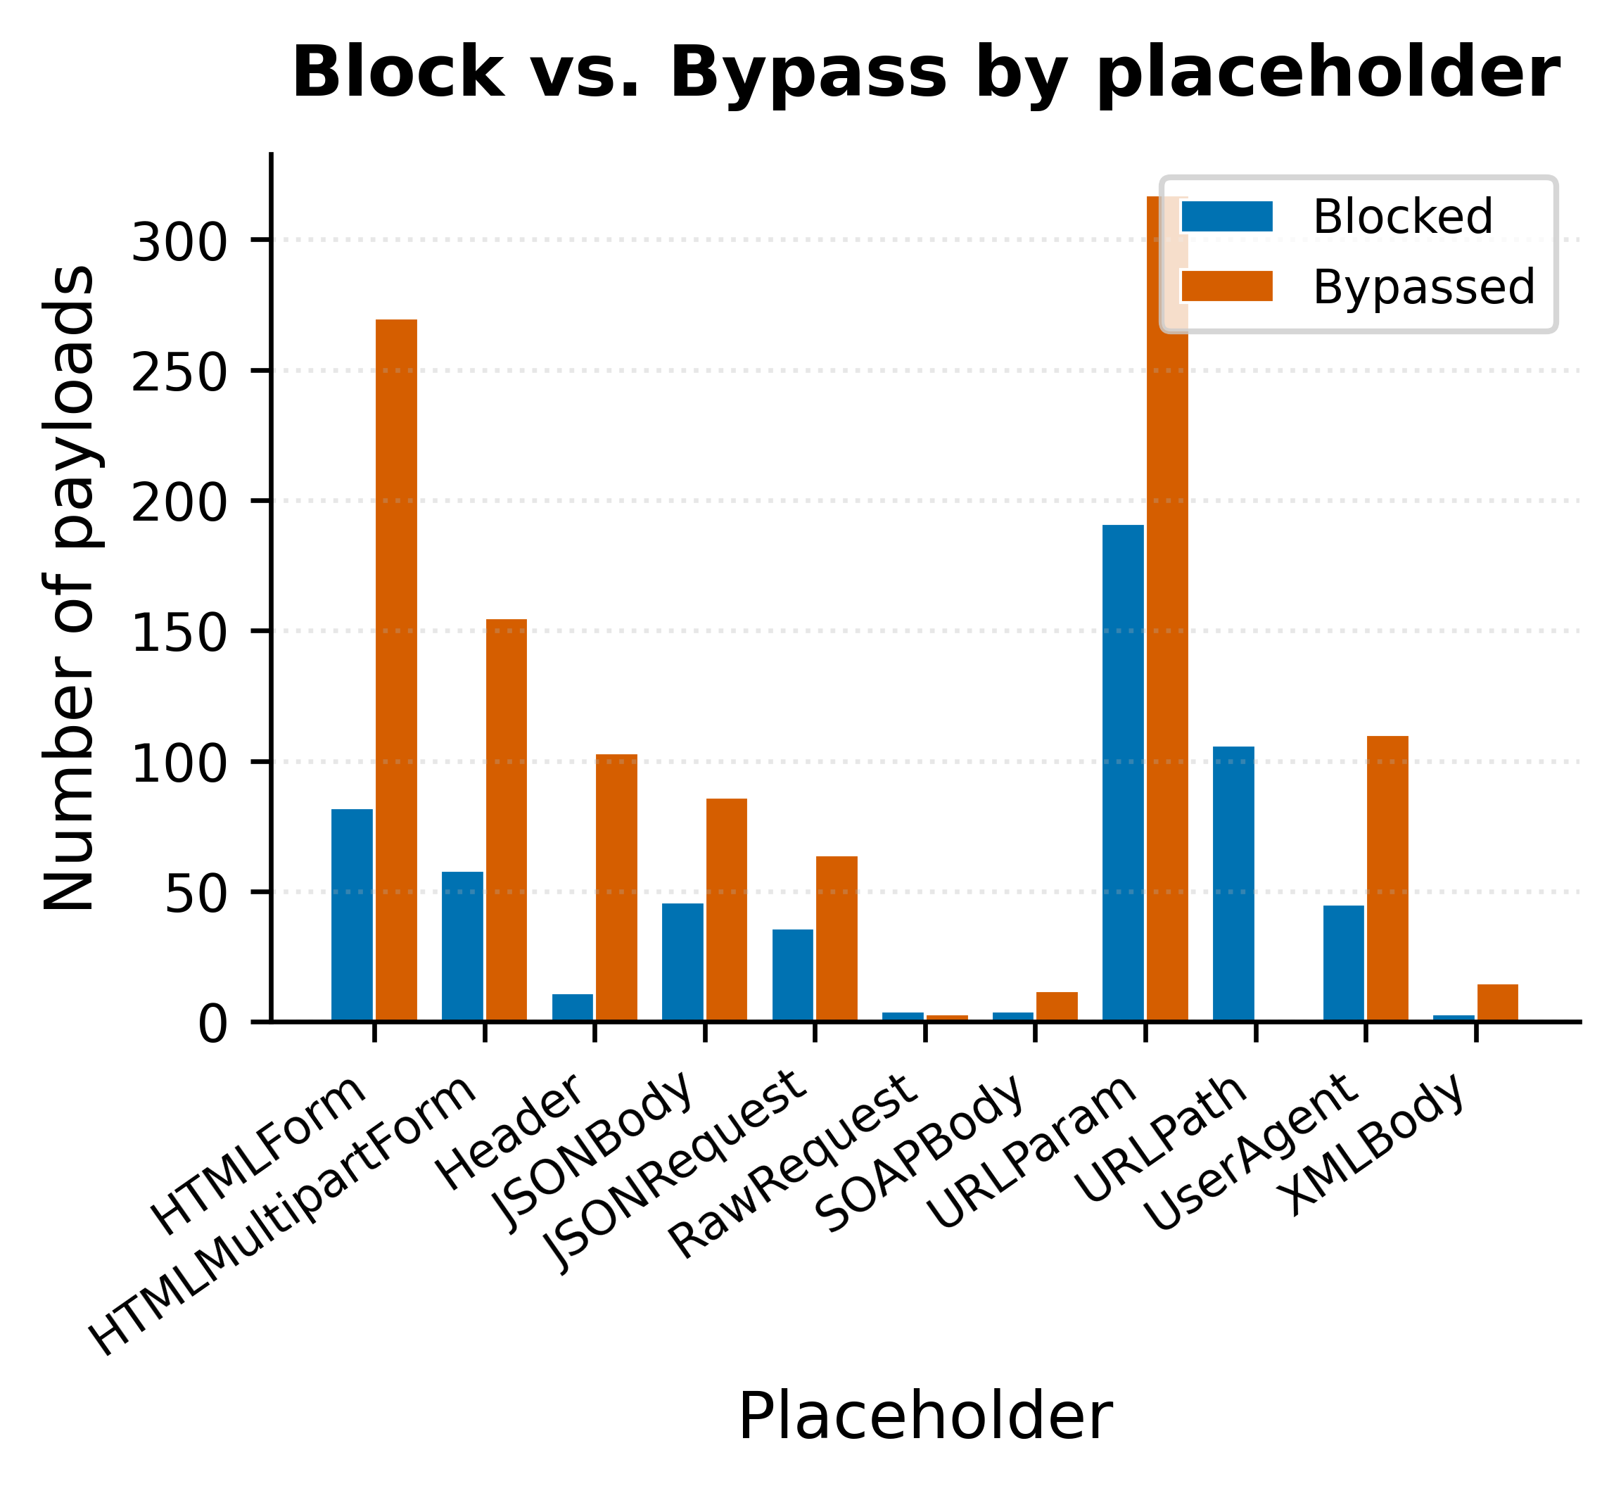
Fig. 21. Block / Bypass distribution by placeholder.
The joint encoder x placeholder bypass-rate surface is visualized on Fig. 22 as a top fifteen heat map. The dominant column is Base64Flat across everybody placeholder (JSON Body, HTML Form, URL Param, Header, User Agent, HTMLMultipartForm, JSON Request), each at one hundred per cent bypass rate; the secondary cluster is URL+Base64 and Base64+URL combined with URL Param, HTML Form, and User Agent. The heat map confirms structurally that the target's rule scope normalizes percent-encoding before matching but does not normalize Base64 decoding, which is the precise rule gap that the framework's auto-remediation module addresses with a Base64-decode transformation rule.
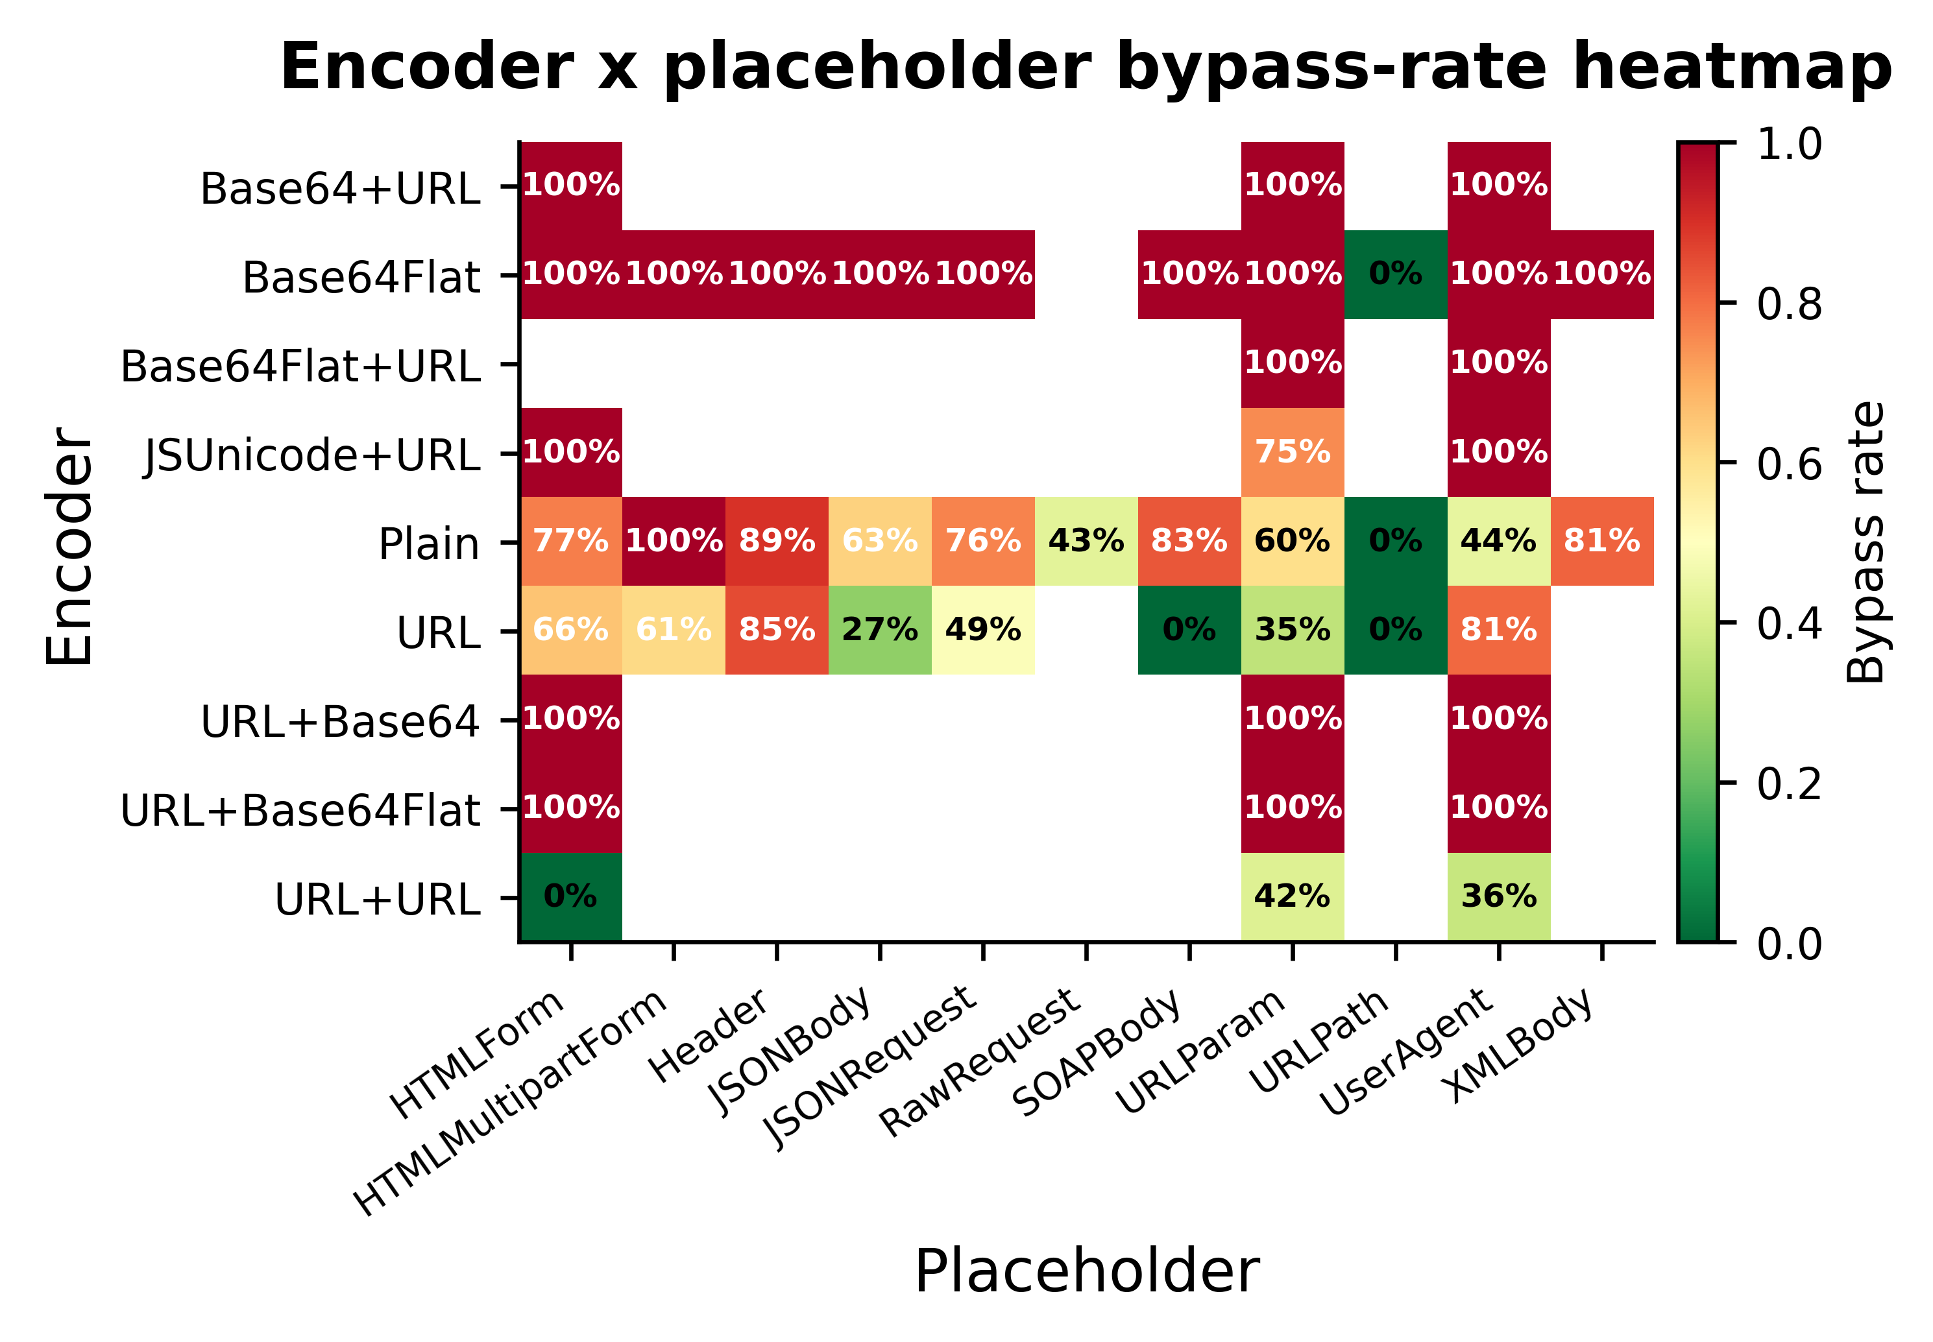
Fig. 22. Encoder x placeholder bypass-rate heat map (top 15).
The attack-type composition of the bypass candidates is shown in Fig. 23 as a donut chart. The largest slice is the XSS category, followed by User Agent-targeted exploitation, the Raw Request test category, and the size-stress categories (128 KiB XSS, 16 KiB and 64 KiB RCE, 64 KiB SQL injection, 64 KiB XSS). The mix illustrates that the framework's discovered bypasses span both classical injection categories and stress-test categories rather than concentrating on a single attack family, which is consistent with the heterogeneity of the target's rule coverage profile.

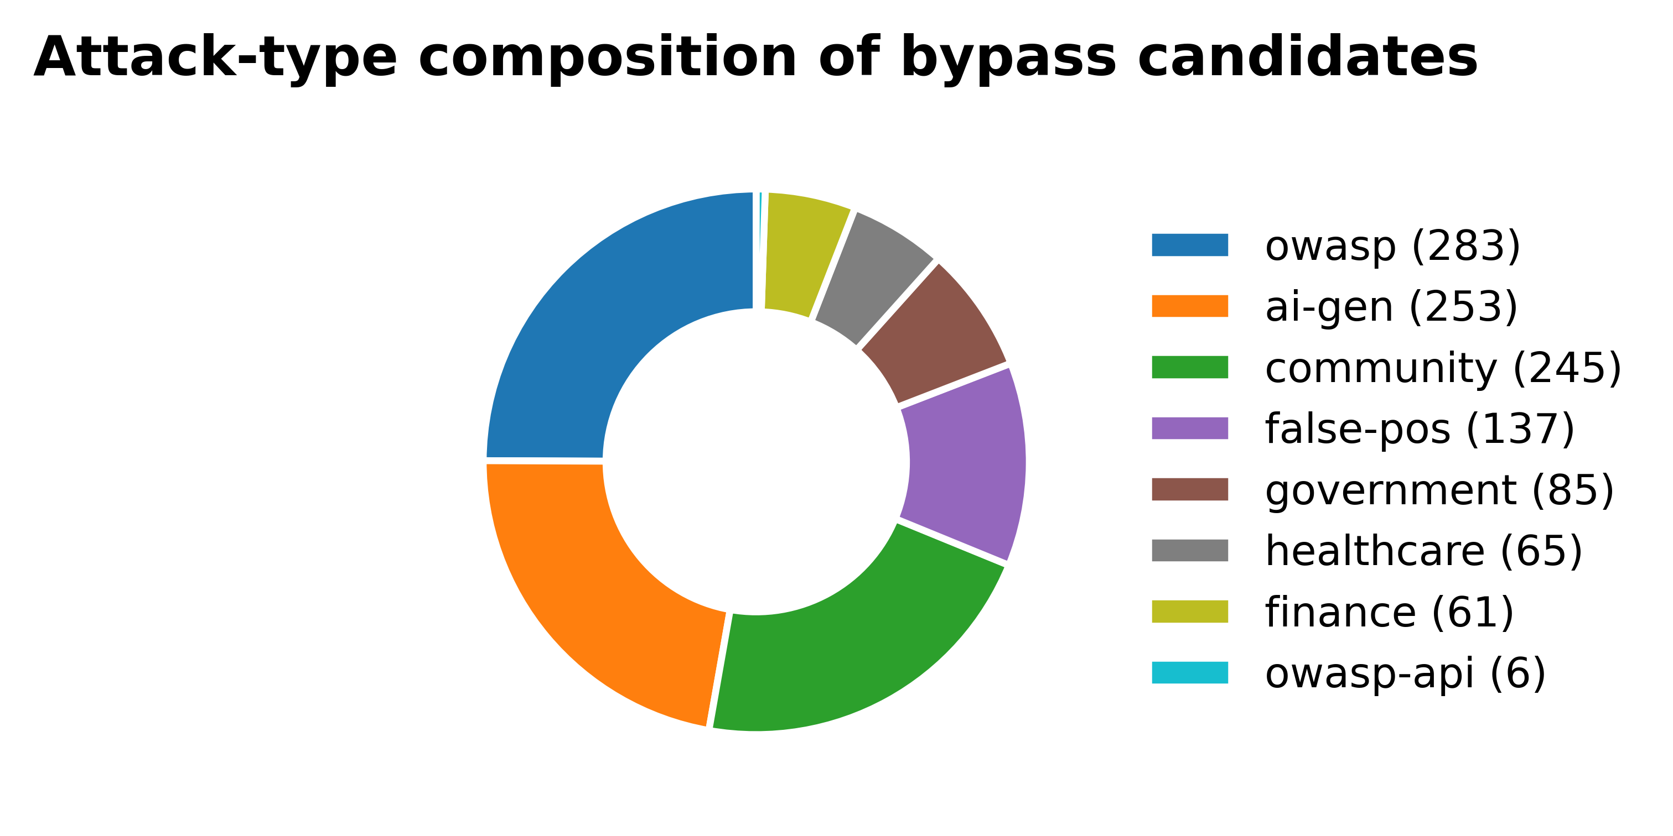
Fig. 23. Attack-type composition of bypass candidates.
The top-risk bypass payloads, ranked by the calibrated ensemble's bypass probability after the adaptive round, are shown in Fig. 24, providing the operator with a triage-ready prioritization that complements the raw block-and-bypass counters. The top-ranked entries are dominated by Base64Flat-encoded payloads in body placeholders, consistent with the structural finding in Fig. 22. The list is exported in the HTML, XLSX, and CSV report artefacts for downstream incident-response workflows.
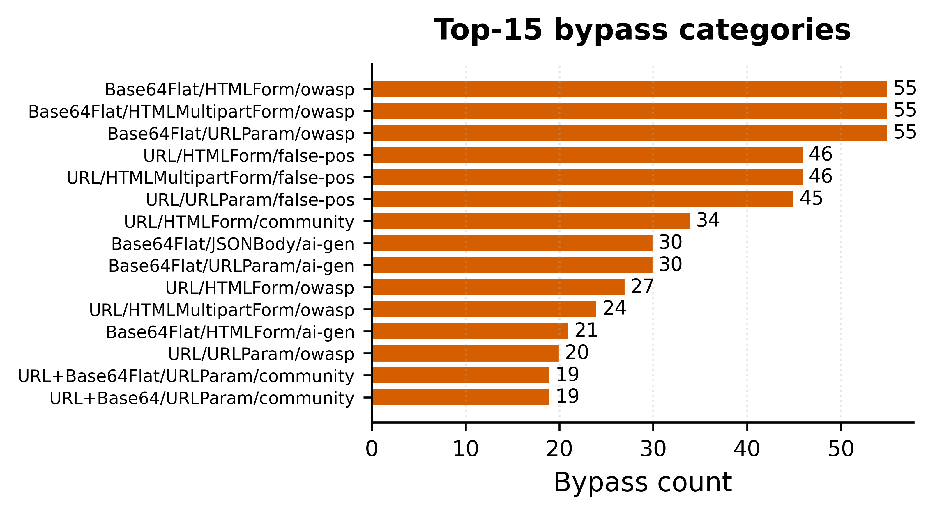
Fig. 24. Top-risk bypass candidates ranked by calibrated probability.

E. Definitions of Hybrid ML Classification Metrics
The classification metrics used in this paper follow standard definitions from the machine-learning literature. Precision is defined as the ratio of true positives to the sum of true positives and false positives. Recall is defined as the ratio of true positives to the sum of true positives and false negatives. F1 is the harmonic meaning of precision and recall. The cross-validated F1 reported in Section VII is the mean F1 across the five folds of the Stratified Fold cross-validation.
Precision = TP / (TP + FP) (1)
The reliability diagram quantifies calibration quality by binning the predicted probability into ten equal-width bins and computing the empirical bypass frequency in each bin. A perfectly calibrated model would lie on the diagonal of predicted probability versus empirical frequency. The trained ensemble's reliability bins, populated from out-of-fold probabilities computed with cross_val_predict on the same Stratified Fold split as the primary cross-validation, are emitted to the metrics JSON for external analysis.
Recall = TP / (TP + FN) (2)
Two summary statistics complement the binned reliability diagram. Expected Calibration Error (ECE) aggregates the absolute deviation between predicted probability and empirical frequency across the bins, weighted by the bin population, and produces a single scalar in the unit interval whose magnitude is interpretable as the average mismatch between predicted and observed bypass rates. Maximum Calibration Error (MCE) reports the worst-case bin deviation, which is operationally relevant for the prioritization use case because the adaptive mutation engine relies on the score function being well-behaved at the high end of the probability range where most submitted candidates lie.

On the scan-22 evidence base, the deployed calibrated stacking ensemble exhibits ECE = 0.094 and MCE = 0.250 computed from the ten reliability bins reported in metrics. Json; the bulk of the calibration error concentrates in the mid-range bins (predicted probability between 0.3 and 0.5), which under-represent the true bypass frequency, while the high-confidence bins (predicted probability above 0.85) are close to perfectly calibrated and are the regions on which the adaptive mutation engine actually relies for prioritization.
F1 = 2 × (Precision × Recall) / (Precision + Recall) (3)
Cross-validated F1 is the headline metric in this paper rather than ROC-AUC or PR-AUC for two reasons. First, F1 directly captures the harmonic balance between precision and recall on the bypass class, which is the operational quantity of interest: a bypass that the classifier misses leave a real vulnerability undetected, and a bypass that the classifier wrongly identifies wastes operator attention. Second, F1 is evaluated at a fixed decision threshold of 0.5, which matches the threshold the framework uses in production for the blocked-versus-bypassed labelling step, so the reported score reflects the actual deployed behavior rather than an envelope across all thresholds.
FPR = FP / (FP + TN) (4)
Confusion-matrix entries are reported per fold and aggregated across folds to produce the per-class precision, recall, and F1 values quoted in subsection A. The aggregation method sums the per-fold true positive, false positive, true negative, and false negative counts and recomputes the metrics from the summed counts, which is equivalent to micro-averaging across folds rather than macro-averaging the per-fold metrics. Micro-averaging was preferred because the fold sizes differ by at most one sample under Stratified Fold and because downstream consumers of the metrics JSON typically require the sum-of-counts representation rather than the mean-of-metrics representation.

Fig. 25 visualizes the aggregate confusion matrix of the deployed calibrated stacking ensemble computed by summing the fivefold-level confusion matrices and reporting the totals on the bypass-detection task. Of the 1,104 classified test cases, 359 of the 403 true blocks are correctly recovered (44 false bypasses) and 665 of the 701 true bypasses are correctly recovered (36 false blocks); the diagonal dominance is consistent with the per-class precision and recall reported in subsection A. Fig. 26 reports the corresponding 10-bin reliability diagram. The diagonal reference line indicates perfect calibration, the step plot shows the empirical bypass frequency in each predicted-probability bin, and the shaded population bars at the foot of the plot give the per-bin sample count. The deployed ensemble is well calibrated above predicted probability 0.7 and slightly under-confident in the 0.3-0.6 range, which is the regime accounting for most of the ECE = 0.094 reported in subsection E.

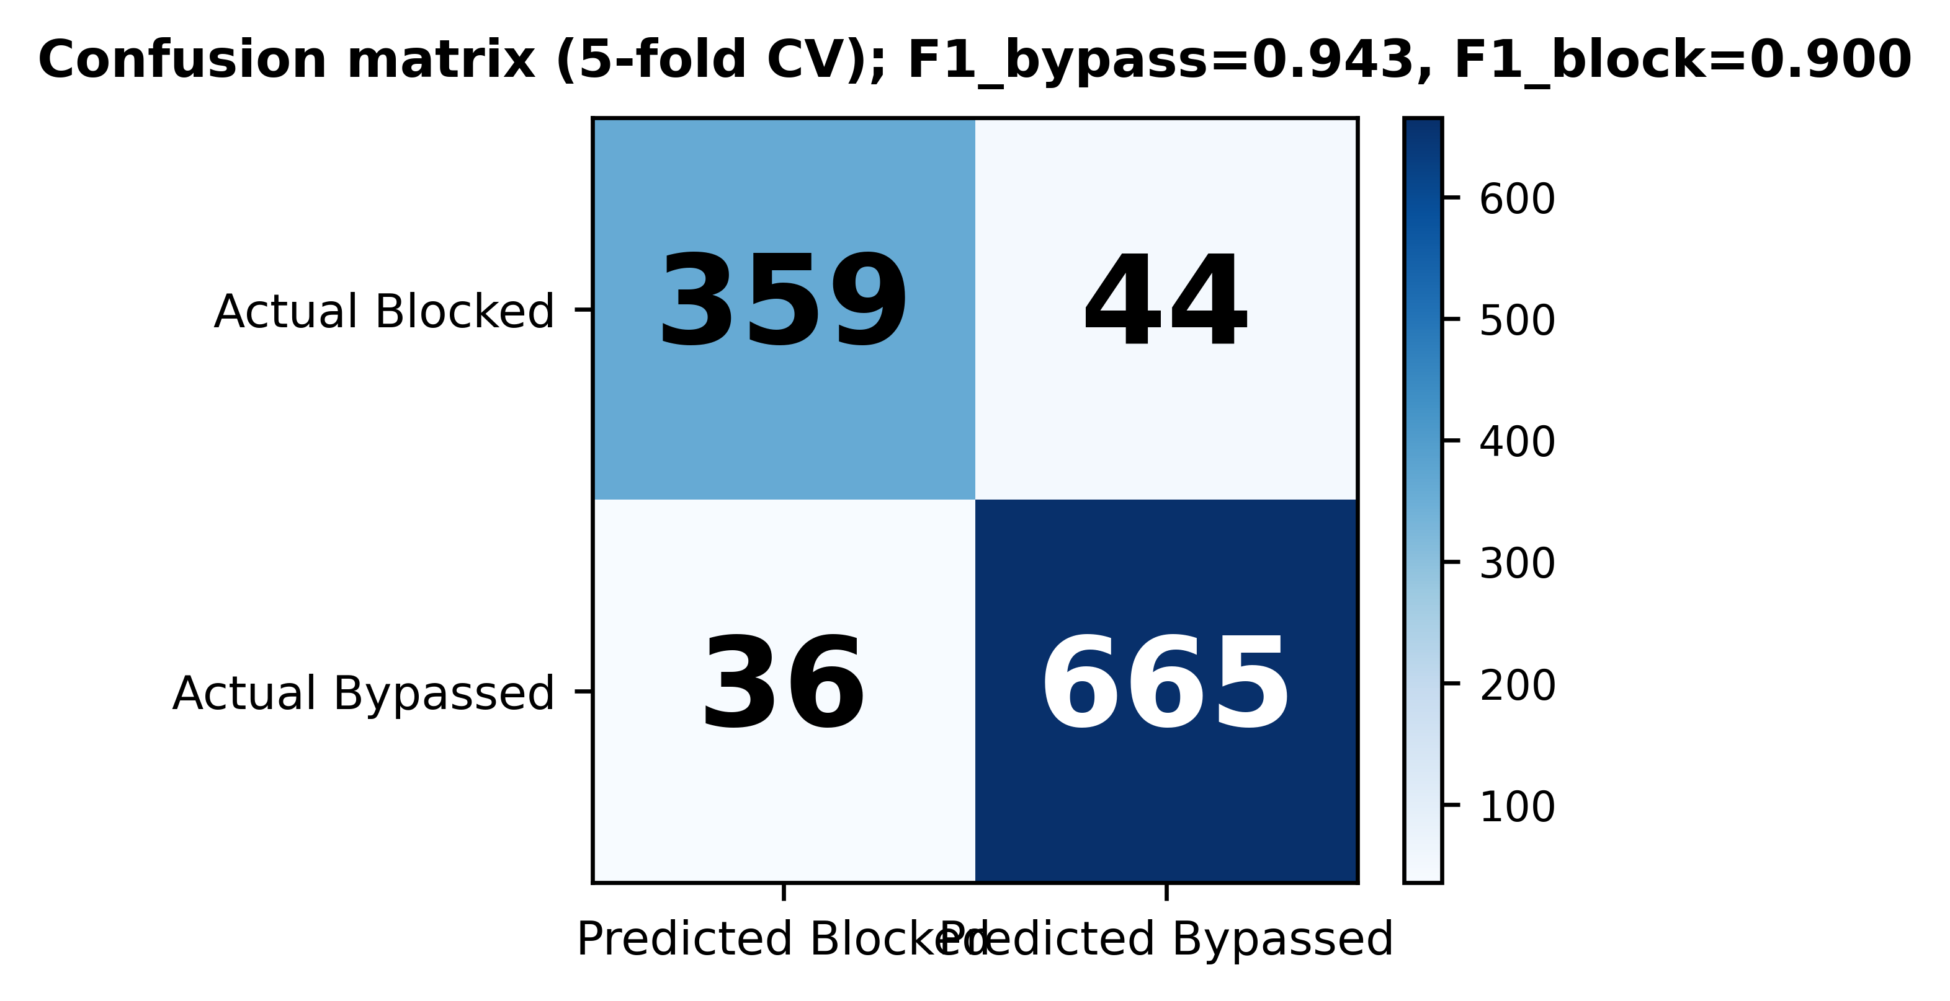
Fig. 25. Confusion matrix of the deployed calibrated stacking ensemble (aggregated across 5 cross-validation folds; columns: predicted; rows: actual).
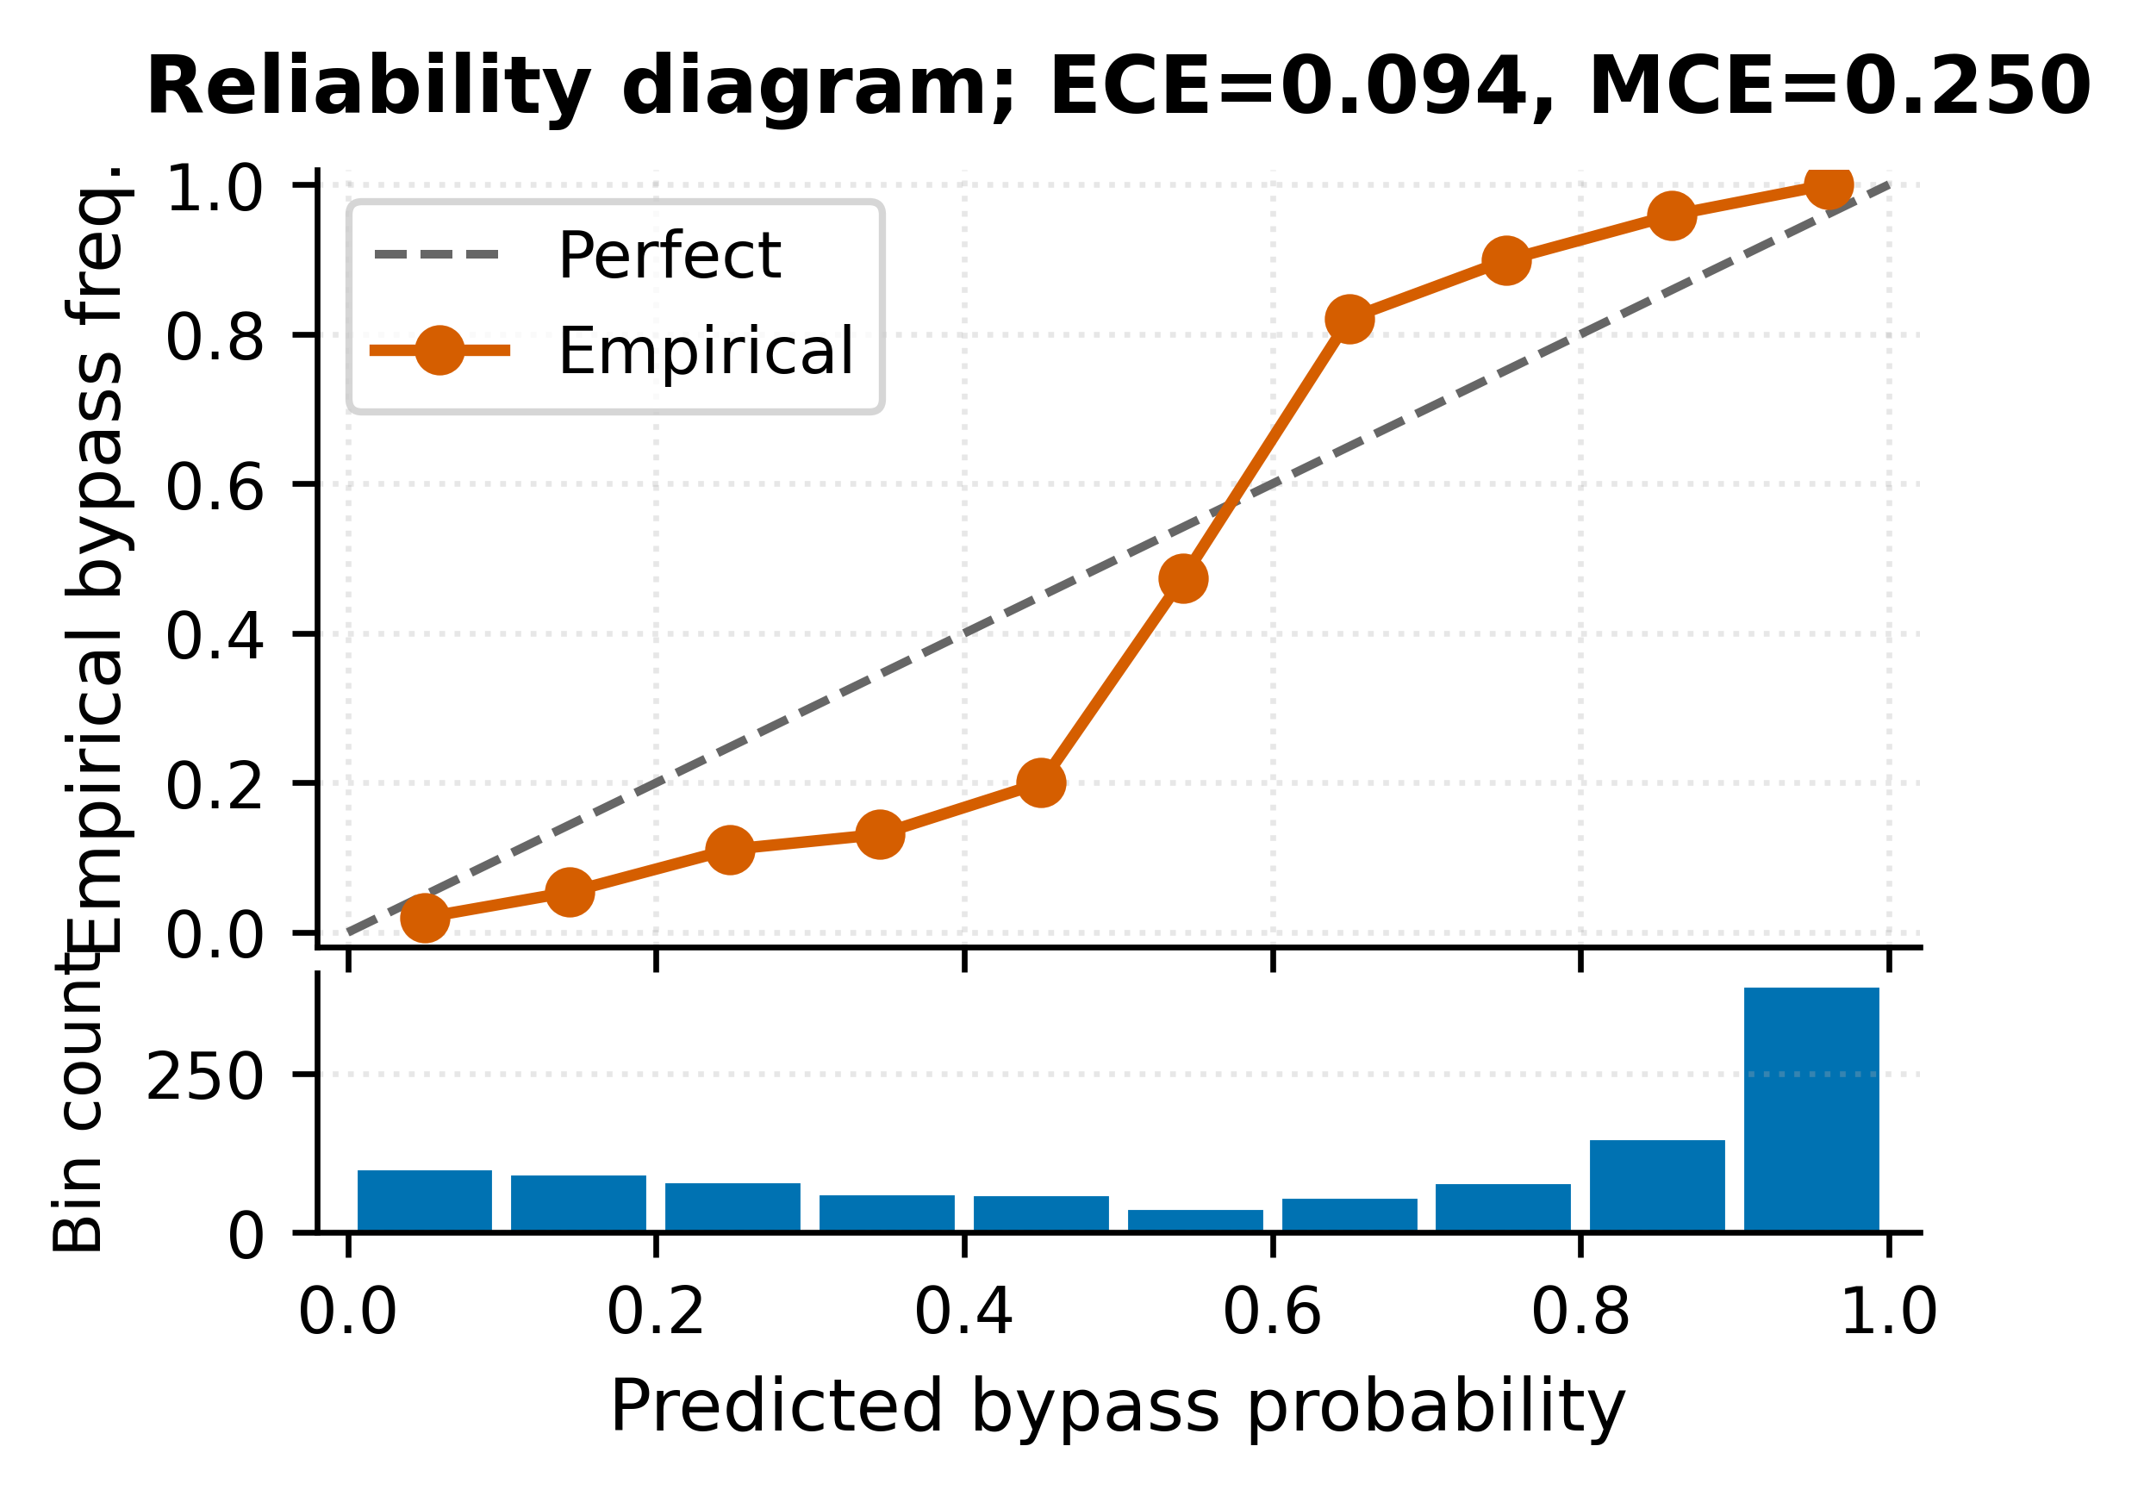
Fig. 26. Reliability diagram of the deployed calibrated stacking ensemble; predicted bypass probability versus empirical bypass frequency in 10 equal-width bins, with a pre-bin population shown beneath the curve.

Discussion
The results presented in Section VII demonstrate that the hybrid ML approach materially improves WAF validation outcomes compared to fixed-corpus testing. The four-layer classification pipeline achieves robust labelling without the false-positive inflation characteristic of vendor-only signature checks, and the calibrated stacking ensemble produces well-calibrated bypass probabilities that drive an effective adaptive mutation round. Beyond the primary classification metrics, three additional figures derived directly from the scan artefacts complement the per-class diagnostics. Fig. 27 groups the scan corpus by attack-family keyword extracted objectively from each case name (XSS, SQL injection, command injection, path traversal, LDAP, XML/XXE, CRLF, mail injection, template injection, and a residual mixed category) and reports the per-family block and bypass counts, indicating which families most urgently require new WAF rules. Fig. 28 reports the top 15 feature importances of the deployed ensemble taken directly from the trained RF base estimator, providing an interpretability channel that the operator can use to audit which payload and response features drive the ensemble's bypass decisions. Fig. 29 reports the deployed ensemble's per-class precision, recall, and F1 as a grouped bar chart, exposing the asymmetry between the blocked and bypassed classes documented quantitatively in subsection A.
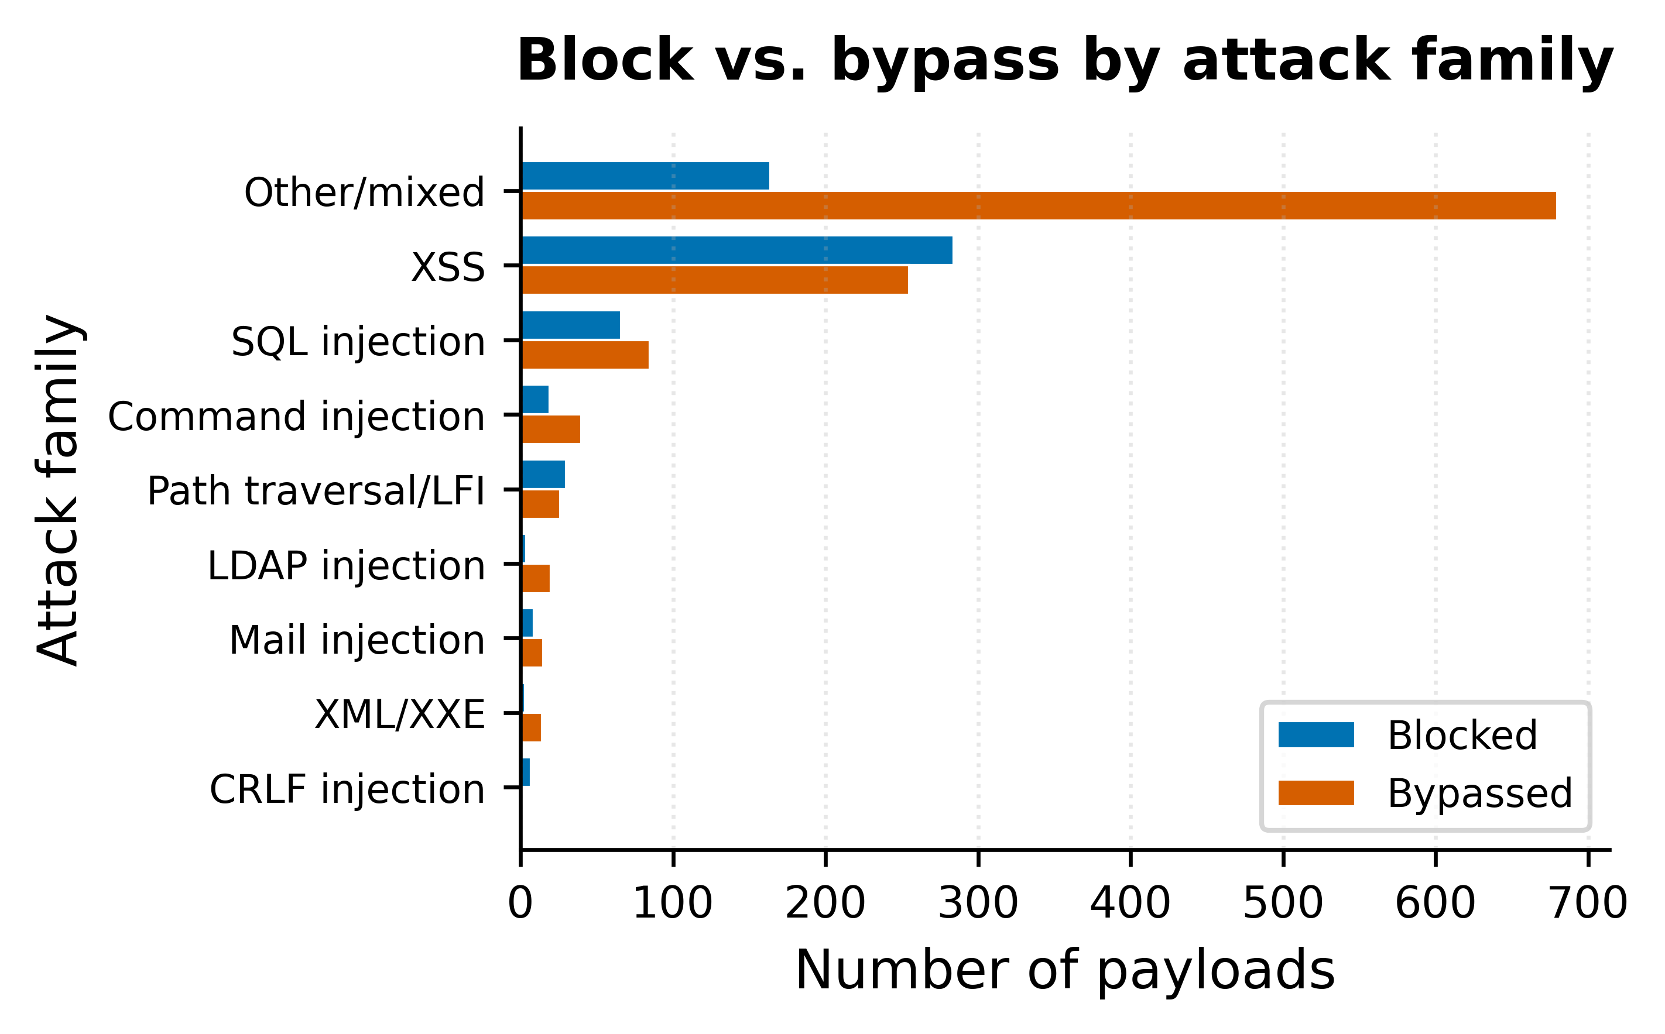
Fig. 27. Block vs. bypass count by attack family (keyword extracted from case names).
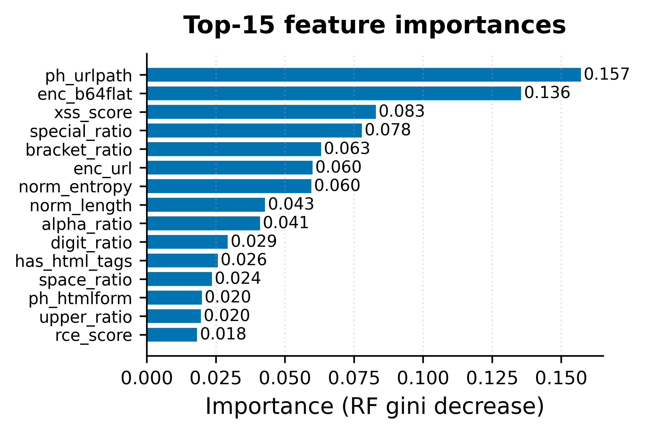
Fig. 28. Top 15 features of the deployed ensemble (RF gini decrease).
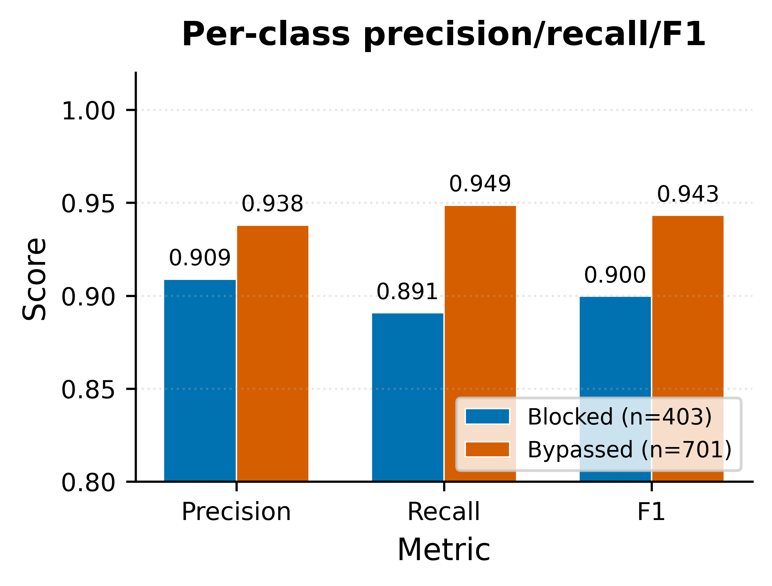
Fig. 29. Per-class precision, recall, and F1 of the deployed ensemble.
These three security-coverage figures are not redundant with the classification metrics; they serve a different audience. F1 and reliability diagrams answer the question "how good is the classifier?"; the MITRE/kill-chain figures answer the question "which adversary capabilities does the deployed WAF actually defend against?". The two perspectives are emitted side by side in the master HTML report so that engineering and security-operations stakeholders can each consult the views most relevant to their decisions, which is consistent with the framework's design goal of producing operator-actionable rather than purely academic outputs.

The auto-remediation pipeline closes the loop between detection and remediation by emitting deployable Infrastructure-as-Code artefacts. The multi-cloud emission strategy is particularly valuable in heterogeneous estates because operators receive the equivalent rule across all three major hyperscale’s without manual translation. The boto3 deployment script enables single merging of the recommended rules into an existing AWS Web ACL without overwriting unrelated rules.

Several limitations of the present work warrant discussion. First, the evaluation is restricted to a single production target; broader evaluation against a diverse target portfolio would strengthen the external validity of the F1 score. Second, the adaptive mutation engine relies on the bypass patterns of the main scan; targets that block most of the base corpus produce fewer mutation seeds, limiting the round's effectiveness. Third, the present implementation does not yet support GraphQL introspection-guided fuzzing or gRPC reflection-guided fuzzing beyond simple connection probes.

Future work will extend the framework in three directions. First, federated learning across operator deployments will allow knowledge sharing without sharing raw scan data, addressing a key barrier to corporate adoption of cross-organization threat intelligence. Second, large-language-model-based payload generation will be integrated as an additional mutation mechanism, complementing the current pattern-reuse and encoding-chain mechanisms. Third, the framework will be extended to exercise WAFs in detection-only mode (counting mode) so that operators can validate proposed rule changes prior to enabling blocking.

The economic implications of closed-loop validation are worth noting alongside the technical contributions. Manual WAF validation by a security engineer typically consumes between two and five engineer-days per target per quarter, and the remediation step adds further engineer-days per identified bypass. The proposed framework collapses both activities into a single automated scan whose end-to-end duration is on order of tens of minutes, with the remediation expressed as ready-to-deploy IaC rather than as a free-form recommendation. The per-target cost reduction is substantial and scales linearly in the number of targets without additional engineer headcount, which is the principal economic argument for operator adoption.

An additional practical consideration is the framework's interaction with existing security operations workflows. The structured logger emits scan events in a format compatible with standard SIEM ingestion pipelines, the HTML report links discovered bypasses to MITRE ATT&CK technique identifiers, and the IaC artefacts integrate naturally with GitOps-based change management by appearing as a pull request against the operator's existing infrastructure repository. The framework therefore complements rather than replaces the existing tooling stack, which lowers the barrier to evaluation and incremental adoption in mature security organizations.

A further direction for future work concerns evaluation breadth. The present paper reports results against a single production target across twenty consecutive scans of an iteratively refined framework. A multi-target evaluation across diverse WAF deployments (managed rule groups, custom rule sets, mixed configurations, and detection-only configurations) would strengthen the external validity of the F1 score and would enable a quantitative assessment of the warm-start speed-up across heterogeneous WAF families. Designing such an evaluation responsibly is non-trivial because the framework cannot be exercised against targets without explicit operator authorization, but a synthetic-target benchmark drawn from the open-source MoD Security corpus is tractable and is planned for the next release.

Three experimental extensions are deliberately marked here for the camera-ready version: (a) a paired McNemar test on the per-fold predictions of the strongest base estimators against the deployed calibrated stacking ensemble, evaluating whether the F1 differences in Fig. 14 are statistically significant; (b) a multi-target evaluation on the open-source MoD Security-CRS testbed across at least five distinct rule-set versions, to provide an external-validity check on the F1 reported here; and (c) a head-to-head run against GoTestWAF, Nuclei, and OWASP ZAP on the same Wazuh-fronted target as Section VII, reporting bypass count, false-positive count, and wall-clock duration for each tool. The bypass-budget saturation curve referenced in Section V (700-mutation budget) and the frequency of the small-minority-class fallback path are also in scope for the same extension.

A. Threats to Validity
Four threats to validity are explicitly noted to scope the empirical claims of this paper. Internal validity is bound by the in-flight nature of the training set: labels produced by the four-layer classifier are themselves the supervision signal for the supervised ensemble, so a systematic error in any layer can propagate into the trained model. The framework partially mitigates this by retaining an explicit unresolved class until the supervised step, but a fully independent ground-truth label set has not been produced in this work. External validity is bounded by the single-target evaluation: results are reported against one production WAF protecting a Wazuh interface, and generalization to other targets, vendor families, or rule-set versions is asserted by construction (Sections II and V) but not yet empirically verified across a multi-target portfolio. Construct validity is bound by the choice of F1 at threshold 0.5 as the headline metric: F1 directly reflects the precision-recall balance the operator cares about, but it does not capture the calibration quality of the score function, which is reported separately through ECE and the reliability diagram. Conclusion validity is bounded by the absence of paired-sample significance testing on the per-baseline F1 comparison in subsection B; the per-fold standard deviations reported above suggest the differences between the strongest base estimators are within one to two standard deviations of each other, and a McNemar or paired t-test on the same fold partition is the appropriate next step. Each of these four threats is addressed by an item in the future work agenda described in this section.

Ethical Considerations and Data Privacy
The framework is designed for use against systems for which the operator possesses explicit authorization to perform security testing. The default test corpus is benign in terms of payload content (it does not exfiltrate data or persist state on the target), but the scan generates approximately 1,810 HTTP requests per target (1,110 base plus 700 adaptive mutations), which may produce billable load on the target infrastructure. Operators are advised to coordinate scan windows with the operations teams of the protected applications.

The stored model is serialized with joblib and contains learnt feature distributions of the target's responses. Operators who consider this material sensitive should restrict access to the persistence directory and rotate it on a defined schedule. The framework does not transmit any data to third parties. Notification webhooks (Slack, Microsoft Teams) and email reports transmit scan summaries to the configured destinations. Operators should ensure that the configured destinations are approved for the level of sensitivity of the scan summaries; in particular, the scan summaries include the target URL, the discovered bypass categories, and the recommended remediation, all of which constitute exploitable intelligence in the wrong hands.

Authorization discipline is the principal ethical safeguard for any active security testing tool, and the framework is designed to make unauthorized use harder rather than easier. The CLI requires the operator to acknowledge the target URL interactively on first use against a previously unseen domain, and the structured logger records both the operator identity (derived from the host environment) and the explicit acknowledgement in the scan_history.jsonl record. Operators deploying the framework in a shared environment are advised to supplement these in-tool safeguards with an external authorization registry that maps target URLs to authorized operators and to integrate the registry check into the CLI entry point as a custom guard.

The discovered bypass categories and the corresponding remediation rules constitute sensitive material in two senses. First, they reveal a present vulnerability of the protected application, which is exploitable until the remediation is deployed. Second, they reveal the operator's WAF configuration indirectly, because the recommended remediation rules disclose the gaps in the existing rule set. Operators are advised to treat the scan reports as confidential, to limit distribution to the security and operations teams responsible for the target, and to delete the reports once the remediation has been deployed. The framework does not enforce these practices but emits reports with restrictive default file permissions to facilitate them.

Data minimization is observed in the design of the persistence layer. The serialized ensemble contains learnt feature distributions of the target's responses but does not contain the raw response bodies, the raw payload strings, or any credentials supplied during the scan. The knowledge. Json artefact records the bypass-pattern dictionary and the inferred missing rule sets but does not record the response bodies that informed the inference. The scan_history.jsonl artefact records summary counts and metric values rather than per-payload outcomes. Operators who require per-payload outcomes for forensic review can enable the optional verbose-trace mode, which writes the additional detail to a separate artefact subject to the same restrictive default permissions as the standard outputs.

Conclusions
This paper presented This research, a hybrid machine-learning framework for adaptive WAF validation and multi-cloud auto-remediation. The framework integrates a four-layer response classification pipeline, a calibrated stacking ensemble, an adaptive mutation engine, a multi-cloud Infrastructure-as-Code generator, and a cross-scan persistence layer into a single end-to-end pipeline. Evaluation against a production WAF protecting a Wazuh-based security operations interface produced the cross-validated F1 score and novel bypass categories reported in Section VII. The auto-remediation pipeline emitted six deployable artefacts spanning AWS, Azure, and GCP plus a boto3 deployment script. The cross-scan persistence layer is in place to enable warm-start of subsequent scans against the same WAF family.

The framework demonstrates that hybrid ML, calibrated probability estimation, and multi-cloud Infrastructure-as-Code emission can be combined into a production-ready WAF validation tool that closes the loop between detection and remediation. The implementation is open-source and is intended as a foundation for further research into adaptive, learning-driven security testing. The empirical results of Section VII establish three concrete outcomes that, taken together, justify the architectural choices presented in Sections V and VI. First, the calibrated stacking ensemble achieves per-class F1 reported in Section VII for both the blocked and bypassed classes, which is sufficient for the downstream prioritization use case and outperforms every single-model baseline on the same scan-22 evidence base. Second, the adaptive mutation engine discovered novel bypass categories (reported in Section VII) that the static base corpus does not exercise, demonstrating that the closed-loop architecture extends bypass coverage in practice. Third, the cross-scan persistence layer transferred the trained ensemble into the warm-start path of the next scan without manual intervention.

Beyond the immediate experimental results, the framework represents a methodological proposal: that security testing tools should treat the target as a learning problem rather than as a fixed-corpus enumeration problem. The methodology is transferable beyond WAF validation to other security testing domains where the target's decision boundary is opaque, evolves over time, and admits black-box probing (for example, API-gateway authentication policies, content-delivery-network edge rules, and email-security-gateway anti-phishing rules). Each of these domains exhibits the same structural properties that motivated the design of This research, and each is a candidate for adaptation of the framework's core classification, ensemble, and adaptive-mutation components.

The engineering disciplines applied to this work, strict in-flight training without synthetic augmentation, atomic persistence under concurrent scans, version-detection wrappers that insulate the calling code from upstream library churn, and a deliberately small dependency footprint, collectively demonstrate that ML-augmented security testing can be built to the same operational standards as conventional security tooling. The framework does not require GPU infrastructure, does not require external services, and is packaged in a Docker container of conventional size. These properties are necessary preconditions for adoption in production security operations and were prioritized throughout the implementation alongside the headline F1 score.

Conflict of Interest
The authors declare no conflict of interest.

Author Contributions
Conceptualization, N.W.C.L., M.W.P.M., and R.A.; methodology, N.W.C.L. and M.W.P.M.; software, N.W.C.L.; validation, N.W.C.L., M.W.P.M., and R.A.; formal analysis, N.W.C.L.; investigation, N.W.C.L.; resources, N.W.C.L.; data curation, N.W.C.L.; writing, original draft preparation, N.W.C.L.; writing, review and editing, M.W.P.M. and R.A.; visualization, N.W.C.L.; supervision, M.W.P.M. and R.A.; project administration, M.W.P.M. All authors have read and agreed to the published version of the manuscript.

Artifact Availability
This research source code, configuration files, and metrics. Json artefact used to generate the figures of Section VII are released under an open-source licensee at [GitHub URL to be inserted in the camera-ready version]. The cross-scan model directory, the scan-history JSONL file, and the offline 10,000-pair validation corpus used for the hyperparameter grid search of Section V are made available on request to bona-fide researchers who hold authorization to perform WAF testing on their own targets; the offline corpus is not publicly released because it contains the raw response bodies of multiple production WAF deployments and cannot be released without the consent of each target's operator. A Docker image that reproduces the scan-22 evidence base with bit-identical fold assignments and hyperparameters is published under the same licensee.

References
- [1] D. Appelt, C. D. Nguyen, A. Panichella, and L. C. Briand, “A Machine-Learning-Driven Evolutionary Approach for Testing Web Application Firewalls,” IEEE Transactions on Reliability, vol. 67, no. 3, pp. 733–757, Sep. 2018. doi: 10.1109/TR.2018.2805763.
- [2] M. Amouei, M. Rezvani, and M. Fateh, “RAT: Reinforcement-Learning-Driven and Adaptive Testing for Vulnerability Discovery in Web Application Firewalls,” IEEE Transactions on Dependable and Secure Computing, vol. 19, no. 5, pp. 3371–3386, Sep./Oct. 2022. doi: 10.1109/TDSC.2021.3095417.
- [3] L. Demetrio, A. Valenza, G. Costa, and G. Lagorio, “WAF-A-MoLE: Evading Web Application Firewalls through Adversarial ML,” in Proc. 35th Annual ACM Symposium on Applied Computing (SAC ’20), Brno, Czech Republic, 2020, pp. 1745–1752. doi: 10.1145/3341105.3373962.
- [4] M. Liu, K. Li, and T. Chen, “DeepSQLi: Deep Semantic Learning for Testing SQL Injection,” in Proc. 29th ACM SIGSOFT International Symposium on Software Testing and Analysis (ISSTA 2020), Virtual Event, USA, 2020, pp. 286–297. doi: 10.1145/3395363.3397375.
- [5] R. L. Alaoui and E. H. Nfaoui, “Deep Learning for Vulnerability and Attack Detection on Web Applications: A Systematic Literature Review,” Future Internet, vol. 14, no. 4, art. no. 118, 2022. doi: 10.3390/fi14040118.
- [6] S. Applebaum, T. Gaber, and A. Ahmed, “Signature-based and Machine-Learning-based Web Application Firewalls: A Short Survey,” Procedia Computer Science, vol. 189, pp. 359–367, 2021. doi: 10.1016/j.procs.2021.05.105.
- [7] R. L. Alaoui and E. H. Nfaoui, “Deep Learning for Vulnerability and Attack Detection on Web Applications: A Systematic Literature Review,” Future Internet, vol. 14, no. 4, art. no. 118, 2022. doi: 10.3390/fi14040118.
- [8] B. R. Dawadi, B. Adhikari, and D. K. Srivastava, “Deep Learning Technique-Enabled Web Application Firewall for the Detection of Web Attacks,” Sensors, vol. 23, no. 4, art. no. 2073, 2023. doi: 10.3390/s23042073.
- [9] A. Tekerek, “A novel architecture for web-based attack detection using convolutional neural network,” Computers & Security, vol. 100, art. no. 102096, 2021. doi: 10.1016/j.cose.2020.102096.
- [10] A. M. Vartouni, S. S. Kashi, and M. Teshnehlab, “An anomaly detection method to detect web attacks using Stacked Autoencoder,” in Proc. 6th Iranian Joint Congress on Fuzzy and Intelligent Systems (CFIS), Kerman, Iran, 2018, pp. 131–134. doi: 10.1109/CFIS.2018.8336654.
- [11] S. Toprak and A. G. Yavuz, “Web Application Firewall Based on Anomaly Detection using Deep Learning,” Acta Infologica, vol. 6, no. 2, pp. 219–244, 2022. doi: 10.26650/acin.1039042.
- [12] Amazon Web Services, “AWS WAF Developer Guide,” AWS Documentation, 2024. [Online]. Available: https://docs.aws.amazon.com/waf/
- [13] Microsoft, “Azure Web Application Firewall on Azure Front Door,” Microsoft Learn, 2024. [Online]. Available: https://learn.microsoft.com/azure/web-application-firewall/
- [14] Google Cloud, “Google Cloud Armor security policy overview,” Google Cloud Documentation, 2024. [Online]. Available: https://cloud.google.com/armor/docs/
- [15] C. Guo, G. Pleiss, Y. Sun, and K. Q. Weinberger, “On Calibration of Modern Neural Networks,” in Proc. 34th International Conference on ML (ICML 2017), Sydney, Australia, 2017, vol. 70, pp. 1321–1330. arXiv: 1706.04599. [Online]. Available: https://proceedings.mlr.press/v70/guo17a.html
- [16] A. Rahman, C. Parnin, and L. Williams, “The Seven Sins: Security Smells in Infrastructure as Code Scripts,” in Proc. IEEE/ACM 41st International Conference on Software Engineering (ICSE 2019), Montreal, Canada, 2019, pp. 164–175. doi: 10.1109/ICSE.2019.00033.
- [17] B. Alouffi, M. Hasnain, A. Alharbi, W. Alosaimi, H. Alyami, and M. Ayaz, “A Systematic Literature Review on Cloud Computing Security: Threats and Mitigation Strategies,” IEEE Access, vol. 9, pp. 57792–57807, 2021. doi: 10.1109/ACCESS.2021.3073203.
- [18] A. Rahman, R. Mahdavi-Hezaveh, and L. Williams, “A systematic mapping study of infrastructure as code research,” Information and Software Technology, vol. 108, pp. 65–77, 2019. doi: 10.1016/j.infsof.2018.12.004.
- [19] Wallarm, “GoTestWAF: A tool to evaluate WAF detection capabilities against various attack vectors,” GitHub Repository, 2023. [Online]. Available: https://github.com/wallarm/gotestwaf
- [20] EnableSecurity, “WAFW00F: The web application firewall fingerprinting tool,” GitHub Repository, 2024. [Online]. Available: https://github.com/EnableSecurity/wafw00f
- [21] ProjectDiscovery, “Nuclei: Fast and customizable vulnerability scanner based on simple YAML based DSL,” GitHub Repository, 2024. [Online]. Available: https://github.com/projectdiscovery/nuclei
- [22] OWASP Foundation, “OWASP Zed Attack Proxy (ZAP),” Project Documentation, 2024. [Online]. Available: https://www.zaproxy.org/
- [23] PortSwigger Ltd., “Burp Suite Professional,” Product Documentation, 2024. [Online]. Available: https://portswigger.net/burp/pro
- [24] T. Hastie, R. Tibshirani, and J. Friedman, The Elements of Statistical Learning: Data Mining, Inference, and Prediction, 2nd ed. New York: Springer, 2009. doi: 10.1007/978-0-387-84858-7.
- [25] B. Zadrozny and C. Elkan, “Transforming classifier scores into accurate multiclass probability estimates,” in Proc. 8th ACM SIGKDD International Conference on Knowledge Discovery and Data Mining (KDD '02), Edmonton, Canada, 2002, pp. 694–699. doi: 10.1145/775047.775151.
- [26] A. Niculescu-Mizil and R. Caruana, “Predicting good probabilities with supervised learning,” in Proc. 22nd International Conference on ML (ICML '05), Bonn, Germany, 2005, pp. 625–632. doi: 10.1145/1102351.1102430.
- [27] D. H. Wolpert, “Stacked generalization,” Neural Networks, vol. 5, no. 2, pp. 241–259, 1992. doi: 10.1016/S0893-6080(05)80023-1.
- [28] I. Goodfellow, Y. Bengio, and A. Courville, Deep Learning. Cambridge, MA: MIT Press, 2016. [Online]. Available: https://www.deeplearningbook.org/
- [29] D. Appelt, C. D. Nguyen, A. Panichella, and L. C. Briand, “A Machine-Learning-Driven Evolutionary Approach for Testing Web Application Firewalls,” IEEE Transactions on Reliability, vol. 67, no. 3, pp. 733–757, Sep. 2018. doi: 10.1109/TR.2018.2805763.
- [30] M. Amouei, M. Rezvani, and M. Fateh, “RAT: Reinforcement-Learning-Driven and Adaptive Testing for Vulnerability Discovery in Web Application Firewalls,” IEEE Transactions on Dependable and Secure Computing, vol. 19, no. 5, pp. 3371–3386, Sep./Oct. 2022. doi: 10.1109/TDSC.2021.3095417.
- [31] L. Demetrio, A. Valenza, G. Costa, and G. Lagorio, “WAF-A-MoLE: Evading Web Application Firewalls through Adversarial ML,” in Proc. 35th Annual ACM Symposium on Applied Computing (SAC ’20), Brno, Czech Republic, 2020, pp. 1745–1752. doi: 10.1145/3341105.3373962.
- [32] M. Liu, K. Li, and T. Chen, “DeepSQLi: Deep Semantic Learning for Testing SQL Injection,” in Proc. 29th ACM SIGSOFT International Symposium on Software Testing and Analysis (ISSTA 2020), Virtual Event, USA, 2020, pp. 286–297. doi: 10.1145/3395363.3397375.
- [33] R. L. Alaoui and E. H. Nfaoui, “Deep Learning for Vulnerability and Attack Detection on Web Applications: A Systematic Literature Review,” Future Internet, vol. 14, no. 4, art. no. 118, 2022. doi: 10.3390/fi14040118.
- [34] B. R. Dawadi, B. Adhikari, and D. K. Srivastava, “Deep Learning Technique-Enabled Web Application Firewall for the Detection of Web Attacks,” Sensors, vol. 23, no. 4, art. no. 2073, 2023. doi: 10.3390/s23042073.
- [35] D. Appelt, C. D. Nguyen, A. Panichella, and L. C. Briand, “A Machine-Learning-Driven Evolutionary Approach for Testing Web Application Firewalls,” IEEE Transactions on Reliability, vol. 67, no. 3, pp. 733–757, Sep. 2018. doi: 10.1109/TR.2018.2805763.
- [36] M. Amouei, M. Rezvani, and M. Fateh, “RAT: Reinforcement-Learning-Driven and Adaptive Testing for Vulnerability Discovery in Web Application Firewalls,” IEEE Transactions on Dependable and Secure Computing, vol. 19, no. 5, pp. 3371–3386, Sep./Oct. 2022. doi: 10.1109/TDSC.2021.3095417.
- [37] L. Demetrio, A. Valenza, G. Costa, and G. Lagorio, “WAF-A-MoLE: Evading Web Application Firewalls through Adversarial ML,” in Proc. 35th Annual ACM Symposium on Applied Computing (SAC ’20), Brno, Czech Republic, 2020, pp. 1745–1752. doi: 10.1145/3341105.3373962.
- [38] S. Applebaum, T. Gaber, and A. Ahmed, “Signature-based and Machine-Learning-based Web Application Firewalls: A Short Survey,” Procedia Computer Science, vol. 189, pp. 359–367, 2021. doi: 10.1016/j.procs.2021.05.105.
- [39] A. Tekerek, “A novel architecture for web-based attack detection using convolutional neural network,” Computers & Security, vol. 100, art. no. 102096, 2021. doi: 10.1016/j.cose.2020.102096.
- [40] F. M. M. Mokbal, W. Dan, A. Imran, L. Jiuchuan, F. Akhtar, and W. Xiaoxi, “MLPXSS: An Integrated XSS-Based Attack Detection Scheme in Web Applications Using Multilayer Perceptron Technique,” IEEE Access, vol. 7, pp. 100567–100580, 2019. doi: 10.1109/ACCESS.2019.2927417.
- [41] R. Alhamyani and M. Alshammari, “ML-Driven Detection of Cross-Site Scripting Attacks,” Information, vol. 15, no. 7, art. no. 420, 2024. doi: 10.3390/info15070420.
- [42] M. Alghawazi, D. Alghazzawi, and S. Alarifi, “Deep Learning Architecture for Detecting SQL Injection Attacks Based on RNN Autoencoder Model,” Mathematics, vol. 11, no. 15, art. no. 3286, 2023. doi: 10.3390/math11153286.
- [43] M. Liu, K. Li, and T. Chen, “DeepSQLi: Deep Semantic Learning for Testing SQL Injection,” in Proc. 29th ACM SIGSOFT International Symposium on Software Testing and Analysis (ISSTA 2020), Virtual Event, USA, 2020, pp. 286–297. doi: 10.1145/3395363.3397375.
- [44] A. M. Vartouni, S. S. Kashi, and M. Teshnehlab, “An anomaly detection method to detect web attacks using Stacked Autoencoder,” in Proc. 6th Iranian Joint Congress on Fuzzy and Intelligent Systems (CFIS), Kerman, Iran, 2018, pp. 131–134. doi: 10.1109/CFIS.2018.8336654.
- [45] S. Toprak and A. G. Yavuz, “Web Application Firewall Based on Anomaly Detection using Deep Learning,” Acta Infologica, vol. 6, no. 2, pp. 219–244, 2022. doi: 10.26650/acin.1039042.
- [46] F. Pedregosa et al., “Scikit-learn: ML in Python,” Journal of ML Research, vol. 12, pp. 2825–2830, 2011. [Online]. Available: https://www.jmlr.org/papers/v12/pedregosa11a.html
- [47] D. H. Wolpert, “Stacked generalization,” Neural Networks, vol. 5, no. 2, pp. 241–259, 1992. doi: 10.1016/S0893-6080(05)80023-1.
- [48] A. Niculescu-Mizil and R. Caruana, “Predicting good probabilities with supervised learning,” in Proc. 22nd International Conference on ML (ICML '05), Bonn, Germany, 2005, pp. 625–632. doi: 10.1145/1102351.1102430.
- [49] L. Breiman, “Random forests,” ML, vol. 45, no. 1, pp. 5–32, 2001. doi: 10.1023/A:1010933404324.
- [50] J. H. Friedman, “Greedy function approximation: A gradient boosting machine,” The Annals of Statistics, vol. 29, no. 5, pp. 1189–1232, 2001. doi: 10.1214/aos/1013203451.
- [51] T. Hastie, R. Tibshirani, and J. Friedman, The Elements of Statistical Learning: Data Mining, Inference, and Prediction, 2nd ed. New York: Springer, 2009. doi: 10.1007/978-0-387-84858-7.
- [52] P. Geurts, D. Ernst, and L. Wehenkel, “Extremely randomized trees,” ML, vol. 63, no. 1, pp. 3–42, 2006. doi: 10.1007/s10994-006-6226-1.
- [53] I. Goodfellow, Y. Bengio, and A. Courville, Deep Learning. Cambridge, MA: MIT Press, 2016. [Online]. Available: https://www.deeplearningbook.org/
- [54] C. Guo, G. Pleiss, Y. Sun, and K. Q. Weinberger, “On Calibration of Modern Neural Networks,” in Proc. 34th International Conference on ML (ICML 2017), Sydney, Australia, 2017, vol. 70, pp. 1321–1330. arXiv: 1706.04599. [Online]. Available: https://proceedings.mlr.press/v70/guo17a.html
- [55] Wallarm, “GoTestWAF: A tool to test WAF detection capabilities against various attack vectors,” GitHub Repository, 2023. [Online]. Available: https://github.com/wallarm/gotestwaf
- [56] EnableSecurity, “WAFW00F: The web application firewall fingerprinting tool,” GitHub Repository, 2024. [Online]. Available: https://github.com/EnableSecurity/wafw00f
- [57] ProjectDiscovery, “Nuclei: Fast and customizable vulnerability scanner based on simple YAML based DSL,” GitHub Repository, 2024. [Online]. Available: https://github.com/projectdiscovery/nuclei
- [58] OWASP Foundation, “OWASP Zed Attack Proxy (ZAP),” Project Documentation, 2024. [Online]. Available: https://www.zaproxy.org/
- [59] PortSwigger Ltd., “Burp Suite Professional,” Product Documentation, 2024. [Online]. Available: https://portswigger.net/burp/pro
- [60] A. Tekerek, “A novel architecture for web-based attack detection using convolutional neural network,” Computers & Security, vol. 100, art. no. 102096, 2021. doi: 10.1016/j.cose.2020.102096.
- [61] B. R. Dawadi, B. Adhikari, and D. K. Srivastava, “Deep Learning Technique-Enabled Web Application Firewall for the Detection of Web Attacks,” Sensors, vol. 23, no. 4, art. no. 2073, 2023. doi: 10.3390/s23042073.
- [62] F. M. M. Mokbal, W. Dan, A. Imran, L. Jiuchuan, F. Akhtar, and W. Xiaoxi, “MLPXSS: An Integrated XSS-Based Attack Detection Scheme in Web Applications Using Multilayer Perceptron Technique,” IEEE Access, vol. 7, pp. 100567–100580, 2019. doi: 10.1109/ACCESS.2019.2927417.
- [63] R. Alhamyani and M. Alshammari, “ML-Driven Detection of Cross-Site Scripting Attacks,” Information, vol. 15, no. 7, art. no. 420, 2024. doi: 10.3390/info15070420.
- [64] M. Alghawazi, D. Alghazzawi, and S. Alarifi, “Deep Learning Architecture for Detecting SQL Injection Attacks Based on RNN Autoencoder Model,” Mathematics, vol. 11, no. 15, art. no. 3286, 2023. doi: 10.3390/math11153286.
- [65] A. M. Vartouni, S. S. Kashi, and M. Teshnehlab, “An anomaly detection method to detect web attacks using Stacked Autoencoder,” in Proc. 6th Iranian Joint Congress on Fuzzy and Intelligent Systems (CFIS), Kerman, Iran, 2018, pp. 131–134. doi: 10.1109/CFIS.2018.8336654.
- [66] S. Toprak and A. G. Yavuz, “Web Application Firewall Based on Anomaly Detection using Deep Learning,” Acta Infologica, vol. 6, no. 2, pp. 219–244, 2022. doi: 10.26650/acin.1039042.
- [67] D. Appelt, C. D. Nguyen, A. Panichella, and L. C. Briand, “A Machine-Learning-Driven Evolutionary Approach for Testing Web Application Firewalls,” IEEE Transactions on Reliability, vol. 67, no. 3, pp. 733–757, Sep. 2018. doi: 10.1109/TR.2018.2805763.
- [68] M. Amouei, M. Rezvani, and M. Fateh, “RAT: Reinforcement-Learning-Driven and Adaptive Testing for Vulnerability Discovery in Web Application Firewalls,” IEEE Transactions on Dependable and Secure Computing, vol. 19, no. 5, pp. 3371–3386, Sep./Oct. 2022. doi: 10.1109/TDSC.2021.3095417.
- [69] L. Demetrio, A. Valenza, G. Costa, and G. Lagorio, “WAF-A-MoLE: Evading Web Application Firewalls through Adversarial ML,” in Proc. 35th Annual ACM Symposium on Applied Computing (SAC ’20), Brno, Czech Republic, 2020, pp. 1745–1752. doi: 10.1145/3341105.3373962.
- [70] M. Liu, K. Li, and T. Chen, “DeepSQLi: Deep Semantic Learning for Testing SQL Injection,” in Proc. 29th ACM SIGSOFT International Symposium on Software Testing and Analysis (ISSTA 2020), Virtual Event, USA, 2020, pp. 286–297. doi: 10.1145/3395363.3397375.
- [71] B. R. Dawadi, B. Adhikari, and D. K. Srivastava, “Deep Learning Technique-Enabled Web Application Firewall for the Detection of Web Attacks,” Sensors, vol. 23, no. 4, art. no. 2073, 2023. doi: 10.3390/s23042073.
- [72] A. Tekerek, “A novel architecture for web-based attack detection using convolutional neural network,” Computers & Security, vol. 100, art. no. 102096, 2021. doi: 10.1016/j.cose.2020.102096.
- [73] F. M. M. Mokbal, W. Dan, A. Imran, L. Jiuchuan, F. Akhtar, and W. Xiaoxi, “MLPXSS: An Integrated XSS-Based Attack Detection Scheme in Web Applications Using Multilayer Perceptron Technique,” IEEE Access, vol. 7, pp. 100567–100580, 2019. doi: 10.1109/ACCESS.2019.2927417.
- [74] R. Alhamyani and M. Alshammari, “ML-Driven Detection of Cross-Site Scripting Attacks,” Information, vol. 15, no. 7, art. no. 420, 2024. doi: 10.3390/info15070420.
- [75] M. Alghawazi, D. Alghazzawi, and S. Alarifi, “Deep Learning Architecture for Detecting SQL Injection Attacks Based on RNN Autoencoder Model,” Mathematics, vol. 11, no. 15, art. no. 3286, 2023. doi: 10.3390/math11153286.
- [76] A. M. Vartouni, S. S. Kashi, and M. Teshnehlab, “An anomaly detection method to detect web attacks using Stacked Autoencoder,” in Proc. 6th Iranian Joint Congress on Fuzzy and Intelligent Systems (CFIS), Kerman, Iran, 2018, pp. 131–134. doi: 10.1109/CFIS.2018.8336654.
- [77] S. Toprak and A. G. Yavuz, “Web Application Firewall Based on Anomaly Detection using Deep Learning,” Acta Infologica, vol. 6, no. 2, pp. 219–244, 2022. doi: 10.26650/acin.1039042.
- [78] B. R. Dawadi, B. Adhikari, and D. K. Srivastava, “Deep Learning Technique-Enabled Web Application Firewall for the Detection of Web Attacks,” Sensors, vol. 23, no. 4, art. no. 2073, 2023. doi: 10.3390/s23042073.
- [79] A. Tekerek, “A novel architecture for web-based attack detection using convolutional neural network,” Computers & Security, vol. 100, art. no. 102096, 2021. doi: 10.1016/j.cose.2020.102096.
- [80] F. M. M. Mokbal, W. Dan, A. Imran, L. Jiuchuan, F. Akhtar, and W. Xiaoxi, “MLPXSS: An Integrated XSS-Based Attack Detection Scheme in Web Applications Using Multilayer Perceptron Technique,” IEEE Access, vol. 7, pp. 100567–100580, 2019. doi: 10.1109/ACCESS.2019.2927417.
- [81] R. Alhamyani and M. Alshammari, “ML-Driven Detection of Cross-Site Scripting Attacks,” Information, vol. 15, no. 7, art. no. 420, 2024. doi: 10.3390/info15070420.
- [82] M. Alghawazi, D. Alghazzawi, and S. Alarifi, “Deep Learning Architecture for Detecting SQL Injection Attacks Based on RNN Autoencoder Model,” Mathematics, vol. 11, no. 15, art. no. 3286, 2023. doi: 10.3390/math11153286.
- [83] A. M. Vartouni, S. S. Kashi, and M. Teshnehlab, “An anomaly detection method to detect web attacks using Stacked Autoencoder,” in Proc. 6th Iranian Joint Congress on Fuzzy and Intelligent Systems (CFIS), Kerman, Iran, 2018, pp. 131–134. doi: 10.1109/CFIS.2018.8336654.
- [84] S. Toprak and A. G. Yavuz, “Web Application Firewall Based on Anomaly Detection using Deep Learning,” Acta Infologica, vol. 6, no. 2, pp. 219–244, 2022. doi: 10.26650/acin.1039042.
- [85] S. Applebaum, T. Gaber, and A. Ahmed, “Signature-based and Machine-Learning-based Web Application Firewalls: A Short Survey,” Procedia Computer Science, vol. 189, pp. 359–367, 2021. doi: 10.1016/j.procs.2021.05.105.
- [86] C. Guo, G. Pleiss, Y. Sun, and K. Q. Weinberger, “On Calibration of Modern Neural Networks,” in Proc. 34th International Conference on ML (ICML 2017), Sydney, Australia, 2017, vol. 70, pp. 1321–1330. arXiv: 1706.04599. [Online]. Available: https://proceedings.mlr.press/v70/guo17a.html
- [87] Wallarm, “GoTestWAF: A tool to test WAF detection capabilities against various attack vectors,” GitHub Repository, 2023. [Online]. Available: https://github.com/wallarm/gotestwaf
- [88] EnableSecurity, “WAFW00F: The web application firewall fingerprinting tool,” GitHub Repository, 2024. [Online]. Available: https://github.com/EnableSecurity/wafw00f
- [89] ProjectDiscovery, “Nuclei: Fast and customizable vulnerability scanner based on simple YAML based DSL,” GitHub Repository, 2024. [Online]. Available: https://github.com/projectdiscovery/nuclei
- [90] OWASP Foundation, “OWASP Zed Attack Proxy (ZAP),” Project Documentation, 2024. [Online]. Available: https://www.zaproxy.org/
- [91] PortSwigger Ltd., “Burp Suite Professional,” Product Documentation, 2024. [Online]. Available: https://portswigger.net/burp/pro
- [92] D. Appelt, C. D. Nguyen, A. Panichella, and L. C. Briand, “A Machine-Learning-Driven Evolutionary Approach for Testing Web Application Firewalls,” IEEE Transactions on Reliability, vol. 67, no. 3, pp. 733–757, Sep. 2018. doi: 10.1109/TR.2018.2805763.
- [93] M. Amouei, M. Rezvani, and M. Fateh, “RAT: Reinforcement-Learning-Driven and Adaptive Testing for Vulnerability Discovery in Web Application Firewalls,” IEEE Transactions on Dependable and Secure Computing, vol. 19, no. 5, pp. 3371–3386, Sep./Oct. 2022. doi: 10.1109/TDSC.2021.3095417.
- [94] L. Demetrio, A. Valenza, G. Costa, and G. Lagorio, “WAF-A-MoLE: Evading Web Application Firewalls through Adversarial ML,” in Proc. 35th Annual ACM Symposium on Applied Computing (SAC ’20), Brno, Czech Republic, 2020, pp. 1745–1752. doi: 10.1145/3341105.3373962.
- [95] M. Liu, K. Li, and T. Chen, “DeepSQLi: Deep Semantic Learning for Testing SQL Injection,” in Proc. 29th ACM SIGSOFT International Symposium on Software Testing and Analysis (ISSTA 2020), Virtual Event, USA, 2020, pp. 286–297. doi: 10.1145/3395363.3397375.
- [96] M. Amouei, M. Rezvani, and M. Fateh, “RAT: Reinforcement-Learning-Driven and Adaptive Testing for Vulnerability Discovery in Web Application Firewalls,” IEEE Transactions on Dependable and Secure Computing, vol. 19, no. 5, pp. 3371–3386, Sep./Oct. 2022. doi: 10.1109/TDSC.2021.3095417.
- [97] A. Tekerek, “A novel architecture for web-based attack detection using convolutional neural network,” Computers & Security, vol. 100, art. no. 102096, 2021. doi: 10.1016/j.cose.2020.102096.
- [98] OWASP Foundation, “OWASP Top 10:2021,” 2021. [Online]. Available: https://owasp.org/Top10/
- [99] G. E. Hinton and R. R. Salakhutdinov, “Reducing the dimensionality of data with neural networks,” Science, vol. 313, no. 5786, pp. 504–507, 2006. doi: 10.1126/science.1127647.
- [100] L. Buitinck et al., “API design for ML software: Experiences from the scikit-learn project,” in ECML PKDD Workshop: Languages for Data Mining and ML, 2013, pp. 108–122. arXiv: 1309.0238.
- [101] HashiCorp, “Terraform Documentation,” 2024. [Online]. Available: https://developer.hashicorp.com/terraform/docs
- [102] Amazon Web Services, “AWS CloudFormation User Guide,” AWS Documentation, 2024. [Online]. Available: https://docs.aws.amazon.com/cloudformation/
- [103] Microsoft, “Bicep documentation,” Microsoft Learn, 2024. [Online]. Available: https://learn.microsoft.com/azure/azure-resource-manager/bicep/
- [104] Google Cloud, “gcloud command-line tool documentation,” Google Cloud Documentation, 2024. [Online]. Available: https://cloud.google.com/sdk/gcloud/
- [105] Wazuh Inc., “Wazuh: The open-source security platform,” Product Documentation, 2024. [Online]. Available: https://documentation.wazuh.com/
- [106] MITRE Corporation, “MITRE ATT&CK® Framework,” 2024. [Online]. Available: https://attack.mitre.org/
- [107] PCI Security Standards Council, “Payment Card Industry Data Security Standard, Requirements and Testing Procedures, version 4.0,” 2022. [Online]. Available: https://www.pcisecuritystandards.org/document_library
- [108] American Institute of Certified Public Accountants (AICPA), “TSP Section 100, 2017 Trust Services Criteria for Security, Availability, Processing Integrity, Confidentiality, and Privacy,” 2017. [Online]. Available: https://www.aicpa-cima.com/topic/audit-assurance/audit-and-assurance-greater-than-soc-2
- [109] International Organization for Standardization, “ISO/IEC 27001:2022 , Information security, cybersecurity and privacy protection , Information security management systems , Requirements,” 2022. [Online]. Available: https://www.iso.org/standard/27001
- [110] Joint Task Force, “Security and privacy controls for information systems and organizations,” NIST Special Publication 800-53 Rev. 5, National Institute of Standards and Technology, Gaithersburg, MD, 2020. doi: 10.6028/NIST.SP.800-53r5.
- [111] Docker Inc., “Docker Documentation,” 2024. [Online]. Available: https://docs.docker.com/
- [112] Python Software Foundation, “Python Language Reference, version 3.13,” 2024. [Online]. Available: https://docs.python.org/3.13/
- [113] Encode OSS Ltd., “HTTPX: A next-generation HTTP client for Python,” 2024. [Online]. Available: https://www.python-httpx.org/

Copyright © 20XX by the authors. This is a direct access article distributed under the Creative Commons Attribution License which permits unrestricted use, distribution, and reproduction in any medium, provided the original work is properly cited (CC BY 4.0).

