Optimizing Mosquito Repellent Dispersion Utilizing Autonomous Drone Controls
Group 2: Joe Conroy, Noah Constable

Problem Statement
Our intent is to compare two EGI training methods for the purpose of seeking mosquito nests. The first method will utilize autonomous drones via edge protocols. The second will utilize near-edge protocols in the form of a truck that controls the drones autonomously. The models are trained with Minnesota wetland geographic survey data in order to seek a specific location where mosquitos are known to occupy and repopulate. While a goal is usually determined by collecting data in the environment, our experiment’s goal is to compare communication disruptions and keeps the goal simpler to train for.

Introduction
Automated analysis and prediction model generation has advanced quite considerably to present day. Notable examples range from Waymo’s autonomous ridesharing vehicles [1], John Deere’s Precision AG Technology [2], and the recent application of attack drones in Operation Spider’s Web [3]. All three enterprises are also examples of spatial data being used to remove people from harm’s way, reduce costs or improve production. Presuming that the hardware for data training remains readily accessible, applying spatial data will continue to provide economic and societal benefits.
One area where this technology is likely going to become critical is environmental preservation and adaptation. The most recent (2022) report of the IPCC indicates that various natural and developed ecosystems are all subject to adverse impacts from the changes in the climate caused by greenhouse gas emissions from human enterprises should the global average temperature reach 1.5⁰C above the global average in the pre-industrial era [6]. You can observe how various systems are expected to be affected by climate change in Figure SPM.2, shown below. This visualization was taken directly from the IPCC’s Sixth Assessment Report [6].
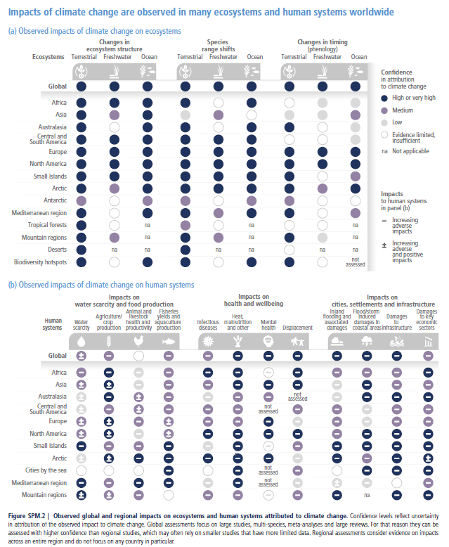
One significant expected trend is that terrestrial ecosystems across the globe are highly likely to experience attribution from climate change. In addition, the North American, European, Small Island and Arctic regions are all highly likely to experience attributions from climate change. It is also clear that nearly all cities, infrastructure, health and (human) wellbeing are expected to experience adverse impacts without notable positives. Based on these trends, should they come to pass, we can expect that managing these risks will involve deciding whether to prioritize human systems or ecosystems.

Three years after the IPCC Sixth Report, studies had reported that we were likely to pass the 1.5⁰C threshold within a 20-year period [7] and that global temperature trends over a consecutive 12-month period are indicative of being on track to passing 1.5⁰C [8]. Assuming the assessments from these studies were correct, resource management is going to become critical in the coming decades. Human resources are particularly going to become increasingly strained for availability, as expertise and adaptability will be indispensable for handling multiple crises of different and overlapping varieties. Automation will be necessary to both free resources up and fill in gaps where people are not available to help.
A particular example of environmental control that interests us and will likely be affected by climate change is managing mosquito populations. Mosquitos can carry deadly diseases such as Dengue, Malaria, West Nile and Zika viruses [4]. Controlling mosquito populations is thus a critical line of defense for preventing deadly diseases from spreading to people. To control mosquito populations, the Minneapolis Mosquito Control District (MMDC) employs various larval controls such as Bacillus thuringiensis isrealensis (Bti), methoprene and Spinosad [9]. Deploying these controls requires identifying mosquito nesting locations while the mosquitos are still in their larval state.
There are three main challenges to overcome when reducing mosquito populations with the MMCD’s current method. Exposure to the mosquito population greatly increases the chances of mosquito bites and in turn the risk of transmitting diseases. At the same time, attempting to control mosquito populations can disturb the freshwater food webs they tend to be a part of if deployment isn’t methodical. For example, Bti presents risks to chironomid larvae as well as to mosquito larvae [5]. Chironomids tend to be diverse, highly digestible, and protein-rich sources of food for various freshwater creatures. Deploying too much Bti risks significantly reducing the chironomid species and thus doing more harm to the environment. The third challenge is the required accuracy of deployment procedure itself, and that is where we believe our method will be able to fill a gap caused by resource constraints. Deployment can only be done on a seasonal basis to target the larvae before they develop into adults. A successful deployment framework for mosquito controls will need to deploy control methods over a familiar seasonal landscape, with accurate identification of the targeted areas and a measured volume of the control deployed.

Literature Review

Graphs
Graphs are an organizational way to arrange data that is defined by nodes and vertices between nodes. Nodes represent data points and can contain multiple attributes that are specific to each data point. Vertices represent relationships between nodes and can contain attributes that are exclusively tied to the relationship between the connected nodes. Vertices can also be directional, meaning that one node is related to another but not the other way around.
Consider the chart on the right from a BBC article detailing the current British Royal Family [10]. Each family member has a name, a title of royalty, a picture of them when available, lines connecting them based on succession and direct descendance, and are positioned by their spouses. We can translate this to a graph by treating each person in the family as a node, with attributes tied to their name, title, if they are in the line of succession, and any details contained in the photos. Vertices would represent familial relationships such as being a spouse, a sibling, who descends from them and who they are descendants from. Whether a family member is in the line of succession can be represented as either an attribute on the nodes or as an attribute of the vertices. Which representation we would prefer depends on the intended purpose of the graph we wish to construct.

Graph Intelligence (GI) Models
Graph intelligence (GI) models treat graphs as input and output either node predictions, vertex predictions or graph predictions. Node predictions are predictions about attribute changes for each node. Vertex predictions are predictions on relationships between the existing nodes on the input graphs. Graph predictions are where an entire graph is provided as output.
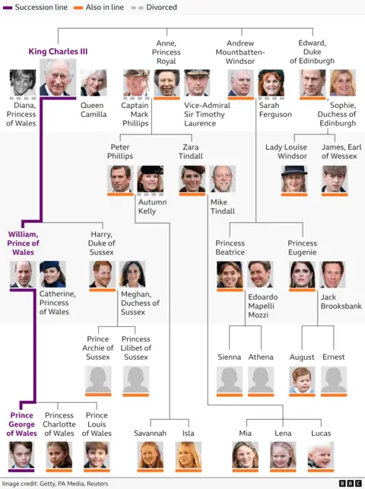
Consider the graph we derived from the Royal Family chart above, which includes all relationships in the vertices. A node prediction model for this graph might attempt to predict changes in each member’s title, name or filling in a picture when none is present. Meanwhile, a vertex prediction model would try to predict changes in the lines of succession or whether a divorce was going to happen. Finally, a graph model would try to predict changes to the entire family tree structure, such as family members getting removed, new children being born, or whether the line of succession has effectively ended.
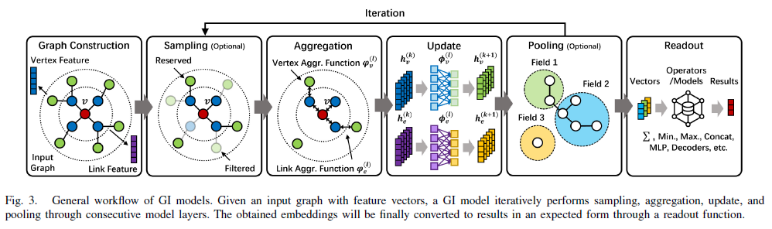
GI models are trained through an iterative process, which is illustrated in Figure 3 shown above [11]. Each iteration starts with a subgraph being sampled from the main graph. The subgraph is then aggregated into a representation vector based on the neighbors of the sampled vertices. Neighbors for a vertex can be the nodes that form the vertex and the nodes connected to those initial nodes by other vertices. Which details are included in the representation vector is based on shared attributes between the initial nodes, and specifications from the user(s). Finally, the aggregation then gets passed through a neural network to update the representation to the desired output. If the output passes enough cutoff requirements for the neural network, then it is returned as the model. Otherwise, the iterative sampling starts over from the sampling step.

Edge Computing and Networks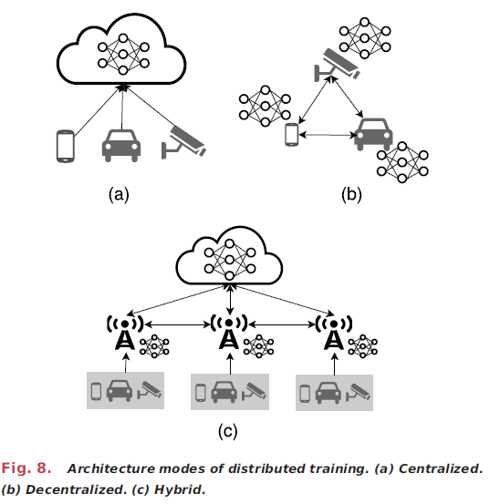
Edge networks are networks of computers that are organized to manage limited or changing resources without a centralized resource. We provided a visualization of how edge networks are different from centralized and hybrid networks (like federated) in the figure above, “Fig. 8.”, which is from the Edge Intelligence: Paving the Last Mile of Artificial Intelligence With Edge Computing article by Zhi Zhou et al [15]. Computers in an edge network vary widely in computing or memory capacity and are dispersed geographically with multiple changing resource constraints that are a result of their environment. Edge networks are designed with the understanding that there is no guarantee of a consistent connection between any of its devices. To resolve this, devices on the network are categorized based on their processing capacity. End devices, which are at the ends of the network, typically contain simple devices unable to handle high-cost processing such as sensors and mobile devices. Meanwhile edge devices can handle collecting data or simple processed information as the end devices connect and disconnect. Edge devices typically include micro data centers. Edge cloud devices are typically at the top of the network, and handle the heavy processing expected to be dispersed to the edge devices. Robots and vehicles can be categorized as either end or edge devices, depending on their function. Given the wide variety of computer types on an edge network, the software networking them is often required to be some combination of cross-platform capable, cross-protocol capable, language-agnostic and resource-efficient.

Edge Graph Intelligence (EGI)
Edge networks that utilize artificial intelligence (AI) are instances of edge intelligence, with EGI being the case where graphs are treated as the input and define the output. One key advantage of edge intelligence is that data centers are freed from storing large amounts of data and handling high amounts of traffic. The edge devices can handle the traffic and data for end devices connected to it, freeing specific tasks from the cloud servers. Meanwhile, the cloud devices provide more general services for the edge devices, preventing edge network devices from having to attempt to communicate with each other all at once.
In the Edge IG: Reciprocally Empowering Edge Networks with Graph Intelligence study from Zeng et al [11], EGI was classified into 6 different levels depending on where the AI was applied within the edge network and how much awareness of the graph was utilized in the training process. Applications of AI that are performed on the end devices alone are handled at levels 0 (not even aware of a graph structure) through 2 (GI). Meanwhile levels 3 (cloud and end devices) through 5 (the full network connection) involve applications that require interactions between edge and cloud devices to train models with full knowledge of the graph data itself.
Consider how a self-driving vehicle may utilize each level. Local activities tied to computer vision and movement through dynamic terrain would be classified as levels 0 through 2. Finding an optimal distance/minimally difficult path through a global environment would be level 3, where GI training is handled by a single cloud or edge device. Level 4 would involve training GI across multiple edge devices, such as a model to predict traffic changes across cities where each city monitors its own traffic. Finally, a dynamic weather forecast that requires all edge devices to train together using all their own data would be an example of a level 5 EGI framework.

Federated Learning
Federated learning is a framework in which edge devices communicate with a central server to implement iterative model aggregation. Each iteration involves the edge devices training their own models and sharing partial models with the central server. The central server then aggregates the partial models into its own generalized model, which is then divided into partial models and sent back to the edge devices to assist with their local training. In the paper Peer-to-Peer Variational Federated Learning Over Arbitrary Graphs, federated learning had the central server communication replaced with each edge devices’ neighbors [12].

Gossip-Based Training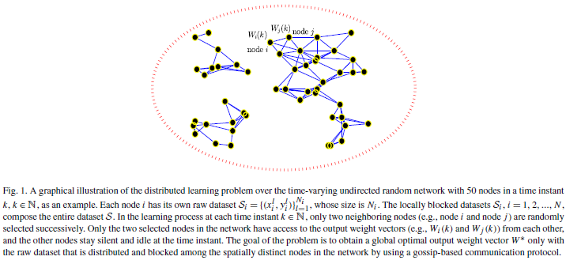
Gossip-based communication protocols are designed to spread communication between edge devices. Figure 1 above highlights an example of a gossip-based network in action [13]. The protocol starts with each edge device randomly selecting one of its neighbor devices to pair with. Each pair of devices then shares information during a fixed period of either iterations of sharing, iterations of learning, or fixed time. At the end of each period, the devices select different neighbors to exchange information with. The intent of this process is to prevent a fixed line of communication and enable easier recovery when communication protocols are disrupted. One application of gossip-based training we studied for our project outlined an algorithm graph-based distributed cooperative learning (GBDCL) [13]. GBDCL measures weights of each paired edge device before returning each measured weight to be aggregated into a sum.

Limitations of Existing Work
The papers we reviewed for our project (11-13) all propose some form of device communication framework or analysis of graph data. Based on our research before carrying out our project, contrasting the utility of each of the frameworks and measuring their effective loss in performance in carrying out specific tasks was not previously done. The graph analysis papers focused on the performance of their systems with the assumption that communication was uninterrupted. The communication papers showed that their methods could provide further safeguards from network drops or lack of availability, but did not evaluate the loss in performance as a result of the communication losses.

Proposed Approach
Our approach has six major components: loading the data, building the graph datasets and partitions, building communication channels and the simulator, centralized training, federated average and gossip training, and evaluation. In this section we'll focus on the first five of those components.

Loading the Data
We used data from the National Wetlands Inventory Update for Minnesota, 2009-2014 [14]. This is a publicly available GIS database, constructed by the Department of Natural Resources with help from St. Mary's University of Minnesota. This dataset provides broad statistics about Minnesota wetlands including shape, size (acreage), and classification. We load the data as a GeoPackage and utilize only one feature, statewide_NWI. The feature is a categorical index for the type of environment that a region is classified as. Using only statewide_NWI keeps the data small enough to run in a reasonable time frame with our current hardware. One of our laptops utilizes: an Intel Core i7-8550U CPU @ 1.80GHz, 16GB RAM, an Intel UHD Graphics 620 card (not compatible with CUDA), and up to 1TB storage. The variable allows our models to take the environment into account despite the hardware restrictions.

Graph Datasets and Partitions
Once the data is loaded into the GeoDataFrame, we want to build a graph and partition the graph for the federated average and gossip training modes. We constructed a square grid over the geographic extent of the input wetlands layer by calling create_grid. This is a discretization step that converts irregular polygon geometry into a fixed set of graph nodes. The return values include one polygon per cell plus the bounding-box and cell-dimension information.
We then compute the per-cell wetland signal as the fractional coverage in the interval (0.0, 1.0) before building the graph topology as an edge index tensor. The result is a 4-neighbor lattice used by other parts of the project, which gives us the node set and adjacency. Supervision labels are then generated using Dijkstra to calculate terrain-dependent shortest-path distances.
Finally, we construct a node feature matrix by computing normalized cell-center coordinates for every node and then deriving the node position, goal position (for each node), and node-to-goal deltas. If a goal node is not supplied, we use a random one. The end result is a data object that stores: node features, grid adjacency, shortest-path distance labels, node coordinates, and several metadata objects such as the grid size.
To partition the grid, we split the region into a set of spatial columns determined by our nodes. In this simulation, a node is a drone, and to maximize efficiency we want each drone to only move within its own partition. Using 'strips' to partition the area creates a simple and interpretable motion constraint. This also simplifies communication comparisons, as they become driven by rules and scheduling for updates instead of partition geometry.

Communication Channels and Simulator
We created a custom CommunicationChannels class for simulating communication interruptions. It takes a tally of all agents present in a network, and randomly assigns them a value that determines whether they were present in a communication step or if they had ‘dropped out’. It is given a baseline dropout probability that is assigned to every agent, and assigns it as the expected blackout rate when one is not specified. If a drone drops out and the total number of dropouts among all drones is beneath the blackout rate then the drone is labeled as ‘dropped out’ and not ‘blackout’. The CommunicationChannels object keeps a log of which drones dropped out and blacked out over a series of communications between agents. It can be utilized as is for both gossip-training (monitoring how many drones on the network communicate with each other) and federated averaging (how often the edge drones communicate with the central node). The separation of the communication channels from the training isolates the effect of communication drops from each agent’s own training.
Earlier, we constructed the graph and partitions. Those partitions are used as the spatial 'ownership' map for the drones. When simulator integration is enabled, we build a base simulator from the grid size, partition layout, and full graph data. We then clone this base simulator into a fedavg_simulator and gossip_simulator, similar to how we created the communication channels separately to avoid interference during training. The simulator, while optional, is core to the idea of the project. It allows us to simulate the drone's movements on the spatial grid, as well as enforce communication boundaries and 'vision' boundaries, limiting drones to information within the parameterized zone.
All models’ frameworks and their environment are initialized before training, with the environment being represented with the class WetlandGCN (Wetland Graph Convolutional Network). To ensure some fairness between the models, we snapshot the initial weights of this GCN into state dicts to hand off to the federated and gossip models later. This means all models inherit the same starting parameters

Centralized Training
To train the centralized model, we use the computed initial_model to create a copy and prevent accidental mutation. That copy is what we used for training with the Pytorch torch library. We specify the optimizer as an Adam optimizer tied directly to the model parameters. This tells PyTorch how parameter updates should be computed after gradients are backpropagated.
` We switch the model into training mode, then start a loop for each epoch where we clear previous gradients, run a full forward-pass of the GNN over the graph, compare predictions against ground-truth Dijkstra labels, compute gradients, apply Adam updates, and store the loss for inspection later. This is effectively full-batch supervised learning on the complete graph (no partitions) and this gives us a 'baseline' to compare the federated average and gossip training methods to.

Federated Average Training
The high-level pattern with federated average training differs slightly from centralized training. In federated average, we initialize one global model and broadcast it to all drone agents. Each drone trains locally, and their updates are aggregated on communication rounds (when they participate). The averaged weights are then broadcasted back out to the drones, and the process repeats itself.
We provide the train_fedavg() method with the model weights from the shared baseline model, ensuring the edge drone training method matches the baseline agent’s. We then create a CentralAgent and one NodeAgent per partition, simulating the server and clients. We store and broadcast the weights from the CentralAgent to each NodeAgent.
If simulator mode is off, we precompute one local subgraph per drone's assigned partition regardless of the drone’s position. If simulator mode is turned on, we instead derive a fresh local view from each drone's simulated position. At the start of each epoch, if the simulator is enabled, the simulator advances the drones one step. We then capture the current node positions to pass into the training phase. When simulator mode is on, we use the position to train on a local view centered on its simulator position.
When training each node, we specify a number of parameters to enforce simulation constraints, namely num_threads and time_budget_ms. These each simulate drone resource limitations, in the number of available threads for processing and the time allotted to each drone, respectively.
After training, we check if this is a 'communication round'. A 'communication round' in this context means we want to transmit the locally-trained subgraph updates (node's current model parameters and the number of nodes it trained on) back to the CentralAgent. When it is a communication round, we select participants in one of two ways. When simulation is enabled, we sample participants using a radius drawn around the node on the graph. If the drone is near the fixed base, then it transmits its data back. If simulation is disabled, any node can participate in communication, subject only to random dropout.
If there are updates transmitted back to the CentralAgent, it performs the actual federated averaging step of aggregating the updates by computing a weighted average of the participant client models, normalized by the amount of local data used by each client. Once this is done, the new average is pushed back out to every node (not only participants).
At the end of each epoch, whether it was a communication round or not, we compute an averaged state across all node agents and evaluate on the full graph. This does mean that, even though training is decentralized, reporting is still global. This helps to compare the training methods against each other.
Once we've completed all epochs, we load the final averaged state into a WetlandGCN and return the full loss curve and final global model.

Gossip Training
The high-level pattern of gossip training is similar to that of federated average in that there are multiple local models trained in parallel, but the key difference is that there is no central server. Instead, local models are periodically averaged directly with other nearby models in randomly selected pairs. Again we use the same shared ingredients from the centralized and federated models to enable comparison.
In train_gossip(), the first thing we want to do is determine how many drones there are, which we match to the count of partitions (computed earlier). This is done even when simulation is enabled because we still need to define how many drones there are and how they are allowed to move.
When constructing the actual models, we create one per drone. This differs from the other methods where there is one central model that will get updated (the normal model in centralized, the CentralAgent in federated averaging). Each model gets its own Adam optimizer.
When simulation mode is off, we precompute one fixed local subgraph per partition. Otherwise, for each round, we ask the simulator for a fresh local view based on the drone's current position. Each epoch then has three conceptual phases: optional movement, local training, and optional pairwise model exchange.
At the beginning of the epoch, if simulation is enabled, each drone moves within its assigned partition. Once movement has ended, we can determine the actual training graph for each drone that round.
During the training phase, each model performs up to local_steps gradient steps on its own current local graph. This is similar to the centralized training loop, except replicated for each drone on a smaller graph. Again, we introduce resource parameters num_threads and time_budget_ms here to simulate physical resource constraints.
Once local training is done, we check if it is a communication round. If not, each drone keeps its locally updated model and the round ends. If it is a communication round, we gossip. Gossiping in this case happens in a pairwise fashion. Over enough iterations and pairwise groupings, this should average-out the models. When simulation is disabled, we randomly draw pairs between every drone on the graph. When it is enabled, we use a proximity based pairing method. In both cases, every drone is subject to random communication dropouts.
Once the pairs are chosen, each pair averages weights directly. After the exchange, both drones hold the same averaged parameter state. We then reset the optimizers for the models that were exchanged because the old Adam optimizer momentum statistics won't correspond to the new weights.
At the end of each round, we compute a global averaged state across all drones, only as a means of evaluation. This enables us to compare the methods, even though in a real gossip training scenario you wouldn't do this just yet.

Validation
Methodology
Evaluating each method’s performance was intended to be based on multiple factors. The number of false positives where a nest is incorrectly identified provides insight into how likely the method is to unnecessarily harm the environment. Failing to find a nest before the drones need to be recalled for battery consumption would constitute either a true negative, or accurately determining no nest is present. If there was a nest, then the robot presented a true negative that entails risk of letting populations grow. Measuring both false positives and true negatives will enable us to contrast the expected failure type.
Resource management could have also been evaluated based on what was required to train a model to achieve acceptable accuracy and efficient use of time, as well as how many resources were required of the agents making the decisions. This measurement will help clarify if the preferred method involves treating drones as remotely piloted devices (our baseline), as edge devices (drones make decisions on their own), or as an extension of a platform hosting a trained model. Furthermore, it can determine if a portable computer, computer-embedded vehicle, or remote data center is a preferred host for the trained model.

Shortcomings
While we were able to design the code for our simulated experiment (https://github.com/nwconstable/sdsr-site), we were unable to produce results that could be verified with our chosen methodology. The limitations of our hardware resulted in a maximum of 200 epochs per run before simulations took longer than the time we allocated for experimentation. The trained models from those simulations also did not converge to a useful MSE. The two bar charts below show the resulting and mean MSE in the final models for our run with the lowest MSE between the three methods.
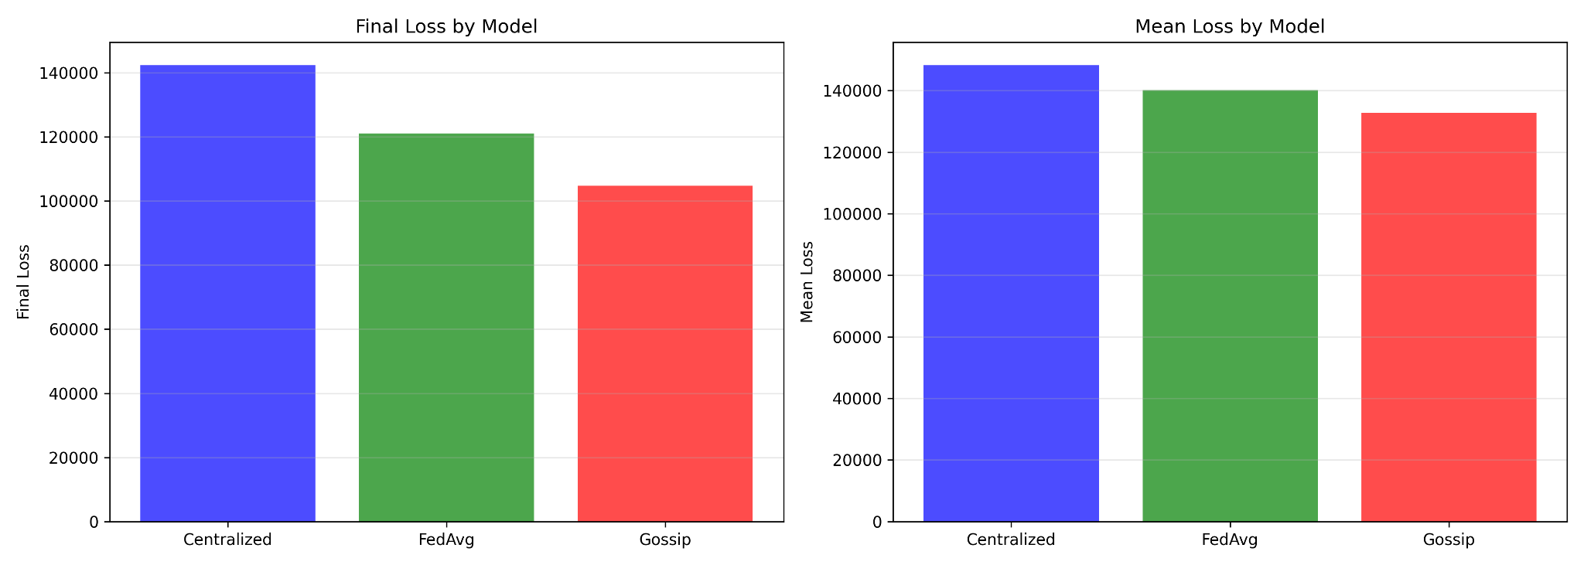
As the figure highlights, none of the final models’ MSE improved to below 100,000. This was true for all 16 runs we managed to complete. The resulting models also could not effectively reach a test goal destination in our wetlands simulated environment in the time budget we provided them. Testing the model’s effectiveness outside of training was inconclusive.
In addition, we made an error in judgement by having our baseline blackout ratio be 10%. Every run we completed only had 8 drones. The result is that any single drone dropped out was counted as a blackout event. While we could still compare the dropout rates to see how they affected the model training, we are unable to contrast dropout and blackout effects with the runs we completed.
We also did not implement the blackout log for gossip training and centralized training. The CommunicationChannels class is able to form groups of two in the class, and can be modified to identify drones that did not get grouped as having dropped out. Our results for blackout information should only be used in the context of its effect on our federated training.

Findings
We ran 16 simulations with the same grid size (500x500), drone count (8), blackout threshold (10%), learning rate (0.1%), simulator parameters (simulator view, communication radius, integrating the simulator and snapshot log) and epoch limit (200). The first 8 runs were made with communication between devices occurring once every 5 steps of training, while the last 8 had a communication rate of once every 10. Among those groups of 8, we had the first four communicate with a dropout rate of 10% and the last four with a dropout rate of 25%. Every group of two runs kept the same number of threads (2 threads per agent, then 4, then 2, and so forth) while every run switched the time budget from 1000ms to 2000ms. The partitioned regions for the drones had no overlap in any of the runs.
The figure below shows the results of our first run, where we had one communication every 5 steps of an epoch, a dropout rate of 10%, a thread limit of 2 and a time budget of 1000ms per thread. We also found no logged dropouts nor blackouts over the entire training period.
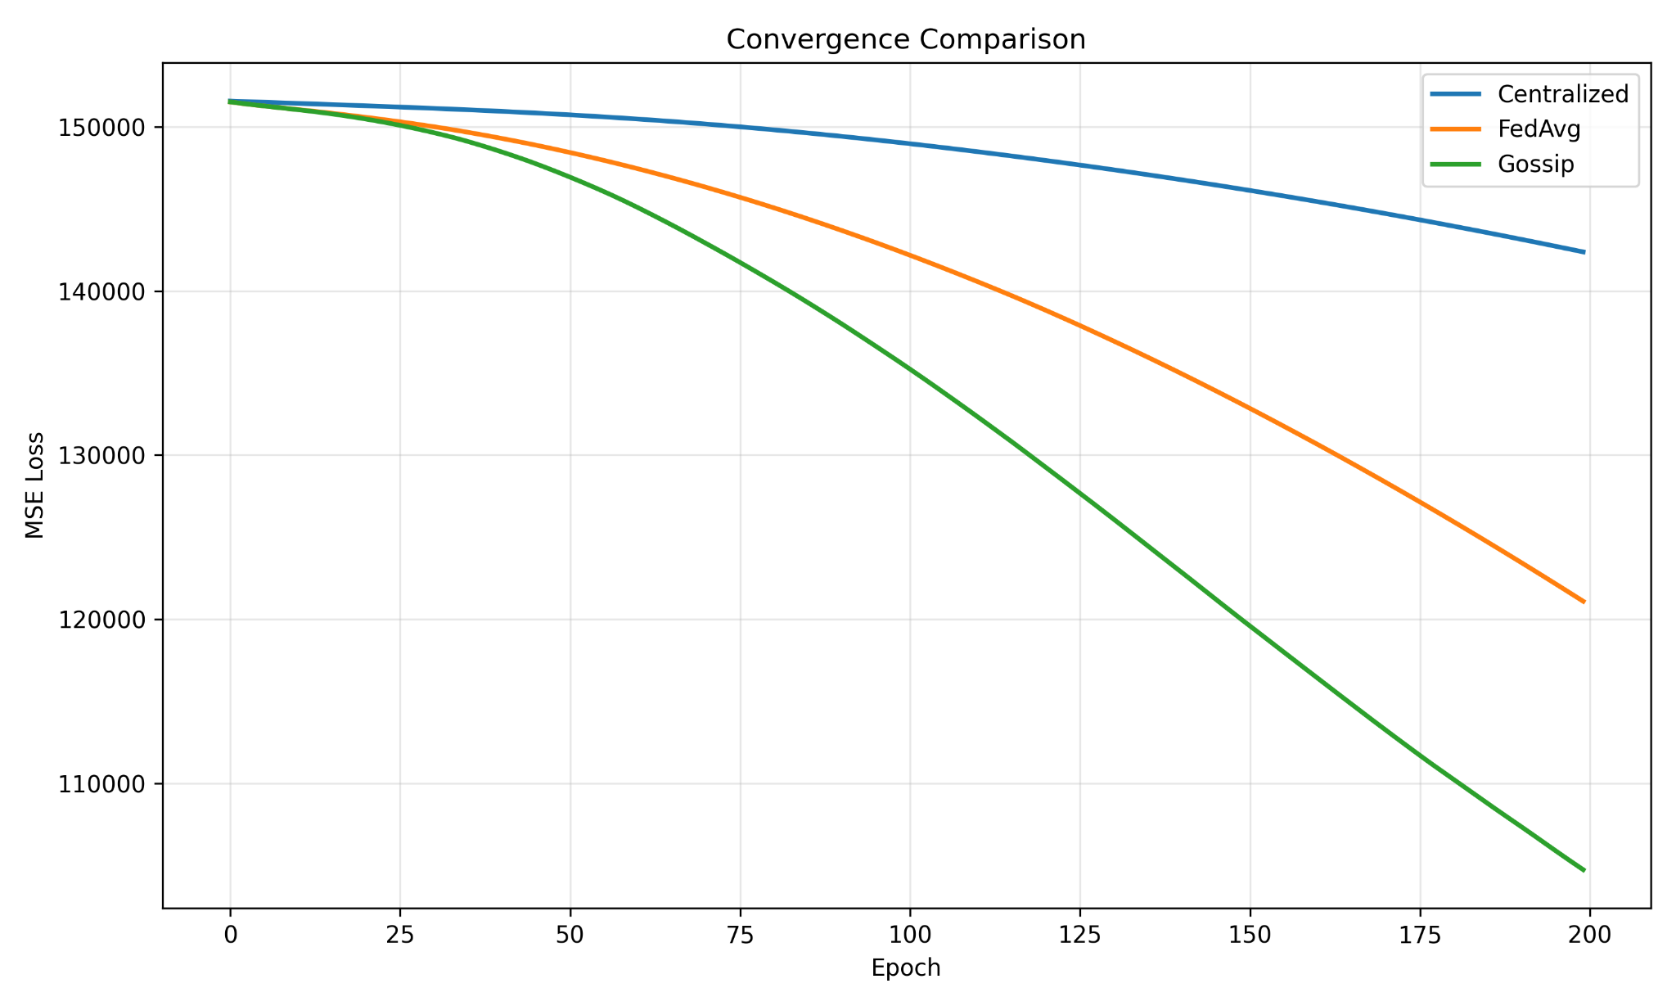
The trend of gossip learning outpacing federated learning, which itself is outpacing centralized learning, appeared in all 16 of our runs. The centralized learning model likely performed worst because it had to train over the entire region, the 500x500 grid. Meanwhile the agents in the decentralized training methods only had to train over partitioned subregions and could thus evaluate each step more quickly.
Federated learning converged at roughly the same rate as gossip learning for the first 25 epochs when considering the scale of MSE reduction. Both training methods exhibited an accelerating MSE reduction that is concave down until the 200th epoch. The split between the two methods’ results after 25 epochs is not the result of dropouts, since the log for the dropouts for federated training was empty for the 40 rounds of communication made. Both sets of agents are trained with the same method locally, so the averaging update the federated nodes are receiving must be less effective than the more limited averaging between node pairs in gossip training. Without seeing a successful conversion of MSE for either method, we cannot say for certain that this will be the result in practice.
The shape of the three curves also stayed consistent between the 16 runs. We expected the centralized learning curve to remain consistent since it did not receive the communication blackouts that gossip and federated learning did. Gossip and federated keeping their learning rates also suggests that the communication interruptions did not significantly change the results. Given the drop-rates of our project were 10% and 25%, we suspect that we did not use a high enough drop rate to significantly impact the learning rates.

Conclusions
Based on our usable results, it appears that group messaging is the current favored means of performing the mosquito propellant application. We were unable to compare the effects of dropouts successfully, though we suspect that future attempts would be able to build a proper experiment using our code as a template. It is strongly recommended that any attempts utilize computers with improved RAM and storage capacity, along with GPUs that are CUDA-compatible for PyG.
One of the main updates needed to the code would be the addition of a centralized communication channel to simulate a centralized blackout. The nodes are not agents in that network, so the disruption can be handled in one of two ways: a pause in the learning process; or recycling a current model to make an improvement. The pause may be more appropriate given central servers typically have their data stored on their own devices.
We also have suggestions for improved methodologies once the code is finalized. Future attempts at our project should utilize drop rates ranging from 30-90% while keeping all other variables fixed. This would help provide a clearer view into how communication disruptions can affect each model. The results from the runs should also be plotted together in the same diagram to help illustrate how the changes in the runs’ parameters diverged from each other. Using multiple different datasets spanning visual, audial, spatiotemporal and strictly categorical data would also remove potential biases if a general study comparing the three training methods was desired. Changing the number of nodes for each network can also reveal what kind of network scales are needed to overcome communication disruptions. For example, is it better to use gossip training through smart phones because there are so many, or is it better to utilize it for cars because they are fewer in number and have greater spatial and temporal overlap with their environment (i.e. are restricted to roads)?
Our work can also be expanded on for general use once it is more clear how communication disruptions affect the three different training methods. The three training methods could be modified to better handle communication interruptions. Allowing overlaps in training partitions would reveal how much overlap can hinder gossip and federated learning contrasted to centralized learning. A greater range of hybrid edge training methods can determine which degree of hybridization would be appropriate for small-scale and mass-scale applications.

Resources
- WAYMO; WAYMO Home Page; 2019-2026 Waymo LLC; https://waymo.com/
- John Deere; Prevision AG Technology Page; 2026 Deere & Company; https://www.deere.com/en/technology-products/precision-ag-technology/
- CSIS; How Ukraine’s Operation “Spider’s Web” Redefines Asymmetric Warfare; 2025 Center for Strategic & International Studies; https://www.csis.org/analysis/how-ukraines-spider-web-operation-redefines-asymmetric-warfare
- Texas Health and Human Services, 2026 Texas Department of State Health Services, List of Mosquito-Borne Diseases, https://www.dshs.texas.gov/mosquito-borne-diseases/list-mosquito-borne-diseases
- Stefanie Allgeier, Anna Friedrich, Carsten A. Brühl, Mosquito control based on Bacillus thuringiensis israelensis (Bti) interrupts artificial wetland food chains, Science of The Total Environment, Volume 686, 2019, Pages 1173-1184, ISSN 0048-9697, https://doi.org/10.1016/j.scitotenv.2019.05.358.
- IPCC; 2022 Intergovernmental Panel on Climate Change; Climate Change 2022: Impacts, Adaptation and Vulnerability; Working Group II Contribution to the Sixth Assessment Report of the Intergovernmental Panel on Climate Change; https://www.ipcc.ch/report/ar6/wg2/
- Bevacqua, E., Schleussner, CF. & Zscheischler, J. A year above 1.5 °C signals that Earth is most probably within the 20-year period that will reach the Paris Agreement limit. Nat. Clim. Chang. 15, 262–265 (2025). https://doi.org/10.1038/s41558-025-02246-9
- Cannon, A.J. Twelve months at 1.5 °C signals earlier than expected breach of Paris Agreement threshold. Nat. Clim. Chang. 15, 266–269 (2025). https://doi.org/10.1038/s41558-025-02247-8
- MMCD, 2026, Mosquito Control, https://mmcd.org/mosquito-control/
- BBC, 20 February 2026 BBC, Royal Family tree: King Charles III’s closest family and line of succession, https://www.bbc.com/news/articles/c867plj4vgqo
- L. Zeng et al., Edge Graph Intelligence: Reciprocally Empowering Edge Networks With Graph Intelligence, in IEEE Communications Surveys & Tutorials, vol. 27, no. 6, pp. 3417-3454, Dec. 2025, doi: 10.1109/COMST.2025.3527561.
- X. Wang, A. Lalitha, T. Javidi and F. Koushanfar, "Peer-to-Peer Variational Federated Learning Over Arbitrary Graphs," in IEEE Journal on Selected Areas in Information Theory, vol. 3, no. 2, pp. 172-182, June 2022, doi: 10.1109/JSAIT.2022.3189051.
- Pengfei Ren, Hao Dai, Weisheng Chen, Distributed cooperative learning over time-varying random networks using a gossip-based communication protocol, Fuzzy Sets and Systems, Volume 394, 2020, Pages 124-145, ISSN 0165-0114, https://doi.org/10.1016/j.fss.2019.05.009
- Tiles © Esri — Esri, DeLorme, NAVTEQ, TomTom, Intermap, iPC, USGS, FAO, NPS, NRCAN, GeoBase, Kadaster NL, Ordnance Survey, Esri Japan, METI, Esri China (Hong Kong), and the GIS User Community, National Wetland Inventory for Minnesota, https://gisdata.mn.gov/dataset/water-nat-wetlands-inv-2009-2014
- Z. Zhou, X. Chen, E. Li, L. Zeng, K. Luo and J. Zhang, "Edge Intelligence: Paving the Last Mile of Artificial Intelligence With Edge Computing," in Proceedings of the IEEE, vol. 107, no. 8, pp. 1738-1762, Aug. 2019, doi: 10.1109/JPROC.2019.2918951, https://ieeexplore-ieee-org.ezp1.lib.umn.edu/document/8736011

