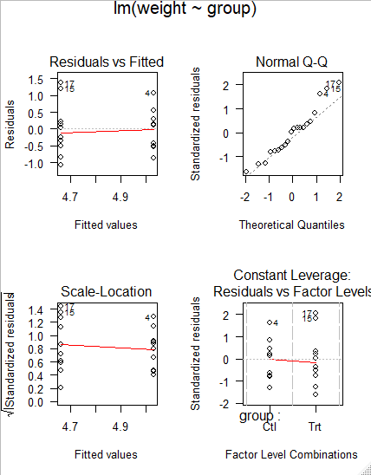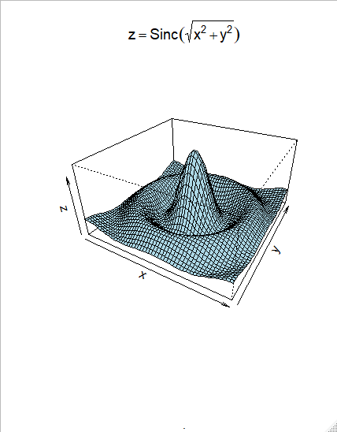

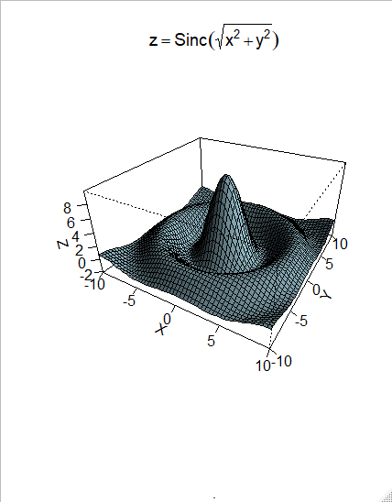

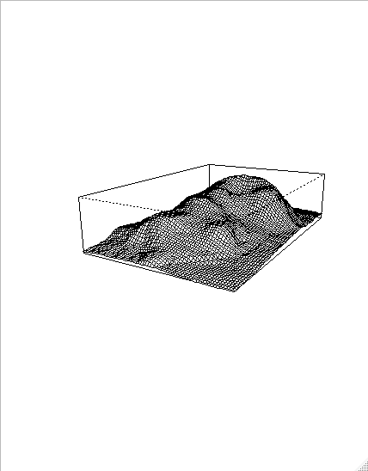

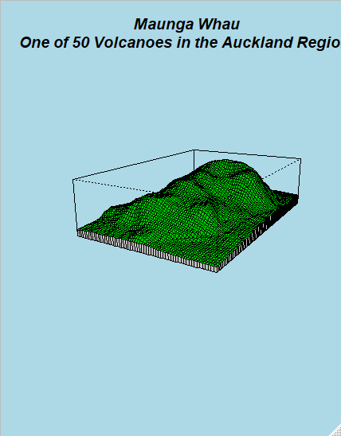

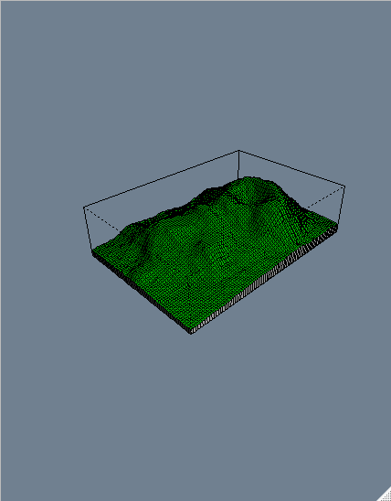

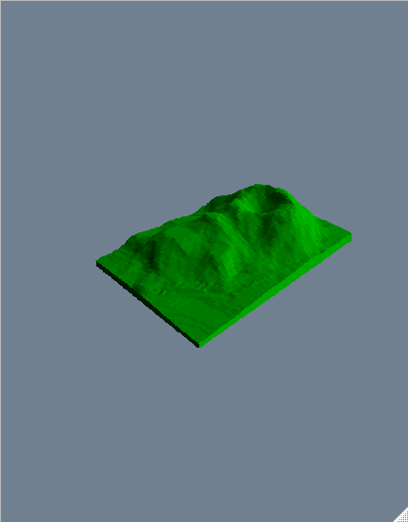

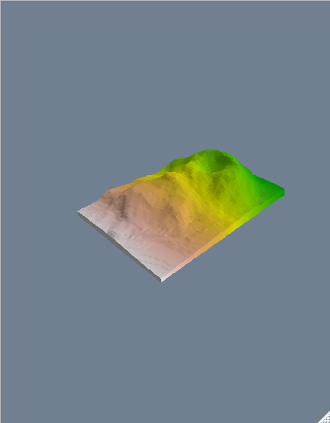

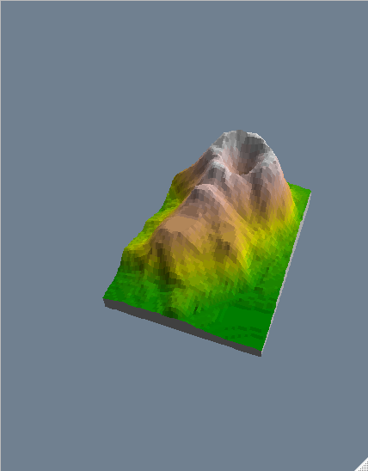

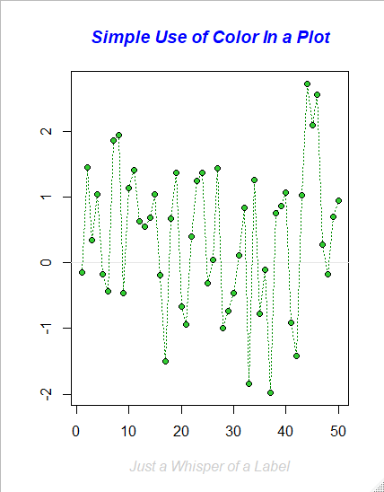

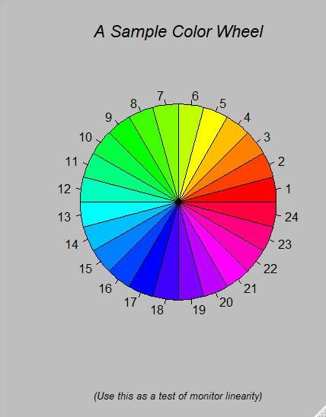

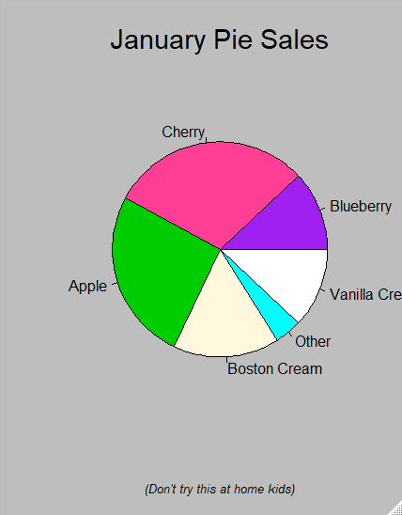

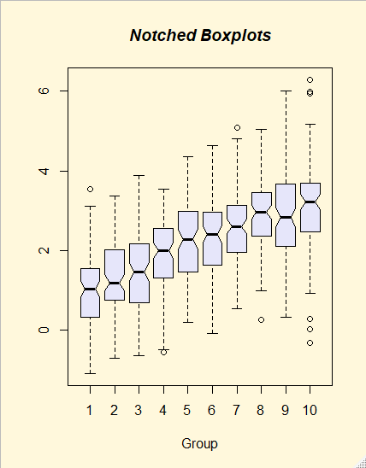

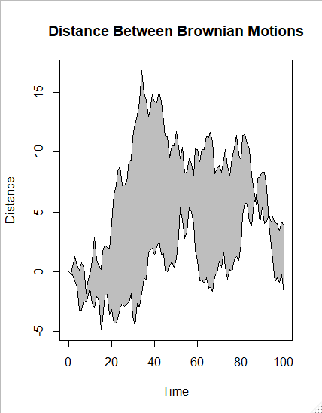

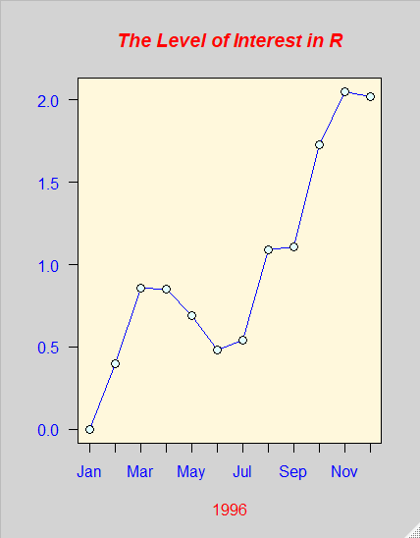

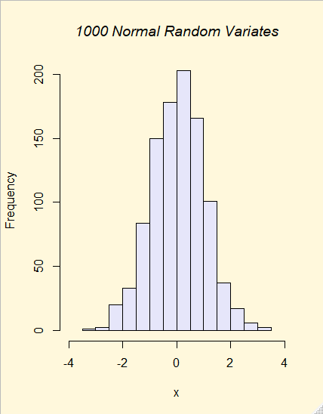

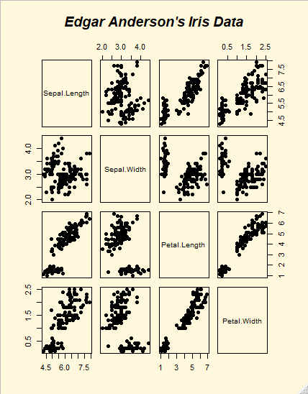

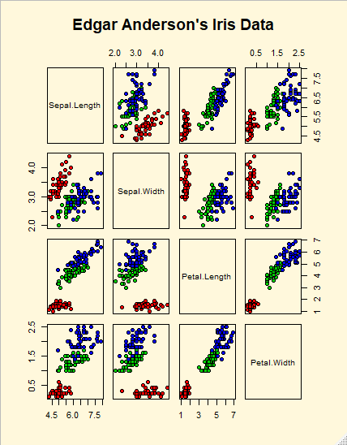

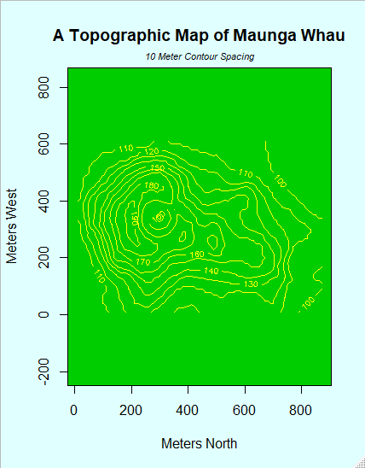

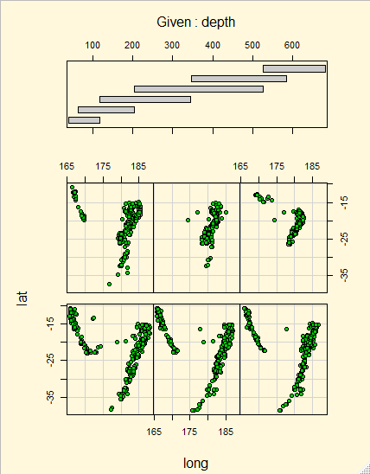

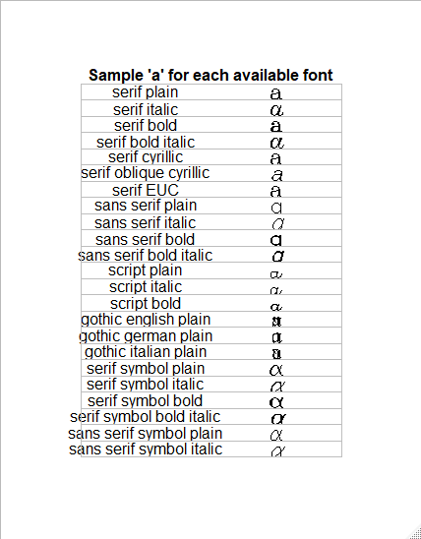

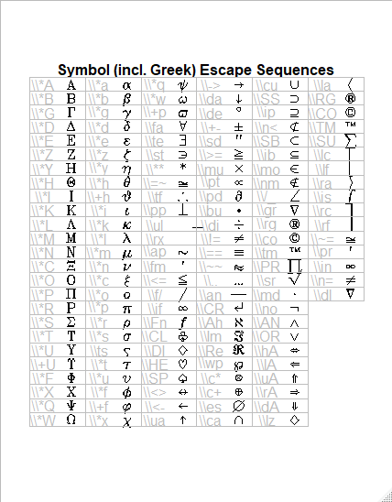

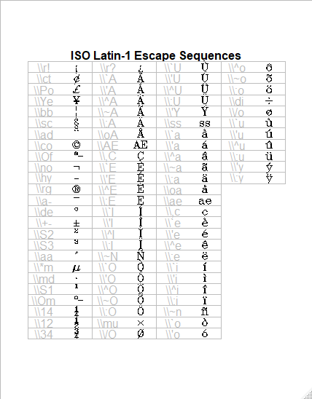

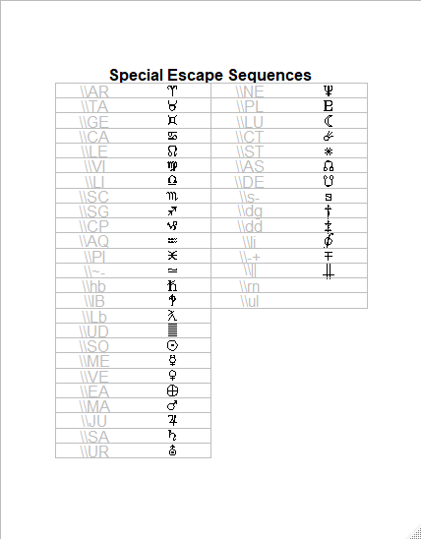

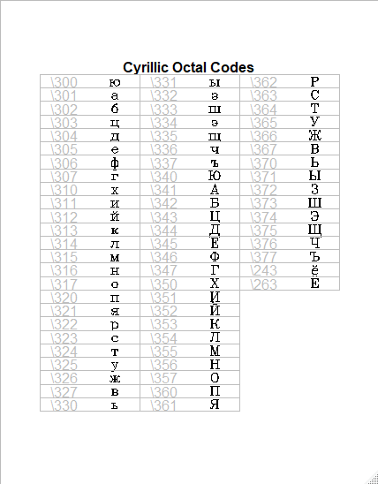

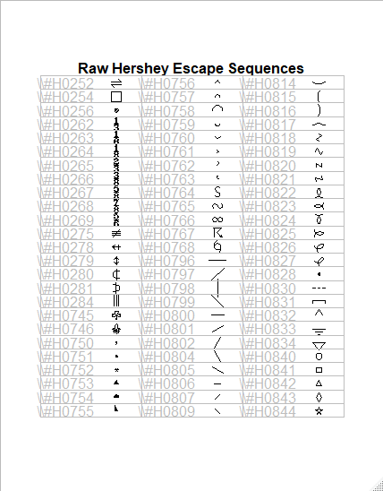

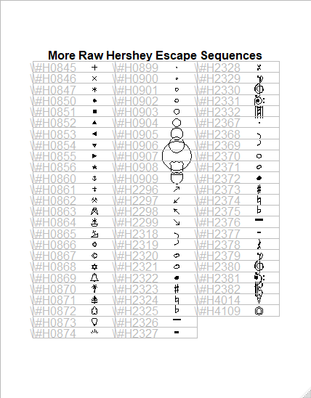

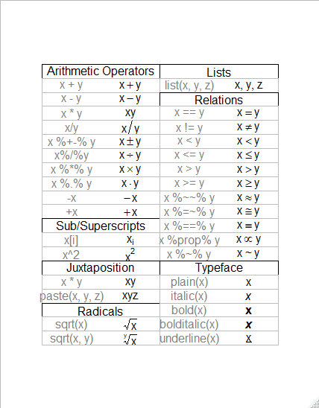

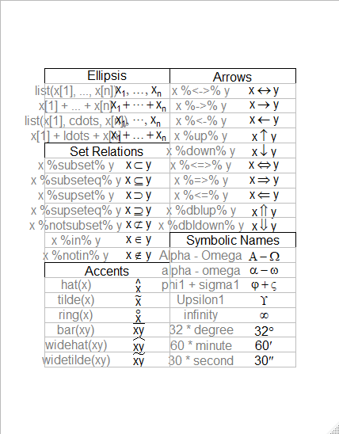

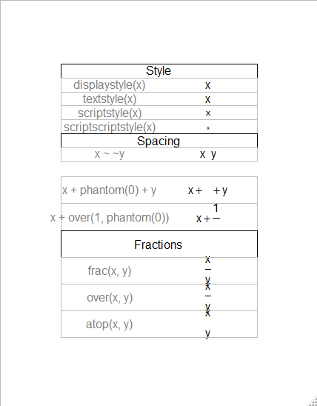

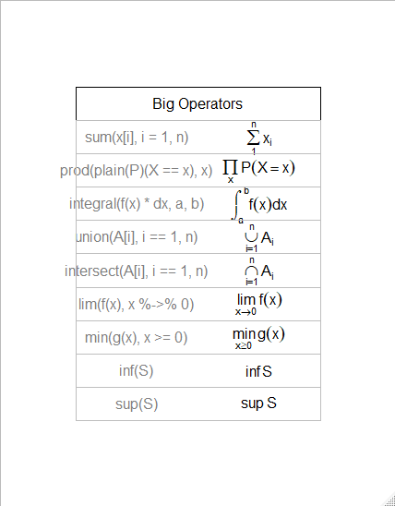

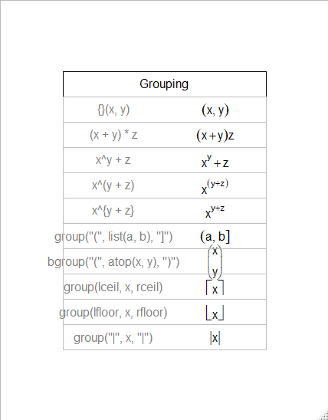

|  |  |
| --- | --- |
| Kfn {spatial} | R Documentation |

Compute K-fn of a Point Pattern

**Description**

Actually computes *L = sqrt(K/pi)*.

**Usage**

Kfn(pp, fs, k=100)

**Arguments**

|  |  |
| --- | --- |
| pp | a list such as a pp object, including components x and y |
| fs | full scale of the plot |
| k | number of regularly spaced distances in (0, fs) |

**Details**

relies on the domain D having been set by ppinit or ppregion.

**Value**

A list with components

|  |  |
| --- | --- |
| x | vector of distances |
| y | vector of L-fn values |
| k | number of distances returned – may be less than k if fs is too large |
| dmin | minimum distance between pair of points |
| lm | maximum deviation from L(t) = t |

**References**

Ripley, B. D. (1981) *Spatial Statistics.* Wiley.

Venables, W. N. and Ripley, B. D. (2002) *Modern Applied Statistics with S.* Fourth edition. Springer.

**See Also**

[ppinit](http://127.0.0.1:46997/help/library/spatial/help/ppinit), [ppregion](http://127.0.0.1:46997/help/library/spatial/help/ppregion), [Kaver](http://127.0.0.1:46997/help/library/spatial/help/Kaver), [Kenvl](http://127.0.0.1:46997/help/library/spatial/help/Kenvl)

**Examples**

towns <- ppinit("towns.dat")

par(pty="s")

plot(Kfn(towns, 10), type="s", xlab="distance", ylab="L(t)")

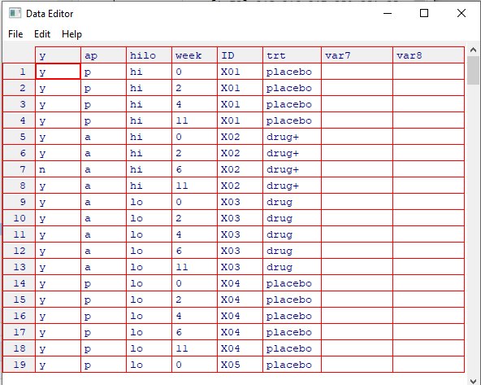

Code begins here:

[1] "ccedilla"

> draw.vf.cell(tf, fi, "\\`e", i, nr); i<-i+1; { "egrave"}

[1] "egrave"

> draw.vf.cell(tf, fi, "\\'e", i, nr); i<-i+1; { "eacute"}

[1] "eacute"

> draw.vf.cell(tf, fi, "\\^e", i, nr); i<-i+1; { "ecircumflex"}

[1] "ecircumflex"

> draw.vf.cell(tf, fi, "\\:e", i, nr); i<-i+1; { "edieresis"}

[1] "edieresis"

> draw.vf.cell(tf, fi, "\\`i", i, nr); i<-i+1; { "igrave"}

[1] "igrave"

> draw.vf.cell(tf, fi, "\\'i", i, nr); i<-i+1; { "iacute"}

[1] "iacute"

> draw.vf.cell(tf, fi, "\\^i", i, nr); i<-i+1; { "icircumflex"}

[1] "icircumflex"

> draw.vf.cell(tf, fi, "\\:i", i, nr); i<-i+1; { "idieresis"}

[1] "idieresis"

> draw.vf.cell(tf, fi, "\\~n", i, nr); i<-i+1; { "ntilde"}

[1] "ntilde"

> draw.vf.cell(tf, fi, "\\`o", i, nr); i<-i+1; { "ograve"}

[1] "ograve"

> draw.vf.cell(tf, fi, "\\'o", i, nr); i<-i+1; { "oacute"}

[1] "oacute"

> draw.vf.cell(tf, fi, "\\^o", i, nr); i<-i+1; { "ocircumflex"}

[1] "ocircumflex"

> draw.vf.cell(tf, fi, "\\~o", i, nr); i<-i+1; { "otilde"}

[1] "otilde"

> draw.vf.cell(tf, fi, "\\:o", i, nr); i<-i+1; { "odieresis"}

[1] "odieresis"

> draw.vf.cell(tf, fi, "\\di", i, nr); i<-i+1; { "divide"}

[1] "divide"

> draw.vf.cell(tf, fi, "\\/o", i, nr); i<-i+1; { "oslash"}

[1] "oslash"

> draw.vf.cell(tf, fi, "\\`u", i, nr); i<-i+1; { "ugrave"}

[1] "ugrave"

> draw.vf.cell(tf, fi, "\\'u", i, nr); i<-i+1; { "uacute"}

[1] "uacute"

> draw.vf.cell(tf, fi, "\\^u", i, nr); i<-i+1; { "ucircumflex"}

[1] "ucircumflex"

> draw.vf.cell(tf, fi, "\\:u", i, nr); i<-i+1; { "udieresis"}

[1] "udieresis"

> draw.vf.cell(tf, fi, "\\'y", i, nr); i<-i+1; { "yacute"}

[1] "yacute"

> draw.vf.cell(tf, fi, "\\:y", i, nr); i<-i+1; { "ydieresis"}

[1] "ydieresis"

> nr <- 25

> nc <- 2

> make.table(nr, nc)

Hit <Return> to see next plot:

> i <- 0

> draw.title("Special Escape Sequences", i, nr, nc)

> draw.vf.cell(tf, fi, "\\AR", i, nr); i<-i+1; { "aries"}

[1] "aries"

> draw.vf.cell(tf, fi, "\\TA", i, nr); i<-i+1; { "taurus"}

[1] "taurus"

> draw.vf.cell(tf, fi, "\\GE", i, nr); i<-i+1; { "gemini"}

[1] "gemini"

> draw.vf.cell(tf, fi, "\\CA", i, nr); i<-i+1; { "cancer"}

[1] "cancer"

> draw.vf.cell(tf, fi, "\\LE", i, nr); i<-i+1; { "leo"}

[1] "leo"

> draw.vf.cell(tf, fi, "\\VI", i, nr); i<-i+1; { "virgo"}

[1] "virgo"

> draw.vf.cell(tf, fi, "\\LI", i, nr); i<-i+1; { "libra"}

[1] "libra"

> draw.vf.cell(tf, fi, "\\SC", i, nr); i<-i+1; { "scorpio"}

[1] "scorpio"

> draw.vf.cell(tf, fi, "\\SG", i, nr); i<-i+1; { "sagittarius"}

[1] "sagittarius"

> draw.vf.cell(tf, fi, "\\CP", i, nr); i<-i+1; { "capricornus"}

[1] "capricornus"

> draw.vf.cell(tf, fi, "\\AQ", i, nr); i<-i+1; { "aquarius"}

[1] "aquarius"

> draw.vf.cell(tf, fi, "\\PI", i, nr); i<-i+1; { "pisces"}

[1] "pisces"

> draw.vf.cell(tf, fi, "\\~-", i, nr); i<-i+1; { "modifiedcongruent"}

[1] "modifiedcongruent"

> draw.vf.cell(tf, fi, "\\hb", i, nr); i<-i+1; { "hbar"}

[1] "hbar"

> draw.vf.cell(tf, fi, "\\IB", i, nr); i<-i+1; { "interbang"}

[1] "interbang"

> draw.vf.cell(tf, fi, "\\Lb", i, nr); i<-i+1; { "lambdabar"}

[1] "lambdabar"

> draw.vf.cell(tf, fi, "\\UD", i, nr); i<-i+1; { "undefined"}

[1] "undefined"

> draw.vf.cell(tf, fi, "\\SO", i, nr); i<-i+1; { "sun"}

[1] "sun"

> draw.vf.cell(tf, fi, "\\ME", i, nr); i<-i+1; { "mercury"}

[1] "mercury"

> draw.vf.cell(tf, fi, "\\VE", i, nr); i<-i+1; { "venus"}

[1] "venus"

> draw.vf.cell(tf, fi, "\\EA", i, nr); i<-i+1; { "earth"}

[1] "earth"

> draw.vf.cell(tf, fi, "\\MA", i, nr); i<-i+1; { "mars"}

[1] "mars"

> draw.vf.cell(tf, fi, "\\JU", i, nr); i<-i+1; { "jupiter"}

[1] "jupiter"

> draw.vf.cell(tf, fi, "\\SA", i, nr); i<-i+1; { "saturn"}

[1] "saturn"

> draw.vf.cell(tf, fi, "\\UR", i, nr); i<-i+1; { "uranus"}

[1] "uranus"

> draw.vf.cell(tf, fi, "\\NE", i, nr); i<-i+1; { "neptune"}

[1] "neptune"

> draw.vf.cell(tf, fi, "\\PL", i, nr); i<-i+1; { "pluto"}

[1] "pluto"

> draw.vf.cell(tf, fi, "\\LU", i, nr); i<-i+1; { "moon"}

[1] "moon"

> draw.vf.cell(tf, fi, "\\CT", i, nr); i<-i+1; { "comet"}

[1] "comet"

> draw.vf.cell(tf, fi, "\\ST", i, nr); i<-i+1; { "star"}

[1] "star"

> draw.vf.cell(tf, fi, "\\AS", i, nr); i<-i+1; { "ascendingnode"}

[1] "ascendingnode"

> draw.vf.cell(tf, fi, "\\DE", i, nr); i<-i+1; { "descendingnode"}

[1] "descendingnode"

> draw.vf.cell(tf, fi, "\\s-", i, nr); i<-i+1; { "s1"}

[1] "s1"

> draw.vf.cell(tf, fi, "\\dg", i, nr); i<-i+1; { "dagger"}

[1] "dagger"

> draw.vf.cell(tf, fi, "\\dd", i, nr); i<-i+1; { "daggerdbl"}

[1] "daggerdbl"

> draw.vf.cell(tf, fi, "\\li", i, nr); i<-i+1; { "line integral"}

[1] "line integral"

> draw.vf.cell(tf, fi, "\\-+", i, nr); i<-i+1; { "minusplus"}

[1] "minusplus"

> draw.vf.cell(tf, fi, "\\||", i, nr); i<-i+1; { "parallel"}

[1] "parallel"

> draw.vf.cell(tf, fi, "\\rn", i, nr); i<-i+1; { "overscore"}

[1] "overscore"

> draw.vf.cell(tf, fi, "\\ul", i, nr); i<-i+1; { "underscore"}

[1] "underscore"

> nr <- 25

> nc <- 3

> make.table(nr, nc)

Hit <Return> to see next plot:

> ## octal escape codes, as decimals

> code <- c(300:307,310:317,320:327,330:337,340:347,350:357,360:367,370:377,

+ 243,263)

> ocode <- 64*(code%/%100) + 8*(code%/%10)%%10 + code%%10

> string <- rawToChar(as.raw(ocode), multiple=TRUE)

> draw.title("Cyrillic Octal Codes", i = 0, nr ,nc)

> for (i in 1:66)

+ draw.vf.cell(tf, "cyrillic", string[i], i-1, nr,

+ raw.string=paste("\\", as.character(code[i]), sep=""))

> nr <- 25

> nc <- 3

> make.table(nr, nc)

Hit <Return> to see next plot:

> code <- c(252,254,256,262:269,275,278:281,284,745,746,750:768,796:802,

+ 804:807,809,814:828,830:834,840:844)

> draw.title("Raw Hershey Escape Sequences", i=0, nr, nc)

> for (i in 1:75)

+ draw.vf.cell(tf, fi, paste("\\#H",formatC(code[i],wid=4,flag="0"),sep=""),

+ i-1, nr)

> make.table(nr, nc)

Hit <Return> to see next plot:

> code <- c(845:847,850:856,860:874,899:909,2296:2299,2318:2332,2367:2382,

+ 4014,4109)

> draw.title("More Raw Hershey Escape Sequences", i=0, nr, nc)

> for (i in 1:73)

+ draw.vf.cell(tf, fi, paste("\\#H",formatC(code[i],wid=4,flag="0"),sep=""),

+ i-1, nr)

> par(oldpar)

> demo(plotmath)

demo(plotmath)

---- ~~~~~~~~

Type <Return> to start :

> # Copyright (C) 2002-2016 The R Core Team

>

> require(datasets)

> require(grDevices); require(graphics)

> ## --- "math annotation" in plots :

>

> ######

> # create tables of mathematical annotation functionality

> ######

> make.table <- function(nr, nc) {

+ savepar <- par(mar=rep(0, 4), pty="s")

+ plot(c(0, nc*2 + 1), c(0, -(nr + 1)),

+ type="n", xlab="", ylab="", axes=FALSE)

+ savepar

+ }

> get.r <- function(i, nr) {

+ i %% nr + 1

+ }

> get.c <- function(i, nr) {

+ i %/% nr + 1

+ }

> draw.title.cell <- function(title, i, nr) {

+ r <- get.r(i, nr)

+ c <- get.c(i, nr)

+ text(2*c - .5, -r, title)

+ rect((2*(c - 1) + .5), -(r - .5), (2*c + .5), -(r + .5))

+ }

> draw.plotmath.cell <- function(expr, i, nr, string = NULL) {

+ r <- get.r(i, nr)

+ c <- get.c(i, nr)

+ if (is.null(string)) {

+ string <- deparse(expr)

+ string <- substr(string, 12, nchar(string) - 1)

+ }

+ text((2*(c - 1) + 1), -r, string, col="grey50")

+ text((2*c), -r, expr, adj=c(.5,.5))

+ rect((2*(c - 1) + .5), -(r - .5), (2*c + .5), -(r + .5), border="grey")

+ }

> nr <- 20

> nc <- 2

> oldpar <- make.table(nr, nc)

Hit <Return> to see next plot:

> i <- 0

> draw.title.cell("Arithmetic Operators", i, nr); i <- i + 1

> draw.plotmath.cell(expression(x + y), i, nr); i <- i + 1

> draw.plotmath.cell(expression(x - y), i, nr); i <- i + 1

> draw.plotmath.cell(expression(x * y), i, nr); i <- i + 1

> draw.plotmath.cell(expression(x / y), i, nr); i <- i + 1

> draw.plotmath.cell(expression(x %+-% y), i, nr); i <- i + 1

> draw.plotmath.cell(expression(x %/% y), i, nr); i <- i + 1

> draw.plotmath.cell(expression(x %*% y), i, nr); i <- i + 1

> draw.plotmath.cell(expression(x %.% y), i, nr); i <- i + 1

> draw.plotmath.cell(expression(-x), i, nr); i <- i + 1

> draw.plotmath.cell(expression(+x), i, nr); i <- i + 1

> draw.title.cell("Sub/Superscripts", i, nr); i <- i + 1

> draw.plotmath.cell(expression(x[i]), i, nr); i <- i + 1

> draw.plotmath.cell(expression(x^2), i, nr); i <- i + 1

> draw.title.cell("Juxtaposition", i, nr); i <- i + 1

> draw.plotmath.cell(expression(x * y), i, nr); i <- i + 1

> draw.plotmath.cell(expression(paste(x, y, z)), i, nr); i <- i + 1

> draw.title.cell("Radicals", i, nr); i <- i + 1

> draw.plotmath.cell(expression(sqrt(x)), i, nr); i <- i + 1

> draw.plotmath.cell(expression(sqrt(x, y)), i, nr); i <- i + 1

> draw.title.cell("Lists", i, nr); i <- i + 1

> draw.plotmath.cell(expression(list(x, y, z)), i, nr); i <- i + 1

> draw.title.cell("Relations", i, nr); i <- i + 1

> draw.plotmath.cell(expression(x == y), i, nr); i <- i + 1

> draw.plotmath.cell(expression(x != y), i, nr); i <- i + 1

> draw.plotmath.cell(expression(x < y), i, nr); i <- i + 1

> draw.plotmath.cell(expression(x <= y), i, nr); i <- i + 1

> draw.plotmath.cell(expression(x > y), i, nr); i <- i + 1

> draw.plotmath.cell(expression(x >= y), i, nr); i <- i + 1

> draw.plotmath.cell(expression(x %~~% y), i, nr); i <- i + 1

> draw.plotmath.cell(expression(x %=~% y), i, nr); i <- i + 1

> draw.plotmath.cell(expression(x %==% y), i, nr); i <- i + 1

> draw.plotmath.cell(expression(x %prop% y), i, nr); i <- i + 1

> draw.plotmath.cell(expression(x %~% y), i, nr); i <- i + 1

> draw.title.cell("Typeface", i, nr); i <- i + 1

> draw.plotmath.cell(expression(plain(x)), i, nr); i <- i + 1

> draw.plotmath.cell(expression(italic(x)), i, nr); i <- i + 1

> draw.plotmath.cell(expression(bold(x)), i, nr); i <- i + 1

> draw.plotmath.cell(expression(bolditalic(x)), i, nr); i <- i + 1

> draw.plotmath.cell(expression(underline(x)), i, nr); i <- i + 1

> # Need fewer, wider columns for ellipsis ...

> nr <- 20

> nc <- 2

> make.table(nr, nc)

Hit <Return> to see next plot:

$mar

[1] 0 0 0 0

$pty

[1] "s"

> i <- 0

> draw.title.cell("Ellipsis", i, nr); i <- i + 1

> draw.plotmath.cell(expression(list(x[1], ..., x[n])), i, nr); i <- i + 1

> draw.plotmath.cell(expression(x[1] + ... + x[n]), i, nr); i <- i + 1

> draw.plotmath.cell(expression(list(x[1], cdots, x[n])), i, nr); i <- i + 1

> draw.plotmath.cell(expression(x[1] + ldots + x[n]), i, nr); i <- i + 1

> draw.title.cell("Set Relations", i, nr); i <- i + 1

> draw.plotmath.cell(expression(x %subset% y), i, nr); i <- i + 1

> draw.plotmath.cell(expression(x %subseteq% y), i, nr); i <- i + 1

> draw.plotmath.cell(expression(x %supset% y), i, nr); i <- i + 1

> draw.plotmath.cell(expression(x %supseteq% y), i, nr); i <- i + 1

> draw.plotmath.cell(expression(x %notsubset% y), i, nr); i <- i + 1

> draw.plotmath.cell(expression(x %in% y), i, nr); i <- i + 1

> draw.plotmath.cell(expression(x %notin% y), i, nr); i <- i + 1

> draw.title.cell("Accents", i, nr); i <- i + 1

> draw.plotmath.cell(expression(hat(x)), i, nr); i <- i + 1

> draw.plotmath.cell(expression(tilde(x)), i, nr); i <- i + 1

> draw.plotmath.cell(expression(ring(x)), i, nr); i <- i + 1

> draw.plotmath.cell(expression(bar(xy)), i, nr); i <- i + 1

> draw.plotmath.cell(expression(widehat(xy)), i, nr); i <- i + 1

> draw.plotmath.cell(expression(widetilde(xy)), i, nr); i <- i + 1

> draw.title.cell("Arrows", i, nr); i <- i + 1

> draw.plotmath.cell(expression(x %<->% y), i, nr); i <- i + 1

> draw.plotmath.cell(expression(x %->% y), i, nr); i <- i + 1

> draw.plotmath.cell(expression(x %<-% y), i, nr); i <- i + 1

> draw.plotmath.cell(expression(x %up% y), i, nr); i <- i + 1

> draw.plotmath.cell(expression(x %down% y), i, nr); i <- i + 1

> draw.plotmath.cell(expression(x %<=>% y), i, nr); i <- i + 1

> draw.plotmath.cell(expression(x %=>% y), i, nr); i <- i + 1

> draw.plotmath.cell(expression(x %<=% y), i, nr); i <- i + 1

> draw.plotmath.cell(expression(x %dblup% y), i, nr); i <- i + 1

> draw.plotmath.cell(expression(x %dbldown% y), i, nr); i <- i + 1

> draw.title.cell("Symbolic Names", i, nr); i <- i + 1

> draw.plotmath.cell(expression(Alpha - Omega), i, nr); i <- i + 1

> draw.plotmath.cell(expression(alpha - omega), i, nr); i <- i + 1

> draw.plotmath.cell(expression(phi1 + sigma1), i, nr); i <- i + 1

> draw.plotmath.cell(expression(Upsilon1), i, nr); i <- i + 1

> draw.plotmath.cell(expression(infinity), i, nr); i <- i + 1

> draw.plotmath.cell(expression(32 * degree), i, nr); i <- i + 1

> draw.plotmath.cell(expression(60 * minute), i, nr); i <- i + 1

> draw.plotmath.cell(expression(30 * second), i, nr); i <- i + 1

> # Need even fewer, wider columns for typeface and style ...

> nr <- 20

> nc <- 1

> make.table(nr, nc)

Hit <Return> to see next plot:

$mar

[1] 0 0 0 0

$pty

[1] "s"

> i <- 0

> draw.title.cell("Style", i, nr); i <- i + 1

> draw.plotmath.cell(expression(displaystyle(x)), i, nr); i <- i + 1

> draw.plotmath.cell(expression(textstyle(x)), i, nr); i <- i + 1

> draw.plotmath.cell(expression(scriptstyle(x)), i, nr); i <- i + 1

> draw.plotmath.cell(expression(scriptscriptstyle(x)), i, nr); i <- i + 1

> draw.title.cell("Spacing", i, nr); i <- i + 1

> draw.plotmath.cell(expression(x ~~ y), i, nr); i <- i + 1

> # Need fewer, taller rows for fractions ...

> # cheat a bit to save pages

> par(new = TRUE)

> nr <- 10

> nc <- 1

> make.table(nr, nc)

$mar

[1] 0 0 0 0

$pty

[1] "s"

> i <- 4

> draw.plotmath.cell(expression(x + phantom(0) + y), i, nr); i <- i + 1

> draw.plotmath.cell(expression(x + over(1, phantom(0))), i, nr); i <- i + 1

> draw.title.cell("Fractions", i, nr); i <- i + 1

> draw.plotmath.cell(expression(frac(x, y)), i, nr); i <- i + 1

> draw.plotmath.cell(expression(over(x, y)), i, nr); i <- i + 1

> draw.plotmath.cell(expression(atop(x, y)), i, nr); i <- i + 1

> # Need fewer, taller rows and fewer, wider columns for big operators ...

> nr <- 10

> nc <- 1

> make.table(nr, nc)

Hit <Return> to see next plot:

$mar

[1] 0 0 0 0

$pty

[1] "s"

> i <- 0

> draw.title.cell("Big Operators", i, nr); i <- i + 1

> draw.plotmath.cell(expression(sum(x[i], i=1, n)), i, nr); i <- i + 1

> draw.plotmath.cell(expression(prod(plain(P)(X == x), x)), i, nr); i <- i + 1

> draw.plotmath.cell(expression(integral(f(x) * dx, a, b)), i, nr); i <- i + 1

> draw.plotmath.cell(expression(union(A[i], i==1, n)), i, nr); i <- i + 1

> draw.plotmath.cell(expression(intersect(A[i], i==1, n)), i, nr); i <- i + 1

> draw.plotmath.cell(expression(lim(f(x), x %->% 0)), i, nr); i <- i + 1

> draw.plotmath.cell(expression(min(g(x), x >= 0)), i, nr); i <- i + 1

> draw.plotmath.cell(expression(inf(S)), i, nr); i <- i + 1

> draw.plotmath.cell(expression(sup(S)), i, nr); i <- i + 1

> nr <- 11

> make.table(nr, nc)

Hit <Return> to see next plot:

$mar

[1] 0 0 0 0

$pty

[1] "s"

> i <- 0

> draw.title.cell("Grouping", i, nr); i <- i + 1

> # Those involving '{ . }' have to be done "by hand"

> draw.plotmath.cell(expression({}(x , y)), i, nr, string="{}(x, y)"); i <- i + 1

> draw.plotmath.cell(expression((x + y)*z), i, nr); i <- i + 1

> draw.plotmath.cell(expression(x^y + z), i, nr); i <- i + 1

> draw.plotmath.cell(expression(x^(y + z)), i, nr); i <- i + 1

> draw.plotmath.cell(expression(x^{y + z}), i, nr, string="x^{y + z}"); i <- i + 1

> draw.plotmath.cell(expression(group("(", list(a, b), "]")), i, nr); i <- i + 1

> draw.plotmath.cell(expression(bgroup("(", atop(x, y), ")")), i, nr); i <- i + 1

> draw.plotmath.cell(expression(group(lceil, x, rceil)), i, nr); i <- i + 1

> draw.plotmath.cell(expression(group(lfloor, x, rfloor)), i, nr); i <- i + 1

> draw.plotmath.cell(expression(group("|", x, "|")), i, nr); i <- i + 1

> par(oldpar)

> library(spatial)

> library(help=spatial)

> objects(grep("spatial",search()))

[1] "anova.trls" "anovalist.trls" "correlogram"

[4] "expcov" "gaucov" "Kaver"

[7] "Kenvl" "Kfn" "plot.trls"

[10] "ppgetregion" "ppinit" "pplik"

[13] "ppregion" "predict.trls" "prmat"

[16] "Psim" "semat" "sphercov"

[19] "SSI" "Strauss" "surf.gls"

[22] "surf.ls" "trls.influence" "trmat"

[25] "variogram"

> ?Kfn

> install.packages("akima")

WARNING: Rtools is required to build R packages but is not currently installed. Please download and install the appropriate version of Rtools before proceeding:

https://cran.rstudio.com/bin/windows/Rtools/

Installing package into ‘C:/Users/Nathan/Documents/R/win-library/3.6’

(as ‘lib’ is unspecified)

trying URL 'https://cran.rstudio.com/bin/windows/contrib/3.6/akima_0.6-2.zip'

Content type 'application/zip' length 247494 bytes (241 KB)

downloaded 241 KB

package ‘akima’ successfully unpacked and MD5 sums checked

The downloaded binary packages are in

C:\Users\Nathan\AppData\Local\Temp\RtmpoZkusB\downloaded_packages

> install.packages("boot")

WARNING: Rtools is required to build R packages but is not currently installed. Please download and install the appropriate version of Rtools before proceeding:

https://cran.rstudio.com/bin/windows/Rtools/

Installing package into ‘C:/Users/Nathan/Documents/R/win-library/3.6’

(as ‘lib’ is unspecified)

trying URL 'https://cran.rstudio.com/bin/windows/contrib/3.6/boot_1.3-23.zip'

Content type 'application/zip' length 639930 bytes (624 KB)

downloaded 624 KB

package ‘boot’ successfully unpacked and MD5 sums checked

The downloaded binary packages are in

C:\Users\Nathan\AppData\Local\Temp\RtmpoZkusB\downloaded_packages

> install.packages("car")

WARNING: Rtools is required to build R packages but is not currently installed. Please download and install the appropriate version of Rtools before proceeding:

https://cran.rstudio.com/bin/windows/Rtools/

Installing package into ‘C:/Users/Nathan/Documents/R/win-library/3.6’

(as ‘lib’ is unspecified)

also installing the dependencies ‘BH’, ‘rematch’, ‘prettyunits’, ‘assertthat’, ‘utf8’, ‘forcats’, ‘hms’, ‘readr’, ‘cellranger’, ‘progress’, ‘zip’, ‘cli’, ‘crayon’, ‘fansi’, ‘pillar’, ‘pkgconfig’, ‘rlang’, ‘SparseM’, ‘MatrixModels’, ‘haven’, ‘curl’, ‘data.table’, ‘readxl’, ‘openxlsx’, ‘tibble’, ‘carData’, ‘pbkrtest’, ‘quantreg’, ‘maptools’, ‘rio’

trying URL 'https://cran.rstudio.com/bin/windows/contrib/3.6/BH_1.69.0-1.zip'

Content type 'application/zip' length 19008275 bytes (18.1 MB)

downloaded 18.1 MB

trying URL 'https://cran.rstudio.com/bin/windows/contrib/3.6/rematch_1.0.1.zip'

Content type 'application/zip' length 16195 bytes (15 KB)

downloaded 15 KB

trying URL 'https://cran.rstudio.com/bin/windows/contrib/3.6/prettyunits_1.0.2.zip'

Content type 'application/zip' length 33583 bytes (32 KB)

downloaded 32 KB

trying URL 'https://cran.rstudio.com/bin/windows/contrib/3.6/assertthat_0.2.1.zip'

Content type 'application/zip' length 55187 bytes (53 KB)

downloaded 53 KB

trying URL 'https://cran.rstudio.com/bin/windows/contrib/3.6/utf8_1.1.4.zip'

Content type 'application/zip' length 215428 bytes (210 KB)

downloaded 210 KB

trying URL 'https://cran.rstudio.com/bin/windows/contrib/3.6/forcats_0.4.0.zip'

Content type 'application/zip' length 345805 bytes (337 KB)

downloaded 337 KB

trying URL 'https://cran.rstudio.com/bin/windows/contrib/3.6/hms_0.5.1.zip'

Content type 'application/zip' length 111554 bytes (108 KB)

downloaded 108 KB

trying URL 'https://cran.rstudio.com/bin/windows/contrib/3.6/readr_1.3.1.zip'

Content type 'application/zip' length 1589831 bytes (1.5 MB)

downloaded 1.5 MB

trying URL 'https://cran.rstudio.com/bin/windows/contrib/3.6/cellranger_1.1.0.zip'

Content type 'application/zip' length 104955 bytes (102 KB)

downloaded 102 KB

trying URL 'https://cran.rstudio.com/bin/windows/contrib/3.6/progress_1.2.2.zip'

Content type 'application/zip' length 84990 bytes (82 KB)

downloaded 82 KB

trying URL 'https://cran.rstudio.com/bin/windows/contrib/3.6/zip_2.0.3.zip'

Content type 'application/zip' length 443148 bytes (432 KB)

downloaded 432 KB

trying URL 'https://cran.rstudio.com/bin/windows/contrib/3.6/cli_1.1.0.zip'

Content type 'application/zip' length 175619 bytes (171 KB)

downloaded 171 KB

trying URL 'https://cran.rstudio.com/bin/windows/contrib/3.6/crayon_1.3.4.zip'

Content type 'application/zip' length 750115 bytes (732 KB)

downloaded 732 KB

trying URL 'https://cran.rstudio.com/bin/windows/contrib/3.6/fansi_0.4.0.zip'

Content type 'application/zip' length 221583 bytes (216 KB)

downloaded 216 KB

trying URL 'https://cran.rstudio.com/bin/windows/contrib/3.6/pillar_1.4.2.zip'

Content type 'application/zip' length 182545 bytes (178 KB)

downloaded 178 KB

trying URL 'https://cran.rstudio.com/bin/windows/contrib/3.6/pkgconfig_2.0.2.zip'

Content type 'application/zip' length 22509 bytes (21 KB)

downloaded 21 KB

trying URL 'https://cran.rstudio.com/bin/windows/contrib/3.6/rlang_0.4.0.zip'

Content type 'application/zip' length 1090443 bytes (1.0 MB)

downloaded 1.0 MB

trying URL 'https://cran.rstudio.com/bin/windows/contrib/3.6/SparseM_1.77.zip'

Content type 'application/zip' length 1087073 bytes (1.0 MB)

downloaded 1.0 MB

trying URL 'https://cran.rstudio.com/bin/windows/contrib/3.6/MatrixModels_0.4-1.zip'

Content type 'application/zip' length 357053 bytes (348 KB)

downloaded 348 KB

trying URL 'https://cran.rstudio.com/bin/windows/contrib/3.6/haven_2.1.1.zip'

Content type 'application/zip' length 1028356 bytes (1004 KB)

downloaded 1004 KB

trying URL 'https://cran.rstudio.com/bin/windows/contrib/3.6/curl_4.0.zip'

Content type 'application/zip' length 3839497 bytes (3.7 MB)

downloaded 3.7 MB

trying URL 'https://cran.rstudio.com/bin/windows/contrib/3.6/data.table_1.12.2.zip'

Content type 'application/zip' length 1943579 bytes (1.9 MB)

downloaded 1.9 MB

trying URL 'https://cran.rstudio.com/bin/windows/contrib/3.6/readxl_1.3.1.zip'

Content type 'application/zip' length 1530441 bytes (1.5 MB)

downloaded 1.5 MB

trying URL 'https://cran.rstudio.com/bin/windows/contrib/3.6/openxlsx_4.1.0.1.zip'

Content type 'application/zip' length 2546968 bytes (2.4 MB)

downloaded 2.4 MB

trying URL 'https://cran.rstudio.com/bin/windows/contrib/3.6/tibble_2.1.3.zip'

Content type 'application/zip' length 337264 bytes (329 KB)

downloaded 329 KB

trying URL 'https://cran.rstudio.com/bin/windows/contrib/3.6/carData_3.0-2.zip'

Content type 'application/zip' length 1817452 bytes (1.7 MB)

downloaded 1.7 MB

trying URL 'https://cran.rstudio.com/bin/windows/contrib/3.6/pbkrtest_0.4-7.zip'

Content type 'application/zip' length 263216 bytes (257 KB)

downloaded 257 KB

trying URL 'https://cran.rstudio.com/bin/windows/contrib/3.6/quantreg_5.51.zip'

Content type 'application/zip' length 1781622 bytes (1.7 MB)

downloaded 1.7 MB

trying URL 'https://cran.rstudio.com/bin/windows/contrib/3.6/maptools_0.9-5.zip'

Content type 'application/zip' length 2152947 bytes (2.1 MB)

downloaded 2.1 MB

trying URL 'https://cran.rstudio.com/bin/windows/contrib/3.6/rio_0.5.16.zip'

Content type 'application/zip' length 505408 bytes (493 KB)

downloaded 493 KB

trying URL 'https://cran.rstudio.com/bin/windows/contrib/3.6/car_3.0-3.zip'

Content type 'application/zip' length 1593327 bytes (1.5 MB)

downloaded 1.5 MB

> install.packages("lme4")

WARNING: Rtools is required to build R packages but is not currently installed. Please download and install the appropriate version of Rtools before proceeding:

https://cran.rstudio.com/bin/windows/Rtools/

Installing package into ‘C:/Users/Nathan/Documents/R/win-library/3.6’

(as ‘lib’ is unspecified)

trying URL 'https://cran.rstudio.com/bin/windows/contrib/3.6/lme4_1.1-21.zip'

Content type 'application/zip' length 5692625 bytes (5.4 MB)

downloaded 5.4 MB

package ‘lme4’ successfully unpacked and MD5 sums checked

The downloaded binary packages are in

C:\Users\Nathan\AppData\Local\Temp\RtmpoZkusB\downloaded_packages

> install.packages("meta")

WARNING: Rtools is required to build R packages but is not currently installed. Please download and install the appropriate version of Rtools before proceeding:

https://cran.rstudio.com/bin/windows/Rtools/

Installing package into ‘C:/Users/Nathan/Documents/R/win-library/3.6’

(as ‘lib’ is unspecified)

trying URL 'https://cran.rstudio.com/bin/windows/contrib/3.6/meta_4.9-6.zip'

Content type 'application/zip' length 1218600 bytes (1.2 MB)

downloaded 1.2 MB

package ‘meta’ successfully unpacked and MD5 sums checked

The downloaded binary packages are in

C:\Users\Nathan\AppData\Local\Temp\RtmpoZkusB\downloaded_packages

> install.packages("mgcv")

WARNING: Rtools is required to build R packages but is not currently installed. Please download and install the appropriate version of Rtools before proceeding:

https://cran.rstudio.com/bin/windows/Rtools/

Installing package into ‘C:/Users/Nathan/Documents/R/win-library/3.6’

(as ‘lib’ is unspecified)

trying URL 'https://cran.rstudio.com/bin/windows/contrib/3.6/mgcv_1.8-28.zip'

Content type 'application/zip' length 2944411 bytes (2.8 MB)

downloaded 2.8 MB

package ‘mgcv’ successfully unpacked and MD5 sums checked

The downloaded binary packages are in

C:\Users\Nathan\AppData\Local\Temp\RtmpoZkusB\downloaded_packages

> install.packages("nlme")

WARNING: Rtools is required to build R packages but is not currently installed. Please download and install the appropriate version of Rtools before proceeding:

https://cran.rstudio.com/bin/windows/Rtools/

Installing package into ‘C:/Users/Nathan/Documents/R/win-library/3.6’

(as ‘lib’ is unspecified)

trying URL 'https://cran.rstudio.com/bin/windows/contrib/3.6/nlme_3.1-141.zip'

Content type 'application/zip' length 2375924 bytes (2.3 MB)

downloaded 2.3 MB

package ‘nlme’ successfully unpacked and MD5 sums checked

The downloaded binary packages are in

C:\Users\Nathan\AppData\Local\Temp\RtmpoZkusB\downloaded_packages

> install.packages("deSolve")

WARNING: Rtools is required to build R packages but is not currently installed. Please download and install the appropriate version of Rtools before proceeding:

https://cran.rstudio.com/bin/windows/Rtools/

Installing package into ‘C:/Users/Nathan/Documents/R/win-library/3.6’

(as ‘lib’ is unspecified)

trying URL 'https://cran.rstudio.com/bin/windows/contrib/3.6/deSolve_1.24.zip'

Content type 'application/zip' length 2912182 bytes (2.8 MB)

downloaded 2.8 MB

package ‘deSolve’ successfully unpacked and MD5 sums checked

The downloaded binary packages are in

C:\Users\Nathan\AppData\Local\Temp\RtmpoZkusB\downloaded_packages

> install.packages("R2jags")

WARNING: Rtools is required to build R packages but is not currently installed. Please download and install the appropriate version of Rtools before proceeding:

https://cran.rstudio.com/bin/windows/Rtools/

Installing package into ‘C:/Users/Nathan/Documents/R/win-library/3.6’

(as ‘lib’ is unspecified)

trying URL 'https://cran.rstudio.com/bin/windows/contrib/3.6/R2jags_0.5-7.zip'

Content type 'application/zip' length 99742 bytes (97 KB)

downloaded 97 KB

package ‘R2jags’ successfully unpacked and MD5 sums checked

The downloaded binary packages are in

C:\Users\Nathan\AppData\Local\Temp\RtmpoZkusB\downloaded_packages

> install.packages("RColorBrewer")

WARNING: Rtools is required to build R packages but is not currently installed. Please download and install the appropriate version of Rtools before proceeding:

https://cran.rstudio.com/bin/windows/Rtools/

Installing package into ‘C:/Users/Nathan/Documents/R/win-library/3.6’

(as ‘lib’ is unspecified)

trying URL 'https://cran.rstudio.com/bin/windows/contrib/3.6/RColorBrewer_1.1-2.zip'

Content type 'application/zip' length 55569 bytes (54 KB)

downloaded 54 KB

package ‘RColorBrewer’ successfully unpacked and MD5 sums checked

The downloaded binary packages are in

C:\Users\Nathan\AppData\Local\Temp\RtmpoZkusB\downloaded_packages

> install.packages("RODBC")

WARNING: Rtools is required to build R packages but is not currently installed. Please download and install the appropriate version of Rtools before proceeding:

https://cran.rstudio.com/bin/windows/Rtools/

Installing package into ‘C:/Users/Nathan/Documents/R/win-library/3.6’

(as ‘lib’ is unspecified)

trying URL 'https://cran.rstudio.com/bin/windows/contrib/3.6/RODBC_1.3-15.zip'

Content type 'application/zip' length 880848 bytes (860 KB)

downloaded 860 KB

package ‘RODBC’ successfully unpacked and MD5 sums checked

The downloaded binary packages are in

C:\Users\Nathan\AppData\Local\Temp\RtmpoZkusB\downloaded_packages

> install.packages("rpart")

WARNING: Rtools is required to build R packages but is not currently installed. Please download and install the appropriate version of Rtools before proceeding:

https://cran.rstudio.com/bin/windows/Rtools/

Installing package into ‘C:/Users/Nathan/Documents/R/win-library/3.6’

(as ‘lib’ is unspecified)

trying URL 'https://cran.rstudio.com/bin/windows/contrib/3.6/rpart_4.1-15.zip'

Content type 'application/zip' length 770126 bytes (752 KB)

downloaded 752 KB

package ‘rpart’ successfully unpacked and MD5 sums checked

The downloaded binary packages are in

C:\Users\Nathan\AppData\Local\Temp\RtmpoZkusB\downloaded_packages

> install.packages("spatstat")

WARNING: Rtools is required to build R packages but is not currently installed. Please download and install the appropriate version of Rtools before proceeding:

https://cran.rstudio.com/bin/windows/Rtools/

Installing package into ‘C:/Users/Nathan/Documents/R/win-library/3.6’

(as ‘lib’ is unspecified)

trying URL 'https://cran.rstudio.com/bin/windows/contrib/3.6/spatstat_1.60-1.zip'

Content type 'application/zip' length 15389311 bytes (14.7 MB)

downloaded 14.7 MB

package ‘spatstat’ successfully unpacked and MD5 sums checked

The downloaded binary packages are in

C:\Users\Nathan\AppData\Local\Temp\RtmpoZkusB\downloaded_packages

> install.packages("spdep")

WARNING: Rtools is required to build R packages but is not currently installed. Please download and install the appropriate version of Rtools before proceeding:

https://cran.rstudio.com/bin/windows/Rtools/

Installing package into ‘C:/Users/Nathan/Documents/R/win-library/3.6’

(as ‘lib’ is unspecified)

trying URL 'https://cran.rstudio.com/bin/windows/contrib/3.6/spdep_1.1-2.zip'

Content type 'application/zip' length 2585359 bytes (2.5 MB)

downloaded 2.5 MB

package ‘spdep’ successfully unpacked and MD5 sums checked

The downloaded binary packages are in

C:\Users\Nathan\AppData\Local\Temp\RtmpoZkusB\downloaded_packages

> install.packages("tree")

WARNING: Rtools is required to build R packages but is not currently installed. Please download and install the appropriate version of Rtools before proceeding:

https://cran.rstudio.com/bin/windows/Rtools/

Installing package into ‘C:/Users/Nathan/Documents/R/win-library/3.6’

(as ‘lib’ is unspecified)

trying URL 'https://cran.rstudio.com/bin/windows/contrib/3.6/tree_1.0-40.zip'

Content type 'application/zip' length 179168 bytes (174 KB)

downloaded 174 KB

package ‘tree’ successfully unpacked and MD5 sums checked

The downloaded binary packages are in

C:\Users\Nathan\AppData\Local\Temp\RtmpoZkusB\downloaded_packages

> library(MASS)

> fix(bacteria)

> objects()

[1] "bacteria" "code"

[3] "ctl" "draw.plotmath.cell"

[5] "draw.sample.cell" "draw.title"

[7] "draw.title.cell" "draw.vf.cell"

[9] "fcol" "fi"

[11] "fill" "g"

[13] "get.c" "get.r"

[15] "group" "i"

[17] "i1" "i2"

[19] "lev" "lm.D9"

[21] "lm.D90" "make.table"

[23] "n" "nc"

[25] "nr" "ocode"

[27] "oldpar" "opar"

[29] "pie.sales" "pin"

[31] "rotsinc" "scale"

[33] "sinc.exp" "string"

[35] "tf" "trt"

[37] "usr" "weight"

[39] "x" "xadd"

[41] "xdelta" "xscale"

[43] "xx" "y"

[45] "yadd" "ydelta"

[47] "yscale" "yy"

[49] "z" "z0"

[51] "zi"

> search()

[1] ".GlobalEnv" "package:MASS"

[3] "package:spatial" "tools:rstudio"

[5] "package:stats" "package:graphics"

[7] "package:grDevices" "package:utils"

[9] "package:datasets" "package:methods"

[11] "Autoloads" "package:base"

> # rm(x,y,z)

> # detach(worms)

Chapter 2 starts here:

> log(42/7.3)

[1] 1.749795

> 5+6+3+6+4+2+4+8+3+2+7

[1] 50

> 2+3; 5*7; 3-7

[1] 5

[1] 35

[1] -4

> # 2.1.1 Complex numbers in R

> z <- 3.5-8i

> Re(z)

[1] 3.5

> Im(z)

[1] -8

> Mod(z)

[1] 8.732125

> Arg(z)

[1] -1.158386

> Conj(z)

[1] 3.5+8i

> is.complex(z)

[1] TRUE

> as.complex(3.8)

[1] 3.8+0i

> floor(5.7)

[1] 5

> ceiling(5.7)

[1] 6

> rounded <- function(x) floor(x+0.5)

> rounded(5.7)

[1] 6

> rounded(5.4)

[1] 5

> ceiling(-5.7)

[1] -5

> floor(-5.7)

[1] -6

> trunc(5.7)

[1] 5

> trunc(-5.7)

[1] -5

> round(5.7,0)

[1] 6

> round(5.5,0)

[1] 6

> round(5.4,0)

[1] 5

> round(-5.7,0)

[1] -6

> signif(12345678,4)

[1] 12350000

> signif(12345678,5)

[1] 12346000

> signif(12345678,6)

[1] 12345700

> # 2.1.3 Arithmetic

> 7 + 3 - 5 * 2

[1] 0

> 3^2 / 2

[1] 4.5

> log(10)

[1] 2.302585

> exp(1)

[1] 2.718282

> log10(6)

[1] 0.7781513

> log(9,3)

[1] 2

> setwd("C:/Users/Nathan/Desktop/Important Docs/school/stats db")

> setwd("C:/Users/Nathan/Desktop/Important Docs/school/stats db/therbook")

> pi

[1] 3.141593

> sin(pi/2)

[1] 1

> cos(pi/2)

[1] 6.123032e-17

> 119 %/% 13

[1] 9

> 119 %% 13

[1] 2

> 9 %% 2

[1] 1

> 8 %% 2

[1] 0

> 15421 %% 7 == 0

[1] TRUE

> # 2.1.5 Variable names and assignment

> x <- 5

> x <- c(5,3,7,8)

> is.integer(x)

[1] FALSE

> is.numeric(x)

[1] TRUE

> x <- c(5,3,7,8)

> x <- as.integer(x)

> is.integer(x)

[1] TRUE

> as.integer(5.7)

[1] 5

> as.integer(-5.7)

[1] -5

> as.integer(5.7 -3i)

[1] 5

Warning message:

imaginary parts discarded in coercion

> # 2.1.8 Factors

> gender <- factor(c("female", "male", "female", "male", "female"))

> class(gender)

[1] "factor"

> mode(gender)

[1] "numeric"

> #data <- read.table("c:\\temp\\daphnia.txt",header=T)

> #data <- read.table("F:\\JunYe_Files\\Jun_2016Spring_Course\\Spring2016_Advanced_Computinbg\\therbook\\daphnia.txt",header=T)

> #setwd("F:/JunYe_Files/Jun_2016Spring_Course/Spring2016_Advanced_Computinbg/therbook")

> data <- read.table("daphnia.txt",header=T)

> attach(data)

> head(data)

Growth.rate Water Detergent Daphnia

1 2.919086 Tyne BrandA Clone1

2 2.492904 Tyne BrandA Clone1

3 3.021804 Tyne BrandA Clone1

4 2.350874 Tyne BrandA Clone2

5 3.148174 Tyne BrandA Clone2

6 4.423853 Tyne BrandA Clone2

> is.factor(Water)

[1] TRUE

> levels(Detergent)

[1] "BrandA" "BrandB" "BrandC" "BrandD"

> nlevels(Detergent)

[1] 4

> length(levels(Detergent))

[1] 4

> as.vector(unclass(Daphnia))

[1] 1 1 1 2 2 2 3 3 3 1 1 1 2 2 2 3 3 3 1 1 1 2 2 2 3 3

[27] 3 1 1 1 2 2 2 3 3 3 1 1 1 2 2 2 3 3 3 1 1 1 2 2 2 3

[53] 3 3 1 1 1 2 2 2 3 3 3 1 1 1 2 2 2 3 3 3

> # 2.2 Logical operations

> # 2.2.1 TRUE and T with FALSE and F

> TRUE == FALSE

[1] FALSE

> T == F

[1] FALSE

> T <- 0

> T == FALSE

[1] TRUE

> F <- 1

> TRUE == F

[1] TRUE

> T != F

[1] TRUE

> # 2.2.2 Testing for equality with real numbers

> x <- sqrt(2)

> x * x == 2

[1] FALSE

> x * x - 2

[1] 4.440892e-16

> # 2.2.3 Equality of floating point numbers using all.equal

> x <- 0.3 - 0.2

> y <- 0.1

> x == y

[1] FALSE

> identical(x,y)

[1] FALSE

> all.equal(x,y)

[1] TRUE

> # 2.2.4 Summarizing differences between objects using all.equal

> a <- c("cat","dog","goldfish")

> b <- factor(a)

> all.equal(a,b)

[1] "Modes: character, numeric"

[2] "Attributes: < target is NULL, current is list >"

[3] "target is character, current is factor"

> class(b)

[1] "factor"

> mode(b)

[1] "numeric"

> attributes(b)

$levels

[1] "cat" "dog" "goldfish"

$class

[1] "factor"

> n1 <- c(1,2,3)

> n2 <- c(1,2,3,4)

> all.equal(n1,n2)

[1] "Numeric: lengths (3, 4) differ"

> n2 <- as.character(n2)

> all.equal(n1,n2)

[1] "Modes: numeric, character"

[2] "Lengths: 3, 4"

[3] "target is numeric, current is character"

> # 2.2.5 Evaluation of combinations of TRUE and FALSE

> x <- c(NA, FALSE, TRUE)

> names(x) <- as.character(x)

> outer(x, x, "&")

<NA> FALSE TRUE

<NA> NA FALSE NA

FALSE FALSE FALSE FALSE

TRUE NA FALSE TRUE

> outer(x, x, "|")

<NA> FALSE TRUE

<NA> NA NA TRUE

FALSE NA FALSE TRUE

TRUE TRUE TRUE TRUE

> # 2.2.6 Logical arithmetic

> x <- 0:6

> x < 4

[1] TRUE TRUE TRUE TRUE FALSE FALSE FALSE

> all(x>0)

[1] FALSE

> any(x<0)

[1] FALSE

> sum(x<4)

[1] 4

> (x<4)*runif(7)

[1] 0.4076596 0.9964966 0.9575625 0.4517811 0.0000000

[6] 0.0000000 0.0000000

> (treatment <- letters[1:5])

[1] "a" "b" "c" "d" "e"

> (t2 <- factor(1+(treatment=="b")+2*(treatment=="c")+2*(treatment=="d")))

[1] 1 2 3 3 1

Levels: 1 2 3

> # 2.3 Generating sequences

> 0:10

[1] 0 1 2 3 4 5 6 7 8 9 10

> 15:5

[1] 15 14 13 12 11 10 9 8 7 6 5

> seq(0, 1.5, 0.1)

[1] 0.0 0.1 0.2 0.3 0.4 0.5 0.6 0.7 0.8 0.9 1.0 1.1 1.2

[14] 1.3 1.4 1.5

> seq(6,4,-0.2)

[1] 6.0 5.8 5.6 5.4 5.2 5.0 4.8 4.6 4.4 4.2 4.0

> N <- c(55,76,92,103,84,88,121,91,65,77,99)

> seq(from=0.04,by=0.01,length=11)

[1] 0.04 0.05 0.06 0.07 0.08 0.09 0.10 0.11 0.12 0.13

[11] 0.14

> seq(0.04,by=0.01,along=N)

[1] 0.04 0.05 0.06 0.07 0.08 0.09 0.10 0.11 0.12 0.13

[11] 0.14

> seq(from=0.04,to=0.14,along=N)

[1] 0.04 0.05 0.06 0.07 0.08 0.09 0.10 0.11 0.12 0.13

[11] 0.14

> seq(1.4,2.1,0.3)

[1] 1.4 1.7 2.0

> sequence(c(4,3,4,4,4,5))

[1] 1 2 3 4 1 2 3 1 2 3 4 1 2 3 4 1 2 3 4 1 2 3 4 5

> # 2.3.1 Generating repeats

> rep(9,5)

[1] 9 9 9 9 9

> rep(1:4, 2)

[1] 1 2 3 4 1 2 3 4

> rep(1:4, each = 2)

[1] 1 1 2 2 3 3 4 4

> rep(1:4, each = 2, times = 3)

[1] 1 1 2 2 3 3 4 4 1 1 2 2 3 3 4 4 1 1 2 2 3 3 4 4

> rep(1:4,1:4)

[1] 1 2 2 3 3 3 4 4 4 4

> rep(1:4,c(4,1,4,2))

[1] 1 1 1 1 2 3 3 3 3 4 4

> rep(c("cat","dog","gerbil","goldfish","rat"),c(2,3,2,1,3))

[1] "cat" "cat" "dog" "dog"

[5] "dog" "gerbil" "gerbil" "goldfish"

[9] "rat" "rat" "rat"

> # 2.3.2 Generating factor levels

> gl(4,3)

[1] 1 1 1 2 2 2 3 3 3 4 4 4

Levels: 1 2 3 4

> gl(4,3,24)

[1] 1 1 1 2 2 2 3 3 3 4 4 4 1 1 1 2 2 2 3 3 3 4 4 4

Levels: 1 2 3 4

> Temp <- gl(2, 2, 24, labels = c("Low", "High"))

> Soft <- gl(3, 8, 24, labels = c("Hard","Medium","Soft"))

> M.user <- gl(2, 4, 24, labels = c("N", "Y"))

> Brand <- gl(2, 1, 24, labels = c("X", "M"))

> data.frame(Temp,Soft,M.user,Brand)

Temp Soft M.user Brand

1 Low Hard N X

2 Low Hard N M

3 High Hard N X

4 High Hard N M

5 Low Hard Y X

6 Low Hard Y M

7 High Hard Y X

8 High Hard Y M

9 Low Medium N X

10 Low Medium N M

11 High Medium N X

12 High Medium N M

13 Low Medium Y X

14 Low Medium Y M

15 High Medium Y X

16 High Medium Y M

17 Low Soft N X

18 Low Soft N M

19 High Soft N X

20 High Soft N M

21 Low Soft Y X

22 Low Soft Y M

23 High Soft Y X

24 High Soft Y M

> # 2.4 Membership: Testing and coercing in R

> lv <- c(T,F,T)

> is.logical(lv)

[1] FALSE

> levels(lv)

NULL

> NULL

NULL

> (fv <- as.factor(lv))

[1] 0 1 0

Levels: 0 1

> is.factor(fv)

[1] TRUE

> (nv <- as.numeric(lv))

[1] 0 1 0

> as.numeric(factor(c("a","b","c")))

[1] 1 2 3

> as.numeric(c("a","b","c"))

[1] NA NA NA

Warning message:

NAs introduced by coercion

> as.numeric(c("a","4","c"))

[1] NA 4 NA

Warning message:

NAs introduced by coercion

> geometric <- function(x){

+ if(!is.numeric(x)) stop ("Input must be numeric")

+ exp(mean(log(x))) }

> geometric(c("a","b","c"))

Error in geometric(c("a", "b", "c")) : Input must be numeric

> geometric <- function(x){

+ if(!is.numeric(x)) stop ("Input must be numeric")

+ if(min(x)<=0) stop ("Input must be greater than zero")

+ exp(mean(log(x))) }

> geometric(c(2,3,0,4))

Error in geometric(c(2, 3, 0, 4)) : Input must be greater than zero

> geometric(c(10,1000,10,1,1))

[1] 10

> A <- 1:10

> B <- c(2,4,8)

> A * B

[1] 2 8 24 8 20 48 14 32 72 20

Warning message:

In A * B : longer object length is not a multiple of shorter object length

> # 2.5 Missing values, infinity and things that are not numbers

> 3/0

[1] Inf

> -12/0

[1] -Inf

> exp(-Inf)

[1] 0

> 0/Inf

[1] 0

> (0:3)^Inf

[1] 0 1 Inf Inf

> 0/0

[1] NaN

> Inf-Inf

[1] NaN

> Inf/Inf

[1] NaN

> is.finite(10)

[1] TRUE

> is.infinite(10)

[1] FALSE

> is.infinite(Inf)

[1] TRUE

> y <- c(4,NA,7)

> y == NA

[1] NA NA NA

> y == "NA"

[1] FALSE NA FALSE

> is.na(y)

[1] FALSE TRUE FALSE

> y[! is.na(y)]

[1] 4 7

> y1 <- c(1,2,3,NA)

> y2 <- c(5,6,NA,8)

> y3 <- c(9,NA,11,12)

> y4 <- c(NA,14,15,16)

> full.frame <- data.frame(y1,y2,y3,y4)

> reduced.frame <- full.frame[!is.na(full.frame$y1),]

> reduced.frame

y1 y2 y3 y4

1 1 5 9 NA

2 2 6 NA 14

3 3 NA 11 15

> x <- c(1:8,NA)

> mean(x)

[1] NA

> mean(x,na.rm=T)

[1] NA

> vmv <- c(1:6,NA,NA,9:12)

> vmv

[1] 1 2 3 4 5 6 NA NA 9 10 11 12

> seq(along=vmv)[is.na(vmv)]

[1] 7 8

> which(is.na(vmv))

[1] 7 8

> vmv[is.na(vmv)] <- 0

> vmv

[1] 1 2 3 4 5 6 0 0 9 10 11 12

> vmv <- c(1:6,NA,NA,9:12)

> ifelse(is.na(vmv),0,vmv)

[1] 1 2 3 4 5 6 0 0 9 10 11 12

> # 2.6 Vectors and subscripts

> peas <- c(4, 7, 6, 5, 6, 7)