Nathan Wemmer

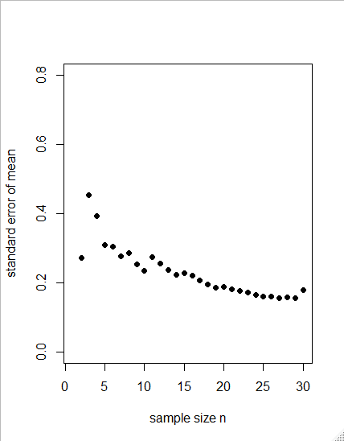

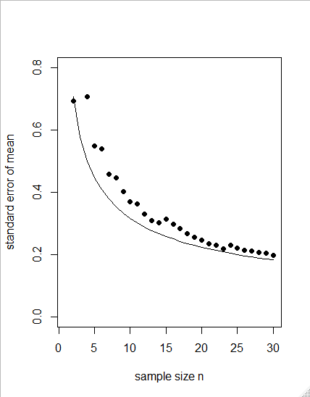

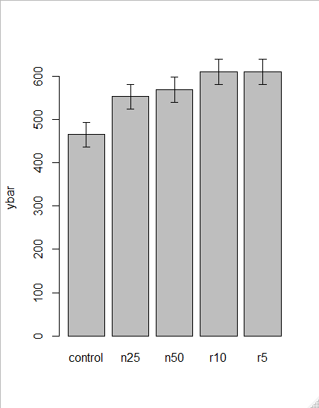

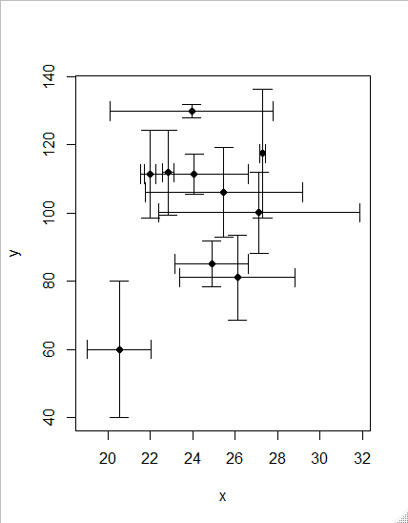

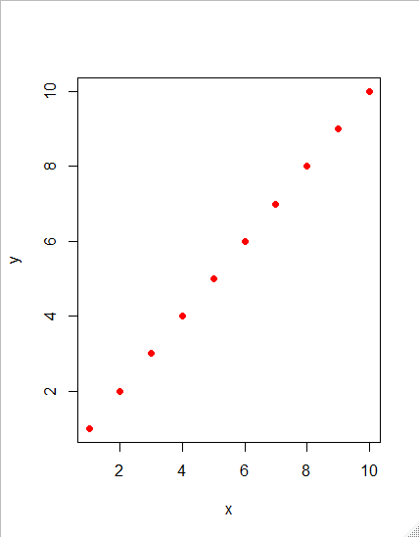

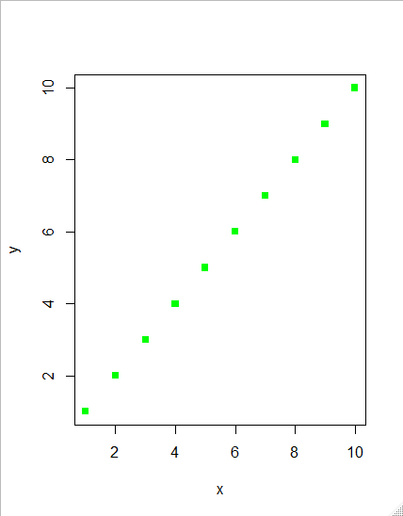

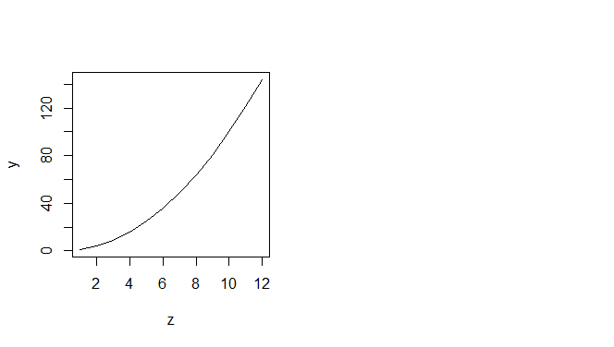



My code starts here:

R version 3.6.1 (2019-07-05) -- "Action of the Toes"

Copyright (C) 2019 The R Foundation for Statistical Computing

Platform: x86_64-w64-mingw32/x64 (64-bit)

R is free software and comes with ABSOLUTELY NO WARRANTY.

You are welcome to redistribute it under certain conditions.

Type 'license()' or 'licence()' for distribution details.

R is a collaborative project with many contributors.

Type 'contributors()' for more information and

'citation()' on how to cite R or R packages in publications.

Type 'demo()' for some demos, 'help()' for on-line help, or

'help.start()' for an HTML browser interface to help.

Type 'q()' to quit R.

> arithmetic.mean <- function(x) sum(x)/length(x)

> y <- c(3,3,4,5,5)

> arithmetic.mean(y)

[1] 4

> # there is a built-in function for arithmetic means called mean

> mean(y)

[1] 4

> med <- function(x) {

+ odd.even <- length(x)%%2

+ if (odd.even == 0) (sort(x)[length(x)/2]+sort(x)[1+ length(x)/2])/2

+ else sort(x)[ceiling(length(x)/2)]

+ }

> med(y)

[1] 4

> med(y[-1])

[1] 4.5

> med <- function(x) ifelse(length(x)%%2==1, sort(x)[ceiling(length(x)/2)],

+ (sort(x)[length(x)/2]+sort(x)[1+ length(x)/2])/2 )

> # 2.15.3 Geometric mean

> 100000^0.2

[1] 10

> insects <- c(1,10,1000,10,1)

> mean(insects)

[1] 204.4

> exp(mean(log(insects)))

[1] 10

> geometric <- function (x) exp(mean(log(x)))

> geometric(insects)

[1] 10

> # 2.15.4 Harmonic mean

> harmonic <- function (x) 1/mean(1/x)

> harmonic(c(1,2,4,1))

[1] 1.454545

> # 2.15.5 Variance

> # 2.15.6 Degrees of freedom

> y <- c(13,7,5,12,9,15,6,11,9,7,12)

> variance <- function(x) sum((x - mean(x))^2)/(length(x)-1)

> variance(y)

[1] 10.25455

> var(y)

[1] 10.25455

> # 2.15.7 Variance ratio test

> variance.ratio <- function(x,y) {

+ v1 <- var(x)

+ v2 <- var(y)

+ if (var(x) > var(y)){

+ vr <- var(x)/var(y)

+ df1 <- length(x)-1

+ df2 <- length(y)-1}

+ else {

+ vr <- var(y)/var(x)

+ df1 <- length(y)-1

+ df2 <- length(x)-1}

+ 2*(1-pf(vr,df1,df2)) }

> a <- rnorm(10,15,2)

> b <- rnorm(10,15,4)

> variance.ratio(a,b)

[1] 0.03852586

> # We can compare our p with the p value given by the built-in function called var.test:

> var.test(a,b)

F test to compare two variances

data: a and b

F = 0.22845, num df = 9, denom df = 9, p-value =

0.03853

alternative hypothesis: true ratio of variances is not equal to 1

95 percent confidence interval:

0.0567444 0.9197489

sample estimates:

ratio of variances

0.2284526

> # 2.15.8 Using variance

> se <- function(x) sqrt(var(x)/length(x))

> ci95 <- function(x) {

+ t.value <- qt(0.975,length(x)-1)

+ standard.error <- se(x)

+ ci <- t.value*standard.error

+ cat("95 Confidence Interval = ", mean(x) -ci, "to ", mean(x) +ci,"\n") }

> x <- rnorm(150,25,3)

> ci95(x)

95 Confidence Interval = 24.23761 to 25.27361

> xv <- rnorm(30)

> sem <- numeric(30)

> sem[1] <- NA

> for(i in 2:30) sem[i] <- se(xv[1:i])

> plot(1:30,sem,ylim=c(0,0.8),

+ ylab="standard error of mean",xlab="sample size n",pch=16)

> xv <- rnorm(30)

> sem <- numeric(30)

> sem[1] <- NA

> for(i in 2:30) sem[i] <- se(xv[1:i])

> plot(1:30,sem,ylim=c(0,0.8),

+ ylab="standard error of mean",xlab="sample size n",pch=16)

> lines(2:30,1/sqrt(2:30))

> error.bars <- function(yv,z,nn){

+ xv <-

+ barplot(yv,ylim=c(0,(max(yv)+max(z))),names=nn,ylab=deparse(substitute(yv)

+ ))

+ g=(max(xv)-min(xv))/50

+ for (i in 1:length(xv)) {

+ lines(c(xv[i],xv[i]),c(yv[i]+z[i],yv[i]-z[i]))

+ lines(c(xv[i]-g,xv[i]+g),c(yv[i]+z[i], yv[i]+z[i]))

+ lines(c(xv[i]-g,xv[i]+g),c(yv[i]-z[i], yv[i]-z[i]))

+ }}

> comp <- read.table("c:\\temp\\competition.txt",header=T)

Error in file(file, "rt") : cannot open the connection

In addition: Warning message:

In file(file, "rt") :

cannot open file 'c:\temp\competition.txt': No such file or directory

> setwd("C:/Users/Nathan/Desktop/Important Docs/school/stats db/therbook")

> comp <- read.table("c:\\temp\\competition.txt",header=T)

Error in file(file, "rt") : cannot open the connection

In addition: Warning message:

In file(file, "rt") :

cannot open file 'c:\temp\competition.txt': No such file or directory

> attach(comp)

Error in attach(comp) : object 'comp' not found

> comp <- read.table("competition.txt",header=T)

> attach(comp)

> names(comp)

[1] "biomass" "clipping"

> se <- rep(28.75,5)

> labels <- as.character(levels(clipping))

> ybar <- as.vector(tapply(biomass,clipping,mean))

> error.bars(ybar,se,labels)

> xy.error.bars <- function (x,y,xbar,ybar){

+ plot(x, y, pch=16, ylim=c(min(y-ybar),max(y+ybar)),

+ xlim=c(min(x-xbar),max(x+xbar)))

+ arrows(x, y-ybar, x, y+ybar, code=3, angle=90, length=0.1)

+ arrows(x-xbar, y, x+xbar, y, code=3, angle=90, length=0.1) }

> x <- rnorm(10,25,5)

> y <- rnorm(10,100,20)

> xb <- runif(10)*5

> yb <- runif(10)*20

> xy.error.bars(x,y,xb,yb)

> central <- function(y, measure) {

+ switch(measure,

+ Mean = mean(y),

+ Geometric = exp(mean(log(y))),

+ Harmonic = 1/mean(1/y),

+ Median = median(y),

+ stop("Measure not included")) }

> central(rnorm(100,10,2),"Harmonic")

[1] 9.843467

> central(rnorm(100,10,2),4)

[1] 9.816854

> charplot <- function(x,y,pc=16,co="red"){

+ plot(y~x,pch=pc,col=co)}

> charplot(1:10,1:10)

> plot(y~x,pch=pc,col=co)

Error in FUN(X[[i]], ...) : object 'pc' not found

> charplot(1:10,1:10)

> charplot(1:10,1:10,17)

> charplot(1:10,1:10,co="navy")

> charplot(1:10,1:10,15,"green")

> charplot(1:10,1:10,"green",15)

> charplot(1:10,1:10,co="green",pc=15)

> # 2.15.14 Variable numbers of arguments ( . . . )

> many.means <- function ( ...) {

+ data <- list( ...)

+ n <- length(data)

+ means <- numeric(n)

+ vars <- numeric(n)

+ for (i in 1:n) {

+ means[i] <- mean(data[[i]])

+ vars[i] <- var(data[[i]])

+ }

+ print(means)

+ print(vars)

+ invisible(NULL)

+ }

> # 2.15.14 Variable numbers of arguments ( . . . )

> many.means <- function ( ...) {

+ data <- list( ...)

+ n <- length(data)

+ means <- numeric(n)

+ vars <- numeric(n)

+ for (i in 1:n) {

+ means[i] <- mean(data[[i]])

+ vars[i] <- var(data[[i]])

+ }

+ print(means)

+ print(vars)

+ invisible(NULL)

+ }

>

> x <- rnorm(100)

> y <- rnorm(200)

>

> many.means(x,y,z)

Error in many.means(x, y, z) : object 'z' not found

> y <- rnorm(200)

> z <- rnorm(300)

> many.means(x,y,z)

[1] -0.11173548 -0.13156909 -0.04674153

[1] 0.8561954 0.9487411 0.9615911

> # 2.15.15 Returning values from a function

> parmax <- function (a,b) {

+ c <- pmax(a,b)

+ median(c) }

> x <- c(1,9,2,8,3,7)

> y <- c(9,2,8,3,7,2)

> parmax(x,y)

[1] 8

> parboth <- function (a,b) {

+ c <- pmax(a,b)

+ d <- pmin(a,b)

+ answer <- list(median(c),median(d))

+ names(answer)[[1]] <- "median of the parallel maxima"

+ names(answer)[[2]] <- "median of the parallel minima"

+ return(answer) }

> parboth(x,y)

$`median of the parallel maxima`

[1] 8

$`median of the parallel minima`

[1] 2

> # 2.15.16 Anonymous functions

> (function(x,y){ z <- 2* x^2 + y^2; x+y+z })(0:7, 1)

[1] 2 5 12 23 38 57 80 107

> # 2.15.17 Flexible handling of arguments to functions

> plotx2 <- function (x, y = z^2) {

+ z <- 1:x

+ plot(z,y,type="l") }

> windows(7,4)

> par(mfrow=c(1,2))

> plotx2(12)

> plotx2(12,1:12)

> (y <- seq(0.9,0.3,-0.1))

[1] 0.9 0.8 0.7 0.6 0.5 0.4 0.3

> str(y)

num [1:7] 0.9 0.8 0.7 0.6 0.5 0.4 0.3

> #data <- read.table("c:\\temp\\spino.txt",header=T)

> data <- read.table("spino.txt",header=T)

Error in file(file, "rt") : cannot open the connection

In addition: Warning message:

In file(file, "rt") :

cannot open file 'spino.txt': No such file or directory

> str(data)

function (..., list = character(), package = NULL,

lib.loc = NULL, verbose = getOption("verbose"),

envir = .GlobalEnv, overwrite = TRUE)

> #data <- read.table("c:\\temp\\spino.txt",header=T)

> data <- read.table("spino.txt",header=T)

Error in file(file, "rt") : cannot open the connection

In addition: Warning message:

In file(file, "rt") :

cannot open file 'spino.txt': No such file or directory

> attach(data)

Error in attach(data) :

'attach' only works for lists, data frames and environments

> attach(data)

Error in attach(data) :

'attach' only works for lists, data frames and environments

> y <- factor(1+(condition=="better")+(condition=="much.better"))

Error in factor(1 + (condition == "better") + (condition == "much.better")) :

object 'condition' not found

> model <- glm(y~treatment,binomial)

Error in eval(predvars, data, env) : object 'treatment' not found

> summary(model)

Error in summary(model) : object 'model' not found

> str(model)

Error in str(model) : object 'model' not found

> # 2.16 Writing from R to file

> # 2.16.1 Saving your work

> save(list = ls(all=TRUE), file= "c:\\temp\\session")

Error in gzfile(file, "wb") : cannot open the connection

In addition: Warning message:

In gzfile(file, "wb") :

cannot open compressed file 'c:\temp\session', probable reason 'No such file or directory'

> load(file= "c:\\temp\\session")

Error in readChar(con, 5L, useBytes = TRUE) : cannot open the connection

In addition: Warning message:

In readChar(con, 5L, useBytes = TRUE) :

cannot open compressed file 'c:\temp\session', probable reason 'No such file or directory'

> # 2.16.2 Saving history

> history(Inf)

> savehistory(file = "c:\\temp\\session18.txt")

> loadhistory(file = "c:\\temp\\session18.txt")

> # 2.16.3 Saving graphics

> pdf("c:\\temp\\fig1.pdf")

Error in pdf("c:\\temp\\fig1.pdf") : cannot open file 'c:\temp\fig1.pdf'

> # 2.16.4 Saving data produced within R to disc

> nbnumbers <- rnbinom(1000, size=1, mu=1.2)

> write(nbnumbers,"c:\\temp\\nbnumbers.txt",1)

Error in file(file, ifelse(append, "a", "w")) :

cannot open the connection

In addition: Warning message:

In file(file, ifelse(append, "a", "w")) :

cannot open file 'c:\temp\nbnumbers.txt': No such file or directory

> #data <- read.table("c:\\temp\\spino.txt",header=T)

> data <- read.table("spino.txt",header=T)

Error in file(file, "rt") : cannot open the connection

In addition: Warning message:

In file(file, "rt") :

cannot open file 'spino.txt': No such file or directory

> attach(data)

Error in attach(data) :

'attach' only works for lists, data frames and environments

> y <- factor(1+(condition=="better")+(condition=="much.better"))

Error in factor(1 + (condition == "better") + (condition == "much.better")) :

object 'condition' not found

> model <- glm(y~treatment,binomial)

Error in eval(predvars, data, env) : object 'treatment' not found

> summary(model)

Error in summary(model) : object 'model' not found

> # 2.16 Writing from R to file

> # 2.16.1 Saving your work

> save(list = ls(all=TRUE), file= "c:\\temp\\session")

Error in gzfile(file, "wb") : cannot open the connection

In addition: Warning message:

In gzfile(file, "wb") :

cannot open compressed file 'c:\temp\session', probable reason 'No such file or directory'

> setwd("C:/Users/Nathan/Desktop/Important Docs/school/stats db/therbook")

> load(file= "c:\\temp\\session")

Error in readChar(con, 5L, useBytes = TRUE) : cannot open the connection

In addition: Warning message:

In readChar(con, 5L, useBytes = TRUE) :

cannot open compressed file 'c:\temp\session', probable reason 'No such file or directory'

> savehistory(file = "c:\\temp\\session18.txt")

> loadhistory(file = "c:\\temp\\session18.txt")

> # 2.16.3 Saving graphics

> pdf("c:\\temp\\fig1.pdf")

Error in pdf("c:\\temp\\fig1.pdf") : cannot open file 'c:\temp\fig1.pdf'

> dev.off()

RStudioGD

2

> # 2.16.4 Saving data produced within R to disc

> nbnumbers <- rnbinom(1000, size=1, mu=1.2)

> write(nbnumbers,"c:\\temp\\nbnumbers.txt",1)

Error in file(file, ifelse(append, "a", "w")) :

cannot open the connection

In addition: Warning message:

In file(file, ifelse(append, "a", "w")) :

cannot open file 'c:\temp\nbnumbers.txt': No such file or directory

> xmat <- matrix(rpois(100000,0.75),nrow=1000)

> write.table(xmat,"c:\\temp\\table.txt",col.names=F,row.names=F)

Error in file(file, ifelse(append, "a", "w")) :

cannot open the connection

In addition: Warning message:

In file(file, ifelse(append, "a", "w")) :

cannot open file 'c:\temp\table.txt': No such file or directory

> nbtable <- table(nbnumbers)

> nbtable

nbnumbers

0 1 2 3 4 5 6 7 8 9 11

453 271 119 68 50 17 8 4 3 6 1

> write.table(nbtable,"c:\\temp\\table.txt",col.names=F,row.names=F)

Error in file(file, ifelse(append, "a", "w")) :

cannot open the connection

In addition: Warning message:

In file(file, ifelse(append, "a", "w")) :

cannot open file 'c:\temp\table.txt': No such file or directory

> write.table(unclass(nbtable),"c:\\temp\\table.txt",col.names=F,row.names=F)

Error in file(file, ifelse(append, "a", "w")) :

cannot open the connection

In addition: Warning message:

In file(file, ifelse(append, "a", "w")) :

cannot open file 'c:\temp\table.txt': No such file or directory

> # 2.16.5 Pasting into an Excel spreadsheet

> writeClipboard(as.character(factor.name))

Error in writeClipboard(as.character(factor.name)) :

object 'factor.name' not found

> writeClipboard(as.character(numeric.variable))

Error in writeClipboard(as.character(numeric.variable)) :

object 'numeric.variable' not found

> data <- read.table("c:\\temp\\worms.txt",header=T)

Error in file(file, "rt") : cannot open the connection

In addition: Warning message:

In file(file, "rt") :

cannot open file 'c:\temp\worms.txt': No such file or directory

> write.table(data,"clipboard",sep="\t",col.names=NA)

Error in as.data.frame.default(x[[i]], optional = TRUE) :

cannot coerce class ‘"function"’ to a data.frame

>

Chapter 3

> y <- c (6,7,3,4,8,5,6,2)

> # 3.1 Data input from the keyboard

> x <-scan()

1: setwd("~/therbook")

1: 1

Error in scan() : scan() expected 'a real', got 'setwd("~/therbook")'

> y <- c (6,7,3,4,8,5,6,2)

> # 3.1 Data input from the keyboard

> x <-scan()

1: 2

2: 4

3: 6

4: 8

5: 10

6: 12

7: 14

8: 16

9: 18

10: 20

11:

Read 10 items

> setwd("~/therbook")

Error in setwd("~/therbook") : cannot change working directory

> getwd()

[1] "C:/Users/Nathan/Documents"

> setwd("\therbook")

Error in setwd("\therbook") : cannot change working directory

> setwd("C:/Users/Nathan/Desktop/Important Docs/school/stats db/therbook")

> mine<-getwd()

> setwd("C:\Users\Nathan\Desktop\Important Docs\school\stats db\therbook")

Error: '\U' used without hex digits in character string starting ""C:\U"

> setwd(mine)

> setwd("C:/Users/Nathan/Desktop/Important Docs/school/stats db/therbook")

> data<-read.table(file.choose(),header=T)

Error in file.choose() : file choice cancelled

> # 3.2 Data input from files

> # 3.2.1 The working directory

> # setwd("F:/JunYe_Files/Jun_2016Spring_Course/Spring2016_Advanced_Computinbg/therbook")

> setwd("C:/Users/Nathan/Desktop/Important Docs/school/stats db/therbook")

> getwd()

[1] "C:/Users/Nathan/Desktop/Important Docs/school/stats db/therbook"

> # 3.2.2 Data input using read.table

> setwd("C:/Users/Nathan/Desktop/Important Docs/school/stats db/therbook")

> data <- read.table("yields.txt",header=T)

> head(data)

sand clay loam

1 6 17 13

2 10 15 16

3 8 3 9

4 6 11 12

5 14 14 15

6 17 12 16

> data <- read.delim("yields.txt")

> rt <- function(x) read.table(paste("c:\\temp\\",x,".txt",sep=""),

+ header=TRUE)

> data <- rt("yields.txt")

Error in file(file, "rt") : cannot open the connection

In addition: Warning message:

In file(file, "rt") :

C:\Users\Nathan\AppData\Local\Microsoft\Windows\INetCache\Content.MSO\7DD90D5A.tmp Show Traceback

C:\Users\Nathan\AppData\Local\Microsoft\Windows\INetCache\Content.MSO\16DF8E78.tmp Rerun with Debug

Error in file(file, "rt") : cannot open the connection

> data <- read.delim("yields.txt")

> rt <- function(x) read.table(paste("c:/Users/Nathan/Desktop/Important Docs/school/stats db/therbook",x,".txt",sep=""),

+ header=TRUE)

> data <- rt("yields.txt")

Error in file(file, "rt") : cannot open the connection

In addition: Warning message:

In file(file, "rt") :

C:\Users\Nathan\AppData\Local\Microsoft\Windows\INetCache\Content.MSO\63219346.tmp Show Traceback

C:\Users\Nathan\AppData\Local\Microsoft\Windows\INetCache\Content.MSO\380C744.tmp Rerun with Debug

Error in file(file, "rt") : cannot open the connection

> # 3.2.3 Common errors when using read.table

> map <- read.table("C:/Users/Nathan/Desktop/Important Docs/school/stats db/therbook/bowens.csv",header=T,sep=",")

> # 3.2.4 Separators and decimal points

> murder <- read.table("c:\\temp\\murders.txt",header=T,as.is="region")

Error in file(file, "rt") : cannot open the connection

In addition: Warning message:

In file(file, "rt") :

cannot open file 'c:\temp\murders.txt': No such file or directory

> # 3.2.3 Common errors when using read.table

> map <- read.table("C:/Users/Nathan/Desktop/Important Docs/school/stats db/therbook/bowens.csv",header=T,sep=",")

> # 3.2.4 Separators and decimal points

> murder <- read.table("C:/Users/Nathan/Desktop/Important Docs/school/stats db/therbook/murders.txt",header=T,as.is="region")

> # 3.2.5 Data input directly from the web

> data2 <- read.table("http://www.bio.ic.ac.uk/research/mjcraw/therbook/data/cancer.txt",header=T)

> head(data2)

death treatment status

1 4 DrugA 1

2 26 DrugA 1

3 2 DrugA 1

4 25 DrugA 1

5 7 DrugA 1

6 6 DrugA 0

> # 3.3 Input from files using scan

> read.table("C:/Users/Nathan/Desktop/Important Docs/school/stats db/therbook/rt.txt")

Error in scan(file = file, what = what, sep = sep, quote = quote, dec = dec, :

line 1 did not have 4 elements

> #scan("t:\\data\\worms.txt",skip=1,what=as.list(rep("",7)))

> scan("worms.txt",skip=1,what=as.list(rep("",7)))

Read 20 records

[[1]]

[1] "Nashs.Field" "Silwood.Bottom" "Nursery.Field"

[4] "Rush.Meadow" "Gunness.Thicket" "Oak.Mead"

[7] "Church.Field" "Ashurst" "The.Orchard"

[10] "Rookery.Slope" "Garden.Wood" "North.Gravel"

[13] "South.Gravel" "Observatory.Ridge" "Pond.Field"

[16] "Water.Meadow" "Cheapside" "Pound.Hill"

[19] "Gravel.Pit" "Farm.Wood"

[[2]]

[1] "3.6" "5.1" "2.8" "2.4" "3.8" "3.1" "3.5" "2.1" "1.9" "1.5"

[11] "2.9" "3.3" "3.7" "1.8" "4.1" "3.9" "2.2" "4.4" "2.9" "0.8"

[[3]]

[1] "11" "2" "3" "5" "0" "2" "3" "0" "0" "4" "10" "1"

[13] "2" "6" "0" "0" "8" "2" "1" "10"

[[4]]

[1] "Grassland" "Arable" "Grassland" "Meadow" "Scrub"

[6] "Grassland" "Grassland" "Arable" "Orchard" "Grassland"

[11] "Scrub" "Grassland" "Grassland" "Grassland" "Meadow"

[16] "Meadow" "Scrub" "Arable" "Grassland" "Scrub"

[[5]]

[1] "4.1" "5.2" "4.3" "4.9" "4.2" "3.9" "4.2" "4.8" "5.7" "5"

[11] "5.2" "4.1" "4" "3.8" "5" "4.9" "4.7" "4.5" "3.5" "5.1"

[[6]]

[1] "F" "F" "F" "T" "F" "F" "F" "F" "F" "T" "F" "F" "F" "F" "T" "T"

[17] "T" "F" "F" "T"

[[7]]

[1] "4" "7" "2" "5" "6" "2" "3" "4" "9" "7" "8" "1" "2" "0" "6" "8"

[17] "4" "5" "1" "3"

> #data <-as.data.frame(scan("t:\\data\\worms.txt",skip=1,what=as.list(rep("",7))))

> data <-as.data.frame(scan("worms.txt",skip=1,what=as.list(rep("",7))))

Read 20 records

> names(data)<-header

Error: object 'header' not found

> head(data)

c..Nashs.Field....Silwood.Bottom....Nursery.Field....Rush.Meadow...

1 Nashs.Field

2 Silwood.Bottom

3 Nursery.Field

4 Rush.Meadow

5 Gunness.Thicket

6 Oak.Mead

c..3.6....5.1....2.8....2.4....3.8....3.1....3.5....2.1....1.9...

1 3.6

2 5.1

3 2.8

4 2.4

5 3.8

6 3.1

c..11....2....3....5....0....2....3....0....0....4....10....1...

1 11

2 2

3 3

4 5

5 0

6 2

c..Grassland....Arable....Grassland....Meadow....Scrub....Grassland...

1 Grassland

2 Arable

3 Grassland

4 Meadow

5 Scrub

6 Grassland

c..4.1....5.2....4.3....4.9....4.2....3.9....4.2....4.8....5.7...

1 4.1

2 5.2

3 4.3

4 4.9

5 4.2

6 3.9

c..F....F....F....T....F....F....F....F....F....T....F....F...

1 F

2 F

3 F

4 T

5 F

6 F

c..4....7....2....5....6....2....3....4....9....7....8....1...

1 4

2 7

3 2

4 5

5 6

6 2

> # 3.3.2 Input from more complex file structures using scan

> scan("C:/Users/Nathan/Desktop/Important Docs/school/stats db/therbook/rt.txt")

Read 10 items

[1] 138 27 44 19 20 345 48 115 2366 59

> scan("C:/Users/Nathan/Desktop/Important Docs/school/stats db/therbook/rt.txt",sep="\n")

Read 5 items

[1] 138 2744 192034548 1152366 59

> scan("C:/Users/Nathan/Desktop/Important Docs/school/stats db/therbook/rt.txt",sep="\t")

Read 20 items

[1] 138 NA NA NA 27 44 NA NA 19 20 345 48

[13] 115 2366 NA NA 59 NA NA NA

> length(scan("C:/Users/Nathan/Desktop/Important Docs/school/stats db/therbook/rt.txt",sep="\n"))

Read 5 items

[1] 5

> length(scan("C:/Users/Nathan/Desktop/Important Docs/school/stats db/therbook/rt.txt",sep="\t"))

Read 20 items

[1] 20

> length(scan("C:/Users/Nathan/Desktop/Important Docs/school/stats db/therbook/rt.txt",sep="\n"))

Read 5 items

[1] 5

> length(scan("C:/Users/Nathan/Desktop/Important Docs/school/stats db/therbook/rt.txt",sep="\t"))

Read 20 items

[1] 20

> scan("C:/Users/Nathan/Desktop/Important Docs/school/stats db/therbook/rt.txt",sep="\t")[1:4]

Read 20 items

[1] 138 NA NA NA

> as.numeric(na.omit(scan("C:/Users/Nathan/Desktop/Important Docs/school/stats db/therbook/rt.txt",sep="\t",quiet=T)[1:4]))

[1] 138

> sapply(1:5, function(i)

+ as.numeric(na.omit(

+ scan("C:/Users/Nathan/Desktop/Important Docs/school/stats db/therbook/rt.txt",sep="\t",quiet=T)[(4*i-3):

+ (4*i)])))

[[1]]

[1] 138

[[2]]

[1] 27 44

[[3]]

[1] 19 20 345 48

[[4]]

[1] 115 2366

[[5]]

[1] 59

> # 3.4.1 Input a dataframe using readLines

> line<-readLines("worms.txt")

> line

[1] "Field.Name\tArea\tSlope\tVegetation\tSoil.pH\tDamp\tWorm.density"

[2] "Nashs.Field\t3.6\t11\tGrassland\t4.1\tF\t4"

[3] "Silwood.Bottom\t5.1\t2\tArable\t5.2\tF\t7"

[4] "Nursery.Field\t2.8\t3\tGrassland\t4.3\tF\t2"

[5] "Rush.Meadow\t2.4\t5\tMeadow\t4.9\tT\t5"

[6] "Gunness.Thicket\t3.8\t0\tScrub\t4.2\tF\t6"

[7] "Oak.Mead\t3.1\t2\tGrassland\t3.9\tF\t2"

[8] "Church.Field\t3.5\t3\tGrassland\t4.2\tF\t3"

[9] "Ashurst\t2.1\t0\tArable\t4.8\tF\t4"

[10] "The.Orchard\t1.9\t0\tOrchard\t5.7\tF\t9"

[11] "Rookery.Slope\t1.5\t4\tGrassland\t5\tT\t7"

[12] "Garden.Wood\t2.9\t10\tScrub\t5.2\tF\t8"

[13] "North.Gravel\t3.3\t1\tGrassland\t4.1\tF\t1"

[14] "South.Gravel\t3.7\t2\tGrassland\t4\tF\t2"

[15] "Observatory.Ridge\t1.8\t6\tGrassland\t3.8\tF\t0"

[16] "Pond.Field\t4.1\t0\tMeadow\t5\tT\t6"

[17] "Water.Meadow\t3.9\t0\tMeadow\t4.9\tT\t8"

[18] "Cheapside\t2.2\t8\tScrub\t4.7\tT\t4"

[19] "Pound.Hill\t4.4\t2\tArable\t4.5\tF\t5"

[20] "Gravel.Pit\t2.9\t1\tGrassland\t3.5\tF\t1"

[21] "Farm.Wood\t0.8\t10\tScrub\t5.1\tT\t3"

> db<-strsplit(line,"\t")

> db

[[1]]

[1] "Field.Name" "Area" "Slope" "Vegetation"

[5] "Soil.pH" "Damp" "Worm.density"

[[2]]

[1] "Nashs.Field" "3.6" "11" "Grassland"

[5] "4.1" "F" "4"

[[3]]

[1] "Silwood.Bottom" "5.1" "2"

[4] "Arable" "5.2" "F"

[7] "7"

[[4]]

[1] "Nursery.Field" "2.8" "3" "Grassland"

[5] "4.3" "F" "2"

[[5]]

[1] "Rush.Meadow" "2.4" "5" "Meadow"

[5] "4.9" "T" "5"

[[6]]

[1] "Gunness.Thicket" "3.8" "0"

[4] "Scrub" "4.2" "F"

[7] "6"

[[7]]

[1] "Oak.Mead" "3.1" "2" "Grassland" "3.9"

[6] "F" "2"

[[8]]

[1] "Church.Field" "3.5" "3" "Grassland"

[5] "4.2" "F" "3"

[[9]]

[1] "Ashurst" "2.1" "0" "Arable" "4.8" "F"

[7] "4"

[[10]]

[1] "The.Orchard" "1.9" "0" "Orchard"

[5] "5.7" "F" "9"

[[11]]

[1] "Rookery.Slope" "1.5" "4" "Grassland"

[5] "5" "T" "7"

[[12]]

[1] "Garden.Wood" "2.9" "10" "Scrub"

[5] "5.2" "F" "8"

[[13]]

[1] "North.Gravel" "3.3" "1" "Grassland"

[5] "4.1" "F" "1"

[[14]]

[1] "South.Gravel" "3.7" "2" "Grassland"

[5] "4" "F" "2"

[[15]]

[1] "Observatory.Ridge" "1.8" "6"

[4] "Grassland" "3.8" "F"

[7] "0"

[[16]]

[1] "Pond.Field" "4.1" "0" "Meadow" "5"

[6] "T" "6"

[[17]]

[1] "Water.Meadow" "3.9" "0" "Meadow"

[5] "4.9" "T" "8"

[[18]]

[1] "Cheapside" "2.2" "8" "Scrub" "4.7"

[6] "T" "4"

[[19]]

[1] "Pound.Hill" "4.4" "2" "Arable" "4.5"

[6] "F" "5"

[[20]]

[1] "Gravel.Pit" "2.9" "1" "Grassland" "3.5"

[6] "F" "1"

[[21]]

[1] "Farm.Wood" "0.8" "10" "Scrub" "5.1"

[6] "T" "3"

> bb<-unlist(db)

> dim(bb)<-c(7,21)

> bb

[,1] [,2] [,3] [,4] [,5] [,6] [,7] [,8] [,9]

[1,] "Field.Name" "Nashs.Field" "Silwood.Bottom" "Nursery.Field" "Rush.Meadow" "Gunness.Thicket" "Oak.Mead" "Church.Field" "Ashurst"

[2,] "Area" "3.6" "5.1" "2.8" "2.4" "3.8" "3.1" "3.5" "2.1"

[3,] "Slope" "11" "2" "3" "5" "0" "2" "3" "0"

[4,] "Vegetation" "Grassland" "Arable" "Grassland" "Meadow" "Scrub" "Grassland" "Grassland" "Arable"

[5,] "Soil.pH" "4.1" "5.2" "4.3" "4.9" "4.2" "3.9" "4.2" "4.8"

[6,] "Damp" "F" "F" "F" "T" "F" "F" "F" "F"

[7,] "Worm.density" "4" "7" "2" "5" "6" "2" "3" "4"

[,10] [,11] [,12] [,13] [,14] [,15] [,16] [,17] [,18]

[1,] "The.Orchard" "Rookery.Slope" "Garden.Wood" "North.Gravel" "South.Gravel" "Observatory.Ridge" "Pond.Field" "Water.Meadow" "Cheapside"

[2,] "1.9" "1.5" "2.9" "3.3" "3.7" "1.8" "4.1" "3.9" "2.2"

[3,] "0" "4" "10" "1" "2" "6" "0" "0" "8"

[4,] "Orchard" "Grassland" "Scrub" "Grassland" "Grassland" "Grassland" "Meadow" "Meadow" "Scrub"

[5,] "5.7" "5" "5.2" "4.1" "4" "3.8" "5" "4.9" "4.7"

[6,] "F" "T" "F" "F" "F" "F" "T" "T" "T"

[7,] "9" "7" "8" "1" "2" "0" "6" "8" "4"

[,19] [,20] [,21]

[1,] "Pound.Hill" "Gravel.Pit" "Farm.Wood"

[2,] "4.4" "2.9" "0.8"

[3,] "2" "1" "10"

[4,] "Arable" "Grassland" "Scrub"

[5,] "4.5" "3.5" "5.1"

[6,] "F" "F" "T"

[7,] "5" "1" "3"

> t(bb)[-1,]

[,1] [,2] [,3] [,4] [,5] [,6] [,7]

[1,] "Nashs.Field" "3.6" "11" "Grassland" "4.1" "F" "4"

[2,] "Silwood.Bottom" "5.1" "2" "Arable" "5.2" "F" "7"

[3,] "Nursery.Field" "2.8" "3" "Grassland" "4.3" "F" "2"

[4,] "Rush.Meadow" "2.4" "5" "Meadow" "4.9" "T" "5"

[5,] "Gunness.Thicket" "3.8" "0" "Scrub" "4.2" "F" "6"

[6,] "Oak.Mead" "3.1" "2" "Grassland" "3.9" "F" "2"

[7,] "Church.Field" "3.5" "3" "Grassland" "4.2" "F" "3"

[8,] "Ashurst" "2.1" "0" "Arable" "4.8" "F" "4"

[9,] "The.Orchard" "1.9" "0" "Orchard" "5.7" "F" "9"

[10,] "Rookery.Slope" "1.5" "4" "Grassland" "5" "T" "7"

[11,] "Garden.Wood" "2.9" "10" "Scrub" "5.2" "F" "8"

[12,] "North.Gravel" "3.3" "1" "Grassland" "4.1" "F" "1"

[13,] "South.Gravel" "3.7" "2" "Grassland" "4" "F" "2"

[14,] "Observatory.Ridge" "1.8" "6" "Grassland" "3.8" "F" "0"

[15,] "Pond.Field" "4.1" "0" "Meadow" "5" "T" "6"

[16,] "Water.Meadow" "3.9" "0" "Meadow" "4.9" "T" "8"

[17,] "Cheapside" "2.2" "8" "Scrub" "4.7" "T" "4"

[18,] "Pound.Hill" "4.4" "2" "Arable" "4.5" "F" "5"

[19,] "Gravel.Pit" "2.9" "1" "Grassland" "3.5" "F" "1"

[20,] "Farm.Wood" "0.8" "10" "Scrub" "5.1" "T" "3"

> frame<-as.data.frame(t(bb)[-1,])

> head(frame)

V1 V2 V3 V4 V5 V6 V7

1 Nashs.Field 3.6 11 Grassland 4.1 F 4

2 Silwood.Bottom 5.1 2 Arable 5.2 F 7

3 Nursery.Field 2.8 3 Grassland 4.3 F 2

4 Rush.Meadow 2.4 5 Meadow 4.9 T 5

5 Gunness.Thicket 3.8 0 Scrub 4.2 F 6

6 Oak.Mead 3.1 2 Grassland 3.9 F 2

> names(frame)<-t(bb)[1,]

> head(frame)

Field.Name Area Slope Vegetation Soil.pH Damp Worm.density

1 Nashs.Field 3.6 11 Grassland 4.1 F 4

2 Silwood.Bottom 5.1 2 Arable 5.2 F 7

3 Nursery.Field 2.8 3 Grassland 4.3 F 2

4 Rush.Meadow 2.4 5 Meadow 4.9 T 5

5 Gunness.Thicket 3.8 0 Scrub 4.2 F 6

6 Oak.Mead 3.1 2 Grassland 3.9 F 2

> # 3.4.2 Reading non-standard files using readLines

> readLines("c:\\temp\\rt.txt")

Error in file(con, "r") : cannot open the connection

In addition: Warning message:

In file(con, "r") :

cannot open file 'c:\temp\rt.txt': No such file or directory

> # 3.4.2 Reading non-standard files using readLines

> readLines("C:/Users/Nathan/Desktop/Important Docs/school/stats db/therbook/rt.txt")

[1] "138\t\t\t" "27\t44\t\t" "19\t20\t345\t48" "115\t2366\t\t" "59\t\t\t"

> strsplit(readLines("C:/Users/Nathan/Desktop/Important Docs/school/stats db/therbook/rt.txt"),"\t")

[[1]]

[1] "138" "" ""

[[2]]

[1] "27" "44" ""

[[3]]

[1] "19" "20" "345" "48"

[[4]]

[1] "115" "2366" ""

[[5]]

[1] "59" "" ""

> strsplit(readLines("C:/Users/Nathan/Desktop/Important Docs/school/stats db/therbook/rt.txt"),"\n")

[[1]]

[1] "138\t\t\t"

[[2]]

[1] "27\t44\t\t"

[[3]]

[1] "19\t20\t345\t48"

[[4]]

[1] "115\t2366\t\t"

[[5]]

[1] "59\t\t\t"

> rows<-lapply(strsplit(readLines("C:/Users/Nathan/Desktop/Important Docs/school/stats db/therbook/rt.txt"),"\t"),as.numeric)

> rows

[[1]]

[1] 138 NA NA

[[2]]

[1] 27 44 NA

[[3]]

[1] 19 20 345 48

[[4]]

[1] 115 2366 NA

[[5]]

[1] 59 NA NA

> sapply(1:5, function(i) as.numeric(na.omit(rows[[i]])))

[[1]]

[1] 138

[[2]]

[1] 27 44

[[3]]

[1] 19 20 345 48

[[4]]

[1] 115 2366

[[5]]

[1] 59

> murder <- read.table("c:\\temp\\murders.txt",header=T,as.is="region")

Error in file(file, "rt") : cannot open the connection

In addition: Warning message:

In file(file, "rt") :

cannot open file 'c:\temp\murders.txt': No such file or directory

> murder <- read.table("C:/Users/Nathan/Desktop/Important Docs/school/stats db/therbook/murders.txt",header=T,as.is="region")

> attach(murder)

The following object is masked _by_ .GlobalEnv:

murder

> head(murder)

state population murder region

1 Alabama 3615 15.1 South

2 Alaska 365 11.3 West

3 Arizona 2212 7.8 West

4 Arkansas 2110 10.1 South

5 California 21198 10.3 West

6 Colorado 2541 6.8 West

> table(region)

region

North.Central Northeast South West

12 9 16 13

> table(murder$region)

North.Central Northeast South West

12 9 16 13

> z <- 10

> z <- 2.5

> ################################################################

> # 3.7 Input and output formats

> ################################################################

> data<-read.table("c:\\temp\\catdata.txt",header=T)

Error in file(file, "rt") : cannot open the connection

In addition: Warning message:

In file(file, "rt") :

cannot open file 'c:\temp\catdata.txt': No such file or directory

> ################################################################

> # 3.7 Input and output formats

> ################################################################

> data<-read.table("C:/Users/Nathan/Desktop/Important Docs/school/stats db/therbook/catdata.txt",header=T)

Error in file(file, "rt") : cannot open the connection

In addition: Warning message:

In file(file, "rt") :

cannot open file 'C:/Users/Nathan/Desktop/Important Docs/school/stats db/therbook/catdata.txt': No such file or directory

> attach(data)

> names(data)

[1] "c..Nashs.Field....Silwood.Bottom....Nursery.Field....Rush.Meadow..."

[2] "c..3.6....5.1....2.8....2.4....3.8....3.1....3.5....2.1....1.9..."

[3] "c..11....2....3....5....0....2....3....0....0....4....10....1..."

[4] "c..Grassland....Arable....Grassland....Meadow....Scrub....Grassland..."

[5] "c..4.1....5.2....4.3....4.9....4.2....3.9....4.2....4.8....5.7..."

[6] "c..F....F....F....T....F....F....F....F....F....T....F....F..."

[7] "c..4....7....2....5....6....2....3....4....9....7....8....1..."

> model<-lm(y~soil)

Error in eval(predvars, data, env) : object 'soil' not found

> summary.aov(model)

Error in summary.aov(model) : object 'model' not found

> df1<-unlist(summary.aov(model)[[1]] [1])[1]

Error in summary.aov(model) : object 'model' not found

> df2<-unlist(summary.aov(model)[[1]] [1])[2]

Error in summary.aov(model) : object 'model' not found

> ss1<-unlist(summary.aov(model)[[1]] [2])[1]

Error in summary.aov(model) : object 'model' not found

> ss2<-unlist(summary.aov(model)[[1]] [2])[2]

Error in summary.aov(model) : object 'model' not found

> {cat("ANOVA table","\n")

+ cat("Source","\t\t","SS","\t","d.f.","\t","MS","\t\t","F","\n")

+ cat("Treatment","\t",ss1,"\t",df1,"\t",ss1/df1,"\t\t",

+ (ss1/df1)/(ss2/df2),"\n")

+ cat("Error","\t\t",ss2,"\t",df2,"\t",ss2/df2,"\n")

+ cat("Total","\t\t",ss1 + ss2,"\t",df1 + df2,"\n")}

ANOVA table

Source SS d.f. MS F

Error in cat("Treatment", "\t", ss1, "\t", df1, "\t", ss1/df1, "\t\t", :

object 'ss1' not found