(Team Name)

**(Attendance Sysem)**

Software Design Document

Name (s): Mohamed Salah Zawi

212185005

Lab Section: ITSE421

Workstation:

Date: (07/20/2018)

**TABLE OF CONTENTS**

1. **INTRODUCTION**

1.1 Purpose

1.2 Scope

1.3 Overview

1.4 Reference Material

1.5 Definitions and Acronyms

1. **SYSTEM OVERVIEW**
2. **SYSTEM ARCHITECTURE**

3.1 Architectural Design

3.2 Decomposition Description

3.3 Design Rationale

1. **DATA DESIGN**

4.1 Data Description

4.2 Data Dictionary

1. **COMPONENT DESIGN**
2. **HUMAN INTERFACE DESIGN**

6.1 Overview of User Interface

6.2 Screen Images

6.3 Screen Objects and Actions

1. **REQUIREMENTS MATRIX**
2. **APPENDICES**

1. **INTRODUCTION**

**1.1 Purpose**

The purpose of this Software Design Document is providing the details of project titled as “Attendance System with Using QR Code”.

The target audience is university students at Tripoli University. The application will provide opportunity to track course attendances of each students and report system for both lecturers and students. We aim to provide a mobile environment and take attendance with using QR Code.

In order to better comprehension, this SDD includes various diagrams such as UML diagram of project, activity diagram and block diagram.

**1.2 Scope**

This document includes brief and complete description about the design of project which is named as Attendance Tracking System using QR.

Android Studio is benefited to create the all aspects of the mobile application. Android Studio is the platform that provides the Software Development Kit (SDKs) and Application Programming Interface(API) to create a mobile application for the Android devices. As a scripting language in Android Studio, Java will be used because there is no other programming language that can be used in Android Studio This platform does not allow to build applications for the iOS or any other operating systems. Thus, developers which work with Android Studio can have chance to focus on the Android operating system entirely. Moreover, Android Studio provides implementing interfaces. Thus, there is no necessity to use any other software programs to create graphical interfaces. Additionally, developers have a chance to build applications for any version of Android operating system. Since the Android operating system ensures the idea that all applications that can run in the lower versions can run in the higher versions, developers have no concern to develop the applications for the lower versions of Android operating system.

MySQL is utilized for managing the database of the system. It is a free and open source platform which is developed for creating and handling the databases. Additionally, it contains many features that developers can use different programming languages such as PHP. As an example, phpMyAdmin which is developed by PHP is supported in MySQL.

Scripting part of the project is transpired with using Java scripts. Java is one of the most used programming language all around the world. Moreover, Java includes all aspects of the object-oriented programming approach so that the developers can create much more systems that almost encapsulated from the outside of the system. Additionally, creating and handling the exceptions is easier than the other object-oriented programming languages. Besides, developers which work with the Java do not have to use any other software. Java ensures its own interface libraries and with these libraries, building user-driven and purposive interfaces is easy to develop.

**1.3 Overview**

Contents of the remaining chapters are explained below.

Section 2 is Architectural Design which ensures brief information about the development phase of the project. This section also contains class diagram of the system and the architecture design. Architecture design contains following attributes which identifies following terminologies: Actors, pre-conditions, post-conditions, basic sequences, exceptions and priorities of each module of system.

Section 3 is Use Case Realization. This section’s purpose is providing a brief explanation about components of the system. To be able to do that, Section 3 contains a block diagram of the system which is created according to the Software Requirements Specification document. Also, Section 3 provides a brief information of the each component in the block diagram.

**1.4 Reference Material**

**1.5 Definitions and Acronyms**

1. **SYSTEM OVERVIEW**

Section 3 is Architectural Design which ensures brief information about the development phase of the project. This section also contains class diagram of the system and the architecture design. Architecture design contains following attributes which identifies following terminologies: Actors, pre-conditions, post-conditions, basic sequences, exceptions and priorities of each module of system.

1. **SYSTEM ARCHITECTURE**

**3.1 Architectural Design**

**3.1.1 Class Diagram**

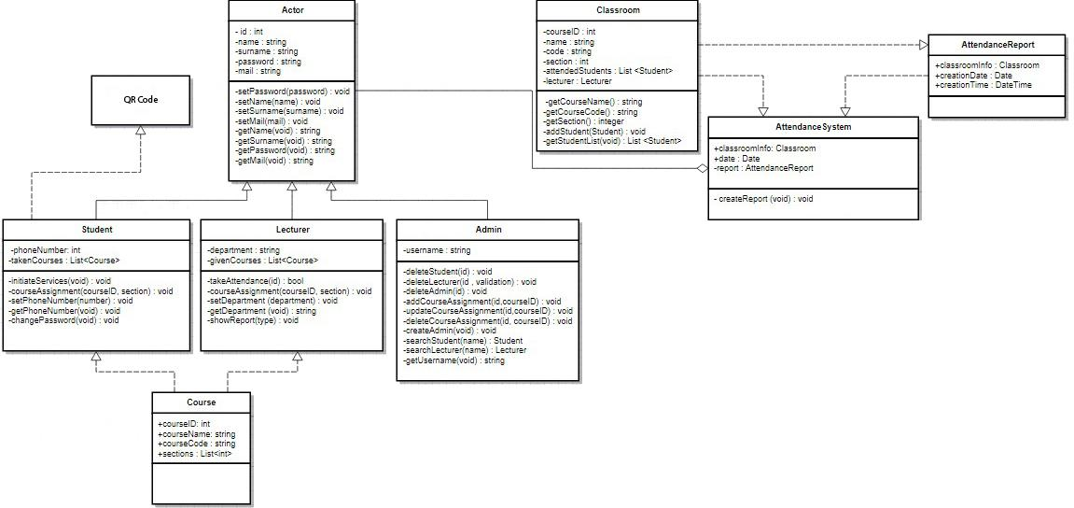

*Figure 1 Class Diagram of Attendance Tracking System*

Figure 1 shows information about connection and relationships between the classes within the system. AttendanceSystem is the main class which contains other components of the other actors. It is responsible for taking attendance in the classroom. Also, it is responsible for connections between other classes. Actor class represents all the users who use the system. Student class represents all students that are taking and attending courses and there will be interaction between Student and QR Code. Lecturer class describes all lecturers that are giving courses and want to take attendance with Attendance System. Admin class is for actor which manages and maintains the system. Course class includes data that is about courses such as course code, course name and sections related with the course. Classroom class represents a class where the attendance system works. AttendanceReport class describes an attendance report of a classroom.

**3.2 Decomposition Description**

### 3.2.1 Course Assignment

Summary: Student and lecturer can make assignment for a course. Student must be taking the course and lecturer must be giving the course in the semester.

Actor: Student, Lecturer

Precondition: User must be logged into the system.

Basic Sequence:

1. User can select a course from the course list.
2. User can select a section for the course from the section list.
3. User can make assignment by selecting save button from the interface.

Exception: Database error can be occurred.

Post Conditions: None

Priority: Low

### 3.2.2 Secure Attendance Tracking System

Summary: Secure attendance tracking mode is used for exams for courses, to prevent students who attends exams for a different student. Student should take and upload his/her photograph to the server. Lecturer can check the photograph of the student and mark him/her as attended to the exam process.

Actor: Student, Lecturer

Preconditions: User must be logged into the system. Student should have a camera on his/her mobile phone.

Basic Sequence:

1. Student can take his/her face photograph by selecting take photo button from the interface.
2. Student can upload the face photograph by selecting upload photo button from the interface.
3. Lecturer can see uploaded photographs by selecting current classroom button from the interface.
4. Lecturer can mark students as attended if the student and his/her photograph is properly matching by selecting approve buttons near the list of students in the current classroom.

Exception: Database error can be occurred. There can be a connection error between student’s phone and the server. Student can have an issue with his/her camera.

Post Conditions: None.

Priority: High

### 3.2.3 Reporting System

Summary: Student can trace his/her attendance information to the courses on whole semester. Moreover, lecturer can trace daily, weekly, monthly or yearly attendance information of the all students for the course which lecturer gives.

Actor: Student, Lecturer

Preconditions: User must be logged into the system.

Basic Sequence:

1. Student can see only his/her attendance information on courses by selection course name from the reporting menu.
2. Lecturer can see attendance report of students for a specific course by selecting course name from the reporting menu.
3. Lecturer can change the report type as daily, weekly, monthly or yearly by selecting from a drop-down list.
4. Lecturer can see a student’s attendance report for a specific course that is given by the lecturer by typing the name of the student.

Exception: Database error can be occurred.

Post Conditions: None

Priority: Medium

## 2.3. Activity Diagram

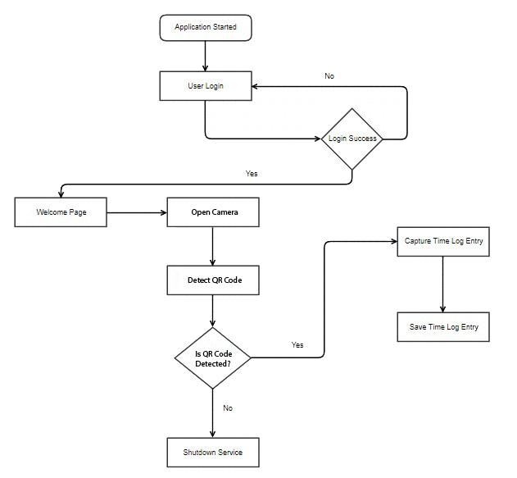

*Figure 2 Activity Diagram of Attendance System*

Figure 2 shows how the regular attendance tracking system works as an activity diagram. After student log into the system will be shown to the student. The student shall initiate the QR Code detection service on his/her mobile phone for tracking attendance information with QR Code. After that, the application shall detect QR Code that displayed. If the QR Code received properly, the application will capture current time log entry and save in the database with the related student ID number. If the Code is not received properly, the system shall shutdown service.

**3.3 Design Rationale**

1. **DATA DESIGN**

**4.1 Data Description**

## 4.1.1 Database Diagram

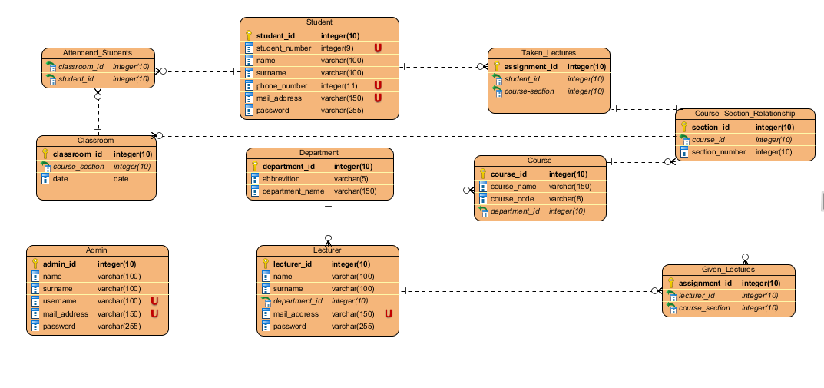*Figure 3 Database Diagram of Attendance System*

Figure 3 shows the database diagram of Attendance Tracking System. Admin, Lecturer and Student tables store actor information related with the statue in the system. Department table represents departments in the university and is consisted of department name and abbreviation of the department like Software Engineering, Networking etc. Course table is consisted of course name, course code and includes information of related department with course. Course-Section_Relationship table stores sections of the courses. Taken_Lectures is represents taken courses of the students. When a student makes a course assignment this table will be used to match a student with a course and section. Given_Lectures table stores information of given courses by a lecturer. Similarly, with Taken_Lectures, when a lecturer makes a course assignment, this table will be used to store assignment data for lecturers. Classroom table is used to store general information of a classroom environment for a course. Attended_Students stores students who are attended to classroom activity. Thus, we can capture attended student list and also we can easily find absent students.

**4.2 Data Dictionary**

1. **COMPONENT DESIGN**

1. **HUMAN INTERFACE DESIGN**

**6.1 Overview of User Interface**

Creation purpose of the GUI design is providing the proper interaction between the user and the system. There are three sub-systems in GUI design and they are named as follows: Profile Management Menu, Reporting Menu and Course Assignment Menu.

In the Profile Management Menu model, admins, students and lecturers can update their accounts’ attributes such as e-mail addresses. Admins can create a new admin, delete the user and change the course assignment for user from this menu. In Reporting Menu model, attendance reports for each course can be reached and only students and lecturers can get these reports. Lecturer can see daily, weekly and a semester report for each course that s/he is assigned to. Also, lecturer can see the attendance report of a specific student who takes one of the lecturer courses. Student can see his/her attendance report for each course that s/he takes.

Course Assignment Menu model provides a selection-based interface for both lecturers and students. Lecturer can select the courses and the sections of the courses that s/he gives. Also, student can select the courses that s/he takes in the semester. All of this information shall be stored in the appropriate tables and attributes in the Database System.

**6.2 Screen Images**

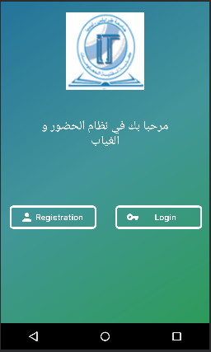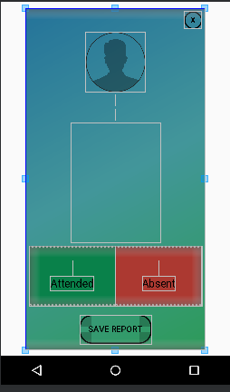

**6.3 Screen Objects and Actions**

1. **REQUIREMENTS MATRIX**
2. **APPENDICES**