**Word Puzzle Game**

Software Design Document

Name (s): Islam Ghretlli

Lab Section: ITSE421

Workstation: Home

Date: (07/21/2018)

**TABLE OF CONTENTS**

**1. INTRODUCTION**

1.1 Purpose

1.2 Scope

1.3 Overview

1.4 Reference Material

1.5 Definitions and Acronyms

**2. SYSTEM OVERVIEW**

**3. SYSTEM ARCHITECTURE**

3.1 Architectural Design

3.2 Decomposition Description

3.3 Design Rationale

**4. DATA DESIGN**

4.1 Data Description

4.2 Data Dictionary

**5. COMPONENT DESIGN**

**6. HUMAN INTERFACE DESIGN**

6.1 Overview of User Interface

6.2 Screen Images

6.3 Screen Objects and Actions

**7. REQUIREMENTS MATRIX**

**8. APPENDICES**

**1. INTRODUCTION**

**1.1 Purpose**

This documents covers the main architecture and design of the *Word Puzzle Game*, an Android OS application.

The expected audience is Faculty of Information Technology, Tripoli University, including Dr. Abd Asalam Nwesri, and may also serve as a reference for Software Quality Assurance Students.

**1.2 Scope**

Word Puzzle Game is intended as an Android OS application. It is a single player puzzle game to be launched on Google Play, for ages 5 and up.

This document contains a brief description of the game’s design, to be developed on Android Studio in JAVA. External software may be used for GUI purposes.

**1.3 Overview**

The following segments describe the System and its architecture, listing its data and detailing its components, as well as providing a sample of the UIs.

**1.4 Reference Material**

*Software Design Document (SDD) Template (summarized from IEEE STD 1016)*

**1.5 Definitions and Acronyms**

**2. SYSTEM OVERVIEW**

The application generates a cross-word puzzle based on category selected by the user. It also allows the user to continue a previously started game.

System functions as follows:

- Start a new game or load an old one

- Select a puzzle category

- Play the crossword puzzle.

**3. DATA DESIGN**

**3.1 Data Description**

Contains the main data used to generate the puzzles.

**CREATE TABLE CATEGORY** (Cat_ID INT NOT NULL PRIMARY KEY, Cat_Name VARCHAR(50));

**CREATE TABLE PUZZLE** (Puz_ID INT NOT NULL PRIMARY KEY, Row_Num int, Column_Num int, Cat_ID INT);

**CREATE TABLE WORD_LIST** (List_ID INT NOT NULL PRIMARY KEY, Word_len int, Index_num ENUM default (0,0), Puz_ID int);

**4. HUMAN INTERFACE DESIGN**

**4.1 Overview of User Interface**

The main menu contains the title of the game with two buttons underneath (New Game, Continue); continue button is only active if there is an already started game available.

The Category window contains 6 buttons filling the screen in different colors (Science, Kids, Astronomy, Art, Animals, Food)

The puzzle fills the screen, with a return button visible on the banner up top, and a retractable menu at the bottom containing the word list.

**4.2 Screen Images**

**4.2.1 Main Menu**

Enables you to start the game

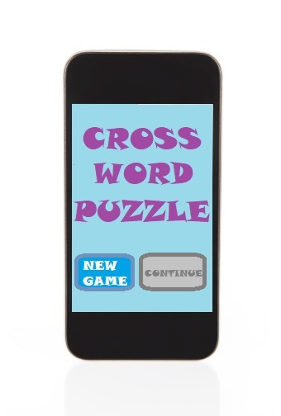

Fig 1. Main Menu with continue disabled

**4.2.2 Catagories**

Enables you to select a category to generate puzzle from

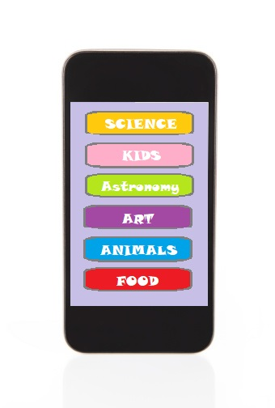

Fig 2. Available Categories

**4.2.3. In-Game View**

Play Screen, with retractable word list

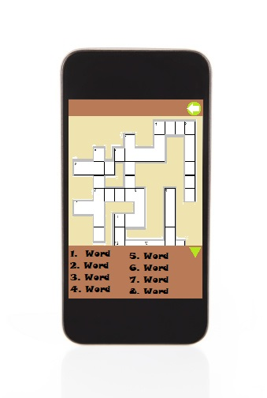

Fig 3. Empty Puzzle with Word list opened

**4.3 Screen Objects and Actions**

- Button: Clickable area on screen that reacts (launches an event) when clicked, if enabled.

- ExpandableListView: A view that shows items in a vertically scrolling two-level list.