**Large Scale**

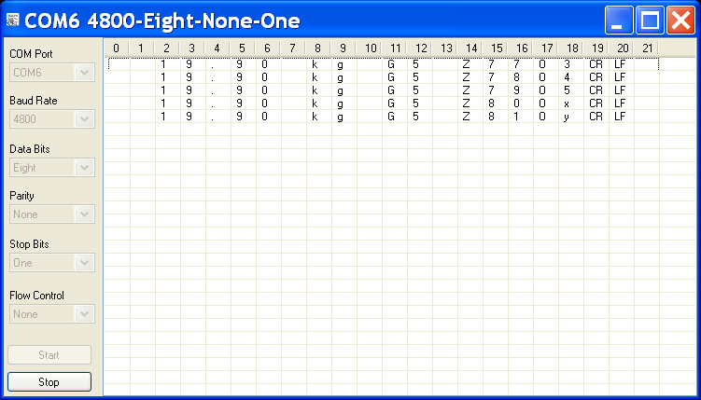

19.90 kg G5 Z77O3CRLF

19.90 kg G5 Z78O4CRLF

19.90 kg G5 Z79O5CRLF

19.90 kg G5 Z80OxCRLF

19.90 kg G5 Z81OyCRLF

**SMALL Scale**

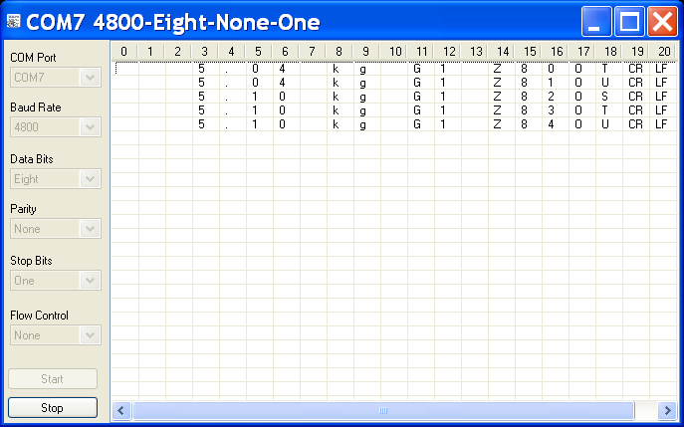

5.04 kg G1 Z80OTCRLF

5.04 kg G1 Z81OUCRLF

5.10 kg G1 Z82OSCRLF

5.10 kg G1 Z83OTCRLF

5.10 kg G1 Z84OUCRLF