SYSTEM DESIGN PROCESS

THE OXISCOPE



TEXAS PRENATAL SYSTEMS

SPONSORED BY

ADVANCED MATERNITY INNOVATIONS

# Date

5/1/2017

# Authors

David Delamater Matt Kellogg Adam McGaffin

Gustavo Ordonez Nathan Wiatrek

# Table of Contents

Contents

1 Executive Summary 7

2 Problem Statement 8

2.1 Background 8

2.2 Project Problem Statement 9

2.3 Solution 9

3 Concept of Operation 11

4 Functional Requirements 12

4.1 Hardware 12

4.2 Software 13

4.3 User Interface and Control 13

4.4 Testing 13

4.5 Documentation 14

5 Conceptual Block Diagram 15

6 Performance Specifications 18

6.1 Hardware 18

6.2 Software 18

6.3 User Interface and Control 19

6.4 Testing 19

6.5 Documentation 20

7 Technology Survey 21

7.1 Laser Diodes 21

7.2 Optical Coupler 22

7.3 Y-Cable 22

7.4 Photodiode 23

7.5 Microcontroller 24

7.6 Wireless Communication 25

8 Functional Block Diagram 26

8.1 Overview 27

8.2 Power 27

8.3 Programming and Debugging 30

8.4 Laser and Photodiode Interface 31

8.5 Communications 34

8.6 Start Button 35

9 Sensor Characterization 36

9.1 Fiber Optic System 36

9.2 Laser Diodes 37

9.3 Optical Coupler 37

9.4 Y - Cable 39

9.5 Photodiode 40

9.6 Signal Processing 41

10 Communication Interfaces/Protocols 47

10.1 UART 47

10.2 Bluetooth BLE V4.0 48

10.3 Message Sequence 49

11 Flowchart 51

12 Deliverables 73

12.1 Hardware 74

12.2 Software 76

12.3 Test/Documentation 78

13 Milestones 80

13.1 Hardware 80

13.2 Software 81

13.3 Test/Documentation 81

14 Gantt Chart 82

15 Costing 83

15.1 Direct Cost 83

15.2 Indirect Cost 87

15.3 Profit 88

15.4 Other Cost 88

15.5 Total Project Cost 89

16 Test Matrix 90

17 Technical Merit 94

18 References 98

Notes 99

# List of Figures

Figure 1 - Transmittance-based Pulse Oximetry 9

Figure 2 - Reflectance-based Pulse Oximetry 9

Figure 3 - Conceptual Block Diagram 15

Figure 4 - Graphical User Interface 16

Figure 5 - Signal Attenuation Based on Hydroxyl Content 23

Figure 6 - Functional Block Diagram 26

Figure 7 - Battery and Supporting Circuitry 27

Figure 8 - Battery Level Monitoring 28

Figure 9 - UCC283T-5 28

Figure 10 - TPS75833KC 29

Figure 11 - TPS75925KC 29

Figure 12 - UC385-1 30

Figure 13 - MSP432 Programming and Debugging Header 30

Figure 14 - CC2650 Programming and Debugging Header 31

Figure 15 - Laser Diode Interface 31

Figure 16 - FCMM625-50A-FC and RP23 32

Figure 17 - FDSP625 Photodiode and I/V Conversion Circuit 32

Figure 18 - Unity Gain Buffers and Filters 33

Figure 19 - Two Wire UART Interface 34

Figure 20 - CC2650, BLED112, Laptop Interface 34

Figure 21 - Start Button 35

Figure 22 - Optical System Setup 36

Figure 23 - Drawing of the 50:50 Coupler 37

Figure 24 - 50:50 Coupler Performance 38

Figure 25 - RP23 Coupler with Reflection Probe 39

Figure 26 - RP23 Demonstration 39

Figure 27 - FC/PC to SMA Adaptor 40

Figure 28 - FDSP625 Typical Responsivity 40

Figure 29 - AC and DC of Received Signal 41

Figure 30 - Signal Processing 42

Figure 31 - Signal Processing Simulation 43

Figure 32 - Current to Voltage Simulation 44

Figure 33 - Band Pass Filter Simulation 45

Figure 34 - Non-Inverting Amplifier Simulation 45

Figure 35 - Low Pass Filter Simulation 46

Figure 36 - Example Message Group 47

Figure 37 - Message Sequence Diagram 49

Figure 38 - Flowchart Legend 51

Figure 39 - MSP432 Hierarchy Chart 52

Figure 40 - Main Initialization 53

Figure 41 - Bluetooth Pairing Process 54

Figure 42 - Main Program Loop 55

Figure 43 - Assorted ISRs 56

Figure 44 - Sample Light Process 57

Figure 45 - Example of a Sampled Waveform 58

Figure 46 - Calculate Waveform Characteristics 59

Figure 47 - Calculate SpO2 and Pulse Rate 60

Figure 48 - Retrieve Battery Level 61

Figure 49 - Build TX Message 62

Figure 50 - UART TX ISR 63

Figure 51 - 8-bit CRC Related Subroutines 64

Figure 52 - Polyalphabetic Substitution Cipher Encryption and Decryption 65

Figure 53 - UART RX Subroutines 66

Figure 54 - CC2650 Hierarchy Chart 67

Figure 55 - CC2650 Main Routine 67

Figure 56 - Assorted CC2650 Interrupt Service Routines 68

Figure 57 - Main LabVIEW Routine 69

Figure 58 - Received Message Sub VI 70

Figure 59 - Assorted LabVIEW Sub VIs 71

Figure 60 - Deliverables Timeline 73

Figure 61 - Milestones Timeline 80

Figure 62 - Phase Gantt Chart 82

Figure 63 - Activity Gantt Chart 82

# List of Tables

Table 1: Red Laser Diode Survey 21

Table 2: Infrared Laser Diode Survey 21

Table 3: Optical Coupler Survey 22

Table 4: Y-Cable Survey 23

Table 5: Photodiode Survey 24

Table 6: Microcontroller Survey 24

Table 7: Wireless Communication Survey 25

Table 8: Pigtailed Laser Diode Characteristics 37

Table 9: Labor Cost 83

Table 10: Fiber Optic System Cost 84

Table 11: Hardware Costs 85

Table 12: Software Cost 86

Table 13: Resource Cost 86

Table 14: Total Direct Cost 87

Table 15: Indirect Cost 88

Table 16: Profit 88

Table 17: Other Cost 89

Table 18: Total Project Cost 89

Table 19: Test Matrix 90

Table 20: Technical Merit Matrix 94

## 

## 1 Executive Summary

As birth rates increase every year, the medical industry recognizes a need in investing on effective ways to improve the process of childbirth across the United States. Current technology introduces major potential risks to both the mother and the child during the birthing process; therefore, a technological advancement needs to occur in order to protect the lives of mothers and their infants. Some major concerns involve the brain oxygenation level and the heart rate of the infant during the labor process. These can be measured through a combination of pulse rate and oxygen saturation. Oxygen saturation (SpO2) is the measurement of oxyhemoglobin (HbO2) in blood, which shows how much oxygen is in the tissue being measured. Current methods of measuring SpO2 are invasive and cannot be displayed in real time.

Pulse oximetry is a non-invasive method that has the capability to provide real time measurements of both pulse rate (PR) and oxygen saturation. There are two forms of pulse oximetry, transmittance-based and reflectance-based. Due to the limited applications of transmittance-based pulse oximetry, reflectance-based pulse oximetry is the ideal method for taking measurements during the birthing process. Reflectance-based pulse oximetry uses incident light that passes through the skin and reflects off subcutaneous tissue and bone. This reflected light is detected by a photodiode, producing a signal that can be used to calculate both pulse rate and oxygen saturation.

Texas Prenatal Systems recognizes this issue and will be developing a fully functional prototype that will use reflectance-based pulse oximetry to measure and display oxygen saturation and pulse rate. This system, the OxiScope, will be battery powered and will wirelessly transmit both pulse rate and oxygen saturation measurements to a remote laptop. The OxiScope will allow medical professionals to quickly and accurately diagnose emergency Caesarean sections (C-sections) during childbirth. This document outlines the design and development of the OxiScope.

## 2 Problem Statement

### 2.1 Background

There have been many advances over the past thirty years within the medical field. One aspect of the industry that has not received as many innovations is the prenatal sector. Caesarean deliveries, also known as C-sections, have become a more common practice in recent years, with nearly one in three children being born through them [1]. Despite their commonality, C-sections are still major surgeries and can pose major risks to the mother and child. Because of these risks, doctors need to be sure when it is necessary to have an emergency C-section.

The current process for medical professionals to determine the need for an emergency C-section is to use ultrasound technology to measure the heart rate of the infant. During a contraction, the heart rate of the baby drops and returns to normal after a short period of time. However, complications can begin to arise if the heart rate takes too long to return to its normal pace. This is referred to as a late deceleration. If three late decelerations occur in series, doctors assume that the infant is in need of oxygen, resulting in an emergency C-section. However, 60% of these emergency C-sections are incorrectly diagnosed based on an inaccurate reading, putting the mother and infant in danger. One way to improve this process is to determine the heart rate and oxygen level of the infant baby directly. However, there is no device currently on the market that has the ability to physically measure both while also being noninvasive.

There is a high demand and need for a noninvasive device that has the ability to measure the oxygen level, as well as pulse rate of an infant during childbirth. Such a device would have the ability to determine the need for a C-section more reliably, reducing the number of mothers and children put in danger as well as reducing the financial burden that a C-section can have. In 2014 alone, there were a total of four million births within the United States[2] . With one in three children born through C-section, there were close to one and a half million C-sections in 2014[3]. At an average additional cost of twenty thousand dollars, the total financial cost for C-sections in 2014 was twenty six billion dollars[4]. In regards to the mother's health, about four deaths for every one hundred thousand women occur from vaginal deliveries, while thirteen deaths for every one hundred thousand women occur from deliveries through C-section[5]. Using the birthing data previously stated for 2014, one hundred and seventeen mothers potentially passed away due to an unnecessary C-section. Texas Prenatal Systems believes that a device that has the ability to accurately diagnose emergency C-sections would have a profound positive impact on society.

### 2.2 Project Problem Statement

Texas Prenatal Systems, sponsored by Advanced Maternity Innovations, will be researching and developing a prototype that will be used to further develop a device that is capable of quickly and noninvasively measuring the oxygen saturation and pulse rate of an infant during labor, through the use of reflectance-based pulse oximetry.

### 2.3 Solution

There are technologies currently available that can be used to potentially solve this problem, but Texas Prenatal Systems will focus on pulse oximetry. This is a noninvasive method for determining a person's oxygen saturation (SpO2), the amount of oxygen in the blood, and pulse rate, how quickly the heart pumps blood through the circulatory system. There are two distinct categories for pulse oximetry: transmittance-based and reflectance-based. Visual representations of these technologies are shown in Figures 1 and 2, respectively.

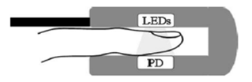

Figure 1 - Transmittance-based Pulse Oximetry



Figure 2 - Reflectance-based Pulse Oximetry

Both pulse oximetry technologies are comprised of the same components: a series of light emitting diodes (LEDs), red and infrared, as well as photodiodes. What differentiates the two methods are the placement of the LEDs and photodiodes relative to one another. Transmittance-based pulse oximetry, illustrated in Figure 1, requires the LEDs and photodiode to be on opposite sides of one another. The LEDs are placed on a permeable portion of the body (finger, earlobe, etc.), and passes light through the body, which is read on the opposite end using the photodiode. However, the OxiScope will use reflectance-based pulse oximetry. As shown in Figure 2, the LEDs and photodiodes are placed adjacent to each other. This allows the light to pass through the skin and reflect off subcutaneous tissue and bone. This reflected light is then captured by the photodiode. This method is the only option available for determining the oxygen saturation level of an infant during the birthing process.

## 3 Concept of Operation

The OxiScope prenatal monitoring system, developed by Texas Prenatal Systems, is a prototype that will be used exclusively within a clinical research environment for further testing and development purposes in order to facilitate the customer in producing a finalized and commercially-available system. This build-to-order, functional prototype will be further developed to be incorporated into the labor and delivery equipment rack that will measure and display the pulse rate and peripheral oxygen saturation levels of an unborn child to the operating medical professionals. Due to the lack of available time to undergo through the Food and Drug Administration (FDA) approval process, the objective of all designs will be geared towards the fabrication of a prototype that has the possibility to obtain Institutional Review Board (IRB) approval through proper documentation. IRB approval is not a goal of the project. An operational prototype will be delivered to the customer once all the phases of product development are completed.

## 4 Functional Requirements

Functional requirements are requirements that the customer has defined as necessary for the product to be considered a success. The purpose of these are to provide a vision of what the end product will provide so that it does not have unnecessary features that would increase the cost and duration of the project.

The OxiScope’s functional requirements have been broken down into five major categories: hardware, software, user interface and control, testing, and documentation.

### 4.1 Hardware

*Fiber Optic Coupled Laser Diodes and Photodiode*

The first hardware functional requirement is that fiber optic coupled laser diodes and a photodiode must be used. Fiber optics are required because the measurement probe must be able to reach the baby so making the probe small is required. Laser diodes are required because there needs to be enough light to reflect back into the photodiode, and lasers provide more light than LEDs. A photodiode is required because the reflected light must be detected but it also replaces an expensive spectrometer.

*Software Secured Microcontroller*

The second hardware functional requirement is that a software secured microcontroller must be used. This is to help protect the intellectual property inside of the device. Secured IP hinders potential copycats from reverse engineering the device.

*Battery Powered*

The third hardware functional requirement is that the device must be battery powered. The main reason for this is to remove tripping hazards from the labor and delivery room. An additional benefit of this is the device can be anywhere in the room so the fiber optic cable can be shorter.

### 4.2 Software

*Encrypted Wireless Communication*

The first software functional requirement is that the wireless communication between devices must be encrypted. The first reason for this is the same as the battery, to reduce the number of tripping hazards. The second reason is because the FDA[6] requires having secure communication.

*Short Measurement Time and Transmission Delay*

The second software functional requirement is the need for a short measurement time and transmission delay between the two devices. Measurement time describes the time it takes for the device to take a measurement after a start command is received. Transmission time describes the time it takes the device to communicate its measurements to the graphical user interface. This is a requirement because the user cannot wait too long for critical, life-changing information.

### 4.3 User Interface and Control

*Measurements Displayed on a Graphical User Interface (GUI)*

The first user interface and control functional requirement is that the measurements need to be displayed on a GUI. This interface must be able to provide information in an easy-to-read format. Visual indicators will allow for quick interpretations of the information and further assist the user to making a vital decision.

*One Button Interface*

The second user interface and control functional requirement is that the device must have a one-button interface on the physical enclosure. One button allows the user to control the device easily.

### 4.4 Testing

*Accurately Measure SpO2 and Pulse Rate Compared to a Commercially Available Product*

The first testing functional requirement is that the device needs to be able to measure oxygen saturation and pulse rate accurately compared to a commercially available product. Being able to obtain accurate measurements is important because the measurements can be the deciding factor on whether surgery will be necessary. If the system provides false information then it could potentially have fatal consequences. Comparing the OxiScope to commercially available products allows for easy testing while also providing reliable results.

*Human Testing with Institutional Review Board (IRB) Approval*

The second testing functional requirement is that human testing will be performed after the IRB approves testing. The Institutional Review Board is the committee that decides whether certain studies can be performed. For example, if the study harms a patient to find blood pressure then it could be rejected. This allows the full device to be tested and provides real world measurements, which can be used to prove the device is capable of providing reliable measurements.

### 4.5 Documentation

*Submit a Journal Paper*

The final functional requirement is that a journal paper will be submitted. This paper does not have to be published. This is required because it would allow for feedback from other professionals in the industry.

## 5 Conceptual Block Diagram

A conceptual block diagram is a high-level representation tool that allows the viewer to easily understand the system’s functionality. Figure 3 is a conceptual block diagram for the OxiScope.

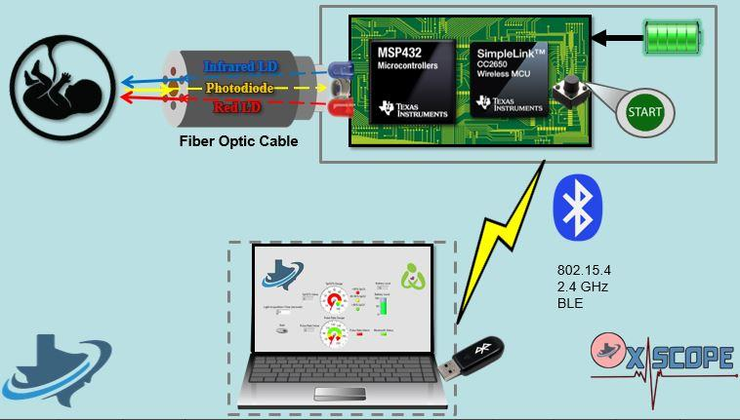

Figure 3 - Conceptual Block Diagram

There are two distinct aspects of the OxiScope, an embedded system paired with a user interface application which will be connected through wireless communication. The embedded system will include a printed circuit board (PCB), a rechargeable battery, a photodiode, and two laser diodes. These will all be housed inside a 3D printed enclosure, shown by the solid grey rectangle. The PCB will host both the MSP432 and CC2650, which will be used as the intelligence for the system and the wireless communication platform, respectively. The system will be powered by a battery that will be able to be recharged inside the enclosure. Additionally, the board will have a push button that will enable the user to start the measurement taking process. Since the OxiScope will use reflectance-based pulse oximetry, a fiber optic cable will be used to transmit and receive photons. The laser diodes will emit photons at specific wavelengths through their respective fibers. The photons will travel through these optical fibers, reach the subject, and reflect back through a different fiber coupled to the photodiode. When the user starts the measurement-taking process, the microcontroller will alternate turning on the red laser diode and the infrared laser diode, until the light acquisition time expires. Photons will be emitted and received through a probe that will house all the optical fibers. Once the reflected photons reach the photodiode, a current will be generated based on the amount of photons that were received.

Once the measurements are calculated, they will need to be displayed onto a graphical user interface, which will allow critical decisions to be made quickly and decisively. The OxiScope will be using Texas Instrument’s CC2650 to wirelessly transmit the measurements. The CC2650 will communicate to a BLED112 Bluetooth dongle connected to a USB port on a remote laptop. The graphical user interface is shown in Figure 4.

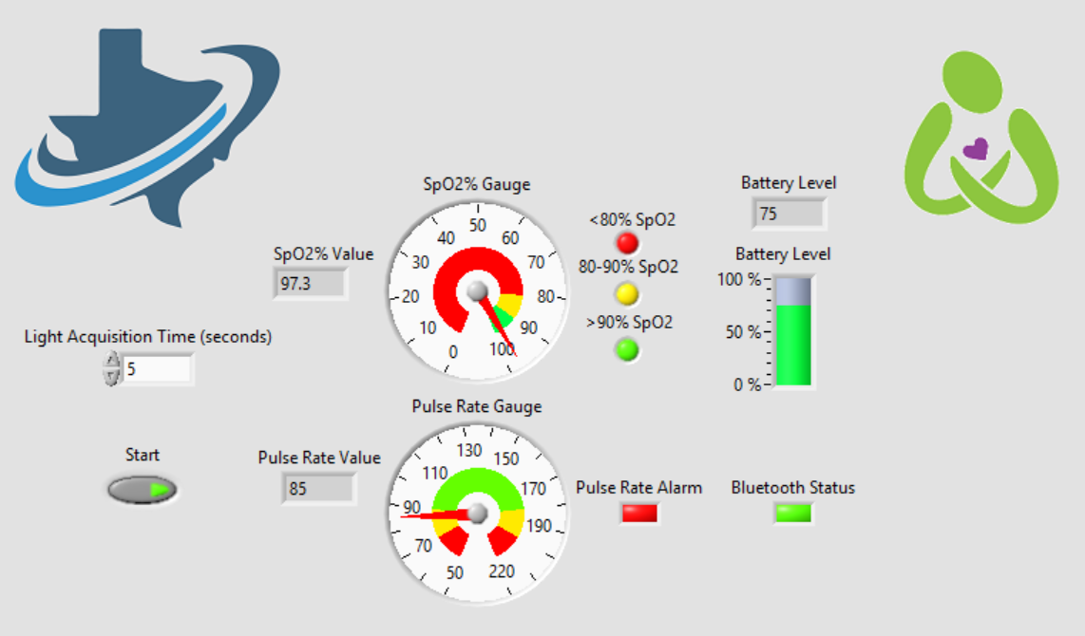

Figure 4 - Graphical User Interface

The graphical user interface will also have interactive features. A start button will be placed on the GUI that will allow the user to start measurement-taking process along with input field to adjust the light acquisition time. Numerical values as well as gauges will show the pulse rate and the oxygen saturation levels. Additionally, three indicators correspond to different oxygen saturation levels that will activate if the value falls within each of their specified range. These indicators, along with the Pulse Rate Alarm, are placed on the GUI to signal the state of the baby to the operating professionals.

Another feature of this GUI is that the status of the system can be regularly examined using two different indicators. The user can observe the percentage of the remaining battery capacity, displayed as a percentage bar that will have a range from zero to one hundred. Lastly, an indicator will be used to indicate a successful connection between the Bluetooth dongle and the CC2650.

## 6 Performance Specifications

Performance specifications further specify and quantify each functional requirement into measurable parameters. Each performance specification is specific to a functional requirement and is categorized into one of five main sections: hardware, software, user interface, testing, or documentation. All of the performance specifications have been reviewed and agreed upon by Texas Prenatal Systems and all stakeholders.

### 6.1 Hardware

*Fiber Optic Coupled Laser Diodes and Photodiode*

There must be two laser diodes, one emitting a 940 nm wavelength and another emitting a 660 nm wavelength. Both these laser diodes will be coupled to their own individual optical fibers, which will increase the amount of photons transmitted through the system. The photodiode must have an operating range that includes the 940 nanometer and the 660 nanometer wavelength and must be coupled to its own optical fiber.

*Software Secured Microcontroller*

To meet the functional requirement of a software secured microcontroller, the microcontroller used must have a JTAG lock on it. This is to protect the embedded code stored on the microcontroller. Texas Instruments’ MSP432P401R has a JTAG lock feature which provides secure IP zones and will be used as the intelligence in Texas Prenatal Systems’ design.

*Battery Powered*

The OxiScope must be battery powered. The battery must be able to power the system for one continuous hour of operation and must be capable of recharging through a barrel plug, inside the enclosure.

### 6.2 Software

*Encrypted Wireless Communication*

The OxiScope must communicate wirelessly via Bluetooth Low Energy V4.0 (BLE). Due to the security requirements in a medical environment, the messages sent from the OxiScope to the GUI must be encrypted. The encryption algorithm utilized in the system, will be chosen by Texas Prenatal Systems.

*Short Measurement Time and Transmission Delay*

There must be a short measurement time and transmission delay between the OxiScope and the GUI. To ensure a real-time aspect of the OxiScope, measurements must be taken in less than five seconds. This will provide enough time for five heartbeats and 2500 samples to be taken, increasing the accuracy of the measurements.

Once the measurements are taken, they will need to be displayed on the GUI in less than one second. This will consist of encrypting the message on the OxiScope, transmitting the message to the laptop, decrypting the message and finally displaying it on the front panel of the GUI.

### 6.3 User Interface and Control

*Measurements Displayed on a GUI*

To add ease of use, the measurements must be displayed on a user-friendly GUI. The OxiScope will utilize LabVIEW to implement the GUI, not only providing a user-friendly interface, but also for testing and debugging.

*One button interface*

The GUI will allow the user to start taking measurements using a start button. There will also be an input to allow the user to adjust the exposure time or the amount of time the system takes measurements.

### 6.4 Testing

*Accurately Measure SpO2 and Pulse Rate Compared to a Commercially Available Product*

The OxiScope must be able to measure both SpO2 and pulse rate within ±5% of a commercially available, customer provided pulse oximeter.

*Human Testing with IRB Approval*

To ensure consistency with the measurements, at least 500 samples must be taken during IRB approved testing. Each sample will last a minimum of five seconds and a broad spectrum of skin tones will be tested. If IRB approval is not received, a scope change will be implemented and the system will be tested through another method.

### 6.5 Documentation

*Submit a Journal Paper*

A paper must be generated and submitted to a journal specified by Texas Prenatal Systems. This paper does not have to be published, only submitted. This paper will consist of Texas Prenatal Systems’ design, implementation, and testing of the system.

## 7 Technology Survey

A technology survey was performed on each of the major components on the OxiScope system. Each survey shows a minimum of three potential solutions for each functional requirement and its associated performance specification. The major components that will be covered by the technology survey are the fiber optic system components, microcontroller and wireless communication module.

### 7.1 Laser Diodes

The technology survey for the red laser diode to be used in the OxiScope is shown in Table 1.

###### Table 1: Red Laser Diode Survey

|  |  |  |  |
| --- | --- | --- | --- |
| Manufacturer: | Device: | Pros: | Cons: |
| Thorlabs | LPS-660-FC | Low cost  Outputs the correct wavelength | Low output power |
| Thorlabs | LP660-SF20 | Low cost,  Adequate power output  Outputs the correct wavelength |  |
| Thorlabs | LP660-SF40 | Adequate power output  Outputs the correct wavelength | High cost |

There are multiple characteristics that were taken into consideration for each of the laser diodes: the cost of the device, the laser output power level, and the wavelength of the output signal. The most important factor in choosing the correct laser diode is the output wavelength, with the output power being a close second. The LP660-SF20 was found to be the best match from the list of factors and criteria. Table 2 shows the technology survey for the infrared laser diode.

###### Table 2: Infrared Laser Diode Survey

|  |  |  |  |
| --- | --- | --- | --- |
| Manufacturer: | Device: | Pros: | Cons: |
| Thorlabs | LP915-SF40 | Adequate power output | High cost  Output wavelength is smaller than needed |
| Thorlabs | LP940-SF30 | Outputs the correct wavelength  Adequate power output | High cost |
| Thorlabs | LP980-SF15 | Low Cost | Low output power |

Similar to the red laser diode, the major factors taken into consideration for choosing the infrared laser diode were the device cost, the laser output power level, and the wavelength of the output signal. The LP915-SF40 and LP980-SF15 both output wavelengths that are either too small or too large. Although the LP940-SF30 was the most expensive laser diode, it met the criteria of outputting a signal with a wavelength of 940 nm and had an adequate power level of 30 mW.

### 7.2 Optical Coupler

The technology survey performed for the optical coupler, which will couple both laser diodes together, is shown in Table 3.

###### Table 3: Optical Coupler Survey

|  |  |  |  |
| --- | --- | --- | --- |
| Manufacturer: | Device: | Pros: | Cons: |
| Thorlabs | FCMM50-90A-FC | Has a FC/PC connection | 90/10 output split ratio  High cost |
| Thorlabs | FCMM625-50A | 50/50 output split ratio  Low cost | Does not have a FC/PC connection |
| Thorlabs | FCMM625-50A-FC | Has a FC/PC connection  50/50 output split ratio | High cost |

Three primary factors were considered for the optical coupler; the cost of the device, the output ratio, and its connection type. The most important factor and criteria when picking the coupler was the output ratio. Of the options, a 50:50 coupler was found to have the best performance. The FCMM625-50A-FC met the high output requirement as well as a fiber-optic connecter (FC) physical contact / (PC) connection.

### 7.3 Y-Cable

The technology survey done for the Y-cable, which has the purpose of coupling the output from the optical coupler to the pigtailed photodiode, is shown in Table 4.

###### Table 4: Y-Cable Survey

|  |  |  |  |
| --- | --- | --- | --- |
| Manufacturer: | Device: | Pros: | Cons: |
| Thorlabs | RP21 | Low Hydroxyl (OH) content  Low cost | No reflection probe |
| Thorlabs | RP22 | Has a reflection probe | High cost  High Hydroxyl (OH) content |
| Thorlabs | RP23 | Has a reflection probe  Low Hydroxyl (OH) content | High cost |

For the Y-cable, there were three factors that were taken into consideration: the cost of the device, the Hydroxyl content, and the ability to take measurements from the cable itself. The Hydroxyl content determines how different wavelengths attenuate through the cable. Figure 5 shows the correlation between the attenuation of the signal (y-axis) in respects to the input wavelengths (x-axis).

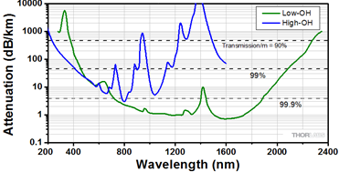

Figure 5 - Signal Attenuation Based on Hydroxyl Content

The blue line represents a high Hydroxyl content cable with the green line representing a low hydroxyl content cable. Since the two laser diodes have operating frequencies of 660 nm and 940 nm, a low Hydroxyl system is needed. Considering this factor, as well as the need for the reflection probe, the RP23 was chosen.

### 7.4 Photodiode

The technology survey performed for the pigtailed photodiode is shown in Table 5.

###### Table 5: Photodiode Survey

|  |  |  |  |
| --- | --- | --- | --- |
| Manufacturer: | Device: | Pros: | Cons: |
| Thorlabs | FDSP625 | Adequate frequency response range  Adequate rise/fall time  Uses a multi-mode fiber | No connector |
| Thorlabs | FDSP660 | Adequate rise/fall time | Frequency response range does not include IR laser  No connector  Uses a single-mode fiber |
| Thorlabs | FDSP780 | Adequate rise/fall time | Frequency response range does not include red laser  No connector  Uses a single-mode fiber |

For the photodiode, four factors were taken into consideration: the frequency response range, the rise/fall time, the type of fiber used, and the connection type. The most important factor when choosing the photodiode was the frequency response range as the red and infrared laser diodes have different wavelengths. The FDSP625 was the only photodiode that included both laser diode wavelengths within its frequency response, and was chosen for this reason.

### 7.5 Microcontroller

The technology survey of the microcontroller to be used in the OxiScope is shown in Table 6.

###### Table 6: Microcontroller Survey

|  |  |  |  |
| --- | --- | --- | --- |
| Manufacturer: | Device: | Pros: | Cons: |
| Texas Instruments | MSP432P401R | High Frequency, JTAG Secure Lock, Secure IP Zones, 16 bit oversampling ADC | High Cost |
| Texas Instruments | MSP430FR5962 | Very Low Power, low cost | 12 Bit ADC, no secure IP Protection, low frequency |
| Texas Instruments | MSP432P401M | Low Cost, similar to the P401R variant | Not as much RAM or Flash as the P401R variant |

The three primary options for the intelligence control of the OxiScope are the MSP432P401R, the MSP430FR5962, and the MSP432P401M. The MSP432P401R was chosen due to having more RAM and flash than the MSP432P401M variant. All MSP432 variants utilize an ARM-M4 Cortex processor, and have a high enough resolution analog to digital converter (ADC) to accurately measure the signals that need to be processed. While the MSP432 is not as power efficient as the MSP430, the MSP432 has more advantages that will contribute to the overall success of the OxiScope.

### 7.6 Wireless Communication

The technology survey of the wireless communication device used by the OxiScope is shown in Table 7.

###### Table 7: Wireless Communication Survey

|  |  |  |  |  |
| --- | --- | --- | --- | --- |
| Manufacturer: | Device: | Protocol: | Pros: | Cons: |
| Texas Instruments | CC2650 | Multi-protocol | Development board easily accessible, different options for wireless communication | Since Bluetooth is the main focus this chip is overkill, high cost |
| Texas Instruments | CC2640 | Bluetooth | Low cost, low energy | Not easily programmed |
| Texas Instruments | CC2530 | ZigBee | Low cost | ZigBEE is not as easily approved by the FDA, as Bluetooth |

The three primary options for the wireless control were the CC2650, the CC2640, and the CC2530. The CC2650 was chosen for the ability to prototype with a BoosterPack and interface with the MSP432 LaunchPad. Bluetooth is the chosen protocol for the OxiScope due to its reliability as well as precedent with a large number of medical devices that currently utilize Bluetooth.

## 8 Functional Block Diagram

The functional block diagram outlines all connections within the OxiScope. Figure 6 shows the functional block diagram in its entirety. The functional block diagram will be a tool used by both hardware and software engineers.

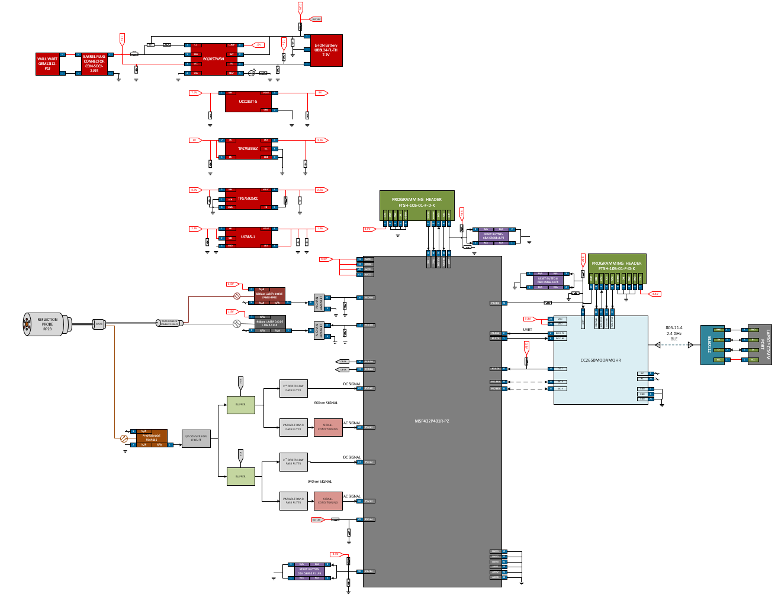

Figure 6 - Functional Block Diagram

The functional block diagram is used by both the hardware and software engineers to achieve a functional understanding of how all components will interface with each other. The hardware engineers will generate a pin level schematic based on the functional block diagram and the software engineers will reference it when developing embedded software. Having a diagram that is created by both the hardware and software engineers allows both sides of the project to create their section that will be integrated to the system correctly.

### 8.1 Overview

A MSP432P401R-PZ (MSP432) will serve as the embedded intelligence of the OxiScope and will control the two laser diodes, as well as handle all of the digital signal processing and calculations of the measurements. The MSP432 will communicate with a CC2650MODAMOHR (CC2650) that will serve as Bluetooth module, using two wire UART. The CC2650 will then transmit the calculated measurements to a computer through a dongle via Bluetooth Low Energy.

### 8.2 Power

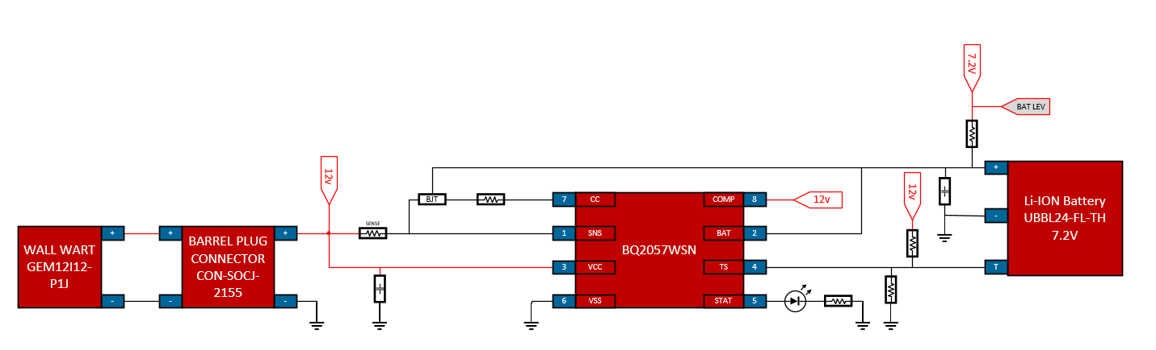The OxiScope will be powered by a UBBL-24-FL-TH lithium-ion battery. This rechargeable battery has a capacity of 4.8 Ah and can provide a minimum voltage of 6 V and a maximum voltage of 8.4 V. The battery will be recharged inside the enclosure using a BQ2057WSN charge controller. This will be powered with 12V provided through a wall wart, and will recharge the battery with a regulated 8.4 V. A status LED located on the outside of the enclosure will indicate when the battery is being charged.

Figure 7 - Battery and Supporting Circuitry

The BQ2057WSN will also monitor the temperature of the battery through the battery’s internal thermistor. If the battery gets too hot, the BQ2057WSN will automatically cease charging. The output voltage of the battery will be monitored through an ADC pin on the MSP432. This will allow the battery level to be assessed and displayed on the user interface. This will help ensure that the battery is not allowed to discharge past a point where it cannot be recharged. The ADC pin and supporting circuitry is shown in Figure 8.



Figure 8 - Battery Level Monitoring

The ADC pins on the MSP432 can tolerate an absolute maximum voltage of 3.7 V. Since the UBBL-24-FL-TH battery can output up to 8.4 V, a voltage divider is required to reduce the voltage into the ADC pin.

The nominal voltage of the UBBL-24-FL-TH is 7.2 V, but has a range of 6 V to 8.4 V. This output voltage will need to be regulated to 5 V to power operational amplifiers used in the signal conditioning section. This regulated 5 V will be provided through a UCC283T-5 fixed output, low dropout voltage regulator, shown in Figure 9.

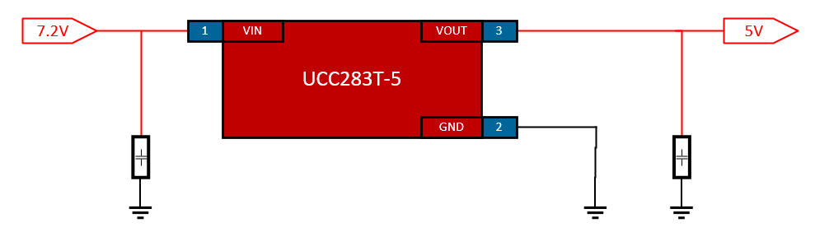

Figure 9 - UCC283T-5

The UCC283T-5 has a maximum dropout voltage of 450 mV, which will ensure a 5 V output even if the battery outputs its minimum voltage. It can also output up to 3 A, guaranteeing it will not limit any other components. Both the input and output lines will have decoupling capacitors to suppress any high frequency noise in the signal.

The 5 V provided by the UCC283T-5 will need to be regulated down to 3.3 V to power the MSP432 and CC2650. This will be done using a TPS75833KC fixed output, low dropout voltage regulator, shown in Figure 10.

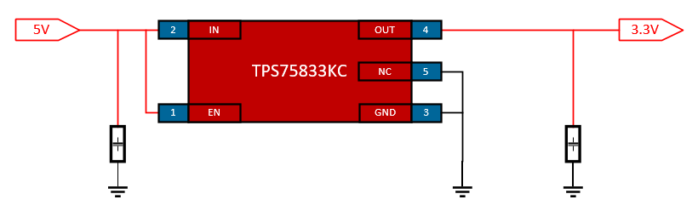

Figure 10 - TPS75833KC

The TPS75833KC has an enable pin that will be tied to the input since there is no need to control when the device is operating or not. A decoupling capacitor will also be tied to the input as well as the output to remove high frequency noise. Voltages ranging from 2.8 V to 5.5 V can be inputted into the TPS75833KC, and up to 3 A can be outputted. The TPS79633-Q1 has a typical dropout voltage of 150mV with a load of 3 A.

The 3.3 V provided by the TPS75833KC must be regulated down to 2.5 V to power the red laser diode. A regulated 2.5 V will be provided using a TPS75925KC low dropout voltage regulator shown in Figure 11.

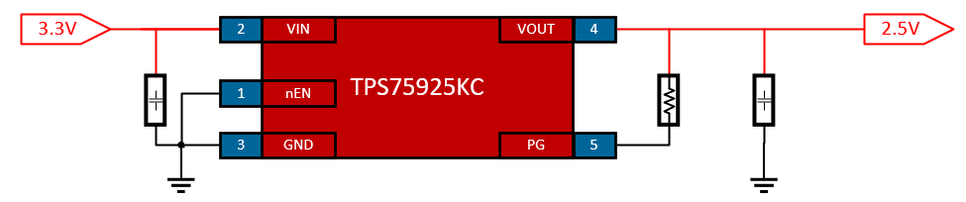

Figure 11 - TPS75925KC

The TPS79633-Q1 has an active low enable pin, which will be tied to ground since control over when the voltage regulator is operating is not of interest. The TPS79633-Q1 has an input voltage range of 2.8 V to 5.5 V and can output up to 7.5 A. At 7.5 A, the drop out voltage is 400 mV, ensuring a constant 2.5 V output. Both input and output signals will have decoupling capacitors to remove unwanted noise.

Lastly, a UC385-1 low dropout voltage regulator will be used to drop the regulated 2.5 V to 1.5 V, this will power the infrared laser diode as well as provide an offset in the signal conditioning process. The UC385-1 is shown in Figure 12.

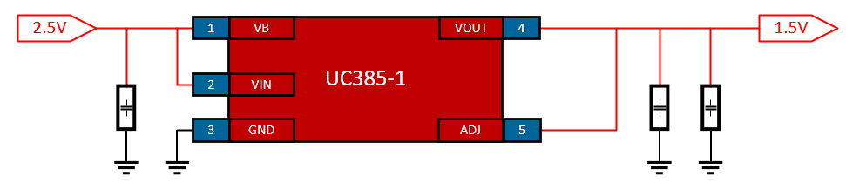

Figure 12 - UC385-1

The UC385-1 has a dropout voltage of 500 mV at a maximum load of 5 A. It has an absolute maximum input voltage of 7.5 V and can output up to 5 A of current. Decoupling capacitors will be connected to both the input and output signals to eliminate any high frequency noise.

### 8.3 Programming and Debugging

Both the MSP432 and CC2650 will be programmed and debugged using their own respective FTSH-105-01-F-D-K header. The MSP432 and CC2650 interfaces are shown in Figure 13 and Figure 14, respectively.



Figure 13 - MSP432 Programming and Debugging Header



Figure 14 - CC2650 Programming and Debugging Header

The FTSH-105-01-F-D-K is a 2x5 header that will interface with the XDS110 debugger onboard a MSP432 LaunchPad. There will be two push buttons to manually reset the MSP432 and CC2650 that will both be tied high to 3.3 V. A major difference between the MSP432 programming and debugging interface and that of the CC2650 is that the MSP432 will have the capability to reset the CC2650 using a digital out pin.

### 8.4 Laser and Photodiode Interface

The LP660-SF60 laser diode will emit photons at a wavelength of 660 nanometer through a pre-coupled optical fiber. It will be powered with 2.5 V, nominally draw 133 mA of current and output 40 mW of power.

The LP940-SF30 laser diode will emit infrared light at a wavelength of 940 nanometer through a pre-coupled optical fiber. It will be powered with 1.5 V and nominally draw 93 mA while outputting 30 mW of power.

The LP660-SF60 and LP940-SF30 laser diodes are shown in Figure 15.



Figure 15 - Laser Diode Interface

Both laser diodes will be controlled through low side switching using N-Channel E-MOSFETs. The MSP432 will output a high signal of 3.3 V to the gate of the desired MOSFET, creating a significant potential difference between the gate and source, allowing current to flow from the power supply through the laser diode to ground. Both the lines from the MSP432 to the gates of the MOSFETs will be pulled low to ensure the laser diodes are not accidentally activated when the MSP432 is initially powered.

Once activated, the laser diodes will emit photons that will travel through their respective optical fibers until they reach the FCMM625-50A-FC 50:50 coupler. This coupler will combine both laser diodes’ optical fibers into one. This fiber will be inputted into the RP23 reflection probe. Both the FCMM625-50A-FC and RP23 are shown in Figure 16.

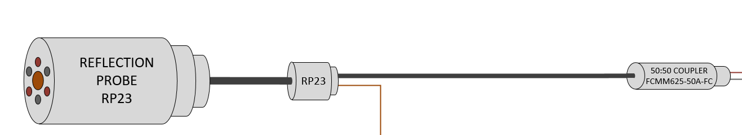

Figure 16 - FCMM625-50A-FC and RP23

Within the probe, the laser diodes’ optical fibers will surround the photodiode’s optical fiber. The light emitted from the laser diodes will reflect off of the subject’s tissue and will travel through the optical fiber coupled to the photodiode. Figure 17 shows the FDSP625 photodiode and the current to voltage conversion circuit that will follow.

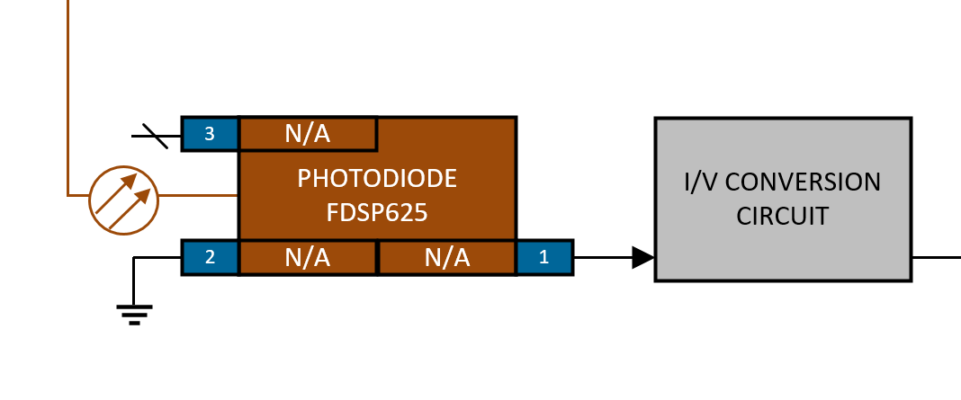

Figure 17 - FDSP625 Photodiode and I/V Conversion Circuit

The reflected photons from the RP23 will be converted into a current by the FDSP625 photodiode. This current will then be converted to a voltage using an OPA430PA operational amplifier.

Once converted to a voltage, the signal will need to be separated into an AC and a DC component. This will be achieved through a series of low pass and band pass filters. The operational amplifiers and filters are shown in Figure 18.

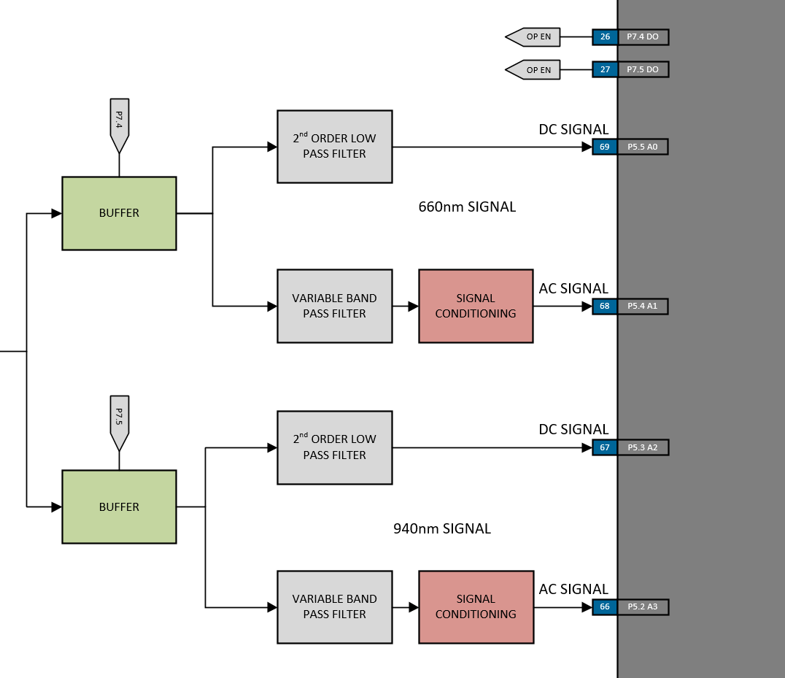

Figure 18 - Unity Gain Buffers and Filters

There will be two sets of filters. One for the 660 nanometer signal and one for the 940 nanometer signal. Two OPA341 operational amplifiers will act as unity gain buffers to select which set of filters the signal goes through. These operational amplifiers have enable pins which will allow them to be used as switches controlled by the MSP432. Separating the 660 nanometer signal from the 940 nanometer signal will allow each wavelength to have its own individual set of ADC pins. Once the signal passes through the desired buffer, it will be separated into a DC component using a second order low pass filter and an AC component using a variable band pass filter. The DC and AC components will be read by individual ADC pins on the MSP432. The AC signal will need to be amplified using a TLV2782AID operational amplifier before it is read by the ADC pin on the MSP432.

### 8.5 Communications

The MSP432 and CC2650 will communicate using two wire UART running at 9600 bits per second, shown in Figure 19.



Figure 19 - Two Wire UART Interface

There is an additional line between the CC2650 and the MSP432, which will allow the CC2650 to let the MSP432 know when it has been paired with the BLED112. This line will be pulled high to ensure there is no miscommunication when the devices are powered up. There will also be two additional digital input/output connections between the MSP432 and CC2650 to help with unforeseen issues.

The CC2650 will communicate with the BLED112 over 805.11.4 Bluetooth Low Energy, shown in Figure 20.



Figure 20 - CC2650, BLED112, Laptop Interface

The BLED112 will create a virtual communications port on the laptop that will be able to interface with LabVIEW. These packets will implement an 8-bit cyclical redundancy check (CRC) and be encrypted with a polyalphabetic substitution cipher.

### 8.6 Start Button

The OxiScope will have a push button to initiate the measurement taking process. The start button is shown in Figure 21. This push button is tied high similar to the reset buttons.

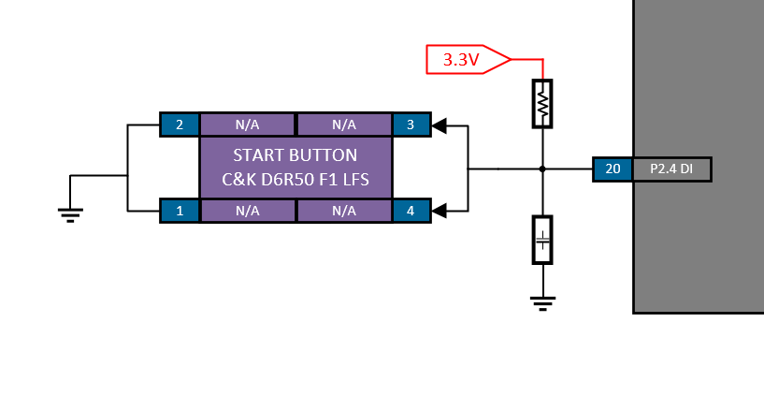

Figure 21 - Start Button

The start button will be located on the outside of the enclosure to allow the operator to start taking measurements.

## 9 Sensor Characterization

### 9.1 Fiber Optic System

The OxiScope will be comprised of a single sensor; a pigtailed or fiber optic coupled, photodiode manufactured by Thorlabs. Figure 22 shows the setup of the optical system.

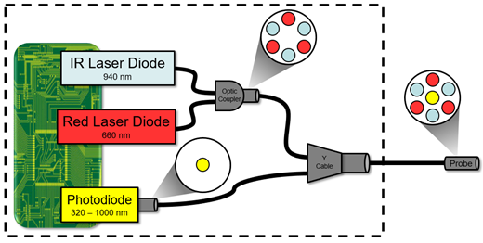

Figure 22 - Optical System Setup

Three components from the optical system will be connected directly to the custom PCB: the pigtailed infrared laser diode, the pigtailed red laser diode, and the pigtailed photodiode. Both pigtailed laser diodes will be coupled using a 50:50 optical coupler, which will house six individual optical fibers. Three optical fibers will be connected to the pigtailed infrared laser diode, while the other three optical fibers will be connected to the red laser diode. The three optical fibers attached to their respected laser diode will be oriented in a triangular pattern.

The pigtailed photodiode will be connected to a single optical fiber. This fiber, as well as the six optical fibers from the coupler, will be combined using a Y-cable. The Y-cable will allow the optical fibers from the laser diodes to be coupled with the fiber connected to the photodiode. The Y-cable will arrange the optical fibers in a manner that allows for the fiber connected to the photodiode to be in the center, surrounded by the fibers connected to both laser diodes. The Y-cable will connect to a reflection probe that will output the light from each laser diode and receive the reflected light. The reflection probe will be the only part of the optical system that will be outside of the custom enclosure.

### 9.2 Laser Diodes

All the optical components within this design will be manufactured by Thorlabs. The pigtailed laser diodes that will be used and their characteristics are shown in Table 8.

###### Table 8: Pigtailed Laser Diode Characteristics

|  |  |  |  |  |  |  |
| --- | --- | --- | --- | --- | --- | --- |
| **Laser Diode** | **Part #** | **Output Power** | **Wavelength** | **Operating Current** | **Operating Voltage** | **Connection Type** |
| Infrared | LP940-SF30 | 30 mW | 940 nm | 90 mA | 1.5 V | FC/PC |
| Red | LP660-SF20 | 20 mW | 658 nm | 80 mA | 2.6 V | FC/PC |

The two main differences between the laser diodes are their operating voltage and output power. Research showed that the different output powers for each laser diode would not have a significant impact on the performance of the OxiScope. When calculating the oxygen saturation level and pulse rate, the value assigned for the output power will be different for the infrared laser and red laser. The system’s operating voltage will incorporate multiple voltage regulators to power each laser diode.

### 9.3 Optical Coupler

The 50:50 optical coupler that will be used in the OxiScope will be the FCMM50-50A-FC. The “50:50” represents how much of the original signal strength will be outputted from the coupler, which in this case is 50%. A drawing of the coupler is shown in Figure 23.

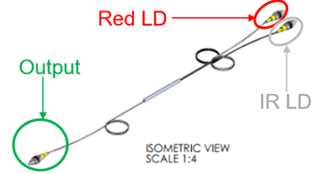

Figure 23 - Drawing of the 50:50 Coupler

Similar to the pigtailed laser diodes, the 50:50 coupler uses a FC/PC connection. Ideally, the output power of both laser diodes would be exactly 50% of the input power. However, due to non-ideal characteristics of the fibers within the coupler, this is not the case. Figure 24 is a graphical representation for the relationship of the output signal strength in respects to the input signal wavelength.

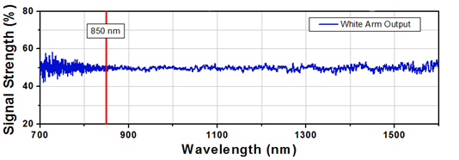

Figure 24 - 50:50 Coupler Performance

The blue line, White Arm Output, represents the output of the optical coupler. The x-axis represents the wavelength of the signal and the y-axis represents the strength of the signal that the coupler outputs. The optimal wavelength for this specific optical coupler is 850 nanometers. This will cause the signal strength for the infrared laser diode (940 nanometer) to be around 50%. However, the signal strength for the red laser diode (660 nanometer) is not directly shown on Figure 24. An applications engineer from Thorlabs verified that the amplitude of the oscillation at 700 nanometer continues as the wavelength decreases. This assured that the red laser diode will output 45% to 55% of its original power.

### 9.4 Y - Cable

The Y- cable that will be used within the optical system is the RP23. The primary purpose of the RP23 will be to couple the pigtailed photodiode with the output of the 50:50 optical coupler. Figure 25 shows the RP23, labeling the inputs for both laser diodes and photodiode, as well as the reflection probe output. Figure 26 shows a demonstration of the reflection probe.

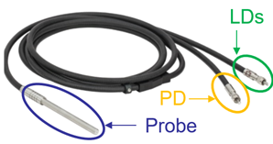

Figure 25 - RP23 Coupler with Reflection Probe



Figure 26 - RP23 Demonstration

The individual optical fibers that are inputted into the RP23 from both the 50:50 optical coupler and photodiode will be protected by a stainless steel inner casing, enclosed within a rubber furcation tubing. The reflection probe will be a three inch long cylinder with a quarter inch diameter. The light sent from the laser diodes will output from the end of the reflection probe, reach the point of measurement, and reflect back. This reflected light will be picked up by the reflection probe, and sent to the photodiode. The reflection probe will be the only portion of the optical system that will not be enclosed. An important aspect about the RP23 is that it has an SMA connection instead of the FC/PC connection used by the 50:50 optical coupler. Figure 27 shows an AutoCAD drawing for the FC/PC to SMA adaptor.

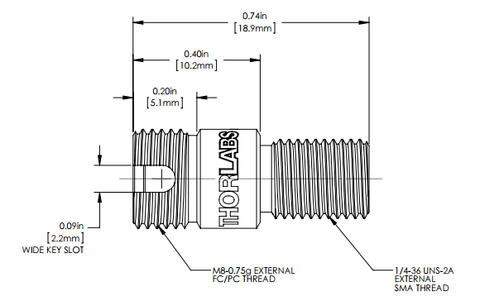

Figure 27 - FC/PC to SMA Adaptor

The FC/PC thread is shown on the left side of the connector, with the SMA thread on the right. The threads are different sizes, therefore incompatible with one another without the use of an adaptor. A special adaptor will be used to connect both optical systems together, allowing for a connection between the FC/PC and SMA connectors.

### 9.5 Photodiode

The sensor that will be used within the OxiScope is the FDSP625, which is a pigtailed PIN photodiode manufactured by Thorlabs. The FDSP625 was chosen over other similar photodiodes due to the detector responsivity over the desired wavelength range. Figure 28 shows the detector responsivity with the x-axis representing the frequency of the signal being sent to the photodiode and the y-axis representing the responsivity in amperes per watt (A/W) of the input wavelength.

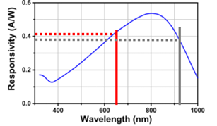

Figure 28 - FDSP625 Typical Responsivity

The FDSP625 photodiode has a wavelength range of 320 nanometer to 1000 nanometer. Both the red and infrared laser diodes will have a responsivity of about 0.4 A/W. Although the FDSP625 is the ideal photodiode to use for the OxiScope, it is not perfect. The FDSP625 is a pigtailed photodiode, meaning that the photodiode itself is directly coupled to a single optical fiber. Unlike the pigtailed laser diodes, the FDSP625 does not have a connector at the end of optical fiber. In order to allow the integration and connection between the photodiode and RP23, Thorlabs will manufacture a custom FDSP625 with an SMA connection for the OxiScope.

### 9.6 Signal Processing

The OxiScope will operate by pulsing the infrared laser diode and red laser diode individually. This light will travel through the designed optical system, and output from the reflection probe. The light will then reach the point of measurement and reflect back to the reflection probe. This reflected light will travel through the optical system to the photodiode. There are two main components within this received signal: an AC component and a DC component. The relationship between these two signals is shown in Figure 29.

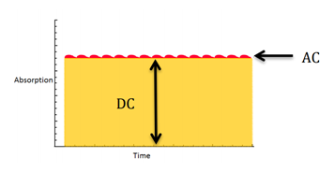

Figure 29 - AC and DC of Received Signal

The AC component of the received signal is the photoplethysmogram (PPG), which allows SpO2 and pulse rate to be calculated by measuring changes in light absorbed by the blood. The AC component is a small percentage of the total signal received and rides on top of a large DC offset. This DC offset occurs due to static absorbencies at the point of measurement such as skin or other non-arterial tissues that maintain a constant absorbance. In order to read the AC component for proper calculations, its signal must be amplified. However, if the signal is amplified before filtering out the DC offset, the AC component will be lost in the noise. To properly amplify the PPG signal, the DC offset must first be filtered out using a band-pass filter. Figure 30 shows the filtering and amplification process that the received signal will go through to calculate SpO2 and pulse rate.

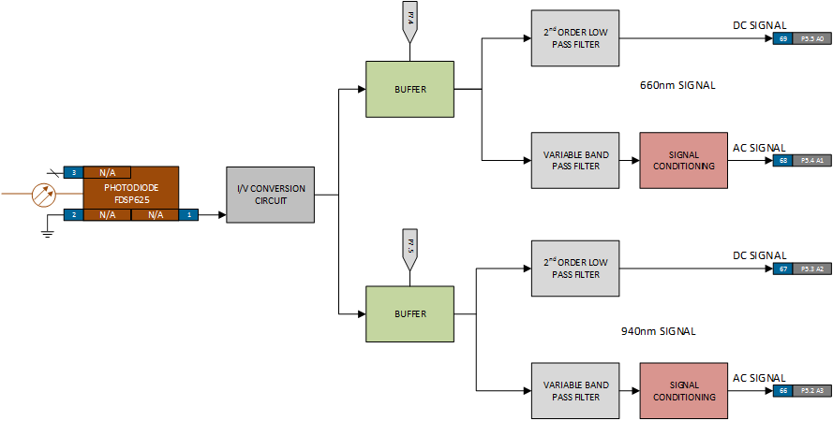

Figure 30 - Signal Processing

The signal processing will be comprised of four main components: current to voltage conversion, operational amplifiers acting as buffers, band-pass and low-pass filters, and signal amplification. The process will begin with the MSP432 activating the N-channel E-MOSFET, powering the laser diodes individually. The reflected light will be received by the photodiode, creating a current. This current will be converted to a voltage, through a current to voltage circuit. To allow for signal isolation, the conversion circuit will feed into two individual buffers. These buffers will be controlled by enables tied to pins on the microcontroller, allowing the desired signal to pass. When the buffer is not enabled, it will act as an open circuit, blocking the signal from passing. The signal that passes through the buffers will be the combined AC signal with the DC offset as shown in Figure 29. This AC and DC signal will then go through two individual circuit paths to isolate the AC and DC components from one another. To isolate the AC component from the DC offset, the signal will be sent through a variable band-pass filter since the specific cutoff frequencies have not yet been determined. With the AC component being very small, the filtered signal will go through a variable gain amplifier, and be read by ADC pins on the MSP432. Like the band-pass filter, the gain for the amplifier has not been chosen, and will be determined during the testing portion of the system design process. To isolate the DC offset, the AC and DC signal will go through a second order low-pass filter with a cut-off frequency of 1.3 Hz, which will be read by the ADC pins on the MSP432.

To validate the potential of this design, a simulation was created using Multisim as the PSpice software. Figure 31 shows the Multisim design containing the current to voltage converter, filters, and variable gain amplifier.

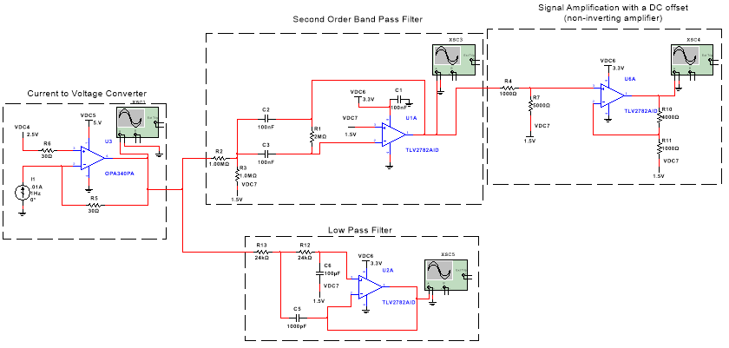

Figure 31 - Signal Processing Simulation

As shown in Figure 31, the signal conditioning circuitry will be composed of two different operational amplifiers. The current to voltage converter will use the OPA340PA, with a power supply of 5 V to ground and 2.5 V offset. Both the filters and the non-inverting amplifier will use the TLV2782AID, which will be powered by a single supply voltage of 3.3 V and an offset of 1.5 V. There are two main reasons why a system with varying supply voltages and varying operational amplifiers was chosen. First, the MSP432 can receive a maximum input voltage of 3.7 V to its ADC pins, because of this; the operational amplifiers connected to the MSP432 must have a supply voltage less than 3.7 V. The second reason for the differing supply voltages is if an operational amplifier supplied by 5 V to ground is chosen, this allows for the current to potentially be converted to a higher voltage. This is beneficial when taking into consideration the characteristics of the signal that the OxiScope will be receiving. The AC component that is being isolated may have a larger peak-to-peak difference at 5 V than 3.3 V.

Figure 31 shows an oscilloscope attached to the output of each section to see the characteristics of that waveform, and the effects that the operational amplifier has on the signal. Figure 32 shows the current to voltage converter, with a signal reading from the oscilloscope.

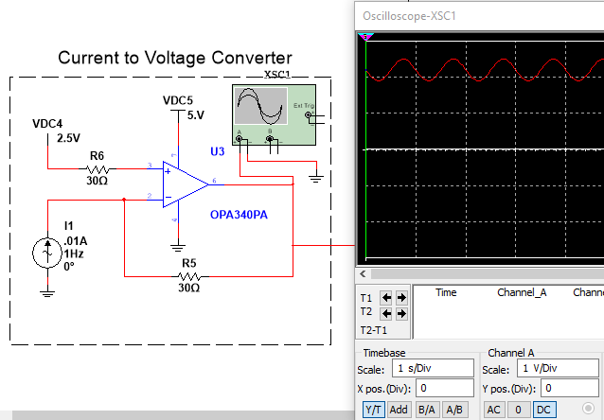

Figure 32 - Current to Voltage Simulation

The AC current source, with a built-in DC offset, provides the signal to the converter, representing the photodiode. The exact amount of current that will be created by the photodiode is unknown, therefore the supply that was chosen is an estimate based off research and past documents. This current then feeds into a typical current to voltage converter. The output waveform of this converter is shown in Figure 32, as a sinusoidal voltage signal. This signal has both the AC and DC components that will later be isolated from one another. This signal will be fed into both the band pass filter and the low pass filter. Figure 33 shows the block simulation for the second order low pass filter.

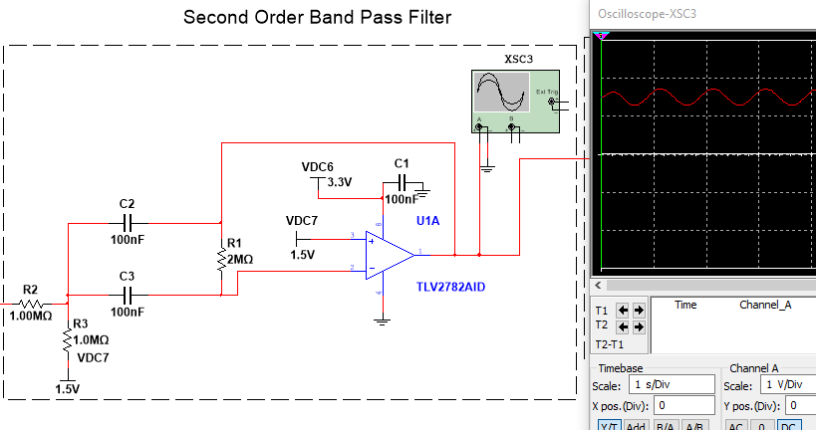

Figure 33 - Band Pass Filter Simulation

The purpose of the band pass filter is to isolate the AC component from the DC offset. This is shown in Figure 33, with the AC signal riding on a 1.5 V offset. The offset ensures that the signal is not cut off due to the operational amplifier being powered by 3.3 V. This signal is then fed into a non-inverting amplifier with a variable gain, the simulation and waveform is shown in Figure 34.

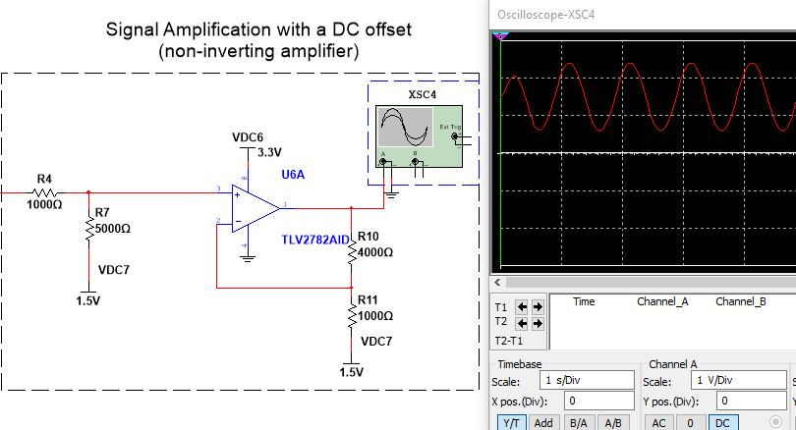

Figure 34 - Non-Inverting Amplifier Simulation

The non-inverting amplifier will have a variable gain as well as a variable offset. The signal may require larger amplification than what is shown in the simulation, as well as require an additional offset to ensure the signal is not cut-off. The signal simulation is shown in Figure 34. This signal will then feed directly to an ADC pin on the MSP432, which will then make the proper calculations to determine the oxygen saturation as well as the pulse rate. In order to isolate the DC signal from the received converted voltage, the signal will go through a low pass filter, shown in Figure 35.

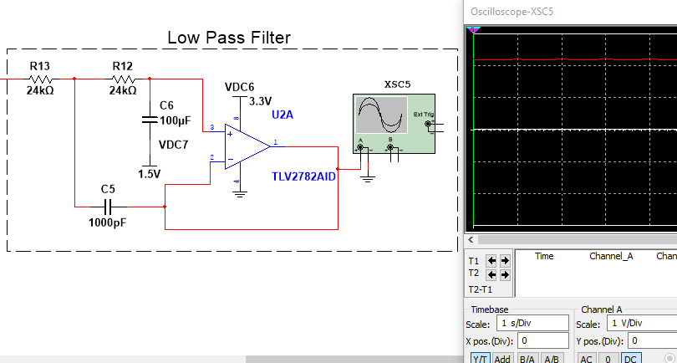

Figure 35 - Low Pass Filter Simulation

Similar to the band pass filter and non-inverting amplifier, the low pass filter will have a single power supply of 3.3 V with a 1.5 V offset. The filter removes the AC signal riding on top of the DC offset. This simulated signal is shown in Figure 35, which will then feed into a separate ADC pin on the MSP432.

## 10 Communication Interfaces/Protocols

The OxiScope utilizes two primary communication protocols, Universal Asynchronous Receiver/Transmitter (UART) and Bluetooth Low Energy V4.0. The communication aspect is critical for the OxiScope to achieve all of the functional requirements and performance specifications regarding communication.

### 10.1 UART

UART will be used in the communication channel between the MSP432 and the CC2650, as well as between the BLED112 and the LabVIEW application. Information will be sent at 9600 bits per second, with eight data bits, no parity bit, and one stop bit. 9600 bits per second was chosen because it is a reliable speed with low chance of data collision, while also being fast enough to meet the performance specification set forth by the stakeholder. No parity bit is included in these messages due to its low-level form of error detection and the addition of a data integrity byte attached to the end of each of the messages. All of the devices used will be set to the same standard as is required by the protocol. The TX of the microcontroller will be tied to the RX of the CC2650, and the TX of the CC2650 will be tied to the RX of the microcontroller. On the laptop side, the BLED112 creates a virtual communication port to send information to the LabVIEW GUI. This information will be in UART format which LabVIEW and the BLED112 both support. Information will be sent in groups of bytes called messages. The message groups are oxygen saturation, pulse rate, battery level of the device, and light acquisition time. An example message group is shown in Figure 36.

C:\Users\nwiat\AppData\Local\Microsoft\Windows\INetCache\Content.Word\bluetooth packet (5).png

Figure 36 - Example Message Group

Figure 36 shows a full oxygen saturation message. Each message group begins with an identifier byte. This byte is either an ASCII ‘S’, ‘P’, ‘B’, ‘K’, ‘N’, ‘L’, or ‘G’ for oxygen saturation (SpO2), pulse rate, battery level, acknowledge, non-acknowledge, light acquisition time, or go from LabVIEW, respectively. The identifier byte informs the LabVIEW application what type of information it is receiving so it can properly display the information. The next set of bytes are data bytes, which are the actual values of the data type that was specified in the identifier byte. Oxygen saturation and pulse rate have three data bytes, battery level and light exposure time have two data bytes, and the acknowledge, non-acknowledge, and go from LabVIEW all have zero data bytes. In the example shown in Figure 36, the values 9 7 3 will be interpreted as 97.3% oxygen saturation level, where the leading data byte will be the tens place, the middle data byte will be the ones place, and the trailing data byte will be the tenths place. In the pulse rate message the leading data byte will be the hundreds place, the middle will be the tens place, and the trailing will be the ones place. The battery level message will have the leading data byte be viewed as the tens place and the trailing data packet be viewed as the ones place. The final byte of the message group is the data integrity byte; all of the different message group types excluding the acknowledge, non-acknowledge, and go will have an 8-bit CRC, to determine if any errors were introduced during the communication. This CRC will be calculated on the LabVIEW application side as well as the microcontroller side to ensure that it is correct. The time to transfer a five-byte message from the microcontroller to the CC2650 at 9600 bits per second is 4.7 milliseconds. This is the same time it takes to communicate between the BLED and the LabVIEW application.

### 10.2 Bluetooth BLE V4.0

Bluetooth Low Energy V4.0 will be the wireless communication protocol used for the OxiScope, and will be used between the CC2650 and the BLED112. Bluetooth BLE V4.0 operates at 2.4 GHz, which is the same as standard Bluetooth, with information being sent at up to 25 MBps. In this protocol, the CC2650 will be the master and the BLED112 will be the slave. This means the CC2650 will make the initial connection after scanning for advertisement packets from the BLED112. Once the connection has been made, the CC2650 will send packets over the Bluetooth channel. Figure 36 shows that the Bluetooth packet has an access code, a header, and the payload. The access code identifies the master and includes the synchronization bits for the receiving device, while the header block contains the slave address, the data type, and the checksum for the Bluetooth packet. The payload for this packet will be the message group described in the UART communication channel.

### 10.3 Message Sequence

The message sequence diagram is a chart that clearly shows how the information will be sent by the OxiScope and how the communication error handling will be implemented. The message sequence diagram is shown in Figure 37.

C:\Users\nwiat\AppData\Local\Microsoft\Windows\INetCache\Content.Word\comm diagram rev2 (5).png

Figure 37 - Message Sequence Diagram

The first message that will be sent from the application is the Start button being pressed, which can be sent at the same time as the Light Acquisition Time message. This will travel the full communication channel which starts at the LabVIEW application to the BLED112 via UART, from the BLED to the CC2650 using BLE V4.0, and from the CC2650 to the MSP432 via UART. This is the communication path that all messages will take. Once the MSP432 has received the Light Acquisition Time message and ensured that the value is valid by checking the 8-bit CRC, it will send back an acknowledgement packet to the LabVIEW application. The first message that will be sent from the MSP432 to the application, after the start message has been received, is the oxygen saturation message value. If an ASCII ‘N’ is received back from the application or the timeout value - 84 milliseconds - has been reached, the MSP432 will send the oxygen saturation level another time. If there is a non-acknowledgement or a timeout three times in a row, the CC2650 and the BLED will be disconnected, as indicated by the danger symbol on the diagram. This error handling is the same for all message groups even though it is only shown underneath the SpO2 message group. The timing value is three times the time it takes to send five bytes from the MSP432 to the LabVIEW application added to the time it takes and acknowledgement packet to return from the LabVIEW application and be received by the MSP432, which is 28 milliseconds, resulting in an 84-millisecond timeout value.

## 11 Flowchart

This section covers the software flowcharts of the OxiScope. Flowcharts are diagrams that explain the flow of a process. Software flowcharts visually show the flow of a program. This allows the viewer to grasp the idea of what a program does while also allowing for an easy transition from an idea into actual code. Figure 38 is a legend for the various symbols found in flowcharts.

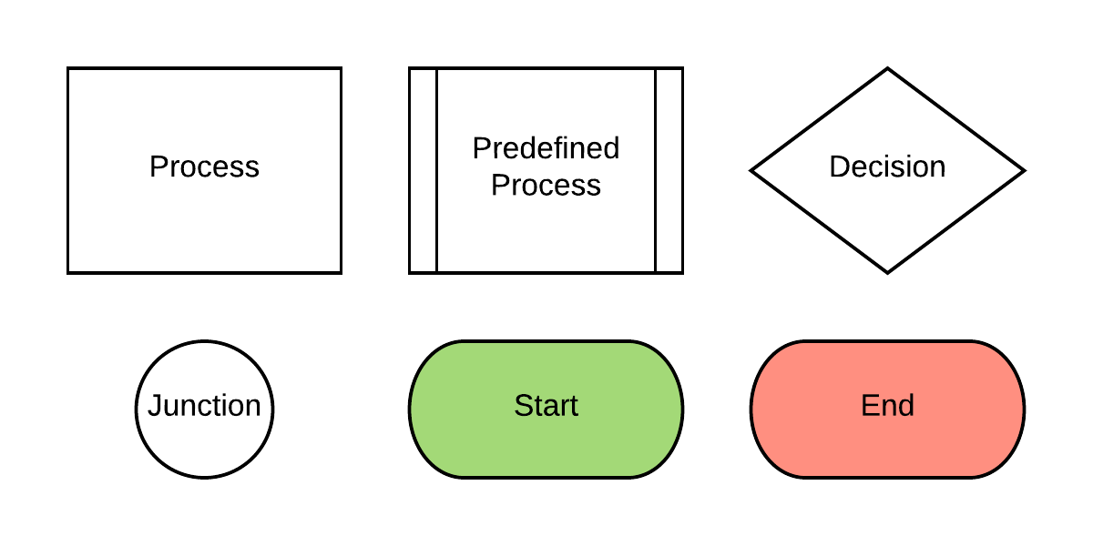

Figure 38 - Flowchart Legend

Starting from the top-left, processes are represented by a square. Processes are a series of steps to accomplish a task. To the right of that is the rectangle with two vertical bars. This represents a predefined process, which is a process defined in another flowchart. Next, the diamond is a decision block. This block branches out to other blocks based on the answer to the question inside the block. On the bottom-left, junctions are represented by circles. These gather multiple arrows into a single arrow, which makes the flowchart easier to read. To the right of that are the start and end blocks, which represent the beginning and end of a routine. The end block might also return a value from the subroutine.

A hierarchy chart is a visual representation of which routines call each other in order to identify where functions need to be made in order to reduce redundancy. The top row contains routines that are not called on by other routines. All of the other rows are called by the function connected to it. Figure 39 shows the hierarchy chart for the MSP432.

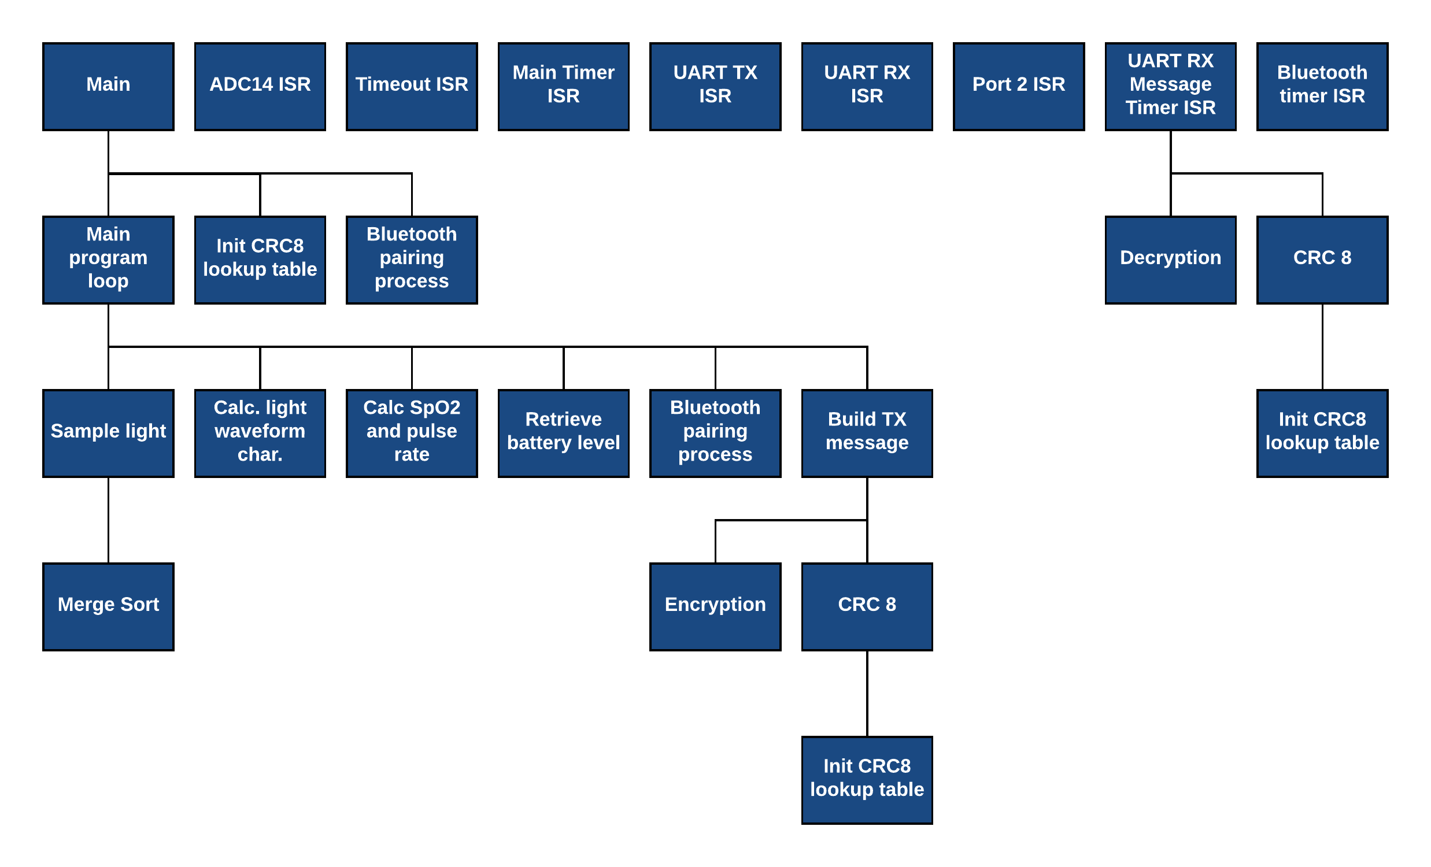

Figure 39 - MSP432 Hierarchy Chart

The first row contains the main program as well as all of the interrupt service routines (ISR). Main is not called by anything else, and neither are the ISRs. Connected to main are the main program loop and any initialization subroutines. The main program loop calls multiple subroutines that are not related to one another. The entire program could be made into a single subroutine, but breaking functions down makes development and testing easier. The only ISR that calls a subroutine is the UART RX Timer ISR due to its need to decrypt and check the 8-bit CRC. Initializing the 8-bit CRC lookup table will be called multiple times to ensure that the table is calculated to create the 8-bit CRC.

Figure 40 shows the main program that performs setups on many of the MSP432’s subsystems.

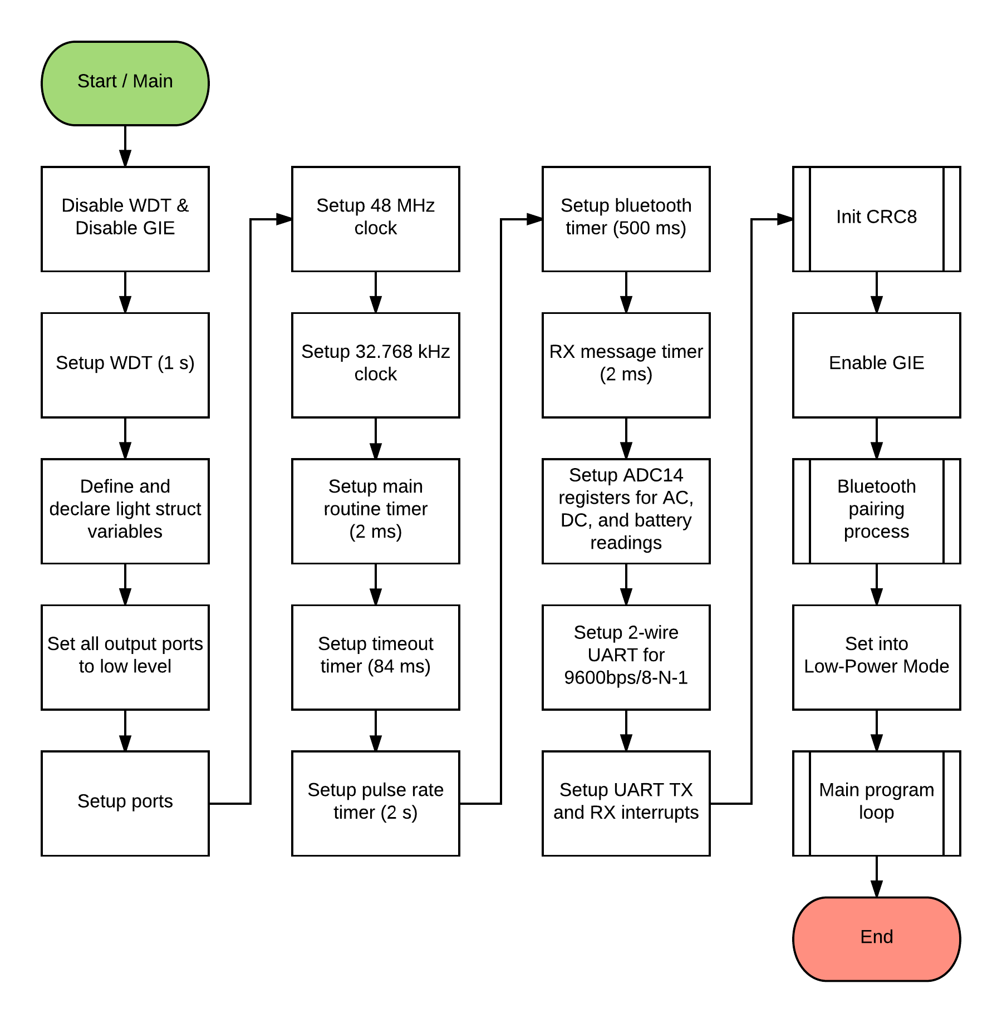

Figure 40 - Main Initialization

The routine starts by disabling the Watch Dog Timer (WDT) and Global Interrupt Enable (GIE). This prevents the system initialization from being interrupted or reset from anything other than the reset pin. Next, the WDT is configured for one second; this value was chosen because it is long enough to allow the system to free itself but short enough to provide a quick response to issues. Then, the assorted variables used throughout the program will be defined and declared. Next, all the output ports are set to low in order to save power from leaking out of the outputs. Afterwards, the various general-purpose input outputs (GPIOs) are setup. Next, the 48 MHz high-speed clock and the 32.768 kHz slow clock sources are set up. Then, all of the various timers are setup. The main routine timer is set to two milliseconds, the timeout timer to 84 milliseconds, the pulse rate timer to two seconds, the Bluetooth timer to 500 milliseconds, and the UART RX message timer to two milliseconds. Then, the UART registers are setup for 9600 bits per second with eight data bits, no parity bit, and one stop bit. Next, the UART interrupts are setup. Then, the 8-bit CRC lookup table is created for a different subroutine. Next, the GIE is enabled and the Bluetooth paring process is started. Finally, the MSP432 is set into low-power mode, which it will exit once the user starts the measurement taking process.

Figure 41 shows the MSP432’s Bluetooth pairing process.

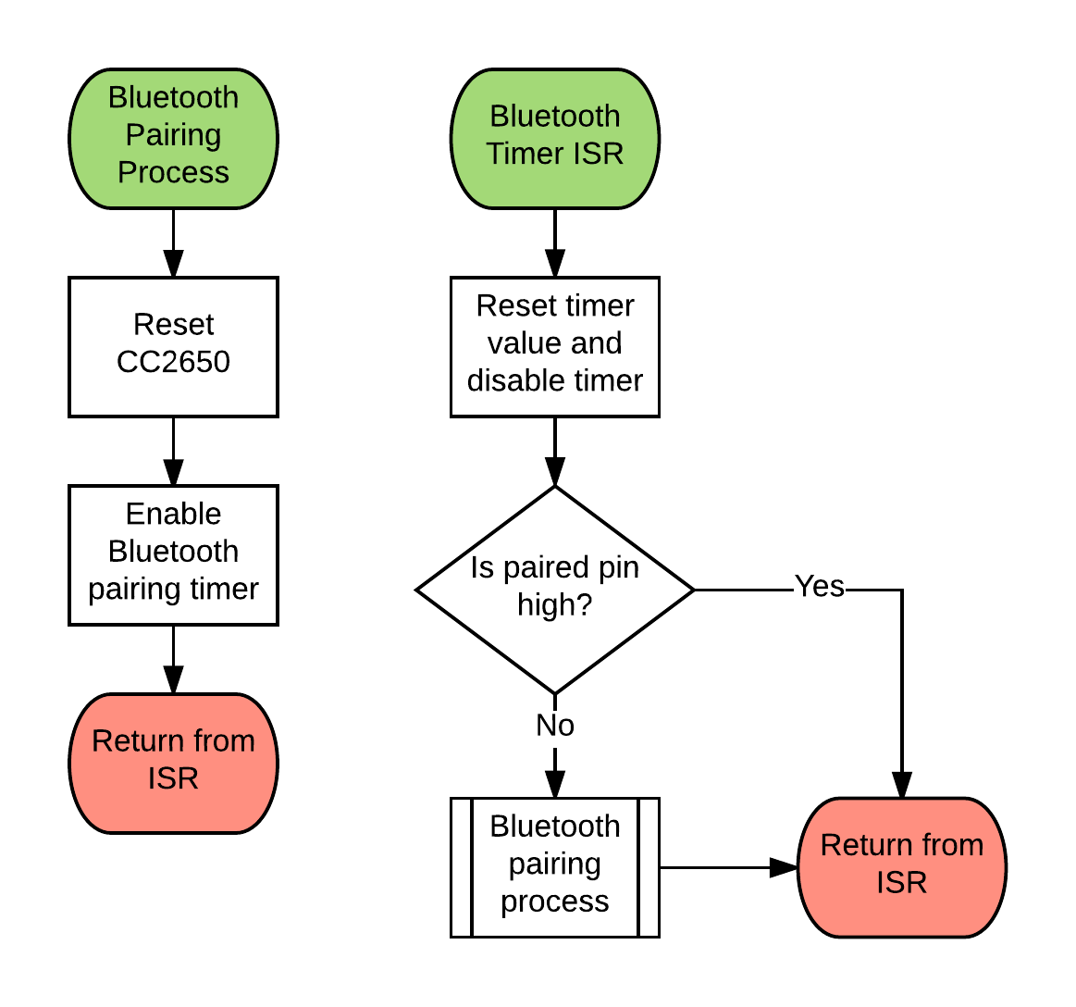

Figure 41 - Bluetooth Pairing Process

The pairing process starts by resetting the CC2650, which will go through a separate pairing process. It then starts the Bluetooth pairing timer. When the timer expires, the program goes into the Bluetooth Timer ISR. This service routine starts by resetting and disabling the pairing timer. Then it checks to see if the paired pin is active, if it is, then Bluetooth is paired so nothing happens. If the two devices are not paired, the system will go through the process again.

Figure 42 shows the main program loop where the MSP432 performs the measurement taking process.

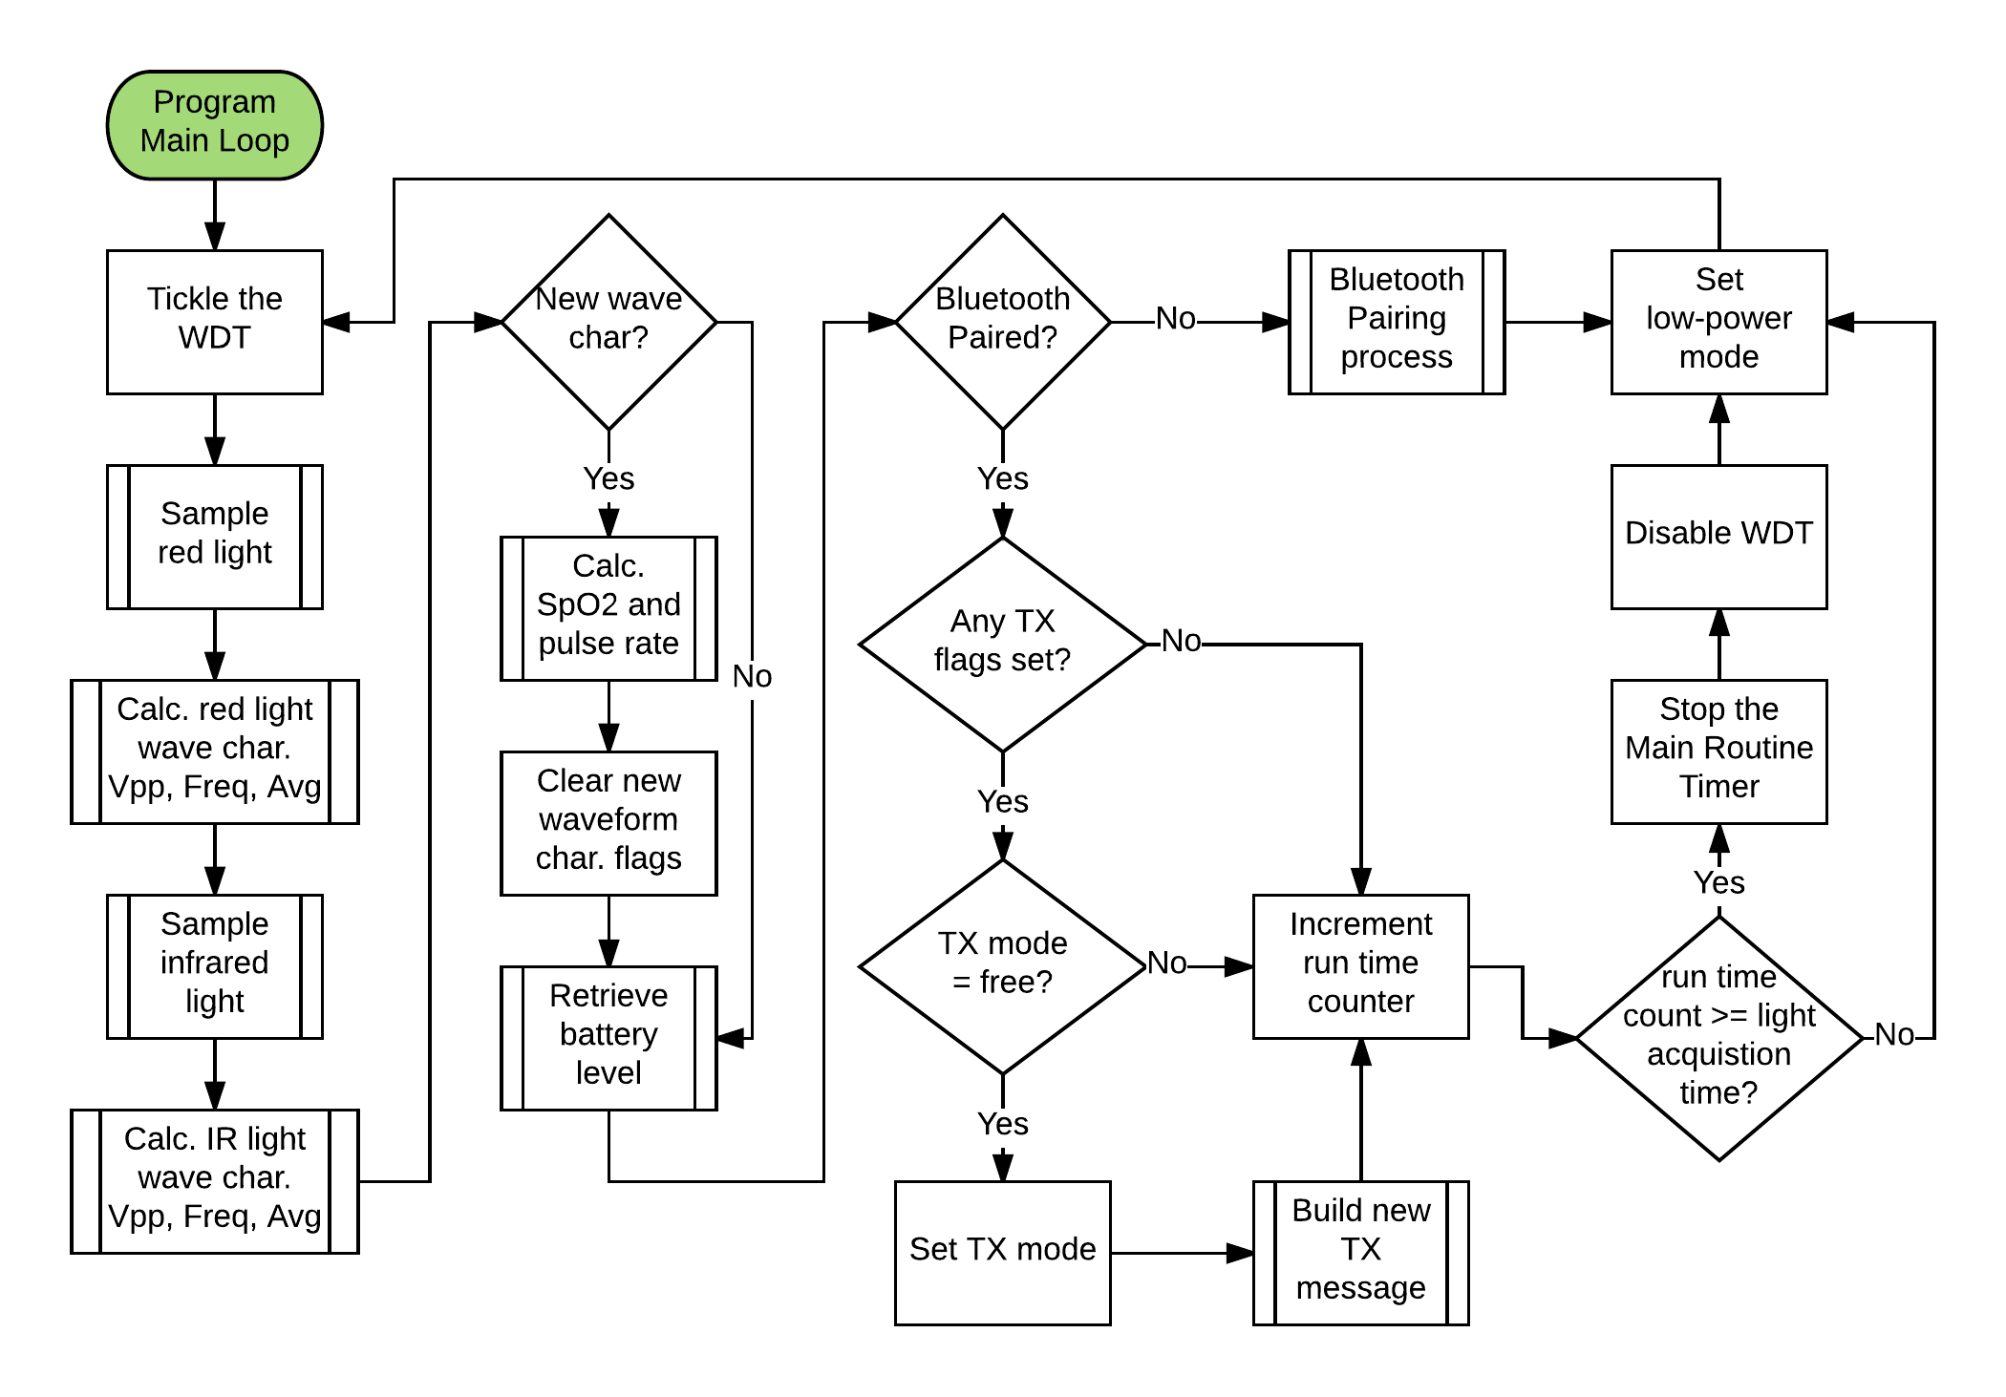

Figure 42 - Main Program Loop

This entire routine occurs every two milliseconds. The process starts by tickling the WDT so that the hardware is not reset. Next, it samples the red laser diode and calculates voltage peak-to-peak, frequency, and the average DC voltage of the waveform. This sequence is repeated for the infrared laser diode. Then, it will check to see if there are any new waveform characteristics. If there are, then it calculates a new SpO2 and pulse rate then clears the new characteristics flags. If no new waveform characteristics are measured, no new calculations will be made. Next, the battery level is sampled and calculated. The next step is to see whether Bluetooth is paired. If the CC2650 is not paired with the BLED112, the device goes through the Bluetooth paring process. However, if it is paired, the OxiScope checks to see if any of the transmission (TX) flags are set. If flags are set, the program will check to see if the TX state is free. If none of the TX flags are set or the TX state is not free, then the run time counter will be incremented. However, if the TX state is free, then the TX state is changed, a message is built, and the run time counter is incremented. If the run time counter is greater than the Light Acquisition Time set by the user, then the main routine timer is stopped, the WDT is disabled, and the device is put into low-power mode. If the counter is not greater than the Light Acquisition Time then measurements are still being taken and the device is set into low-power mode, waiting until the main routine timer starts the loop again.

Figure 43 shows the assorted ISRs used throughout the program.

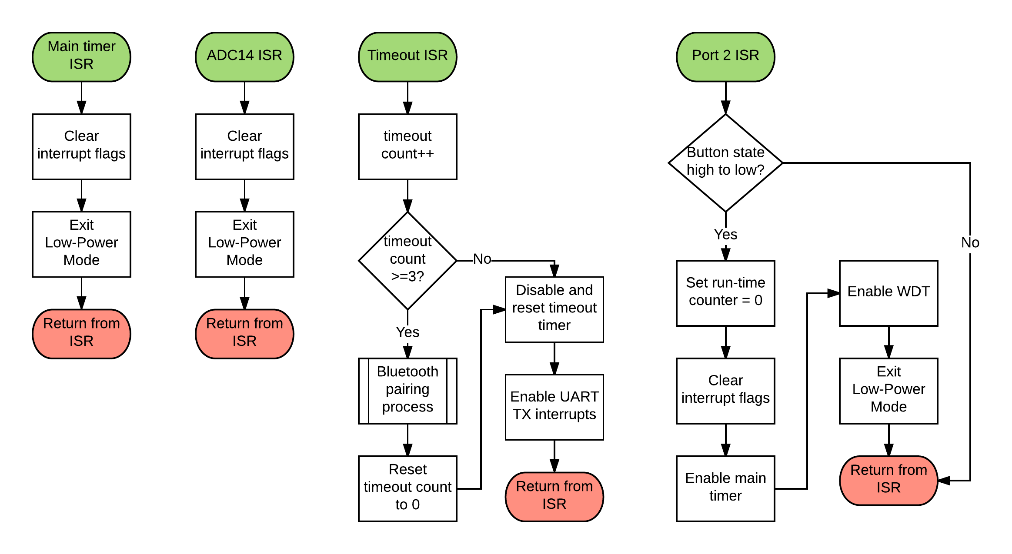

Figure 43 - Assorted ISRs

The main program timer is shown first in Figure 43. It interrupts every two milliseconds and exits low-power mode to continue the main program loop. Next is the ADC14 ISR, which will be used during the sampling process to let the MSP432 know that a sample conversion is complete, conserving battery life. The Timeout ISR will start by incrementing the timeout counter and checking to see if the counter is greater than or equal to three. If the count is not greater than or equal to three then the timer gets reset and disabled and the TX message is resent, which will enable the timeout timer again. If it is greater than or equal to three, then there is a problem with the communication and the Bluetooth pairing process is performed. The counter will be reset, timeout timer is disabled and reset, and the TX message is resent. Finally, the Port 2 ISR will start by checking to see if the button’s state changed from high to low. If it has, the runtime counter is reset, main routine timer is started, WDT is enabled, and the device exits low-power mode.

Figure 44 shows the light sampling process.

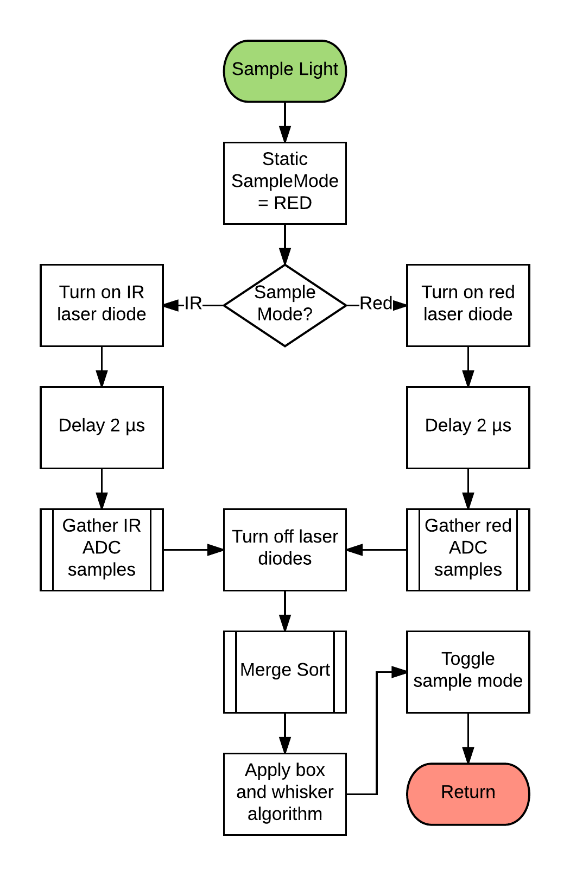

Figure 44 - Sample Light Process

The light sampling process starts by declaring a static variable named “sampleMode” as red. This is only declared the first time this subroutine is called. Afterwards, sampleMode is checked and, depending on its state, it turns on either the red or IR laser diode, and then waits two microseconds. The process then gathers the corresponding samples and turns off the diodes. The new array of samples is sorted using a merge sort and a box-and-whisker algorithm is applied to the sorted array to find a single value. Finally, sampleMode is toggled so that next time the subroutine is called it samples the other light.

Figure 45 is a visual explanation of the way the waveform will be sampled. The floppy disk icons represent attributes that will be saved; “A” is amplitude, “T” is a timestamp. The lock icon represents the sample where either the current maximum or minimum will be locked in, and the flag icon represents various flags being set.

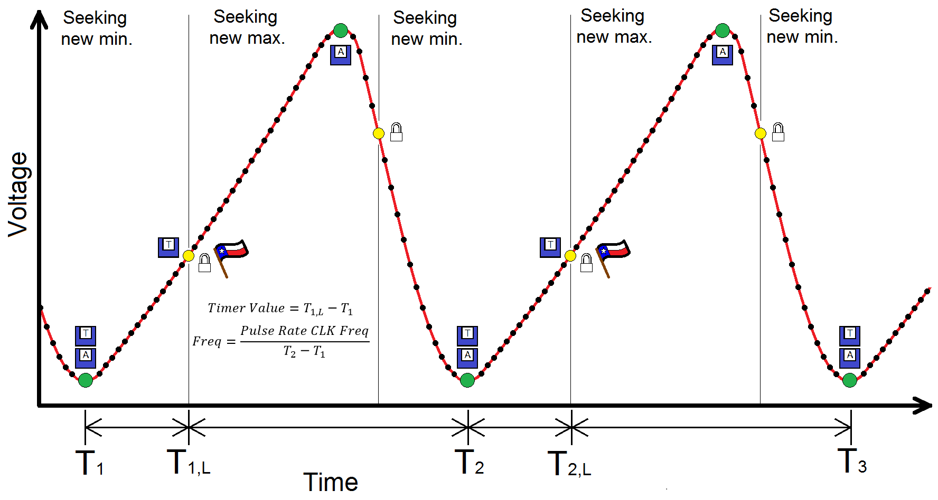

Figure 45 - Example of a Sampled Waveform

Starting at T1, the time and amplitude are saved since it is the lowest value. After a number of samples, T1, L will be reached, this will lock in the current minimum amplitude and timestamp. This also saves its own timestamp, toggle the sampling mode, and set a series of flags to start calculating new values. The reason the flags are set only on a new minimum is due to the fact that there is more time to process the values on the upward slope in comparison to the downward slope. The device will then begin looking for a new maximum. When a new maximum is reached, the amplitude will be saved. Like the minimum, the routine waits for a specific number of samples, then locks in and toggles the seeking mode. This process repeats until measurements are no longer being taken.

Voltage peak-to-peak (Vpp) is the difference between the saved maximum and minimum amplitudes. Frequency is the pulse rate timer’s clock frequency divided by the difference between the T2 and T1 timestamps. A potential problem is that the timestamps used to calculate frequency could overlap. This issue can be fixed by setting the timers current count value equal to the difference between the minimum timestamp and the timestamp that was locked in. This effectively resets the timer when the minimum is found. Figure 46 shows the flowchart that implements the sampling method.

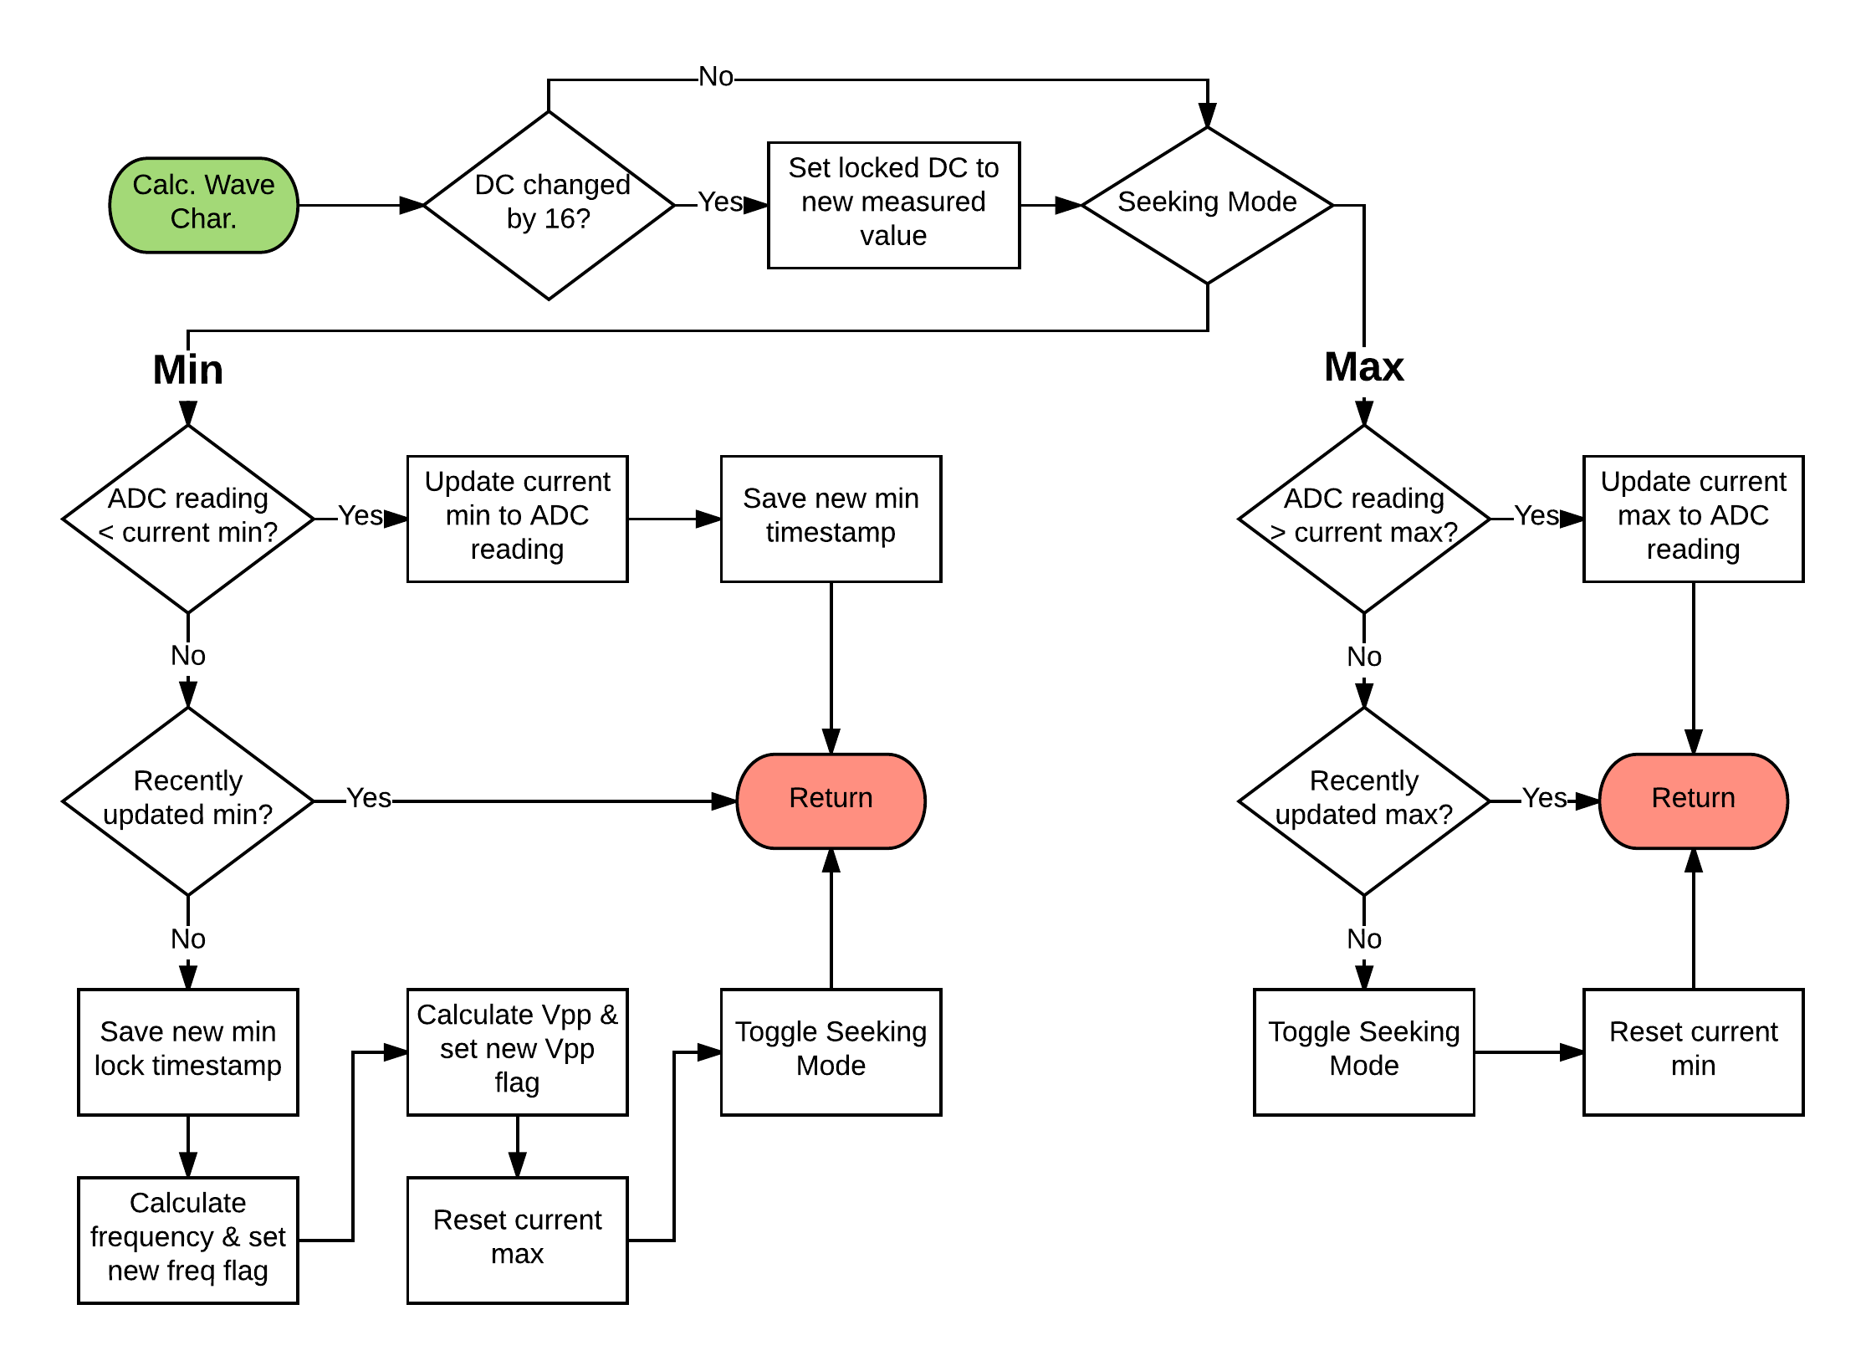

Figure 46 - Calculate Waveform Characteristics

The subroutine starts by checking to see if the DC reading has changed significantly. A significant change is defined by sixteen steps in either direction. This is because the ADC14 has 14-bits, while the SpO2 is represented by 10-bits of data. Two to the power of the difference gives sixteen steps. If the DC value has significantly changed, then the value is saved. Next, the seeking mode is checked. If the device is looking for a new minimum then it will check to see if the ADC14 reading is lower than the current minimum. If a new minimum is found, then the current minimum is updated and a timestamp is saved. If the read value is not smaller than the current minimum then the routine checks to see if it is time to lock in the minimum amplitude. If it is not, then nothing happens. However, it if is time, the locked timestamp will be saved, the frequency and Vpp value flags are set, the current maximum is reset, and the seeking mode is toggled. Setting the timer count to the timestamp difference is done inside of the frequency calculation.

If the device is looking for a new maximum, it will check to see if the ADC14 value is larger than the current max. If the value is larger, the current maximum will be updated. If it is not larger, much like the minimum, it will check to see if it is time to lock in. If it is time to lock in, the seeking mode is toggled and the current minimum is reset.

Figure 47 shows how the SpO2 and pulse rate will be calculated.

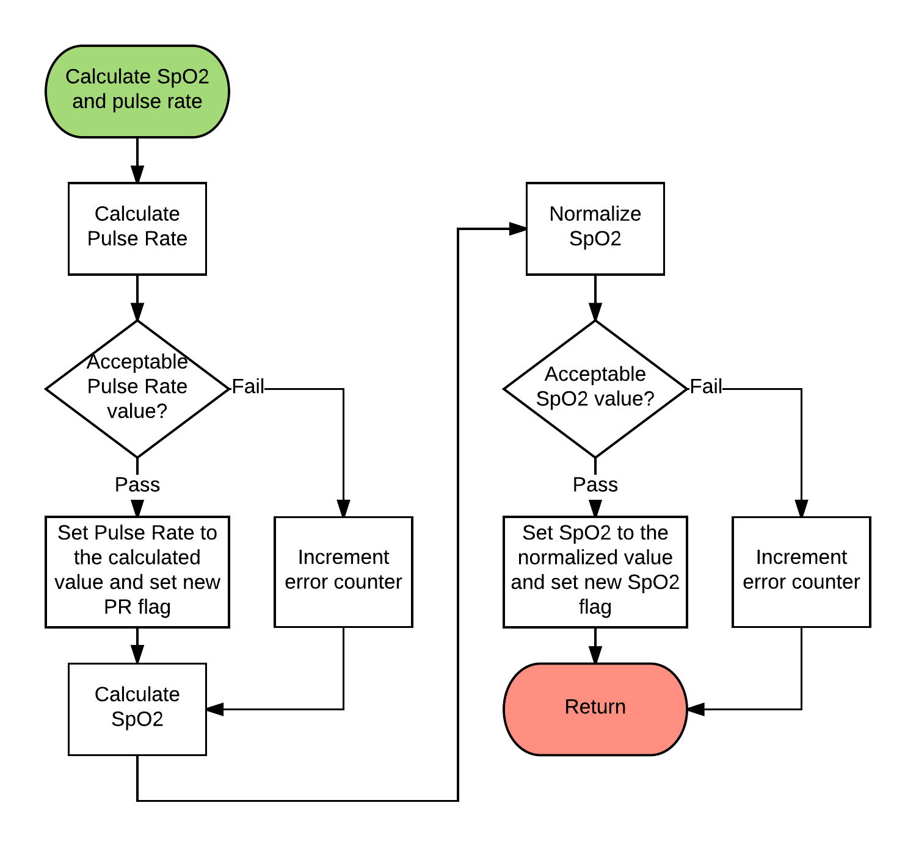

Figure 47 - Calculate SpO2 and Pulse Rate

First, the routine will calculate the pulse rate and check to see if the value is at an acceptable level, ranging from zero to 240. This is because the human heart cannot beat faster than 240 BPM. If the value is valid then it as well as the TX flag will be set. However, if the value is not in the acceptable range, then the value will not be saved. This process will repeat for calculating the SpO2 value. The acceptable range for SpO2 is between 0% and 100%. The equations for SpO2 and pulse rate are as follows:

Figure 48 shows how the battery level will be measured and calculated.

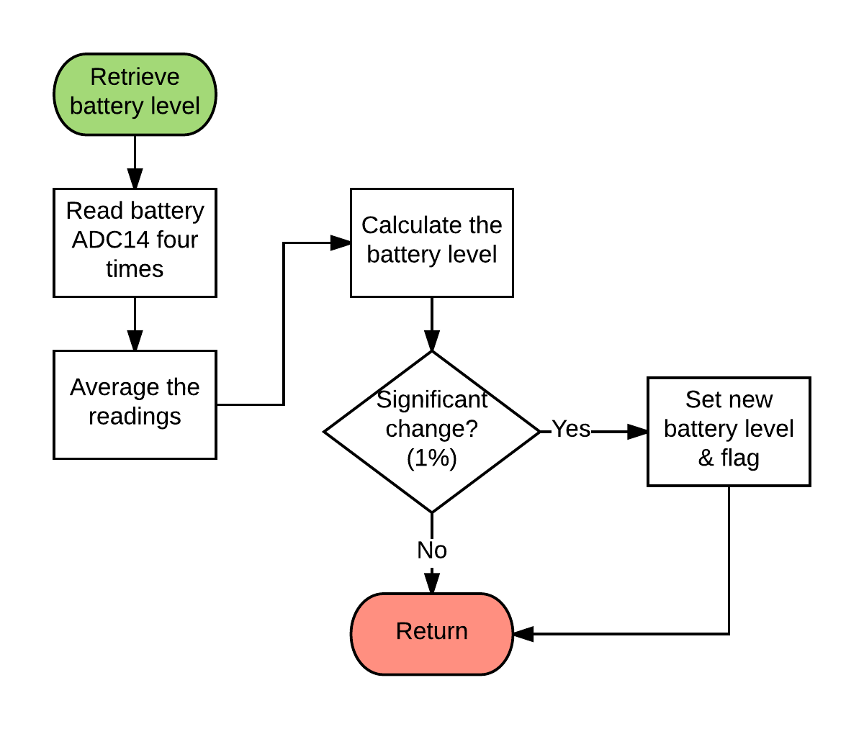

Figure 48 - Retrieve Battery Level

This subroutine starts by sampling the ADC14 four times and averaging the readings. These samples are used to calculate the battery level using a best-fit line. If the change is ± 1% then the battery level is updated and the TX flag is set.

Figure 49 shows how the TX messages will be built.

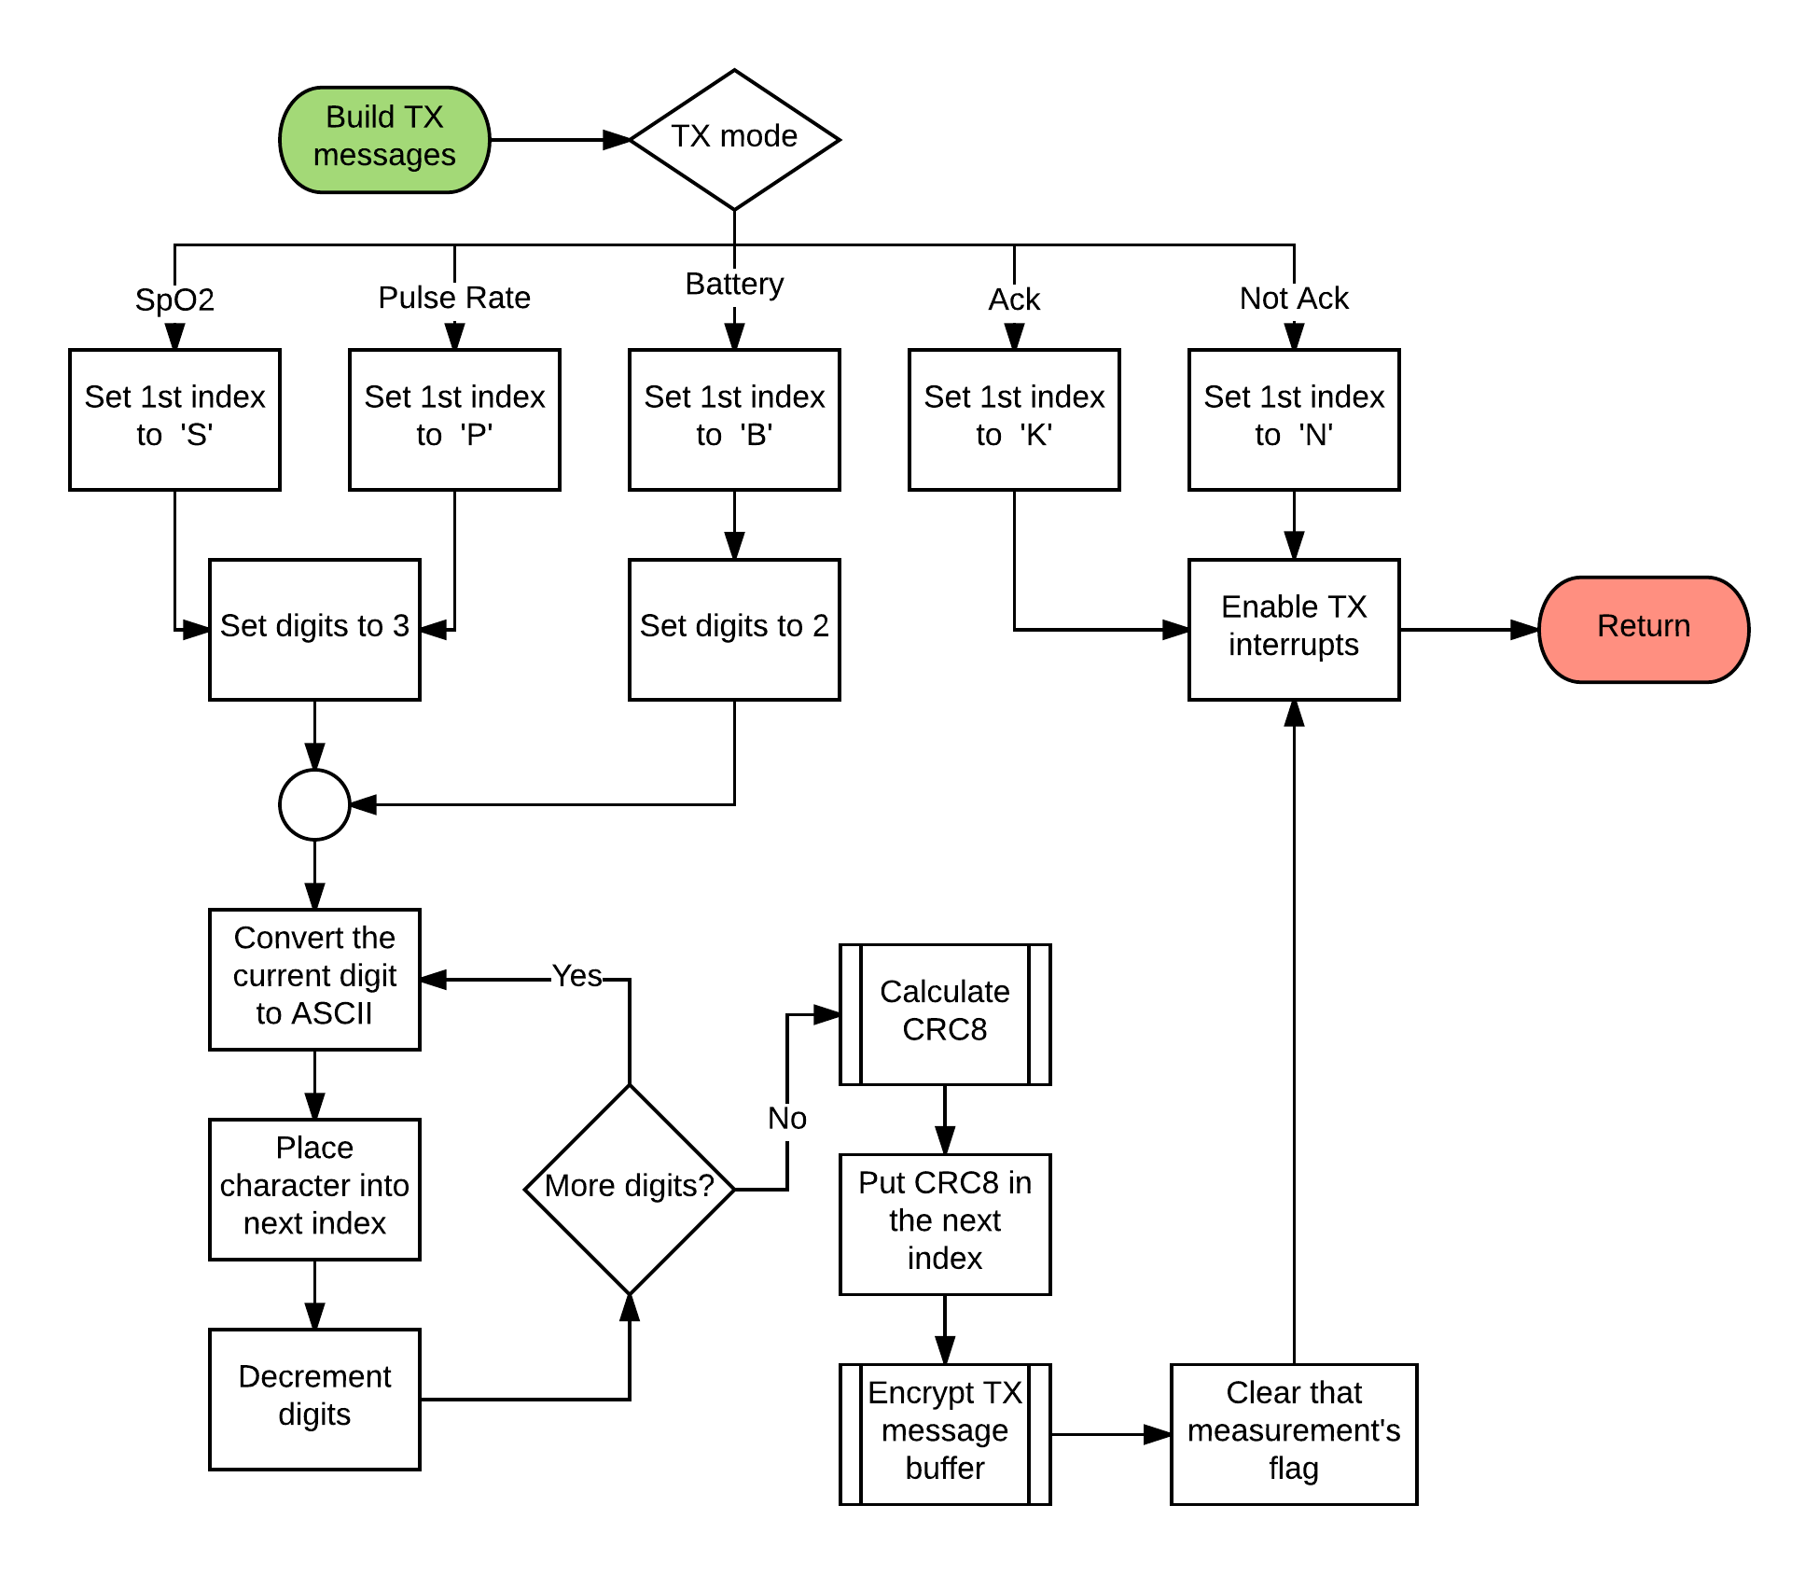

Figure 49 - Build TX Message

Building the TX messages starts by checking the TX mode. When building an SpO2 message, the first index is set to ‘S’; then the number of digits is set to three because the SpO2 value is represented by three digits. The most significant digit is converted to ASCII and placed into the next index. This process continues until all of the digits have been converted. Afterwards, the 8-bit CRC is calculated and placed into the final index. Next, the message is encrypted and the SpO2 TX flag is reset. Finally, the TX interrupts are enabled to push the message through the UART communication.

Figure 50 shows the TX ISR which is called whenever the TX buffer is ready to transmit the next byte.

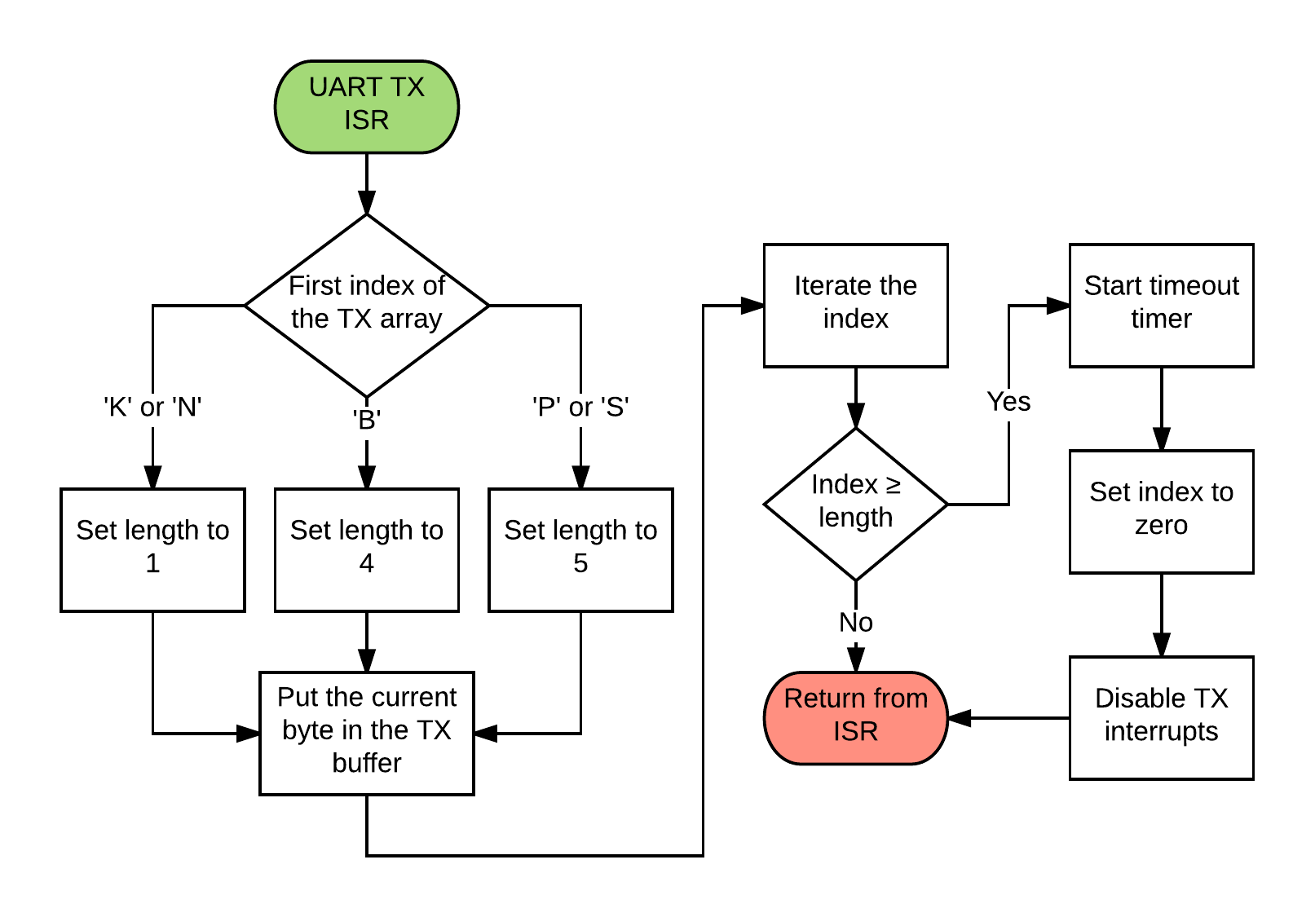

Figure 50 - UART TX ISR

An important aspect about this service routine is that it doesn’t send the entire message in one iteration. The ISR is called once for every byte in a message until the entire message has been sent. The service routine will start by checking the first index of the array for the identifier and will set the length accordingly. Next, the ISR will place the current byte into the buffer and iterate the index, ensuring that the next time the ISR is called it will send that byte. If the index is longer than the length, then the entire message was sent. In this case, the timeout timer is started, the index is set to zero, and the TX interrupts are disabled.

Figure 51 shows the 8-bit cyclic redundancy check subroutines. The initialize CRC8 lookup table will speed up processing by creating a lookup table for the CRC8 subroutine to utilize.

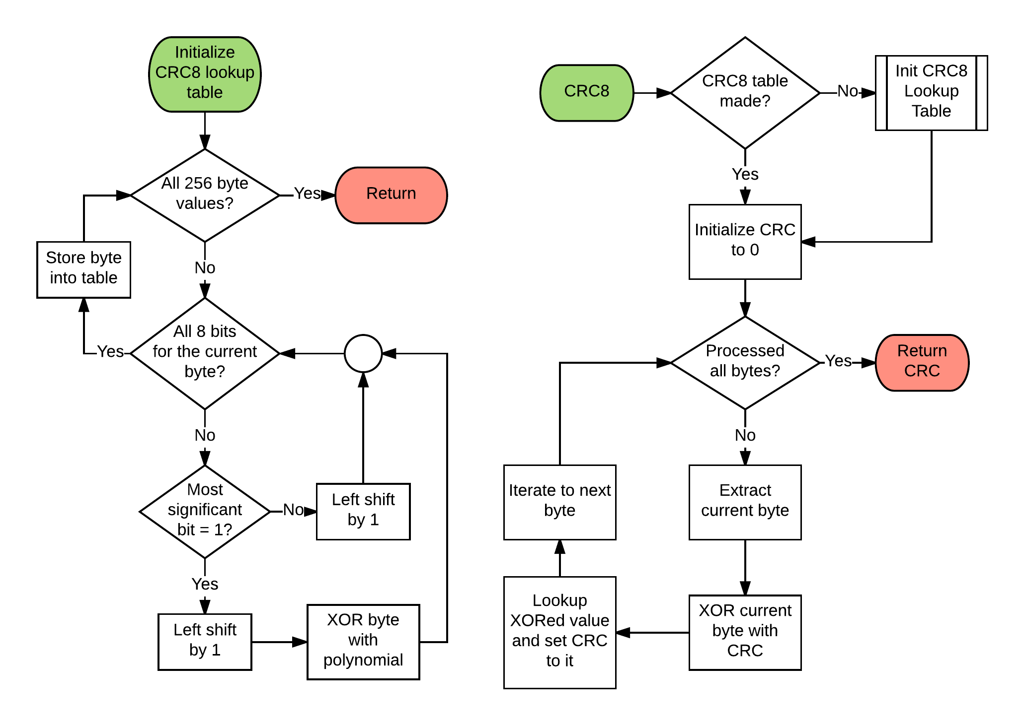

Figure 51 - 8-bit CRC Related Subroutines

The initialize CRC8 lookup table subroutine starts by checking to see if all 256 possible byte values are calculated. If not all the values have been calculated, the routine will check to see if all eight bits of the current value have been processed. If so, the value is saved into the table. If not, the routine will check to see if the most significant bit is a “1”. If the most significant bit is not, the value is left shifted by one. If it is, the value is left shifted by one and XORed with the preselected CRC polynomial.

The CRC8 subroutine begins by making sure the lookup table has been made. If the table has not been made, the initialize CRC8 lookup table subroutine will be called. If the table has been made, then the CRC value is initialized to zero. Next, the subroutine checks to see if every byte in the message has been processed. If not, then it will extract the current byte, XOR it with the current CRC value, look up the new value in the lookup table, and move on to the next byte. If the message is complete, then the CRC value is returned.

Figure 52 show the polyalphabetic substitution cipher encryption and decryption process used by the OxiScope.

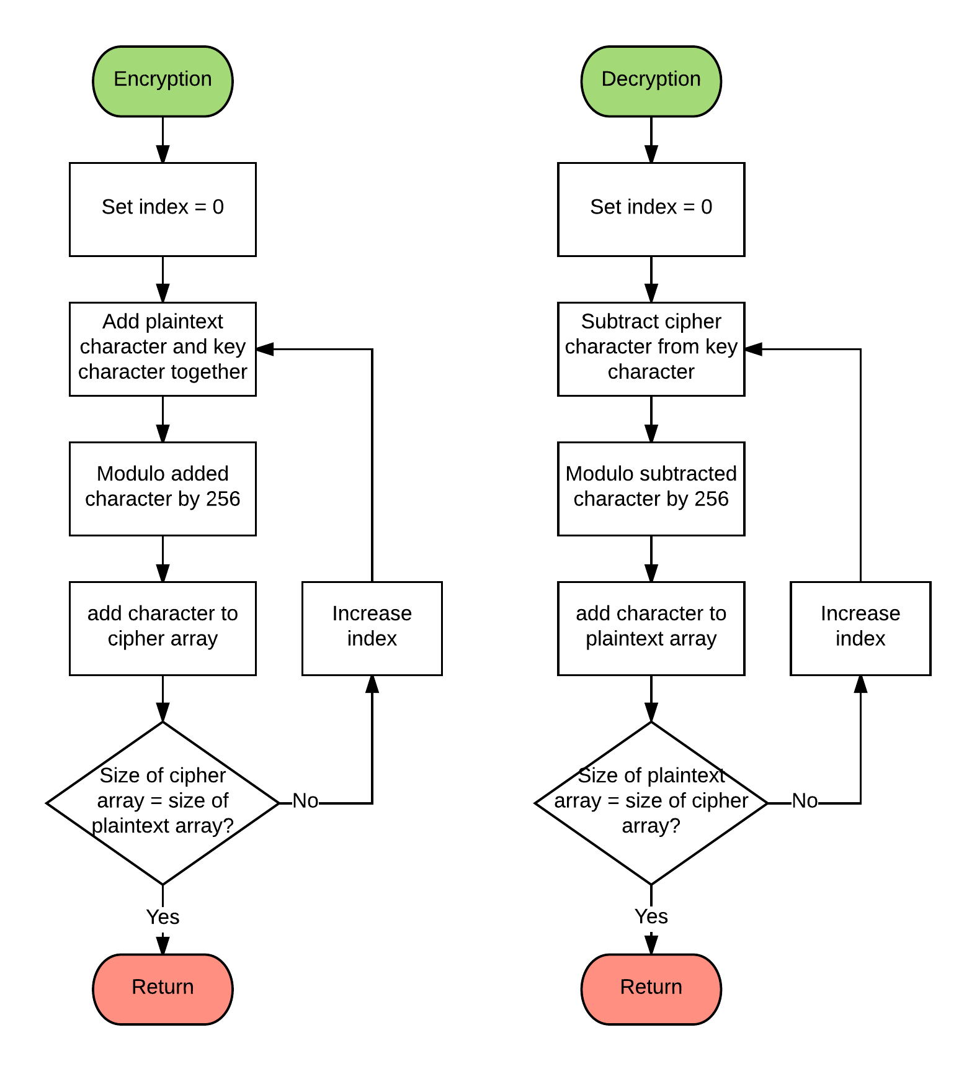

Figure 52 - Polyalphabetic Substitution Cipher Encryption and Decryption

Both the encryption and decryption algorithms are similar to each other. The encryption routine will set the index to zero so it starts at the beginning of the message. The current byte is added to the secret key and modulo by 256 to give the cipher byte. This byte is then put back into the message. This repeats until the whole message is encrypted. The decryption algorithm is similar, except that the cipher text will be subtracted by the key to recover the plaintext.

Figure 53 shows how the UART interface will receive and process messages.

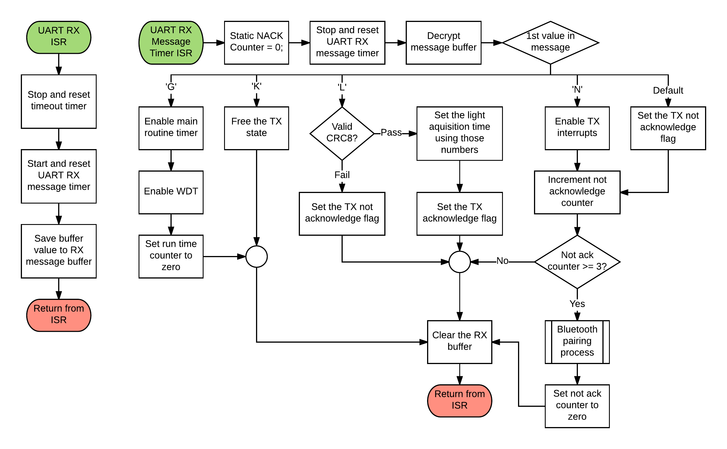

Figure 53 - UART RX Subroutines

The receive message process begins with the UART receiver (RX) ISR. The ISR first stops the timeout timer, resets the UART RX message timer, and saves the value of the RX buffer into the RX message. Messages will be separated with the RX message timer. The timer is long enough so that when a new byte comes in, the timer is reset before it overflows. After a complete message is sent, the timer will overflow and interrupt, allowing the timer ISR to processes the message. The service routine will start by declaring a static non-acknowledge counter. Next, it stops the RX message timer and decrypts the message. Once decrypted, the ISR will check the identifier byte and follow the correct path. If the identifier is a ‘G’, the ISR will enable the main routine and WDT and the run time counter will be reset to zero. If the identifier is a ‘K’, the TX state will be freed. If the identifier is an ‘L’, a new Light Acquisition Time will be set. Setting the Light Acquisition Time will start by checking the 8-bit CRC. If it is valid, a new Light Acquisition Time will be set and the acknowledgement flag is set. However, if it is not valid then the non-acknowledge flag will be set. If the identifier is an ‘N’, the routine will enable the TX interrupts so the message is resent and will increment the non-acknowledge counter. If the counter is greater than or equal to three, then an error has occurred in the communication channel and the Bluetooth Pairing Process subroutine will be called. After the process is done, the non-acknowledge counter is reset to zero. If the identifier is not expected, then the non-acknowledge flag is set and the non-acknowledge counter is incremented. After the message has been processed, the RX buffer is cleared.

Figure 54 shows the CC2650 hierarchy chart.

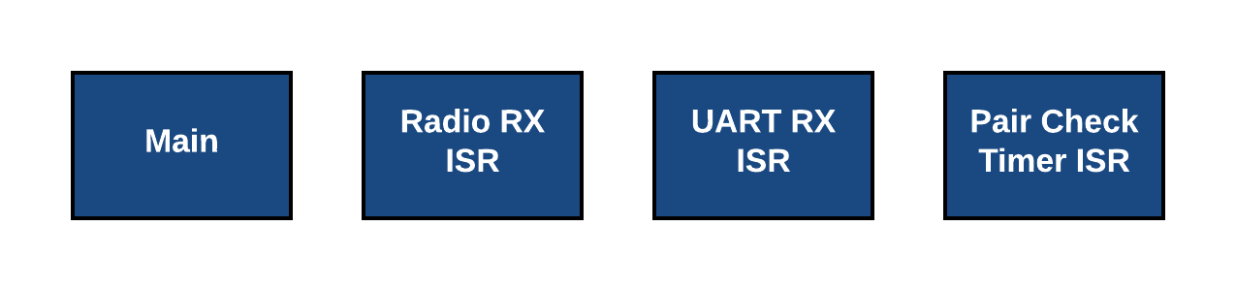

Figure 54 - CC2650 Hierarchy Chart

The focus of the CC2650 is to move data from the embedded system to the LabVIEW application.

Figure 55 shows the main routine of the CC2650.

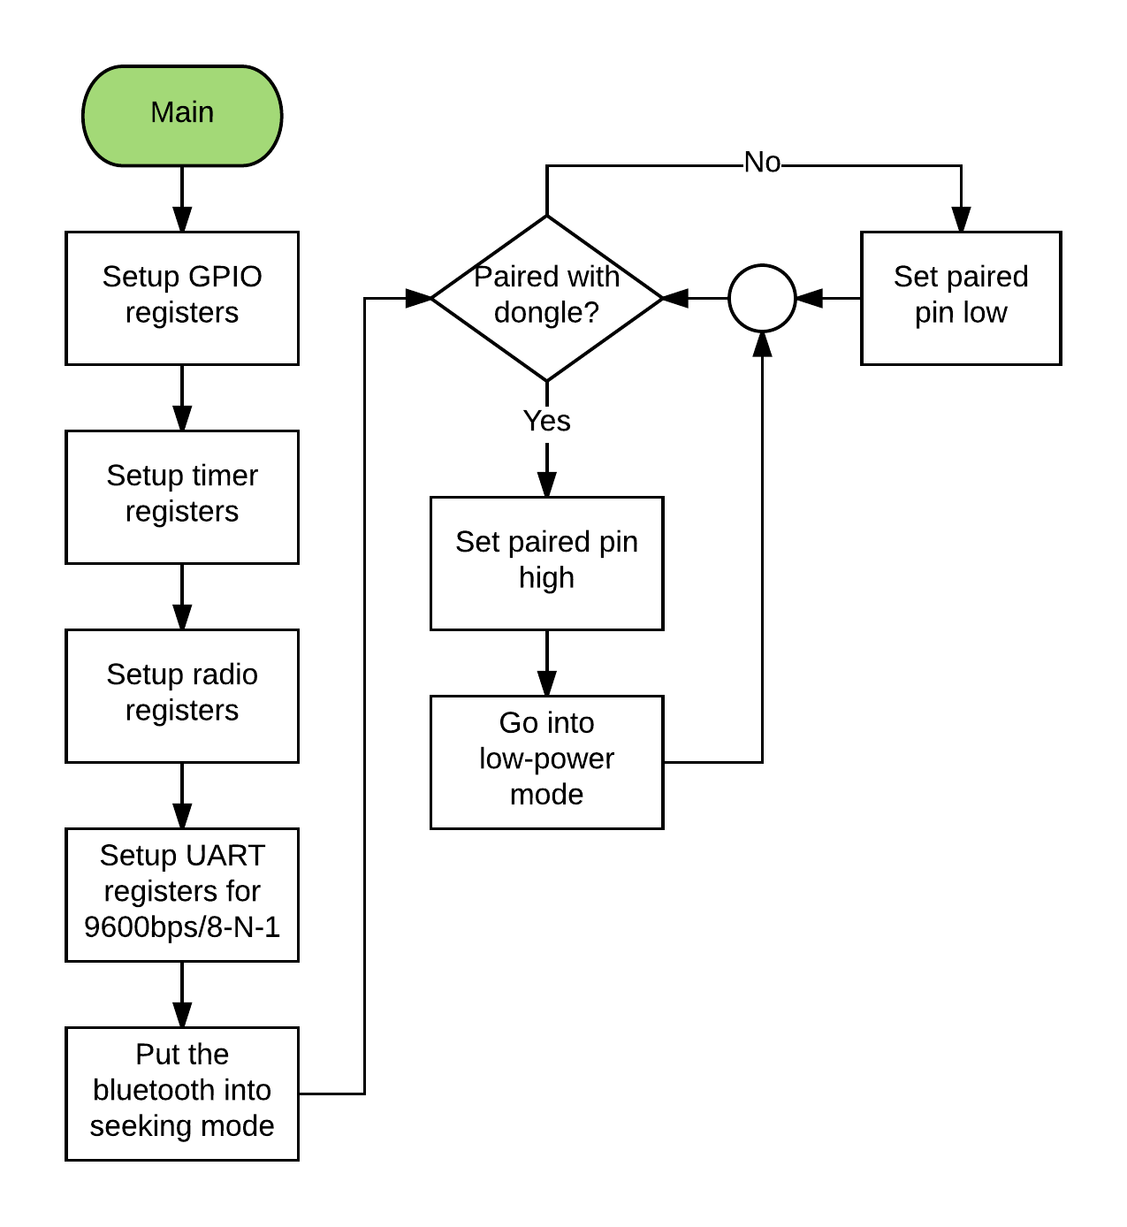

Figure 55 - CC2650 Main Routine

The main routine begins by setting up all of the peripherals: such as GPIOs, timers, UART, and the radio. The radio will be set into seeking mode to find the BLED112 dongle. The routine then checks to see if the CC2650 is paired with the dongle. If not, the paired pin is set low. If it is, then the paired pin is set high and the device goes into low-power mode. This checking continues throughout the use of the system.

Figure 56 shows all of the various ISRs used by the CC2650.

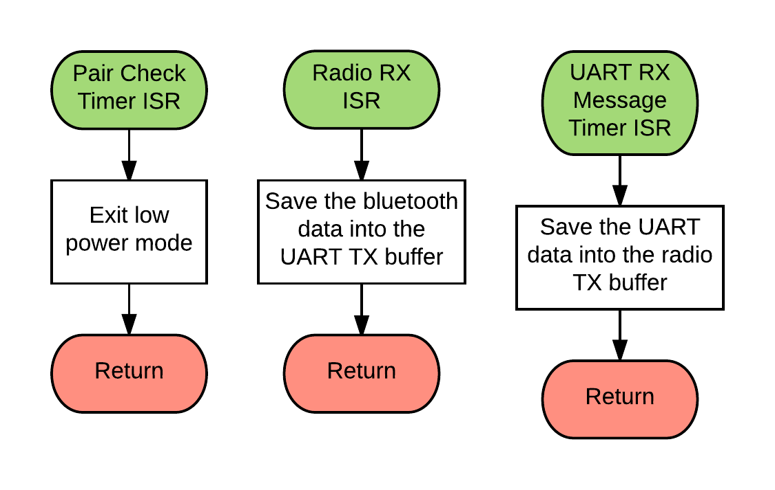

Figure 56 - Assorted CC2650 Interrupt Service Routines

The Pair Check Timer ISR periodically frees the main routine, from low power mode, to check the Bluetooth status. The Radio RX ISR occurs when the radio receives a message that has passed Bluetooth’s Checksum. It transfers the data from the Bluetooth RX buffer into the UART TX buffer. The UART RX Message Timer ISR occurs when the UART RX buffer has not received anything recently, which is meant to separate messages. This saves the UART RX buffer into the Bluetooth TX buffer.

Figure 57 shows the main LabVIEW routine.

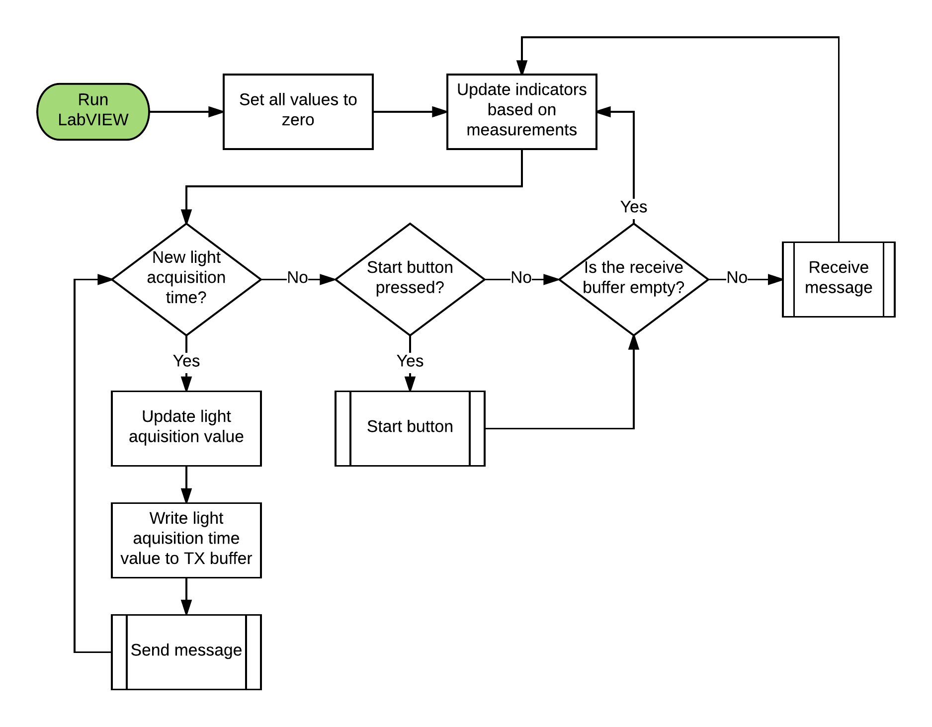

Figure 57 - Main LabVIEW Routine

The LabVIEW virtual instrument (VI) starts out by setting all of the values to zero, this includes the oxygen saturation, pulse rate, and battery level. Once the values have been set to their starting value, the program will update the indicators on the GUI to reflect the current values. This box is returned to very often throughout the VI, including after the check on the receive buffer and after receiving a message. Once the values are set the VI checks to see if the user has set a new light acquisition time on the front panel. If the user has set a new time the value will be updated, the message will be sent to the microcontroller, and will return to check if another new light time was set. If no new light acquisition time is set, the VI will check and see if the start button has been pressed on the front panel. If the button has been pressed, it will move into the Start Button Sub VI. If the button was not pressed, or after the Start Button Sub VI is finished, the program will check and see if the receive buffer is empty. If the buffer is not empty, the VI will move into the Receive Message Sub VI; either way the program ends up updating the indicators based on values.

Figure 58 shows the Receive Message Sub VI that the OxiScope will be utilizing.

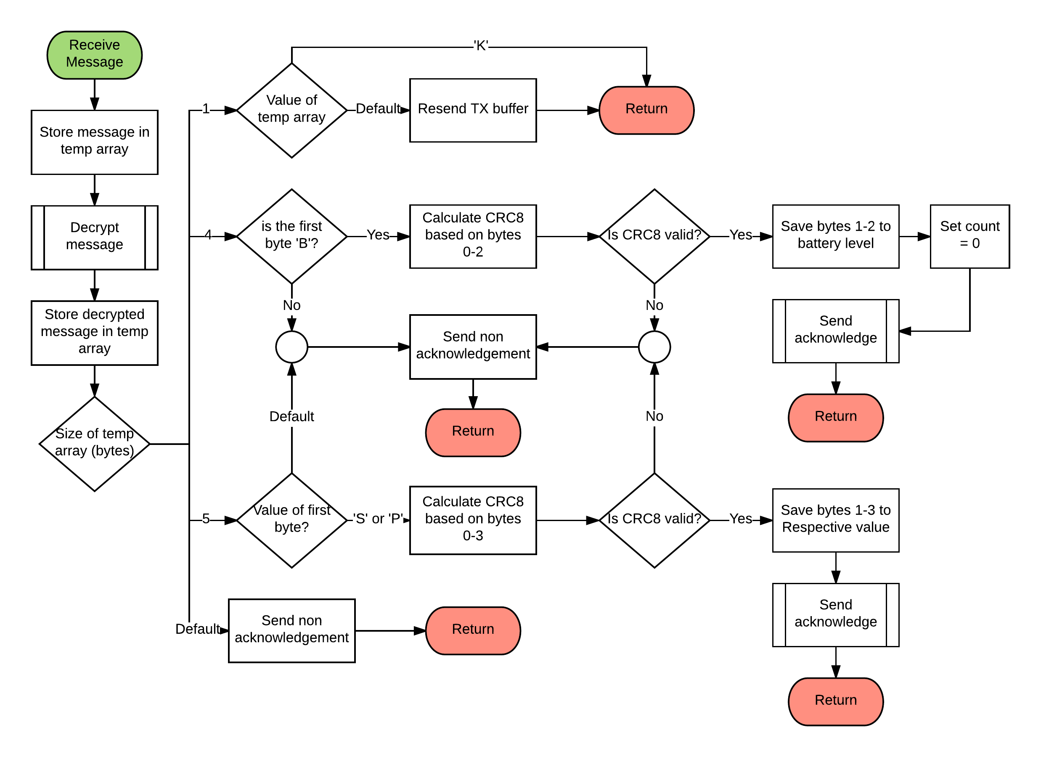

Figure 58 - Received Message Sub VI

Figure 58 shows the sub VI that will be used by the system to receive information from the MSP432. The message will first be stored into a temporary array, and then decrypted using a polyalphabetic substitution cipher described in Figure 52. The decrypted message will be stored into a new temporary array and the VI will determine the size of this array. The expected size of this array will be one, four, or five bytes long. If the size of the array is not one of these sizes, a non-acknowledgement will be sent and the sub VI will return. If the size of the array is one byte, the expected value will be a ‘K’ or an ‘N’, and the program will check to see if the value is a ‘K’. If the value is not a ‘K’ then the LabVIEW program will resend the TX buffer. If the value is a ‘K’, then the message sent to the MSP432 was acknowledged as correct and the sub VI will once again return to the main routine. If the size of the array is four bytes, the expected value is the battery level. If the identifier byte is not a ‘B’, a non-acknowledgement will be sent back to the MSP432. If the identifier byte is a ‘B’, then the CRC8 will be calculated and checked. If the two CRCs do not match, a non-acknowledgement will be sent; but if both match then the value sent in the message will be used in the VI, the count will be set to zero, which is used by the Start Button Sub VI, and an acknowledgement will be sent. If the size of the temporary array is five bytes long, the identifier will be checked to see if it is either an ‘S’ or a ‘P’. If the identifier byte is neither of these, a non-acknowledgement will be sent. If the identifier is either an ‘S’ or a ‘P’, the CRC will be calculated and checked in the same manner as the four-byte value; if the CRCs are matching the data will be used.

Figure 59 shows the remaining sub VIs, which are the Send Acknowledge, Send Message, and Start Button.

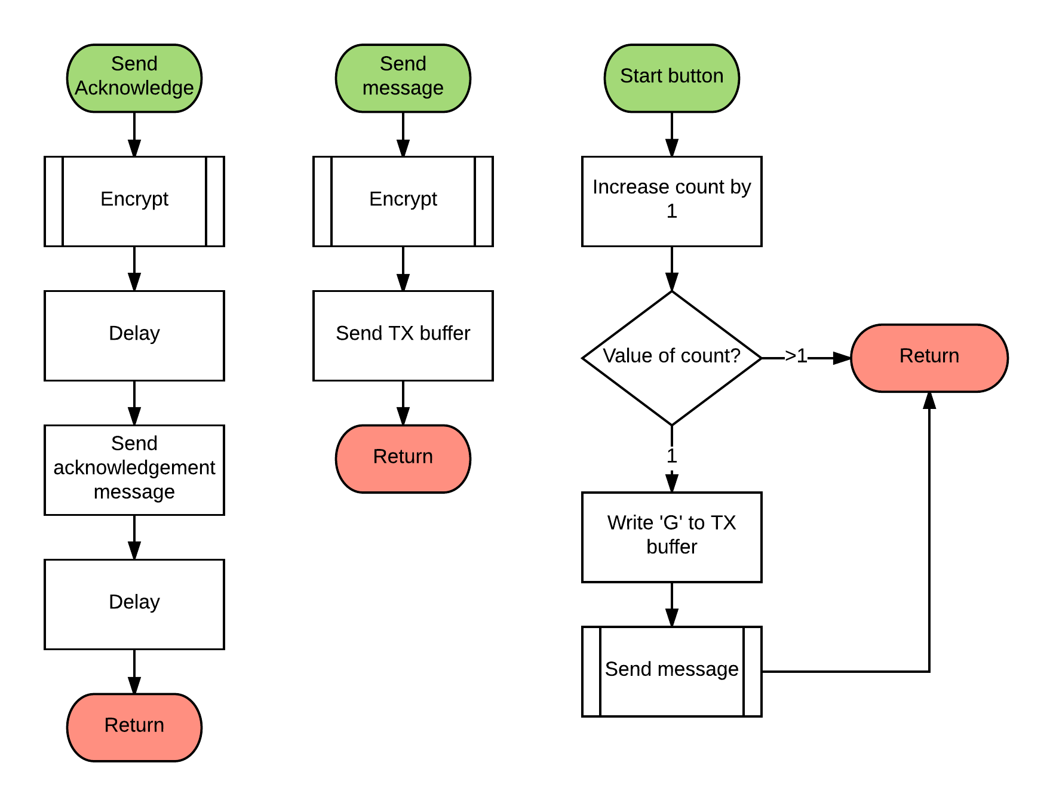

Figure 59 - Assorted LabVIEW Sub VIs

The Send Acknowledge Sub VI will encrypt the ‘K’ ASCII character, delay for two milliseconds, send the message and delay for another two milliseconds. The delay in this routine will be used on the MSP432 side to separate messages. The Send Message sub VI will encrypt the message in the buffer and then send it. The final sub VI in Figure 59 is the Start Button routine. This controls when the LabVIEW application will send the start signal to the MSP432. The VI starts by increasing the count by one. If the count is one, a ‘G’ will be written to the TX buffer and the message will be sent. If the count is not equal to one, meaning that the button has not been pressed, or has been pressed multiple times, nothing will happen. The count is reset to zero after the battery level has been updated; this is because the battery level is always the last message that will be received.

## 12 Deliverables

The following section covers the deliverables that are required of Texas Prenatal Systems over the course of the OxiScope project. The deliverables have been placed on a timeline graph, shown in Figure 60. The graph allows the team members and key stakeholders to determine when to expect specific deliverables to be completed, as well as the number of deliverables that will be received.

deliverables (5).png

Figure 60 - Deliverables Timeline

The deliverables were split into three distinct categories: hardware, software, and test/documentation. Each of the deliverables will be described in the sections corresponding to their category. The deliverables are primarily split into three main stages: alpha, beta, and final. Additionally, there are initials underneath each of the deliverable names; these are the initials of the team member that is ultimately responsible for the completion of the deliverable by the assigned date.

### 12.1 Hardware

*9/4/2017 Alpha Schematic*

The Alpha Schematic is the initial design of the embedded system. Altium will be used to create the schematic, and will include all of the circuitry for the design along with the correct symbols and labels for all devices used, as well as the signals for each of the devices. This deliverable will be given as an Altium schematic file as well as a PDF soft copy to the customer.

*9/18/2017 Alpha PCB Layout*

The Alpha PCB layout is the transformation from the Alpha schematic to a board layout that will be utilized for the manufacturing of a printed circuit board. Altium will be used to create this PCB layout and will include specific devices and components that will be used to populate the board once it has been fabricated. This deliverable will be the Altium file, all associated Gerber files, a PDF, and the bill of materials for the devices and components that will be needed to populate the board.

*10/4/2017 Alpha Enclosure*

The Alpha Enclosure is the 3D printed case that will house the embedded system as well as the majority of the fiber optic system. This enclosure will ensure that all of the components in the system fit securely, as well as make sure the one-button interface is usable. This deliverable will consist of the CAD and STL files used to create the enclosure.

*10/25/2017 Beta Schematic*

The Beta Schematic is a revised version of the Alpha Schematic. This will correct any mistakes that were created in the Alpha Schematic as well as include any changes that were made to further improve the OxiScope. Altium will be used to create the schematic, and will include all of the circuitry for the design along with the correct symbols and labels for all devices used, as well as the signals for each of the devices. This deliverable will be given as an Altium schematic file as well as a PDF soft copy to the customer.

*10/30/2017 Beta PCB Layout*

The Beta PCB Layout is a revised version of the Alpha PCB Layout. This will correct any mistakes that were created in Alpha PCB Layout as well as include any changes that were made to further improve the OxiScope. Altium will be used to create this PCB layout and will include specific devices and components that will be used to populate the board once it has been fabricated. This deliverable will include the Altium file, all associated Gerber files, a PDF, and the bill of materials for the devices and components that will be needed to populate the board.

*11/13/2017 Final Schematic*

The Final Schematic is a revised version of the Beta Schematic. This will correct any mistakes that were created in the Beta Schematic. Altium will be used to create the schematic, and will include all of the circuitry for the design along with the correct symbols and labels for all devices used, as well as the signals for each of the devices. This deliverable will be given as an Altium schematic file as well as a PDF soft copy to the customer.

*11/16/2017 Final PCB Layout*

The Final PCB Layout is a revised version of the Beta PCB Layout. This will correct any mistakes that were created in the Beta PCB Layout. Altium will be used to create this PCB layout and will include specific devices and components that will be used to populate the board once it has been fabricated. This deliverable will include the Altium file, all associated Gerber files, a PDF, and the bill of materials for the devices and components that will be needed to populate the board.

### 12.2 Software

*9/1/2017 LabVIEW Provisional GUI*

The LabVIEW Provisional GUI is an outline of what the user interface will be once the OxiScope has been completed. This will include functionalities for the end user, such as measurement and status indicators. This deliverable will be a PDF document that contains a picture of the GUI as well as an explanation of each of the components of the GUI.

*9/3/2017 Flowchart*

The Flowchart is an outline of what the software system of the OxiScope will be executing. This will include the main routine as well as all the subroutines and interrupt routines that are expected for the project. This deliverable will be a PDF document that contains the flowchart as well as an explanation of the flowchart.

*9/20/2017 Alpha LabVIEW Code*

The Alpha LabVIEW Code is the initial design of the application code for the project. This will include the ability to parse messages sent from the microcontroller into the correct gauges and numbers for the user to read and interpret correctly. This will also include the ability to monitor messages received from the microcontroller before they were parsed for testing purposes. This deliverable will be a PDF document with a picture of the LabVIEW front panel and an explanation of the choices made for the design, as well as the LabVIEW VI project.

*10/2/2017 Alpha Embedded Code*

The Alpha Embedded Code is the code that will run on the Alpha PCB. This will be programmed on the MSP432 and will interface with the CC2650. The ability to measure and calculate oxygen saturation and pulse rate will be tested and verified with this code. The capability of sending information over Bluetooth to the wireless dongle attached to the laptop running LabVIEW will also be tested and verified using this code. This deliverable will be a document containing an explanation of the program as well as the code composer project.

*10/23/2017 Beta Embedded Code*

The Beta Embedded Code is the code that will run on the Beta PCB. This will include all improvements that have been created since the Alpha Embedded Code, as well as any new functionality for the OxiScope. The ability to measure and calculate oxygen saturation and pulse rate will be tested and verified with this code. The capability of sending information over Bluetooth to the wireless dongle attached to the laptop running LabVIEW will also be tested and verified using this code. This deliverable will be a document containing an explanation of the program as well as the code composer project.

*10/24/2017 Beta LabVIEW Code*

The Beta LabVIEW Code is a revised version of the Alpha LabVIEW Code. This will include any changes necessary for the end user’s readability and understanding of the information received. This will also include any modifications necessary for the testing of the communication system on the application side of the project. This deliverable will be a PDF document with pictures of the LabVIEW environment as well as an explanation of each section, the front panel and the block diagram, as well as the LabVIEW VI.

*11/20/2017 Final LabVIEW Code*

The Final LabVIEW Code is the revised version of the Beta LabVIEW Code. This will include all of the changes made since the Beta LabVIEW Code, as well as a separate testing section on the front panel from the user interface portion of the front panel. This deliverable will be a PDF document with pictures of the LabVIEW environment as well as an explanation of each section, the front panel and the block diagram, as well as the LabVIEW VI.

*11/22/2017 Final Embedded Code*

The Final Embedded Code is the program that will run on the Final PCB. This will include all improvements that have been created since the Beta Embedded Code. The ability to measure and calculate oxygen saturation and pulse rate will be tested and verified with this code. The capability of sending information over Bluetooth to the wireless dongle attached to the laptop running LabVIEW will also be tested and verified using this code. This deliverable will be a document containing an explanation of the program as well as the code composer project.

### 12.3 Test/Documentation

*9/19/2017 Alpha Test Plan*

The Alpha Test Plan is the initial design of how the OxiScope will be tested to ensure that the functional requirements, as well as their performance specifications, are met. This deliverable will be a document with the test plan as well as an explanation for each of the tests that will be done.

*10/11/2017 Critical Design Review*

The Critical Design Review is a presentation in which Texas Prenatal Systems will explain the final design of the OxiScope as well as demonstrate the project’s functionality at the current time of the presentation. This presentation will be given in person to the stakeholders by the team and a copy of the presentation and a video recording, will be given to the stakeholders.

*11/24/2017 Final Test Plan*

The Final Test Plan is the revised version of the Alpha Test Plan, and will include any modifications that need to be made in order to properly test the Final PCB, Final Embedded code, and Final LabVIEW code to ensure that all functional requirements are met. This deliverable will be the final test plan document as well as a document with an explanation for each of the tests that will be done.

*11/29/2017 Final Test Report*

The Final Test Report is the document that contains the results of the Final Test Plan. This document will be used to verify that the OxiScope meets all of the functional requirements and performance specifications that were set by the key stakeholders and team members. This deliverable will be a copy of the Final Test Report.

*12/1/2017 Final Demo*

The Final Demo is proof to the stakeholders that the OxiScope is fully functional and all associated performance specifications are met. The Final Embedded Code will run on the Final PCB in front of the stakeholders to verify the functionality and performance of the project. This deliverable will be a video recording of the demonstration.

*12/2/2017 Journal Entry*

The Journal Entry will be submitted to a journal chosen by Texas Prenatal Systems. This journal article will be submitted but does not need to be accepted. The entry will include research findings from the OxiScope as well as results from human subject testing if IRB approval was obtained. This deliverable will be a copy of the Journal Entry that was submitted.

*12/4/2017 Final Presentation*

The Final Presentation is where Texas Prenatal Systems will explain and present the final design of the OxiScope. This deliverable will be a video recording of the presentation as well as a soft copy of all materials, such as PowerPoint slides, given to the stakeholders.

*12/4/2017 Final Documentation*

The Final Documentation is a compilation of all the documentation for the hardware, software, and testing portions of the project. All parts of the project will be described in detail. This deliverable will be a hard and soft copy of the final documentation.

*12/5/2017 Final Sign Off*

The Final Sign Off is where Texas Prenatal System will receive the final approval of project completion from the key stakeholders. The final approval indicates that all of the functional requirements for the project were met, the device has sufficient documentation, and the team has a complete understanding of the device. This deliverable will be a copy of the signatures from the key stakeholders and team members.

## 13 Milestones

Along with the deliverables that Texas Prenatal Systems has created, a set of milestones have been set to demonstrate the status of the project to the primary stakeholders. Although some of the milestones have been fully described within the deliverables section, not all deliverables are milestones. Texas Prenatal Systems has chosen a limited set of events that are important enough to notify the customer once these actions have been completed. The milestones timeline is shown in Figure 61. Similar to the deliverables timeline, the different events are separated into three different categories: hardware, software and test/documentation.

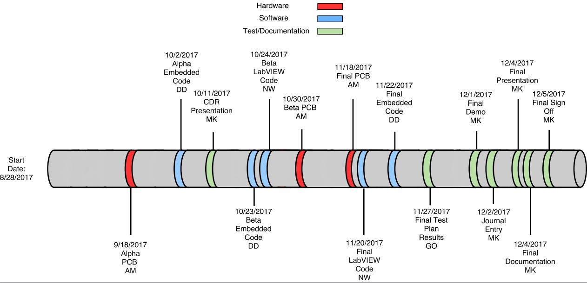

Figure 61 - Milestones Timeline

### 13.1 Hardware

The hardware milestones include all phases of the printed circuit board’s production as well as the creation of the 3D printed enclosure. The phases include an Alpha, Beta, and Final board fabrication. The stakeholders will be made aware of the results that each board provides for Texas Prenatal Systems. In addition to the production of the different versions of the printed circuit board, the customer will also be notified when the final version of the enclosure has been designed and printed.

### 13.2 Software

The software milestones have been separated into three phases: Alpha, Beta, and Final versions of the embedded code. Each phase will have a software package that will include the source files, header files, and the main functions within the embedded code. These different versions of code will be implemented and tested on their respective printed circuit board. Once the results have been collected, they will be shown to the customer in order to demonstrate the progress that has been made within each phase. For the LabVIEW code, only the Beta and Final code will be presented to the primary stakeholders. The customer will also be able to identify the different capabilities of the software.

### 13.3 Test/Documentation

Testing will be performed, documented, and presented to the customer in the Final Test Plan Results document. The customer will review the test results collected from the various test iterations through all phases of production.

Once the journal entry has been completed, it will be presented to the customer for a final review before it is submitted. The Critical Design Review is a presentation given to all stakeholders briefing the status of the project’s design. The stakeholders will be sent a copy of the Final Documentation in order to review and approve all the material that has been produced. Lastly, the customer will be asked to sign off on the project once all functional requirements and associated performance specifications have been met.

## 14 Gantt Chart

Gantt charts are graphical representations that use calendar dates to show the planned execution of each task. The entire project is broken down using two Gantt charts: Figure 62 representing the five phases and Figure 63 representing each phase activity in a Gantt chart.

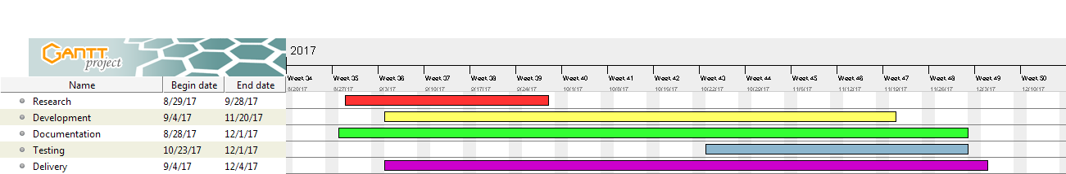

Figure 62 - Phase Gantt Chart

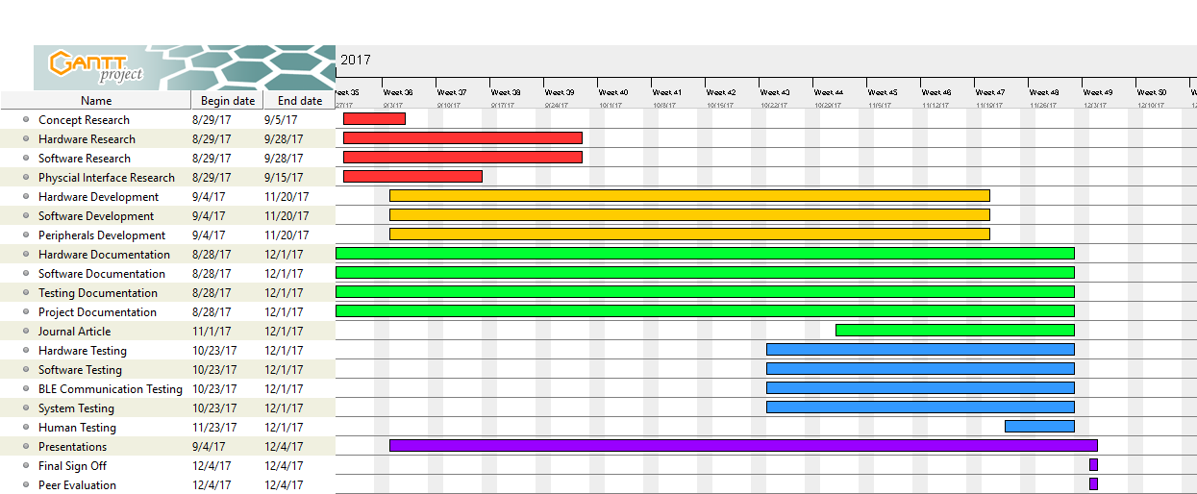

Figure 63 - Activity Gantt Chart

Gantt charts can be used by stakeholders to assess the overall status of the project. During the research phase, problems will be identified and solutions will be explored for all phases. The development stage will encompass hardware and software design and fabrication. The documentation phase will start at the beginning of the project and last until the end. The testing phase will validate that the system meets all functional requirements, as well as collect measurements during IRB approved testing. In the delivery phase, presentations will be made, final sign offs will be received and the final system will be turned over to the customer.

## 15 Costing

### 15.1 Direct Cost

Direct costs consist of all the financials that will be needed for the direct production of the OxiScope. The category of direct costs will be divided into five main categories: labor cost, fiber optic system cost, hardware cost, software cost, and resource cost. Table 9 shows the hourly wage each team member will receive, the total number of hours they have budgeted for this project, and the total amount of benefits that each member will receive.

###### Table 9: Labor Cost

|  |  |  |  |  |
| --- | --- | --- | --- | --- |
| **Employee** | **Hourly Wage** | **Budgeted Hours** | **Benefits** | **Total** |
| Matthew Kellogg  Project Manager | $42.19 | 276 | $3493.33 | $15,137.77 |
| Adam McGaffin  Hardware Engineer | $40.45 | 893 | $10,836.56 | $46,958.41 |
| David Delamater  Software Engineer | $39.78 | 474 | $5,656.72 | $24,512.44 |
| Nathan Wiatrek  Software Engineer | $39.78 | 384 | $4,582.66 | $19,858.18 |
| Gustavo Ordonez  Test Engineer | $37.08 | 644 | $7,163.86 | $31,043.38 |
| **Total** |  | **2671** | **$31,733.13** | **$137,510.18** |

The hourly wage was determined by researching the national average pay for each individual job title. The benefits assigned for each employee will be 30% of their total compensation for work, which was chosen based on a recommendation. The team’s budgeted hours, employee benefits, and total overall cost are shown at the bottom. Table 10 shows components that will be purchased for the OxiScope fiber optic system.

###### Table 10: Fiber Optic System Cost

|  |  |  |  |
| --- | --- | --- | --- |
| **Part** | **Quantity** | **Cost Per Unit** | **Subtotal** |
| Red Laser Diode  LP660-SF20 | 1 | $536 | $536 |
| Infrared Laser Diode  LP940-SF30 | 1 | $704 | $704 |
| Pigtailed Photodiode  FDSP625 | 1 | $134 | $134 |
| Y-Cable  RP23 | 1 | $475 | $475 |
| 50:50 Optic Coupler  FCMM625-50A-FC | 1 | $115 | $115 |
| FC/PC to SMA  ADAFCSMA1 | 1 | $44 | $44 |
| Laser Diode Socket  S8060 | 2 | $6.85 | $13.7 |
| **Total** |  |  | **$1,977.70** |

The part number, as listed by Thorlabs, is shown in the part column. The subtotal cost for each part was found by multiplying the quantity by the cost per unit. These prices do not have a discount, as Thorlabs does not offer any discounts for bulk orders. Table 11 shows the hardware costs that will be needed for the development and implementation of the OxiScope’s PCB.

###### Table 11: Hardware Costs

|  |  |  |  |
| --- | --- | --- | --- |
| **Part** | **Quantity** | **Cost Per Unit** | **Subtotal** |
| MSP432P401R LaunchPad | 1 | $12.99 | $12.99 |
| CC2650 Module BoosterPack | 1 | $29.00 | $29.00 |
| CC2650MODA | 1 | $12.81 | $12.81 |
| MSP432P401R | 1 | $7.89 | $7.89 |
| BLED 112 | 1 | $11.83 | $11.83 |
| 3.6 V Battery Pack | 1 | $53.86 | $53.86 |
| 5 V Voltage Regulator | 1 | $6.19 | $6.19 |
| 3.3 V Voltage Regulator | 1 | $9.76 | $9.76 |
| 2.5 V Voltage Regulator | 1 | $7.09 | $7.09 |
| 1.5 V Voltage Regulator | 1 | $5.24 | $5.24 |
| Debugger Header Pins | 20 | $2.78 | $2.78 |
| Start Button | 1 | $0.82 | $0.82 |
| Reset Button | 2 | $0.63 | $1.26 |
| N-Chan E-MOSFET | 2 | $0.75 | $1.50 |
| Op-Amps | 9 | $8.69 | $8.69 |
| **Total** |  |  | **$171.71** |

The name and number of each hardware component are shown, along with the quantity needed. Similar to the fiber optic system cost, a subtotal is calculated from the quantity and cost per unit, having the total hardware cost calculated from the summation of these subtotals. Table 12 shows the cost breakdown for the software necessary for this project.

###### Table 12: Software Cost

|  |  |  |  |
| --- | --- | --- | --- |
| **Software** | **Quantity** | **Cost Per Unit** | **Subtotal** |
| Altium Designer | 1 | $7,250 | $7,250 |
| SolidWorks | 1 | $3,995 | $3,995 |
| LabVIEW Full | 1 | $2,999 | $2,999 |
| **Total** |  |  | **$14,244** |

The name of the software, the number of licenses needed, and the cost per license are shown within this table. Only one license per software package is needed for this project. Similarly, the subtotal is calculated from the number of licenses and cost per license, with the total software cost being a summation of these subtotals. Table 13 shows all other resources needed for this project.

###### Table 13: Resource Cost

|  |  |  |  |
| --- | --- | --- | --- |
| **Part** | **Quantity** | **Cost Per Unit** | **Subtotal** |
| Digital Multimeter | 1 | $1,094 | $1,094 |
| Oscilloscope | 1 | $5,675 | $5,675 |
| Power Supply | 1 | $62.90 | $62.90 |
| Spectrum Analyzer | 1 | $3,825 | $3,825 |
| Soldering Equipment | 1 | $150 | $150 |
| Laptop for User Interface | 1 | $400 | $400 |
| Bluetooth Sniffer | 1 | $29.95 | $29.95 |
| **Total** |  |  | **$11,236.85** |

The resource table shows the pieces of equipment that will be needed in order to test, debug, and verify the OxiScope. A laptop is also included within this table, as the data collected by the OxiScope will be displayed on a separate laptop using the LabVIEW program. Only one of each piece of testing equipment is needed, as the team will share the equipment. Table 14 shows the total direct costs for the OxiScope.

###### Table 14: Total Direct Cost

|  |  |
| --- | --- |
| **Category** | **Subtotal** |
| Labor | $137,510.18 |
| Fiber Optic System | $1,977.70 |
| Hardware | $173.21 |
| Software | $14,244 |
| Resource | $11,236.85 |
| **Total** | **$165,141.94** |

### 15.2 Indirect Cost

The indirect costs are the financials that allow for the leasing of office spaces and pay for heating and cooling. These financials do not purchase any components needed for the project, but create an environment for the engineers to work. Indirect costs can be broken down into two categories; overhead as well as general and administrative (G&A). Table 15 shows the total indirect costs associated with this project.

###### Table 15: Indirect Cost

|  |  |
| --- | --- |
| **Category** | **Subtotal** |
| Overhead (40%) | $66,056.78 |
| G&A (12%) | $19,817.03 |
| **Total** | **$85,873.81** |

The overhead category is calculated by taking 40% of the total direct costs, and the G&A category is 12% of the total direct costs. These two categories are added together to give the total indirect cost associated with this project.

### 15.3 Profit

Profit is defined as the return on investment for a company or individual sponsoring a project, and is calculated by a percent margin from the combination of both the direct and indirect costs (TDIC). Texas Prenatal Systems as well as its stakeholders have set this profit margin percentage at 15%. This is shown in Table 16.

###### Table 16: Profit

|  |  |
| --- | --- |
| **Category** | **Subtotal** |
| Direct Costs | $165,141.94 |
| Indirect Costs | $85,873.81 |
| Total Direct and Indirect Costs | $251,015.75 |
| **Total Profit (15% of TDIC)** | **$37,652.36** |

### 15.4 Other Cost

The other cost category is comprised of financials and other expenses that cannot be classified under direct or indirect costs. Table 17 shows the other costs associated with this project.

###### Table 17: Other Cost

|  |  |
| --- | --- |
| **Category** | **Subtotal** |
| Risk Aversion (15%) | $37,652.36 |
| Cost of Money (1%) | $2,510.18 |
| **Total** | **$40,162.54** |

The other costs can be broken down into two separate categories of risk aversion and cost of money. The financials associated with risk aversion are used to reduce uncertainties that are likely to occur within a project. This value was determined by taking 15% of the sum of direct costs and indirect costs. The cost of money is related to the cost of obtaining and using money, and is 1% of the sum of direct costs, indirect costs, and labor.

### 15.5 Total Project Cost

All costs and financials associated with the OxiScope are shown in Table 18.

###### Table 18: Total Project Cost

|  |  |
| --- | --- |
| **Category** | **Subtotal** |
| Direct Costs | $165,141.94 |
| Indirect Costs | $85,873.81 |
| Profit | $37,652.36 |
| Other Costs | $40,162.54 |
| **Total** | **$328,830.65** |

Adding together the direct and indirect costs, as well as the profit and other costs the OxiScope project is projected to cost over $300,000.

## 16 Test Matrix

Texas Prenatal Systems will utilize a test matrix to ensure all functional requirements are validated and they meet their respective performance specifications. All of the functional requirements are associated with at least one test case.

###### Table 19: Test Matrix

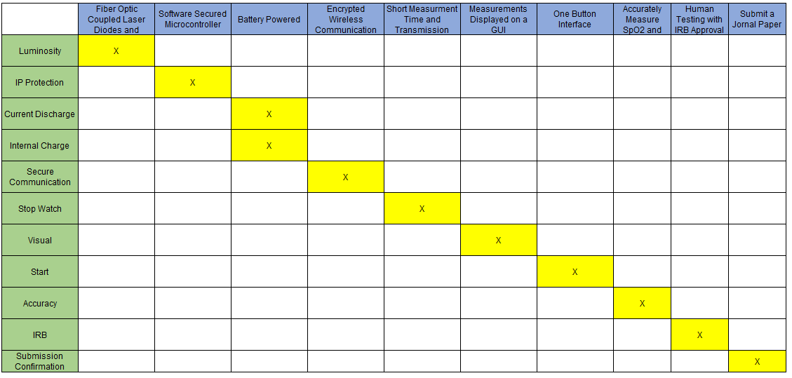

The test matrix defines the functional requirements within the columns of Table 19, while the test cases are defined within the rows. The “X” in the yellow boxes represents which test will be used to validate each functional requirement.

*Luminosity*

The Luminosity test will determine the effectiveness of the coupling between each diode and the optical fiber. The red laser diode will be powered by 2.5 V and will begin to emit photons. Any light that escapes the coupled system will be visible, revealing the imperfections of the coupling. The process for the IR laser diode is similar. The diode will be powered by 1.5 V and monitored with a camera to view the IR wavelength photons coming out of the coupling. The photodiode coupling system will be tested by shining a light into the optical fiber, towards the photodiode. If any light escapes the coupling, it will be visible. If light is detected coming out of the coupling, for any of the devices, the device will need to be re-coupled.

*IP Protection*

The IP Protection test will determine the ability of the microcontroller to be debugged after reprogramming capabilities have been disabled. The MSP432 will execute a JTAG lock and a separate program will be attempted to be programmed onto the microcontroller. If the program is successfully debugged, the test has failed.

*Current Discharge*

The Current Discharge test will determine the length of time the OxiScope can be functioning continuously. A power budget will be created to determine the maximum amount of current that can be pulled from the battery at any time. The battery will be discharged at this maximum current until the voltage level reaches its minimum value of 6 V. The amount of time this test takes will determine the maximum battery life for continuous operation of the system.

*Internal Charge*

The Internal Charge test will determine if the battery can be recharged within the enclosure. The voltage level of the battery will be measured prior to plugging in the device to a wall wart. The battery will be given sufficient time to charge and the voltage of the battery will be measured again. If the voltage level increases after the charging time, the battery was successfully charged.

*Secure Communication*

The Secure Communication test will determine if the information is encrypted throughout the communication channels. A 32-bit message, an ASCII ‘ABCD’ will be sent from the microcontroller after being encrypted with a known key. A logic analyzer will be used on the UART lines between the MSP432 and the CC2650 to determine if the message has been changed to the value expected from the cipher. If successful, this will indicate that the UART communication is secure. Next, a wireless communication packet sniffer will intercept the packet that is being sent from the CC2650 to the BLED112. The payload of this packet will be analyzed to see if it is the same encrypted message as seen in the UART channel. If the cipher value is not the same as in the UART channel, the communication is not fully secure.

*Stop Watch*

The Stop Watch test will determine the amount of time needed to take measurements, as well as the time it takes to wirelessly transmit these measurements from the OxiScope to the GUI. A stopwatch will be started when the start button on the enclosure is pressed. The elapsed time will be recorded with the lap function of the stopwatch when the red laser diode turns on and stays on, indicating that the measurement taking process has been completed. The first part of the test will pass if this time is less than five seconds. The second part of the Stop Watch test will deal with the wireless transmission time. The stopwatch will continue running after lap is pressed, and will be stopped when the measurements are shown on the LabVIEW GUI. If this time is less than one second, this portion of the test is successful.

*Visual*

The Visual test will determine if the measurements can be successfully displayed on the GUI. A measurement will be taken and transmitted to LabVIEW. If the gauges and numerical values correspond, the test is successful.

*Start*

The Start test will determine if the OxiScope is able to start taking measurements with either button pressed. This test will be performed on the enclosure’s start button as well as the start button on the LabVIEW GUI. If the red laser diode turns on after a press from the push button, the test is successful.

*Accuracy*

Once IRB approval has been received, the Accuracy test will be performed. This test will consist of taking 500 measurements with a commercially available pulse oximeter as well as the OxiScope. The measurements will then be compared and the error percentage of the OxiScope calculated. If the error percentage is less than ±5% for both SpO2 and pulse rate, the test passes.

*IRB*

Human testing will be performed after IRB approval is acquired. This testing will generate results that will prove that human testing was performed after IRB approval. If the testing is well documented and proof of permission are presented this test will pass.

*Submission Confirmation*

Once human testing has been accomplished and documented, a journal entry will be written and revised for submission to an academic journal. This paper does not have to be published and only needs to be successfully submitted to the journal of choice. Providing proof that this journal has been submitted will pass this test.

## 17 Technical Merit

The technical merit matrix is a series of technical factors that are present in a project. As the complexity of these factors increases, so does their value. Texas Prenatal Systems will use this matrix to determine if a project is worth pursuing. A project with a technical merit less than 1.2 will not be pursued. The technical merit matrix for the OxiScope is shown in Table 20.

###### Table 20: Technical Merit Matrix

|  |  |  |
| --- | --- | --- |
| **Technical Factors** | **Merit** | **Project** |
| A clearly described and completely understood technical challenge | 0.1 | 0.1 |
| A requirement for system integration | 0.2 | 0.2 |
| A requirement for system testing | 0.2 | 0.2 |
| A requirement for theoretical analysis and simulation | 0.2 | 0.2 |
| Hardware design, development and test | 0.3 | 0.3 |
| Software design, development and test | 0.3 | 0.3 |
| An enclosure design/fabrication requirement | 0.2 | 0.2 |
| A requirement for documentation other than project related | 0.2 | 0.2 |
| A requirement for intellectual property protection | 0.1 | 0.0 |
| A requirement beyond capstone | 0.1 | 0.1 |
| **TOTAL** | **1.9** | **1.8** |

The OxiScope received a 1.8 out of a possible 1.9, scoring high enough to be pursued. A list of all the technical factors and justifications for them will be further described in the following sections.

*Clearly described and completely understood technical challenge*

The first technical factor is a clearly described and completely understood technical challenge. This represents something that the team has never done before or is incredibly difficult to accomplish. No member of the team has worked with fiber optics prior to this project. The hardware team has never filtered quantized signals using analog filters, and the software team has never worked with Bluetooth, performed digital filtering, or created a full duplex UART communication channel with acknowledgements.

*System integration*

The second technical factor is a requirement for system integration. This means interfacing properly with a system that was not designed specifically for the OxiScope. The project requires the use of a fiber optics system that is designed by another company not specific to the project.

*System testing*

The third technical factor is a requirement for system testing. The functionality of the entire system must be tested and verified. Before human testing, the device will be tested with signals that simulate reflected light. After human testing approval, the device will be tested thoroughly enough to write a journal paper.

*Theoretical analysis and simulation*

The fourth technical factor is a requirement for theoretical analysis and simulation. The analog filters and amplifiers that are between the photodiode and the analog-to-digital converter will be simulated using Multisim and then analyzed to determine how the analog filtering system works on quantized signals.

*Hardware design, development, and testing*

The fifth technical factor is hardware design, development, and test. A printed circuit board will be designed that includes a microcontroller, Bluetooth module, JTAG interfaces, power regulation, battery recharging, laser controllers, connectors to fiber optics, unity gain buffers, band-pass and low-pass filters, and push buttons. The PCB will be populated using a one to one printed representation of the board, to verify, and soldering equipment. Texas Prenatal Systems will be testing connections using test points and common testing equipment such as oscilloscopes, waveform generators, digital multimeters, and power supplies.

*Software design, development, and testing*

The sixth technical factor is software design, development and test. Software for the MSP432, CC2650, and LabVIEW will be designed using flowcharts. This software will need to be able to reliably read and filter voltage values, track AC and DC characteristics, calculate meaningful values from measurements, wirelessly communicate those values, and display those values on a GUI. The embedded code will be written in C using Code Composer Studio. The LabVIEW code will be created using various Virtual Instrument (VI) blocks. The code will be tested using debuggers as well as snippets of test code.

*Enclosure design and fabrication*

The seventh technical factor is an enclosure design and fabrication requirement. An enclosure will be designed to house the PCB, battery, fiber coupling, another device the customer has requested, and the start button will need to be accessed. The enclosure will be fabricated using 3D printing techniques.

*Other documentation*

The eighth technical factor is a requirement for documentation other than project-related documentation. This could be a user manual, research paper, journal article, etc. A journal article will be written for the project that will be submitted but does not have to be published.

*Intellectual property protection*

The ninth technical factor is a requirement for intellectual property protection. This is the only point that wasn’t awarded to this project. While Texas Prenatal Systems will be assisting, the majority of the process will be completed by Advanced Maternity Innovations. For this reason, the points will not count towards the project.

*Beyond capstone*

The tenth technical factor is a requirement beyond capstone. This is anything not related to the normal scope of a project. Texas Prenatal Systems will present the OxiScope in the Texas A&M Engineering Project Showcase as well as the Raymond Ideas Challenge.

## 18 References

[1] Thielking, Megan. "Sky-high C-section rates in the US don’t translate to better birth outcomes." *STAT News*. STAT, 09 Mar. 2016. Web. 19 Feb. 2017.

[2] "Birth Data." *Centers for Disease Control and Prevention*. Centers for Disease Control and Prevention, 29 Sept. 2015. Web. 19 Feb. 2017.

[3] Thielking, Megan. "Sky-high C-section rates in the US don’t translate to better birth outcomes." *STAT News*. STAT, 09 Mar. 2016. Web. 19 Feb. 2017.

[4] Benedikt, Allison. "Having a Baby in the U.S. Costs Way Too Much, Especially If You Actually Pay Your Bills." *Slate Magazine*. N.p., 01 July 2013. Web. 19 Feb. 2017.

[5] Goodman, Brenda. "Data shines a light on C-sections, maternal mortality." *Association of Health Care Journalists*. N.p., 14 May 2014. Web. 19 Feb. 2017.

[6] Center for Devices and Radiological Health. "Medical Devices - Radio Frequency Wireless Technology in Medical Devices - Guidance for Industry and Food and Drug Administration Staff." *U S Food and Drug Administration Home Page*. Center for Devices and Radiological Health, 13 Aug. 2013. Web. 21 Mar. 2017.

[7] Dr. Morgan, Joesph. "ENTC_419_SDP". 2017. Presentation.

## Notes