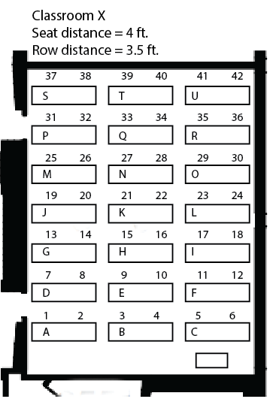

|  |
| --- |
| **Classrooms** |
| AD303 |
| AD304 |
| AD306 |
| AD307 |
| AD308 |
| BH214 |
| BH215 |
| BH216 |
| BH217 |
| BH235 |
| BH236 |
| BH237 |
| BH238 |
| BH239 |
| BH241 |
| BHHMANNGYM |
| BIOGRNHSE |
| CH1150 |
| CH1200 |
| CH1300 |
| CH1350 |
| CH1400 |
| CH1600 |
| CH1630 |
| CH1670 |
| CH1700 |
| CH1750 |
| CH3010 |
| CH3100 |
| CH3120 |
| CH3150 |
| CH3170 |
| CH3200 |
| CH3250 |
| CH3300 |
| CH3350 |
| CH3400 |
| CH3500 |
| CH3600 |
| CH3650 |
| CH3700 |
| CH3750 |
| CH3800 |
| CH3850 |
| CH3950 |
| CIE1201 |
| CIE1202 |
| CIE1203 |
| CIE1204 |
| CIE1215 |
| CIE1231 |
| CIE1405 |
| CIE1420 |
| CIE1421 |
| CIE1430 |
| CIE1433 |
| FA1 |
| FA107 |
| FA108 |
| FA108/116 |
| FA109 |
| FA116 |
| FA122 |
| FA128 |
| FA132 |
| FA200 |
| FA244 |
| FA248 |
| FA254 |
| FA259 |
| FA25A |
| FA25B |
| FA7 |
| FACJT |
| FFC106 |
| FIR103 |
| FIR105 |
| FIR118 |
| FIR125 |
| GS1050 |
| GS1100 |
| GS1150 |
| GS1200 |
| GS1290 |
| GS1310 |
| GS1400 |
| GS1420 |
| GS1520 |
| GS1620 |
| GS1680 |
| GS1850 |
| GS1950 |
| GS2050 |
| GS2100 |
| GS2150 |
| GS2200 |
| GS2290 |
| GS2350 |
| GS2520 |
| GS2550 |
| GS2560 |
| GS2680 |
| GS2850 |
| GS2900 |
| GS2950 |
| GS3030 |
| GS3100 |
| GS3200 |
| GS3290 |
| GS3330 |
| GS3350 |
| GS3370 |
| GS3520 |
| GS3600 |
| GS3650 |
| GS3700 |
| GS3850 |
| GS3900 |
| GS3950 |
| HORTHORT |
| HUGHES210 |
| HUGHES211 |
| LAC057 |
| LAC133 |
| LAC134 |
| LAC137 |
| LAC49 |
| MCK117 |
| MH101 |
| MH102 |
| MH116 |
| MH200 |
| MH301 |
| MH302 |
| OL231 |
| PAC7 |
| PACMLA |
| SRC172 |
| SRCMF |
| SRCRQ |
| SRCWR |
| VLK107 |
| VLK111 |
| VLK117 |
| VLK118 |
| VLK127 |
| VLK128 |
| VLK129 |
| VLK20 |
| VLK30 |
| VLK40 |
| VLK50 |
| VLK80 |
| VLK90 |
| WH111 |
| WH112 |
| WH117 |
| WH126 |
| WH131 |
| WH132 |
| WH135 |
| WH138 |
| WH141 |
| WH227 |
| WH232 |
| WHMMLB |