**Gallagher technical challenge**

Required tools: [CocoaPods](<https://cocoapods.org>)

To run the application, run

1. ‘pod install’

This will install all CocoaPods required to run this application

Minimum iOS version – 14

**App Overview**

App design with basic UI and not used pretty UI

This is the first page of the application.

User can select the image types from the picker view, what they need to proceed with the app (ex – gif, jpg,png or gif,jpg,png)

By default ‘gif’ selected as image type.

By clicking the “Cats List” button users can navigate to the My Cat List screen

My cat list page displacing cats images from “The Cat API” according to the user image type selection from first screen

Pagination implemented with this displayed list

If user clicks any of the row, it will navigate to the next page.

This page displayed the detailed view of selected row with larger image size.

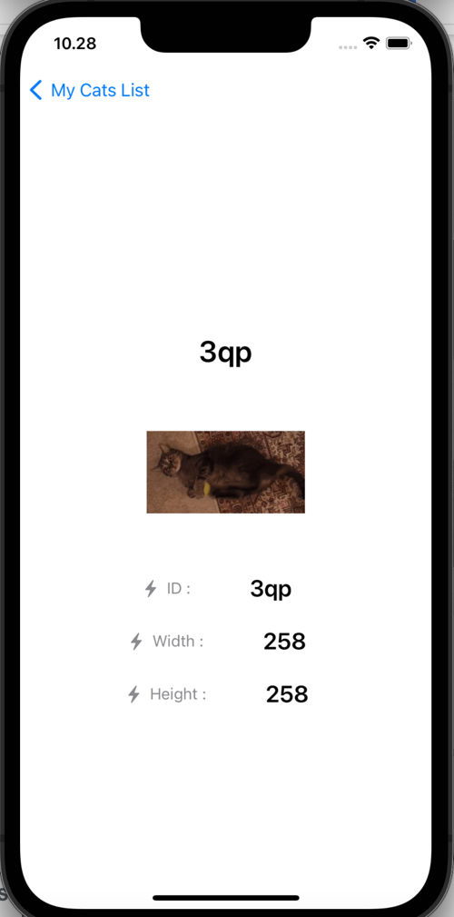

**App Architecture**

* Used SwiftUI to design the UI of this application.
* Used [Alamofire](https://github.com/Alamofire) for network request.
* Also used [SwiftyJSON](https://github.com/SwiftyJSON) for json decoding and [SDWebImageSwiftUI](https://github.com/SDWebImage/SDWebImageSwiftUI)for display gif images
* MVVM is the architecture design this application
* With MVVM architecture business logic separated in to ‘view model’.
* Separating all business logics to separate location achieved write tests is simple and easy.
* It is possible to introduce dependency injection to view model for testability with this architecture
* Combine framework used with MVVM architecture.
* Allowed user to select image type that should support with the application.
* App architected in such a way that it is simple to add further filtering requirements
* The filtering requirement is that once you receive the data from the api any gif with the category of ‘hat’ are not displayed
* Allow the users to choose whether to search images, gif or both.
* Pagination introduced to the displayed list