ELECTRONIC ASSIGNMENT COVERSHEET | 

Student Number: | 35517678
Surname: | New
Given name: | Wei Nern
Email: | 35517678@student.murdoch.edu.au
Unit Code: | ICT283
Unit name: | Data Structures and Abstraction
Enrolment mode: | Internal
Date: | 27/7/2025
Assignment number: | 2
Assignment name:
Tutor: | Leng Kang

Student’s Declaration:
- Except where indicated, the work I am submitting in this assignment is my own work and has not been submitted for assessment in another unit.
- This submission complies with Murdoch University's academic integrity commitments. I am aware that information about plagiarism and associated penalties can be found at http://our.murdoch.edu.au/Educational-technologies/Academic-integrity/. If I have any doubts or queries about this, I am further aware that I can contact my Unit Coordinator prior to submitting the assignment.
- I acknowledge that the assessor of this assignment may, for the purpose of assessing this assignment:
  - reproduce this assignment and provide a copy to another academic staff member; and/or
  - submit a copy of this assignment to a plagiarism-checking service. This web-based service may retain a copy of this work for the sole purpose of subsequent plagiarism checking, but has a legal agreement with the University that it will not share or reproduce it in any form.
- I have retained a copy of this assignment.
- I will retain a copy of the notification of receipt of this assignment. If you have not received a receipt within three days, please check with your Unit Coordinator.

I am aware that I am making this declaration by submitting this document electronically and by using my Murdoch ID and password it is deemed equivalent to executing this declaration with my written signature.
Optional Comments to Tutor:
e.g. If this is a group assignment, list group members here

If you can, please insert this completed form into the body of each assignment you submit. Follow the instructions in the Unit Information and Learning Guide about how to submit your file(s) and how to name them, so the Unit Coordinator knows whose work it is.
Start your assignment on the next page.
Contents
UML Diagram 4
Data Dictionary 5
AVL Class 5
BST Class 6
Controller Class 8
CSVRecord Class 9
Date Class 10
Model Class 11
MTime Class 12
Utils Namespace 12
Vector Class 13
View Class 15
WeatherRecord Class 16
Map Class 17
Rationale for Map<int, AVL<WeatherRecord> 19
Test Plans 20
Date Class (Unit Test) 20
MTime Class (Unit Test) 21
Vector Class (Unit Test) 22
WeatherRecord Class (Integration Test) 25
Map Test (Unit Test) 26
BST Test (Unit Test) 28
Application Test 31

UML Diagram
Below is a high-level diagram for assignment 2. The structure is modified to include CSVRecord, Map, AVL, and BST. Additionally, a namespace called ‘Utils’ is created.
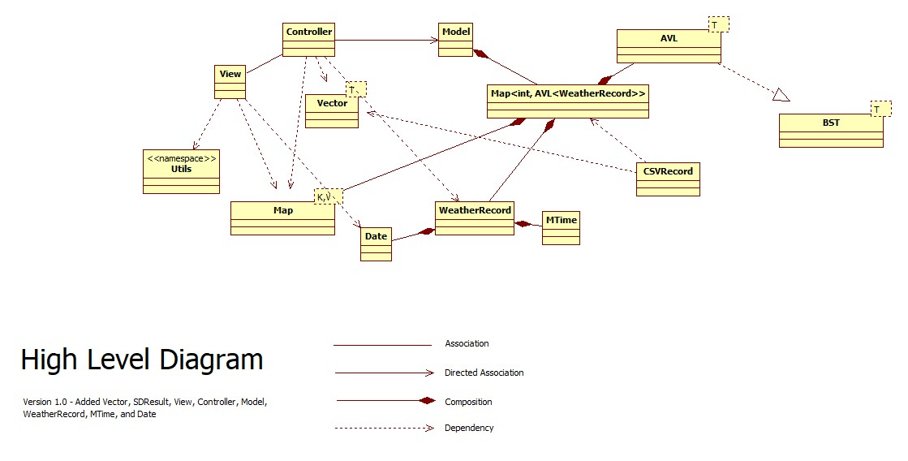
Below is a low-level diagram containing all the properties and methods of the classes.
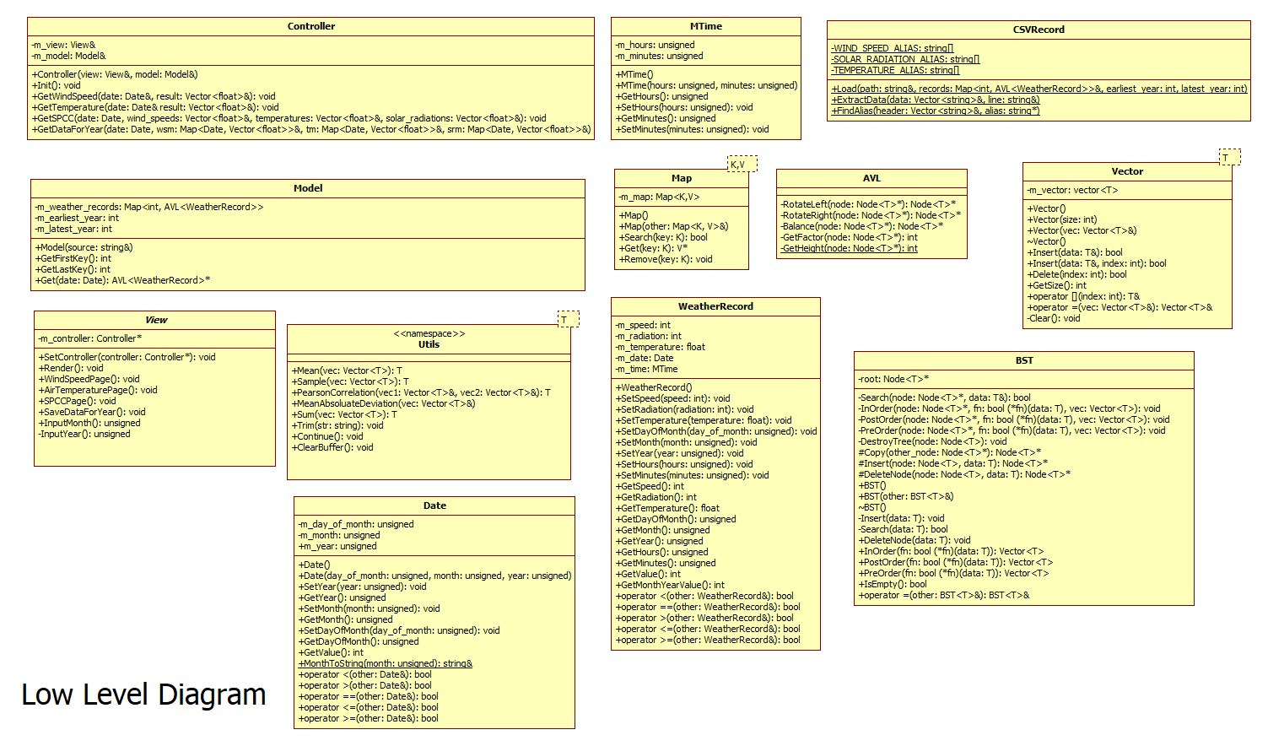

Data Dictionary

AVL Class
Name | Type | Access Modifier | Description | Rationale
RotateLeft(  Node<T>* node  ) | Node<T>* | Private | Rotate a subtree to the left. | Rotates the subtree to the left if the tree is right-heavy.
RotateRight(  Node<T>* node  ) | Node<T>* | Private | Rotate a subtree to the right. | Rotates the subtree to the right if the tree is left-heavy.
Balance(Node<T>* node) | Node<T>* | Private | Balance the AVL tree. | Ensures the AVL tree remains balanced after insertion or deletions. This guarantees logarithmic time complexity rather than linear time complexity.
GetFactor(Node<T>* node) | Int | Private | Get the balance factor of a node. | Get the balance factor of a node. The metric is used to determine whether rotations are needed to balance the tree.
GetHeight(Node<T>* node) | Int | Private | Get the height of a node. | Get the height of the node. It is used in conjunction with GetFactor method by subtracting the left and the right nodes.

BST Class
Name | Type | Access Modifier | Description | Rationale
BST() | Constructor  (Default) | Public | Constructor to initialize an empty BST. | This constructor initializes the BST by setting nullptr to root.
BST(BST<T>& other) | Constructor  (Copy) | Public | Copy constructor to create a new BST from another initialized BST. | Copies the data inside of another BST via deep copy.
~BST() | Destructor | Public | Destructor to clean up the BST. | Deletes all nodes that were initialized using new.
Search(Node<T>* node, T& data) | Bool | Private | Search for a node with the given data. | Searches a value by traversing left or right of the node. If the value does not match, it will traverse until it encounters a nullptr and returns false. Otherwise, it will return true.
InOrder(  Node<T>* node,  bool(*fn)(T& data),  Vector<T>& vec  ) | Void | Private | Perform an in-order traversal of the BST. | Traverses the tree by visiting the left subtree, the current node, then the right subtree. This is used for sorting values.
PreOrder(  Node<T>* node,  bool(*fn)(T& data) ,  Vector<T>& vec  ) | Void | Private | Perform a pre-order traversal of the BST. | Traverses the tree from the, the current node, the left subtree, then the right subtree. This is used for copying the tree.
PostOrder(  Node<T>* node,  Bool(*fn)(T& data) ,  Vector<T>& vec | Void | Private | Perform a post-order traversal of the BST. | Traverses the tree from the left subtree, the right subtree, then the current node. This is used for deleting nodes.
DestroyTree(Node<T>* node) | Void | Private | Destroy the entire tree and free memory. | Destroys the entire tree by clearing all the memory.
Copy(Node<T>* other_node) | Node<T>* | Protected | Copy a node from another tree. | Copies the node from another tree. When an assignment or copy operator is used, this method allows the other node to be copied into the current tree.
DeleteNode(Node<T>* node, T& data) | Node<T>* | Protected | Delete a node that matches the value. | Deletes the node that matches the value by removing it from the BST.
Insert(T& data) | Void | Public | Insert a value into the BST. | Inserts a value into the BST. It provides external method to insert value without going through the process of Insert implementation.
Search(T& data) | Bool | Public | Search for a value in the BST. | Searches for a specific element by leveraging the BST to reduce search time.
DeleteNode(T& data) | Void | Public | Delete a node from the table. | Deletes a node by specifying the value to search for.
InOrder(bool (*fn)(T& data) | Vector<T> | Public | Perform an in-order traversal of the BST. | Retrieves the data in sorted order and call the function to each of the node found in the tree. The collated result are returned.
PostOrder(bool (*fn)(T& data) | Vector<T> | Public | Perform a post-order traversal of the BST. | Retrieves the data starting from the left subtree, the right subtree, and finally, the node. The collated result are returned.
PreOrder(bool (*fn)(T& data) | Vector<T> | Public | Perform a pre-order traversal of the BST. | Retrieves the data starting from the node, the left subtree, and then, the right subtree. The collated result are returned.
IsEmpty() | Bool | Public | Check whether the tree is empty. | Checks whether the root is empty which is only accessible internally.
m_root | Node<T>* | Private | The root node of the BST. | The root node of the BST is required to traverse through the node to find, delete, and insert value.

Controller Class
Name | Type | Access Modifier | Description | Rationale
Controller(  View &view,  Model &model  ) | Constructor  (Parameterized) | Public | Constructor for the Controller Class. | The constructor initializes the Controller object with Model and View.
Init() | Void | Public | Initializes the Controller. | Serves as the controller’s entry point by rendering the initial view.
GetWindSpeed(  const Date& date,  Vector<float>& result  ) | Void | Public | Gets the wind speed for a specific month and year. | Retrieves the wind speed from the Model for a specific month and year before returning the result back using a pass by reference.
GetTemperature(  const Date& date,  Vector<float>& result  ) | Void | Public | Gets the temperature for each month of a specific year. | Retrieves the temperature from the Model based on a specific year before returning the result back using a pass by reference.
GetSPCC(  Date date,  Vector<float>& wind_speeds,  Vector<float>& temperatures,  Vector<float>& solar_radiations  ) | Void | Public | Get the sample Pearson Correlation Coefficient from the loaded data. | Retrieves the sample Pearson Correlation Coefficient by populating the pass by reference vector.
GetDataForYear(  Date date,  Map<Date, Vector<float>>& wind_speed_map,  Map<Date, Vector<float>>& temperature _map,  Map<Date, Vector<float>>& solar_radiation _map  ) | Void | Public | Get the data for a specific year. | Retrieves the data for each month of a specific year and insert the data with Date as a key and Vector<float> as a value into a pass by reference map.
m_view | View& | Private | Handles rendering of the view. | Enables the controller to render pages.
m_model | Model& | Private | Manages the retrieval of data from the model. | Enables the controller to retrieve relevant weather data.

CSVRecord Class
Name | Type | Access Modifier | Description | Rationale
Load(  string& path, Map<int, AVL<WeatherRecord>> records,  int& earliest_year,  int& latest_year  ) | Void | Public | Load weather records from a CSV file and populate the record map. | This method loads the record into a Map which is stored in Model.
ExtractData(  Vector<string>& data,  String& line  ) | Void | Private | Extract and parses each line into a vector string data. | Extracts data from a line and stores it inside a vector string for further processing.
FindAlias(  Vector<string>& header,  string* alias  ) | Int | Private | Finds the index of an alias in the headers vector. | Searches through the header for any of the alternative names.
WIND_SPEED_ALIAS[] | String | Private | Wind speed alias used in the CSV file. | A constant static property that stores different alias for wind speed. This property is only accessible to CSVRecord.
SOLAR_RADIATION_ALIAS[] | String | Private | Solar radiation alias used in the CSV file. | A constant static property that stores different alias for solar radiation. This property is only accessible to CSVRecord.
TEMPERATURE_ALIAS[] | String | Private | Air ambient temperature alias used in the CSV file | A constant static property that stores different alias for temperature. This property is only accessible to CSVRecord.

Date Class
Name | Type | Access Modifier | Description | Rationale
Date() | Constructor  (Default) | Public | Default constructor for Date object. | The constructor initializes the Date object with default values.
Date(  unsigned day_of_month,  unsigned month,  unsigned year  ) | Constructor  (Parameterized) | Public | Parameterized constructor for Date object. | The constructor initializes the Date object with day, month, and year.
MonthToString(unsigned month) | Const string& | Public | Converts a month number to its string representation. | Allow the program to display the month name.
m_day_of_month | Unsigned | Private | The day of the month (1-31) | Represents the day of the month as a non-negative integer and applies modulo arithmetic to limit the range from 1 to 31.
m_month | Unsigned | Private | The month (1-12) | Represents the month as a non-negative integer and applies modulo arithmetic to limit the range from 1 to 12. Acts as a filter when processing weather record.
m_year | Unsigned | Private | The year. | Represents the year as a non-negative integer. Acts as a filter when processing weather record.

Model Class
Name | Type | Access Modifier | Description | Rationale
Model(const string& source) | Constructor  (Parameterized) | Public | Default constructor for the Model object. | The constructor initializes the Model object and loads all the weather records from the specified source.
GetFirstKey() | Int | Public | Retrieve the first key in the model. | Get the first key. The method allows the controller method GetSPCC to decode the earliest year that was set.
GetLastKey() | Int | Public | Retrieve the last key in the model. | Get the last key. The method allows the controller method GetSPCC to decode the latest year that was set.
m_earliest_year | Int | Private | The earliest year in the weather records. | Allows the first key to be retrieved using GetFirstKey method.
m_latest_year | Int | Private | The latest year in the weather records. | Allows the last key to be retrieved using GetLastKey method.
m_weather_records | Map<int, AVL<WeatherRecord>> | Private | A map to hold weather records indexed by year and month. | Stores the weather record in an indexed map of AVL<WeatherRecord>

MTime Class
Name | Type | Access Modifier | Description | Rationale
MTime() | Constructor  (Default) | Public | A default constructor for Time object. | The constructor initializes the Date object.
MTime(  unsigned hours,  unsigned minutes  ) | Constructor  (Parameterized) | Public | Parameterized constructor for Time object. | Constructs Time object using the parameters, hours, and minutes.
m_hours | Unsigned | Private | Hours in a 24-hour format. | Completes the Time API and reserves for future use. Represents time in a 24-hours format. The modulo arithmetic is applied to ensure it stays between 0 and 23.
m_minutes | Unsigned | Private | Minutes ranging from 0 to 59 | Completes the Time API and reserves for future use. Represents time as minutes. The modulo arithmetic is applied to ensure it stays between 0 and 59.

Utils Namespace
Name | Type | Access Modifier | Description | Rationale
Mean(Vector<T>& vec) | T | Public | Calculate the mean of the dataset. | Uses the data stored in the vector to process and return the average.
Sample(Vector<T>& vec) | T | Public | Calculate the sample standard deviation of a vector. | Uses the data stored in the vector to process and return the sample standard deviation.
PearsonCorrelation(  Vector<T>& vec1,  Vector<T>& vec2  ) | T | Public | Calculate the  Sample Pearson Correlation Coefficient. | Uses vec1 and vec2 to calculate the SPCC and return the result.
MeanAbsoluteDeviation(  Vector<T>& vec  ) | T | Public | Calculate the mean absolute deviation of a vector. | Uses the data stored in the vector to process and return the mean absolute deviation.
Sum(Vector<T>& vec) | T | Public | Calculate the sum of a vector. | Uses the data to calculate the sum and return the total of all values added.
Trim(string& str) | Void | Public | Trim leading and trailing whitespace from the string. | Trims the CSV header along with the data to prevent any comparison and conversion issue.
Continue() | Void | Public | Display a message to continue. | Informs the user that the page has finished displaying the result. This stops the page from displaying other pages immediately.
ClearBuffer() | Void | Public | Clear the input buffer. | Clears the input buffer such as newline after keying in values (e.g. double, float, string). If the user provides an invalid value, it will reset the error state.

Vector Class
Name | Type | Access Modifier | Description | Rationale
Vector() | Constructor  (Default) | Public | Default constructor for the vector object. | The default constructor object that allows variable to be declared without any parameter.
Vector(int size) | Constructor  (Parameterized) | Public | Parametized constructor for the Vector object. | The constructor initializes Vector object and allocates the vector with the provided capacity.
Vector(const Vector<T>& vec) | Constructor  (Copy Assignment) | Public | Copies from another Vector object. | The constructor copies from another vector object.
Insert(const T& data) | Bool | Public | Inserts data into the vector at the last index. | Inserts the data without providing the second parameter.
Insert(  const T& data,  int index  ) | Bool | Public | Inserts data into the vector at a specific index. | Allows for the insertion of items in different position.
Delete(int index) | Bool | Public | Deletes data from the vector at a specific index. | Allows for deletion of item.
GetSize() | Int | Public | Get the size of the vector. | Get the current size of the vector and determines if the vector contains any items.
operator [](int index) | Const T& | Public | Subscript operator to access elements in the vector as a read-only reference. | Enables the vector object to retrieve data using [i].
operator [](int index) | T& | Public | Subscript operator to access elements in the vector as a modifiable reference. | Enables the specific index to be modified using [i].
operator =(const Vector<T>& vec) | Vector<T>& | Public | Assignment operator to copy the contents of another vector. | Enables vector to assign data from another vector easily.
Clear() | Void | Public | Clear the vector by removing all elements. | Deletes the element inside the vector without redeclaring a vector to clear the data.
m_vector | T* | Private | Stores the vector data. | Stores the object inside the vector for further processing.

View Class
Name | Type | Access Modifier | Description | Rationale
SetController(const Controller* controller) | Void | Public | Sets the controller. | Assigns the controller to view without direct manipulation of the m_controller property.
Render(const string& page) | Void | Public | Renders the specific page. | Renders the available page in the if statement and display the list of available options.
WindSpeedPage() | Void | Private | Displays the average and sample standard deviation of the wind speed for a specific month and year. | Displays information about the wind speed after user enters the month and year.
AirTemperaturePage() | Void | Private | Displays the average and sample standard deviation of the ambient air temperature. | Displays information about the ambient air temperature for each month after user enters the year.
SPCCPage() | Void | Private | Display Sample Pearson Correlation Coefficient. | Displays information for a specific month based on the data collected.
SaveDataForYear() | Void | Private | Saves the average, mean absolute deviation, and sample standard deviation of the wind speed and ambient air temperature, the total solar radiation for each month into a file called “WindTempSolar.csv.” | Saves the data into a file called “WindTempSolar.csv”
InputMonth() | Unsigned | Private | Gets the input month from the user. | Validates the month input by checking that the value is between 1 and 12, rejecting alphabetic or out-of-range numbers, and preventing overflow. It informs the user on any invalid input.
InputYear() | Unsigned | Private | Gets the input year from the user. | Validates the year input by checking that the value is between 1 and 9999, rejecting alphabetic or out-of-range numbers, and preventing overflow. It informs the user on any invalid input.
m_controller | Controller* | Private | A pointer to the controller object. | Stores a reference to the controller object. It also allows view to fetch the required data via the controller.

WeatherRecord Class
Name | Type | Access Modifier | Description | Rationale
WeatherRecord() | Constructor  (Default) | Public | Default constructor for WeatherRecord object. | The constructor initializes WeatherRecord object.
m_speed | Int | Private | Speed of the wind in m/s. | Represents speed as an integer. If speed is below 0, a sentinel value -9999 will replace the invalid value.
m_radiation | Int | Private | Solar radiation in W/m2 | Represents solar radiation as an integer. The maximum recorded solar radiation is 1361 W/m^{2,} ; therefore, value above 1500 W/m² is invalid. Similarly, if the values falls below 0, the sentinel value -9999 will replace the invalid value.
m_temperature | Float | Private | Temperature in degrees Celsius. | Represents air ambient temperature as an integer. The lowest temperature is around -89.2C, while the highest temperature is 56.7C. Valid values are capped between -100C to 100C. Any value outside the range is replaced by the sentinel value -9999.
m_date | Date | Private | Date of the weather record. | Holds the date object. The object is used to validate the specific date by checking the month and year.
m_time | MTime | Private | Time of the weather record. | Holds the time object. Reserved for future use.

Map Class
Name | Type | Access Modifier | Description | Rationale
Map() | Constructor  (Default) | Public | Default constructor for Map object. | The constructor initializes Map object.
Map(const Map<K, V>& other) | Constructor  (Copy) | Public | Copy constructor for Map object | Copies the data inside of another Map using std::map assignment operator.
Insert(K& key, V& value) | Void | Public | Insert a key-value pair into map. | Assigns the value with a key in the map object.
Search | Bool | Public | Search for a key in the map. | Finds the key that matches the provided value. The search will return either true if the key exist or false if no key is found.
Get | V* | Public | Retrieve the value associated with a key. | Return the value that is associated with the key. If no value is found, a nullptr is returned.
Remove | Void | Public | Remove a key-value pair from the map. | Removes the key-value pair that matches the selected key.

Rationale for Map<int, AVL<WeatherRecord>

The program uses Map<int, AVL<WeatherRecord>> to structure weather data by month and year, and then by timestamp within that month.

((GetYear() - 1970) * 372 + GetMonth() * 31)

The design of this formula ensures that varying month lengths are abstracted away by treating each month uniformly as 31 days, eliminating the need to calculate the actual number of days in each month. Another benefit is that it accommodates year before 1970, as the key can be negative.

The decision to use AVL lies in its ability to self-rebalance after insertion. This ensures that both insertion and lookup operations to remain efficient. Since it stores WeatherRecord objects, the overloaded comparison operator uses the following formula to impose the temporal ordering:

((GetMonthYearValue() + (GetDayOfMonth() - 1)) * 24 * 60) + (GetHours() * 60 + GetMinutes())

Despite its efficiency, the chosen representation introduces certain drawbacks. By integrating the day of month into the timestamp, it becomes difficult to retrieve individual date component directly from the AVL tree. One possible solution is to introduce a secondary map nested within the outer map, which would increase overhead but reduce the number of data elements within each AVL tree.

Map<int, Map<int, AVL<WeatherRecord>>>

Another alternative is to invert the hierarchy, using the AVL tree for month-year lookup while the inner map manages day and time. This becomes a viable option but introduces an issue where the nodes becomes larger, leading to increased overhead during rebalancing, as each balancing operation involves copying or moving data structures.

Test Plans
The test plan contains Unit Test, Integration Test, Application Test, and edge cases. Unit Test and Integration Test can be found in test folder.

Date Class (Unit Test)
ID | Description | Input | Expected Output | Outcome
1 | Create a date object without any parameter. | Date date;  cout << "Day: " << date.GetDayOfMonth() << ", Month: " << date.GetMonth() << ", Year: " << date.GetYear() << endl; | Day: 1, Month: 1, Year: 1 | Pass
2 | Create a date with parameters. | Date date(15, 8, 2023);  cout << "Day: " << date.GetDayOfMonth() << ", Month: " << date.GetMonth() << ", Year: " << date.GetYear() << endl; | Day: 15, Month: 8, Year: 2023 | Pass
3 | Set the date object with setter methods. | Date date;  date.SetDayOfMonth(25);  date.SetMonth(12);  date.SetYear(2023);  cout << "Day: " << date.GetDayOfMonth() << ", Month: " << date.GetMonth() << ", Year: " << date.GetYear() << endl; | Day: 25, Month: 12, Year: 2023 | Pass
4 | Invalid date. | Date date(35, 13, 2023);  cout << "Day: " << date.GetDayOfMonth() << ", Month: " << date.GetMonth() << ", Year: " << date.GetYear() << endl; | Day: 3, Month: 1, Year: 2023 | Pass
5 | Compares date with another date. | Date date1(15, 8, 2023);  Date date2(16, 8, 2023);  cout << date1.GetDayOfMonth() << '/' << date1.GetMonth() << '/' << date1.GetYear() << endl;  cout << date2.GetDayOfMonth() << '/' << date2.GetMonth() << '/' << date2.GetYear() << endl;  cout << "Date1 < Date2: " << (date1 < date2) << endl;  cout << "Date1 > Date2: " << (date1 > date2) << endl;  cout << "Date1 == Date2: " << (date1 == date2) << endl;  cout << "Date1 <= Date2: " << (date1 <= date2) << endl;  cout << "Date1 >= Date2: " << (date1 >= date2) << endl; | 15/8/2023  16/8/2023  Date1 < Date2: 1  Date1 > Date2: 0  Date1 == Date2: 0  Date1 <= Date2: 1  Date1 >= Date2: 0 | Pass

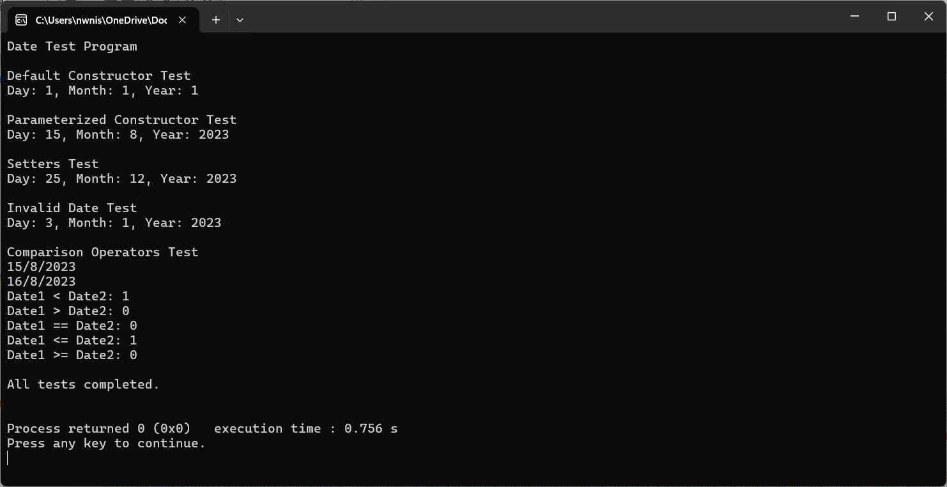

MTime Class (Unit Test)
ID | Description | Input | Expected Output | Outcome
1 | Create a time object without any parameter. | MTime time;  cout << "Hour: " << time.GetHours() << ", Minute: " << time.GetMinutes() << endl; | Hour: 0, Minute: 0 | Pass
2 | Create a time object with parameters. | MTime time(10, 30);  cout << "Parameterized Constructor Test" << endl;  cout << "Hour: " << time.GetHours() << ", Minute: " << time.GetMinutes() << endl; | Hour: 10, Minute: 30 | Pass
3 | Set the time object with setter methods. | MTime time;  time.SetHours(12);  time.SetMinutes(30);  cout << "Hour: " << time.GetHours() << ", Minute: " << time.GetMinutes() << endl; | Hour: 12, Minute: 30 | Pass
4 | Invalid time. | MTime time(24, 61); // Invalid time  cout << "Hour: " << time.GetHours() << ", Minute: " << time.GetMinutes() << endl; | Hour: 0, Minute: 1 | Pass

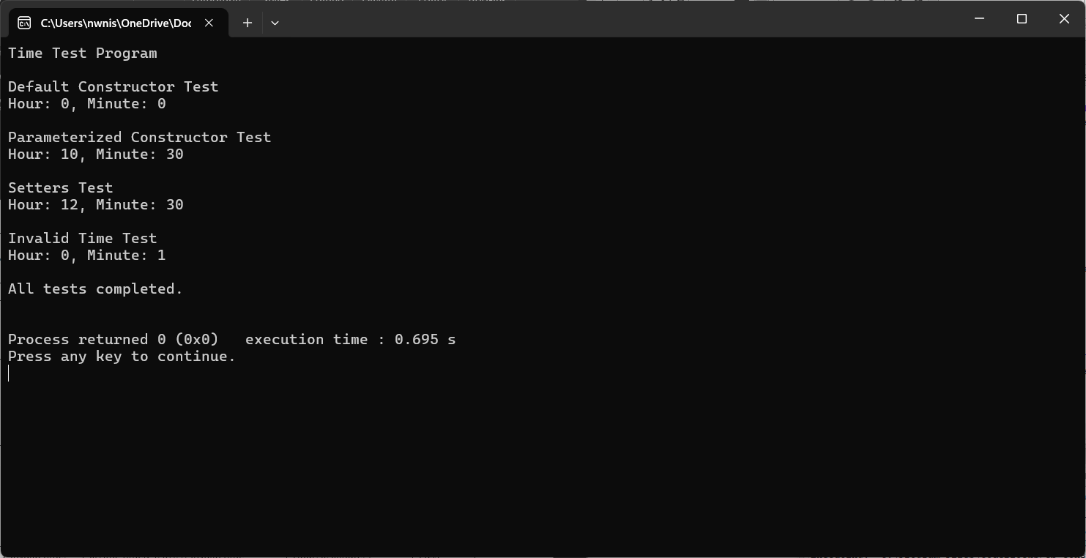

Vector Class (Unit Test)
ID | Description | Input | Expected Output | Outcome
1 | Create a vector object without any parameter. | Vector<int> vec;  cout << "Size: " << vec.GetSize() << ", Capacity: " << vec.GetCapacity() << endl; | Size: 0, Capacity: 10 | Pass
2 | Create a vector object with an invalid size. | Vector<int> vec(-10);  cout << "Size: " << vec.GetSize() << ", Capacity: " << vec.GetCapacity() << endl; | Size: 0, Capacity: 10 | Pass
3 | Create a vector object with a valid size. | Vector<int> vec(5);  cout << "Size: " << vec.GetSize() << ", Capacity: " << vec.GetCapacity() << endl;  for (int i = 0; i < 5; ++i) {  vec.Insert(i);  }  cout << "After inserting elements: Size: " << vec.GetSize() << ", Capacity: " << vec.GetCapacity() << endl; | Size: 0, Capacity: 5  After inserting elements: Size: 5, Capacity: 10 | Pass
4 | Insert numbers into a vector object. | Vector<int> vec(2);  vec.Insert(1);  vec.Insert(2);  vec.Insert(3);  cout << "After inserting elements: Size: " << vec.GetSize() << ", Capacity: " << vec.GetCapacity() << endl;  for (int i = 0; i < vec.GetSize(); ++i) {  cout << "Element at index " << i << ": " << vec[i] << endl;  } | After inserting elements: Size: 3, Capacity: 4  Element at index 0: 1  Element at index 1: 2  Element at index 2: 3 | Pass
5 | Insert numbers at specific indices. | Vector<int> vec(5);  vec.Insert(10, 0);  vec.Insert(20, 1);  vec.Insert(30, 2);  cout << "After inserting elements: Size: " << vec.GetSize() << ", Capacity: " << vec.GetCapacity() << endl;  for (int i = 0; i < vec.GetSize(); ++i) {  cout << "Element at index " << i << ": " << vec[i] << endl;  } | After inserting elements: Size: 3, Capacity: 5  Element at index 0: 10  Element at index 1: 20  Element at index 2: 30 | Pass
6 | Insert numbers at specific indices twice. | Vector<int> vec(5);  vec.Insert(1, 0);  vec.Insert(2, 1);  vec.Insert(3, 2);  vec.Insert(4, 3);  vec.Insert(5, 4);  vec.Insert(6, 2);  for (int i = 0; i < vec.GetSize(); ++i) {  cout << "Element at index " << i << ": " << vec[i] << endl;  } | Element at index 0: 1  Element at index 1: 2  Element at index 2: 6  Element at index 3: 3  Element at index 4: 4  Element at index 5: 5 | Pass
7 | Insert numbers at specific indices with invalid index. | Vector<int> vec(5);  if(!vec.Insert(10, -1)){  cout << "Failed to insert at index -1" << endl;  }  if(!vec.Insert(20, 6)){  cout << "Failed to insert at index 6" << endl;  } | Insert elements at specific indices with invalid index.  Failed to insert at index -1.  Failed to insert at index 6 | Pass
8 | Delete number from the vector. | Vector<int> vec(5);  vec.Insert(1);  vec.Insert(2);  vec.Insert(3);  cout << "Before deletion: Size: " << vec.GetSize() << ", Capacity: " << vec.GetCapacity() << endl;  for (int i = 0; i < vec.GetSize(); ++i) {  cout << "Element at index " << i << ": " << vec[i] << endl;  }  vec.Delete(1);  cout << "After deleting element at index 1: Size: " << vec.GetSize() << ", Capacity: " << vec.GetCapacity() << endl;  for (int i = 0; i < vec.GetSize(); ++i) {  cout << "Element at index " << i << ": " << vec[i] << endl;  } | Before deletion: Size: 3, Capacity: 5  Element at index 0: 1  Element at index 1: 2  Element at index 2: 3  After deleting element at index 1: Size: 2, Capacity: 5  Element at index 0: 1  Element at index 1: 3 | Pass
9 | Delete number at invalid indices. | Vector<int> vec(5);  vec.Insert(1);  vec.Insert(2);  cout << "Before deletion: Size: " << vec.GetSize() << ", Capacity: " << vec.GetCapacity() << endl;  if (!vec.Delete(-1)) {  cout << "Failed to delete at index -1" << endl;  }  if (!vec.Delete(5)) {  cout << "Failed to delete at index 5" << endl;  }  cout << "After attempting invalid deletions: Size: " << vec.GetSize() << ", Capacity: " << vec.GetCapacity() << endl; | Before deletion: Size: 2, Capacity: 5  Failed to delete at index -1.  Failed to delete at index 5.  After attempting invalid deletions: Size: 2, Capacity: 5 | Pass
10 | Access number using subscript operator. | Vector<int> vec(5);  try{  vec[3] = 10;  }  catch(std::out_of_range& e){  cout << "Caught exception: " << e.what() << endl;  } | Caught exception: Index must be from 0 to size – 1 | Pass
11 | Modify elements using subscript operator. | Vector<int> vec(5);  vec.Insert(1);  vec.Insert(2);  vec.Insert(3);  cout << "Before modification: Size: " << vec.GetSize() << ", Capacity: " << vec.GetCapacity() << endl;  for (int i = 0; i < vec.GetSize(); ++i) {  cout << "Element at index " << i << ": " << vec[i] << endl;  }  try{  vec[1] = 10;  }  catch(std::out_of_range& e){  cout << "Caught exception: " << e.what() << endl;  }  cout << "After modification: Size: " << vec.GetSize() << ", Capacity: " << vec.GetCapacity() << endl;  for (int i = 0; i < vec.GetSize(); ++i) {  cout << "Element at index " << i << ": " << vec[i] << endl;  } | Before modification: Size: 3, Capacity: 5  Element at index 0: 1  Element at index 1: 2  Element at index 2: 3  After modification: Size: 3, Capacity: 5  Element at index 0: 1  Element at index 1: 10  Element at index 2: 3 | Pass

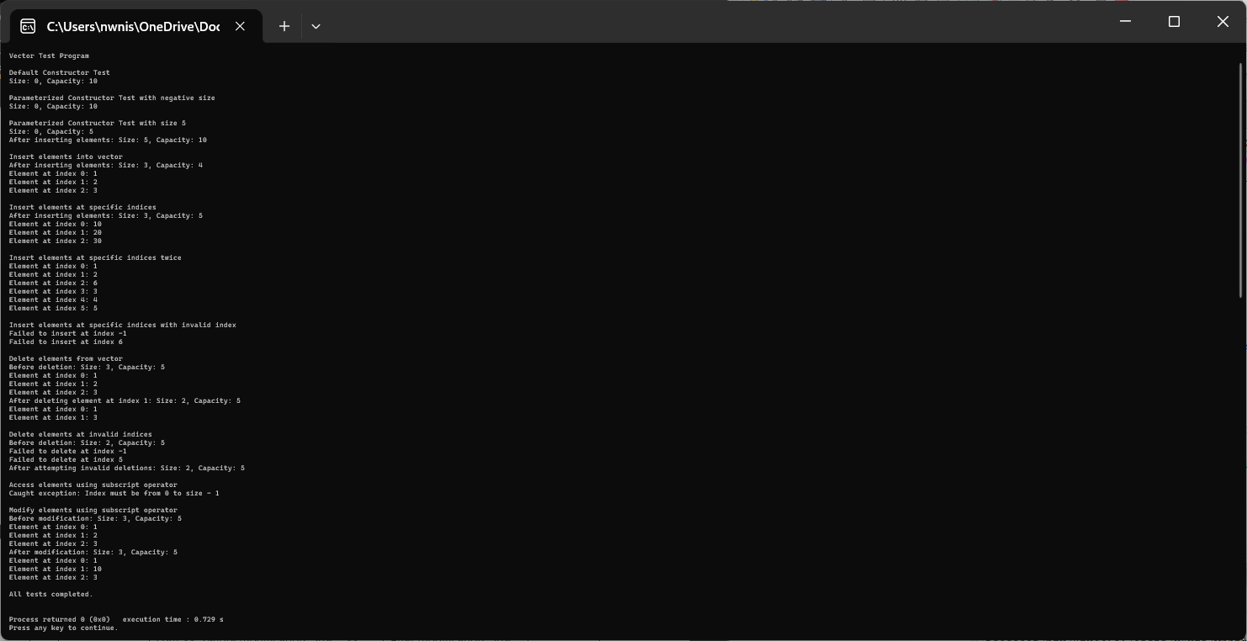

WeatherRecord Class (Integration Test)
ID | Description | Input | Expected Output | Outcome
1 | Create a weather record object without any parameter. | WeatherRecord record;  cout << "Date: " << record.GetDayOfMonth() << "/"  << record.GetMonth() << "/" << record.GetYear()  << ", Temperature: " << record.GetTemperature()  << ", Humidity: " << record.GetRadiation()  << ", Wind Speed: " << record.GetSpeed()  << ", Time: " << record.GetHours() << ":"  << record.GetMinutes() << endl; | Date: 1/1/1, Temperature: 0, Humidity: 0, Wind Speed: 0, Time: 0:0 | Pass
2 | Set the weather record object with setter methods. | WeatherRecord record;  record.SetSpeed(10);  record.SetRadiation(200);  record.SetTemperature(25.5f);  record.SetDayOfMonth(15);  record.SetMonth(8);  record.SetYear(2023);  record.SetHours(14);  record.SetMinutes(30);  cout << "Date: " << record.GetDayOfMonth() << "/"  << record.GetMonth() << "/" << record.GetYear()  << ", Temperature: " << record.GetTemperature()  << ", Humidity: " << record.GetRadiation()  << ", Wind Speed: " << record.GetSpeed()  << ", Time: " << record.GetHours() << ":"  << record.GetMinutes() << endl; | Date: 15/8/2023, Temperature: 25.5, Humidity: 200, Wind Speed: 10, Time: 14:30 | Pass

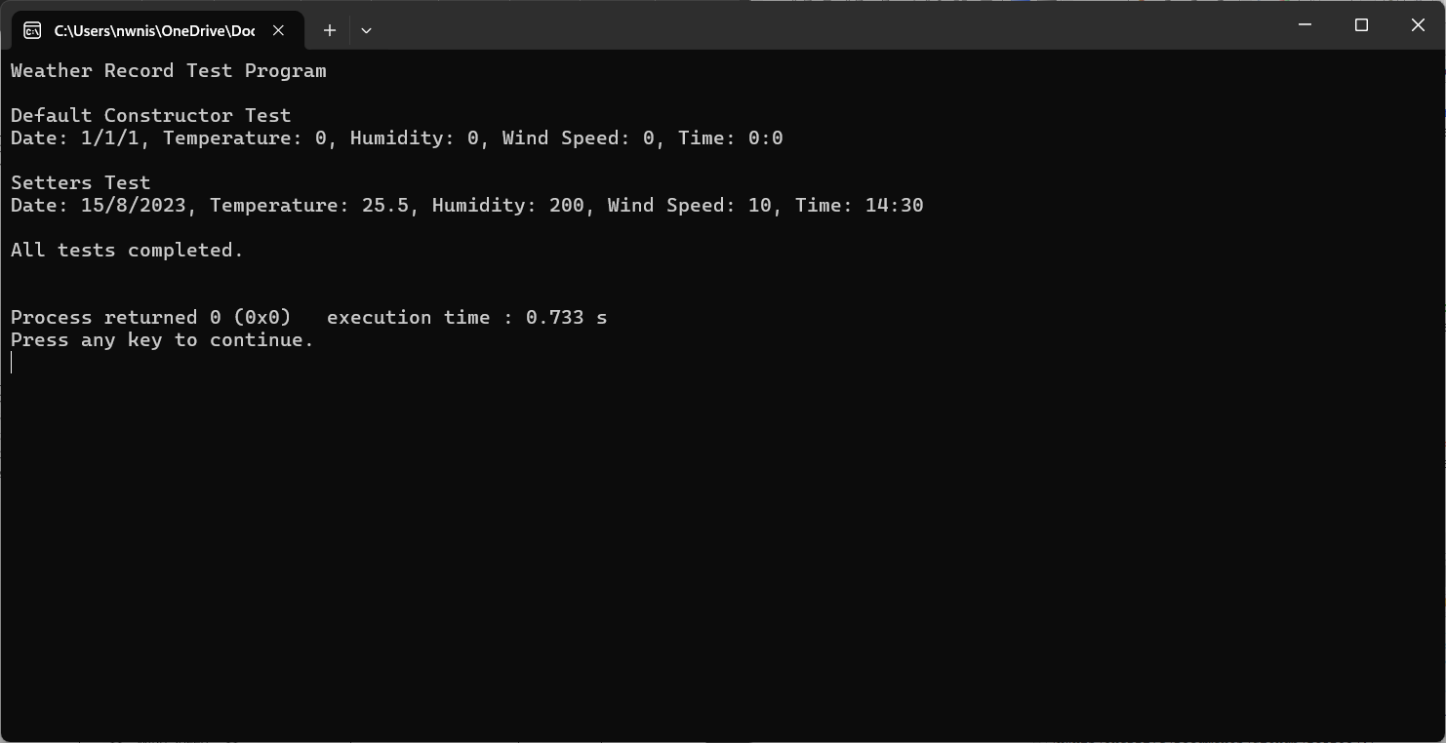

Map Test (Unit Test)
ID | Description | Input | Expected Output | Outcome
1 | Insert number into a map. | Map<int, string> map;  map.Insert(1, “one”);  map.Insert(2, “two”);  map.Insert(3, “three”);  cout << "Map 1: " << *map.Get(1) << endl;  cout << "Map 2: " << *map.Get(2) << endl;  cout << "Map 3: " << *map.Get(3) << endl; | Map 1: One  Map 2: Two  Map 3: Three | Pass
2 | Search for an existing and non-existing number. | Map<int, string> map;  map.Insert(1, "One");  map.Insert(2, "Two");  map.Insert(3, "Three");  cout << "Search for key 1: " << (map.Search(1) ? "Found" : "Not Found") << endl;  cout << "Search for key 4: " << (map.Search(4) ? "Found" : "Not Found") << endl; | Search for key 1: Found  Search for key 4: Not Found | Pass
3 | Assign a map to another map. | Map<int, string> map;  Map<int, string> map_1;  map.Insert(1, "One");  map.Insert(2, "Two");  map.Insert(3, "Three");  map_1 = map;  cout << "Map 1:" << map_1.Get(1) << endl;  cout << "Map 2:" << map_1.Get(2) << endl;  cout << "Map 3:" << map_1.Get(3) << endl; | Map 1:One  Map 2:Two  Map 3:Three | Pass
4 | Remove number from a map. | Map<int, string> map;  map.Insert(1, "One");  map.Insert(2, "Two");  map.Insert(3, "Three");  cout << "Remove Test" << endl;  cout << "Before removal: " << *map.Get(2) << endl;  map.Remove(2);  cout << "After removal: " << (map.Get(2) ? *map.Get(2) : "Not Found") << endl; | Before removal: Two  After removal: Not Found | Passed

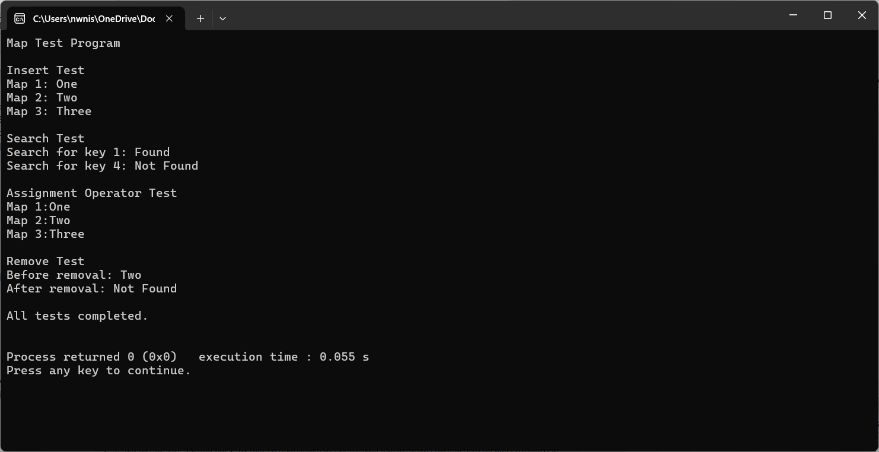

BST Test (Unit Test)
ID | Description | Input | Expected Output | Outcome
1 | Insert value into BST | BST<int> bst;  bst.Insert(5);  bst.Insert(3);  bst.Insert(7);  cout << "Is number 5 in BST? " << (bst.Search(5) ? "Yes" : "No") << endl;  cout << "Is number 3 in BST? " << (bst.Search(3) ? "Yes" : "No") << endl;  cout << "Is number 7 in BST? " << (bst.Search(7) ? "Yes" : "No") << endl;  cout << "Is number 10 in BST? " << (bst.Search(10) ? "Yes" : "No") << endl; | Is number 5 in BST? Yes  Is number 3 in BST? Yes  Is number 7 in BST? Yes  Is number 10 in BST? No | Pass
2 | PreOrder traversal from BST. | BST<int> bst;  bst.Insert(34);  bst.Insert(23);  bst.Insert(45);  bst.Insert(12);  bst.Insert(67);  bst.PreOrder([](const int& data){  cout << data << " ";  return true;  });  cout << endl; | 34 23 12 45 67 | Pass
3 | InOrder traversal from BST. | BST<int> bst;  bst.Insert(34);  bst.Insert(23);  bst.Insert(45);  bst.Insert(12);  bst.Insert(67);  bst.InOrder([](const int& data){  cout << data << " ";  return true;  });  cout << endl; | 12 23 34 45 67 | Pass
4 | PostOrder traversal from BST. | BST<int> bst;  bst.Insert(34);  bst.Insert(23);  bst.Insert(45);  bst.Insert(12);  bst.Insert(67);  bst.PostOrder([](const int& data){  cout << data << " ";  return true;  });  cout << endl; | 12 23 67 45 34 | Pass
5 | Delete node from the BST. | BST<int> bst;  bst.Insert(34);  bst.Insert(23);  bst.DeleteNode(23);  cout << "Is number 23 in BST? " << (bst.Search(23) ? "Yes" : "No") << endl;  cout << "Is number 34 in BST? " << (bst.Search(34) ? "Yes" : "No") << endl; | Is number 23 in BST? No  Is number 34 in BST? Yes | Pass
6 | Destroy BST tree. | BST<int> bst;  bst.Insert(34);  bst.Insert(23);  bst.Insert(45);  cout << "Is BST empty? " << (bst.IsEmpty() ? "Yes" : "No") << endl;  bst.InOrder([](const int& data){  cout << data << " ";  return true;  });  bst.DestroyTree();  cout << "Is BST empty after destroy? " << (bst.IsEmpty() ? "Yes" : "No") << endl; | Destroy Tree Test  Is BST empty? No  23 34 45 Is BST empty after destroy? Yes | Pass
7 | Copy from another BST. | BST<int> bst;  bst.Insert(10);  bst.Insert(20);  bst.Insert(5);  BST<int> bst_copy(bst);  bst_copy.InOrder([](const int& data){  cout << data << " ";  return true;  });  cout << endl; | 5 10 20 | Pass
8 | Assign BST with another BST. | BST<int> bst;  bst.Insert(10);  bst.Insert(20);  bst.Insert(5);  BST<int> bst_assignment_op;  bst_assignment_op = bst;  cout << "Assignment Operator Test" << endl;  bst_assignment_op.InOrder([](const int& data){  cout << data << " ";  return true;  });  cout << endl; | 50 10 20 | Pass

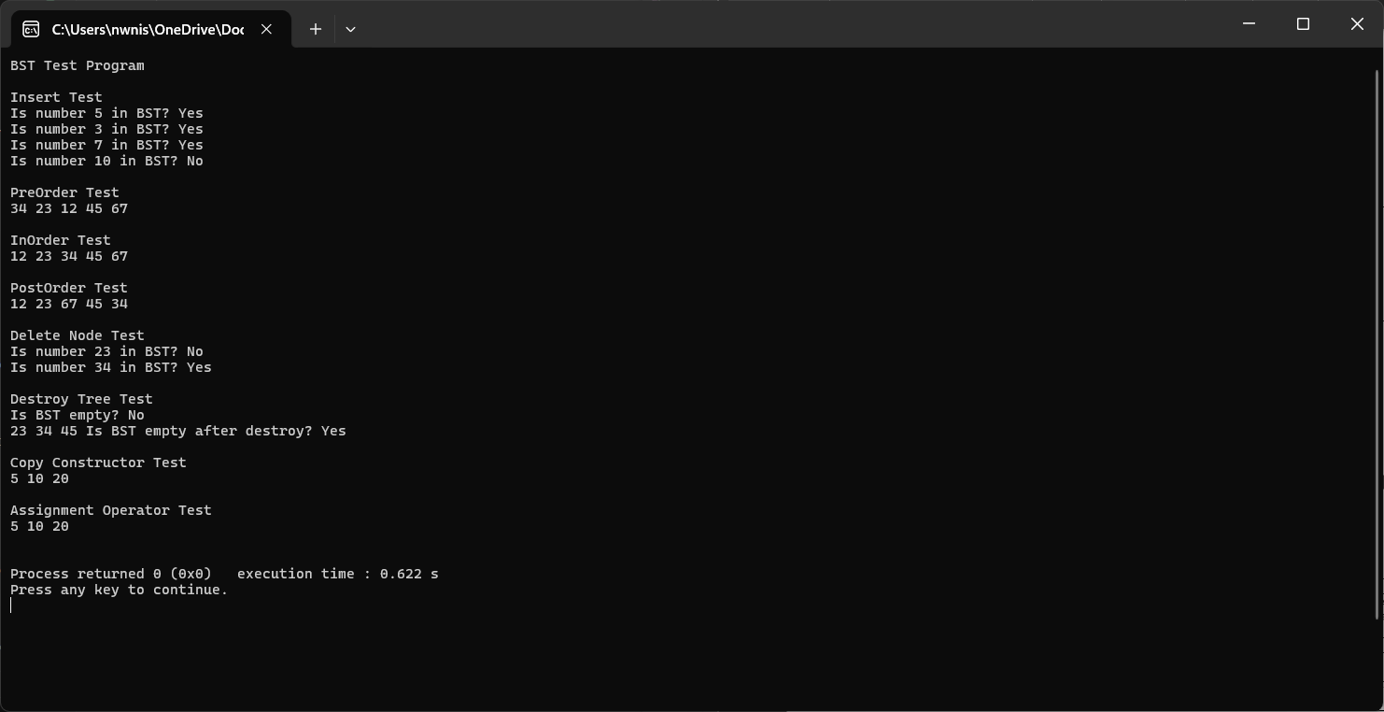

Application Test

Test ID | APP_PAGE_1
Description | Verify that the system calculates the average and standard deviation of wind speed based on user’s input.
Precondition | CSV is loaded from data_source.txt.
Input | Please enter the month (1-12): 3  Please enter the year: 2015
Expected Result | The correct average and standard deviation of the wind speed in km/h are displayed.

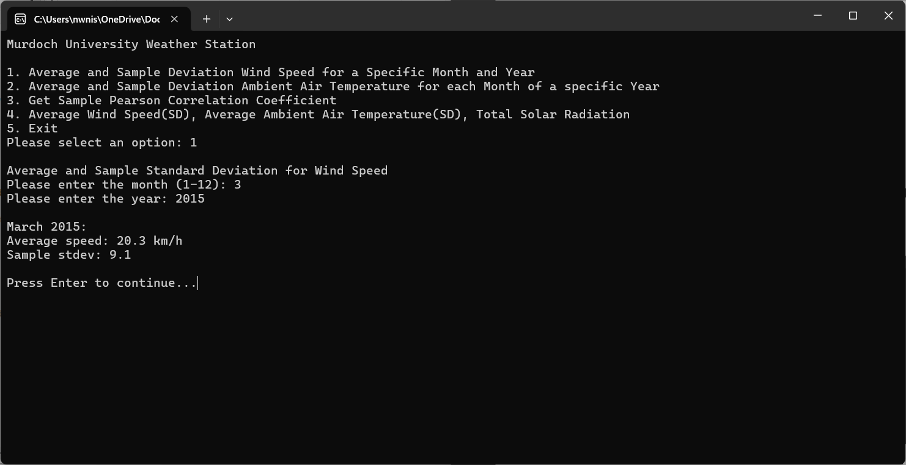

Test ID | APP_PAGE_2
Description | Verify that the system calculates the average and standard deviation of the temperature for each month of a specific year.
Precondition | CSV is loaded from data_source.txt.
Input | Please enter the year: 2015
Expected Result | The correct average and standard deviation of the temperature for all the months are displayed.

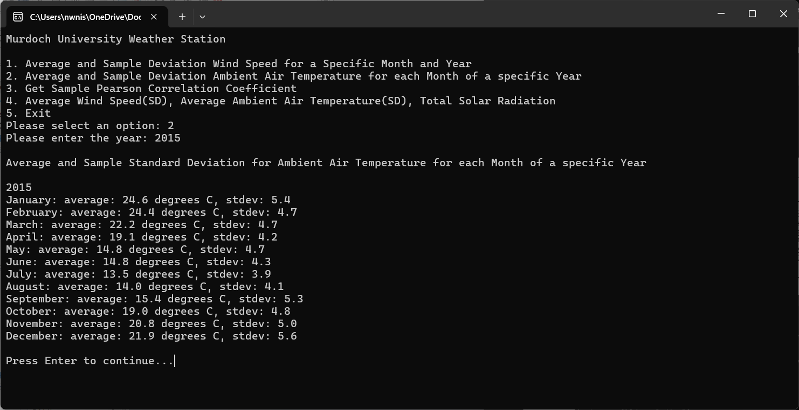

Test ID | APP_PAGE_3
Description | Verify that the system calculates sample Pearson correlation coefficient.
Precondition | CSV is loaded from data_source.txt.
Input | Please enter the month (1-12): 4
Expected Result | The correct Sample Pearson Correlation Coefficient for April.

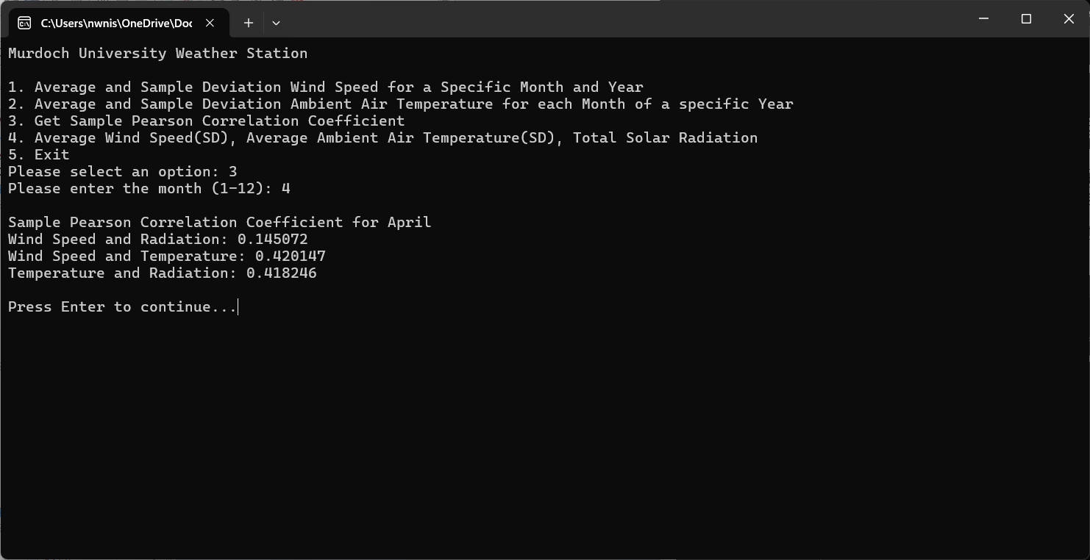

Test ID | APP_PAGE_4
Description | Verify that the system generates a file called WindTempSolar.csv. The file contains the average and sample standard deviation of the temperature, wind speed, and the total solar radiation for each month based on a specific year.
Precondition | CSV is loaded from data_source.txt.
Input | Please enter the year: 2015
Expected Result | A generated file containing the data for a specific year.

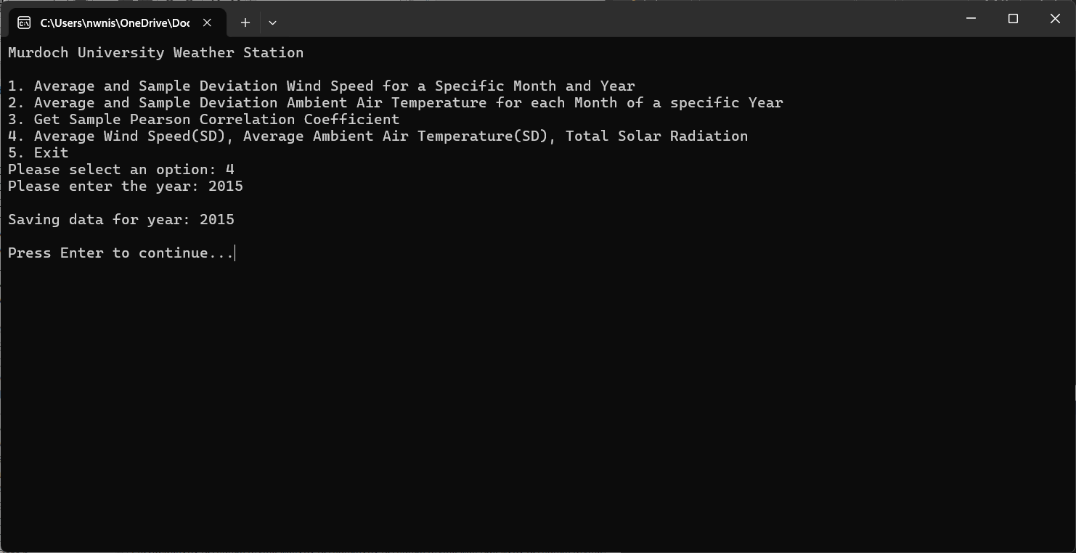
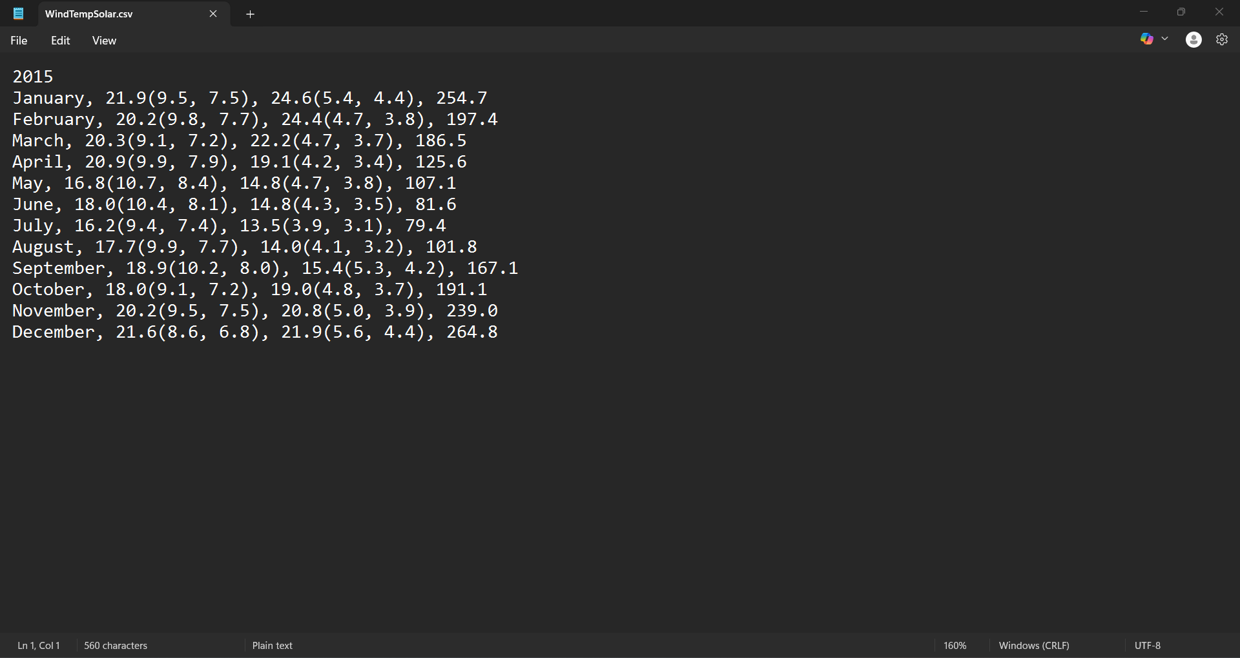

Test ID | APP_INVALID_1
Description | Verify that the menu ignores invalid input that are either out of range or non-numeric character.
Precondition | CSV is loaded from data_source.txt.
Input | Please select an option: 123  Please select an option done
Expected Result | Prints the menu if it encounters the error.
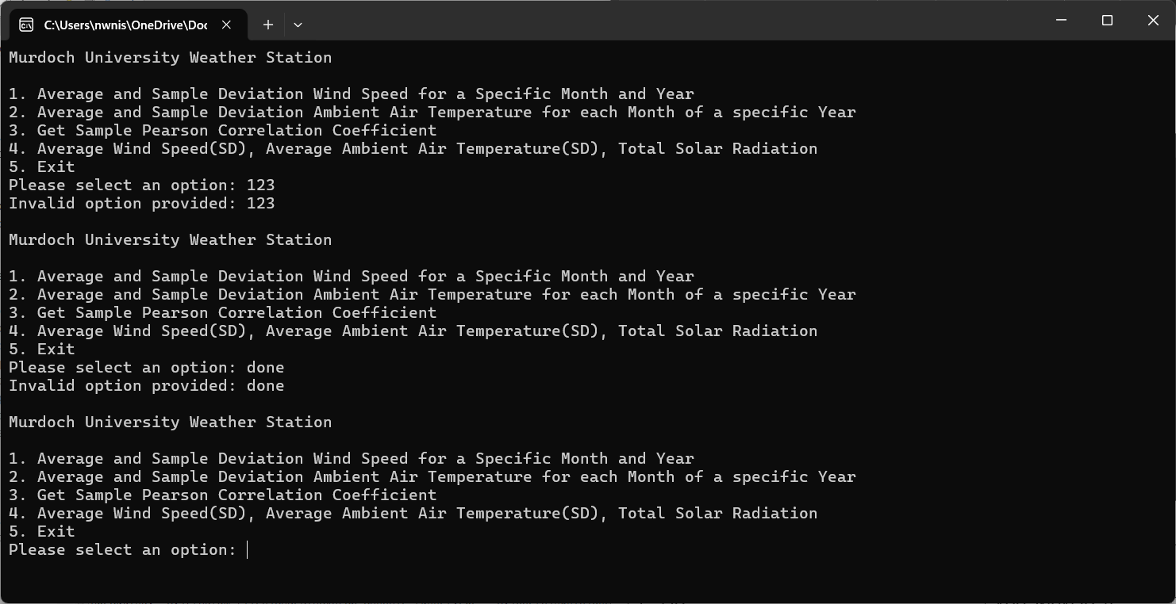

Test ID | APP_INVALID_2
Description | Verify that the month ignores invalid input that are:  - Non-numeric character.  - Out of the unsigned data type range.  - Less than 1 or more than 12.
Precondition | CSV is loaded from data_source.txt.
Input | Please enter the month (1-12): Jan  Please enter the month (1-12): 99999999999999999  Please enter the month (1-12): 13
Expected Result | Display the error message and ask the user to enter the valid month.

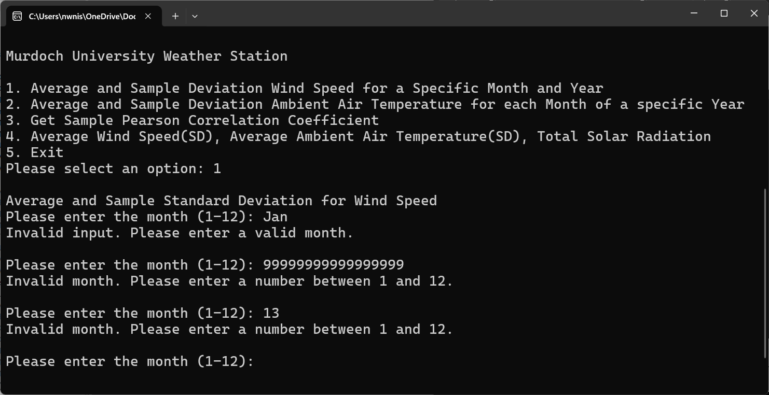

Test ID | APP_INVALID_3
Description | Verify that the system stops processing after the required is not found.
Precondition | CSV is loaded from data_source.txt.
Input
Expected Result | Display the error message “Required headers not found.”

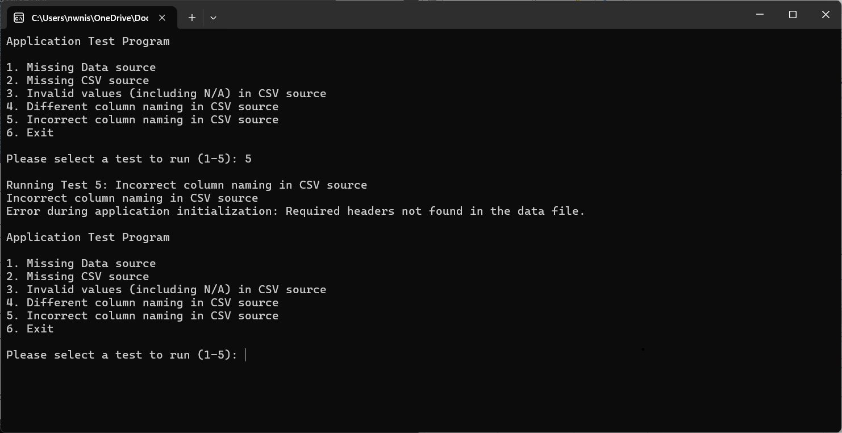

Test ID | APP_MISSING_SOURCE_1
Description | Verify that the system stops processing if the data_source.txt is not found.
Precondition
Input
Expected Result | Display the error message “Data source file not found.”

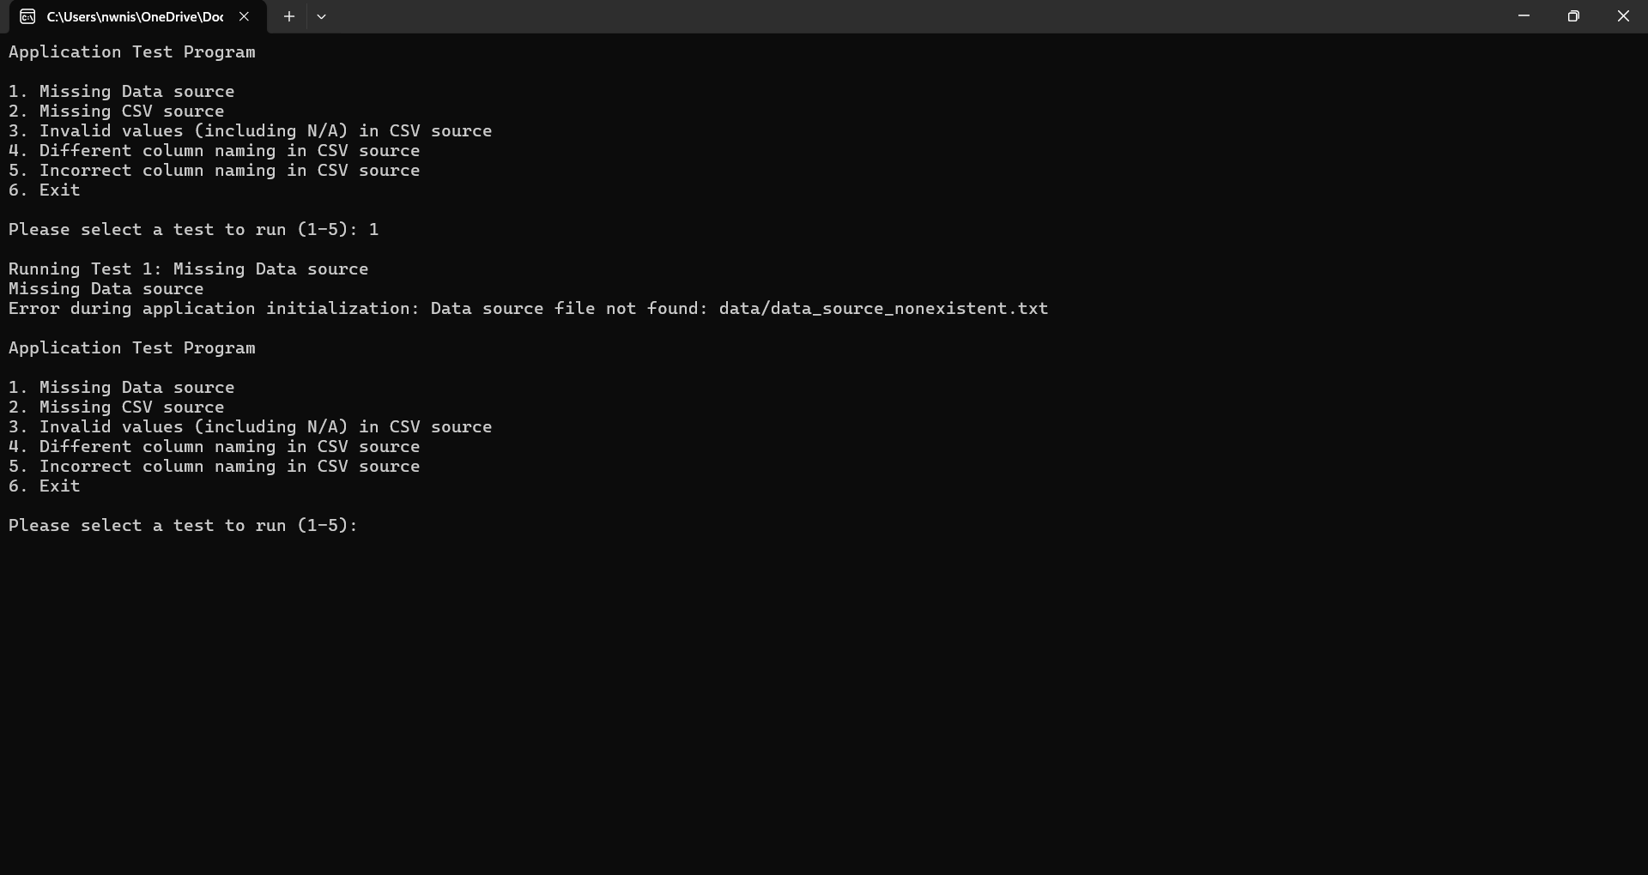

Test ID | APP_MISSING_SOURCE_2
Description | Verify that the system stops processing if the link inside data_source.txt is invalid.
Precondition | data_source.txt is loaded.
Input
Expected Result | Display the error message “Data file not found.”
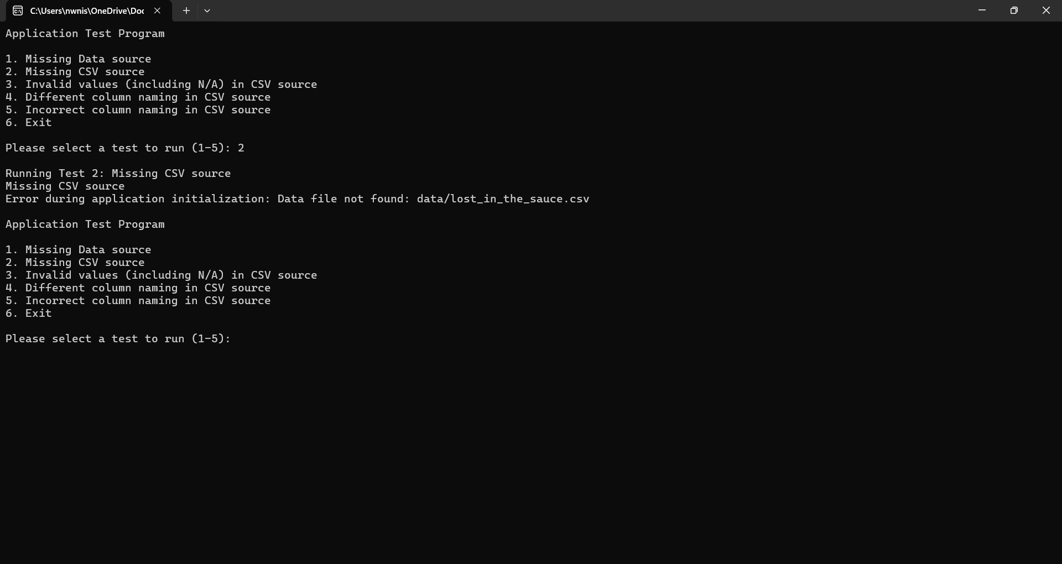

Test ID | APP_DATA_1
Description | Verify that the system can process rows containing partial or fully invalid data.
Precondition | CSV is loaded from data_source.txt.
Input | Please select an option: 4  Please enter the year: 2016
Expected Result | Calculates the data from columns while ignoring invalid columns.

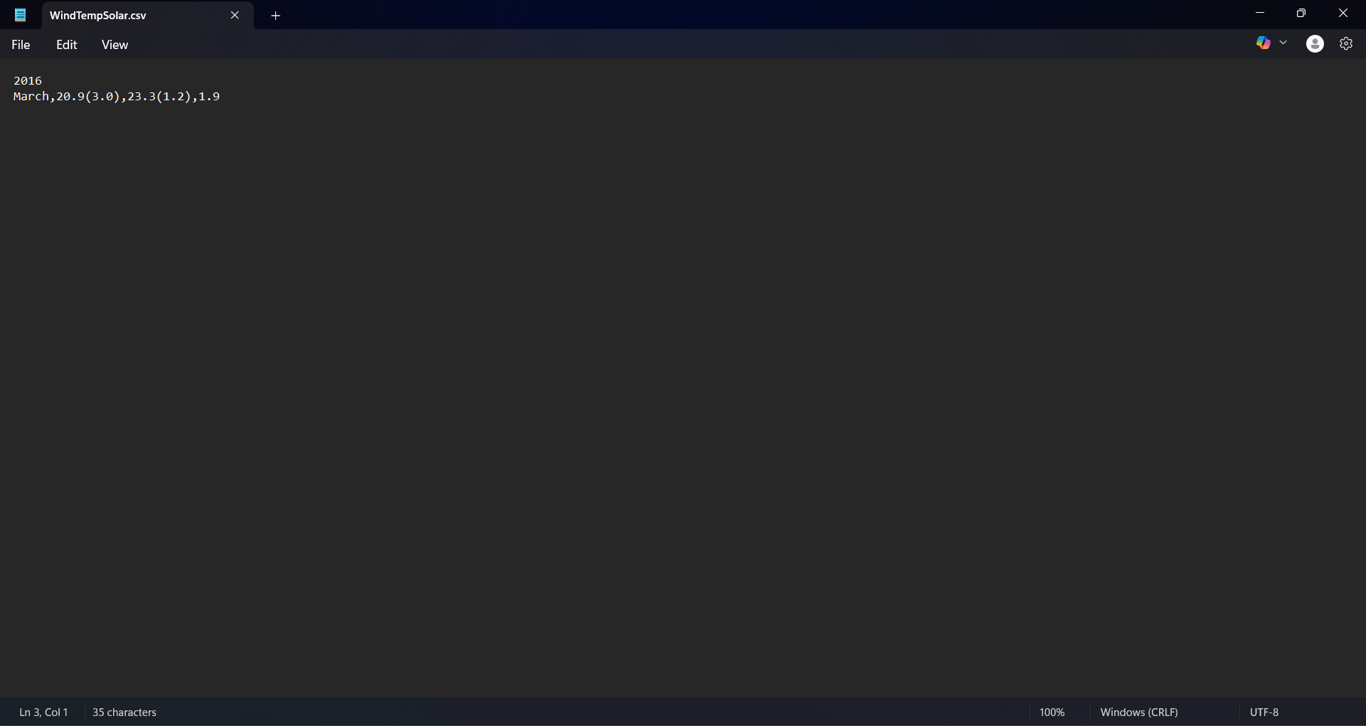Note: The data comes from TEST_INVALID_VALUES.csv. The first row contains out of range values, the second row contains invalid data (N/A, offline, NaN), and the third row contains an empty value along with two valid values.

Test ID | APP_DATA_2
Description | Verify that the system can process the CSV with different headers.
Precondition | CSV is loaded from data_source.txt.
Input | Please select an option: 1  Please enter the month (1-12): 3  Please enter the year: 2016
Expected Result | Calculates the data from columns while ignoring invalid columns.

