ELECTRONIC ASSIGNMENT COVERSHEET | 

Student Number: | 35517678
Surname: | New
Given name: | Wei Nern
Email: | 35517678@student.murdoch.edu.au
Unit Code: | ICT373
Unit name: | Software Architecture
Enrolment mode: | Internal
Date: | 18/7/2025
Assignment number:
Assignment name:
Tutor: | Andy Lee

Student’s Declaration:
- Except where indicated, the work I am submitting in this assignment is my own work and has not been submitted for assessment in another unit.
- This submission complies with Murdoch University's academic integrity commitments. I am aware that information about plagiarism and associated penalties can be found at http://our.murdoch.edu.au/Educational-technologies/Academic-integrity/. If I have any doubts or queries about this, I am further aware that I can contact my Unit Coordinator prior to submitting the assignment.
- I acknowledge that the assessor of this assignment may, for the purpose of assessing this assignment:
  - reproduce this assignment and provide a copy to another academic staff member; and/or
  - submit a copy of this assignment to a plagiarism-checking service. This web-based service may retain a copy of this work for the sole purpose of subsequent plagiarism checking, but has a legal agreement with the University that it will not share or reproduce it in any form.
- I have retained a copy of this assignment.
- I will retain a copy of the notification of receipt of this assignment. If you have not received a receipt within three days, please check with your Unit Coordinator.

I am aware that I am making this declaration by submitting this document electronically and by using my Murdoch ID and password it is deemed equivalent to executing this declaration with my written signature.
Optional Comments to Tutor:
e.g. If this is a group assignment, list group members here

If you can, please insert this completed form into the body of each assignment you submit. Follow the instructions in the Unit Information and Learning Guide about how to submit your file(s) and how to name them, so the Unit Coordinator knows whose work it is.
Start your assignment on the next page.

Subscription Management
GUI

The GUI provides an easy way to navigate through customers and their subscription records using visual cues to enhance the administrative workflows.

Author: New Wei Nern
Murdoch Student ID: 35517678
Date: 23/3/2026
Contents
List Of Files 5
User Guide 13
Requirement / Specification 15
Input Conditions 16
Output Conditions 17
Diagrams 18
Low-Level Class Diagram 18
High-Level Class Diagram 25
State Transition Diagram 27
Program Design 28
UI Design 30

List Of Files

Below is the list of files along with their respective folders.

ict373.assignment2
File Name | Summary
App.java | The application class that runs the system.
FormRecord.java | An interface that defines the structure of form records.

ict373.assignment2.controllers
File Name | Summary
HomeController.java | The HomeController class manages the interface, handling navigation between pages, modal dialogs, toast notifications, and saving / loading of data.
LoaderController.java | The LoaderController class loads the data when the application starts.

ict373.assignment2.controllers.customer
File Name | Summary
CustomerController.java | The CustomerController class manages the customer interface by displaying customers in a paginated table, managing the detail view, and processing customer-related events.
CustomerDetailController.java | The CustomerDetailController class manages the customer detail view, populating fields with existing customer data or providing empty fields for creating a new customer.

ict373.assignment2.controllers.customer
File Name | Summary
AddressForm.java | The AddressForm record manages address input fields and handles loading, saving, and validation of address data.
PaymentForm.java | The PaymentForm record manages payment input fields and handles loading, saving, and validation of payment data.
ProfileForm.java | The ProfileForm record manages customer input fields and handles loading, saving, and validation of customer data.

ict373.assignment2.controllers.publication
File Name | Summary
PublicationController.java | The PublicationController class manages the publication interface by displaying publication in a paginated table, managing the detail view, and processing publication-related events.
PublicationDetailController.java | The PublicationDetailController class manages the publication detail view, populating fields with existing publication data or providing empty fields for creating a new customer.

ict373.assignment2.controllers.publication.forms
File Name | Summary
DetailForm.java | The DetailForm record manages publication input fields and handles loading, saving, and validation of publication data.

ict373.assignment2.events
File Name | Summary
CustomerEvent.java | The CustomerEvent represents events related to customer action, such as CUSTOMER_CREATED, CUSTOMER_DELETED, and CUSTOMER_EDITED.
ModalEvent.java | The ModalEvent represents events related to modal, such as MODAL_OPEN and MODAL_CLOSE.
PageEvent.java | The PageEvent represents events related to page actions, such as PAGE_VIEW, PAGE_ADD, PAGE_EDIT, and PAGE_BACK.
PublicationEvent.java | The PublicationEvent represents events related to publication action, such as PUBLICATION_CREATED, PUBLICATION_DELETED, PUBLICATION_EDITED.
TableEvent.java | The TableEvent represents events related to table action, such as TABLE_EDIT, TABLE_DELETE, TABLE_VIEW, and TABLE_ADD.
ToastEvent.java | The ToastEvent represents an event related to toast notification.
WindowEvent.java | The WindowEvent represents events related to windows, such as WINDOW_MINIMIZE, WINDOW_MAXIMIZE, and WINDOW_CLOSE.

ict373.assignment2.models
File Name | Summary
Address.java | The class represents an address.
CustomerSubscription.java | The class represents a customer and their subscription to a publication.

ict373.assignment2.models.customers
File Name | Summary
AssociateCustomer.java | The class represents an associate customer.
Customer.java | The class is a base class for all customers.
PayingCustomer.java | The class represents a paying customer.

ict373.assignment2.models.payments
File Name | Summary
CreditCard.java | The class represents a credit card.
DirectDebit.java | The class represents a direct debit.
Method.java | The interface represents the payment methods that a user can use.

ict373.assignment2.models.publications
File Name | Summary
Magazine.java | The class represents a magazine.
Publication.java | The class is a base class for Magazine and Supplement.
Supplement.java | The class represents a supplement.

ict373.assignment2.services
File Name | Summary
CustomerService.java | The class manages customer data and operations.
PublicationService.java | The class manages publication data and operations.
Service.java | The base class for all services.
SubscriptionService.java | The class manages subscription data and operations.

ict373.assignment2.ui
File Name | Summary
ActionCell.java | A custom TableCell that includes action buttons (Add, Edit, Delete) for table rows and triggers corresponding events when the buttons are clicked.
Modal.java | A custom StackPane used to display modal dialogs by rendering and overlay and modal content above the main interface.
TitleBar.java | A custom BorderPane used for the customized windows.

ict373.assignment2.ui.inputs
File Name | Summary
DateInputField.java | The class wraps a DatePicker to provide a labelled input field with value management and reset functionality.
InputField.java | A custom HBox that holds a label and an input field.
SelectInputField.java | The class wraps a ComboBox to provide a labelled input field with value and reset functionality.
TextInputField.java | The class wraps a TextField to provide a labelled input field with value and reset functionality.

ict373.assignment2.ui.table
File Name | Summary
DataTableView.java | A custom TableView that adds an action column with Add, Edit, and Delete buttons, and fires events when rows are clicked.
PropertyColumn.java | A custom TableColumn that automatically sets the PropertyValueFactory to CellValueFactory.

ict373.assignment2.utils
File Name | Summary
Validator.java | A utility class that provides validation for input field.

User Guide

To run the project, ensure that the following programs are installed on your system:
- Apache NetBeans IDE 28
  - Download Apache NetBeans from the official Apache NetBeans website.
  - Install NetBeans.
- Java Development Kit (JDK) 25.0.1
  - Go to the official Oracle Archive website.
  - Navigate to Windows x64 Compressed Archive and download the ZIP file.
  - Create a folder called JDK inside the NetBeans folders.
  - Extract the folder called jdk-25.0.1 into the abovementioned folder.
  - Under File > Project Properties > Build > Compile, click on Manage.
  - Click on Add Platform.
  - Select Java Standard Edition.
  - Navigate to the folder called jdk-25.0.1 and hit Enter.
  - Name the platform and click Finish.

Once the following programs are installed, extract the ZIP file “ICT373_New_Wei_Nern_Assignment2.zip” to NetBeansProject folder.
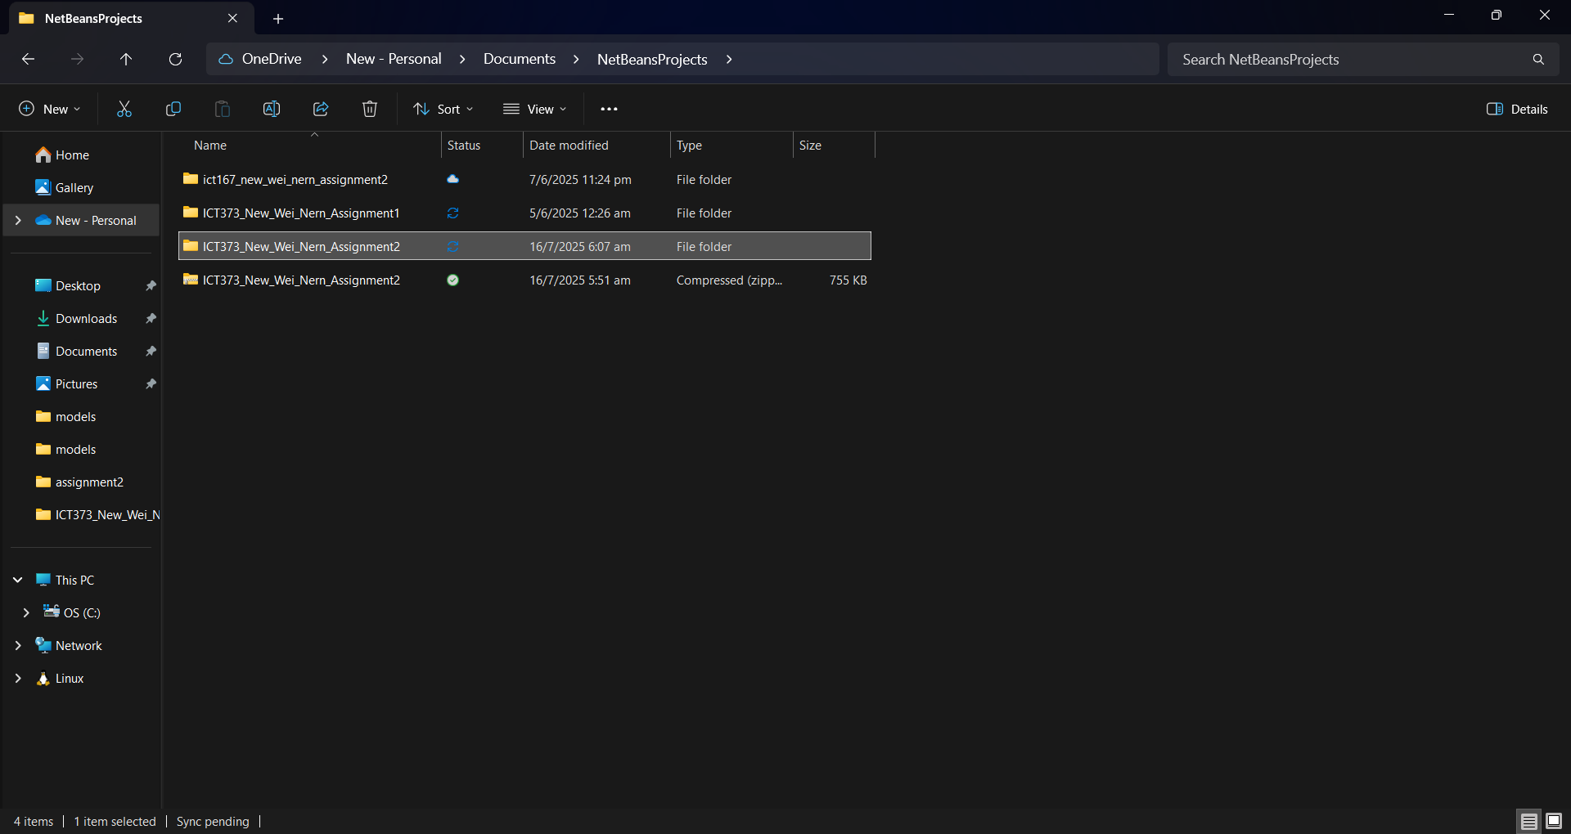

Open the IDE and click on File > Open Project.
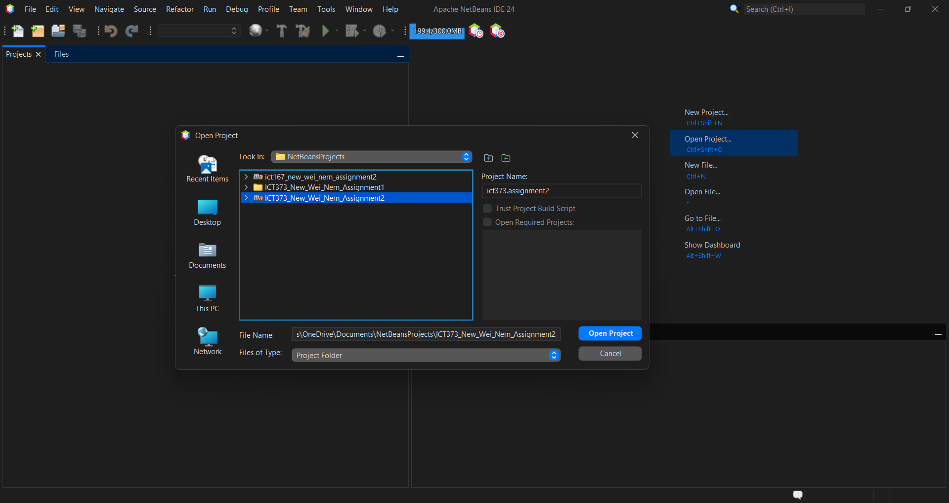

Navigate to “ICT373_New_Wei_Nern_Assignment2” and open the project. 

Click the Run button in the toolbar or press F6 to run the project.

Requirement /
Specification

The Subscription Management GUI replaces the previous CLI by offering a user-friendly and intuitive experience for the administrator. It retains most of the original system’s core features, including adding, removing, and editing customers and publications, and assigning publications to customers.

Customers are classified into two types: Paying and Associate. For an associate customer, the Profile, Address, and Subscription tabs are provided, whereas a paying customer includes the Payment, Associates, and Billing tabs. By organizing features into tabs, administrators can navigate the system more efficiently.

Removing an Associate customer is accomplished by going to Associates tab and deleting the customer. Subscriptions are similarly managed via the Subscription tab. Customer and subscription data can be edited directly in their respective tabs. After making changes, the administrator must finalize them by clicking the Save button, which updates the data in the system.

Before the data is saved, all fields are automatically validated to ensure accuracy and completeness. Any errors or inconsistencies – such as empty fields, invalid values, or incorrect formats – will prompt the program to navigate to the tab containing the invalid field and display a tooltip, informing the administrator to correct the issue before proceeding. This validation process helps maintain data integrity and prevents incomplete information from being recorded.

Unlike the previous version, this system integrates persistent data storage using Java serialization. Data is stored within the service, alongside other records, and includes automatically incremented identifier that increments for each publication or customer added to the service.

Input Conditions

- Magazine Subscription – A customer must subscribe to a magazine before subscribing to its supplements.
- Supplement Subscription – Supplements can be subscribed once per customer.
- Payer and Associate – An associate customer may have zero or one paying customer.
- Paying Customer Deletion – Deleting a paying customer will remove all subscriptions associated with that customer and any of their associates.
- Associate Customer Deletion – Deleting an associate customer will remove the subscriptions made by itself.
- Input Fields – Each input field has specific validation rules that must be satisfied before the data can be saved.
- Associate Assignment – An associate customer must be linked to a paying customer before subscriptions can be made.
- Deserialization – Customer, publication, and subscription are deserialized once a file is selected in the file picker.
- Adding Subscription and Associate – A customer must be created before a subscription or associate can be added.
- Search filter – The search field filters the data by name.

Output Conditions

- Publication and Customer – Publications and customers are displayed in table view.
- Serialization – Customers, publications, and subscriptions are serialized together to preserve the relationship between the data during exporting.
- View, Edit, and Add – All three actions open a detail page with tabs tailored to different customers and publications.
- Billing – The cost of the subscription, the number of weeks, and the total cost of the subscription are displayed in the paying customer’s billing tab.
- Invalid Fields – Fields that are invalid will display the tooltip upon attempting to save.
- Toast Notification – Toast notifications use specific colours and messages to inform the user of the system status.

Diagrams

Below is an illustration of both the low-level and high-level diagrams. Portions of the diagrams are intentionally omitted, such as event and UI components in the high-level diagrams for brevity and clarity. The diagram can also be viewed here.

Low-Level Class Diagram
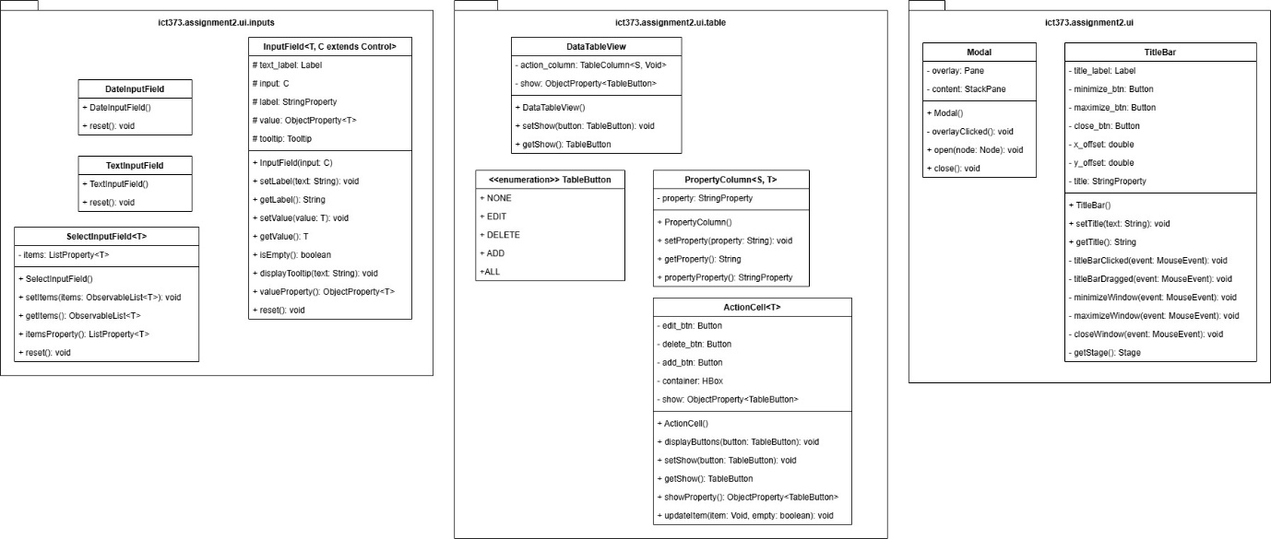
This diagram represents low-level UI classes that are specifically designed for use with FXML and referenced in controllers, form records, and validator.

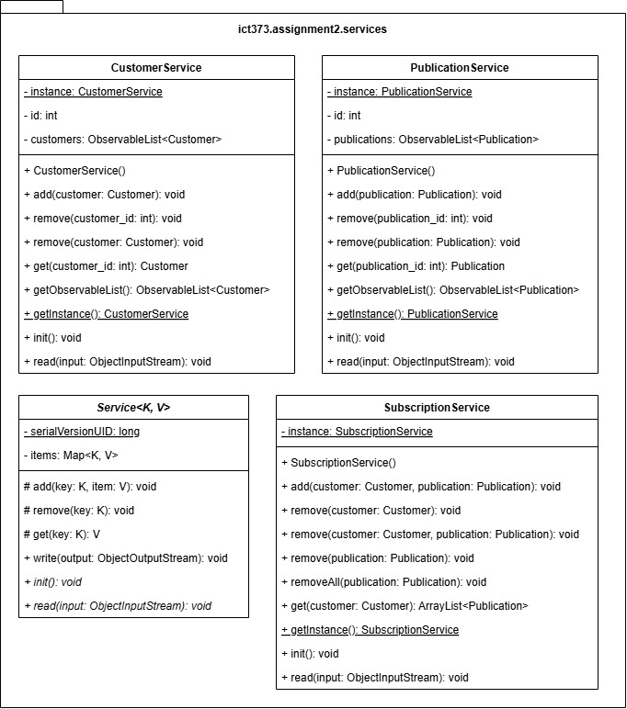
This diagram illustrates the service classes used within the system. The abstract parent class Service uses a generic key to store the value within the Map, allowing different service implementations to manage their respective data types. In the cases of CustomerService and PublicationService, the ID is automatically incremented whenever a new item is added.
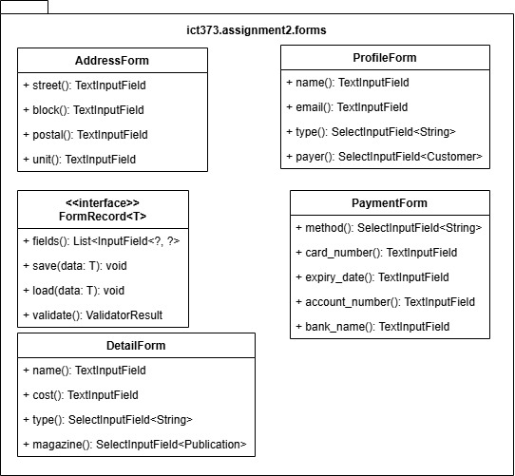
This diagram illustrates the records classes, including AddressForm, ProfileForm, PaymentForm, and DetailForm. These records are containers that hold user interface components that inherits from InputField.

An interface, FormRecord<T>, is implemented to all the forms, with T representing the data associated with the form. The data can then be saved or loaded from the form, acting as an adapter between the field and the object. Additionally, the validate() method ensures that all inputs satisfy the requirements before returning ValidatorResult.

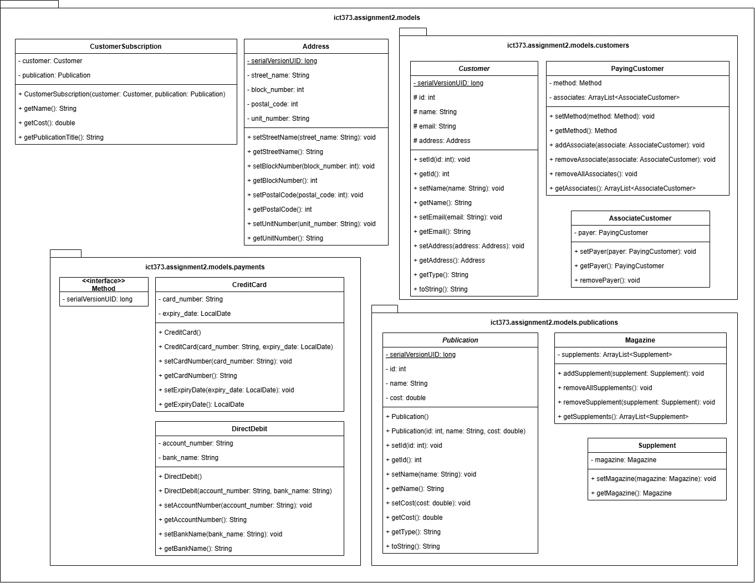
This diagram illustrates the model classes that represent the entities of the system. They form the backbone of the application’s domain model by providing structures for services, forms, and controllers to operate.

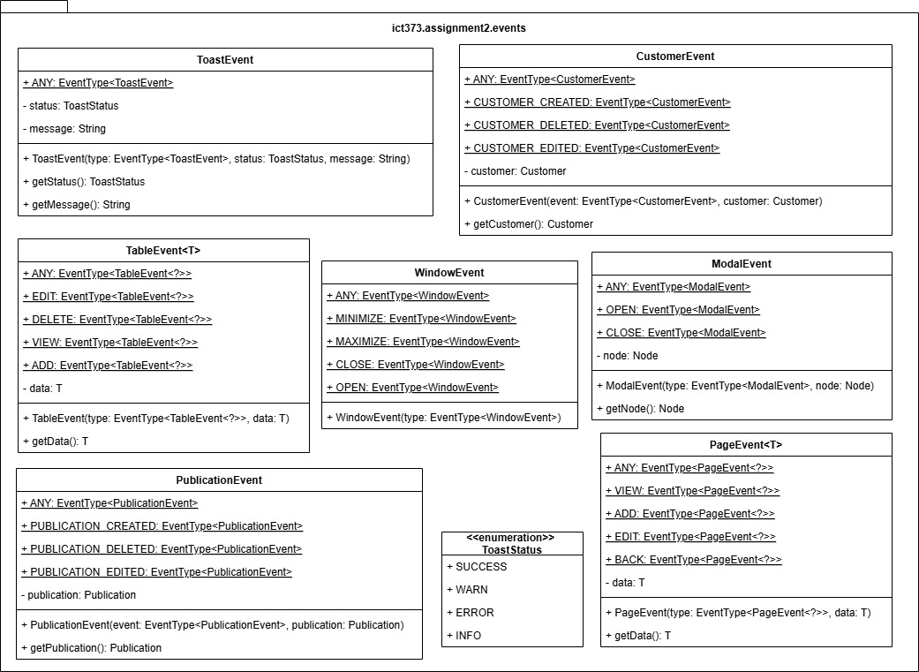
This diagram illustrates the event classes, which encapsulates the operations and interactions performed by the system. They serve as the mechanism for the addEventHandler() method to respond, allowing the system to react dynamically to any internal changes when the event is fired.
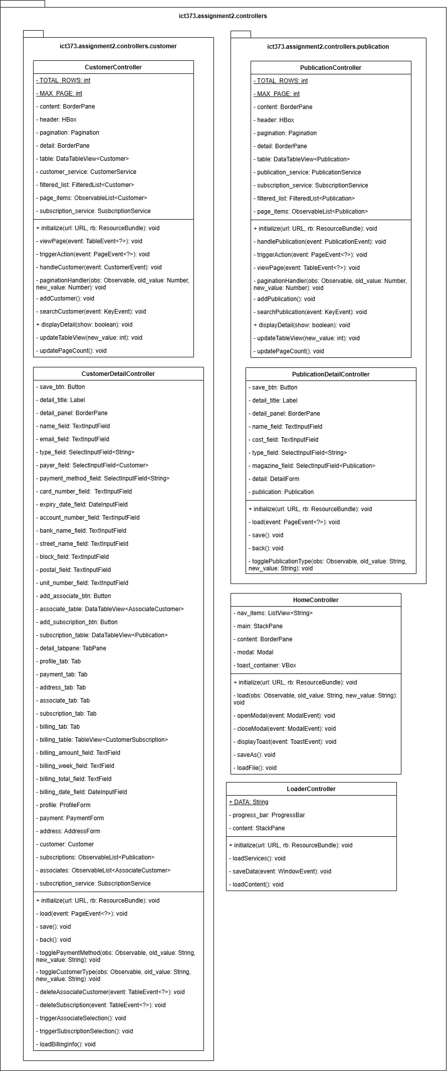
This diagram illustrates the controller classes, which mediates between the user interface and system logic. It handles user interactions, updates the UI, and perform data processing.

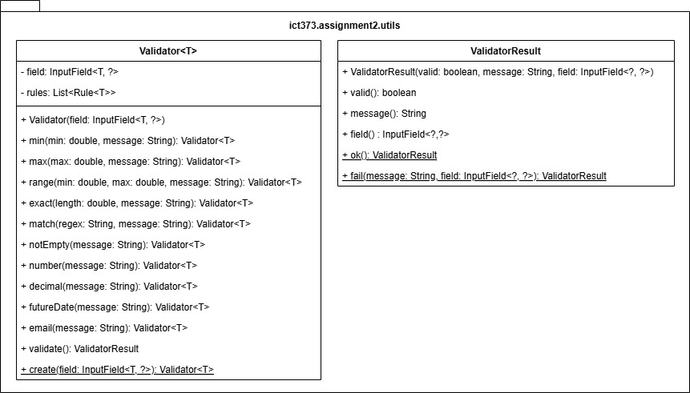
This diagram illustrates utility classes, including Validator and ValidatorResult. The Validator is responsible for checking input data against predefined rules set by the FormRecord to ensure that values meet the requirements before they are processed or saved. The ValidatorResult returns the outcome of the checks by indicating whether the result is valid, the error message, and the input field that caused the validation to fail.

High-Level Class Diagram

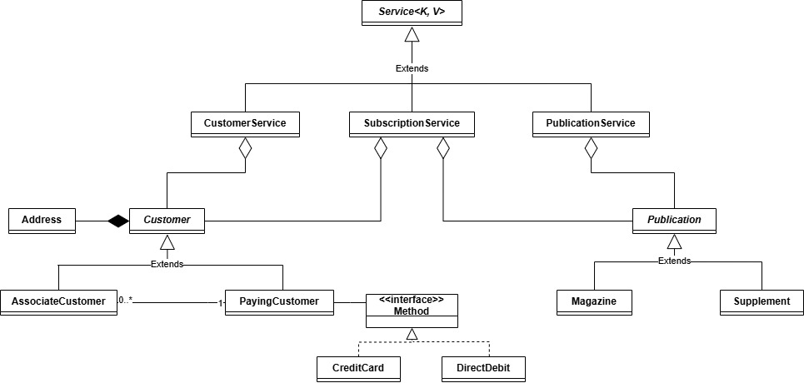
This diagram is a high-level class diagram highlighting the model classes and the services that manage them. It shows how each type of data is organized and stored by the corresponding service.

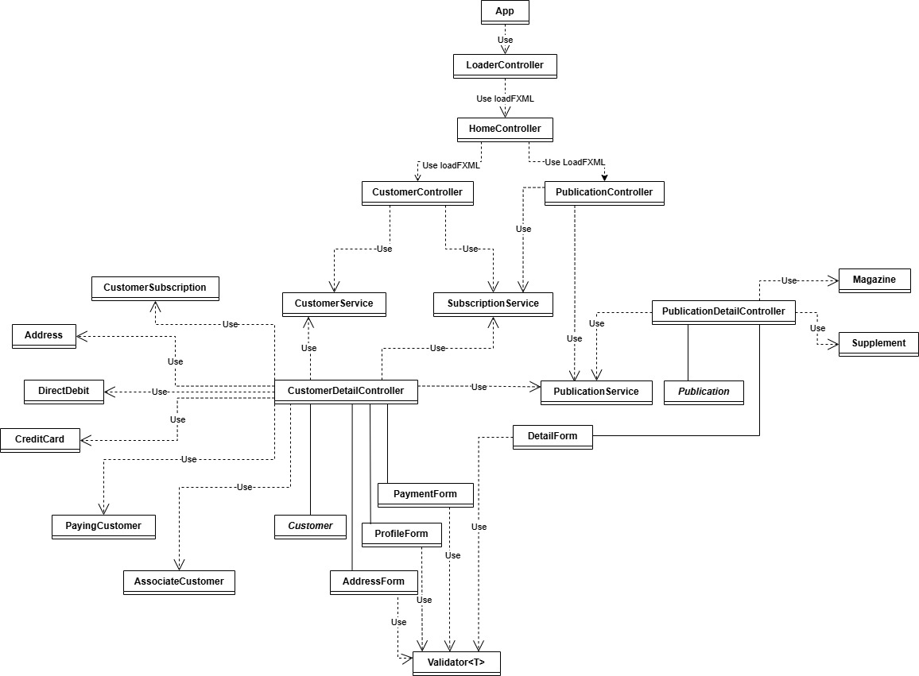
This diagram provides an overview of the controllers, services, models, and form in the system and how they interact with each other.

State Transition Diagram
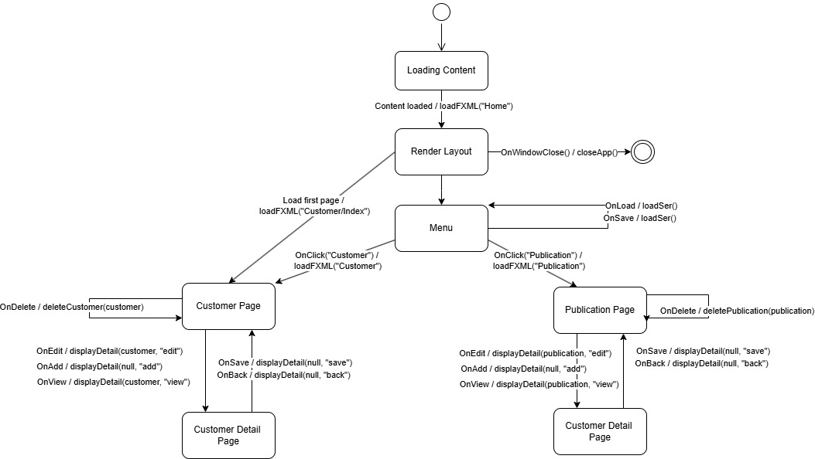
This state transition diagram illustrates how the system navigates between different pages. Once the content is loaded, it renders a layout consisting of the navigation menu and the default content, which is the customer page. Each page supports editing, adding, viewing, and deleting records. Whenever an edit, add, or row is clicked, the detail page appears, allowing data to be modified or viewed. After the administrator finalizes the input, they can either click save the changes or undo them by hitting the back button. Additionally, the menu provides options to save and load the master list, enabling data retrieval across different states.

Program Design

The program's design employs the Model-View-Controller (MVC) architecture to achieve effective content management. In JavaFX, a controller is associated with a root FXML element to link the User Interface (UI) with the application logic, thereby enabling interactivity. While JavaFX offers a wide array of features, it lacks certain functionalities required for this program. For example, it does not natively support adding an action column to the table view or automatically setting cells based on class properties without additional coding. To overcome these limitations, custom UI classes were developed to extend and enhance the capabilities of standard JavaFX components. Another issue that the custom UI classes address is standardizing input value properties: for example, TextField uses StringProperty, while ComboBox and DatePicker use ObjectProperty. These inconsistencies were resolved by binding them bidirectionally to InputField's own ObjectProperty.

During the development of the project, event handling was initially overlooked. However, it became clear that proper event management is crucial, especially when data needs to be propagated upward in the UI hierarchy. This is particularly important when implementing features such as modals, toast notifications, and detail page. Since FXML is rendered layer by layer, modals must be placed in specific FXML files; otherwise, they can interfere with layout dimensions and prevent proper display.

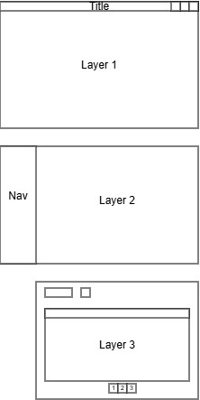

In the figure, the modal should be triggered in layer 2: triggering it in layer 3 would not overlay the navigation bar, whereas triggering it in layer 1 would obstruct the customized window bar.

The architecture of the system adheres to SOLID principles, ensuring that the system remains extensible for future development. The Service class is a good example of a SOLID-compliant class, serving as a template for handling model-specific logic. It follows the Single Responsibility Principle by managing only the collection of items and supports the Open/Closed Principle by allowing subclasses to extend functionality without modifying the base class.

Another example of SOLID compliance can be seen in the FormRecord interface. The interface supports the Liskov Substitution Principle, since any implementation of FormRecord can be used wherever the interface is required, allowing different form types to be substituted. Additionally, the methods are purely focused on form behaviours, which reflects the Interface Segregation Principle. Finally, the design follows the Dependency Inversion Principle, where implementations depend on the abstraction defined by the interface.

As each controllers require access to the services, it is paramount that the PublicationService, SubscriptionService, and CustomerService maintain a single instance of themselves using the Singleton pattern. This approach ensures that all controllers operate on the same state and data, preserving consistency across the application while reducing data initialization and memory overhead.

In parallel, the Adapter pattern is utilized to bridge the gap between the input fields and the model. This is achieved through save() and load() methods in FormRecord interface, which convert user input into the corresponding model properties and, conversely, populate the fields with data from the model. The implementation is further streamlined using record – a feature introduced in Java 16 – which eliminates the need for additional code thereby enhancing code clarity.

UI Design

Much of the basic styling provided by JavaFX has been overwritten to suit a dark and modern theme. Despite these changes, the interface maintains consistency, presenting a clean and uniform look across all pages. While the overall layout remains similar, the interface varies depending on the customer type. For instance, paying customers are presented with additional tabs such as Payment, Associates, and Billing.
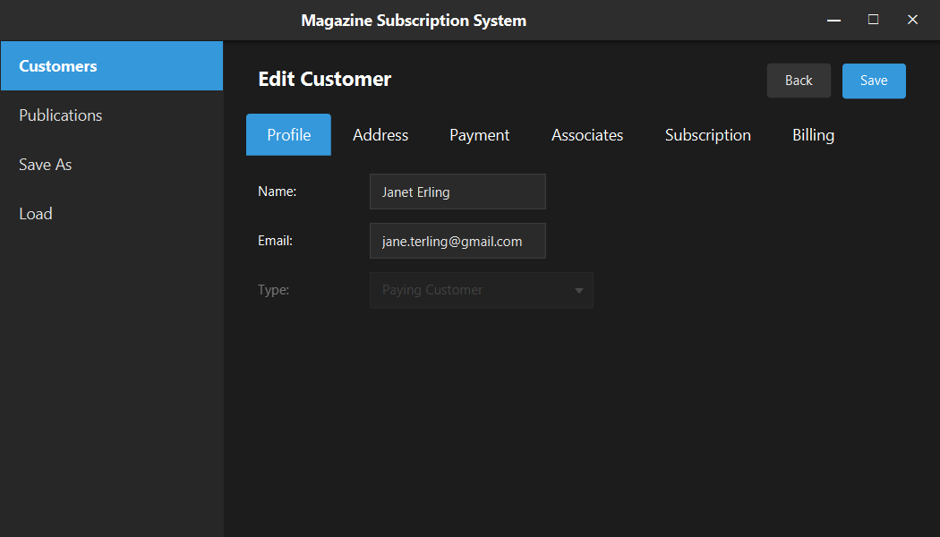
Figure 1 shows paying customer interface

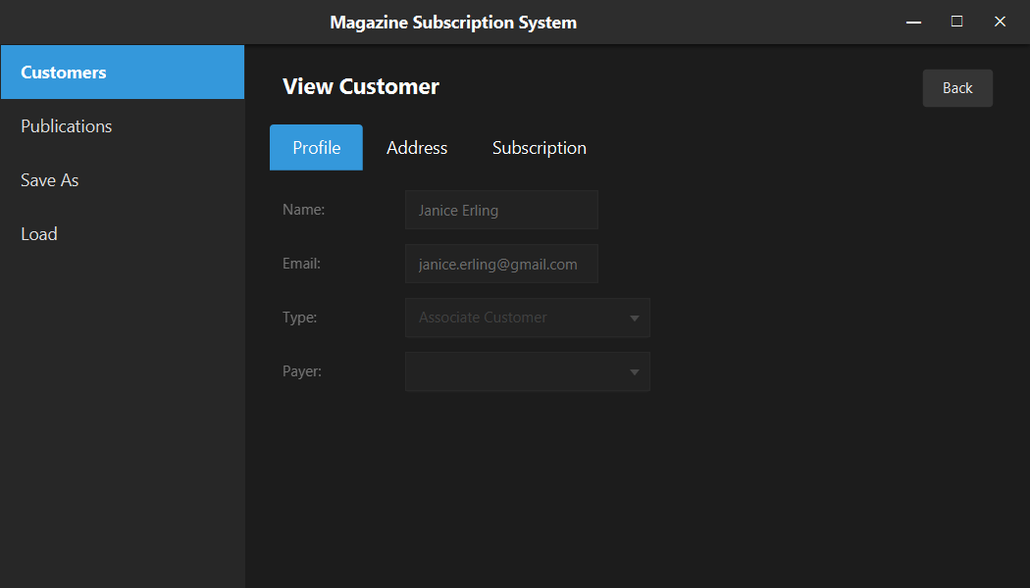
Figure 2 shows associate customer interface

The TableView serves as a key component for data representation by providing a structured way to display content. The DataTableView further extends this functionality by introducing an additional action column containing buttons. These buttons trigger a TableEvent, signalling that an interaction has occurred and allowing the user interface to respond.
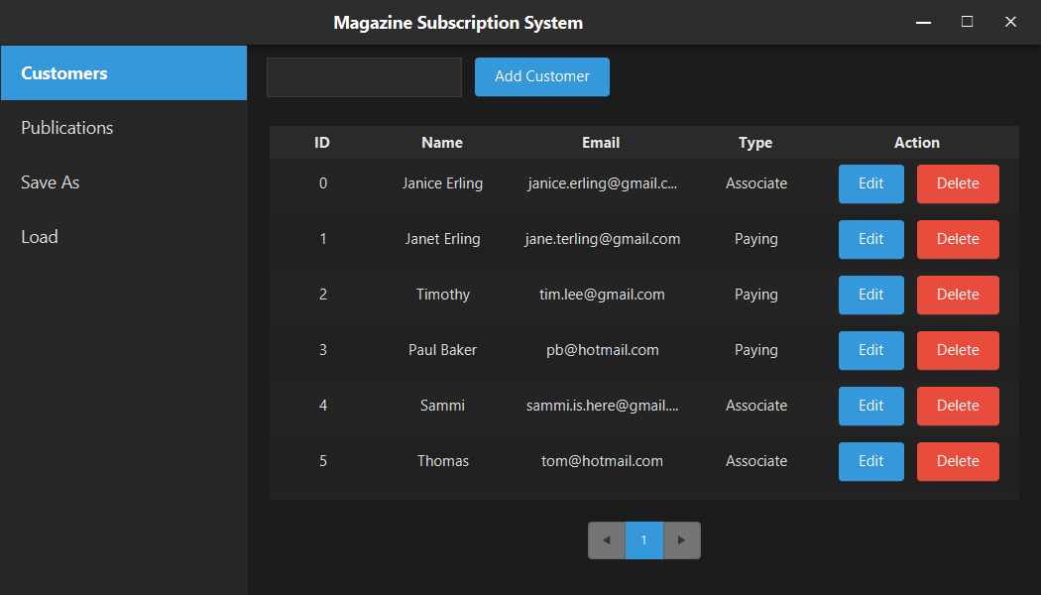
Figure 3 shows a list of customers using data table view in customer page.

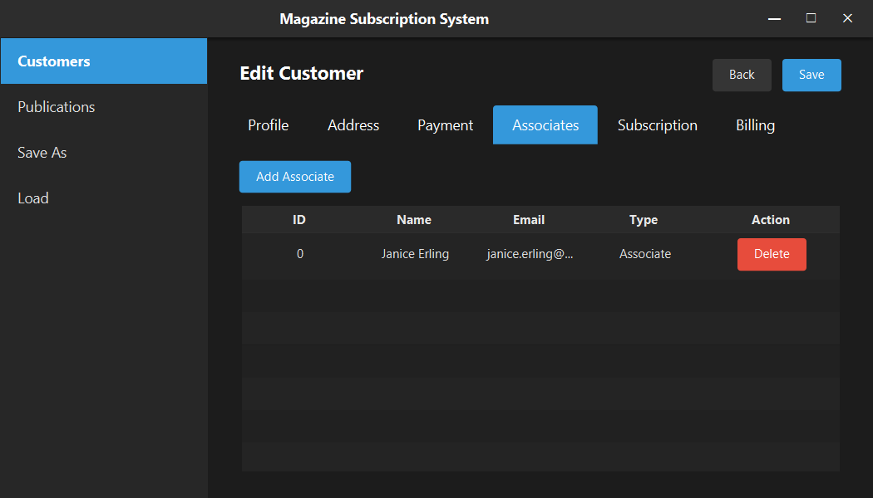
Figure 4 shows the same table being reused in associates tab for paying customer

Lastly, feedback for each interaction is essential in guiding the administrator through the workflow. By using visual cues such as input highlights, pop-ups, and toast notifications, the interface reinforces confidence and reduces likelihood of mistakes.
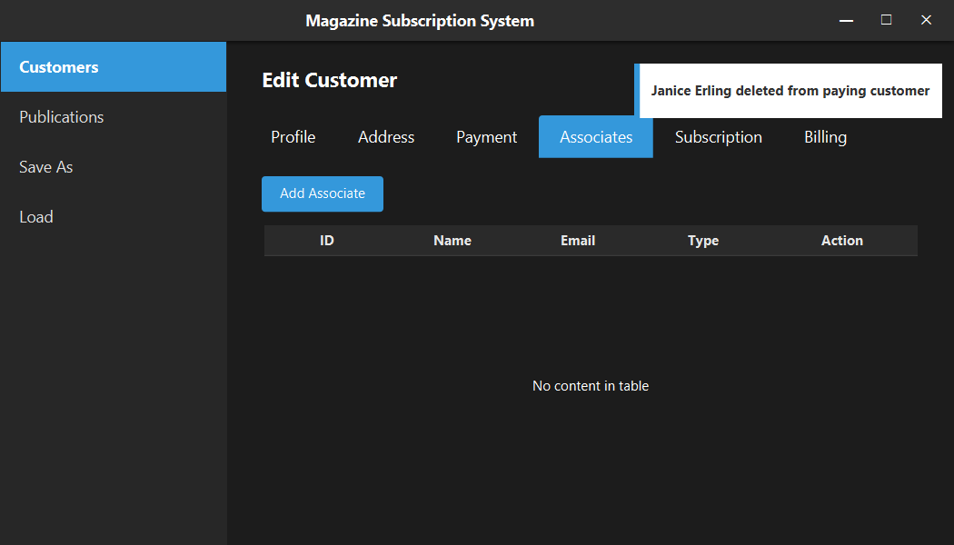
Figure 5 shows a toast notification popping up.

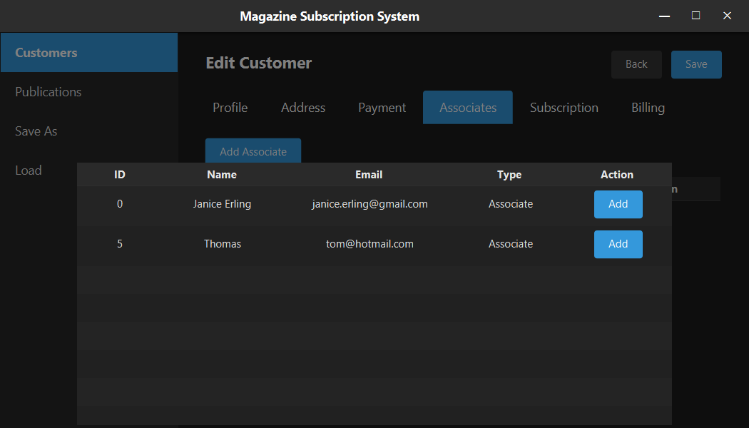
Figure 6 shows a modal with background overlay
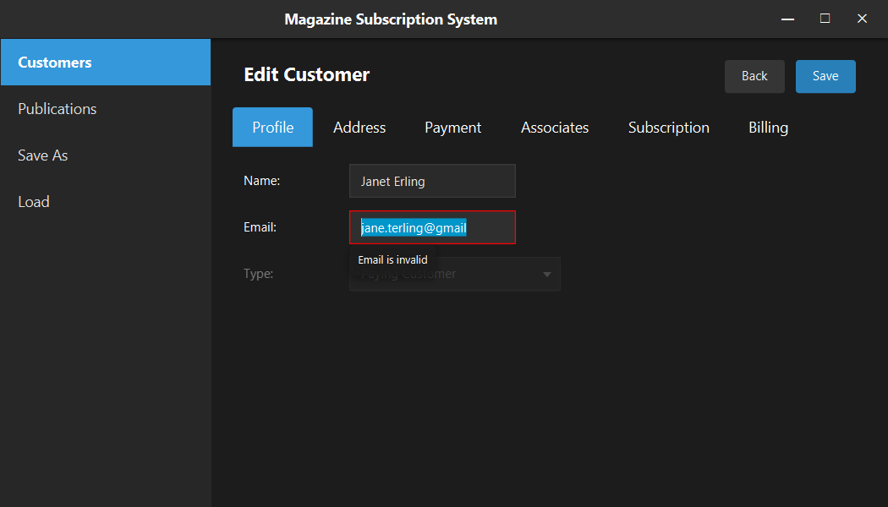
Figure 7 shows the tooltip along with the error message being displayed

