**A CRM Application for Wholesale Rice Mill**

**By**

**Prince Prasad**

**Princeprasad113@gmail.com**

**Project Abstract**

The Wholesale Rice Mill is a company that deals with bulk purchasing and distribution of rice. To streamline their customer relationship management processes and enhance overall efficiency, the Wholesale Rice Mill has decided to implement a CRM application tailored to their specific needs.

**Objectives**

* Improve customer communication and engagement
* Streamline sales processes and increase lead conversion rates
* Enhance data management and analytics for better decision-making
* Increase overall operational efficiency and customer satisfaction

**Features of the CRM Application**

1. **Customer Database Management**:
   * Centralized database to store and manage customer information
   * Easy access to customer profiles, purchase history, preferences, and contacts
2. **Sales Pipeline Tracking**:
   * Monitor leads, opportunities, and deals through the sales pipeline
   * Track interactions with customers, status of deals, and sales performance
3. **Communication Tools**:
   * Integrated email and messaging features for seamless communication
   * Automated reminders and notifications for follow-ups and important tasks
4. **Inventory Management**:
   * Track available stock, orders, and deliveries
   * Generate reports on inventory levels and forecasting for better planning
5. **Reporting and Analytics**:
   * Generate custom reports on sales performance, customer insights, and trends
   * Utilize analytics to identify opportunities for growth and process improvement
6. **Task Automation**:
   * Automate repetitive tasks such as data entry, scheduling, and follow-ups
   * Save time and increase productivity of sales and customer service teams

**INDEX PAGE**

|  |  |  |
| --- | --- | --- |
| **TOPICS NO.** | **NAMES** | **PAGE NO.** |
| **1.** | Implementation Plan |  |
| **2.** | Object & Relationship in Salesforce |  |
| **3.** | Formula Fields and Validation Rules |  |
| **4.** | Cross Object Formula Fields |  |
| **5.** | Page Layouts |  |
| **6.** | Roll-Up Summary Fields |  |
| **7.** | Reports and Dashboards |  |
| **8.** | Conclusion |  |

**TOPIC - 1**

**Implementation Plan**

1. **Assessment and Planning**:
   * Identify CRM requirements and goals
   * Plan customization and integration with existing systems
2. **Development and Testing**:
   * Build and configure the CRM application based on requirements
   * Test functionality, usability, and data integrity
3. **Training and Adoption**:
   * Provide training to users on CRM usage and best practices
   * Encourage adoption and feedback from users for continuous improvement
4. **Launch and Monitoring**:
   * Roll out the CRM application to users
   * Monitor usage, feedback, and performance to make necessary adjustments

.

#### **2. Object & Relationship in Salesforce**

**Overview:** Objects in Salesforce are database tables that store data. Relationships define how objects relate to each other.

**Steps:**

1. **Create Objects:**
   * Navigate to Setup -> Object Manager.
   * Click "Create" -> "Custom Object".
   * Define the object label, plural label, and other settings.
2. **Define Relationships:**
   * Create lookup relationships to link objects.
   * Create master-detail relationships for tighter data binding.
   * Use junction objects for many-to-many relationships.
3. **Add Fields:**
   * Navigate to the object.
   * Click "Fields & Relationships".
   * Click "New" to create custom fields.
4. **Establish Relationship Fields:**
   * Choose the relationship type when creating a new field.
   * Define the related object and field settings.

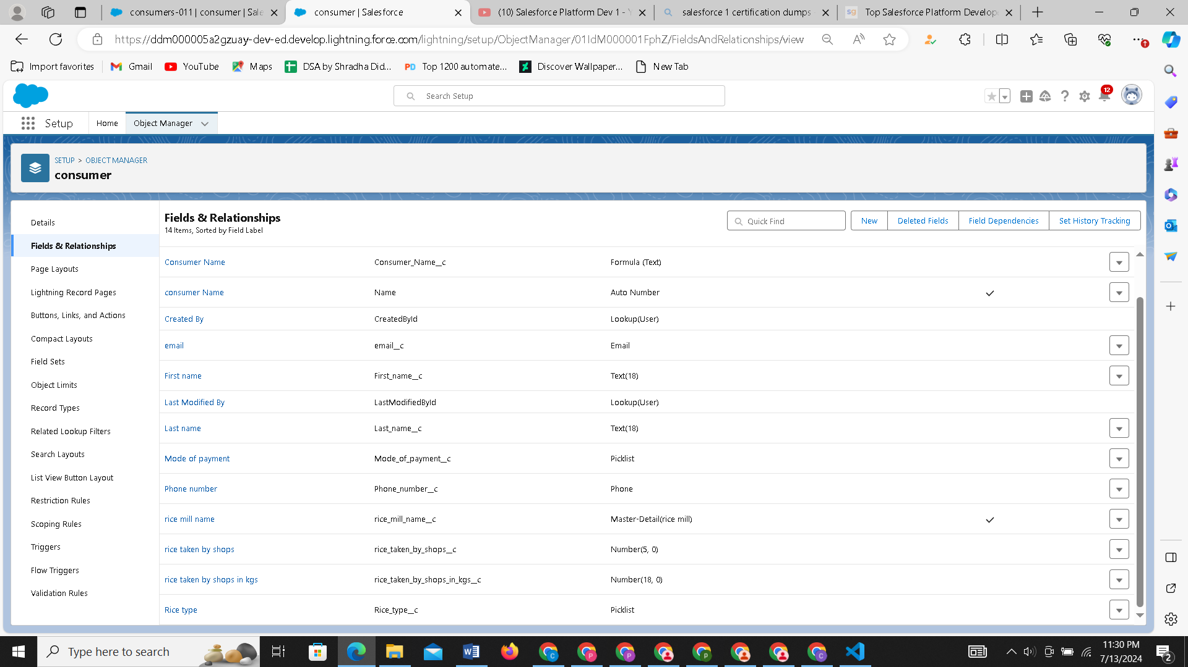

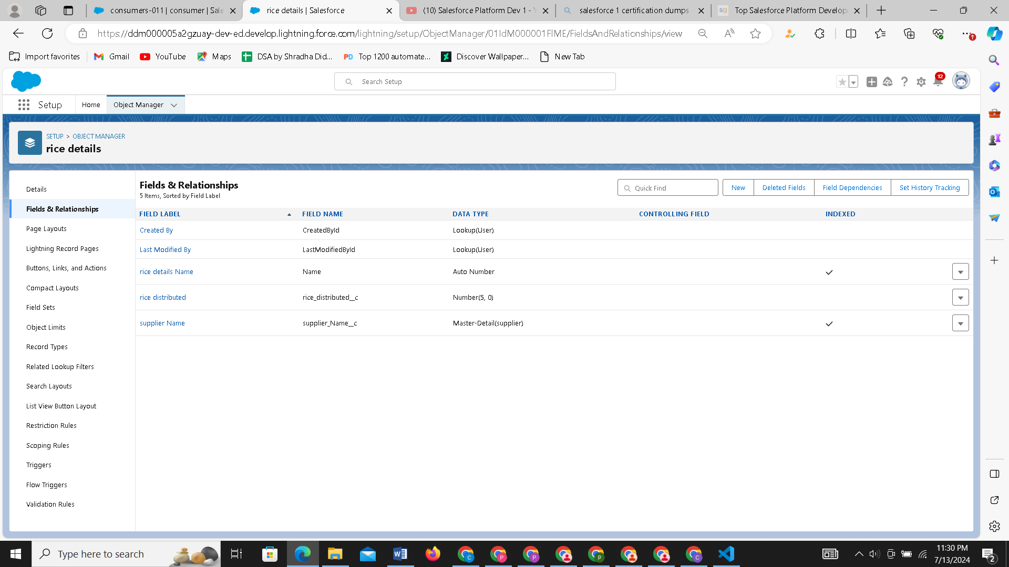

#### **3. Formula Fields and Validation Rules**

**Overview:** Formula fields are read-only fields that automatically calculate values based on other fields. Validation rules ensure data integrity by enforcing specific criteria.

**Steps for Formula Fields:**

1. **Create Formula Field:**
   * Navigate to Object Manager -> [Object Name] -> Fields & Relationships.
   * Click "New" and select "Formula".
   * Define the formula field label and type.
2. **Build Formula:**
   * Use the formula editor to create the formula.
   * Test the formula to ensure accuracy.
   * Save the formula field.

**Steps for Validation Rules:**

1. **Create Validation Rule:**
   * Navigate to Object Manager -> [Object Name] -> Validation Rules.
   * Click "New".
2. **Define Rule:**
   * Enter the rule name and description.
   * Use the formula editor to define the validation criteria.
   * Provide an error message for when the validation fails.
3. **Activate Rule:**
   * Save and activate the validation rule.

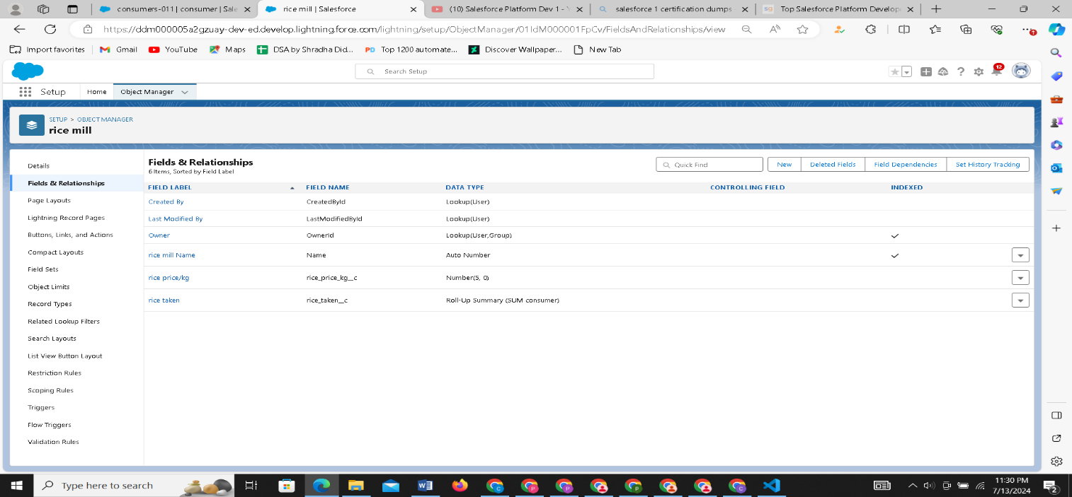

#### **4. Cross Object Formula Fields**

**Overview:** Cross-object formula fields are formula fields that reference fields from parent objects.

**Steps:**

1. **Create Cross Object Formula Field:**
   * Navigate to Object Manager -> [Child Object Name] -> Fields & Relationships.
   * Click "New" and select "Formula".
   * Define the formula field label and type.
2. **Build Cross-Object Formula:**
   * In the formula editor, use the Insert Field button.
   * Navigate through the related objects to select the parent object field.
   * Complete the formula and save.

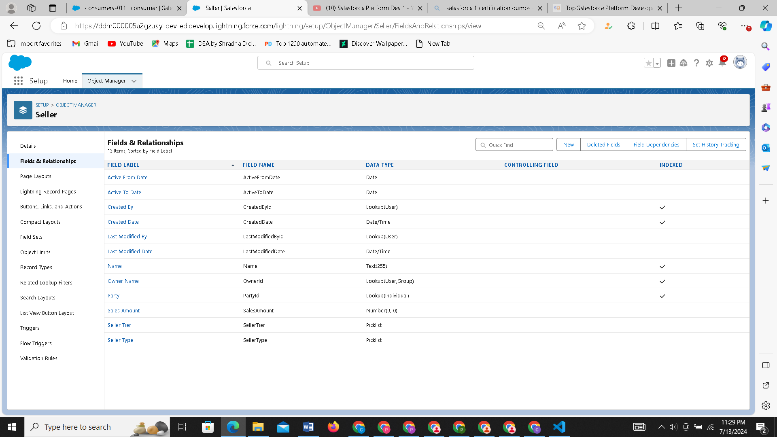

#### **5. Page Layouts**

**Overview:** Page layouts control the layout and organization of fields, related lists, and custom links on record pages.

**Steps:**

1. **Edit Page Layout:**
   * Navigate to Object Manager -> [Object Name] -> Page Layouts.
   * Click "Edit" next to the layout you want to modify.
2. **Customize Layout:**
   * Drag and drop fields, sections, and related lists.
   * Configure properties for each element.
   * Save the changes.
3. **Assign Layouts:**
   * Assign the page layout to different profiles based on user roles.

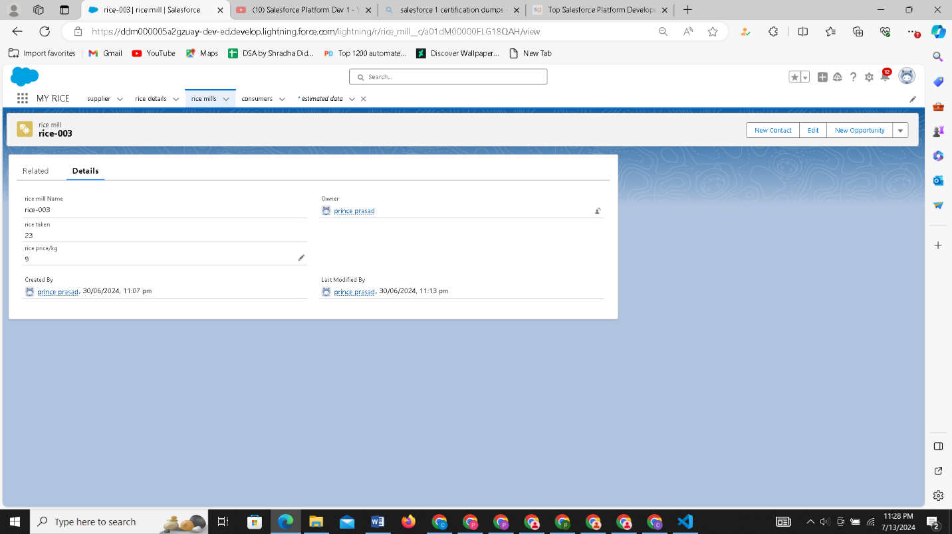

#### **6. Roll-Up Summary Fields**

**Overview:** Roll-up summary fields calculate values from related records, such as sums, counts, and averages.

**Steps:**

1. **Create Roll-Up Summary Field:**
   * Navigate to Object Manager -> [Parent Object Name] -> Fields & Relationships.
   * Click "New" and select "Roll-Up Summary".
2. **Define Roll-Up Criteria:**
   * Specify the child object and relationship.
   * Choose the type of summary (e.g., Sum, Count).
   * Define filter criteria if necessary.
   * Save the roll-up summary field.

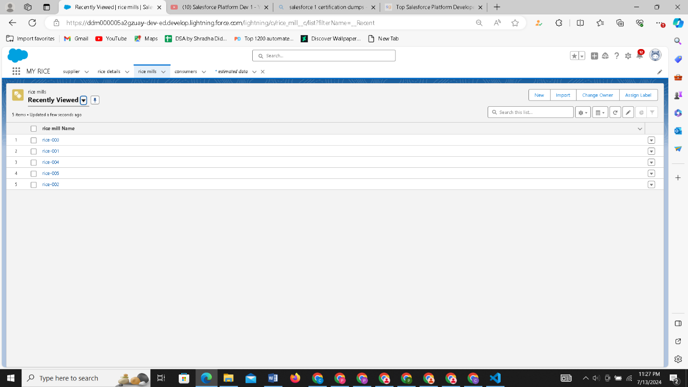

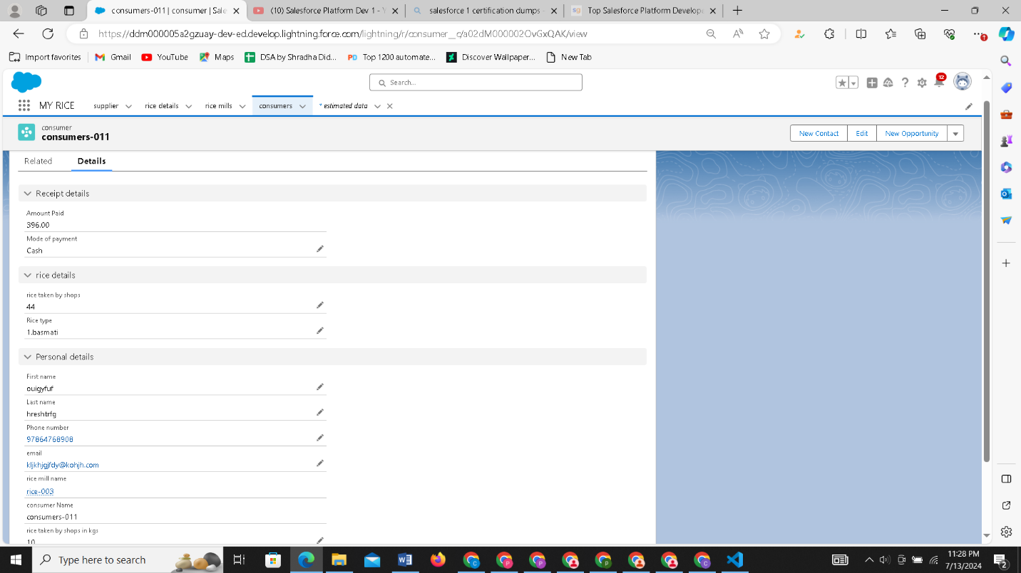

#### **7. Reports and Dashboards**

**Overview:** Reports and dashboards provide data insights through customizable, visual representations.

**Steps for Reports:**

1. **Create Report:**
   * Navigate to the Reports tab.
   * Click "New Report".
   * Select the report type.
2. **Configure Report:**
   * Use the report builder to add filters, groupings, and columns.
   * Customize the report format (tabular, summary, matrix).
3. **Run and Save Report:**
   * Run the report to preview results.
   * Save and name the report.

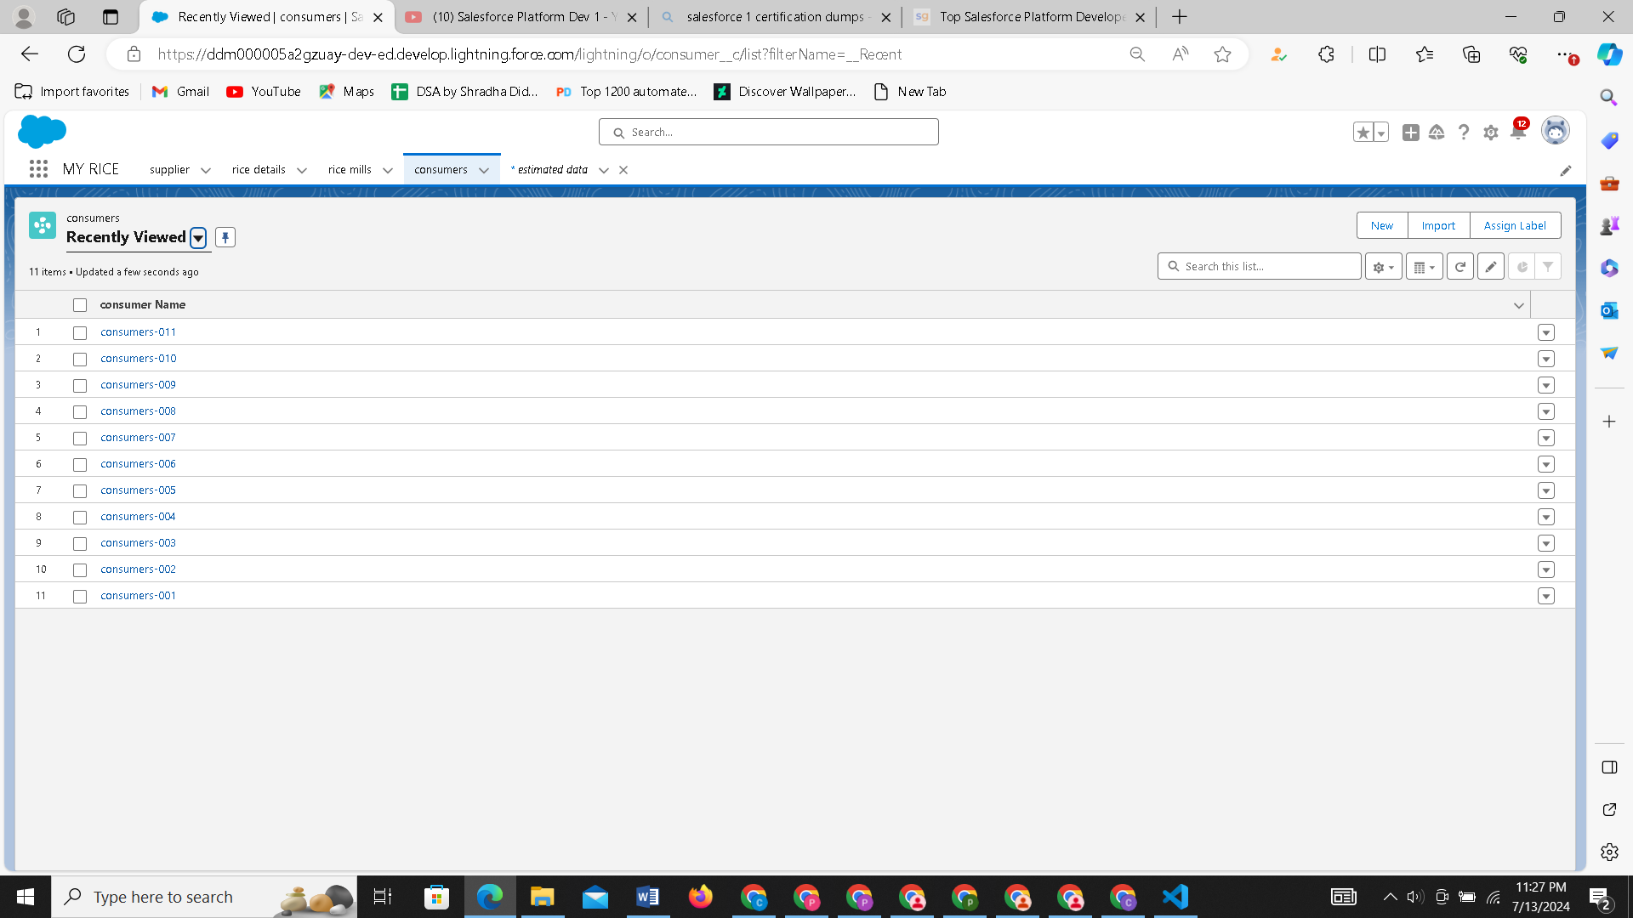

**Steps for Dashboards:**

1. **Create Dashboard:**
   * Navigate to the Dashboards tab.
   * Click "New Dashboard".
   * Enter dashboard name and properties.
2. **Add Components:**
   * Use the drag-and-drop interface to add components (charts, tables).
   * Link components to existing reports.
3. **Customize and Save Dashboard:**
   * Customize the appearance and layout.
   * Save the dashboard.

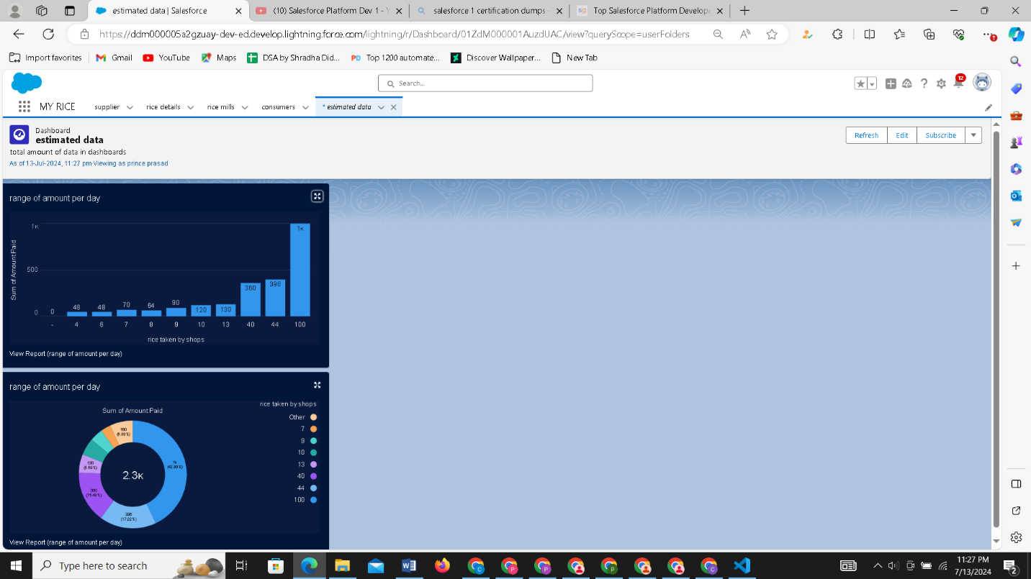

**8. Conclusion**

The implementation of a CRM application tailored to the needs of the Wholesale Rice Mill can greatly benefit the company by improving customer relationships, increasing sales efficiency, and enhancing overall business operations. By leveraging the features and benefits of the CRM application, the Wholesale Rice Mill can achieve its objectives and drive success in the wholesale rice industry.

**THANK YOU!**