PHASE 2 DESIGN GUIDE
By Fatimah Aliyu Jigam.
  - April 17, 2026.

design proposALS. (SOUNDING BOARD)

THE LOG-IN PAGE.
 | Some kind of motif/moving elements, faintly in the background of the log in page. I think this would elevate it a bit. It doesn’t have to be too crazy on the movement. Example: Subtle animated geometric patterns or a soft gradient wave in the background, opacity ≤10%, with very slow movement (~10s loop)  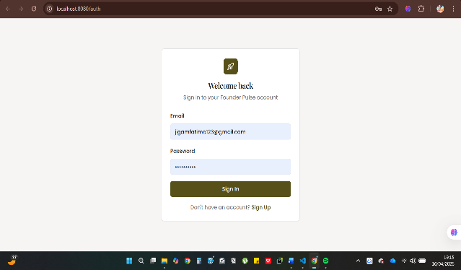 |  | 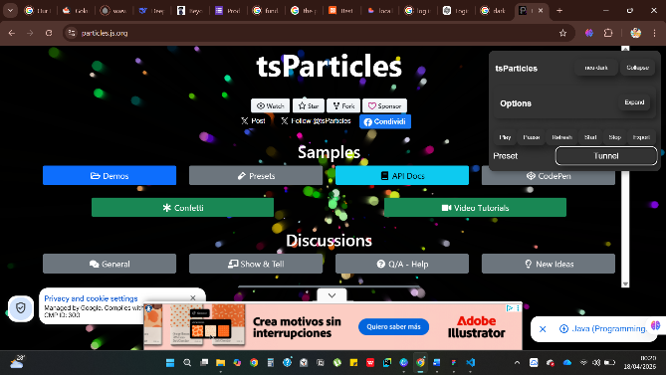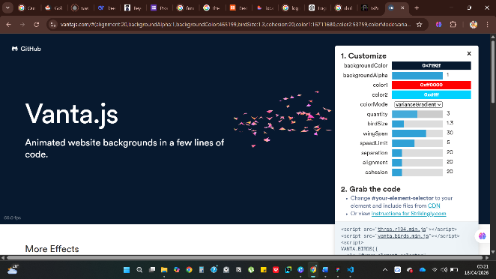

OVERVIEW DASHBOARD.
A lifted look for the dashboard, kinda like a card, and for other dashboards maybe? E.g.: Dashboard cards should use a subtle drop shadow (e.g., 0 4px 12px rgba(0,0,0,0.05)), rounded corners (12–16px), and a white background to create a layered, elevated effect.
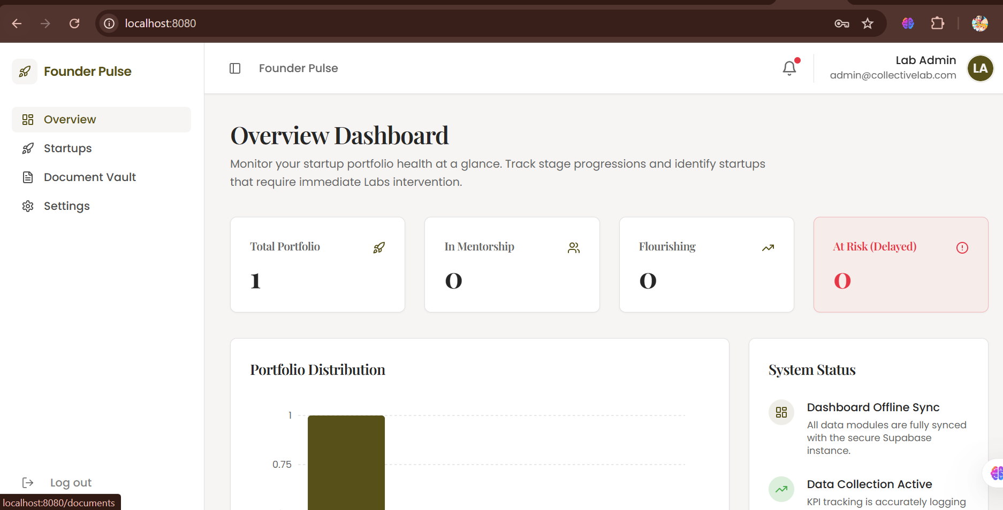

THE COLOR PALETTE.
Using the teal accents:
- Progress indicators (very good fit)
- Active states (selected tabs, toggles)
- Secondary charts
Small highlights (icons, tags)

TYPOGRAPHY
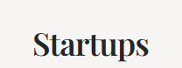
Retain current fonts: Playfair Display Bold for headings, Poppins for body text. However, standardize body text to a suitable value for consistency, see attached screenshot where text appears smaller:

LAYOUT DESIGN FOR NEW TABS.
For the newsletter tab, I’d suggest a card grid similar to the one on Fundu VC for the primary users, because it would be easier for them to interact with and make changes. Meanwhile for the Admin view I’d suggest a sort of vertical timeline hybrid? It will be better for quick oversight and seeing patterns over time for each startup. Add soft shadows to give the card a more lifted effect too btdubs.
The other tabs can be modelled closely after preexisting ones/like the ones on Fundu VC.

DESCRIPTION OF MOCKUP FOR PROGRESS BARS.
Progress bars should be thin (approximately 6px height) with rounded edges. The background should be a light neutral gray, while the fill uses the primary blue color(#002D75). At full completion (100%), the bar should display a subtle glow or highlight effect to emphasize completion. Transitions between values should be smooth and minimal to maintain a premium feel.”

NOTES FOR TONY TONY (NOT CHOPPER :)

- I’ve attached the new color palette y’all wished for below. If y’all change your minds, I can adjust it again.
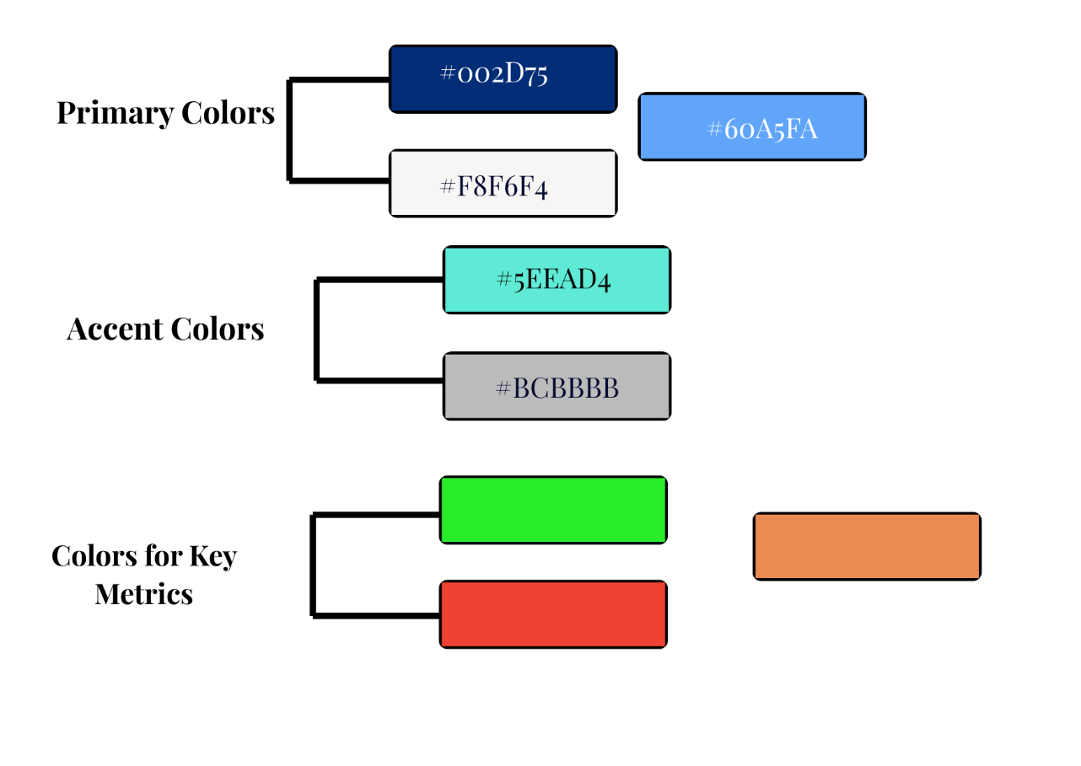
- The dashboards all feel a bit flat and I suggest a graphical face lift.

