Agriculture ministers agree to smart initiatives to move agriculture

Ministers in-charge of Agricultural Research for Development from Kenya, Mozambique, Rwanda, Tanzania, and Uganda have pledged to fast-track the implementation of sustainable intensification of agricultural practices to optimize benefits.

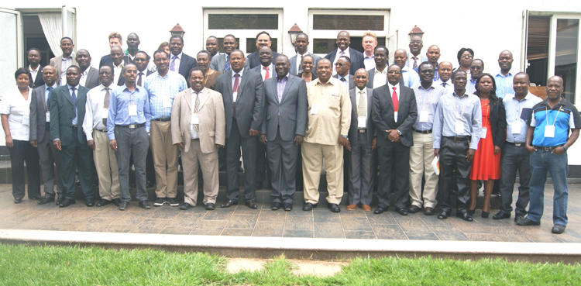

 The ministers pledged to influence their governments to put in place and implement sound policies, which are backed by evidence from agricultural researchers, socio-economists and development workers.

Addressing the High Level Policy Forum on Sustainable Intensification of Maize- Legume Cropping Systems for Food Security in Eastern and Southern Africa (SIMLESA), in Entebbe, Uganda, the ministers agreed with researchers that enhancing access to extension services, agricultural inputs and markets, are part of the critical package of policy actions that must be fast-tracked to maximize benefits from agriculture.

The High Level Policy Forum, running from October 27th to 28th was organized by ASARECA in conjunction with CIMMYT, the Australian Government, the National Agricultural Organisation (NARO) and the Ministry of Agriculture, Uganda.

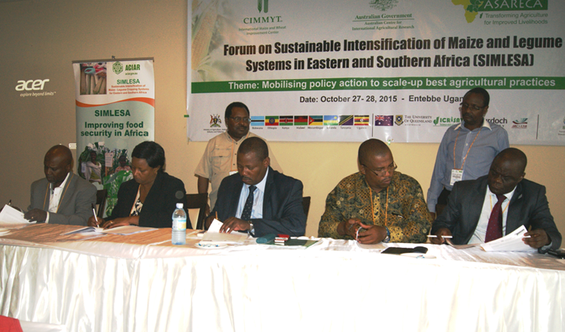

The ministers were represented by  Ms. Jacinta Ngwiri, representing the Ministry of Agriculture, Livestock and Fisheries, Kenya; Mr. Feliciano Mazuze, representing the Ministry of Agriculture and Food Security, Mozambique; Dr. Charles Murekezi, representing the Minister of Agriculture and Animal Resources, Rwanda; Dr. Mansoor Hussein, representing the Minister of Agriculture, Food Security and Cooperatives, Tanzania; Dr. Ambrose Agona, representing the Minister of Agriculture, Animal Industry and Fisheries, Uganda.

In a joint a communiqué, the ministers agreed that Governments, researchers, extension agencies and the private sector need to work in concert and in complement to enable agriculture attain its potential. They agreed to the recommendation that frontline extension workers should be increased to at least 33 staff per 10,000 farmers for an effective extension system.

Other recommendations arrived at during the Forum included:

•    Facilitating farm level access to investment capital through innovative rural financing.  
•    Improving the logistics of fertilizer distribution by investing in ongoing efforts at the regional economic blocs level to make port and customs operations more efficient, improving road and railway networks and streamlining fertilizer tax structures.

•    Domesticating harmonized quality and quantity standard specifications for fertilizer, herbicide and seed across the region; streamlining investments in blending, bagging and labelling; and strengthening regulatory institutions.  
•    Simplifying documentation and approval procedures for importation and marketing of fertilizer, herbicides and seed in the region.  
•    Promoting access to improved maize and legume seed by strengthening public private partnerships to fast-track scaling up and delivery of seeds to smallholder farmers.  
•    Training farmers in sustainable intensification practices and proper application, safe use and handling of fertilizers and herbicides.  
•    Strengthening existing and additional efforts to grow social capital by supporting the creation of innovation platforms, farmer groups, cooperatives etc.  
•    Removing barriers to cross border trade by prioritizing and implementing road and trade infrastructure development, supporting the COMESA, EAC and SADC Tripartite Free Trade Area online non-tariff barriers reporting, monitoring and eliminating mechanism.  
•    Enhancing value addition and diversification by fostering public-private sector partnerships.  
•    Preventing the spread of MLN causing viruses from endemic to non-endemic areas by among other measures, mandating and enforcing synchronized maize planting and maize-free windows in severely affected areas.

Speaking at Forum, ASARECA, Interim Executive Secretary, Prof. Francis Wachira, said, sustainable intensification practices are part of a range of measures to address low productivity while addressing effects of climate change.

The Coordinator for the SIMLESA project at CIMMYT, Dr. Mekuria Mulugetta, urged researchers and socio-economists to proactively provide policy makers factual and researched information to facilitate formulation of sound policies.

ASARECA theme leader for Markets, Market linkages, Dr. Michael Waithaka, in a presentation, urged the representatives of the ministers to advise governments to always resist the temptation of imposing non tariff barriers.

Article by Ben Moses Ilakut  
Communication, Public Relations and Knowledge Hub  
ASARECA

-[See joint communiqué](http://asareca.org/~asareca/sites/default/files/Joint%20Communique%20by%20Ministers%20of%20Agric%5B1%5D.pdf)  
-[See detailed policy briefs on intensification package](http://asareca.org/~asareca/sites/default/files/SIMLESA%20POLICY%20BRIEFS.pdf)

**Date Published:**

Thursday, 29 October 2015

Tags: Climate Smart Agriculture