Dexter’s Phone Bill

Structure of a database management system (DBMS)

Creating a database form

**Dexter’s problem**

I am angry. Lately, my phone bill has increased and I am not sure why. I have asked my phone provider to check my bill but they have told me that it is correct - but I want to check!

So I need you to do me a favour.

I want you to build a database management system (DBMS) that will calculate and display the cost of my phone bill.

I will then compare my phone bill to the amount calculated by the DBMS.

**Note:**

* Only voice calls are made using the phone
* Some calls are included for free within my phone plan
* The cost of other calls are charged at $0.03 per second

My phone bill for March 2018 was:

|  |
| --- |
| The Phone Company  Related image  $35.85  Please pay by 28 April 2018 |

**Activity – creating a database form.**

In the last activity, we created a new DBMS, which included a table which we populated with data.

**Note:** We are going to continue working with the same file today. 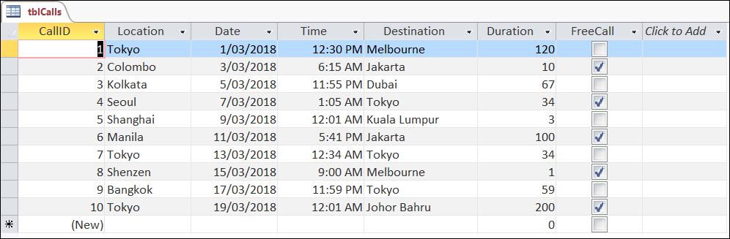

**Forms**

Today we are going to create a form for the Phone Bill DBMS.

A form is the user interface of a DBMS. It is used to input data into the table. It is also used to view data stored in the table.

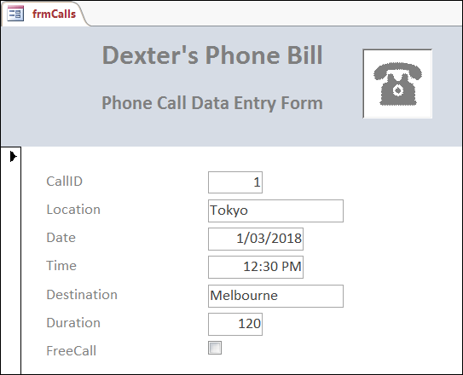

|  |
| --- |
| **Notice:**  The steps in these instructions are based on Access 2013 and are used for demonstration purposes only.  These steps may vary from version to version of Access or for other types of DBMS software.  Please check with your teacher if you have any questions. |

**Required:**

**1. Open** the Phone Bill database management system (DBMS) software file.

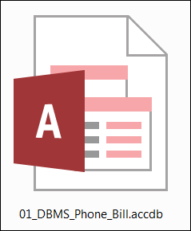

**2. Open** the Calls table to check that all the data has been saved.



**3.** With the Calls table open, **click** Create > Form Wizard.

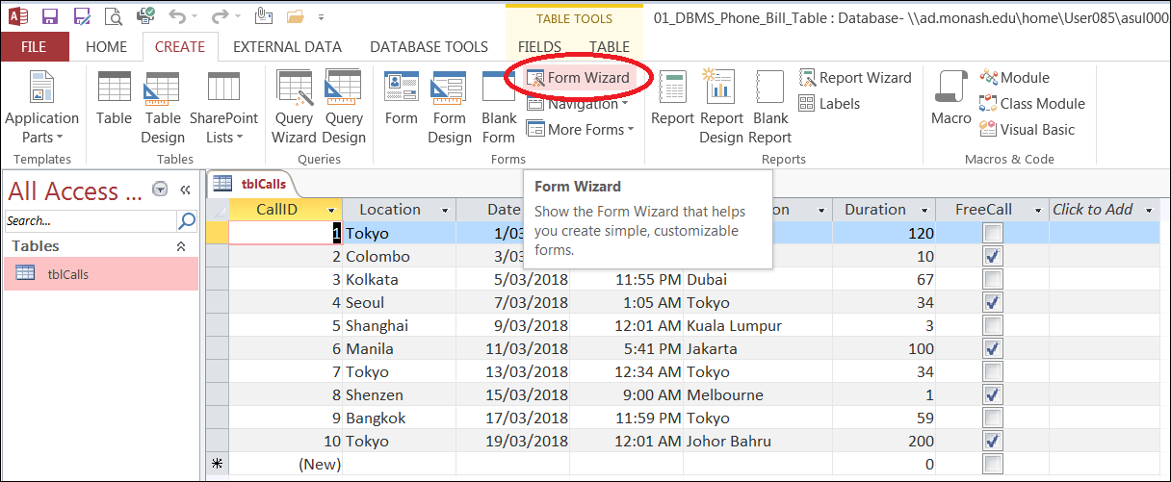

**4. Add** all fields to the selected fields list, then **click** Next.

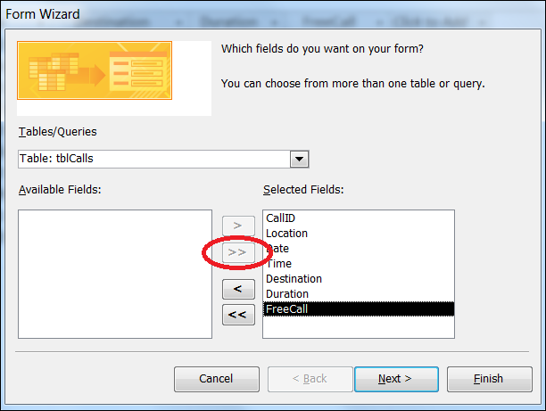

**5. Select** the Columnar radio button, then **click** Next.

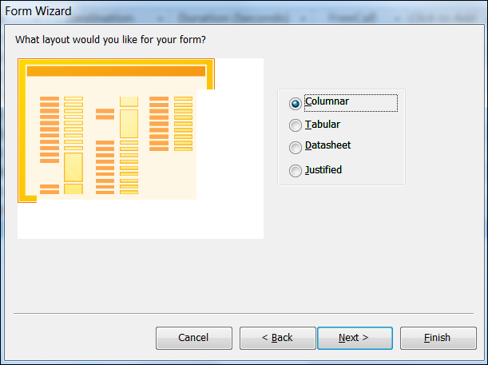

**7. Change** the name (or title) of the form to frmCalls and **click** Finish.

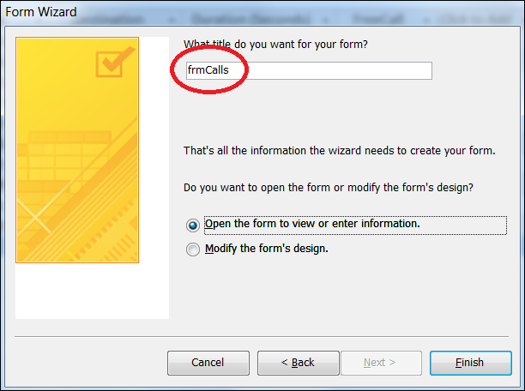

You have now created a DBMS form, well done!

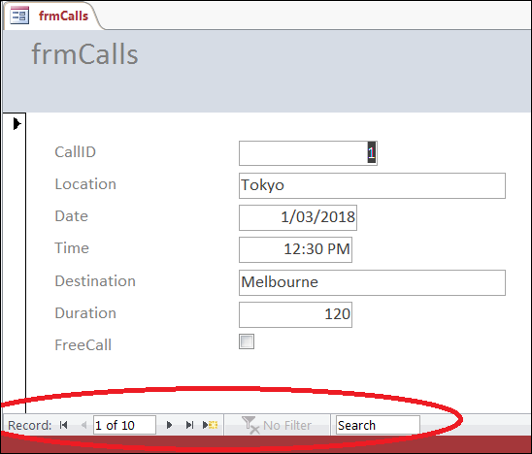

Use the icons at the bottom of the form to scroll through the data stored in the table.

**Formatting a form**

Before we start using the form to input data, we first need to format the form to make it user-friendly.

**8. Click** View > Design View.

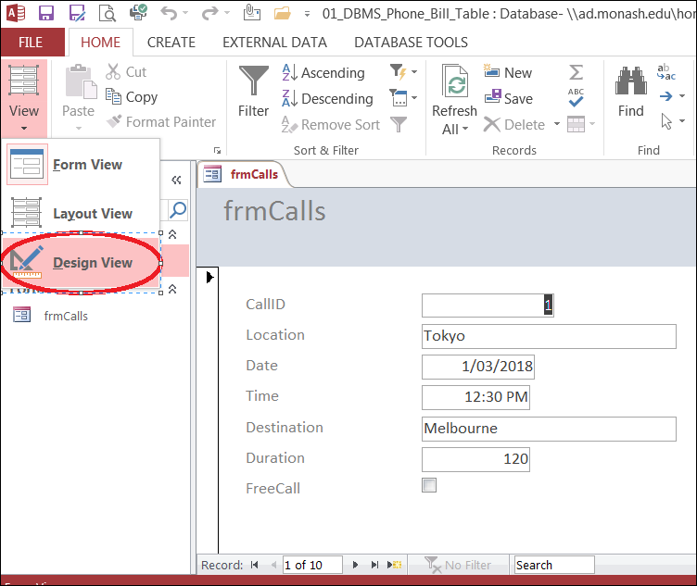

**9. Rename** the title of the form to Dexter’s Phone Bill. **Move** the label to the centre of the form’s header.

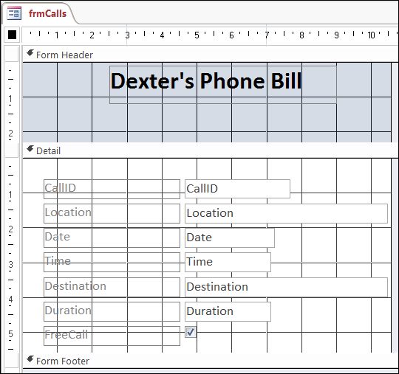

**10. Click** Design > Label. **Drag** the label on to the form.

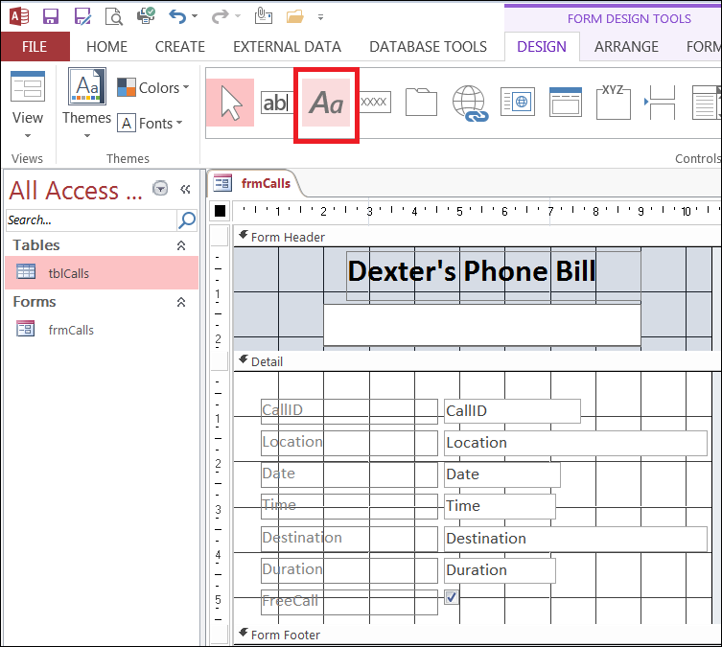

**11.** **Add** the text “Phone Call Data Entry Form” to the label.

**Note:** Switch back to Form View to check how the form appears.

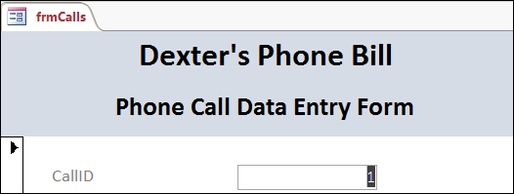

**12.** Back in Design View, **re-size** each of the input controls to make them a suitable size for the data being entered.

**Note:** keep switching between design and form view to check if the input controls are a suitable size.

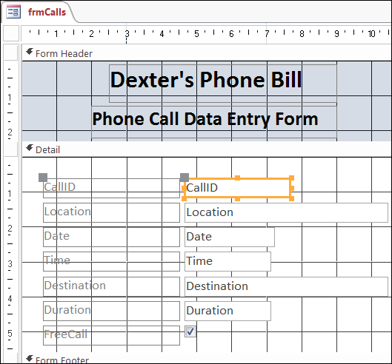

A sample of the completed form is shown below.

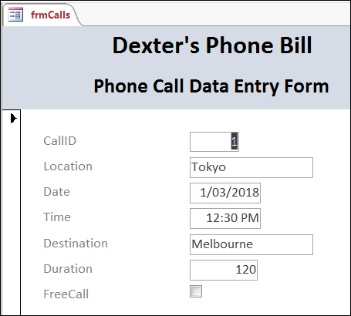

**Images/Logos**

You can also add images or logos to the form.

**13. Add** an image of a phone to the header.

**14. Add** the following data to the DBMS, using the form.

|  |  |  |  |  |  |
| --- | --- | --- | --- | --- | --- |
| **Location** | **Call Date** | **Call Time** | **Destination** | **Duration** | **Free Call** |
| Melbourne | 21/03/2018 | 2:30pm | Melbourne | 45 | No |
| Jakarta | 23/03/2018 | 4:15pm | Jakarta | 19 | Yes |
| Mumbai | 25/03/2018 | 11:15am | Jakarta | 134 | No |
| Singapore | 27/03/2018 | 1:05am | Tokyo | 67 | Yes |
| Beijing | 29/03/2018 | 12:01am | Johor Bahru | 300 | No |
| Sydney | 31/03/2018 | 5:41pm | Jakarta | 2 | Yes |

**15. Open** the table to check that the following data has been input.

**Note:** The table should contain 16 records (or rows).

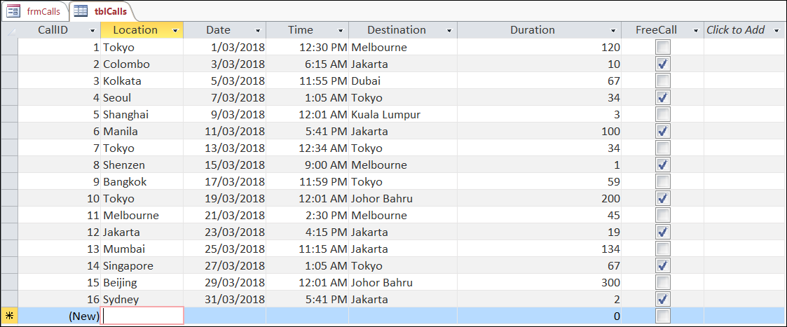

**16. Click** Save and close the DBMS software.



You have now finished this activity.

In this activity you have:

* Created a new database form.
* Formatted the form to make it more user-friendly.
* Viewed data using the form.
* Inputted data, using the form, into the table.

Well done!

**Note:**

You will need the PhoneBill DBMS file for the next activity. Save it in a safe place.