

Dexter’s Phone Bill

Structure of a database management system (DBMS)

Creating DBMS reports

**Dexter’s problem**

I am angry. Lately, my phone bill has increased and I am not sure why. I have asked my phone provider to check my bill but they have told me that it is correct - but I want to check!

So I need you to do me a favour.

I want you to build a database management system (DBMS) that will calculate and display the cost of my phone bill.

I will then compare my phone bill to the amount calculated by the DBMS.

**Note:**

* Only voice calls are made using the phone
* Some calls are included for free within my phone plan
* The cost of other calls are charged at $0.03 per second

My phone bill for March 2018 was:

|  |
| --- |
| The Phone Company  Related image  $35.85  Please pay by 28 April 2018 |

**Activity – creating database reports**

So far, we have created a form, a table and some queries.

Forms are used to add and view data, tables are used to store the data and queries are used to retrieve data and perform calculations.

**Database form**

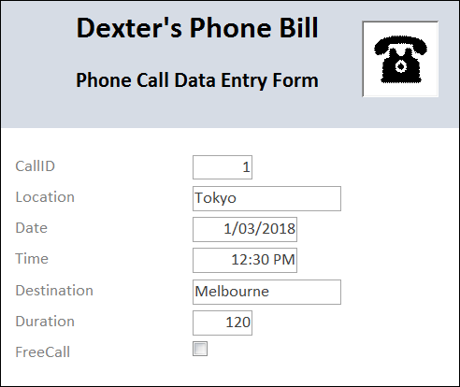

**Table**

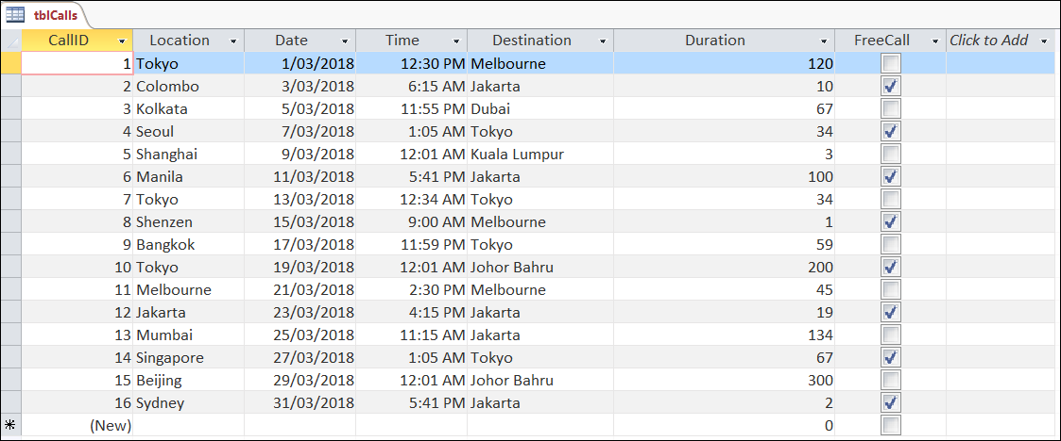

**Query**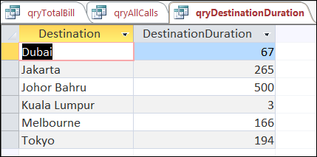

In this activity a report will be created. A report is used to display data retrieved from the database in a user-friendly format.

Reports are used to output the results of a query to the user. They are similar to a Word document.

**1. Open** the PhoneBill DBMS file.

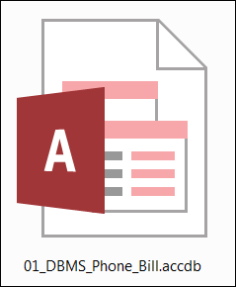

**2. Check** that the DBMS contains the following elements.

* + one table
  + one form
  + five queries

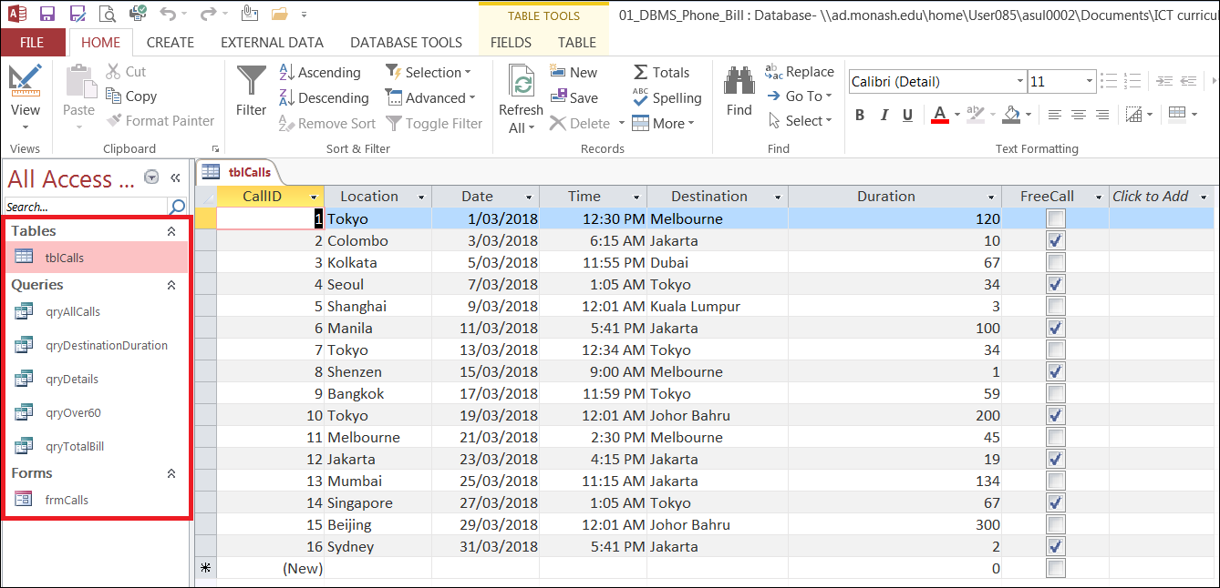

**3. Open** the qryTotalBill query (and **close** all other tabs).

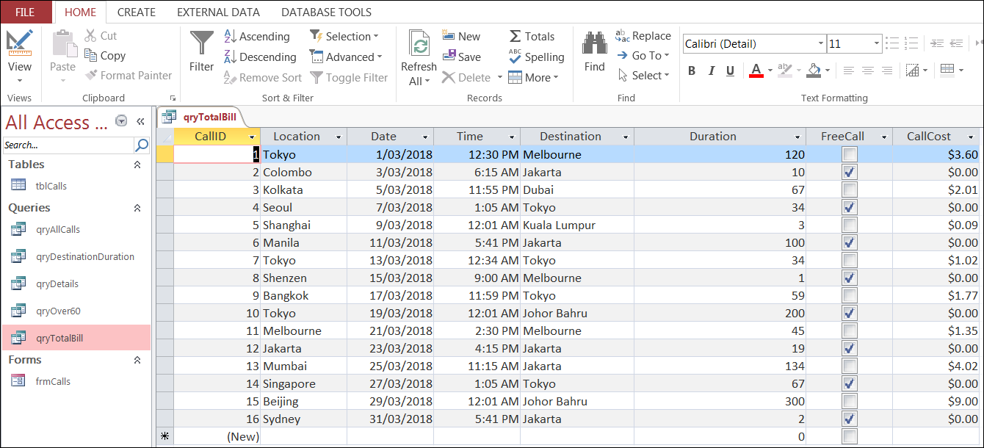

**4. Click** Create > Report.

**Note:** The qryTotalBill must also be open.

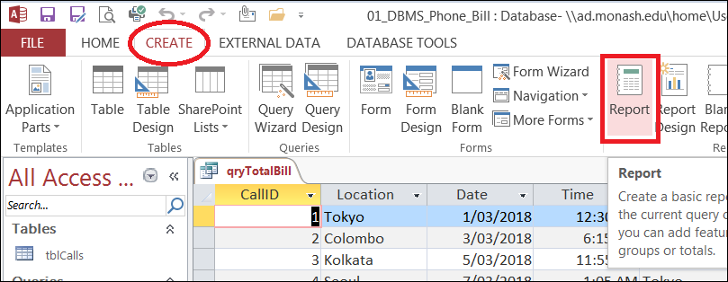



Congratulations! You have created a DBMS report.

The report now needs to be formatted to improve the appearance of the information (and to make the report more user-friendly).

**5. Select** the label and all of the data in the CallCost field.

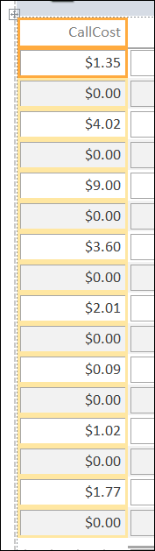

**6. Drag** the column across so it is placed last on the report.

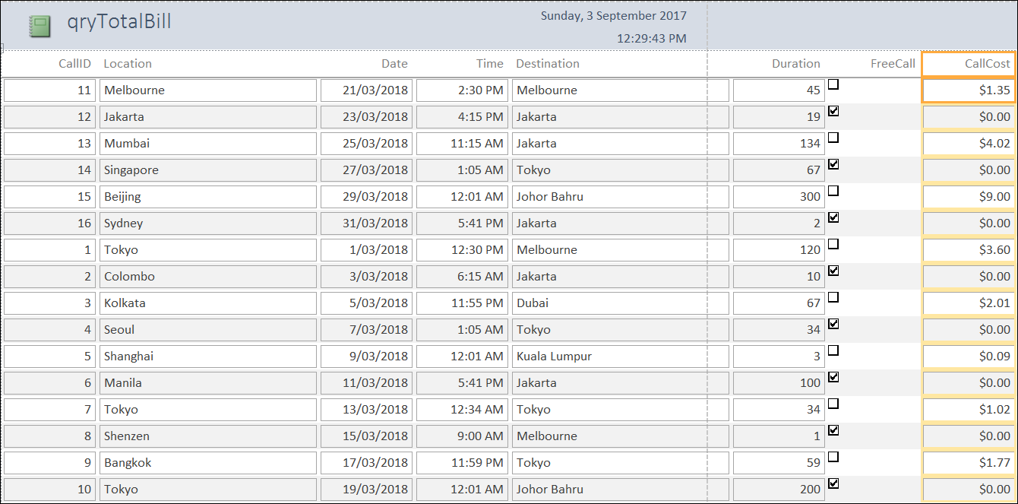

**7. Click** on a value in the CallID column then sort the column from lowest to highest.

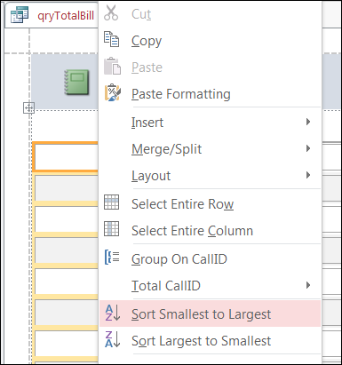

The data should appear in order by CallID.

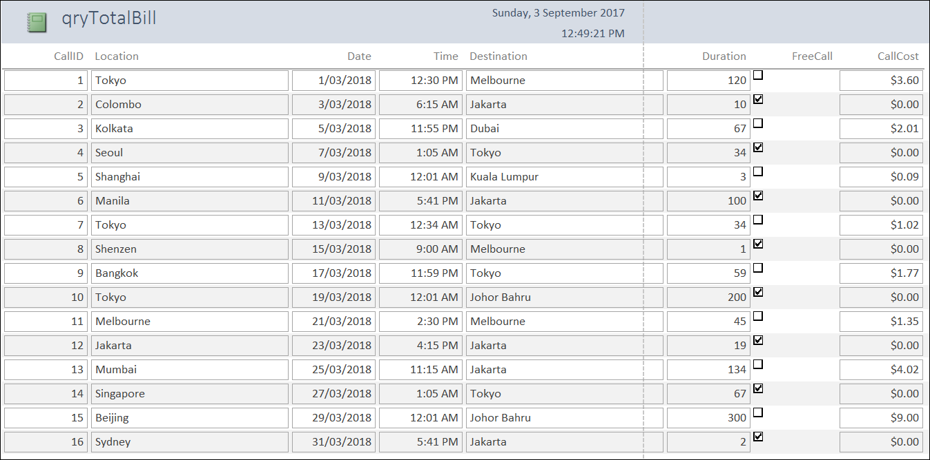

**8. Click** on each field label and **re-size** the column width to an appropriate size.

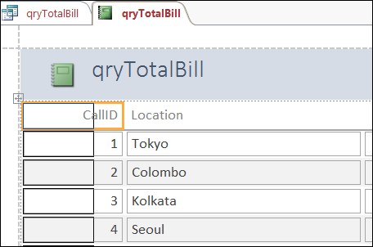

The report should look similar to the sample below.

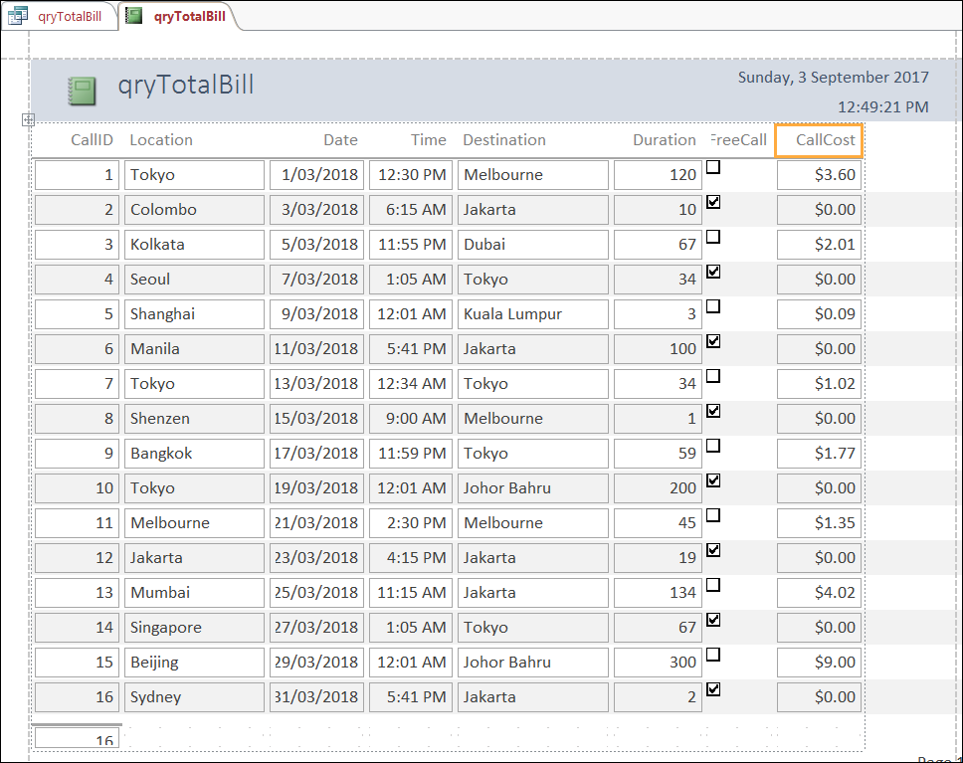

**9. Click** on the label containing the name of the report and **change** to ‘Dexter’s Phone Bill’.

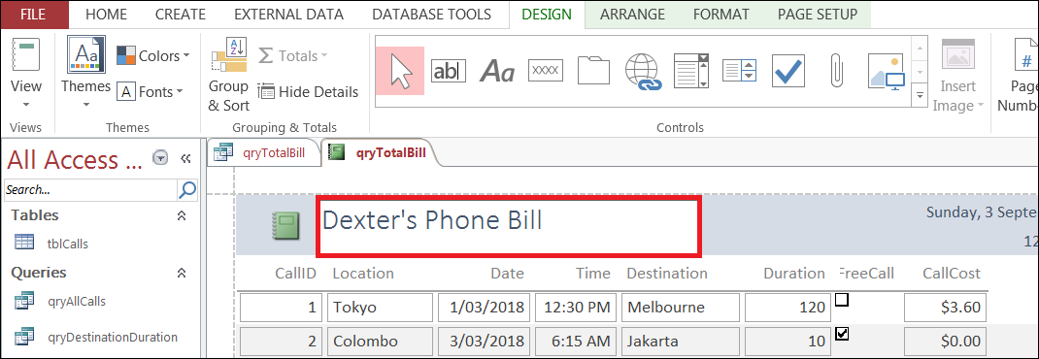

**10. Click** View > Design View.

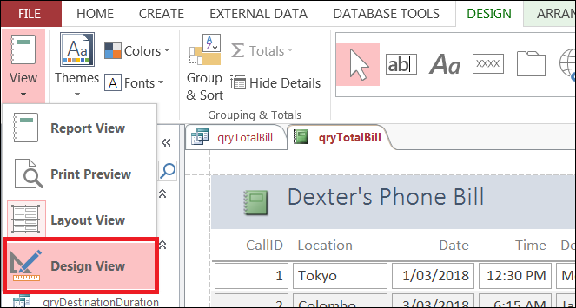

In Design View the different sections of the report are visible.

These include:

* report header
* detail
* page footer
* report footer

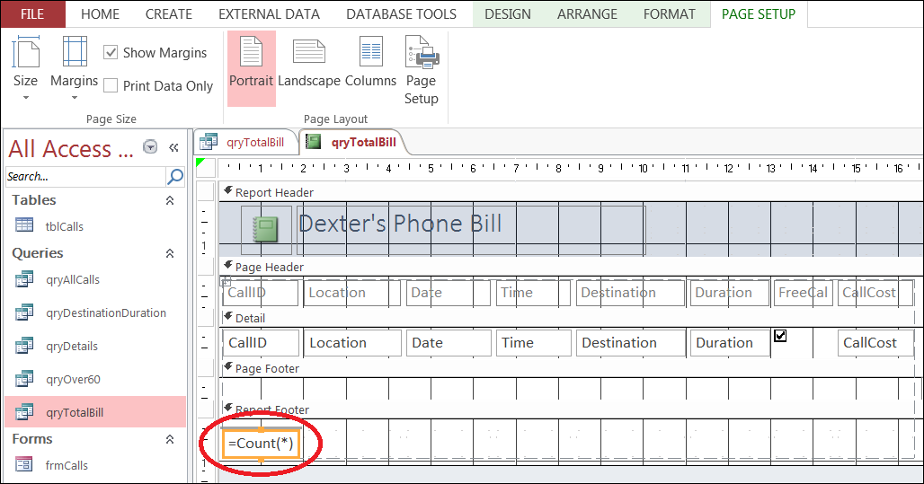

In the report footer, one calculation has already been performed on the data in the report.

The number of records (rows) have been counted. There are 16 records in this report.

**11. Click** on the cell containing the COUNT function and **copy** the cell.

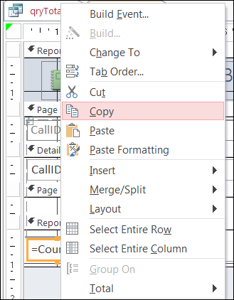

**12. Paste** the cell under the CallCost field (column).

**13. Add** the formula =SUM([CallCost]) in the cell.

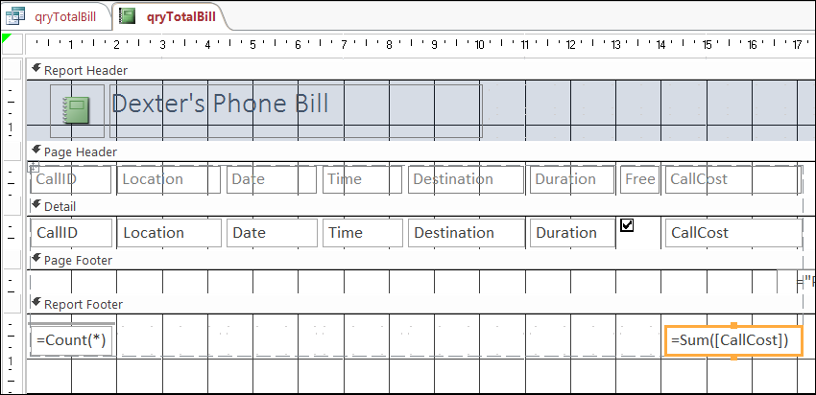

**14. Add** a label next to the SUM(CallCost) cell and name the label ‘Total Bill’.

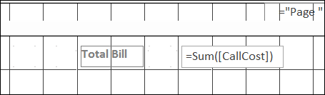

**15. Replace** the logo in the header with an image of a telephone.

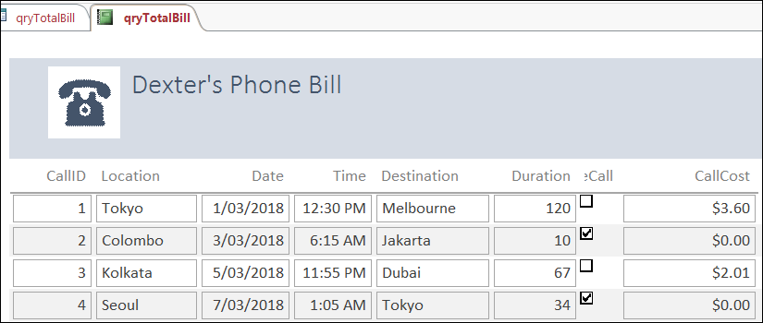

**16. Click** View > Report View.

**17. Save** the report as rptTotalBill.

You have now finished this activity.

In this activity you have:

* Created a DBMS report based on the results of a query
* Formatted the report
* Performed calculations in the report

Well done!

**Note:**

You will need the PhoneBill DBMS file for the next activity. Save it in a safe place.

**Phone Bill**

|  |
| --- |
| The Phone Company  Related image  $35.85  Please pay by 28 April 2018 |

So my bill from The Phone Company was incorrect.

Thank you for helping confirm that fact.

But can you tell me why the bill was incorrect in the first place?

What error do you think The Phone Company was making?