Dexter’s Movie Shop

Purpose and structure of a relational DBMS

Types of relationships in relational DBMS

**Dexter’s problem**

Dexter is sad! He has a problem.

He owns a shop that sells DVD and Blu-ray disks that contains the latest movies from around the world.

Currently all of the data related to selling movies is stored in a flat-file database management system (DBMS).

This is creating lots of redundant data within the database.

As a result, Dexter is upset because:

* the file size of the DBMS is large and takes up too much storage space
* data already stored in the database needs to be input again wasting time
* errors occur when inputting all the data
* it takes a long time to retrieve data from the DBMS
* when editing values, the same value needs to be changed in different locations

**Relational database management system solution**

Dexter wants you to design and develop a relational database management system that can be used to reduce redundant data.

He has provided a sample of the data stored in the flat-file database on the next page.

**tblData**

|  |  |  |  |  |  |  |  |  |  |
| --- | --- | --- | --- | --- | --- | --- | --- | --- | --- |
| **SalesID** | **First** | **Last** | **Email** | **SalesDate** | **Copies** | **Cash?** | **Title** | **Genre** | **CostPerCopy$** |
| 23 | Grace | Park | grace@qq.com | 1st Dec 2017 | 2 | Cash | Wolf Warriors | Action | 7 |
| 24 | Grace | Park | grace@qq.com | 1st Dec 2017 | 1 | Cash | Furious 7 | Action | 9 |
| 25 | Grace | Park | grace@qq.com | 1st Dec 2017 | 3 | Cash | Transformers | Sci-Fi | 7 |
| 26 | Grace | Park | grace@qq.com | 1st Dec 2017 | 1 | Cash | The Mermaid | Romance | 8 |
| 27 | David | Wu | wud@163.com | 2nd Dec 2017 | 1 |  | Wolf Warriors | Action | 7 |
| 28 | David | Wu | wud@163.com | 2nd Dec 2017 | 2 |  | Furious 7 | Action | 9 |
| 29 | David | Wu | wud@163.com | 2nd Dec 2017 | 3 |  | Transformers | Sci-Fi | 7 |
| 30 | Jane | Zhang | jane@yahoo.com | 5th Dec 2017 | 4 | Cash | The Mermaid | Romance | 8 |
| 31 | May | Truong | may@yahoo.com.my | 9th Dec 2017 | 3 |  | Wolf Warriors | Action | 7 |
| 32 | May | Truong | may@yahoo.com.my | 9th Dec 2017 | 2 |  | Furious 7 | Action | 9 |
| 33 | May | Truong | may@yahoo.com.my | 9th Dec 2017 | 1 |  | Transformers | Sci-Fi | 7 |
| 34 | Grace | Park | grace@go-myanmar.com | 9th Dec 2017 | 2 |  | The Mermaid | Romance | 8 |
| 35 | Syed | Shah | sshad@inbox.com | 15th Dec 2017 | 5 | Cash | Wolf Warriors | Action | 7 |
| 36 | Syed | Shah | sshad@inbox.com | 15th Dec 2017 | 2 | Cash | Furious 7 | Action | 9 |
| 37 | Syed | Shah | sshad@inbox.com | 15th Dec 2017 | 2 | Cash | Transformers | Sci-Fi | 7 |

**Design**

**1. Complete** the entity-relationship (ER) diagram below to show all of the attributes, entities and relationships in the proposed relational database.

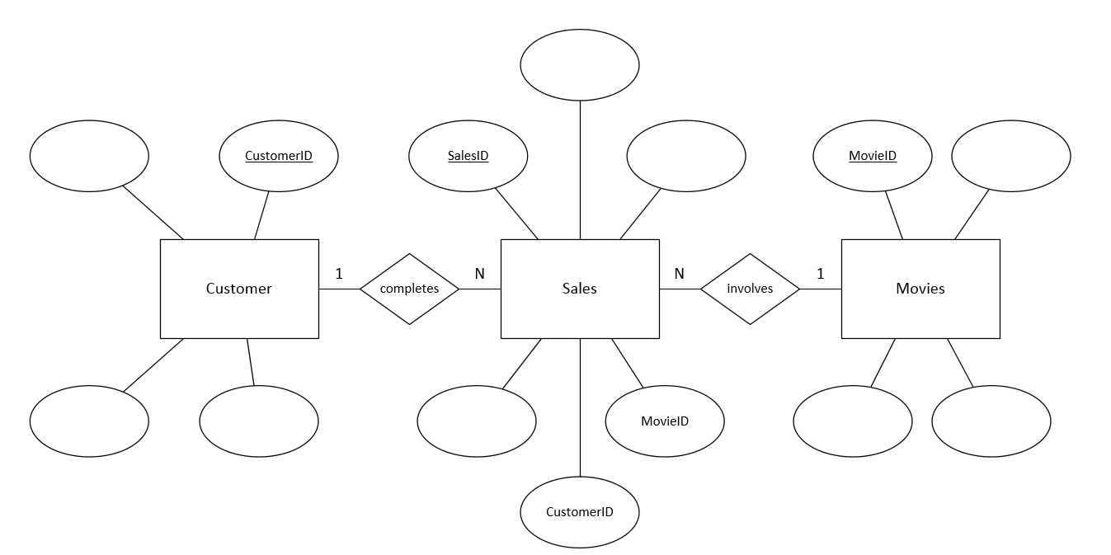

**2. Complete** the data dictionary for each entity (table) for the Movie DBMS.

tblCustomers

|  |  |  |  |
| --- | --- | --- | --- |
| **Field** | **Data type** | **Field Size**  **(if short text)** | **Other properties** |
| CustomerID | AutoNumber |  | Primary key |
|  |  |  |  |
|  |  |  |  |
|  |  |  |  |

tblSales

|  |  |  |  |
| --- | --- | --- | --- |
| **Field** | **Data type** | **Field Size**  **(if short text)** | **Other properties** |
| SalesID | Number |  | Primary key |
|  |  |  |  |
|  |  |  |  |
|  |  |  |  |
| CustomerID | Number |  | Foreign key |
| MovieID | Number |  | Foreign key |

tblMovies

|  |  |  |  |
| --- | --- | --- | --- |
| **Field** | **Data type** | **Field Size**  **(if short text)** | **Other properties** |
| MovieID | AutoNumber |  | Primary key |
|  |  |  |  |
|  |  |  |  |
|  |  |  |  |

**Development**

**3. Create** a new blank desktop database.

**4. Create** the three tables based on the specifications listed in the data dictionaries.

**5. Create** the relationships between tables based on the cardinality shown in the entity-relationship (ER) diagram.

**6. Create** a form for each table.

**7. Populate** each table, using a form, with the appropriate data from the flat-file table.

**Hint:** Input the customer and movie data first, then populate the sales table last.