

Dexter’s Canine Supplies

Structure of a relational database management system

Extension activity

**Help me!**

I own a canine supplies business that sells supplies for dogs, but the DBMS used by the pet supplies business is a flat-file database. This causes all sorts of problems.

Orders are taken online and when a customer places an order, I need to record the following:

* First (name)
* Last (name)
* Address
* Town
* Post code
* Order date
* Product
* Product price
* Quantity of product purchased
* If the customer paid or not

**Products**

Dexter’s Canine Supplies sells six products:

* Squeaker ball
* Lead
* Shampoo
* Water bowl
* Name tag
* Fluffy bed

**Additional information**

* One customer can place many orders
* An order can only consist of one product
* All products are priced between $2.25 and $10.00
* The maximum quantity allowed in an order is eight for a product
* Postcodes in Australia consist of a four digit number between 0000 and 9999

**Required**

Design and develop a relational database management system to help me out!

**Sample data**

|  |  |  |  |  |  |  |  |  |  |
| --- | --- | --- | --- | --- | --- | --- | --- | --- | --- |
| **First** | **Last** | **Address** | **Town** | **Postcode** | **OrderDate** | **Product** | **Price$** | **Quantity** | **Paid?** |
| Peter | Zhou | 12 Wooralla Drive | Mount Eliza | 3930 | 19/02/2018 | Squeaker ball | 4.50 | 4 | Yes |
| James | Gregory | 45 Gavin Street | Moorabbin | 3186 | 20/02/2018 | Lead | 6.00 | 3 | No |
| James | Gregory | 45 Gavin Street | Moorabbin | 3186 | 21/02/2018 | Shampoo | 3.75 | 2 | No |
| Sarah | Robertson | 12 Sunshine Road | Surfers Paradise | 4217 | 21/02/2018 | Water bowl | 5.00 | 1 | No |
| James | Gregory | 45 Gavin Street | Moorabbin | 3186 | 23/02/2018 | Name tag | 2.25 | 5 | No |
| Peter | Williams | 12 Cambridge Road | West Perth | 6005 | 24/02/2018 | Squeaker ball | 4.50 | 6 | Yes |
| Chloe | Bridges | 23 Miners Road | Stanley | 7331 | 24/02/2018 | Lead | 6.00 | 7 | Yes |
| Sarah | Robertson | 12 Sunshine Road | Surfers Paradise | 4217 | 24/02/2018 | Shampoo | 3.75 | 8 | Yes |
| Harold | Holt | 56 Glenelg Drive | South Adelaide | 5002 | 25/02/2018 | Water bowl | 5.00 | 1 | No |
| Chloe | Bridges | 23 Miners Road | Stanley | 7331 | 26/02/2018 | Name tag | 2.25 | 2 | Yes |
| Sarah | Robertson | 12 Sunshine Road | Surfers Paradise | 4217 | 26/02/2018 | Fluffy bed | 10.00 | 3 | Yes |
| Peter | Williams | 12 Cambridge Road | West Perth | 6005 | 26/02/2018 | Squeaker ball | 4.50 | 4 | Yes |
| Peter | Zhou | 12 Wooralla Drive | Mount Eliza | 3930 | 27/02/2018 | Water bowl | 5.00 | 8 | Yes |
| Harold | Holt | 56 Glenelg Drive | South Adelaide | 5002 | 27/02/2018 | Squeaker ball | 4.50 | 7 | No |

**Design**

**1. Complete** the entity-relationship (ER) diagram for the relational database for Dexter’s Pet Supplies. **Indicate** the type of relationship (in the red square) between Products and Orders.

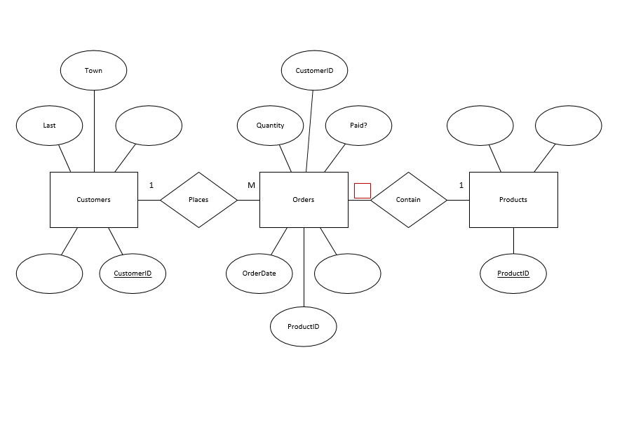

**2. Complete** each data dictionary to show details of the fields contained within each table by filling in the cells highlighted red.

tblCustomers

|  |  |  |  |
| --- | --- | --- | --- |
| **Field** | **Data type** | **Field Size**  **(if short text)** | **Other properties** |
| CustomerID | AutoNumber |  | Primary key |
| First | Short Text |  |  |
| Last |  | 50 |  |
| Address | Short Text | 80 |  |
| Town | Short Text | 50 | Foreign key |
| Postcode | Number |  | Format = 0000 |

tblOrders

|  |  |  |  |
| --- | --- | --- | --- |
| **Field** | **Data type** | **Field Size**  **(if short text)** | **Other properties** |
| OrderID | AutoNumber |  | Primary key |
| OrderDate |  |  |  |
| Quantity | Number |  |  |
| Paid? |  |  |  |
| CustomerID | Number |  | Foreign key |
|  | Number |  | Foreign key |

tblProducts

|  |  |  |  |
| --- | --- | --- | --- |
| **Field** | **Data type** | **Field Size**  **(if short text)** | **Other properties** |
| ProductID | AutoNumber |  | Primary key |
| Product | Short Text |  |  |
| Price$ |  |  | Validation rule  >=2.25 and <=10.00 |

**Development**

**3. Create** the DBMS using software.

Including:

* + creating tables (including data types and validation)
  + creating relationships between tables
  + populating data into tables

**4. Create** queries, using SQL, to retrieve the following information:

* A list of all customer details sorted from A to Z by last (name)
* A list of all product details sorted by price from highest to lowest
* A list of orders including the order date and quantity, customer first and last names, product name and price
* A list of orders including the order date and quantity, customer first and last names, product name and price with the total price of each order calculated by multiplying price and quantity
* A list of all products and calculate the number of orders (COUNT) grouped by product
* A list of products and calculate the total quantity (SUM) of products ordered grouped by product
* A list of orders including the order date and quantity, customer first and last names, product name and price, with the total price of each order calculated by multiplying price and quantity, of the orders placed on 24/02/2018

