Shares 4 You

Functions and techniques used to test that a solution is working correctly.

Dexter likes to buy shares online. He purchases his shares through a business named Shares 4 You.

Shares 4 You have recently developed a relational database management system to help process orders from clients like Dexter.

But the DBMS has yet to be tested and they would like you to test the DBMS to make sure it is working correctly.

The entity-relationship diagram of the DBMS is shown below:

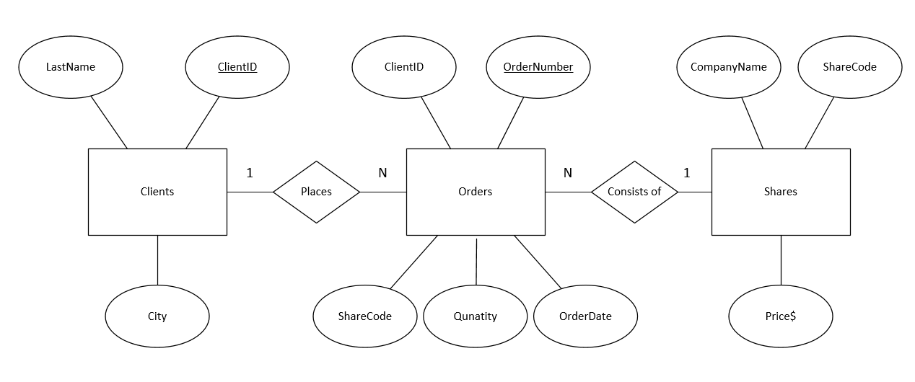

The data dictionary for each table is shown below:

tblClients

|  |  |  |  |
| --- | --- | --- | --- |
| **Field** | **Data type** | **Field Size**  **(if short text)** | **Other properties** |
| ClientID | AutoNumber |  | Primary key |
| LastName | Short Text | 40 |  |
| City | Short Text | 50 |  |

tblShares

|  |  |  |  |
| --- | --- | --- | --- |
| **Field** | **Data type** | **Field Size**  **(if short text)** | **Other properties** |
| ShareCode | Short Text | 3 | Primary key  Input mask = LLL |
| CompanyName | Short Text | 50 |  |
| Price | Currency |  | Validation rule >=1.00 and <=5.00 |

tblOrders

|  |  |  |  |
| --- | --- | --- | --- |
| **Field** | **Data type** | **Field Size**  **(if short text)** | **Other properties** |
| OrderNumber | AutoNumber |  | Primary key |
| ClientID | Number |  | Foreign key |
| ShareCode | Short Text |  | Foreign key |
| Quantity | Number |  | Validation rule >=10 |
| OrderDate | Date/Time |  |  |

**Testing**

Complete the first three columns of each test table to test if the input mask and validation rules are working as expected.

Input mask for ShareCode

|  |  |  |  |
| --- | --- | --- | --- |
| Test | Test data | Expected result | Actual result |
|  |  |  |  |
|  |  |  |  |

Validation rule for Quantity

|  |  |  |  |
| --- | --- | --- | --- |
| Test | Test data | Expected result | Actual result |
|  |  |  |  |
|  |  |  |  |

Validation rule for Price

|  |  |  |  |
| --- | --- | --- | --- |
| Test | Test data | Expected result | Actual result |
|  |  |  |  |
|  |  |  |  |
|  |  |  |  |
|  |  |  |  |

The data stored in each table is as follows:

tblShares

|  |  |  |
| --- | --- | --- |
| **ShareCode** | **CompanyName** | **Price** |
| AGO | Atlas | 3.59 |
| BSL | Bluescope | 1.39 |
| DOW | Downer | 3.79 |
| LYC | Lynas | 2.20 |
| SGM | Sims Metal | 4.91 |

tblClients

|  |  |  |
| --- | --- | --- |
| **ClientID** | **LastName** | **City** |
| 1 | Dexter | Melbourne |
| 2 | Kim | Seoul |
| 3 | Ahmed | Tehran |
| 4 | Yilmaz | Istanbul |
| 5 | Wang | Chengdu |

tblOrders

|  |  |  |  |  |
| --- | --- | --- | --- | --- |
| **OrderNumber** | **ClientID** | **ShareCode** | **Quantity** | **OrderDate** |
| 1 | 1 | BSL | 10 | 20/02/2018 |
| 2 | 2 | AGO | 100 | 20/02/2018 |
| 3 | 3 | SGM | 30 | 20/02/2018 |
| 4 | 4 | LYC | 200 | 20/02/2018 |
| 5 | 5 | DOW | 50 | 23/02/2018 |
| 6 | 1 | SGM | 40 | 23/02/2018 |
| 7 | 3 | LYC | 30 | 23/02/2018 |
| 8 | 1 | BSL | 100 | 24/02/2018 |

**Queries**

The following queries have been included in the RDBMS.

1. List all shares where the price is over $3.

2. List order details that involve Dexter.

3. List all the orders that involved DOW.

4. List all orders made by ClientID = 3, including calculating the total cost of each order.

5. List all orders, where the total cost of the order is greater than $150.

**Testing**

Complete the first three columns of each test table to identify the expected result for each query.

1. List all shares where the price is over $3

|  |  |  |  |
| --- | --- | --- | --- |
| Test | Test data | Expected result | Actual result |
|  |  |  |  |

2. List order details that involve Dexter

|  |  |  |  |
| --- | --- | --- | --- |
| Test | Test data | Expected result | Actual result |
|  |  |  |  |

3. List all the orders that involve DOW.

|  |  |  |  |
| --- | --- | --- | --- |
| Test | Test data | Expected result | Actual result |
|  |  |  |  |

4. List all orders made by ClientID = 3, including calculating the total cost of each order.

|  |  |  |  |
| --- | --- | --- | --- |
| Test | Test data | Expected result | Actual result |
|  |  |  |  |
|  |  |  |  |

5. List all orders, where the Quantity is greater than 100.

|  |  |  |  |
| --- | --- | --- | --- |
| Test | Test data | Expected result | Actual result |
|  |  |  |  |

**Calculating the expected result**

Open the Shares 4 You DBMS and run each test to calculate the expected result.