Data Science reports

Interpret and analyse data visualisations

Below is the raw data and chart, created in Infogram, for the Australia’s size by state activity.

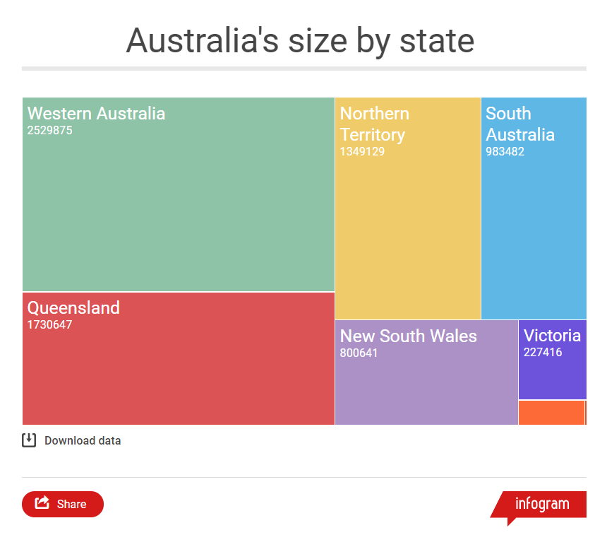

|  |  |
| --- | --- |
| **State** | **Size** |
| Western Australia | 2,529,875 |
| Queensland | 1,730,647 |
| Northern Territory | 1,349,129 |
| South Australia | 983,482 |
| New South Wales | 800,641 |
| Victoria | 227,416 |
| Tasmania | 68,401 |
| Australian Capital Territory | 2,358 |

**Data visualisation analysis**

**Required:**

**1. Write** a report that analyses the data visualisation shown.

You can use the following framework, also used in ICT Unit 1, to guide you.

**Note:** You can add additional information if you wish.

**2. Upload** the completed analysis into the HTML page created in the previous activity.

|  |
| --- |
| **Analysis framework**   1. **Introduction** (write one sentence describing the overall purpose of the graph). 2. **Graph type and purpose** (write two sentences, one sentence identifying the type of graph, the 2nd sentence describing the genetic purpose of that type of graph). 3. **Data included** (write one sentence for each data item in the graph). 4. **Main finding/trend** (write one sentence describing the main finding or trend in the graph). 5. **Other findings** (select two or three other things that stand out in the graph – write one sentence for each area.) 6. **Source of the data** (write one sentence identifying where the data came from). 7. **Conclusion** (write one sentence, restating the main findings (in different words) above). |

**Data visualisation analysis**

|  |
| --- |
| **Introduction**  The graph displays the number of people living in a particular state in Australia.  **Graph type and purpose**  An infographic is used to represent the population data. Infographics are used to create graphical visual representations of information, data or knowledge intended to present information quickly and clearly.  **Data included**  The population of each state are represented by the size of each boxes while different colours are used to represent identify the state of that slice.  **Main finding/trend**  The main finding in the trend is that Western Australia has the largest population in Australia.  **Other findings**  Australian Capital Territory has the smallest population compared to the other states in the Data. Western Australia, Queensland and Northern Territory more than 1 million people living in them  **Source of data**  The source data came from Wikipedia, their website’s Address is  <https://en.wikipedia.org/wiki/Ranked_list_of_states_and_territories_of_Australia>  **Conclusion**  Overall, the infographic shows that the population in Western Australia is the biggest. |
|  |