Google Public Data www.google.com/publicdata/directory

Acquire and visualise data from secondary sources

Methods and techniques used to clean and prepare data

Understanding of HTML used to create webpages

Interpret and analyse data visualisations

**Required resources**

This activity requires the following resources:

**Google.com**

Access to google.com/publicdata/directory#

**Text editor**

A text editor e.g. Notepad++ or TextEdit to embed HTML code snippets and edit a web page.

**Required**

**1. Go** to <https://www.google.com/publicdata/directory> .

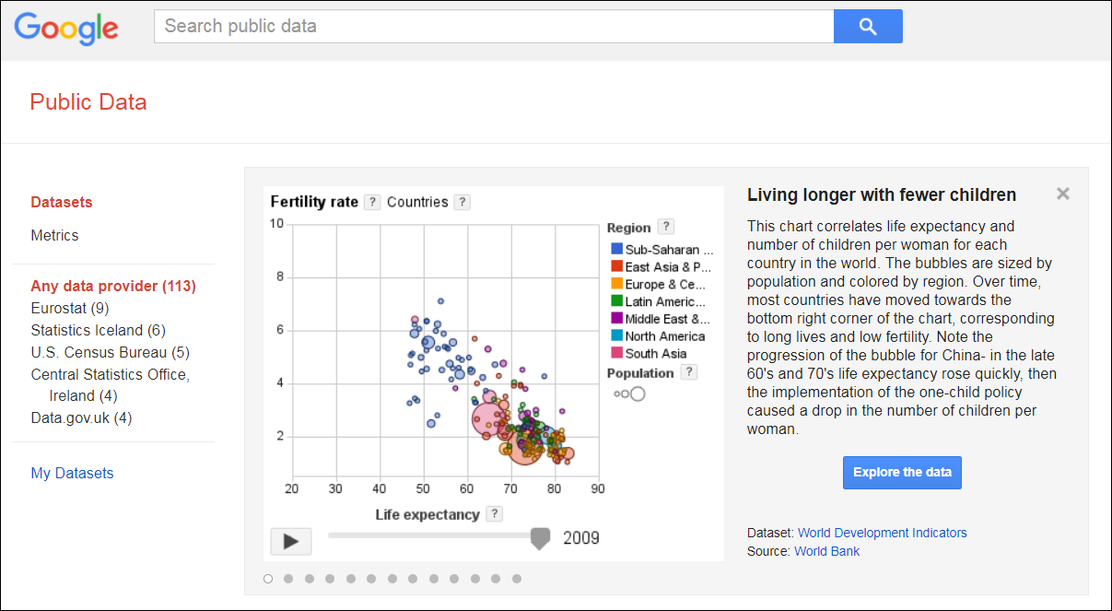

**2. Scroll** down and click ‘ICT Statistics Database.’

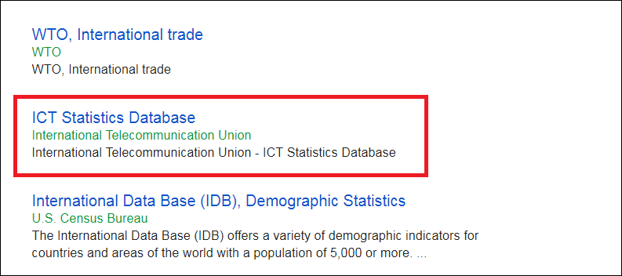

**3. Select ‘**internet’ **>** ‘percentage of individuals using the internet’.

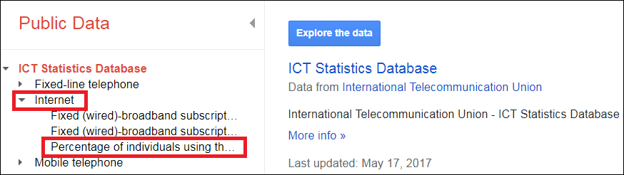

**4. Unselect ‘**total’.

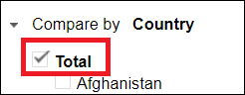

**5. Select** the following countries:

* Australia
* Bangladesh
* China
* Egypt
* Malaysia
* Pakistan
* Saudi Arabia
* Singapore
* Sri Lanka
* Vietnam

**7. Take** a screenshot of the line graph and **paste** into a Word document.

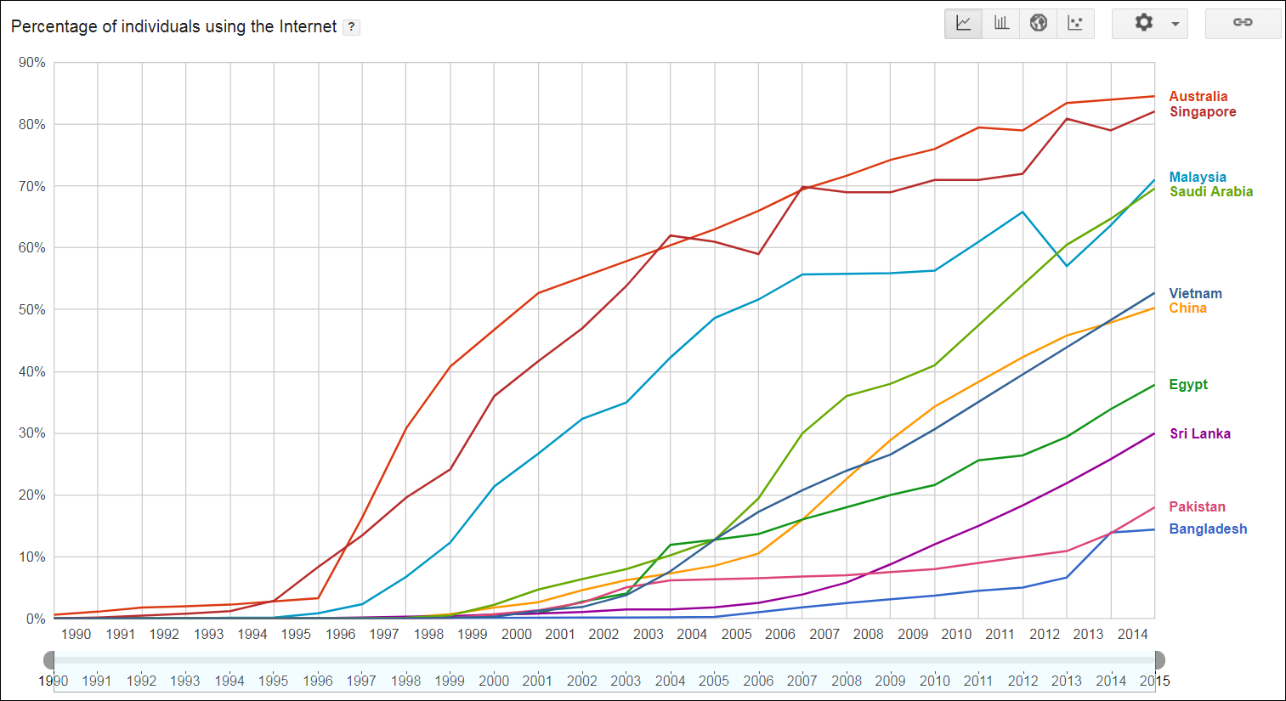

**8. Select** the column graph type.



**9. Select** ‘settings’ then unselect ‘show non-selected items’.

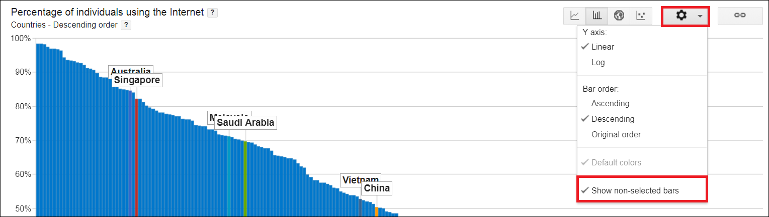

**10. Move** the slider to 1990 and then **press** ‘play’.

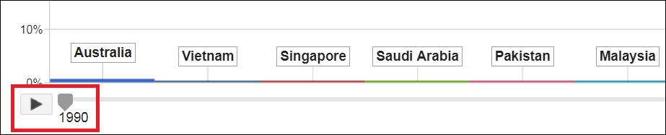

**11. Click** the link button and **copy** the HTML code.

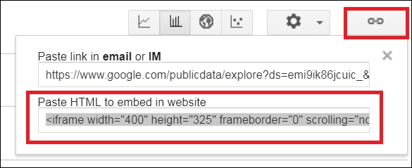

**12. Select** the map graph type.



**13. Move** the ruler to 1990 and **press** ‘play’.

**14.** **Click** the link button and **copy** the HTML code.

**15. Select** the bubble chart icon.



**16. Move** the ruler to 1990 and **press** ‘play’.

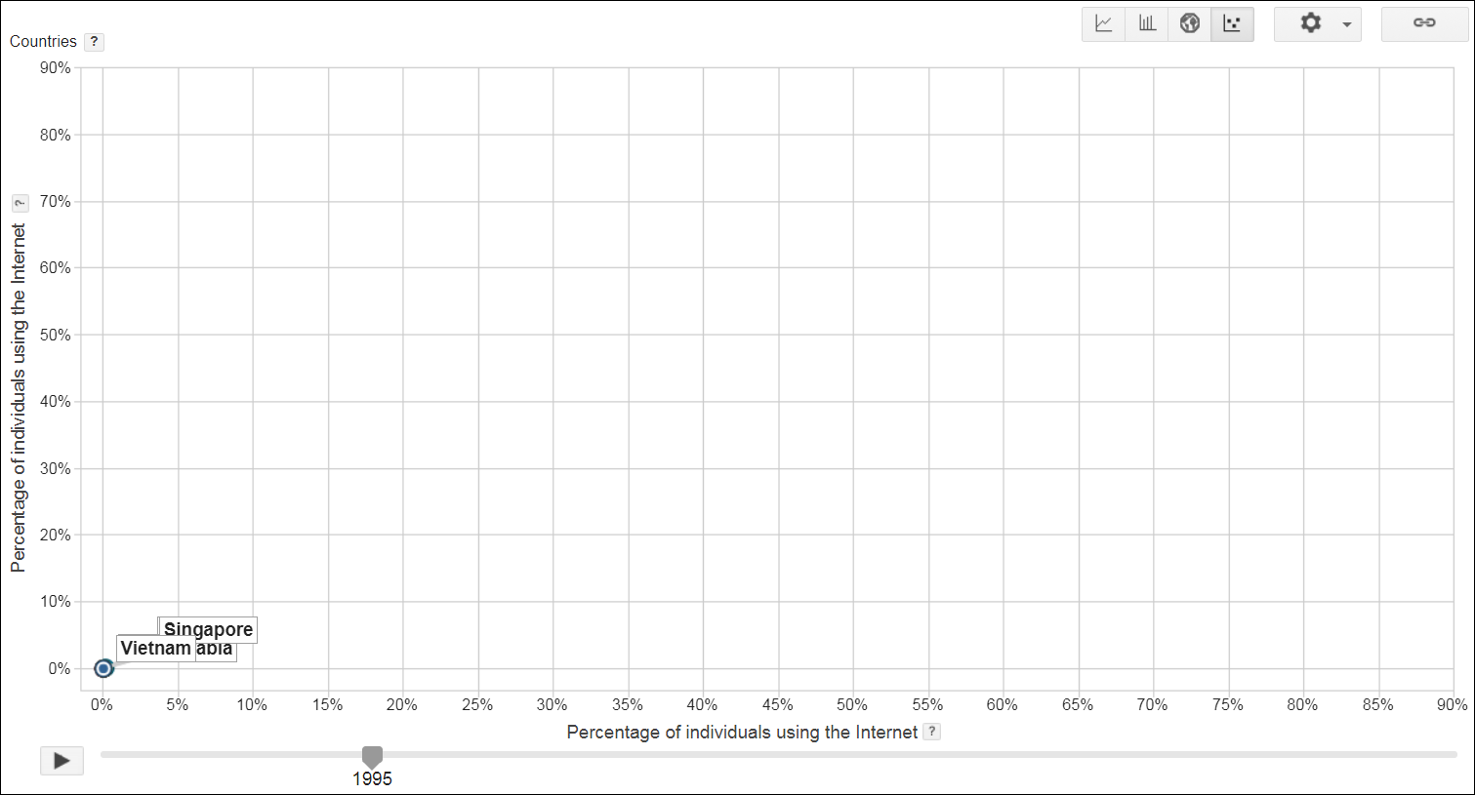

**17.** **Click** the link button and **copy** the HTML code.

**18. Paste** the HTML code snippets into a text editor to view the visualisations in a website.

**19. Edit** the HTML code so there is a title above each visualisation and at least one sentence below each visualisation **explaining** the type of visitation used and key findings.

**20. Save** the text editor file in a safe location.